

* Home
* About
* Shop
  + All Products
  + Popular Items
  + New Arrivals

Cart 0

Search

Location

S M L XL Saiz

Start Date

End Date

Cari Sekarang



Sinuangga

$40.00 - $80.00

View options

Sale

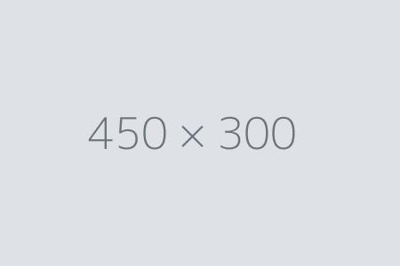

Special Item

$20.00 $18.00

Add to cart

Sale



Sale Item

$50.00 $25.00

Add to cart



Popular Item

$40.00

Add to cart

Sale



Sale Item

$50.00 $25.00

Add to cart



Fancy Product

$120.00 - $280.00

View options

Sale



Special Item

$20.00 $18.00

Add to cart



Popular Item

$40.00

Add to cart

© 2025 Wakasku. Semua Hak Cipta Terpelihara.