Add to Cart

Size: SM LXL Duration (days): 123 4567

Cancel Confirm



* Home
* About
* Shop
  + All Products
  + Popular Items
  + New Arrivals

Cart 0

Your Cart



Sinuangga

RM 100 / 1 DAY

Add to cart

Sale

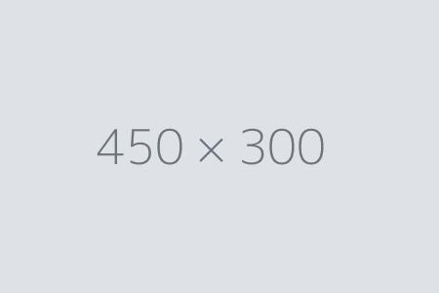

Gaung

RM100 RM 98 / 1 DAY

Add to cart

Sale



Tinohian

RM 88 / 1 DAY

Add to cart

© 2025 Wakasku. Semua Hak Cipta Terpelihara.