***Pavlenko Mariia,***

***BPS-222.***

**[Plot 1. Histograms combined in one line]**

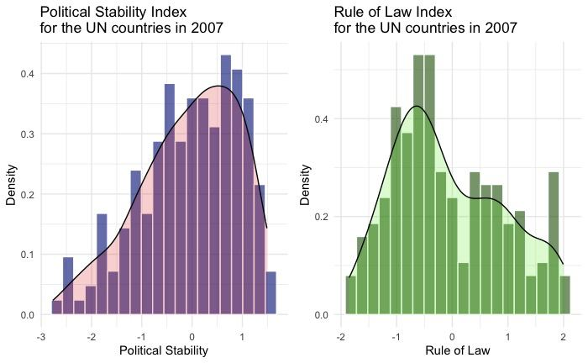

**[Plot 2. Graph combining boxplots]**

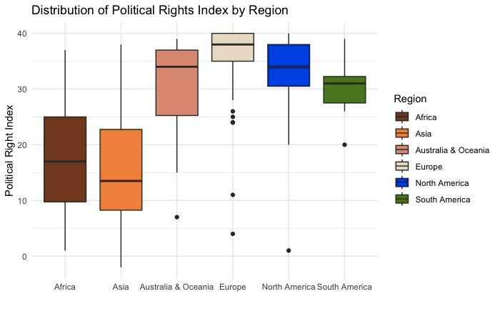

**[Plot 3. 6 unified scatterplots]**

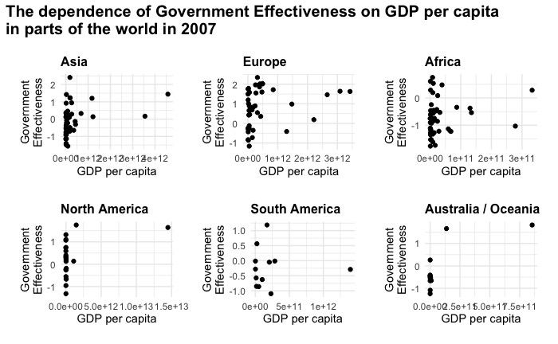

**[Plot 4. Q-Q plot]**

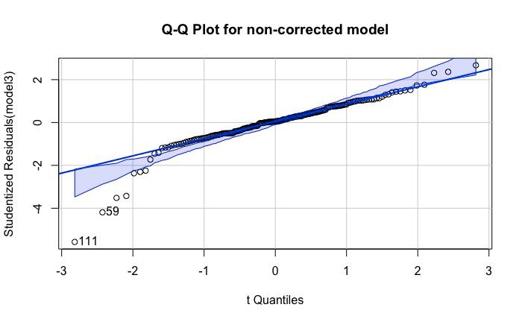

**[Plot 5. crPlots]**

