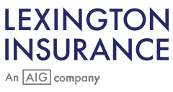
Lexington Healthcare Professional Liability and General Liability Quote
April 8, 2023
ATTN: Diamond Medi Spa, LLC
Thank you for your submission and the opportunity to quote. On behalf of Lexington Healthcare, we are pleased to offer the following terms:

Policy Dates: April 8, 2023 to April 9, 2024
Policy Form: Claims-Made
Professional Liability Coverage
- Each Claim Limit: $1,000,000
- Aggregate Limit: $3,000,000
General Liability Coverage
- Each Claim Limit: $1,000,000
- Aggregate Limit: $3,000,000
Deductible: $2,500 per claim
Retro Date: April 8, 2022
Premium:
$30,383

This Quote is valid for 30 days of current policy expiration date.
Please contact me if you have any questions.
Norika Heathdale
Underwriter

