Collaborative Notes

https://pad.carpentries.org/2025-03-22-Tucson

Username: norikotamari

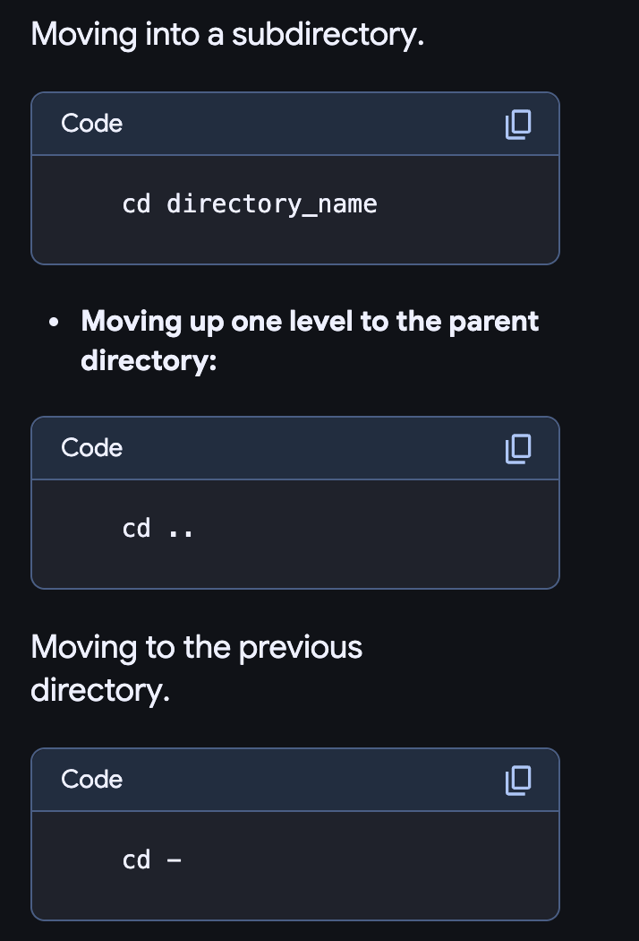Github:E@bqEPC7yg4pgBp

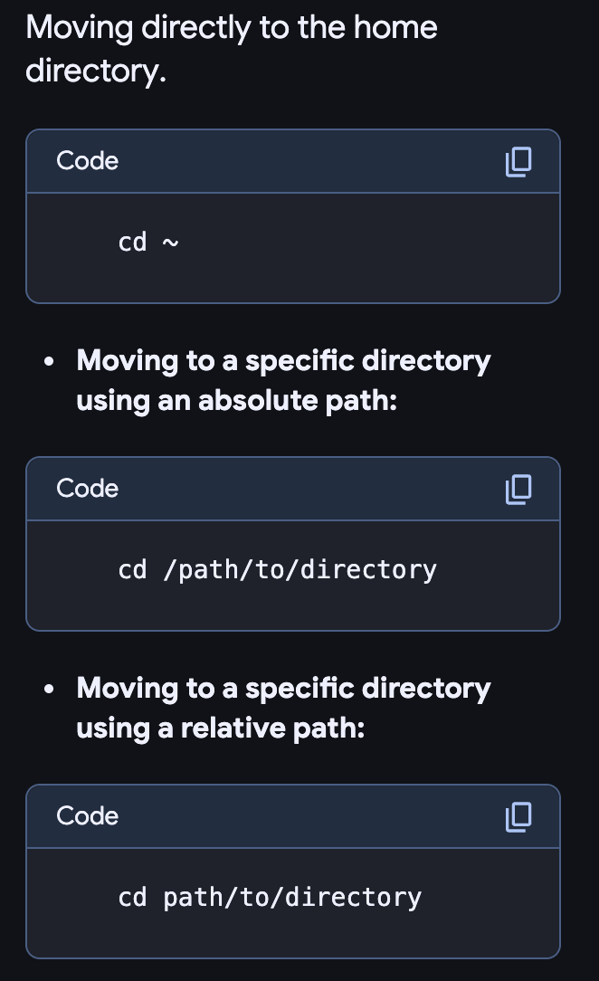

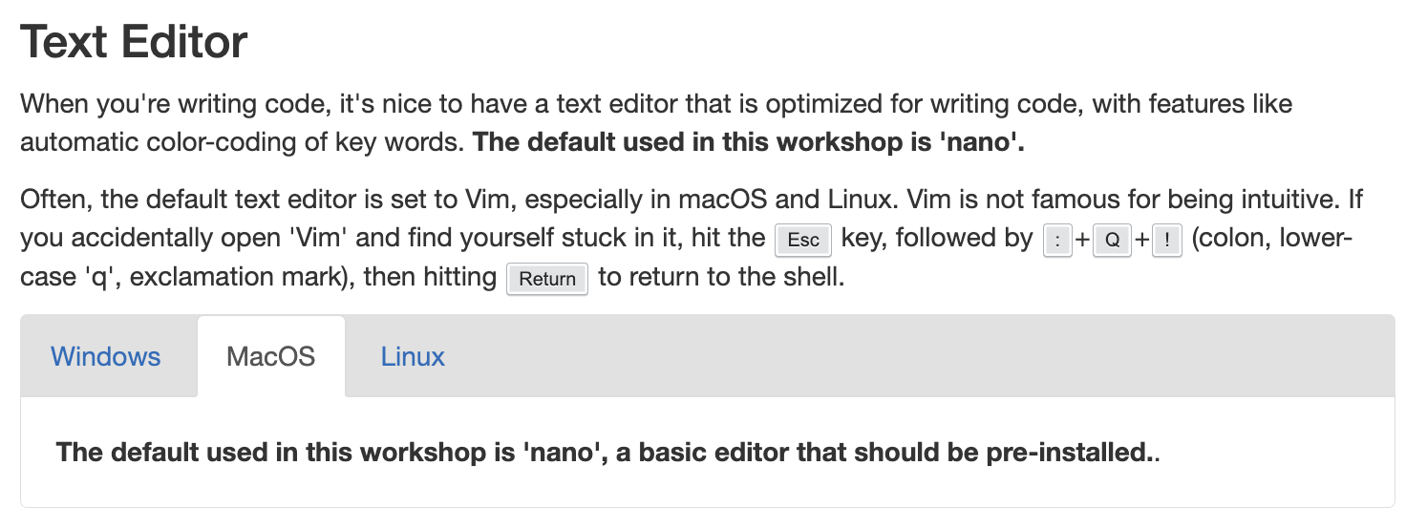

Terminal

man ls

q (quit)