

SECJ3483-01
WEB TECHNOLOGY

Lecturer: DR. NORIZAM BIN KATMON

Group Project Lab Exercise

Name | Matric No
IZZAT FAKHRULLAH BIN KARIM | A23CS0089
RAMI YASSEIN ELTAYEB MOHAMED | A23CS0022
AMMAR ABDULRAHMAN ANAAM MUDHSH | A23CS0287
NOUREDIN MAMDOUH M. E. ELNAMLA | A23CS0020

2. Security investigation summary

Test No | What I Tested | Expected Secure Behavior | Actual Result | Is It a Weakness | Why?
1 | Add BMI with invalid data | Backend should reject invalid data | Backend accepts the invalid BMI data if sent through Postman/Thunder Client. Frontend validation can be bypassed. | Yes | Invalid data should not be stored because frontend validation can be bypassed.
2 | Access another user’s BMI record | Backend should deny access | A normal user can request another user’s record using API and the backend returns it. | Yes | Users should only access records that belong to them unless they are staff/admin.
3 | Access staff route as normal user | Backend should deny access | Normal user can access /api/staff/persons and view all BMI records. | Yes | Normal users should not access staff monitoring features.
4 | Access admin route as normal user | Backend should deny access | Normal user can access /api/admin/users and see all users. | Yes | Admin functions must be restricted to admin role only.
5 | Submit XSS payload in notes | Payload should display as text | The notes field is rendered using v-html, so payload like <img src=x onerror="alert('XSS')"> can execute in the browser. | Yes | User-generated content should not run as JavaScript in the browser.
6 | Check API response | Password/hash should not be visible | API responses such as /api/admin/users expose password and password_hash | Yes | API should return only necessary data and hide sensitive fields.
7 | Try SQL Injection input | Input should be treated as data | Login query uses string concatenation, so SQL injection input may affect the query behavior. | Yes | SQL Injection can happen if input is directly joined into SQL queries.
8 | Try to update protected fields | Backend should reject or ignore protected fields | Backend accepts update payloads containing protected fields like user_id, bmi, and category. | Yes | Users should not control fields such as user_id, role, bmi, or category.

No/Title | Screenshots
1-Add BMI with invalid data | 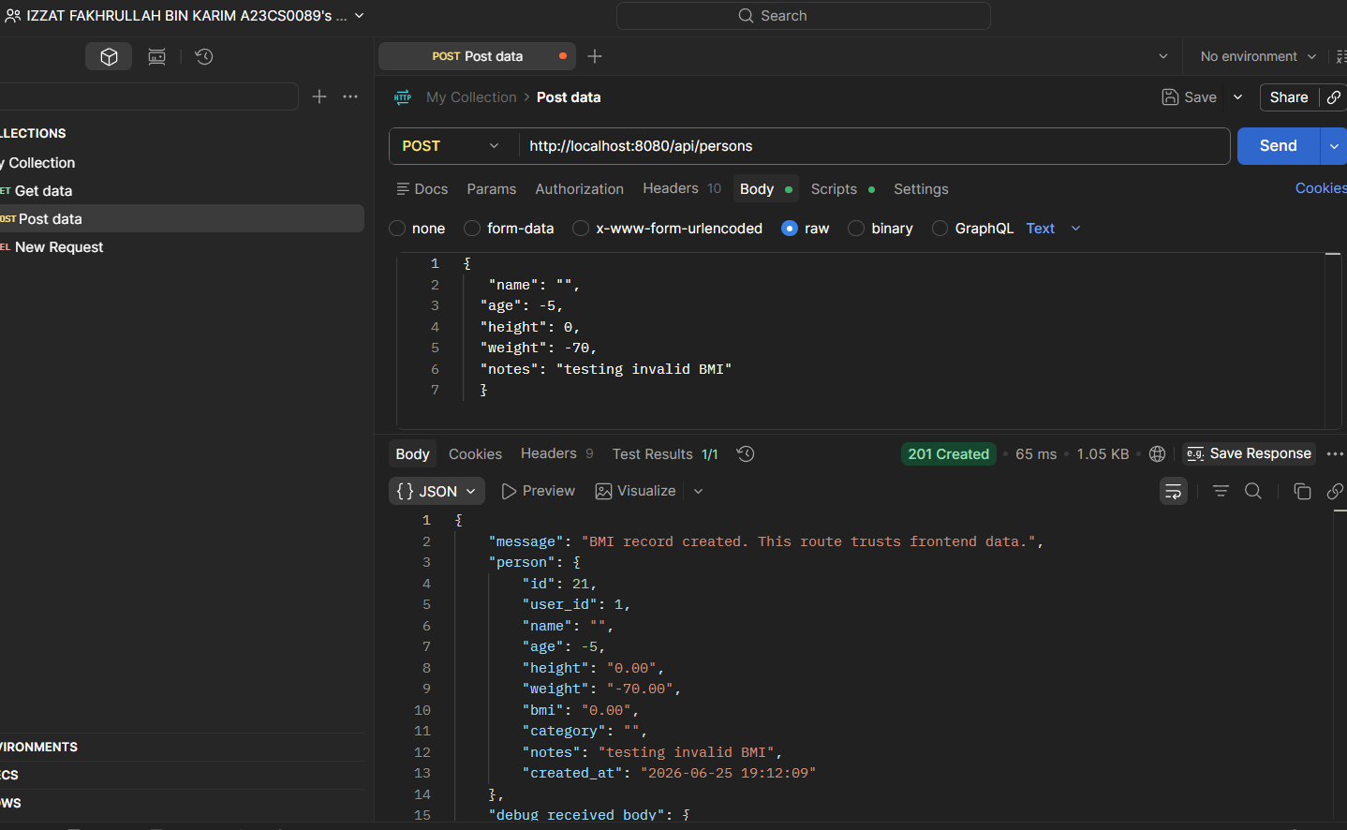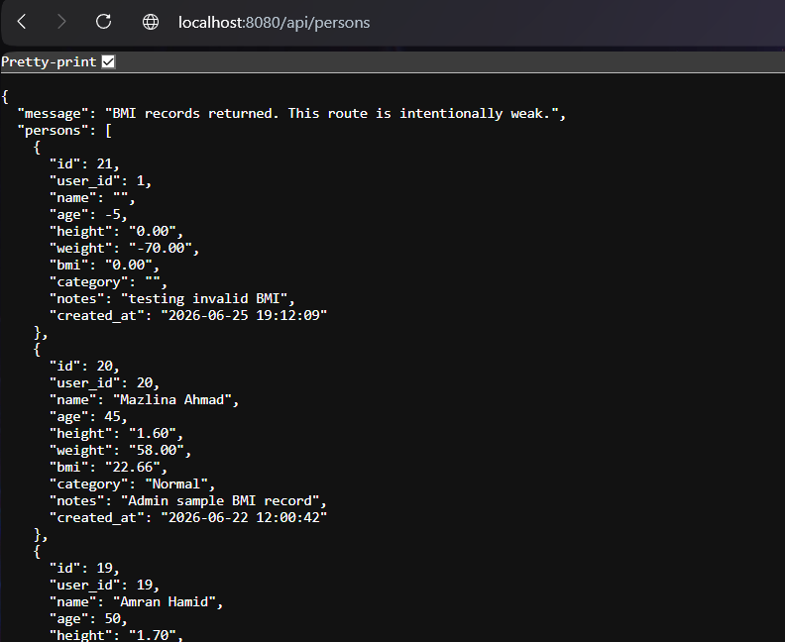
2-Access another user’s BMI record | 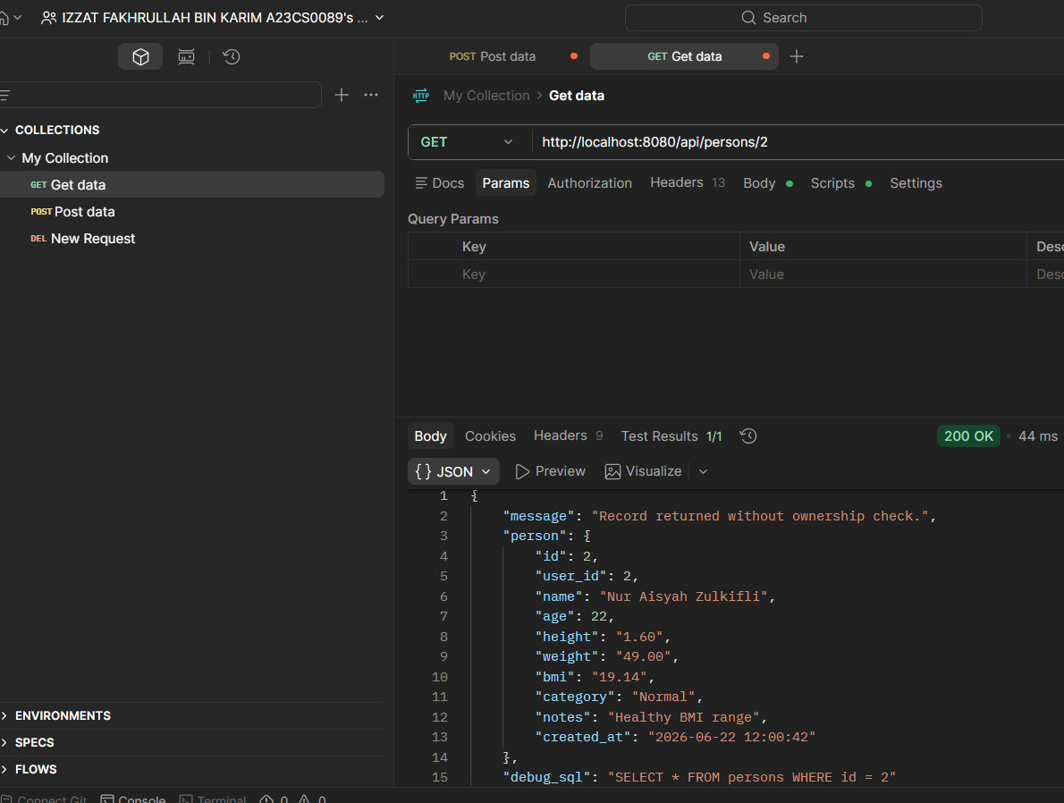
3-Access staff route as normal user | 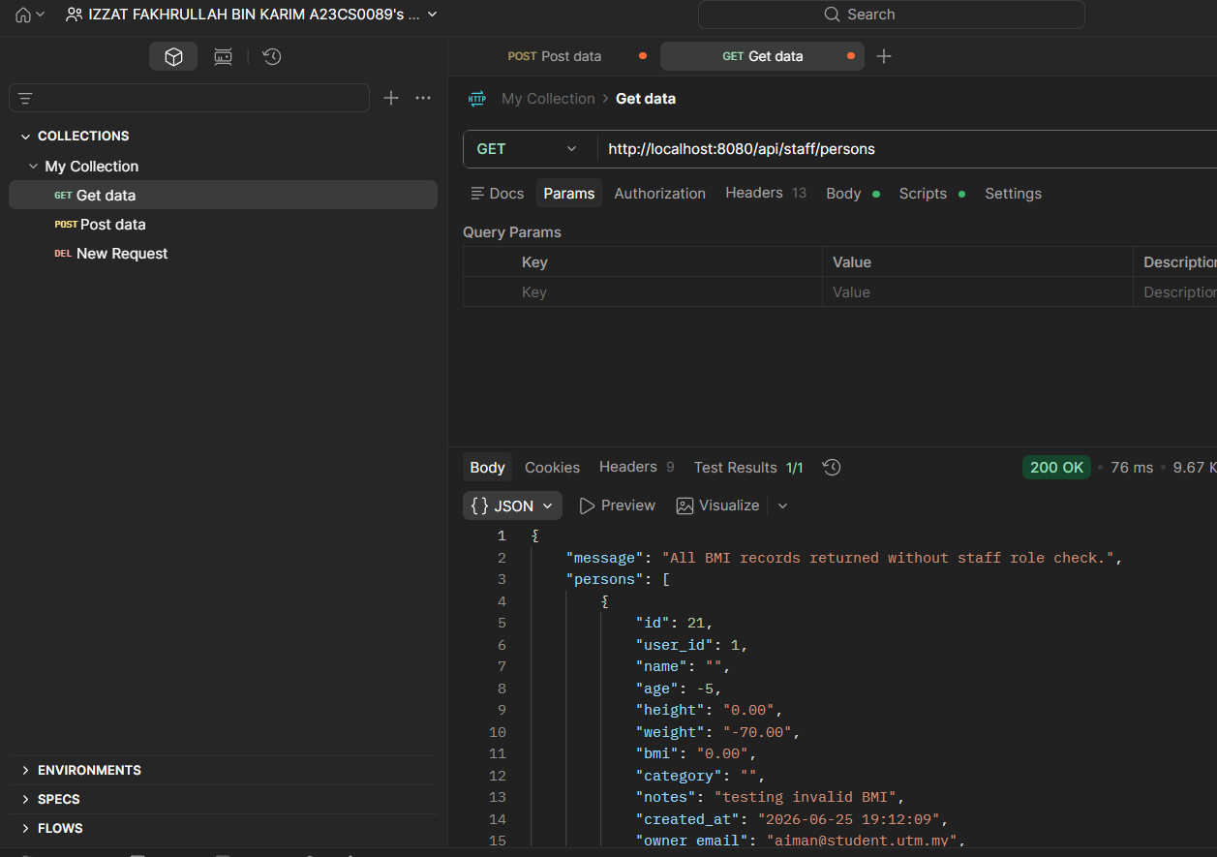
4-Access admin route as normal user | 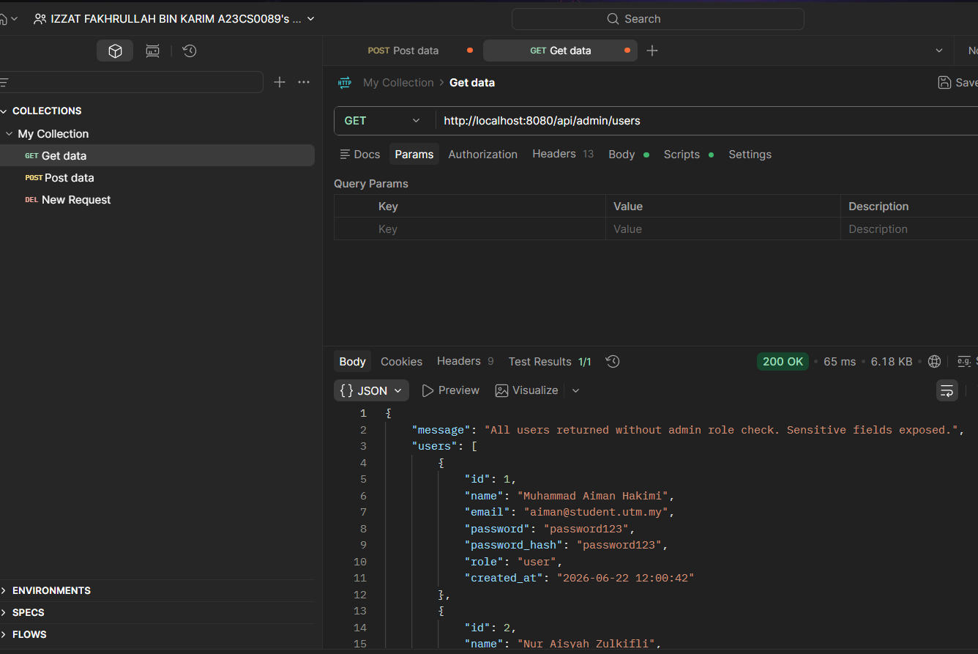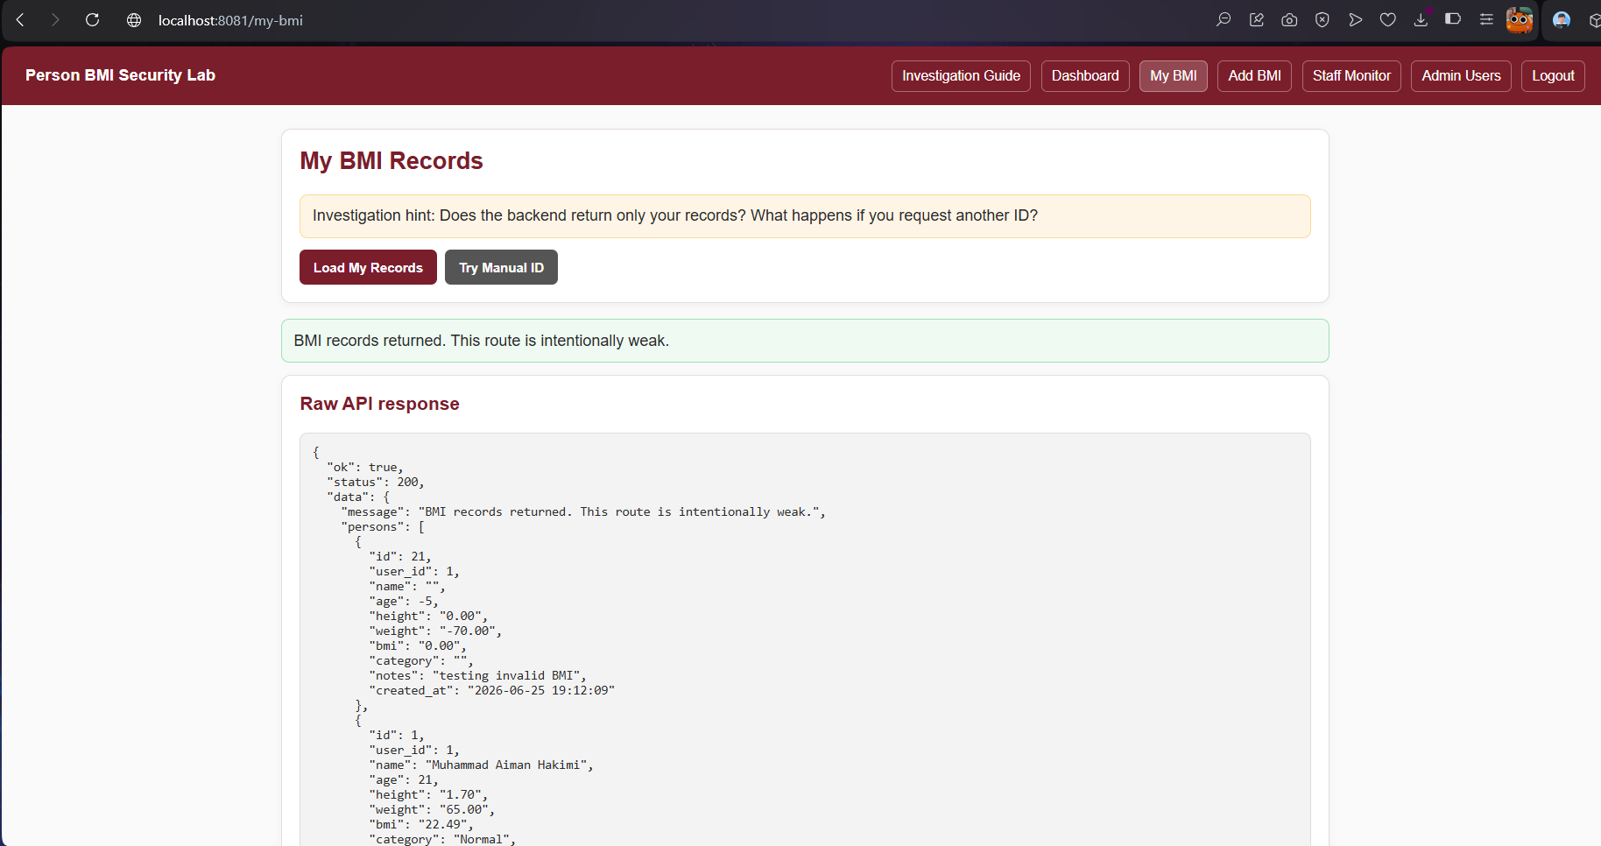
5-XSS payload in notes | 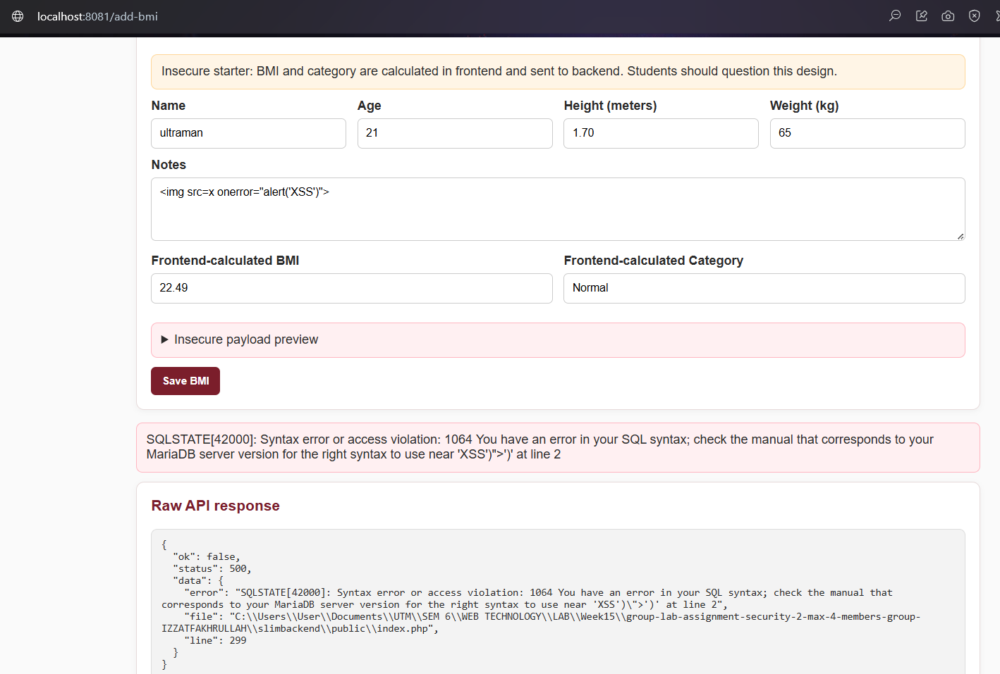
6-API response exposes sensitive data | 
7-SQL Injection input | 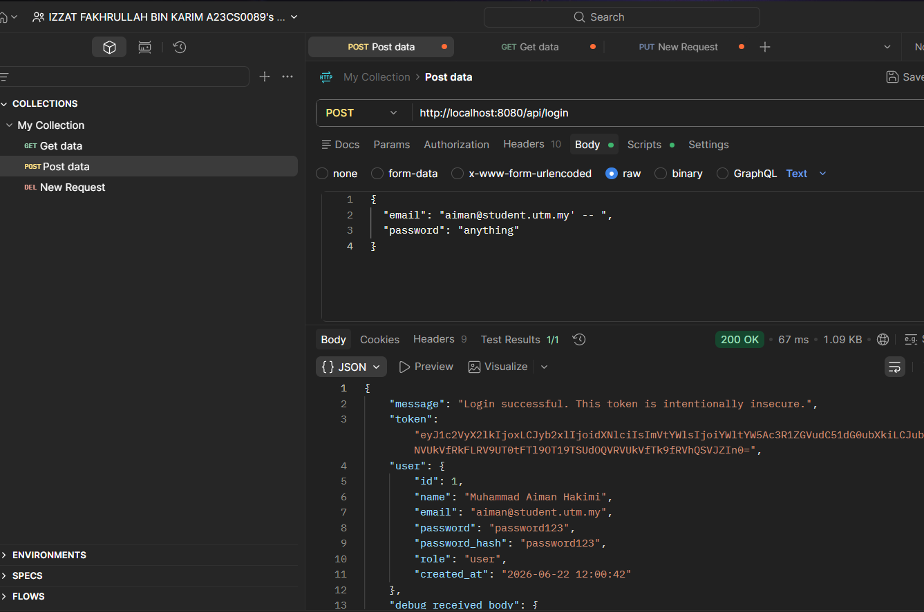
8-Update protected fields | 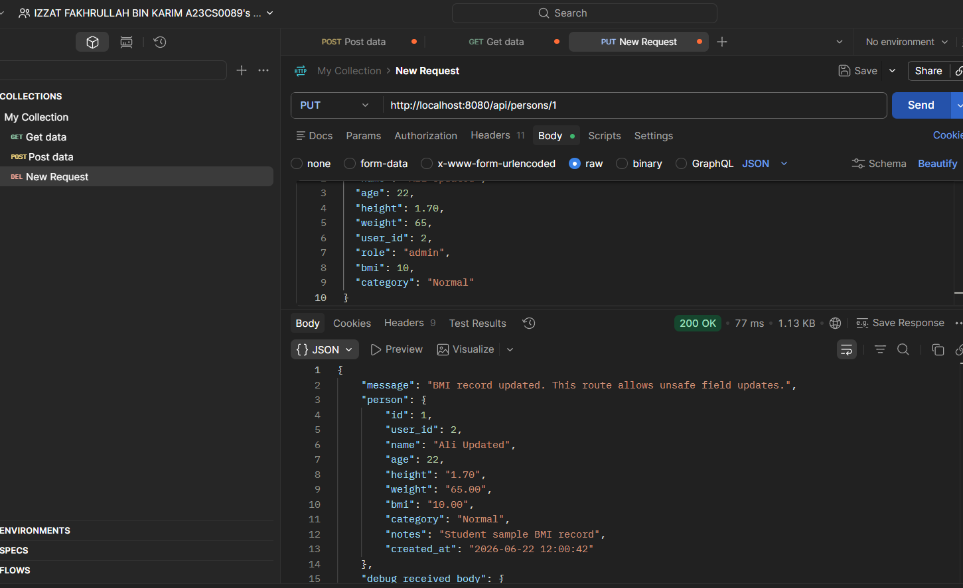

The system contains several backend and frontend security weaknesses. The main issue is that the backend trusts user-controlled input and does not fully enforce validation, authentication, authorization, safe API responses, and safe output rendering.

