Part 1: Data Understanding

1.1 Feature Descriptions
The dataset has 768 patient records with 8 input features and 1 target variable (Outcome).

Feature | Data Type | Description
Pregnancies | Integer | Number of times the patient has been pregnant.
Glucose | Integer (mg/dL) | Blood sugar level measured 2 hours after a glucose drink. The strongest predictor of diabetes.
BloodPressure | Integer (mm Hg) | Diastolic (lower number) blood pressure reading.
SkinThickness | Integer (mm) | Skin fold thickness at the triceps. Used to estimate body fat.
Insulin | Integer (mu U/ml) | Insulin level in the blood 2 hours after the glucose drink.
BMI | Float (kg/m²) | Body Mass Index: weight divided by height squared. Higher BMI means higher diabetes risk.
DiabetesPedigreeFunction | Float | A score that estimates diabetes risk based on family history.
Age | Integer (years) | Age of the patient. Risk increases with age.
Outcome | 0 or 1 | Target variable. 0 = No diabetes (500 patients), 1 = Has diabetes (268 patients).

1.2 Feature Importance and Problematic Values
Most Important Features:
Glucose, BMI, and Age are the strongest predictors. Higher glucose directly indicates diabetes; higher BMI reflects obesity which causes insulin resistance; and risk increases significantly with age.

Features with Missing Values:
Some features contain 0 values that are medically impossible. For example, a blood pressure of 0 or a BMI of 0 cannot exist in a living person. These zeros are actually missing data that was recorded as 0 in the dataset.

Feature | Zero Count | % of Dataset | Problem
Glucose | 5 | 0.7% | Blood sugar cannot be zero
BloodPressure | 35 | 4.6% | Blood pressure cannot be zero
SkinThickness | 227 | 29.6% | Skin fold cannot be zero
Insulin | 374 | 48.7% | Insulin cannot be zero in a living patient
BMI | 11 | 1.4% | BMI of zero is impossible

Part 2: Data Preprocessing

2.1 Checking for Zero / Missing Values
We checked all features where a zero value is impossible. The table below shows how many zeros were found in the raw dataset:

Feature | Zero Count | % of Records | Action
Glucose | 5 | 0.7% | Replace with median
BloodPressure | 35 | 4.6% | Replace with median
SkinThickness | 227 | 29.6% | Replace with median
Insulin | 374 | 48.7% | Replace with median
BMI | 11 | 1.4% | Replace with median

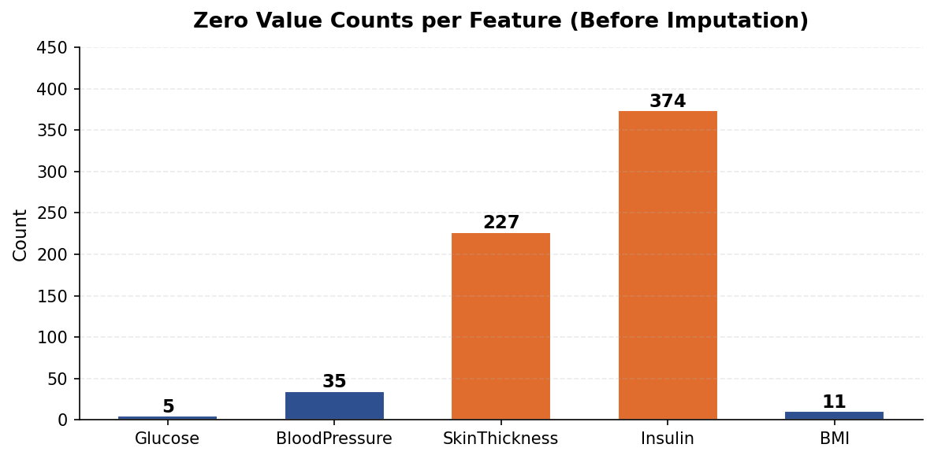
Figure 1. Number of zero (missing) values per feature. Insulin has the most missing data at 374 records (48.7%).

2.2 Handling Missing Data – Median Imputation
Method used: Median Imputation
We replaced each zero with the median (middle value) of that feature’s valid data. We chose the median instead of the mean (average) because features like Insulin have very high outliers (max = 846) that would pull the mean too high, making it an unfair replacement. The median is not affected by extreme values.

Steps:
- Mark all zero values as missing (NaN).
- Calculate the median from the remaining valid values.
- Fill all missing entries with that median.

Feature | Median Value Used to Replace Zeros
Glucose | 117.0 mg/dL
BloodPressure | 72.0 mm Hg
SkinThickness | 29.0 mm
Insulin | 125.0 mu U/ml
BMI | 32.3 kg/m²

The table below shows the statistics for SkinThickness and Insulin before and after imputation. Notice that after imputation, the minimum value is no longer 0, and the mean increases because zeros are replaced with real values.

Statistic | SkinThickness Before | SkinThickness After | Insulin Before | Insulin After
Count | 768 | 768 | 768 | 768
Mean | 20.54 | 29.11 | 79.80 | 140.67
Std Dev | 15.95 | 8.79 | 115.24 | 86.38
Min | 0.00 (invalid) | 7.00 | 0.00 (invalid) | 14.00
25th Pct | 0.00 | 25.00 | 0.00 | 121.50
50th Pct (Median) | 23.00 | 29.00 | 30.50 | 125.00
75th Pct | 32.00 | 32.00 | 127.25 | 127.25
Max | 99.00 | 99.00 | 846.00 | 846.00
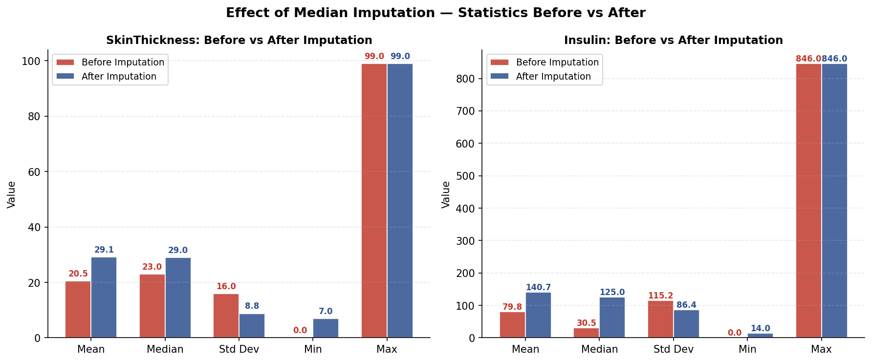

Figure 2. Box plots showing SkinThickness and Insulin before and after imputation. The zero outliers on the left disappear after replacement.

2.3 Feature Scaling – Z-score Standardization
Why scaling is needed: KNN works by measuring the distance between data points. If we do not scale, a feature with a large range like Insulin (14–846) will have a much bigger effect on the distance than a feature with a small range like DiabetesPedigreeFunction (0.08–2.42). This would make smaller-range features almost irrelevant.

z = (x − mean) ÷ std
This converts every feature so it has: mean = 0 and standard deviation = 1

The table below shows each feature before and after scaling. After scaling, all features are on the same scale so KNN treats them equally.

Feature | Mean Before | Std Before | Range Before | Mean After | Std After
Pregnancies | 3.85 | 3.37 | 0 – 17 | ≈0.000 | ≈1.000
Glucose | 121.66 | 30.44 | 44 – 199 | ≈0.000 | ≈1.000
BloodPressure | 72.39 | 12.10 | 24 – 122 | ≈0.000 | ≈1.000
SkinThickness | 29.11 | 8.79 | 7 – 99 | ≈0.000 | ≈1.000
Insulin | 140.67 | 86.38 | 14 – 846 | ≈0.000 | ≈1.000
BMI | 32.46 | 6.88 | 18.2 – 67.1 | ≈0.000 | ≈1.000
DiabetesPedigreeFunction | 0.47 | 0.33 | 0.08 – 2.42 | ≈0.000 | ≈1.000
Age | 33.24 | 11.76 | 21 – 81 | ≈0.000 | ≈1.000

Sample rows showing original vs. scaled values for 3 features:

Row | Glucose (raw) | Insulin (raw) | Age (raw) | Glucose (z) | Insulin (z) | Age (z)
1 | 148 | 125* | 50 | +0.8660 | −0.1815 | +1.4260
2 | 85 | 125* | 31 | −1.2051 | −0.1815 | −0.1907
3 | 183 | 125* | 32 | +2.0167 | −0.1815 | −0.1056
4 | 89 | 94 | 21 | −1.0736 | −0.5406 | −1.0415
5 | 137 | 168 | 33 | +0.5044 | +0.3166 | −0.0205
* Insulin was 0 in rows 1–3 and was replaced with the median value of 125.
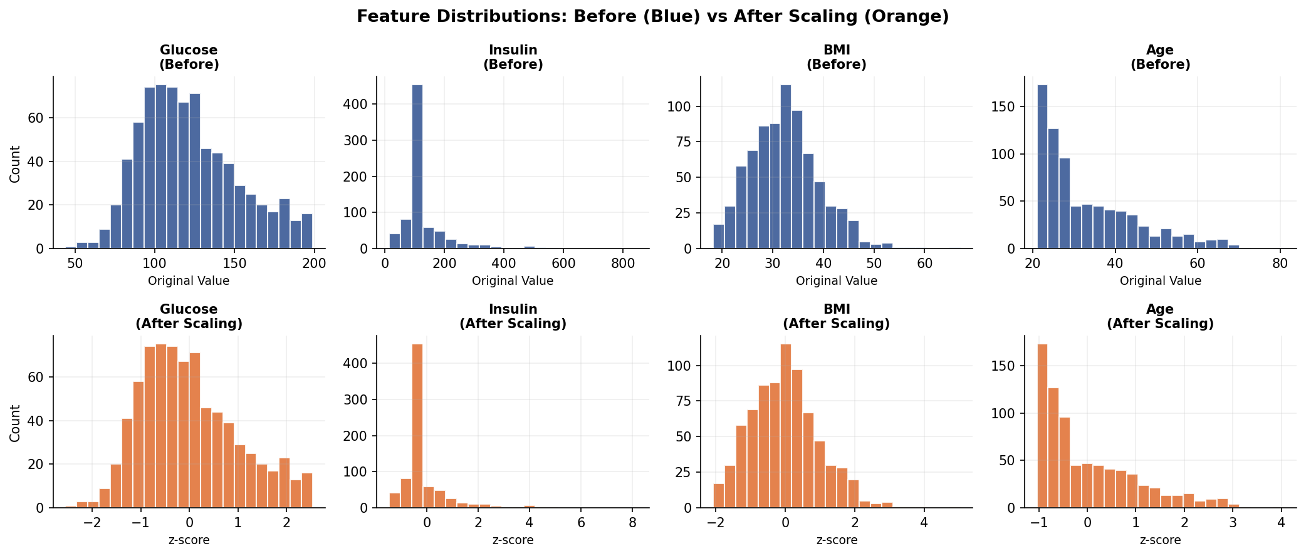

Figure 3. Feature distributions before (blue) and after (orange) scaling. All features now center around 0.
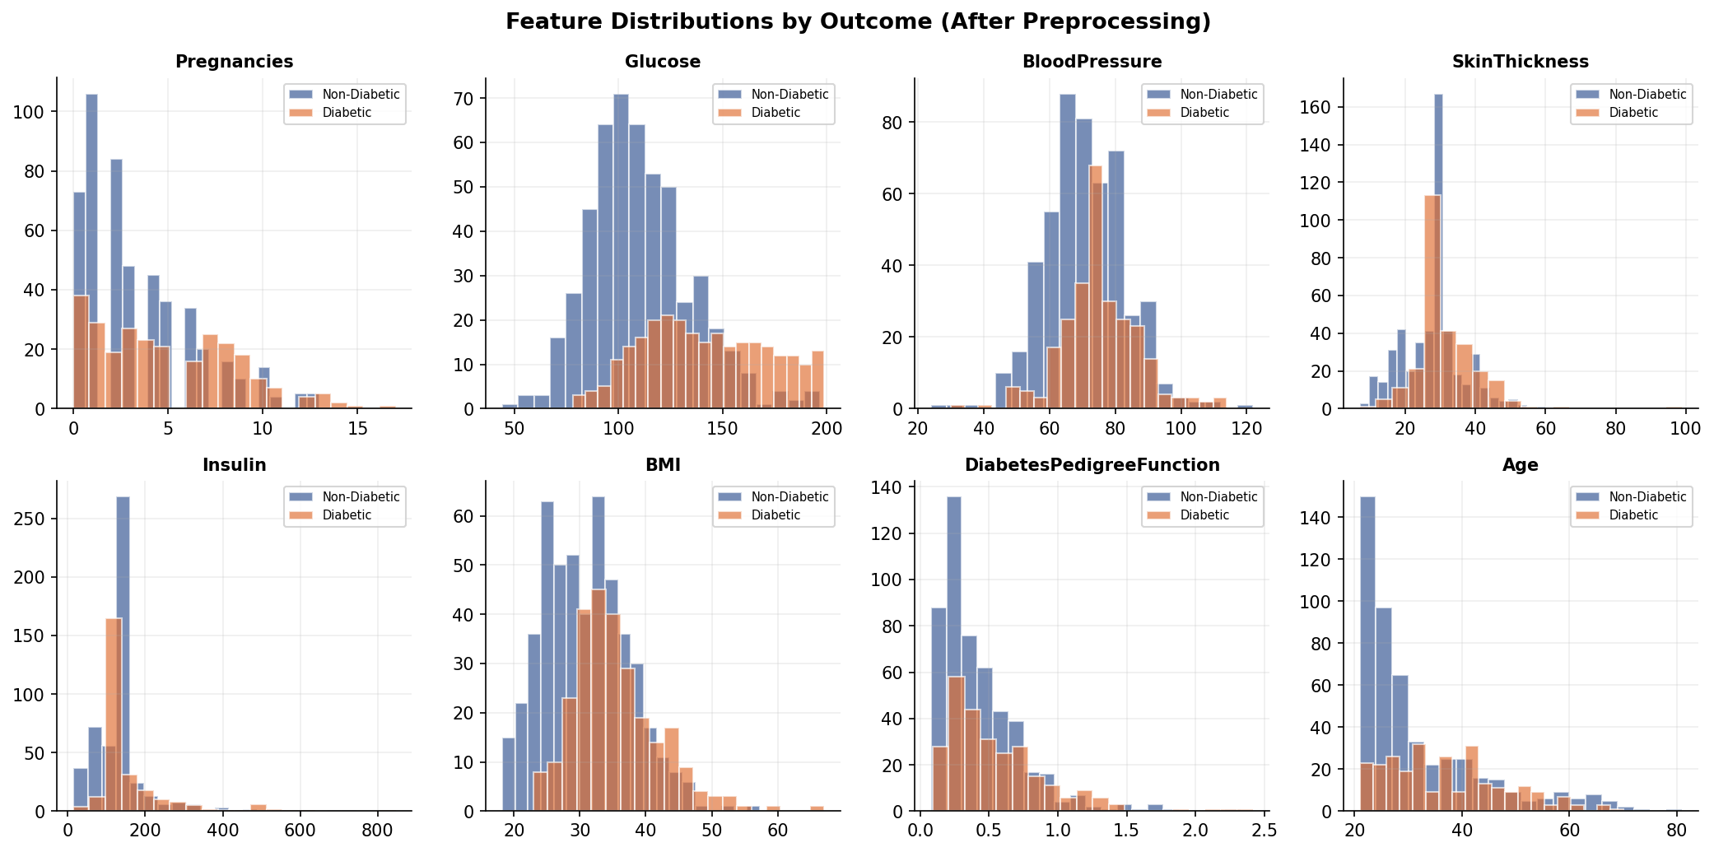

Figure 4. Feature distributions by Outcome. Diabetic patients (orange) tend to have higher Glucose, BMI, and Age.

2.4 Preprocessing Summary
Here is a summary of every step done to clean and prepare the data:

Step | What We Did | Result
1. Find missing data | Checked for zero values in 5 features | Found: Glucose(5), BP(35), Skin(227), Insulin(374), BMI(11)
2. Fix missing data | Replaced zeros with each feature’s median | Glucose=117, BP=72, Skin=29, Insulin=125, BMI=32.3
3. Scale features | Applied Z-score standardization | All 8 features now have mean=0 and std=1
4. Final output | Clean, scaled dataset ready for KNN | 768 records, 8 features, no more invalid zeros

Part 3: KNN Implementation

3.1 Train-Test Split
The dataset was split into two parts:
- Training Set (80%) → 614 records – used to teach the model
- Test Set (20%) → 154 records – used to test how well the model works on new data
We used random_state = 42 to make sure the split is the same every time we run the code.

3.2 KNN Training – K = 3, 5, and 7
Euclidean Distance Formula:
d(x, y) = √[ (x₁−y₁)² + (x₂−y₂)² + ⋯ + (x₈−y₈)² ]
KNN classifies a new record by finding its K nearest neighbors in the training set and using majority vote. We trained three models using K = 3, 5, and 7.

K Value | Accuracy | Correct out of 154 | Incorrect
K = 3 | 70.78% | 109 | 45
K = 5 | 73.38% | 113 | 41
K = 7 | 71.43% | 110 | 44

3.3 Manual Distance Computation – Test Instance #0
We picked Test Instance #0 from the test set to show how KNN works step by step. Below are its standardized feature values:

Feature | Scaled Value | What It Means
Pregnancies | +0.6399 | Slightly above average (≈6 pregnancies)
Glucose | −0.7777 | Below average (≈97 mg/dL)
BloodPressure | −1.1901 | Well below average (≈58 mm Hg)
SkinThickness | +0.4430 | Slightly above average (≈33 mm)
Insulin | +0.5714 | Slightly above average (≈174 mu U/ml)
BMI | +0.2248 | Near average (≈34.0 kg/m²)
DiabetesPedigreeFunction | −0.1265 | Near average (≈0.42)
Age | +0.8304 | Above average (≈43 years)

Actual label: 0 – Non-Diabetic

Step-by-step distance calculation to the nearest training sample (Rank 1):

Feature | Test (xᵢ) | Train (yᵢ) | (xᵢ − yᵢ) | (xᵢ − yᵢ)²
Pregnancies | +0.6399 | +0.6399 | 0.0000 | 0.0000
Glucose | −0.7777 | −0.2209 | −0.5568 | 0.3123
BloodPressure | −1.1901 | −1.3557 | +0.1656 | 0.0274
SkinThickness | +0.4430 | −0.2392 | +0.6822 | 0.4664
Insulin | +0.5714 | −0.1793 | +0.7507 | 0.5669
BMI | +0.2248 | +0.1810 | +0.0438 | 0.0019
DiabetesPedigreeFunction | −0.1265 | +0.4320 | −0.5585 | 0.3122
Age | +0.8304 | +1.0858 | −0.2554 | 0.0652
 |  |  | Sum of squares: | 1.7523
 |  |  | Distance = √1.7523 = | 1.3237

This is repeated for all 614 training samples. After sorting by distance, the 10 nearest neighbors are:

Rank | Distance | Class | In K=3? | In K=5? | In K=7?
1 | 1.3237 | 1 – Diabetic | Yes | Yes | Yes
2 | 1.3728 | 1 – Diabetic | Yes | Yes | Yes
3 | 1.3952 | 0 – Non-Diabetic | Yes | Yes | Yes
4 | 1.4517 | 1 – Diabetic | No | Yes | Yes
5 | 1.6715 | 1 – Diabetic | No | Yes | Yes
6 | 1.6836 | 0 – Non-Diabetic | No | No | Yes
7 | 1.6851 | 1 – Diabetic | No | No | Yes
8 | 1.7071 | 0 – Non-Diabetic | No | No | No
9 | 1.7184 | 0 – Non-Diabetic | No | No | No
10 | 1.7379 | 1 – Diabetic | No | No | No

Majority vote results for this instance:

K | Votes: Class 0 vs Class 1 | Predicted | Actual | Correct?
K = 3 | 1 vs 2 | 1 – Diabetic | 0 – Non-Diabetic | No (wrong)
K = 5 | 1 vs 4 | 1 – Diabetic | 0 – Non-Diabetic | No (wrong)
K = 7 | 2 vs 5 | 1 – Diabetic | 0 – Non-Diabetic | No (wrong)

This one instance was misclassified by all three K values. This is normal – no model is perfect on every single record. The overall accuracy is judged across all 154 test records, where K=5 correctly classifies 113 of them.

Part 4: Model Evaluation

4.1 Accuracy and Confusion Matrix Results
Each model was evaluated on the 154 test records. The confusion matrix breaks down predictions into four categories:
- TN (True Negative) – correctly predicted Non-Diabetic
- FP (False Positive) – predicted Diabetic, but actually Non-Diabetic
- FN (False Negative) – predicted Non-Diabetic, but actually Diabetic
- TP (True Positive) – correctly predicted Diabetic

K Value | Accuracy | TN | FP | FN | TP
K = 3 | 70.78% | 74 | 25 | 20 | 35
K = 5 | 73.38% | 75 | 24 | 17 | 38
K = 7 | 71.43% | 74 | 25 | 19 | 36

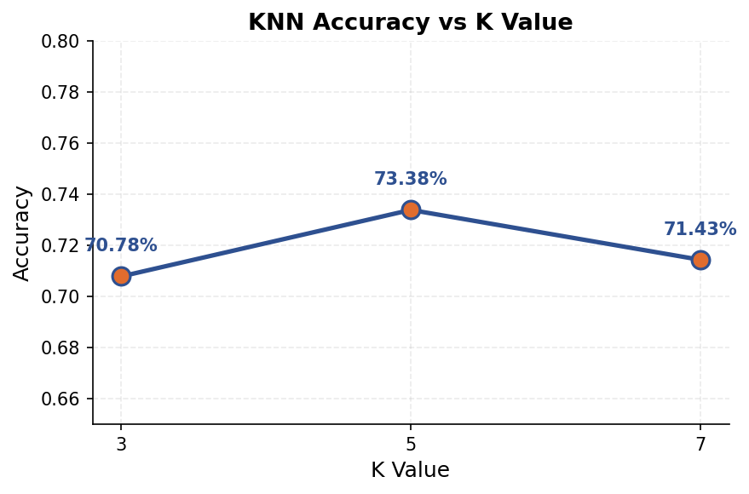
Figure 5. Accuracy for each K value. K=5 gives the best accuracy at 73.38%.

4.2 Analysis Questions
Q1. Which K value performed best?
K = 5 performed best with 73.38% accuracy. It correctly identified 113 out of 154 test records, had the most True Positives (38 diabetic patients found), and the fewest False Negatives (only 17 diabetic patients missed). In medicine, missing a diabetes diagnosis is dangerous, so fewer False Negatives is very important.

Q2. Why does accuracy change with different K values?
A smaller K (like K=3) is more sensitive to individual data points and can make more errors when the training data has noise. A larger K (like K=7) smooths out decisions by considering more neighbors, but may miss fine details. K=5 found the best balance for this dataset.

Q3. What happens when K is too small or too large?
When K is too small (e.g., K=1): the model memorizes the training data too closely and performs poorly on new data – this is called overfitting. When K is too large (e.g., K=200): the model ignores local patterns and just predicts the most common class for almost everything – this is called underfitting. The best K is somewhere in between.

Part 5: Analysis and Reflection

Strengths of KNN
KNN is one of the easiest machine learning algorithms to understand. The idea is simple: classify a new record based on what its nearest neighbors are. You do not need complex math or assumptions about the data. KNN also works well when the boundary between classes is curved or irregular, since it learns directly from the data without fitting a fixed formula. It has no real training step – it just stores the data and computes distances when a prediction is needed, which means adding new data is as easy as adding rows to the dataset.

Limitations of KNN
KNN becomes slow when the dataset is large because it must compute the distance to every training record for each prediction. It is also very sensitive to scaling – if features have different ranges and you skip standardization, the large-range features will control the distances and the small-range features become useless. Another weakness is that KNN stores all training data in memory, which uses a lot of RAM. Finally, if the dataset has more records from one class (like 500 non-diabetic vs 268 diabetic here), KNN tends to predict the majority class more often.

When KNN Is and Is Not a Good Choice
Use KNN when:
- The dataset is small or medium in size.
- You need a simple model to start with before trying more complex ones.
- The relationship between features and the outcome is not linear.

Do not use KNN when:
- The dataset has millions of records – prediction will be too slow.
- You need fast real-time predictions in a live application.
- The data has many features without feature selection.
- Memory is limited, since KNN must store all training data.

Observations from the Experiment
The KNN model reached its best accuracy of 73.38% at K=5. The key findings from this experiment are:

- Insulin had the worst missing data problem with 374 zeros (48.7% of the dataset). After replacing these with the median value of 125, the mean of Insulin rose from 79.80 to 140.67.
- Standardization was the most important preprocessing step. Without it, Insulin (range 14–846) would have been roughly 360 times more influential than DiabetesPedigreeFunction (range 0.08–2.42) in the distance formula.
- K=5 gave the best balance. K=3 was slightly noisy and K=7 was slightly over-smoothed.
- The model is better at finding non-diabetic patients (TN=74–75) than diabetic ones (TP=35–38). This is partly because non-diabetic records outnumber diabetic ones in the dataset (500 vs 268).
- For medical use, missed diabetic diagnoses (False Negatives) are the most dangerous type of error. At K=5, only 17 diabetic patients were missed.

Bonus: KNN vs Logistic Regression
We also trained a Logistic Regression model using the same data and split to compare it with KNN.

Model | Accuracy | Correct / 154 | Notes
KNN (K=3) | 70.78% | 109 | Most sensitive to noise
KNN (K=5) | 73.38% | 113 | Best KNN result
KNN (K=7) | 71.43% | 110 | Slightly over-smoothed
Logistic Regression | 75.32% | 116 | Best overall

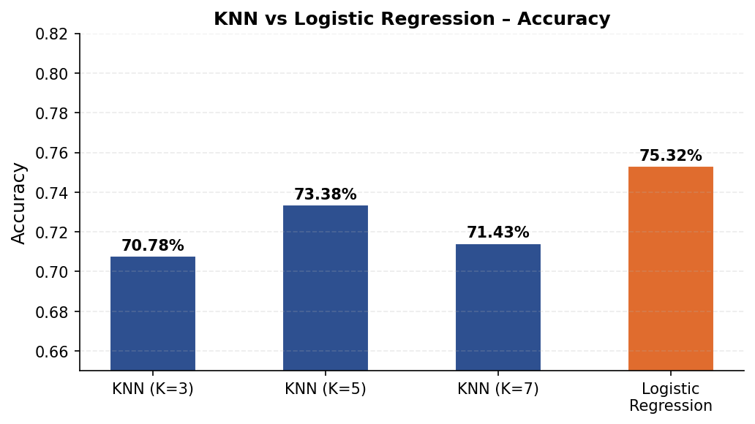
Figure 6. Accuracy comparison. Logistic Regression (orange) slightly outperforms all KNN models.

What This Means
Logistic Regression scored 75.32%, which is about 2 percentage points better than the best KNN result (73.38%). This tells us that the boundary between diabetic and non-diabetic patients in this dataset is fairly straight (linear), which suits Logistic Regression well. KNN, which looks for local clusters of similar patients, does not benefit as much here because the two groups overlap in many areas.
However, KNN has an advantage in datasets where the boundary is curved or irregular. Future improvements could include using cross-validation to find the best K, or applying SMOTE to create more synthetic diabetic records to fix the class imbalance.

