1. **Add Plugins:**
   1. *With the search option: Go to dashboard -> Plugins. Type in the name of the plugin name or function and hit search. Al list of pluggins will display to choose from. Hit the plugin that suits the need. A window will pop up with the information about that plugin. Click the installation button. After installing the plugin, a new dialog will appear. Make sure to click ‘Activate Plugin’. The plugin is now installed. All what remains is to adjust some configuration according to our needs.*



* 1. *With the upload option: If the plugin you want is not in the WordPress Plugin directory for some reason either because it was a paid plugin, or a non-GPL plugin, then go for this option. Download a plugin separately, go to dashboard -> Plugins-> Upload and upload the zipped file. All that remains is to activate the plugin just like it is done above.*

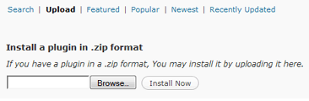

1. **Recommended Plugins :**
2. WP-statistics: A perfect plugin for your blog visitors’ statistics. With this plugin, you can get hit full blog. Visitors and visits your blog from today to 1 year before you can get! Statistics report on the screen can also view statistics with graphs.
3. TablePress:enables you to create and manage tables on your WordPress site. No HTML knowledge is needed, as a comfortable interface allows to easily edit table data.
4. Compact Archives:Compact Archives displays the monthly archive of posts in a more compact form than the usual long list. It can be shown as a compact block suitable for the body of an archives page:

2009: Jan Feb Mar Apr May Jun Jul Aug Sep Oct Nov Dec

2008: Jan Feb Mar Apr May Jun Jul Aug Sep Oct Nov Dec

2007: Jan Feb Mar Apr May Jun Jul Aug Sep Oct Nov Dec

1. Limit Login Attempts
2. **Stop search engines from indexing me**
   1. *Go to dashboard -> settings -> reading settings and check the box below*



* 1. I *would also add a robots.txt file for more reliability*

1. **Keep the posts private: i.e. to be read by logged in users only**
   1. *By changing the visibility of the post to ‘private’ on the right column of the post page*



* 1. *Make all posts private by default*

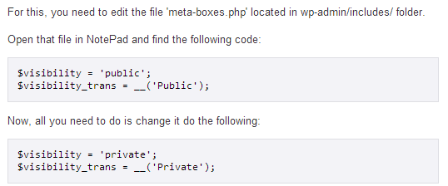

1. **Security/hacking issues: recommendations to avoiding them?**
2. Avoid obvious passwords and use a complex one instead: A secure password is a mix of at least eight upper and lowercase letters, numbers and the kinds of ‘special’ characters used to depict curse-words (^%$#@*)!
3. Create another user and give him all admin privileges
4. Always update WordPress
5. Install a security plugin?