Caso | Imagen | Algoritmo
1 | 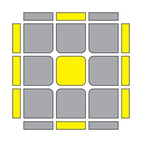 | R U2' R2' F R F' U2 R' F R F'
2 | 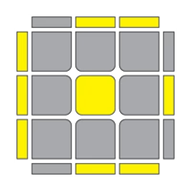 | F R U R' U' F' f R U R' U' f'
3 | 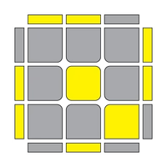 | f R U R' U' f' U' F R U R' U' F'
4 | 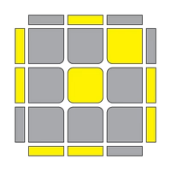 | f R U R' U' f' U F R U R' U' F'
5 | 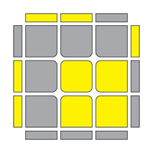 | r' U2' R U R' U r
6 | 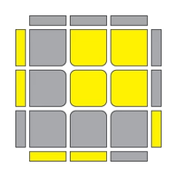 | r U2 R' U' R U' r'
7 | 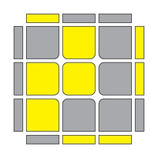 | r U R' U R U2' r'
8 | 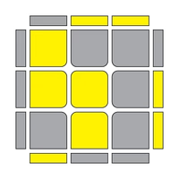 | r' U' R U' R' U2 r
9 | 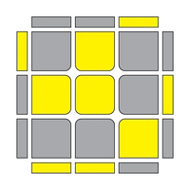 | R U R' U' R' F R2 U R' U' F'
10 | 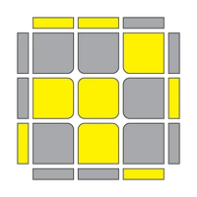 | R U R' U R' F R F' R U2' R'
11 | 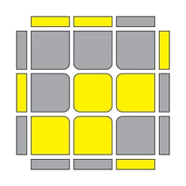 | r' R2 U R' U R U2 R' U M'
12 | 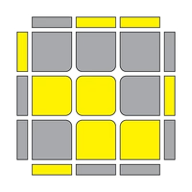 | M' R' U' R U' R' U2 R U' M
13 | 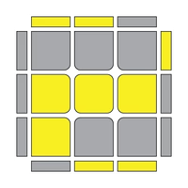 | r U' r' U' r U r' y' R' U R
14 | 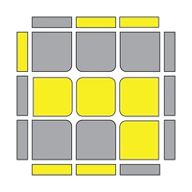 | R' F R U R' F' R F U' F'
15 | 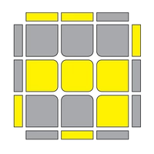 | r' U' r R' U' R U r' U r
16 | 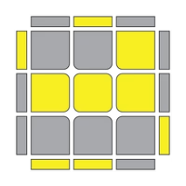 | r U r' R U R' U' r U' r'
17 | 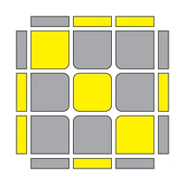 | R U R' U R' F R F' U2' R' F R F'
18 | 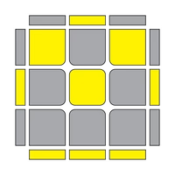 | r U R' U R U2 r2 U' R U' R' U2 r
19 | 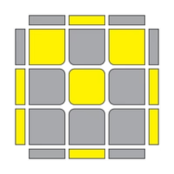 | M U R U R' U' M' R' F R F'
20 | 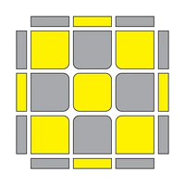 | M U R U R' U' M2' U R U' r'
21 | 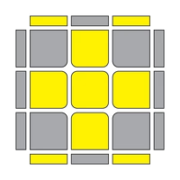 | R U2 R' U' R U R' U' R U' R'
22 | 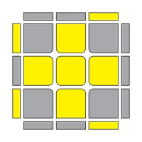 | R U2 R2 U' R2 U' R2 U2 R
23 | 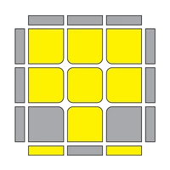 | R2 D R' U2 R D' R' U2 R'
24 | 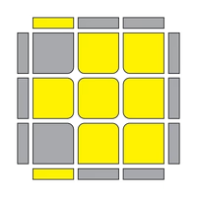 | r U R' U' r' F R F'
25 | 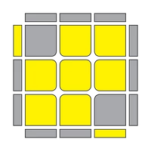 | F' r U R' U' r' F R
26 | 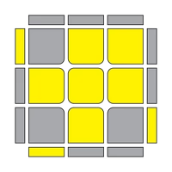 | R U R' U R U2' R'
27 | 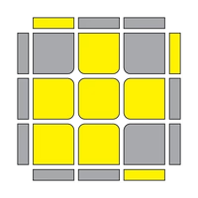 | R U R' U R U2' R'
28 | 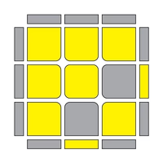 | r U R' U' M U R U' R'
29 | 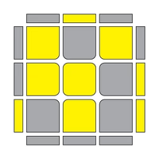 | y R U R' U' R U' R' F' U' F R U R'
30 | 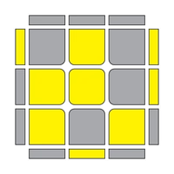 | F U R U2 R' U' R U2 R' U' F'
31 | 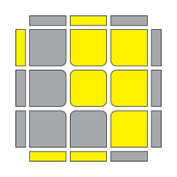 | R' U' F U R U' R' F' R
32 | 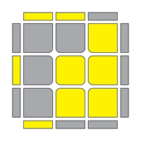 | R U B' U' R' U R B R'
33 | 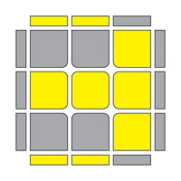 | R U R' U' R' F R F'
34 | 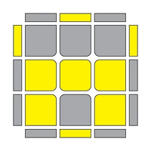 | R U R2' U' R' F R U R U' F'
35 | 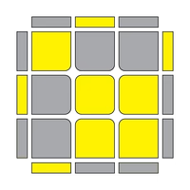 | R U2' R2' F R F' R U2' R'
36 | 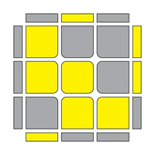 | R' U' R U' R' U R U l U' R' U x
37 | 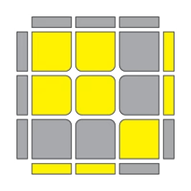 | F R U' R' U' R U R' F'
38 | 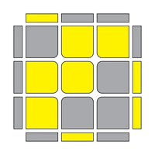 | R U R' U R U' R' U' R' F R F'
39 | 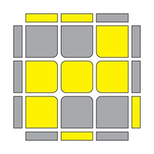 | L F' L' U' L U F U' L'
40 | 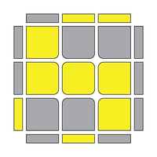 | R' F R U R' U' F' U R
41 | 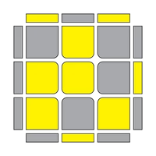 | R U R' U R U2' R' F R U R' U' F'
42 | 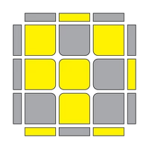 | R' U' R U' R' U2 R F R U R' U' F'
43 | 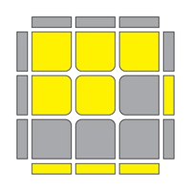 | R' U' F' U F R
44 | 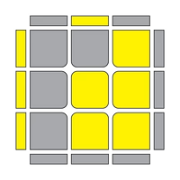 | f R U R' U' f'
45 | 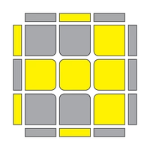 | F R U R' U' F'
46 | 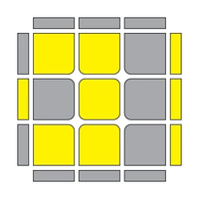 | R' U' R' F R F' U R
47 | 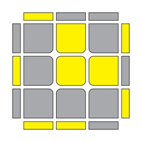 | F' L' U' L U L' U' L U F
48 | 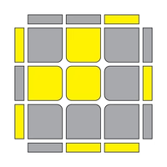 | F R U R' U' R U R' U' F'
49 | 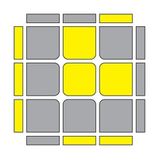 | r U' r2' U r2 U r2' U' r
50 | 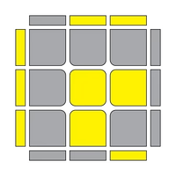 | r' U r2 U' r2' U' r2 U r'
51 | 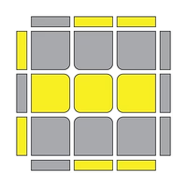 | f R U R' U' R U R' U' f'
52 | 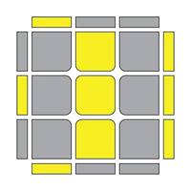 | R' U' R U' R' U y' R' U R B
53 | 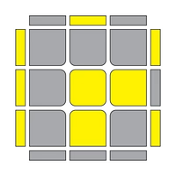 | r' U' R U' R' U R U' R' U2 r
54 |  | r U R' U R U' R' U R U2' r'
55 | 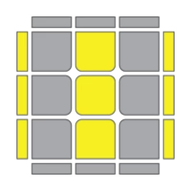 | y R' F R U R U' R2' F' R2 U' R' U R U R'
56 | 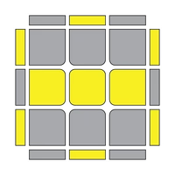 | r' U' r U' R' U R U' R' U R r' U r
57 | 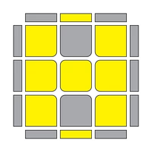 | R U R' U' M' U R U' r'

