Caso | Imagen | Algoritmo
1 | 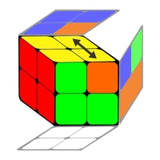 | R U R' U' R' F R2 U' R' U' R U R' F’
2 | 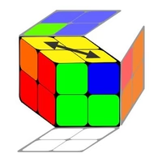 | R2 F2 R2
3 | 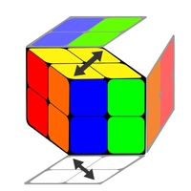 | (R’ F’ R U) (R U’ R’ F)
4 | 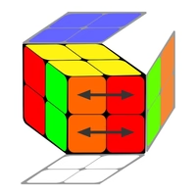 | R2 U' R2 U2 F2 U' R2
5 | 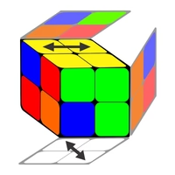 | R F U R U’ R’ F’ U’ R’
6 | 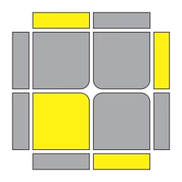 | R U R' U R U2 R'
7 | 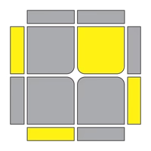 | R U2 R' U' R U' R'
8 | 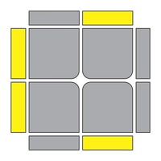 | F (R U R' U2') F'
9 | 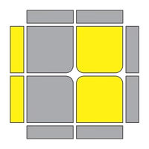 | F (R U R' U') F'
10 | 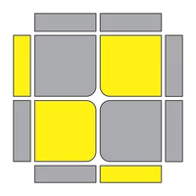 | F’ R U R' U' R’ F R
11 | 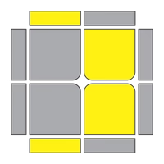 | (R U R' U' ) R' F R F'
12 | 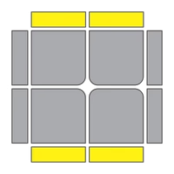 | R2 U2 R U2 R2

