CLARIFIBIDS: A FRAMEWORK FOR INTELLIGENT BIDDER ASSISTANCE
(An Intelligent Assistance Layer over the GePNIC eProcurement Portal)

ABSTRACT
GePNIC (Government eProcurement National Information Centre) is a Government-to-Business (G2B) eProcurement application that supports bidders and department users through every stage of the procurement lifecycle. Today, that support leans almost entirely on static FAQs, guidelines, and procedural documents, so users are left to hunt across several knowledge sources and piece together an answer themselves. This works reasonably well for simple, direct questions, but it breaks down for procedural or multi-source queries, where the relevant information is scattered and the connections between pieces of evidence matter as much as the pieces themselves.
This dissertation proposes ClarifiBids, a context-aware framework for intelligent bidder assistance that sits above the existing GePNIC portal as an additional support layer, without altering the underlying procurement workflow. ClarifiBids organises the knowledge space along four dimensions — query category, user role, information type, and knowledge source — and uses Retrieval-Augmented Generation (RAG) to pull relevant evidence from FAQs, historical clarification records, support knowledge bases, and applicable portal or procedural documents. Where a query depends on connected pieces of information, such as a procedure with multiple conditions, the framework explores a graph-based retrieval mechanism that captures relationships between concepts, procedures, and supporting evidence. A corrective retrieval step is also built in, so the system can attempt a second retrieval pass when the initial evidence turns out to be thin or off-target.
Queries are handled through a hierarchical taxonomy — high-level category, subcategory, intent, and required context or evidence — which lets the framework treat direct, procedural, context-dependent, and multi-source queries differently rather than applying one retrieval strategy to everything. The proposed approach will be benchmarked against conventional keyword/FAQ retrieval, a baseline vector-RAG system, and Graph RAG, using standard retrieval and answer-quality metrics. The overarching goal is to make bidder assistance more relevant, better grounded in evidence, and more sensitive to context, while leaving the existing GePNIC procurement workflow untouched.
Signature of the Student Signature of the Supervisor
Name: Name:
Date: Date:
Place: Place:

Contents
ABSTRACT 1
Contents 1
1. INTRODUCTION 1
2. PROBLEM STATEMENT 1
3. SCOPE OF THE STUDY 1
4. SYSTEM DESIGN AND ARCHITECTURE 1
4.1 System Overview 1
4.2 High-Level Architecture 1
4.3 Knowledge Ingestion and Preparation 1
4.4 Query Understanding and Categorisation 1
4.5 Retrieval Architecture 1
4.6 Corrective Retrieval 1
4.7 Response Generation 1
4.8 Proposed End-to-End Architecture 1
4.9 Design Principle 1
5. PROPOSED SYSTEM / MODULES IN CLARIFIBIDS 1
a) Knowledge Source Ingestion Module 1
b) Knowledge Graph Construction Module 1
c) Query Understanding and Categorisation Module 1
d) Context and Evidence Identification Module 1
e) Retrieval Module 1
f) Corrective Retrieval Module 1
g) Response Generation Module 1
h) Evaluation and Benchmarking Module 1
6. FUNCTIONAL BLOCK DIAGRAM / DESCRIPTION 1
7. TECHNICAL SPECIFICATIONS 1
8. EVALUATION PLAN 1
8.1 Evaluation Dataset 1
8.2 Approaches to be Compared 1
8.3 Evaluation Measures 1
8.4 Comparative Evaluation 1
8.5 Expected Outcome 1
9. FUTURE PLAN 1
10. ABBREVIATIONS 1

1. INTRODUCTION
GePNIC is a Government-to-Business (G2B) eProcurement application that supports bidders and department users across the different stages of the procurement lifecycle. It offers a range of resources — FAQs, guidelines, checklists, user manuals, and procedural documentation — intended to help users carry out procurement-related tasks on their own.
In practice, though, users often have to consult several of these sources to answer a single question. A simple query might be settled by one FAQ entry, but many others involve multiple steps, conditions, or interlinked pieces of information that are not written down in any one place. This is the gap ClarifiBids is meant to close: an assistance mechanism that can recognise what kind of question is being asked and go fetch the right information for it, rather than leaving that work to the user.
This project proposes ClarifiBids: A Context-Aware Graph Retrieval-Augmented Generation (RAG) Framework for Intelligent Bidder Assistance. It is designed to sit above the existing GePNIC portal as an assistance layer, working alongside the current procurement workflow rather than changing it.
The study begins with a baseline RAG system built on the existing knowledge sources — FAQs, guidelines, support records, and procedural documents. For the harder cases, where a query touches multiple related steps or draws on more than one source, Graph RAG will be explored as a way to capture how procedures, conditions, and supporting evidence relate to one another.
Queries are also classified by category, subcategory, intent, user role, and context. This classification is what allows the framework to treat different kinds of bidder queries differently and to apply the retrieval approach best suited to each.

2. PROBLEM STATEMENT
GePNIC already gives bidders a substantial body of FAQs, guidelines, checklists, and procedural information. The difficulty is less about availability and more about access: finding the right piece of information for a specific situation often means searching across several sources and interpreting how they fit together.
Bidder queries themselves vary a great deal in complexity. Some are answered fully by a single source. Others — procedural or multi-hop queries — require connecting information across sources and understanding how one step or condition depends on another.
With that in mind, the project focuses on building an assistance framework that can:
- Categorise queries by type, intent, role, and context.
- Retrieve relevant information from multiple knowledge sources.
- Provide a baseline RAG approach for general bidder queries.
- Explore Graph RAG for multi-hop and complex procedural queries.
- Ground every response in retrieved evidence.
- Evaluate how well each retrieval approach performs across different query types.
In short, ClarifiBids aims to make bidder assistance more context-aware and evidence-backed, without touching the GePNIC procurement workflow that already works.

3. SCOPE OF THE STUDY
The scope of this study is to develop and evaluate ClarifiBids, an intelligent assistance framework for bidder-related queries in the GePNIC eProcurement domain. It covers the following areas:
- Query diversity: queries will be studied across six major categories — Portal Guidelines & Procurement Terms, Portal Usage & User Management, Technical Assistance, Tender & Bid Information, Security Information, and Foreign Bidder Information.
- User roles: the framework accounts for queries from bidders, foreign bidders, and department users, since the appropriate response can depend on who is asking.
- Query depth: queries are classified as Direct, Procedural, Context-dependent, or Multi-source, based on how much information is needed to answer them.
- Query categorisation: queries are organised through the hierarchy High-Level Category → Subcategory → Query Intent → Required Context/Evidence.
- Knowledge sources: the study draws on the FAQ repository, a Support Knowledge Base of historical clarification queries, and applicable portal or procedural documents.
- Baseline RAG: a baseline retrieval-augmented generation system will retrieve relevant evidence and generate grounded responses.
- Graph RAG: graph-based retrieval will be explored, particularly for multi-hop and procedural queries where relationships between concepts, procedures, conditions, and supporting information matter.
- Corrective retrieval: a retrieval-evaluation mechanism will be explored to catch insufficient evidence and trigger an additional retrieval pass where needed.
- Evaluation: the baseline RAG and Graph RAG approaches will be compared using defined retrieval and answer-quality measures across the relevant query types.
The study is scoped to the intelligent assistance layer only. It does not modify the existing GePNIC procurement workflow, transactional processes, the number of departments, the types of bids, or any other GePNIC-wide system parameter.

4. SYSTEM DESIGN AND ARCHITECTURE

4.1 System Overview
ClarifiBids is designed as an intelligent assistance layer over the existing GePNIC eProcurement system, and it deliberately stays out of the procurement workflow itself. The system takes in a user query, works out its category and context, pulls relevant evidence from the available knowledge sources, and returns an evidence-supported response.
The architecture rests on two complementary paths:
- Baseline RAG path — the initial retrieval approach for general queries.
- Graph RAG path — explored for procedural, context-dependent, and multi-hop queries, where the relationships between pieces of information matter as much as the pieces themselves.
At a high level, the flow runs:
User Query → Query Understanding → Query Categorisation → Context/Evidence Identification → Retrieval → Evidence Evaluation → Response Generation

4.2 High-Level Architecture
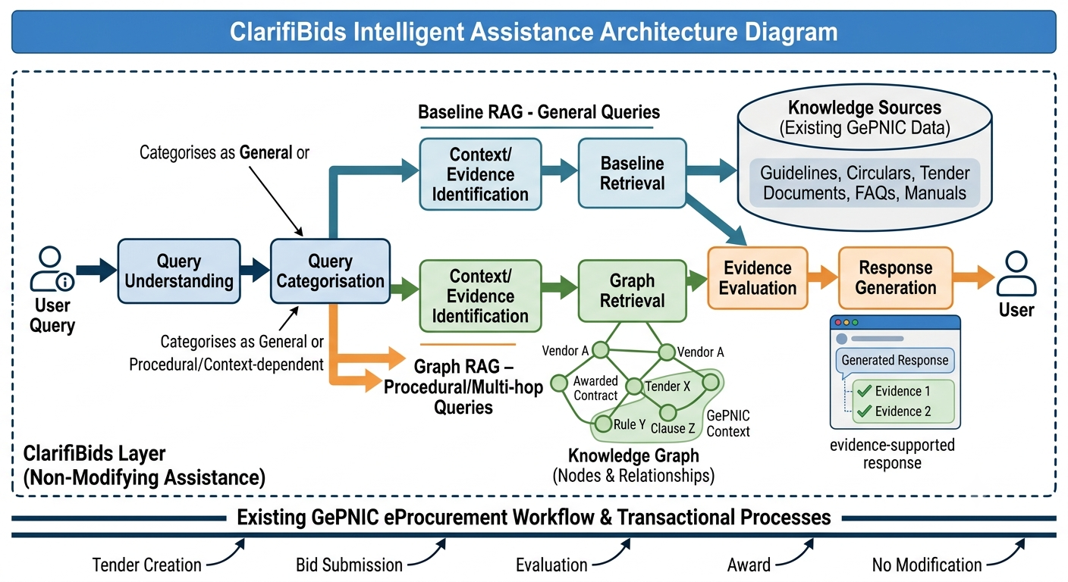
Figure 1: Modules in ClarifiBids
The architecture is organised into the following layers:
Layer | Components | Purpose
User Layer | Bidder / Foreign Bidder / Department User | Submits the query
Query Understanding Layer | Query classification, intent detection, context identification | Understands what the user is asking
Knowledge Layer | FAQ, Support Knowledge Base, portal/procedural documents | Provides domain knowledge
Retrieval Layer | Vector retrieval, Knowledge Graph, graph retrieval | Retrieves relevant evidence
Evaluation Layer | Relevance & sufficiency evaluation, corrective retrieval | Checks whether retrieved evidence is adequate
Generation Layer | LLM / response generation | Produces the final grounded response
Evaluation & Benchmarking | Test dataset, metrics, baseline comparison | Measures system performance

4.3 Knowledge Ingestion and Preparation
The knowledge ingestion pipeline prepares GePNIC's existing information for retrieval. The primary sources are:
- FAQ repository
- Support Knowledge Base of historical clarification queries
- Portal and procedural documents
- Relevant guidelines, eligibility conditions, and rules
Each document passes through parsing, cleaning, chunking, metadata extraction, and indexing. Metadata such as document type, category, procedure, user role, and applicable context is attached to each knowledge chunk to support more precise retrieval later on.

4.4 Query Understanding and Categorisation
When a query arrives, the system first works out its characteristics and maps it onto the hierarchy:
High-Level Category → Subcategory → Query Intent → Required Context/Evidence
For example, the query “My DSC is not detected while submitting the bid. What should I do?” would be classified as:
Technical Assistance → DSC → DSC Detection Issue → Bid Submission Context → Applicable Technical Procedure/Guideline
The user's role also factors in here, since the applicable information can differ between bidders, foreign bidders, and department users.

4.5 Retrieval Architecture
A. Baseline RAG
The baseline system uses conventional vector-based retrieval:
Query → Embedding → Vector Search → Top-K Evidence → LLM → Response
Retrieved chunks are passed to the LLM as context for generating the answer. This baseline also serves as the reference point against which the enhanced retrieval approach is evaluated.
B. Graph RAG
For queries that depend on several related pieces of information, the system explores Graph RAG. A Knowledge Graph represents relationships such as:
Query → Issue → Procedure → Condition → Document/Rule
For the DSC example above, the chain would look like:
DSC Detection Issue → Bid Submission → Technical Requirement → Applicable Procedure → Supporting Guideline
Traversing this graph lets the system retrieve connected evidence for a multi-hop procedural query, rather than just the single closest-matching chunk.

4.6 Corrective Retrieval
Once the initial retrieval is done, the retrieved evidence is checked for relevance and sufficiency.
If the evidence is sufficient:
Retrieved Evidence → Response Generation
If it is not:
Retrieved Evidence → Corrective Retrieval → Additional Evidence → Response Generation
This gives the system a second attempt at retrieval when the first pass does not adequately cover what the query actually needs.

4.7 Response Generation
The Response Generation module takes the verified evidence, the query, and the relevant context, and produces a response that is:
- relevant to the query,
- appropriate to the user's role,
- grounded in retrieved evidence, and
- suited to the identified procedure or context.
Where possible, the response also names the supporting document or source it drew on.

4.8 Proposed End-to-End Architecture
Put together, the complete flow reads as:
User → Query Input → Query Understanding & Categorisation → Category → Subcategory → Intent → Required Context/Evidence → Retrieval Strategy Selection → [Baseline Vector RAG | Graph RAG] → Candidate Evidence Retrieval → Evidence Relevance & Sufficiency Evaluation → Corrective Retrieval (if required) → Evidence-Checked Context → LLM Response Generation → Context-Aware, Evidence-Supported Response

4.9 Design Principle
The guiding principle behind ClarifiBids is not to replace baseline RAG with Graph RAG outright, but to examine how different retrieval strategies suit different kinds of query. Specifically:
- Direct queries → Baseline RAG
- Procedural queries → Baseline RAG / Graph RAG
- Context-dependent queries → Context-aware retrieval
- Multi-hop queries → Graph RAG
- Insufficient retrieval → Corrective retrieval
This mapping ties directly back to the study's framing around query diversity, query depth, hierarchical categorisation, and the baseline-versus-Graph-RAG evaluation described in the following sections.

5. PROPOSED SYSTEM / MODULES IN CLARIFIBIDS
ClarifiBids is proposed as an intelligent assistance layer over the existing GePNIC portal. The system understands the user's query, identifies the relevant context, retrieves supporting information, and generates an evidence-based response. Its major modules are described below.

a) Knowledge Source Ingestion Module
Collects and prepares the identified knowledge sources — the FAQ repository, the Support Knowledge Base of historical clarification queries, and applicable portal and procedural documents. Data is cleaned, parsed, chunked, and prepared for both retrieval and graph construction.

b) Knowledge Graph Construction Module
Builds the relationships between concepts, procedures, conditions, and supporting documents, primarily to support Graph RAG for queries that need several connected pieces of information.

c) Query Understanding and Categorisation Module
Analyses each incoming query and maps it onto the hierarchy High-Level Category → Subcategory → Query Intent → Required Context/Evidence, also taking the user's role — bidder, foreign bidder, or department user — into account.

d) Context and Evidence Identification Module
Works out what information is actually needed to answer a query correctly — this may include user role, procedure, tender or eligibility condition, and the applicable document or rule.

e) Retrieval Module
Supports both baseline vector-based RAG and Graph RAG. Baseline RAG is the default approach; Graph RAG is explored for multi-hop and procedural queries where the relationships between pieces of information carry meaning of their own.

f) Corrective Retrieval Module
Evaluates whether the initially retrieved evidence is relevant and sufficient, and triggers an additional retrieval pass when important evidence appears to be missing.

g) Response Generation Module
Feeds the retrieved and evaluated evidence to the language model to produce a response tailored to the query's context and the user's role, grounded throughout in the available GePNIC knowledge.

h) Evaluation and Benchmarking Module
Evaluates the system against a defined query dataset using retrieval and answer-quality measures, comparing baseline RAG and Graph RAG performance across the different query-depth levels — direct, procedural, context-dependent, and multi-source.

6. FUNCTIONAL BLOCK DIAGRAM / DESCRIPTION
The functional flow begins when a user submits a query. The system first identifies the user's role, then analyses the query to determine its category, subcategory, intent, and required context.
Based on these characteristics, the system retrieves relevant evidence from the available knowledge sources. Baseline RAG handles the initial retrieval; for queries that need multiple related pieces of information — particularly procedural and multi-hop queries — Graph RAG is explored to pull connected evidence from the Knowledge Graph.
The retrieved evidence is then checked for relevance and sufficiency. Where it falls short, the corrective retrieval mechanism runs an additional retrieval pass. Once enough evidence is in hand, the Response Generation module combines it with the query context to produce a context-aware response.
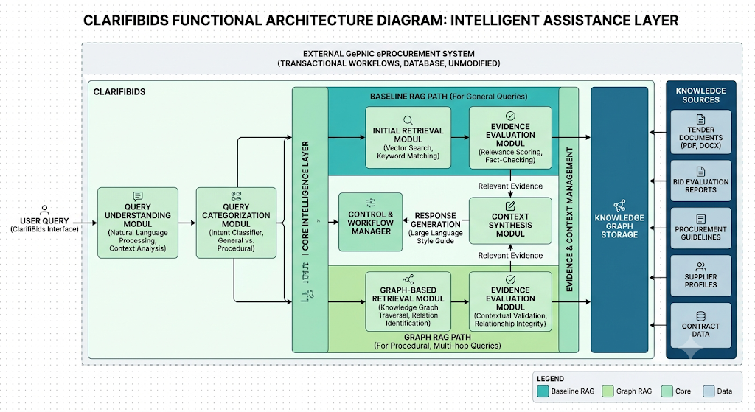
Figure 2: Functional block diagram of ClarifiBids
The Query Understanding and Categorisation module passes its output to the Graph-based and Vector Retrieval module, which retrieves candidate evidence from the FAQ repository, the Support Knowledge Base, and the applicable portal or procedural documents. The Corrective Retrieval Evaluator then checks whether this evidence is sufficient and relevant to the required context; if it is not, an additional retrieval pass is triggered.
Once sufficient evidence has been assembled, the Response Generation module composes the final answer, which is returned to the user along with any supplementary related information, as shown in Figure 2.

7. TECHNICAL SPECIFICATIONS
The planned technology stack for ClarifiBids is summarised in Table 1.
Layer | Technologies
Frontend | React 18, TypeScript, Vite, Lucide Icons, a vanilla-CSS design system
Backend | Python 3.11+, FastAPI, Uvicorn, Pydantic v2, SQLAlchemy, Alembic
AI & Graph Workflow | LangGraph state graphs, LlamaIndex Core
Vector Database | PostgreSQL 15+ with the pgvector extension
Local LLM Inference | Ollama (qwen2.5:1.5b)
Embeddings | SentenceTransformers (BAAI/bge-small-en-v1.5 — 384-dimensional vectors)
Web Search Fallback | DuckDuckGo Search API (duckduckgo-search)
OCR Engine | PaddleOCR with the PyMuPDF layout parser
Secrets & Auth | HashiCorp Vault, Keycloak OIDC JWT / PyJWT
Table 1: Technical specifications of ClarifiBids

8. EVALUATION PLAN
The evaluation of ClarifiBids will focus on measuring how well different retrieval approaches serve different types of GePNIC queries, using a curated set of representative queries that span the defined categories and depth levels.

8.1 Evaluation Dataset
A query dataset will be assembled from the identified GePNIC knowledge sources — FAQs, historical clarification queries, and applicable portal and procedural documents — covering the six query categories and the four query-depth levels:
- Direct
- Procedural
- Context-dependent
- Multi-source
Each query in the dataset will be tagged with its category, intent, user role, expected evidence, and a reference answer where one is available.

8.2 Approaches to be Compared
- Conventional FAQ/keyword retrieval — retrieves information using traditional search or matching techniques.
- Baseline Vector RAG — retrieves semantically relevant knowledge chunks by vector similarity and generates a response from the retrieved context.
- Graph RAG — uses the Knowledge Graph alongside retrieval to identify connected evidence, particularly for procedural and multi-hop queries.
Graph RAG will be evaluated mainly on query types where relationships between multiple pieces of information are genuinely required.

8.3 Evaluation Measures
- Precision@K — the proportion of relevant information among the top-K retrieved results.
- Recall@K — how much of the required relevant evidence was actually retrieved.
- Answer correctness — whether the generated response is consistent with the reference answer or verified domain evidence.
- Answer relevance — whether the response directly addresses the user's query.
- Faithfulness / groundedness — whether the response is supported by the retrieved evidence.
- Context completeness — whether all the steps, conditions, or evidence needed for a procedural query are covered.

8.4 Comparative Evaluation
Results will be broken down by query-depth level rather than reduced to a single overall score, to see how each retrieval approach performs across:
Direct → Procedural → Context-dependent → Multi-source queries
Particular attention will go to procedural and multi-hop queries, to check whether Graph RAG genuinely retrieves connected evidence better than the baseline approach. Where appropriate, human evaluation will also be used to judge correctness, relevance, completeness, and grounding.

8.5 Expected Outcome
The evaluation is intended to establish:
- how well baseline RAG handles general GePNIC queries;
- which query types need deeper, relationship-based retrieval;
- how Graph RAG performs on multi-hop and procedural queries; and
- whether the proposed approach improves the completeness and grounding of responses to complex queries.
Together, these findings should give a practical basis for choosing the right retrieval strategy for each type of bidder query.

9. FUTURE PLAN
The remaining work is organised into the following phases:
Phase | Work to be Done | Status
1. Problem formulation & literature review | Define the problem statement and scope; review existing RAG, Graph RAG, and corrective-retrieval approaches. | Completed
2. Query space design | Define query categories, user roles, knowledge sources, depth levels, and the query categorisation hierarchy. | Completed
3. Knowledge base consolidation | Consolidate the FAQ repository, Support Knowledge Base, and portal/procedural documents for ingestion. | Pending
4. Retrieval pipeline development | Implement query understanding/categorisation, context/evidence identification, graph-based and vector retrieval, and the corrective retrieval evaluator. | Pending
5. Baseline implementation | Implement keyword/FAQ retrieval and Vector RAG baselines for comparison. | Pending
6. Evaluation & comparison | Evaluate the proposed approach against baselines using retrieval and answer-quality measures across all query categories and depth levels. | Pending
7. Dissertation review | Submit the dissertation to the supervisor and additional examiner for review and feedback. | Pending
8. Final submission | Final review and submission of the dissertation. | Pending
Table 2: Planned phases of work

10. ABBREVIATIONS
Abbreviation | Full Form
G2B | Government-to-Business
GePNIC | Government eProcurement National Information Centre
RAG | Retrieval-Augmented Generation
FAQ | Frequently Asked Questions
LLM | Large Language Model
DSC | Digital Signature Certificate
OCR | Optical Character Recognition
JWT | JSON Web Token
OIDC | OpenID Connect
Top-K | The K highest-ranked results returned by a retrieval system

