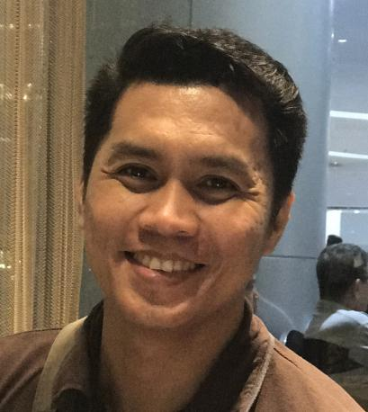**Normaneil E. Macutay**

300 Masikap Street Matungao,

Bulakan, Bulacan

0947-657-2024

[normaneil.macutay@gmail.com](mailto:normaneil.macutay@gmail.com)

Skype : normaneil

**Objective**

I would like to work for a company that will enhance the skills I already have as well as provide the opportunity for personal and professional growth and advancement opportunities.

**Skills**

*PHP, LARAVEL, ZEND FRAMEWORK, PYTHON, DJANGO, CELERY, FALCON API, FAST API, NODEJS, ANGULARJS, JQUERY, VUEJS, REACTJS, IONIC, MYSQL, COUCHDB, MONGODB, DOCKER*

**Employment History:**

**Company:** Xali

**Position:** Front End

**Website:** https://devapp.xali.com.au

**Responsibilities:**

* Develop the web app UI using Vuejs, Ionic and tailwindcss
* Integrated the app to the existing api
* Responsiveness of the UI

**Company**: Aben

**Position**: Front End

**Website**: https://app.joinaben.com/

**Responsibilities**:

* Develop the web app using VueJs, Metronic UI Theme, Bootstrap
* Created reports using apexcharts

**Company**: Remote Staff Inc.

**Position**: Senior Developer

**Responsibilities:**

* Pioneering Developer of the Company.
* Responsible in the maintenance of the website front pages and backend
* Develop company website from scratch
* Develop and maintenance of company Admin Portal. This includes tools and report generations of in all transactions of the Company.
* Develop and maintenance of the Client Portal. A page for leads who registered.
* Develop and maintenance of Subcon Portal. A page for applicants who registered.
* Develop and maintenance of Business Developer Portal. A page for approved affiliate page.

**Company:** WhatsBusy

**Position:** Developer

**Website:** [http://whatsbusy.com](http://whatsbusy.com/)

**Responsibilities:**

* Converted old UI site into a Metronic version
* Updated backend scripts for the new UI requirements

**Company:** Intimate

**Position :** Front End Developer

**Website:** [**https://intimate.io/**](https://intimate.io/)

**Responsibilities:**

* Build the front end from scratch
* Built the front end using VueJs
* Using Bulma css framework

**Company:** Online Sabong

**Position:** Web Developer

**Website:** [**http://sabongbarkadahan.com/**](http://sabongbarkadahan.com/)

**Responsibilities:**

* Used Code Igniter framework
* Built custom api for the user credits status.
* Integrated casino api for the game console

**Company:** STAKE

**Position:** Developer

**Website:** [**https://stakegg-production-393260781.us-east-1.elb.amazonaws.com/**](https://stakegg-production-393260781.us-east-1.elb.amazonaws.com/)

**Responsibilities:**

* VueJs front end
* Integrated the front end to their existing api
* Created pages that involved Team status, reports and profiles
* Created a mobile game BINGO and SWERTRES app.
* Integrated the app to the Gaming API.
* Created custom Restful API’s
* Created Restful API’s for the Emango App
* Generated Cards to be used by OFW abroad.

**Highest Educational Attainment**

Diploma in Computer Studies

STI-College Balagtas

March 2006

**Personal Information**

Birth Date : August 12, 1977

Gender : Male

Marital Status: Married

Nationality : Filipino

Religion : Christian

**Character Reference**

Allanaire C. Tapion

**Senior Software Engineer - CloudStaff Inc.**

09472895507

Anne Charise Mancenido

**Product Owner – Navagis Philippines**

*I hereby certify that the presented information above is true and correct based on my knowledge and beliefs.*

**Normaneil E. Macutay**