Johanna Escudero
Escjo192@student.otago.ac.nz
water fluoridation
Impacts on Community Water Fluoridation to support Te Āti Awa submission on the proposed Water Fluoridation Referendum

Table of Contents
Executive summary 2
Introduction 3
HIA 3
Screening 3
Scoping 4
Key Stakeholders 4
Geographical Scope 5
Identification & Assessment of Impacts 5
Health Impacts of Excess Fluoride 6
Health Impacts of Removing Fluoride 6
Adverse Impacts on Māori and Pasifika Communities 7
Recommendations 8
Reporting, monitoring, evaluation and follow-up 8
References 10
Appendix: Environmental Health Risk Assessment (EHRA) 11
Problem formulation 11
Hazard Identification 11
Fluoride in Water 11
Absence of fluoride from water 11
Dose-response assessment 11
Fluoride as a Hazardous Chemical 12
Beneficial Effects at Low Doses 12
Adverse Health Effects at Higher Doses 12
Regulatory Standards and Risk Mitigation 12
Exposure assessment 13
Fluoride Exposure in New Zealand 13
Positive Impacts of Fluoride Exposure 13
Potential Risks of Excessive Fluoride Exposure 14
Risk characterisation 14
Risk management 14

Executive summary

This report will review the health impacts of the proposed Fluoradation Referendum Bill, which looks to reverse the Health (Fluoridation of Drinking Water) Amendment Act 2021, which changes the decision-making process for Community Water Fluoridation (CWF) from the Director General of Health to Local Council led referenda. This report focuses on the possible health impacts caused by removing fluoride from the water supply in Wellington and Taranaki regions - that are of particular concern for Te Āti Awa, who established in these areas.

The Health Impact Assessment (HIA) done as part of this report seeks to evaluate the potential effects of removing fluoride and its impacts on oral health, health equity and public health consequences especially for Maori and Pasifika communities. Fluoride has a significant impact on reducing dental caries, especially in underprivileged populations like children and people with limited access to dental care. Taking fluoride away could increase existing health inequities, especially within for Māori and Pasifika communities which already experience higher rates of dental decay and difficulties to access dental services.

This report is considers the implications of the Bill on Te Tiriti o Waitangi. It has an emphasis on equity and the Crown’s responsibility to protect Māori health in their communities. Removing fluoride may cause the increase of health inequities and higher demand on oral health services, that is already in high demand due to workforce shortages in New Zealand.

Key stakeholders for this report are, Te Āti Awa, Māori and Pacifika communities, regional health providers, the Ministry of Health and Wellington and Taranaki local councils and recidents. This HIA is intented to submit Te Āti Awa submission on the proposed Bill, as it outlines the risks of removing fluoride and suggesting that the decision-making continue to be centralized under the Director-General of Health to make sure is consistent and equal in fluoridation practices across Wellington and Taranaki.

In summary, this report promotes the rejection of the Fluoridation Referendum Bill, stating that removing fluoride from the water supply would affect Māori and Pacifika communities, breach Te Tiriti o Waintanga principles, and the public health outcones, around increase dental caries, will be worse. This report recommends that CWF continues to be centraly managed to mantain health equity and protect vulnerable populations.

Introduction
Fluoride is added to the water supply in various regions across New Zealand to prevent dental decay. On February 11, 2025, NZ First introduced the Fluoridation Referendum Bill, to repeal the Health (Fluoridation of Drinking Water) Amendment Act 2021, which centralized authority to the Director-General of Health. The proposed Bill would instead require local binding referenda on fluoridation decisions.
Te Āti Awa (a Wellington and Taranaki based Iwi) will submit its position. A Health Impact Assessment (HIA) will evaluate the potential benefits and risks of removing fluoride from Wellington and Taranaki’s water supply, focusing on oral health, health equity, and broader public health implications.

HIA

Screening
A Health Impact Assessment (HIA) will be used in response to the proposed repeal of the Health (Fluoridation of Drinking Water) Amendment Act 2021. This change is likely to result in reduced fluoridation in regions such as Taranaki which may significantly impact oral health outcomes.
Fluoridation helps to prevent caries especially among vulnerable populations such as children, those living in highly deprived areas and Māori and Pasifika communities, who often face greater barriers to access private dental care ^{1,2}. There groups already face greater barriers to access dental care and removing fluoride may lead to higher rated of dental caries, worser oral health outcomes and increase demand on oral health services.
This change requires an HIA due to potential to negatively impact public health
Given that oral health is a key determinant of overall wellbeing, the removal of fluoride could increase in dental disease, widening health inequities, and place greater demand on oral health services.
New Zeeland has a shortage of oral health professions with dentists, dental hygienists and therapists all listed in the Immigration Green List due to workforce gaps (3). The Bill could further stretch oral health services and increase inequalities in oral health.
The HIA assess health and wellbeing impacts of the Bill, it will be guided bu the Minsitry of Health HIAA. It will also look at implications on Te Tiriti o Witangi principles, particularly equity and active proctetion.
Findings will support Te Ati Awa’s submission to the select Committee by identifying health risks and informing recommendations.

Scoping
This HIA will follow the process described by the Guide to HIA in New Zeland ³. The health lens will be used to assess the impact of the proposed repeal.
The HIA will focus on individual and population-level of health outcomes, with a focus on the below areas:
- Changes in dental caries prevalence.
- Structural barriers to accessing oral health services.
- Health equity outcomes, especially for Māori.
- Alignment with Te Tiriti o Waitangi principles.
- Economic and service delivery impacts.

Key Stakeholders
Sakeholders relevant to this HIA include:
- Te Āti Awa (mana whenua in Wellington and Taranaki)
- Māori and Pasifika communities.
- Te Whatu Ora Capital, Coast & Hutt and Te Whatu Ora Taranaki.
- Territorial Authorities and Water Service Entities that fall within Te Āti Awa’s area of interest (see Figures 1 and 2)
- Ministry of Health.
- Oral health professionals – dentists, dental therapists and hygenists.
- Residents of Wellington and Taranaki.

Geographical Scope
The HIA will focus on Wellington and Taranaki-regions important to Te Āti Awa, demonstrated by their rohe in the below maps.
Figure 1 - Te Āti Awa Wellington ⁴  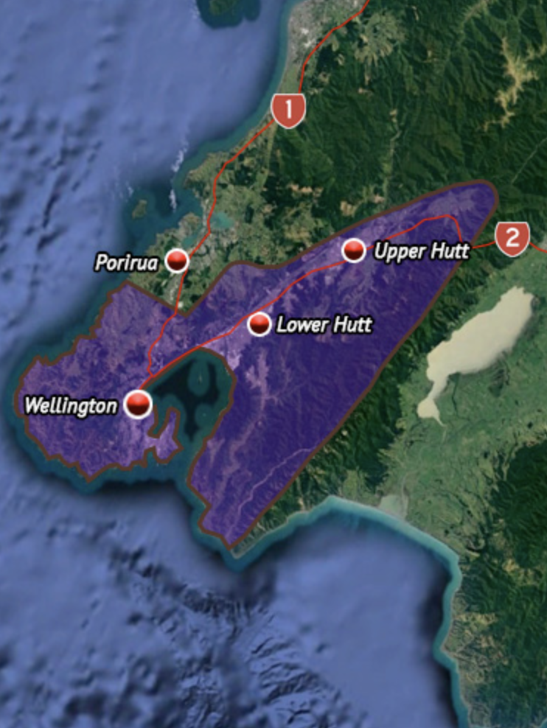 | Figure 2- Te Āti Awa Taranaki ⁵  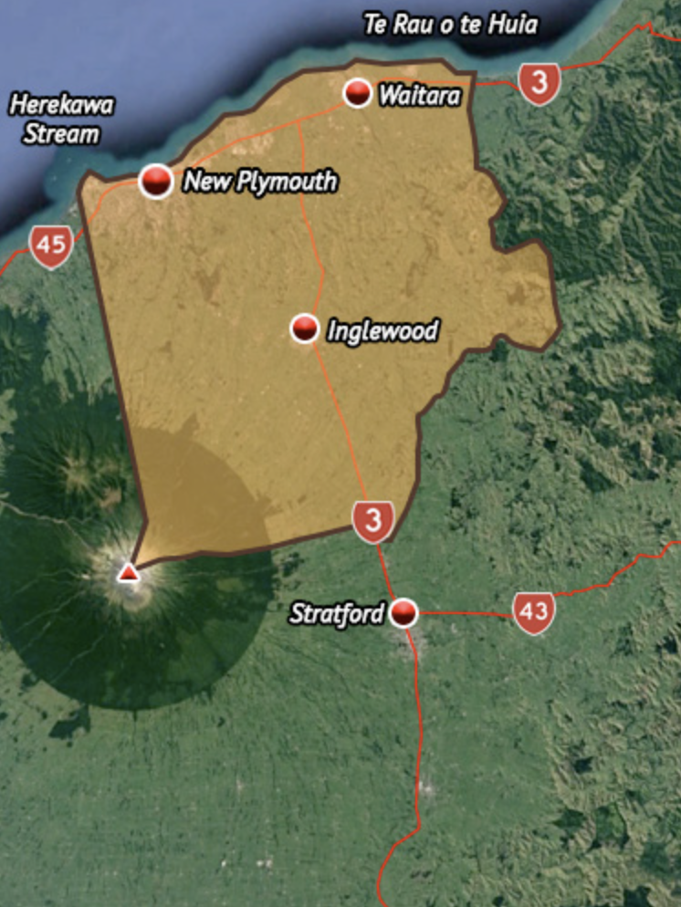

Identification & Assessment of Impacts
The Guide to Health Impact Assessment (HIA) was used to identify key health determinants relevant to Te Āti Awa’s submission on the Fluoridation Referendum Bill. A health lens approach assessed potential impacts on health outcomes, inequalities, and Māori wellbeing. This HIA, focuses on the health effects of fluoride removal, particularly for Māori and Pasifika communities.

Health Impacts of Excess Fluoride
The main concern with fluoride is when it exceeds recommended levels.
Dental Fluorosis: The most common effect of excessive fluoride exposure is dental fluorosis, which usually presents as mild, with faint white streaks or spots on the teeth. While it may have cosmetic implications, mild fluorosis does not affect tooth function or overall oral health. New Zealand’s regulatory system closely monitors and maintains fluoride levels within safe limits to minimise this risk ⁶.
Systemic Health Risks: Reviews, including one by the Prime Minister’s Chief Science Advisor, have found no significant evidence of adverse systemic health effects when fluoride is added to drinking water at the recommended levels. This reinforces the safety of fluoridation within the current regulatory guidelines ⁶.

Health Impacts of Removing Fluoride
Removing fluoride disproportionately harms those with limited access to dental care.
Increased Dental Caries: Removing fluoride would likely lead to a measurable increase in tooth decay, particularly in Māori and Pasifika children, as shown by Table 1 below.
Mental Health Outcomes: Those struggling with mental health are less likely to use dentist or other oral health providers, due to stigma, low self-esteem, or lack of income ⁷. Areas that remove fluoride would likely have a more pronounced negative impact on this group.
Equity Concerns: The removal of fluoride disproportionately affects Māori and Pasifika communities. For example, Table 1 shows that in the Te Manawa Taki and Ikaroa Ministry of Health regions — which include Taranaki and Wellington — Māori and Pasifika children are more likely to be caries-free by Year 8 in areas with fluoridated water. Nationally Māori and Pasifika children show a greater increase in caries-free rates compared to other ethnic groups when compared to other ethnicities. This policy would widen those inequities, in breach of Article 3 (equity) and Article 2 (active protection) of Te Tiriti o Waitangi ^{8,9}. Further impacts on Māori and Pasifika are discussed below.
Table 1 - Year 8 Oral Health Data (Ministry of Health) ¹⁰
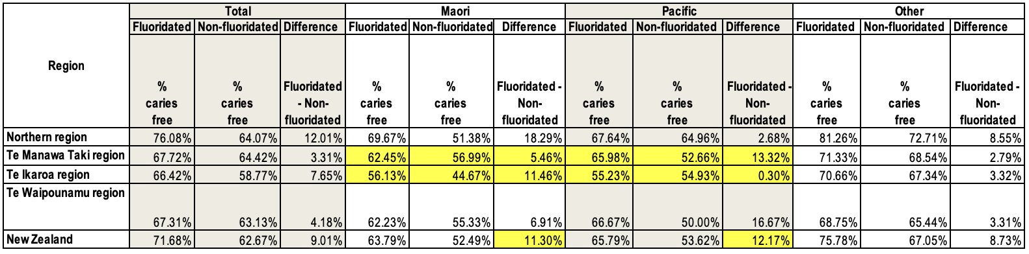

Adverse Impacts on Māori and Pasifika Communities
Tooth decay disproportionately affects lower socioeconomic groups, with Māori and Pasifika communities experiencing significantly higher rates of dental caries ². Māori adults have 10% more affected teeth than non-Māori, while Māori children have 50% more primary teeth and 80% more permanent teeth affected by caries ². Additionally, Māori children are 30% less likely to be caries-free compared to non-Māori ². In 2013, only 43% of Māori children in Year 8 were reported to be caries-free, compared to 57% of non-Māori ².
Given the already existing barriers Māori and Pasifika communities face in accessing dental care, removing fluoride from community water supplies would likely exacerbate oral health inequities and contribute to worsening overall health outcomes. Addressing these disparities requires careful consideration of public health policies that ensure equitable access to dental protection measures such as fluoridation.
Te Tiriti o Waitangi obliges the Crown to uphold the principle of equity and actively protect Māori health ^{8,9}. Removing fluoride without free, universal access to dental services would breach those obligations. Fluoridation is a low-cost, population-level interventions that does not rely on individual behaviour or access. Its removal would strip away a key protective factor for the most vulnerable.

Recommendations
- Centralised decision-making should stay under the Director-General of Health
Justification: Ensures consistent and equity in fluoridation and has positive impacts on public health outcomes.
Evidence: There has been no evidence of detrimental health impacts for CFW and it is widely regarded as an effective measure to reduce caries.
Trade-off: Limits local control but beneficial impacts of CWF warrant centralisation.

- Reject the Fluoridation Referendum Bill
Justification: Risks fragmenting decisions on CWF which could impact Maori & Pasifika communities.
Evidence: CWF reduces health disparities for groups with limited access to dental care.
Trade-off: Reduces local autonomy.

- Apply a Te Tiriti o Waitangi lens to oral health policies
Justification: Uphold the Crown’s responsibility to protect Māori health.
Evidence: Māori that have CWF tend to have less caries than those that do not (demonstrated by Table 1 above), this aligns with the treaty principle of active protection by providing a universal health benefit.
Trade-off: May require longer consultation but it will provide more equitable health outcomes.

Reporting, monitoring, evaluation and follow-up

Health impacts of fluoridation decisions should be monitored through regular oral health data collection by Te Whatu Ora, include dating on ethnicity, age, and region. Repoting should include Dental caries rates, as well as levels of fluoride at water treatment plants, in Wellington and Taranaki.

Findings should be shared with key stakeholders outlined in the Scoping section.

Any proposed changes to fluoridation status must in Taranaki or Wellington should be done in consultation with Te Āti Awa and other affected Māori groups, in accordance with Te Tiriti o Waitangi. Evaluation outcomes should be publicly shared and used to inform future health policy.

References
1. Armfield JM. Community Effectiveness of Public Water Fluoridation in Reducing Children's Dental Disease. Public Health Reports® 2010; 125(5): 655-64.
2. Moore D, Poynton M, Broadbent JM, Thomson WM. The costs and benefits of water fluoridation in NZ. BMC Oral Health 2017; 17(1).
3. Health Mo. Whānau Ora Health Impact Assessment. Wellington: Ministry of Health. Wellington, 2007.
4. Kōkiri TP. Te Moana O Raukawa Te Ātiawa. https://www.tkm.govt.nz/iwi/te-atiawa-wellington/ (accessed 5/4/2025 2025).
5. Kōkiri TP. Hauāuru Te Ātiawa. 2014. https://www.tkm.govt.nz/iwi/te-atiawa-taranaki/ (accessed 5/4/2025 5/4/2025).
6. Advisor OotPMsCS. Fluoridation: an update on evidence. Wellington, 2023.
7. Tiwari T, Kelly A, Randall CL, Tranby E, Franstve-Hawley J. Association Between Mental Health and Oral Health Status and Care Utilization. Frontiers in Oral Health 2022; 2.
8. Lacey J, Thomson W, Crampton P, Willing E. Working towards Māori oral health equity: Why te Tiriti o Waitangi needs to underpin the oral health system, using evidence from the New Zealand Oral Health Survey. NZ Dent J 2021; 117(3): 105-10.
9. Barrett M, Connolly-Stone K. The Treaty of Waitangi and social policy. Social Policy Journal of New Zealand 1998: 29-48.
10. Health Mo. Age 5 and Year 8 oral health data. 2023. https://www.health.govt.nz/publications/age-5-and-year-8-oral-health-data (accessed 5/5/2025 2025).
11. Organisation WH. Guidelines for drinking-water quality, 3rd edition: Volume 1 - Recommendations incorporating the first and second addenda. World Health Organisation 2008; Volume 1: 668.
12. Peter Gluckman DS. Health effects of water fluoridation: A review of the scientific evidence. The Royal Society of New Zealand, 2014.
13. Niazi FC, Pepper T. Dental Fluorosis. StatPearls. Treasure Island (FL): StatPearls Publishing
Copyright © 2025, StatPearls Publishing LLC.; 2025.
14. Taylor KW, Eftim SE, Sibrizzi CA, et al. Fluoride Exposure and Children’s IQ Scores. JAMA Pediatrics 2025; 179(3): 282.
15. Jarosz PM, Gołacki J, Matuszek M. Is water fluoridation correlated with hypothyroidism? Journal of Education, Health and Sport 2022; 12(7): 121-6.
16. Gage R, Broadbent J, Leung W, Lee M, Sullivan T. The declining affordability of dental care in New Zealand from 1978 to 2023. Community Dentistry and Oral Epidemiology 2025; 53(1): 17-25.
17. Selwitz RH, Ismail AI, Pitts NB. Dental caries. The Lancet 2007; 369(9555): 51-9.
18. Water W. Fluoride at water treatment plants. 2025. https://www.wellingtonwater.co.nz/resources/topic/drinking-water/whats-in-your-water/fluoride-at-water-treatment-plants?utm_source=chatgpt.com (accessed 2025 4/5/2025).
19. Campbell G. Wellington's water has been inadequately fluoridated for six years, review finds. 2025. https://www.nzherald.co.nz/nz/wellingtons-water-has-been-inadequately-fluoridated-for-six-years-review-finds/MJ7AUDN7TUVLKYDSXMZHL4OAQU/?utm_source=chatgpt.com (accessed 5/4/2025 2025).
20. Council NPD. Fluoride set to enter New Plymouth’s water supply after instruction from the Director-General of Health. 2023. https://www.npdc.govt.nz/council/news/2023/july/fluoride-set-to-enter-new-plymouth-s-water-supply-after-instruction-from-the-director-general-of-health/ (accessed 28/3/2025 2025).

*ChatGPT was used to help me to reduce the word count, I asked it to show me where I could remove duplication or use more concise language. It was only used to identify areas that I could then edit, it was not used to write the essay, or sections of it.

Appendix: Environmental Health Risk Assessment (EHRA)

Problem formulation
This EHRA will evaluate health risks associated with removing fluoride from the community water supply in the Wellington and Taranaki region, by comparing health risks of continued fluoride exposure versus its removal.

Hazard Identification

Fluoride in water
Fluoride added to water to prevent dental decay. The World Health Organization (WHO) sets a limit of 1.5 mg/L as safe for humans ¹¹. In New Zealand levels of fluoride are maintained below this threshold ¹². Excessive levels of fluoride can cause dental fluorosis during tooth development ¹³. There are concerns about the potential neurological effects of fluoride, although evidence is still debated ¹⁴. Additionally, some research has analysed possible associations with thyroid disorders, but the results are inconclusive ¹⁵.

Absence of fluoride from water
Removing fluoride could increase dental decay, especially in deprived communities ²; in New Zealand 44% of adults that participated in the New Zealand Health Survey did not fix a dental problem due to treatment costs ¹⁶, leading to dental pain, tooth loss, and it has been found to affect the quality of life of children ¹⁷. Evidence shows that fluoridation is very cost-effective for every dollar spent on CWF saves $38 on dental treatment ².

Dose-response assessment
Fluoride, like many environmental chemicals, exhibits both beneficial and harmful effects depending on the dose. The dose-response relationship of fluoride exposure highlights that while low concentrations contribute to improved dental health, excessive exposure can lead to toxicological concerns, including skeletal and dental fluorosis, bone fractures, and other systemic effects ¹².

Fluoride as a Hazardous Chemical
Fluoride is a naturally occurring substance but it can be toxic at higher concentrations. A report by the Prime Minister’s Chief Science advisor recommends fluoride concentration in drinking water to range from 0.7–1.2 mg/L ¹². New Zealand's natural water sources have low fluoride concentrations, so water supplies require fluoridation as a public health measure ¹².

Beneficial Effects at Low Doses
At 0.7–1.2 mg/L, fluoride is highly effective in reducing dental caries by strengthening enamel and increasing its resistance to acid degradation ¹². This level is recommended worldwide, to provide optimal benefits without causing harm.

Adverse Health Effects at Higher Doses
- Dental Fluorosis: Prolonged exposure to fluoride above 1.5 mg/L, particularly during tooth development, can result in dental fluorosis, characterized by white spots or streaks on teeth. Severe fluorosis is rare in New Zealand due to regulated levels ¹².
- Skeletal Fluorosis and Bone Fractures: Fluoride levels of above 4 mg/L can result in skeletal fluorosis, which leads to joint pain, stiffness, and bone deformities. Evidence suggests that fluoride levels around 1 mg/L may enhance bone strength, whereas concentrations exceeding 4 mg/L can increase fracture risk ¹².
- Neurological and Cognitive Effects: Concerns have been raised regarding fluoride’s impact on neurological development, particularly in children. A New Zealand study found no evidence that water fluoridation at recommended levels affects IQ or cognitive development ¹².

Regulatory Standards and Risk Mitigation
In New Zealand, where natural fluoride levels are low, water fluoridation is important for improving oral health. New Zealand has strict regulation of fluoride concentration to ensure public safety ¹². The removal of fluoride could led to an increase in dental caries, particular amoung vulnerable populations such as Māori and those from lower socio-economic background.
The dose-response relationship for flouride is well established – low levels of fluoride has oral health benefits and excessive doses can cause adverse oral health impacts. It is important to maintain fluoride levels within the recommended limits and any decisions to remove fluoride should be informed by the HIA and EHRA’s findings.

Exposure assessment
Fluoride exposure primarily occurs through drinking water, food, dental products, and air. CWF remains the most significant and controlled source of fluoride exposure in many communities ¹². Globally, about 30 countries have fluoridated their water supplies, benefiting approximately 370 million people, and more than 50 million people consume naturally fluoridated water at or near the optimal level of around 1.0 mg/L ¹².

Fluoride Exposure in New Zealand
New Zealand's natural water sources typically have low fluoride concentrations, ranging from ~0.1 to 0.2 mg/L ¹². Water sources in some regions are fluoridated to levels between 0.7 and 1.0 mg/L— enough to prevent tooth decay while minimizing adverse effects ¹². However, the availability of fluoridated water varies, leading to differences in oral health outcomes across populations ¹².

Positive Impacts of Fluoride Exposure
At levels (0.7–1.0 mg/L), fluoride strengthens tooth enamel, making it more resistant to acid attacks and significantly reducing the prevalence of dental caries ¹. CFW has shown to reduce tooth decay rates across all age groups, particularly benefiting children, low-income populations, and those with limited access to dental care ¹. Fluoride exposure through water, combined with fluoride toothpaste and dental treatments ¹² ⁶, contributes to improved oral health and reduces the need for costly dental interventions ¹.

Potential Risks of Excessive Fluoride Exposure
In some regions, particularly parts of China and Africa, fluoride concentrations in drinking water can exceed 20 mg/L, leading to an increased risk of dental and skeletal fluorosis ⁶. Prolonged exposure to these high levels can result in enamel defects, bone abnormalities, and potential neurological concerns. In contrast, at recommended levels used in New Zealand (0.7-1.0 mg/L), the risk of adverse effects is minimal ⁶. This regulation ensures that the benefits of fluoride exposure in New Zealand and maximised and pontial risks are minimized.

Risk characterisation
Fluoride can be harmful at high concentrations, but at the levels used in CWF, typically 0.7 to 1.2 mg/, it is considered safe and effective ¹².
In Wellington, ongoing improvements and strict monitoring mean the risk of overexposure is very low. Past operational issues have been addressed, and compliance with national fluoride targets is now consistently high, reinforcing a low-risk, high-benefit profile.
In contrast, parts of Taranaki have only recently begun fluoridating water. This underexposure increases the risk of dental caries, particularly among vulnerable populations with limited access to dental care. The absence of fluoride, rather than the precense of fluoride is the a larger public health risk.

Risk management
In New Zealand, water fluoridation is carefully managed, with regular monitoring to ensure that it remains within the recommended 0.7 – 1.0mg/L range. For example Flouride levels in Wellington have been within this range with the Te Mārua and Wainuiomata treatment plants reporting compliance rated of 99.5% and 98.9%. They use automatic sensors to constantly check how much fluoride is in the water ¹⁸, which means that fluoride levels are safe and promote oral health.

However, there have been issues in the past. A review found that from July 2016 to 2022, fluoride was properly added to the water only about 20% of the time at Te Mārua and Gear Island ¹⁹. This was primarly due to the use of old equipment. Since then, Wellington Water has made big improvements, including building new fluoride facilities. By September 2022, the systems were working properly again and compliant with national standards ¹⁹.

It is more challenging to find readily available data on CWF in Taranaki. Water Fluoridation has only occurred recently - as of the end of July 2023 New Plymouth District Council added fluoride to their drinking supply after being directed by the Director General of Health ²⁰. Without the involvement of the Director General of Health there is the risk that communities such as New Plymouth will not fluoridate drinking water which increases the risk of dental caries for its population.

As demonstrated by the Wellington region it is important to invest in infrastructure and closely monitor fluoride levels. This ensures that fluoride levels will not be higher enough to have negative health impacts on the community yet they are sufficient to benefit the community in reducing dental caries. The Taranaki region's non-fluoridation status shows the need for decisions on fluoride to be managed by the director general of health, to ensure equitable access to fluoridated water across New Zealand.

