Project | Sunny Jim
Report | Motor Spin Test
Author | Peter Fall
Date | 15 October 2021

Introduction
- We aim to get the motor to spin in a bench test

Setup
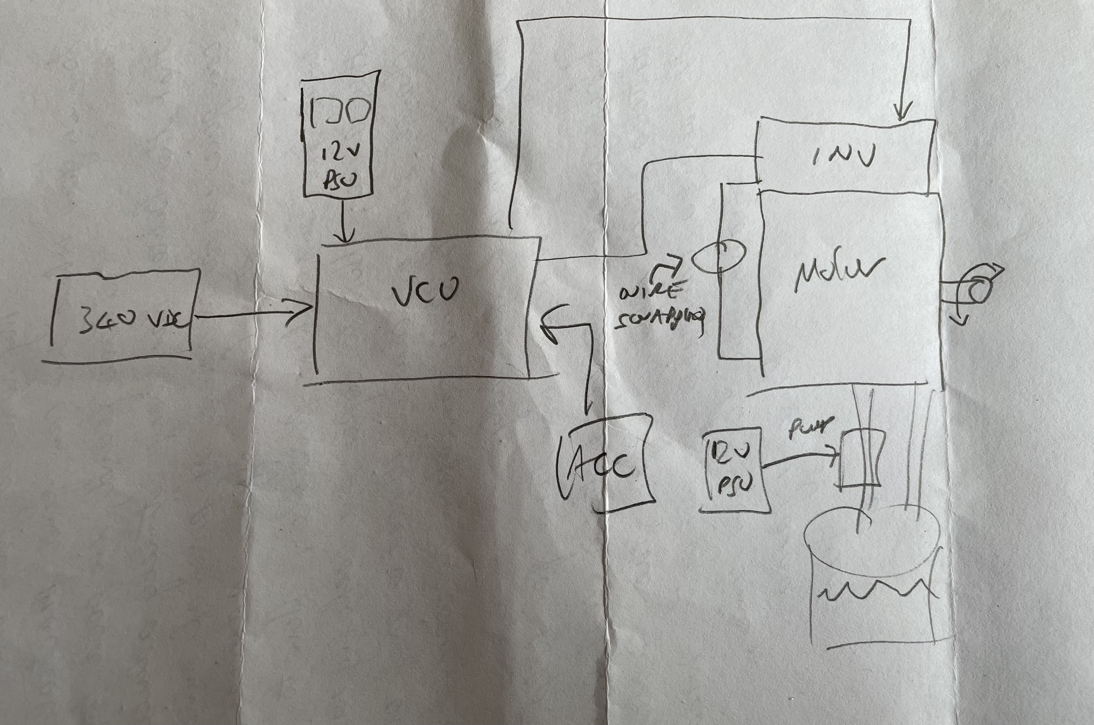

Initial Findings
With straight through connections, motor just cogs.

Experimentation and wire swapping
We experimented by swapping the polarity of both the exciting and sensing windings that provide motor direction feedback to the inverter.

Config | Gear | Stimulus | Result | Shaft Rotation | RPM indication
Straight connections. | FWD | accel | Motor cogging
Blu S3 / PUR S1 swapped | FWD |  | rotated for a while. then blew fuse in 340v PSU |  | -ve
Reduced max torque 100->50. Reduced max speed 10k->600 | FWD | manual spin |  | clockwise | -ve
Restored 100/10k settings | FWD | manual spin |  | clockwise | –ve
Straight connections. | FWD | manual spin |  | clockwise | +ve
GRN S2 / YEL S4 swapped | FWD | manual spin |  | clockwise | –ve
Blu S3 / PUR S1 swapped and  GRN S2 / YEL S4 swapped | FWD | manual spin |  | clockwise | +ve
Blu S3 / PUR S1 swapped and  GRN S2 / YEL S4 swapped | FWD | accel | Motor cogging
BRN R1 / GRY R2 swapped | FWD | manual spin |  | clockwise | +ve
BRN R1 / GRY R2 swapped | FWD | accel | Motor cogging
BRN R1 / GRY R2 swapped  and  BLU S3 / PUR S1 swapped | FWD | manual spin |  | clockwise | -ve
BRN R1 / GRY R2 swapped  and  BLU S3 / PUR S1 swapped | FWD | accel | Motor runs continuously | anti-clockwise | +ve
BRN R1 / GRY R2 swapped  and  BLU S3 / PUR S1 swapped | REV | accel | Motor runs continuously | clockwise | -ve

Conclusion
- We were able to get the motor to reliably drive in both forward and reverse directions by swapping both R1/R2 and S3/S1.
- Motor spin appears to be anticlockwise in FWD gear. Not sure if this will be an issue or not.
- In the test setup, it is easy to blow the 5A fuse in the 340v PSU – need to be careful not to give too much accel.
- On accel, the workshop lights flickered.

