Dev Assessment Platform — User Guide
A practical, step-by-step guide to running technical assessments: building your question bank, configuring tests, sending links to candidates, and reading the results.
In one sentence: You build a bank of questions — across several question types (multiple choice, matching, ordering, fill-in-the-blank and more) — group them into a test configuration (technology + seniority + length + pass mark), generate a one-off link for each candidate, and the platform auto-grades their timed test the moment they submit.
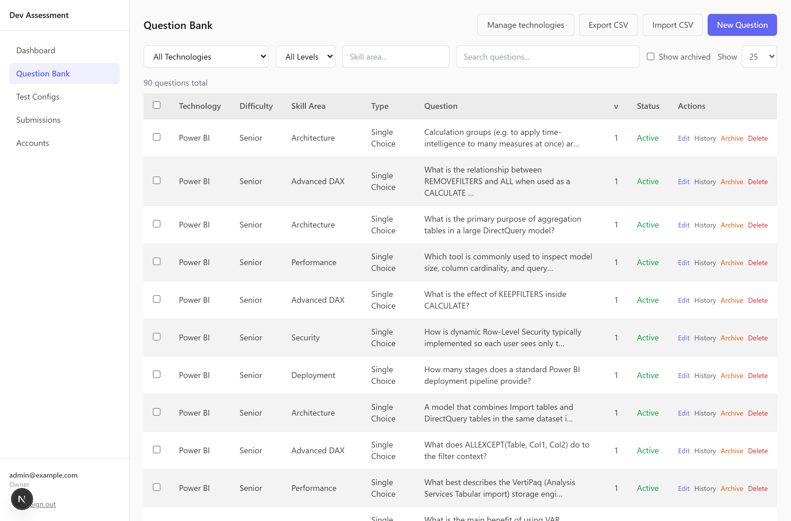
The Question Bank — the heart of the platform.
——————————————————————————————

Contents
- Who does what — roles
- Signing in
- The big picture — how a test flows
- Building the question bank
- Creating a test configuration
- Generating and sharing candidate links
- What the candidate sees
- Reading results
- The dashboard
- Managing team accounts
- Your own account settings
- Tips & FAQ
——————————————————————————————

1. Who does what — roles
Every admin account has one of three roles. What you can do depends on your role:
Capability | Owner | Reviewer | Member
View dashboard, submissions & results | ✅ | ✅ | ✅
Generate & share candidate links | ✅ | ❌ | ✅
Create / edit / archive / delete questions | ✅ | ❌ | ❌
Import / export questions (CSV) | ✅ | ❌ | ❌
Create / delete test configurations | ✅ | ❌ | ❌
Delete a submission | ✅ | ❌ | ❌
Manage team accounts | ✅ | ❌ | ❌

- Owner — full control. Sets up questions, tests, and the team.
- Reviewer — read-only. Can see everything but change nothing.
- Member — interviewers/recruiters. Can send links and read results, but
can't touch the question bank or test setup.
If a button described in this guide isn't visible to you, it's almost always a role restriction.
——————————————————————————————

2. Signing in
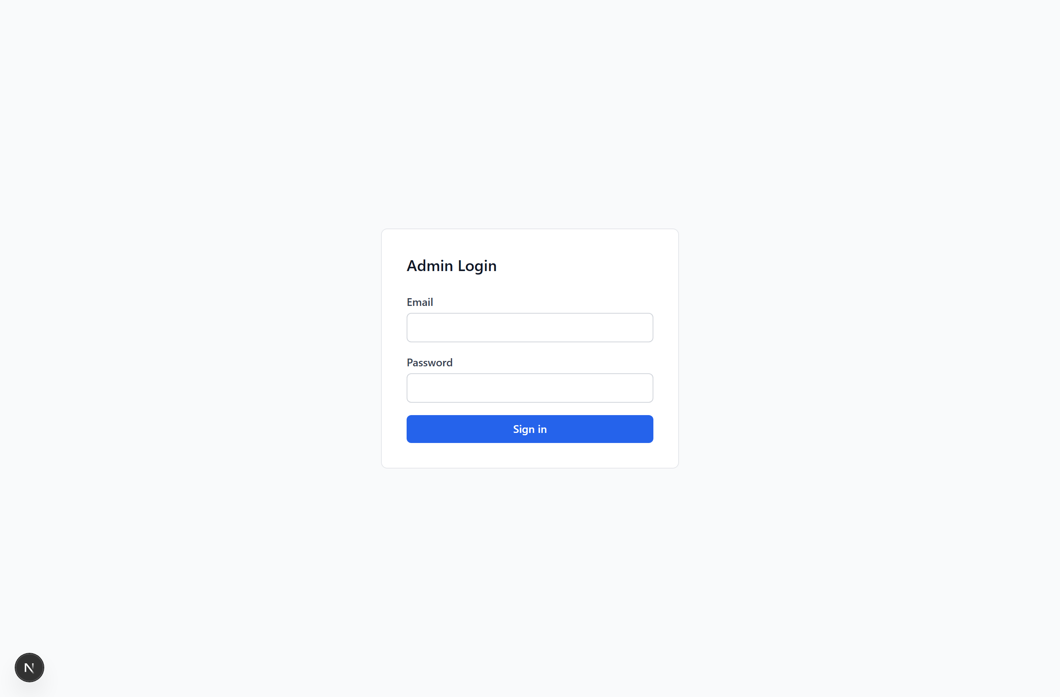
- Go to the admin site and you'll land on Admin Login.
- Enter your email and password and click Sign in.
- You're taken into the admin area. Navigation lives in the left sidebar:
Dashboard · Question Bank · Test Configs · Submissions (and Accounts if you're an Owner).
Other things in the sidebar:
- Theme toggle (sun/moon icon, bottom-left) — switch light/dark mode.
- Your name/email block (bottom-left) — click it to open Settings.
- Sign out — next to the theme toggle.
On a phone or narrow screen, tap the menu (☰) icon in the top bar to open the sidebar.
——————————————————————————————

3. The big picture — how a test flows
┌─────────────┐ ┌────────────────────┐ ┌──────────────┐
│ Questions │ ──▶ │ Test Configuration │ ──▶ │ Candidate │
│ (the bank) │ │ (tech + level + │ │ link │
│ │ │ count + pass %) │ │ (one per │
└─────────────┘ └────────────────────┘ │ candidate) │
└──────┬───────┘
▼
┌──────────────┐
│ Auto-graded │
│ result │
└──────────────┘
- Build a question bank — tag each question with a technology, level, and
skill area, and pick the right question type for what you want to test.
- Create a test configuration — e.g. "Power BI — Mid, 20 questions, pass 70%".
The platform will randomly pull that many matching questions per candidate.
- Generate a link for a named candidate and share it (copy / email / Teams).
- The candidate takes a 30-minute timed test with no login required.
- On submit, the test is auto-graded and appears under Submissions and on the Dashboard.
——————————————————————————————

4. Building the question bank
Owner only. Reviewers and Members can view questions but not change them.
Open Question Bank from the sidebar. You'll see a searchable, paginated table of every question. Each row shows its Type (e.g. Single Choice, Matching, Ordering), technology, level, skill area, and a preview of the question text.

Filtering and finding questions
Use the filter row at the top:
- Technology dropdown
- Difficulty / level (Junior / Mid / Senior)
- Skill area text box (matches partial text, e.g. "DAX")
- Search box (searches the question text)
- Show archived checkbox — include retired questions
- Show (page size) — 10 / 25 / 50 / 100 / All rows per page

Question types
A question is built from two independent parts:
- The stimulus — what the candidate reads. This can mix text, a
syntax-highlighted code snippet, and an uploaded image (e.g. a model diagram or a screenshot).
- The answer — how the candidate responds. Choose one of six types:
Type | The candidate… | Graded
Single choice | picks one option (classic A/B/C/D) | exact
Multiple select | ticks every option that applies | all-or-nothing
True / False | picks True or False | exact
Matching | pairs each item on the left with one on the right | all-or-nothing
Ordering | drags items into the correct order | all-or-nothing
Fill in the blank | types the missing word(s) into ___ gaps | all-or-nothing

Every type is auto-graded instantly — there's no manual marking step. Grading is all-or-nothing: a question counts as correct only if the whole answer is right (e.g. all matches correct, the full order correct). Scores stay a simple "questions correct ÷ questions asked".

Adding a single question
- Click New Question (top-right).
- Fill in the shared fields:
- Technology — pick from the list.
- Difficulty — Junior / Mid / Senior. This is what test configs match against.
- Skill Area — a free-text tag, e.g. DAX, Data Modelling, Visuals.
Skill areas drive the per-skill breakdown on results, so keep them consistent.
- Type — choose one of the six types above. The answer editor below changes
to match.
- Build the Question stimulus using the block buttons:
- + Text — a paragraph the candidate reads.
- + Code — a code block with a language label (e.g. dax, sql, m),
shown to the candidate in monospace.
- + Image — upload a PNG/JPEG/WEBP/GIF (up to 1 MB). It's stored with the
question and shown inline. You can add several blocks and remove any with remove.
- Fill in the answer editor for your chosen type (see below).
- (Optional) add an Explanation — shown internally; helps reviewers and exports.
- Click Save Question.

The answer editor, per type
Ordering — type the items in the correct order; candidates see them shuffled and drag them back into place.
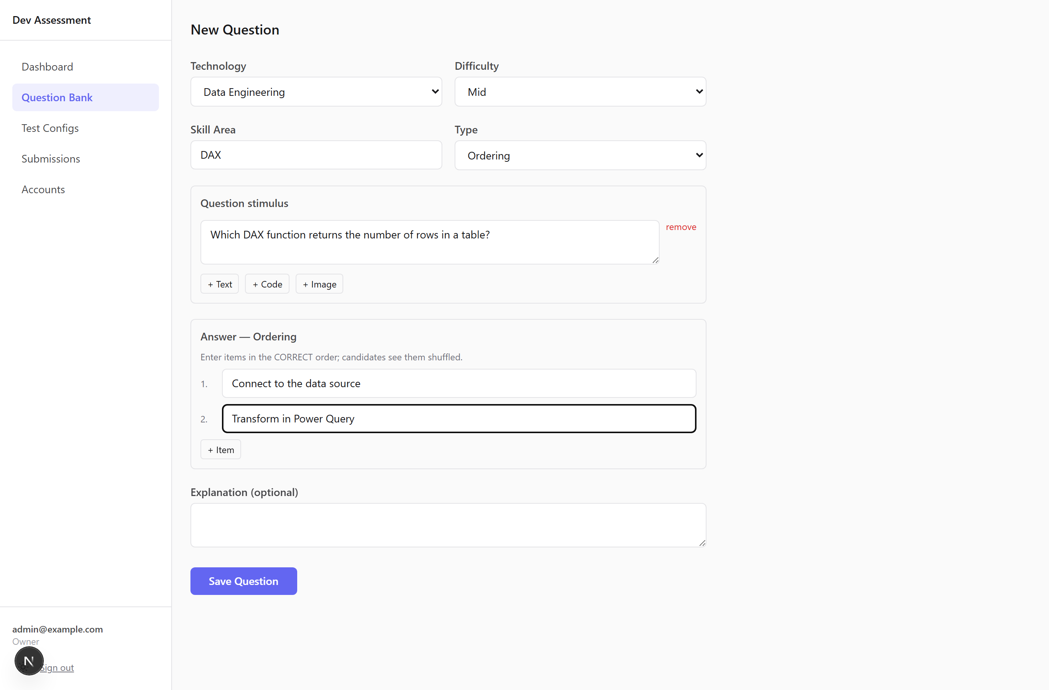
Fill in the blank — put ___ (three underscores) wherever you want a gap in your stimulus text, then give the accepted answers for each blank (comma-separated, so you can allow variants like ALL, ALL()). Matching is case-insensitive and ignores surrounding spaces. (Markers only work in text blocks, not inside code blocks.)
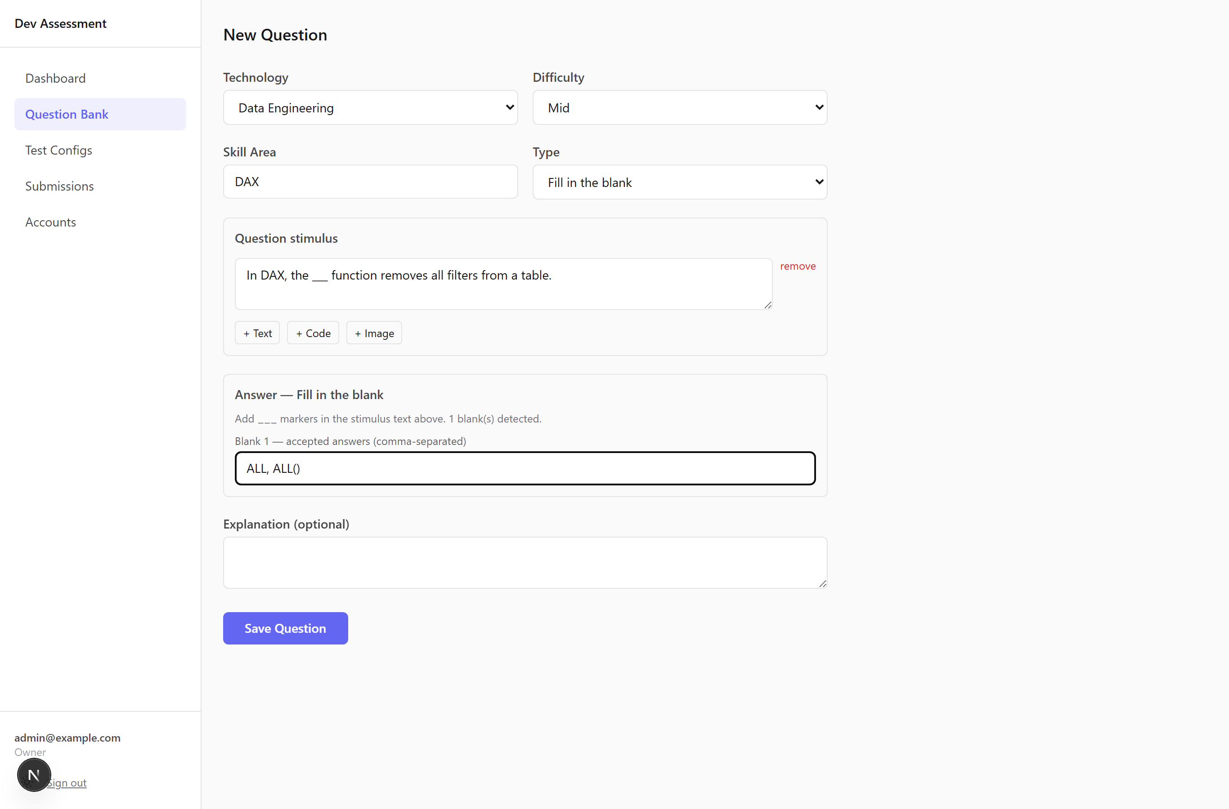
Matching — type each correct pair on one row (left ↔ right). The right column is shuffled for the candidate.
Single / Multiple choice — type the options and mark the correct one(s): a radio button for single choice, checkboxes for multiple select.
True / False — just pick which is correct.
Tip — fairness by design: for matching and ordering, the platform shuffles the options independently for every candidate, so the on-screen order never gives the answer away.

Editing a question — and how versioning works
Click Edit on any row. Important behaviour:
- Editing never overwrites history. Saving an edit creates a new version
(the form tells you: "Editing v2 — saving will create v3").
- Any candidate who already took a test keeps the exact version of the
question they saw. Their past results never change underneath them.
- Click History on a row to see every version with timestamps; the current
one is marked (current).
- You can change a question's type when editing — but if you do, re-check the
answer editor, since the answer fields differ per type.

Retiring vs deleting a question
You have two ways to remove a question — they are very different:
- Archive (orange) — reversible. Hides the question from future tests but
keeps it in the system and tied to past submissions. This is the safe default. Tick Show archived to see and restore archived questions.
- Delete (red) — permanent. Only works if the question has never been
used in a submission. If it has been used, the platform blocks the delete and tells you to archive it instead.

Bulk actions
Tick the checkboxes on the left of each row (or the header checkbox to select the page). A bar appears at the bottom of the screen:
- Archive N selected — hide many at once (reversible).
- Delete N selected — permanently delete many at once. Any that are in use
are skipped and listed back to you, so the rest still go through.

Import questions from CSV (bulk add)
This is the fastest way to load a large bank of single-choice questions.
- On Question Bank, click Import CSV and choose your file.
- The platform processes every row and shows a summary:
"Import complete: N imported", plus a per-row error table for anything that failed (so you can fix just those rows and re-import).
CSV format — a header row plus one row per question, in this exact column order:
Column | Required | Notes
technology | ✅ | The technology slug (not display name) — e.g. power-bi
difficulty | ✅ | junior, mid, or senior
skill_area | ✅ | Free text, e.g. DAX
text | ✅ | The question
option_a | ✅
option_b | ✅
option_c | ✅
option_d | ✅
correct_option | ✅ | a, b, c, or d
explanation | optional | Last column, may be left blank

Notes:
- CSV is for single-choice questions only. The richer types (matching,
ordering, fill-in-the-blank, multiple select, true/false) are created in the New Question form, where you can add code and images.
- The easiest way to get a valid template is to click Export CSV first —
it produces a file in exactly this shape that you can edit and re-import.
- The technology must already exist; an unknown slug is reported as an error for
that row.
- Quoted fields (commas, line breaks inside a cell) are handled correctly.
- Max file size 5 MB.

Export questions to CSV
Click Export CSV. A short dialog lets you choose the scope — the selected rows, the current page, or all rows matching your current filters. The export covers single-choice questions and comes out in the exact shape the importer expects, so you can edit it and re-import.

Managing technologies
Click Manage technologies (Owner only) to add, rename, archive, or delete the technologies that questions and tests are organised under. Deleting a technology that still has questions or live links is guarded — you'll be offered a safe Archive instead.
——————————————————————————————

5. Creating a test configuration
Owner only.
A test configuration is the recipe for a test. It says: "For this technology at this level, give each candidate this many random questions, and they pass at this percentage."
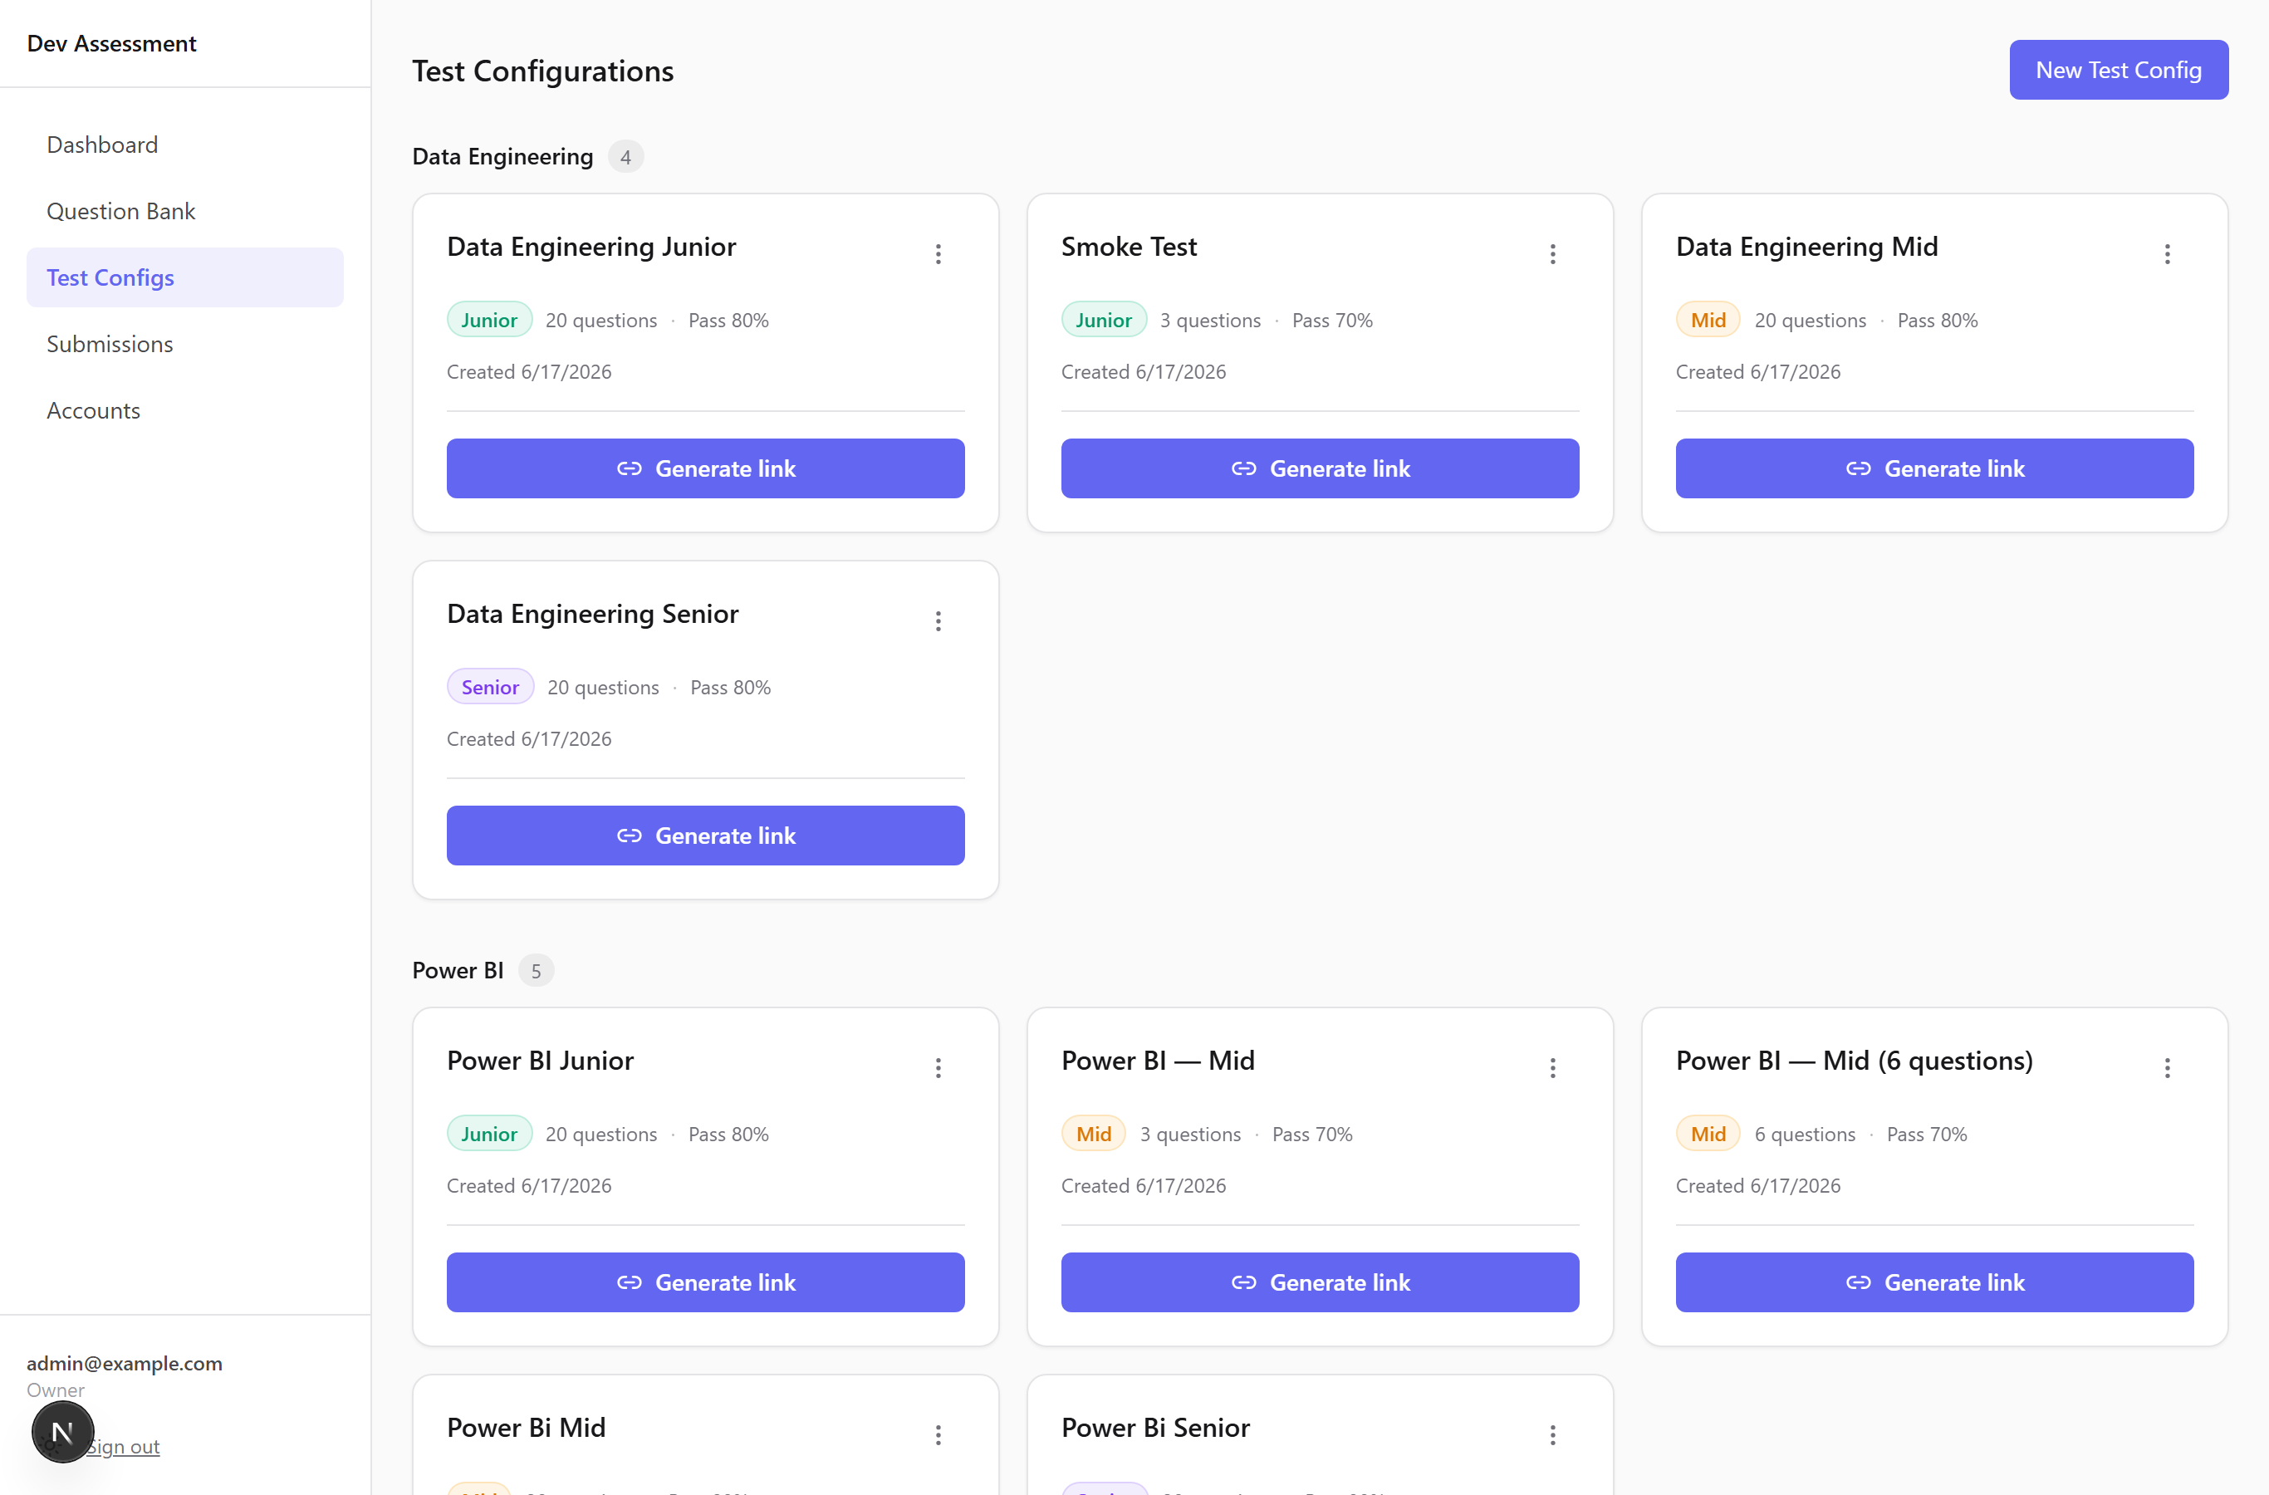
Open Test Configs. Existing configs are shown as cards, grouped by technology and ordered Junior → Mid → Senior. Each card shows the level, the number of questions, the pass mark, and a coloured difficulty badge.
To create one:
- Click New Test Config (top-right).
- Fill in:
- Name — what you'll recognise it by, e.g. Power BI Mid Test.
- Technology — questions are pulled from this technology's bank.
- Difficulty — only questions at this level are eligible.
- Number of Questions — how many each candidate gets (1–100, default 20).
- Pass Threshold % — the score needed to pass (default 70%).
- Click Create Test Config.
⚠️ Make sure the bank has enough questions at that technology + level. If there aren't enough to fill the requested count, you may see a warning — add more questions or lower the count. (Question type doesn't matter here — a test mixes whatever types are in the eligible pool.)
How question selection works: each candidate link gets a random but fair set drawn from the matching pool. The selection is seeded to the link, so:
- The same link always shows the same questions (e.g. on a page refresh).
- Different candidates get different but equivalent sets at the same level.

Deleting a test config
On a config card, click the ⋮ (kebab) menu → Delete. You'll be asked to confirm. This is permanent.
——————————————————————————————

6. Generating and sharing candidate links
Owner and Member roles can generate links.
Each candidate gets their own link. There are two ways to create one.

Quick way — from the Test Configs cards (recommended)
- On the Test Configs page, find the right card.
- Click Generate link.
- In the dialog, type the Candidate name (required — it labels their
submission; the candidate themselves never logs in).
- Click Generate link. The link appears, ready to share:
- Copy — copies the URL to your clipboard.
- Email — opens a pre-written email with the link.
- Teams — opens Microsoft Teams to share it.
- More… — your device's native share sheet (where available).
- Click Generate another to make a link for the next candidate, or Done.

Detailed way — from the links list
- On a Test Config card, click ⋮ → View links & results.
- Use the Candidate Name box (optional here) and Generate New Link.
- The new URL appears in a green panel with a Copy button.
This page also gives you a full table of every link for that config:
Column | Meaning
Candidate | The name you entered (or —)
Token | Short ID of the link
State | pending → started → submitted (or expired)
Created / Started / Submitted | Timestamps as the candidate progresses
Actions | View result once submitted; Revoke to kill an unused link (Owner only)

Revoke invalidates a link that hasn't been used yet — handy if you sent it to the wrong person. You can't revoke a test that's already submitted or expired.
——————————————————————————————

7. What the candidate sees
You don't need to do anything here, but it helps to know what you're sending:
- They open the link — no login, no signup. The test starts immediately.
- A 30-minute countdown runs in the header (green → amber → red). The clock
is enforced on the server, so it can't be cheated by closing the tab.
- They answer one question at a time, moving with Previous / Next, and can
jump around using the question map. A counter shows how many they've answered.
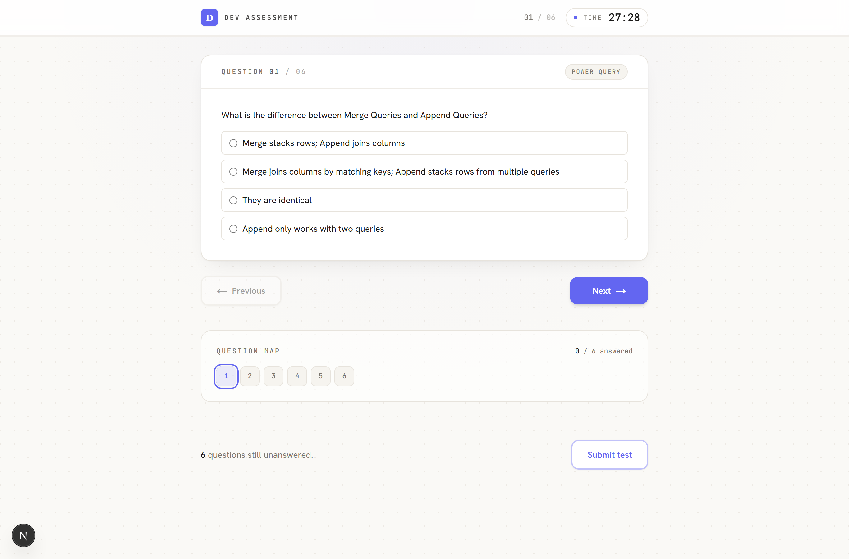
- Each question type has its own controls — radio buttons or checkboxes for
choice questions, drop-downs for matching, reorder controls for ordering, and inline boxes for fill-in-the-blank. Code and images in the question are shown right above the answer.
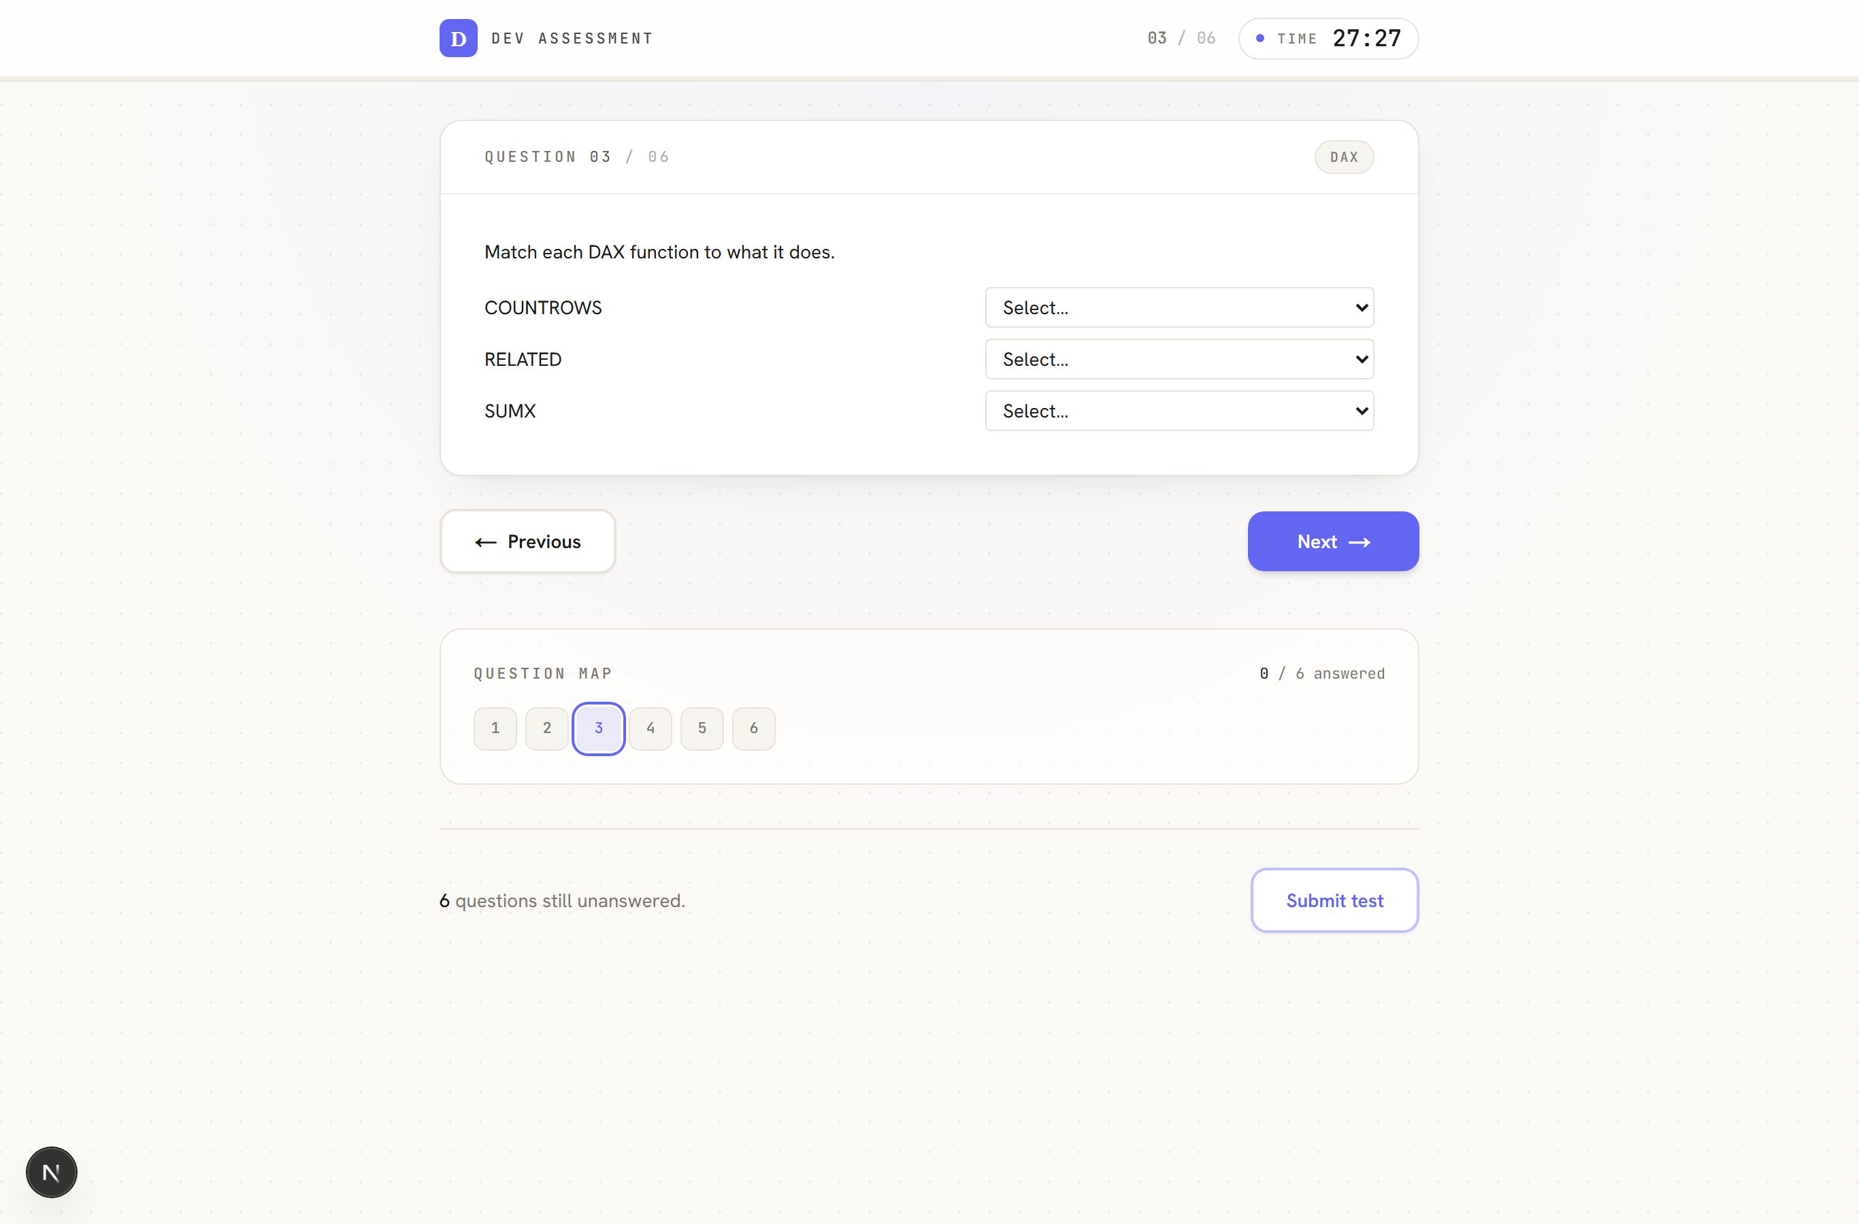
- If they refresh or briefly lose connection, the test resumes with the right
remaining time and their answers intact.
- On the last question, the primary button becomes Submit test; they can also
submit early at any time (with a confirmation step).
- If time runs out, the test auto-submits.
- They immediately see a results page: overall score, pass/fail verdict,
time taken, a per-skill breakdown, and a full answer sheet.
——————————————————————————————

8. Reading results
Open Submissions from the sidebar for the full, paginated list of completed tests (newest first).
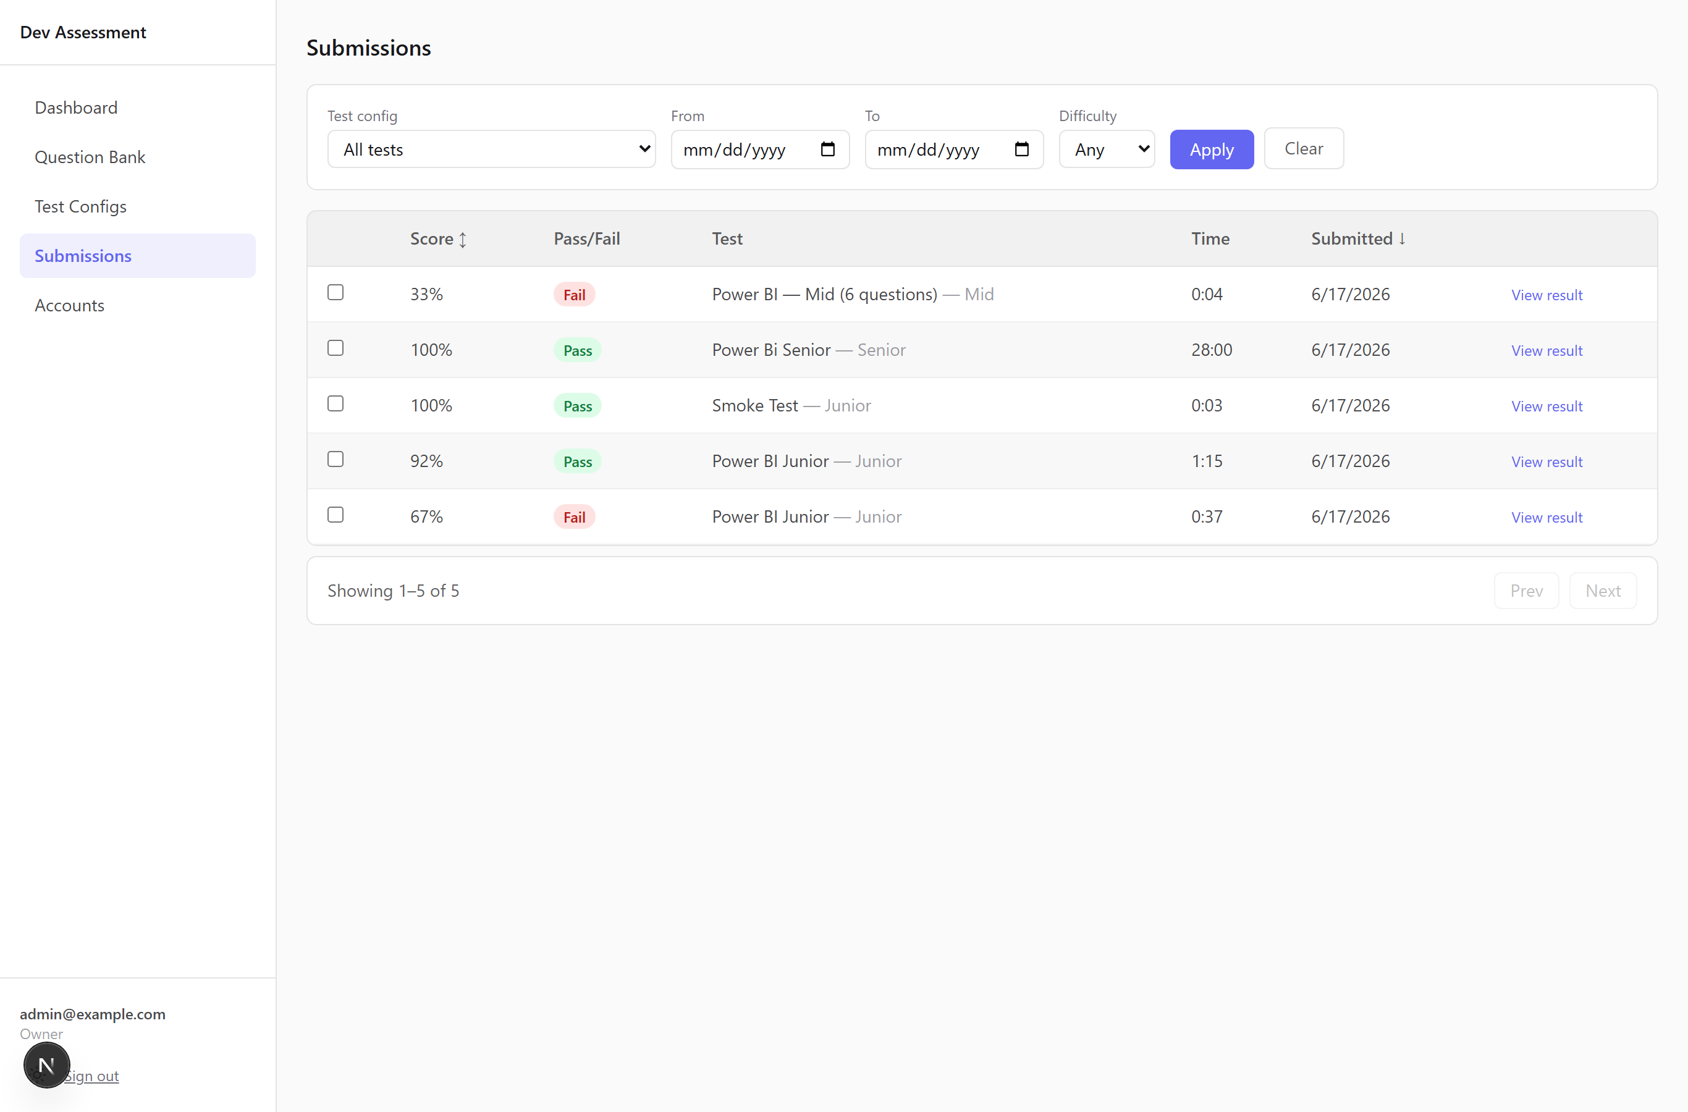

Filtering and exporting
The filter bar lets you narrow by Test config, date range (From/To), and Difficulty. Click Apply (or Clear to reset).
- When you pick a single Test config, a stats panel appears above the table:
total submissions, average score, pass rate, and a score-distribution bar chart for that test — plus an Export CSV button to download those submissions.

The submissions table
Each row shows Score, Pass/Fail, the Test and level, Time taken, and the Submitted date. Click the Score or Submitted headers to sort. Click View result to drill in.

Comparing candidates side by side
Tick the checkbox on two or more rows. A bar appears at the bottom — click Compare selected to see them side by side (great for choosing between shortlisted candidates).

A single candidate's result
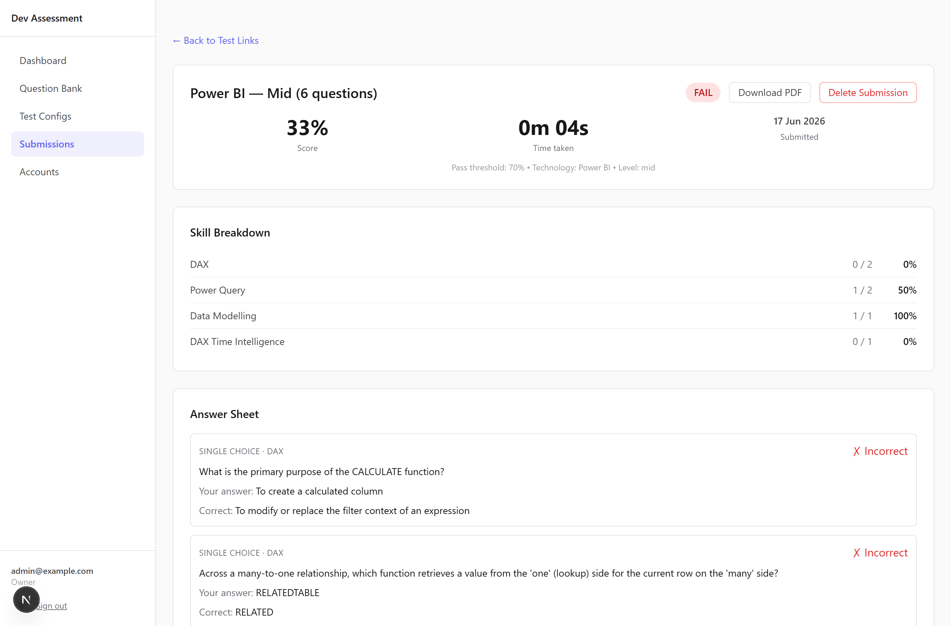
The detail page shows:
- A summary card — score %, time taken, submission date, the pass threshold,
technology, and level, with a clear PASS/FAIL badge.
- A skill breakdown — how they did in each skill area (correct/total and %).
- The full answer sheet — every question rendered in its own type, showing the
candidate's answer, the correct answer, a ✓/✗ result, and which question version they saw. (The candidate sees the same answer sheet on their own results page.)
The candidate's own results page mirrors this:
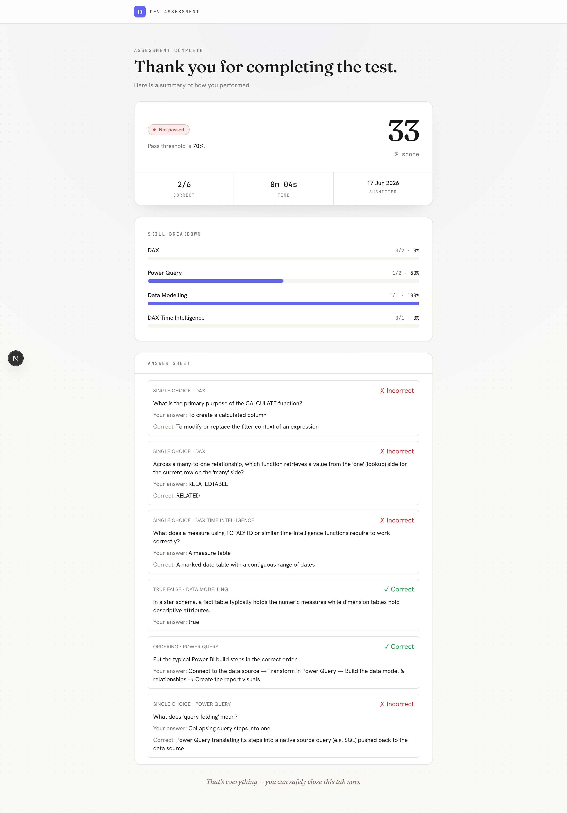
Two buttons (top-right of the admin view):
- Download PDF — opens your browser's print dialog with a clean,
print-friendly layout (save as PDF or print).
- Delete Submission (Owner only) — permanently removes this result. Use
with care.
——————————————————————————————

9. The dashboard
Dashboard (sidebar) is your at-a-glance overview across all candidates. Everyone with an account can view it.
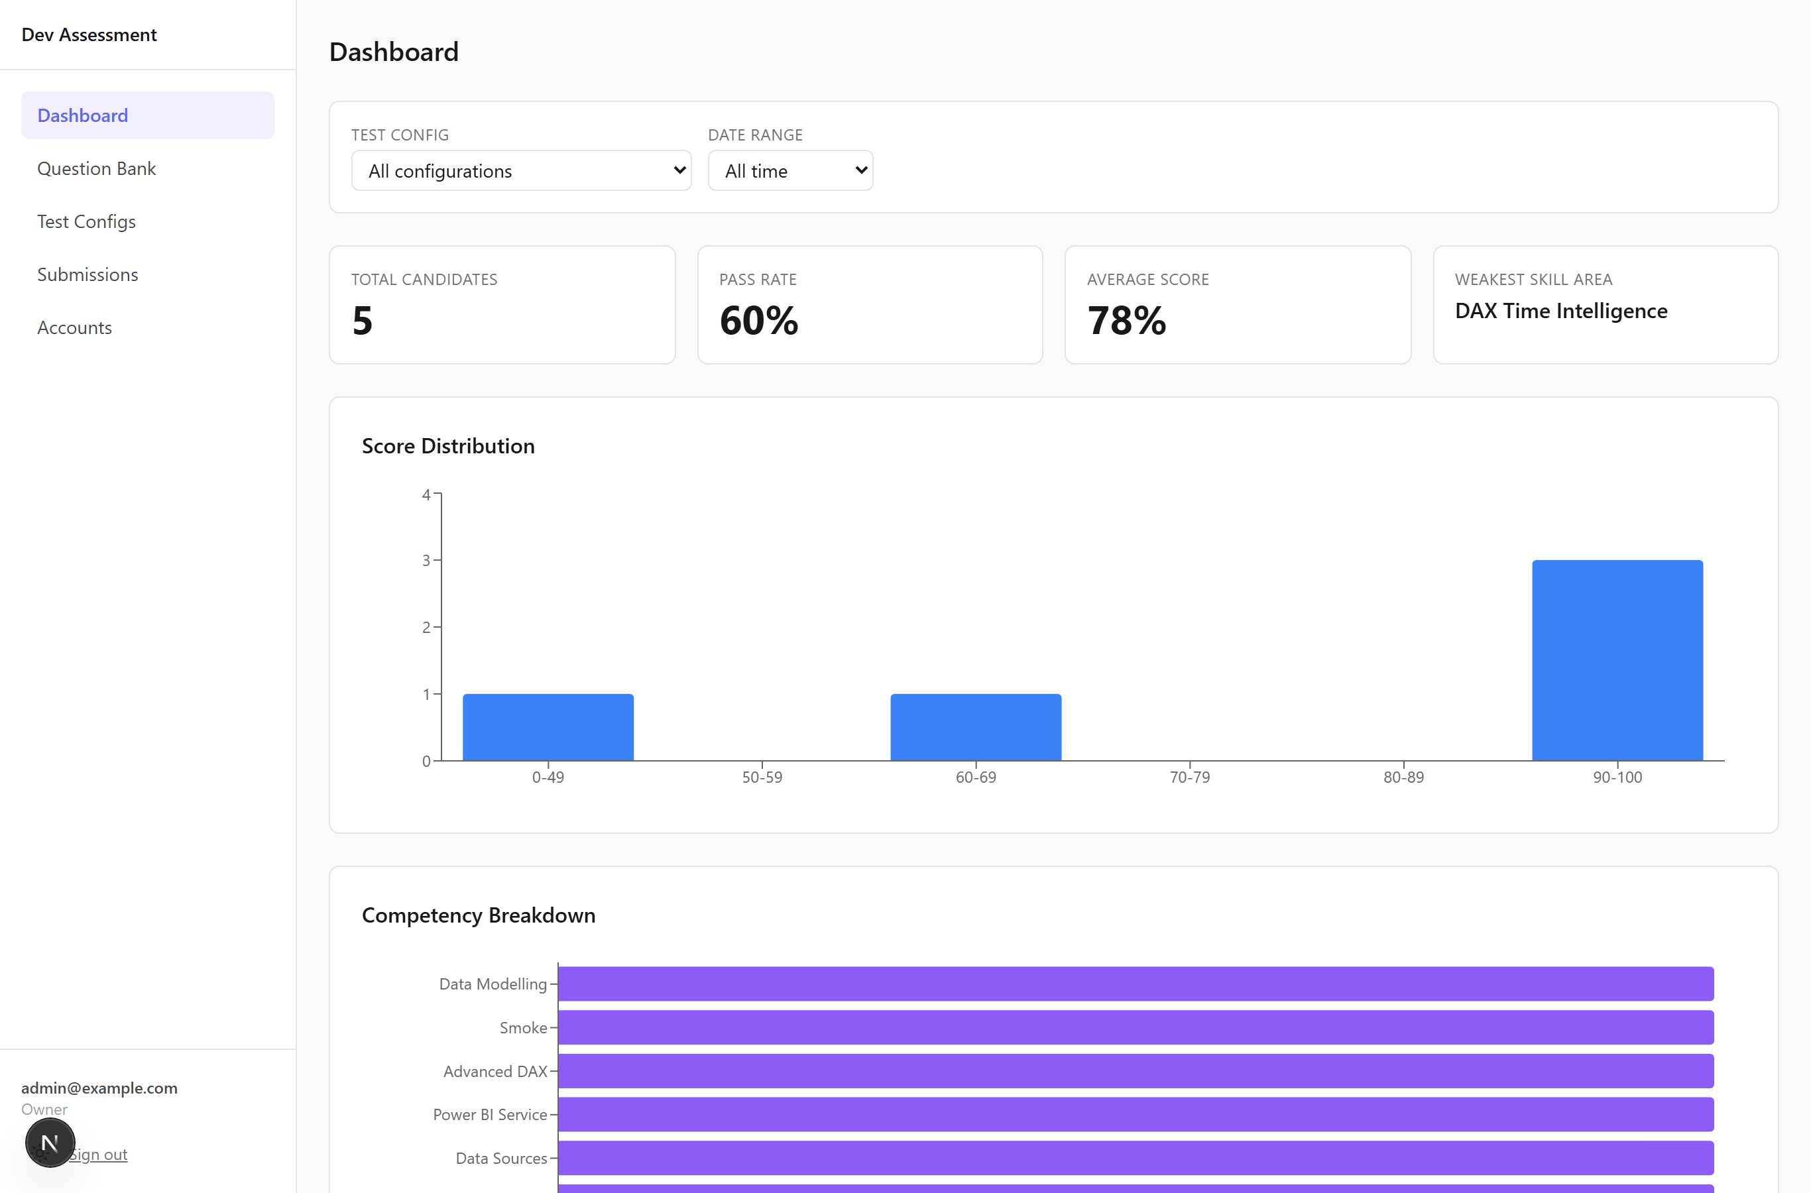
- Filter bar — narrow everything below by Test config and Date range
(All time / Last 7 / 30 / 90 days / Custom). For Custom, fill both From and To.
- KPI cards — Total Candidates, Pass Rate, Average Score, and the **Weakest
Skill Area** across the selection.
- Score Distribution — how scores cluster across bands (0–49 … 90–100).
- Competency Breakdown — average score per skill area, so you can see where
candidates collectively struggle.
- Recent Candidates — the latest submissions with score and pass/fail.
——————————————————————————————

10. Managing team accounts
Owner only. The Accounts item only appears in the sidebar for Owners.
- Open Accounts to see all admin users, their role, and when they were created.
- Click Create Account, then fill in:
- Name
- Email (their login)
- Role — Owner / Reviewer / Member (see roles)
- Password — minimum 8 characters
- Click Create Account.
- Edit a row to change someone's name or role.
- Delete a row to remove an account (with confirmation). The system prevents
deletions that would leave the team without an owner.
——————————————————————————————

11. Your own account settings
Click your name/email at the bottom of the sidebar to open Settings.
- Display Name — update the name shown across the app. You must enter your
current password to confirm the change. (Your email can't be changed here.)
- Change Password — enter your current password, then your new password
twice (minimum 8 characters).
——————————————————————————————

12. Tips & FAQ
Which question type should I use? Use single / multiple choice for knowledge checks, true/false for quick concept checks, matching to test "which goes with which" (function ↔ purpose), ordering for processes and pipelines, and fill-in-the-blank to test exact syntax or terminology. Add a code or image block to any of them when the question needs context.
Why can't I import matching/ordering questions via CSV? CSV import covers single-choice only. The richer types are quick to build in the New Question form, where you also get code blocks and image uploads.
How is a multi-part question graded? All-or-nothing: a matching, ordering, or multiple-select question is correct only if every part is right. There's no partial credit, which keeps scores simple and comparable.
How many questions should a test config have? Fewer than the eligible pool at that technology + level. If the pool is smaller than the requested count you'll get a warning — add questions or lower the count.
Can I reuse one link for several candidates? No — generate one link per candidate so results are attributed correctly. A link is tied to a single sitting.
I sent a link to the wrong person — what now? If they haven't started, open View links & results for that config and Revoke the link (Owner only), then generate a fresh one.
A candidate's connection dropped mid-test — did they lose everything? No. The test resumes on refresh with the correct remaining time and their saved answers. The timer is server-enforced, so the total time is unaffected.
I need to fix a typo in a live question. Edit it — this creates a new version for future tests. Candidates who already sat the test keep the version they saw, so existing results stay valid.
I want to remove a question but it's been used in tests. Use Archive, not Delete. Archiving hides it from future tests while keeping past results intact. Delete is only allowed for never-used questions.
Where do pass/fail thresholds come from? Each test configuration sets its own Pass Threshold % (default 70%). A candidate's pass/fail is decided against the threshold of the config they took.
How do I get a printable/PDF copy of a result? Open the submission and click Download PDF — it uses your browser's print dialog with a clean layout.

