|  |  |
| --- | --- |
| Course Name | ITD 2313 – Script Programming |
| Instructor | Greg Morris |
| Student Name | Braden Norris |
| Due date | 5/29 |
| Grade | Put grade earned here |
| Grading Comments | Put instructor comments here |

Pr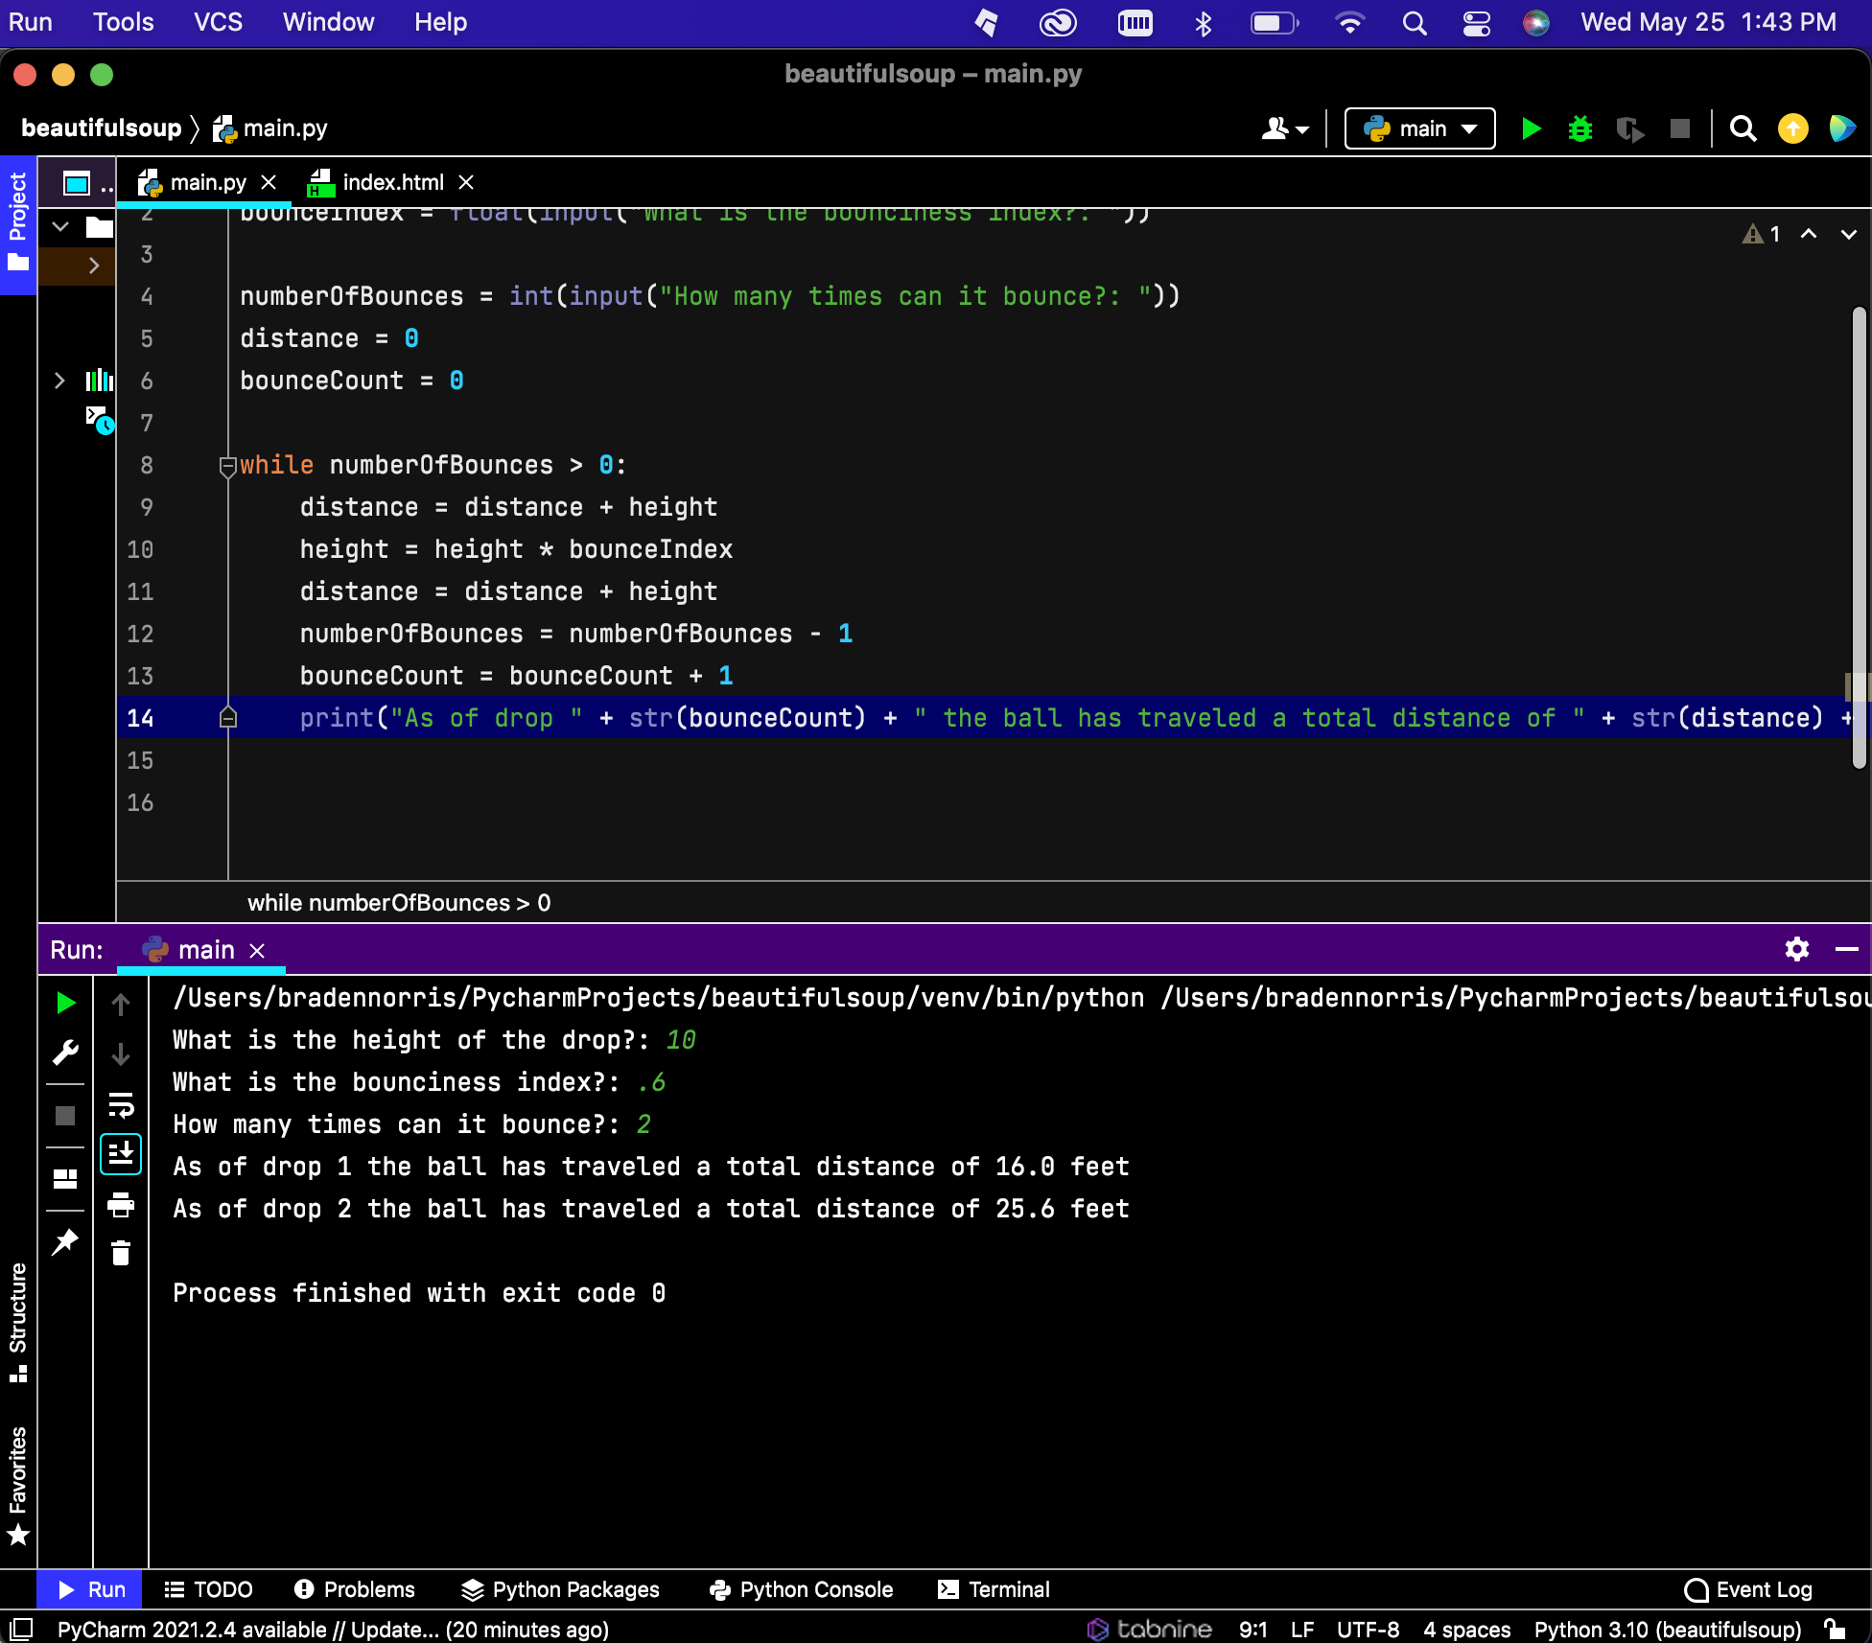oject 4

Project 6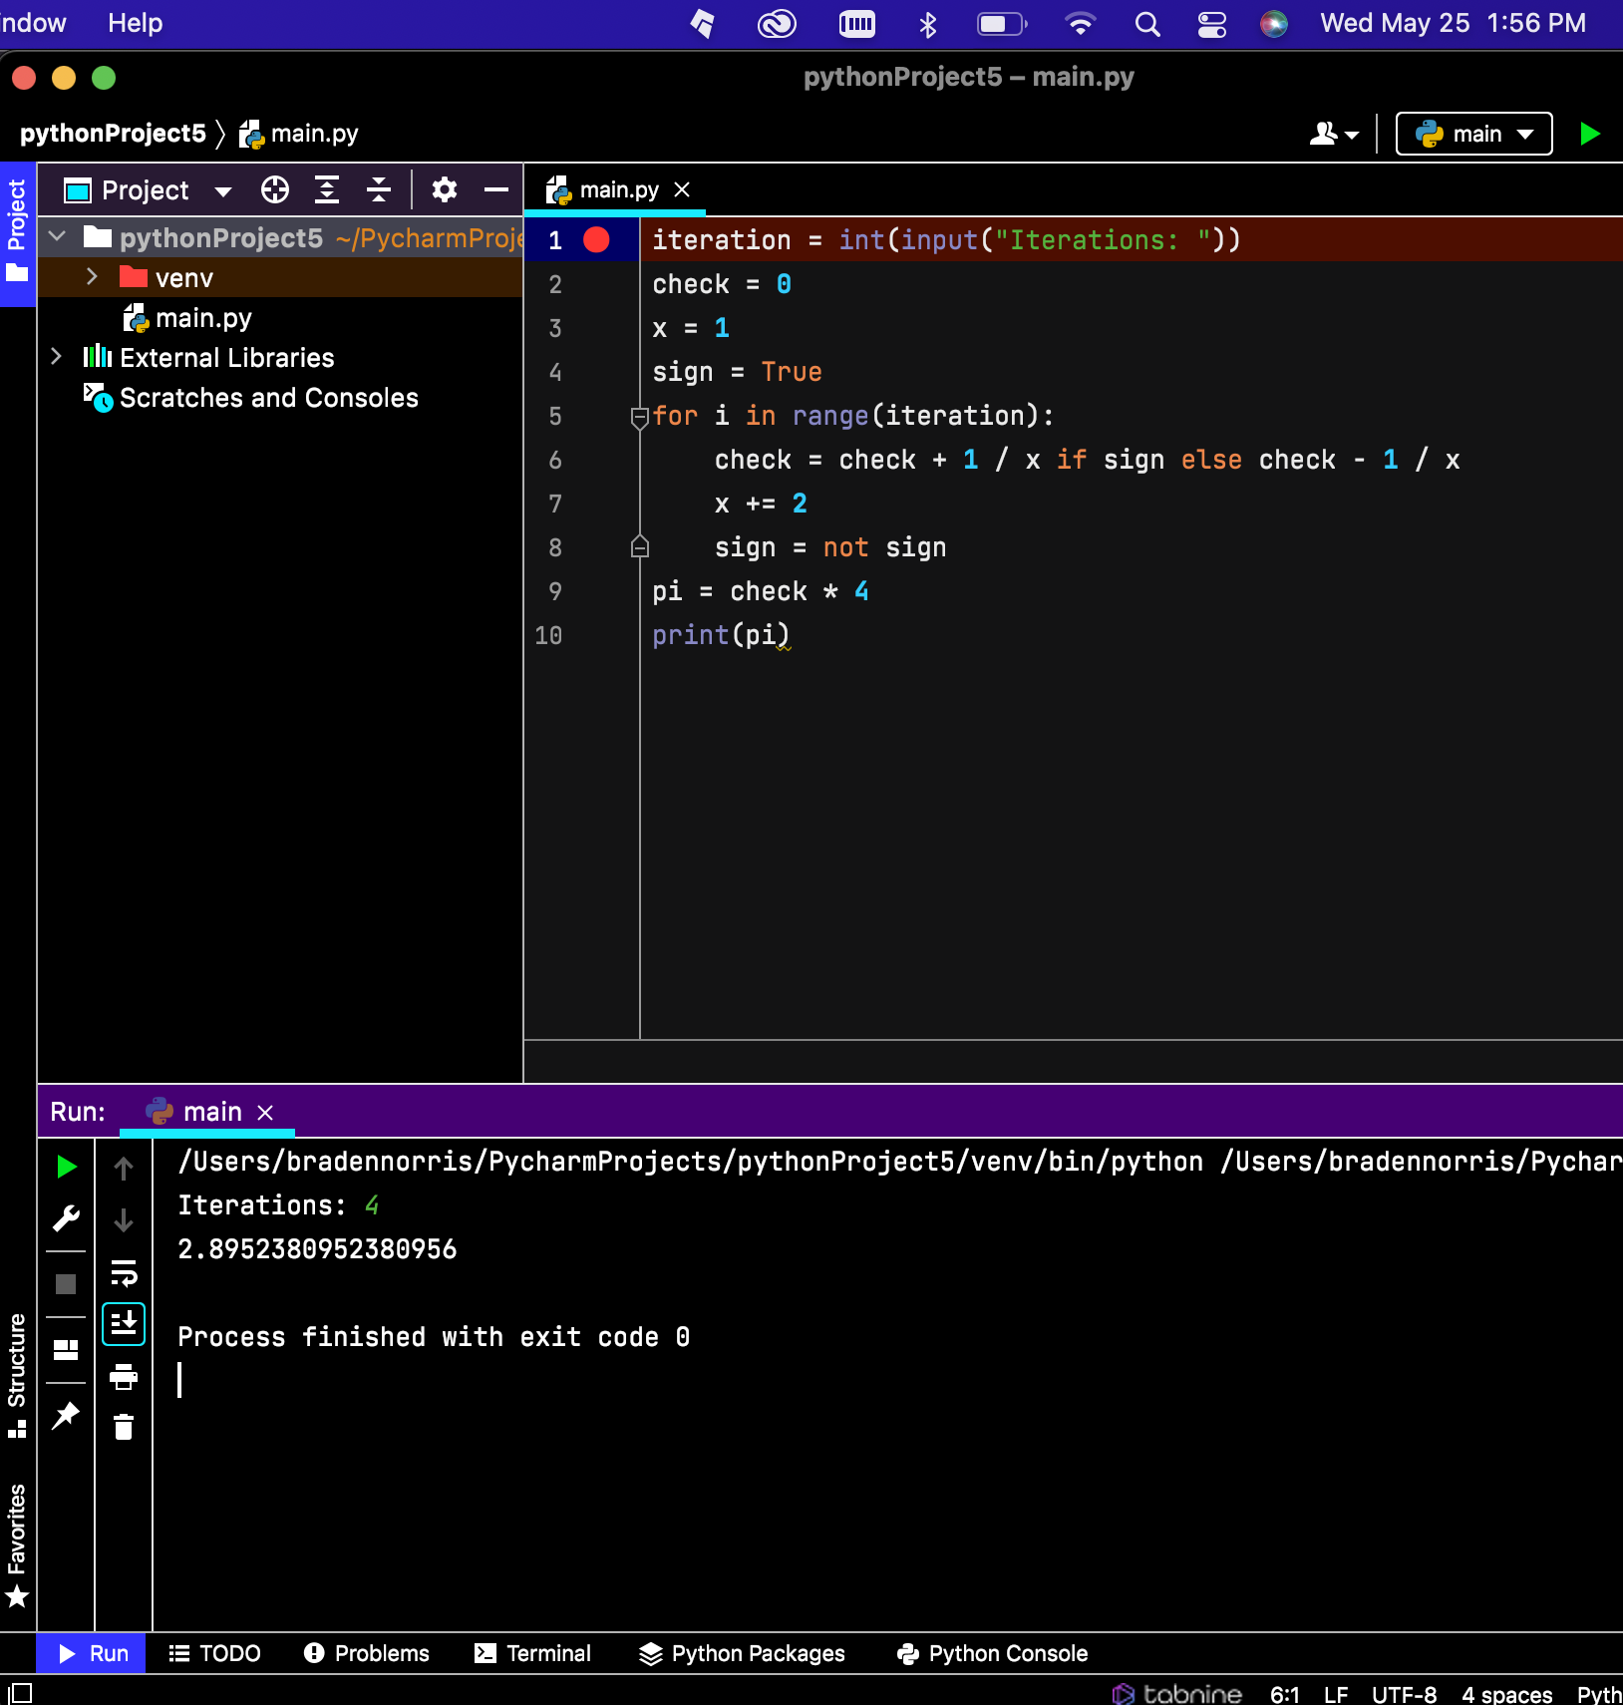

Project 7