|  |  |
| --- | --- |
| Course Name | ITD 2313 – Script Programming |
| Instructor | Greg Morris |
| Student Name | Braden Norris |
| Due date | 5/29 |
| Grade | Put grade earned here |
| Grading Comments | Put instructor comments here |

Pg 65 Code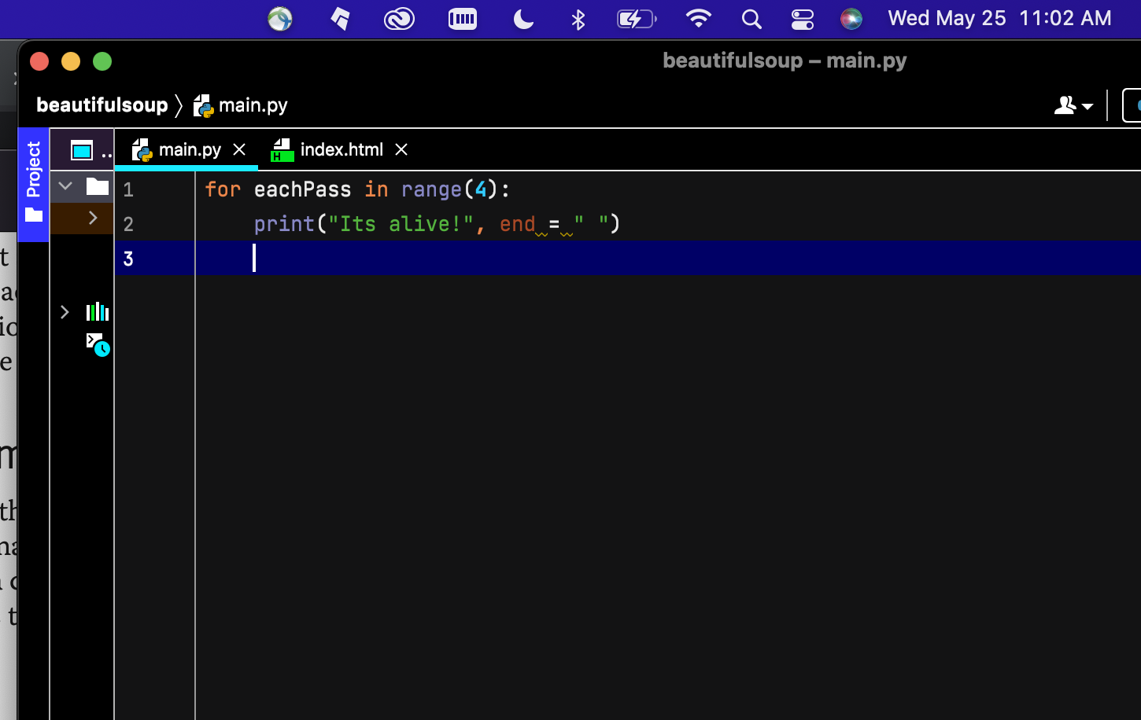

Pg 65 Output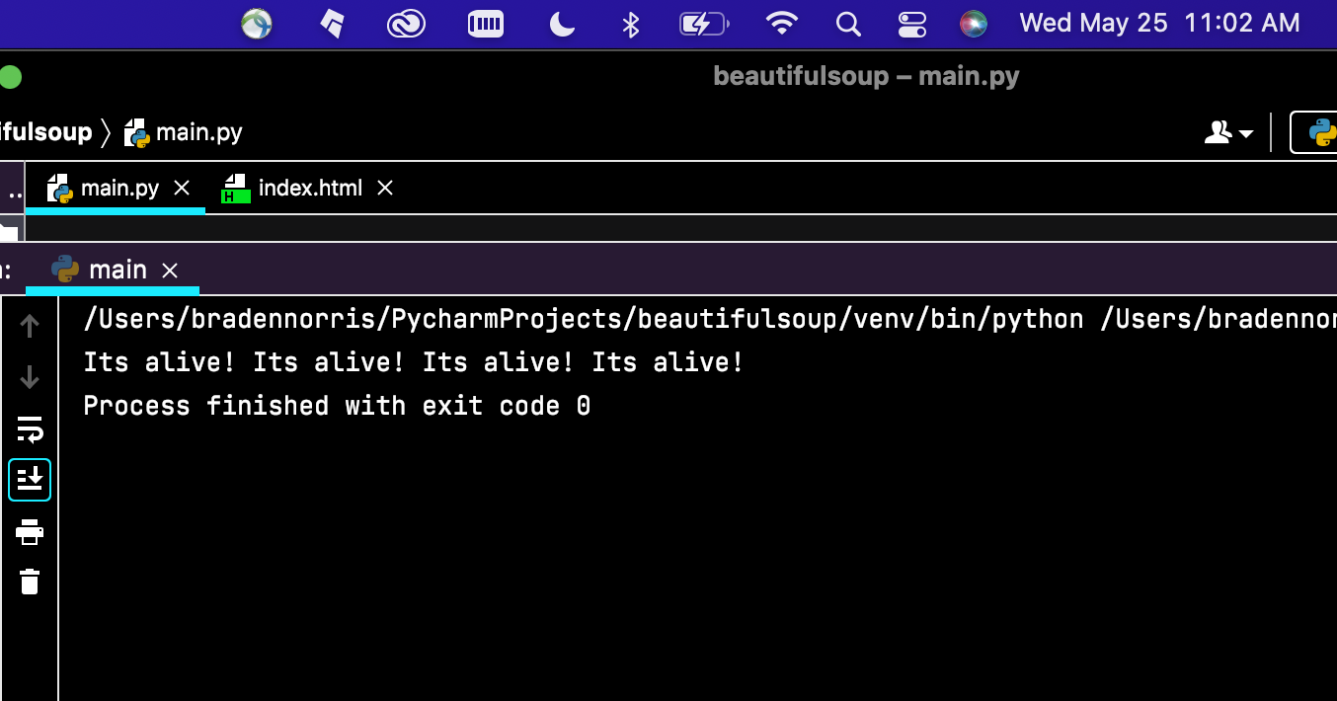

Pg 66 Code

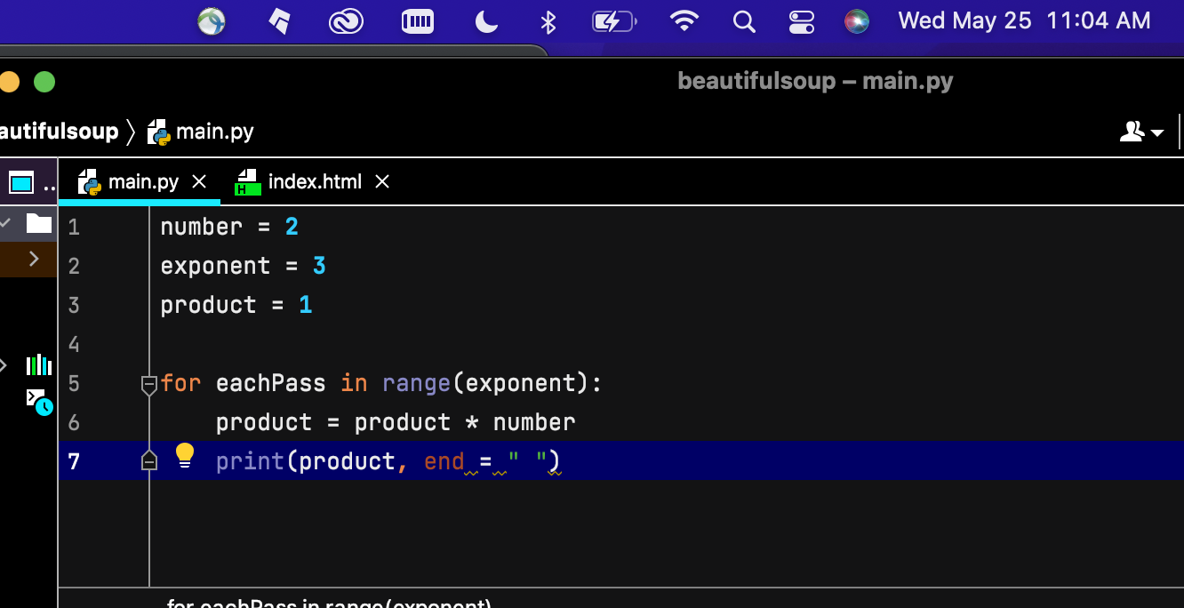

Pg 66 Output

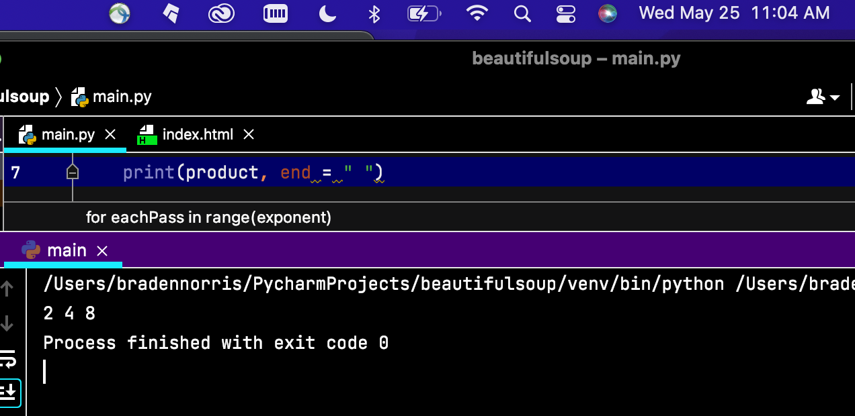

Pg 66 (Exercise 2)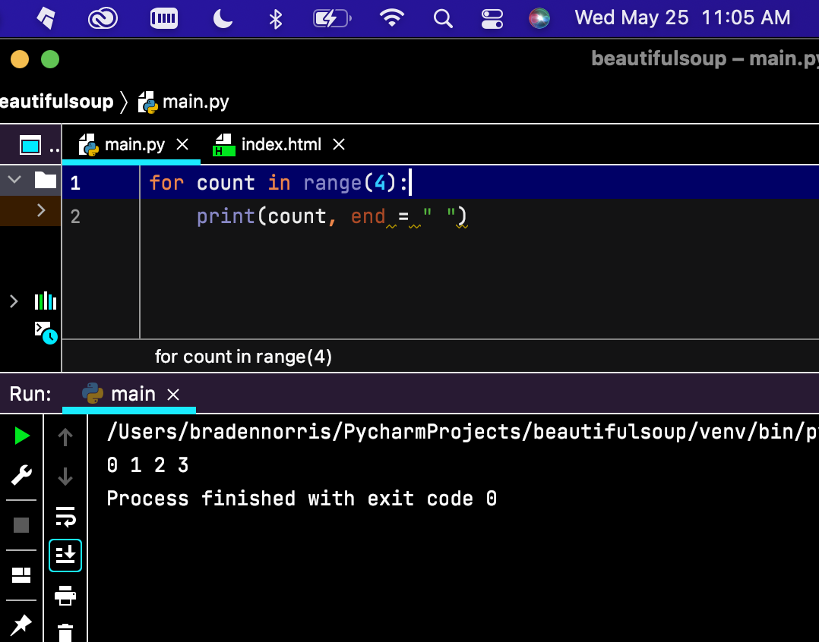

Pg 66 Exercise 3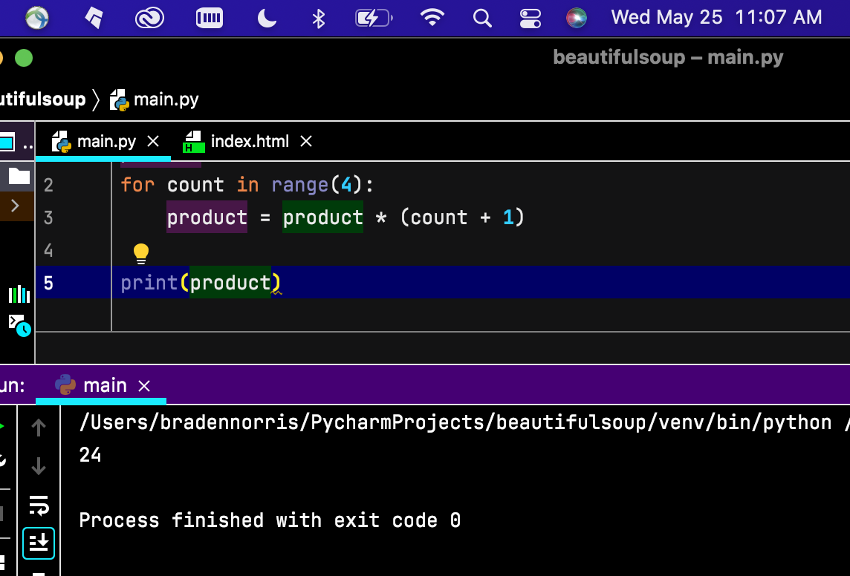

Pg 67 Ex. 1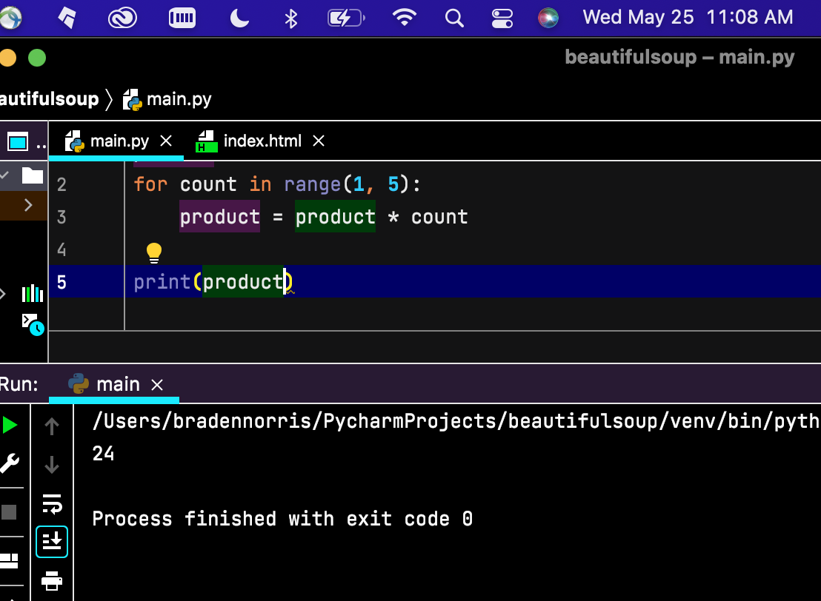

Pg 67 Ex. 2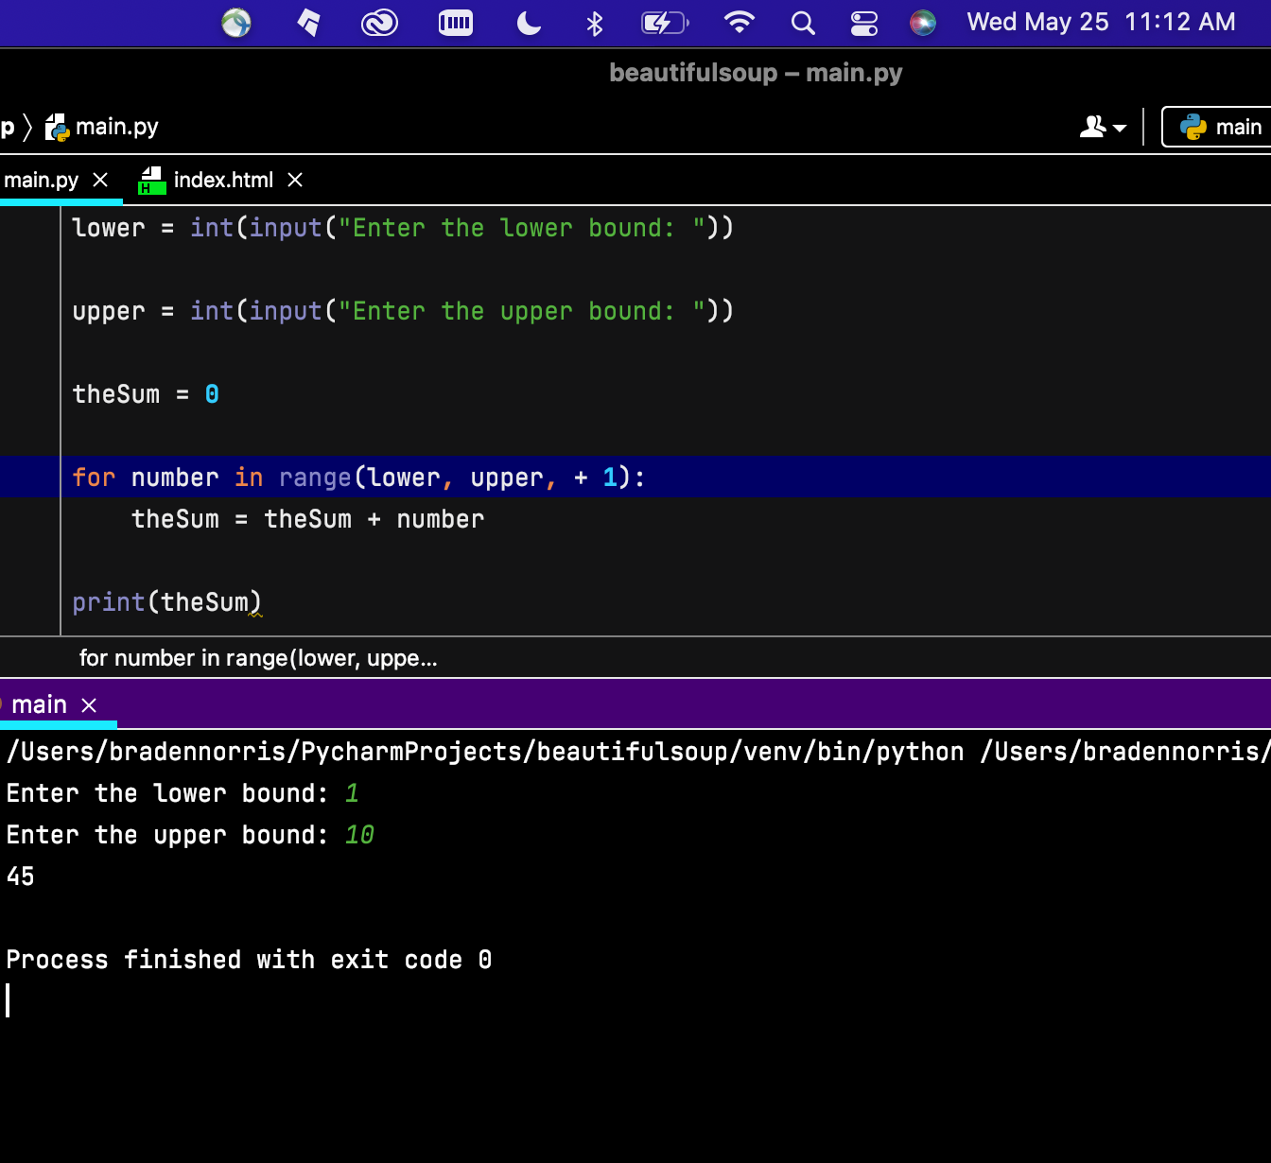

Pg 68 Ex 1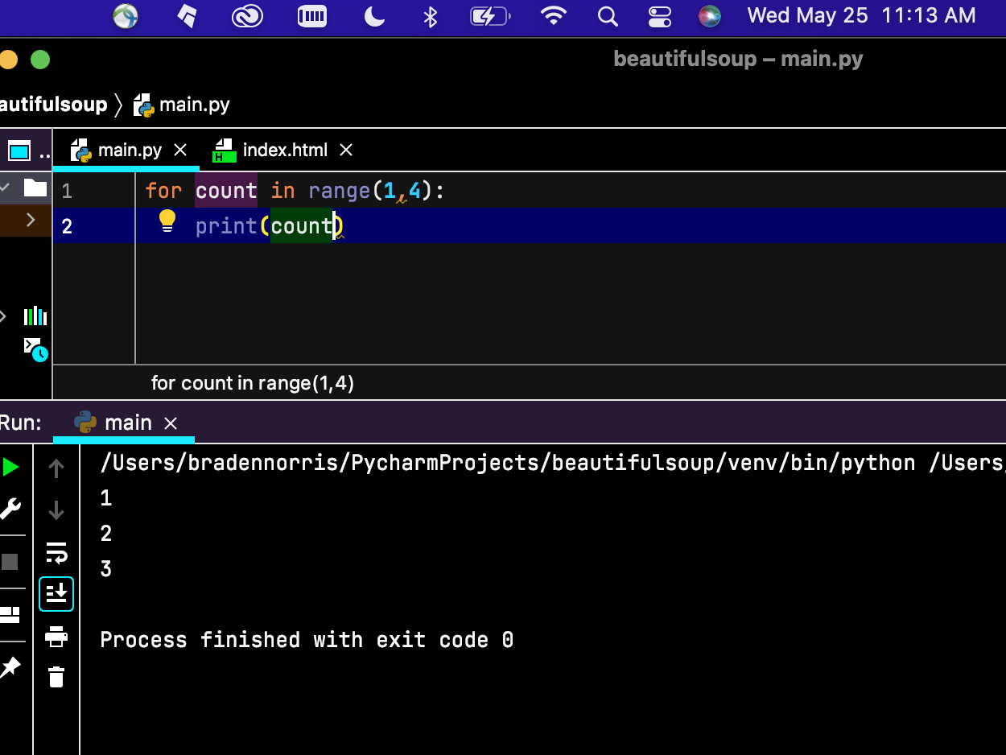

Pg 68 Ex. 2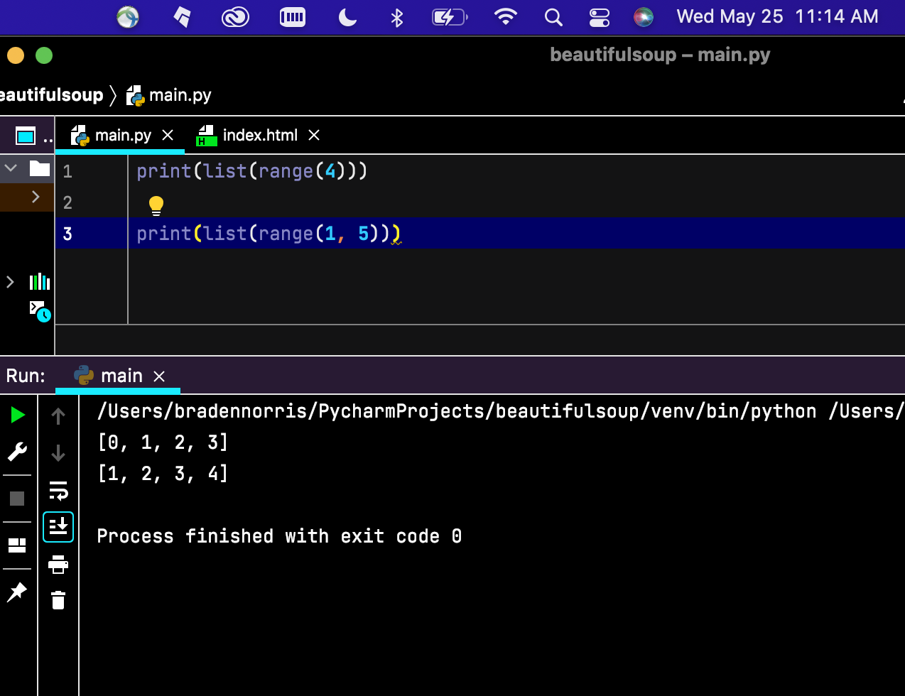

Pg 69 Ex. 1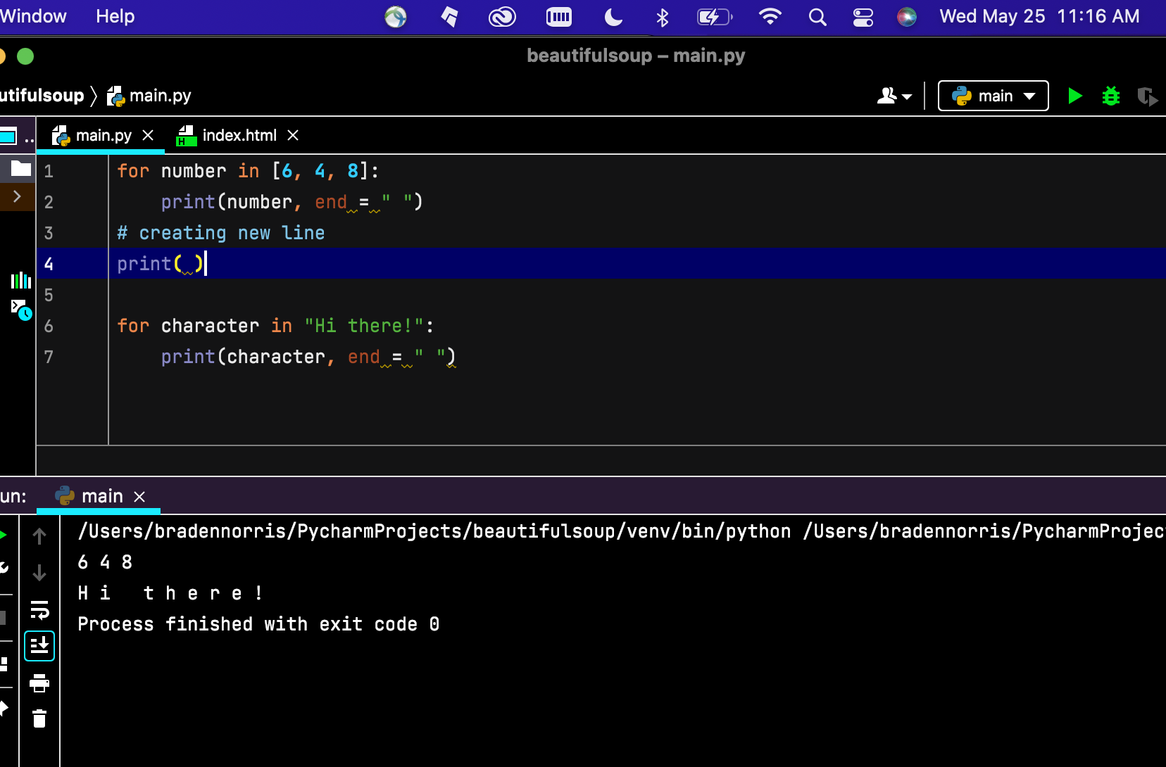

Pg 69 Ex. 2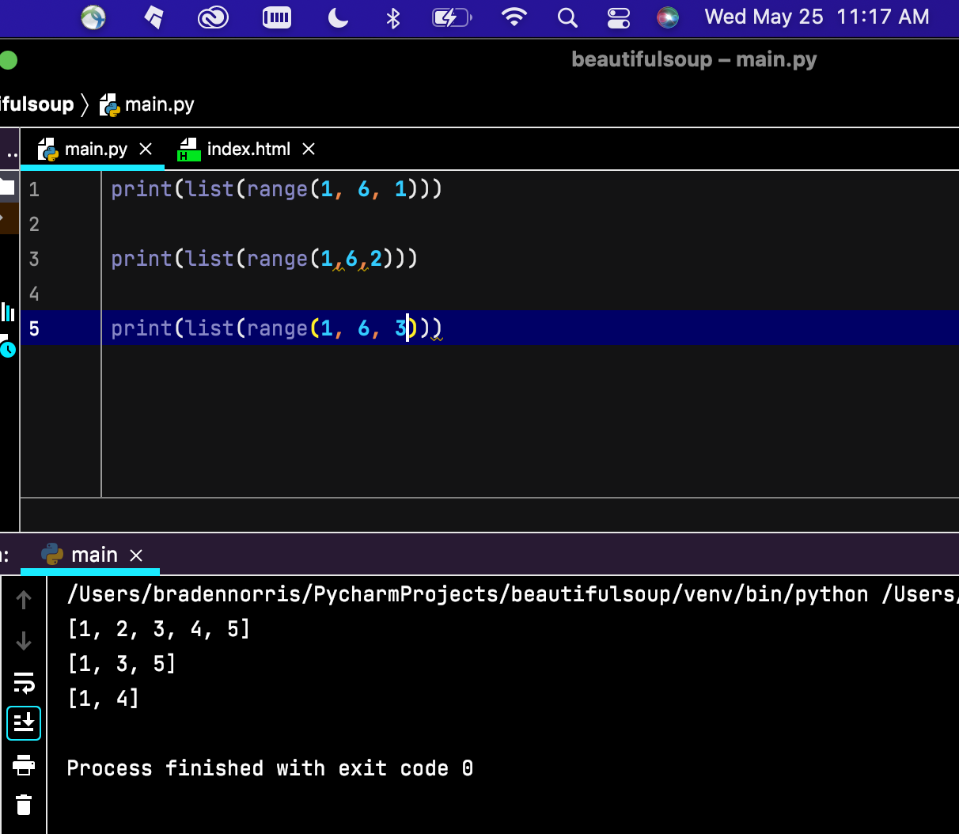

Pg 69 Ex. 3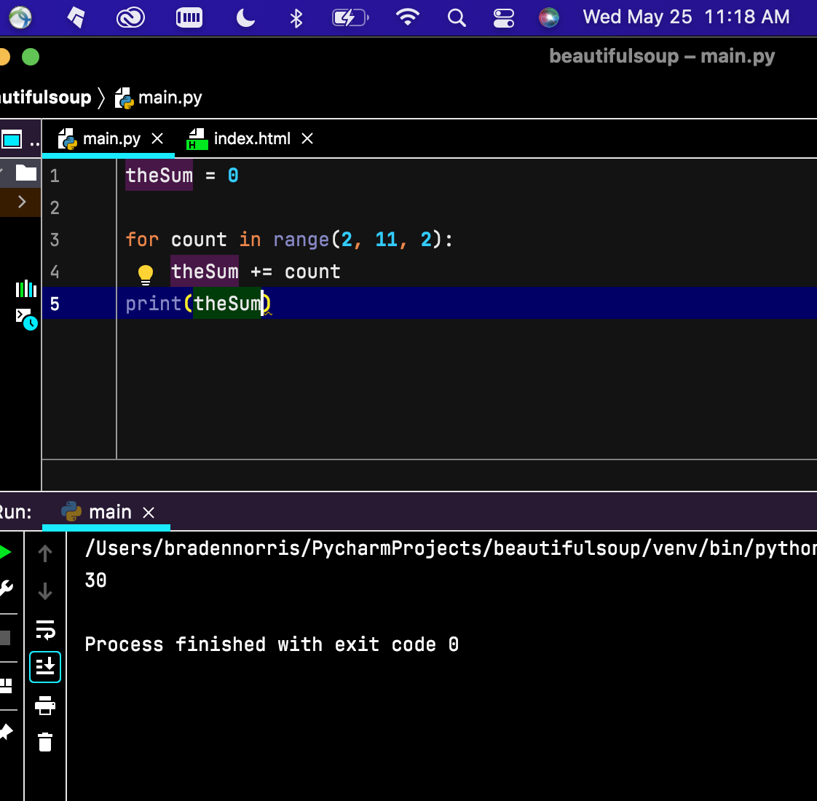

Pg 69 Ex. 4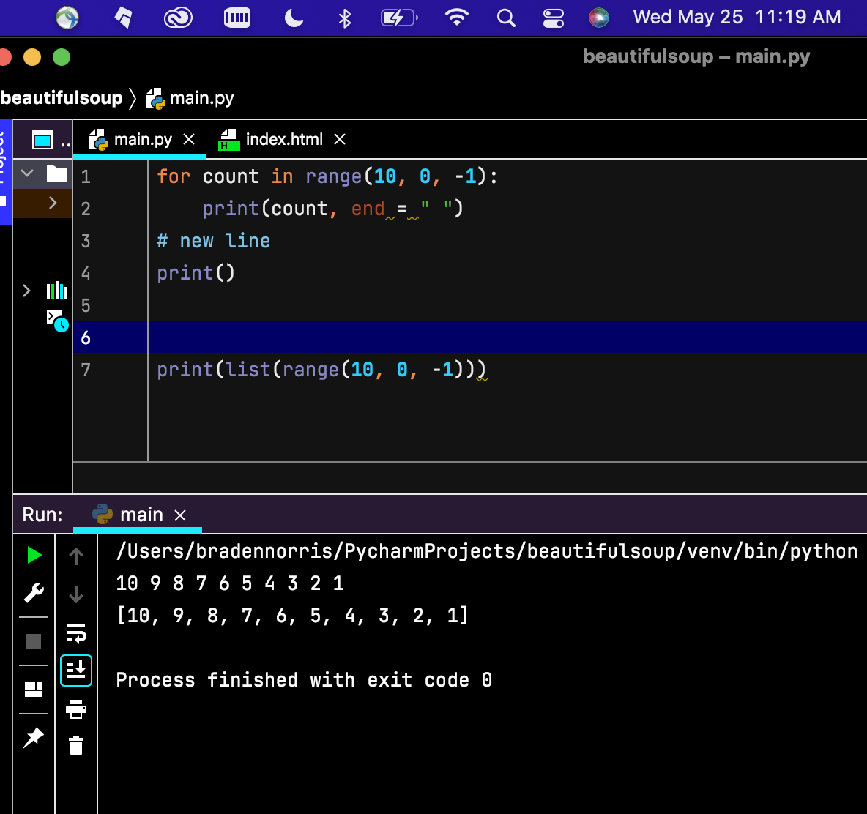

Pg 71 Ex. 1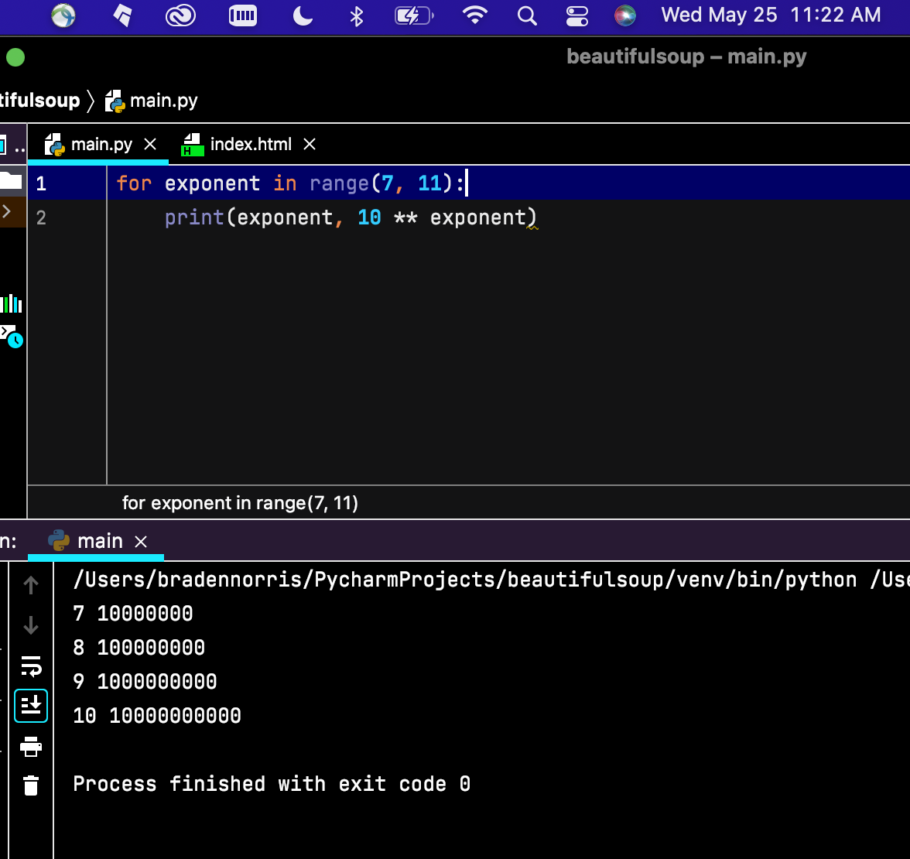

Pg 71 Ex. 2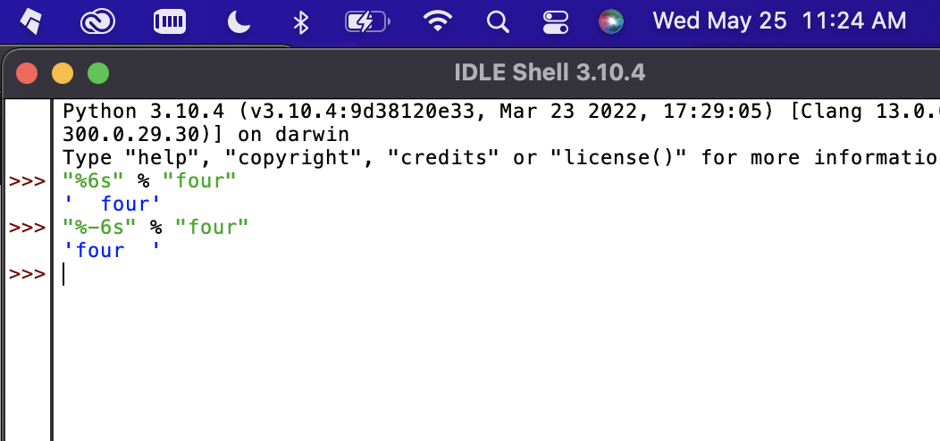

Pg 72 ex. 1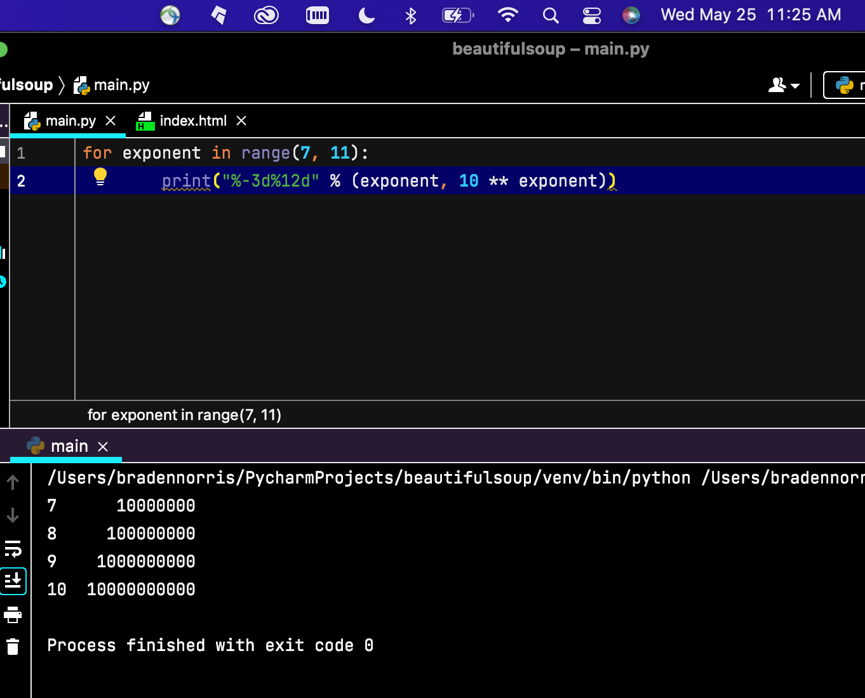

Pg 72 Ex. 2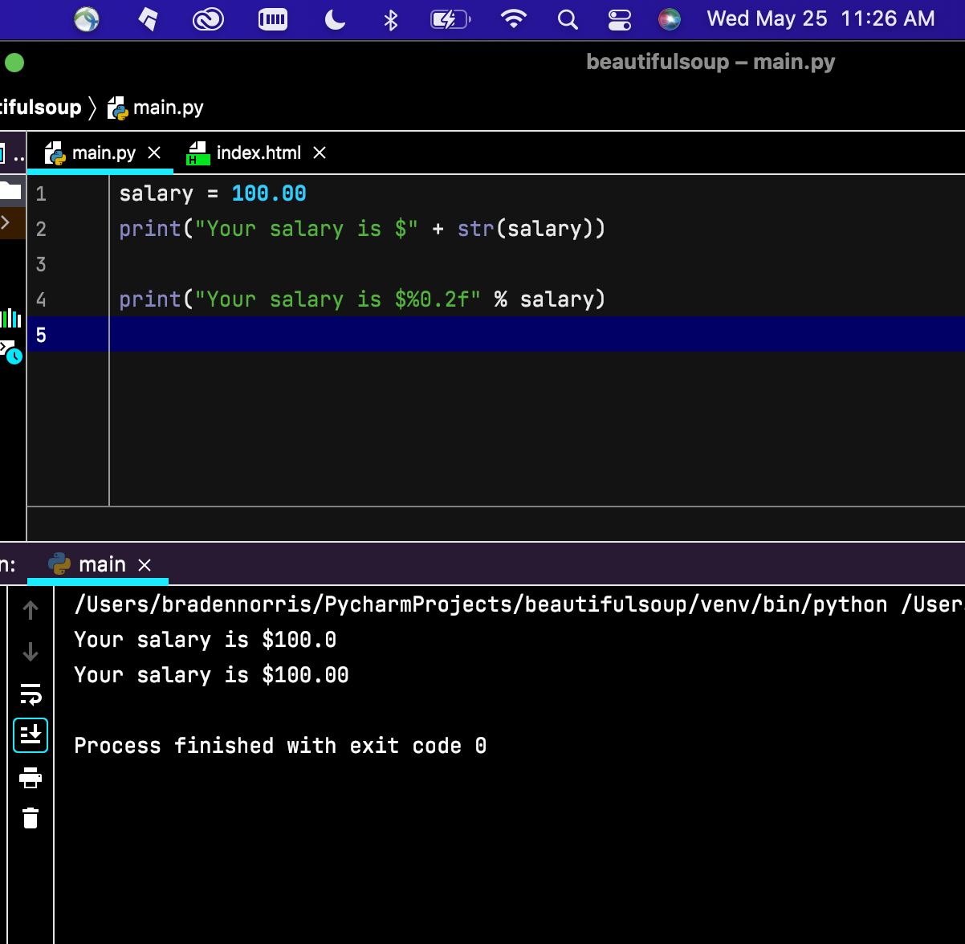

Pg 72 Ex. 3