|  |  |
| --- | --- |
| Course Name | ITD 2313 – Script Programming |
| Instructor | Greg Morris |
| Student Name | Braden Norris |
| Due date | 5/22 |
| Grade | Put grade earned here |
| Grading Comments | Put instructor comments here |

P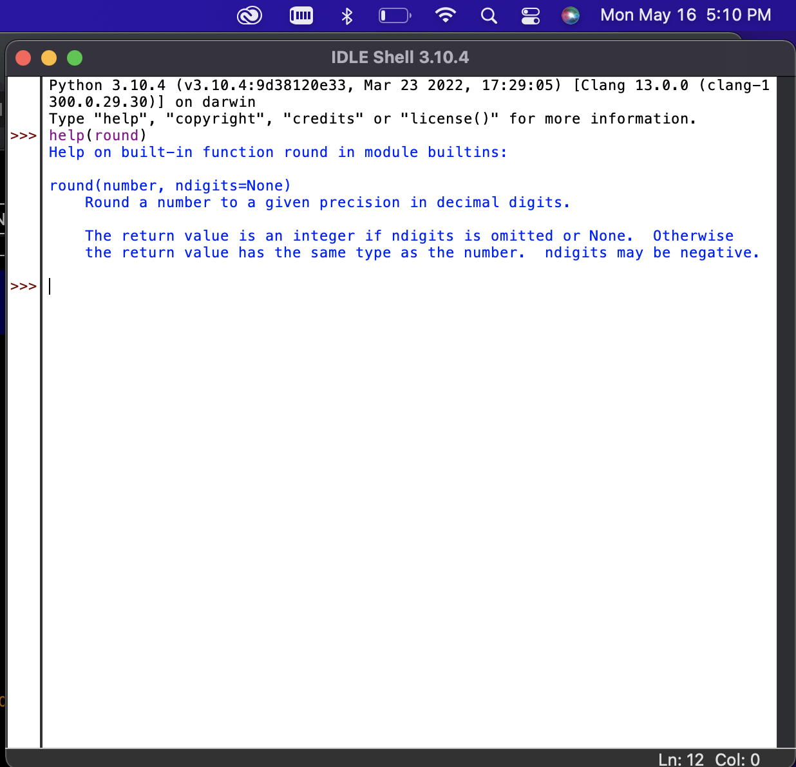g 55

Pg 55 part 2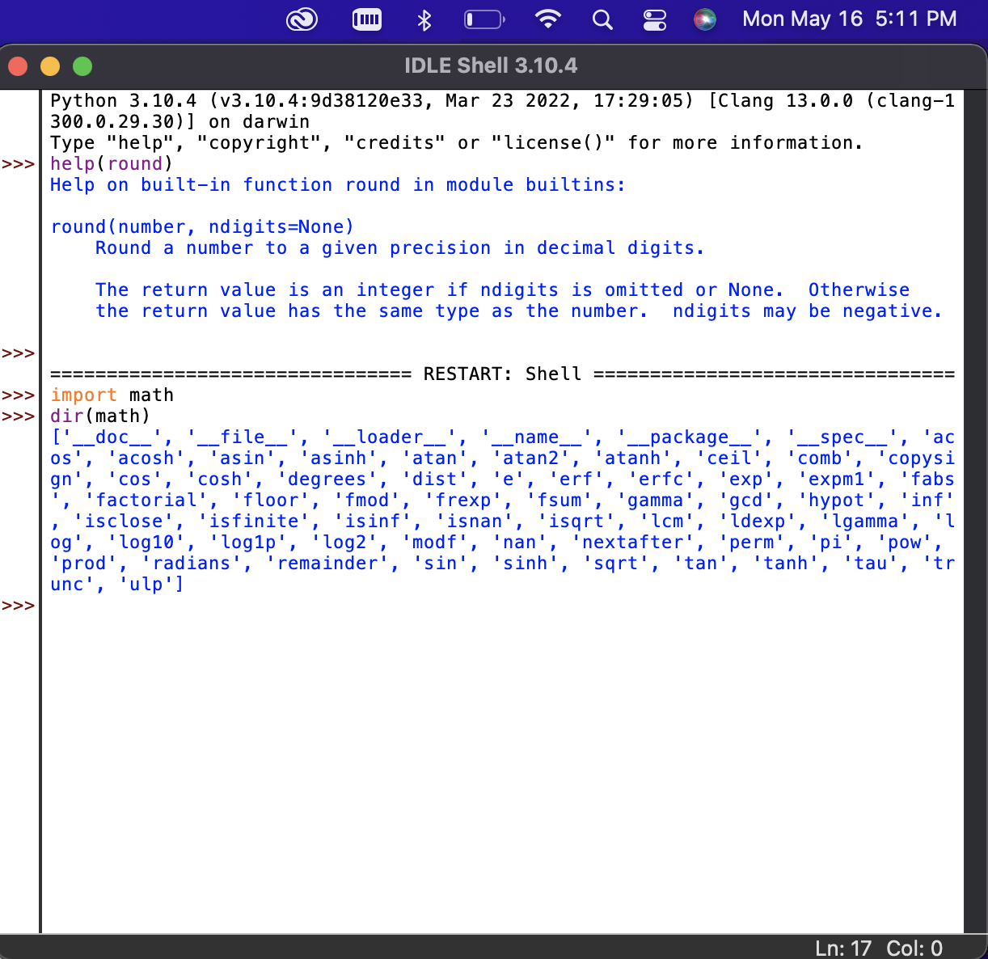

Pg 56 part 1 & 2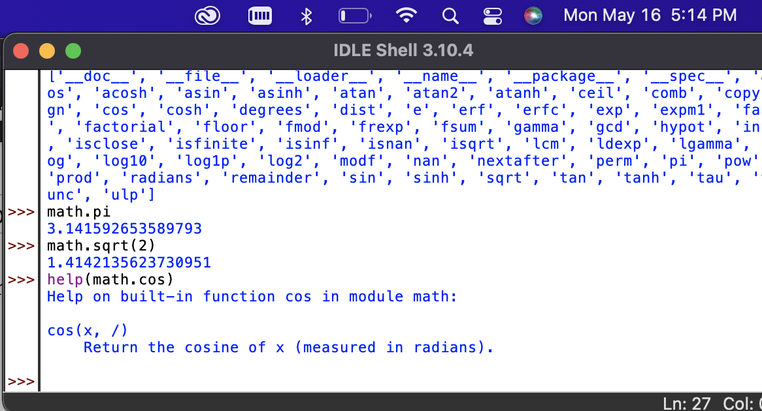

Pg 56 part 3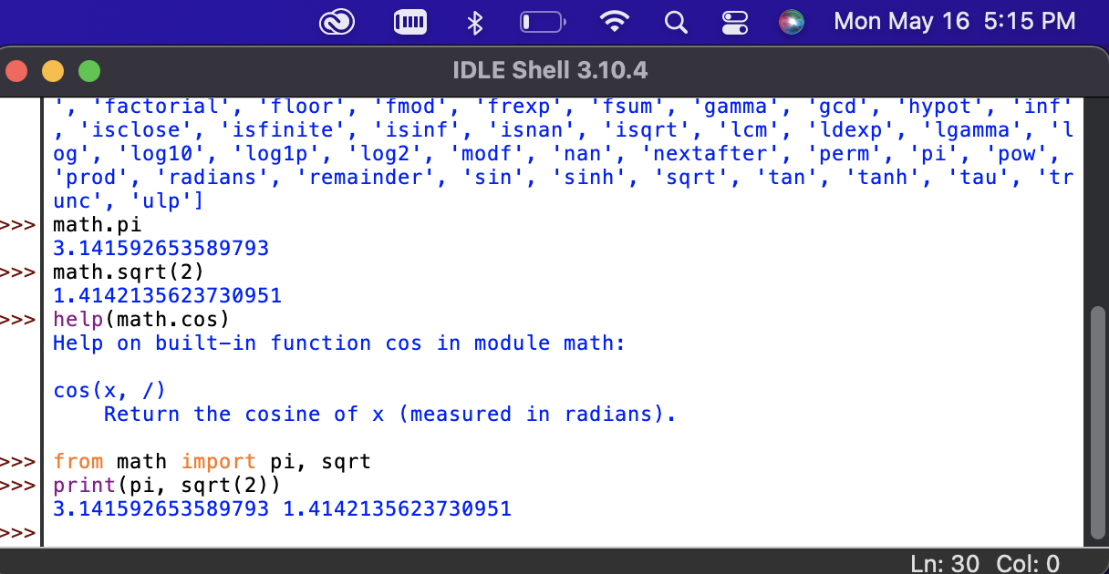

Pg 56 part 4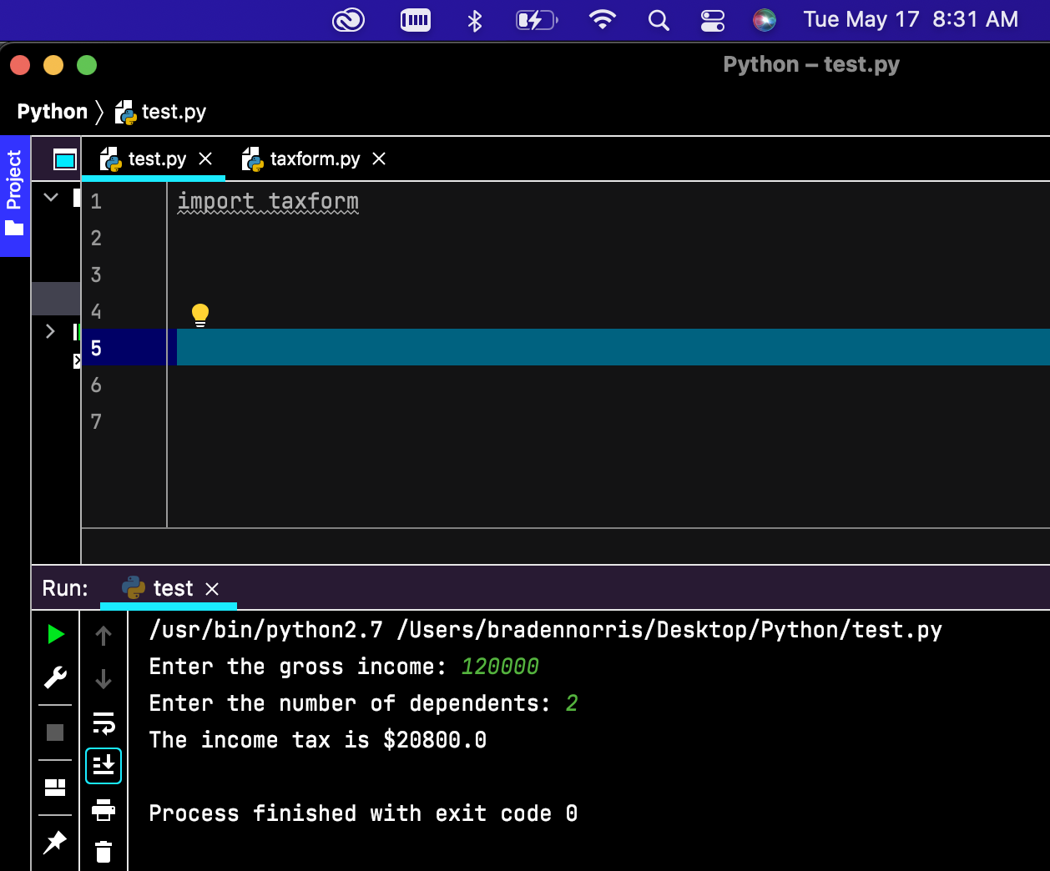

Pg 57

