Introduction
Human civilization is dependent on energy use, and energy consumption is growing rapidly as the human population increases exponentially. Each country has an energy mix unique to them, and proportions of fossil fuel use and renewable energy use can differ drastically relative to one another. Another way to classify the energy mix is as clean energy and not clean energy. Fossil fuel extraction and production negatively impact environmental health and thus human health. Adoption of renewable energy sources either reduces or eliminates such impacts altogether. Which source a country primarily relies on is dependent on a country’s socio-economic factors, geography, population, etc. I want to understand how certain factors influence a country’s energy source. Autocracies tend to prioritize economic development and undervalue environmental policy, thus leading to a trend of dependency on fossil fuels. Democracies tend to be held to environmental policies by the public and thus are more likely to adopt clean sources, but there is more variation in democratic energy mixes.
Globally, regime stability and population are likely to experience fluctuations, so it is important to model how potential scenarios may influence the energy sector. Reliance on fossil fuels can drive a cycle of worsening climate change impacts on the population. I suspect a country’s regime will matter the most in predicting its energy source. Using data on each country’s percentage of low-carbon sources, population data over time, current regimes, and population projections, I apply Random Forest, Gradient Boosted Trees, and Logistic Regression to predict whether the majority of a given country’s energy source is clean or not clean with regard to low-carbon sources. Inspecting the coefficients of regression, I find that stable autocracies have the most influence, suggesting a preference for not clean energy sources. This is probably because autocracies have a strong trend in their energy mix.
Methods
I will predict whether the majority of a given country’s energy source is clean or not clean with regard to low-carbon sources. Model features from OurWorldInData datasets (Table 1) include regime stability and type, population growth rate, percent change in population growth rate each year, percent change in projected population growth rate, and the percent change in low-carbon sources.
Table 1. Data sources.
Name | Source | Time Valid | Description
Political regime | V-Dem (2025) | 2024 | Based on the classification by Lührmann et al. (2018) and the estimates by V-Dem’s experts. Feature: regime stability and type
Population growth rate, 1950 to 2100 | UN, World Population Prospects (2024) | 1950-2100 | The growth rate is the population change determined by births, deaths, and migration flows. Projections from2024 onwards are based on the UN's medium scenario.  Features: population growth rate, percent change in population growth rate each year, percent change in projected population growth rate each year
Share of electricity generated by low-carbon sources | Ember (2024); Energy Institute - Statistical Review of World Energy (2024) | 2023 | Low-carbon electricity is the sum of electricity from nuclear and renewable sources (including solar, wind, hydropower, biomass and waste, geothermal and wave and tidal). Features: percent change in low-carbon sources.

I merged the datasets in Table 1 into a single data frame. Using the merged data frame, I feature-engineered percent change in population growth each year, percent change in projected population growth rate, and the percent change in low-carbon sources.
One assumption I made for the purpose of the model is the threshold for clean or not clean energy. I generalized "clean" with a threshold of ≥50% low-carbon sources. The three models I ran were Random Forest (RandomForestClassifier), Gradient Boosted Trees (GradientBoostingClassifier), and Logistic Regression (LogisticRegression). Random Forests outperform single trees by combining multiple models, but are less interpretable than Logistic Regression. Unlike Logistic Regression, Random Forests handle non-linear interactions. Random Forest performs well with minimal tuning, works with both categorical and numerical data, and is robust to overfitting. Gradient Boosted Trees have higher accuracy than Random Forests and are flexible with missing data, but they are more prone to overfitting. Gradient Boosted Trees work well with complex interactions in data. Logistic Regression is designed for binary classification problems, which serves as a model baseline for these models. These are the best options for this large, complex dataset. After selecting models, I transformed the numerical and categorical features with a transformer (ColumnTransformer). The best hyperparameters were found using a grid search with cross-validation (GridSearchCV).Next steps include:
- Plot decision tree
- Run random forest with pipelines
- Run gradient boosted classifier with Pipeline
- Run logistic regression and confusion matrix
- Compare each model’s classification report(classification_report)
Results
Each model performed with high accuracy. Metrics for not clean sources were higher than for clean sources.
Decision Tree
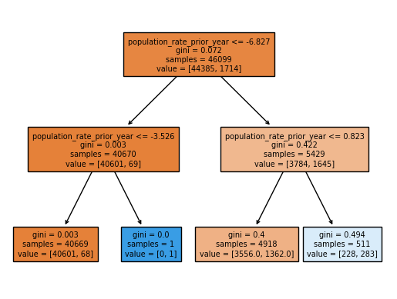
Figure 1. Decision tree

Random Forest
Table 2. Random forest classification report with precision, recall, f1-score metrics
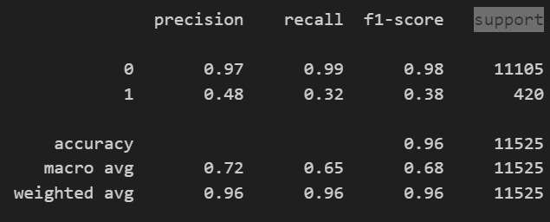

Gradient Boosted Tree

Table 3. Gradient Boosted Tree classification report with precision, recall, f1-score metrics
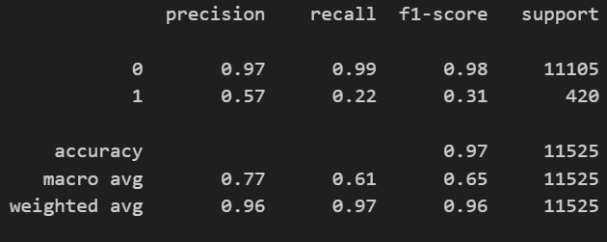

Table 4. Logistic Regression classification report with precision, recall, f1-score metrics
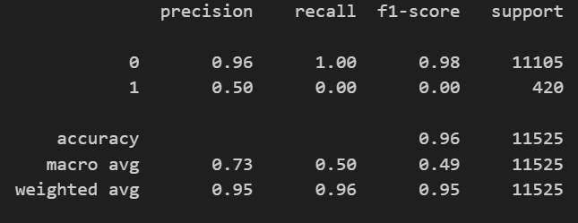
Logistic Regression

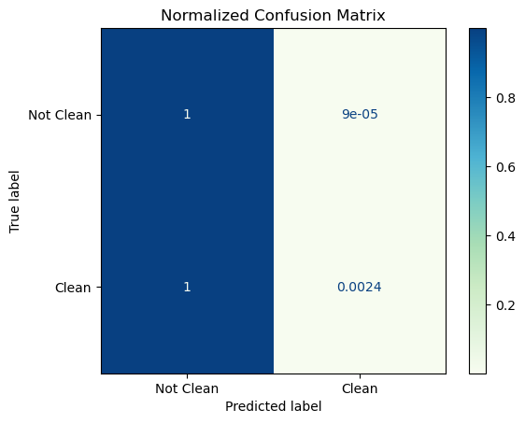
Figure 2. Confusion Matrix

Discussion
The best model was Random Forest in balancing precision and recall for detecting clean energy, the minority class. Gradient Boosted Trees missed most positive cases, while Logistic Regression failed to identify any true positives for clean energy (Figure 2). Predicting a clean source when it’s not clean (false positive) leads to issues, and precision becomes more important. For example, a government report on energy sustainability cannot mistakenly suggest a "clean" source that isn't actually clean. Missing a "clean" source (false negative) can also be costly and could result in overlooking an actual clean energy source that could help mitigate climate change.
Low metrics for clean sources may be due to the limited data set available. Globally, we primarily utilize fossil fuels. If more countries progress sustainably, then this model’s performance would be enhanced by more support.
On the other hand, each model performed very well at predicting non-clean countries. Population growth rate had the most influence on Logistic Regression classification, which I did not expect. Fossil fuels are a baseload source of energy and are better suited for supporting large populations, as opposed to more intermittent energy sources—which are a trade-off of most renewable sources. I hypothesized that political regime would have the most influence, but it was a close second (Figure 3).
If I were to continue refining the model, I would include more useful features. For example, I could add energy consumption rates or the availability of domestic renewable resources to inform the model of a country’s specific energy capabilities. Predicting whether countries will rely on clean or non-clean energy sources has important implications for the future of climate change. Socio-political, economic, and environmental factors interact with climate change. By understanding current relationships and future projections, we can create a sustainable energy mix as a form of energy security and climate change mitigation.

References
Political regime. (2025). Our World in Data. https://ourworldindata.org/grapher/political-regime?tab=table
Population & Demography Data Explorer. (2024). Our World in Data.https://ourworldindata.org/explorers/population-and-demography?indicator=Population+growth+rate&Sex=Both+sexes&Age=Total&Projection+scenario=Medium&country=CHN~IND~USA~IDN~PAK~NGA~BRA~JPN
Share of electricity from low-carbon sources. (n.d.). Our World in Data. https://ourworldindata.org/grapher/share-electricity-low-carbon
ChatGPT

Appendix


Figure 1. Decision tree


Figure 2. Confusion matrix to visualize logistic regression model performance.

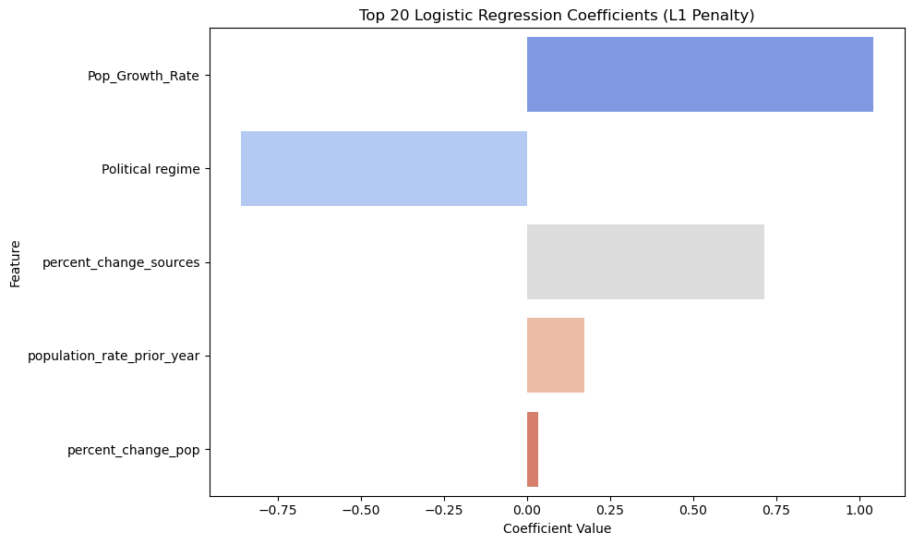
Figure 3. Feature coefficients influence on model relative to one another.

