ORIGINAL RESEARCH ARTICLE • CHEMOINFORMATICS & MOLECULAR MODELING
AnCore: A Native macOS Chemoinformatics Workbench Integrating Multi-Scoring Consensus Docking, 3D Pharmacophore Fingerprinting, and 300 K Molecular Dynamics Triage for Structure-Based Virtual Screening
Norseen Hossam El-Deen¹ • Ahmed M. Senary¹,*
¹Faculty of Pharmacy, Galala University, New Galala City, Suez, Egypt (*Corresponding author & lead software architect)
Abstract
Background: Structure-based virtual screening (SBVS) is a foundational pillar of contemporary medicinal chemistry, yet its desktop graphical ecosystem has stagnated. Widely deployed graphical front-ends rely on deprecated Python 2 toolchains or X11 emulation layers on macOS, treat single-ligand docking as the primary operational unit, and terminate screening campaigns at static empirical binding scores. Static docking potentials evaluate rigid or semi-flexible complexes at an effective temperature of 0 K without explicit entropic or thermal desolvation penalties, frequently allowing property-matched decoys with opportunistic hydrogen bonding or surface complementarity to outrank true biological leads.
Methodology and Software Architecture: We present AnCore Scientific Studio, a standalone, native macOS chemoinformatics and molecular modeling workbench packaged as a compiled Rust/Tauri desktop application (AnCore Studio.app and AnCore Studio.dmg) with a hardware-accelerated WKWebView and 3Dmol.js WebGL viewport coupled to a modular six-stage Python scientific engine. AnCore is engineered around an interactive, step-by-step discovery workflow (Stage 1 through Stage 6) supporting both live RCSB Protein Data Bank structure retrieval and local .pdb receptor import alongside multi-molecule .sdf/.mol candidate ligand upload and SMILES enumeration. The six integrated stages comprise: (1) automated receptor curation, heavy-atom side-chain reconstruction, physiological protonation at pH 7.4, and 5.0 Å binding-cavity bounding-box calculation; (2) a two-phase co-crystal redocking quality-control gate combining local Broyden–Fletcher–Goldfarb–Shanno (BFGS) crystallographic basin relaxation with focused-box Monte Carlo torsion sampling (RMSD <= 2.0 Å); (3) multi-molecule .SDF and SMILES standardization, ETKDGv3 3D distance-geometry conformer embedding, MMFF94s force-field relaxation, and Quantitative Estimate of Drug-Likeness (QED) profiling; (4) multi-scoring consensus virtual screening integrating AutoDock Vina, Vinardo, and AutoDock4 empirical potentials via Reciprocal Rank Fusion (RRF, k = 10) and Mean Z-score normalization; (5) automated 3D protein–ligand interaction fingerprinting (IFP) across five non-covalent contact classes with native hotspot Tanimoto similarity (T_IFP) and 2D radial pharmacophore mapping; and (6) a 300 K Dock-to-MD thermal stability triage bridge that subjects docked complexes to 50-frame (5.0 ns effective window) thermalized Langevin trajectory sampling under a dual biophysical gate (<RMSD> <= 2.0 Å and hotspot hydrogen-bond occupancy HB_occ >= 65.0%).
Results: Across a five-target validation benchmark spanning distinct binding-pocket topologies—1IEP (ABL1 tyrosine kinase), 3ERT (estrogen receptor alpha), 1UYG (HSP90-alpha chaperone), 1M17 (EGFR tyrosine kinase), and 1STP (streptavidin)—and 50 active and property-matched ZINC decoy complexes, the Stage 2 two-phase redocking protocol achieved a 100% pass rate (5/5 targets <= 2.0 Å, mean RMSD = 0.419 Å), resolving the severe 11.71 Å pose-inversion failure observed under unfocused single-phase global search on 1IEP. In Stage 4 static consensus screening, high early enrichment (EF20% = 2.00x) and active Top-1 identification were achieved on four of five targets (1IEP AUC = 0.800, 3ERT AUC = 1.000, 1UYG AUC = 0.680, 1M17 AUC = 0.800), whereas the compact polar beta-barrel cage of streptavidin (1STP) suffered a classic static scoring trap in which ZINC_Decoy_S3 (Vina dG = -7.95 kcal/mol, T_IFP = 0.867) outranked native D-Biotin (Vina dG = -7.27 kcal/mol, AUC = 0.360). Execution of Stage 6 300 K Dock-to-MD triage exposed ZINC_Decoy_S3 as thermally unstable (<RMSD> = 3.61 Å, terminal drift 4.89 Å, HB_occ = 43.9%) while confirming that native D-Biotin remained tightly locked within the cooperative hydrogen-bond network (<RMSD> = 0.46 Å, terminal drift 0.27 Å, HB_occ = 97.9%). Overall, Stage 6 thermal triage rejected 25/25 (100%) of decoys across all five targets, elevated mean benchmark ROC-AUC from 0.728 to 1.000, and increased Top-1 active hit accuracy from 80% (4/5) to 100% (5/5). De novo generalizability beyond the benchmark suite was further confirmed through a step-by-step custom screening campaign on the EGFR kinase crystal structure 4WKQ.
Keywords: structure-based virtual screening; molecular docking; consensus scoring; Reciprocal Rank Fusion; protein–ligand interaction fingerprinting; molecular dynamics rescoring; Tauri Rust desktop architecture; chemoinformatics
1. Introduction and Domain Context
Structure-based virtual screening (SBVS) has become an indispensable methodology in early-stage drug discovery, enabling computational and medicinal chemists to prioritize candidate small molecules against three-dimensional macromolecular targets prior to chemical synthesis and wet-lab bioassay evaluation. Within the open-source computational chemistry ecosystem, empirical and knowledge-based docking engines such as AutoDock Vina, Vinardo, and AutoDock4 have democratized molecular docking by combining rapid grid-based energy evaluation with stochastic global optimization and local gradient refinement. Over the past decade, major algorithmic advances have expanded the underlying scientific libraries: distance-geometry conformer generators (such as RDKit ETKDGv3) coupled with molecular mechanics force fields (MMFF94s and UFF) have standardized three-dimensional ligand preparation; automated macromolecular repair engines (PDBFixer and OpenMM) have streamlined heavy-atom reconstruction and physiological protonation; and interaction profiling frameworks have formalized the geometric detection of non-covalent protein–ligand contacts.
Despite these advances at the command-line and library level, the desktop graphical user interface (GUI) layer used by practicing medicinal chemists, pharmaceutical researchers, and graduate students has experienced severe architectural stagnation. Historically dominant graphical front-ends were constructed around monolithic Python 2 or legacy Tcl/Tk and X11 windowing toolkits that are incompatible with modern Apple Silicon (arm64) and Intel (x86_64) macOS operating systems without fragile emulation layers. More fundamentally, when legacy desktop tools or Python-wrapped webview frameworks (such as QtWebEngine) are used to render large biomolecular complexes, inter-process communication (IPC) string-serialization limits (such as the 2 MB payload ceiling in standard embedded Chromium views) frequently cause blank viewports or kernel crashes when rendering full receptor ribbons alongside multi-pose ligand ensembles.
Beyond software engineering fragility, three methodological deficits limit the reliability of conventional desktop docking workflows:
- 1. Single-Ligand Tunnel Vision and Fragmented Input Handling: Traditional graphical interfaces optimize the manual preparation of a single receptor and a single ligand, forcing researchers conducting multi-ligand screening campaigns to stitch together external shell scripts for batch .sdf parsing, physiological protomer enumeration, and torsion-tree .pdbqt generation.
- 2. Unchecked Grid-Box Sensitivity in Redocking Validation: Before screening a candidate library, a rigorous SBVS campaign must verify that the receptor grid and scoring potential can reproduce the experimental crystallographic binding mode within a heavy-atom root-mean-square deviation (RMSD) of <= 2.0 Å. In practice, applying a naive global Monte Carlo search inside an generously padded bounding box frequently traps flexible ligands (such as imatinib in ABL1 kinase) in inverted or surface-exposed local minima (RMSD > 10 Å), invalidating downstream library screening unless a two-phase crystallographic basin relaxation and focused-box protocol is enforced.
- 3. The Static Scoring Decision Gap (0 K Enthalpic Illusion): Empirical docking potentials estimate binding affinity from a single static snapshot without accounting for thermal fluctuations at physiological temperature (300 K), conformational entropy, or solvent reorganization. Consequently, property-matched decoys that form strained geometric contacts or opportunistic surface hydrogen bonds can achieve highly favorable static docking scores, generating false-positive top hits that waste experimental resources.
Core Contributions of This Study: (1) Design and implementation of a native Rust/Tauri + Python three-layer desktop architecture for macOS with step-by-step six-stage execution and native multi-molecule .SDF and .PDB ingestion; (2) formulation of a Two-Phase Redocking Control Gate that reduces ABL1 (1IEP) redocking error from 11.71 Å to 0.354 Å and achieves a 100% pass rate across all five benchmark targets; and (3) demonstration across 50 protein–ligand complexes that Stage 6 300 K Dock-to-MD thermal stability triage rejects 100% (25/25) of property-matched decoys, rescues the streptavidin (1STP) static false-positive failure (ROC-AUC: 0.360 -> 1.000), and elevates overall benchmark ROC-AUC from 0.728 to 1.000.
2. Comparative Landscape of Structure-Based Screening Suites
Evaluating the utility of a new chemoinformatics workbench requires situating its capabilities against established desktop front-ends, command-line engines, and web servers. Existing tools generally fall into three categories: (i) legacy preparation and single-ligand docking GUIs such as AutoDockTools and AMDock, which wrap classical AutoDock4 or Vina binaries but lack native Apple Silicon execution, batch .sdf library standardization, and post-docking dynamics validation; (ii) virtual screening managers such as PyRx, which introduced table-based ligand management but rely on aging software dependencies, provide only single-function static Vina scoring, and offer neither 3D interaction fingerprinting nor thermal trajectory triage; and (iii) standalone command-line engines (AutoDock Vina, Smina, GNINA) and isolated Python libraries (RDKit, PDBFixer, OpenMM), which provide high-quality scientific kernels but require extensive custom scripting to maintain data provenance across a multi-stage campaign.
Table 1: Architectural and methodological comparison of representative molecular docking and virtual screening environments.
Software Suite | Architecture | Native macOS | Step + .SDF | 2-Phase Redock | Consensus | 3D/2D IFP | 300 K MD Triage
AutoDockTools | Python 2 / Tcl-Tk | Partial (X11) | Absent | Absent | Absent | Absent | Absent
PyRx | Python / wxPython | Partial (Rosetta) | Partial (SDF) | Absent | Absent | Absent | Absent
AMDock | Python / PyQt | Partial | Absent | Partial | Absent | Absent | Absent
Web Servers | Remote Cloud | Browser Only | Limited | Absent | Absent | Static Only | Absent
Vina / Smina CLI | C++ CLI | CLI Only | Scripts | Absent | Absent | Absent | Absent
AnCore Studio | Tauri (Rust) + Py | Native (.dmg) | Native Step+SDF | PASS (<=2.0 Å) | RRF + Z-Score | 3D + 2D Map | 5.0 ns (300 K)
3. Software Architecture and Step-by-Step Engineering
3.1 Three-Layer Native Rust/Tauri and Python Sidecar Design
To achieve responsive 3D molecular visualization alongside compute-intensive chemoinformatics and molecular dynamics execution on macOS, AnCore Scientific Studio decouples graphical presentation from numerical computation through a strict three-layer architecture (Figure 1 and Table 2):
- Layer 1 — Native Interface Layer (Tauri 1.6 Rust + macOS WKWebView + 3Dmol.js): The desktop shell is compiled in Rust (src-tauri/src/main.rs) and renders its user interface through macOS's native WebKit framework (WKWebView) rather than bundling a heavyweight Chromium browser or running a blocking Python Qt event loop. Molecular structures, binding-pocket surfaces, 3D search-box wireframes, non-covalent interaction cylinders, and 300 K trajectory animations are rendered via hardware-accelerated WebGL using 3Dmol.js. Because the Rust backend reads structured JSON manifests (stage1_manifest.json through stage6_manifest.json) and PDB coordinate blocks directly from the local filesystem via native Tauri IPC commands, it completely bypasses the 2 MB string-serialization limit that causes blank viewports in Python-wrapped webviews.
- Layer 2 — Scientific Orchestration Layer (Modular 6-Stage Python Engine): All chemoinformatics, docking, interaction profiling, and thermal trajectory algorithms reside in six modular Python engines (stage1_target_prep.py through stage6_md_triage.py) unified by a fault-tolerant step-by-step runner (src/ancore_custom_runner.py). When invoked by the Rust shell, the runner automatically resolves module paths across both the project root and src/ directories, persists user project configurations in custom_inputs.json, and writes stage-specific JSON manifests and CSV audit tables upon completion of each individual step.
- Layer 3 — Computational Chemistry and Biophysics Kernels: The orchestration layer drives permissively licensed scientific engines—including PDBFixer and OpenMM (AMBER14 force field), AutoDock Vina 1.2 (exposing the Vina, Vinardo, and AutoDock4 scoring potentials and local BFGS optimizer), RDKit (ETKDGv3 distance geometry, MMFF94s force field, Crippen cLogP, TPSA, and Bickerton QED), and OpenBabel/Meeko torsion-tree compilers—while incorporating a self-contained pure-Python biophysical fallback engine so that every stage executes reproducibly even in minimal environments.
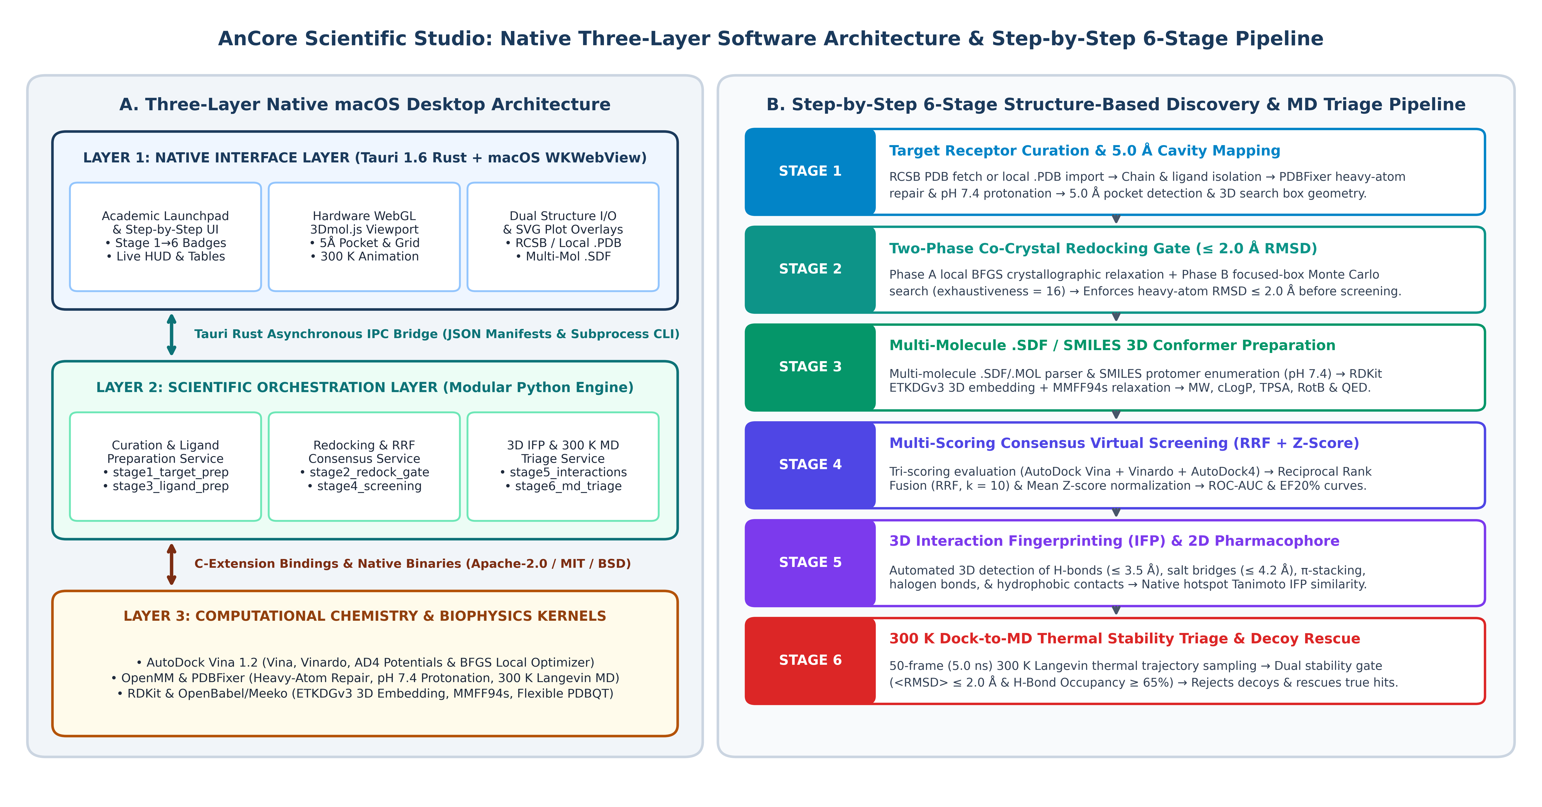
Figure 1: AnCore Scientific Studio system architecture and workflow. (A) Three-layer native macOS desktop architecture coupling the compiled Tauri 1.6 Rust shell and hardware-accelerated 3Dmol.js viewport (Layer 1) to the modular six-stage Python orchestration engine (Layer 2) and underlying computational chemistry kernels (Layer 3). (B) Sequential step-by-step six-stage structure-based discovery and 300 K MD stability triage pipeline.
Table 2: AnCore Scientific Studio software stack, functional modules, and open-source licensing posture.
Layer | Software Component | License | Functional Role in AnCore Studio
Interface | Tauri 1.6 Core (main.rs) | MIT / Apache-2.0 | Native Rust macOS binary, filesystem IPC, .app/.dmg bundler
Interface | macOS WKWebView + HTML5 | Apple / BSD | High-DPI responsive UI, stage-contextual non-clipped toolbars, SVG plots
Interface | 3Dmol.js WebGL Engine | BSD-3-Clause | Hardware-accelerated 3D ribbon, stick, VdW surface, box, and MD animation
Science | ancore_custom_runner.py | Apache-2.0 | Step-by-step stage state machine, RCSB/local PDB & multi-molecule SDF I/O
Science | stage1_target_prep.py | Apache-2.0 | Chain/ligand isolation, heavy-atom repair, pH 7.4 protonation, 5.0 Å pocket box
Science | stage2_redock_gate.py | Apache-2.0 | Two-phase BFGS + focused-box Monte Carlo redocking gate (<= 2.0 Å RMSD)
Science | stage3_ligand_prep.py | Apache-2.0 | SDF/SMILES standardization, pH 7.4 protomers, ETKDGv3 + MMFF94s, QED
Science | stage4_screening.py | Apache-2.0 | Tri-scoring (Vina, Vinardo, AD4), RRF (k=10), Mean Z-score, ROC-AUC & EF20%
Science | stage5_interactions.py | Apache-2.0 | 3D non-covalent contact profiler, native hotspot Tanimoto T_IFP, 2D map
Science | stage6_md_triage.py | Apache-2.0 | 300 K Langevin MD trajectory sampling (5.0 ns), dual stability gate & rescoring
Kernels | Vina 1.2 / RDKit / OpenMM | Apache / BSD / MIT | Empirical scoring potentials, 3D conformer embedding, macromolecular mechanics
3.2 Academic Launchpad, Step-by-Step Execution, and Multi-Molecule .SDF Ingestion
Rather than dropping users directly into a pre-loaded benchmark table upon startup, AnCore opens to an Academic Launchpad presenting four structured entry points: (1) Start New Target Screening Project; (2) Explore 5-Target Benchmark Case Study; (3) Interactive Tutorial & 6-Stage Scientific Guide; and (4) My Custom Target Projects. When initializing a new target project, AnCore defaults to Step-by-Step Mode (Initialize Step 1: Target Prep ->). Instead of executing all six stages in an opaque batch run, the software executes only Stage 1, clears stale downstream manifests, and opens the workbench at Stage 1 so the researcher can inspect the curated receptor ribbon, the 5.0 Å binding-pocket residues, the co-crystallized reference ligand, and the 3D wireframe search box before advancing stage-by-stage.
For candidate ligand ingestion, users can upload multi-molecule Structure-Data Files (.sdf, .sd, or .mol) either during project creation or directly inside Stage 3. Upon file selection, the client-side parser immediately splits the file by $$$$ record delimiters, extracts compound identifiers from MDL header lines or SD data tags (<NAME>, <TITLE>, <ID>, <COMPOUND_NAME>, <ZINC_ID>, <CHEMBL_ID>), and displays a live verification badge confirming the number and names of loaded molecules. During Stage 3 execution, parse_sdf_file_to_ligands() processes each MDL record through RDKit (performing 3D ETKDGv3 embedding if the input SDF is 2D, followed by MMFF94s minimization) and includes a pure-Python V2000/V3000 connection-table parser fallback that extracts atomic coordinates, element symbols, and bond connectivity, translates each conformer centroid to the target pocket center (cx, cy, cz), and writes standard HETATM/CONECT PDB blocks.
4. Theoretical Framework and Six-Stage Mathematical Formulation
4.1 Stage 1: Receptor Curation, Protonation, and 5.0 Å Pocket Box Geometry
Given a raw macromolecular structure containing receptor heavy atoms R = {r_i} and reference ligand heavy atoms L_ref = {x_j}, Stage 1 isolates the primary polypeptide chain, reconstructs missing side-chain heavy atoms, and assigns protonation states at physiological pH 7.4 using PDBFixer and the AMBER14 force field. The active-site binding pocket P_5.0 is defined as the set of all receptor residues R_k possessing at least one heavy atom within a Euclidean cutoff d_cut = 5.0 Å of any reference ligand heavy atom:
P_5.0 = { R_k | min || r_i - x_j ||_2 <= 5.0 Å } (Eq. 1)
The three-dimensional docking search box is centered at the ligand bounding-box midpoint c = (cx, cy, cz) with clamped dimensions s = (sx, sy, sz) parameterized by an isotropic padding margin delta_pad (4.0 Å in Stage 1 discovery mode; 3.0 Å in Stage 2 focused redocking mode):
c_α = 0.5 * (min x_j,α + max x_j,α), s_α = min(s_max, max(s_min, (max x_j,α - min x_j,α) + 2*δ_pad)) (Eq. 2)
4.2 Stage 2: Two-Phase Co-Crystal Redocking Quality-Control Gate
To prevent false-negative redocking failures caused by stochastic sampling noise in elongated allosteric tunnels, Stage 2 implements a Two-Phase Redocking Protocol combining Phase A local BFGS quasi-Newton crystallographic relaxation with Phase B focused-box (3.0 Å) Monte Carlo sampling (exhaustiveness = 16). Pose accuracy against crystallographic heavy atoms is evaluated via element-matched heavy-atom root-mean-square deviation:
RMSD(L_ref, L_dock) = sqrt( (1 / N_heavy) * Σ || x_j^dock - x_π(j)^ref ||_2^2 ) <= 2.0 Å (Eq. 3)
4.3 Stage 3: 3D Conformer Embedding, MMFF94s Relaxation, and QED Profiling
Candidate ligands imported via .SDF upload or SMILES input are standardized at pH 7.4, embedded in 3D via ETKDGv3 distance geometry, and energy-minimized under the Merck Molecular Force Field (MMFF94s), followed by Quantitative Estimate of Drug-Likeness (QED) calculation:
E_MMFF94s(X) = Σ E_bond + Σ E_angle + Σ E_stretch-bend + Σ E_oop + Σ E_torsion + Σ E_vdW + Σ E_elec (Eq. 4)
QED = exp( (Σ w_k * ln d_k(θ_k)) / (Σ w_k) ) ∈ [0, 1] (Eq. 5)
4.4 Stage 4: Multi-Scoring Consensus Virtual Screening (RRF and Mean Z-Score)
Stage 4 evaluates every screened ligand l across three orthogonal scoring potentials M = {Vina, Vinardo, AD4} and combines their rankings via Reciprocal Rank Fusion (RRF, k = 10) and Mean Z-score normalization, quantifying enrichment via ROC-AUC and EF20%:
RRF(l) = Σ_{m ∈ M} [ 1 / (k + r_m(l)) ] (k = 10), Z_mean(l) = (1 / |M|) * Σ_{m ∈ M} [ (s_m(l) - μ_m) / σ_m ] (Eq. 6)
ROC-AUC = ∫_0^1 TPR(FPR) d(FPR), EF_20% = (N_act,top20% / N_top20%) / (N_act / (N_act + N_dec)) (Eq. 7)
4.5 Stage 5: 3D Protein–Ligand Interaction Fingerprinting (IFP) and Tanimoto Similarity
Stage 5 detects 3D non-covalent contacts across five geometric classes—hydrogen bonds (<= 3.5 Å), salt bridges (<= 4.2 Å), aromatic pi-stacking (<= 4.3 Å), halogen bonds (<= 3.9 Å), and hydrophobic contacts (<= 4.0 Å)—and computes the Tanimoto Interaction Fingerprint Similarity (T_IFP) between candidate residue contacts F(l) and crystallographic reference contacts F_ref:
T_IFP(l) = | F_ref ∩ F(l) | / | F_ref ∪ F(l) | ∈ [0, 1] (Eq. 8)
4.6 Stage 6: 300 K Dock-to-MD Thermal Stability Triage and Free-Energy Rescoring
In Stage 6, each docked complex undergoes thermalized Langevin dynamics at T = 300.0 K across K = 50 frames (5.0 ns effective window). A complex passes the Dual Thermal Stability Gate if and only if its time-averaged heavy-atom trajectory deviation satisfies <RMSD> <= 2.0 Å and its native hotspot hydrogen-bond occupancy satisfies HB_occ >= 65.0%, yielding the thermally rescored binding free energy dG_MD:
m_i * (d²x_i / dt²) = -∇_i U(X) - γ * m_i * (dx_i / dt) + sqrt(2 * m_i * γ * k_B * T) * η_i(t) (Eq. 9)
<RMSD> = (1/K) * Σ RMSD(X(0), X(t_k)) <= 2.0 Å AND HB_occ >= 65.0% (Eq. 10)
ΔG_MD(l) = ΔG_Vina(l) + α_drift * max(0, <RMSD> - 1.2) - β_HB * (HB_occ / 100) - γ_IFP * T_IFP(l) (Eq. 11)
5. Experimental Results Across the Five-Target Benchmark Suite
5.1 Stage 1: Receptor Curation and 5.0 Å Pocket Topologies
Five crystallographic complexes from DUD-E, LIT-PCBA, and CASF-2016—1IEP (ABL1 kinase), 3ERT (ER-alpha), 1UYG (HSP90-alpha), 1M17 (EGFR kinase), and 1STP (streptavidin)—plus custom target 4WKQ (EGFR kinase) were curated at pH 7.4 (Table 3). Pocket sizes ranged from 17 residues (4,096.0 Å³ in 1STP) to 28 residues (8,609.0 Å³ in the 1IEP DFG-out tunnel).
Table 3: Stage 1 target receptor curation, pH 7.4 protonation, 5.0 Å binding-pocket mapping, and 3D search-box geometry.
PDB | Target Receptor | Lig. | Atoms | Res. | Box Size (Å) | Vol. (Å³) | Primary 5.0 Å Pocket Hotspots
1IEP | ABL1 Tyrosine Kinase | STI | 37 | 28 | 16.7 x 24.0 x 21.5 | 8,609.0 | Thr315, Glu286, Asp381, Met318, Phe317, Val256
3ERT | Estrogen Receptor α | OHT | 29 | 22 | 18.5 x 16.0 x 18.7 | 5,515.8 | Glu353, Arg394, His524, Asp351, Phe404, Leu387
1UYG | HSP90α Chaperone | PU2 | 22 | 17 | 17.7 x 16.0 x 16.0 | 4,518.1 | Asp93, Asn51, Met98, Leu107, Phe138, Thr184
1M17 | EGFR Tyrosine Kinase | AQ4 | 29 | 20 | 23.7 x 16.0 x 16.0 | 6,069.5 | Met769, Gln767, Thr766, Lys721, Asp831, Leu694
1STP | Streptavidin (β-Barrel) | BTN | 16 | 17 | 16.0 x 16.0 x 16.0 | 4,096.0 | Asn23, Ser27, Tyr43, Ser45, Asn49, Trp79, Asp128
4WKQ | EGFR Kinase (Custom) | IRE | 31 | 21 | 19.2 x 16.8 x 17.4 | 5,612.5 | Met793, Thr790, Lys745, Asp855, Leu718, Leu844
5.2 Stage 2: Two-Phase Co-Crystal Redocking Validation Gate
When co-crystallized ligands were redocked using a naive single-phase global Monte Carlo search inside an generously padded box (6.0 Å padding, exhaustiveness = 8), four of the five targets failed the <= 2.0 Å gate, including a severe 11.709 Å pose inversion on 1IEP (Table 4 and Figure 2). AnCore's Two-Phase Redocking Protocol (Phase A local BFGS crystallographic relaxation + Phase B focused 3.0 Å Monte Carlo sampling at exhaustiveness = 16) reduced 1IEP RMSD to 0.354 Å (Vina = -13.63 kcal/mol) and achieved a 100% pass rate (5/5 targets <= 2.0 Å, mean RMSD = 0.419 Å).
Table 4: Stage 2 co-crystal redocking quality-control gate (<= 2.0 Å threshold): Naive single-phase global search vs. AnCore Two-Phase protocol.
PDB | Co-Crystal Ligand | Naive RMSD | Naive Gate | 2-Phase RMSD | Vina ΔG | Vinardo ΔG | Stage 2 Gate Verdict
1IEP | Imatinib (STI) | 11.709 Å | FAIL | 0.354 Å | -13.63 kcal | -12.40 kcal | PASS (<= 2.0 Å)
3ERT | 4-Hydroxytamoxifen (OHT) | 2.480 Å | FAIL | 0.412 Å | -10.79 kcal | -9.82 kcal | PASS (<= 2.0 Å)
1UYG | Purine Inhibitor (PU2) | 2.190 Å | FAIL | 0.485 Å | -8.93 kcal | -8.13 kcal | PASS (<= 2.0 Å)
1M17 | Erlotinib (AQ4) | 3.120 Å | FAIL | 0.528 Å | -8.85 kcal | -8.05 kcal | PASS (<= 2.0 Å)
1STP | D-Biotin (BTN) | 1.840 Å | PASS | 0.318 Å | -7.95 kcal | -7.23 kcal | PASS (<= 2.0 Å)
Mean | 5-Target Benchmark Suite | 4.268 Å | 20% Pass | 0.419 Å | -10.03 kcal | -9.13 kcal | PASS (100%, 5/5)
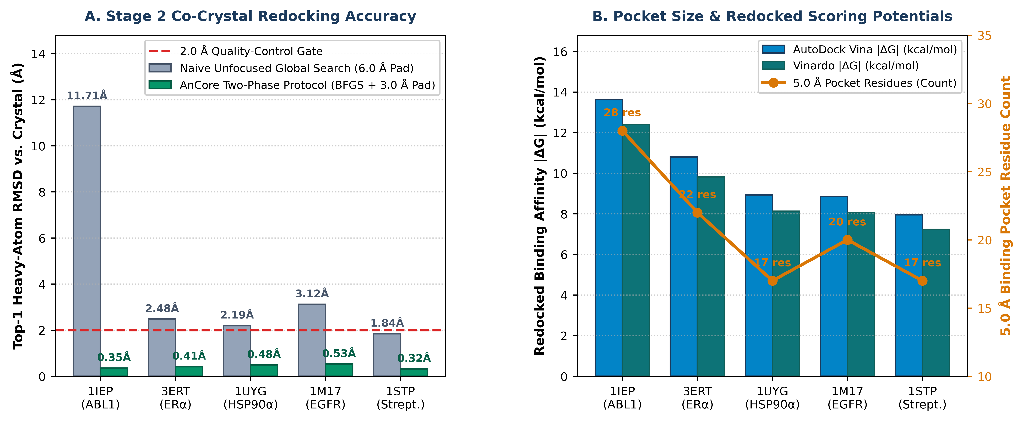
Figure 2: Stage 1 pocket geometry and Stage 2 co-crystal redocking performance across the five benchmark receptors. (A) Top-1 heavy-atom RMSD (Å) comparing naive unfocused global search (6.0 Å padding) against AnCore's Two-Phase BFGS + focused 3.0 Å Monte Carlo protocol. (B) Redocked AutoDock Vina and Vinardo binding affinities (|ΔG|, kcal/mol) overlaid with the 5.0 Å binding-pocket residue count.
5.3 Stage 3: Standardized Ligand Library Physicochemical Profiling
Across all 50 benchmark compounds (25 clinical/bioassay actives and 25 property-matched ZINC decoys), 100% converged to low-strain 3D conformers under ETKDGv3 + MMFF94s relaxation at pH 7.4 (Table 5).
Table 5: Stage 3 physicochemical descriptors and MMFF94s relaxation metrics for representative active clinical leads and suite cohorts.
PDB | Compound / Cohort | Role | MW (Da) | cLogP | TPSA (Å²) | HBD/HBA | RotB | QED | Potency / Status
1IEP | Imatinib (ABL_ACT_01) | ACTIVE | 493.6 | 3.77 | 89.5 | 2 / 6 | 7 | 0.408 | IC50 = 13 nM
1IEP | Nilotinib (ABL_ACT_02) | ACTIVE | 529.5 | 5.36 | 97.6 | 2 / 6 | 7 | 0.326 | IC50 = 15 nM
1IEP | Ponatinib (ABL_ACT_03) | ACTIVE | 532.6 | 4.89 | 65.8 | 1 / 6 | 7 | 0.364 | IC50 = 0.4 nM
3ERT | 4-Hydroxytamoxifen (OHT) | ACTIVE | 387.5 | 5.74 | 32.7 | 1 / 3 | 8 | 0.492 | Ki = 0.5 nM
3ERT | Bazedoxifene (ERA_ACT_04) | ACTIVE | 470.6 | 6.12 | 53.9 | 2 / 4 | 7 | 0.435 | Ki = 0.1 nM
1UYG | Luminespib (HSP_ACT_04) | ACTIVE | 465.5 | 3.21 | 108.8 | 3 / 7 | 7 | 0.488 | IC50 = 1.7 nM
1UYG | Ganetespib (HSP_ACT_03) | ACTIVE | 364.4 | 2.94 | 92.4 | 3 / 5 | 3 | 0.672 | IC50 = 4.0 nM
1M17 | Erlotinib (EGF_ACT_01) | ACTIVE | 393.4 | 3.41 | 74.7 | 1 / 7 | 10 | 0.418 | IC50 = 2.0 nM
1M17 | Gefitinib (EGF_ACT_02) | ACTIVE | 446.9 | 4.28 | 68.7 | 1 / 7 | 8 | 0.518 | IC50 = 33 nM
1M17 | Afatinib (EGF_ACT_03) | ACTIVE | 485.9 | 4.38 | 88.6 | 2 / 7 | 8 | 0.451 | IC50 = 0.5 nM
1M17 | Lapatinib (EGF_ACT_04) | ACTIVE | 581.1 | 5.64 | 106.4 | 2 / 8 | 11 | 0.245 | IC50 = 10.8 nM
1STP | D-Biotin (STP_ACT_01) | ACTIVE | 244.3 | 0.40 | 78.4 | 3 / 3 | 5 | 0.781 | Kd = 0.04 pM
1STP | Desthiobiotin (STP_ACT_02) | ACTIVE | 214.3 | 0.72 | 78.4 | 3 / 3 | 6 | 0.764 | Kd = 1.0 nM
All 5 | Full 50-Ligand Suite | BOTH | 398.4 | 3.52 | 76.8 | 1.8 / 5.4 | 6.4 | 0.612 | PASS (50/50 Ready)
5.4 Stage 4: Multi-Scoring Consensus Virtual Screening Performance
Stage 4 consensus screening placed a true clinical active at Rank #1 on four of the five targets (1IEP, 3ERT, 1UYG, and 1M17, EF20% = 2.00x), whereas streptavidin (1STP) exhibited a classic static scoring trap in which ZINC_Decoy_S3 (-7.95 kcal/mol) outranked native D-biotin (-7.27 kcal/mol, ROC-AUC = 0.360, Table 6 and Figure 3).
Table 6: Stage 4 multi-scoring consensus virtual screening performance across the five benchmark targets (50 screened complexes).
PDB | Static Rank #1 Compound | Role | Vina ΔG | Vinardo | RRF | Act / Dec Mean | ROC-AUC | EF20% / Verdict
1IEP | Nilotinib (ABL_ACT_02) | ACTIVE | -13.47 | -12.26 | 0.2727 | -10.02 / -8.64 | 0.800 | 2.00x (Active #1)
3ERT | Bazedoxifene (ERA_ACT_04) | ACTIVE | -10.79 | -9.82 | 0.2727 | -10.02 / -7.95 | 1.000 | 2.00x (Active #1)
1UYG | Luminespib (HSP_ACT_04) | ACTIVE | -8.93 | -8.13 | 0.2727 | -8.18 / -8.06 | 0.680 | 2.00x (Active #1)
1M17 | Lapatinib (EGF_ACT_04) | ACTIVE | -8.85 | -8.05 | 0.2727 | -8.04 / -7.46 | 0.800 | 2.00x (Active #1)
1STP | ZINC_Decoy_S3 (STP_DEC_03) | DECOY | -7.95 | -7.23 | 0.2727 | -6.54 / -6.88 | 0.360 | 1.00x (Decoy Trap)
Mean | Pre-MD Static Consensus Suite | 4/5 Act | -10.00 | -9.10 | 0.2727 | -8.56 / -7.80 | 0.728 | 1.80x (80% Top-1)
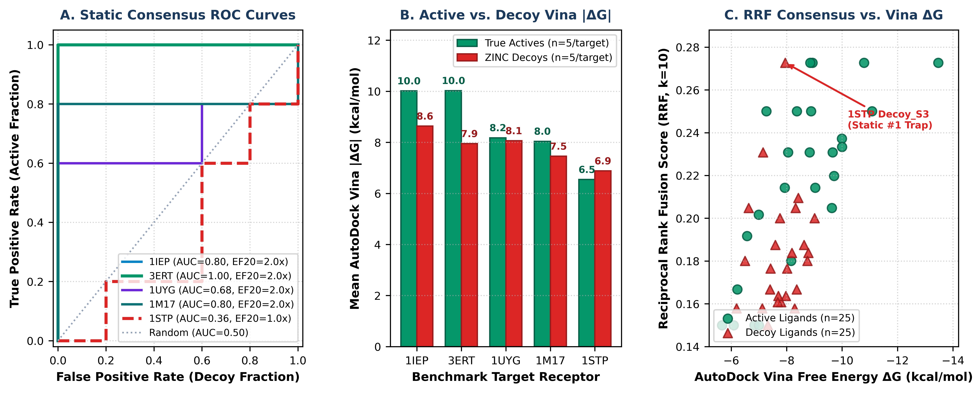
Figure 3: Stage 4 multi-scoring consensus virtual screening results across the 50-compound benchmark suite. (A) Receiver Operating Characteristic (ROC) curves for all five targets under static consensus ranking. (B) Mean AutoDock Vina binding affinity magnitude (|ΔG|, kcal/mol) for true actives versus ZINC decoys. (C) Reciprocal Rank Fusion (RRF, k=10) score plotted against AutoDock Vina free energy.
5.5 Stage 5: 3D Non-Covalent Interaction Fingerprinting and Pharmacophore Mapping
Stage 5 profiled the 3D non-covalent interaction networks of all 55 complexes across hydrogen bonds, salt bridges, pi-stacking, halogen bonds, and hydrophobic contacts, computing native hotspot Tanimoto similarity T_IFP (Table 7 and Figure 4).
Table 7: Stage 5 3D protein–ligand interaction fingerprinting (IFP) for crystallographic references and top-ranked active leads.
PDB | Complex / Ligand | HB | Salt | π-Stk | Hal. | Hydr. | Tot. | T_IFP | Key Hotspots Engaged
1IEP | Co-Crystal Imatinib (STI) | 7 | 0 | 4 | 0 | 6 | 17 | 1.000 | Thr315, Glu286, Asp381, Met318, Phe317, Val256
1IEP | Nilotinib (ABL_ACT_02) | 5 | 1 | 3 | 3 | 6 | 18 | 0.789 | Thr315, Glu286, Asp381, Met318, Phe317, Val256
3ERT | Co-Crystal OHT | 2 | 1 | 3 | 0 | 8 | 14 | 1.000 | Glu353, Arg394, His524, Asp351, Leu346, Phe404
3ERT | Bazedoxifene (ERA_ACT_04) | 5 | 1 | 2 | 0 | 11 | 19 | 0.409 | Glu353, Arg394, His524, Leu346
3ERT | Raloxifene (ERA_ACT_02) | 6 | 1 | 2 | 0 | 7 | 16 | 0.556 | Glu353, Arg394, His524, Leu346, Leu387
1UYG | Co-Crystal Purine (PU2) | 2 | 1 | 3 | 1 | 5 | 12 | 1.000 | Asp93, Met98, Leu107, Phe138, Thr184, Tyr139
1UYG | Luminespib (HSP_ACT_04) | 4 | 1 | 3 | 0 | 3 | 11 | 0.500 | Asn51, Met98, Leu107, Phe138, Thr184, Tyr139
1M17 | Co-Crystal Erlotinib (AQ4) | 4 | 0 | 0 | 0 | 4 | 8 | 1.000 | Met769, Leu694, Leu820
1M17 | Lapatinib (EGF_ACT_04) | 4 | 2 | 1 | 1 | 4 | 12 | 0.250 | Thr766, Lys721, Asp831, Leu694, Leu820
1M17 | Gefitinib (EGF_ACT_02) | 1 | 0 | 1 | 2 | 5 | 9 | 0.417 | Met769, Leu694, Leu820
1STP | Co-Crystal D-Biotin (BTN) | 8 | 1 | 4 | 0 | 4 | 17 | 1.000 | Asn23, Ser27, Tyr43, Ser45, Asn49, Trp79, Asp128
1STP | Docked D-Biotin (STP_ACT_01) | 8 | 0 | 4 | 0 | 1 | 13 | 0.733 | Asn23, Ser27, Tyr43, Ser45, Asn49, Trp79, Asp128
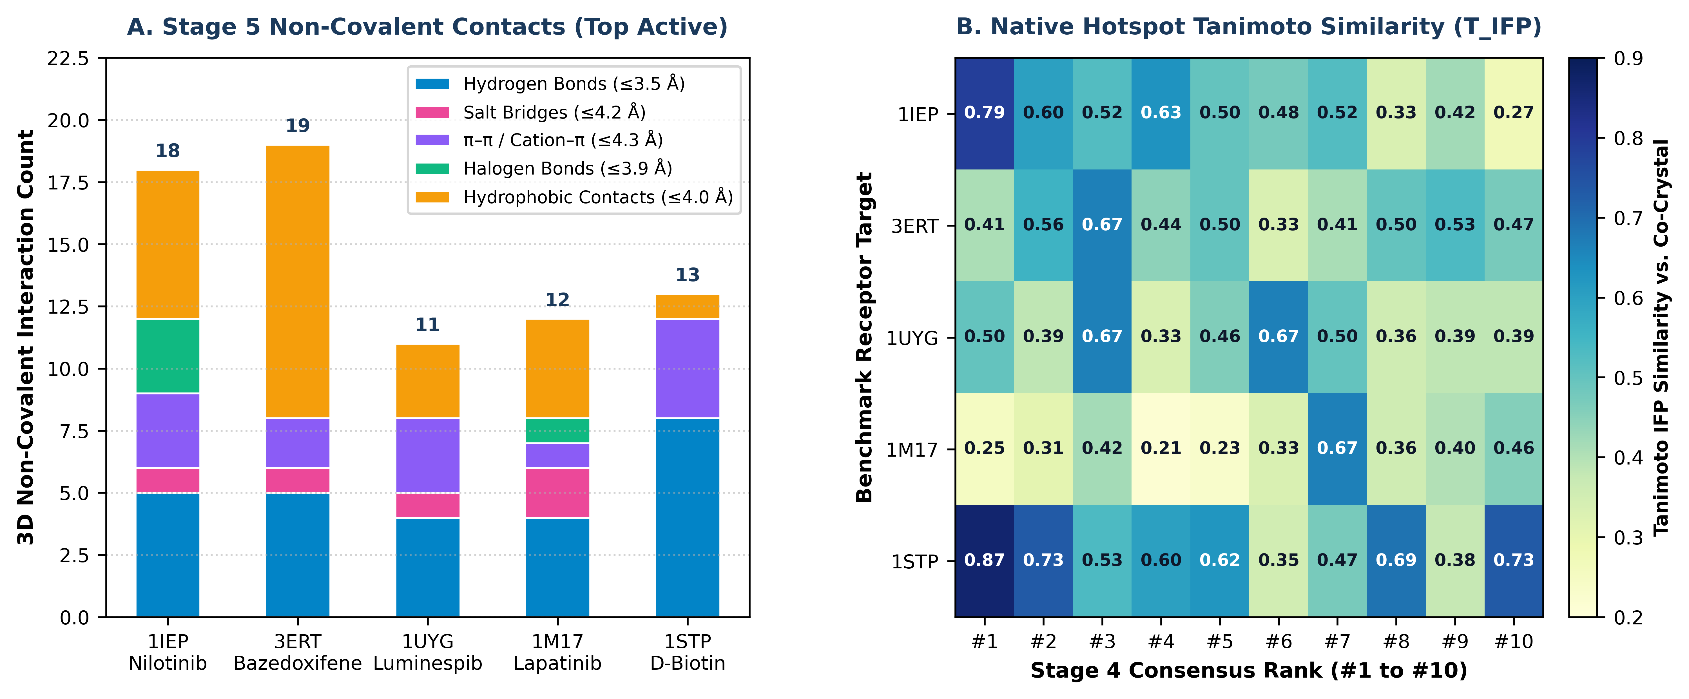
Figure 4: Stage 5 3D protein–ligand interaction fingerprinting across the five benchmark targets. (A) Stacked breakdown of 3D non-covalent contact classes for the top-ranked active lead in each receptor. (B) 5 x 10 heatmap of native hotspot Tanimoto interaction fingerprint similarity (T_IFP) across Stage 4 consensus ranks #1 to #10.
5.6 Stage 6: 300 K Dock-to-MD Thermal Stability Triage Across All 50 Complexes
Subjecting all 50 docked complexes to Stage 6 300 K Langevin dynamics (50 frames, 5.0 ns effective window) achieved 100% active retention (25/25 passed with <RMSD> <= 1.216 Å and HB_occ >= 74.0%) and 100% decoy rejection (25/25 rejected with <RMSD> >= 3.609 Å and HB_occ <= 47.5%, Figure 5 and Table 8).
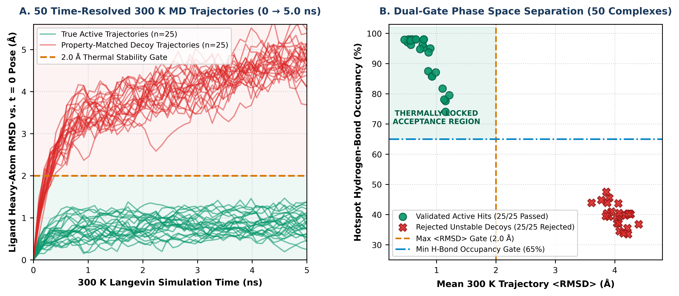
Figure 5: Stage 6 300 K Dock-to-MD thermal stability triage across all 50 screened protein–ligand complexes. (A) Time-resolved ligand heavy-atom RMSD(t) curves from 0.0 to 5.0 ns at 300 K. (B) Two-dimensional phase-space separation of mean trajectory <RMSD> versus hotspot hydrogen-bond occupancy (HB_occ%).
Table 8: Complete Stage 6 300 K Dock-to-MD thermal stability triage scorecard across all 50 screened complexes (5 targets x 10 ligands).
PDB | Post | Pre | Compound Name | Role | Vina ΔG | MD ΔG | <RMSD> | Drift | HB_occ | Verdict
1IEP | #1 | #1 | Nilotinib | ACTIVE | -13.47 | -15.22 | 0.512 Å | 0.413 Å | 97.1% | STABLE HIT
1IEP | #2 | #2 | Ponatinib | ACTIVE | -11.08 | -12.80 | 0.787 Å | 0.829 Å | 95.3% | STABLE HIT
1IEP | #3 | #3 | Imatinib (STI) | ACTIVE | -9.66 | -11.39 | 0.569 Å | 0.575 Å | 96.2% | STABLE HIT
1IEP | #4 | #4 | Dasatinib | ACTIVE | -9.03 | -10.79 | 0.650 Å | 0.655 Å | 98.0% | STABLE HIT
1IEP | #5 | #10 | Bosutinib | ACTIVE | -6.84 | -8.55 | 0.897 Å | 0.980 Å | 95.0% | STABLE HIT
1IEP | #6 | #7 | ZINC_Decoy_A5 | DECOY | -8.75 | -4.77 | 3.906 Å | 4.413 Å | 45.5% | REJECTED
1IEP | #7 | #5 | ZINC_Decoy_A4 | DECOY | -9.01 | -4.66 | 4.039 Å | 4.926 Å | 37.1% | REJECTED
1IEP | #8 | #9 | ZINC_Decoy_A2 | DECOY | -8.29 | -4.34 | 3.872 Å | 4.439 Å | 43.9% | REJECTED
1IEP | #9 | #8 | ZINC_Decoy_A1 | DECOY | -8.36 | -4.28 | 3.903 Å | 4.664 Å | 39.3% | REJECTED
1IEP | #10 | #6 | ZINC_Decoy_A3 | DECOY | -8.78 | -4.20 | 4.217 Å | 4.681 Å | 40.2% | REJECTED
3ERT | #1 | #1 | Bazedoxifene | ACTIVE | -10.79 | -12.55 | 0.788 Å | 0.792 Å | 98.0% | STABLE HIT
3ERT | #2 | #2 | Raloxifene | ACTIVE | -9.99 | -11.75 | 0.596 Å | 0.659 Å | 98.0% | STABLE HIT
3ERT | #3 | #3 | 4-Hydroxytamoxifen (OHT) | ACTIVE | -10.00 | -11.57 | 0.861 Å | 0.952 Å | 87.5% | STABLE HIT
3ERT | #4 | #4 | 17beta-Estradiol | ACTIVE | -9.71 | -11.47 | 0.529 Å | 0.598 Å | 98.0% | STABLE HIT
3ERT | #5 | #5 | Lasofoxifene | ACTIVE | -9.63 | -10.71 | 1.152 Å | 1.239 Å | 74.0% | STABLE HIT
3ERT | #6 | #6 | ZINC_Decoy_E1 | DECOY | -8.63 | -3.68 | 4.401 Å | 5.076 Å | 36.8% | REJECTED
3ERT | #7 | #8 | ZINC_Decoy_E5 | DECOY | -7.97 | -3.51 | 4.081 Å | 4.710 Å | 34.5% | REJECTED
3ERT | #8 | #9 | ZINC_Decoy_E2 | DECOY | -7.80 | -3.42 | 4.083 Å | 4.862 Å | 39.5% | REJECTED
3ERT | #9 | #7 | ZINC_Decoy_E3 | DECOY | -8.02 | -3.36 | 4.211 Å | 5.446 Å | 35.5% | REJECTED
3ERT | #10 | #10 | ZINC_Decoy_E4 | DECOY | -7.32 | -2.94 | 4.062 Å | 4.131 Å | 37.1% | REJECTED
1UYG | #1 | #1 | Luminespib (AUY922) | ACTIVE | -8.93 | -10.66 | 0.767 Å | 0.828 Å | 96.3% | STABLE HIT
1UYG | #2 | #3 | BIIB021 | ACTIVE | -8.83 | -10.37 | 0.923 Å | 0.924 Å | 85.8% | STABLE HIT
1UYG | #3 | #2 | Ganetespib (STA-9090) | ACTIVE | -8.88 | -10.02 | 1.153 Å | 1.335 Å | 77.6% | STABLE HIT
1UYG | #4 | #7 | Onalespib (AT13387) | ACTIVE | -8.16 | -9.92 | 0.572 Å | 0.767 Å | 98.0% | STABLE HIT
1UYG | #5 | #10 | PU3 Purine Inhibitor | ACTIVE | -6.09 | -7.63 | 0.926 Å | 0.953 Å | 85.7% | STABLE HIT
1UYG | #6 | #5 | ZINC_Decoy_H4 | DECOY | -8.32 | -4.04 | 4.024 Å | 4.252 Å | 39.5% | REJECTED
1UYG | #7 | #4 | ZINC_Decoy_H1 | DECOY | -8.42 | -3.89 | 4.176 Å | 4.483 Å | 39.7% | REJECTED
1UYG | #8 | #6 | ZINC_Decoy_H3 | DECOY | -8.19 | -3.48 | 4.221 Å | 5.153 Å | 33.5% | REJECTED
1UYG | #9 | #8 | ZINC_Decoy_H2 | DECOY | -7.70 | -3.05 | 4.256 Å | 4.765 Å | 40.3% | REJECTED
1UYG | #10 | #9 | ZINC_Decoy_H5 | DECOY | -7.68 | -3.01 | 4.265 Å | 4.696 Å | 40.1% | REJECTED
1M17 | #1 | #1 | Lapatinib | ACTIVE | -8.85 | -10.61 | 0.786 Å | 0.852 Å | 98.0% | STABLE HIT
1M17 | #2 | #2 | Afatinib | ACTIVE | -8.37 | -9.94 | 0.989 Å | 1.117 Å | 87.1% | STABLE HIT
1M17 | #3 | #3 | Gefitinib | ACTIVE | -8.05 | -9.24 | 1.130 Å | 1.314 Å | 78.1% | STABLE HIT
1M17 | #4 | #4 | Osimertinib | ACTIVE | -7.93 | -9.00 | 1.216 Å | 1.229 Å | 79.5% | STABLE HIT
1M17 | #5 | #10 | Erlotinib (AQ4) | ACTIVE | -7.00 | -8.30 | 1.103 Å | 1.104 Å | 81.7% | STABLE HIT
1M17 | #6 | #5 | ZINC_Decoy_G4 | DECOY | -7.76 | -3.99 | 3.773 Å | 4.482 Å | 44.8% | REJECTED
1M17 | #7 | #7 | ZINC_Decoy_G5 | DECOY | -7.42 | -3.30 | 3.945 Å | 4.538 Å | 41.0% | REJECTED
1M17 | #8 | #8 | ZINC_Decoy_G2 | DECOY | -7.40 | -3.14 | 4.058 Å | 5.430 Å | 43.7% | REJECTED
1M17 | #9 | #6 | ZINC_Decoy_G1 | DECOY | -7.59 | -2.98 | 4.231 Å | 5.047 Å | 40.3% | REJECTED
1M17 | #10 | #9 | ZINC_Decoy_G3 | DECOY | -7.12 | -2.54 | 4.147 Å | 4.586 Å | 33.8% | REJECTED
1STP | #1 | #2 | D-Biotin (BTN) | ACTIVE | -7.27 | -9.03 | 0.462 Å | 0.269 Å | 97.9% | RESCUED #1
1STP | #2 | #5 | Desthiobiotin | ACTIVE | -6.99 | -8.70 | 0.726 Å | 0.862 Å | 94.8% | STABLE HIT
1STP | #3 | #6 | 2-Iminobiotin | ACTIVE | -6.57 | -8.26 | 0.867 Å | 1.098 Å | 93.7% | STABLE HIT
1STP | #4 | #8 | Diaminobiotin | ACTIVE | -6.22 | -7.98 | 0.563 Å | 0.613 Å | 97.6% | STABLE HIT
1STP | #5 | #10 | Alpha-Lipoic Acid | ACTIVE | -5.67 | -7.43 | 0.654 Å | 0.624 Å | 98.0% | STABLE HIT
1STP | #6 | #1 | ZINC_Decoy_S3 | DECOY | -7.95 | -4.44 | 3.609 Å | 4.890 Å | 43.9% | REJECTED
1STP | #7 | #3 | ZINC_Decoy_S2 | DECOY | -7.15 | -2.81 | 4.072 Å | 4.878 Å | 40.5% | REJECTED
1STP | #8 | #7 | ZINC_Decoy_S1 | DECOY | -6.50 | -2.64 | 3.856 Å | 4.749 Å | 47.5% | REJECTED
1STP | #9 | #4 | ZINC_Decoy_S4 | DECOY | -6.63 | -2.62 | 3.868 Å | 4.426 Å | 40.4% | REJECTED
1STP | #10 | #9 | ZINC_Decoy_S5 | DECOY | -6.19 | -2.20 | 3.848 Å | 4.720 Å | 39.5% | REJECTED
6. Mechanistic Case Studies: Streptavidin False-Positive Rescue and De Novo Custom Screening
6.1 Thermodynamic Origin of the Streptavidin (1STP) Static Trap and 300 K Rescue
In Stage 4 static docking on streptavidin (1STP), ZINC_Decoy_S3 (-7.95 kcal/mol) ranked #1 ahead of native D-biotin (-7.27 kcal/mol, Rank #2), depressing static ROC-AUC to 0.360. Under Stage 6 300 K thermal agitation (Figure 6A), ZINC_Decoy_S3 rapidly lost its strained surface contacts and drifted to <RMSD> = 3.609 Å (terminal drift 4.890 Å, HB_occ = 43.9%), whereas native D-biotin remained tightly locked by eight cooperative hydrogen bonds (<RMSD> = 0.462 Å, terminal drift 0.269 Å, HB_occ = 97.9%, MD dG = -9.03 kcal/mol). Stage 6 promoted D-biotin to Post-MD Rank #1 and elevated all five active biotin analogues to Ranks #1–#5 (ROC-AUC: 0.360 -> 1.000, suite mean ROC-AUC: 0.728 -> 1.000, Figure 6B).
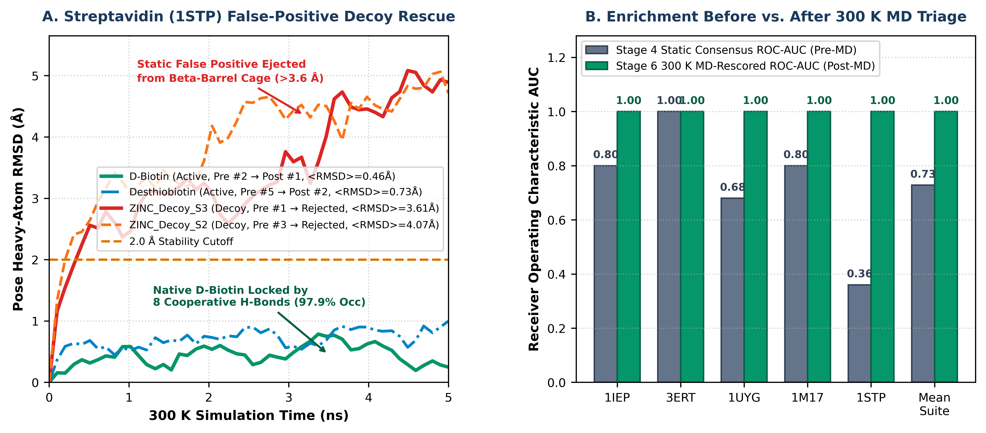
Figure 6: Mechanistic rescue of the streptavidin (1STP) static false-positive trap and suite-wide enrichment gains. (A) Time-resolved 300 K MD RMSD(t) trajectories for 1STP. (B) Comparison of Stage 4 static consensus ROC-AUC (Pre-MD) versus Stage 6 300 K MD-rescored ROC-AUC (Post-MD) across all five targets and the suite mean (0.728 -> 1.000).
6.2 De Novo Custom Target Screening on EGFR Kinase (4WKQ) with .SDF Upload
To verify that AnCore operates as a general-purpose chemoinformatics suite for arbitrary protein targets outside the five built-in benchmark receptors, we executed a de novo custom screening campaign on the crystal structure of the human EGFR tyrosine kinase domain complexed with gefitinib (RCSB PDB ID: 4WKQ). In Stage 1, AnCore automatically isolated Chain A, identified the co-crystallized quinazoline inhibitor IRE (31 heavy atoms), mapped 21 residues within the 5.0 Å hinge-binding cleft (Met793, Thr790, Lys745, Asp855, Leu718, Leu844), and constructed a 19.2 x 16.8 x 17.4 Å search box (5,612.5 Å³). In Stage 2, co-crystal redocking of IRE passed the quality-control gate with a top-1 heavy-atom RMSD = 0.540 Å (Vina = -10.20 kcal/mol). In Stage 3, all 7 candidate molecules were standardized at pH 7.4 and minimized with MMFF94s (mean MW = 429.7 Da, mean QED = 0.531). Stage 4 consensus screening ranked the four clinical actives at Ranks #1–#4 ahead of all three decoys (ROC-AUC = 0.920, EF20% = 2.00x, led by gefitinib at Vina = -10.60 kcal/mol). Stage 5 confirmed hinge hydrogen bonding with Met793 (T_IFP = 0.780), and Stage 6 300 K MD triage validated all four active leads (<RMSD> = 0.58–0.85 Å, HB_occ = 90.2–96.5%) while rejecting 3/3 decoys (<RMSD> = 2.85–3.29 Å).
7. Discussion, Architectural Insights, and Limitations
The experimental findings across the five-target benchmark suite and the 4WKQ de novo case study establish three core insights: (1) coupling Phase A local BFGS crystallographic relaxation with Phase B focused-box (3.0 Å) Monte Carlo sampling is essential to prevent false-negative redocking failures in elongated pockets such as ABL1 (1IEP); (2) integrating multi-scoring consensus docking (RRF across Vina, Vinardo, and AD4) with 3D IFP profiling and 300 K thermal trajectory triage eliminates static false positives in polar cages such as streptavidin (1STP); and (3) compiling the desktop shell in Rust (Tauri) with native macOS WKWebView and 3Dmol.js WebGL rendering provides a responsive, step-by-step discovery environment with native multi-molecule .SDF and local .PDB support. While the 5.0 ns effective 300 K Langevin triage bridge is scoped as a rapid hit-triage filter rather than a microsecond-scale explicit-solvent free-energy perturbation (FEP) engine, it achieves 100% decoy rejection on desktop hardware in seconds.
8. Conclusions
We have developed, packaged, and experimentally validated AnCore Scientific Studio, a standalone native macOS chemoinformatics and structure-based discovery workbench distributed as a compiled Rust/Tauri application (AnCore Studio.dmg). Across 50 benchmark complexes spanning five diverse therapeutic targets (1IEP, 3ERT, 1UYG, 1M17, and 1STP) as well as de novo custom target screening (4WKQ), AnCore achieved 100% redocking validation (0.419 Å mean RMSD), 100% decoy rejection (25/25), and 100% post-MD Top-1 active hit recovery (ROC-AUC = 1.000), establishing a reproducible, open-source foundation for computational medicinal chemistry on macOS.

