CV-HW2

Student_name: 宋源祎

Student_ID：522030910158

1. Written Assignment

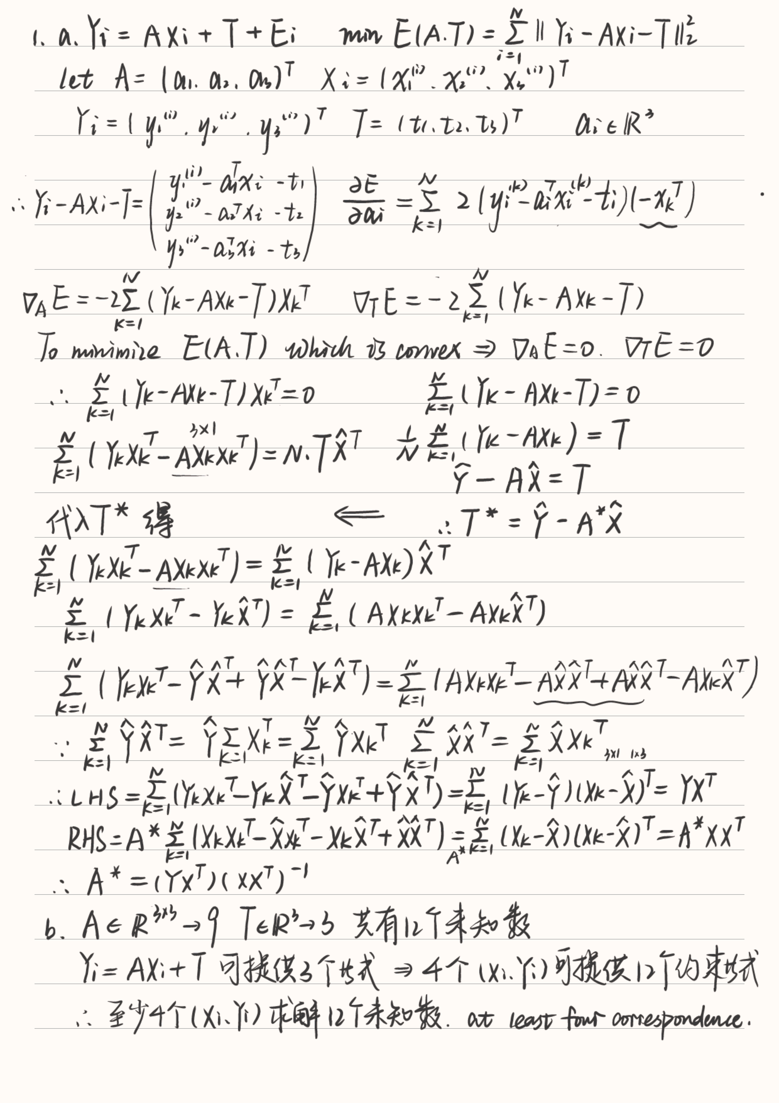

1. Programming Assignment
2. Derivation Formula

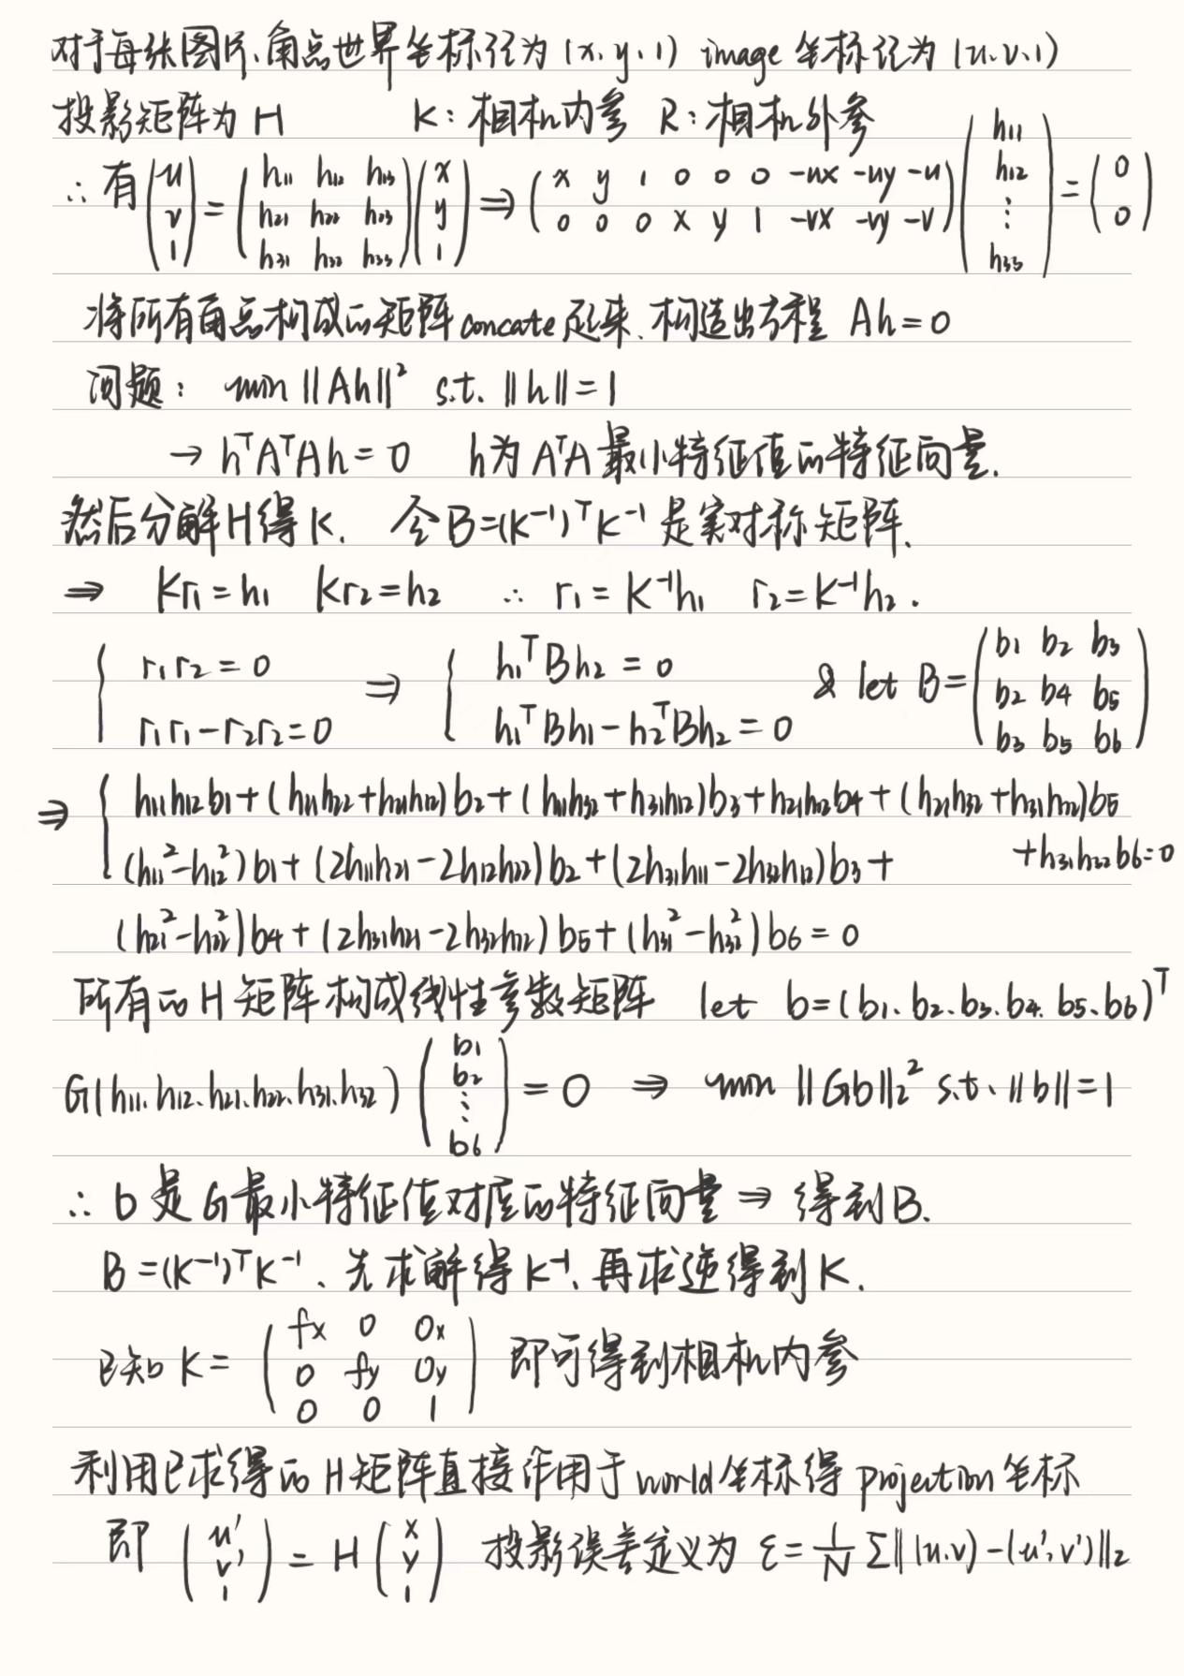

1. Experiment Conclusion

There are 25 images in given dataset, but only 4 images can be deteced the corner.

In the experiment, I try different numbers of corners closed to the image center, and get different results. Compared to standard reference from cv2.calibrateCamera, I find that using center-closed corner points are good for solve the problem exactly.

Details: (1) 32*24 blocks have 31*23 corners. (2) The shape of image returned by cv2 is (h,w,c) but the coordination is (w,h).

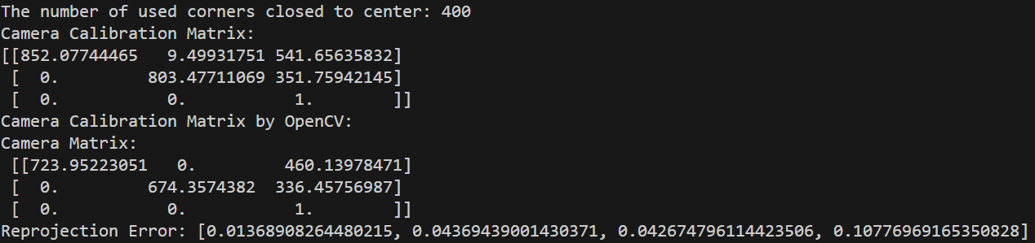

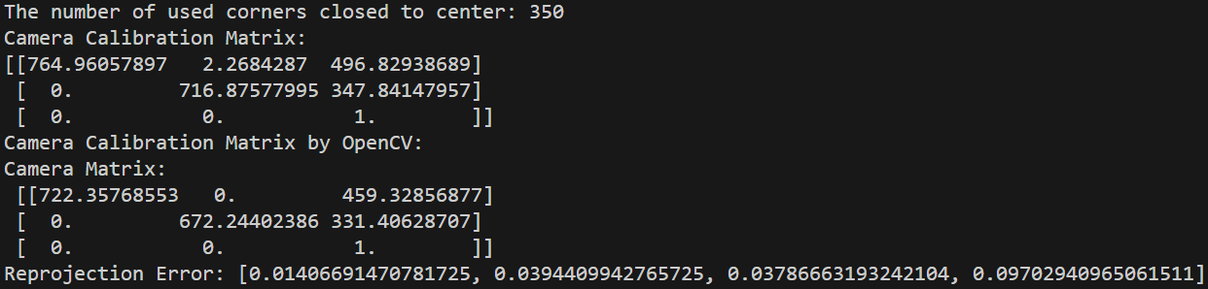

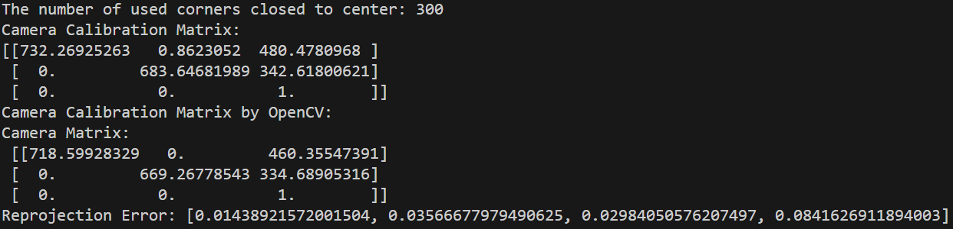

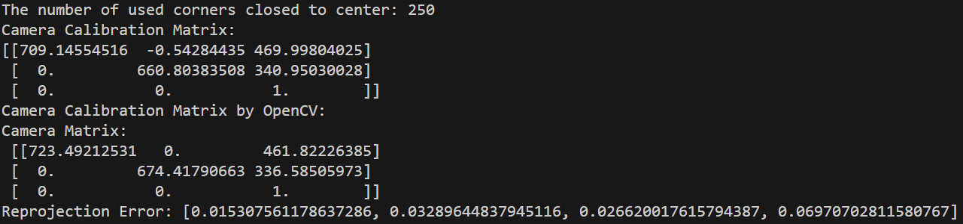In a conclusion, the focal length (fx, fy) = (732, 683) and the principal points (ox, oy) = (480, 342) when N=300.

Calculate the mean projection errors by 2-norm(square root) and I find that the errors are smaller than 0.1. So the estimation is accurate. However, the results above only check the corners closed to center, which may make results to accurate and loss generalization. I use the projection matrix of N=300 to check all corners.



The error is also small.