An Analysis of Enterprise Zone Designations in Baltimore, Maryland

Nicholas A. Orsini

Urban Economics AS.440.667.80.SP26

Spring 2026

Contents
Section I: Background 3
Deindustrialization and Disinvestment in Baltimore, Maryland: 3
Maryland's Enterprise Zone Program: 4
Section II: Policy Analysis 5
Enterprise Zones in Baltimore: 5
Enterprise Zones in Action: 6
Theoretical Framework: 8
Empirical Strategy and Data: 11
Section III: Conclusions 15
References: 17

Section I: Background

Deindustrialization and Disinvestment in Baltimore, Maryland:
Baltimore, Maryland occupies a distinctive place in American urban history: once among the nation's foremost industrial, maritime, and shipping centers, the city has spent the better part of the last century navigating the consequences of deindustrialization, population loss, and concentrated neighborhood disinvestment. Sparrows Point was once the world's largest steel producer, supporting over 30,000 families across the Baltimore region at its mid-century peak. By the time the facility finally ceased operations in 2012, after passing through five owners in the span of a decade, fewer than 2,000 workers remained on the floor (Stefano, 2017; Bloomberg, 2019). The collapse of Sparrows Point was not an isolated event but rather the most visible manifestation of a broader deindustrialization that had been hollowing out Baltimore's economic base since the 1970s (Pursuit of History, 2021). As manufacturing employment eroded, the city's population followed. Baltimore shed nearly 80,000 residents between 2000 and 2022 alone, a continuation of a decades-long exodus that has reduced the city from a mid-century population of nearly 950,000 to fewer than 575,000 today (FRED, 2026). The departure of residents and employers was neither random nor evenly distributed across the city's geography. Disinvestment concentrated in the same working-class neighborhoods that had once organized their lives around the steel mills, the shipyards, and the port, leaving behind vacancy, eroded property values, and a diminished tax base that compounded the fiscal pressures facing city government.
Table 1 presents key socioeconomic indicators for Baltimore City over the last three decades, painting a picture of persistent and compounding decline. Population fell by over 165,000 persons between 1990 and 2024, nearly a quarter of the city's residents, while total employed persons declined by more than 40,000 over the same period. Together these trends reflect a steadily eroding tax base that has compounded the fiscal pressures on city government as described above. The unemployment rate, already elevated at 7.6% in 1990, reached 11.3% at the height of the Great Recession in 2010 and has remained structurally above national averages throughout the panel window (FRED, 2026). Perhaps most striking is the divergence between housing costs and household purchasing power. The All-Transactions House Price Index, indexed to 100 in 2000, reached 266.7 by 2024, representing a near tripling of nominal housing costs over the analysis window. Real median household income, by contrast, increased by less than $8,000 in inflation-adjusted terms over the same period, oscillating narrowly between roughly $52,000 and $63,000. The result is a city where housing has become dramatically more expensive relative to the incomes of the residents who remain, a dynamic that both reflects and reinforces the spatial concentration of disinvestment.

Table 1. Baltimore City Socioeconomic Indicators, Selected Years
Year | Population | Labor Force | Employed Persons | Unemp. Rate (%) | Median HH Income (Real 2024$) | House Price Index
1990 | 735,632 | 337,841 | 312,117 | 7.6% | — | 77.1
1995 | 701,685 | 313,158 | 287,332 | 8.3% | — | 81.0
2000 | 648,746 | 280,104 | 263,514 | 5.9% | $55,903 | 100.0
2002 | 642,514 | 275,376 | 255,735 | 7.1% | $51,804 | 119.8
2005 | 640,064 | 274,072 | 255,001 | 7.0% | $54,444 | 180.8
2010 | 620,942 | 296,834 | 263,211 | 11.3% | $54,470 | 180.7
2012 | 623,035 | 298,049 | 268,157 | 10.0% | $52,925 | 168.0
2015 | 622,831 | 295,986 | 273,886 | 7.5% | $56,493 | 186.1
2020 | 583,295 | 290,141 | 266,224 | 8.3% | $62,458 | 209.4
2024 | 570,053 | 282,716 | 271,271 | 4.0% | $63,451 | 266.7
Table 1: House Price Index indexed to 2000=100. Median household income deflated to 2024 dollars using Baltimore-Columbia-Towson, MD CPI. Data Sources: Federal Reserve Bank of St. Louis (FRED), Baltimore City Series; Bureau of Labor Statistics (CPI).
The consequences of deindustrialization did not remain contained within the factory gates. Vacant industrial sites generate negative externalities that ripple outward into surrounding neighborhoods, suppressing residential property values, reducing tax revenues, and accelerating the departure of households with options (Han, 2014). As these dynamics compounded across multiple decades and multiple neighborhoods simultaneously, the scale of market failure in Baltimore's most distressed corridors grew beyond what household-level or citywide policy instruments could plausibly address. It is precisely this spatial concentration of economic dysfunction that provides the theoretical justification for place-based intervention: targeting resources not broadly but at the specific geographies where market forces alone have proven insufficient to restore equilibrium. Maryland's Enterprise Zone program represents the state's primary legislative response to precisely this kind of spatially concentrated market failure.

Maryland's Enterprise Zone Program:
Enterprise Zone Designations (EZDs) are a place-based policy designed to encourage revitalization through commercial development in economically distressed areas. The program operates through two targeted tax incentives: a local property tax credit on the assessed value of real property improvements, and a state income tax credit tied to job creation within designated boundaries. The property tax credit follows a ten-year declining schedule, providing an 80% credit for the first five years before stepping down by 10 percentage points annually through year ten. Within designated zones, certain corridors may receive Focus Area status, an intensified sub-designation that supplements the standard real property credit with an additional ten-year personal property tax credit held flat at 80% throughout its duration. Together these incentives reduce the effective cost of capital investment and incentivize firms to locate and expand within designated boundaries (Maryland Department of Commerce, 2025).
Maryland introduced its Enterprise Zone program in 1982 with two designations across two jurisdictions. Over the following four decades the program expanded steadily, growing to 34 designated zones across the state by 2025 (Maryland Department of Commerce, 2025). The program's administration is distinctive in its multilateral structure: local jurisdiction administrators manage day-to-day program operations and may establish additional eligibility requirements beyond state statute, while the Maryland Department of Commerce approves zone designations and the State Department of Assessments and Taxation tracks credit utilization. While a local jurisdiction may appear to forego tax revenue on new capital improvements, the state reimburses up to half of the abated property tax, and the investment itself generates an expanded tax base that would not otherwise exist. Statewide, EZ-designated areas attracted over $5 billion in capital investment in FY 2025 alone (Maryland Department of Commerce, 2025). This paper examines whether that investment has translated into measurable property value appreciation within Baltimore's designated zones, and what that relationship implies for the program's continued use as a tool for urban revitalization.

Section II: Policy Analysis

Enterprise Zones in Baltimore:
Baltimore City implemented its first Enterprise Zone Designations (EZDs) in 2002 and has since grown to become one of the most active participants in Maryland's statewide EZ program. There have been two subsequent redesignation waves, in 2012 and 2022, each reshaping the program's geographic footprint to reflect shifting patterns of disinvestment and emerging revitalization priorities across the city. By FY 2025, Baltimore's designated zones spanned over 16,700 acres and accounted for approximately 36% of cumulative statewide capital investment over the preceding four fiscal years, with over $1.8 billion in qualifying property improvements projected for FY 2026 alone (Maryland Department of Commerce, 2025).
The first major redesignation was in 2012, producing a zone covering 13,453 acres across Baltimore, representing nearly a quarter of the city's total land area. In 2022, the Maryland Department of Commerce approved a substantial redesignation, expanding the zone to 16,674 acres and introducing significant boundary changes. Areas that had improved sufficiently were removed while new distressed corridors were added (Miller & Williams, 2022; Maryland Department of Commerce, 2025). Notable areas that were removed include Harbor Point, portions of Canton, and Little Italy, areas whose economic trajectories no longer reflected the distress conditions the program is designed to address. In their place, corridors including Belair Road, Greenmount Avenue, Highlandtown, and the York Road Corridor were brought into designation, extending EZ coverage deeper into Baltimore's persistently disinvested eastern and northern neighborhoods (Miller & Williams, 2022).
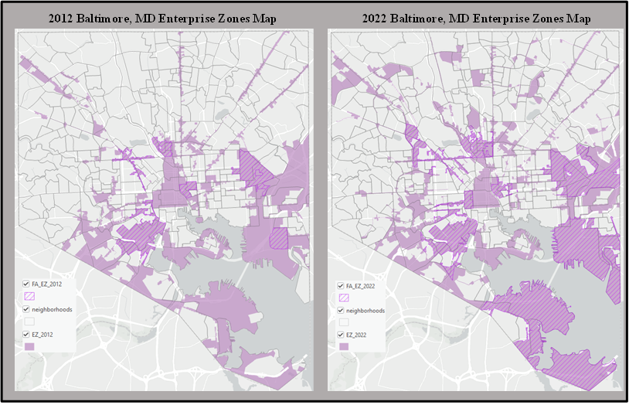
Within the broader EZ geography, select corridors carry Focus Area (FA) designation, an intensified sub-designation that holds the real property tax credit flat at 80% for the full ten-year period and extends coverage to personal property taxes on new investment. Baltimore is one of only two jurisdictions in Maryland currently operating Focus Areas, alongside Prince George's County (Maryland Department of Commerce, 2025). FAs are not a recent innovation; by 2012, Baltimore City was already operating several, including the Carroll Camden, Central West, Holabird/Orangeville, Jones Falls, and Oldtown Focus Areas, encompassing more than 2,100 acres within the broader EZ footprint (Maryland Department of Commerce, 2018). The 2022 redesignation further expanded FA boundaries in the Canton and Pulaski/Orangeville corridors and new FA status was added to the South Industrial Areas. These expansions reflect continued institutional confidence in the FA tool as a mechanism for catalyzing investment in Baltimore's most distressed corridors. The renewal and growth of legacy Focus Areas such as Holabird/Orangeville and Oldtown across multiple designation cycles suggests the enhanced incentive structure has been sufficient to attract and retain certified businesses, providing the empirical basis for extending the model to new areas.
Map 1: Enterprise Zone and Focus Area designations for Baltimore City under the 2012 and 2022 Maryland EZ cycles. Hatched polygons indicate Focus Areas; solid shading indicates broader EZ coverage. Neighborhood boundaries shown for reference.

Enterprise Zones in Action:
Enterprise Zones are not unique to Maryland; place-based tax incentive programs targeting economically distressed geographies have been implemented across the United States for decades and have generated a substantial body of empirical research. That research, however, has produced decidedly mixed results. While Baltimore's sustained redesignations and FA expansions suggest the program has been sufficient to attract continued investment, the broader literature cautions against assuming designation alone drives meaningful economic change. This section examines the theoretical mechanisms through which EZ designations are expected to produce property value appreciation and reviews the empirical evidence on when and why those mechanisms succeed or fall short.
The empirical study of Enterprise Zone programs dates back to the program's infancy. Early descriptive assessments, including case studies of individual zones by Jones (1985, 1987) and a ten-zone survey conducted by the U.S. Department of Housing and Urban Development (1986), documented measurable increases in investment and employment activity following designation, but could not establish a causal relationship. The foundational comparative work of Brintnall and Green (1988) catalogued the structural diversity of state EZ programs along seven dimensions, from incentive mix and eligibility criteria to administrative autonomy and zone size. They concluded that this heterogeneity made cross-program generalization analytically untenable. Wilder and Rubin (1996) extended that critique into a systematic review of the empirical literature, finding two common constraints that crippled early research, the absence of reliable quantitative data and the endogenous nature of the problem that made it near-impossible to isolate program effects from the broader economic conditions that shaped both designation decisions and post-designation trajectories. When analyzing Baltimore, these concerns are not merely abstract. The city's economic trajectory over the decades preceding each designation wave is marked by deindustrialization, population loss, and the spatial concentration of vacancy as documented in Section I. And the areas selected for EZ status were already among the most distressed in the city. Disentangling the program's contribution from the underlying conditions that motivated designation in the first place is precisely the identification challenge faced in early literature and one that is important to address when evaluating the efficacy of EZs in Baltimore.
What the early literature did establish is that EZ incentives appear to operate differently depending on the local economic context. Zones anchored in areas retaining some commercial base showed more consistent evidence of investment activity than those targeting the most severely distressed corridors. Larger capital-intensive firms responded more reliably to property tax incentives than the small labor-intensive businesses that populated the neighborhoods the programs were designed to help (Wilder & Rubin, 1996). The identification revolution in applied economics during the nineties sharpened both the tools and the frustrations in causal inference. Papke (1994) provided one of the first credible quasi-experimental assessments of EZ impacts by exploiting variation in Indiana's EZ program. He found an eight percent increase in inventory values and a nineteen percent reduction in unemployment claims following designation. Boarnet and Bogart (1996) found no significant employment or property value effects in New Jersey, and Bondonio and Engberg (2000) reached the same null conclusion across five state programs simultaneously. Additionally, Billings (2009), using a border-matching strategy that compared establishments just inside and just outside EZ boundaries in Colorado, found that while tax credits had no measurable effect on where new businesses chose to locate, they did generate modest employment gains within designated areas. Billings also noted the modest employment gains observed were consistent with landlords capitalizing the tax credits into higher rents through increased land values, effectively neutralizing the cost advantage the program was designed to provide to firms. Neumark and Kolko (2010) arrived at similar conclusion from analyzing California’s Enterprise Zones. They found no significant employment effects and no evidence of positive spillovers to surrounding areas. Neumark and Young (2021) extended the analysis across thirteen states and through longer time horizons, finding that the absence of positive effects was not merely a short-run phenomenon. If anything, longer-run effects trended negative and emphasized the importance of program design and the structure of incentives offered to designated firms.
Despite all of the inconclusive findings associated with Enterprise Zones, Busso, Gregory, and Kline (2013) found that federal Empowerment Zones generated substantial employment gains and wage increases for local workers without corresponding increases in population or housing costs. Their results suggest that under certain conditions place-based subsidies can produce genuine welfare improvements rather than mere transfers to landowners. Notably, Busso et al. found no corresponding increases in housing costs or property values within Empowerment Zones, suggesting that under federal program conditions, employment gains did not fully capitalize into land values. That finding stands in tension with the Billings (2009) result, where capitalization into rents appeared to be the primary channel through which designation affected local markets. This along with the broader review of the literature therefore yields an uncomfortable conclusion: results are mixed, context-dependent, and sensitive to both program design and identification strategy. That tension is not one that more data alone can resolve. It reflects a deeper theoretical question about how the incidence of a place-based tax incentive is determined, whether the benefit flows to the firms the program targets, the property owners who supply the space those firms occupy, or the workers whose wages and residential options adjust in response. Answering that question requires working through the economic mechanisms from first principles.

Theoretical Framework:
At its most fundamental level, an Enterprise Zone designation is a tax incentive, and the welfare economics of tax incentives provides the appropriate starting point for evaluating what such a program can and cannot accomplish. We begin by considering the traditional setup of the Rosen-Roback model (Brueckner, 2011). Consider a set of agents $\{x, y\}$ distributed across a discrete set of locations $j ∈J.$ Utility-maximizing consumers choose where to live and how much housing and consumption to demand, and profit-maximizing firms choosing where to locate and how much real estate to occupy as a factor of production. Agents are initially assumed to be identical and perfectly mobile across locations. Consumers maximize a CES utility function defined over consumption of a numeraire commodity, bread, $c$, housing $q$, and a location-specific amenity index $a_{j}$:
$$u\left(c,q,a\right)={\left[αc^{\frac{σ-1}{σ}}+ βq^{\frac{σ-1}{σ}}+γa^{\frac{σ-1}{σ}}\right]}^{\frac{σ}{σ-1}}$$
where $σ>0$ is the elasticity of substitution between goods and $α,β,γ>0$are share parameters. Optimizing subject to the budget constraint $y=c+pq$, where $y$ is income and $p$ is the price per unit of real estate. Together, this yields the indirect utility function $V(y,p,a)$, which summarizes the maximum utility achievable at a given income, price level, and amenity endowment. With perfect mobility, spatial equilibrium requires:
$$V\left(y_{j},p_{j},a_{j}\right)=\overline{u} ∀j∈J$$
On the firm side, producers face a unit cost function $C(y_{j},p_{j},a_{j})$ that is increasing in wages and prices, with ambiguous movement in amenities. Under perfect competition with constant returns to scale, zero profits require:
$$C\left(y_{j}​,p_{j}​,a_{j}​\right)=1∀j∈J$$
Together, these two conditions pin down the equilibrium wage $y_{j}$and land price $p_{j}$as joint functions of the amenity index $a_{j}$at each location. The model predicts that high-amenity locations command higher land prices and, depending on whether amenities reduce firm costs, potentially lower wages: consumers bid up rents to access desirable locations while firms adjust wages to reflect their local cost conditions (Brueckner, 2011). In this benchmark, any location-specific advantage is fully arbitraged away through price adjustment.
Now consider an enterprise zone is introduced at location $j$, which operates as an ad valorem subsidy, $s$, on assessed real property improvements, reducing the effective land price faced by firms from $p_{j}$ to $p_{j}(1-s)$. This shock affects both consumer and firm equilibrium conditions simultaneously. The zero-profit condition becomes $C\left(y_{j}​,p_{j}​(1-s),a_{j}​\right)=1$. This new equilibrium occurs at a lower land price or higher wage than before, shifting the firm’s isoprofit curve outward and altering the equilibrium pair $\left(y_{j}^{*} , p_{j}^{*}\right)$. The consumer indifference condition adjusts in response as workers and landlords respond to changed local prices and amenity conditions. The direction of these adjustments is determined analytically, but their magnitudes, and crucially the question of who captures the welfare gain, is not. If labor and capital are highly mobile across locations, the subsidy is rapidly arbitraged: firms flood into the designated area, driving up demand for commercial space, and landlords raise rents until the cost advantage is eliminated. The subsidy has been capitalized into land values and the firm is no better off than before designation. If, on the other hand, agents are imperfectly mobile, some combination of genuine firm-level cost reduction, local employment gains, and residential property value appreciation may materialize before full arbitrage occurs. As Busso, Gregory, and Kline (2013) demonstrate formally, the incidence of a place-based subsidy depends critically on the distribution of agents' preferences over residential and commuting options. When most agents are inframarginal in their location decisions, deadweight loss is small and local stakeholders capture real welfare gains. However, when agents are nearly identical and perfectly mobile, as the canonical Rosen-Roback framework assumes, the subsidy is fully capitalized into rents and welfare gains are zero. The EZ designation therefore could generate genuine improvements in local welfare, or it could function as a transfer of public revenue to private landowners, and the model alone cannot tell us which.
The assumptions underlying this framework, perfect mobility and constant returns to scale, are useful theoretical benchmarks precisely because Baltimore's designated corridors violate them. In reality, the locations selected for EZ designation are chosen because they have failed to attract investment through normal market mechanisms, which is itself evidence that the frictionless arbitrage the Rosen-Roback model assumes has broken down. Returns to scale in urban production are not constant: as Neumark and Simpson (2015) and the broader agglomeration literature document, the density of economic activity generates positive externalities through shared labor markets, knowledge spillovers, and thick intermediate input markets that increase the productivity of firms and workers. These increasing returns create the conditions for a poverty trap. Distressed corridors remain underinvested not because firms are irrational, but because the private return to locating there is too low, even when the social return, accounting for the spillovers that additional investment would generate for neighboring firms and residents, is high. No individual firm has an incentive to internalize that gap. When this is the case, the simple capitalization result no longer holds. A well-targeted subsidy does not merely reshuffle who pays for space; it can make investment privately rational in a location where it otherwise would not be, potentially triggering the kind of self-reinforcing density increase that agglomeration economies require to take hold.
The theoretical framework developed here motivates a reduced-form empirical strategy centered on a single estimable quantity: the average difference in real assessed property values between EZ-designated parcels and the broader citywide distribution of commercial and residential parcels, before and after each designation wave. Formally, the baseline estimating equation takes the form:
$$ln⁡V_{jt}=α+β⋅{\text{EZ}}_{jt}+X_{jt}γ+δ_{t}+ε_{jt}$$
where $\ln{V_{jt}}$ is the log of real assessed property value for parcel $j$ in year $t$, ${\text{EZ}}_{jt}$ is an indicator for active EZ designation, $X_{jt}$ is a vector of parcel-level controls, and $δ_{t}$ is a vector of year fixed effects absorbing citywide valuation trends. The coefficient $β$ captures the net capitalization effect of EZ designation into real property values above those trends. The theoretical ambiguity established above means that $β$ could be positive, zero, or negative depending on the degree of agent mobility, the elasticity of local housing supply, and whether agglomeration externalities are sufficient to sustain investment above the private return threshold. Resolving that ambiguity empirically is the task of the analysis that follows.

Empirical Strategy and Data:
The empirical analysis draws on a parcel-level panel dataset provided by the Maryland Department of Planning (MDP) through a data sharing arrangement with Gary Maragos. The dataset spans 2002 through 2024 and covers the universe of assessed parcels within Baltimore City, with each observation recording the state-assessed real property value alongside a set of structural characteristics such as square footage of structure (SQFTSTRC), year built (YEARBLT), and a structural grade classification (STRUGRAD). All assessed values are deflated to constant 2024 dollars using the Baltimore-Columbia-Towson MSA Consumer Price Index, ensuring that the outcome variable reflects real changes in property wealth rather than nominal price movements driven by regional inflation trends. Additionally, 2012 and 2022 Enterprise Zone and Focus Area boundaries were provided by Gabrielle Linder from Baltimore Development Corporation. Unfortunately, BDC records from the original 2002 designation were never digitized, and a subsequent review of cold-storage paper files confirmed the original boundary maps have been lost (G. Linder, personal communication, April 2025). Therefore, the subsequent analysis draws on insights provided in 2012 and 2022 waves.
The parcel panel is unbalanced. Assessment records are available for 2002–2013, 2015, 2017, 2021–2024; observations for 2014, 2016, 2018–2020 are absent from the MDP extract. The post-2012 gap sequence is consequential for the methodological approach. The 2012 designation wave, which expanded the EZ footprint to up to 13,453 acres, is followed almost immediately by the gap sequence, leaving the post-2012 treatment window too thin to support reliable estimation of the program's capitalization effects. The 2022 designation wave, by contrast, is preceded by a single clean pre-period observation in 2021 and followed by three consecutive post-designation years covering 2022, 2023, and 2024. The 2022 wave therefore serves as the primary treatment effect estimator in this analysis. The 2012 wave is retained in the panel and used primarily to validate the parallel trends assumption: the pre-2012 window from 2002 through 2011 provides a long baseline over which parcels later designated under the 2022 wave can be compared for differential pre-trends, though it bears noting that an active EZ program was operating under the unrecoverable 2002 designation throughout this period, meaning the pre-2012 window does not represent a fully untreated baseline.
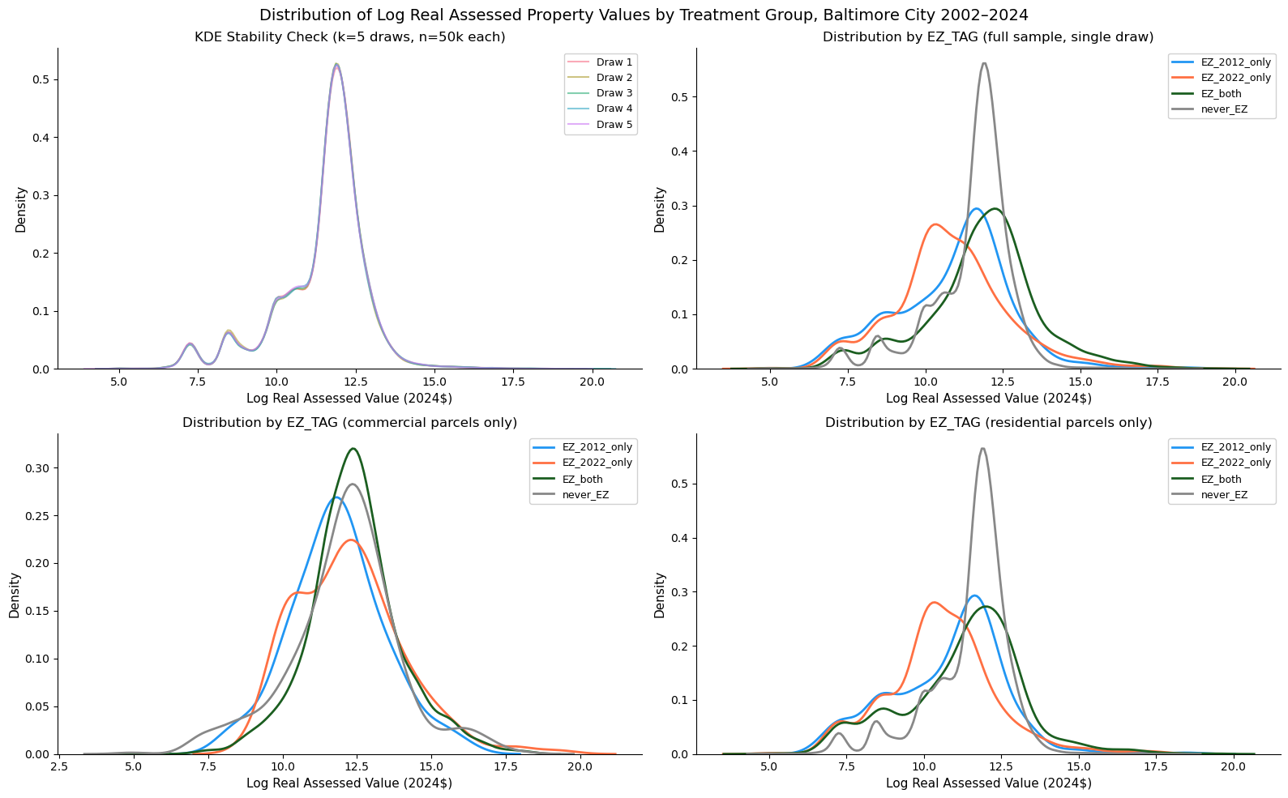
To begin analyzing the effectiveness of Baltimore's Enterprise Zone program, I assembled a full parcel-year panel from the MDP extract, removing observations with null or zero total assessed values, null or blank street addresses, and parcel centroids falling outside the Maryland State Plane bounding box for Baltimore City. These records primarily represent utility infrastructure, public rights-of-way, and geocoding artifacts rather than taxable real property, and their inclusion would introduce noise into the distributional analysis. After applying these filters, the resulting panel contains approximately 4,075,312 parcel-year observations across 18 assessment years. From the assembled panel, I deflated all nominal assessed values to constant 2024 dollars using the Baltimore-Columbia-Towson MSA Consumer Price Index, constructing the primary outcome variable, log real total assessed value. I then constructed several key analytical variables including binary land use indicators distinguishing commercial and industrial parcels from residential, treatment indicators for EZ and Focus Area designation status based on spatial joins to the 2012 and 2022 boundary shapefiles provided by the Baltimore Development Corporation (BDC), and year and neighborhood identifiers for use as fixed effects.
Figure 1. Distribution of log real assessed property values (2024 dollars) by Enterprise Zone treatment group, Baltimore City, 2002–2024. Panels draw on a single random sample of 50,000 parcel-year observations; KDE stability check across k=5 independent draws confirms the sample is representative of the full observation panel. Data Source: parcel data Maryland Department of Planning; values deflated using the Baltimore-Columbia-Towson MSA Consumer Price Index BLS.
I then analyzed the distribution of log real assessed values across treatment groups. Figure 1 presents this distribution under four views, all drawing on a single random sample of 50,000 parcel-year observations from the full panel. The top-left panel confirms the sample is representative through a KDE stability check across k=5 independent draws, with near-perfect overlap across all five. The remaining three panels stratify observations by EZ designation history, parcels designated only under the 2012 wave (EZ_2012_only), only under the 2022 wave (EZ_2022_only), those designated under both waves (EZ_both), and those never designated (never_EZ).
Never-designated parcels concentrate narrowly around a log value of 12, while EZ-designated groups are flatter and left-shifted, consistent with the program's targeting of distressed corridors. This pattern sharpens among commercial parcels, where continuously designated properties (EZ_both) show a pronounced rightward shift relative to never-designated commercial parcels, suggesting higher-valued commercial properties have been drawn into or retained within EZ boundaries across multiple cycles. Residential parcels tell a different story: since EZ incentives target commercial investment directly, any residential effect operates solely through spillover, and the left-shift among designated residential parcels reflects the underlying distress of selected corridors rather than a program outcome.
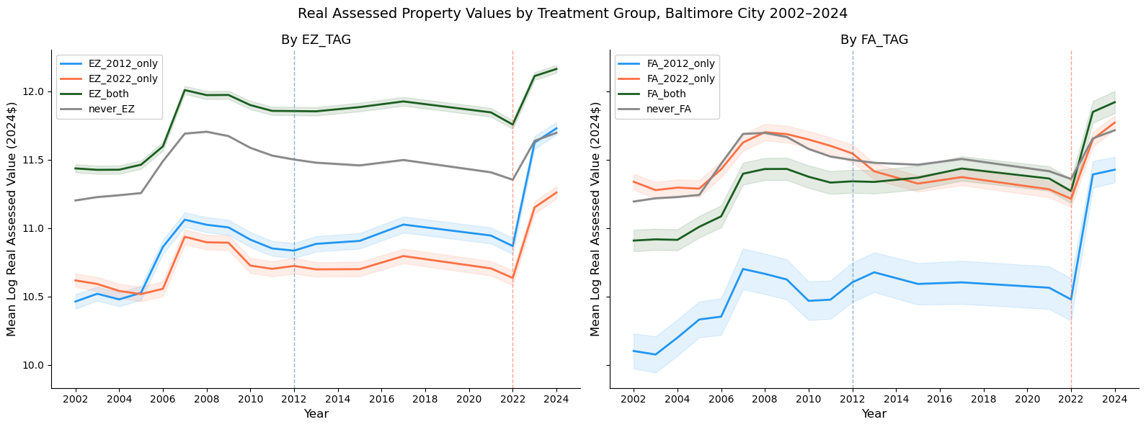
Figure 2 presents mean log real assessed property values by treatment group over the full 2002–2024 panel, with dashed vertical lines marking the 2012 and 2022 redesignation years. Prior to 2022, treatment groups track broadly similar trajectories, particularly between EZ_2022_only and never_EZ parcels, the operative comparison for the primary estimator. Parcel fixed effects absorb time-invariant differences in levels across groups, so the identifying assumption requires only that changes in assessed values would have followed parallel paths absent designation. The visual evidence is broadly consistent with that assumption over the pre-period. A formal Wald test on the pre-period interaction terms rejects the null of parallel trends, though this result should be interpreted cautiously given the sample size: with over three million observations the test has sufficient power to flag economically negligible deviations, and the figure suggests the pre-period differentials are modest in magnitude rather than systematic.
Figure 2. Mean log real assessed property value (2024 dollars) by treatment group, Baltimore City, 2002–2024. Left panel groups parcels by Enterprise Zone designation history; right panel groups the same parcels by Focus Area designation history. Shaded bands represent ±2 standard errors of the group mean. Dashed vertical lines mark the 2012 and 2022 EZ redesignation years. Assessed values reflect Maryland State Department of Assessments and Taxation (SDAT) parcel-level data provided by the Maryland Department of Planning; all nominal values deflated to constant 2024 dollars using the Baltimore-Columbia-Towson MSA Consumer Price Index. Panel years 2014, 2016, 2018, 2019, and 2020 are absent from the MDP extract and are excluded from the series.
The sharp upward jump visible across all groups at 2022 warrants separate attention. This spike is not unique to EZ-designated parcels and therefore does not reflect a treatment effect. Rather it reflects two compounding features of the data-generating process. Maryland's triennial reassessment cycle means the 2021 and 2022 assessment records absorb value changes that accumulated during the missing 2018–2020 years, compressing gradual appreciation into a single visible step. The year fixed effects in all regression specifications absorb this common shock, isolating within-group variation in assessed values net of citywide reassessment timing.
To estimate the effect of EZ designation on real property values, I estimate a panel OLS model with parcel fixed effects and year indicators for 2022, 2023, and 2024, using 2021 as the omitted baseline. The specification controls for structural grade, land area, and structure square footage. Standard errors are clustered at the neighborhood level to account for spatial correlation in assessed values within Baltimore's defined neighborhood boundaries. I estimate four models: Models A and B run on the full parcel sample, with Model B adding Focus Area status to the baseline EZ treatment indicator; Models C and D restrict the sample to commercial and industrial parcels, the population most directly targeted by the real property tax credit, with Model D again adding Focus Area status. The results presented in Table 2 show EZ designation has had little to no measurable impact on real assessed property values.
Table 2. EZ OLS Regression Results
Table 2: OLS regression results across 4 tested models.
The null results still tell a compelling narrative while also highlighting deeper data concerns that can be addressed in future work. The only variable of significance across all four models was STRUGRAD, where a one-unit increase in structural grade is associated with approximately a 39% increase in real assessed property value (e^0.33 - 1). This makes sense as variations in grade are primarily driven by new construction or substantial improvement, precisely the kind of investment the EZ program is designed to catalyze. Structure square footage tells a theoretically similar story but its coefficient is effectively zero, likely because square footage changes rarely within a parcel over time, leaving little within-variation for the fixed effects estimator to identify. The treatment indicator IN_EZ_ACTIVE is statistically insignificant across all four specifications, with p-values well above conventional thresholds. Rather than interpreting this as evidence that EZ designation has no effect, the null likely reflects the limitations of a short post-designation window combined with Maryland's triennial reassessment cycle, which means EZ-driven investment may not yet have been captured in assessed values within the 2021-2024 observation period.

Section III: Conclusions
The Rosen-Roback spatial equilibrium framework provides the theoretical lens through which to interpret these results. An Enterprise Zone designation operates as an amenity shock targeted at firms, reducing the effective cost of capital investment through the real property tax credit. Theory predicts that in a frictionless market this shock would be rapidly arbitraged as firms flood into designated corridors, driving up demand for commercial space, and landlords raise rents until the cost advantage is eliminated. The subsidy capitalizes into land values and the firm is no better off than before designation. In practice however Baltimore's designated corridors are precisely the locations where frictionless arbitrage has broken down. The more realistic expectation is that designation lowers the private cost of investment enough to make distressed corridors marginally attractive, triggering new construction and improvement activity that, once assessed by SDAT, would reflect as higher real property values. The null results in this analysis are consistent with that mechanism being present but not yet detectable within the short post-designation window available.
Without intervention, distressed corridors can fall into a negative feedback loop where depressed property values discourage investment, accelerating vacancy and further suppressing values. Baltimore's post-industrial landscape, documented in Section I, is precisely this dynamic playing out over decades. In this context the appropriate benchmark for evaluating Enterprise Zone effectiveness may not be dramatic property value appreciation but stabilization. A program that arrests decline in corridors that have been disinvesting for fifty years is delivering real value even if assessed values do not surge above citywide trends. The trade-off worth noting however is the one Billings (2009) identified, where if the tax credit succeeds in attracting investment, landlords rather than firms may capture the benefit through higher rents, neutralizing the cost advantage the program was designed to provide. This incidence question cannot be resolved with property value data alone and represents an important caveat on any positive interpretation of future capitalization effects.
A significant limitation in this analysis was the absence of recoverable 2002 EZ designation boundaries, which prevented full utilization of the parcel time series and hampered estimation of the 2012 wave's capitalization effects. Compounding this, the MDP extract contains mid-panel gaps for 2014, 2016, and 2018 through 2020, leaving the post-2012 treatment window too thin to support reliable inference and reducing the 2022 wave to a single pre-period observation in 2021. Maryland's triennial reassessment cycle presents a further constraint, as SDAT reassesses properties on a rolling three-year schedule meaning any given cross-section contains a mix of freshly assessed and lagged values. EZ-driven investment completed after the 2022 redesignation may not yet appear in assessed values within the 2021 through 2024 observation window, which is the most plausible explanation for the null results.
Table 3. EZ Descriptive Value Changes
Table 3: 2021 and 2024 mean assessed value within each designation and their 2021-2024 changes.
While causal identification remains constrained by the data limitations described above, descriptively EZ-designated parcels have appreciated at a faster rate than non-designated parcels over the 2021-2024 window, a pattern consistent with the capitalization mechanism even if it cannot yet be attributed to designation alone. Table 3 presents mean log real assessed values by treatment group for 2021 and 2024. Focus Area designated parcels show the largest change at 0.615 log points, roughly double the 0.308 recorded for never-designated parcels. EZ-only parcels appreciated at 0.273, modestly below the never-designated group. The FA result warrants caution however, as the 2022 boundary expansion added substantial industrial acreage to Focus Area coverage, and the observed appreciation may partly reflect composition effects rather than the incentive structure alone.
The literature largely shows mixed results on whether Enterprise Zone designations successfully translate investment incentives into measurable welfare improvements. This analysis of Baltimore's 2022 redesignation largely reflects that null finding, with EZ designation producing no statistically significant effect on real assessed property values over the 2021-2024 window. The Rosen-Roback framework reminds us however that the absence of detectable capitalization is not the same as the absence of effect; in corridors as distressed as Baltimore's designated areas, even stabilizing values against a decades-long disinvestment trend represents a meaningful policy outcome. The descriptive evidence in Table 3 is at least consistent with that interpretation. Future work should obtain a continuous longitudinal panel directly from SDAT, which would fill the mid-panel gaps, enable a cleaner evaluation of the 2012 wave, and provide the post-designation depth needed to complete a full reassessment rotation. The 2032 redesignation cycle is the natural horizon for a more definitive evaluation, and the spatial joins, treatment indicators, and panel structure developed here can be extended rather than rebuilt as additional years become available.

References:
Billings, S. (2009). Do enterprise zones work? An analysis at the borders. Public Finance Review, 37(1), 68–93. https://doi.org/10.1177/1091142108321238
Bloomberg. (2019, May 15). Photos: What Bethlehem Steel meant to Baltimore. https://www.bloomberg.com/news/articles/2019-05-15/photos-what-bethlehem-steel-meant-to-baltimore
Boarnet, M. G., & Bogart, W. T. (1996). Enterprise zones and employment: Evidence from New Jersey. Journal of Urban Economics, 40(2), 198–215. https://doi.org/10.1006/juec.1996.0029
Bondonio, D., & Engberg, J. (2000). Enterprise zones and local employment: Evidence from the states' programs. Regional Science and Urban Economics, 30(5), 519–549. https://doi.org/10.1016/S0166-0462(00)00042-9
Brintnall, M. A., & Green, R. E. (1988). Comparing state enterprise zone programs: Variations in structure and coverage. Economic Development Quarterly, 2(1), 50–68. https://doi.org/10.1177/089124248800200106
Busso, M., Gregory, J., & Kline, P. (2013). Assessing the incidence and efficiency of a prominent place-based policy. American Economic Review, 103(2), 897–947. https://doi.org/10.1257/aer.103.2.897
Han, H.-S. (2014). The impact of abandoned properties on nearby property values. Housing Policy Debate, 24(2), 311–334. https://doi.org/10.1080/10511482.2013.832350
Jones, E. (1985). Enterprise zone studies in Bridgeport, Connecticut and Decatur, Illinois, as cited in Wilder, M. G., & Rubin, B. M. (1996). Rhetoric versus reality: A review of studies on state enterprise zone programs. Journal of the American Planning Association, 62(4), 472–492. https://doi.org/10.1080/01944369608975709
Maryland Department of Commerce, Office of Finance Programs. (2025, December). Enterprise zones annual status report: Calendar year 2025. https://commerce.maryland.gov/Documents/Enterprise.Zone.Annual.Report.2025.pdf
Miller, A., & Williams, J. (2022, June 7). Baltimore City's Enterprise Zone boundaries are being redrawn and expanded – Certain businesses and developers in areas losing the designation must act quickly to preserve eligibility for tax credits. Rosenberg Martin Greenberg. https://rosenbergmartin.com/baltimore-citys-enterprise-zone-boundaries-are-being-redrawn-and-expanded-certain-businesses-and-developers-in-areas-losing-the-designation-must-act-quickly-to-preserve-eligibility/
Neumark, D., & Kolko, J. (2010). Do enterprise zones create jobs? Evidence from California's enterprise zone program. Journal of Urban Economics, 68(1), 1–19. https://doi.org/10.1016/j.jue.2010.01.002
Neumark, D., & Young, T. (2021). Heterogeneous effects of state enterprise zone programs in the shorter run and longer run. Economic Development Quarterly, 35(2), 91–107. https://doi.org/10.1177/0891242420982341
Nicholas, O. (2026). Baltimore parcel analysis [Source code]. GitHub. https://github.com/norsini1515/baltimoreparcel
Papke, L. E. (1994). Tax policy and urban development: Evidence from the Indiana enterprise zone program. Journal of Public Economics, 54(1), 37–49. https://doi.org/10.1016/0047-2727(94)90069-8
The Pursuit of History. (2021, December 22). Sparrows Point: From steelmaking to distribution center hub. https://thepursuitofhistory.org/2021/12/22/sparrows-point-from-steelmaking-to-distribution-center-hub/
Stefano, M. L. (2017, May 4). Industrial boom and bust: The living heritage of the Sparrows Point steel mill (Baltimore, MD). Library of Congress Folklife Today. https://blogs.loc.gov/folklife/2017/05/industrial-boom-and-bust/
U.S. Bureau of Labor Statistics. (n.d.). Civilian labor force in Baltimore City, MD [MDBALT5LFN]. FRED, Federal Reserve Bank of St. Louis. https://fred.stlouisfed.org/series/MDBALT5LFN
U.S. Bureau of Labor Statistics. (n.d.). Employed persons in Baltimore City, MD [LAUCN245100000000005A]. FRED, Federal Reserve Bank of St. Louis. https://fred.stlouisfed.org/series/LAUCN245100000000005A
U.S. Bureau of Labor Statistics. (n.d.). Resident population in Baltimore City, MD [MDBALT5POP]. FRED, Federal Reserve Bank of St. Louis. https://fred.stlouisfed.org/series/MDBALT5POP
U.S. Bureau of Labor Statistics. (n.d.). Unemployment rate in Baltimore City, MD [MDBALT5URN]. FRED, Federal Reserve Bank of St. Louis. https://fred.stlouisfed.org/series/MDBALT5URN
U.S. Census Bureau. (n.d.). Estimate of median household income for Baltimore City, MD [MHIMD24510A052NCEN]. FRED, Federal Reserve Bank of St. Louis. https://fred.stlouisfed.org/series/MHIMD24510A052NCEN
U.S. Department of Housing and Urban Development. (1986). Enterprise zones: Lessons from the field. U.S. Government Printing Office.
U.S. Federal Housing Finance Agency. (n.d.). All-transactions house price index for Baltimore City, MD [ATNHPIUS24510A]. FRED, Federal Reserve Bank of St. Louis. https://fred.stlouisfed.org/series/ATNHPIUS24510A
Wilder, M. G., & Rubin, B. M. (1996). Rhetoric versus reality: A review of studies on state enterprise zone programs. Journal of the American Planning Association, 62(4), 472–492. https://doi.org/10.1080/01944369608975709

