

Joomla! 1.5: Quick Start Guide

Table of Contents
Table of Contents 2
Introduction 3
XAMPP Setup 4
Download & Unzip Joomla! 6
Joomla! Installation 8
Sections, Categories, and Articles 10
Users 15
Web Links 18
News Feeds 19
Menu 20
Home 20
Categories 22
Contact 25
Web Links 28
News Feeds 31
Search 34
Modules 37
Syndicate 37
Login 39
Newsflash 41
Breadcrumbs 44
Templates 46
Further Resources 49

Introduction
Hello there! Today, we are going to walk you through setting up your first Joomla! website. In this demonstration, you are going to help set up a website for a landscaping company. In your meeting with the company's president, he described that he would like a section dedicated to trees, another for bushes, and a final for grasses. He would like his own section that will be dedicated to company reports and such. The front page will be reserved for specific material. You also need a section for links, a search page, and a page dedicated to news feeds relevant to landscaping. The public relations director also requested that news feeds be made available for the front page.

In this guide, you will be setting up a website to meet these needs in no time at all!

XAMPP Setup

In order to set up Joomla! for this website, you first need to have a server installed on which Joomla! can run. The easiest way to set up a server on your own computer is to use XAMPP. If you are installing Joomla! on a web host, please check out the “Official Joomla 1.5 Installation Guide” at http://help.joomla.org. Do not install the sample content and skip ahead to the “Sections, Categories, and Articles” chapter after your installation is complete.
Note: The following instructions are based on a Windows install. Other operating systems will be similar but slightly different. Please refer to the XAMPP installation manual for your operating system.
- Download the XAMPP installer for your version of Windows from the XAMPP website: http://www.apachefriends.org/en/xampp.html.
- After downloading XAMPP, run the setup and follow the given instructions. Installing Apache and MySQL as services is recommended:
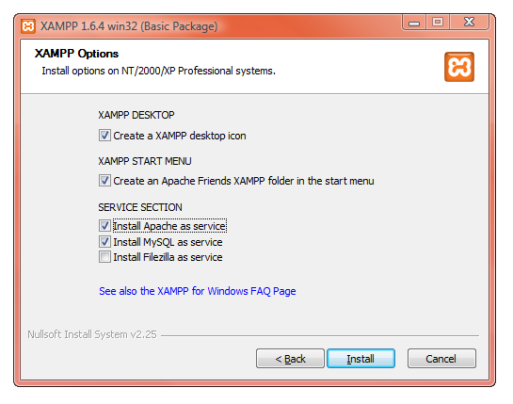
- Once you have completed the installation, make sure that the installation was successful by visiting http://localhost/. If you have been successful, you should see the following screen:
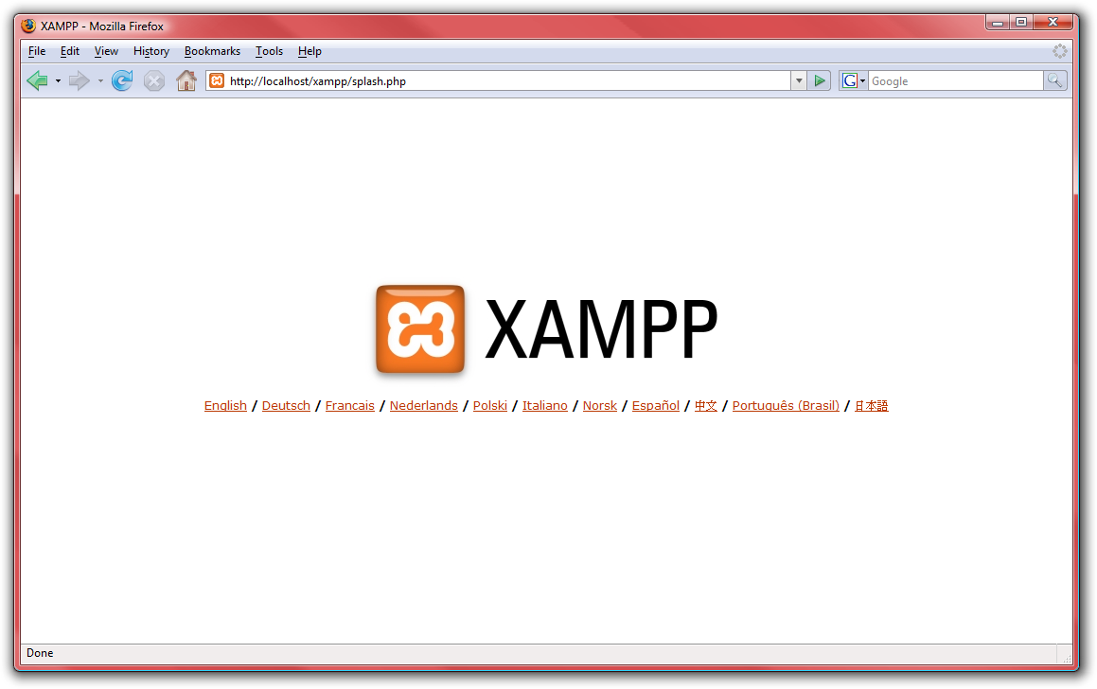
- Congratulations, XAMPP is now correctly installed; now let us go get Joomla! setup!

Download & Unzip Joomla!
Now that you are done setting up the server, it is time to download and unzip Joomla!.
- First, we need to make a folder for Joomla!. Open the folder that you installed XAMPP into – usually C:\XAMPP or C:\Program Files\XAMPP on Windows.
- Open up the folder “htdocs:”
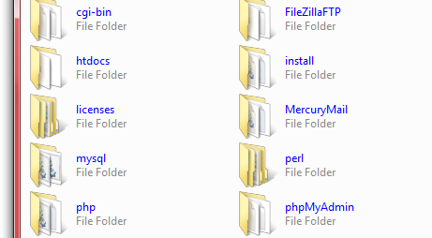
- Create a new folder in “htdocs” titled “joomla15.”
- Now we need to download the latest copy of Joomla! 1.5 from the net. Go to http://www.joomla.org and scroll down the left hand side to find “Download Latest” and click on “1.5” to open the download page:
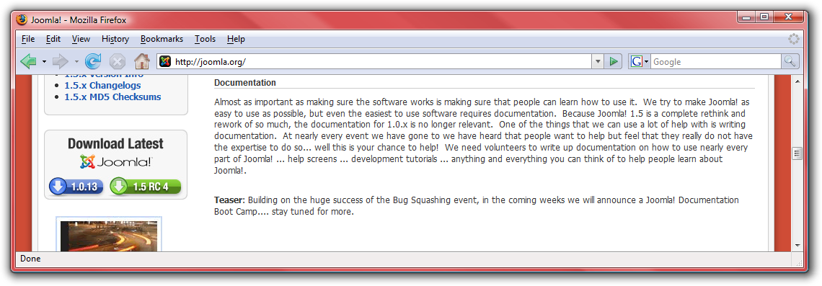
- Then choose the file with the “.zip” ending:
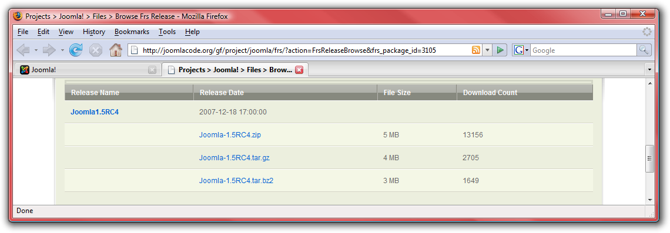
- After completing the download, use your favorite program to unzip the files into the “joomla15” directory that we created:
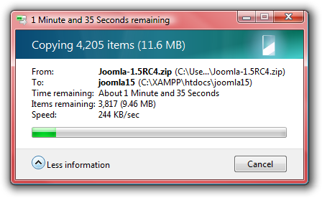
Great! Now we are ready to setup Joomla!.

Joomla! Installation
Installing Joomla! is a simple thing.
- First, go to http://localhost/joomla15.
- Select your language on step 1 and press “Next” at the top.
- Make sure that there are no red items on step 2 (if you set up with XAMPP, you should already be fine) and press “Next” to proceed.
- Read over the license in step 3 and press “Next.”
- On the “Database Configuration” page, enter the following details, then press “Next:”
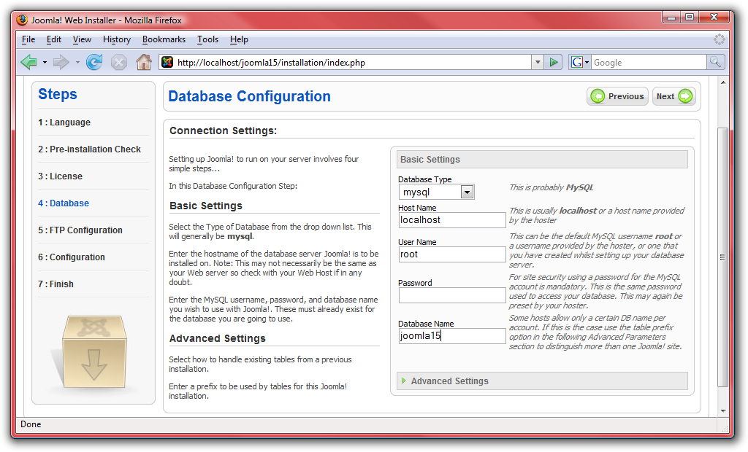
- Skip over step 5 and press “Next” to proceed to step 6.
- Enter the site name “Landscape Smart!”, then the e-mail address and admin password of your choice. NOTE: DO NOT PRESS “Install Sample Data!”
- Press “Next” to complete the installation.
- IMPORTANT: Open up the location where you unzipped Joomla! (usually C:\XAMPP\htdocs\joomla15 or C:\Program Files\XAMPP\htdocs\joomla15) and delete the “installation” directory:
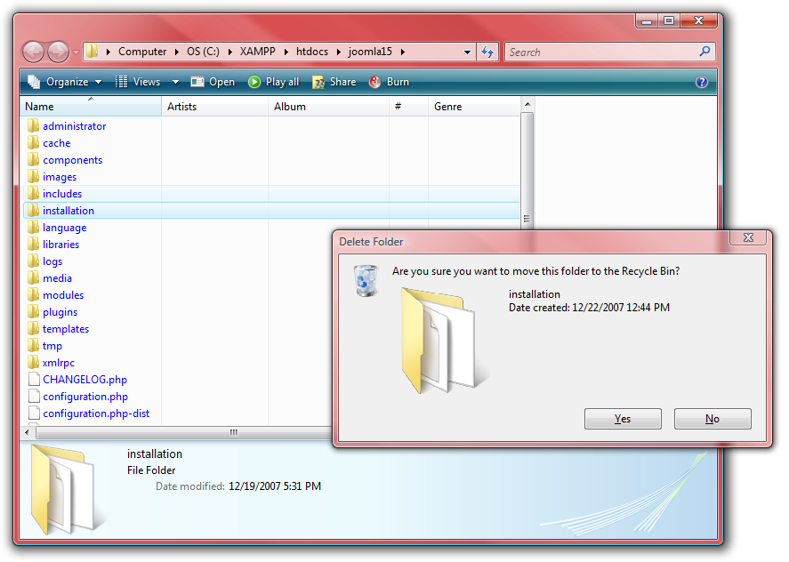
- Return back to the installer and click on “Site.”
If you completed the install successfully, you should now see a blank page ready for all your Joomla! content!

Sections, Categories, and Articles
One of the most important parts of a website is the content. Now that we have a blank site setup, let us get some articles on the site! Articles are sorted in two ways: sections and categories. Sections can contain numerous categories, and categories can contain numerous articles.
- To add a section to your website, go to http://localhost/joomla15/administrator and log in with the username “admin” and the password you specified during the installation.
- To begin managing sections, click on section manager:
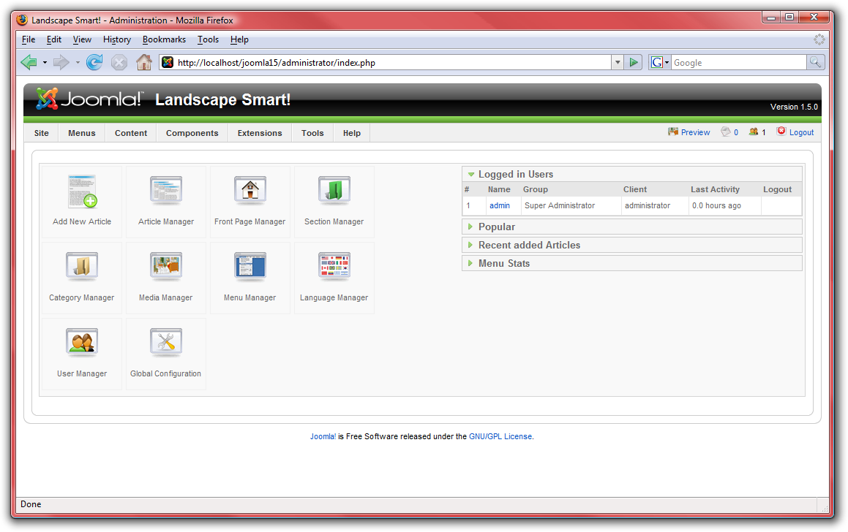
- Click on “New” on the Joomla! toolbar.
- Insert a title and description for the section and then press “Save” on the toolbar.
- Create as many sections as you need. Use sections to group generally similar items together into groups. For our landscaping site, add a section for “Corporate” and a section for “Products.”
- Click on “Content” on the menu and select “Category Manager” when you are done with sections.
- Follow the same steps to create categories, assigning each to one of the sections created above. Use categories for more specific groupings. For the “Products” section, create a category for “Trees,” “Bushes,” and one for “Grasses.” Under “Corporate,” create a “President” category:
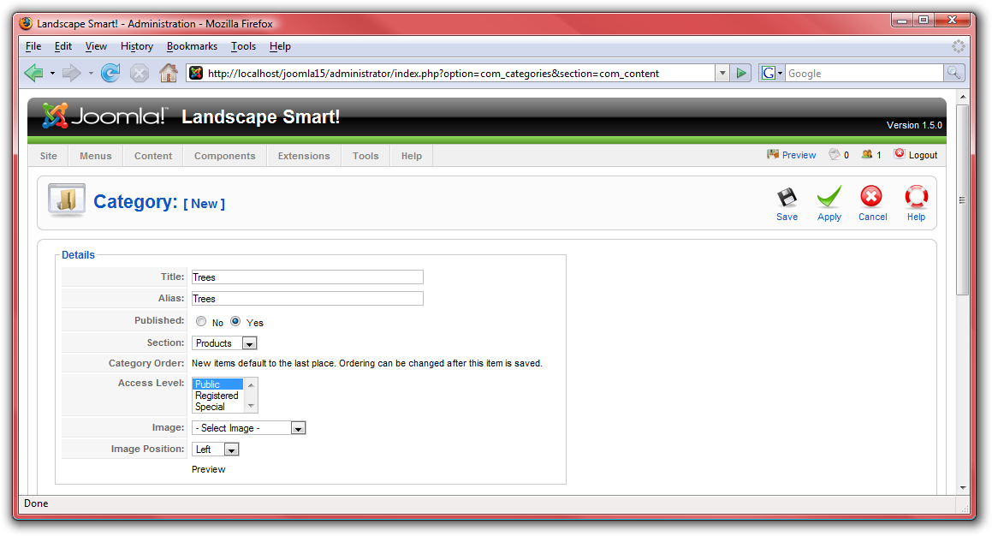
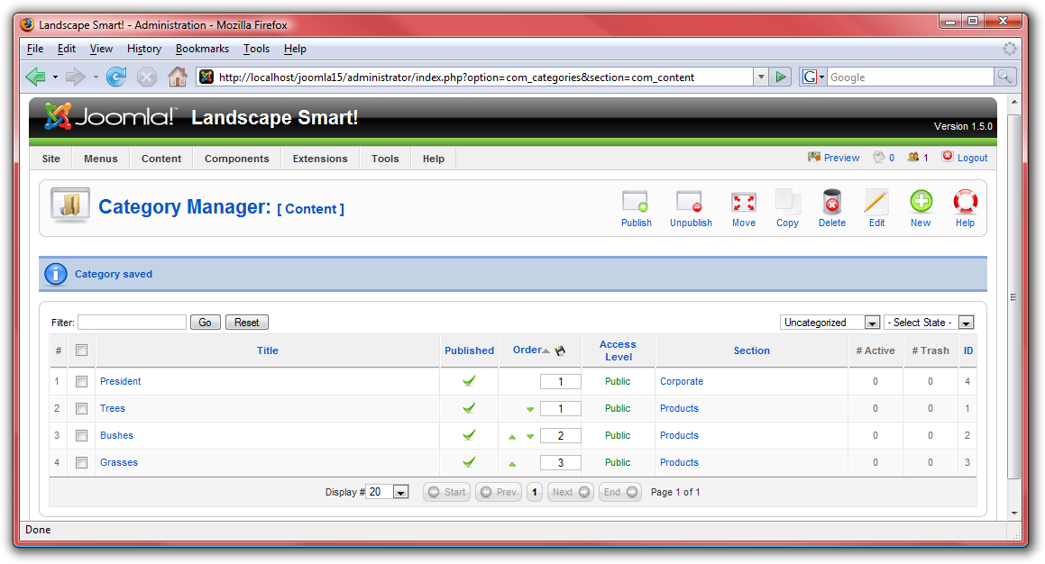
- Finally, we need to create some articles. Click on “Content,” then “Article Manager,” and select “New” from the toolbar.
- This is the article screen. There are a lot of different things you can do here:
  - Add a title for the article, and put it into a section and category.
  - You have the option to publish or un-publish your article, as well as the choice whether to display the article on the front page.
  - The large box is for the article's contents.
    - You can use the “page break” button to divide the article into pages.
    - You can use the “read more” to divide the article into the section to display in a summary view and full view.
    - You can use the “image” button to insert an image into your article using the simple upload form in combination with Joomla!'s media manager.
- For the landscaping website, create five different articles in each of our categories. Use the “read more” button to divide each article into introductory information and then full content. From each category, choose two items to display on the front page using the “Front Page” toggle switch:
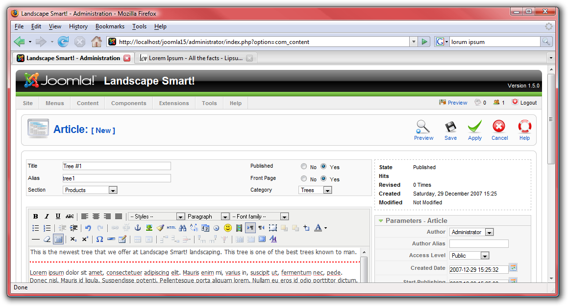
- When you are done typing each article, click “Save” to save it and return to the article manager, or “Apply” to save it and continue editing. If you selected “yes” for “Front Page,” then your article will show up on the home page: http://localhost/joomla15/:
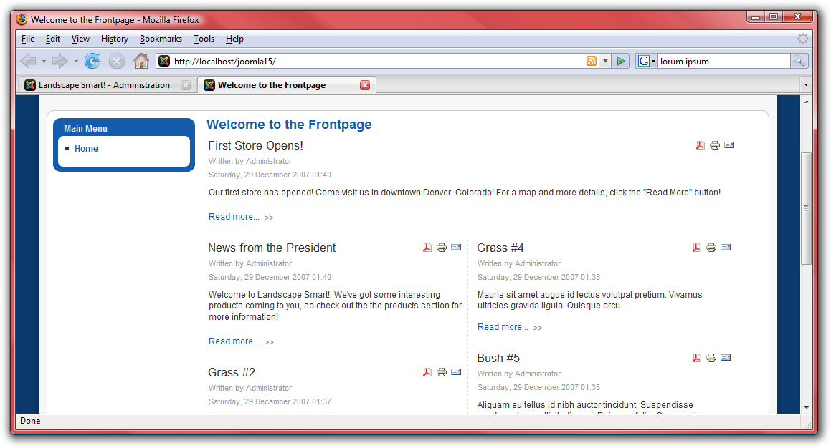

Users
Next, the company president as well as the public relations director and product manager are all going to need to be able to edit the website, so we need to create logins for them.
- First, go to http://localhost/joomla15/administrator and log in with the username “admin” and the password you specified during the installation. If you are already logged in, go to the “Site” menu and select “Control Panel.”
- Click on “User Manager:”
- Click on “New” from the Joomla! toolbar.

- Enter details for each user you wish to create. Give both the president and public relations director the group level “Administrator” so that they can make changes to the site. Give the product manager the “Manager” group level so that he can add products but not make changes to the website:
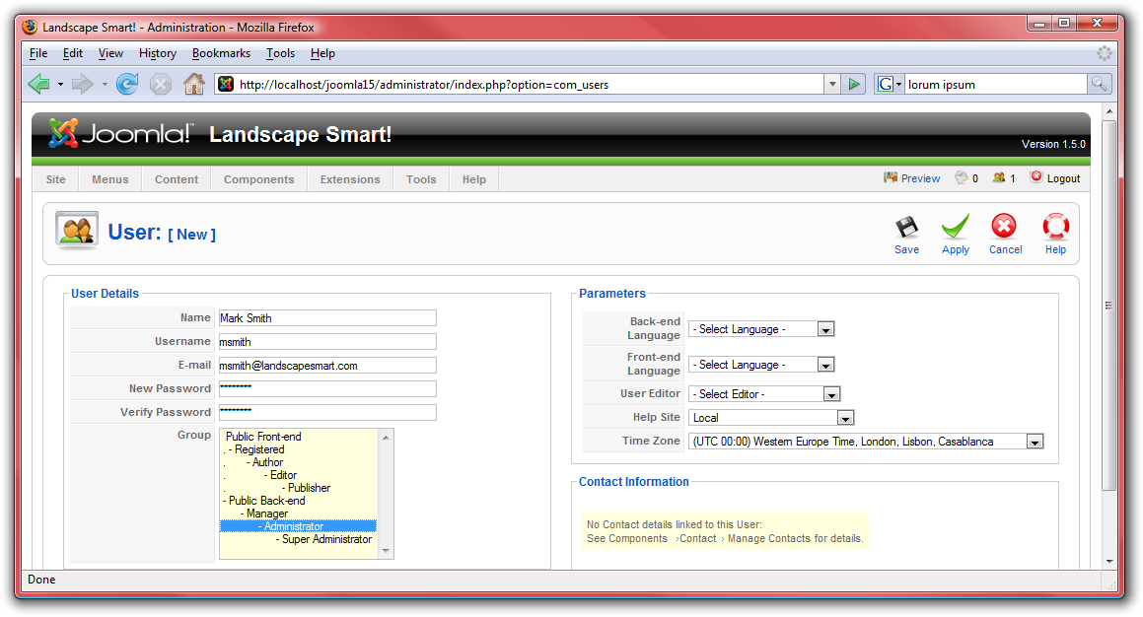
- Press “Save” when you are done creating each user.
- Next, we need to set up a way for visitors to the site to contact the president, PR director, and product manager. From the “Components” menu, select “Contacts” and then “Categories.”
- Create a new category titled “Corporate” and press “Save.”
- Click on the “Contacts” button and then press “New.”

- Create four different contacts—one for the president, one for the PR director, one for the product manager, and one for yourself: the web master. Be sure to include their e-mail addresses and positions within the company. Place each user inside of the “Corporate” category that we created earlier and link each contact to the user that we created earlier:
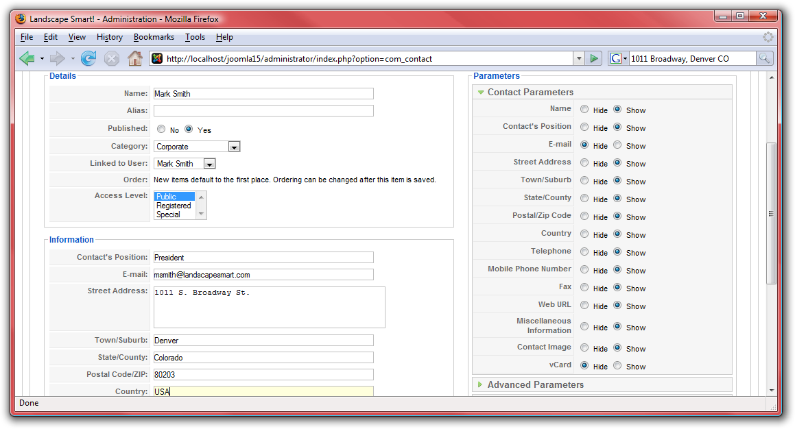

Web Links
In your briefing from the President, he wanted a section for links to landscaping resources. Let us go ahead and get that set up.
- First, go to http://localhost/joomla15/administrator and log in with the username “admin” and the password you specified during the installation. If you are already logged in, you do not need to do this again.
- From the “Components” menu, select “Web Links” and then “Categories.”
- Press “New” and create a category for “Landscape Information,” then press “Save.”
- Click on the “Links” button.
- Click “New” to create a new link. Create links for information about landscaping information. Press “Save” to save your link. Add a few links to the “Landscaping Information” category. Web links are things such as:
- http://www.joomla.org
- http://www.google.com
- http://www.deere.com
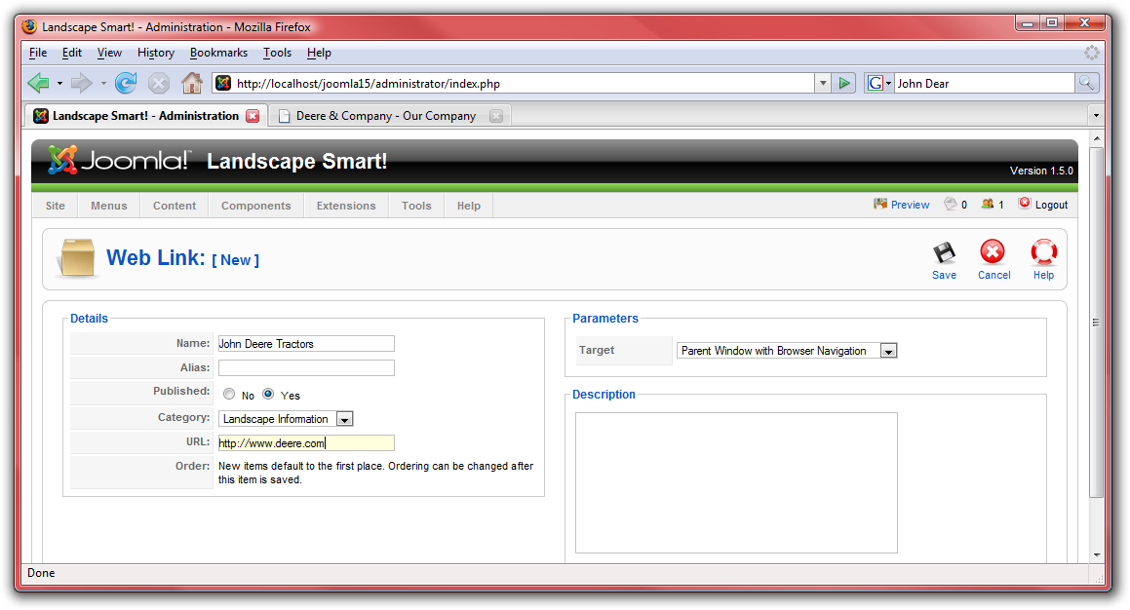

News Feeds
The president also requested a section to display news feeds from other landscape sites.
- First, go to http://localhost/joomla15/administrator and log in with the username “admin” and the password you specified during the installation. If you are already logged in, you do not need to do this again.
- From the “Components” menu, select “News Feeds” and then “Categories.”
- Press “New” and create a category for “Landscaping,” then press “Save.”
- Click on the “Feeds” button.
- Click on “New” to add a news feed. Search around the Internet to find a few RSS feeds with landscaping information. Then name the feeds and add the URL of the RSS feed in the “Link” box. Make sure each is in the “Landscaping” category and choose the number of articles to display from this news feed. Some examples of news feeds may be:
- http://www.joomla.org/index.php?option=com_jd-wp&Itemid=105&feed=rss2
- http://consumer.einnews.com/rss/news/landscaping
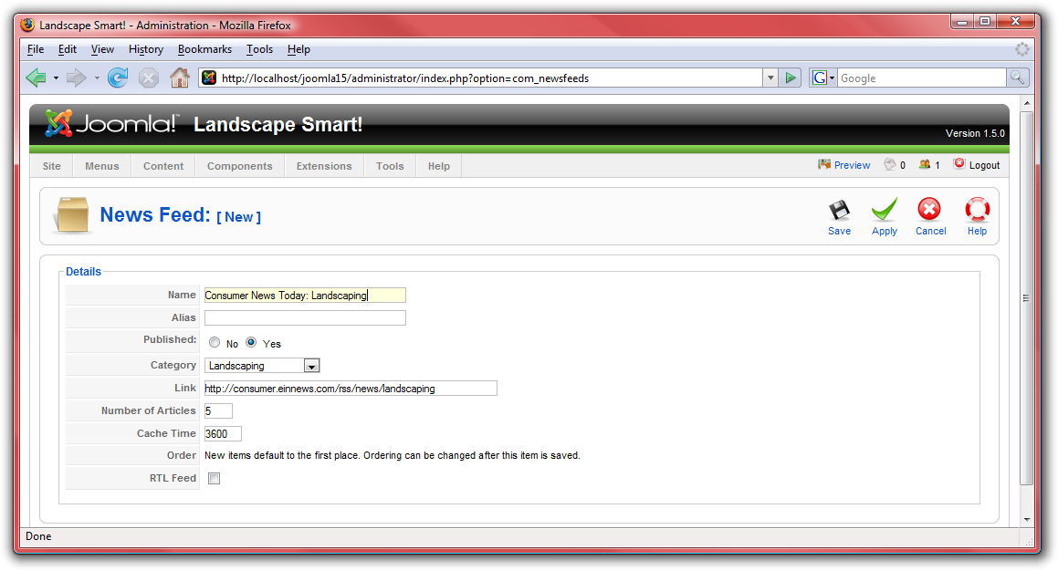
- Click “Save” when you are done to save the news feed. Add a few different news feeds to the “Landscaping” category.

Menu
A website will not do you much good unless there is a menu to help users navigate to different pages. Joomla! has a built-in system for managing menus. This system is built around the three types of information in Joomla!—components, modules, and plugins. If Components are the main information in Joomla! and are driven by menus. If you look at the front page of your site, you can see only the front page articles. The contact information, web links, news feeds, and articles not published on the front page are not visible. This is because each page displays one component at a time. Let us add the components we have already configured to the site:
- First, go to http://localhost/joomla15/administrator and log in with the username “admin” and the password you specified during the installation. If you are already logged in, you do not need to do this again.
- From the “Menus” menu, select “Main Menu.”

Home
Already on the menu is the default “Home” link, which provides access to articles to which you have enabled the “Front Page” option. You can click on “Home” to edit many of its settings including the name of the home page as well as the number of articles that are displayed.
- Click on “Home” to configure the home page.
- In the “Parameters - Basic” area, there are a number of different options you can configure:
  - “# Leading” is the number of article intros to display on the front page with a “read more” link to see the entire article. These articles will stretch the entire width of the news box.
  - “# Intro” is the number of article intros to display on the front page with a “read more” link to see the entire article. These articles will fill only the width of one column, not the entire page.
  - “Columns” is the number of columns in which articles are display.
  - “# Links” is the number of articles to display only as links at the bottom of the page.
- In “Parameters – Advanced” make sure that “Show a Feed Link” is enabled. This will make the front page accessible by an RSS news feed.
- In “Parameters – System,” enter a title for the page inside of the “Page Title” field. This will display in the browser's header as well as in the header for that page in the document. For this website, enter “Landscape Smart” to replace the “Welcome to the Frontpage!” text:
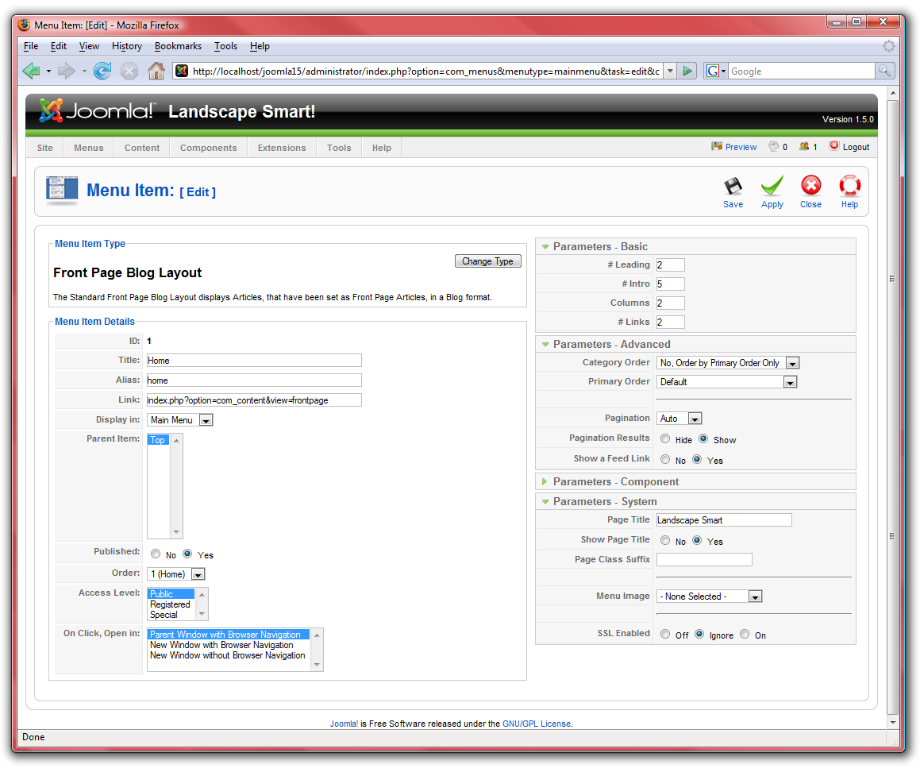
- Click “Save” to finish setting up the home page. Go to http://localhost/joomla15 to see the results of your changes:
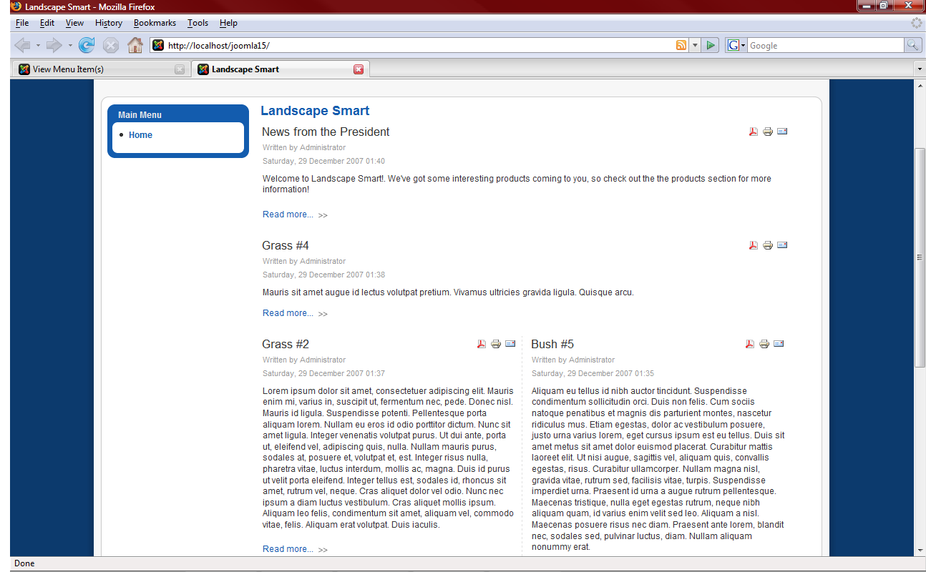

Categories
Next, we need to create four links to the “Trees,” “Bushes,” “Grasses,” and “President” categories that we created:
- From the “Menus” menu, select “Main Menu.”
- Click on “New,” select “Articles” and then “Category Blog Layout.”
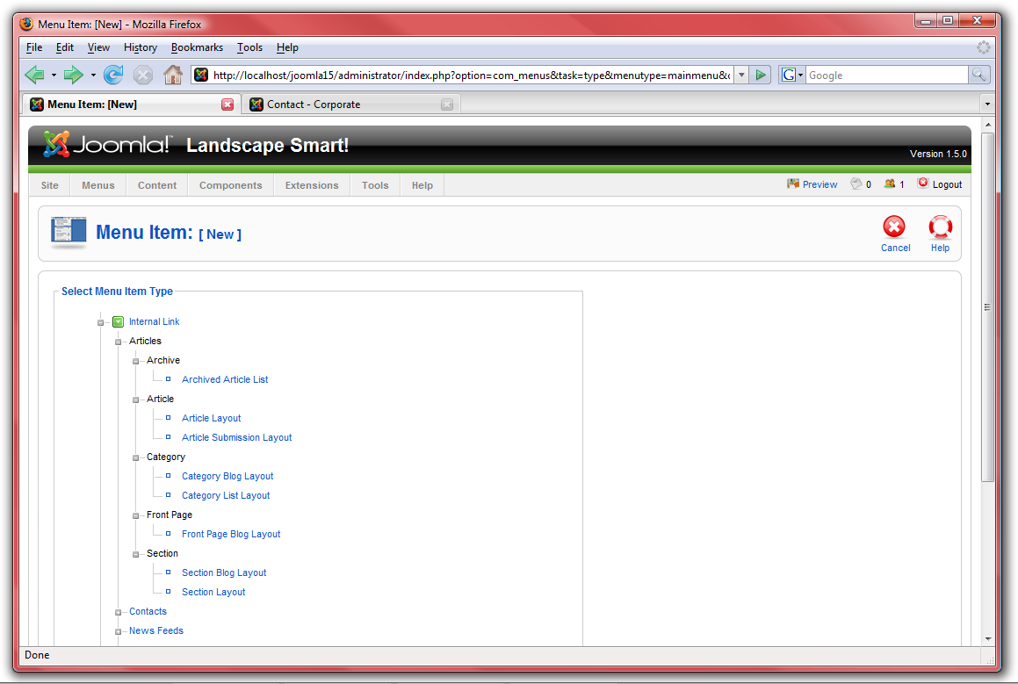
- Under “Parameters – Basic” select one of the four categories we created. Name the menu item accordingly. Adjust the settings similarly to the “Home” item and make sure to include a feed link in “Parameters – Advanced.” Title the page in “Parameters – System.” You also may want to change the “Primary Order” to “Title – Alphabetical” in “Parameters - Advanced:”
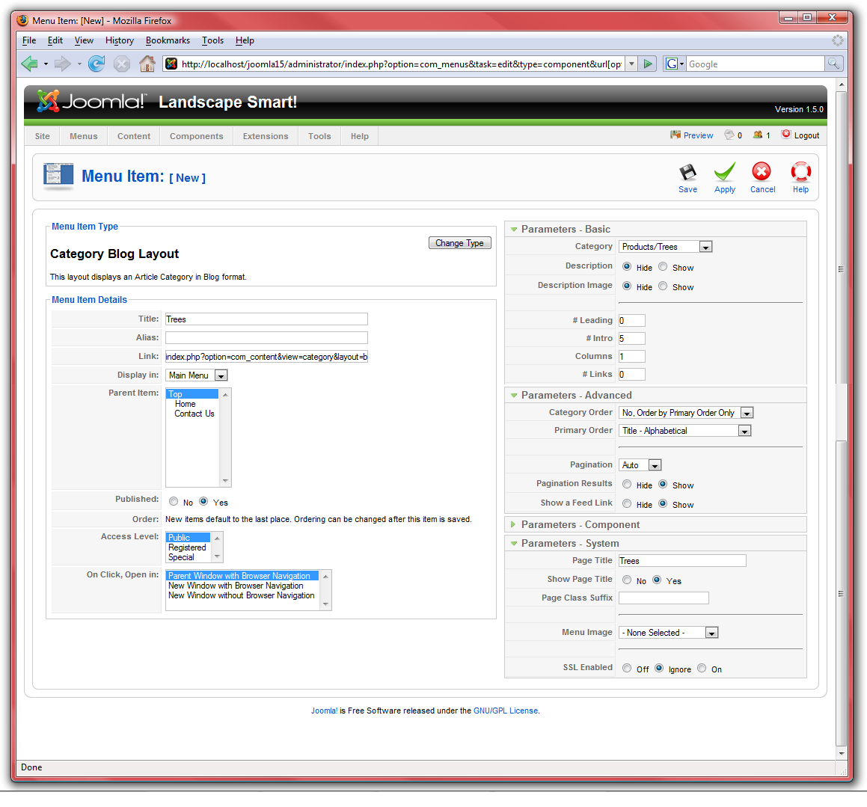
- Click “Save” and check out the site for the results:
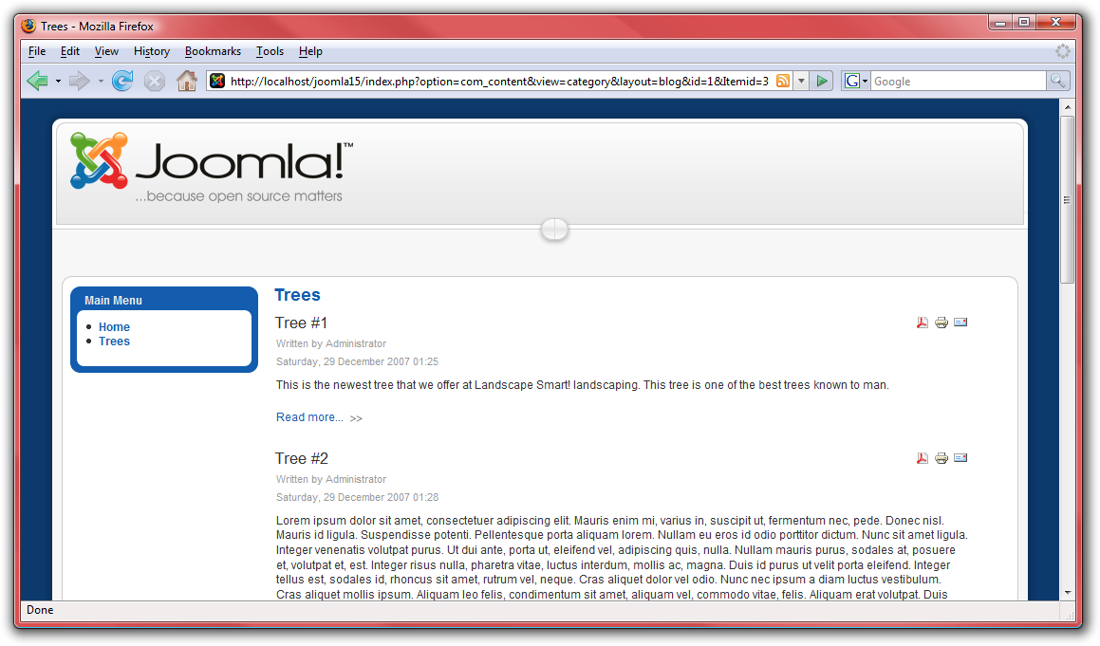
- Repeat these steps for “Bushes,” “Grasses,” and “President.”

Contact
Next up, we need to add a link to the “Contact Us” page:
- From the “Menus” menu, select “Main Menu.”
- Select “New,” then click “Contacts” followed by “Contact Category Layout:”
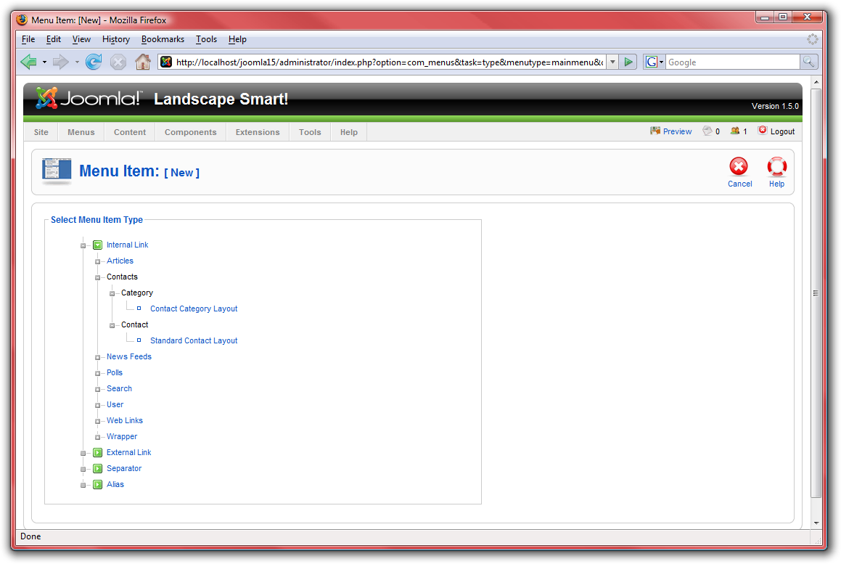
- Name the page “Contact Us” and select “Corporate” for the category. There is no need for a news feed from this page, so disable that option. Under “Parameters – System,” make sure to name the page “Contact Us:”
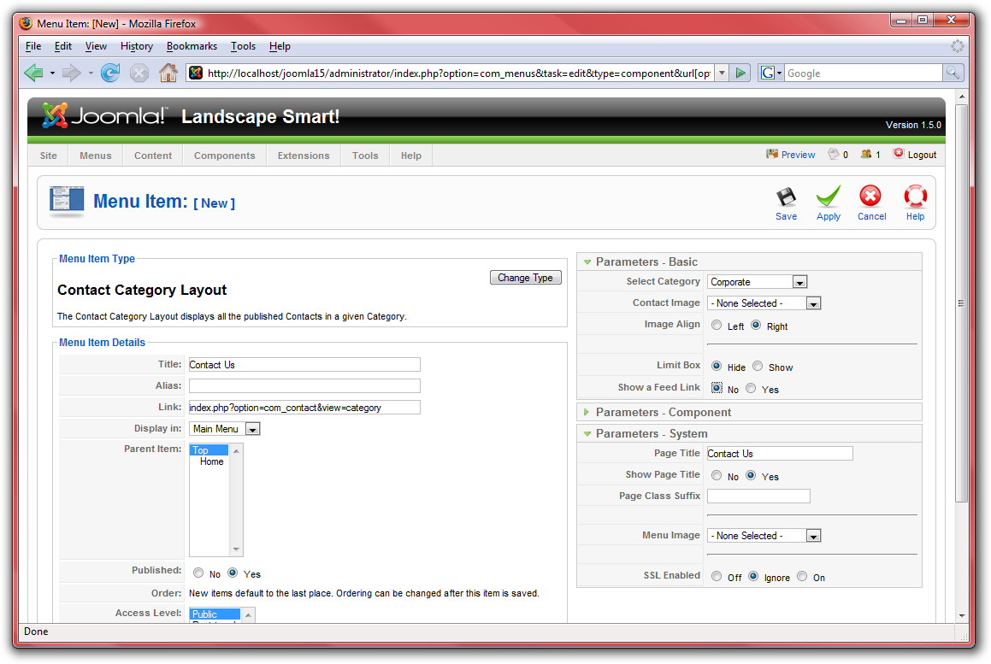
- Click “Save” and check out the site for the results:
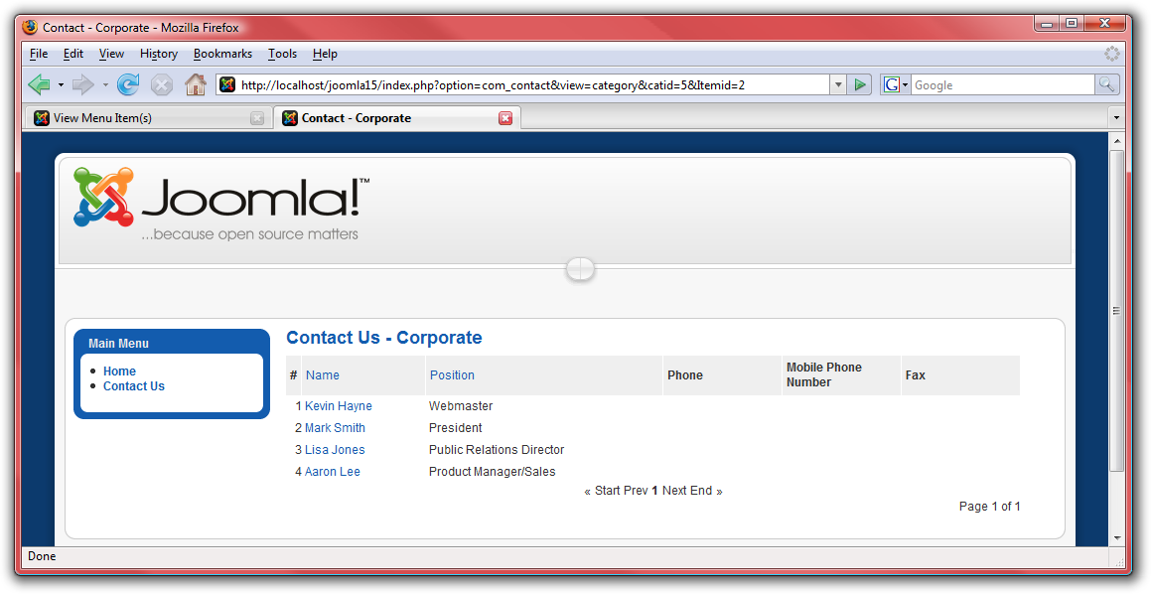

Web Links
Our next component is “Web Links:”
- From the “Menus” menu, select “Main Menu.”

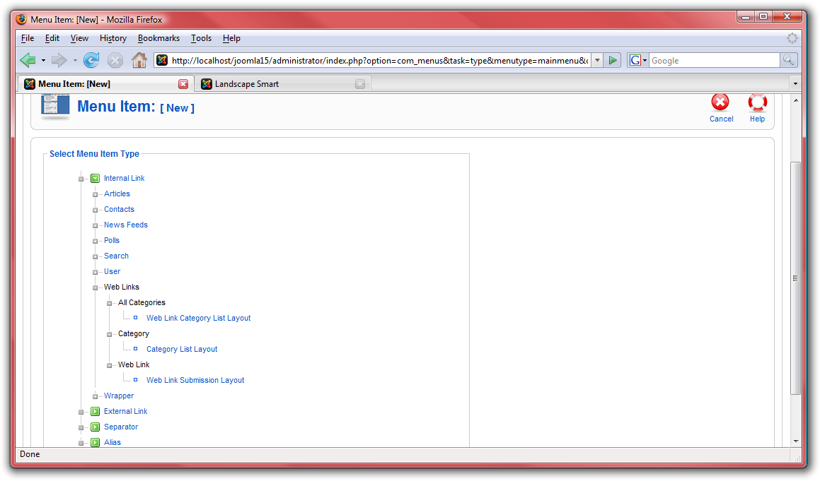
- Click on “New,” select “Web Links” and then “Category List Layout:”
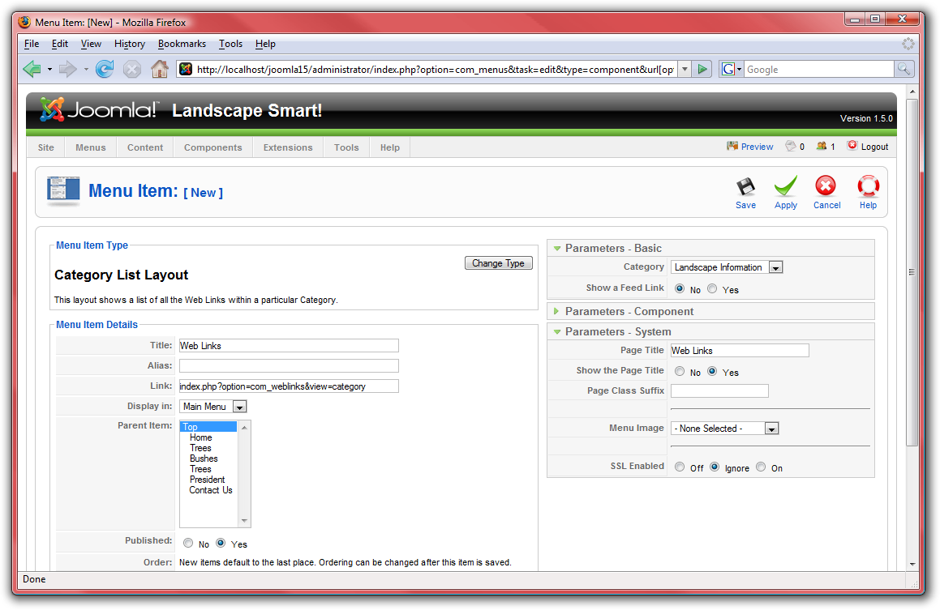
- Name the page “Web Links” and select “Landscape Information” for the category. There is no need for a news feed from this page, so disable that option. Under “Parameters – System,” make sure to name the page “Web Links:”
- Click “Save” and check out the site for the results:
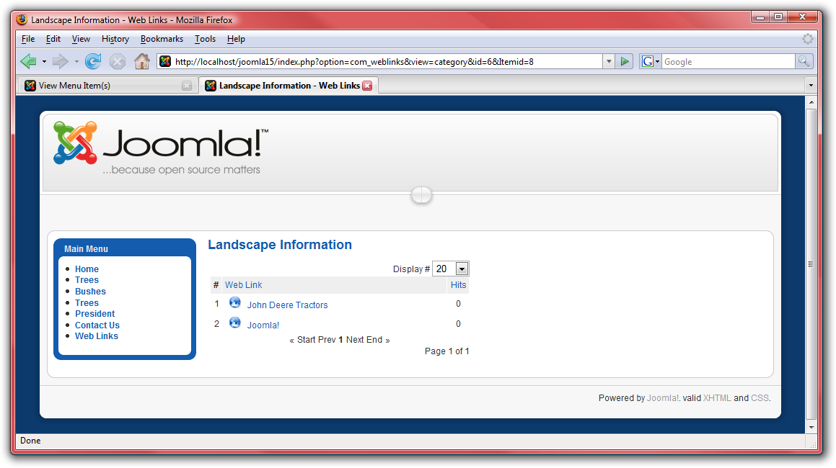

News Feeds
The next menu item we need to add is “News Feeds:”
- From the “Menus” menu, select “Main Menu.”
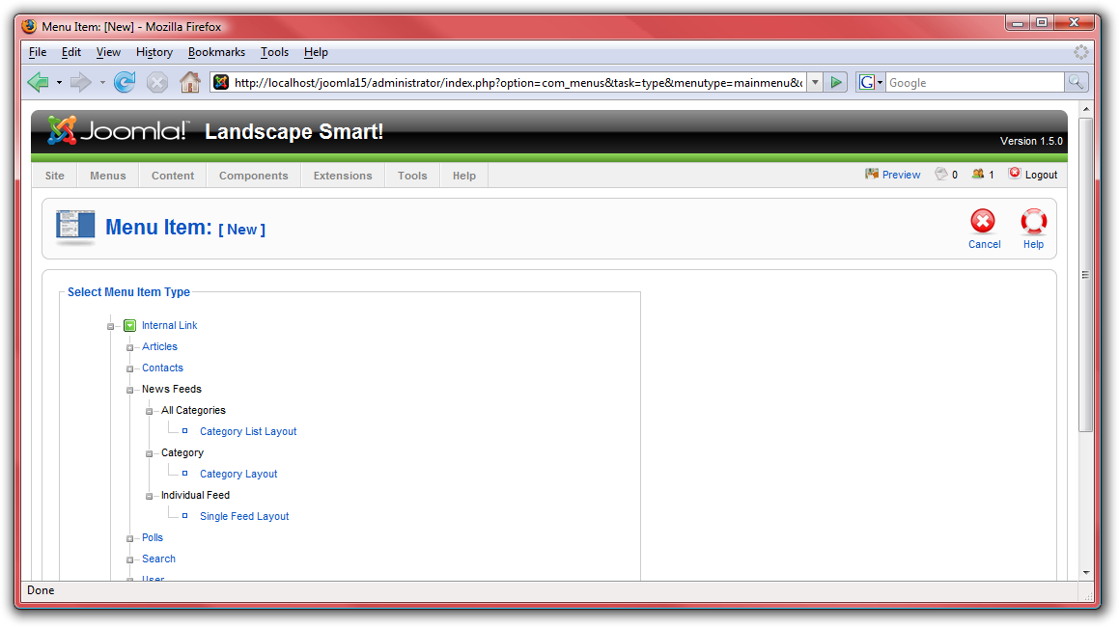
- Click on “New,” select “News Feeds” followed by “Category Layout:”
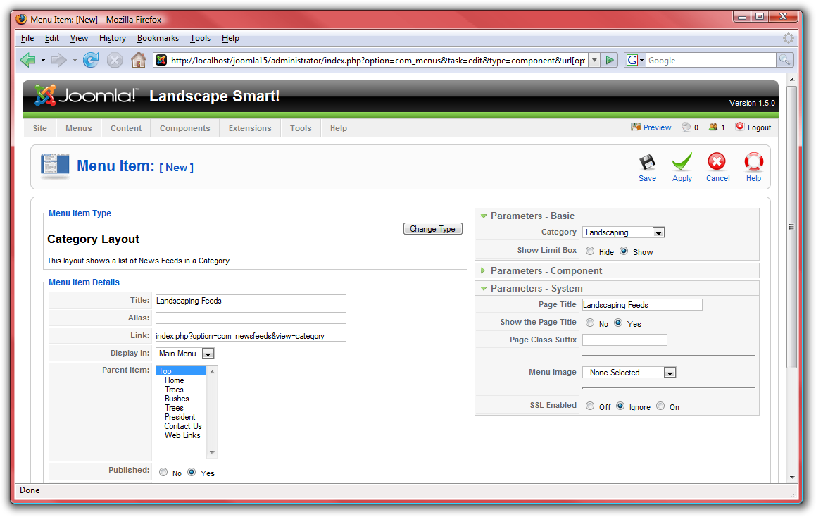
- Name the page “Landscaping Feeds” and select “Landscaping” for the category. Under “Parameters – System,” make sure to name the page “Landscaping Feeds:”
- Click “Save” and check out the site for the results:
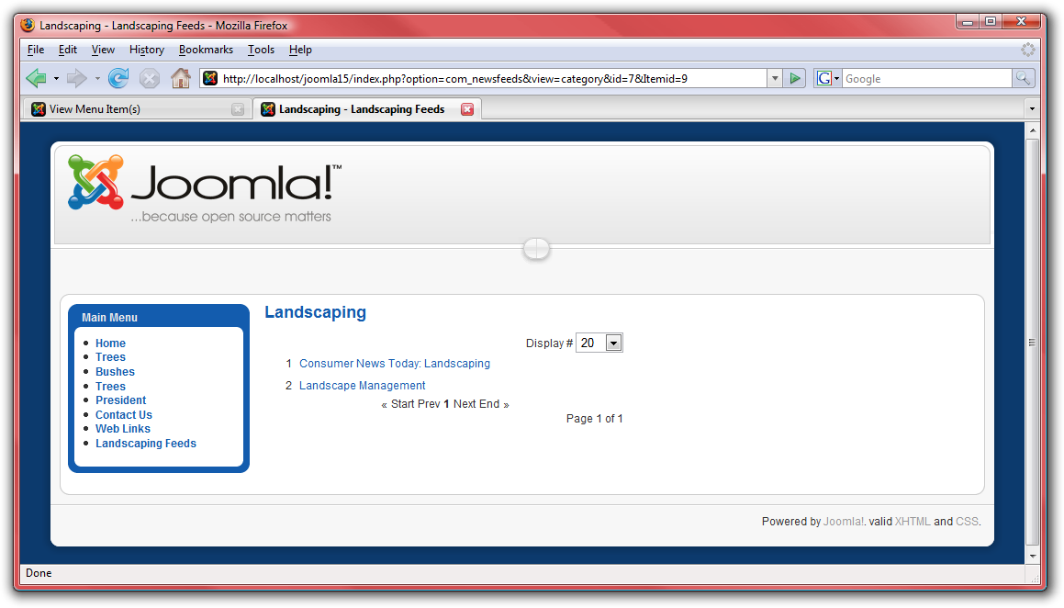

Search
The last menu item we need to create is the “Search” page:
- From the “Menus” menu, select “Main Menu.”
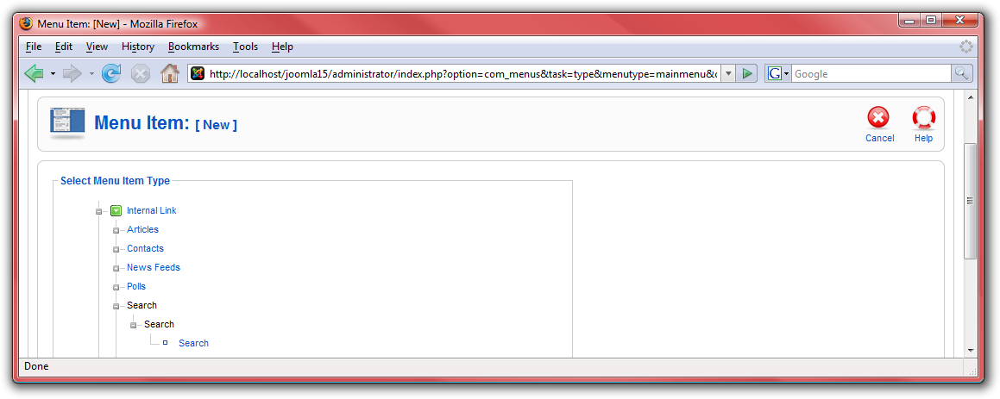
- Click on “New,” select “Search” and then “Search:”
- Name the page “Search.” Under “Parameters – System,” make sure to name the page “Search:”
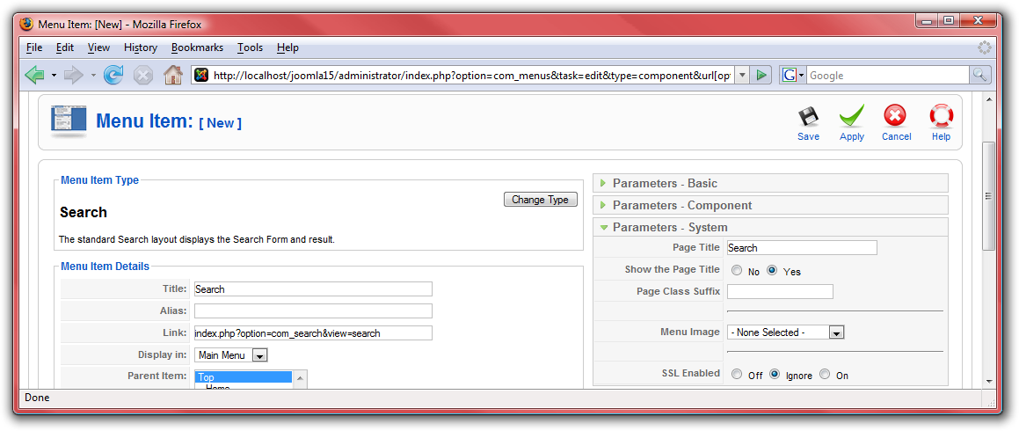
- Click “Save” and check out the site for the results:
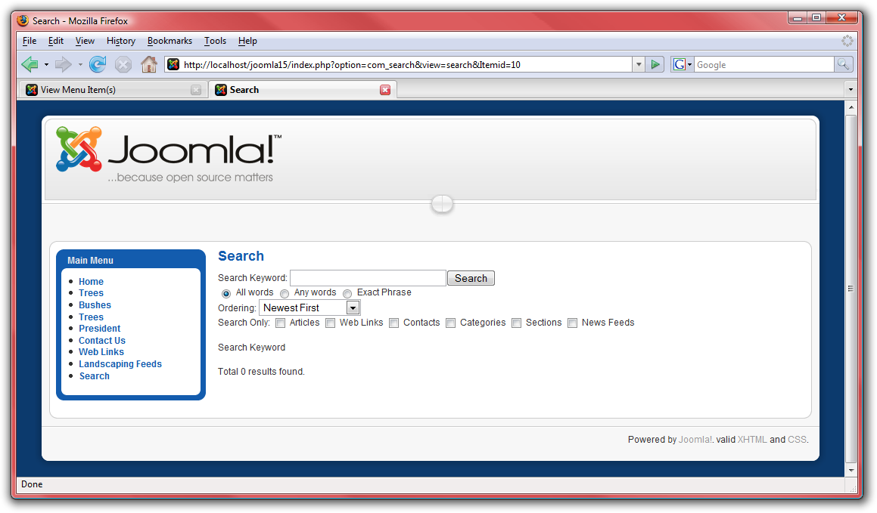

Modules
The next type of content in Joomla! are modules. Modules are sections that lie in pre-defined boxes along each page around the main content. These boxes may be such things as “left,” “right,” or “footer.” The menu displayed on the front page is one example of a module. For this website, let us add a few helpful modules:
- First, go to http://localhost/joomla15/administrator and log in with the username “admin” and the password you specified during the installation. If you are already logged in, you do not need to do this again.
- From the “Extensions” menu, select “Module Manager.”

Syndicate
This is the module manager page. From here, you can manage which modules display on each page. First off, let us add a module to show the RSS feed that we created for the front page:
- Click on “New,” then select “Syndicate” and click “Next:”
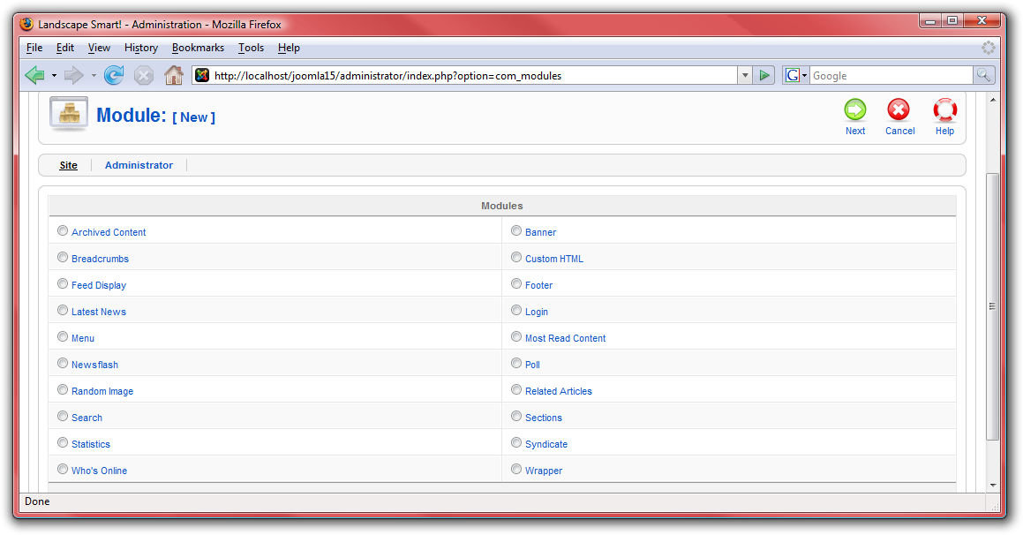
- Type a name for the syndicate box. Select a position to display your syndicate module in: usually “left” or “right.” For this module, the default template has a special “syndicate” section. These sections are defined in the template, which we will get to next. Under menu assignments, choose “Select Menu Item(s) from the List” in order to pick the pages on which the syndicate module will be available:
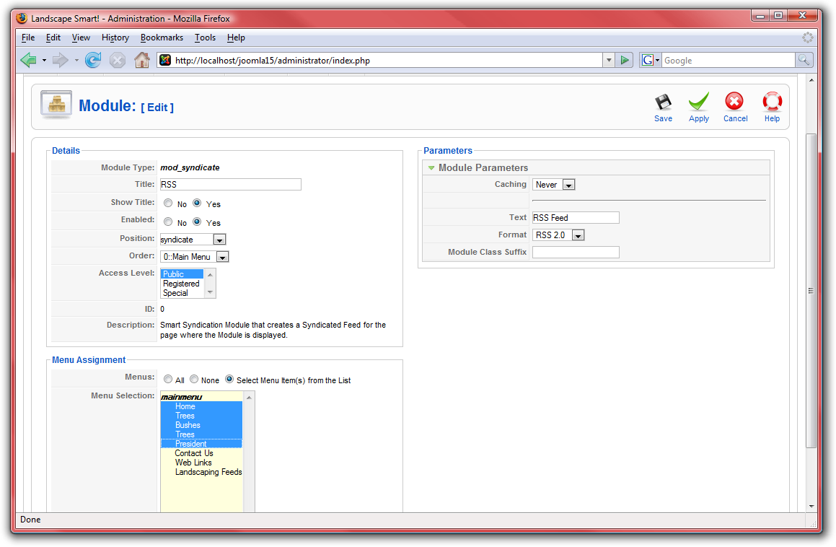
- Click “Save” and check out the site for the results:
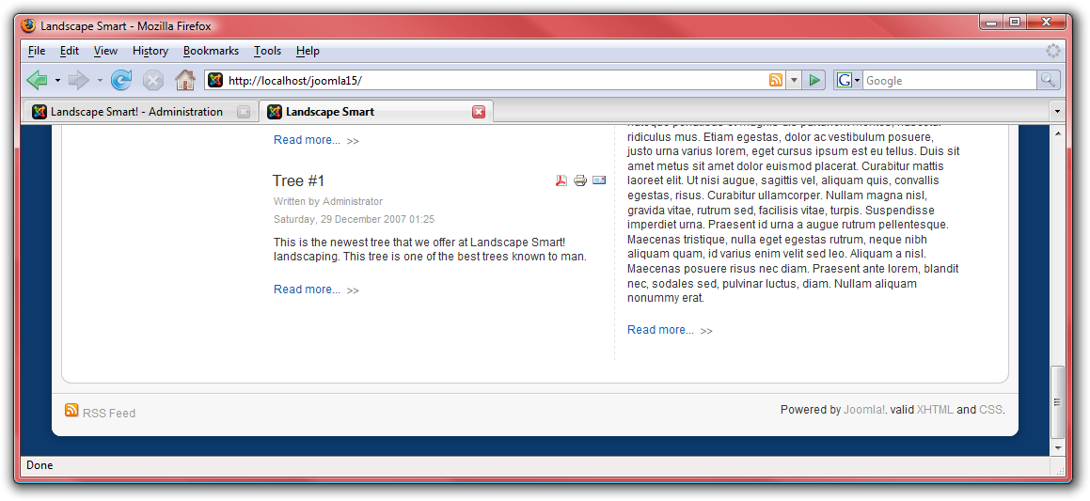

Login
Great! Now, let us add a login box so that the users we set up earlier can easily access the site.
- From the “Extensions” menu, select “Module Manager.”

- Click on “New,” then select “Login” and click “Next:”
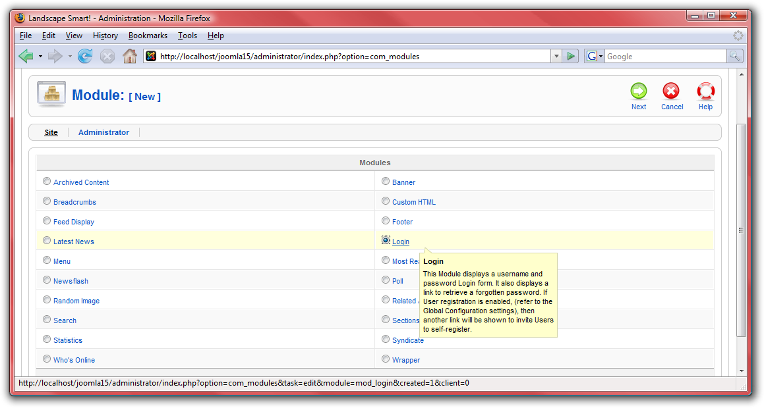
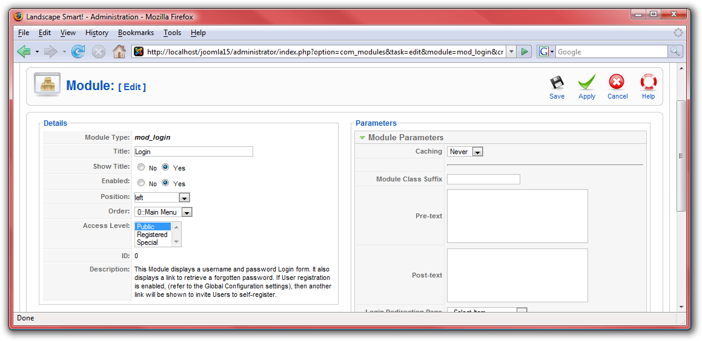
- Configure this module with the name “Login” and choose the “left” position. This will display the module immediately below the menu. We do want this module to appear on all pages, so there is no need to change these settings:
- Click “Save” and check out the site for the results:
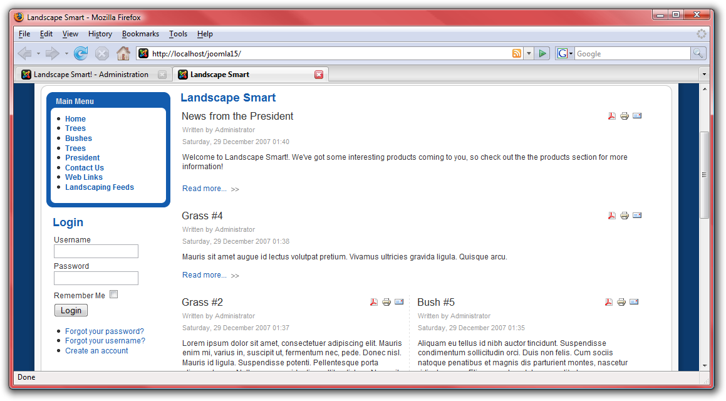

Newsflash
For another module, let us add a “Newsflash” module. This module displays a random article from a specific category. For this demonstration, the “Newsflash” module will display news from the president:
- From the “Extensions” menu, select “Module Manager.”

- Click on “New,” then select “Newsflash” and click “Next:”
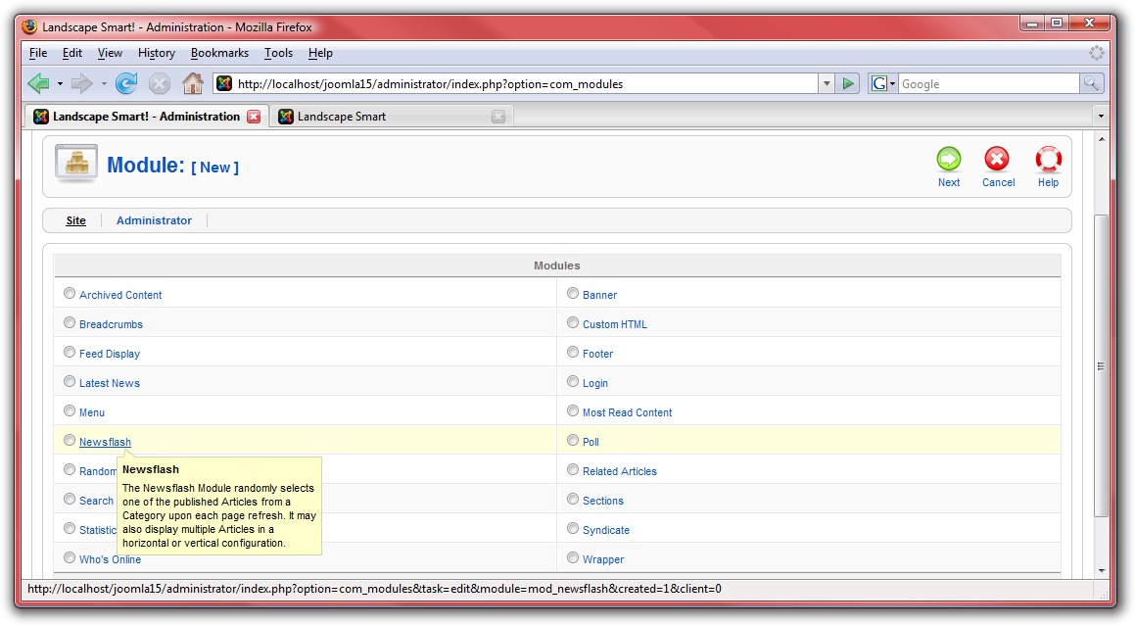
- Name the module “Latest News” and choose the “Top” position in order to display this next to the logo. Choose the “President” category to display updates from the president in this module. Make the title linkable so that the reader can view the full article after clicking on the title and mark “Yes” in “Article Title” to show the title of the article:
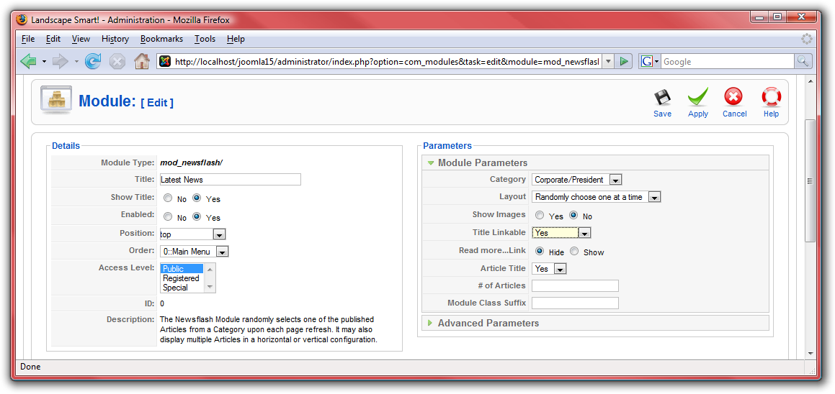
- Click “Save” and check out the site for the results:
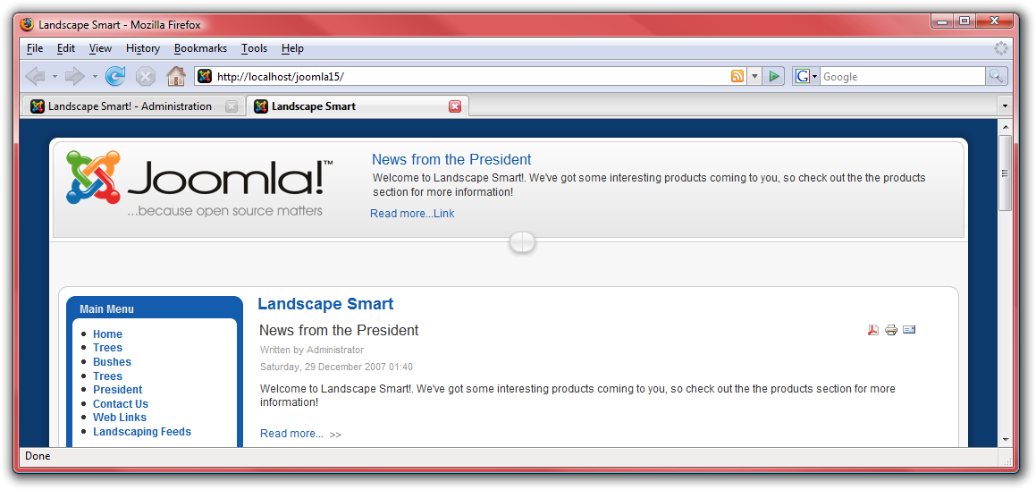

Breadcrumbs
Let us add one final module, the “Breadcrumbs” module. This module helps users navigate the site.
- From the “Extensions” menu, select “Module Manager.”
- Click on “New,” then select “Breadcrumbs” and click “Next:”
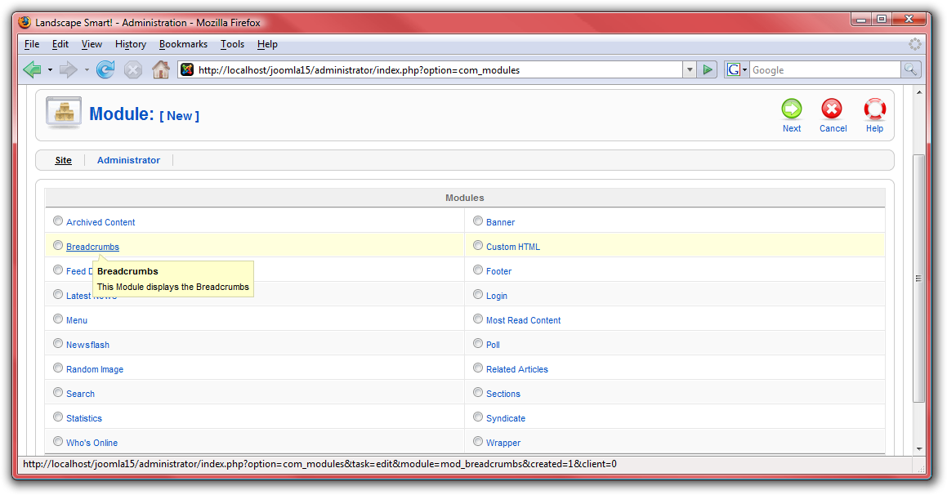
- Name the module “Breadcrumbs” but disable the title in the “Show Title” setting. Leave the rest of the settings the same:
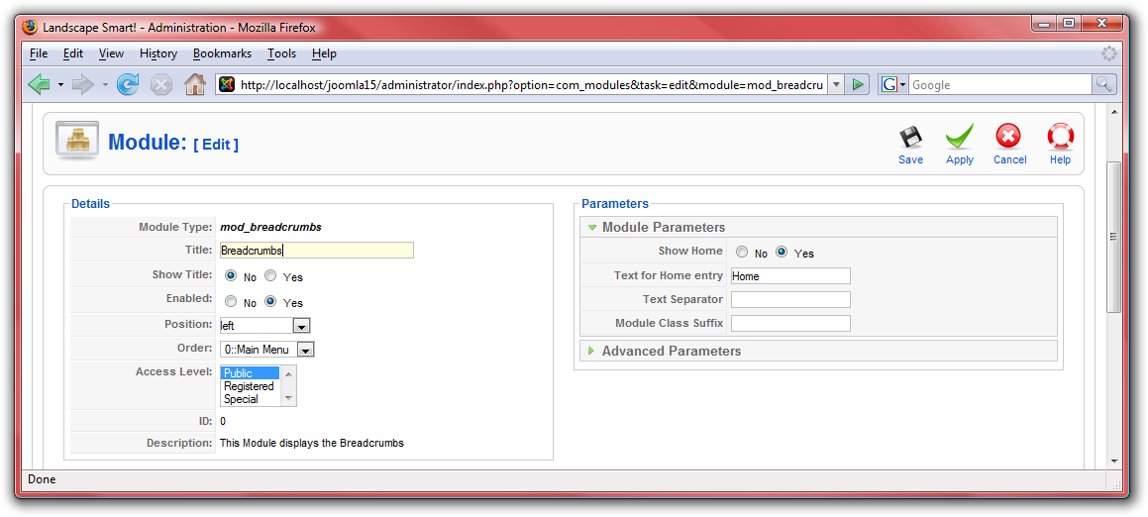
- Click “Save” and check out the site for the results. Navigate around to different pages to see how the breadcrumbs change:
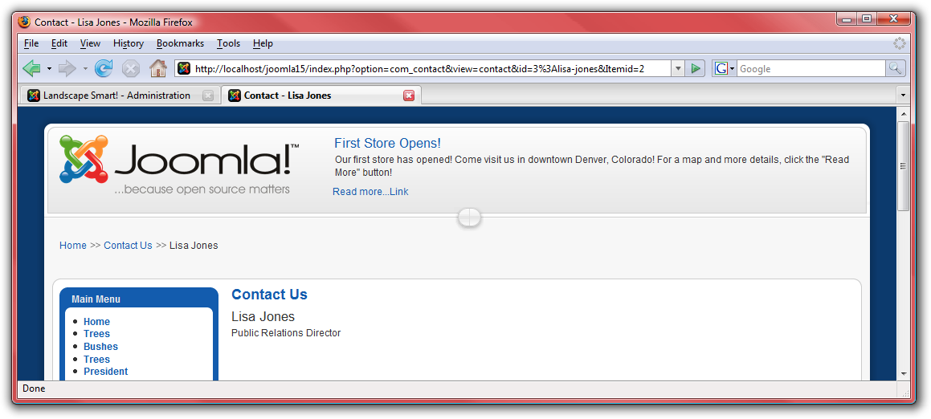

Templates
Templates allow you to define the look and feel of your Joomla! website. Joomla! ships with two default templates, but many more can be found at Joomla.org.
- First, go to http://localhost/joomla15/administrator and log in with the username “admin” and the password you specified during the installation. If you are already logged in, you do not need to do this again.
- From the “Extensions” menu, select “Template Manager.”
The template selected with the star is the current template. To change to a different template, select the template you wish to use and click on “Default.” For the landscaping website, the “rhuk_milkyway” template will fit well:
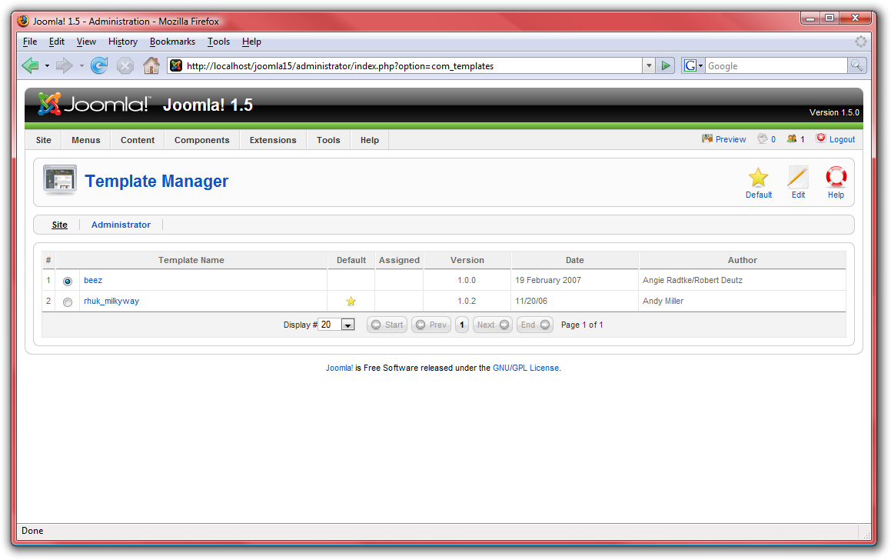

- Click on “rhuk_milkyway” in order to edit some of the settings for the template. Because this is a landscaping website, let us change the color scheme to green:
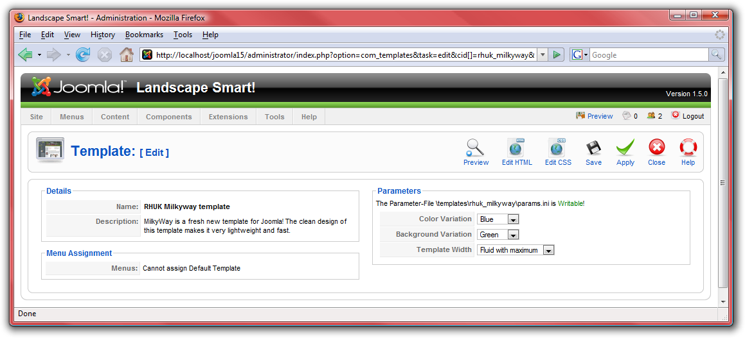
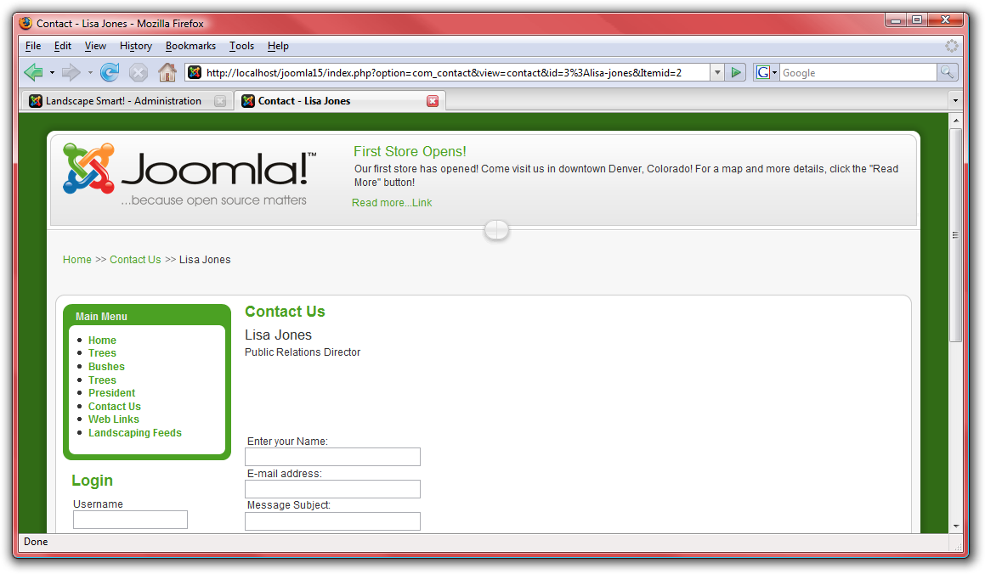
- Take a look to see how the look and feel of the site has changed:
- Next, on the edit page, click on “Edit HTML” in order to adjust the template itself.
- Remember when we put modules in? Each module was placed into a specific section. These sections are defined in the template. For example, the “top” position is defined by this code: <jdoc:include type="modules" name="top" />.

Further Resources
With all of this completed, and only a short amount of work with Joomla!, you have a professional looking web page that meets all of the requirements from the company. In no time at all, you will be getting a nice big pay check for doing just a few hours of work on the website! Chances are, you are going to want to go further and do more with Joomla!. Check out some of these resources to help you further your Joomla! experience:
- http://forum.joomla.org – Sign up for the forums, search, and ask questions, even helping others if you are able!
- http://help.joomla.org – Find more documentation and training information.
- http://extensions.joomla.org – Find lots of very cool extensions to further enhance your Joomla! websites.
- http://www.joomla.org – Find a way to give something back to the community!

Enjoy!

