期末大作业综述报告
课程名称 |  |  |  | 课程编号
开课学院
指导教师
实践作业地点
团队成员 | 学号 | 姓名 | 任务分工 |  |  | 分工系数
团队成员 |  |  |  |  |  | 1

一、期末大作业目的及要求

(一) 掌握D3可视化平台。

(二) 根据历年“可视分析挑战赛”的题目和数据，基于D3完成一个可视化作品，并提交期末大作业报告。（https://chinavis.org/2019/challenge.html）
(三) 报告提交文件命名规则“组长学号-组长姓名-成员1-...”，多个文件（报告、原始代码、数据、视频）请压缩为一个文件。

二、报告主要内容

(一)选题概述（10分）
1.题目描述
CICSC(China Intelligence Cyber Security Conference)（虚构）是一个智能网络安全领域的全国性学术大会，会议旨在增进学界，商界，及社会人士之间的交流与合作，推动该领域的发展创新。本次会议为期三天，包括学术研讨、成果展览、黑客大赛三大组成部分，设置数据安全、物联网安全、移动安全、隐私保护、智能场馆、及智能安全技术创新六大研讨主题。会议期间有多位资深专家和商业大咖带来精彩的主旨报告、经验分享与成果展示，同时还邀请了许多参展单位和媒体记者。本次会议参会人员规模在5000人左右。
为了加强会场管理，也为了呼应“智能场馆安全运营”的会议主题，本次会议采用了无线传感器技术获取参会人员的实时位置信息。参会人员在进入会场时需要佩戴电子胸牌，胸牌内置信号发射器并绑定其个人信息。会场内布置的无线传感器可以实时接收并记录其覆盖范围内的信号发射器发出的信号。采集的传感器数据可用于实时检测会场人群分布情况，便于会场管理人员及时合理地调动资源，处理各种突发状况，为会议各项议题的顺利进行保驾护航。会议组委会临时成立了一个数据分析小组，负责分析这些传感器数据，协助组委会管理会场，响应和处理各类应急事件。假设您是数据分析小组成员，请您设计并实现一套数据可视分析解决方案，完成组委会交代的数据分析任务。

2.任务目标及分析
作为数据分析小组成员,本次任务旨在设计并实现一套可视分析方案,协助组委会管理会场，响应和处理各类应急事件。
一方面需要能够依据会场人群分布对会场情况进行分析,另一方面需要尽可能发现可能潜在的异常。

（二）可视方案设计(What-Why-How）（30分）
1.数据抽象
传感器分布数据: position.csv
表1. 传感器布置表
字段名称 | 字段含义
sid | 传感器id
floor | 传感器所在楼层
x | 传感器横坐标位置
y | 传感器纵坐标位置

传感器日志数据: conference.csv
表1. 传感器日志表
字段名称 | 字段含义
id | 人员id编号
sid | 传感器id编号
time | 当前时间 (单位:秒,从每天00:00:00更新)

2.任务抽象
(1).分析会场内活动流程安排情况,了解突发状况;
(2).分析大会期间可能出现的异常事件,以及时防范应对;
(3).分析大会可能改进之处;

3.如何实现
(1).分析各会场内人数随时间的变化情况
对于每个时间点,都可以使用传感器日志数据(横坐标,纵坐标)计算出每个人的位置情况(即,是否在某个会场内) ,若会场内某个时间段人数激增说明即将开始某项活动,人数相对减少/增加说明活动暂停/重新开始,人数大幅减少则说明该会议室活动安排结束。如下左图即可发现上午著会议室活动被分为两大部分,说明是进行了两场不同的大型活动,而下午则没有安排。同时将多个会议室的曲线绘制在同一幅图内以更好的观察各个时间段会场的利用情况。如下右图即可发现分会议室A的流程安排有别于其他三个分会议室。
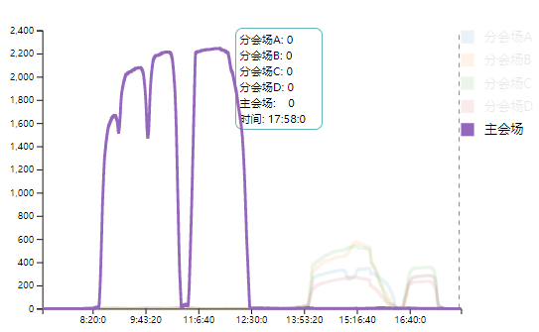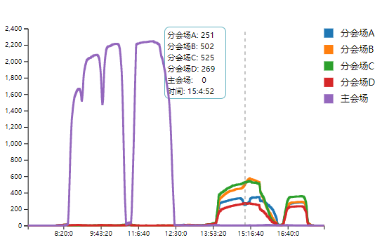
(2).分析整个场地内人群分布(密度)随时间的动态变换
同时结合传感器布置数据和传感器日志数据可以实施计算出每个传感器检测区域内的人数(即人群密度),我们可以观察人群密度极大的传感器处人数随时间的变化,以重点关注防范意外。同时注意人群密度极小的传感器处人数随时间的变化,在会议期间室内我们可以考虑它是对会场起主要作用的人物,如演讲人或嘉宾,从而在会场服务上对其提供优待。若在室外定点一段时间内不动则可以考虑是工作人员,若在黑客比赛期间远离比赛区则可以考虑为异常情况。如下图就是一处室外人群拥挤位置,需要对此有一定的安全防范措施。
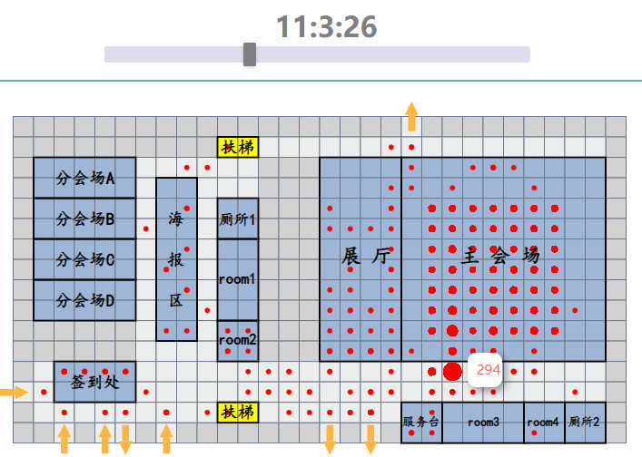

（三）实现过程及其关键代码（50分）
1.基本构图布局
<!-------------- 人物流动图 ------------>

<!-- 画布 -->
<div id="svg1">
<svg class="contain"></svg>
</div>
<!-- 某点位置的人数 -->
<div id="tooltip" class="hidden">
<p id="value"><strong>100</strong></p>
</div>

<!-- 时间文字 -->
<div id="timeText">
7:0:0
</div>
<!-- 时间拖动 -->
<div id="container">
<div id="control"></div>
</div>

<!-------------- 时间点会场人数统计图 ----------->
<!-- 人数统计 -->
<div id="textContainer">
<p><span>分会场A: </span><span id="confA"></span></p>
<p><span>分会场B: </span><span id="confB"></span></p>
<p><span>分会场C: </span><span id="confC"></span></p>
<p><span>分会场D: </span><span id="confD"></span></p>
<p><span style="margin-right: 10px;">主会场: </span><span id="conf"></span></p>
<p><span>时间: </span><span id="time1"></span></p>
</div>

2.人物流动分布图
(1).网格绘制(1单位=8米*8米)
//画布局图(网格)
function drawGrids() {

/////////////////一楼////////////////////////////////////
/////////////////////////////////////////////////////////

//一楼所有元素
grids1 = svg.append("g").attr("class", "grids1");
//一楼灰色区域
var grayArea1 = grids1.append("g").attr("class", "grayArea1");
//扶梯
var futiArea1 = grids1.append("g").attr("class", "futiArea1");
//各大分会场
var confA = grids1.append("g").attr("class", "confA");
var confB = grids1.append("g").attr("class", "confB");
var confC = grids1.append("g").attr("class", "confC");
var confD = grids1.append("g").attr("class", "confD");
//签到处
var signIn = grids1.append("g").attr("class", "signIn");
//海报区
var poster = grids1.append("g").attr("class", "poster");
//一楼厕所
var WC1 = grids1.append("g").attr("class", "WC1");
//服务台
var service = grids1.append("g").attr("class", "service");
//一楼room
var room1 = grids1.append("g").attr("class", "room1");
var room2 = grids1.append("g").attr("class", "room2");
var room3 = grids1.append("g").attr("class", "room3");
var room4 = grids1.append("g").attr("class", "room4");
//展厅
var display = grids1.append("g").attr("class", "display");
//主会场
var conf = grids1.append("g").attr("class", "conf");
//出入口
var exArea = grids1.append("g").attr("class", "exArea");
//白色区域
var whiteArea1 = grids1.append("g").attr("class", "whiteArea1");

//绘制一楼灰色区域
var wcgqy = [
0, 1, 2, 3, 4, 5, 6, 7, 8, 9, 10, 11, 12, 13, 14, 15, 16, 17, 18, 20, 21, 22, 23, 24, 25, 26, 27, 28, 29,
0, 1, 2, 3, 4, 5, 6, 7, 8, 9, 29,
0, 12, 13, 14, 29,
0, 12, 13, 14, 29,
0, 12, 13, 14, 29,
0, 12, 13, 14, 29,
0, 12, 13, 14, 29,
0, 12, 13, 14, 29,
0, 12, 13, 14, 29,
0, 12, 13, 14, 29,
0, 1, 2, 3, 4, 5, 12, 13, 14, 29,
0, 1, 2, 3, 4, 5, 12, 13, 14, 29,
0, 29,
29,
0, 29,
0, 1, 3, 6, 8, 9, 10, 11, 12, 13, 14, 16, 18, 29
];

var wcgqx = [
0, 0, 0, 0, 0, 0, 0, 0, 0, 0, 0, 0, 0, 0, 0, 0, 0, 0, 0, 0, 0, 0, 0, 0, 0, 0, 0, 0, 0,
1, 1, 1, 1, 1, 1, 1, 1, 1, 1, 1,
2, 2, 2, 2, 2,
3, 3, 3, 3, 3,
4, 4, 4, 4, 4,
5, 5, 5, 5, 5,
6, 6, 6, 6, 6,
7, 7, 7, 7, 7,
8, 8, 8, 8, 8,
9, 9, 9, 9, 9,
10, 10, 10, 10, 10, 10, 10, 10, 10, 10,
11, 11, 11, 11, 11, 11, 11, 11, 11, 11,
12, 12,
13,
14, 14,
15, 15, 15, 15, 15, 15, 15, 15, 15, 15, 15, 15, 15, 15
];
var currArea = [];
for (var i = 0; i < wcgqx.length; i++) {
currArea.push({
x: (wcgqx[i]),
y: (wcgqy[i])
});
}
drawItem1(grayArea1, currArea, "#D2D2D2");

// 扶梯
currArea = [];
var futiy = [10, 11, 10, 11];
var futix = [1, 1, 14, 14];
for (var i = 0; i < futix.length; i++) {
currArea.push({
x: (futix[i]),
y: (futiy[i])
});
}
drawItem1(futiArea1, currArea, "yellow");

//分会场A
currArea = [];
for (var i = 2; i < 4; i++) {
for (var j = 1; j < 6; j++) {
currArea.push({
x: i,
y: j
});
}
}
drawItem1(confA, currArea, "rgb(158,183,214)");
//分会场B
currArea = [];
for (var i = 4; i < 6; i++) {
for (var j = 1; j < 6; j++) {
currArea.push({
x: i,
y: j
});
}
}
drawItem1(confB, currArea, "rgb(158,183,214)");
//分会场C
currArea = [];
for (var i = 6; i < 8; i++) {
for (var j = 1; j < 6; j++) {
currArea.push({
x: i,
y: j
});
}
}
drawItem1(confC, currArea, "rgb(158,183,214)")
//分会场D
currArea = [];
for (var i = 8; i < 10; i++) {
for (var j = 1; j < 6; j++) {
currArea.push({
x: i,
y: j
});
}
}
drawItem1(confD, currArea, "rgb(158,183,214)");

//签到处
currArea = [];
for (var i = 12; i < 14; i++) {
for (var j = 2; j < 6; j++) {
currArea.push({
x: i,
y: j
});
}
}
drawItem1(signIn, currArea, "rgb(158,183,214)")

//海报区
currArea = [];
for (var i = 3; i < 11; i++) {
for (var j = 7; j < 9; j++) {
currArea.push({
x: i,
y: j
});
}
}
drawItem1(poster, currArea, "rgb(158,183,214)");

//展厅
currArea = [];
for (var i = 2; i < 12; i++) {
for (var j = 15; j < 19; j++) {
currArea.push({
x: i,
y: j
});
}
}
drawItem1(display, currArea, "rgb(158,183,214)");

//主会场
currArea = [];
for (var i = 2; i < 12; i++) {
for (var j = 19; j < 29; j++) {
currArea.push({
x: i,
y: j
});
}
}
drawItem1(conf, currArea, "rgb(158,183,214)");

//服务台
currArea = [];
for (var i = 14; i < 16; i++) {
for (var j = 19; j < 21; j++) {
currArea.push({
x: i,
y: j
});
}
}
drawItem1(service, currArea, "rgb(158,183,214)");

//厕所
currArea = [];
for (var i = 4; i < 6; i++) {
for (var j = 10; j < 12; j++) {
currArea.push({
x: i,
y: j
});
}
}
for (var i = 14; i < 16; i++) {
for (var j = 27; j < 29; j++) {
currArea.push({
x: i,
y: j
});
}
}
drawItem1(WC1, currArea, "rgb(158,183,214)");

// room1
currArea = [];
for (var i = 6; i < 10; i++) {
for (var j = 10; j < 12; j++) {
currArea.push({
x: i,
y: j
});
}
}
drawItem1(room1, currArea, "rgb(158,183,214)");
// room2
currArea = [];
for (var i = 10; i < 12; i++) {
for (var j = 10; j < 12; j++) {
currArea.push({
x: i,
y: j
});
}
}
drawItem1(room2, currArea, "rgb(158,183,214)");
// room3
currArea = [];
for (var i = 14; i < 16; i++) {
for (var j = 21; j < 25; j++) {
currArea.push({
x: i,
y: j
});
}
}
drawItem1(room3, currArea, "rgb(158,183,214)");
// room4
currArea = [];
for (var i = 14; i < 16; i++) {
for (var j = 25; j < 27; j++) {
currArea.push({
x: i,
y: j
});
}
}
drawItem1(room4, currArea, "rgb(158,183,214)");

// 出入口
currArea = [];
var cry = [0, 2, 4, 5, 7, 15, 17, 19];
var crx = [13, 15, 15, 15, 15, 15, 15, 0];
for (var i = 0; i < crx.length; i++) {
currArea.push({
x: (crx[i]),
y: (cry[i])
});
}
drawItem1(exArea, currArea, "rgb(235,238,236)");

// 过道
currArea = [];
for (var i = 12; i < 29; i++) {
currArea.push({
x: 1,
y: i
});
}
for (var i = 2; i < 15; i++) {
currArea.push({
x: i,
y: 6
});
}
for (var i = 7; i < 9; i++) {
currArea.push({
x: 2,
y: i
});
}
for (var i = 2; i < 15; i++) {
currArea.push({
x: i,
y: 9
});
}
for (var i = 2; i < 4; i++) {
for (var j = 10; j < 12; j++) {
currArea.push({
x: i,
y: j
});
}
}
for (var i = 12; i < 15; i++) {
currArea.push({
x: i,
y: 1
});
}
for (var i = 2; i < 6; i++) {
currArea.push({
x: 14,
y: i
});
}
for (var i = 11; i < 15; i++) {
for (var j = 7; j < 9; j++) {
currArea.push({
x: i,
y: j
});
}
}
for (var i = 12; i < 14; i++) {
for (var j = 10; j < 29; j++) {
currArea.push({
x: i,
y: j
});
}
}
for (var i = 12; i < 19; i++) {
currArea.push({
x: 14,
y: i
});
}
drawItem1(whiteArea1, currArea, "rgb(235,238,236)")

// 一楼绘制
function drawItem1(item, data, color) {
item.selectAll("rect")
.data(data)
.enter()
.append("rect")
.attr("x", function(d) {
return xScale(d.y);
})
.attr("y", function(d) {
return xScale(d.x);
})
.attr("width", gridSize)
.attr("height", gridSize)
.attr("fill", color)
.attr("class", "ggrid");
}

/////////////////二楼////////////////////////////////////
/////////////////////////////////////////////////////////
currArea = [];
//画二楼
//二楼所有元素
grids2 = svg.append("g").attr("class", "grids2");
//灰色区域
var grayArea2 = grids2.append("g").attr("class", "grayArea2");
//扶梯
var futiArea2 = grids2.append("g").attr("class", "futiArea2");
//room区域
var room2 = grids2.append("g").attr("class", "room2");
//食堂
var canteen = grids2.append("g").attr("class", "canteen");
//休闲区
var relaxation = grids2.append("g").attr("class", "relaxation");
//厕所
var WC2 = grids2.append("g").attr("class", "WC2");
//白色区域
var whiteArea2 = grids2.append("g").attr("class", "whiteArea2");
//二楼灰色区域绘制 ##D4D4D4
var wcgqy2 = [
0, 1, 2, 3, 4, 5, 6, 7, 8, 9, 10, 11,
0, 1, 2, 3, 4, 5, 6, 7, 8, 9,
0,
0,
0,
0,
0,
0,
0, 10, 11,
0, 10, 11,
0, 10, 11,
0, 10, 11,
0, 1, 2, 3, 4, 5,
6, 7, 8, 9, 10, 11
];
var wcgqx2 = [
0, 0, 0, 0, 0, 0, 0, 0, 0, 0, 0, 0,
1, 1, 1, 1, 1, 1, 1, 1, 1, 1,
2,
3,
4,
5,
6,
7,
8, 8, 8,
9, 9, 9,
10, 10, 10,
11, 11, 11,
12, 12, 12, 12, 12, 12,
15, 15, 15, 15, 15, 15
];
for (var i = 0; i < wcgqx2.length; i++) {
currArea.push({
x: (wcgqx2[i]),
y: (wcgqy2[i])
});
}
for (var i = 0; i < 16; i++) {
for (var j = 12; j < 30; j++) {
currArea.push({
x: i,
y: j
});
}
}
drawItem2(grayArea2, currArea, "#D2D2D2");

//扶梯
currArea = [];
var futiy = [10, 11, 10, 11];
var futix = [1, 1, 14, 14];
for (var i = 0; i < futix.length; i++) {
currArea.push({
x: (futix[i]),
y: (futiy[i])
});
}
drawItem2(futiArea2, currArea, "yellow");

//room2
currArea = [];
for (var i = 10; i < 12; i++) {
for (var j = 1; j < 6; j++) {
currArea.push({
x: i,
y: j
});
}
}
for (var i = 6; i < 8; i++) {
for (var j = 10; j < 12; j++) {
currArea.push({
x: i,
y: j
});
}
}
drawItem2(room2, currArea, "rgb(158,183,214)");

//餐厅
currArea = [];
for (var i = 2; i < 10; i++) {
for (var j = 1; j < 6; j++) {
currArea.push({
x: i,
y: j
});
}
}
drawItem2(canteen, currArea, "rgb(158,183,214)");

//休闲区
currArea = [];
for (var i = 13; i < 16; i++) {
for (var j = 0; j < 6; j++) {
currArea.push({
x: i,
y: j
});
}
}
drawItem2(relaxation, currArea, "rgb(158,183,214)");

//厕所
currArea = [];
for (var i = 4; i < 6; i++) {
for (var j = 10; j < 12; j++) {
currArea.push({
x: i,
y: j
});
}
}
drawItem2(WC2, currArea, "rgb(158,183,214)");

//过道
currArea = [];
for (var i = 2; i < 15; i++) {
for (var j = 6; j < 10; j++) {
currArea.push({
x: i,
y: j
});
}
}
for (var i = 2; i < 4; i++) {
for (var j = 10; j < 12; j++) {
currArea.push({
x: i,
y: j
});
}
}
for (var i = 12; i < 14; i++) {
for (var j = 10; j < 12; j++) {
currArea.push({
x: i,
y: j
});
}
}
drawItem2(whiteArea2, currArea, "rgb(235,238,236)");
currArea = [];
}

//二楼绘制
function drawItem2(item, data, color) {
item.selectAll("rect")
.data(data)
.enter()
.append("rect")
.attr("x", function(d) {
return xScale(d.y);
})
.attr("y", function(d) {
return xScale(d.x) + xScale(16);
})
.attr("width", gridSize)
.attr("height", gridSize)
.attr("fill", color)
.attr("class", "ggrid");
}

(2).建筑区域划分
//最大位置
function largestOfFour(arr) {
return d3.max(arr.map(Function.apply.bind(Math.max, null)), function(d) {
return d;
});
}
//最小位置
function leastOfFour(arr) {
return d3.min(arr.map(Function.apply.bind(Math.min, null)), function(d) {
return d;
});
}

svg = d3.select("#svg1 svg");
d3.csv("./data/position.csv", rowConventerDay, function(dataday) {
day = dataday;
old_time = 25200;
getTimeIn(day, old_time);

for (var i = 0; i < people.length; i++) {
var X = people[i].x;
var Y = people[i].y;
//到一楼
if (people[i].floor == 1) {
floor1.push(people[i]);
grid_SumOfPeople_floor1[X][Y]++;
}
//到二楼
else {
floor2.push(people[i]);
grid_SumOfPeople_floor2[X][Y]++;
}
}

//确定楼层绘图区域
rScale1 = d3.scaleLinear()
.domain([leastOfFour(grid_SumOfPeople_floor1), largestOfFour(grid_SumOfPeople_floor1)])
.range([3, (gridSize - 3) / 2]);
rScale2 = d3.scaleLinear()
.domain([leastOfFour(grid_SumOfPeople_floor2), largestOfFour(grid_SumOfPeople_floor2)])
.range([3, (gridSize - 3) / 2]);
drawGrids();
draws(floor1, 1);
draws(floor2, 2);
drag(son, parent);

var svg = d3.select(".contain");

//划分一楼房间并标注
drawBorder1(1, 2, 5, 2);
appendText(10.1, 2, "扶梯", 20);
drawBorder1(1, 4, 5, 2);
appendText(10.1, 15, "扶梯", 20);
drawBorder1(1, 6, 5, 2);
appendText(2, 3.5, "分会场A", 20);
drawBorder1(1, 8, 5, 2);
appendText(2, 5.5, "分会场B", 20);
drawBorder1(7, 3, 2, 8);
appendText(2, 7.5, "分会场C", 20);
drawBorder1(10, 4, 2, 2);
appendText(2, 9.5, "分会场D", 20);
drawBorder1(10, 6, 2, 4);
appendText(7.5, 5.5, "海", 20);
appendText(7.5, 7.5, "报", 20);
appendText(7.5, 9.5, "区", 20);
drawBorder1(10, 10, 2, 2);
appendText(2.7, 13.5, "签到处", 20);
drawBorder1(2, 12, 4, 2);
appendText(10, 5.5, "厕所1", 18);
drawBorder1(15, 2, 4, 10);
appendText(10, 8.4, "room1", 18);
drawBorder1(19, 2, 10, 10);
appendText(10, 11.4, "room2", 18);
drawBorder1(19, 14, 2, 2);
appendText(16, 7.4, "展 厅", 24);
drawBorder1(21, 14, 4, 2);
appendText(21.8, 7.4, "主 会 场", 24);
drawBorder1(25, 14, 2, 2);
appendText(19, 15.4, "服务台", 15);
drawBorder1(27, 14, 2, 2);
appendText(22.2, 15.4, "room3", 15);
drawBorder1(10, 1, 2, 1);
appendText(25.1, 15.4, "room4", 15);
drawBorder1(10, 14, 2, 1);
appendText(27.1, 15.4, "厕所2", 15);

//划分二楼房间并标注
drawBorder2(1, 2, 5, 8);
appendText2(2.2, 6.6, "餐 厅", 24);
drawBorder2(1, 10, 5, 2);
appendText2(2.2, 11.4, "room5", 20);
drawBorder2(0, 13, 6, 3);
appendText2(1.7, 15, "休闲区", 20);
drawBorder2(10, 4, 2, 2);
appendText2(10.1, 2, "扶梯", 20);
drawBorder2(10, 6, 2, 2);
appendText2(10.1, 15, "扶梯", 20);
drawBorder2(10, 1, 2, 1);
appendText2(10, 5.5, "厕所3", 18);
drawBorder2(10, 14, 2, 1);
appendText2(10, 7.4, "room6", 18);

//添加defs标签
var defs = svg.append("defs");
//添加marker标签及其属性
var arrowMarker = defs.append("marker")
.attr("id", "arrow")
.attr("markerUnits", "strokeWidth")
.attr("markerWidth", 12)
.attr("markerHeight", 12)
.attr("viewBox", "0 0 12 12")
.attr("refX", 6)
.attr("refY", 6)
.attr("orient", "auto")

var arrow_path = "M6,5 L8,6 L6,7 L6,6 L6,3";
arrowMarker.append("path")
.attr("d", arrow_path)
.attr("fill", "rgb(255,181,62)")

appendArrow(20, 0.8, 20, 0)
appendArrow(-0.2, 13.6, 0.6, 13.6)
appendArrow(3, 16.6, 3, 15.8)
appendArrow(5, 16.6, 5, 15.8)
appendArrow(8, 16.6, 8, 15.8)
appendArrow(6, 15.2, 6, 16.0)
appendArrow(16, 15.2, 16, 16.0)
appendArrow(18, 15.2, 18, 16.0)

});

//一楼房间
function drawBorder1(x, y, width, height) {
svg.append('rect')
.attr("x", padding + x * gridSize - gridSize / 2 + 2)
.attr("y", padding + y * gridSize - gridSize / 2 + 2)
.attr("width", gridSize * width)
.attr("height", gridSize * height)
.attr("fill", "none")
.attr("stroke-width", 2)
.attr("stroke", "black");
}
//一楼房间标注
function appendText(x, y, str, fontSize) {
svg.append('text')
.attr('x', padding + x * gridSize - gridSize / 2 + 3)
.attr('y', padding + y * gridSize - gridSize / 2 - 3)
.text(str)
.style('font-size', fontSize)
.style('font-weight', 'bold')
.style('font-family', 'cursive');
}

//二楼房间
function drawBorder2(x, y, width, height) {
svg.append('rect')
.attr("x", padding + x * gridSize - gridSize / 2 + 2)
.attr("y", padding + xScale(16) + y * gridSize - gridSize / 2 + 2)
.attr("width", gridSize * width)
.attr("height", gridSize * height)
.attr("fill", "none")
.attr("stroke-width", 2)
.attr("stroke", "black");
}
//二楼房间标注
function appendText2(x, y, str, fontSize) {
svg.append('text')
.attr('x', padding + x * gridSize - gridSize / 2 + 3)
.attr('y', padding + xScale(16) + y * gridSize - gridSize / 2 - 3)
.text(str)
.style('font-size', fontSize)
.style('font-weight', 'bold')
.style('font-family', 'cursive');
}

(3).当前人群密度
// 人群数据
function appendArrow(x1, y1, x2, y2) {
svg.append('line')
.attr("x1", padding + (x1 - 1) * gridSize + 2)
.attr("y1", padding + y1 * gridSize - gridSize / 2)
.attr("x2", padding + (x2 - 1) * gridSize + 2)
.attr("y2", padding + y2 * gridSize - gridSize / 2)
.attr('stroke', 'rgb(255,181,62)')
.attr('stroke-width', 8)
.attr("marker-end", "url(#arrow)");
}

// 人到达出口
function GetIndex(m, d) {
for (var i = 0; i < m.length; i++) {
if (m[i].x == d.x && m[i].y == d.y)
return i;
}
return -1;
}

//画人群
function findX(x, floor) {
return xScale(x) + gridSize / 2;
}

function findY(y, floor) {
if (floor == 1) {
return xScale(y) + gridSize / 2;
} else {
return xScale(16) + xScale(y) + gridSize / 2;
}
}

function draws(floor, i) {
if (floor.length > 0) {
if (i == 1) {
var item = grids1.selectAll("circle")
.data(floor);
//update
item.attr("cx", function(d) {
return findX(d.y, 1);;
})
.attr("cy", function(d) {
return findY(d.x, 1);;
})
.attr("r", function(d) {
return rScale1(grid_SumOfPeople_floor1[d.x][d.y]);
})
.attr("class", "people");
//enter
item.enter()
.append("circle")
.attr("cx", function(d) {
return findX(d.y, 1);
})
.attr("cy", function(d) {
return findY(d.x, 1);
})
.attr("r", function(d) {
return rScale1(grid_SumOfPeople_floor1[d.x][d.y]);
})
.attr("class", "people");
//exit
item.exit()
.remove();
} else {
var item = grids2.selectAll("circle")
.data(floor);
//update
item.attr("cx", function(d) {
return findX(d.y, 2);
})
.attr("cy", function(d) {
return findY(d.x, 2);
})
.attr("r", function(d) {
return rScale2(grid_SumOfPeople_floor2[d.x][d.y]);
})
.attr("class", "people");
//enter
item.enter()
.append("circle")
.attr("cx", function(d) {
return findX(d.y, 2);
})
.attr("cy", function(d) {
return findY(d.x, 2);
})
.attr("r", function(d) {
return rScale2(grid_SumOfPeople_floor2[d.x][d.y]);
})
.attr("class", "people");
//exit
item.exit()
.remove();
}
} else {
if (i == 1) {
grids1.selectAll("circle")
.data(floor)
.exit()
.remove();
} else {
grids2.selectAll("circle")
.data(floor)
.exit()
.remove();
}
}

}

(4).人群动态分布的实现
//时间格式化
function timeFormat(time) {
var hour = parseInt(time / 3600);
var minute = parseInt((time % 3600) / 60);
var second = (time % 3600) % 60;
return hour + ":" + minute + ":" + second;
}

// 拖动观察
function drag(obj1, obj3) { // obj1:子元素的jQuery对象, obj3: 父元素的jQuery对象
var x, y;
var gapX, gapY;
obj1.mousedown(start);
// 启动动态图
function start(event) {
//是否点击鼠标左键
if (event.button == 0) {
//减去鼠标相对于子元素的偏移量后，父元素相对于屏幕的横向距离
gapX = event.clientX - obj1.offset().left + obj3.offset().left;
//减去鼠标相对于子元素的偏移量后，父元素相对于屏幕的纵向距离
gapY = event.clientY - obj1.offset().top + obj3.offset().top;
$(document).mousemove(move);
$(document).mouseup(stop);
}
}

//鼠标拖动
function move(event) {
bfb = parseFloat(((obj1.offset().left - obj3.offset().left) / (obj3[0].offsetWidth - obj1[0].offsetWidth)));
//鼠标相对屏幕的横向距离 - 父元素相对于屏幕的横向距离
x = event.clientX - gapX;
//限制obj1移出obj3左端
if (x < 0) {
x = 0;
}
//限制obj1移出obj3的右端
else if (x > (obj3[0].offsetWidth - obj1[0].offsetWidth)) {
x = obj3[0].offsetWidth - obj1[0].offsetWidth;
}
obj1.css({
"left": x + "px"
});
now_time = parseInt(bfb * (time_max - time_min)) + time_min;
d3.select("#timeText")
.text(function() {
return timeFormat(now_time);
});
}

//鼠标停下
function stop() {
$(document).unbind("mousemove", move);
$(document).unbind("mouseup", stop);
//往右滑动
if (now_time > old_time) {
old_time = now_time;
getTimeIn(day, now_time);
floor1 = [];
floor2 = [];
for (var i = 0; i < 16; i++) {
for (var j = 0; j < 30; j++) {
grid_SumOfPeople_floor1[i][j] = 0;
grid_SumOfPeople_floor2[i][j] = 0;
}
}
for (var i = 0; i < people.length; i++) {
var X = people[i].x;
var Y = people[i].y;
if (people[i].floor == 1) {
floor1.push(people[i]);
grid_SumOfPeople_floor1[X][Y]++;
} else {
floor2.push(people[i]);
grid_SumOfPeople_floor2[X][Y]++;
}
}
rScale1.domain([leastOfFour(grid_SumOfPeople_floor1), largestOfFour(grid_SumOfPeople_floor1)]);
rScale2.domain([leastOfFour(grid_SumOfPeople_floor2), largestOfFour(grid_SumOfPeople_floor2)]);
draws(floor1, 1);
draws(floor2, 2);

grids1.selectAll(".ggrid")
.on("mousemove", function(d) {
console.log(event)
var xPosition = event.offsetX + 210;
var yPosition = event.offsetY + 70;
//更新tooltip
d3.select("#tooltip")
.style("left", xPosition + "px")
.style("top", yPosition + "px")
.select("#value")
.text(function() {
return grid_SumOfPeople_floor1[d.x][d.y];
});
//展示tooltip
d3.select("#tooltip").classed("hidden", false);
})
.on("mouseout", function() {
//隐藏tooltip
d3.select("#tooltip").classed("hidden", true);

});

grids2.selectAll(".ggrid")
.on("mousemove", function(d) {
var xPosition = event.offsetX + 210;
var yPosition = event.offsetY + 70;
//更新tooltip
d3.select("#tooltip")
.style("left", xPosition + "px")
.style("top", yPosition + "px")
.select("#value")
.text(function() {
return grid_SumOfPeople_floor2[d.x][d.y];
});
//展示tooltip
d3.select("#tooltip").classed("hidden", false);
})
.on("mouseout", function() {
//隐藏tooltip
d3.select("#tooltip").classed("hidden", true);

});
}
//往左滑动
else if (now_time < old_time) {
old_time = now_time;
getTimeDe(day, now_time);
floor1 = [];
floor2 = [];
for (var i = 0; i < 16; i++) {
for (var j = 0; j < 30; j++) {
grid_SumOfPeople_floor1[i][j] = 0;
grid_SumOfPeople_floor2[i][j] = 0;
}
}
for (var i = 0; i < people.length; i++) {
var X = people[i].x;
var Y = people[i].y;
if (people[i].floor == 1) {
floor1.push(people[i]);
grid_SumOfPeople_floor1[X][Y]++;
} else {
floor2.push(people[i]);
grid_SumOfPeople_floor2[X][Y]++;
}
}
rScale1.domain([leastOfFour(grid_SumOfPeople_floor1), largestOfFour(grid_SumOfPeople_floor1)]);
rScale2.domain([leastOfFour(grid_SumOfPeople_floor2), largestOfFour(grid_SumOfPeople_floor2)]);
draws(floor1, 1);
draws(floor2, 2);

grids1.selectAll(".ggrid")
.on("mousemove", function(d) {
var xPosition = event.offsetX + 210;
var yPosition = event.offsetY + 70;
//更新tooltip
d3.select("#tooltip")
.style("left", xPosition + "px")
.style("top", yPosition + "px")
.select("#value")
.text(function() {
return grid_SumOfPeople_floor1[d.x][d.y];
});
//展示tooltip
d3.select("#tooltip").classed("hidden", false);
})
.on("mouseout", function() {
//隐藏tooltip
d3.select("#tooltip").classed("hidden", true);

});
grids2.selectAll(".ggrid")
.on("mousemove", function(d) {
var xPosition = event.offsetX + 210;
var yPosition = event.offsetY + 70;
//更新tooltip
d3.select("#tooltip")
.style("left", xPosition + "px")
.style("top", yPosition + "px")
.select("#value")
.text(function() {
return grid_SumOfPeople_floor2[d.x][d.y];
});
//展示tooltip
d3.select("#tooltip").classed("hidden", false);
})
.on("mouseout", function() {
//隐藏tooltip
d3.select("#tooltip").classed("hidden", true);

});
}
}
}

(5).动态分布可按时间回退展示
// 时间递增(右滑)
function getTimeIn(day, time) {
for (; curr < day.length; curr++) {
if (day[curr].time < time) {
if (index.indexOf(day[curr].id) == -1) {
index.push(day[curr].id);
people.push(day[curr]);
} else {
var term = {
x: (day[curr].x),
y: (day[curr].y)
}; //判断是否到达出口位置
if (GetIndex(exits, term) == -1) {
people[index.indexOf(day[curr].id)] = day[curr];
} else //到达出口位置，需要删去该元素
{
people.splice(index.indexOf(day[curr].id), 1);
index.splice(index.indexOf(day[curr].id), 1);
}
}
} else
break;
}
}

//时间减少(左滑)
function getTimeDe(day, time) {
var result = [],
indexs = [];
for (var i = 0; i < day.length; i++) {
if (day[i].time < time) {
if (indexs.indexOf(day[i].id) == -1) {
indexs.push(day[i].id);
result.push(day[i]);
} else {
var term = {
x: (day[i].x),
y: (day[i].y)
}; //判断是否到达出口位置
if (GetIndex(exits, term) == -1) {
result[indexs.indexOf(day[i].id)] = day[i];
} else {
result.splice(indexs.indexOf(day[i].id), 1);
indexs.splice(indexs.indexOf(day[i].id), 1);
}
}
} else {
people = result;
index = indexs;
curr = i;
break;
}
}
}

3.各会场人员统计随时间分布图
(1).基本构图
var dataset;
var result = [];
var xScale1, yScale1;
var svg2,
width1 = 600,
height1 = 400;
svg2 = d3.select("body")
.append("svg")
.attr("width", width1)
.attr("height", height1)
.attr("class", "svg2");
var color = d3.scaleOrdinal(d3.schemeCategory10);

d3.csv("./data/conference.csv", function(data) {
dataset = data;
for (var i = 0; i < dataset.length; i++) {
var pic = [];
for (var key in dataset[i]) {
var temp = {
people: parseInt(dataset[i][key]),
time: parseInt(key)
};
pic.push(temp);
}
pic.shift();
pic.pop();
result.push({
place: i,
data: pic
});
}

//坐标轴横轴
xScale1 = d3.scaleLinear()
.domain([
d3.min(result, function(d) {
return d3.min(d.data, function(dd) {
return dd.time;
})
}),
d3.max(result, function(d) {
return d3.max(d.data, function(dd) {
return dd.time;
})
})
])
.range([padding, width1 - 2 * padding]);

//坐标轴纵轴
yScale1 = d3.scaleLinear()
.domain([
d3.min(result, function(d) {
return d3.min(d.data, function(dd) {
return dd.people;
})
}),
d3.max(result, function(d) {
return d3.max(d.data, function(dd) {
return dd.people;
})
})
])
.range([height1 - padding, padding])
.nice();

//坐标轴横坐标刻度
var xAxis = d3.axisBottom().scale(xScale1)
.tickFormat(function(d) {
return timeFormat(d); //格式化时间坐标
});
svg2.append("g")
.attr("class", "axis")
.attr("transform", "translate(" + 0 + ", " + (height1 - padding) + ")")
.attr("id", "xAxisG")
.call(xAxis);

// 坐标轴纵坐标刻度
var yAxis = d3.axisLeft().scale(yScale1);
svg2.append("g")
.attr("class", "axis")
.attr("transform", "translate(" + (padding) + ", 0)")
.attr("id", "yAxisG")
.call(yAxis);

//图例布局
var legend = svg2.append("g")
.attr("class", "legend")
.attr("x", width1 - padding)
.attr("y", padding)
.attr("height", 100)
.attr("width", 100);
//图例绘制
legend.selectAll("g")
.data(result)
.enter()
.append("g")
.each(function(d, i) {
var g = d3.select(this);
g.append("rect")
.attr("x", width1 - 2 * padding)
.attr("y", function() {
return padding + i * 25;
})
.attr("width", 14)
.attr("height", 14)
.style("fill", color(i));
g.append("text")
.attr("x", width1 - 2 * padding + 25)
.attr("y", function() {
return padding + i * 25 + 12;
})
.text(function() {
return i == 0 ? "分会场A" : i == 1 ? "分会场B" : i == 2 ? "分会场C" : i == 3 ? "分会场D" : "主会场";
})
.attr("font-family", "sans-serif")
.attr("font-size", "14px");
});

//折线
var line = d3.line()
.x(function(d) {
return xScale1(d.time);
})
.y(function(d) {
return yScale1(d.people);
});
//折线绘制
svg2.selectAll(".pp")
.data(result)
.enter()
.append("g")
.attr("class", "pp")
.append("path")
.datum(function(d) {
return d.data;
})
.attr("class", "line")
.attr("stroke", function(d, i) {
return color(i);
})
.attr("fill", "none")
.attr("stroke-width", 3)
.attr("opacity", 1)
.attr("d", line);

(2).数目统计与查看
//鼠标移动竖线
svg2.append("line")
.attr("id", "YY")
.attr("stroke-dasharray", '5,5');

// 统计当下时间 各会议室人数
svg2.on("mousemove", function(d) {
var x = event.offsetX;
var y = event.offsetY;
if (x >= padding && x <= width1 - 2 * padding) {
var time = parseInt(xScale1.invert(x));
svg2.select("#YY")
.attr("x1", x)
.attr("y1", height1 - padding)
.attr("x2", x)
.attr("y2", padding)
.attr("stroke", "gray")
.attr("opacity", 1);

d3.select("#confA").text(getPeople(time, result[0]));
d3.select("#confB").text(getPeople(time, result[1]));
d3.select("#confC").text(getPeople(time, result[2]));
d3.select("#confD").text(getPeople(time, result[3]));
d3.select("#conf").text(getPeople(time, result[4]));
d3.select("#time1").text(timeFormat(time)); //当前时间
}

});

(3).按图例突出显示
//突出显示指定图例的折线图
legend.selectAll("g")
.on("mouseover", function(d) {
legend.selectAll("g").style("opacity", 0.1);
d3.select(this).style("opacity", 1);
d3.selectAll(".pp")
.each(function(dd) {
var g = d3.select(this);
g.style("opacity", function() {
return d.place == dd.place ? 1 : 0.1;
});
})
})
.on("mouseout", function(d) {
legend.selectAll("g").style("opacity", 1);
d3.selectAll(".pp").style("opacity", 1);
});

（四）结果分析与总结（10分）
1.结果分析
(1).对会议期间主会场及各分会场日常安排的分析
主会场:
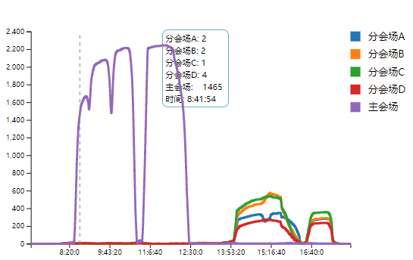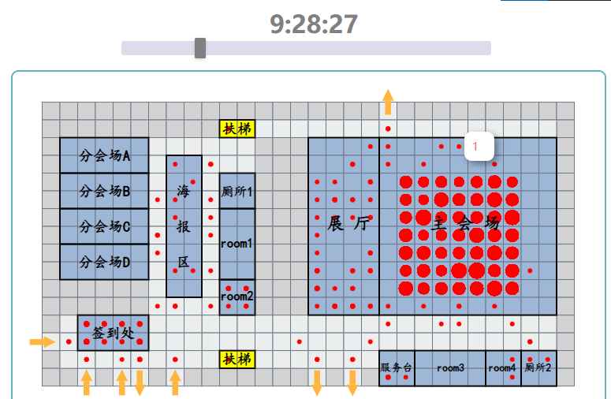
图 1主会场日程分析 图 2主会场演讲人数分析
分析结果: (由演讲处传感器在时间段内测定的人数判断演讲人数)
8:30-8:40 | 开启主会场,人员进场
8:40-9:00 | 开场演讲(单人)
9:00-9:45 | 演讲(双人)
9:45-10:30 | 演讲(双人)
10:30-10:53 | 中场休息
10:53-12:20 | 演讲(四人)
12:20后 | 人员离场,关闭主会场

分会场A:
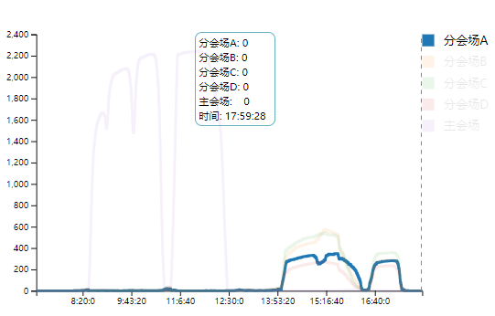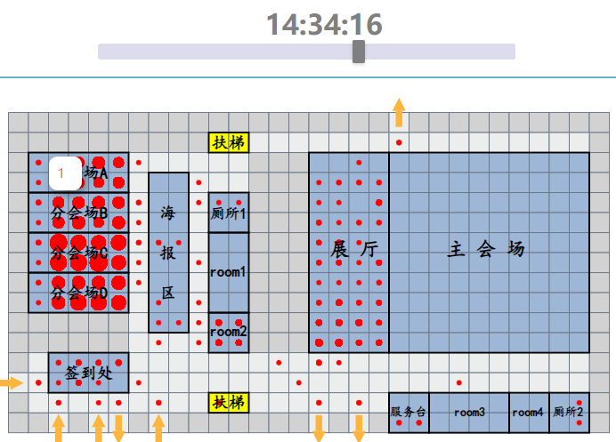
图 3分会场A日程分析 图 4分会场A演讲人数分析
分析结果:
14:00-15:00 | 演讲(单人)
15:00-15:20 | 中场休息
15:20-16:15 | 演讲(单人)
16:40-17:30 | 演讲(双人)

分会场B分析结果:
14:00-16:15 | 演讲(双人)
16:15-16:35 | 中场休息
16:35-17:30 | 演讲(双人)
分会场C分析结果:
14:00-16:15 | 演讲(双人)
16:15-16:35 | 中场休息
16:35-17:30 | 演讲(双人)
分会场D分析结果:
14:00-16:15 | 演讲(双人)
16:15-16:35 | 中场休息
16:35-17:30 | 演讲(双人)

(2).对会议期间的异常事件的分析
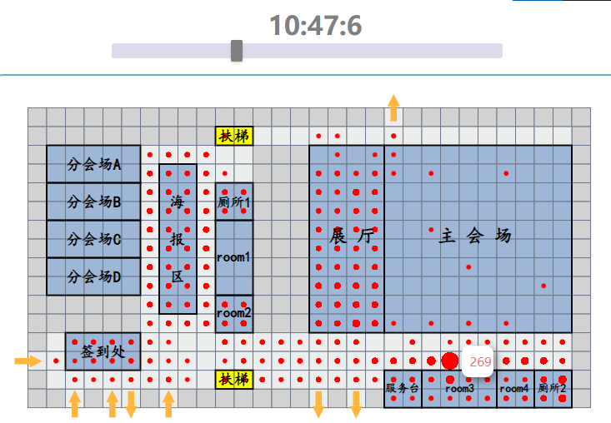
图 5 room3门口异常 图 6 主会议室左门口异常
10:47 room3门口发生剧烈拥挤,平均一平米容纳4人以上
11:03演讲已开始,主会场左门口发生剧烈拥挤,传感器感应人数高达294人

(3).对会场安排的分析
<1>.主会场利用率太低,只有上午在用,而分会场B下午人数较多,可将分会场B的会议改到主会场开;
<2>.分会场B,C,D的开会时间相同导致中场休息厕所等公共场所出现拥挤情况,可适当错开时间;
<3>.主会场进场时左、中、右三个门没有做好引流工作，在左门处发生较为严重的拥挤和排队行为,可以考虑人工引导人流从而缓解左侧门的压力;
<4>.午间休息时比较休闲区与room2,推测room2可能为VIP休息房,但room2房间过小,可改在更为宽阔的room1,以缓解房间压力;
<5>.厕所数目不足,一楼有食堂,容易聚集人群,但仅有一个厕所,二楼5个会议室但只有两个厕所;
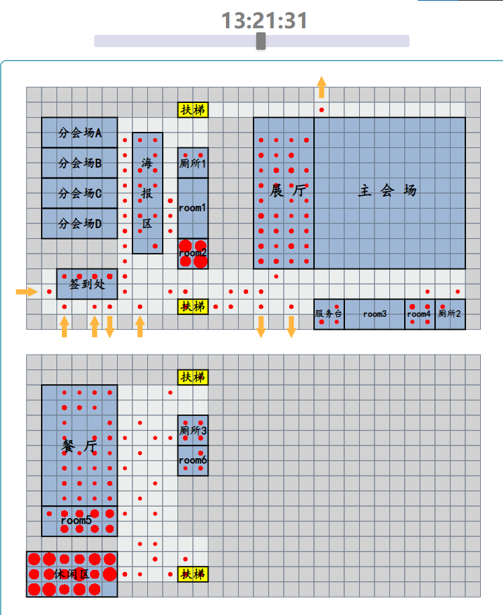
图 7 午间休息的room2

2.总结与心得
在本次大作业中,我选择的题是2019年ChinaVis数据可视分析挑战赛的题1,并成功地通过数据可视化完成了对会场情况的分析和可能潜在异常的发现,同时也对会场安排提出了建议。虽然我的作品相对”参考答案”有些简略,但本次实验是单独一人完成,这使得我对可视化分析项目的应用实践有了更为完整性的了解,也将对我今后的学习或工作产出诸多益处。
尽管我们目前学习的只是简单的可视化基础内容,但通过理论与实践结合学习,当我们面对大数据项目或比赛时能够学会从不同的方面看待数据,从而更好地分析和优化算法。同时学会了在处理数据时联系生活实际,分析问题的前因后果。
最后感谢杨老师通俗易懂的讲解教学, 我也更加有了往后继续学习数据可视化的动力,也期待能够在今后的课程中能再次遇到杨老师。

