SniffLock

# 

**App Description** **1**

**Customers** **2**

**Mockups** **3**

# 

# App Description

The app grants its users full anonymity, leaving no history behind. There have been a lot of problems and talks about big companies using out data for personal gain. The app will be able to access multiple servers all over the world, with proxy servers included.

We’ve made the app as user-friendly as possible, with all of the features shown on the home screen without hiding anything important behind walls of different menus.

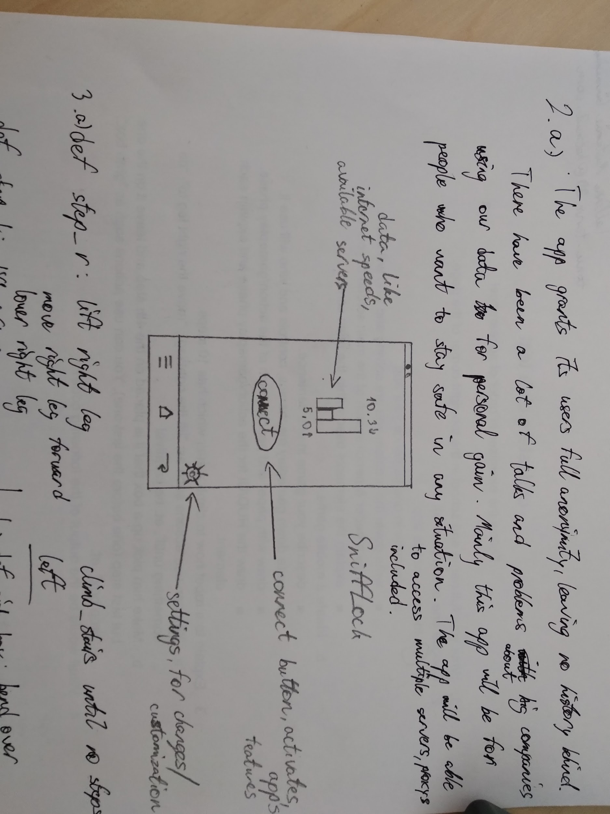

# Customers

This app will be for people who really care for their online safety, or for those who wish to leave nothing onto the sites they visit.

# 

# 

# Figma

<https://www.figma.com/file/pbB31m8aybDCfAfDft7oeD/SniffLock?node-id=1%3A104>

Vectr icon:

<https://vectr.com/nerthchang/b2izUpvkhD.svg?width=640&height=640&select=b2izUpvkhDpage0>

Pixilart icon : https://imgur.com/5HM2rVs