Installing the LEAVENWRTH Odue Macro

In order to follow the process outlined in “leavenwrth.odue.training.docx” you need a computer with Microsoft Word with access to the developer toolbar and the custom LVPL_ODUE_MACRO package installed. These instructions attempt to show how to set these things up on Word.

1. If you don’t see the developer tab at the top of the screen in Word, you need to enable it.  
     
   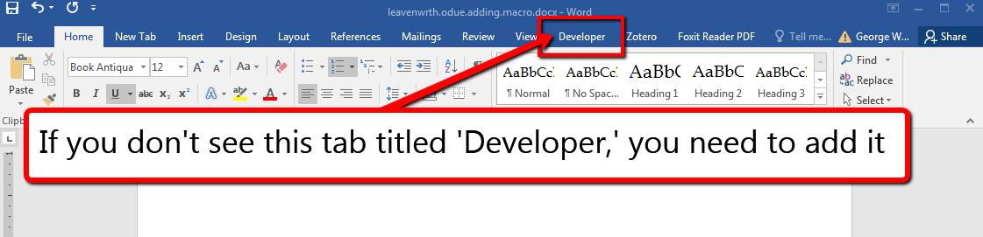
2. To add the developer tab, right click on an existing tab and click on “Customize the Ribbon . . .”  
     
   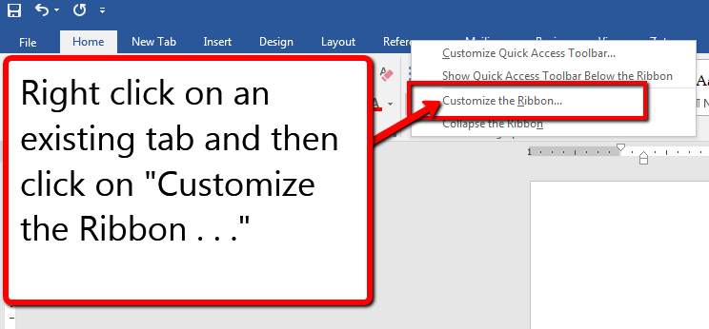
3. Once the “Options” window opens, check the box next to “Developer” from the “Main Tabs” drop-down and then click OK.  
     
   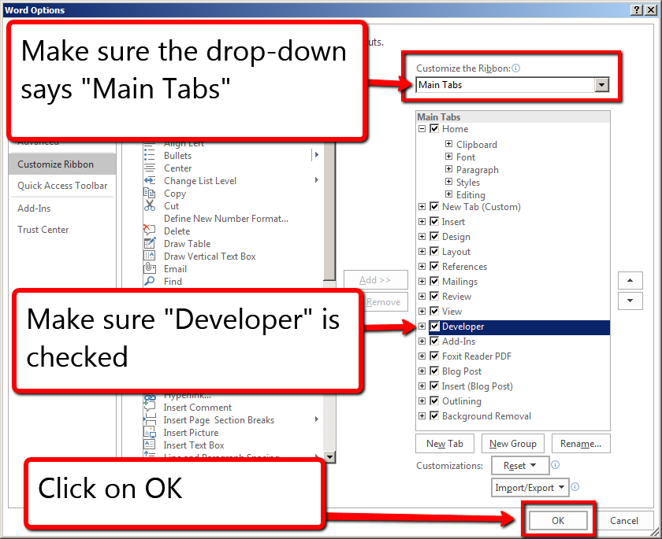
4. You should now see the Developer tab whenever you open Word.  
     
   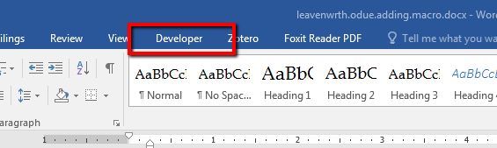

Once you have the developer tab added to Word, you need to install the Macro.

1. Click on the Developer tab in Word.  
     
   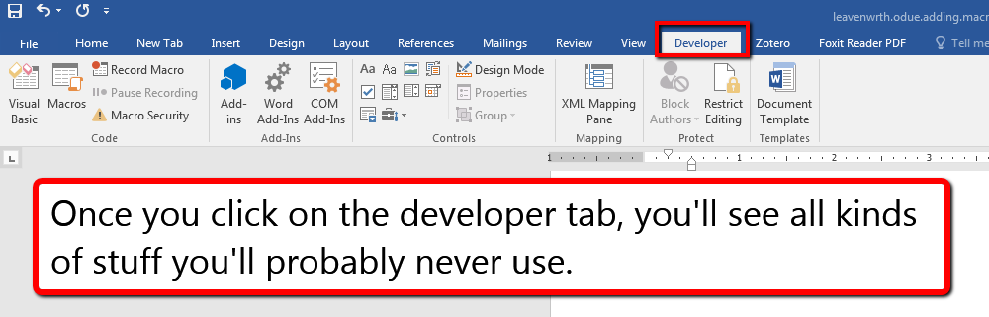
2. Click on “Visual Basic”  
     
   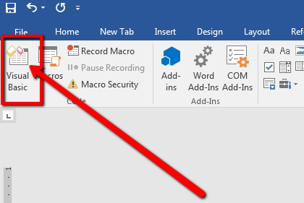  
     
   and you should see:  
     
   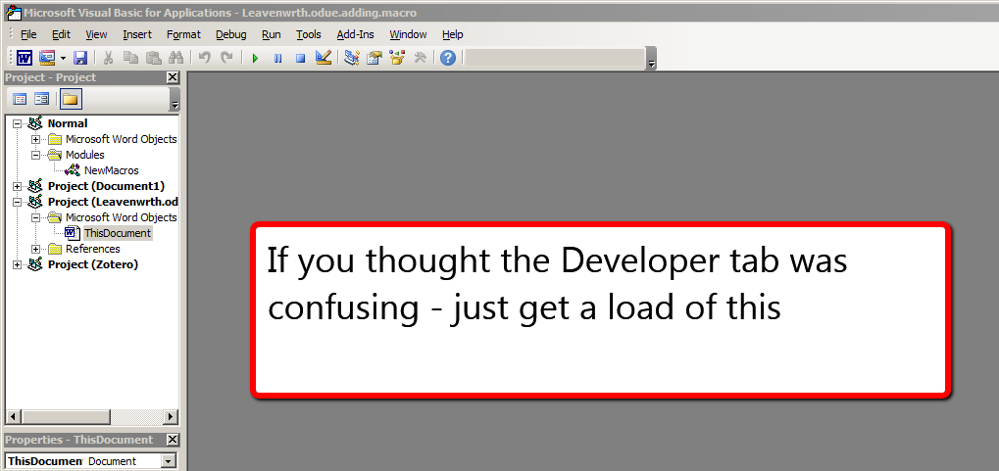
3. In Visual Basic, right click on “Modules,” then click on “Insert,” then click on “Module”  
     
   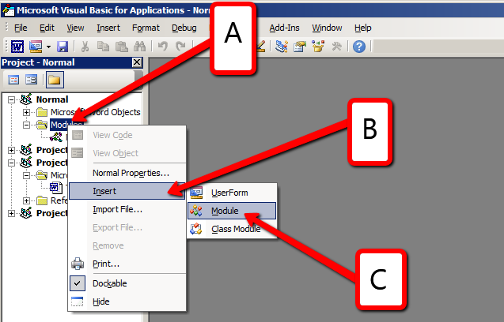
4. This will open a Module window  
     
   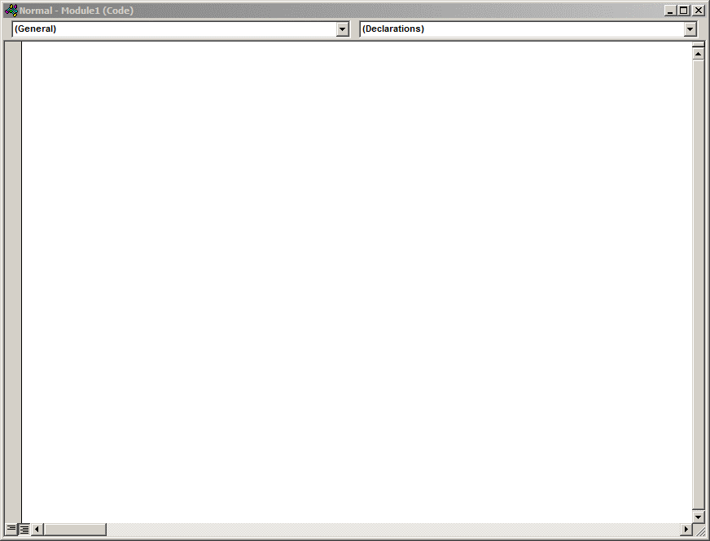
5. Open the file “lvpl_odue_macros.txt,” highlight all of the text, and type ctrl-c to copy the text to the clipboard.  
     
   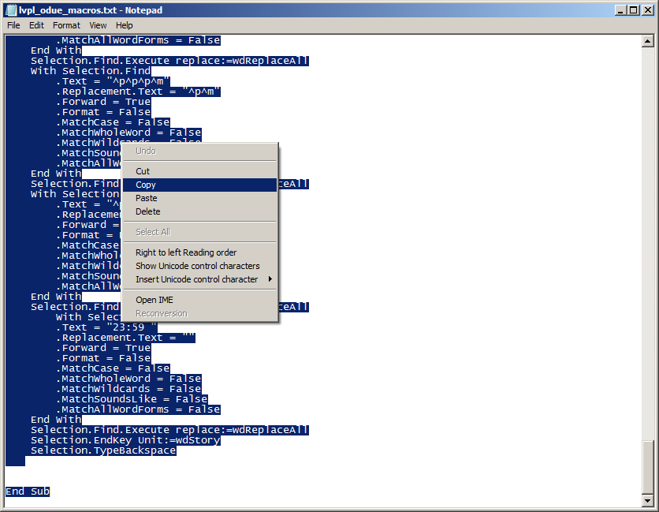
6. Switch back to the Module window in Visual Basic and paste the text you’ve copied into the Module window  
     
   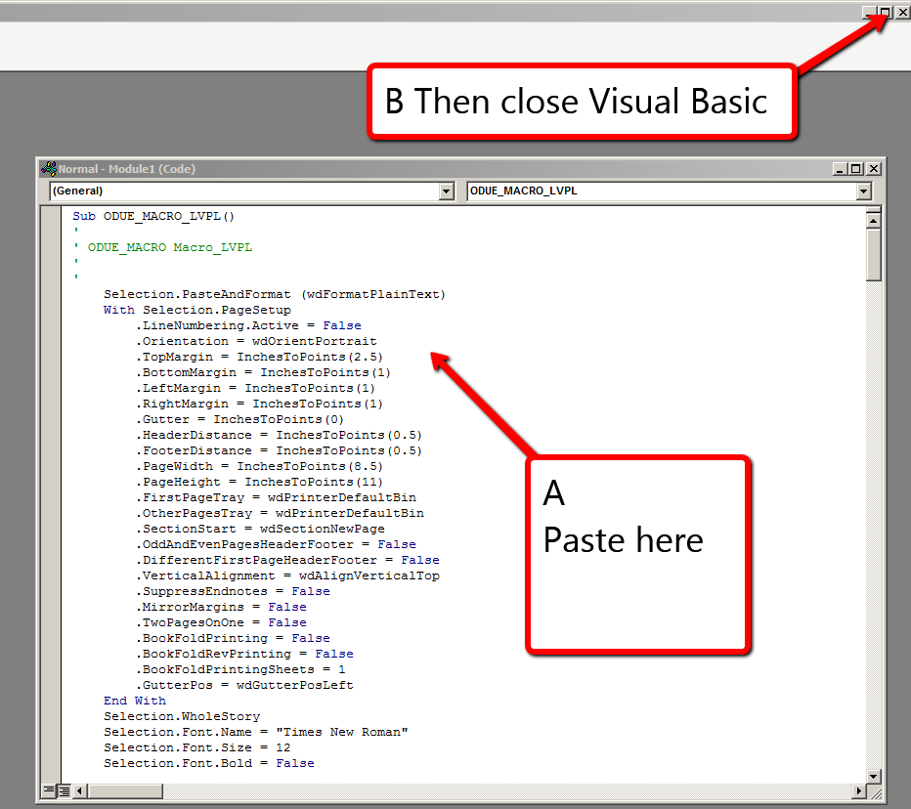
7. If you click on the “Macros” button now, you should see ODUE_MACRO_LVPL and ODUE_SINGLE_LVPL in the list of available Macros  
     
   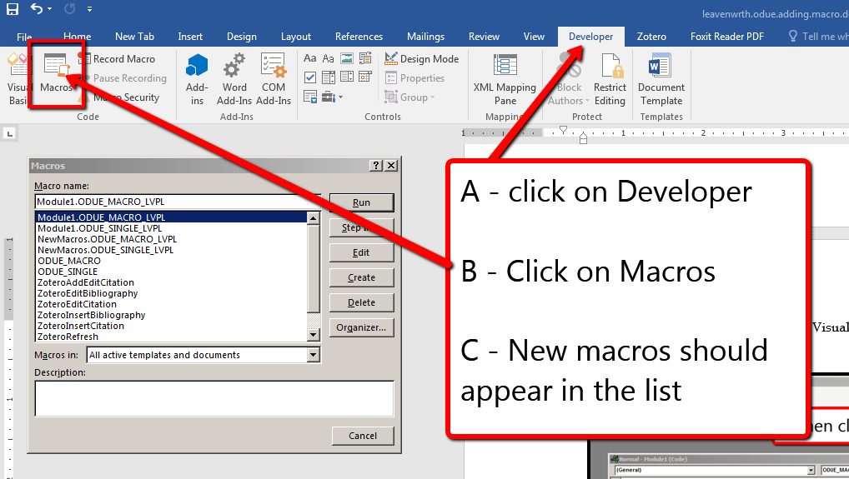
8. From now on, when you open Word, the macros you have added should be available.