Printing LEAVENWRTH Overdue Notices

The purpose of this training document is to show staff at LEAVENWRTH how to print their outgoing overdue notices from Koha. The first part explains how to print these documents from an e-mail sent by Koha and the second part explains how to do the same process using report 2856.

# Koha daily e-mail

If Koha generates any overdue notices for patrons and those patrons do not have an e-mail address on their library account, Koha will generate that patron’s overdue notices and e-mail them to the default e-mail address for the library at which those notices were generated. This e-mail is, generally, sent at about 2:15 a.m., daily.

To convert these notices into printable letters at LVPL:

1. Open the file titled “leavenwrth.odue.master.docx” on a computer that has the Microsoft Word VBA macros for LVPL overdues installed on it.  
     
   If you do not have “leavenwrth.odue.master.docx” and you do not have the macros installed on your computer, please contact the NExpress coordinator at [nexpresshelp@nekls.org](mailto:nexpresshelp@nekls.org) for more help or see the document titled “leavenwrth.odue.macros.docx.”
2. Use Notepad to open the .txt file attachment that Koha sends to your library’s default e-mail address. Currently (as of 2/28/2017) LEAVENWRTH uses circulation@lvplks.org as their default e-mail address.  
     
   This .txt file should look something like this when opened with notepad:  
     
   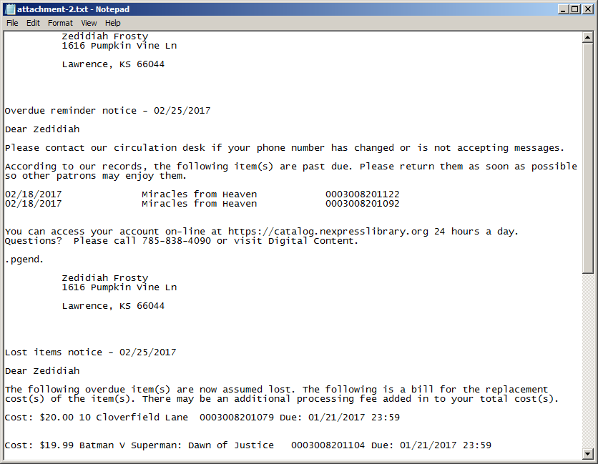
3. Place the cursor somewhere inside of the Notepad document, highlight (ctrl-a) all of the text, and then copy the text to the clipboard (ctrl-c).  
     
   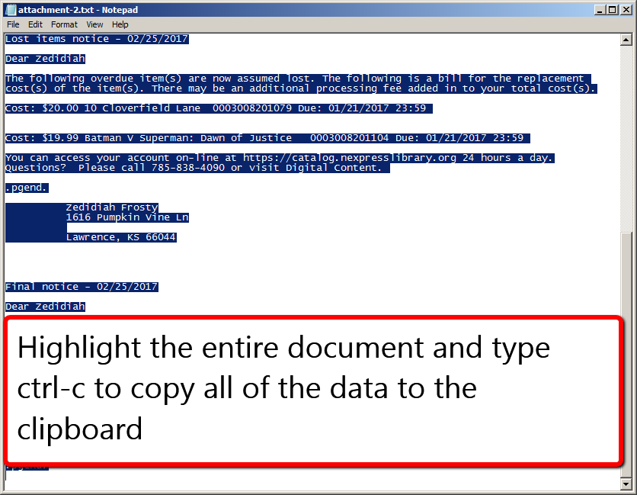
4. Switch windows to Microsoft Word and place the cursor somewhere inside of the open “leavenwrth.odue.master.docx”document.  
     
   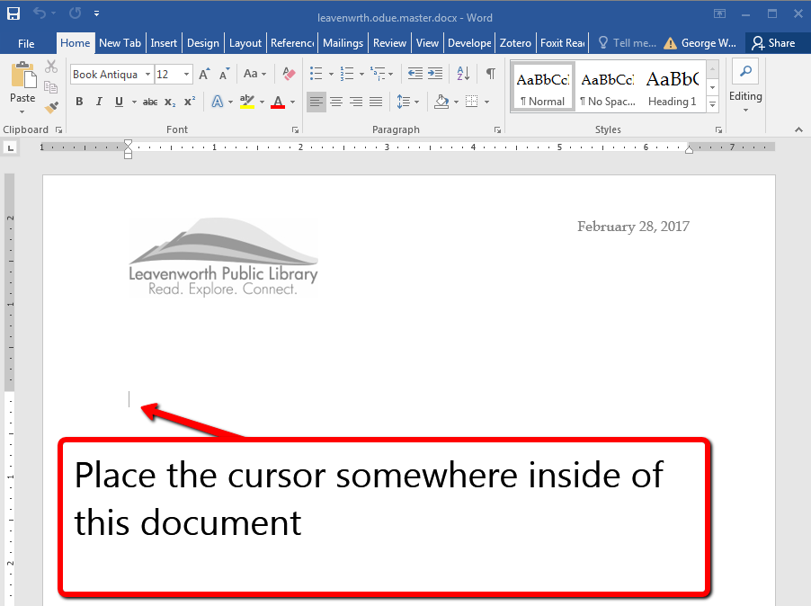
5. Then click on the tab labeled “Developer” and select the button that says “Macros”  
     
   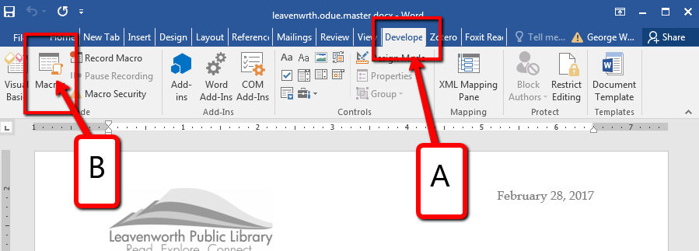
6. Click on the Macro that says “ODUE_MACRO_LVPL” and then click on “Run.”  
     
   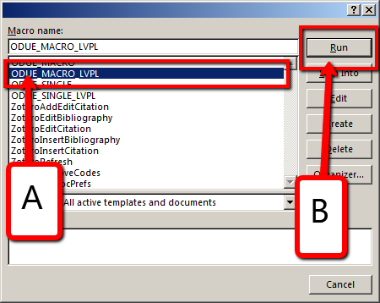
7. Once you click on “Run,” the Macro will paste the text from the attachment into the document and then set all of the document formatting so that the notices can easily be printed on a printer.  
     
   Once printed, if you fold the document in thirds just about the line that says “Overdue reminder . . .,” “Lost items . . .,” or “Final notice,” the patron’s address should appear in correct spot for display in a standard business sized window envelope.  
     
   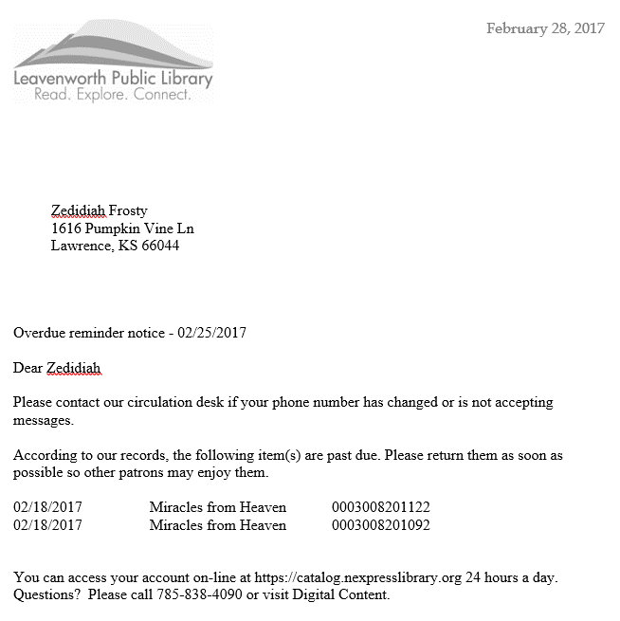
8. Any “Lost items . . .,” or “Final notice” letters will include prices for each individual item, but they will not display a total amount.  
     
   If you want the notices to display a total due, you must do that math manually.

# Report 2856

If Koha generates any overdue notices for patrons and those patrons do not have an e-mail address and you do not wish to use the .txt file that Koha sends to the library’s default e-mail address, you can also retrieve the notices that need to be printed by running report 2856.

To run this report and convert these notices into printable letters at LVPL:

1. Open the file titled “leavenwrth.odue.master.docx” on a computer that has the Microsoft Word VBA macros for LVPL overdues installed on it.  
     
   If you do not have “leavenwrth.odue.master.docx” and you do not have the macros installed on your computer, please contact the NExpress coordinator at [nexpresshelp@nekls.org](mailto:nexpresshelp@nekls.org) for more help or see the document titled “leavenwrth.odue.macros.docx.”
2. Go to the Koha reports module, click on “Use saved” reports, and search for report 2856.  
     
   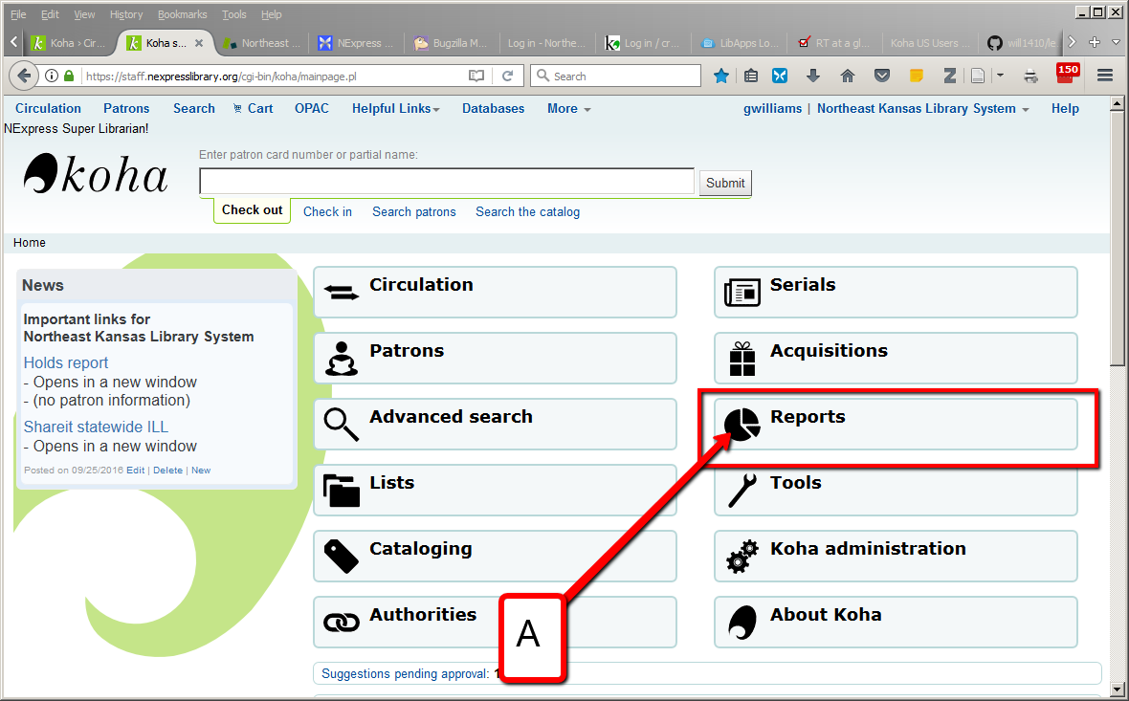  
     
   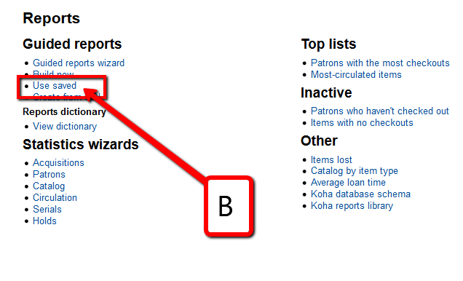  
     
   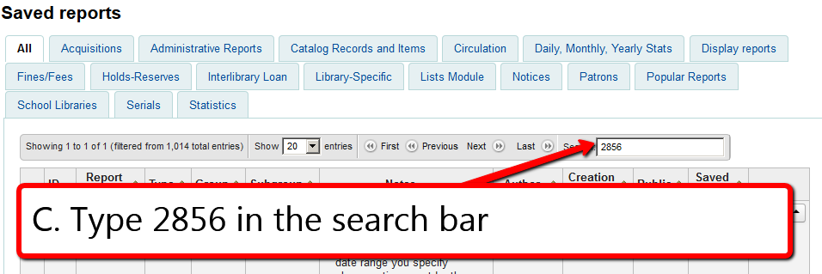
3. Once you’ve found Report 2856, click on the “Actions” button and then click on “Run.”  
     
   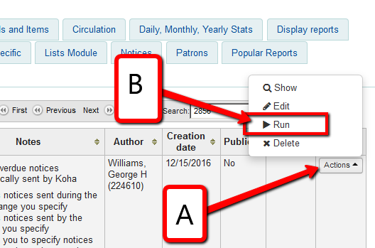
4. This report has a lot of parameters.  
     
   For the purposes of printing these notices at LVPL, you can leave the first 3 parameters set at their defaults. (i.e. Overdue 1-All, Overdue 2-All, Overdue 3-All.)  
     
   For “Type of notice” you should select “Print notices”  
   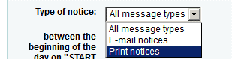  
     
   For “. . . Start date” and “. . . End date” you can select a date range (i.e. you can print notices from several different days at one time)  
     
   For “Choose location” you should select Leavenworth Public Library.
5. Once you’ve set your parameters, click on “Run the report.”  
     
   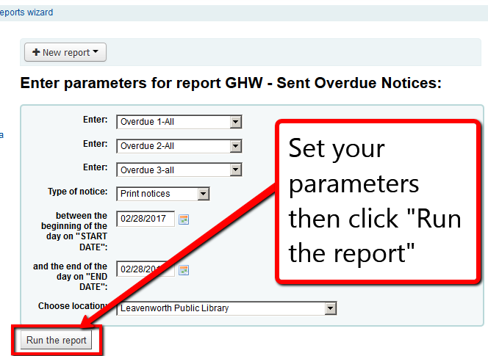
6. The results that appear on the screen will not look normal. In order to utilize the output, you must download the report and open it in Excel.  
     
   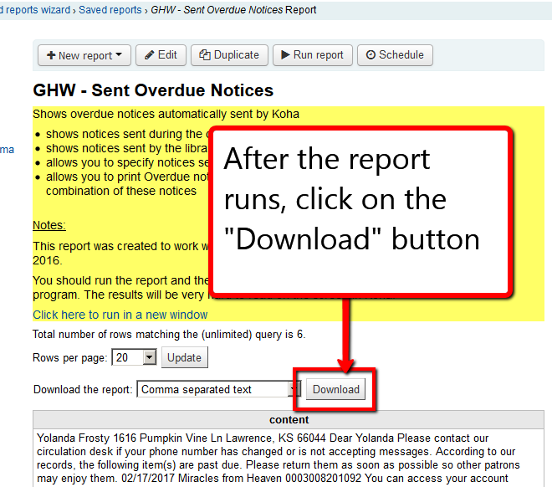
7. Once you’ve opened the report in Excel, highlight all of the rows in Column A that contain data except for the header row (which should be titled “content”)  
     
   (Sometimes it’s hard to tell which rows contain data – you can expand the rows and more easily see the content if you turn on the Wrap Text feature in Excel.)  
     
   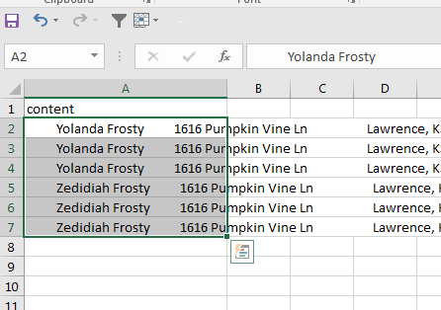
8. Switch windows to Microsoft Word and place the cursor somewhere inside of the open “leavenwrth.odue.master.docx”document.  
     
   
9. Then click on the tab labeled “Developer” and select the button that says “Macros”  
     
   
10. Click on the Macro that says “ODUE_MACRO_LVPL” and then click on “Run.”  
      
    
11. Once you click on “Run,” the Macro will paste the data from Excel into the document and then set all of the document formatting so that the notices can easily be printed on a printer.  
      
    Once printed, if you fold the document in thirds just about the line that says “Overdue reminder . . .,” “Lost items . . .,” or “Final notice,” the patron’s address should appear in correct spot for display in a standard business sized window envelope.  
      
    
12. Any “Lost items . . .,” or “Final notice” letters will include prices for each individual item, but they will not display a total amount.  
      
    If you want the notices to display a total due, you must do that math manually.