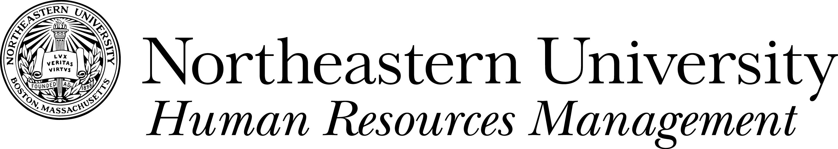
TUITION WAIVER PROGRAM

DEPENDENT CERTIFICATION FORM
Please print all information.
In accordance with the Northeastern University Tuition Waiver policy, I hereby certify that the student named below is:

- My unmarried son, daughter, stepchild, or legally adopted child and this student was claimed as a dependent on my most recent federal tax return.

- The unmarried son, daughter, stepchild, or legally adopted child of my same sex spousal equivalent and this student was claimed as a dependent on the most recent federal tax return of my same sex spousal equivalent.

- My unmarried son, daughter, stepchild, or legally adopted child who otherwise meets the definition of dependent, but who is not listed as a dependent on my most recent federal tax return due to a domestic relations order.

Dependent children must remain a dependent during their entire course of study.
Upon request, I agree to provide to HRM/Benefits a copy of the federal tax return verifying the dependent status of this student, or, if applicable, a copy of the domestic relations order verifying the dependent status of the student.

____________________________________________ ________________________________

Employee’s Signature Date

Academic Term __________________ Academic Year ________
(Fall, Winter, Spring, Summer 1 or Summer 2)

Student's Name Student's NU ID

Student's Date of Birth

Employee's Name Employee's NU ID

___
Department Campus Mailstop Campus Extension

Mail completed Dependent Certification Form and Tuition Waiver Form to Human Resources Management, 250 Columbus Place or fax to 617-373-7610. If additional information is needed you will be notified in writing.

