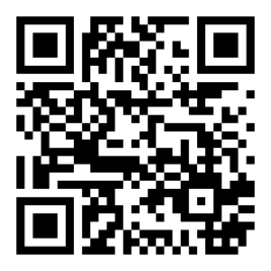
Board Members  Kenneth Underwood  President  Wyn Spiller  Treasurer  Paula Campbell Secretary  Rick Panos  Jeff Cereghino  Rich Hill  Use QR Code to sign up for our Loyalty Program or visit:  www.NorthStarHouse.org/loyalty | {{DonorName}}  {{Address}}  Dear {{Name}},  On behalf of the Board of Directors of the North Star Historic Conservancy, thank you for your generous in-kind contribution of {{Description of Donated Goods/Services}}, with an estimated value of {{Estimated Value}}, received on {{Date}}.  Your support makes a meaningful difference in our ability to care for and activate the North Star House as a vibrant community gathering space. Contributions like yours help offset operational costs, allowing us to direct more resources toward restoration, programming, and public engagement.  We are deeply grateful for your willingness to support this work in such a practical and impactful way. Your contribution directly strengthens our ability to move projects forward and serve the community more effectively.  With sincere appreciation,    Ken Underwood  President

