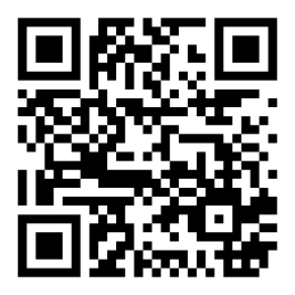
Board Members  Kenneth Underwood  President  Wyn Spiller  Treasurer  Paula Campbell Secretary  Rick Panos  Jeff Cereghino  Rich Hill  Use QR Code to sign up for our Loyalty Program or visit:  www.NorthStarHouse.org/loyalty | {{DonorName}}  {{Address}}  Dear {{Name}},  On behalf of the Board of Directors of the North Star Historic Conservancy, thank you for your generous gift of {{Amount}}, designated to support {{Restricted Purpose / Project}}.  Your thoughtful support plays an important role in helping us advance this specific area of work while continuing to care for and steward the North Star House as a whole. Gifts like yours allow us to move forward with intention—ensuring that each project is approached responsibly, respectfully, and in alignment with our long-term vision for the house as a community gathering space.  We are truly grateful for your commitment to this work and for your belief in the importance of preserving and activating the North Star House for future generations. We look forward to keeping you updated as this project progresses.  With sincere appreciation,    Ken Underwood  President

