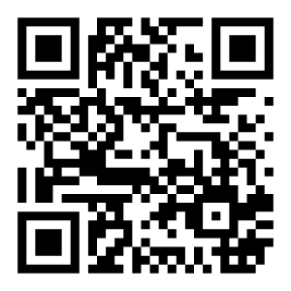
Board Members  Kenneth Underwood  President  Wyn Spiller  Treasurer  Paula Campbell Secretary  Rick Panos  Jeff Cereghino  Rich Hill  Use QR Code to sign up for our Loyalty Program or visit:  www.NorthStarHouse.org/loyalty | {{DonorName}}  {{Address}}  On behalf of the Board of Directors of the North Star Historic Conservancy, thank you for your thoughtful gift of {{Amount}} received on {{Date}}, made in tribute to {{Name of Honoree}}.  Tribute gifts like yours carry special meaning. They allow us to honor individuals who have made an impact while supporting the ongoing care and future of the North Star House as a welcoming community gathering space. Your generosity helps ensure that this place continues to bring people together in meaningful ways.  We are grateful for your support and for the care reflected in this tribute. It is an honor to acknowledge {{Name of Honoree}} through work that preserves and activates the North Star House for generations to come.  With sincere appreciation,    Ken Underwood  President

