Northumbrian Concert

An evening of traditional music, songs & dialect

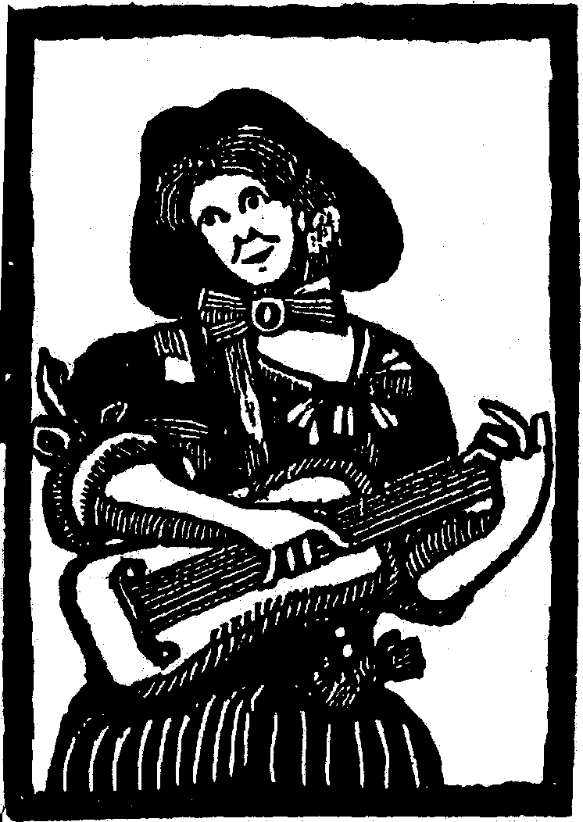

Alistair Anderson
Graham Bell & Anne Lamb
Border Directors
Miggins Fiddle
Sophie Fraser
James Tait

M.C. Ron Forster

Fri. 14th March 7.30pm

The Ballroom, Morpeth Town Hall, Market Place, Morpeth, NE61 1LZ

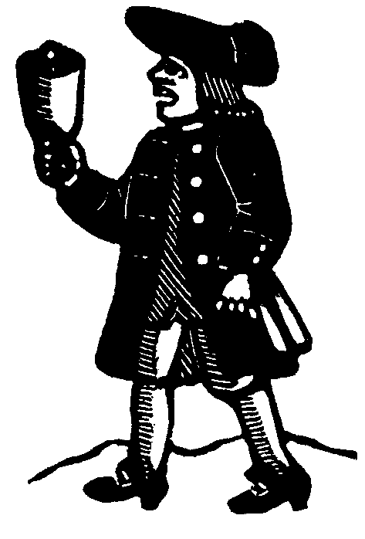
Tickets: Adult £15; Child £6
On sale at Morpeth Chantry TIC 01670 623455

or from Kim Bibby-Wilson 01670 513308
Queries: kim@northumbriana.org.uk

Interval refreshments available

A fund-raiser for 57th Morpeth Northumbrian Gathering 25th-27th April 2025
Festival of music, song, dance, craft, dialect, heritage, family events

