Northwest Syria Cash Working Group Earthquake Response Bulletin

12 April, 2023

Table of Contents

# 1. MPC response overview

As of 11 April 2023, a total of 448,317 persons or 90,324 families have been reached by MPC interventions. A total of USD 13.3 million has been disbursed by 17 implementing agencies across 28 sub-districts.

With only certain exceptions (such as activities specified as non-MPC cash-for-food), only beneficiaries who have received at least USD 100/family/month have been included.

448,000 people reached with MPC, USD 13.3 million disbursed, 11 April 2023

| **governorate** | **district** | **communities** | **partners** | **households** | **beneficiaries** | **total_usd** | **%_beneficiariesb** |
| --- | --- | --- | --- | --- | --- | --- | --- |
| Aleppo | A'zaz | 5 | 7 | 2,994 | 14,578 | 424,067 | 3.25 |
| Aleppo | Afrin | 75 | 10 | 25,162 | 125,312 | 3,726,192 | 27.95 |
| Aleppo | Al Bab | 3 | 2 | 998 | 5,011 | 137,791 | 1.12 |
| Aleppo | Jarablus | 1 | 3 | 589 | 2,805 | 88,350 | 0.63 |
| Aleppo | Jebel Saman | 15 | 8 | 9,226 | 53,754 | 1,380,550 | 11.99 |
| Idleb | Harim | 38 | 13 | 43,136 | 204,566 | 6,273,250 | 45.63 |
| Idleb | Idleb | 17 | 10 | 5,634 | 28,502 | 879,372 | 6.36 |
| Idleb | Jisr-Ash-Shugur | 21 | 3 | 2,585 | 13,789 | 350,200 | 3.08 |
| Total | - | - | - | 90,324 | 448,317 | 13,259,772 | 100.00 |
| bAs percentage of all MPC beneficiaries reached in NW Syria; | | | | | | | |

177,525 beneficiaries were reached in February 2023 and 200,330 were reached in March 2023. 52,252 have been reached so far in April 2023.Changes in numbers of persons reached were due to cleaning and verification of the dataset – this process is still ongoing and will only be completed once the CWG fully transitions to 4W reporting.

## 1.1 Progress by date

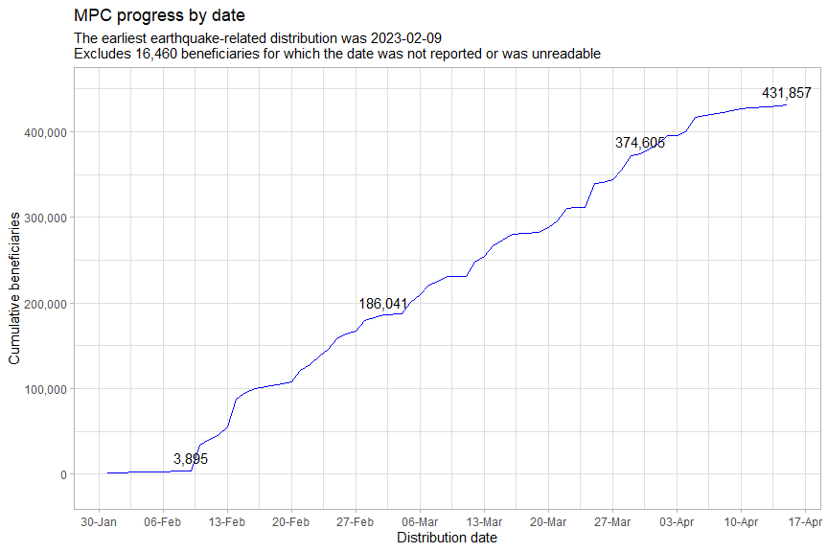

The 6,160` beneficiaries reached earlier that 2023-02-09 all pertained to the HRP, the only such beneficiaries reported so far.

# 2. Map of activities

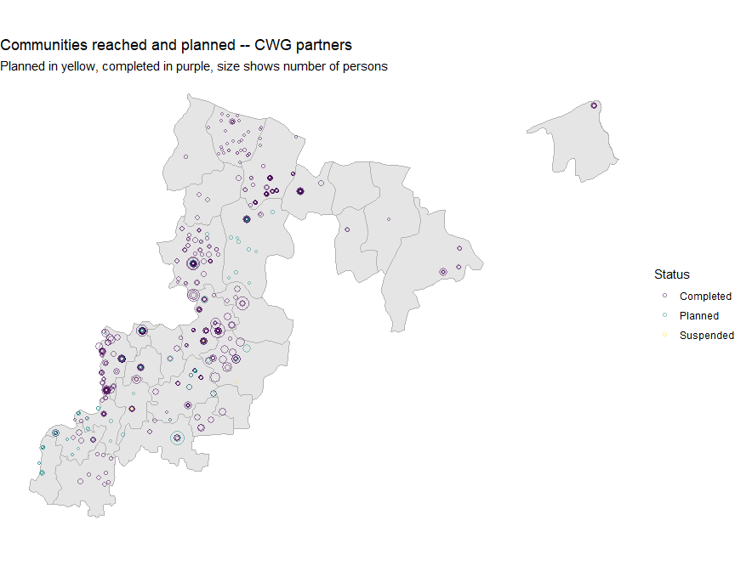

# 3. Geographic breakdown of beneficiaries

Coverage continues to be highest in Afrin and Harim districts, which have been worst-hit by the earthquake.

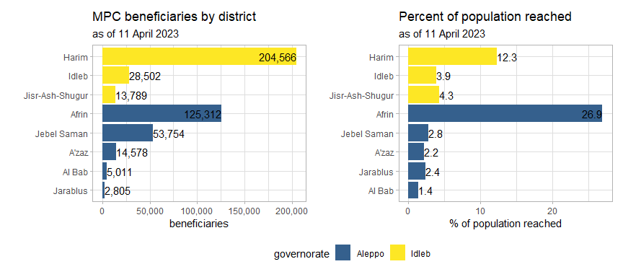

Casualties and damaged houses, absolute figures and per 100,000 persons

| **governorate** | **district** | **wounded_dead1** | **wounded_dead_100k1** | **damaged_houses1** | **damaged_houses_100k1** |
| --- | --- | --- | --- | --- | --- |
| Aleppo | A'zaz | 356 | 57.87 | 276 | 44.86 |
| Aleppo | Afrin | 2,232 | 478.79 | 2,910 | 624.22 |
| Aleppo | Al Bab | 206 | 70.04 | 832 | 282.89 |
| Aleppo | Jarablus | 40 | 33.82 | 257 | 217.30 |
| Aleppo | Jebel Saman | 616 | 236.80 | 176 | 67.66 |
| Idleb | Harim | 8,449 | 507.65 | 3,230 | 194.07 |
| Idleb | Idleb | 350 | 48.23 | 946 | 130.37 |
| Idleb | Jisr-Ash-Shugur | 595 | 183.68 | 1,915 | 591.18 |
| 1Data from the Assistance Coordination Unit, Syria 20230328; | | | | | |

Below is a breakdown of beneficiaries based on whether they originate from camps or villages:

More than twice as many beneficiaries from villages as from camps

| **village_camps** | **beneficiaries** | **%_beneficiaries** |
| --- | --- | --- |
| camp | 94,430 | 21.06 |
| village | 228,690 | 51.01 |
| NA | 125,197 | 27.93 |

### 3.1 By sub-district

The plots below show the breakdown of beneficiaries by sub-district. Caution must be taken to ensure that allocations are fair across the affected areas: there are numerous sub-districts where a very large proportion of the total population has already been reached by multi-purpose cash, in particular, Jandairis, Hairm, Salqin and Sharan.

Response activities must be proportional with the magnitude and severity of earthquake damage. Overallocation deprives affected persons of the aid they are due.

The average percentage of the population reached, of all sub-districts, is 10.63%.

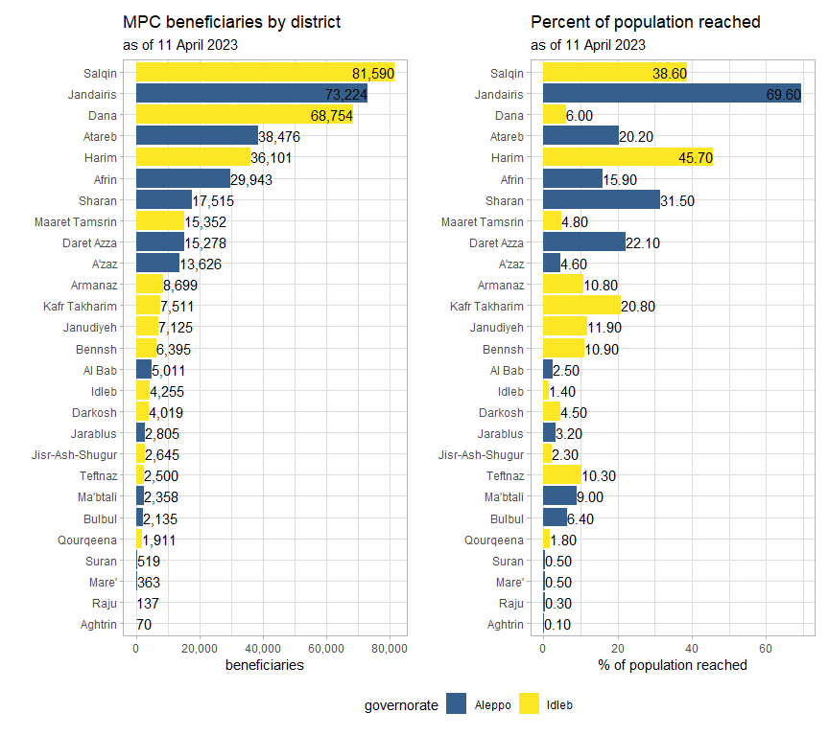

### 3.2 Comparisons with PIN and earthquake damage

The plot below shows the total population of each sub-district on the x-axis (for the moment, all persons in these areas are assumed to be affected and are included in the PIN) and the number of beneficiaries on the y-axis.

The size of each point indicates the number of dead or wounded persons there per 100,000.

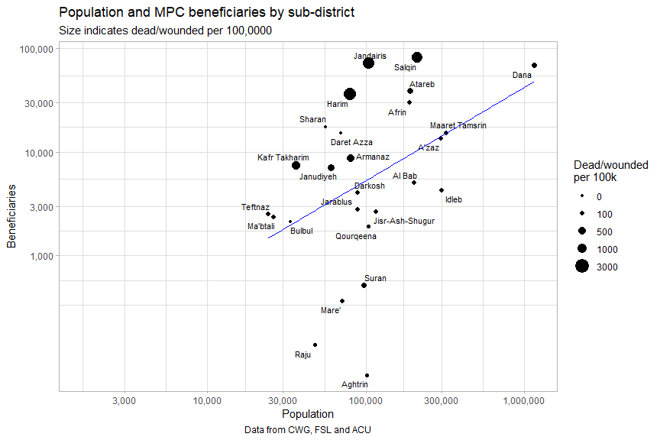

The higher or lower a sub-district is above the blue line, the more disproportionate the number of beneficiaries allocated to that location are.

This should also be compared to each sub-district’s share of the earthquake damage. Of particular note, sub-districts in grey have yet to receive any MPC assistance.

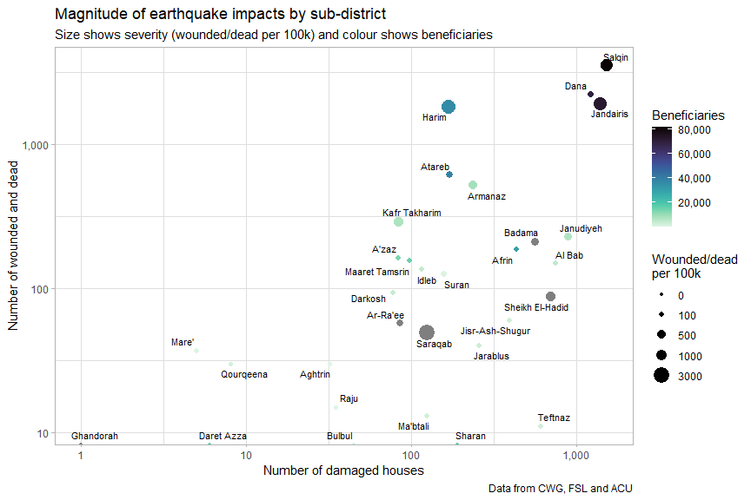

The CWG is currently working on a prioritisation score, which can be a useful shorthand (or crutch), that will take into account pre-existing vulnerability (likely from the MSNA) as well as earthquake impacts.

### 3.3 Planned activities

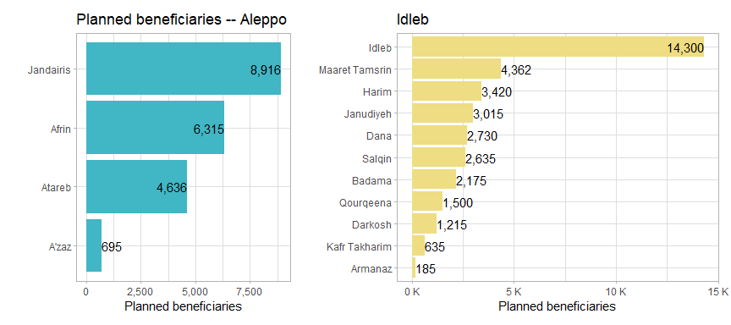

# 4. Cash response actors and cash disbursed

In the scatterplot below, each point is a single cash working group partner. The x-axis indicates the number of beneficiaries reached per agency and the y-axis indicates the number of communities (admin4) reached.

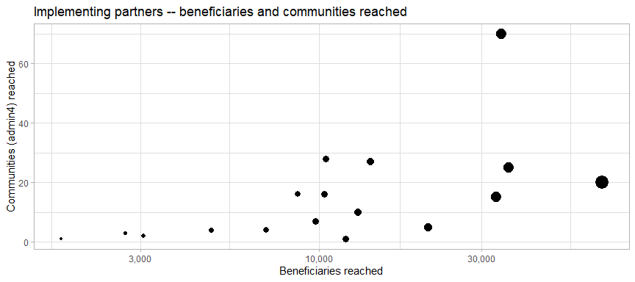

USD 13.3 million has been distributed across 174 communities and 28 sub-districts in NW Syria.

The table below summarises the information in the scatterplot above in tabular form:

Reach and footprint of cash response actors

| **implementing_partner1** | **beneficiaries** | **districts** | **communities** |
| --- | --- | --- | --- |
| CBRTWG-006 | 67,989 | 3 | 20 |
| People in Need (PIN) | 36,144 | 3 | 25 |
| GOAL (GOAL) | 34,310 | 3 | 70 |
| CBRTWG-010 | 33,115 | 5 | 15 |
| Norwegian Refugee Council (NRC) | 20,900 | 2 | 5 |
| CBRTWG-035 | 14,197 | 5 | 27 |
| Mercy Without Limits | 13,016 | 4 | 10 |
| Bahar Organization (BO) | 12,000 | 1 | 1 |
| Agency for Technical Cooperation and Development (ACTED) | 10,481 | 7 | 28 |
| Uluslararasi Insani Yardimlasma Dernegi (IYD) | 10,351 | 4 | 16 |
| Syria Relief | 9,750 | 5 | 7 |
| Ihsan for Relief and Development | 8,655 | 5 | 16 |
| World Vision International (WVI) | 7,008 | 1 | 4 |
| Welthungerhilfe (WHH) | 4,830 | 4 | 4 |
| Ataa Humanitarian Relief Association (ATAA) | 3,060 | 1 | 2 |
| MASRRAT | 2,692 | 3 | 3 |
| Elaf for relief and development | 1,750 | 1 | 1 |
| NULLOnly partners who provided more than USD 100/family/month; | | | |

### 4.1 USD disbursed per partner

USD disbursed and families reached by partner

| **implementing_partner** | **total_usd** | **families** | **usd_per_fam** | **%_usd_total** |
| --- | --- | --- | --- | --- |
| GOAL (GOAL) | 2,998,650 | 19,991 | 150.00 | 22.61 |
| CBRTWG-006 | 1,773,750 | 11,825 | 150.00 | 13.38 |
| CBRTWG-010 | 1,590,100 | 11,287 | 140.88 | 11.99 |
| Norwegian Refugee Council (NRC) | 1,266,450 | 8,443 | 150.00 | 9.55 |
| People in Need (PIN) | 927,450 | 6,183 | 150.00 | 6.99 |
| Ihsan for Relief and Development | 854,250 | 5,695 | 150.00 | 6.44 |
| Syria Relief | 724,500 | 4,830 | 150.00 | 5.46 |
| Agency for Technical Cooperation and Development (ACTED) | 515,350 | 3,373 | 152.79 | 3.89 |
| Mercy Without Limits | 438,372 | 3,325 | 131.84 | 3.31 |
| CBRTWG-035 | 409,800 | 4,098 | 100.00 | 3.09 |
| Uluslararasi Insani Yardimlasma Dernegi (IYD) | 375,000 | 2,500 | 150.00 | 2.83 |
| Bahar Organization (BO) | 360,000 | 2,400 | 150.00 | 2.71 |
| Welthungerhilfe (WHH) | 344,400 | 2,296 | 150.00 | 2.60 |
| World Vision International (WVI) | 301,200 | 2,008 | 150.00 | 2.27 |
| Ataa Humanitarian Relief Association (ATAA) | 177,000 | 1,180 | 150.00 | 1.33 |
| Elaf for relief and development | 122,500 | 350 | 350.00 | 0.92 |
| MASRRAT | 81,000 | 540 | 150.00 | 0.61 |

The CWG is currently working with other Clusters to consolidate all cash-based activities and will soon be able to provide more comprehensive reporting.

# 5. Annexes

### 5.1 Interactive reference table at sub-district level

Columns include: governorate, district, sub-district, total population, beneficiaries, total usd disbursed, wounded and dead, wounded and dead per 100k, damaged houses, damaged houses per 100k, admin3pcode

### 5.2 Reporting quality

This section documents issues encountered in the cleaning of 4W and FSL data and their impacts on the quality of reporting the CWG can provide.

Note that substantial cleaning has already taken place and these outstanding issues could not be resolved by the time of reporting.

However, the CWG recognises that not all reporting issues were due to partner error. The CWG will work with partners to continue improving reporting quality.

Still, one third of reporting originates from the FSL tracker

| **source** | **partners** | **beneficiaries** | **%_beneficiaries** |
| --- | --- | --- | --- |
| 4ws | 11 | 308,417 | 68.79 |
| fsl_tracker | 7 | 139,900 | 31.21 |

Below is a breakdown of reporting by date:

January reporting is still largely incomplete

| **month** | **partners** | **beneficiaries** | **%_beneficiaries** |
| --- | --- | --- | --- |
| Jan | 2 | 3,778 | 0.84 |
| Feb | 8 | 177,525 | 39.60 |
| Mar | 10 | 200,330 | 44.68 |
| Apr | 5 | 52,252 | 11.66 |
|  | 1 | 14,432 | 3.22 |

Activities pertaining to 14,432 were missing their date or had dates in unreadable formats. However, the columns start date, end date and month of reporting were some of the most troublesome and consumed a large part of the time dedicated to data cleaning.

The CWG would like to reiterate that start date and end date should be entered in the format mm/dd/yyyy and that month of reporting should be selected from the dropdown menu.

12 partners have reported planned activities

| **project_status** | **partners** | **beneficiaries** | **%_beneficiaries** |
| --- | --- | --- | --- |
| Completed | 17 | 448,317 | 87.83 |
| Planned | 12 | 62,129 | 12.17 |
| Suspended | 1 | 0 | 0.00 |

The sum of planned beneficiaries is 62,129. If this is the extent of all planned MPC activities, the CWG as a whole can expect to reach around 77% of its target of 662,942 persons.

Below is a breakdown of planned actitivities by source:

Breakdown of planned activities by source

| **source** | **partners** | **beneficiaries** | **%_beneficiaries** |
| --- | --- | --- | --- |
| 4ws | 7 | 40,542 | 65.25 |
| fsl_tracker | 5 | 21,587 | 34.75 |