DisasterAware: AI Enhanced Concept-Based Fuzzy Reasoning for Scalable Wildfire Decision Support

Çağlar Akman, Hasan Furkan Öztürk and Kemal Leblebicioğlu

Abstract— Wildfire incident commanders act under time pressure and incomplete information, yet most decision support systems (DSS) still choose from a fixed catalogue of actions, assume complete observation, and expose their reasoning only through post-hoc attribution. This article presents DisasterAware, a wildfire DSS framework built on concept-based fuzzy reasoning that converts raw observations into a small set of domain-meaningful concepts before any action is formed. Four properties define the framework. The decision space is open: an evolving Fuzzy Inference System (evFIS) adapts the rule base by membership modification and resolution increase, a generative model proposes genuinely new rules, and a reinforcement learning (RL) optimizer tunes the admitted rules under cost minimization, with every candidate verified before it can act. Reasoning proceeds under partial observability, where epistemic uncertainty is propagated by confidence gating without any prior distribution, so the system degrades gracefully when inputs are missing. Each recommendation is intrinsically traceable to the concepts and rules that produced it, and a sensitivity analysis quantifies how the inputs drive the decision. The framework is demonstrated on an end-to-end wildfire response use-case that couples a spatio-temporal spread simulation with the decision pipeline and an operator dashboard.
Index Terms—Concept-based fuzzy reasoning, decision support systems, hierarchically distributed multi-agent systems, partial observability, wildfire response management.

I. INTRODUCTION
W
ildfires have become more frequent and more severe over recent decades, and the climatic and land-use conditions that drive them continue to intensify across most fire-prone regions [1, 2]. During an active incident, operators must decide where to send limited crews, which assets to protect first, and whether direct attack is feasible, and these calls are made quickly, under pressure, and on incomplete information. Decision support systems (DSS) exist to turn heterogeneous and fast-changing data into structured guidance for such choices [3, 4]. The operational value of a wildfire DSS depends less on raw predictive accuracy than on whether its recommendations stay meaningful when the situation shifts, when part of the observation is missing, and when responders need to understand why a given action is proposed.
A wide range of systems supports parts of this task. The U.S. Wildland Fire DSS couples weather, fire behavior, and economic information for incident-level decisions [5], while fire-behavior models such as FlamMap [6], built on the Rothermel spread model [7], predict how a front advances across a landscape. Operations research has produced optimization models for suppression-resource allocation and evacuation [8], together with multi-criteria toolkits [9] and classical methods that rank predefined alternatives against weighted criteria [10]. Integrated platforms link sensing, GIS, and decision logic for real-time suppression management [11], and machine learning has been applied to spread prediction over large remote-sensing archives [12, 13, 14, 15, 16], including hybrid designs that pair learned prediction with fuzzy rule bases [17]. More recently, large language models (LLMs) have entered the field as analysis and response agents: WildfireGPT adapts a general model to wildfire risk queries [18], and geospatially grounded agents retrieve terrain, infrastructure, and weather context to produce resource-allocation recommendations [19], and ontology-driven systems pair semantic rules with LLMs for forest-fire decision support [20]. Systematic reviews of this landscape report steady progress on individual capabilities, but also a persistent distance between what the literature emphasizes and what is actually adopted in the field [21].
Current DSS approaches share several limitations. Most systems reason over a closed catalogue of predefined actions, so any response outside that catalogue is unreachable, even though fire behavior evolves continuously and rarely matches a fixed strategy. Moreover, recommendations are commonly produced under an assumption of complete observation, or an evidence-theoretic one [22], although the missing information in an incident seldom carries known statistical properties [23, 24, 25]. Third, the reasoning behind a recommendation is often exposed only through post-hoc attribution [26, 27], which approximates a trained model after the fact rather than tracing a decision to its causes. DisasterAware is a wildfire DSS framework built on concept-based fuzzy reasoning that addresses these gaps within a single design. Raw observations are first mapped onto a small set of domain-meaningful concepts such as fire threat, suppression feasibility, asset exposure, and intervention urgency, and inference is then carried out over these concepts rather than over the raw signals [28]. The framework rests on fuzzy set theory [29], the theory of linguistic variables [30] and Mamdani-type inference [31], which together form the Fuzzy Inference System (FIS) at its core and have a long record in fire-risk assessment [32]. The contributions are as follows.
Open decision space through adaptive rule generation. Instead of selecting from a fixed menu, DisasterAware treats the intervention as a field that is reshaped online. An evolving FIS (evFIS) of the Takagi-Sugeno type [33] adapts the active rule base through two complementary operators, modification of membership-function parameters and increase of resolution by adding linguistic terms or splitting a region [34, 35]. When neither operator removes a persistent cost, a generative model proposes a genuinely new candidate rule [18], and a RL optimizer tunes the admitted rule and decides when generation is warranted, with the whole loop driven by cost minimization [36, 37] under a satisficing acceptance rule [38]. Every candidate passes verification before it can act, so the realized response stays admissible while the decision space itself remains open. This combination of evolving fuzzy adaptation, generative proposal, and learned optimization extends the hierarchical decision-fusion principle of [39], which draws on multi-agent [40] and hierarchical fuzzy [41] traditions, from a fixed to an open action set.
Reasoning under partial observability and missing data. The decision core operates only on observation-derived quantities. Epistemic uncertainty is propagated without a prior distribution by blending each concept with a persistence-based estimate in proportion to observation confidence, so a low-confidence input is attenuated rather than trusted [24, 25]. Because concepts, not raw signals, drive the inference, the framework still returns a usable recommendation when an input is absent, which avoids the need for a separate model for every observable subset [23].
Sensitivity analysis and intrinsic traceability. Every decision is linked to the concept activations that produced it, the rules they fired, and the confidence of the underlying observations, so the reasoning can be inspected directly rather than approximated afterward [26, 27]. On top of this chain, a sensitivity analysis quantifies how a change in each input or concept propagates to the decision, which exposes the drivers of a recommendation and the conditions under which it would change. Traceability is therefore a structural property of the pipeline rather than an interpretation layer added later.
End-to-end use-case demonstration. The framework is exercised on a complete wildfire response scenario that couples a spatio-temporal spread simulation with the decision pipeline and an operator-facing dashboard, in the setting of the TeamAware project [42]. The use-case ties the preceding contributions to an operational workflow and responds to the research-to-practice distance reported in recent reviews [21].
Together, these contributions turn wildfire decision support from a predefined and centralized toolkit into an open, uncertainty-aware, and traceable reasoning system. The remainder of this article is organized as follows. Section II reviews background and related work on fuzzy reasoning, open and closed decision spaces, decision making under partial observability, and distributed architectures. Section III presents the DisasterAware method. Section IV reports the simulation study. Section V concludes and future work.

II. Background Work

Observation Space and Heterogeneous Field Data
Wildfire responses begin with information that arrives from many sources and in many forms. Weather stations, terrain and fuel maps, satellite and aerial imagery, in-situ sensors, and field reports each describe a different part of the same incident, at different scales and refresh rates. The data are heterogeneous in type, resolution, and reliability, and they rarely agree on a single picture of the fire [12, 19, 21].
None of these sources observes the fire state directly. What reaches the decision layer is a region-restricted and uncertain view of a hidden situation, limited by sensor coverage, occlusion, and reporting delay. This structural incompleteness, rather than statistical noise, is the dominant uncertainty during an incident. The framework reasons under it instead of assuming it away, and the formal input and observation models are given in Section III.

Operational Questions
The wildfire literature identifies the recurring operational concerns [23, 42, 43], stated here as five questions, one per decision concept: Q1, how severe is the fire threat here; Q2, can an intervention be carried out here; Q3, how exposed are the assets here; Q4, how urgent is action here; and Q5, is evacuation pressure building here. Each question maps to a decision concept that the framework computes and reasons over, which keeps the internal variables close to operational meaning and lets every output be read back as an answer to one of these questions.

Feature Sets and Concept Space Based on Operational Questions
Answering the operational questions needs a small, interpretable set of features rather than the full sensor stream. Ten bounded features are extracted from the heterogeneous inputs, covering fire behavior, fuel and terrain, exposed value, and the crews and logistics available for response. The choice follows established wildfire science rather than convenience, so each feature carries a clear physical meaning.
Reasoning directly over ten features would leave the rule base large and the variables far from the questions. The features are therefore abstracted into a concept hierarchy. Base concepts summarize physically related features, and higher-level concepts combine them into the quantities the operational questions ask about. The concept set mirrors the question set, with base concepts acting as intermediate summaries and decision concepts carrying operational meaning. The full feature list, the concept hierarchy, and the membership functions are specified in Section III.

Decision Generation: EvFIS, Generative AI, and RL
The decision layer reasons over the concepts with a evFIS, so interventions follow from linguistic rules stated in operational terms rather than from opaque scores. A fixed rule base, however, fixes the set of responses that can ever be expressed. DisasterAware instead treats the decision as an open problem: when no admissible rule yields an acceptable response, the system adapts its own decision space.
What counts as acceptable is set by a cost function that scores how well a candidate intervention serves the active concepts. Adaptation proceeds in stages, from tuning the membership functions, to increasing resolution, to proposing genuinely new rules with a generative model. Two learning components keep this open adaptation reliable. The generative model acts as a proposer whose suggestions must pass admissibility gates, and RL sequences the adaptation steps from cost feedback. The mechanism and its equations are developed in Section III.

III. Method

DisasterAware Framework
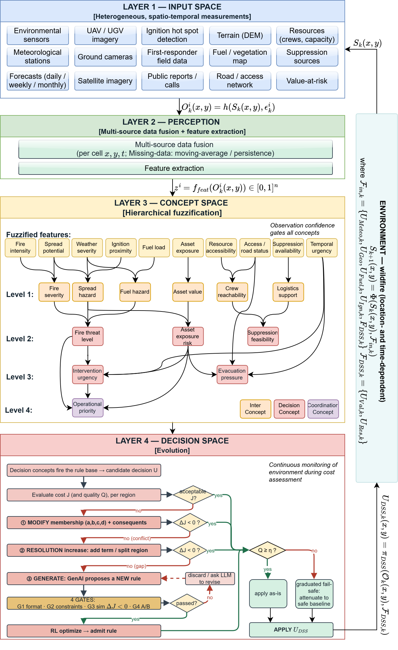
DisasterAware has a 4-layer-pipeline which includes an input space that gathers the heterogeneous field data, a perception stage that extracts features, a concept space that abstracts them into a hierarchy of operational concepts, and a decision space that turns the concepts into an intervention. The intervention applies on external input set and drives the next state, so the framework runs as a closed loop rather than as a one-shot predictor (Fig. 1).
Fig. 1. DisasterAware Framework.
Reasoning is hierarchically distributed (Fig. 2). The spatial area is partitioned into $N$ regions, each served by a local DSS agent $i$ that runs the full input-to-decision pipeline on its own observation; a non-inferential coordinator ($A_{DSS})$ then assembles the regional interventions into a globally consistent field without performing any inference of its own [39]. Throughout this section the superscript $i$denotes the local DSS agent and the subscript $k$ the step. In fact, placing inference at the local level and keeping coordination free of reasoning is what lets the open, concept-based decision scale across a large domain.

Layer 1: Input Space
Layer 1 collects the heterogeneous inputs into structured sets defined over the spatial domain. The external input set drives the environment, while the decision-related inputs carry the value and resource quantities used later for evaluation. The composition is listed in the input tables of this layer ( 1 ).
$$F_{in,k}=\left\{U_{Meteo,k}, U_{Geo}, U_{Fuel,k}, U_{Ign,k}, U_{DSS,k}\right\}, \\ F_{DSS,k}=\{U_{Val,k}, U_{Res,k}\}$$ | ( 1 )
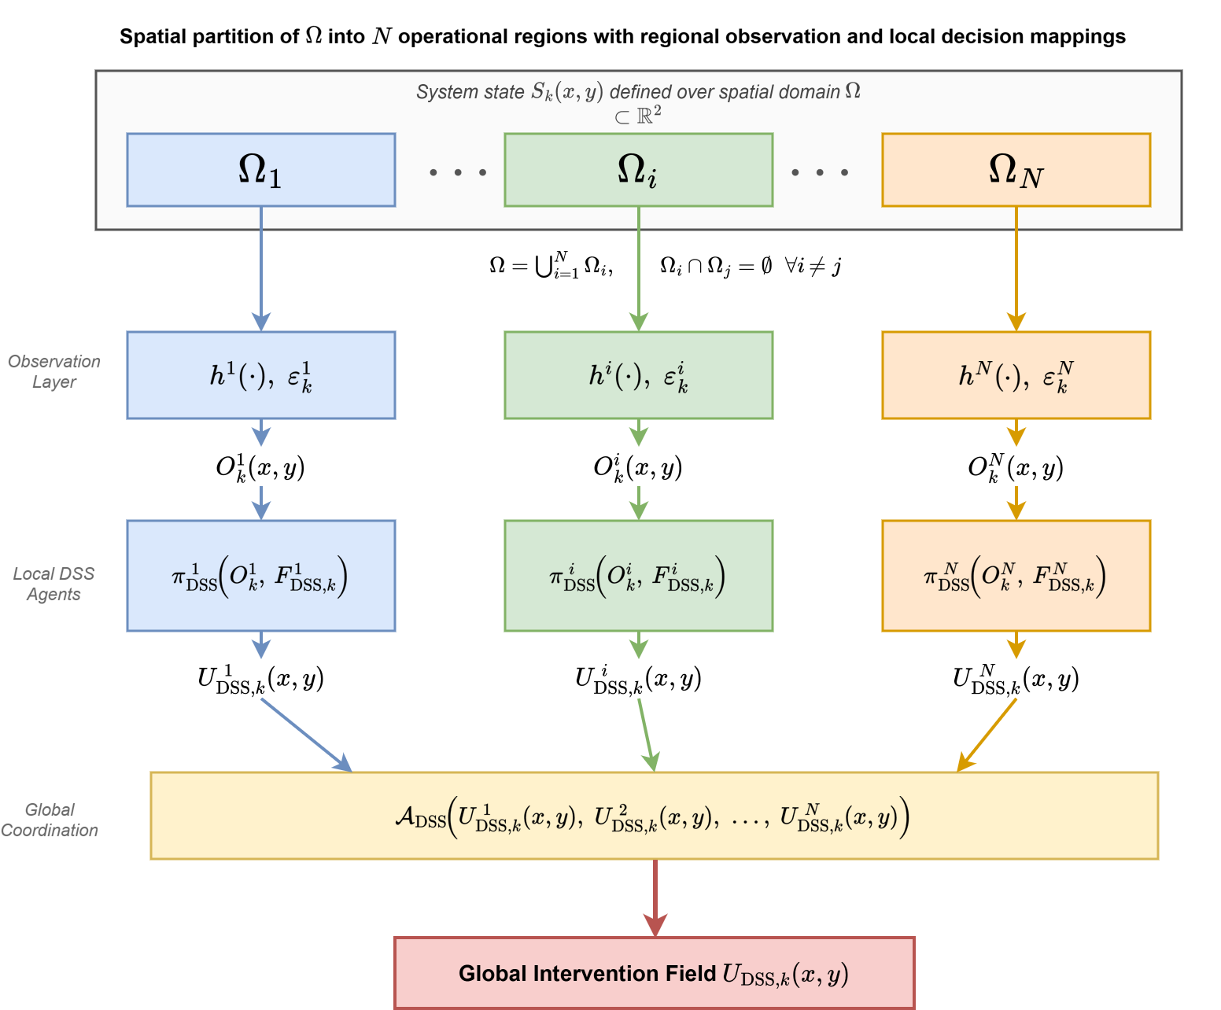
Fig. 2. Hierarchical architecture of DisasterAware.
$U_{Meteo,k}$ denotes the meteorological forcing, $U_Geo$ the static terrain, $U_{Fuel,k}$ the fuel state, $U_{Ign,k}$ the ignition input, and $U_{DSS,k}$ the suppression field that the decision layer injects into the environment; their composition is listed in Table A.I. The set $F_{DSS,k}$ is not part of the physical forcing but the decision-context set used by the DSS, made up of the value-at-risk field $U_{Val,k}$ and the resource field $U_{Res,k}$, with composition in Table A.II.
This set is chosen so that every operational question of Section II-C is supported by extracted features. Bounding each feature to the unit interval keeps the downstream fuzzification and concept construction well defined and comparable across features. Feature values inherit the reliability of the observations behind them, which is why observation confidence is retained as a first-class quantity rather than discarded after sensing. A feature computed from a stale or
sparsely covered cell must not carry the same weight as one computed from a fresh, well-covered cell. Section II-D shows how this confidence gates the concepts so that the decision degrades gracefully when inputs are missing, which is the mechanism behind the partial-observability behavior promised in the introduction [24, 25].

Layer 2: Perception
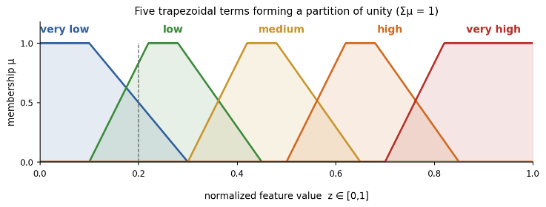
Layer 2 turns the inputs into what an agent can actually use. Each agent forms a region-restricted observation under partial observability, then a feature-extraction map converts the observation into the ten bounded features ( 2 ).
Fig. 3. Five trapezoidal linguistic terms.

$$O_{k}^{ i}=h^{ i}(S_{k})⊕ε_{k}^{ i}, ∥ε_{k}^{ i}∥≤δ (1-γ_{k}^{ i})$$ | ( 2 )

Here $h^{i}$ is the region-restricted observation operator, $S_{k}$ the hidden wildfire state, and $ε_{k}^{i}$ a bounded epistemic disturbance whose magnitude is capped by $δ$ and shrinks with the observation confidence $γ_{k}^{i} ∈ [0,1]$; this confidence is formed at each cell from sensor coverage, sensor density, and the age of the most recent report, and is taken conservatively as the weakest channel rather than an average.
$$z_{k}^{ i}=Ψ\left(o_{k}^{ i}\right)∈[0,1]^{F}, F=10$$ | ( 3 )

Raw observations are not used directly as decision inputs. A feature-extraction map converts them to a set of bounded, normalized indicators with ten features: fire intensity, spread potential, weather severity, ignition proximity, fuel load, asset exposure, resource accessibility, access and road status, suppression availability, and temporal urgency, each a clamped scalar in the unit interval ( 3 ).
The choice of variables follows established wildfire science rather than convenience. Fire intensity, spread potential, weather severity, ignition proximity, and fuel load are the behavioral drivers that govern how a front ignites and advances, as captured by semi-empirical spread models [6, 7] and confirmed by the input sets of data-driven spread predictors [12, 13, 14]. Asset exposure encodes the value at risk in the wildland-urban interface, while resource accessibility, access and road status, and suppression availability encode the operational feasibility that operations-research models of suppression and deployment treat as first-order [8, 43]. Temporal urgency adds the timing dimension. The ten features listed in Table A.III therefore span the threat, exposure, feasibility, and timing that the five operational questions require, so that no question is left without a supporting feature and none of the ten is redundant.

Layer 3: Concept Space
Reasoning directly over the ten features still leaves the rule base large and the internal variables far from operational language. Naturalistic decision-making research shows that experienced commanders classify a situation by a few recognizable patterns rather than optimizing exhaustively [44]. Conceptualization follows this practice: it maps the feature vector onto a compact set of operational concepts before any rule fires, which both reduces the rule base and keeps the representation meaningful to the operator [28].
The concept set listed in TABLE I is derived from the questions a commander must answer at each location. Rather than a flat set, the concepts are organized as a four-level hierarchy: the ten fuzzified features feed six base concepts (fire severity, spread hazard, fuel hazard, asset value, crew reachability, and logistics support); these combine into three mid-level concepts (fire threat level, asset exposure risk, and suppression feasibility); two higher-level concepts, intervention urgency and evacuation pressure, follow; and a single top concept, operational priority, supports cross-region coordination. The mid- and higher-level concepts answer the questions and fire the decision rules, while the base concepts act as interpretable intermediate hazards.
TABLE I
Concept hierarchy and decision roles. Concept symbol $c_{n}^{(l)}$ uses subscript $n$ for the concept index within a level and superscript $(l)$ for the level, consistent with Eq. (5); features use $z_{f}$.
Concept(s) | Built from | Role
Fire severity, $c_{1}^{(1)}$ | Fire intensity $z_{1}$, spread potential $z_{2}$ | base (inter.)
Spread hazard, $c_{2}^{(1)}$ | Spread potential $z_{2}$, weather severity $z_{3}$, ignition proximity $z_{4}$ | base (inter.)
Fuel hazard, $c_{3}^{(1)}$ | Weather severity $z_{3}$, fuel load $z_{5}$ | base (inter.)
Asset value, $c_{4}^{(1)}$ | Asset exposure $z_{6}$ | base (inter.)
Crew reachability, $c_{5}^{(1)}$ | Resource accessibility $z_{7}$, access and road status $z_{8}$ | base (inter.)
Logistics support, $c_{6}^{(1)}$ | Suppression availability $z_{9}$ | base (inter.)
Fire threat level, $c_{1}^{(2)}$ | Fire severity $c_{1}^{(1)}$, spread hazard $c_{2}^{(1)}$, fuel hazard $c_{3}^{(1)}$ | decision
Asset exposure risk, $c_{2}^{(2)}$ | Spread hazard $c_{2}^{(1)}$, asset value $c_{4}^{(1)}$ | decision
Suppression feasibility, $c_{3}^{(2)}$ | Crew reachability $c_{5}^{(1)}$, logistics support $c_{6}^{(1)}$ | decision
Intervention urgency, $c_{1}^{(3)}$ | Fire threat level $c_{1}^{(2)}$, asset exposure risk $c_{2}^{(2)}$, temporal urgency $z_{10}$ | decision
Evacuation pressure, $c_{2}^{(3)}$ | Asset exposure risk $c_{2}^{(2)}$, access and road status $z_{8}$, temporal urgency $z_{10}$ | decision
Operational priority, $c_{1}^{(4)}$ | Fire threat level $c_{1}^{(2)}$, asset exposure risk $c_{2}^{(2)}$ | Coord.
In fact, each feature is first fuzzified into five trapezoidal linguistic terms ( 4 ) that form a partition of unity (Fig. 3), and concepts are then built by weighted aggregation of the fuzzified features and gated by observation confidence [29, 31] in ( 5 ).
$$\sum_{j=1}^{m}{μ_{ij}}(z_{i})=1, ∀ z_{i}, m=5$$ | ( 4 )
$$c_{n}^{(1)}=\sum_{f=1}^{F}{a_{nf}} z_{f}, c_{m}^{(l)}=g_{m}\left(c^{(l-1)}\right),l=2,3,4$$ | ( 5 )
Here $f$ indexes the ten features and n a concept; $a_{nf}$ are the nonnegative first-level aggregation weights that build the base concepts $c^{1}$ from the features, and $g_{m}$ is the higher-level aggregation that forms a concept at level $l$ from the concepts at level $l-1$, so the four levels run from base hazards up to the single operational-priority concept.
Because observations carry varying reliability, each concept is gated by its observation confidence and blended with a persistence-based prior ( 6 ) so that a fully reliable observation passes through unchanged while an uninformative one falls back to the previous estimate [24], where $γ_{k}^{i}$ is the observation confidence of agent $i$ at step k, $c_{n,k}^{i}$ the raw activation of concept n, and $c_{n,k}^{i,prior}$ its persistence-based prior carried from the previous step. The regional decision is then the concept-based FIS of agent $i$ applied to the gated concept vector ( 7 ).
$${\tilde{c}}_{n,k}^{ i}=γ_{k}^{ i} c_{n,k}^{ i}+(1-γ_{k}^{ i}) c_{n,k}^{ i, prior} \\ U_{k}^{ i}=Π\left({\tilde{c}}_{k}^{ i}\right)$$ | ( 6 )  ( 7 )

Layer 4: Concept Space to Decision Space

Explainability and Fail-Safe Governance

IV. Simulation Test

Simulation Environment

Baseline and Scenarios

Metrics and Acceptance Criteria

Results and Sensitivity Analysis

V. Conclusion and Future Work
This paper presented DisasterAware, a concept-based fuzzy decision architecture for wildfire response that treats the problem as distributed, partially observable, and satisficing rather than as a single global optimization. The framework extracts a small set of bounded features from each region, abstracts them through a four-level hierarchy of concepts, and reasons over the decision concepts with a compact rule base, cutting the rule count by several orders of magnitude relative to direct inference over the ten features while keeping every decision traceable to the concepts, rules, and observations that produced it. Regional decisions are merged by a non-inferential coordinator that projects the combined field onto a resource-feasible set, and a confidence-gated, satisficing evaluation accepts an intervention once it is good enough or attenuates it through a graduated fail-safe.
The architecture was given a formal basis: bounded outputs, Lipschitz continuity in the observation, compliance with partial observability, and a unique non-expansive coordination projection. A controlled simulation built on a Rothermel-type spread model confirmed the design. Against a no-decision baseline the framework lowered the mean burned area from 43.7 to 32.4 percent and the cumulative asset loss by 62 percent, scaled with linear communication and bounded per-region cost without changing the decision, and degraded gracefully as observation noise grew and resources tightened.
Several directions remain. The concept weights are currently set from domain knowledge and could be calibrated against historical incidents or learned under expert supervision. The spread model, though faithful to established fire behavior, should be validated against field data and remote-sensing observations, and the resource and value layers extended with operational logistics. The same concept-based, distributed satisficing pattern also appears applicable to other spatially distributed emergencies, such as floods and industrial hazards, which the authors intend to explore.

Appendix

External Input Set
The external input set drives the environment and is summarized in Table A.I; each layer is a field defined over the grid cells.
TABLE A.I
Composition of the External Input Set
Symbol | Content
$$U_{Meteo,k}$$ | Air temperature, relative humidity, wind speed, wind direction, wind gust, and precipitation.
$$U_{Geo}$$ | Elevation, slope, orientation (aspect), and accessibility level.
$$U_{Fuel,k}$$ | Vegetation/fuel class, available combustible mass, and surface fuel moisture content.
$$U_{Ign,k}$$ | Binary ignition-injection indicator per cell.
$$U_{DSS,k}$$ | Coordinated decision field fed back by the system; the only decision-controlled component.

Decision-Related Inputs
The decision-related inputs supply the value- and resource-related quantities used for evaluation and feasibility, summarized in Table A.II.
TABLE A.II
Composition of the Decision-Related Inputs
Layer | Content
$$U_{Val,k}$$ | Exposed assets and socio-economic elements (critical facilities, population, infrastructure), aggregated into a per-cell protection-priority score.
$$U_{Res,k}$$ | Available suppression capacity, operational availability status, suppression effectiveness, and estimated travel time to each grid cell.

Ten Bounded Features
The ten bounded features and their grounding in wildfire science are summarized in Table A.III.
TABLE A.III
Ten Bounded Features
Feature | Grounding in DSS
Fire intensity $(z_{1})$ | Byram’s fire line intensity and the intensity output of Rothermel’s surface fire model are the standard descriptors of how hard a front is burning [7, 45].
Spread potential $(z_{2})$ | Rothermel’s quasi-empirical surface fire spread model gives steady-state rate of spread from fuel, wind, and slope; still the most widely used operational basis [7, 46].
Weather severity $(z_{3})$ | The Canadian Forest Fire Weather Index System derives spread and intensity potential from four weather observations and is a long-standing fire-danger standard [47].
Ignition proximity $(z_{4})$ | Human-caused ignitions cluster near roads and infrastructure; distance-to-road is a consistent driver in ignition-probability studies [48, 49].
Fuel load $(z_{5})$ | Standard fire-behavior fuel models parameterize load by size class and drive every surface-fire prediction [50, 51].
Asset exposure $(z_{6})$ | Wildland-urban interface growth and values-at-risk mapping quantify what a fire threatens and underpin risk-based response [52, 53].
Resource accessibility $(z_{7})$ | The Suppression Difficulty Index combines terrain, fuels, and access into a measure of how hard a site is to work [54].
Access and road status $(z_{8})$ | Road/trail access is an explicit component of suppression difficulty and also governs evacuation egress [54].
Suppression availability $(z_{9})$ | Fireline production rates and risk-based resource allocation describe whether suppression can actually be mounted [23, 54]
Temporal urgency $(z_{10})$ | Incident command is a time-critical task; naturalistic, recognition-primed decision making formalizes acting under urgency [55].

Acknowledgment
This work was informed by the authors' experience in the TeamAware project, funded by the European Union's Horizon 2020 research and innovation programme under Grant Agreement No. 101019808. The research reported in this paper was carried out independently and received no specific grant from any funding agency in the public, commercial, or not-for-profit sectors.

References

[1] | CRED and UCLouvain, "EM-DAT, The International Disaster Database," Brussels, Belgium, 2024.
[2] | W. M. Jolly, "Climate-induced variations in global wildfire danger from 1979 to 2013," Nature Communications, vol. 6, 2015.
[3] | J. P. Shim, "Past, present, and future of decision support technology," Decision Support Systems, vol. 33, no. 2, pp. 111-126, 2002.
[4] | G. Kostopoulos, G. Davrazos and S. Kotsiantis, "Explainable Artificial Intelligence-Based Decision Support Systems: A Recent Review," Electronics, vol. 13, no. 14, p. 2842, 2024.
[5] | E. K. Noonan-Wright, "Developing the U.S. Wildland Fire Decision Support System," Journal of Combustion, vol. 2011, 2011.
[6] | M. A. Finney, "An overview of FlamMap fire modeling capabilities," in Fuels Management - How to Measure Success, USDA Forest Service Proc. RMRS-P-41, 2006.
[7] | R. C. Rothermel, "A mathematical model for predicting fire spread in wildland fuels," 1972.
[8] | S. Zhou and A. Erdogan, "A spatial optimization model for resource allocation for wildfire suppression and resident evacuation," Computers & Industrial Engineering, vol. 138, 2019.
[9] | T. Orphanoudakis, C. Betzelos and H. C. Leligou, "MORA: A multicriteria optimal resource allocation and decision support toolkit for wildfire management," Algorithms, vol. 18, no. 11, 2025.
[10] | E. Triantaphyllou, Multi-Criteria Decision Making Methods: A Comparative Study, Dordrecht: Kluwer, 2000.
[11] | M. Lourenco, L. B. Oliveira and A. Mora, "An integrated decision support system for improving wildfire suppression management," ISPRS International Journal of Geo-Information, vol. 10, no. 8, 2021.
[12] | F. Huot, "Next day wildfire spread: A machine learning dataset to predict wildfire spreading from remote-sensing data," IEEE Transactions on Geoscience and Remote Sensing, vol. 60, pp. 1-13, 2022.
[13] | M. A. Akhloufi, "Machine learning and deep learning for wildfire spread prediction: A review," Fire, vol. 7, no. 12, p. 482, 2024.
[14] | J. G. Borges, "A systematic review of applications of machine learning techniques for wildfire management decision support," Inventions, vol. 7, no. 1, p. 15, 2022.
[15] | D. Shadrin, S. Illarionova, F. Gubanov, K. Evteeva, M. Mironenko, I. Levchunets, R. Belousov and E. Burnaev, "Wildfire spreading prediction using multimodal data and deep neural network approach," Scientific Reports, vol. 14, p. 2606, 2024.
[16] | A. M. Elshewey, A. M. Osman and R. Y. Youssef, "Enhancing forest fires classification using a hybrid convolutional and BiLSTM deep learning model," Modeling Earth Systems and Environment, vol. 11, p. 379, 2025.
[17] | P. Dubey, "Bridging spatiotemporal wildfire prediction and decision modeling using transformer networks and fuzzy inference systems," MethodsX, vol. 15, 2025.
[18] | Y. Xie, B. Jiang, T. Mallick, J. D. Bergerson, J. K. Hutchison and D. R. Verner, "WildfireGPT: Tailored large language model for wildfire analysis," arXiv:2402.07877, 2024.
[19] | Y. Chen, L. Li, Z. Ma, Q. Hu, Y. Zhu, M. Deng and R. Yu, "Empowering LLM agents with geospatial awareness: Toward grounded reasoning for wildfire response," arXiv:2510.12061, 2025.
[20] | R. Chandra, S. S. Kumar, R. Patra and S. Agarwal, "Decision support system for forest fire management using ontology with big data and LLMs," Cluster Computing, vol. 28, p. 548, 2025.
[21] | T. O’Mara, A. S. Sánchez Meador, M. Colavito, A. Waltz and E. Barton, "Navigating the evolving landscape of wildfire management: A systematic review of decision support tools," Trees, Forests and People, vol. 16, 2024.
[22] | G. Shafer, A Mathematical Theory of Evidence, Princeton, NJ: Princeton University Press, 1976.
[23] | M. P. Thompson and D. E. Calkin, "Uncertainty and risk in wildland fire management: A review," Journal of Environmental Management, vol. 92, no. 8, pp. 1895-1909, 2011.
[24] | L. P. Kaelbling, M. L. Littman and A. R. Cassandra, "Planning and acting in partially observable stochastic domains," Artificial Intelligence, vol. 101, pp. 99-134, 1998.
[25] | P. Walley, Statistical Reasoning with Imprecise Probabilities, London, U.K.: Chapman & Hall, 1991.
[26] | S. M. Lundberg and S. I. Lee, "A unified approach to interpreting model predictions," in Advances in Neural Information Processing Systems (NeurIPS), 2017.
[27] | M. T. Ribeiro, S. Singh and C. Guestrin, "Why should I trust you?: Explaining the predictions of any classifier," in Proc. ACM SIGKDD, 2016.
[28] | P. W. Koh, "Concept bottleneck models," in Proc. 37th Int. Conf. Machine Learning (ICML), 2020.
[29] | L. A. Zadeh, "Fuzzy sets," Information and Control, vol. 8, no. 3, pp. 338-353, 1965.
[30] | L. A. Zadeh, "Outline of a new approach to the analysis of complex systems and decision processes," IEEE Transactions on Systems, Man, and Cybernetics, Vols. SMC-3, no. 1, pp. 28-44, 1973.
[31] | E. H. Mamdani and S. Assilian, "An experiment in linguistic synthesis with a fuzzy logic controller," International Journal of Man-Machine Studies, vol. 7, no. 1, pp. 1-13, 1975.
[32] | T. Tsataltzinos, L. Iliadis and S. Spartalis, "An intelligent fuzzy inference system for risk estimation: The case of forest fires in Greece," in IFIP AIAI, 2009.
[33] | T. Takagi and M. Sugeno, "Fuzzy identification of systems and its applications to modeling and control," IEEE transactions on systems, man, and cybernetics, vol. 1, pp. 116-132, 1985.
[34] | P. P. Angelov and D. P. Filev, "An approach to online identification of Takagi-Sugeno fuzzy models," IEEE Transactions on Systems, Man, and Cybernetics, Part B, vol. 34, no. 1, pp. 484-498, 2004.
[35] | J. M. Mendel, "Fuzzy logic systems for engineering: a tutorial," Proceedings of the IEEE, vol. 83, no. 3, pp. 345-377, 1995.
[36] | R. S. Sutton and A. G. Barto, Reinforcement Learning: An Introduction, 2nd ed., Cambridge, MA, USA: MIT Press, 2018.
[37] | L. Murray, T. Castillo, J. Carrasco, A. Weintraub, R. Weber and I. M. de Diego, "Advancing forest fire prevention: Deep reinforcement learning for effective firebreak placement," arXiv:2404.08523, 2024.
[38] | H. A. Simon, "Rational choice and the structure of the environment," Psychological Review, vol. 63, no. 2, pp. 129-138, 1956.
[39] | U. Beldek and K. Leblebicioğlu, "Local decision making and decision fusion in hierarchical levels," TOP, vol. 17, no. 1, pp. 44-69, 2009.
[40] | M. Wooldridge, An Introduction to MultiAgent Systems, Chichester, U.K.: Wiley, 2009.
[41] | G. V. Raju, J. Zhou and R. A. Kisner, "Hierarchical fuzzy control," International Journal of Control, vol. 54, no. 5, pp. 1201-1216, 1991.
[42] | European Commission, "TEAMAWARE," Horizon 2020 Programme, Grant Agreement No. 101019808, 2021.
[43] | D. L. Martell, "Forest fire management: Current practices and new challenges for operational researchers," in Handbook of Operations Research in Natural Resources, Springer, 2007, pp. 489-509.
[44] | G. A. Klein, Sources of Power: How People Make Decisions, 20th Anniversary ed., Cambridge, MA, USA: MIT Press, 2017.
[45] | G. M. Byram, "Combustion of forest fuels," in Forest Fire: Control and Use, K. P. Davis, Ed., New York, NY, USA, McGraw-Hill, 1959, pp. 61-89.
[46] | P. L. Andrews, "The Rothermel surface fire spread model and associated developments: A comprehensive explanation," Fort Collins, CO, USA, 2018.
[47] | C. E. Van Wagner, "Development and structure of the Canadian Forest Fire Weather Index System," Ottawa, ON, Canada, 1987.
[48] | A. D. Syphard, V. C. Radeloff, J. E. Keeley, T. J. Hawbaker, M. K. Clayton, S. I. Stewart and R. B. Hammer, "Predicting spatial patterns of fire on a southern California landscape," Int. J. Wildland Fire, vol. 17, no. 5, pp. 602-613, 2008.
[49] | A. Ganteaume, A. Camia, M. Jappiot, J. San-Miguel-Ayanz, M. Long-Fournel and C. Lampin, "A review of the main driving factors of forest fire ignition over Europe," Environ. Manage., vol. 51, no. 3, pp. 651-662, 2013.
[50] | H. E. Anderson, "Aids to determining fuel models for estimating fire behavior," Ogden, UT, USA, 1982.
[51] | J. H. Scott and R. E. Burgan, "Standard fire behavior fuel models: A comprehensive set for use with Rothermel’s surface fire spread model," Fort Collins, CO, USA, 2005.
[52] | V. C. Radeloff, D. P. Helmers, H. A. Kramer, M. H. Mockrin, P. M. Alexandre, A. Bar-Massada, V. Butsic, T. J. Hawbaker, S. Martinuzzi, A. D. Syphard and S. I. Stewart, "Rapid growth of the US wildland-urban interface raises wildfire risk," Proc. Natl. Acad. Sci. USA, vol. 115, no. 13, pp. 3314-3319, 2018.
[53] | D. E. Calkin, J. D. Cohen, M. A. Finney and M. P. Thompson, "How risk management can prevent future wildfire disasters in the wildland-urban interface," Proc. Natl. Acad. Sci. USA, vol. 111, no. 2, pp. 746-751, 2014.
[54] | F. Rodriguez y Silva, J. R. Molina and A. Gonzalez-Caban, "A methodology for determining operational priorities for prevention and suppression of wildland fires," Int. J. Wildland Fire, vol. 23, no. 4, pp. 544-554, 2014.
[55] | G. Klein, "Naturalistic decision making," Hum. Factors, vol. 50, no. 3, pp. 456-460, 2008.
[56] | A. Virmaux and K. Scaman, "Lipschitz regularity of deep neural networks: Analysis and efficient estimation," in NeurIPS, 2018.
[57] | G. B. Folland, Real Analysis: Modern Techniques and Their Applications, New York, NY, USA: Wiley, 1999.
[58] | A. Şahin and K. Leblebicioğlu, "Approximating the optimal mapping for weapon target assignment by fuzzy reasoning," Information Sciences, vol. 255, pp. 30-44, 2014.
[59] | E. Lughofer, Evolving Fuzzy Systems: Methodologies, Advanced Concepts and Applications, Berlin, Germany: Springer, 2011.
[60] | Y. Tu, Z. Ma, J. Liu and X. Zhou, "Enhancing fuzzy evidential reasoning approach using a dynamic adjustment mechanism and new rule-based transformation for engineering emergency response evaluation," Engineering Applications of Artificial Intelligence, 2023.
[61] | U. Beldek and K. Leblebicioğlu, "A new systematic and flexible method for developing hierarchical decision-making models," Turkish Journal of Electrical Engineering and Computer Sciences, vol. 23, no. 1, pp. 279-297, 2015.
[62] | U. Beldek and K. Leblebicioğlu, "Strategy creation, decomposition and distribution in particle navigation," Information Sciences, vol. 177, no. 3, pp. 755-770, 2007.
[63] | C. H. Papadimitriou and J. N. Tsitsiklis, "The complexity of Markov decision processes," Mathematics of Operations Research, vol. 12, no. 3, pp. 441-450, 1987.


Çağlar Akman received the B.S. and M.S. degrees in Electrical and Electronics Engineering from the Middle East Technical University (METU), Ankara, Türkiye, in 2008 and 2017, respectively, where he is currently pursuing the Ph.D. degree.
He is currently the Senior Principal Team Manager of the Modeling and Sensor Technologies at HAVELSAN, Ankara, Türkiye, where he manages national and international research and development projects of advanced sensor systems, decision support architectures, and intelligent automation technologies. Over the past 10 years, he has acquired extensive experience in leading multidisciplinary R&D initiatives, managing national and international research collaborations, and coordinating complex technical projects across multiple organizations and consortia.
He serves as an Industrial Reviewer for TÜBİTAK (Turkish Scientific and Technical Research Council), evaluating research proposals across multiple research domains. He also performs peer review for IEEE Transactions and related journals, contributing to the quality assurance of peer-reviewed literature. Additionally, he has been a part-time lecturer at Atılım University. His research interests, expertise, and professional recognition reflect a strong commitment to advancing the fields of artificial intelligence, autonomous systems, decision support technologies, and sensor fusion in both civilian and defense applications.

Kemal Leblebicioğlu received his Ph.D. from the Department of Mathematics of the Middle East Technical University (METU), in 1988.
He has been a full professor in the Department of Electrical and Electronics Engineering of METU since 1999. He has a background in optimization, optimal control theory, computer vision, intelligent systems, flight control, walking robots, and unmanned vehicles.
Dr. Leblebicioğlu has been a member of numerous international program committees and has been (co-) author of more than 40 journal papers, book chapters, and numerous conference papers. He is on several IFAC technical committees. He was the editor of the journal ELEKTRIK published by TÜBİTAK (Turkish Scientific and Technical Research Council) from 1996 to 2009. He is on the editorial board of several Turkish technical journals. He organized an international workshop on computer vision and intelligent systems and two national conferences on control.
He conducted several R&D projects as project leader and researcher and gave consultancy to BİLTEN (TÜBİTAK’s Research Center on Electronics and Information Technologies), 3rd Supply and Maintenance Center of Turkish Air Forces (Ankara), TÜBİTAK-İltaren, and to ASELSAN on the topic of “real time automatic visual tracking of targets.” Now he is studying unmanned vehicles, in particular, unmanned air and underwater vehicles.
He completed a project (supported by TÜBİTAK) on the construction of a special unmanned under-sea vehicle, called ULISAR, which is a mixture of an ROV and a fully automated system. He completed a project, also supported by TÜBİTAK, on the coordinated guidance of multiple unmanned air vehicles.

Çağlar Akman and Kemal Leblebicioğlu are with the Department of Electrical and Electronics Engineering, Middle East Technical University, 06800 Ankara, Türkiye.

