A Distributed Decision Support Architecture With a Verified Open Decision Space for Wildfire Response
Çağlar Akman and Kemal Leblebicioğlu

Abstract—Decision support systems (DSSs) are systems of systems. Most decide inside a closed decision space, a set of rules fixed before the incident. Outside this set, the system cannot respond. This article presents the Verified Open Decision Architecture (VODA), an architecture with an open decision space. It defines the invariants of the space, a verified set of physical effects from which new interventions are composed, and a chain of gates. A generative model proposes new rules and blended or composed interventions. A proposal enters the rule base only after deterministic checks and a paired forecast test on reseeded futures. A simulation core holds the hazard state. A decision core reads it through confidence-rated observations. The decision core has a closed layer, a sparse Takagi-Sugeno rule base that tunes itself online, and an open layer that proposes and verifies new objects. The approach is applied to wildfire response and tested on paired worlds in various scenarios. Compared with the closed layer alone, the open layer reduces burned area by 40%, affected population by 70%, and committed response by 28%. It raises the share of extinguished incidents from 52 to 75%. The decision core is distributed and suits real-time operation. Each agent reasons only over its own region, so computing cost grows slowly with the number of regions.

Index Terms— Decision support systems, open decision space, generative rule proposal, system-of-systems architecture, wildfire management.

I. INTRODUCTION
W
ILDFIRE response is carried out by a system of systems [1]. A hazard model turns the observations retrieved from heterogeneous sources into a forecast of where the fire will spread. Regional teams decide where to commit crews, aircraft, and evacuation orders. An operator supervises the whole under a clock set by the fire [2, 3]. Fire seasons are becoming longer and more severe [2]. Moreover, the decisions that matter most are taken in the first hours. In these hours observations are sparse, the forecast is uncertain, and a wrong commitment is costly [3, 4]. A recommendation after the fire has moved is useless, so the support has to adapt to the incident as it moves.
DSSs exist for parts of this task [5]. Spread simulators forecast fire behavior from fuel, terrain, and weather [6, 7]. Allocation tools assign crews and aircraft against a forecast [8, 9]. Integrated platforms bring these parts together for use in the field [4, 10]. However, field studies of these tools measure how widely they are used, not whether the decisions taken with them are better [11, 12]. A critical review of DSS research finds the same pattern across the field, many systems built and few shown to help [13]. VODA is therefore measured as the change in the outcome of the same incidents, with and without the system.
Three structural limits exist across these systems. First, the alternatives are predefined. A rule base, a menu of tactics, or an optimization model fixes the orders before the incident, so the system can only rank what it is given [10]. Decision analysis has long identified the generation of alternatives as the weakest step of the process [14, 15, 16]. The methods proposed for it either enumerate variations of a fixed model [17] or depend on the recall of the operator under time pressure [18]. Second, uncertainty is representable only through prior distributions or belief intervals. Real-time sensing cannot supply them [19, 20], and the reasoning behind a recommendation is exposed through post-hoc attribution [21]. Third, integrated platforms embed the forecast and the decision logic in one tool [4, 10]. Hence, neither is validated on its own, and the benefit of a decision mechanism cannot be separated from the quality of the forecast behind it.
VODA answers the first limit with an open decision space, its central contribution. The set of orders is not fixed. It grows during the incident, under verification by the hazard model. The decision core has two layers. The closed layer is a self-tuning fuzzy doctrine that maps decision concepts to intervention families through a sparse rule base. When it falls short, the open layer lets a pretrained large language model (LLM) propose a new rule, a blend of existing interventions, or a new intervention composed from physical effects the simulator can execute. Nothing enters the doctrine without a chain of algebraic gates and a paired forecast test. Hence, the space is closed at physical effects and open at interventions.
The second limit is answered in two steps. Each observation carries a confidence, and the confidence gates every concept that depends on it, so uncertainty is handled without a distribution. Moreover, every order is written over named decision concepts and every edit, rejection, and generated object is logged. Hence, the reason for a recommendation is read from the rule that produced it, not reconstructed afterwards. Under degraded observation the response of VODA degrades only slightly and remains the best tested.
The third limit is answered by the separation of two cores. A simulation core owns the hazard state, and a decision core reads it through confidence-rated observations. The simulation core is validated by blind hindcast against satellite records of documented fires, and the decision core by paired comparison on that validated core, so the benefit of opening the decision space is read as a difference on identical worlds. The decision core is distributed over regional agents, decides in a small fraction of a second, and its cost grows slowly with the number of agents, so it suits real-time operation.
The remainder of the article is organized as follows. Section II reviews related work. Section III presents the architecture and Section IV the decision core. Section V reports the results, Section VI discusses them, and Section VII concludes.

II. Related Work and Background

A. Wildfire Dynamics and Decision Support
Rothermel-type models give the surface rate of spread from fuel, moisture, wind, and slope [6, 22]. These models are implemented in operational tools such as FlamMap [7] and in cellular simulators such as Cell2Fire [23]. The simulation core of VODA uses a model of the same family. Decision support built on these models ranges from strategic risk assessment [4, 8] and multi-criteria allocation [9] to the integrated platform [10], whose field use has been studied extensively [11, 12]. In all of them the decision logic is authored offline and the intervention menu is fixed. Fire management economics judges a response by the sum of two terms, the cost of the resources committed and the loss that still occurs [3]. The decision cost of VODA has the same two parts.

B. Observation Features and Fuzzy Reasoning Over Concepts
VODA reads 10 features extracted from observations of heterogeneous sources. Each is bounded, meaningful to an expert, and not redundant. They are fire intensity and spread potential, weather severity, ignition proximity, fuel load, asset exposure, resource accessibility, access and road status, suppression availability, and temporal urgency. Together they cover threat, exposure, feasibility, and timing.
Operational assessments are graded and linguistic, such as a high fire threat or a low suppression feasibility. Fuzzy set theory represents such judgments as partial membership in a linguistic term and lets domain knowledge be written as IF-THEN rules over these terms [24], so a graded observation becomes a decision without a crisp threshold. VODA uses the Takagi-Sugeno (TS) model, whose constant consequents [25] give a numeric intensity command the simulator can apply and let rules be tuned online with a predictable effect, as evolving TS models have shown [26]. Rules cannot be written over the features directly, since $N$ features with $T$ terms each need $T^{N}$ antecedents, about ${10}^{7}$ for 10 features and 5 terms. The remedy is a conceptual middle layer. Features are composed into decision concepts by weighted aggregation, and rules are written over the concepts only. VODA uses 5 concepts because each answers one of the 5 questions that operators ask during response [3, 18], namely how severe the fire threat is, whether an intervention can feasibly be mounted, how exposed the assets are, how urgent action is, and whether evacuation pressure is building. The concepts are fire threat level, suppression feasibility, asset exposure risk, intervention urgency, and evacuation pressure. Hence, the antecedent space of VODA falls to $5^{5} = 3125$.

C. Closed and Open Decision Spaces
Under time pressure, the weak point of decision support is that decision analysis evaluates a given set of alternatives [27]. Option generation precedes choice yet is a neglected phase [14], even though it can be formalized as a recursion of decision problems [16], and systems that hard-wire the open parts of a problem are not adopted [15]. Cognitive evidence agrees, since generating options in ill-structured problems requires ideation beyond memory retrieval and raises the quality of the best option [28], and operators build courses of action from recognized patterns rather than from menus [18]. Hence, a DSS should generate alternatives during operation and filter them by a strict, external evaluation.
Mechanisms that generate alternatives share one pattern. Some search a fixed model for structurally different solutions [17]. Some combine modules under compatibility constraints [29]. Some add new actions to the action model at run time [30, 31]. In every case the new alternatives are composed from parts the system already understands, so an open decision space is an open composition over a closed and verified basis. Mechanisms that change a rule base at run time follow the same pattern. Evolving TS models tune and add rules within the vocabulary [25, 26]. Value-based selectors learn when a structural change is needed [32]. Generative models draft rules outside the current structure [33]. VODA uses all three, tuning and selection in the closed layer and generation in the open layer, behind one satisficing acceptance rule [34] that keeps rejection cheap and the evaluator independent of the generator.

D. Generative Components in Disaster Decision Support
Recent DSSs add generative components but keep the intervention space closed or unchecked. Dubey and Dubey [35] map a Transformer forecast to four fixed response levels through expert rules. Chandra et al. [36] draw actions from a fixed ontology and check only their consistency. Cheng et al. [37] let LLMs weight a fixed set of indicators. Gerolimos et al. [38] call for open-world learning, but for recognizing unseen events rather than responding to them. Multi-agent LLMs write free-text plans whose hallucinations are contained by retrieval, schemas, or post-hoc grading [39]. Cui et al. [40] argue for verification by physics-based simulation yet confine their agent to a fixed tool library. WildfireKR [41] automates calibrated spread simulation but leaves intervention design to the analyst. None builds new interventions from effects a physical model can execute and lets that model decide admission. VODA fills this gap.

III. System Architecture

A. Two Cores and the Interface
Fig. 1 shows four blocks, namely simulation core, decision core, external sources, and operator dashboard. The external sources feed the meteorological, geographic, and fuel fields; an operator edits the inputs through the dashboard $Θ_{UI}$ and never the state. The simulation core owns the state $S_{k}$ and advances it with the transition $Φ$, which takes the input set $F_{in,k}$ of (1) and returns $S_{k+1}=Φ\left(S_{k},F_{in,k}\right)$. The decision core reads an observation $O_{k}$ of the state and the decisional set $F_{DSS,k}$ and returns the intervention field $U_{DSS,k}$, the only member of $F_{in,k}$ that it writes.
$$F_{in,k}=\left\{U_{Meteo,k},U_{Geo},U_{Fuel,k},U_{Ign,k},U_{DSS,k}\right\} \\ F_{DSS,k}=\{U_{Val,k},U_{Res,k}\}$$ | (1)

In all equations, $k$ is the simulation step at $t_{k}=kΔt_{sim}$, and every field is defined per cell $\left(x,y\right)$ of the grid $G$. $U_{Meteo,k}$ holds the wind speed $W_{s,k}$ and direction $W_{d,k}$, air temperature, humidity, and precipitation. $U_{Geo}$ holds elevation, slope $G_{s}$, aspect $G_{a}$, and road access $G_{c}$. $U_{Fuel,k}$ holds the fuel type $F_{t}$ of a standard fuel model [42], the initial fuel load, and the dead fuel moisture $F_{m,k}$. $U_{Ign,k}∈\{0,1\}$ holds scenario ignitions. The decisional fields never enter $Φ$. $U_{Val,k}$ aggregates buildings, critical facilities, population, and evacuation access into a value at risk, and $U_{Res,k}$ describes crews and water sources by the capacity $R_{c,k}$ an order can draw on a cell, availability $R_{a,k}$, effectiveness $R_{e,k}$, and travel time $R_{t,k}$.
$$S_{k}→O_{k}=h\left(S_{k},ϵ_{k}\right)→U_{DSS,k}=π_{DSS}\left(O_{k},F_{DSS,k}\right) \\ →U_{DSS,k}⊂F_{in,k}→S_{k+1}=Φ\left(S_{k},F_{in,k}\right)$$  $$\left|ϵ_{k}\right|≤\left(1-γ_{k}\right)ϵ_{max}$$ | (2)

The two cores run the loop of (2) once per decision cycle. The observation function $h$ injects the epistemic uncertainty $ϵ_{k}$, bounded by the cell confidence $γ_{k}$ of Section IV as in (2), so a confident cell is observed exactly and an unobserved one admits the worst case $ϵ_{max}$. The decision map $π_{DSS}$ of Section IV maps the observation and the decisional fields to $U_{DSS,k}$, which enters $F_{in,k}$ and acts on the state only through $Φ$. Since the decision core never reads the state directly, any hazard model that exposes its state through $h$ and accepts interventions through $F_{in,k}$ can replace the simulation core. The core is seeded and replayed from a snapshot of its random state, so the same incident runs with and without a decision mechanism and the difference is due to the mechanism alone, the basis of every paired comparison in Section V.

B. State, Transition, and Spread
The state is the collection of per-cell states (3). The burning status $B_{k}∈\{0,1\}$ marks whether the cell burns. The available fuel mass $F_{L,k}∈\left[0,1\right]$ is the remaining fraction of the initial fuel load. The intensity proxy $I_{k}$ is a bounded measure of fireline intensity, and $τ_{k}$ is the time since ignition. One step of $Φ$ updates the four components by (4) to (8), where $\left[⋅\right]$ is the Iverson bracket, equal to one when its condition holds.
$$S_{k}=\{s_{k}\left(x,y\right)\}_{\left(x,y\right)∈G}, s_{k}=\left(B_{k},F_{L,k},I_{k},τ_{k}\right)$$ | (3)

Burning (4) is the maximum of four sources. It persists, $B^{pers}$, while the fuel exceeds the extinction load $ϵ_{L}$ and the moisture stays below the moisture of extinction $ϵ_{m}\left(F_{t}\right)$ of the fuel type [6]. It propagates, $B^{prop}$, when the neighbor impact $Ψ_{k}$ of (9) exceeds the threshold $Θ_{ign}$, the cellular rule of [23]. It starts by spotting, $B^{spot}$, when a seeded ember lands on fuel, or on the injected ignition $U_{Ign,k}$.
$$B_{k+1}=\max\left\{B^{pers},B^{prop},B^{spot},U_{Ign,k}\right\} \\ B^{pers}=B_{k}\left[F_{L,k}>ϵ_{L}\right]\left[F_{m,k}<ϵ_{m}\left(F_{t}\right)\right] \\ B^{prop}=\left[Ψ_{k}>Θ_{ign}\right] \\ B^{spot}=\left[\text{ember lands}\right]\left[F_{L,k}>ϵ_{L}\right]$$ | (4)

Fuel (5) falls through combustion by the fraction $F_{b,k}$ in burning cells and through the suppression term $F_{r,k}$ of (6). The map $f_{supp}$ follows the initial-attack productivity model of [43]. The fuel a crew removes per step grows with the fielded capacity $R_{c,k}⋅R_{a,k}$ and is discounted by the effectiveness $R_{e,k}$, which falls with the local intensity $I_{k}$, by the travel time $R_{t,k}$, and by the access $G_{c}$ of the cell. Hence, an order changes what the fire can burn and never the burning state.
$$F_{L,k+1}=max\{0, F_{L,k}-B_{k}F_{L,k}F_{b,k}-F_{r,k}\}$$ | (5)
$$F_{r,k}=f_{supp}\left(R_{c,k},R_{a,k},R_{e,k},R_{t,k},G_{c}\right)$$ | (6)

The intensity proxy (7) is a bounded map $f_{int}$ of fuel, wind speed, and slope after Byram [44] as parameterized in [6], and is zero where the cell does not burn.
$$I_{k+1}=B_{k+1}f_{int}\left(F_{L,k},W_{s,k},G_{s}\right)$$ | (7)

The ignition clock (8) counts active burning. It restarts at ignition, grows by $Δt_{sim}$ while the cell burns, and returns to zero when it burns out.
$$τ_{k+1}=\left\{\begin{matrix}0 & B_{k+1}=1∧B_{k}=0 \\ τ_{k}+Δt_{sim} & B_{k+1}=1∧B_{k}=1 \\ 0 & B_{k+1}=0\end{matrix}\right.$$ | (8)

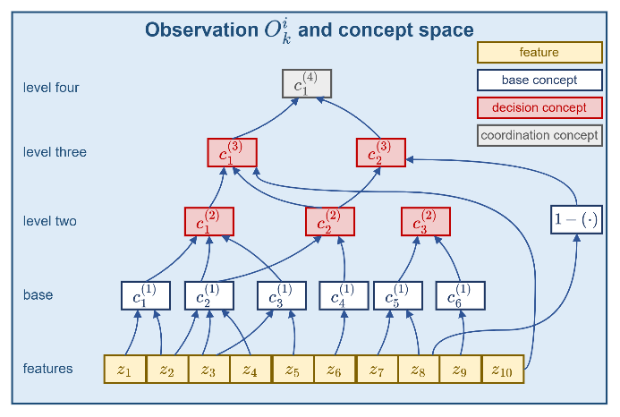
Propagation (9) is anisotropic. Each burning neighbor $\left(i,j\right)$ in the eight-neighborhood $N_{8}$ contributes its rate of spread $ν_{k}$ weighted by the cosine of the angle between the wind direction $W_{d,k}$ and the direction $φ_{ij}$ to the target cell. The rate of spread $ν_{k}$ is the Rothermel map $f_{ros}$ [6] of (10) over wind, slope, aspect, moisture, and fuel type. The front advances in substeps of at most one cell, and spotting is the only stochastic element. Precipitation raises $F_{m,k}$ toward $ϵ_{m}$ gradually, so a front dies out rather than stopping at once.
Fig. 1. The concept space of one agent.
$$Ψ_{k}=\frac{1}{8}\sum_{\left(i,j\right)∈N_{8}}{B_{k}}\left(i,j\right)ν_{k}\left(i,j\right)g_{k}\left(i,j\right) \\ g_{k}\left(i,j\right)=max\{0,cos\left(W_{d,k}\left(i,j\right)-φ_{ij}\right)\}$$ | (9)
$$ν_{k}=f_{ros}\left(W_{s,k},W_{d,k},G_{s},G_{a},F_{m,k},F_{t}\right)$$ | (10)

IV. The Decision Core

The decision core runs as $N$ regional agents over a partition of the grid into regions $G_{i}$. Agent $i$ reads the observation $O_{k}^{i}$ through four stages, feature extraction, the concept space, the closed decision layer, and the open decision layer, and returns an intervention candidate $U_{DSS,k}^{i}$. A local agent is this path confined to one region; the global coordinator ranks the regions, allocates the shared pool, and merges the candidates into $U_{DSS,k}$, as given in Section IV-E.
Fig. 2. The system architecture.

A. Sources, Features, and Confidence
The sources are weather stations and forecasts, satellite and airborne imagery, terrain and fuel maps, road networks, resource status, asset and population layers, and field reports. The agent reduces them to 10 features in the unit interval (11), namely fire intensity $z_{1}$, spread potential $z_{2}$, weather severity $z_{3}$, ignition proximity $z_{4}$, fuel load $z_{5}$, asset exposure $z_{6}$, resource accessibility $z_{7}$, access and road status $z_{8}$, suppression availability $z_{9}$, and temporal urgency $z_{10}$. Every cell has a confidence composed from observability, coverage, freshness, and reliability by their minimum (12). The state is under-observed rather than noisy [19], and Bayesian or Dempster-Shafer treatments presuppose distributional knowledge that real-time sensing lacks [20].
Each extraction map normalizes a standard operational descriptor to the unit interval. Fire intensity and spread potential follow fireline intensity after Byram [44] and the Rothermel rate of spread [6] on the observed fire state; weather severity is a fire weather index of the Canadian type [45]; ignition proximity is the distance to roads and infrastructure; fuel load is the load of the standard fuel model [42]. Asset exposure follows values-at-risk mapping [4], resource accessibility a suppression difficulty index over terrain, fuel, and access [46], access and road status the road network and field reports, suppression availability the fireline production rate of the available crews [43], and temporal urgency the incident clock. Each feature inherits its confidence from the observation fields its map reads.
$$z_{f,k}^{i}=ξ_{f}\left(O_{k}^{i}\right)∈\left[0,1\right], f=1,…,10$$ | (11)
$$γ_{k}=min\{γ_{obs},γ_{cov},γ_{fre},γ_{rel}\}$$ | (12)

In (11), $ξ_{f}$ is the extraction map of feature $f$. In (12), $γ_{obs}$ is observability, $γ_{cov}$ sensor coverage, $γ_{fre}$ freshness, and $γ_{rel}$ source reliability.

B. Concept Space
Fig. 2 shows the path from the sources to the 5 decision concepts. Each feature is fuzzified over a 5-term partition of unity. The concept space composes the features into 6 base concepts, these into 5 decision concepts on two levels, and two of these into one coordination concept, with the sets of (13). An activation is a normalized weighted sum of the memberships or activations below it (14). Each raw activation is gated by its confidence and blended with a persistence-carried prior (15), so a lost observation decays geometrically and returns with confidence. The decision concepts, fire threat level $c_{1}^{\left(2\right)}$, asset exposure risk $c_{2}^{\left(2\right)}$, suppression feasibility $c_{3}^{\left(2\right)}$, intervention urgency $c_{1}^{\left(3\right)}$, and evacuation pressure $c_{2}^{\left(3\right)}$, are the only variables rules are written over.
$$\begin{matrix}C_{1}^{\left(1\right)}=\{z_{1},z_{2}\} & C_{1}^{\left(2\right)}=\{c_{1}^{\left(1\right)},c_{2}^{\left(1\right)},c_{3}^{\left(1\right)}\} \\ C_{2}^{\left(1\right)}=\{z_{2},z_{3},z_{4}\} & C_{2}^{\left(2\right)}=\{c_{2}^{\left(1\right)},c_{4}^{\left(1\right)}\} \\ C_{3}^{\left(1\right)}=\{z_{3},z_{5}\} & C_{3}^{\left(2\right)}=\{c_{5}^{\left(1\right)},c_{6}^{\left(1\right)}\} \\ C_{4}^{\left(1\right)}=\{z_{6}\} & C_{1}^{\left(3\right)}=\{c_{1}^{\left(2\right)},c_{2}^{\left(2\right)},z_{10}\} \\ C_{5}^{\left(1\right)}=\{z_{7},z_{8}\} & C_{2}^{\left(3\right)}=\{c_{2}^{\left(2\right)},1-z_{8},z_{10}\} \\ C_{6}^{\left(1\right)}=\{z_{9}\} & C_{1}^{\left(4\right)}=\{c_{1}^{\left(2\right)},c_{2}^{\left(2\right)}\}\end{matrix}$$ | (13)
$$a_{n,k}^{\left(1\right)}=\sum_{f∈C_{n}^{\left(1\right)}}{ω_{n,f}}μ_{A_{n,f}}\left(z_{f,k}\right) \\ a_{n,k}^{\left(l\right)}=\sum_{m∈C_{n}^{\left(l\right)}}{ω_{n,m}^{\left(l\right)}}a_{m,k}^{\left(l-1\right)}, ∑ω=1$$ | (14)
$$a_{n,k}^{eff}=γ_{n,k} a_{n,k}^{obs}+\left(1-γ_{n,k}\right) ρ a_{n,k-1}^{eff} \\ γ_{n,k}=\min_{f∈C_{n}}γ_{f,k}$$ | (15)

In (13), $C_{n}^{\left(l\right)}$ is the input set of concept $n$ at level $l$, and $c_{1}^{\left(1\right)}$ to $c_{6}^{\left(1\right)}$ are fire severity, spread hazard, fuel hazard, asset value, crew reachability, and logistics support; $c_{1}^{\left(4\right)}$ is the operational priority of the coordinator. In (14), $a$ is an activation, $ω$ a nonnegative weight, and $μ_{A}$ a term membership. In (15), $a^{obs}$ is the observed activation, $a^{eff}$ the gated one that rules consume, and $ρ∈[0,1)$ the persistence decay.

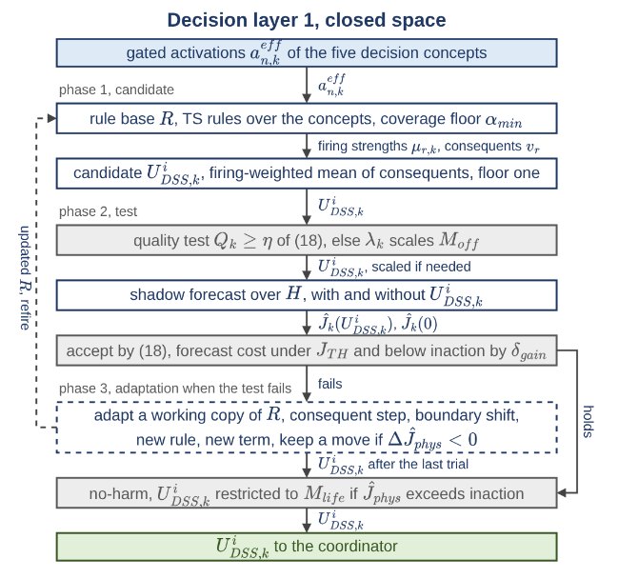
C. The Closed Decision Layer
Fig. 3. The closed decision layer of one agent.
Fig. 3 gives the closed layer. Each rule has the TS form (16) over 5 decision concepts and a constant consequent over 6 intervention families $M$, namely suppression effort, resource deployment, containment line, asset protection, evacuation, and public warning, with inaction as the zero point of each. A rule fires with its weakest clause. The candidate is the firing-weighted average of the consequents, floored at one so that weak support gives a weak order. Five seed rules start the base and must cover every reachable reading above $α_{min}$.
$$R_{r}:\text{IF}a_{1,k}^{eff}\text{is }A_{r,1}\text{AND}⋯\text{AND} a_{5,k}^{eff}\text{ is }A_{r,5}\text{THEN}u_{k}=v_{r}$$  $$u_{m,k}=\frac{\sum_{r}{μ_{r,k}}v_{r,m}}{max\left(1,\sum_{r}{μ_{r,k}}\right)}, μ_{r,k}=\min_{n}μ_{A_{r,n}}\left(a_{n,k}^{eff}\right)$$  $$\min_{a^{eff}∈{\left[0,1\right]}^{5}}\max_{r}μ_{r}\left(a^{eff}\right)≥α_{min}$$ | (16)

In (16), $R_{r}$ is rule $r$, $A_{r,n}$ its term for concept $n$, $v_{r}$ its consequent vector, $u_{m,k}$ the ordered intensity of family $m∈M$, $μ_{r,k}$ the firing strength, and $α_{min}$ the coverage floor.
Every candidate is judged on a shadow copy of the simulation core over a horizon $H$. The decision cost (17) is a weighted sum of five bounded terms, namely burned area, lost asset value, population exposure, committed response, and dispatch delay. The first three form the physical cost $J_{phys}$, the measure read in every comparison across configurations, since a run without intervention carries no response cost. Acceptance is satisficing (18). The forecast cost must stay under a ceiling and improve on inaction by a margin. The quality test in (18) compares each scored concept with the strongest intensity ordered for its answering family. Below $η$ the fail-safe scales the four offensive families $M_{off}$ by $λ_{k}$ and leaves the two life-safety families $M_{life}$, evacuation and warning, untouched, with $M=M_{off}∪M_{life}$.
$$J=\frac{\sum_{j}{w_{j}}J_{j}}{\sum_{j}{w_{j}}},j∈\left\{burn,asset,pop,resp,delay\right\}$$  $$J_{phys}=\frac{J_{burn}+J_{asset}+J_{pop}}{3} \\ J_{burn}=\frac{χ}{1+χ}, χ=\frac{N_{burned}}{ρ_{burn}N_{burnable}} \\ J_{asset}=\frac{V_{lost}}{V_{total}}, J_{pop}=min\left\{1,\frac{P_{steps}}{P_{total}N_{dec}}\right\} \\ J_{resp}=min\left\{1,\frac{C_{steps}}{C_{ref}N_{dec}}\right\}, J_{delay}=min\left\{1,\frac{τ_{disp}}{τ_{ref}}\right\}$$ | (17)
$${\hat{J}}_{k}\left(u_{k}\right) ≤ min\left\{J_{TH},\left(1-δ_{gain}\right){\hat{J}}_{k}\left(0\right)\right\} Q_{k}=1-\frac{1}{4}\sum_{n∈C_{Q}}{\left|a_{n,k}^{eff}-\max_{m∈M_{n}}u_{m,k}\right|} λ_{k}=min\{1,Q_{k}/η\}, u_{m,k}←λ_{k}u_{m,k}, m∈M_{off}$$ | (18)

In (17), $N_{burned}$ and $N_{burnable}$ count burned and burnable cells, $ρ_{burn}$ is the reference burned fraction, $V_{lost}$ and $V_{total}$ the lost and exposed asset value, $P_{steps}$ the person-steps in burning cells, $P_{total}$ the population at risk, $N_{dec}$ the decision steps of the horizon, $C_{steps}$ the fielded capacity summed over steps, $C_{ref}$ the reference capacity, $τ_{disp}$ the capacity-weighted dispatch time, and $τ_{ref}$ the reference dispatch time. In (18), ${\hat{J}}_{k}\left(⋅\right)$ is the forecast cost, $J_{TH}$ the ceiling, $δ_{gain}$ the required gain over the no-action forecast ${\hat{J}}_{k}\left(0\right)$, $C_{Q}$ the four scored concepts, all but suppression feasibility, which gates the others, and $M_{n}$ the families that answer concept $n$.
When the standing decision falls short, the layer adapts within its vocabulary, in the evolving fuzzy tradition [26], by the four moves of (19). A step changes one consequent. A shift moves a term edge with the facing edge of its left neighbor, so the partition of unity is preserved. A new rule is written on the uncovered combination of the two most active concepts. A new term is inserted where no term reads the current value clearly. Every move is tried on a working copy and kept only when the forecast physical cost falls. After the last trial, the no-harm guard restricts the candidate to $M_{life}$ when it forecasts a higher physical cost than inaction. The result is the intervention field $U_{DSS,k}^{i}$ of region $i$, merged by the coordinator.
$$\text{step}\text{: }v_{r,m}←{clip}_{\left[0,1\right]}\left(v_{r,m}±δ\right)$$  $$\text{shift}\text{: }\left(a_{A},b_{A},c_{A^{-}},d_{A^{-}}\right)←\left(a_{A},b_{A},c_{A^{-}},d_{A^{-}}\right)-δ$$  $$\text{new rule}\text{: }A_{new}=\left\{\left(n_{1},t_{n_{1}}^{*}\right),\left(n_{2},t_{n_{2}}^{*}\right)\right\}$$  $$t_{n}^{*}=arg\max_{t∈T_{n}}μ_{t}\left(a_{n,k}^{eff}\right)$$  $$\text{new term}\text{: }\max_{t∈T_{n}}μ_{t}\left(x\right)<θ_{ins},x=a_{n,k}^{eff}⇒$$  $$T_{n}←T_{n}∪trap\left(x-2l,x-l,x+l,x+2l\right)$$  $$\text{keep: }Δ{\hat{J}}_{phys}<0$$ | (19)

In (19), $δ$ is the step, $a_{A}$ and $b_{A}$ the left corners of term $A$, $c_{A^{-}}$ and $d_{A^{-}}$ the right corners of its left neighbor $A^{-}$, $n_{1}$ and $n_{2}$ the two most active concepts, $T_{n}$ the term set of concept $n$, $t_{n}^{*}$ its dominant term, $θ_{ins}$ the insertion threshold, and $trap\left(⋅\right)$ a trapezoid of half-width $l$ centered on the crisp reading $x$.

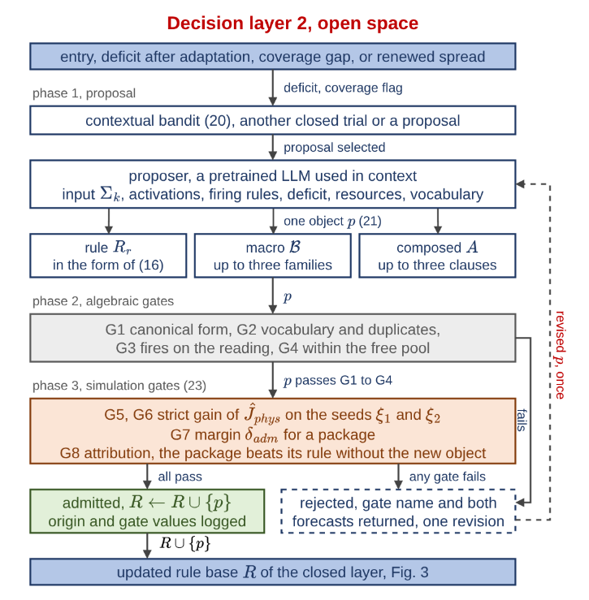
D. The Open Decision Layer
Fig. 4. The open decision layer of one agent.
Fig. 4 gives the open layer. It is entered when adaptation leaves a deficit, when a coverage gap opens while the fire is alive, or when spread renews under applied orders. At entry a contextual bandit [32] chooses between another closed trial and a proposal (20). The context $e_{k}$ is the deficit band and the coverage flag, the options $q$ are the two choices, and the reward $r_{k}$ is the forecast cost reduction of the cycle. The value table $V$ is updated with the step $α_{b}$, and a random option is tried with the exploration rate $ϵ_{b}$.
$$q_{k}=arg\max_{q∈A\left(e_{k}\right)}V\left(e_{k},q\right) \text{ with probability }1-ϵ_{b} \\ V\left(e_{k},q_{k}\right)←V\left(e_{k},q_{k}\right)+α_{b}\left(r_{k}-V\left(e_{k},q_{k}\right)\right)$$ | (20)

The proposer is a pretrained LLM used in context only. It receives the gated activations, the firing rules, the deficit, the resource state, and the vocabulary of effects, sectors, and bands, and returns one object of (21). The object is a rule in the form of (16), a macro $B$ that blends up to three families $b_{j}$ with weights $β_{j}$, or a composed intervention $A$ of up to three clauses. A rule or a macro may also order one of three library interventions $M_{lib}$, namely retardant drop, water drafting, and tactical burn. No seed rule orders them, so they enter the doctrine only through the gates, and the fail-safe and the no-harm rule withhold them together with $M_{off}$. A clause names an effect $e$ from seven verified effects, a sector $s$ from seven sectors, a distance band $\left[ρ_{in},ρ_{out}\right]$ in cells, and an amount $α$.
$$B=\{\left(b_{j},β_{j}\right)\}_{j≤3}, \left(B,v\right)↦\left(b_{j}, β_{j}v\right) \\ A=\{\left(e,s,\left[ρ_{in},ρ_{out}\right],α\right)\}_{≤3} \\ e∈\left\{wet,clear,ignite,coat,draft,evacuate,prime\right\} \\ s∈\{head,flank,rear,ring,at_fire,assets,populated\}$$ | (21)

A clause is resolved on the engine fields by the band geometry and the idempotent operators of (22). The band $B$ is the set of cells within four-neighbor distance $ρ_{out}$ of the sector core $C$ but not within $ρ_{in}-1$, and $D_{ρ}\left(C\right)$ denotes such a disk. The cosine $κ$ between a cell direction from the fire centroid $c_{F}$ and the mean wind ${\overset{‾}{W}}_{k}$ splits head, flank, and rear. The amount $a$ is the clause amount scaled by the firing intensity $u$ of the rule. It raises the retardant field $r_{ret}^{M}$ on the mask $M$ by a maximum and the capacity field $r_{cap}^{M}$ by a minimum, with the drafting gain $g_{w}\left(d_{w}\right)$ at water distance $d_{w}$ and the cap $c_{max}$, so that repeating a clause changes nothing. Hence, the space is open at interventions and closed at effects.
$$B\left(C,ρ_{in},ρ_{out}\right)=D_{ρ_{out}}\left(C\right)\backslash D_{ρ_{in}-1}\left(C\right) \\ κ\left(x\right)=\frac{\left(x-c_{F}\right)⋅{\overset{‾}{W}}_{k}}{∥x-c_{F}∥} a={clip}_{\left[0,1\right]}\left(αu\right) \\ r_{ret}^{M}←max\left(r_{ret}^{M},a\right) \\ r_{cap}^{M}←min\left(r_{cap}^{M} \left(1+g_{w}\left(d_{w}\right)\right), 1.5 c_{max}\right)$$ | (22)

Every proposal is untrusted and passes the gate chain of Fig. 4 in order. The first four gates are algebraic and cost no simulation step. G1 rejects an object that does not parse into the vocabulary, G2 an unknown effect or sector and a duplicate of the base, G3 a rule that does not fire on the current reading, and G4 an order that exceeds the free pool. The last four run on the shadow core (23). G5 and G6 demand a strict gain in the forecast physical cost on two independently seeded futures, G7 a margin $δ_{adm}$ for a package on each seed, and G8 attribution, so that a package beats its own rule stripped of the new object by the same margin. The simulation gates read the physical cost, as the closed layer does. A rejection returns the gate name and both forecasts, and the proposer may revise once. An admitted object joins the base with its origin and gate values logged.
$$\text{G5, G6: }{\hat{J}}_{phys}^{ξ}\left(R∪\{p\}\right)<{\hat{J}}_{phys}^{ξ}\left(R\right) \\ \text{G7: }{\hat{J}}_{phys}^{ξ}\left(R\right)-{\hat{J}}_{phys}^{ξ}\left(R∪\left\{p\right\}\right)≥δ_{adm} \\ \text{G8: }{\hat{J}}_{phys}^{ξ}\left(R∪\{r\backslash A\}\right)-{\hat{J}}_{phys}^{ξ}\left(R∪\left\{r_{A}\right\}\right)≥δ_{adm} \\ \text{for both seeds }ξ∈\{ξ_{1},ξ_{2}\}$$ | (23)

In (23), $p$ is the proposal, $R$ the current base, $ξ_{1}$ and $ξ_{2}$ the two seeds, $r_{A}$ the rule carrying the new object $A$, and $r\backslash A$ the same rule without it.
Four properties follow from the acceptance rules alone and hold whatever the proposer produces. No order reaches the field whose forecast physical cost exceeds the no-action forecast over the guard horizon. The intensities of $M_{life}$ are never reduced, since neither the fail-safe nor the no-harm rule acts on them and a proposal that lowers them fails G2. At every reachable reading some rule fires above the coverage floor of (16), or the layer falls back to the watchful posture and adapts. Each admitted package lowers the forecast physical cost on both seeds by at least $δ_{adm}$, so the admissions in one incident are bounded and the extension halts once no proposal clears the gates. The remaining risk is statistical. A proposal with zero or harmful true effect passes G5 and G6 with probability at most $ψ^{2}$, where $ψ$ is the probability that one shadow forecast reports a gain by chance. Section V-E reports how often admitted objects paid off in the outcome.

E. Local Agents and Global Coordination
Algorithm 1 gives one decision cycle of the decision core. Each of the $N$ local agents runs the closed layer of Section IV-C with the open layer of Section IV-D inside its trial loop, and the coordinator performs no inference. Each agent sends up its operational priority $p_{i}$, its resource request, and a confidence summary, and receives the allocation, the priority weights, and the acceptance thresholds in force. Regions ranked by priority receive the attention share $σ_{i}$ of (24), which scales only the offensive families, and a monitored region faces a stricter quality threshold. The merged field of (25) passes the no-harm guard once more against inaction. When the plan is worse, the field is restricted to $M_{life}$ and the life-safety orders stand.
$$σ_{i}=\left\{\begin{matrix}1 & p_{i}≥τ_{att} p_{max} \\ 0.5+0.5 p_{i}/p_{max} & \text{otherwise}\end{matrix}\right.$$ | (24)
$$U_{DSS,k}=A_{DSS}\left(\{σ_{i} U_{DSS,k}^{i}\}_{i=1}^{N}\right) \\ {\hat{J}}_{phys}\left(U_{DSS,k}\right)>{\hat{J}}_{phys}\left(0\right)⇒U_{DSS,k}←U_{DSS,k}|_{M_{life}}$$ | (25)

In (24), $p_{i}$ is the operational priority $c_{1}^{\left(4\right)}$ of region $i$, $p_{max}$ the highest priority, and $τ_{att}$ the attention threshold. In (25), $A_{DSS}$ merges the regional fields into one intervention field.
Algorithm 1 One decision cycle, $N$ local agents and the coordinator
1: Input: observations $O_{k}^{i}$, rule bases $R$, snapshot of the core, seeds $ξ_{1}$, $ξ_{2}$, shares $σ_{i}$ and thresholds $η_{i}$ of the previous cycle
2: for each agent $i$ in parallel do
3: features and confidences by (11), (12); activations $a^{eff}$ by (14), (15)
4: fire $R$; candidate $u_{k}$ by (16); if $Q_{k}<η_{i}$ then scale $M_{off}$ by $λ_{k}$
5: shadow forecasts over $H$ from the snapshot: ${\hat{J}}_{k}\left(u_{k}\right)$ and ${\hat{J}}_{k}\left(0\right)$
6: while (18) fails and trials remain do
7: closed move from (19) on a working copy of $R$; keep it if $Δ{\hat{J}}_{phys}<0$
8: if the bandit of (20) selects a proposal then
9: $p←LLM\left(Σ_{k}\right)$; test G1 to G4; forecast $R$ and $R∪\{p\}$ on $ξ_{1}$, $ξ_{2}$; test (23)
10: if all gates pass then $R←R∪\{p\}$ else return the gate name and both forecasts, one revision
11: refire $R$; update $u_{k}$ and the forecasts
12: if ${\hat{J}}_{phys}\left(u_{k}\right)>{\hat{J}}_{phys}\left(0\right)$ then $u_{k}←u_{k}|_{M_{life}}$ (no-harm)
13: send $U_{DSS,k}^{i}$ written from $σ_{i}u_{k}$, priority $p_{i}$, resource request, and confidence summary
14: coordinator: rank the regions by $p_{i}$; $p_{max}←\max_{i}p_{i}$
15: for each region $i$ do $σ_{i}$ by (24); allocate from the shared pool in rank order; raise $η_{i}$ if region $i$ is monitored
16: $U_{DSS,k}←A_{DSS}\left(\{σ_{i}U_{DSS,k}^{i}\}\right)$ by (25); forecast ${\hat{J}}_{phys}\left(U_{DSS,k}\right)$ and ${\hat{J}}_{phys}\left(0\right)$
17: if ${\hat{J}}_{phys}\left(U_{DSS,k}\right)>{\hat{J}}_{phys}\left(0\right)$ then $U_{DSS,k}←U_{DSS,k}|_{M_{life}}$ (no-harm)
18: Output: $U_{DSS,k}$ to the simulation core; $σ_{i}$, allocations, and $η_{i}$ to the agents; updated $R$; log of the cycle

V. Results

A. Evaluation Criteria and Validation of the Simulation Core
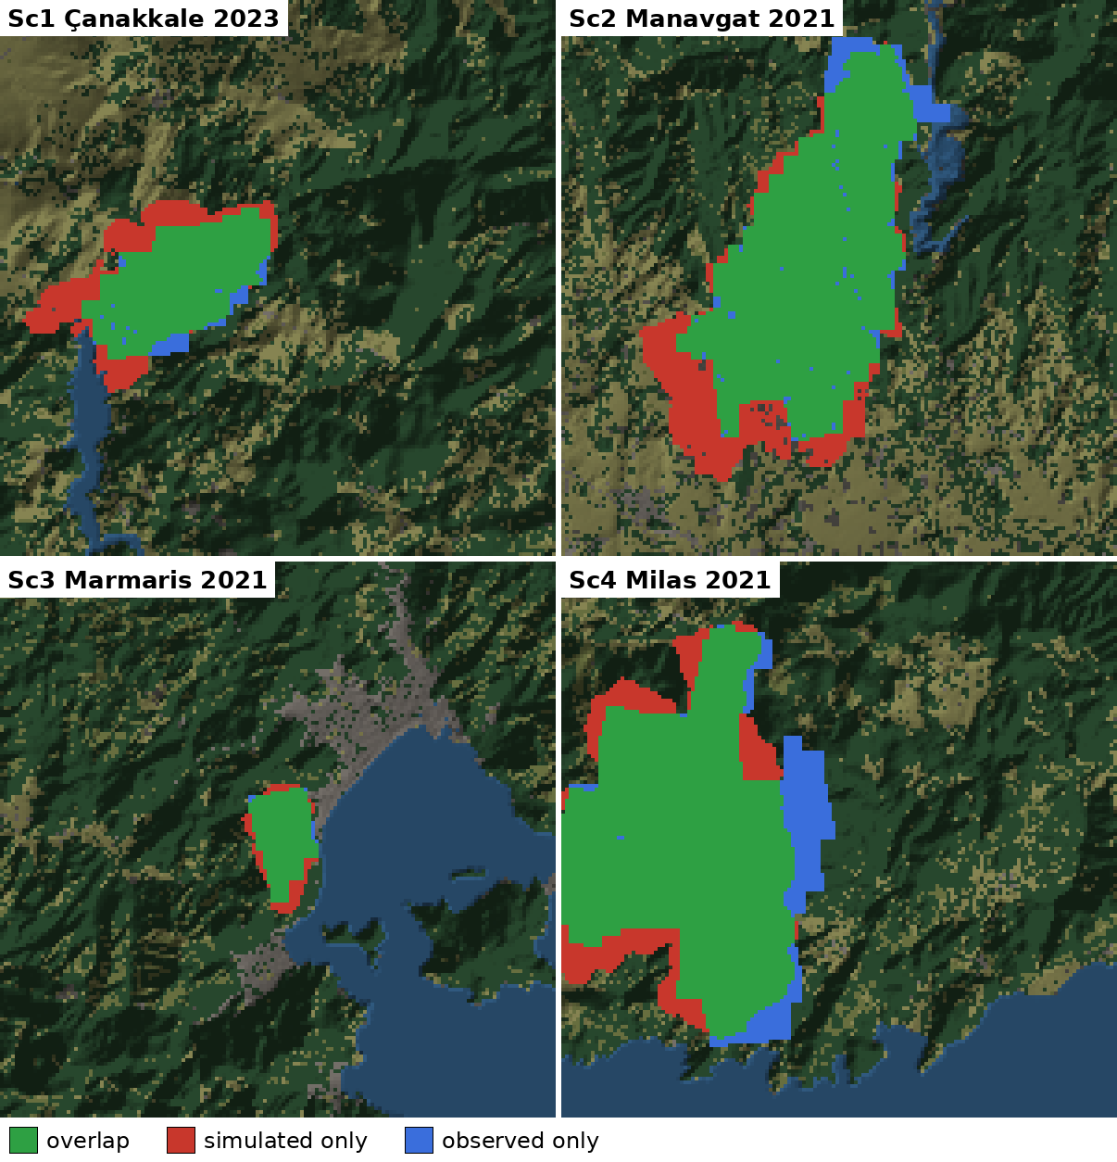
Eight criteria fixed in advance are audited at the end of this section, namely predictive fidelity, decision quality, timeliness, robustness, uncertainty handling, adaptability, explainability, and scalability. Predictive fidelity is tested by blind hindcast. The simulation core receives only the public inputs of a documented fire, with no tuning on that fire, and its output is compared with the satellite record. Terrain comes from Copernicus GLO-30, fuel from ESA WorldCover 2021, weather from ERA5 reanalysis, and ignition points and reference burn from NASA FIRMS VIIRS detections. Four fires in Türkiye cover different fuel, terrain, and wind conditions, namely Sc1 Çanakkale 2023, Sc2 Manavgat 2021, Sc3 Marmaris 2021, and Sc4 Milas 2021. The core models free spread without suppression, so a free run overpredicts the final area and area overlap is not a fair score. Three criteria that are robust to suppression are used instead, each reported as an agreement in Table I. The probability of detection (POD) is the share of the observed burn that the model reaches. It is not lowered by overprediction, and 0.70 is the level at which calibrated growth models are reported to agree with observed footprints [23]. The front agreement is $1-\overset{‾}{d}/R$, where $\overset{‾}{d}$ is the mean distance between the simulated and the observed fronts and $R$ the radius of a disk with the observed burned area, so that 0.9 means the fronts lie within one tenth of the fire size. The arrival-time agreement is $1-τ/T$, where $τ$ is the mean absolute difference between the simulated and the detected arrival times over the shared cells and $T$ the observed duration of the fire. It is the direct test of the rate of spread. The overall agreement is the mean of the three. Over 50 replicates the overall agreement is 86 to 94% and no single score falls below 0.70. Fig. 5 shows the agreement maps over the same window of 150 by 150 cells for each fire.
Fig. 5. Hindcast agreement maps, 150 by 150 cell windows: green simulated and observed, red simulated only, blue observed only.
TABLE I
Hindcast agreement per historical fire (50 replicates)
Score | Sc1 | Sc2 | Sc3 | Sc4
Observed duration $T$ (h) | 14.0 | 72.8 | 14.0 | 58.7
Front agreement $1-\overset{‾}{d}/R$ | 82% | 90% | 89% | 89%
Arrival-time agreement $1-τ/T$ | 90% | 98% | 71% | 96%
Probability of detection | 92% | 93% | 97% | 85%
Overall agreement | 88% | 94% | 86% | 90%

B. Experimental Design
Synthetic scenarios use 72 by 50 cell grids at 30 m with terrain, land cover, settlements, roads, and capacity-limited bases, under critical fire weather. Table II lists the settings of the engine, the closed layer, the open layer, and the coordinator with the reason for each value. Five scenario families, listed in Table III, span remote forest and the wildland-urban interface under sufficient and limited resources, and the fifth repeats the hardest interface family under degraded observation. Each family is generated 30 times from seeds 201 to 230, and every world is replayed identically by three configurations. T0 issues no orders and fixes the cost of inaction. The closed layer alone runs the five seed rules with their self-tuning. VODA is the full architecture, the closed layer with the open layer and the LLM proposer behind the full gate chain. The static seed base without adaptation is run as a fourth reference where it separates the contribution of the doctrine from that of adaptation. Terrain, ignitions, weather, and the random stream are shared, so differences between configurations arise from the issued orders alone, 600 runs in all. Outcome is read at the end of the episode on burned area, affected population, the share of incidents extinguished within the episode, and the physical and total cost. Paired statistics report the mean difference on the same worlds with its 95% half-width and the number of worlds in which the first configuration is better. Sensitivity of the closed layer was assessed one parameter at a time over five worlds, 880 runs in total. Observation quality decides light fire loads and resources decide heavy ones, and the satisficing bound sets how often adaptation engages, 42% of cycles at 0.35.
TABLE II
Settings of the experiments and their justification
Setting | Value | Justification
Physical step, decision cycle | 2 min, 12 min | two-minute spread update, six updates per decision
Planning horizon $H$ | 24 min | two decision cycles ahead
Episode | to extinction or 12 h | cap of the paired comparison
Fire weather | moisture 0.08, wind 8 m/s | critical fire weather
Cost weights $w$ | 1, 1, 1, 0.2, 0.2 | physical terms dominate, response cost breaks ties
Reference burned fraction $ρ_{burn}$ | 0.05 of burnable cells | normalizes the burned-area term of (17)
Satisficing bound $J_{TH}$ | 0.35 | adaptation engages in 42% of cycles
Gain margin $δ_{gain}$, coverage floor $α_{min}$, adaptation step | 0.05 each | one twentieth of the unit interval, the resolution of the 5-term partition
Quality threshold $η$ | 0.60 | mean gap between a scored concept and its answer at most 0.4
Term insertion threshold, half-width $l$ | 0.62, 0.12 | membership level at which two neighbouring terms share a reading
Bandit step $α_{b}$, exploration rate $ϵ_{b}$ | 0.05, 0.10 | one proposal in ten is tried regardless of the value table
Admission margin $δ_{adm}$ | 0.0001 per seed | excludes only a package without a measurable gain
Attention threshold $τ_{att}$ | 0.35 of the highest priority | a region below it gets a reduced offensive share
Degraded observation (S5) | outage 0.25, noise 0.10 | one in four readings missing, 10% noise on the rest

TABLE III
Scenario families (72 by 50 cells at 30 m, 30 paired worlds each)
Family | Landscape | Pool | Ignitions | Observation
S1 | mountain forest, 2 settlements | full | 1, remote | full
S2 | mountain forest, 2 settlements | 0.6 | 2, remote | full
S3 | rolling interface, 12 settlements | full | 1, near interface | full
S4 | rolling interface, 12 settlements | 0.6 | 2, near interface | full
S5 | as S4 | 0.6 | 2, near interface | outage 0.25, noise 0.10

C. Outcome: No Decision Support, Closed Layer, VODA
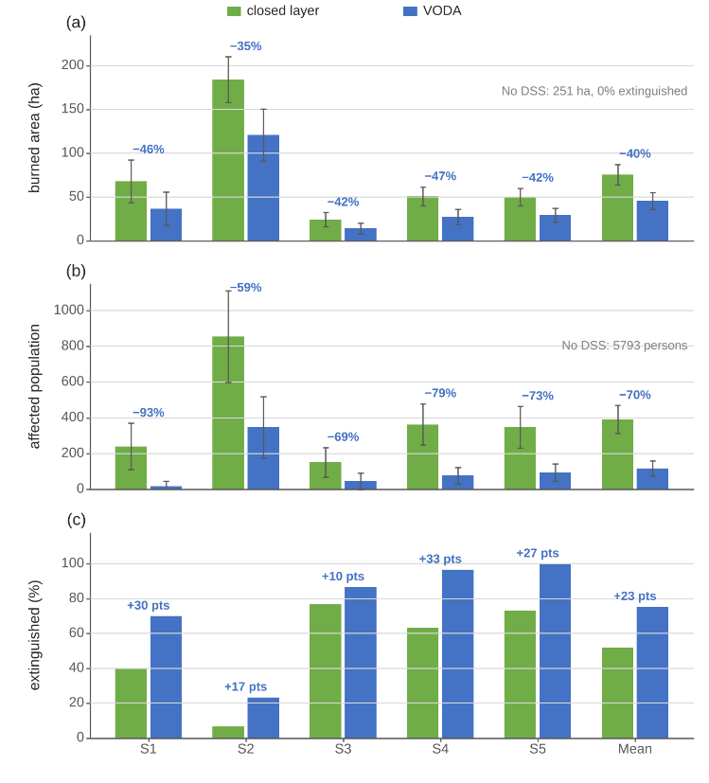
Fig. 6 reports the outcome per family. Free burn consumes 250.7 ha on average and affects 5793 persons. The rule-based core alone changes this most. The static seed base lowers the burned area to 80.9 ha, a paired saving of 169.7 ± 10.3 ha that holds in all 150 worlds, and the affected population to 494. This gain belongs to the doctrine, not to adaptation. The self-tuning of the closed layer changes the character of the response more than its extent. The share of incidents extinguished within the episode rises from 13 to 52% and the delay term falls from 0.347 to 0.274, since tuned consequents commit the same resources sooner, but the burned area moves only to 75.4 ha, a paired difference of 5.5 ± 7.0 ha that does not separate from zero (better in 73 of 150 worlds). Tuning five rules finishes the fires the doctrine already holds. It does not reach the fires the doctrine does not hold.
Fig. 6. Outcome per family, closed layer against VODA: (a) burned area, (b) affected population, (c) share extinguished.
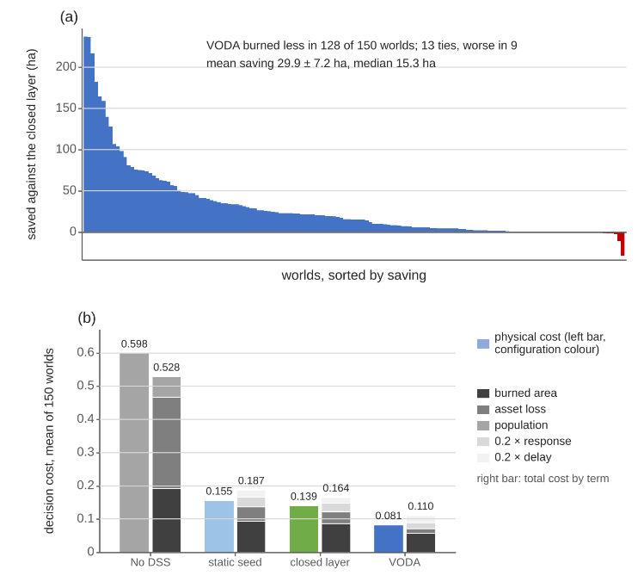
VODA does. Against the closed layer on the same worlds it burns 29.9 ± 7.2 ha less and is better in 128 of 150 worlds, as Fig. 7(a) shows. The 13 ties are small fires the doctrine already contained, and in nine worlds it burned more. It raises the share extinguished to 75% and lowers the affected population to 117 persons, 274 ± 61 fewer per world and 70% below the closed layer. The gain is largest where the doctrine is weakest. In the forest family with a reduced pool and two ignitions (S2) the paired difference is 63.6 ± 27.6 ha. In the interface families with two ignitions (S4, S5) VODA burns less in 30 and 29 of 30 worlds and extinguishes 97 and 100% of the incidents. Under degraded observation (S5) its burned area moves from 27.2 to 29.2 ha, a change of 7% inside the confidence interval of either cell, and the configuration remains the best. Reduced observation degrades the response instead of breaking it.
Fig. 7. (a) Area saved by VODA against the closed layer, 150 worlds sorted. (b) Physical and five-term total cost per configuration.
The gain is not bought with resources. Fig. 7(b) sets the physical cost beside the five-term total cost of each configuration. VODA reaches the lowest physical cost, 0.081 against 0.139 for the closed layer, and the lowest total cost, 0.110 against 0.164, while its response term (0.308) stays below that of the closed layer (0.428) and of the static doctrine (0.501). The saving sits in the physical terms with no growth in the response terms. The rule base reaches 10.4 active rules at the end of an episode under VODA against 10.3 under the closed layer alone, so the margin comes from what the rules say rather than from how many there are. What the open layer costs is computation. An episode makes 10.3 model calls and takes 124 s of wall time against 22 s for the closed layer, about two seconds per decision cycle against the twelve minutes available.

D. What the Open Layer Produced
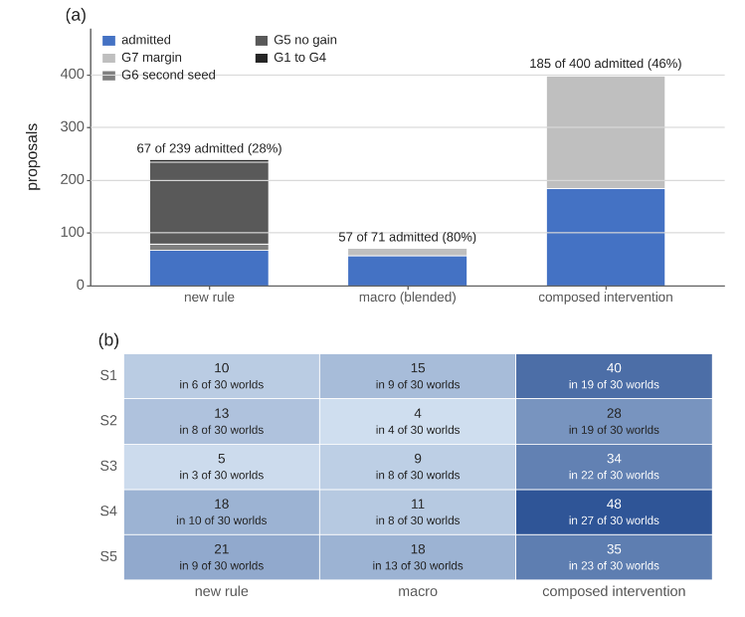
Adaptation runs only on demand. Hence, the volume of trials measures how often the standing decision fell short, and the admission rate measures how strictly the gates filtered the responses. Over the 150 worlds the closed-layer mechanisms inside VODA kept 451 of 2093 consequent-step trials and 469 of 1411 resolution trials. The open layer received 710 proposals, one per call with a single revision, and admitted 309 (44%). Proposals that introduce a new decision concept, 78 in the same runs, are outside the scope of this article. Fig. 8 shows where the rejections fell. In all, 227 proposals passed the forecast tests but failed the package margin G7, 155 did not improve the forecast at G5, 12 failed the second seed at G6, and 7 were stopped by the syntactic gates. In other words, the model writes well-formed objects, and the simulator decides. Admission depends on the form of the proposal. Macros that blend existing families were admitted in 80% of 71 cases, composed interventions in 46% of 400, and plain rules over the existing vocabulary in 28% of 239. Thus, the objects that extend the vocabulary pass more often than new rules inside it.
Fig. 8. (a) The 710 proposals by kind and gate verdict. (b) Admitted objects per family and kind, and the worlds that admitted one.
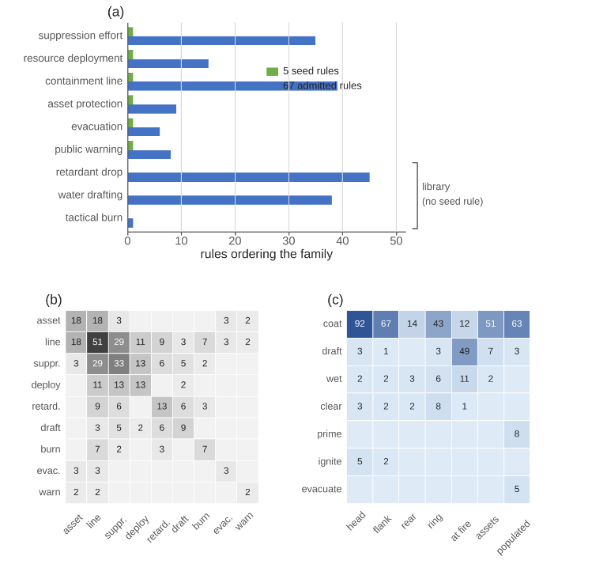
What was written falls into a small number of tactics, each absent from the seed doctrine, as Fig. 9 shows. Of the 67 admitted rules, 58 order a library intervention, retardant drop in 45 and water drafting in 38, beside containment lines (39) and suppression effort (35). No seed rule orders these two families, so the open layer added aerial attack to the doctrine, and it did so in 32 of the 150 worlds. The 57 macros reduce to two archetypes. Interface hardening blends asset protection with a containment line at 0.7 to 0.8 (18 admissions). The line-and-attack macro blends a containment line with suppression effort and, in 11 cases, resource deployment (29 admissions). The 185 composed interventions, 72 distinct clause sets, are dominated by two geometries. The asset collar coats the threatened assets and the populated cells within two to three cells before the fire arrives (26 admissions in its plain form, 42 with variants). The head-flank band coats the head within four to six cells and the flanks within two to three, with or without water drafting at the fire (41 in its two plain forms, 56 with variants). Clauses that wet, clear, ignite, or evacuate are rare and enter only where the forecast rewards them.
Fig. 9. What was written: (a) families ordered by seed and admitted rules, (b) blends in the macros, (c) clauses by effect and sector.

E. Where the Gain Came From
Every world starts from the same five seed rules, and the proposer has no memory across worlds. Hence, an object that recurs in several worlds was rediscovered, not copied. Counting every variant that contains the defining clauses, the asset collar was admitted in 42 distinct worlds, the head-flank band in 51, the interface-hardening macro in 18, and the line-and-attack macro in 28. Recurrence across independent worlds is the first evidence that what the open layer learns is structural rather than incidental.
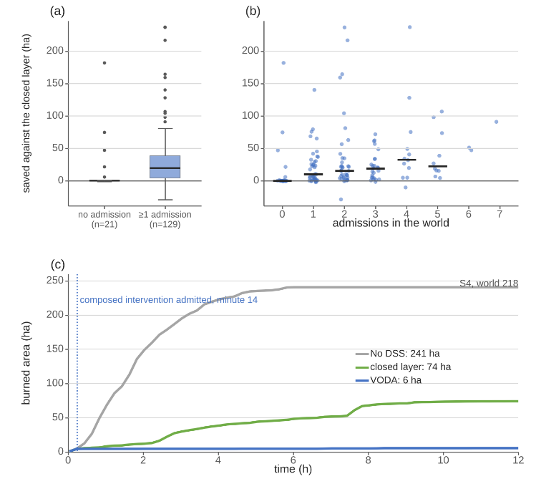
The realized outcome confirms the forecast that admitted the objects, as Fig. 10 shows. In the 21 worlds with no admission, VODA and the closed layer end within 16 ha of each other on average, and 11 of them are identical. The margin of Section V-C comes from the 129 worlds with at least one admission, where the mean saving is 32.2 ha, and the median saving grows from 10 ha with one admission to 33 ha with four. This attribution is observational, since the admitted set is not assigned at random. The causal version, replaying each world with one admitted object removed, is left to future work. The single world in Fig. 10(c) shows the mechanism at the scale of one fire. It is an interface world in which the closed layer ends at 74 ha and VODA at 6 ha. The curves separate at minute 14, when one composed intervention coating the threatened assets and the head was admitted.
Fig. 10. (a) Saving without and with admissions. (b) Saving against the number of admissions, bars are medians. (c) One S4 world.

F. Timeliness, Scalability, and Compliance
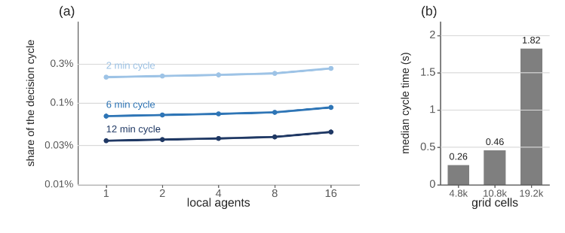
One decision covers the whole loop, including the two shadow forecasts of the acceptance test and any adaptation that runs. It takes a median 274 ms against a twelve-minute cycle, 909 ms at the ninetieth percentile and 1.28 s at the slowest. The first offensive order is fielded at the first decision, two minutes after ignition. Fig. 11(a) reports the decision-layer cost for one to sixteen agents at cycles of two, six, and twelve minutes, as the median over three worlds. Every point lies between 0.03 and 0.27% of the cycle, and sixteen times the agents cost 1.28 times the median of one agent, since each agent reasons over its own region. Fig. 11(b) gives the other axis. Four times the grid raised the median by 6.9, and six times the forecast horizon by 1.4. Thus, scalability holds on the axis the architecture is built for, while domain size remains the binding limit.
Fig. 11. Decision cost: (a) median decision time as a share of the cycle against the number of agents, (b) against the size of the grid.
Against the eight criteria, the picture is as follows. Predictive fidelity rests on four blind hindcasts with an overall agreement of 86 to 94%. Decision quality follows from the paired comparison, 82% less burned area than no action and 40% less than the closed layer, better in 128 of 150 paired worlds, with the lowest cost in every family. Timeliness is met with 274 ms per decision and about two seconds of proposer time per cycle. Scalability is met with 1.28 times the cost for sixteen times the agents. Robustness is met with a loss of 7% under degraded observation while the configuration remains the best tested. Uncertainty handling is structural, since every feature carries a confidence that gates its concept. Adaptability shows in 309 admitted objects that recur across worlds. Explainability shows in every edit, rejection, and generated object being logged with its trigger, gate, and consuming rule. Four criteria are met in full and four on the axis measured here. In detail, the hindcast base covers four fires, outage and noise are tested at one level only, operator-facing interpretability is not evaluated, and uncertainty is carried into the decision but not propagated as an ensemble.

VI. Discussion
Three lessons transfer beyond wildfire. First, separating an authoritative hazard model from the decision layer is what makes both testable. The model was validated against satellite records with no decision logic in the loop. The decision layers were then measured against each other on the same worlds. Hence, the benefit of opening the decision space is a paired difference rather than an absolute score. Second, a vocabulary of orders that grows at run time is safe only when admission is decided by gates that do not trust the proposer. More than half of the proposals were rejected, most of them at the package margin after they had passed the forecast tests. That selectivity is why the admitted objects could be fielded and why the outcome improved rather than merely changed. Third, the two layers divide the work by cost and determinism rather than by capability. The moves of the closed layer are deterministic, cheap, and numerous, 3504 trials against 710, and they finish the fires the doctrine already holds. The proposals of the open layer are expensive and not bitwise reproducible, and they reach the fires the doctrine does not hold. A single generative mechanism could in principle write the tuning edits as rules, at roughly four times the model calls of this campaign. However, keeping the deterministic layer underneath minimizes the number of cycles in which the non-reproducible component acts. It also keeps the ledger able to say which change came from tuning and which from generation.
Three limitations bound the claims. The evaluation is simulated. The hazard model is validated on real records, but no order was executed in a real incident and no fire officer took part in the loop. The attribution of the gain to object kinds is observational. A leave-one-out replay of each admitted object, and an ablation that admits the proposals of one kind only, would turn it into a causal account. The proposals of an LLM are not bitwise reproducible. Nevertheless, the campaign is logged with pinned configuration and seeds, and no admission depends on the proposer. A replication with a different model and a repeated run of the same worlds would measure the variance this introduces.

VII. Conclusion
This article presented VODA, a distributed decision support architecture for wildfire response built on two separated cores and two decision layers. The closed layer is a self-tuning fuzzy doctrine over 5 decision concepts and 6 intervention families. The open layer lets a pretrained LLM extend that doctrine with rules, blended interventions, and interventions composed from verified physical effects. A gate chain preserves no-harm, life-safety invariance, coverage, and monotone descent whatever the proposer. On an independently validated core, 150 paired worlds in five scenario families were replayed with no decision support, with the closed layer alone, and with both layers. The open layer admitted 309 of 710 proposals. It burned 29.9 ± 7.2 ha less per world than the closed layer and was better in 128 of 150 worlds. It raised the share of incidents extinguished from 52 to 75% and left 70% fewer people affected. This was achieved with a smaller committed response, no growth in rule count, and about two seconds of proposer time per decision cycle. The admitted objects recur across independent worlds and reduce to a small set of tactics the seed doctrine did not contain, namely aerial attack, the asset collar, the head-flank retardant band, interface hardening, and the downwind backburn line. Four studies follow. A leave-one-out replay will attribute the gain to each admitted object. A withheld-knowledge study will remove a known tactic from the doctrine and measure its rediscovery. A tabletop exercise will put fire officers in the loop. A transfer study will keep the decision core and replace the hazard model with another spreading hazard.

References
[1] M. Turoff, M. Chumer, B. Van de Walle and X. Yao, "The design of a dynamic emergency response management information system (DERMIS)," J. Inf. Technol. Theory Appl., vol. 5, pp. 1-36, 2004.
[2] D. M. Bowman, C. A. Kolden, J. T. Abatzoglou, F. H. Johnston, G. R. van der Werf and M. Flannigan, "Vegetation fires in the Anthropocene," Nat. Rev. Earth Environ., vol. 1, pp. 500-515, 2020.
[3] M. P. Thompson and D. E. Calkin, "Uncertainty and risk in wildland fire management," J. Environ. Manage., vol. 92, pp. 1895-1909, 2011.
[4] D. E. Calkin, C. D. O'Connor, M. P. Thompson and R. D. Stratton, "Strategic wildfire response decision support and the risk management assistance program," Forests, vol. 12, p. 1407, 2021.
[5] F. Vásquez, A. Cravero, M. Castillo and F. Riquelme, "Decision support system development of wildland fire: A systematic mapping," Forests, vol. 12, p. 943, 2021.
[6] R. C. Rothermel, "A mathematical model for predicting fire spread in wildland fuels," Res. Pap. INT-115, 1972.
[7] M. A. Finney, "An overview of FlamMap fire modeling capabilities," in Fuels Management: How to Measure Success (RMRS-P-41), 2006.
[8] C. Pais, J. Carrasco, P. E. Moudio and Z.-J. M. Shen, "Downstream protection value: Detecting critical zones for effective fuel-treatment under wildfire risk," vol. 90, p. 101703, 2021.
[9] T. Orphanoudakis, C. Betzelos and H. C. Leligou, "MORA: A multicriteria optimal resource allocation and decision support toolkit for wildfire management," Algorithms, vol. 18, p. 677, 2025.
[10] E. K. Noonan-Wright et al., "Developing the US wildland fire decision support system," J. Combust., vol. 2011, p. 168473, 2011.
[11] C. Rapp, E. Rabung, R. Wilson and E. Toman, "Wildfire decision support tools: An exploratory study of use in the United States," Int. J. Wildland Fire, vol. 29, pp. 581-594, 2020.
[12] C. Rapp, K. L. Courtney, S. T. Franz, M. M. Colavito, T. Aldworth and A. S. Cheng, "Wildfire decision support tools: barriers, facilitators, and future directions for effectiveness," Fire Ecol., 2026.
[13] D. Arnott and G. Pervan, "A critical analysis of decision support systems research," J. Inf. Technol., vol. 20, pp. 67-87, 2005.
[14] A. Arbel and R. M. Tong, "On the generation of alternatives in decision analysis problems," J. Oper. Res. Soc., vol. 33, pp. 377-387, 1982.
[15] G. J. Hofstede, "Open problems, formal problems," J. Decis. Syst., vol. 4, pp. 155-165, 1995.
[16] A. Colorni and A. Tsoukias, "Designing alternatives in decision problems," J. Multi-Criteria Decis. Anal., vol. 27, pp. 150-158, 2020.
[17] E. D. Brill, J. M. Flach, L. D. Hopkins and S. Ranjithan, "MGA: A decision support system for complex, incompletely defined problems," IEEE Trans. Syst., Man, Cybern., vol. 20, pp. 745-757, 1990.
[18] G. A. Klein, Sources of Power: How People Make Decisions, 2017.
[19] M. G. Morgan and M. Henrion, Uncertainty: A Guide to Dealing with Uncertainty in Quantitative Risk and Policy Analysis, 1990.
[20] G. Shafer, A Mathematical Theory of Evidence, 1976.
[21] M. T. Ribeiro, S. Singh and C. Guestrin, ""Why should I trust you?" Explaining the predictions of any classifier," in Proc. ACM SIGKDD Int. Conf. Knowl. Discovery Data Mining, 2016.
[22] A. L. Sullivan, "Wildland surface fire spread modelling 1: Physical and quasi-physical models," Int. J. Wildland Fire, vol. 18, pp. 349-368, 2009.
[23] C. Pais, J. Carrasco, D. L. Martell, A. Weintraub and D. L. Woodruff, "Cell2Fire: A cell-based forest fire growth model to support strategic landscape management planning," Front. For. Glob. Change, vol. 4, 2021.
[24] L. A. Zadeh, "Fuzzy sets," Inf. Control, vol. 8, pp. 338-353, 1965.
[25] T. Takagi and M. Sugeno, "Fuzzy identification of systems and its applications to modeling and control," IEEE Trans. Syst., Man, Cybern., vol. 15, pp. 116-132, 1985.
[26] P. P. Angelov and D. P. Filev, "An approach to online identification of Takagi-Sugeno fuzzy models," IEEE Trans. Syst., Man, Cybern. B, vol. 34, pp. 484-498, 2004.
[27] S. French, J. Maule and N. Papamichail, Decision Behaviour, Analysis and Support, 2019.
[28] F. Del Missier, M. Visentini and T. Mantyla, "Option generation in decision making: Ideation beyond memory retrieval," Front. Psychol., vol. 5, p. 1584, 2015.
[29] P. Struss, "Model-based decision support systems: Conceptualization and general architecture," in Proc. Int. Workshop Qualitative Reasoning (QR), 2019.
[30] Y. Ding et al., "Integrating action knowledge and LLMs for task planning and situation handling in open worlds," Auton. Robots, vol. 47, pp. 981-997, 2023.
[31] E. Gizzi, H. Amel, W. W. Lin, K. Rhea and J. Sinapov, "Toward creative problem solving agents: Action discovery through behavior babbling," in Proc. IEEE Int. Conf. Develop. Learn. (ICDL), 2021.
[32] R. S. Sutton and A. G. Barto, Reinforcement Learning: An Introduction, 2018.
[33] Y. Xie, B. Jiang, T. Mallick, J. D. Bergerson, J. K. Hutchison and D. R. Verner, "WildfireGPT: Tailored large language model for wildfire analysis," arXiv:2402.07877, 2024.
[34] H. A. Simon, "Rational choice and the structure of the environment," Psychol. Rev., vol. 63, pp. 129-138, 1956.
[35] P. Dubey and P. Dubey, "Bridging spatiotemporal wildfire prediction and decision modeling using transformer networks and fuzzy inference systems," vol. 15, p. 103498, 2025.
[36] R. Chandra, S. S. Kumar, R. Patra and S. Agarwal, "Decision support system for forest fire management using ontology with big data and LLMs," Cluster Comput., vol. 28, p. 548, 2025.
[37] Y. Cheng et al., "Retrieval over response: Large language model-augmented decision strategies for hierarchical wildfire risk evaluation," Fire, vol. 9, p. 143, 2026.
[38] N. Gerolimos et al., "Autonomous decision-making enhancing natural disaster management through open world machine learning: A systematic review," Hum.-Centric Intell. Syst., vol. 5, pp. 269-284, 2025.
[39] A. Sandeep, S. Jayarathna, S. Sandaruwan, V. Samarappuli, D. Meedeniya and C. Perera, "Context-aware multi-agent architecture for wildfire insights," Sensors, vol. 26, p. 1070, 2026.
[40] J. Cui, C. Zhai, Y. Wang and Y. Li, "Large language models and AI agents in disaster-resilient infrastructure: Concepts, applications, pathways, and challenges," Reliab. Eng. Syst. Saf., vol. 267, p. 111683, 2026.
[41] E. Park, J. Park and T. Kim, "WildfireKR: An LLM-agent decision support framework for autonomous wildfire spread simulation in South Korea," IEEE Access, vol. 14, pp. 59185-59208, 2026.
[42] J. H. Scott and R. E. Burgan, "Standard fire behavior fuel models: A comprehensive set for use with Rothermel's surface fire spread model," Gen. Tech. Rep. RMRS-GTR-153, 2005.
[43] K. G. Hirsch and D. L. Martell, "A review of initial attack fire crew productivity and effectiveness," Int. J. Wildland Fire, vol. 6, pp. 199-215, 1996.
[44] G. M. Byram, "Combustion of forest fuels," in Forest Fire: Control and Use, 1959.
[45] C. E. Van Wagner, "Development and structure of the Canadian Forest Fire Weather Index System," For. Tech. Rep. 35, 1987.
[46] F. Rodríguez y Silva, J. R. Molina Martínez and A. González-Cabán, "A methodology for determining operational priorities for prevention and suppression of wildland fires," Int. J. Wildland Fire, vol. 23, pp. 544-554, 2014.

Çağlar Akman received the B.S. and M.S. degrees in electrical and electronics engineering from Middle East Technical University (METU), Ankara, Türkiye, in 2008 and 2017, respectively, where he is currently pursuing the Ph.D. degree. He is a Senior Principal Team Manager with HAVELSAN, Ankara, where he manages research and development projects on advanced sensor systems, decision support architectures, and command and control software for defense and public-safety programs. His research interests include intelligent decision support systems, fuzzy inference, distributed architectures, and disaster management technologies.
Kemal Leblebicioğlu received the Ph.D. degree from the Department of Mathematics, METU, Ankara, Türkiye, in 1988. He has been a Full Professor with the Department of Electrical and Electronics Engineering, METU, since 1999. He has authored more than 40 journal papers and numerous book chapters and conference papers, and served as the Editor of the journal ELEKTRIK from 1996 to 2009. His research interests include optimization, optimal control, computer vision, intelligent systems, unmanned vehicles, and biomedical signal processing.

Manuscript received [Month DD, 2026]. (Corresponding author: Çağlar Akman.) Ç. Akman and M. K. Leblebicioğlu are with the Department of Electrical and Electronics Engineering, Middle East Technical University, 06800 Ankara, Türkiye (e-mail: caglar.1315akman@metu.edu.tr; kleb@metu.edu.tr).

