TEZ ŞABLONU ONAY FORMU
THESIS TEMPLATE CONFIRMATION FORM.

- Şablonda verilen yerleşim ve boşluklar değiştirilmemelidir. |  |  | - Do not change the spacing and placement in the template.
- Jüri tarihi Başlık Sayfası, İmza Sayfası, Abstract ve Öz’de ilgili yerlere yazılmalıdır. |  |  | - Write defense date to the related places given on Title page, Approval page, Abstract and Öz.
- İmza sayfasında jüri üyelerinin unvanları doğru olarak yazılmalıdır. Tüm imzalar mavi pilot kalemle atılmalıdır. |  |  | - Write the titles of the examining committee members correctly on Approval Page. Blue ink must be used for all signatures.
- Disiplinlerarası programlarda görevlendirilen öğretim üyeleri için jüri üyeleri kısmında tam zamanlı olarak çalıştıkları anabilim dalı başkanlığının ismi yazılmalıdır. Örneğin: bir öğretim üyesi Biyoteknoloji programında görev yapıyor ve biyoloji bölümünde tam zamanlı çalışıyorsa, İmza sayfasına biyoloji bölümü yazılmalıdır. |  |  | - For faculty members working in interdisciplinary programs, the name of the department that they work full-time should be written on the Approval page. For example, if a faculty member staffs in the biotechnology program and works full-time in the biology department, the department of biology should be written on the approval page.
- Tezin son sayfasının sayfa numarası Abstract ve Öz’de ilgili yerlere yazılmalıdır. |  |  | - Write the page number of the last page in the related places given on Abstract and Öz pages.
- Bütün chapterlar, referanslar, ekler ve CV sağ sayfada başlamalıdır. Bunun için kesmeler kullanılmıştır. Kesmelerin kayması fazladan boş sayfaların oluşmasına sebep olabilir. Bu gibi durumlarda paragraf (¶) işaretine tıklayarak kesmeleri görünür hale getirin ve yerlerini kontrol edin. |  |  | - All chapters, references, appendices and CV must be started on the right page. Section Breaks were used for this. Change in the placement of section breaks can result in extra blank pages. In such cases, make the section breaks visible by clicking paragraph (¶) mark and check their position.
- Figürler ve tablolar kenar boşluklarına taşmamalıdır. |  |  | - All figures and tables must be given inside the page. Nothing must appear in the margins.
- Şablonda yorum olarak eklenen uyarılar dikkatle okunmalı ve uygulanmalıdır. |  |  | - All the warnings given on the comments section through the thesis template must be read and applied.
- Tez yazdırılmadan önce PDF olarak kaydedilmelidir. Şablonda yorum olarak eklenen uyarılar PDF dokümanında yer almamalıdır. |  |  | - Save your thesis as pdf and Disable all the comments before taking the printout.
- Tez taslaklarının kontrol işlemleri tamamlandığında, bu durum öğrencilere METU uzantılı öğrenci e-posta adresleri aracılığıyla duyurulacaktır. |  |  | - This will be announced to the students via their METU students e-mail addresses when the control of the thesis drafts has been completed.
- Tez yazım süreci ile ilgili herhangi bir sıkıntı yaşarsanız, Sıkça Sorulan Sorular (SSS) sayfamızı ziyaret ederek yaşadığınız sıkıntıyla ilgili bir çözüm bulabilirsiniz. |  |  | - If you have any problems with the thesis writing process, you may visit our Frequently Asked Questions (FAQ) page and find a solution to your problem.

☒ | Yukarıda bulunan tüm maddeleri okudum, anladım ve kabul ediyorum. / I have read, understand and accept all of the items above.  Name : Çağlar  Surname : Akman  E-Mail : caglar.akman@metu.edu.tr; e134113@metu.edu.tr  Date :  Signature : ________________________

ENHANCED DECISION SUPPORT SYSTEM FOR WILDFIRE DISASTER RESPONSE AND MANAGEMENT (DISASTERAWARE)

A THESIS SUBMITTED TO
THE GRADUATE SCHOOL OF NATURAL AND APPLIED SCIENCES
OF
MIDDLE EAST TECHNICAL UNIVERSITY

BY

ÇAĞLAR AKMAN

IN PARTIAL FULFILLMENT OF THE REQUIREMENTS
FOR
THE DEGREE OF DOCTOR OF PHILOSOPHY
IN
ELECTRICAL AND ELECTRONIC ENGINEERING

[DEFENSE DATE]
Approval of the thesis:

ENHANCED DECISION SUPPORT SYSTEM FOR WILDFIRE DISASTER RESPONSE AND MANAGEMENT (DISASTERAWARE)

submitted by NAME SURNAME in partial fulfillment of the requirements for the degree of Doctor of Philosophy in Electrical and Electronic Engineering, Middle East Technical University by,

Prof. Dr. Naci Emre Altun
Dean, Graduate School of Natural and Applied Sciences

Prof. Dr. Nevzat Güneri Gençer
Head of the Department, Electrical and Electronics Engineering

Prof. Dr. Mehmet Kemal Leblebicioğlu
Supervisor, Electrical and Electronics Engineering, METU

Examining Committee Members:

Prof. Dr. Nevzat Güneri Gençer
Electrical and Electronics Engineering, METU

Prof. Dr. Mehmet Kemal Leblebicioğlu
Electrical and Electronics Engineering, METU

Prof. Dr. XYZ
Electrical and Electronics Engineering, METU

Prof. Dr. XYZ
Electrical and Electronics Engineering, METU

Assoc. Prof. Dr. Ahmet Güneş
Electrical and Electronics Engineering, XYZ

Date: ...

I hereby declare that all information in this document has been obtained and presented in accordance with academic rules and ethical conduct. I also declare that, as required by these rules and conduct, I have fully cited and referenced all material and results that are not original to this work.

Name Last name : Çağlar Akman
Signature :

ABSTRACT

ENHANCED DECISION SUPPORT SYSTEM FOR WILDFIRE DISASTER RESPONSE AND MANAGEMENT (DISASTERAWARE)

Akman, Çağlar
Doctor of Philosophy, Electrical and Electronic Engineering
Supervisor : Prof. Dr. Mehmet Kemal Leblebicioğlu

[Defense Date], 261

Existing wildfire decision support systems are constrained by closed decision spaces, centralized reasoning, tight simulation–decision coupling, and weak representation of epistemic uncertainty. This thesis proposes DisasterAware, a hierarchically distributed, explainable, and uncertainty-aware framework in which six bounded features are fuzzified under partition of unity into a four-dimensional situational concept vector (Fire Threat, Suppression Feasibility, Asset Exposure, Intervention Urgency) that drives a Mamdani-type inference pipeline distributed across regional agents. Concept abstraction yields a proven ninefold rule complexity reduction (729 → 81 rules per intervention type; 351 vs. 2,187 total), enabling improved scalability. Formal guarantees of output boundedness, Lipschitz continuity, and structural partial-observability compliance are established, together with confidence-gated concept modulation that encodes epistemic uncertainty without probabilistic assumptions. A non-inferential global coordination operator assembles resource-normalized regional fields into an intervention input strictly separated from the simulation state, while an Explainability and AI Governance Layer provides audit logging, and operator override. Comparative simulation against a centralized baseline validates adaptability, interpretability, and operational feasibility, positioning DisasterAware as a reproducible alternative to optimization-based and black-box AI wildfire decision support.

Keywords: Wildfire decision support, Hierarchically distributed multi-agent systems, Concept-based fuzzy reasoning, Explainable AI, Partial observability

ÖZ

ORMAN YANGINI AFET MÜDAHALE VE YÖNETİMİ İÇİN GELİŞTİRİLMİŞ KARAR DESTEK SİSTEMİ (DISASTERAWARE)

Akman, Çağlar
Doktora, Elektrik ve Elektronik Mühendisliği
Tez Yöneticisi: Prof. Dr. Mehmet Kemal Leblebicioğlu

[Jüri Tarihi], 261

Mevcut orman yangını karar destek sistemleri; kapalı karar uzayları, merkezi akıl yürütme, simülasyon–karar arasındaki sıkı bağlılaşım ve epistemik belirsizliğin yetersiz temsili nedeniyle kısıtlanmaktadır. Bu tez; hiyerarşik olarkdağıtık, açıklanabilir ve belirsizliğe duyarlı bir çerçeve olan DisasterAware'i önermektedir. Çerçevede, altı sınırlı öznitelik birim bölüşümü altında bulanıklaştırılarak dört boyutlu bir durumsal kavram vektörüne (Yangın Tehdidi, Bastırma Uygunluğu, Varlık Maruziyeti, Müdahale Aciliyeti) dönüştürülmekte ve bu vektör, bölgesel ajanlar arasında dağıtılmış bir Mamdani tipi çıkarım hattını beslemektedir. Kavram soyutlaması, kanıtlanmış dokuz kat kural karmaşıklığı azaltımı sağlar (müdahale tipi başına 729 → 81 kural; toplamda 351'e karşı 2.187 kural); bu da ölçeklenebilirlikte belirgin iyileşme sağlar. Çıktı sınırlılığı, Lipschitz sürekliliği ve yapısal kısmi gözlemlenebilirlik uyumluluğu biçimsel olarak garanti altına alınmış; ayrıca, olasılıksal varsayımlara gerek duymadan epistemik belirsizliği kodlayan güven kapılı kavram modülasyonu tanımlanmıştır. Çıkarımsal olmayan küresel bir koordinasyon işleci, kaynak-normalize bölgesel alanları simülasyon durumundan kesin biçimde ayrılmış bir müdahale girdisi olarak birleştirirken, Açıklanabilirlik ve Yapay Zekâ (YZ) Yönetişim Katmanı denetim kaydı ve operatör geçersiz kılma işlevlerini sağlar. Merkezi bir temel çizgiye karşı yapılan karşılaştırmalı simülasyon; uyarlanabilirliği, yorumlanabilirliği ve operasyonel uygulanabilirliği doğrulayarak, DisasterAware'i optimizasyon tabanlı ve kara kutu yapay zekâ yaklaşımlarına yeniden üretilebilir bir alternatif olarak konumlandırır.

Anahtar Kelimeler: Orman yangını karar desteği, Hiyerarşik dağıtık çok-ajanlı sistemler, Kavram tabanlı bulanık mantık, Açıklanabilir yapay zekâ, Kısmi gözlemlenebilirlik

To my beloved wife Emine and our sons Kuzey, Rüzgar, and Atlas for their endless love, patience, and encouragement. You are my calm after every storm.

ACKNOWLEDGMENTS

I would like to express my deepest gratitude to my supervisor, Prof. Dr. Mehmet Kemal Leblebicioğlu, for his invaluable guidance, patience, and continuous support throughout this research. His insightful feedback, constructive criticism, and calm mentorship have shaped both this dissertation and my professional perspective. His encouragement, especially during times of fatigue and uncertainty, always inspired me to stand up again and move forward with renewed determination.
I would also like to express my sincere appreciation to Dr. Tolga Sönmez for his thoughtful suggestions, constructive approach, and valuable guidance throughout this study. His perspective and contributions have greatly enhanced the academic and methodological depth of this work.
I would also like to extend my heartfelt thanks to İlayda and Furkan for their sincere support and companionship throughout this journey. They believed in me and inspired me with their trust and shared vision. I see them not only as colleagues but as true siblings walking the same path toward growth and purpose.
Finally, and most importantly, I owe my deepest gratitude to my wife, Emine, and my sons, Kuzey, Rüzgar, and Atlas. This achievement would not have been possible without their love, patience, and sacrifices.
Emine, the love of my life, not only stood beside me but also organized, managed, and coordinated every aspect of our family life so that I could devote myself fully to this doctoral journey. Her unwavering support and understanding kept everything together when the demands of research were overwhelming.
To my sons, Kuzey, Rüzgar, and Atlas, I hope this dissertation serves as an example that perseverance and discipline can turn even the most challenging dreams into reality. You are my greatest inspiration and the true meaning behind this effort.
Thank you all, this accomplishment belongs as much to you as it does to me.

TABLE OF CONTENTS
ABSTRACT v
ÖZ vii
ACKNOWLEDGMENTS x
TABLE OF CONTENTS xi
LIST OF TABLES xvii
LIST OF FIGURES xix
LIST OF ABBREVIATIONS xxi
LIST OF SYMBOLS xxii
1 INTRODUCTION 1
1.1 Gap Analysis 4
1.2 Research Question and Hypothesis 8
1.3 Main Contributions of the Thesis 9
1.4 Organization of the Thesis 15
2 PROBLEM DEFINITION 17
2.1 Wildfire Response as a Dynamic Decision Problem 18
2.2 System State and Observable Quantities 20
2.3 Decision Variables, Uncertainty, and Feasible Intervention Space 21
2.4 Multi-Level Decision Requirements in Wildfire Management 22
2.5 Formal Problem Statement 27
2.6 Scope and Assumptions 32
3 BACKGROUND INFORMATION 37
3.1 Core Elements of Decision Support Systems 38
3.2 Fuzzy Logic as a Reasoning Paradigm for Decision Support 43
3.2.1 Core building blocks of fuzzy inference 45
3.2.2 Fuzzification and Data Base (Membership Functions) 46
3.2.3 Rule Base and Knowledge Representation 50
3.2.4 Inference Engine and Rule Evaluation 52
3.2.5 Defuzzification and Decision Output 54
3.2.6 Structural Alignment Between Fuzzy Logic and DisasterAware 56
3.3 Limitations of Classical MCDM and MAGDM Approaches 58
3.3.1 Formal MCDM structure 59
3.3.2 Limit 1 – Dependence on a Closed and Predefined Alternative Set 61
3.3.3 Limit 2 – Crisp Performance Values and Weight Assignment 61
3.3.4 Limit 3 – Computational Scalability Under Real-Time Constraints 62
3.3.5 Limit 4 – MAGDM Consensus Latency and Cognitive Bias 63
3.3.6 Limit 5 – Opacity and Limited Explainability 63
3.4 Decision Levels and Decision Scope in Operational Decision Support 65
3.4.1 Formal Taxonomy of Decision Levels 66
3.4.2 Temporal Urgency and Decision Value Decay 67
3.4.3 Decision Scope and Information Flow 68
3.4.4 Implications for DSS Architecture 69
3.5 Centralized and Distributed Decision Support Architectures 70
3.5.1 Formal Definitions 71
3.5.2 Communication Complexity and Decision Latency 72
3.5.3 Limitations of centralized architecture in wildfire DSS 76
3.5.4 Alignment with DisasterAware 77
3.6 Spatio-Temporal Nature of Decision Making in Wildfire Management 78
3.6.1 Spatial Heterogeneity and Decision Implications 78
3.6.2 Temporal Non-Stationarity and the State Transition Imperative 79
3.6.3 Grid-Based State Representation and Decision Indexing 80
3.6.4 Coupling Between Fire Dynamics and Decision Scope 80
3.6.5 Partial Observability and Spatial Uncertainty 81
4 DISASTERAWARE SIMULATION FRAMEWORK 85
4.1 Overall System Block Diagram 86
4.2 Mathematical Model of the Simulation Core 89
4.2.1 External Input Sources 90
4.2.2 Spatio-Temporal State Transition 93
4.2.3 Hybrid Fire Spread Model 95
4.2.4 Mathematical Formulation of Interaction and Scenario Control 104
4.3 External Data Sources 107
4.3.1 Fire Spread Model External Data Layer 107
4.3.2 Decisional External Sources 111
4.4 UI Dashboard 115
4.5 Decision Support System Core 116
4.6 Summary of the Simulation Framework 118
5 DISASTERAWARE SYSTEM SPECIFICATIONS 121
5.1 Operational Decision Context 122
5.1.1 The Temporal Structure of Wildfire Decisions 122
5.1.2 The Spatial Structure of Wildfire Decisions 123
5.1.3 The Epistemic Uncertainty Challenge 124
5.1.4 The Four Fundamental Operational Questions 125
5.1.5 Connecting Operational Questions to Design Decisions 129
5.1.6 Why Fuzzy Reasoning Is the Appropriate Mechanism 130
5.2 Feature Space Design and Formal Derivation 135
5.2.1 Feature Extraction Mapping and Scalar Indicators 135
5.2.2 Fuzzy Variable Design 143
5.2.3 Concept Space Design and Rule Complexity Reduction 149
5.3 Rule Base Specification 157
5.3.1 Concept Construction Rule Base 158
5.3.2 Intervention Decision Rule Base 162
5.3.3 Action Aggregation Function 171
5.3.4 Decision Quality Criteria and Evaluation Weights 175
5.3.5 Complete Rule Base Summary 178
5.3.6 Formal Composition of the Decision Mapping 179
5.4 Summary of DisasterAware Decision Support System Specifications 184
6 DISASTERAWARE IMPLEMENTATION 187
6.1 Architectural Overview of the DSS 188
6.1.1 Grid State Manager and the Simulation Interface 190
6.1.2 Observation Layer 190
6.1.3 Local DSS Core 194
6.1.4 Global DSS Coordination 198
6.1.5 Closed-Loop Structure 199
6.2 Concept Mapping and Abstraction Layer 200
6.2.1 From Observation to Concept Vector: Runtime Execution 200
6.2.2 Formal Properties of the Transformation 203
6.2.3 Epistemic Encoding Under Partial Observability 204
6.2.4 Confidence-Gated Concept Modulation 206
6.3 Local Decision Generation and Action Aggregation 208
6.3.1 Fuzzy Inference over the Concept Vector 209
6.3.2 Action Aggregation and Local Output Formation 210
6.4 Global Coordination and Spatial Field Generation 211
6.4.1 Spatial Assembly of Regional Fields 213
6.4.2 Resource Normalization and Conflict Resolution 214
6.4.3 Feedback Injection and Loop Closure 217
6.4.4 Decision Quality Evaluation 218
6.4.5 Decision Acceptance Rule and Fail-Safe Policy 220
6.5 Explainability and AI Governance Layer 222
6.5.1 Traceability Mechanism 223
6.5.2 Audit Log Structure 226
6.5.3 Operator Override Interface 227
6.6 Summary of the DisasterAware Decision Support System 228
6.7 Algorithmic Summary of DisasterAware Execution Cycle 229
7 SIMULATION AND PERFORMANCE RESULTS 233
8 CONCLUSION AND FUTURE WORKS 235
8.1 Conclusions 235
8.2 Future Works 235
REFERENCES 237
APPENDICES 247
A. Simulation Mathematics for Evolution of Burning Status 247
B. Simulation Mathematics for Fuel Mass Evolution 251
C. Simulation Mathematics for Fire Intensity Evolution 257
CURRICULUM VITAE 259

LIST OF TABLES
Table 1.1 DSS gaps identified in wildfire decision support literature 4
Table 1.2 Mapping of thesis contributions to identified gaps 9
Table 1.3 Structural comparison of representative wildfire DSS frameworks 13
Table 2.1 Scope and modeling assumptions of the wildfire DSS formulation 33
Table 3.1 DSS core dimensions with DisasterAware architectural realization 42
Table 3.2 Commonly used defuzzification techniques 55
Table 3.3 Alignment between fuzzy logic components and DisasterAware 57
Table 3.4 MCDM/MAGDM method limitations in wildfire DSS context 64
Table 3.5 Decision level characteristics and DSS requirements 69
Table 3.6 Comparison of centralized and distributed DSS architectures 75
Table 3.7 Spatio-temporal properties of wildfire dynamics 82
Table 4.1 Admissible transformations of interaction operator 105
Table 4.2 Meteorology data layer parameters 109
Table 4.3 Geometry (topography) data layer parameters 110
Table 4.4 Fuel data layer parameters 111
Table 4.5 Value data layer parameters 113
Table 4.6 Resource data layer parameters 115
Table 5.1 Operational questions, information requirements, and sources 129
Table 5.2 Comparative assessment of uncertainty reasoning paradigms for DSS 133
Table 5.3 Feature definitions, sources, and operational question assignments 140
Table 5.4 Membership function parameters for each feature 147
Table 5.5 Rule base complexity comparison of varying number of interventions 155
Table 5.6 Rule base for Fire Threat Level 159
Table 5.7 Rule base for Suppression Feasibility 160
Table 5.8 Rule base for Asset Exposure Risk 161
Table 5.9 Rule base for Intervention Urgency 162
Table 5.10 Intervention type definitions and operational semantics 163
Table 5.11 Mapping of linguistic output levels to numerical singleton values 164
Table 5.12 Principal decision rules for Direct Suppression 166
Table 5.13 Operational interpretation for Direct Suppression 166
Table 5.14 Principal decision rules for Preventive Fuel Reduction 168
Table 5.15 Operational interpretation for Preventive Fuel Reduction 168
Table 5.16 Principal decision rules for Asset Protection Priority 169
Table 5.17 Operational interpretation for Asset Protection Priority 170
Table 5.18 Partial criterion scores of evaluation function 175
Table 5.19 Summary and complexity verification 178
Table 5.20 Five-stage composition of decision mapping 180
Table 6.1 Observability weights: interpretation and sensing source 192
Table A.1 Spread rate parameters for each fuel type 249
Table B.1 Baseline combustion coefficients per fuel type 252
Table B.2 Suppression mapping calibration parameters 255
Table C.1 Fire intensity evolution parameters 258

LIST OF FIGURES
Figure 1.1 Global trend in reported natural disasters, 1900–2022 2
Figure 1.2 Research question, hypothesis, gaps and contributions 14
Figure 2.1 Closed-loop decision problem structure 19
Figure 2.2 Spatial observations, local decision mappings, and global aggregation 25
Figure 2.3 Multi-level decision hierarchy for wildfire management 26
Figure 2.4 Conceptual architecture of the DisasterAware DSS 29
Figure 3.1 Fuzzy inference system block diagram 46
Figure 3.2 Shoulder–Triangular–Shoulder membership functions, fuzzification 48
Figure 3.3 Membership degrees produced by fuzzification 48
Figure 3.4 Closed vs open decision space: classical MCDM and DisasterAware 60
Figure 3.5 Decision levels hierarchy and DisasterAware mapping 68
Figure 3.6 Centralized, P2P distributed, and hierarchically distributed DSS 74
Figure 3.7 Spatio-temporal structure of wildfire DSS decision making 81
Figure 4.1 DisasterAware system block diagram 87
Figure 4.2 Grid domain representation and per-cell state structure 95
Figure 4.3 Hybrid fire spread transition mechanism 96
Figure 4.4 Wind-dependent directional propagation into target cell 99
Figure 4.5 DSS–Simulation Core Interface 117
Figure 5.1 Sequential cycle of the DisasterAware DSS 123
Figure 5.2 Membership functions for a representative feature parameterization 146
Figure 5.3 Concept formation structure 152
Figure 5.4 Rule base complexity under direct vs concept-mediated fuzzy inference 155
Figure 6.1 DSS system overview 189
Figure 6.2 The 3-stage pipeline of the concept mapping and abstraction layer 201
Figure 6.3 Membership matrix and concept vector 203
Figure 6.4 Crisp threshold and fuzzy membership 205
Figure 6.5 Runtime inference pipeline of the Local DSS Model 209
Figure 6.6 Global coordination pipeline 211
Figure 6.7 Overall algorithm of DisasterAware DSS 230

LIST OF ABBREVIATIONS
AHP | : | Analytic Hierarchy Process
AI | : | Artificial Intelligence
COP | : | Common Operational Picture
DM | : | Decision Maker
DSS | : | Decision Support System
ELECTRE | : | ELimination Et Choix Traduisant la REalité
FIS | : | Fuzzy Inference System
GIS | : | Geographic Information System
HIL | : | Human-in-the-loop
LIME | : | Local Interpretable Model-agnostic Explanations
MAGDM | : | Multi-Attribute Group Decision Making
MCDM | : | Multi-Criteria Decision Making
POMDP | : | Partially Observable Markov Decision Process
SHAP | : | SHapley Additive exPlanations
TOPSIS | : | Technique for Order of Preference by Similarity to Ideal Solution
UI | : | User Interface
VIKOR | : | Visekriterijumska Optimizacija i Kompromisno Resenje
XAI | : | Explainable Artificial Intelligence
WFDSS | : | Wildfire Decision Support System

LIST OF SYMBOLS
The following list defines all symbols used in this thesis, organized by functional category. Four notational conventions apply throughout: subscript k denotes the discrete time step; arguments (x, y) denote the grid cell; superscript i identifies the operational region; a hat accent (̂) indicates an observed estimate; and an overbar (̅) indicates a confidence-gated or spatially averaged quantity. See Remark 2.2 for the complete convention specification.
1. Fire State and Propagation Variables
$$B_{k}(x,y)$$ | Burning status indicator
$$B_{k+1}^{pers}(x,y)$$ | Burning persistence term
$$B_{k+1}^{prop}(x,y)$$ | Burning propagation term
$${\hat{B}}_{k}^{i}(x,y)$$ | Observed estimate of burning status in region $i$
$${\overline{B}}_{k}^{δ}(x,y)$$ | Mean burning status over δ-extended neighborhood of $(x,y)$
$$F_{burn,k}(x,y)$$ | Fractional burn rate
$$I_{k}(x,y)$$ | Local fire intensity proxy
$${\hat{I}}_{k}^{i}(x,y)$$ | Observed estimate of fire intensity in region $i$
$$I_{Ign,k}(x,y)$$ | External ignition injection indicator
$$R_{spread,k}(x,y)$$ | Rate of spread at time step $k$
$$τ_{k}(x,y)$$ | Time since ignition
$${\hat{τ}}_{k}^{i}(x,y)$$ | Observed estimate of ignition time in region $i$
$$Ψ_{k}(x,y)$$ | Propagation influence
$$Ψ_{ref}$$ | Reference normalization constant for spread potential feature z₃
$$Θ_{ign}$$ | Ignition threshold
$$Φ$$ | State transition operator
2. Fuel Variables
$$F_{load,k}(x,y)$$ | Available combustible fuel mass
$${\hat{F}}_{load,k}^{i}(x,y)$$ | Observed estimate of fuel load in region$i$
$$F_{moist,k}(x,y)$$ | Surface fuel moisture
$$F_{red,k}(x,y)$$ | Suppression-induced fuel reduction
$$F_{type}(x,y)$$ | Fuel type classification
$$U_{Fuel,k}(x,y)$$ | Fuel-related input
$$ε_{fuel_load}$$ | Fuel extinction threshold
3. Terrain / Geographic Variables
$$G_{access}(x,y)$$ | Terrain accessibility index
$$G_{aspect}(x,y)$$ | Terrain orientation (aspect)
$$G_{elev}(x,y)$$ | Terrain elevation
$$G_{slope}(x,y)$$ | Terrain slope
$$U_{Geo}(x,y)$$ | Terrain-related input
4. Meteorological Variables
$$W_{gust,k}(x,y)$$ | Wind gust field
$$W_{prec,k}$$ | Precipitation (domain-uniform scalar, no spatial variation)
$$W_{rh,k}(x,y)$$ | Relative humidity field
$$W_{temp,k}(x,y)$$ | Air temperature field
$$W_{wd,k}(x,y)$$ | Wind direction field
$$W_{ws,k}(x,y)$$ | Wind speed field
$$U_{Meteo,k}(x,y)$$ | Meteorological input
$$δ_{Meteo}$$ | Meteorological perturbation applied by operator
5. Value / Asset Variables
$$V_{bld}(x,y)$$ | Building footprint indicator
$$V_{crit}(x,y)$$ | Critical facility index
$$V_{evac}^{norm}(x,y)$$ | Accessibility to evacuation routes
$$V_{pop}^{norm}(x,y)$$ | Population density at grid cell (person/km²)
$$V_{prio}(x,y)$$ | Asset priority index
$$U_{Val,k}(x,y)$$ | Value-related contextual input
$$σ_{Val}$$ | Value priority scaling factor in $Θ_{UI}$
6. Resource / Suppression Variables
$$C_{k}$$ | Total available resource capacity
$$C_{k,m}$$ | Type-specific available capacity for type m
$$D_{k}$$ | Total integrated intervention demand over the domain at step $k$
$$D_{k,m}$$ | Type-specific integrated intervention demand for type m
$$M$$ | Number of intervention types
$$R_{avail,k}(x,y)$$ | Operational availability of suppression resources
$$R_{cap,k}(x,y)$$ | Available suppression capacity
$$R_{eff,k}(x,y)$$ | Nominal suppression effectiveness
$$R_{time,k}(x,y)$$ | Estimated travel time for suppression resources
$$U_{Res,k}(x,y)$$ | Resource-related contextual input
$$u_{k,m}^{i}(x,y)$$ | Candidate intervention degree for type m in region i
$$α_{m}$$ | Priority weight for intervention type m
$${\bar{α}}_{m}$$ | Normalized priority weight for intervention type m
$$δ_{Res}(x,y)$$ | Resource availability perturbation applied by operator
$$N_{Res,k}(•)$$ | Resource normalization operator
$$χ_{k,m}$$ | Conflict ratio for intervention type m
$${\hat{u}}_{k,m}\left(x,y\right)$$ | Conflict-aware per-type intervention field
7. Observation / Sensing Variables
$$O_{k}^{i}(x,y)$$ | Region-specific observable information at time step k
$$O_{k}(x,y)$$ | Observable information at time step $k$
$$h(•)$$ | Observation process
$$h^{i}(•)$$ | Region-specific observation function for $Ωᵢ$
$${conf}_{k}^{i}(x,y)$$ | Observation confidence coefficient
$$ρ_{k}^{i}(x,y)$$ | Normalized sensor coverage density at $(x,y)$
$$γ_{k}^{i}$$ | Communication reliability factor for region i
$$ε_{k}^{i}\left(x,y\right)$$ | Observation uncertainty
$${Δt}_{rep,k}^{i}(x,y)$$ | Elapsed time since last observation report at $(x,y)$
$$θ_{j,k}^{i}(x,y)$$ | Observability weight for state component$j$, region $i$, step $k$
$$λ_{conf}$$ | Confidence decay rate with reporting delay
8. Spatial Domain / Grid Variables
$$G$$ | Spatial grid domain
$$G_{k}^{+}$$ | Active domain at step k: burning or fire-threatened cells
$$N$$ | Total number of operational regions / local agents
$$N_{x}$$ | Number of grid cells along the horizontal axis
$$N_{y}$$ | Number of grid cells along the vertical axis
$$N^{8}(x,y)$$ | 8-connected neighborhood
$$N^{δ}(x,y)$$ | Set of cells within radius δ of cell $(x,y)$
$$Ω$$ | Full spatial domain
$$Ω_{i}$$ | Operational region of agent i
$$S_{k}(x,y)$$ | Wildfire system state over spatial grid at time step k
9. Decision Support System (DSS) Variables
$$A_{DSS}$$ | Global coordination and spatial field assembly operator
$$A_{DSS}^{sp}$$ | Spatial assembly operator for regional intervention fields
$${\bar{c}}_{sev,k}$$ | Mean operational severity
$$F_{DSS,k}$$ | Contextual input set
$$F_{DSS,k}^{*}$$ | UI-modified decision-context set at step k
$$F_{in,k}$$ | External input set
$$F_{in,k}^{*}$$ | UI-modified external input set at step k
$$L_{k}\left(x,y\right)$$ | Audit record tuple at time step k and cell $(x,y)$
$$R_{m}^{*}\left(x,y\right)$$ | Dominant explanation rule for intervention type m
$$U_{DSS,k}(x,y)$$ | DSS-generated intervention input parameters
$$U_{DSS,k}^{i}\left(x,y\right)$$ | Regional intervention output from agent $i$
$$U_{DSS,k}^{m}\left(x,y\right)$$ | Per-intervention-type global intervention field
$$U_{DSS,k}^{final}\left(x,y\right)$$ | Final intervention field after decision acceptance or fail-safe attenuation
$$U_{safe,k}\left(x,y\right)$$ | Conservative baseline intervention under fail-safe policy
$$U_{DSS}$$ | Feasible intervention space
$$U_{Ign,k}(x,y)$$ | Ignition input
$$Q_{DSS,k}$$ | Multi-criteria decision quality score
$$π_{DSS}^{i}$$ | Regional decision-support mapping
$$π_{i,m}$$ | Local decision mapping for intervention type m
$${\bar{ρ}}_{k}$$ | Mean observation confidence overactive domain
$${\bar{s}}_{k}^{*}$$ | Mean resource sufficiency ratio
$$δ_{DSS}(x,y)$$ | Resource parameter perturbation applied by operator
$$δ_{Ign}(x,y)$$ | Ignition perturbation applied by operator
$$Θ_{UI}$$ | User interaction operator
$$η_{k}$$ | Decision satisfaction threshold
$$η_{min}$$ | Lower bound of adaptive satisfaction threshold
$$η_{max}$$ | Upper bound of adaptive satisfaction threshold
$$ζ_{k}$$ | Decision attenuation coefficient (fail-safe blending weight)
10. Fuzzy Logic Variables
$$N_{concept}$$ | Number of situational concepts
$$N_{feat}$$ | Number of input features
$$N_{μ}$$ | Number of linguistic terms per fuzzy variable
$$R^{concept}$$ | Max rule base size with concept abstraction
$$R^{direct}$$ | Max rule base size without concept abstraction
$$κ$$ | Rule complexity reduction ratio
$$c_{k}^{i}(x,y)$$ | Concept vector at time step k
$${\bar{c}}_{k}^{i}\left(x,y\right)$$ | Confidence-gated concept vector
$$c_{k,h}^{i}(x,y)$$ | Concept vector component (h-th concept at time step k)
$${\bar{c}}_{k,h}^{i}\left(x,y\right)$$ | Confidence-gated concept value for concept $h$, region $i$
$$c_{prior,h}^{i}\left(x,y\right)$$ | Concept prior: persistence-based estimate from previous step
$$μ_{k}^{i}$$ | Membership matrix for region $i$ at step k
$$μ_{k,n,l}^{i}$$ | Membership degree
$$S_{h}$$ | Index set of $(n,l)$ membership pairs contributing to concept h
$$v_{R}$$ | Singleton consequent value for rule R
$$α_{R}$$ | Activation strength of rule R = min over antecedent membership degrees
$$w_{h,n,l}$$ | Weight assigned to (n,l) membership pair contributing to concept h
$$w_{j}$$ | Criterion weight for $f_{eval}$
11. Functions / Mappings
$$f_{agg}$$ | Action aggregation function
$$f_{concept,h}$$ | Concept construction mapping
$$f_{eval}$$ | Multi-criteria decision evaluation function
$$f_{feat}$$ | Feature extraction mapping
$$f_{fuzzy}$$ | Fuzzification mapping
$$f_{intensity}$$ | Fire intensity approximation function
$$f_{ros}$$ | Rate-of-spread mapping function
$$f_{supp}$$ | Suppression-to-mitigation mapping
$$g_{dir,k}$$ | Directional spread weighting factor
$$q_{j,k}$$ | Partial criterion score for criterion j at step k
12. Feature Variables and Parameters
$$z_{k,l}^{i}(x,y)$$ | l-th scalar feature at (x,y), region i, step k; z ∈ [0,1], l = 1…6
$$β_{t}$$ | Travel-time decay coefficient
$$Δt$$ | Simulation time step
$$δ$$ | Neighborhood radius for asset exposure feature z₄ (cells)
$$ε_{j,k}^{i}(x,y)$$ | Epistemic disturbance for component j, region i
$${\overline{ε}}_{j}^{i}$$ | Maximum epistemic disturbance bound for component j, region i
$$λ$$ | Saturation shape parameter for temporal urgency feature z₆
$$τ_{ref}$$ | Reference time scale for temporal urgency feature z₆ (simulation steps)

INTRODUCTION
Decision makers in domains such as disaster response, healthcare, transportation, and critical infrastructure synthesize heterogeneous streams of information under uncertainty, time pressure, and resource constraints, where poor decisions result in severe irreversible consequences. Decision Support Systems (DSS) address this gap by extending the information that can be integrated and evaluated by an operator under pressure (Sprague & Carlson, 1982; Power, 2002; Turban, 2011; Sharda, Delen, & Turban, 2018). Despite decades of co-evolution with data analytics, computational intelligence, and cyber-physical sensing (Power & Heavin, 2017; Sharda, Delen, & Turban, 2018; Arnott & Pervan, 2005), classical DSS remain grounded in assumptions such as full observability, stationary system dynamics, and well-defined objective functions (Keeney & Raiffa, 1976), which rarely hold in real operational environments where significant epistemic uncertainty persists (French, Maule, & Papamichail, 2019; Walker, et al., 2003).
DSS research has shifted toward hybrid architecture that integrates simulation, expert knowledge representation, and uncertainty-aware reasoning (Marakas & O'Brien, 2013; Arnott & Pervan, 2005). Concurrently, artificial intelligence (AI) methods have improved predictive accuracy but often operate as opaque systems whose reasoning is difficult to expose at the decision level (Ribeiro, Singh, & Guestrin, 2016; Abdul, Vermeulen, Wang, Lim, & Kankanhalli, 2018; Sanneman & Shah, 2020). In high-stakes domains such as disaster management, decision outputs must be interpretable, traceable, and aligned with human reasoning (McNeese, Schelble, Canonico, & Demir, 2021); hence, next-generation DSS must simultaneously represent epistemic uncertainty, preserve interpretability, and operate adaptively under dynamic, partially observable conditions (French, Maule, & Papamichail, 2019; Thompson & Calkin, 2011; Comfort, Boin, & Demchak, 2010; Walker, et al., 2003).

Figure 1.1 Global trend in reported natural disasters, 1900–2022
Figure 1.1 illustrates the substantial rise in reported natural disaster events through the twentieth century, with weather- and climate-related events, including wildfires, accounting for a growing share in recent decades (CRED/UCLouvain, 2023; UNEP, 2022). Wildfires are among the most consequential environmental hazards of the twenty-first century. Their frequency, spatial extent, and intensity have risen under climate change, land-use transformation, and wildland-urban interface expansion (Bowman, et al., 2020; UNEP, 2022), producing ecological, economic, and human impacts that outpace conventional response capabilities (Thompson & Calkin, 2011; Pacheco, 2015; Finney, 2006).
Wildfire management represents a particularly demanding decision domain because fire behavior evolves dynamically across both space and time under the simultaneous influence of meteorological forcing, terrain characteristics, fuel availability, and suppression interventions. Wind speed and humidity govern ignition probability and spread rate; slope and aspect introduce directional propagation effects; fuel structure determines combustion intensity and burn duration; and suppression actions alter local conditions in ways that feed back into fire dynamics (Rothermel, 1972; Finney, 2006; Sullivan, 2009a; Sullivan, 2009b; Sullivan, 2009c).
Operational wildfire response therefore relies not only on numerical indicators, but also on incomplete and linguistically expressed situational assessments such as “high spread potential,” “limited suppression feasibility,” or “uncertain fire boundary.” This characteristic makes wildfire management especially suitable for fuzzy reasoning, which enables approximate inference over partial and imprecise evidence without requiring probability distributions that are rarely available in real-time operational settings (Thompson & Calkin, 2011; Pacheco, 2015).
Numerous DSS approaches have been proposed for wildfire management, including optimization-based resource allocation, simulation-based systems, geospatial risk assessment, and fuzzy logic reasoning (Thompson & Calkin, 2011; Pacheco, 2015; Finney, 2006; Vásquez, 2021; Figueiredo, Macedo, Alves, & Figueiredo, 2024). Mature deployed systems such as WFDSS, FlamMap, and recent ML-based hybrids deliver real operational value on subsets of these requirements. The remaining challenge is therefore architectural: no single framework simultaneously addresses adaptability under dynamic conditions, representation of epistemic uncertainty, explainability of decision outputs, and support for distributed multi-level coordination within one coherent design (Thompson & Calkin, 2011; Vásquez, 2021; McNeese, Schelble, Canonico, & Demir, 2021).
This thesis addresses these limitations through the development of DisasterAware, an explainable, uncertainty-aware DSS framework for wildfire disaster response and management. DisasterAware integrates a spatio-temporal wildfire simulation environment with concept-driven fuzzy reasoning in a layered, distributed architecture designed to generate interpretable and adaptive intervention guidance under partial observability. The proposed framework is motivated not by a single methodological deficiency, but by a combination of unresolved structural limitations in existing DSS. These limitations are examined in the Gap Analysis, and the thesis contributions are then mapped to them explicitly.

Gap Analysis
Despite advances in DSS research, the literature still exhibits several unresolved limitations that constrain operational effectiveness. Existing systems have contributed to important capabilities in fire spread prediction, geospatial risk analysis, resource planning, and situation monitoring. However, many of these contributions are bounded by assumptions which are difficult to sustain in dynamic conditions, namely predefined decisions, centralized reasoning, limited treatment of epistemic uncertainty, weak explainability, insufficient integration of operational constraints of partial observability, and reliance on optimization metaphors despite proven computational intractability (Arnott & Pervan, 2005; Turban, 2011). The research gaps identified in this section, summarized in Table 1.1, are each a manifestation of this overarching architectural shortfall.
Table 1.1 DSS gaps identified in wildfire decision support literature
 | Gaps of Existing Wildfire DSS Architectures
G1 | Existing DSS frameworks rely on predefined decision alternatives, preventing adaptation to dynamic, unforeseen conditions.
G2 | Centralized DSS architectures lack hierarchical differentiation, limiting scalability, local responsiveness, and level-appropriate coordination.
G3 | Current systems cannot represent epistemic uncertainty without probability distributions or calibrated belief intervals, which are unavailable at cell-level resolution in real time.
G4 | AI and optimization models limit explainability and erode operator trust.
G5 | Simulation dynamics and decision reasoning remain tightly coupled, reducing traceability and modularity.
G6 | Existing DSS handle operational constraints via offline optimization requiring complete state information, precluding real-time, cell-level reasoning under partial observability.

G1 Closed Decision Spaces in Traditional DSS
Many classical DSS frameworks assume decision alternatives can be enumerated before reasoning begins (Power, 2002; Pacheco, 2015; Sprague & Carlson, 1982). Multi-criteria frameworks similarly require a fixed alternative set ranked against pre-defined criteria (Malczewski, 1999; Keeney & Raiffa, 1976). Wildfire management violates this assumption: fire behavior evolves continuously with wind shifts, fuel variability, and terrain interactions, producing operational conditions that no fixed strategy set can represent (Pacheco, 2015; Vásquez, 2021; Calkin, O'Connor, Thompson, & Stratton, 2021). Field studies confirm the mismatch. Practitioners rely on existing DSS to validate decisions already made from experience rather than to generate new response options (Fillmore & Paveglio, 2023; Rapp, Rabung, Wilson, & Toman, 2020). The closed decision space is therefore not an incidental limitation but a structural barrier to adaptive operational use.
G2 Centralized Architectures with Weak Hierarchical Differentiation
Centralized DSS concentrates observation aggregation, decision evaluation, and response generation within a single analytical core. This structure exhibits computational bottlenecks when the operational state changes rapidly or the spatial domain expands (Arnott & Pervan, 2005; Shim, et al., 2002). Recent reviews call for distributed mechanisms that preserve local responsiveness while maintaining global coordination (Vásquez, 2021). A related limitation is the absence of explicit hierarchical differentiation between decision levels. Wildfire operations span local intervention, regional coordination, and strategic prioritization (Turoff, 2004; Comfort, Boin, & Demchak, 2010), but most DSS treat decision support as a single-layer process, conflating inferential responsibilities with coordinative ones. Post-incident analyses of U.S. wildfire events show that centralized, level-undifferentiated coordination delays localized action by routing regional requests through central nodes (Calkin, O'Connor, Thompson, & Stratton, 2021; Orphanoudakis, Betzelos, & Leligou, 2025).
G3 Absence of Non-Probabilistic Epistemic Uncertainty Mechanisms
Wildfire decisions are shaped more strongly by epistemic uncertainty, arising from incomplete or unreliable information, than by stochastic variability in fire dynamics (Morgan & Henrion, 1990; Walker, et al., 2003; Thompson & Calkin, 2011). Existing uncertainty-aware DSS approaches typically require either prior probability distributions (Bayesian) or pre-calibrated belief intervals (Dempster-Shafer), both of which are rarely available at cell-level resolution in real-time operational settings (Shafer, 1976; Pearl, 1988). Fuzzy logic has been proposed as a principled alternative for graded representation of operational evidence without distributional assumptions (Zadeh, Fuzzy sets, 1965; Mendel, 2017; Duarte, Teodoro, Gonçalves, Soares, & Cunha, 2022), yet its systematic integration into wildfire DSS architectures remains limited. Operators routinely distrust DSS outputs precisely because existing tools do not expose the degree of observational uncertainty underlying recommendations (Rapp, Rabung, Wilson, & Toman, 2020).
G4 Limited Explainability in Decision-Support Systems
AI-based wildfire models increasingly operate as black boxes whose internal reasoning is difficult to interpret (Ribeiro, Singh, & Guestrin, 2016; Guidotti, et al., 2018). Emergency response requires traceable recommendations that operators can justify to multiple stakeholders (McNeese, Schelble, Canonico, & Demir, 2021). Post-hoc attribution methods such as SHAP and LIME provide statistical approximations of model behavior rather than causal rule-level traceability (Ribeiro, Singh, & Guestrin, 2016). Empirical studies show that wildfire managers override or ignore DSS recommendations when the underlying reasoning is opaque, reducing operational value (Fillmore & Paveglio, 2023; Rapp, Rabung, Wilson, & Toman, 2020). Recent hybrid predictive-fuzzy frameworks demonstrate that accuracy and interpretability are not mutually exclusive (Mohammadi, Alesheikh, & Alimohammadi, 2025), but such architecture remains absent from mainstream DSS.
G5 Lack of Separation Between Simulation and Decision Logic
Many wildfire DSS tightly integrate fire-spread simulation with decision reasoning. Modular architectures are essential for traceability and independent validation of system components (Sugumaran & Degroote, 2010), yet tight coupling prevents either component from being updated or verified in isolation (Pacheco, 2015; Vásquez, 2021). WFDSS exemplifies this pattern: its fire-behavior subsystems and decision documentation are architecturally merged within a single platform, constraining substitutability (Noonan-Wright, et al., 2011). Recent hybrid architectures reinforce the same coupling. The transformer-fuzzy decision model of Mohammadi, Alesheikh, & Alimohammadi (2025) and the real-time DSS of Figueiredo, Macedo, Alves, & Figueiredo (2024) both embed decision logic within the prediction pipeline, so their reasoning outputs cannot be validated independently of the underlying simulator. As wildfire simulation science advances separately from DSS research, this coupling increasingly blocks the incorporation of new modeling capabilities into operational decision frameworks.
G6 Constraint Integration Under Partial Observability
Optimization-based DSS represent operational constraints such as resources, travel time, and suppression effectiveness through formal cost functions (Keeney & Raiffa, 1976; Pais, Carrasco, Moudio, & Shen, 2021). These formulations presuppose complete state information, which is rarely available during active wildfire response (Martell, 2007; Finney, 2006). The gap is therefore not lack of awareness but the absence of mechanisms that integrate constraints into real-time, cell-level reasoning under incomplete and evolving observations (Oliveira, Barros, Ager, & Fernandes, 2022). Distributed wildfire response further breaks the completeness assumption. Resources are dispersed, availability changes continuously during an incident, and local accessibility depends on conditions that can only be estimated from partial observations. Existing DSS lack operational mechanisms for constraint-sensitive reasoning at this granularity.

Research Question and Hypothesis
Formally, this thesis addresses the following research question:
How can a wildfire decision support system simultaneously generate adaptive intervention guidance over an open decision space, represent epistemic uncertainty without probabilistic calibration, preserve rule-level interpretability, and provide formal correctness guarantees, while operating under partial observability and real-time distributed constraints?
This question gives rise to the following main hypothesis:
A hierarchically distributed DSS architecture built on concept-driven fuzzy reasoning, equipped with non-inferential global coordination, confidence-gated uncertainty encoding, and a satisficing decision acceptance mechanism, resolves the identified structural gaps within a single coherent framework and admits formal mathematical proof of its pipeline correctness properties that are absent from existing operational DSS.
This hypothesis is decomposed into three testable sub-claims:
H1 (Scalability and Adaptability): A hierarchically distributed architecture with concept-abstracted local fuzzy agents and non-inferential global coordination generates adaptive interventions over an open decision space with lower rule-base complexity and faster response times than centralized, closed-alternative DSS under evolving wildfire conditions.
H2 (Interpretability and Independent Validation): The combination of concept-driven fuzzy reasoning, intrinsic rule-level traceability, and strict architectural separation between the simulation core and the decision core produces interpretable and independently verifiable decision outputs that do not require post-hoc attribution methods such as SHAP or LIME.
H3 (Operational Feasibility Under Uncertainty): Non-probabilistic epistemic uncertainty encoding, satisficing-based decision acceptance, and cost-aware constraint integration produce operationally feasible interventions across a wider range of partially observed, resource-constrained wildfire scenarios than probabilistic or optimization-based alternatives.

Main Contributions of the Thesis
There are six architectural and methodological contributions that collectively address the structural gaps identified in Section 1.1. Each contribution is self-contained and addresses a distinct gap, as summarized in Table 1.2. The contributions are realized across the theoretical framework in Chapter 3, the DSS specifications in Chapter 5, and the DSS architecture and formal analysis in Chapter 6.
Table 1.2 Mapping of thesis contributions to identified gaps
 | Addressed Gap | Contribution
C1 | G1: Closed decision spaces | Concept-based intermediate abstraction with a wildfire-specific concept taxonomy
C2 | G2: Centralized architecture with weak hierarchical differentiation | Hierarchically distributed architecture with non-inferential global coordination
C3 | G3: Non-probabilistic epistemic uncertainty | Confidence-gated uncertainty propagation without probabilistic calibration
C4 | G4: Limited explainability | Intrinsic architectural explainability via rule-level traceability
C5 | G5: Tight simulation-decision coupling | Analytically separated simulation and decision cores with formal pipeline properties under partial observability
C6 | G6: Constraint integration under partial observability | Satisficing-based acceptance with graduated fail-safe attenuation
C1 Concept-Based Intermediate Abstraction
To address G1, this thesis introduces an intermediate abstraction layer that maps raw observations onto a small set of domain-meaningful wildfire concepts (ignition risk, spread potential, asset exposure, decision urgency, and suppression feasibility) before decisions are generated. This layer transforms a fixed menu of predefined alternatives into an open, concept-driven decision field that adapts to evolving operational context. The novelty lies in the wildfire-specific concept taxonomy, which makes the implicit semantic mapping used by domain experts explicit and systematic within the DSS reasoning chain.
C2 Hierarchically distributed architecture/ non-inferential global coordination
To address G2, this thesis proposes an architecture in which local fuzzy agents independently perform region-level inference, while a global coordinator assembles their outputs without itself performing any fuzzy inference. Existing hierarchical fuzzy systems typically rely on inference at multiple levels; here, reasoning is confined to the local level, and the global layer is restricted to spatial assignment and resource normalization. This separation preserves local responsiveness, removes the central inference bottleneck, and enables consistent global behavior without replicating the reasoning burden across the hierarchy.
C3 Confidence-Gated Uncertainty Propagation
To address G3, this thesis introduces a mechanism that propagates epistemic uncertainty through the reasoning pipeline without requiring prior probability distributions or pre-calibrated belief intervals. Concept activations derived from low-confidence observations are blended with persistence-based priors, attenuating unreliable evidence toward the most recent trustworthy estimate. This mechanism provides an operationally feasible uncertainty-handling scheme for real-time, cell-level wildfire sensing regimes in which Bayesian or Dempster-Shafer calibration is unavailable.
C4 Intrinsic Architectural Explainability
To address G4, this thesis structures the DSS reasoning pipeline so that each decision is traceable to an explicit concept activation pattern, a specific set of triggered fuzzy rules, and the observation confidence on which those concepts rest. This intrinsic traceability does not rely on post-hoc attribution approaches such as SHAP or LIME, which provide statistical approximations of otherwise opaque models. The contribution lies in embedding explainability as a structural property of a wildfire DSS pipeline rather than an interpretation layer added after the fact.
C5 Analytically Separated Simulation and Decision Cores
To address G5, this thesis enforces a strict separation between the wildfire simulation core and the decision core, where the decision core operates exclusively on observation-derived quantities and never accesses the true simulation state. This separation is treated not as a software engineering convention but as a foundation for formal analytical properties of the decision pipeline under partial observability, including output boundedness and continuity with respect to observable inputs. The resulting framework can be updated, substituted, or independently validated in either component without compromising the correctness of the other.
C6 Satisficing-Based Acceptance with Graduated Fail-Safe
To address G6, this thesis introduces a satisficing-based evaluation mechanism that accepts interventions when their estimated quality meets an adaptive acceptance threshold, together with a graduated fail-safe that attenuates interventions toward a safe baseline when the threshold is not met. Existing wildfire DSS typically treat decision acceptance as binary and rely on optimization metaphors that are intractable under real operational conditions. The novelty is the continuous, quality-proportional transition between full intervention, partial intervention, and conservative fallback, providing a structured response across the full spectrum of decision confidence.
Collectively, these six contributions transform wildfire DSS from a predefined and centralized decision toolkit into an open, distributed, and uncertainty-aware reasoning system whose operational properties are analytically established rather than empirically assumed.
The six structural gaps G1 to G6 identified above are not uniformly distributed across the wildfire DSS literature. Individual frameworks address some gaps while remaining constrained by others, and no single existing system resolves all six in combination. Table 1.3 positions six representative frameworks against the identified gaps, selected to span the principal methodological families currently in operational use or active academic development: an operationally deployed incident support platform (WFDSS), a widely used fire-behavior simulation system (FlamMap), a recent multi-criteria optimization toolkit (MORA), a real-time operational DSS (Figueiredo, Macedo, Alves, & Figueiredo, 2024), a deep-learning and fuzzy hybrid prediction framework (Mohammadi, Alesheikh, & Alimohammadi, 2025), and the proposed DisasterAware framework.
The comparison in Table 1.3 confirms that no existing framework simultaneously addresses all six structural gaps. Operationally deployed systems such as WFDSS (Noonan-Wright, et al., 2011) offer mature incident-support capabilities but remain constrained by closed decision spaces, centralized reasoning, and tight coupling between fire-behavior modeling and decision documentation. Pure fire-behavior simulators such as FlamMap (Finney, 2006) provide high-fidelity physical modeling but do not constitute decision support systems in the operational sense, as they lack structured decision-generation mechanisms and are therefore marked as non-applicable across most gaps. Recent optimization-based toolkits such as MORA (Orphanoudakis, Betzelos, & Leligou, 2025) advance resource-allocation reasoning but retain a centralized, closed-alternative paradigm with limited explainability. Real-time DSS implementations (Figueiredo, Macedo, Alves, & Figueiredo, 2024) improve responsiveness under dynamic conditions but do not integrate concept-level abstraction or distributed coordination. The hybrid fuzzy and transformer framework of Mohammadi et al. (2025) advances explainable AI for wildfire management, but its focus remains on prediction rather than on the generation of structured, operationally feasible intervention fields under partial observability. Against this landscape, DisasterAware is positioned not as superior along any single dimension, but as the first framework to resolve all six structural gaps within a single coherent architecture, as summarized in the bottom row of Table 1.3. This combined coverage directly motivates the research question and hypotheses formulated in Section 1.2.
Table 1.3 Structural comparison of representative wildfire DSS frameworks
Framework | G1 | G2 | G3 | G4 | G5 | G6
WFDSS | ○ | ○ | ○ | ◐ | ○ | ◐
FlamMap | – | – | ○ | ○ | – | ○
MORA | ○ | ○ | ◐ | ○ | ◐ | ●
Figueiredo et al. | ○ | ◐ | ◐ | ◐ | ◐ | ◐
Mohammadi et al. | ○ | ○ | ● | ◐ | ○ | ○
DisasterAware | ● | ● | ◐ | ● | ● | ●
Legend: ● Addressed · ◐ Partial · ○ Not targeted · – Not applicable
The assessment in Table 1.3 reflects design intent and architectural coverage rather than operational validation maturity. DisasterAware receives partial support on G3 because its non-probabilistic treatment of epistemic uncertainty via confidence-gated fuzzy modulation represents one of several principled paradigms; Bayesian, Dempster-Shafer, and type-2 fuzzy approaches remain complementary rather than dominated. WFDSS, although constrained by closed decision spaces, retains mature resource-integration capabilities, which is reflected in its G6 rating. The partial and full ratings assigned to DisasterAware across G1 to G6 reflect its intentional design as the first wildfire DSS framework that addresses every structural gap identified in Section 1.1 within a single coherent architecture, even where the treatment of a given gap admits multiple complementary paradigms.
Figure 1.2 presents the logical structure of the thesis as a single integrated schema, linking the research question at the top to the six structural gaps at the bottom through an intermediate layer of hypotheses and contributions. The research question articulates four simultaneous requirements that a wildfire DSS must satisfy under partial observability and distributed real-time constraints, and the main hypothesis posits that a hierarchically distributed, concept-driven, confidence-gated, and satisficing-based architecture meets these requirements while admitting formal proof of its pipeline correctness properties. This hypothesis is decomposed into three testable sub-claims arranged as vertical threads: H1 addresses scalability and adaptability, H2 addresses interpretability and independent validation, and H3 addresses operational feasibility under uncertainty. Each sub-claim is realized by two contributions (C1 and C2 under H1, C4 and C5 under H2, C3 and C6 under H3) that in turn address two of the six structural gaps identified in Section 1.1, establishing a one-to-one correspondence between every gap and a targeted architectural contribution. The color-coded vertical alignment visually reinforces this correspondence, so that the flow from research questions through hypothesis, sub-claims, contributions, and gaps can be traced as continuous argument rather than as disconnected elements.
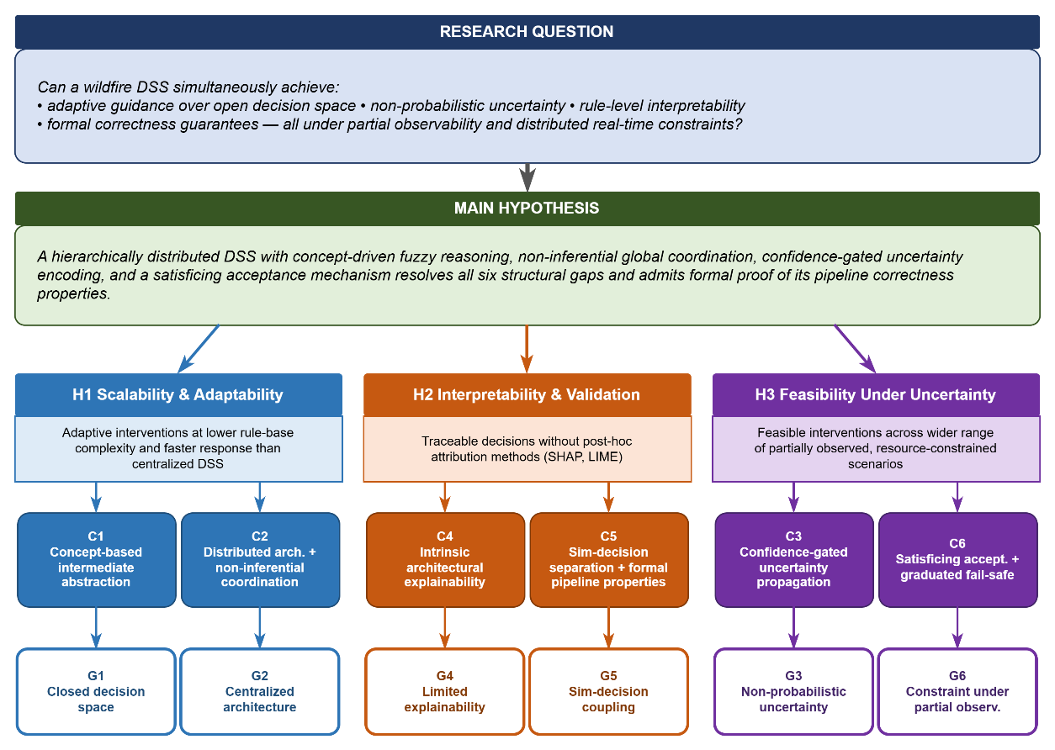
Figure 1.2 Research question, hypothesis, gaps and contributions

Organization of the Thesis
Chapter 2 formalizes the wildfire DSS problem, describing operational challenges and decision requirements under dynamic environmental conditions, uncertain observations, and limited resources. It defines the system state, observation process, decision variables, and feasibility conditions, concluding with a unified spatio-temporal problem statement.
Chapter 3 provides the theoretical background. It introduces DSS principles and fuzzy logic for reasoning under uncertainty, discusses limitations of classical MCDM approaches, examines the temporal and spatial structure of wildfire decisions, and reviews centralized versus distributed DSS architectures.
Chapter 4 introduces the DisasterAware Simulation Framework as the system's computational foundation. It presents the overall architecture, the spatial grid representation of wildfire dynamics, the hybrid fire spread model, external data layers, and the UI dashboard.
Chapter 5 establishes the formal design specification. It derives the six-feature input space from the Chapter 4 state variables, specifies the fuzzy variable design and membership functions, defines the four situational concepts and their construction mappings, proves the ninefold rule complexity reduction, and specifies the intervention decision rule base together with the action aggregation function.
Chapter 6 presents the DisasterAware architecture: a layered decision structure comprising the Observation, Concept Mapping and Abstraction, Local DSS Model, and Global Coordination layers. It details the epistemic encoding of partial observability, the concept mapping pipeline, and its formal properties of output boundedness, partition of unity, and Lipschitz continuity. The Explainability and AI Governance Layer is introduced as a supervisory overlay providing traceability, auditability, and operator override.
Chapter 7 presents the empirical evaluation of DisasterAware against a functionally equivalent centralized DSS baseline. Three scenarios of increasing complexity assess the stated hypotheses across decision quality, adaptability, interpretability, and operational feasibility, followed by a sensitivity analysis over features, membership functions, and priority weights.
Chapter 8 summarizes the main contributions and outlines directions for future research.
Together, these chapters form a coherent argument from problem formulation to theoretical grounding, from system design to formal specification, and from empirical evaluation to synthesis, each building on the one before.

PROBLEM DEFINITION
This chapter formally defines the wildfire DSS problem addressed in this thesis. The formulation captures wildfire dynamics, partial observability, and operational intervention constraints within a unified spatio-temporal framework. The chapter introduces the system state, observation process, decision variables, and feasibility conditions, and concludes with a formal problem statement. The objective of this chapter is to establish a mathematically consistent formulation of wildfire decision support under partial observability while explicitly separating physical system dynamics from decision-generation mechanisms.
Section 2.1 frames wildfire response as a dynamic decision problem shaped by environmental processes, operational interventions, and evolving system conditions.
Section 2.2 defines the wildfire system state and observation model under partial observability, distinguishing the true state from observable information and formalizing the observation mapping with epistemic uncertainty arising from incomplete, delayed, and noisy measurements.
Section 2.3 formalizes the decision variables and the feasible intervention space, representing operational actions as structured inputs and showing how epistemic uncertainty constrains admissible decisions.
Section 2.4 presents the multi-level, spatially distributed decision structure, in which region-specific local decisions are generated from localized observations and integrated through a global coordination mechanism to ensure both spatial responsiveness and system-level coherence.
Section 2.5 provides the unified formal problem statement, integrating state transition, observation, and DSS mapping into a consistent spatio-temporal framework that defines wildfire decision support as a distributed, partially observable, constraint-driven intervention-generation process, distinct from classical optimization-based or control-theoretic formulations.
Section 2.6 defines the modeling scope, assumptions, and abstraction boundaries, specifies the structural separation between physical dynamics and decision generation, and establishes the formal conditions for the simulation and DSS architectures developed in subsequent chapters.

Wildfire Response as a Dynamic Decision Problem
Wildfire response is formulated as a spatio-temporal decision process over a evolving physical system governed by environmental forcing and operational interventions. Unlike static planning problems, it requires sequential decision-making under time-varying conditions, limited resources, and partial observability. The wildfire environment is defined over a spatial domain $Ω⊂R^{2}$, discretized into grid cells indexed by $\left(x , y\right)$. Within the computational framework introduced in Chapter 4, this domain is represented as a structured grid $G\left(x,y\right)$, enabling spatially distributed state evolution.
At each discrete time step $k$, the system is characterized by internal variables such as burning status, available fuel mass, fire intensity, and time since ignition. These variables define the system state $S_{k}\left(x,y\right)$, representing the spatial distribution of wildfire conditions. Environmental and operational factors are explicitly excluded from the system state and are instead modeled as external inputs, ensuring a strict separation between physical dynamics and exogenous influences.
All external influences on wildfire dynamics are represented through the structured input set $F_{in,k}$, which includes meteorological inputs $U_{Meteo,k}$, terrain-related inputs $U_{Geo}$, fuel-related inputs $U_{Fuel,k}$, ignition inputs $U_{Ign,k}$, and DSS-generated intervention inputs $U_{DSS,k}$. These inputs act as boundary conditions governing the evolution of the wildfire system. In addition to $F_{in,k}$, the DSS process relies on a contextual input set $F_{DSS,k}$, which consists of value-related inputs $U_{Val,k}$ and resource-related inputs $U_{Res,k}$. Unlike $F_{in,k}$, which directly affects physical state evolution, $F_{DSS,k}$ does not act on wildfire dynamics itself; instead, it constrains and informs the decision-generation process.
The evolution of the wildfire system is governed by the state transition: $S_{k+1}\left(x,y\right)=Φ\left(S_{k}\left(x,y\right),F_{in,k}\right)$ where $Φ\left(⋅\right)$ denotes the state transition operator encoding fire propagation dynamics as a function of environmental conditions and intervention effects. Within this formulation, the DSS does not directly control the system state. Instead, it generates structured intervention inputs that influence system evolution indirectly through the external input layer. Wildfire response is therefore modeled as a sequential and partially observable intervention-generation process in which decisions are produced over time under evolving environmental conditions, incomplete information, and operational constraints.
The structural relationships among the physical system, observation, decision reasoning, and intervention introduced above are summarized graphically in Figure 2.1. The formal problem statement in Sections 2.2–2.5 builds on this structure.
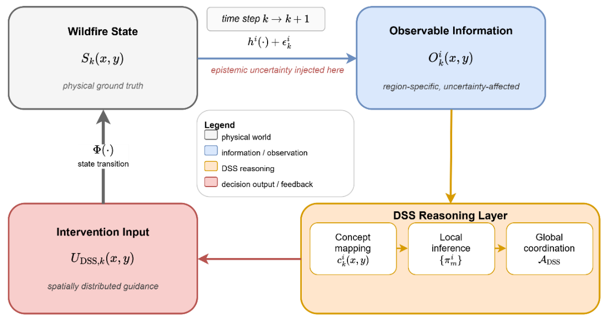
Figure 2.1 Closed-loop decision problem structure
Figure 2.1 shows the four structural components of the wildfire decision process and the causal relationships that link them. The physical system evolves according to the state transition operator $Φ\left(⋅\right)$, producing the wildfire state $S_{k}\left(x,y\right)$ at each discrete time step $k$. The observation mapping $h^{i}\left(⋅\right)$ projects this state onto region-specific observable information $O_{k}^{i}\left(x,y\right)$ subject to epistemic uncertainty $ϵ_{k}^{i}\left(x,y\right)$ that is injected exclusively at this stage. The DSS Reasoning Layer transforms the observations into the global intervention field $U_{DSS,k}\left(x,y\right)$ through three conceptual stages: concept mapping producing the concept vector $c_{k}^{i}\left(x,y\right)$, local inference producing the per-region decision $U_{DSS,k}^{i}\left(x,y\right)$, and global coordination producing the spatially complete intervention $U_{DSS,k}\left(x,y\right)$. The intervention re-enters the physical system through the external input set $F_{in,k}$ and advances the state via $Φ\left(⋅\right)$, closing the loop.
Two structural properties of this formulation are central to the remainder of the thesis: the DSS never accesses $S_{k}\left(x,y\right)$ directly, reasoning exclusively from $O_{k}^{i}\left(x,y\right)$, and it never modifies $S_{k}\left(x,y\right)$ directly, influencing evolution only through the external input layer. The detailed realisation of the DSS Reasoning Layer, including its full pipeline, is deferred to Chapters 5 and 6; this chapter uses the closed-loop abstraction to derive the formal problem statement in Section 2.5.

System State and Observable Quantities
While the system state $S_{k}\left(x,y\right)$ represents the underlying physical condition of the wildfire environment, it is not directly observable to the DSS. Instead, situational awareness is obtained through observable information derived from sensors, remote observations, and operational reports.
The observable information at time step $k$ is denoted by $O_{k}\left(x,y\right)$, representing a set of measurable or inferable quantities associated with each grid cell $\left(x , y\right)$. This observable information is modeled as a function of the underlying system state: $O_{k}\left(x,y\right)=h\left(S_{k}\left(x,y\right), ϵ_{k}\left(x,y\right)\right)$. The observation mapping $h:S→O$ is a nonlinear transformation that extracts observable features from the underlying system state, potentially including spatial aggregation, filtering, and sensor-induced transformations. In addition, $ϵ_{k}\left(x,y\right)$ represents epistemic uncertainty arising from incomplete, delayed, and noisy observations.
The uncertainty term $ϵ_{k}\left(x,y\right)$ captures epistemic disturbance caused by sensing limitations, spatial coverage gaps, and reporting delays. This uncertainty is not assumed to follow a known probabilistic distribution. Instead, it represents structural incompleteness of available information and cannot be reduced through repeated measurement within a single time step.
Within this structure, the wildfire decision process can be expressed as a sequential information–decision mapping: $S_{k}(x,y)→{(O}_{k}(x,y),F_{DSS,k})→U_{DSS,k}(x,y)$. The DSS process operates on observable information $O_{k}\left(x,y\right)$ together with contextual inputs $F_{DSS,k}$. At this stage, the DSS mapping $π_{DSS}$ is introduced only in abstract form as a local decision-generation mapping from observable information and contextual inputs to region-specific intervention outputs.

Decision Variables, Uncertainty, and Feasible Intervention Space
The decision variable at time step $k$ is denoted by $U_{DSS,k}\left(x,y\right)$, representing the intervention-related parameters generated by DSS. The decision variable is defined at the regional level as $U_{DSS,k}^{i}\left(x,y\right)$. The global intervention field $U_{DSS,k}\left(x,y\right)$ is obtained through aggregation of all regional decisions. At the global level, $U_{DSS,k}\left(x,y\right)$ denotes the coordinated intervention field obtained after local regional decisions have been generated and aggregated.
The contextual input set is defined as $F_{DSS,k}=\left\{U_{Val,k},U_{Res,k}\right\}$. It provides value and resource-related data that constrains feasible intervention space. The admissible intervention configurations are: $U_{DSS,k}\left(x,y\right)∈U_{DSS}\left(O_{k}\left(x,y\right),F_{DSS,k}\right)$. The feasible intervention space $U_{DSS}$ is a bounded, context-dependent set defined by operational constraints including resource availability, accessibility, and temporal feasibility.
Formally, $U_{DSS}⊆[0,1]^{M}$ where each dimension corresponds to an intervention type. Decision-making is performed under epistemic uncertainty, since the feasible intervention space depends on incomplete and evolving observable information: $S_{k}\left(x,y\right)→O_{k}\left(x,y\right)→U_{DSS,k}\left(x,y\right)$, $U_{DSS,k}\left(x,y\right)⊂F_{in,k}$. The generated intervention field is designed to be compatible with the external input structure defined in the simulation framework. The feasible intervention space defines admissible actions but does not address their spatial organization.

Multi-Level Decision Requirements in Wildfire Management
Wildfire response decisions are spatially distributed and must be generated across multiple regions of the operational domain. The spatial domain $Ω$ is partitioned into $N$ disjoint regions $Ω_{i}$, such that: $Ω=\bigcup_{i=1}^{N}{Ω_{i}},Ω_{i}∩Ω_{j}=∅ \left(i≠j\right)$. Each region $Ω_{i}$ represents a localized operational area characterized by region-specific wildfire conditions, observable information, and contextual constraints.
Since the global observation process $h\left(·\right)$ defined in Section 2.2 operates over the entire spatial domain $Ω$, the regional decomposition of the decision problem requires a corresponding decomposition of the observation process. The region-specific observation function $h^{i}\left(·\right)$ is defined as the restriction of $h\left(·\right)$ to the spatial subdomain $Ω_{i}$, producing region-specific observable information as $O_{k}^{i}\left(x,y\right) = h^{i}\left(S_{k}\left(x,y\right), ϵ_{k}^{i}\left(x,y\right)\right)$, where $ϵ_{k}^{i}\left(x,y\right)$ denotes the epistemic uncertainty associated with region $Ω_{i}$ at time step $k$.
Global observation process is recovered as the union of all regional observations: $O_{k}(x,y) = h(S_{k}(x,y), ϵ_{k})=Σ_{i=1}^{N} 1_{\left(x,y\right)∈Ω_{i}}·h^{i}(S_{k}\left(x,y\right), ϵ_{k}^{i})$. This decomposition ensures that each local DSS agent reasons exclusively from its own regionally restricted observation, preserving spatial locality of information access.
At time step $k$, the observable information and contextual inputs associated with region $Ω_{i}$ are denoted by $O_{k}^{i}\left(x,y\right)$ and $F_{DSS,k}^{i}$, respectively. Based on this information, region-specific intervention parameters are generated locally as: $U_{DSS,k}^{i}\left(x,y\right)=π_{DSS}^{i}\left(O_{k}^{i}\left(x,y\right),F_{DSS,k}^{i}\right)$. This formulation reflects the requirement that decisions must be generated locally in response to spatially heterogeneous conditions. Fire behavior, resource availability, and asset exposure vary across the domain, making globally uniform decisions both infeasible and operationally ineffective. The mapping $π_{DSS}^{i}$ is shared across all regions and represents a common decision policy applied to region-specific inputs. Spatial variability in decisions arises from differences in local observations and contextual inputs, rather than from region-specific policy definitions.
However, local decision generation alone is insufficient. Wildfire response involves shared and limited resources, and decisions made independently across regions may lead to conflicts, inconsistencies, or inefficient resource allocation. For example, multiple regions may simultaneously require the same limited resources, or local decisions may conflict with broader containment or protection priorities.
To address this, a global coordination mechanism is introduced to integrate region-specific decisions into a coherent intervention strategy. The global decision structure is defined as: $U_{DSS,k}\left(x,y\right)=A_{DSS}\left(U_{DSS,k}^{1}\left(x,y\right),…,U_{DSS,k}^{N}\left(x,y\right)\right)$ where $A_{DSS}\left(⋅\right)$ denotes the spatial coordination and aggregation operator that integrates regional decision outputs into a globally consistent intervention configuration.
The mapping $π_{DSS}^{i}$ operates strictly at regional level and generates region-specific intervention outputs on the basis of local observations and contextual inputs. It does not define the global intervention field directly. Global decision consistency is established only after the regional outputs are integrated through aggregation $A_{DSS}$.
In addition, decisions within each region are not restricted to a single action. Instead, multiple intervention types may be activated simultaneously with varying degrees of priority. The regional decision output is represented as a multi-action structure: $U_{DSS,k}^{i}\left(x,y\right)=\left\{u_{k,1}^{i}\left(x,y\right),u_{k,2}^{i}\left(x,y\right),…,u_{k,M}^{i}\left(x,y\right)\right\}$, $u_{k,m}^{i}∈\left[0,1\right]$ where $u_{k,m}^{i}$ denotes the priority or activation level of intervention type $m$ in region $Ω_{i}$, and $M$ represents the number of intervention types considered within the framework. This representation enables the activation of multiple intervention strategies, reflecting the non-exclusive and context-dependent nature of wildfire response actions.
The overall decision structure hence consists of three coupled components: local decision generation based on region-specific information, multi-action representation of intervention strategies, and global coordination ensuring consistency across regions. This multi-level formulation ensures that the DSS maintains both local responsiveness and global coherence under dynamic, resource-constrained, and partially observable conditions.
Figure 2.2 depicts the hierarchically distributed decomposition in three layered structural components. The spatial partition $Ω = \bigcup_{i=1}^{N}{Ω_{i}}$ is shown with three representative regions $Ω_{1}, Ω_{i}, and Ω_{N}$. In the observation layer, each $h_{i}\left(·\right)$ operates on the restriction of $S_{k\left(x,y\right)}$ to $Ω_{i}$ and injects the region-specific epistemic uncertainty $ε_{k}^{i}$, producing the regional observable $O_{k}^{i}\left(x,y\right)$. The local DSS agents apply the shared policy $π_{DSS}^{i}$ to its region-specific observation and contextual input to yield the local intervention; $U_{DSS,k}^{i}\left(x,y\right)$ the global coordination operator $A_{DSS}$ then aggregates all $N$ regional outputs into the spatially coherent intervention field $U_{DSS,k}\left(x,y\right)$.
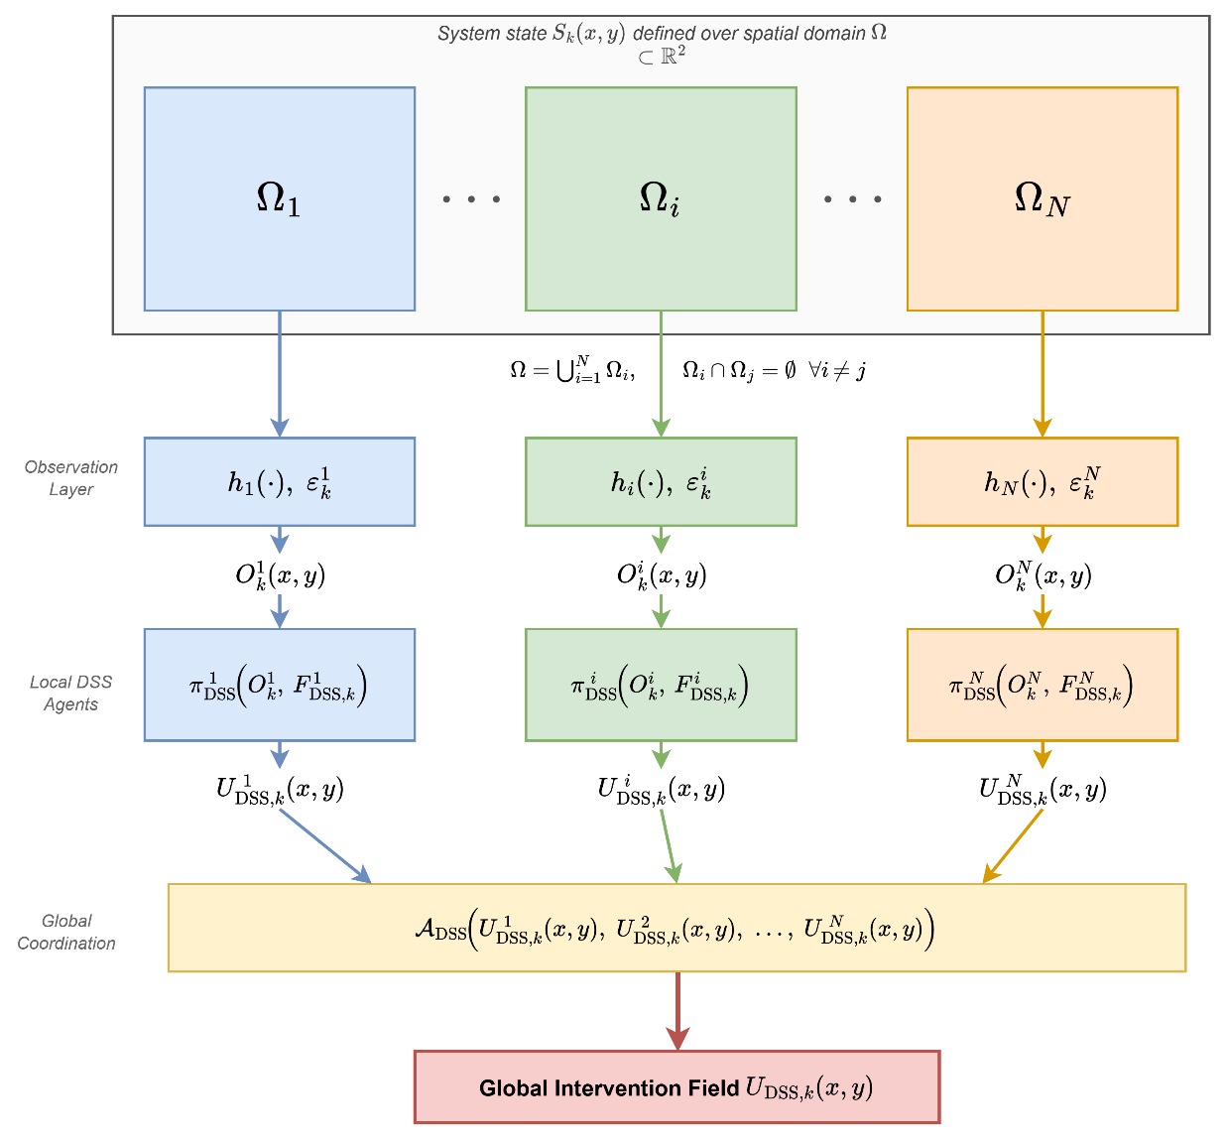
Figure 2.2 Spatial observations, local decision mappings, and global aggregation
The three decision levels that the distributed structure introduced above must accommodate, together with their temporal and spatial scales and the DisasterAware architectural elements that realize them, are summarized in Figure 2.3.
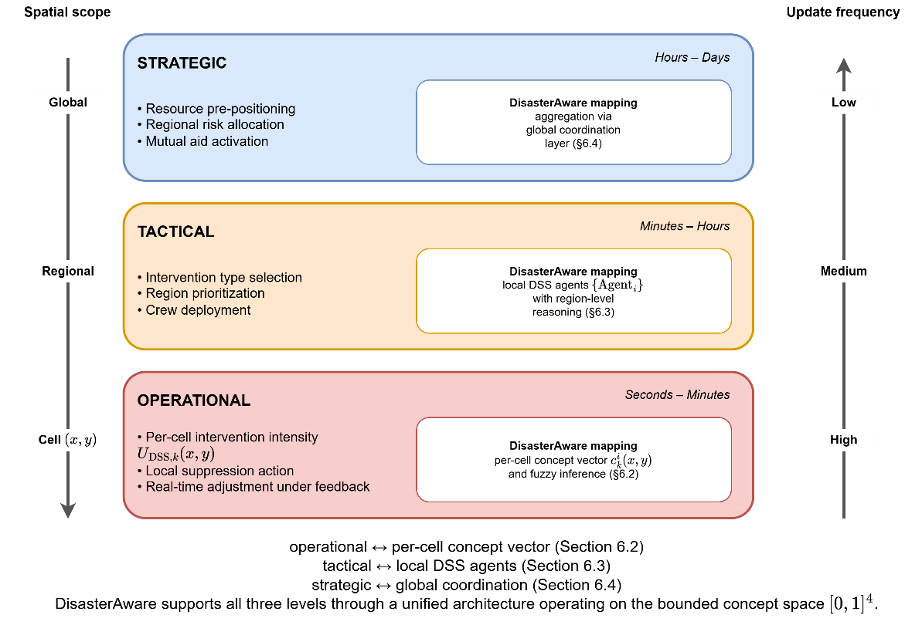
Figure 2.3 Multi-level decision hierarchy for wildfire management
Wildfire response decisions operate across three distinct temporal and spatial scales. At the strategic level, decisions span hours to days and cover the full spatial domain $G$: resource pre-positioning, regional risk allocation across the $N$ regions $\{Ω_{i}\}_{i=1}^{N}$, and mutual aid activation. At the tactical level, decisions span minutes to hours and operate at the region scale $Ω_{i}$: intervention type selection among the $M$ available types, region prioritisation, and crew deployment. At the operational level, decisions span seconds to minutes and operate at the individual grid cell $\left(x,y\right)$: per-cell intervention intensity $U_{DSS,k}\left(x,y\right)$, local suppression action, and real-time adjustment under feedback propagated through the closed loop of Figure 2.1.
Figure 2.1 shows how DisasterAware addresses all three levels through a single unified architecture operating on the bounded concept space ${\left[0,1\right]}^{4}$. The operational level is realized by the per-cell concept vector $c_{k}^{i}\left(x,y\right)$ and fuzzy inference of Section 6.2; the tactical level by the local DSS agents of Section 6.3; and the strategic level by the global coordination operator $A_{DSS}$ of Section 6.4. The spatial scope arrow on the left of the figure (Global $→$ Regional $→$ Cell) and the update frequency arrow on the right (Low $→$ Medium $→$ High) move in opposite directions: coarser spatial scopes admit slower update cycles, while finer spatial scopes require more frequent updates. This inverse relationship is not an incidental design choice but a structural property of the wildfire decision problem that any admissible DSS architecture must respect, motivating the layered realization of DisasterAware developed in Chapter 6.

Formal Problem Statement
This section formulates the wildfire DSS problem as a discrete-time, partially observable, and spatially distributed decision process over an evolving wildfire environment. The formulation is consistent with the Simulation Framework presented in Chapter 4 and preserves the structural separation between system dynamics, observation, and decision generation.
The wildfire system evolves over the spatial domain according to: $S_{k+1}\left(x,y\right)=Φ\left(S_{k}\left(x,y\right),F_{in,k}\right)$ where $S_{k}\left(x,y\right)$ denotes the system state and $F_{in,k}$ represents the structured external input set. Since the system state is not directly observable, decision-making therefore relies on observable information, modeled as $O_{k}\left(x,y\right)=h\left(S_{k}\left(x,y\right),ϵ_{k}\left(x,y\right)\right)$ where $h\left(⋅\right)$ is the observation process and $ϵ_{k}\left(x,y\right)$ represents epistemic uncertainty associated with incomplete and imperfect observation.
Based on observable information and contextual inputs $F_{DSS,k}$, decision generation is performed in a hierarchically distributed manner over spatial regions $Ω_{i}$. Region-specific intervention outputs are generated as: $U_{DSS,k}^{i}\left(x,y\right)=π_{DSS}^{i}\left(O_{k}^{i}\left(x,y\right),F_{DSS,k}^{i}\right)$. Each regional decision is represented as a multi-action structure: $U_{DSS,k}^{i}\left(x,y\right)=\left\{u_{k,1}^{i}\left(x,y\right),u_{k,2}^{i}\left(x,y\right),…,u_{k,M}^{i}\left(x,y\right)\right\}, u_{k,m}^{i}∈\left[0,1\right]$ where $u_{k,m}^{i}\left(x,y\right)$ denotes the activation level of intervention type $m$ in region $Ω_{i}$, and $M$ is the number of intervention types.
Formally, the regional DSS mapping is defined as $π_{DSS}^{i}:(O_{k}^{i},F_{DSS,k}^{i})→U_{DSS,k}^{i}$, where $O_{k}^{i}$ denotes region-specific observable information and $F_{DSS,k}^{i}$ denotes the corresponding contextual decision inputs. The explicit five-stage realization of $π_{DSS}^{i}$ is established in Chapter 5.
Global coordination integrates regional decisions into a consistent intervention field: $U_{DSS,k}\left(x,y\right)=A_{DSS}\left(U_{DSS,k}^{1}\left(x,y\right),…,U_{DSS,k}^{N}\left(x,y\right)\right)$ where $A_{DSS}\left(⋅\right)$ is the aggregation operator enforcing consistency across regions under shared constraints.
The DSS mapping $π_{DSS}^{i}$ operates strictly at the regional level and generates region-specific intervention outputs. It does not define the global intervention field directly. The global intervention field is constructed exclusively through the aggregation operator $A_{DSS}\left(⋅\right)$. The generated intervention field is subject to feasibility and structural constraints: $U_{DSS,k}\left(x,y\right)∈U_{DSS}\left(O_{k}\left(x,y\right),F_{DSS,k}\right)$, $U_{DSS,k}\left(x,y\right)⊂F_{in,k}$. These constraints ensure that decisions remain operationally admissible and influence system evolution only through the external input layer.
Decision quality is evaluated through a multi-criteria function: $Q_{DSS,k}=f_{eval}\left(O_{k}\left(x,y\right),F_{DSS,k},U_{DSS,k}\left(x,y\right)\right)$ with the satisfaction condition: $Q_{DSS,k}≥η_{k}$ where $η_{k}∈\left[0,1\right]$ is a time-varying decision satisfaction threshold.
The decision quality function is not defined as a classical optimization objective, but as a multi-criteria evaluation measure used to assess the admissibility and effectiveness of generated intervention configurations. Furthermore, the function $f_{eval}$ is not part of the intervention-generation mapping $π_{DSS}$. It operates as a post-decision evaluation mechanism computed exclusively from observable information $O_{k}$, contextual inputs $F_{DSS,k}$, and the generated intervention field $U_{DSS,k}$, thereby preserving the structural principle that no DSS component accesses the true state $S_{k}$ directly.
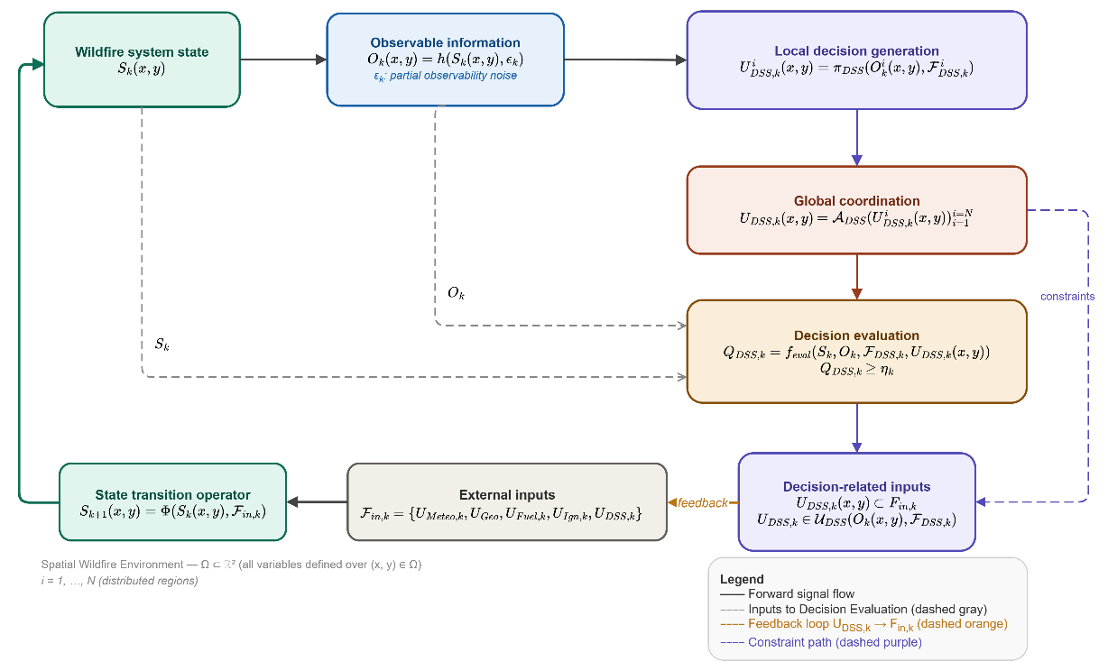
Figure 2.4 Conceptual architecture of the DisasterAware DSS
The overall structure of the DSS, including the interaction between system dynamics, observation, and decision generation, is illustrated in Figure 2.4. The system operates as a closed-loop, hierarchically distributed decision pipeline over a spatial wildfire environment $Ω ⊂ R^{2}$. At each time step $k$, the wildfire system state $S_{k}\left(x,y\right)$ is fed into an observation function $h\left(·\right)$, which produces the observable information $O_{k}\left(x,y\right)$ under the influence of partial observability noise $ϵ_{k}\left(x,y\right)$, acknowledging that the true system state is never fully accessible.
This observable data is then passed to the local decision generation stage, where $N$ spatially distributed DSS agents each independently produce a region-specific intervention input $U_{DSS,k}^{i}$ through their local policy $π_{DSS}^{i}$, conditioned on their respective observations and contextual constraints. These local decisions are subsequently aggregated by the global coordination operator $A_{DSS}$ into a single, globally consistent intervention field $U_{DSS,k}$.
The resulting global decision is then assessed by the decision evaluation function $f_{eval}$, which takes the observable information, contextual factors, and the generated intervention as inputs, and checks whether the multi-criteria decision quality score $Q_{DSS,k}$ meets the minimum satisfaction threshold $η_{k}$. The generated decisions feed into the decision block, which enforces two structural constraints: the intervention must remain a subset of the external input space $F_{in,k}$, and must lie within the feasibility set $U_{DSS}$. $U_{DSS,k}$ itself is also a component of $F_{in,k}$, creating a feedback loop through which decisions re-enter the system as external inputs alongside meteorological, geographical, and fuel-related data.
These combined external inputs drive the state transition operator $Φ\left(·\right)$, which advances the system to its next state $S_{k+1}\left(x,y\right)$, closing the decision loop. Taken together, the architecture formalizes wildfire decision support not as a classical optimization problem, but as a distributed, constraint-driven, and uncertainty-aware intervention generation process under partial observability. The mathematical formulation of the wildfire DSS problem is summarized in Equation ( 1 ).
$$S_{k+1}\left(x,y\right)=Φ\left(S_{k}\left(x,y\right),F_{in,k}\right)$$  $$O_{k}\left(x,y\right)=h\left(S_{k}\left(x,y\right),ϵ_{k}^{i}(x,y)\right)$$  Local decision generation:  $$U_{DSS,k}^{i}\left(x,y\right)=π_{DSS}^{i}\left(O_{k}^{i}\left(x,y\right),F_{DSS,k}^{i}\right)$$  Global coordination:  $$U_{DSS,k}\left(x,y\right)=A_{DSS}\left(U_{DSS,k}^{1}\left(x,y\right),…,U_{DSS,k}^{N}\left(x,y\right)\right)$$  subject to  $$U_{DSS,k}\left(x,y\right)⊂F_{in,k} \\ U_{DSS,k}\left(x,y\right)∈U_{DSS}\left(O_{k}\left(x,y\right),F_{DSS,k}\right)$$  Decision evaluation:  $$Q_{DSS,k}=f_{eval}\left(O_{k}\left(x,y\right),F_{DSS,k},U_{DSS,k}\left(x,y\right)\right)$$  $$Q_{DSS,k}≥η_{k}$$ | ( 1 )
Each equation in ( 1 ) corresponds to a distinct structural component of the DSS: state evolution, observation, local decision generation, and global coordination. In detail, the equation ( 1 ) states that wildfire decision support is posed as the generation of feasible intervention inputs from uncertain observations of an evolving physical system, under region-specific constraints and global coordination requirements. This interpretation is central to the thesis because it distinguishes the problem from classical optimization-based control and establishes the formal basis for the hierarchically distributed DSS architecture developed in DisasterAware.
The formulated DSS problem does not conform to classical optimal control or Markov decision process frameworks. The decision space is not explicitly enumerable, and the system operates under partial observability, where the true state is not fully accessible. Furthermore, the decision process involves evolving constraints and multi-criteria evaluation that cannot be consistently reduced to a single global objective function. Accordingly, decision-making is not defined as the optimization of a predefined objective over a fixed action space, but as the generation of feasible and context-dependent intervention configurations under uncertainty. This perspective defines the structural nature of the problem and distinguishes it from classical decision-theoretic formulations.
Remark 2.1 (Computational Intractability of the Wildfire DSS Problem). The problem defined in Equation ( 1 ) is computationally intractable under any exact optimization formulation, even when simplified. Consider a discretized variant in which each intervention type $m ∈ \{1, …, M\}$ admits L discrete activation levels per grid cell. The joint decision space at a single time step has cardinality $L^{\left|G\right|× M}$ , which grows exponentially in both grid resolution and intervention dimensionality. For a modest configuration of |G| = 2500 cells (50 × 50), M = 3 intervention types, and $L = 5$ levels, the single-step action space exceeds $5^{7500}$, a number that renders exhaustive search, branch-and-bound, or dynamic programming infeasible by many orders of magnitude.
Partial observability compounds this intractability. Since the true system state $S_{k}(x, y)$ is not directly accessible, optimal decision-making would require maintaining and updating a belief distribution over the full state space at every time step, a requirement that is well known to be PSPACE-hard even for finite-state partially observable Markov decision processes (Papadimitriou & Tsitsiklis, 1987).
The wildfire DSS problem further departs from standard POMDP assumptions: the state space is continuous, the observation noise $ϵ_{k}^{i}\left(x,y\right)$ lacks a known distributional form, the feasibility set $U_{DSS}$ evolves dynamically with resource depletion and fire progression, and the evaluation function $f_{eval}$ is multi-criteria rather than scalar-additive. These properties collectively establish that the wildfire DSS problem, as formulated in Equation ( 1 ), does not admit tractable exact solutions under any known computational framework. This intractability provides the formal motivation for the satisfaction-based decision paradigm adopted in this thesis: rather than seeking a globally optimal intervention policy, the framework generates feasible and context-sensitive intervention configurations that satisfy the quality condition $Q_{DSS,k} ≥ η_{k}$ at each time step, replacing an intractable global optimization with a tractable local satisficing process.

Scope and Assumptions
The formulation presented in this chapter defines a structured abstraction of wildfire decision support under partial observability. To ensure mathematical consistency, computational tractability, and alignment with the Simulation Framework, a set of modeling assumptions is introduced. These assumptions explicitly define the scope and limitations of the proposed framework. The system is modeled as a discrete-time, grid-based spatio-temporal process in which physical dynamics, observation, and decision generation are treated as structurally distinct components. The assumptions summarized in Table 2.1 establish the boundaries of the model and ensure consistency between the problem formulation, the simulation framework, and the DSS architecture developed in subsequent chapters.
Table 2.1 Scope and modeling assumptions of the wildfire DSS formulation
Category | Assumption / Scope Definition
Contextual Input Structure | The contextual input set $F_{DSS,k}$ includes value-related and resource-related information used for decision evaluation and feasibility constraints.
Decision Paradigm | The problem is not formulated as an optimal control problem but as a constraint-driven, satisfaction-based decision generation.
Decision Structure | Decision-making is spatially distributed across $Ω_{i}$, with local decisions coordinated through a global aggregation mechanism.
Decision Variables | Operational interventions are represented by $U_{DSS,k}\left(x,y\right)$, as a spatial decision field generated through distributed local decisions and coordinated into a global intervention field.
Execution Synchrony | $N$ regional agents execute their local DSS pipelines synchronously within each discrete time step $k$. Inter-agent communication occurs through the global coordination layer $A_{DSS}$; no direct agent-to-agent message passing is modeled.
External Input Structure | All exogenous influences are represented as $F_{in,k}$, including meteorology, terrain, fuel, ignition, and DSS-generated inputs.
Observation Model | Observable information $O_{k}\left(x,y\right)$ represents the system state partially and uncertainly through the observation process $h\left(⋅\right)$.
Observation Noise Boundedness | The epistemic uncertainty term $ϵ_{k}^{i}\left(x,y\right)$ in the observation model is assumed to be bounded such that $O_{k}^{i}\left(x,y\right)∈{\left[0,1\right]}^{4}$ for all $\left(x,y\right)∈Ω_{i}$ and all $k$. No distributional assumptions (e.g., Gaussianity) are imposed on $ϵ_{k}^{i}\left(x,y\right)$; the fuzzy reasoning mechanism is designed to operate without such assumptions.
Operational Constraints | Feasible decisions are constrained by resource availability, suppression capacity, terrain accessibility, and travel-time.
Regional Partition Stationarity | The spatial partition $Ω=⋃_{i=1}^{N}Ω_{i}$ is defined at initialization and remains fixed throughout the simulation horizon. Dynamic repartitioning in response to evolving fire conditions is not supported in the current formulation.
Spatial Representation | The wildfire environment is defined over a discretized spatial domain $Ω⊂R^{2}$, partitioned into grid cells indexed by $\left(x , y\right)$. Each cell is assumed to be internally homogeneous.
System Immutability | DSS does not directly modify the system state. All intervention effects are applied through the external input set $F_{in,k}$.
System State Definition | The state $S_{k}\left(x,y\right)$ includes only internal wildfire variables such as burning status, fuel load, intensity, and ignition time.
Temporal Representation | System evolution and decision-making are modeled in discrete time steps indexed by $k$.
Uncertainty Representation | The uncertainty term $ϵ_{k}\left(x,y\right)$ represents epistemic uncertainty and is not assumed to follow a known probabilistic distribution.

The three assumptions of execution synchrony, regional partition stationarity, and observation noise boundedness are structural simplifications that enable the formal guarantees established in Chapters 5 and 6 (specifically, Proposition 5.3 and Proposition 5.4, and the boundedness of $A_{DSS}$ in Remark 6.4). Relaxation of these assumptions, particularly dynamic repartitioning and asynchronous agent execution, constitutes a direction for future work identified in Section 8.2.
Remark 2.2 (Notational Conventions). The notation used throughout this thesis follows four systematic conventions that reduce the cognitive effort required to parse multi-index expressions.
Convention 1 (Temporal–spatial–regional indexing). Subscript $k$ denotes the time step and (x, y) denotes the grid cell. Superscript i identifies the operational region $Ω_{i}$. For example, $c_{k,h}^{i}$(x, y) denotes the h-th concept value at cell (x, y), in region i, at time step k. When context is unambiguous, the spatial argument (x, y) is suppressed for readability.
Convention 2 (Observation hat). A hat accent (̂) denotes an observed estimate of a state variable, as distinct from its true value. For instance, ${̂B}_{k}^{i}$ is the observed burning status in region i, derived from the true state $B_{k}$ through the observation process h(·).
Convention 3 (Confidence bar). An overbar (̅) denotes a confidence-gated quantity, obtained by blending the current estimate with a persistence-based prior according to the observation confidence coefficient. For example, ${̅c}_{k,h}^{i}$ is the confidence-weighted concept value, while $c_{k,h}^{i}$ is the raw (unweighted) concept value.
Convention 4 (Subscript hierarchy). Function-level symbols use descriptive subscripts separated by commas: $f_{feat}$, $f_{fuzzy}$, $f_{concept,h}$, $f_{agg}$, $f_{eval}$. Intervention-type-specific quantities are indexed by m (e.g., $u_{k,m}^{i}$ for the candidate degree of type m). Criterion-specific quantities are indexed by j (e.g., $q_{j,k}$ for the j-th quality criterion at step k).
These conventions ensure that every symbol in the thesis can be decoded from its visual structure alone: the base letter identifies the physical quantity, the subscript identifies the time and context, the superscript identifies the region, and the accent identifies the epistemic status (observed, confidence-gated, or true).

BACKGROUND INFORMATION
This chapter provides the theoretical background for the DisasterAware framework. It establishes the fundamental principles of DSS, introduces fuzzy logic as a reasoning paradigm under epistemic uncertainty, and analyzes the limitations of classical decision-making approaches in dynamic and partially observable environments. Furthermore, it examines the structural properties of decision processes in wildfire management, including multi-level decision hierarchies, distributed architectures, and spatio-temporal decision dependencies. These foundations provide the theoretical grounding for the DSS design and architecture presented in Chapters 5 and 6. This chapter is organized as follows.
Section 3.1 introduces the fundamental components of DSS and establishes the conceptual foundations required for analyzing decision processes in complex and uncertain operational environments. It defines the core dimensions of DSS design, including decision structuring, knowledge representation, uncertainty handling, timeliness, and human–machine interaction.
Section 3.2 presents fuzzy logic as a reasoning paradigm suitable for decision support under epistemic uncertainty. It outlines the structure of fuzzy inference systems (FIS), including fuzzification, rule-based knowledge representation, inference mechanisms, and defuzzification, and explains how fuzzy logic enables approximate and interpretable reasoning over imprecise inputs.
Section 3.3 analyzes the structural limitations of multi-criteria decision-making (MCDM) and multi-attribute group decision-making (MAGDM) approaches. It formalizes their underlying assumptions and demonstrates why these frameworks are not well suited for dynamic, partially observable, and time-critical environments.
Section 3.4 examines decision levels and hierarchical structures in operational decision making. It introduces a formal taxonomy based on temporal horizon, spatial scope, epistemic uncertainty, and automation feasibility, and discusses their implications for DSS design.
Section 3.5 compares centralized and distributed DSS architectures from both structural and computational perspectives, focusing on communication complexity, decision latency, scalability, and robustness under partial observability.
Finally, Section 3.6 presents the spatio-temporal nature of decision making in wildfire management. It analyzes how spatial heterogeneity, temporal dynamics, and partial observability jointly constrain decision processes and derives the structural requirements for DSS operating over dynamic environments.

Core Elements of Decision Support Systems
DSS operating in complex and high-stakes environments must satisfy a set of fundamental structural requirements that extend beyond classical analytical capabilities. Rather than being defined by a single algorithmic capability, DSS effectiveness emerges from the coordinated interaction of multiple foundational components. These components jointly determine how decisions are framed, interpreted, supported, and ultimately enacted in practice. The following sections describe the core dimensions that shape operational DSS design, each of which addresses a distinct but interrelated aspect of decision support.
Operational DSS implementations are adaptive decision structuring mechanisms whose scope and effectiveness depend on how well they align decision objectives, information processing, and organizational practice (Power & Heavin, 2017; Arnott & Pervan, 2005). Traditional DSS literature highlights the necessity of articulating the decision context and the intended decision scope, while recognizing that decision objectives should evolve adaptively through iterative interaction between the decision maker and the system (Sprague & Carlson, 1982; Power, Decision support systems: Concepts and resources for managers, 2002). Recent research shows that adaptivity is a core design principle, particularly in environments characterized by rapidly changing conditions and incomplete information (Arnott & Pervan, 2005). Hence, DSS should adopt adaptive structures that go beyond optimizing predefined alternatives, continuously restructuring the decision space to accommodate shifting priorities, emerging constraints, and evolving interpretations of decision relevance in response to operational feedback and contextual dynamics.
A fundamental dimension of DSS is the representation of data and knowledge, including how raw observations are transformed into operationally meaningful information for decision-making. Decision makers do not typically act directly on raw data or model outputs; instead, they rely on interpreted information that reflects context, relevance, and confidence. (Simon H. , 1960; Turban, 2011). In fact, recent studies claim that the practical value of advanced analytics and DSS tools depends not only on data availability, but also on how heterogeneous data is contextualized, integrated, and presented to human decision makers (Sharda, Delen, & Turban, 2018; McNeese, Schelble, Canonico, & Demir, 2021). Thus, data representation serves as an epistemic bridge between raw sensor inputs and higher-level decision reasoning.
Beyond data availability, uncertainty plays a central role in shaping DSS in complex and dynamic domains such as natural disasters (i.e., wildfire, flood, etc.). It is known that real-world decision environments are rarely fully observable, and decision makers must operate with incomplete, delayed, or ambiguous information (Simon H. , 1996; French, Maule, & Papamichail, 2019; Walker, et al., 2003). In such contexts, uncertainty is not only a secondary concern but also a distinguishing property of the decision environment. The sources of uncertainty directly influence (i) the choice of reasoning methods, (ii) the degree of automation that can be safely applied, and (iii) the degree to which human involvement must be retained in the loop.
Another fundamental dimension of DSS is timeliness as the success value of a decision often depends on when it is made rather than on optimality alone (Klein, 2017). Recent research in human-centered and naturalistic decision making emphasizes that, in time-critical situations, DSS must balance analytical depth with responsiveness, acknowledging the cognitive and operational limits of real-world decision environments (Endsley, Situation awareness misconceptions and misunderstandings, 2015; French, Maule, & Papamichail, 2019). Studies on human-machine teaming further show that timely and contextually appropriate actions are often preferable to delayed but analytically superior solutions under uncertainty and time pressure. As a result, time constraints significantly shape DSS by limiting exhaustive analysis and favoring adaptive reasoning strategies.
In high-risk and high-consequence environments explainability plays a crucial role because the decision makers must be able to understand and justify system-supported recommendations to trust and effectively use them. As emphasized by Ribeiro et al. (2016) explanations play a critical role in building trust by allowing users to assess the plausibility and relevance of individual recommendations in specific situations. Similarly, Guidotti et al. (2018) highlight that explainability is essential not only for transparency, but also for accountability and human–machine collaboration.
This perspective is further supported by human-centered XAI research, which shows that explanations tailored to user needs improve calibrated trust, situational awareness, and effective collaboration between humans and intelligent systems (Sanneman & Shah, 2020; Abdul, Vermeulen, Wang, Lim, & Kankanhalli, 2018). Without explainability, even technically sound decision support outputs may be ignored, misinterpreted, or misapplied; thus, explainability must be treated not as an auxiliary feature but as a core requirement that directly supports effective human–machine collaboration in operational decision-making.
Effective DSS are designed to assist human reasoning by structuring information, highlighting trade-offs, and supporting the sensemaking process, rather than replacing human decision makers (Endsley, Toward a Theory of Situation Awareness, 1995; Ross, Shafer, & Klein, 2006). Therefore, human–machine interaction is a core element of DSS in complex and time-critical environments. In this context, DSS contributes to maintaining situation awareness and facilitating context-sensitive judgment under uncertainty. Recent studies show that effective human–machine interaction enhances human cognitive capabilities while preserving human authority over final decisions by providing shared situational awareness, commonly referred to as a Common Operational Picture (COP), and adaptive decision making in dynamic and uncertain environments (McNeese, Schelble, Canonico, & Demir, 2021; Endsley, Situation awareness misconceptions and misunderstandings, 2015).
Finally, decisions are shaped not only by cognitive considerations but also by practical constraints related to available resources and costs in real-world operations. In other words, the decision alternatives must be evaluated in terms of trade-offs between effectiveness, risk, and operational feasibility. This requirement reflects the principle of operational feasibility under resource constraints, in turn, DSS must prioritize actions that are executable within real operational limits rather than those that are analytically optimal but impractical as discussed by Keeney and Raiffa (1976) and Power (2007). Recent studies further confirm that accounting for resource availability, cost, and implementation constraints is essential for DSS adoption and effective use in dynamic, high-risk environments (French, Maule, & Papamichail, 2019; Arnott & Pervan, 2005).
Collectively, these core elements shape how decision problems are framed, how information is interpreted, and how decisions are enacted under real-world operational constraints such as uncertainty, time pressure, and limited resources. In contrast to conventional DSS that emphasize static models or centralized optimization, as introduced in Chapter 1 and formalized in Chapters 4–6, DisasterAware utilizes these dimensions through a layered and adaptive architecture.
Specifically, decision framing and reasoning are supported via concept-based fuzzy reasoning that transforms heterogeneous low-level inputs into semantically meaningful decision constructs. Operational adaptability is achieved through parallel regional agents (a shared reasoning policy evaluated independently on each region's local observations and contextual inputs) enabling timely and location-specific responses without a centralized inferential bottleneck..
At a higher level, an AI-supported governance layer provides interpretive oversight, consistency checking, and explanatory support, ensuring that system outputs remain transparent, accountable, and aligned with human decision-making processes.
Table 3.1 summarizes these core dimensions, clarifying their functional roles in DSS design and highlighting how each is explicitly realized within the proposed framework. These dimensions collectively define the structural requirements that any DSS must satisfy in dynamic and partially observable environments such as wildfire response. As formalized in Chapter 2, these requirements directly motivate the design of the DisasterAware architecture.
Table 3.1 DSS core dimensions with DisasterAware architectural realization
Core DSS Dimension | Why It Matters | DisasterAware Realization
Adaptive Decision Structuring | Operational conditions evolve; fixed alternatives become invalid | Open decision space; decisions emerge from concept configurations
Epistemic Knowledge Representation | Raw data is not decision-ready; inputs must become semantically meaningful | Concept-based fuzzy layers compressing observations into four decision concepts
Uncertainty-Aware Reasoning | Information is incomplete, delayed, and conflicting | Fuzzy inference over graded belief and confidence values
Timely Decision Guidance | Decision value decays under time pressure | Distributed local agents enabling rapid, context-specific inference
Explainable Decision Support | Operators must understand and justify outputs to trust them | Concept-level traceability from input data to final recommendation
Human-in-the-Loop Sensemaking | Human judgment cannot be removed from high-risk decisions | Operator-centered guidance interface, not action prescription
Operational Feasibility | Decisions must respect resource, cost, and safety limits | Cost-aware fuzzy evaluation of risk–effectiveness–resource trade-offs
AI Governance | System-level oversight and consistency checking are required | AI layer for coherence analysis, conflict detection, and audit support

Fuzzy Logic as a Reasoning Paradigm for Decision Support
Given the DSS problem defined in Chapter 2, which operates under partial observability, epistemic uncertainty, and continuously evolving system conditions, the choice of reasoning paradigm becomes a structural design decision rather than a methodological preference. Fuzzy logic provides a practical and theoretically grounded reasoning paradigm for DSS operating under such conditions (Zadeh, Fuzzy sets, 1965; Thompson & Calkin, 2011). Unlike Boolean logic, which assumes that system states and observations can be represented using crisp binary values such as true or false, fuzzy logic allows graded representation through membership in linguistic categories such as Very Low, Low, Medium, High, and Very High. This enables a continuous and operationally meaningful representation of real-world conditions rather than a forced binary abstraction (Pacheco, 2015).
This representational flexibility is particularly suitable for operational DSS, where decision makers must act under time pressure, limited information, and evolving situational constraints. Data streams originating from sensors, models, and human reports are often incomplete, asynchronous, or mutually inconsistent. Fuzzy logic enables the integration of heterogeneous inputs within a unified reasoning framework without requiring premature hard thresholds or precise probabilistic models, which are often unavailable or unjustified in practice (Vásquez, 2021). This property directly addresses the limitations identified in Chapter 1, particularly the need for robust reasoning over incomplete observations while maintaining transparency in decision generation.
Specifically in wildfire management, these characteristics become critical. Measurements derived from remote sensing, in situ sensors, and predictive fire behavior models are frequently affected by noise, latency, spatial limitations, and model simplifications. At the same time, expert reasoning in wildfire operations is predominantly expressed in qualitative terms, such as high spread potential, moderate suppression feasibility, or low confidence detection (Thompson & Calkin, 2011; Soualah, 2024). Fuzzy logic aligns naturally with this form of linguistic reasoning by enabling the direct formalization of expert knowledge through rule-based structures, without requiring rigid numerical thresholds.
Beyond representation, fuzzy logic supports approximate reasoning in decision contexts where complete knowledge and statistically robust uncertainty models are not available. By operating on graded evidence and partial truth values, fuzzy inference mechanisms can produce meaningful decision guidance even when inputs are sparse, partially conflicting, or only weakly reliable. This capability allows DSS to remain operationally useful in conditions where probabilistic or optimization-based approaches may fail due to data scarcity, model instability, or excessive computational requirements (Pacheco, 2015; Vásquez, 2021).
From a DSS design perspective, fuzzy logic functions not merely as a mathematical tool, but as a cognitive bridge between raw data, expert judgment, and actionable decisions. Its emphasis on rule transparency, structured reasoning, and human-readable knowledge representation directly supports trust, explainability, and effective human–machine collaboration in high-risk operational domains such as wildfire management. This cognitive alignment is a key design principle in DisasterAware, where decision reasoning is intentionally structured to reflect human-like interpretation of context-dependent information.

Core building blocks of fuzzy inference
In the context of DisasterAware, the fuzzy inference system is not treated as a generic mapping mechanism, but as the computational realization of the DSS mapping $π_{DSS}$ introduced in Chapter 2. A fuzzy inference system (FIS) is a rule-based reasoning framework that maps uncertain, imprecise, or linguistically expressed inputs into interpretable decision outputs.
Unlike classical logical or probabilistic inference, FIS enables reasoning under partial knowledge and epistemic uncertainty. Formally, a FIS defines a nonlinear mapping from an input space to an output space through linguistic variables, membership functions, and inference rules (Zadeh, Fuzzy sets, 1965; Pacheco, 2015)
Let the crisp input vector be defined as ( 2 ) where each $x_{i}$ represents a measurable or estimated system variable, such as wind speed, fuel moisture, slope, or detection confidence. The output variable is denoted as ( 3 ) which typically corresponds to a decision concept (e.g., Spread Risk, Operational Priority, Alert Level), rather than a raw numerical control signal.
$$x=\left(x_{1},x_{2},…,x_{n}\right)∈R^{n}$$ | ( 2 )
$$y∈R$$ | ( 3 )
In the context of the DSS introduced in Chapter 2, the input vector $x$ represents observable quantities derived from $O_{k}(x,y)$, while the output variable y corresponds to an intermediate or final DSS quantity rather than a direct control action.
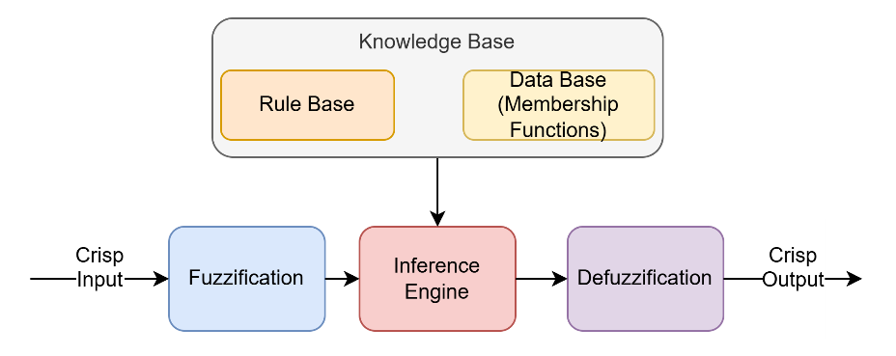
Figure 3.1 Fuzzy inference system block diagram
As illustrated in Figure 3.1, a standard fuzzy inference system consists of four fundamental building blocks (i) Fuzzification, (ii) Rule Base, (iii) Inference Engine and (iv) Defuzzification. Each block contributes a distinct functional role in transforming raw data into DSS outputs.

Fuzzification and Data Base (Membership Functions)
In the wildfire DSS problem defined in Chapter 2, decision-making must operate on observations that are incomplete, delayed, and inherently imprecise. Under such conditions, the transformation of raw observations into a structured representation that preserves uncertainty becomes a fundamental requirement. Fuzzification is therefore introduced not merely as a standard fuzzy-logic operation, but as a mechanism for encoding epistemic uncertainty into a form that can be directly utilized by the DSS process.
Fuzzification is the process of transforming crisp input values into fuzzy representations. Each input variable $x_{i}$ is associated with a linguistic variable $X_{i}$, defined by a finite set of linguistic terms ( 4 ) where each $A_{ij}$ denotes a fuzzy set such as Low, Medium, or High. Each fuzzy set $A_{ij}$ is characterized by a membership function which assigns a degree of membership to the crisp input ( 5 ) where $X_{i}$ denotes the linguistic variable associated with input $x_{i}$, $A_{ij}$ represents its j-th linguistic term, and $μ_{A_{ij}}\left(x_{i}\right)$ defines the degree of membership of $x_{i}$ in that term.
$$X_{i}=\left\{A_{i1},A_{i2},…,A_{im_{i}}\right\}$$ | ( 4 )
$$μ_{A_{ij}}:R→\left[0,1\right]$$  $$μ_{A_{ij}}\left(x_{i}\right)=\text{degree to which }x_{i}\text{ satisfies linguistic concept }A_{ij}$$ | ( 5 )
The fuzzification stage replaces binary classification with graded truth values, allowing the system to represent ambiguity, vagueness, and measurement uncertainty. This property is critically important for representing ambiguity, incomplete knowledge, and epistemic uncertainty in real-world decision environments, where exact system states are not directly observable.
In a FIS, the fuzzification process operates on the definitions provided by the Data Base, which stores the universe of discourse for each input variable, the set of associated linguistic terms, and the parameters of their corresponding membership functions. For each input variable $x_{i}$, the Data Base contains the tuple ( 6 ). Thus, fuzzification performs the numerical transformation from crisp observations to graded memberships, while the Data Base defines the semantic structure within which these memberships become decision-relevant linguistic representations.
$$D_{i}=\left\langle X_{i},\left\{A_{i1},A_{i2},…,A_{im_{i}}\right\},\left\{μ_{A_{i1}},μ_{A_{i2}},…,μ_{A_{im_{i}}}\right\}\right\rangle$$ | ( 6 )
In Figure 3.2, a wind speed of 22 km/h falls precisely in the transition region between the Low and Medium categories, yielding equal membership degrees in both terms. A single crisp input $x=22\text{ km/h}$ is mapped across the three fuzzy sets (Low, Medium, High), with membership degrees $μ_{Low}\left(22\right)=0.50$, $μ_{Medium}\left(22\right)=0.50$, and $μ_{High}\left(22\right)=0.00$, summing to 1.00. This example highlights a key advantage of fuzzification in DSS: a single observation can simultaneously support multiple linguistic interpretations without enforcing rigid threshold-based classifications. This example illustrates how fuzzification preserves uncertainty information by allowing multiple simultaneous linguistic interpretations of a single observation.
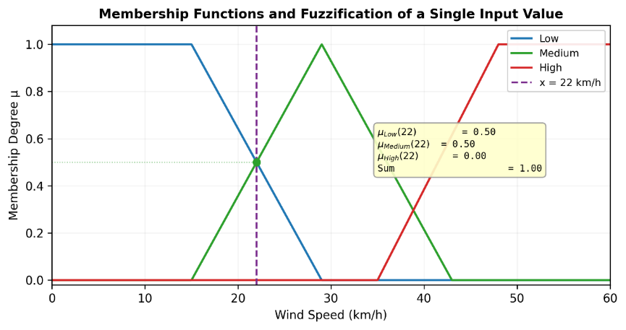
Figure 3.2 Shoulder–Triangular–Shoulder membership functions, fuzzification
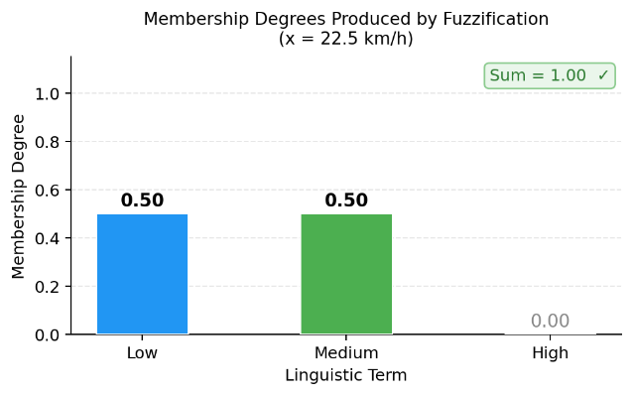
Figure 3.3 Membership degrees produced by fuzzification
More generally, fuzzification allows a single crisp input $x_{i}$ to activate multiple fuzzy sets simultaneously. For a given $x_{i}$, the fuzzified representation is the vector ( 7 ) where$\sum_{j=1}^{m_{i}}{μ_{A_{ij}}}\left(x_{i}\right)$ is not constrained to equal one in the general formulation; however, the DisasterAware framework enforces a partition-of-unity design (Proposition 5.2)guaranteeing that the sum equals one at every point.
$$μ\left(x_{i}\right)=\left[μ_{A_{i1}}\left(x_{i}\right),μ_{A_{i2}}\left(x_{i}\right),…,μ_{A_{im_{i}}}\left(x_{i}\right)\right]$$ | ( 7 )
Overlapping membership representations allow a single observation to support multiple linguistic interpretations, which is essential for modeling ambiguity in real-world decision environments. In the DisasterAware framework, this principle is implemented through a partition-of-unity structure, as formalized in Chapter 5. The choice of membership shape directly influences the behavior, robustness, and interpretability of the fuzzy inference system. Commonly used forms include triangular, trapezoidal, Gaussian, and sigmoidal functions, each offering distinct advantages for different application contexts.
The specific choice of membership function shapes affects both the interpretability and robustness of the fuzzy inference system. In general, piecewise-linear functions are preferred in DSS applications due to their computational simplicity and ease of interpretation. While various forms such as trapezoidal and Gaussian functions can be used, the key requirement in DSS contexts is not the specific functional form, but the ability to represent gradual transitions between linguistic concepts in a stable and interpretable manner.
Figure 3.2 and Figure 3.3 emphasize the key contribution of fuzzification within a DSS: numerical inputs are not treated as exact or definitive, but as evidence supporting multiple linguistic interpretations to varying degrees. This representation forms the foundation for subsequent fuzzy rule evaluation and inference, ultimately enabling decision guidance under epistemic uncertainty.
In DSS applications, fuzzification plays a critical role in aligning numerical sensor data with human reasoning processes. By operating on linguistic concepts rather than hard thresholds, fuzzification improves tolerance to sensor noise, reduces sensitivity to minor measurement fluctuations, and enables smoother transitions between decision regions. This makes the decision logic more robust and interpretable, particularly in operational domains such as wildfire management, where inputs are uncertain and expert knowledge is commonly expressed in qualitative terms rather than precise numerical rules (Thompson & Calkin, 2011). In this thesis, fuzzification serves as the primary mechanism for encoding epistemic uncertainty, ensuring that incomplete and imprecise observations can be systematically incorporated into the DSS process without requiring probabilistic assumptions.
In summary, the fuzzification and Data Base design adopted in this work deliberately balances interpretability and robustness. Trapezoidal membership functions are well suited for encoding stable operating ranges, while Gaussian functions model gradual transitions around prototypical values. In the DisasterAware framework, a piecewise-linear shoulder–triangular–shoulder design is adopted, which combines the flat-core property of trapezoidal functions with computational simplicity and partition-of-unity guarantees, as formalized in Chapter 5.
While the generic formulation in this section uses $x_{i}$ as the input variable and $μ_{A_{ij}}\left(x_{i}\right)$ as the membership function notation following standard fuzzy-logic convention, the DisasterAware framework adopts a structured feature representation denoted as $z_{k,l}^{i}(x,y)$, where $l$ indexes feature dimensions, $i$ denotes the spatial region, and $k$ represents the time step. This distinction separates feature variables from spatial coordinates and ensures consistency with the spatio-temporal DSS formulation introduced in Chapter 2.

Rule Base and Knowledge Representation
Within a fuzzy-logic framework, this mapping $π_{DSS}$ is realized through a structured rule base that encodes domain knowledge in an explicit and interpretable form. The rule base constitutes the core mechanism through which expert knowledge and domain heuristics are encoded within a fuzzy inference system. It represents knowledge in the form of linguistic IF–THEN rules, allowing qualitative human reasoning to be formalized and executed computationally.
Each fuzzy rule $R$ defines a local mapping between conditions observed in the input space and an inferred decision outcome. A generic fuzzy rule $R$ can be expressed as ( 8 ) where $A_{i}^{R}$ denotes the antecedent fuzzy set associated with input variable $x_{i}$ in rule $k$, $B^{R}$ denotes the consequent fuzzy set associated with the output variable $y$.
$$R: \text{IF }x_{1}\text{ is }A_{1}^{R}∧x_{2}\text{ is }A_{2}^{R}∧⋯∧x_{n}\text{ is }A_{n}^{R}\text{ THEN }y\text{ is }B^{R}$$ | ( 8 )
In DSS contexts, these rules do not merely represent logical relationships but act as localized reasoning units that approximate incident-command reasoning documented in operational literature under uncertainty. In Equation ( 8 ), $A_{i}^{R}$ denotes the antecedent fuzzy set associated with input variable $x_{i}$ in rule $R$, while $B^{R}$ represents the consequent fuzzy set defining the output implication of the rule. This structure enables explicit encoding of expert knowledge and supports traceable reasoning, which is essential for high-risk DSS environments.
Each rule represents local reasoning, valid over a specific region of the input space where its antecedent conditions hold to a sufficient degree. Importantly, no single rule is intended to describe the system behavior globally. Instead, the overall system behavior emerges from the collective activation and aggregation of multiple partially fired rules, each contributing proportionally to the final inference result. In the context of wildfire DSS, fuzzy rules naturally reflect the qualitative reasoning used by experienced operators and analysts. An example is:
IF Wind Speed is High AND Fuel Moisture is Low AND Slope is Steep THEN Spread Risk is Very High.
Such rules directly reflect the linguistic reasoning patterns used by human decision-makers in wildfire management, where precise numerical thresholds are rarely available and decisions must be made under partial observability.
From a knowledge representation perspective, the rule base operates in conjunction with the data base (membership functions) to form the knowledge base of the FIS. While the Data Base defines the semantic meaning and numerical realization of linguistic concepts, the rule base defines the inferential structure that governs how these concepts are combined to produce decisions. This separation enables modularity, interpretability, and maintainability: membership functions can be refined independently of rules, and rules can be added or modified without altering the underlying data representation.
The explicit, linguistic nature of the rule base also provides traceability and explainability, which are essential properties for DSS operating in high-risk and safety-critical domains. Each inferred decision can be traced back to a set of activated rules and their corresponding antecedent conditions, facilitating validation, operator trust, and post-event analysis. For these reasons, the rule base serves as a formalized representation of expert reasoning, bridging human knowledge and algorithmic
In the DisasterAware framework, this structure enables decision generation to remain both interpretable and adaptable, ensuring that intervention guidance can be traced back to explicit reasoning steps while operating under partial observability (Pacheco, 2015). This property directly addresses the explainability requirement identified in Chapter 1 (G4) and forms the basis of the interpretable decision-generation mechanism adopted in the DisasterAware framework.

Inference Engine and Rule Evaluation
Within the DSS formulation introduced in Chapter 2, the inference engine provides the computational mechanism through which the mapping $π_{DSS}$ is realized under uncertainty. The inference engine is the computational core of a FIS. Its primary role is to evaluate the rule base using fuzzified inputs and to synthesize a coherent fuzzy output that reflects the combined influence of multiple, partially satisfied rules.
Unlike crisp logical systems, the inference engine operates on graded truth values, enabling approximate reasoning under epistemic uncertainty. Mathematically, the inference process can be decomposed into three sequential stages: rule activation, implication, and aggregation. This type of decomposition is canonical in Mamdani-type FIS and provides a transparent and interpretable reasoning mechanism for DSS applications (Mamdani, 1974).

Rule Activation (Antecedent Evaluation)
In the rule activation stage, a fuzzy rule $R$ is defined as $R:\text{ IF }x_{1}\text{ is }A_{1}^{R}∧x_{2}\text{ is }A_{2}^{R}∧⋯∧x_{n}\text{ is }A_{n}^{R}\text{ THEN }y\text{ is }B^{R}$, while the crisp input vector is $x=\left(x_{1},x_{2},…,x_{n}\right)$. After fuzzification, each input $x_{i}$ is represented by its membership degree in the antecedent fuzzy set $A_{i}^{R}$, denoted as $μ_{A_{i}^{\left(R\right)}}\left(x_{i}\right)∈[0,1]$. The inference engine computes the rule firing strength $α_{R}$, which quantifies the degree to which the antecedent conditions of rule $R$ are satisfied. This is achieved using a fuzzy conjunction operator (t-norm) in ( 9 ) and ( 10 ) where $α_{R}$ denotes the firing strength of rule $R$, computed from the membership degrees of its antecedent conditions. The firing strength $α_{R}∈[0,1]$ allows rules to be partially activated, reflecting the fact that real-world conditions rarely satisfy all antecedent clauses perfectly.
Minimum t-norm: $α_{R}=\underset{i=1,…,n}{min⁡}\left(μ_{A_{i}^{R}}\left(x_{i}\right)\right)$ | ( 9 )
Product t-norm: $α_{R}=\prod_{i=1}^{n}{μ_{A_{i}^{R}}}\left(x_{i}\right)$ | ( 10 )

Implication (Consequent Modulation)
Once the firing strength $α_{R}$ is obtained, the inference engine applies an implication operator to the consequent fuzzy set $B^{R}$. In Mamdani-type inference, the most widely used implication mechanism scales the consequent membership function according to the firing strength ( 11 ) where $μ_{B^{R}}^{'}\left(y\right)$ represents the scaled consequent membership function after applying the implication operator.
$$μ_{B^{R}}^{'}\left(y\right)=α_{R}⋅μ_{B^{R}}\left(y\right)$$ | ( 11 )
This operation preserves the semantic shape of the consequent fuzzy set while proportionally adjusting its influence. Rules that are weakly satisfied contribute marginally to the output, whereas strongly satisfied rules exert greater influence. This implication can be interpreted as a weighting operation in function space, where each rule contributes to a scaled fuzzy set rather than a crisp outcome. This ensures smooth transitions in the output space and avoids discontinuities that would otherwise arise from binary rule evaluation. In DSS, this mechanism ensures that stronger evidence contributes more significantly to the final decision, while weaker or uncertain evidence is still considered without being discarded.

Aggregation
The inference engine aggregates all rule-specific fuzzy outputs into a single fuzzy set since multiple rules may be simultaneously activated ( 12 ) where $∨$ denotes the maximum operator and the union is taken over all rules $R$ in the rule base.
$$μ_{B}\left(y\right)=\bigvee_{R}{μ_{B^{R}}^{'}}\left(y\right)$$ | ( 12 )
This aggregation combines all rule contributions into a single fuzzy output set representing the overall inference result. The aggregated fuzzy set $B$ represents the system's overall reasoning outcome prior to defuzzification. Importantly, aggregation does not resolve conflicts explicitly; instead, it allows overlapping and competing rules to coexist through graded membership values. This mechanism naturally reflects how decision-makers integrate multiple, potentially conflicting sources of information, making it particularly suitable for a DSS operating under uncertainty and partial observability. This inference process provides a structured and interpretable mechanism for transforming fuzzified observations into DSS outputs, forming the DSS mapping defined in Chapter 5.

Defuzzification and Decision Output
Defuzzification is the final stage of a FIS when a crisp output is required, responsible for transforming the aggregated fuzzy output set $B$ into a crisp value $y^{*}$ that can be directly used in decision-making or control actions. While FIS operates on graded membership values and linguistic abstractions, defuzzification provides a single representative output that summarizes the overall reasoning outcome. $μ_{B}\left(y\right)$ denotes the membership function obtained after rule aggregation. The defuzzification process defines a mapping ( 13 ) where $y^{*}$ represents the crisp decision output.
$$D :μ_{B}\left(y\right)→y^{*}∈R$$ | ( 13 )
However, in many DSS applications, especially those involving human-in-the-loop operation, producing a single crisp value is not always necessary or desirable. The most widely used defuzzification technique is the centroid, or center of gravity, method. It computes the weighted average of the output domain, using the aggregated membership function as a weighting factor ( 14 ). This formulation computes the centroid of the output distribution, treating the membership function as a weighting function over the output domain.
$$y^{*}=\frac{∫y⋅μ_{B}\left(y\right) dy}{∫μ_{B}\left(y\right) dy}$$ | ( 14 )
While such methods provide smooth and continuous outputs, they inherently compress the underlying uncertainty into a single representative value. Centroid defuzzification can be interpreted as computing the expected value of the output variable under a possibility distribution induced by fuzzy inference. This interpretation reinforces its suitability for approximate reasoning under uncertainty (Mendel, 2017). In addition to the centroid method, there are several alternative defuzzification techniques listed in Table 3.2.
Table 3.2 Commonly used defuzzification techniques
Defuzzification Methods | Explanations
Mean of maxima | Computes the average of all output values where $μ_{B}\left(y\right)$ reaches its maximum.
Largest of maxima | Selects the largest value of $y$ corresponding to the maximum membership degree.
Weighted average | Often used in Sugeno-type fuzzy systems, where rule consequents are crisp values and defuzzification reduces to a weighted sum (Takagi & Sugeno, 1985).

These methods are computationally simpler than centroid defuzzification but are generally more sensitive to local maxima and less responsive to the overall shape of the fuzzy output. As a consequence, they may introduce discontinuities or abrupt decision changes, which are undesirable in many DSS applications.
In many operational DSS contexts, particularly those involving high uncertainty and HIL decision making, defuzzification is not always mandatory. Instead of producing a single crisp value, the system may present the fuzzy output directly in linguistic form (e.g., Low Risk, Moderate Risk, High Risk), allowing human operators to interpret and contextualize the result. This approach enhances transparency, trust, and cognitive alignment between the DSS and its users (Thompson & Calkin, 2011). In the DisasterAware framework, defuzzification is treated as optional, allowing the system to preserve fuzzy outputs for improved interpretability and HIL interaction.

Structural Alignment Between Fuzzy Logic and DisasterAware
The design principles of fuzzy logic exhibit a strong structural and conceptual alignment with the DisasterAware decision support framework. At its core, DisasterAware is conceived as an adaptive, concept-driven DSS that must operate under uncertainty, heterogeneous data sources, and evolving operational conditions. Fuzzy logic directly supports these requirements by enabling graded reasoning, linguistic abstraction, and rule-based inference without assuming complete or precise information. Rather than forcing premature numerical certainty, fuzzy inference preserves epistemic uncertainty and supports decision making based on partial, local, and context-dependent evidence.
This property is fundamental to DisasterAware, where decisions are not selected from a closed set of predefined alternatives but instead emerge dynamically from configurations in the concept space. Furthermore, the modularity of FIS allows DisasterAware to run the same inference pipeline in parallel across regions, each instance conditioned on its own observations and contextual inputs, while higher-level fusion at the tactical layer integrates the resulting regional outputs.
By separating fuzzification, rule evaluation, inference, and defuzzification, fuzzy logic provides DisasterAware with a flexible reasoning backbone that supports explainability, scalability, and human-centered operation across multiple decision levels and spatio-temporal scales. This alignment confirms that fuzzy logic is not an arbitrary modeling choice, but a direct consequence of the structural requirements of the wildfire DSS problem defined in Chapter 2 as summarized in Table 3.3.
Table 3.3 Alignment between fuzzy logic components and DisasterAware
Fuzzy Logic Component | Role in Classical Fuzzy DSS | Alignment in DisasterAware
Linguistic variables | Represent vague concepts (Low, Medium, High) | Used as decision concepts (e.g., risk level, confidence, priority) rather than raw indices
Fuzzification | Maps crisp inputs to fuzzy sets | Enables semantic abstraction of heterogeneous sensor, model, and human inputs
Membership functions | Encode tolerance and uncertainty | Support robust reasoning under noisy, delayed, or incomplete data
Rule base | Encodes expert IF–THEN knowledge | Implements domain knowledge as explainable reasoning logic at local and global levels
Rule activation (graded firing) | Partial rule satisfaction | Enables approximate reasoning and avoids weak threshold-based decisions
Aggregation of rules | Combines multiple rule outputs | Supports emergent decisions from interacting factors
Defuzzification | Produces crisp outputs | Treated as optional and context-dependent; often deferred or omitted to preserve interpretability
Interpretability | Human-readable reasoning | Directly supports operator trust, explainability, and governance
Modularity | Independent fuzzy components | Enables distributed local decision makers and hierarchical fusion
Non-probabilistic uncertainty handling | No reliance on full probability models | Matches epistemic uncertainty dominant in disaster operations
Static rule evaluation | Fixed rule base | Extended in DisasterAware via adaptive weighting and feedback mechanisms
Closed decision space | Predefined outputs | Replaced by open decision space with emergent decisions

Limitations of Classical MCDM and MAGDM Approaches
Multi-Criteria Decision Making (MCDM) methods constitute a well-established class of decision analysis frameworks for evaluating and ranking a finite set of alternatives across multiple, potentially conflicting criteria (Hwang & Yoon, 1981; Triantaphyllou, 2000; Zavadskas & Turskis, 2011). Their Multi-Attribute Group Decision Making (MAGDM) extensions incorporate consensus mechanisms for settings involving multiple decision makers (Xu, 2015). However, within the DSS problem presented in Chapter 2, the structural assumptions underlying these methods introduce fundamental limitations. This section analyzes these limitations and demonstrates why classical MCDM and MAGDM frameworks are not compatible with dynamic, partially observable, and time-critical decision environments.

Formal MCDM structure
In the canonical MCDM formulation, a decision problem is represented by a decision matrix $X∈R^{m×n}$, where $m$ denotes the number of predefined alternatives $\left\{A_{1},A_{2},…,A_{m}\right\}$ and $n$ denotes the number of evaluation criteria $\left\{C_{1},C_{2},…,C_{n}\right\}$. Each entry $x_{ij}$ encodes the crisp performance value of alternative $A_{i}$ with respect to criterion $C_{j}$. A weight vector $w=(w_{1},w_{2},…,w_{n})^{⊤}$ subject to ( 15 ) encodes the relative importance of each criterion. Here, $w_{j}$ denotes the weight assigned to criterion $C_{j}$, representing its relative importance in the decision process. The final ranking is derived through a method-specific aggregation function $S:R^{m×n}×R^{n}→R^{m}$, yielding a scalar score $S\left(A_{i}\right)$ for each alternative.
$$\sum_{j=1}^{n}{w_{j}}=1,w_{j}≥0∀j$$ | ( 15 )
In Technique for Order of Preference by Similarity to Ideal Solution (TOPSIS), for instance, the performance matrix is first normalized as ( 16 ) and weighted values are computed as $v_{ij}=w_{j}⋅r_{ij}$. In this expression, $r_{ij}$ represents the normalized performance value of alternative $A_{i}$ with respect to criterion $C_{j}$.
$$r_{ij}=\frac{x_{ij}}{\sqrt{\sum_{i=1}^{m}{x_{ij}^{2}}}}$$ | ( 16 )
The positive ideal solution $A^{+}=\left\{v_{j}^{+}=\max_{i}v_{ij}\right\}$ and negative ideal solution $A^{-}=\left\{v_{j}^{-}=\min_{i}v_{ij}\right\}$ are defined, and each alternative is scored by its relative closeness ( 17 ). The value $C_{i}$ denotes the relative closeness of alternative $A_{i}$ to the ideal solution, which is used to rank alternatives.
$$C_{i}=\frac{D_{i}^{-}}{D_{i}^{+}+D_{i}^{-}}, \text{where }D_{i}^{±}=\sqrt{\sum_{j=1}^{n}{(}v_{ij}-v_{j}^{±})^{2}}$$ | ( 17 )
In the Analytic Hierarchy Process (AHP), weights are derived from a pairwise comparison matrix $A=\left[a_{ij}\right]$ where $a_{ij}=\frac{w_{i}}{w_{j}}$, by computing the principal eigenvector $w$ $Aw=λ_{max}w$. Consistency is assessed by the Consistency Ratio $CR=\frac{CI}{RI}$, where $CI=\frac{λ_{max}-n}{n-1}$ and $RI$ is a random index dependent on matrix size (Saaty, 1980).
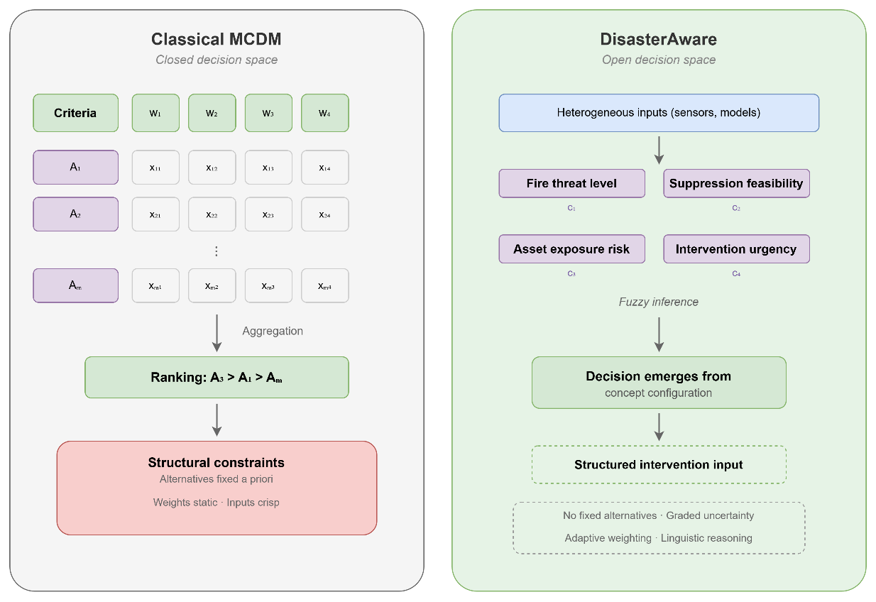
Figure 3.4 Closed vs open decision space: classical MCDM and DisasterAware
As illustrated in Figure 3.4, classical MCDM operates within a structurally closed decision space: a fixed set of alternatives $\left\{A_{1},…,A_{m}\right\}$ is evaluated against predefined criteria using crisp performance values $x_{ij}$ and a static weight vector, ultimately producing a deterministic ranking. This distinction is central to the proposed approach, as DisasterAware eliminates the assumption of predefined alternatives and instead generates decisions dynamically through concept-based reasoning.
The entire reasoning chain from input to output is constrained by the assumption that all relevant alternatives are known and quantifiable prior to evaluation. In contrast, DisasterAware operates within an open decision space in which no alternatives are enumerated in advance.
Heterogeneous sensor and model inputs are transformed through fuzzy inference into a set of decision concepts, such as Spread Risk, Operational Priority, and Alert Level, whose configuration collectively drives the emergence of a structured intervention input. This architecture eliminates the closed-alternative assumption and replaces static aggregation with adaptive, linguistically grounded reasoning. These structural differences form the basis of the limitations analyzed in the following subsections.

Limit 1 – Dependence on a Closed and Predefined Alternative Set
The most fundamental structural constraint is that all alternatives $\left\{A_{1},…,A_{m}\right\}$ must be enumerated prior to evaluation (Comes, Hiete, Wijngaards, & Schultmann, 2011; Triantaphyllou, 2000). This assumption is incompatible with wildfire response, where feasible interventions are not fixed but evolve dynamically with fire behavior, resource availability, and operational constraints. Neither TOPSIS, AHP, nor their extensions support the emergence of new alternatives from operational dynamics; the decision space is closed by design.

Limit 2 – Crisp Performance Values and Weight Assignment
The decision matrix $X$ requires precise, fully observed values $x_{ij}$. Classical MCDM methods are fundamentally designed for deterministic settings, where criteria values are treated as fully observable and precisely quantifiable (Bellman & Zadeh, 1970). In practice, wildfire decision environments are characterized by epistemic uncertainty arising from measurement noise, sensor latency, model simplifications, and partially conflicting information streams (Walker, et al., 2003; French, Maule, & Papamichail, 2019). Interval-valued and fuzzy extensions to MCDM such as fuzzy TOPSIS using triangular or trapezoidal fuzzy numbers ${\tilde{x}}_{ij}=\left(l_{ij},m_{ij},u_{ij}\right)$ have been proposed to partially address this limitation (Chen & Hwang, 1992).
However, these adaptations confine uncertainty to predefined numerical intervals and do not support the continuous, graded, and linguistically expressed uncertainty inherent in real-time operational sensing. Similarly, the weight vector $w$ is typically assigned a priori or elicited through static pairwise comparisons, precluding dynamic reweighting in response to operational feedback. This limitation is particularly critical in wildfire environments, where observations are inherently incomplete and cannot be reliably represented as precise numerical values.

Limit 3 – Computational Scalability Under Real-Time Constraints
Classical MCDM methods carry computational overhead that grows with the number of alternatives and criteria. AHP's pairwise comparison procedure requires $\frac{n\left(n-1\right)}{2}$ comparisons per decision level, and the consistency constraint $CR<0.10$ becomes increasingly difficult to satisfy as $n$ grows. In large-scale operational scenarios involving spatially distributed resources, multiple simultaneous active fire zones, and dynamic prioritization, the computational cost of classical MCDM becomes prohibitive for real-time decision support (Triantaphyllou, 2000). Furthermore, the centralized aggregation mechanism inherent in most MCDM methods is structurally ill-suited to distributed operational architectures requiring local decisions without global communication. This computational burden is incompatible with real-time DSS requirements, where decisions must be generated within strict time constraints.

Limit 4 – MAGDM Consensus Latency and Cognitive Bias
In MAGDM frameworks, individual expert weight vectors $w^{\left(k\right)}$ are aggregated into a group weight vector, typically as ( 18 ). This aggregation assumes synchronized decision cycles and a priori assignment of expert authority weights $ω_{k}$. In time-critical response, the latency of consensus formation is operationally unacceptable, and the normative rational choice model assumed by MAGDM diverges sharply from the pattern-recognition-based decision making observed in experienced operators under time pressure (Klein, 2017; Tversky & Kahneman, 1974). This limitation is particularly problematic in wildfire response, where decision latency directly reduces operational effectiveness due to rapidly evolving conditions.
$${\overset{ˉ}{w}}_{j}=\sum_{k=1}^{K}{ω_{k}}⋅w_{j}^{\left(k\right)},\text{where}\sum_{k=1}^{K}{ω_{k}}=1$$ | ( 18 )

Limit 5 – Opacity and Limited Explainability
While MCDM methods produce ranked alternatives or scalar scores, the reasoning pathway from input data to final recommendation is often opaque to end users. In AHP, a final priority score aggregates contributions from multiple levels of pairwise comparison in ways that are difficult to trace without dedicated analysis tools. In TOPSIS, the distances $D_{i}^{±}$ summarize high-dimensional performance differences to a single closeness coefficient, losing the criterion-level interpretability that operators require for validation and override (Guidotti, et al., 2018). This opacity undermines trust and limits operational adoption in high-risk domains.
Table 3.4 demonstrates that these limitations are consistent across different MCDM variants, indicating that they are inherent to the underlying decision paradigm rather than specific to individual methods.
Table 3.4 MCDM/MAGDM method limitations in wildfire DSS context
Attribute | Description
AHP
Mechanism | Pairwise comparison → priority eigenvector
Assumption | Alternatives, criteria, and expert judgments are stable and enumerable.
Manifestation in DSS | Pairwise consistency breaks under time pressure; the alternative set cannot accommodate emergent response options.
TOPSIS
Mechanism | Distance from positive/negative ideal solution
Assumption | Crisp performance values are available; the ideal solution is known a priori.
Manifestation in DSS | Distances are undefined under epistemic uncertainty; the ideal solution shifts dynamically with fire evolution.
VIKOR
Mechanism | Compromise ranking via Q-index
Assumption | A stable aspiration level exists for each criterion.
Manifestation in DSS | Aspiration levels for suppression effectiveness and resource use cannot be defined a priori in evolving fires.
ELECTRE
Mechanism | Outranking via concordance / discordance thresholds
Assumption | Crisp threshold parameters are available for each criterion pair.
Manifestation in DSS | Binary outranking relations are inappropriate for graded, probabilistic observations; threshold calibration is infeasible.
PROMETHEE
Mechanism | Preference functions per criterion
Assumption | Preference function shape and parameters are calibrated.
Manifestation in DSS | Missing or delayed sensor data renders preference functions uncalibrated; the method collapses under sparse input.
Fuzzy MCDM Extensions
Mechanism | Interval or triangular fuzzy numbers for uncertainty representation
Assumption | Uncertainty is representable by predefined fuzzy intervals.
Manifestation in DSS | Interval bounds require domain calibration that is rarely available; the approach does not support distributed, real-time inference.
MAGDM (Consensus)
Mechanism | Aggregated group preference weights
Assumption | Synchronized expert availability and stable expert authority weights.
Manifestation in DSS | Consensus cycles are incompatible with real-time operational timelines; weight assignment is arbitrary under dynamic role allocation.

Collectively, these limitations are structural rather than incidental, arising directly from the closed, static, and fully observable assumptions embedded in classical MCDM formulations. Hence, these methods are fundamentally incompatible with the open, dynamic, and partially observable decision space defined in Chapter 2. These limitations motivate the architectural departure adopted in DisasterAware, where decision generation is formulated as a distributed, uncertainty-aware reasoning process over an open decision space rather than a ranking problem over predefined alternatives.

Decision Levels and Decision Scope in Operational Decision Support
Operational decision making in complex and dynamic environments such as wildfire response is inherently hierarchical, involving multiple decision levels with distinct temporal, spatial, and informational characteristics. These differences impose structural requirements on DSS design, as a single reasoning mechanism cannot simultaneously satisfy the responsiveness required at the operational level and the analytical depth required at higher levels.

Formal Taxonomy of Decision Levels
The initial taxonomy of decision-making was established by Anthony (1965), who identified three hierarchically nested levels (i.e., strategic planning, management control, and operational control) distinguished primarily by their temporal horizon and degree of environmental uncertainty. Simon (1960) complemented this framework by classifying decisions along a structural dimension: structured decisions are fully specifiable by algorithms; unstructured decisions require human judgment and cannot be reduced to routine procedures; semi-structured decisions exhibit elements of both and represent the primary domain of DSS intervention. Gorry and Scott Morton (1971) synthesized these frameworks, producing a widely adopted classification matrix in which decision types are mapped against organizational levels, establishing the theoretical basis for level-differentiated DSS.
To formalize these distinctions, each decision level ${DL}_{k}$ can be characterized as a tuple of four scope parameters ( 19 ) where ${\text{THR}}_{k}∈R_{>0}$ denotes the temporal horizon of decisions at level $k$, ${\text{SCP}}_{k}$ denotes the spatial scope of decision influence, ${\text{EPI}}_{k}∈\left[0,1\right]$ denotes the normalized epistemic uncertainty level, and ${\text{AUT}}_{k}∈\left[0,1\right]$ denotes the automation feasibility index, the degree to which DSS can be safely delegated to algorithmic reasoning without requiring direct human override.
$${\text{DL}}_{k}=\left({\text{THR}}_{k} , {\text{SCP}}_{k} , {\text{EPI}}_{k} , {\text{AUT}}_{k}\right)$$ | ( 19 )
Across the three canonical levels, these parameters follow consistent monotonic orderings ( 20 ) reflecting the general principle that as decision horizon shortens and spatial scope narrows, uncertainty decreases and automation becomes feasible (Anthony, 1965; French, Maule, & Papamichail, 2019). These relations indicate that as decision levels move from strategic to operational, temporal horizons decrease, uncertainty is reduced, and the feasibility of automated decision-making increases.
$${\text{THR}}_{\text{str}}>{\text{THR}}_{\text{tac}}>{\text{THR}}_{\text{opr}}$$  $${\text{EPI}}_{\text{str}}>{\text{EPI}}_{\text{tac}}>{\text{EPI}}_{\text{opr}}$$  $${\text{AUT}}_{\text{opr}}>{\text{AUT}}_{\text{tac}}>{\text{AUT}}_{\text{str}}$$ | ( 20 )

Temporal Urgency and Decision Value Decay
A critical and often underappreciated dimension of multi-level DSS is the concept of decision value decay: the utility of a decision degrades as a function of elapsed time relative to the operational context in which it is needed (Klein, 2017). This relationship can be formalized as a level-specific exponential decay function ( 21 ) where $V_{k}\left(d,Δt\right)$ is the residual value of decision $d$ at level $k$ after a delay of $Δt$, $V_{0}$ is the initial decision value at zero delay, and $λ_{dec,k}>0$ is the level-specific decay rate. This property is particularly critical in wildfire response, where delayed decisions may lose their operational relevance due to rapidly evolving fire dynamics.
$$V_{k}\left(d,Δt\right)=V_{0}⋅e^{-λ_{dec,k}⋅Δt}$$ | ( 21 )
At the operational level, $λ_{\text{dec,}\text{oprl}}≫λ_{\text{dec,}\text{str}}$: a resource redeployment decision that is delayed by minutes in an active wildfire front may lose all operational relevance, whereas a strategic resource allocation decision may retain its value over hours or days. This asymmetry directly motivates the architectural separation of decision levels in operational DSS: a system that applies strategic-level analytical depth to operational-level decisions will consistently generate outputs that are correct but temporally obsolete (Endsley, Toward a Theory of Situation Awareness, 1995; French, Maule, & Papamichail, 2019).

Decision Scope and Information Flow
As illustrated in Figure 3.5, decision levels are not independent: they form a coupled hierarchy in which aggregated observational data flows upward from the operational level, while decision guidance and resource directives flow downward from the strategic level. A layered information flow in which local observations are aggregated upward while coordination and policy-level guidance propagate downward (Turban, 2011; Power, Decision support systems: Concepts and resources for managers, 2002).
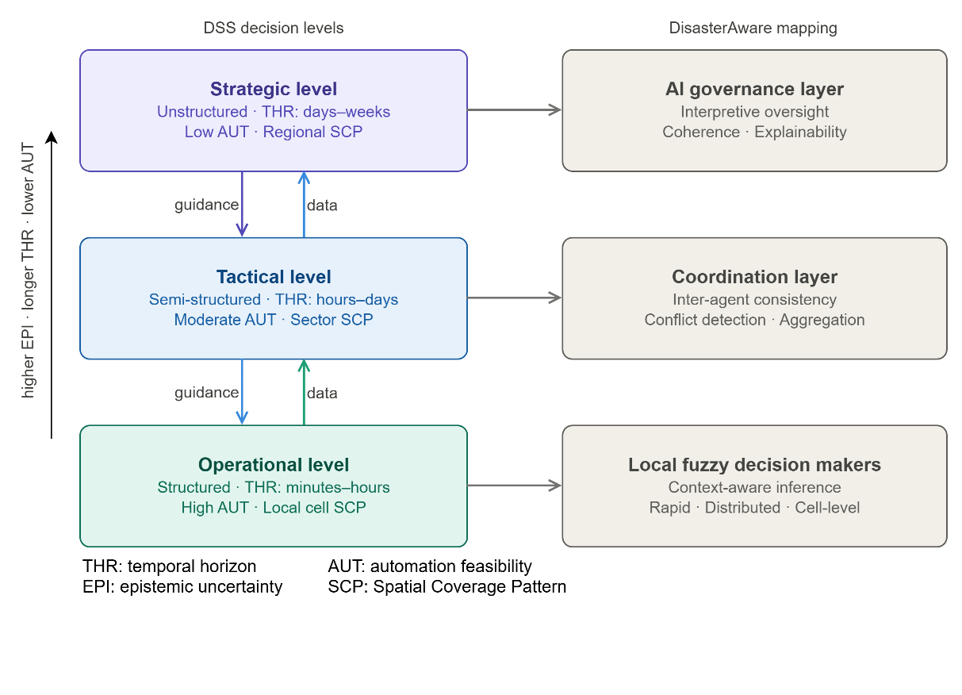
Figure 3.5 Decision levels hierarchy and DisasterAware mapping
This hierarchical structure directly motivates the need for a layered DSS architecture capable of supporting both local responsiveness and global coordination. Each decision level operates with a distinct role, ranging from real-time situational awareness at the operational level to coordination at the tactical level and interpretive oversight at the strategic level.
The properties of the three decision levels and the corresponding DSS design requirements are summarized in Table 3.5. This mapping is not merely descriptive but prescriptive, as it directly determines the architectural decomposition of the DisasterAware framework into operational, tactical, and strategic layers.
Table 3.5 Decision level characteristics and DSS requirements
Dimension | Strategic | Tactical | Operational
Temporal horizon ${\text{THR}}_{k}$ | Days–weeks | Hours–days | Minutes–hours
Spatial scope ${\text{SCP}}_{k}$ | Regional | Sector | Local cell
Epistemic uncertainty ${\text{EPI}}_{k}$ | High | Moderate | Lower
Automation feasibility ${\text{AUT}}_{k}$ | Low | Moderate | High
Decay rate $λ_{dec,k}$ | Slow | Moderate | Rapid
Primary DSS role | Advisory and interpretive | Coordinative and recommendatory | Inferential and directive
DisasterAware realization | AI governance layer | Inter-agent coordination | Local distributed fuzzy DMs

Implications for DSS Architecture
The level taxonomy has direct and non-trivial architectural consequences. A DSS that conflates decision levels by applying a single reasoning engine uniformly across all temporal and spatial scales will systematically fail at the extremes: it will be slow at the operational level and too coarse at the strategic level. This observation motivates level-differentiated DSS architectures in which distinct reasoning mechanisms are deployed at each level, coupled through well-defined information interfaces (Gorry & Scott Morton, 1971; Arnott & Pervan, 2005).
The degree of human involvement must be calibrated to each level. At the strategic level, where uncertainty is high, decisions are unstructured, and consequences are long-lasting, human judgment is irreplaceable and DSS output should remain advisory. At the operational level, where decay rate is high and decisions are relatively structured, a higher degree of algorithmic autonomy is both feasible and necessary to maintain decision responsiveness (Klein, 2017; Endsley, Situation awareness misconceptions and misunderstandings, 2015).
As depicted in Figure 3.5, three functionally distinct layers correspond to the three decision levels: distributed local fuzzy decision makers operating at the operational level provide rapid, cell-level inference under real-time constraints; a coordination layer at the tactical level ensures inter-agent consistency and conflict resolution; and an AI-supported governance layer at the strategic level provides interpretive oversight, explanatory output, and policy-level coherence checking.
This architecture ensures that the decay rate constraint $λ_{dec,k}$ is respected at each level without sacrificing the analytical depth required at higher levels of the hierarchy. DisasterAware adopts a level-differentiated architecture in which distinct reasoning mechanisms are deployed at each decision level while maintaining structured information flow across layers.
Overall, the multi-level structure of decision-making imposes strict architectural requirements on DSS design, including the need for distributed local reasoning, hierarchical coordination, and level-specific decision mechanisms. These requirements are directly addressed in the DisasterAware framework, whose architecture is explicitly designed to operate across multiple decision levels while preserving both responsiveness and global coherence.

Centralized and Distributed Decision Support Architectures
The architecture of a DSS, whether it is centralized or distributed, has fundamental implications for system responsiveness, scalability, and operational feasibility in dynamic environments such as wildfire response. This distinction is not merely an implementation detail but a structural design choice that directly determines whether the system can operate effectively under partial observability, communication constraints, and rapidly evolving conditions (Wooldridge, 2009; Sycara, 1998). Within the distributed paradigm, two structural variants are distinguished: a strict peer-to-peer form in which agents exchange observations with immediate neighbors to reach local decisions without any central coordinator, and a hierarchical form in which agents reason independently and a coordination operator assembles their outputs without itself performing inference. The next sections formalize these three paradigms and examine their communication, latency, and scalability properties.

Formal Definitions
In centralized DSS, a single decision authority $Δ_{c}$ receives state observations from all $n$ field agents $\left\{a_{1},a_{2},…,a_{n}\right\}$, aggregates them into a global state estimate, and issues decisions back to each agent ( 22 ) where $o_{i}$ denotes the local observation of agent $a_{i}$ and $d_{i}$ the resulting decision issued to that agent. The central authority maintains a global world model and is the sole source of decision output.
$$d_{i}=Δ_{c}\left(\bigcup_{i=1}^{n}{o_{i}}\right),∀i∈\left\{1,…,n\right\}$$ | ( 22 )
In a strict peer-to-peer distributed DSS architecture, each agent $a_{i}$ is equipped with a local decision maker $δ_{i}$ that operates exclusively on its own observation $o_{i}$ and the observations of its neighborhood $N\left(i\right)$ ( 23 )
$$d_{i}=δ_{i}\left(o_{i},\left\{o_{j}:j∈N\left(i\right)\right\}\right)$$ | ( 23 )
No global state is required. Each $δ_{i}$ is a self-contained reasoning unit that produces a locally valid decision without waiting for or depending on a central authority. The neighborhood $N\left(i\right)$ is typically defined by spatial adjacency or communication range, establishing a sparse interaction topology rather than a fully connected graph.
In a hierarchically distributed DSS architecture, each agent $a_{i}$ is equipped with a local decision maker $δ_{i}$ that operates exclusively on its own observation $o_{i}$, without exchanging information with other agents. A separate coordination operator $A$, which is explicitly non-inferential, assembles the collection of local decisions into a globally consistent output $U$ ( 24 ).
$$d_{i} = δ_{i}\left(o_{i}\right), ∀i ∈ \left\{1,…,N\right\}; U = A(d_{1}, d_{2}, …, d_{N})$$ | ( 24 )

Communication Complexity and Decision Latency
The communication cost per decision cycle differs fundamentally between the architectures. In the centralized case, every agent must transmit its observation to the center and receive a decision in return, yielding a per-cycle message count of ( 25 ).
$$M_{c}=2n⇒M_{c}∈O\left(n\right)$$ | ( 25 )
In the distributed case, each agent communicates only with its $\left|N\left(i\right)\right|$ neighbors. Assuming a bounded neighborhood size $\left|N\left(i\right)\right|≤K$ for all $i$ ( 26 ) while per-agent communication cost remains $O\left(K\right)$, independent of $n$. This distinction becomes critical at scale: as $n$ grows, the centralized authority becomes a communication bottleneck, whereas each distributed agent's local load remains constant.
$$M_{d}=\sum_{i=1}^{n}{\left|N\left(i\right)\right|≤nK}⇒M_{d}∈O\left(n\right)$$ | ( 26 )
In the hierarchically distributed case, each agent transmits its completed local decision to the coordinator in a single one-way message, and the coordinator's output is consumed by the simulation layer rather than returned to agents. The per-cycle message count is therefore ( 27 ). Although the total scales as O(n), the per-agent load is O(1), and the transmitted messages carry completed decisions rather than raw observations, so no agent blocks on observations from any other agent.
$$M_{h}=n →M_{h}∈O\left(n\right)$$ | ( 27 )
Equations ( 25 ),( 26 ) and ( 27 ) indicate that total communication grows as O(n) in all three architectures. The per-agent load, however, differs: unbounded at the center in the centralized case, bounded by neighborhood size K in the peer-to-peer case, and constant in the hierarchical case. The more fundamental distinction concerns what the messages carry: in the centralized case they carry observations and the central authority performs all inference, whereas in both distributed variants agents complete their local reasoning before any transmission, so the O(n) message count does not translate into an inferential bottleneck.
Decision latency follows a parallel pattern. The end-to-end latency of a centralized decision cycle is ( 28 ) where $τ_{\text{collect}}$ is the time to receive all $n$ observations, $τ_{\text{agg}}$ is global aggregation time, and $τ_{\text{distribute}}$ is the time to issue decisions to all agents.
$$τ_{c}=τ_{\text{collect}}+τ_{\text{agg}}+τ_{\text{distribute}}$$ | ( 28 )
In contrast, the latency of a distributed local decision is ( 29 ) where $τ_{\text{local}}$ is local inference time and $τ_{\text{nb_exchange}}$ is the time to exchange observations with neighbors. Since $τ_{d}≪τ_{c}$ in practice, particularly under communication constraints and large-scale deployments, distributed architectures are structurally better aligned with the temporal urgency constraints formalized in Section 3.4.
$$τ_{d}=τ_{\text{local}}+τ_{\text{nb_exchange}}$$ | ( 29 )
In the hierarchically distributed case, the decision cycle comprises parallel local inference across all N agents, one-way transmission of completed decisions to the coordinator, and non-inferential spatial assembly ( 30 ). Because $τ_{local}$ executes in parallel across agents rather than serially at a central inference node, and because $τ_{assembly}$ covers only deterministic spatial assignment and resource normalization rather than fuzzy inference, the effective latency $τ_{h}$ is dominated by a single local inference pass. This contrasts sharply with the centralized $τ_{c}$ in ( 28 ), which serializes collection, inferential aggregation, and decision distribution.
$$τ_{h} = τ_{local} + τ_{transmit} + τ_{assembly}$$ | ( 30 )
As illustrated in Figure 3.6, the centralized architecture routes all state reports and decisions through a single node as formalized in Equation ( 22 ). This means that no local decision can be issued until the central authority has received observations from all agents, completed global aggregation, and distributed decisions back, a sequential dependency chain that accumulates latency at every stage as captured by $τ_{c}$ in Equation ( 28 ).
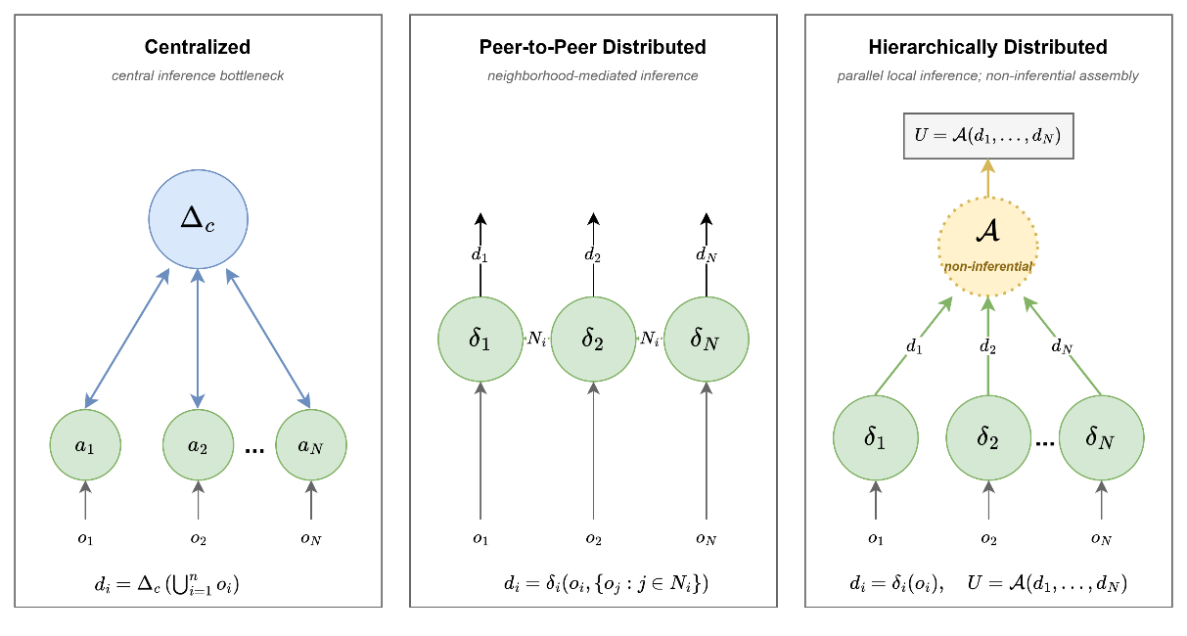
Figure 3.6 Centralized, P2P distributed, and hierarchically distributed DSS
In contrast, the peer-to-peer distributed architecture allows each local DM $δ_{i}$ to infer independently within its neighborhood as formalized in Equation ( 23 ), with no mandatory path through a central bottleneck. Since $δ_{i}$ requires only $o_{i}$ and the observations of its bounded neighborhood $N\left(i\right)$, the decision cycle reduces to the local inference time plus a single neighborhood exchange step, yielding the significantly lower latency $τ_{d}$ defined in Equation ( 29 ).
In the hierarchically distributed architecture, each $δ_{i}$ infers independently using only $o_{i}$, and the completed local decisions are assembled by the coordinator $A$ as formalized in Equation ( 24 ). Since $A$ performs no inference of its own, there is no inferential dependency on a central authority. The decision cycle reduces to parallel local inference plus a non-inferential assembly step, yielding the latency $τ_{h}$ defined in Equation ( 30 ).
This architectural difference is not a performance characteristic but a structural consequence of the dependency graph. In the centralized case, every agent's decision is blocked by the slowest reporting agent and the central inferential aggregation step. In the peer-to-peer distributed case, each agent's decision is blocked only by its own inference and its immediate neighbors. In the hierarchically distributed case, each agent's decision is blocked only by its own inference, since the coordinator's non-inferential assembly introduces no inferential dependency across agents.
Under the rapid decay rates $λ_{\text{dec,}\text{opr}}$ characteristic of the operational decision level, this difference directly determines whether decision outputs retain operational value or arrive too late to influence evolving fire conditions. Table 3.6 summarizes the key architectural differences across dimensions relevant to operational DSS design in disaster management.
Table 3.6 demonstrates that distributed architectures provide structural advantages in terms of latency, scalability, and robustness relative to centralized systems, making them more suitable for dynamic and partially observable environments.
Table 3.6 Comparison of centralized and distributed DSS architectures
Dimension | Centralized | Peer-to-Peer Distributed | Hierarchically Distributed
Comm. per cycle | $O(n)$, all agents report to center | $O(K)$ per agent, neighborhood exchange | $O(n)$ total, $O(1)$ per agent, one-way to coordinator
Decision latency | $$τ_{c} = τ_{collect} + τ_{agg} + τ_{distribute}$$ | $$τ_{d} = τ_{local} + τ_{nb}$$ | $$τ_{h} = τ_{local} + τ_{transmit} + τ_{assembly}$$
Scalability | Degrades with n; central bottleneck | Constant per-agent load | Constant per-agent inference; non-inferential assembly
Single point of failure | Yes; center failure halts all decisions | No; graceful degradation | Partial; local decisions survive coordinator failure
Global optimality | Potentially achievable | Locally optimal; global not guaranteed | Locally optimal; global consistency via assembly
Observability requirement | Full global state required | Local plus neighborhood state | Local observation only
Uncertainty handling | Global model absorbs all uncertainty | Local inference under partial observability | Per-region local inference under partial observability
Fault tolerance | Low | High | Moderate; high at agent level, bounded at coordinator
Human oversight coupling | Single operator interface | Requires coordination layer | Coordination layer plus AI governance overlay
Realization in DisasterAware | AI governance layer (oversight only) | Not used | Local fuzzy DMs plus $A_{DSS}$ coordination

Limitations of centralized architecture in wildfire DSS
In the specific context of wildfire disaster management, the centralized architecture exhibits structural failure modes that are not merely performance concerns but fundamental incompatibilities. Wildfire environments are characterized by rapidly evolving local conditions (i.e., fire front dynamics, fuel state changes, wind shifts) that require decision updates on timescales of minutes or less. A centralized system that must collect global state before issuing any local decision cannot satisfy the temporal decay constraint $λ_{\text{dec,}\text{opr}}$ derived in Section 3.4 (Comes, Hiete, Wijngaards, & Schultmann, 2011).
Furthermore, communication infrastructure in active wildfire zones is frequently degraded by terrain, smoke, and equipment damage, rendering the $O\left(n\right)$ communication requirement of centralized architectures operationally fragile. Finally, the requirement for a fully observed global state is inconsistent with the partial observability that characterizes real wildfire environments (Walker, et al., 2003; French, Maule, & Papamichail, 2019). These limitations indicate that centralized architecture is not only inefficient but structurally incompatible with the requirements of real-time wildfire decision support.

Alignment with DisasterAware
DisasterAware realizes the hierarchically distributed architecture of Equation ( 24 ). Each local fuzzy agent operates on its own regional observation alone, with no inter-agent communication ($N_{i} = ∅ for all i$). The global coordination operator $A_{DSS}$ composes the $N$ regional intervention fields through deterministic spatial assignment and resource normalization; $A_{DSS}$ is non-inferential and carries no reasoning workload. The per-cycle message count and end-to-end latency follow Equations ( 27 ) and ( 30 ). The latency $τ_{h}$ is dominated by a single parallel local inference pass and satisfies the temporal decay constraint $λ_{dec,opr }$ of the operational decision level.
The architecture realizes the three decision levels established earlier in this chapter. The N local fuzzy agents implement the operational level through parallel inference at regional and cell scale. $A_{DSS}$ implements the tactical level through global spatial assembly and resource conflict resolution. The AI Governance Layer implements the strategic level through rule-level traceability, audit logging, and operator override. Completed local decisions flow upward through the assembly stage, and the assembled intervention field influences subsequent observations, closing the decision loop across levels. The architectural realization of these components, including the formal specification of $A_{DSS}$, the concept mapping pipeline, and the AI Governance Layer, is developed in the subsequent chapters.

Spatio-Temporal Nature of Decision Making in Wildfire Management
Wildfire behavior constitutes a highly nonlinear spatio-temporal dynamical process in which environmental conditions, terrain properties, fuel characteristics, and suppression actions interact across space and time. This structure imposes strict requirements on DSS implementations, as decisions must be generated continuously over a spatial domain and updated at each time step under partial observability (Rothermel, 1972; Finney, 2006; Sullivan, 2009a; Sullivan, 2009b; Sullivan, 2009c).
Unlike decision problems in bounded, stationary environments, wildfire management requires decisions that are inherently indexed to both spatial location and discrete time step, a property that imposes specific and non-negotiable requirements on the design of any DSS intended to support wildfire response.

Spatial Heterogeneity and Decision Implications
Wildfire behavior is spatially heterogeneous: fire spread rate, intensity, and suppression feasibility vary across the geographic domain as functions of local terrain slope, fuel type and load, wind field, and accessibility. Consequently, decision variables such as resource deployment, suppression priority, and evacuation routing cannot be defined globally but must be indexed to individual spatial locations.
Formally, any decision-relevant quantity must be treated as a spatial field defined over the discretized grid domain $G$, partitioned into $N_{x}×N_{y}$ cells. For instance, the system state $S_{k}(x,y)$, the intervention field $U_{DSS,k}(x,y)$, and the observable information $O_{k}(x,y)$ are all spatially indexed, emphasizing that decision variables must be treated as spatial fields rather than scalar values. This requirement can be expressed in general form as ( 31 ), where $ξ_{k}(x,y)$ denotes an arbitrary decision-relevant quantity.
$$ξ_{k}:G→R,ξ_{k}=ξ_{k}\left(x,y\right), \left(x,y\right)∈G$$ | ( 31 )
This field representation stands in fundamental contrast to aggregate MCDM formulations in which a single performance value $x_{ij}$ is assigned to an alternative without spatial indexing. A DSS that ignores spatial heterogeneity will systematically misallocate resources by treating spatially distinct fire conditions as equivalent, a critical failure mode in operational wildfire management (Finney, 2006; Thompson & Calkin, 2011).

Temporal Non-Stationarity and the State Transition Imperative
Wildfire evolution is temporally non-stationary: the fire state at time $k+1$ is not predictable from time-independent models but depends on the current state $S_{k}$ and current environmental forcing $F_{in,k}$ through a structured transition mechanism. This implies that the DSS must operate in discrete-time lockstep with the physical simulation, re-evaluating decision concepts at each step $k$ rather than computing a static decision at initialization. The general form of the spatio-temporal state transition is ( 32 ) where $Φ$ denotes the state transition operator encoding fire spread, fuel consumption, and combustion dynamics, and $F_{in,k}$ encompasses all external environmental and intervention inputs at step $k$.
$$S_{k+1}=Φ\left(S_{k} , F_{in,k}\right)$$ | ( 32 )
This formulation implies that a DSS must operate synchronously with system evolution, continuously updating decisions based on the evolving state trajectory. This is elaborated further in Chapter 4, which establishes that wildfire state is never static, it is a trajectory through a high-dimensional state space whose evolution is jointly governed by physical dynamics and operational interventions.

Grid-Based State Representation and Decision Indexing
The wildfire state $S_{k}$ is represented as a collection of local cell states $s_{k}\left(x,y\right)$ over the grid domain. Each cell state captures the local fire condition through a structured set of variables, burning status, available fuel load, local intensity, and time elapsed since ignition, whose values directly determine the decision relevance of each cell at each time step. This cell-level representation enables the DSS to index decisions spatially: a cell with high burning status and high intensity requires immediate suppression attention, while an adjacent unburned cell with high fuel load and wind-aligned position represents an imminent risk requiring preemptive action. The decision concepts formalized in Chapter 5, such as Spread Risk and Operational Priority, are computed per cell and per time step, inheriting the spatio-temporal indexing structure of the underlying state representation. This structure directly supports cell-level decision reasoning, enabling localized intervention strategies that adapt to spatially varying wildfire conditions.

Coupling Between Fire Dynamics and Decision Scope
The spatial scope ${\text{SCP}}_{k}$ introduced in Section 3.4 is not an independent design parameter but is structurally determined by the spatial resolution of the state representation and the temporal horizon ${\text{THR}}_{k}$ at each decision level. At the operational level, decisions are indexed to individual grid cells or small neighborhoods, matching the cell-level granularity of the state vector. At the tactical level, decisions span contiguous sectors, spatial aggregations of cells sharing similar fire behavior, enabling inter-agent coordination without requiring cell-level detail. At the strategic level, decisions apply to the full regional domain and are informed by spatially aggregated summary statistics rather than cell-level state.
As illustrated in Figure 3.7, the left panel shows the grid domain $G$ with spatially heterogeneous cell states at a single time step (burning, burned-out, at-risk, unaffected), while the right panel shows the discrete-time state evolution from $k=0$ through intervention and controlled phases, illustrating how the DSS observes $O_{k}\left(x,y\right)$ and issues $U_{DSS,k}$ at each step. The lower panel shows how decision scope ${\text{SCP}}_{k}$ scales with decision level. This structure illustrates that decision-making cannot be separated from the underlying spatio-temporal dynamics, reinforcing the need for integrated simulation–decision frameworks.
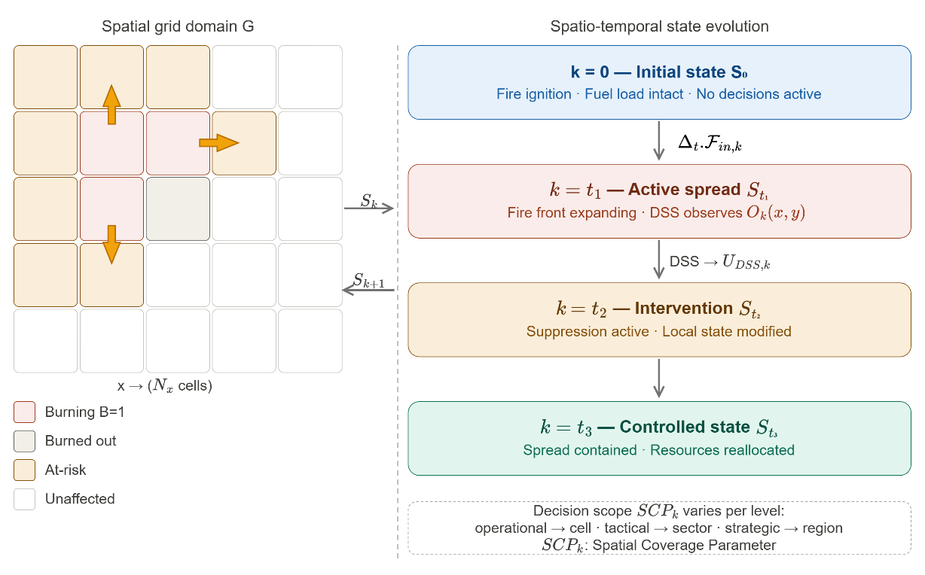
Figure 3.7 Spatio-temporal structure of wildfire DSS decision making
This multi-scale coupling means that spatial structure is not merely a visualization property but a load-bearing element of the decision architecture: the scope of each decision is determined by the spatial resolution at which the state is observable and actionable. This coupling between spatial resolution and decision scope directly how DSS mechanisms must be structured across different levels of DSS architecture.

Partial Observability and Spatial Uncertainty
In operational wildfire environments, the state $S_{k}$ is never fully observable across the entire domain. Sensor coverage is spatially sparse, remote sensing data is subject to cloud occlusion and update latency, and human observers provide information only for accessible terrain. These data are not generated internally by the simulator but are acquired from external sources such as meteorological services, geographic information systems (GIS), remote sensing platforms, and operational databases (Kyzirakos, et al., 2012). The result is a partially observed state field in which cell-level confidence varies across the domain ( 33 ) where $O_{k}⊆G$ denotes the set of observable cells at step $k$, ${\hat{S}}_{k}\left(x,y\right)$ is the estimated state, and ${\tilde{S}}_{k}\left(x,y\right)$ is an inferred estimate for unobserved cells.
$${\hat{S}}_{k}\left(x,y\right)=S_{k}\left(x,y\right)⋅1_{\left(x,y\right)∈O_{k}}+{\tilde{S}}_{k}\left(x,y\right)⋅1_{\left(x,y\right)∉O_{k}}$$ | ( 33 )
This partial observability is a fundamental property of the wildfire decision environment that any DSS must accommodate structurally, not merely as an edge case. It directly motivates the use of fuzzy inference in DisasterAware: rather than requiring precise cell-level state values, the fuzzy decision layer operates on graded membership degrees that explicitly represent the uncertainty associated with partially observed or model-estimated state variables (Thompson & Calkin, 2011; Walker, et al., 2003).
Table 3.7 summarizes these spatio-temporal properties that impose strict structural requirements on DSS design, particularly the need for spatially distributed reasoning, time-synchronous decision updates, and uncertainty-aware inference mechanisms.
Table 3.7 Spatio-temporal properties of wildfire dynamics
Property | Description | DSS Design Implication | DisasterAware Realization
Spatial heterogeneity | Fire behavior varies continuously across $G$ as a function of terrain, fuel, and wind | Decision variables must be spatially indexed fields, not scalar alternatives | Cell-level fuzzy decision makers indexed to grid coordinates (x, y)
Temporal non-stationarity | State $S_{k}$ evolves through transition at every time step k | DSS must re-evaluate decisions at each discrete time step | Event-triggered and step-synchronous inference
Multi-scale coupling | Decision scope depends on aggregation level | Different reasoning granularity per decision level | Operational: cell · Tactical: sector · Strategic: region
Partial observability | $O_{k}\left(x,y\right)= h\left(S_{k}, ϵ_{k}\right)$ only a subset of cells is observable | Reasoning must tolerate missing and uncertain state information | Fuzzy membership degrees encode observation confidence
Nonlinear spread dynamics | Spread rate $R_{spread}$ is nonlinear in wind, slope, fuel moisture | Predictive horizon is short; decisions must be rapidly revised | Short-horizon inference with adaptive reweighting
State–decision coupling | DSS outputs $U_{DSS,k}$ feed back into $F_{in,k}$ | Decision effects must be modeled as state-influencing inputs, not direct overrides | $U_{DSS,k}$ enters simulation as structured external input via $F_{in,k}$

The spatio-temporal properties described in this section establish the structural requirements that the DisasterAware Simulation Framework must satisfy. The grid domain $G$, the state vector $s_{k}(x,y)$, the state transition operator $Φ$, and the external input structure $F_{in,k}$, all formalized in Chapter 4, are direct architectural responses to the requirements of spatial indexing, temporal non-stationarity, and partial observability identified here.
Similarly, the strict separation between physical state evolution and decision logic enforced in Chapter 4 is motivated by the state-decision coupling property: decisions must enter the simulation as structured external inputs through $U_{DSS,k}$, never as direct overwrites of $S_{k}$, in order to preserve physical consistency and simulation integrity.
Specifically, a DSS must operate over spatially indexed state representations, update decisions synchronously with system evolution, and explicitly account for partial observability. These requirements directly motivate the simulation framework presented in Chapter 4 and the distributed DSS architecture developed in Chapters 5 and 6.

DISASTERAWARE SIMULATION FRAMEWORK
This chapter defines the structural, computational, and physical foundations of the DisasterAware Simulation Framework, which serves as the physical backbone of the entire architecture. Its objective is to formalize how wildfire dynamics are represented and computed before the cognitive reasoning mechanisms of the Decision Support System are introduced in the next chapter.
Wildfire evolution is modeled as a spatio-temporal process over a discretized spatial domain partitioned into grid cells. Each cell represents a localized fire condition described by structured state variables: whether combustion is active, the amount of remaining combustible fuel, local fire intensity, and combustion duration. This state-based representation treats fire propagation as a constrained dynamical system rather than a purely geometric spread.
System evolution is driven by several categories of external forcing. Meteorological drivers such as wind speed and humidity affect spread acceleration and combustion sustainability; terrain properties such as slope and aspect introduce directional bias; fuel characteristics regulate ignition thresholds and burn duration; and operational intervention parameters alter local fuel availability through suppression actions. These influences are kept architecturally separate from the internal wildfire state to preserve clarity and computational stability.
A key design principle is the strict separation between physical state evolution and decision logic. The simulation layer models wildfire behavior under environmental and operational inputs without performing reasoning, optimization, or policy selection. Human interaction and scenario manipulation are permitted only through controlled input-level modifications, never through direct state overwriting.
The Decision Support System is introduced here only to clarify its structural interface with the simulation environment; its internal fuzzy reasoning, layered decision synthesis, and optimization mechanisms are deferred to the next chapter. The remainder of this chapter is organized as follows:
Section 4.1 presents the layered architectural structure and inter-layer data flow of the DisasterAware framework.
Section 4.2mechanism, formalizes the external input sources, discrete-time state representation, state variables, hybrid fire spread transition mechanism, and interaction and scenario control.
Section 4.3 specifies the external data layers, (i.e., meteorological, terrain, fuel, value-at-risk, resource) that drive the simulation.
Section 4.4 describes the UI Dashboard as a supervisory interface for visualization and controlled scenario manipulation.
Section 4.5 introduces the structural positioning of the DSS Core within the framework, deferring the design specifications to Chapter 5 and the architectural realization to Chapter 6.
Section 4.6 synthesizes the chapter's architectural and mathematical contributions and transitions to the DSS design specifications in Chapter 5.
Through this structured progression, Chapter 4 establishes the physically grounded computational environment required for reliable, interpretable, and scalable decision support in wildfire management.

Overall System Block Diagram
Figure 4.1 presents the architectural structure of the DisasterAware Simulation Framework. The system is designed as a discrete-time, state-driven, layered DSS architecture with a clear separation between input acquisition, physical state evolution, decision evaluation, and human interaction. The architectural objective is to preserve physical consistency within wildfire simulation while enabling adaptive and interpretable decision-making.
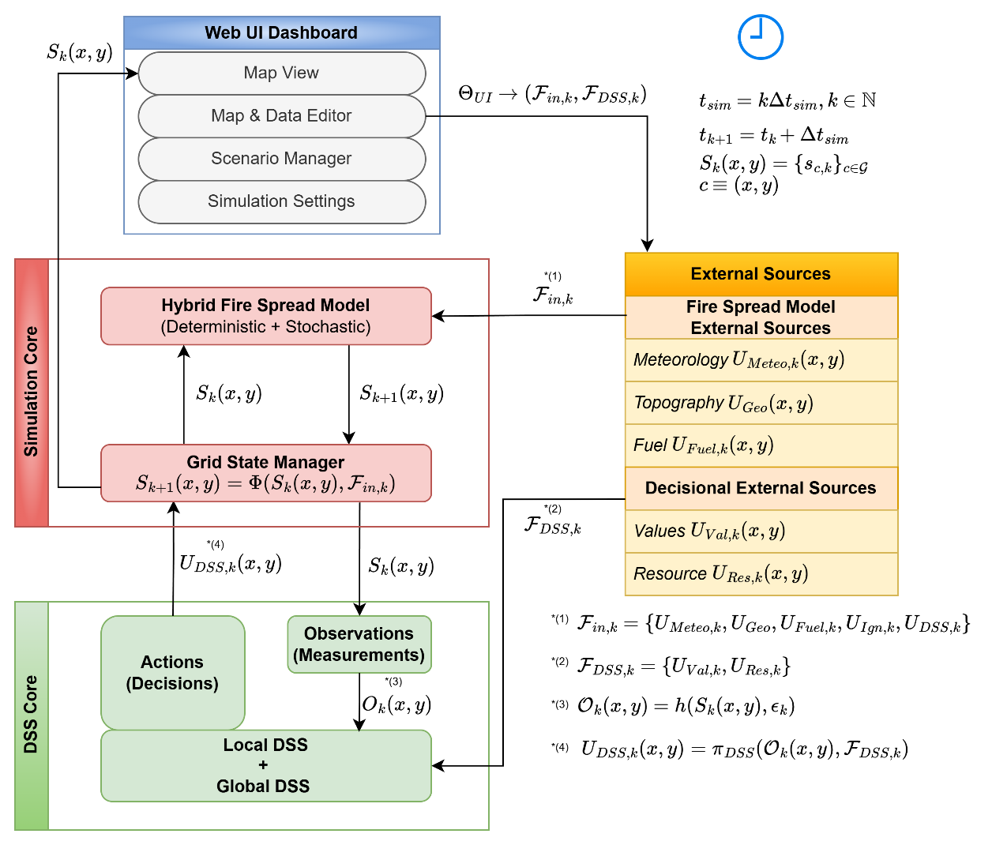
Figure 4.1 DisasterAware system block diagram
The architecture is organized into four principal layers: External Data Sources, Simulation Core, Decision Support System (DSS) Core, and Web UI Dashboard. Each layer performs a strictly defined function and communicates through structured interfaces rather than direct state manipulation. This separation ensures physical consistency, operational robustness, and architectural transparency.
The External Data Sources layer provides structured exogenous inputs including meteorological, terrain, fuel, and decisional parameters. Detailed formulation of these inputs is provided in Section 4.2.1. These inputs act as boundary conditions for the simulation. Environmental inputs are independent of the system state, while decision-driven inputs generated by the DSS depend on observable quantities derived from the system state.
At the center of the framework lies the Simulation Core, which serves as the authoritative computational engine. Wildfire propagation is modeled over a spatial grid where each cell contains a structured representation of local fire conditions. The complete wildfire state includes burning status, available combustible mass, local fire intensity proxy, and time since ignition. This state is maintained and updated at every simulation time step. The Grid State Manager enforces physical constraints such as non-negativity of fuel load and bounded combustion behavior. No external module, including the DSS or the UI, is permitted to directly overwrite internal state variables. All modifications must occur through controlled parameter influence, preserving simulation integrity.
The Decision Support System Core operates as a cognitive layer built on top of the Simulation Core. The DSS operates on observable quantities $O_{k}\left(x,y\right)$ derived from the system state through the observation process. This observation layer extracts structured indicators from the raw state variables, such as fire front behavior, acceleration zones, exposure metrics, and operational accessibility conditions.
The DSS can evaluate conditions at every simulation time step, but decision activation may follow event-triggered conditions. It may operate in an event-driven manner, producing intervention strategies only when predefined thresholds or risk conditions are triggered. When a decision is generated, it is translated into operational parameters that influence subsequent state transitions indirectly through the simulation engine.
The Web UI Dashboard forms the operational boundary between human operators and the computational layers. Unlike the Simulation Core, which is time-synchronous, the UI layer operates asynchronously. The operator can pause the simulation; resume execution; roll back to a stored checkpoint; restart from initial conditions; inject new ignition scenarios; modify operational resource availability; and cancel an active simulation.
Importantly, the UI never directly modifies internal state variables. Instead, it adjusts permissible configuration parameters that affect future simulation steps. This ensures that human intervention remains controlled, traceable, and reversible.
The data flow between layers follows a strict directional structure:
- External inputs feed the Simulation Core at each time step.
- The Simulation Core updates the authoritative wildfire state.
- The DSS observes the current state through observable information $O_{k}\left(x,y\right)$, uses contextual decision inputs $F_{DSS,k}$, evaluates risk, and generates structured intervention recommendations when required.
- The UI visualizes both physical state evolution and DSS outputs while allowing controlled scenario manipulation.
As shown in Figure 4.1, this layered organization enforces a clear separation between wildfire physics, decision cognition, and human supervision. The architecture guarantees: (i) Physical consistency of fire propagation; (ii) Modular extensibility; (iii) Horizontal scalability; (iv) Traceable intervention logic; (v) Robust HIL control.
By maintaining strict boundaries between simulation dynamics and decision reasoning, the framework establishes a stable computational foundation upon which distributed fuzzy reasoning and adaptive coordination mechanisms can be constructed in subsequent chapters.

Mathematical Model of the Simulation Core
This section formalizes the discrete-time wildfire simulation dynamics implemented in the DisasterAware Simulation Core. The objective is to represent wildfire propagation over the spatial grid $G\left(x,y\right)$ using a structured state-space formulation that clearly separates spatial domain definition, physical propagation dynamics, external forcing, and controlled user interaction.
The Simulation Core operates as a discrete-time state evolution system defined over a spatially discretized domain. At each simulation step, the system receives environmental forcing inputs, updates the wildfire state over the grid, and produces the next state through a structured transition mechanism. The Simulation Core is organized around four functional components: the external input structure, the spatial grid and state representation, the wildfire state-transition mechanism, and the interaction layer for controlled scenario manipulation. Together, these components define how wildfire dynamics are represented, updated, and influenced within the DisasterAware simulation environment.
The external input structure defines meteorological, terrain, fuel, ignition, and decision-related inputs in Section 4.2.1. The spatial representation defines the discretized grid and the wildfire state variables associated with each cell in Section 4.2.2. The transition mechanism governs burning persistence, spatial propagation, fuel consumption, and intensity evolution in Section 4.2.3. The interaction layer enables admissible user intervention without direct modification of the internal wildfire state in Section 4.2.4.

External Input Sources
The external input $F_{in,k}$ represents all parameters that influence wildfire evolution at discrete time step $k$. These inputs include both exogenous environmental factors and decision-driven intervention parameters generated by the DSS. These inputs act as boundary conditions and forcing mechanisms for the state transition process. Environmental inputs are updated independently of the system state, whereas decision-driven inputs depend on observable quantities derived from the state. At each discrete simulation step $k$, the external input set is updated and provided to the Simulation Core.
External inputs can be categorized into three distinct groups: (i) Environmental input: including meteorological, terrain, and fuel-related factors that govern physical wildfire dynamics; (ii) Exogenous event inputs: such as ignition events, which trigger fire initiation independently of system evolution; (iii) Decision-driven inputs: intervention parameters generated by the DSS, representing operational actions influencing wildfire evolution.
$F_{in,k}$ ( 34 ) represents all external parameters that influence wildfire dynamics, namely meteorology $U_{Meteo,k}$ ( 35 ), topography $U_{Geo}$ ( 36 ), fuel $U_{Fuel\text{,k}}$ ( 37 ), ignition $U_{Ign,k}$ ( 38 ) and inputs generated by DSS $U_{DSS,k}$ ( 39 ). This structured separation ensures that environmental forcing, ignition triggering, and operational intervention remain conceptually and functionally distinct.
$$F_{in,k}=\left\{U_{Meteo,k},U_{Geo}, {U_{Fuel\text{,k}}, U_{Ign,k}, U}_{DSS,k}\right\}$$ | ( 34 )
In addition to the simulation input set $F_{in,k}$, the DSS process relies on a distinct contextual input set defined as $F_{DSS,k}= \{U_{Val,k}, U_{Res,k}$}. This set represents value-related and resource-related information used by the DSS for decision evaluation. Unlike $F_{in,k}$, which directly influences the state transition operator, $F_{DSS,k}$ does not affect wildfire dynamics directly. Instead, it provides contextual information that guides decision-generation within the DSS layer.
Meteorological inputs $U_{Meteo,k}$ ( 35 ) are spatio-temporal environmental drivers that directly influence ignition sustainability, rate of spread, fuel drying, and combustion intensity. These fields are updated at every discrete simulation step to ensure dynamic adaptation of wildfire behavior to evolving environmental conditions.
$$U_{Meteo,k}\left(x,y\right)=\left[\begin{aligned}W_{temp,k}\left(x,y\right) \\ W_{rh,k}\left(x,y\right) \\ W_{ws,k}\left(x,y\right) \\ W_{wd,k}\left(x,y\right) \\ W_{gust,k}\left(x,y\right) \\ W_{prec,k}\end{aligned}\right]$$  $W_{temp,k}\left(x,y\right)$: Air temperature field  $W_{rh,k}\left(x,y\right)$: Relative humidity field  $W_{ws,k}\left(x,y\right)$: Wind speed field  $W_{wd,k}\left(x,y\right)$: Wind direction field  $W_{gust,k}\left(x,y\right)$: Wind gust field  $W_{prec,k}$: Precipitation (temporal form) | ( 35 )
Terrain parameters $U_{Geo}$ ( 36 ) define static spatial constraints over which wildfire propagation occurs. Unlike meteorological variables, these parameters remain constant during short-horizon simulation but modulate directional spread, acceleration, and accessibility.
$$U_{Geo}\left(x,y\right)=\left[\begin{aligned}G_{elev}\left(x,y\right) \\ G_{slope}\left(x,y\right) \\ G_{aspect}\left(x,y\right) \\ G_{access}\left(x,y\right)\end{aligned}\right]$$  $G_{elev}\left(x,y\right)$: Elevation  $G_{slope}\left(x,y\right)$: Terrain slope  $G_{aspect}\left(x,y\right)$: Terrain orientation  $G_{access}\left(x,y\right)$: Accessibility level | ( 36 )
Fuel-related inputs $U_{Fuel,k}$ ( 37 ) describe the combustible material available at each grid cell. $F_{\text{type}}\left(x,y\right)$ is the vegetation class and $F_{load,0}\left(x,y\right)$ is the available combustible mass at initial time. Fuel moisture $F_{moist,k}\left(x,y\right)$ is treated as an exogenous spatio-temporal input field updated from meteorological drivers or scenario configurations.
$$U_{Fuel,k}\left(x,y\right)=\left[\begin{aligned}F_{\text{type}}\left(x,y\right) \\ F_{load,0}\left(x,y\right) \\ F_{\text{moist,k}}\left(x,y\right)\end{aligned}\right]$$  $F_{\text{type}}\left(x,y\right)$: Vegetation/fuel class  $F_{load,0}\left(x,y\right)$: Available combustible mass at initial time at $k=0$  $F_{\text{moist,k}}\left(x,y\right)$: Surface fuel moisture content | ( 37 )
Ignition is modeled separately from fire intensity. It represents the activation of combustion at a specific grid cell and time step. Ignition may originate from predefined initial conditions, external events, or spotting effects. It functions as a triggering mechanism within the transition dynamics and does not constitute a persistent state variable.
$$U_{Ign,k}\left(x,y\right)=\left[\begin{aligned}I_{Ign,k}\left(x,y\right)\end{aligned}\right]$$  $I_{\text{Ign,k}}\left(x,y\right)$: Binary ignition injection indicator | ( 38 )
The DSS layer generates decision-driven intervention parameters $U_{DSS,k}$ ( 39 ) based on observed system conditions. These parameters do not represent physical measurements but structured representations of operational actions, which are incorporated into the external input set to influence wildfire dynamics.
$$U_{DSS,k}\left(x,y\right)= \left[\begin{aligned}R_{cap,k}\left(x,y\right) \\ R_{avail,k}\left(x,y\right) \\ R_{eff,k}\left(x,y\right) \\ R_{time,k}\left(x,y\right)\end{aligned}\right]$$  $R_{cap,k}\left(x,y\right)$: Available suppression capacity  $R_{avail,k}\left(x,y\right):$ Operational availability status of resources  $R_{eff,k}\left(x,y\right):$ Suppression effectiveness  $R_{time,k}\left(x,y\right):$ Estimated travel time to reach grid cell $\left(x, y\right)$ | ( 39 )
By structuring the external input subsystem into meteorological forcing, terrain constraints, fuel properties, ignition triggers, and operational intervention parameters, the architecture preserves a clear separation between environmental dynamics, fire initiation, and decision-driven mitigation. This modular organization guarantees that physical wildfire behavior remains consistent while enabling adaptive and controlled intervention strategies.

Spatio-Temporal State Transition
The discretized grid map $G$ defines the computational approximation of the continuous geographic wildfire environment. Each grid cell corresponds to a spatial coordinate pair $\left(x, y\right)$ and represents a localized fire condition ( 40 ).
$$G=\left\{\left(x,y\right) ∣ x=1,…,N_{x}, y=1,…,N_{y}\right\}$$  $N_{x}$ is the number of grid cells along the horizontal spatial axis,  $N_{y}$ is the number of grid cells along the vertical spatial axis,  $\left(x,y\right)∈G$ denotes a discrete grid cell coordinate. | ( 40 )
At each simulation step, the wildfire state over the grid is represented by $S_{k}$. The system state is defined as the collection of local cell states over the domain ( 41 ).
$$S_{k}=\left\{s_{k}\left(x,y\right)|(x,y)∈G\right\}$$  $$s_{k}=\left[\begin{aligned}B_{k}\left(x,y\right) \\ F_{load,k}\left(x,y\right) \\ I_{k}\left(x,y\right) \\ τ_{k}\left(x,y\right)\end{aligned}\right]$$  $B_{k}\left(x,y\right)$: Burning status of grid $\left(x,y\right)$  $F_{load,k}\left(x,y\right)$: Available combustible mass  $I_{k}\left(x,y\right)$: Local fire intensity proxy  $τ_{k}\left(x,y\right)$: Time since ignition | ( 41 )
The state vector includes only internal wildfire variables. Environmental factors and operational interventions are not part of the state and are represented as external inputs influencing the state transition.
By representing wildfire evolution as a grid-based state-space system, the framework enables localized propagation analysis; cell-level intervention control; consistent discrete-time state evolution; and direct integration with decision-layer observation mechanisms. This structured state representation forms the foundation for the hybrid transition operator introduced in the subsequent section.
Figure 4.2 illustrates the three-step relationship between the continuous geographic domain $Ω$, its discretization into the grid $G$ of Equation ( 40 ), and the four-component cell state vector $s_{k}\left(x, y\right)$ of Equation ( 41 ) that serves as the authoritative state representation throughout the Simulation Core.
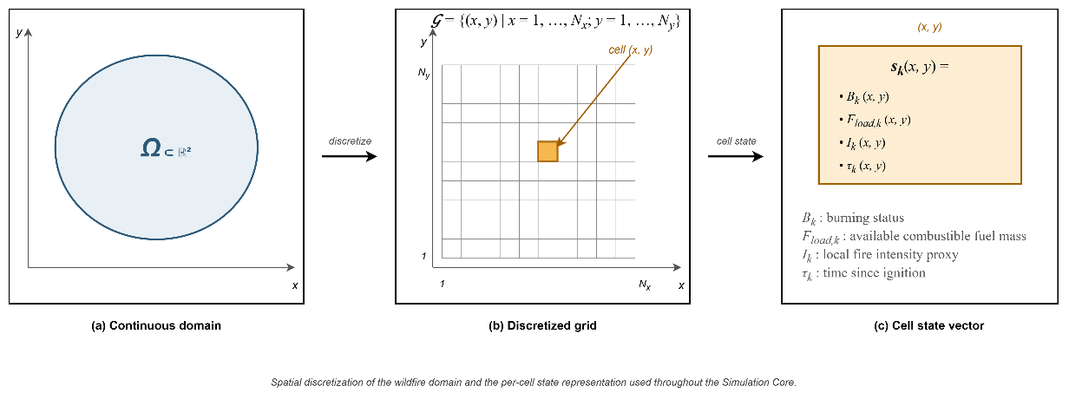
Figure 4.2 Grid domain representation and per-cell state structure

Hybrid Fire Spread Model
The hybrid model integrates deterministic combustion dynamics with stochastic variability to represent realistic wildfire behavior. The global state evolution ( 42 ) is governed by the transition operator where $F_{in,k}$ ( 34 ) includes meteorological forcing, topography, fuel conditions, ignition injection, and DSS-generated intervention parameters. $Φ$ denotes the structured state transition operator composed of burning status evolution, fuel mass evolution, and fire intensity update as defined in the subsequent subsections. The transition operator itself is deterministic. Stochastic variability may arise only through exogenous input fields (e.g., wind gust fluctuations), which are treated as externally provided spatio-temporal inputs.
$$S_{k+1}\left(x,y\right)=Φ\left(S_{k}\left(x,y\right),F_{in,k}\right)$$  $$F_{in,k}=\left\{U_{Meteo,k},U_{Geo}, {U_{Fuel\text{,k}}, U_{Ign,k}, U}_{DSS,k}\right\}$$ | ( 42 )
The transition for each cell satisfies the coupled equations for each grid cell $\left(x,y\right)∈G$, and the update consists of three coupled components: burning status evolution, fuel mass evolution, and fire intensity evolution. Decision-driven inputs $U_{DSS,k}$ influence the transition ensuring that intervention effects are propagated indirectly through the physical model.
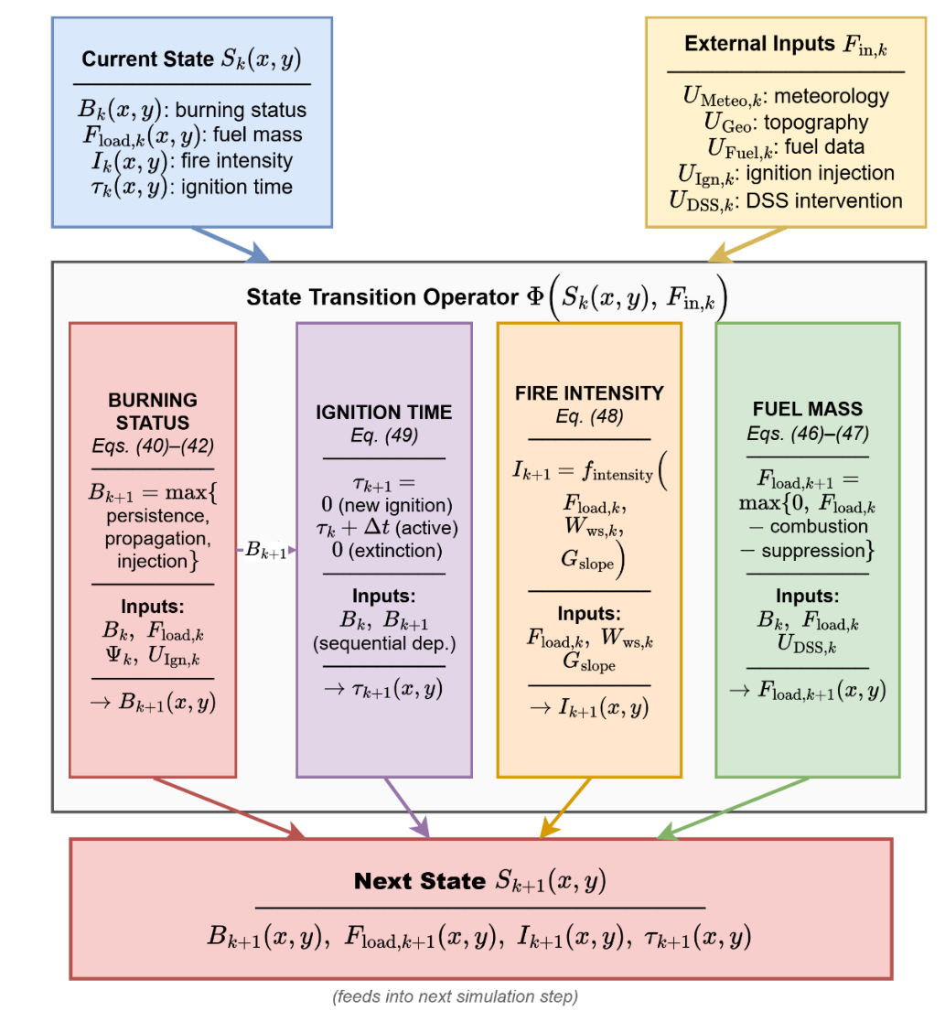
Figure 4.3 Hybrid fire spread transition mechanism
Figure 4.3 decomposes the hybrid transition operator Φ into four parallel update mechanisms, each corresponding to one component of the cell-level state vector $s_{k}(x,y) = \left(B_{k}, F_{load,k}, I_{k}, τ_{k}\right).$ The Burning Status mechanism ( 43 )–( 45 ) combines persistence, propagation, and external ignition injection to produce $B_{k+1}$. The Fuel Mass mechanism ( 49 )–( 50 ) applies combustion-driven depletion, conditioned on $B_{k} = 1$, and suppression-driven reduction, driven by $U_{DSS,k}$, under a non-negativity constraint, yielding $F_{load,k+1}$. The Fire Intensity mechanism ( 51 ) evaluates the intensity function $f_{intensity}$ over current fuel, wind speed, and terrain slope to produce $I_{k+1}$, intentionally excluding any feedback from $I_{k}$ itself in order to preserve the role of intensity as a purely descriptive proxy. The Ignition Time mechanism ( 52 ) updates $τ_{k+1}$ according to the ignition-initialization, active-burning, or extinction rule, and exhibits a distinctive sequential dependency on both $B_k$ and the just-computed $B_{k+1}$, indicated in the figure by the dashed horizontal arrow. Exogenous forcing enters the operator exclusively through the external input set $F_{in,k}$, preserving the architectural separation between physical dynamics and decision-driven inputs established in Section 4.1.
Burning Status Evolution (${B_{k}\left(x,y\right) →B}_{k+1}\left(x,y\right)$)
The burning status $B_{k}\left(x,y\right)∈\left\{0,1\right\}$ indicates whether the cell is actively burning at time step $k$. The burning status at the next step $B_{k+1}$ ( 43 ) is determined by three mechanisms: persistence of ongoing burning $B_{k+1}^{pers}$ ( 44 ), propagation from neighboring burning cells, and external ignition injection $I_{Ign,k}\left(x,y\right)$. Combining these three mechanisms, the burning status update rule is defined as ( 43 ).
$$B_{k+1}\left(x,y\right)=\max\left(B_{k+1}^{pers}\left(x,y\right),B_{k+1}^{prop}\left(x,y\right),I_{Ign,k}\left(x,y\right)\right)$$ | ( 43 )
This formulation ensures that a burning cell persists while fuel remains available; neighboring burning cells may activate a new cell if sufficient spread influence accumulates; external ignition acts as an independent triggering mechanism.
The persistence term $B_{k+1}^{pers}$ ensures that a cell that is already burning remains burning as long as fuel exists( 44 ) where $1\left[∙\right]$ denotes the indicator function. To avoid numerical persistence under vanishing residual fuel mass, a small extinction threshold $ϵ_{fuel_{load}}$ is used.
$$B_{k+1}^{pers}\left(x,y\right)=B_{k}\left(x,y\right)⋅1\left[F_{load,k}\left(x,y\right)>ϵ_{fuel_{load}} \right]$$  $$ϵ_{fuel_{load}}={10}^{-4}$$ | ( 44 )
Propagation to cell $\left(x,y\right)$ occurs if the accumulated influence exceeds a critical ignition threshold $Θ_{ign}$, where $Θ_{ign}$ is a model parameter representing the minimum spread intensity required to activate combustion in a new cell ( 45 ).
$$B_{k+1}^{prop}\left(x,y\right)=1\left[Ψ_{k}\left(x,y\right)> Θ_{ign}\right]$$  $Θ_{ign}∈\left(0,1\right)$: calibrated threshold relative to base spread rate | ( 45 )
Wildfire spread to neighboring cells is modeled through local propagation influence. $N^{8}\left(x,y\right)$ denotes the 8-connected neighborhood of cell $\left(x,y\right)$. The total propagation influence received by cell $\left(x,y\right)$ at time step $k$ $Ψ_{k}\left(x,y\right)$ is defined ( 46 ) where rate of spread $R_{spread,k}\left(x,y\right)$ is ( 47 ). The rate-of-spread mapping $f_{ros}\left(⋅\right)$ is instantiated using a semi-empirical Rothermel-type formulation (Rothermel, 1972). Detailed parameterization is provided in Appendix A.
$$Ψ_{k}\left(x,y\right)=\frac{1}{8}\sum_{\left(i,j)∈N^{8}(x,y\right)}{B_{k}}\left(i,j\right)⋅R_{spread,k}\left(i,j\right)⋅ g_{dir,k}^{\left(i,j)→(x,y\right)}$$ | ( 46 )
$$R_{spread,k}\left(x,y\right)=f_{ros}\left(\begin{aligned}W_{ws,k}\left(x,y\right), W_{wd,k}\left(x,y\right), \\ {G_{slope}\left(x,y\right),G}_{aspect}\left(x,y\right), \\ F_{moist,k}\left(x,y\right),F_{type}\left(x,y\right) \end{aligned}\right)$$  $f_{ros}$: function rate-of-spread (Appendix A)  $W_{ws,k}\left(x,y\right)$: wind speed field  $W_{wd,k}\left(x,y\right)$: wind direction field  $G_{slope}\left(x,y\right)$: terrain slope  $G_{aspect}\left(x,y\right)$: terrain orientation  $F_{moist,k}\left(x,y\right)$: fuel surface moisture  $F_{type}\left(x,y\right)$: fuel type | ( 47 )
The scalar magnitude $R_{spread,k}\left(x,y\right)$ does not determine spread direction. Directional influence ( 48 ) is introduced when propagating fire from a burning neighbor $\left(i , j\right)$ to target cell $\left(x,y\right)$. $θ_{\left(i,j)→(x,y\right)}$ is the geometric direction between cells. This ensures anisotropic spread aligned with wind direction.
$$g_{dir,k}^{\left(i,j)→(x,y\right)}=\max\left(0,\cos\left(W_{wd,k}\left(i,j\right)-θ_{\left(i,j)→(x,y\right)}\right)\right)$$ | ( 48 )
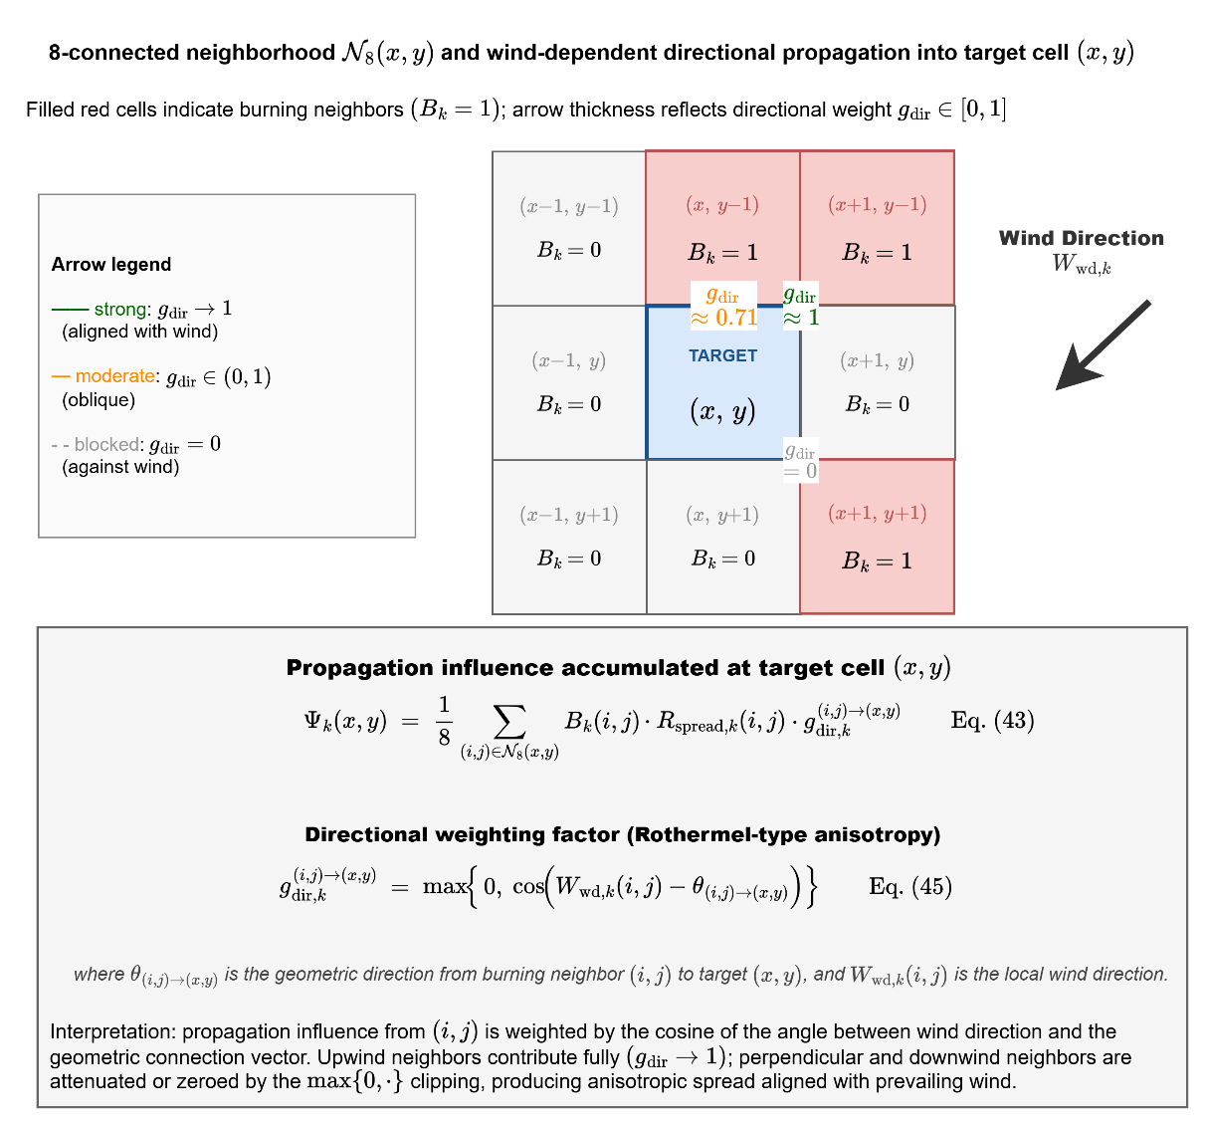
Figure 4.4 Wind-dependent directional propagation into target cell
Figure 4.4 depicts the spatial structure of the propagation influence accumulation. The 3×3 stencil centered on the target cell $(x,y)$ represents the 8-connected neighborhood $N_{8\left(x,y\right)}$ defined in ( 46 ); the three cells shaded in red denote burning neighbors with $B_{k}\left(i,j\right) = 1$, while the remaining five are non-burning. The wind direction $W_{wd,k}$, represented by the large arrow in the upper-right region of the figure, establishes the axis of anisotropy.
For each burning neighbor, a propagation arrow is drawn toward the target cell with line weight proportional to its directional weight $g_{dir,k}^{\left(i,j\right)→\left(x,y\right)}$: the arrow from the northeast neighbor is aligned with the wind vector and therefore receives full weight $g_{dir} → 1$; the arrow from the northern neighbor is oblique and receives an intermediate weight $g_{dir} ≈ 0.71$; and the arrow from the southeastern neighbor is oriented opposite to the wind and is entirely eliminated, $g_{dir} = 0$, by the $max\left\{0, ·\right\}$ clipping. The aggregate propagation influence $Ψ_{k}\left(x,y\right)$ computed through ( 46 ) is therefore not a symmetric average over the 8-neighborhood but a wind-aligned weighted sum, and the ignition condition $Ψ_{k}(x,y) > Θ_{ign}$ $REF _Ref223041204 \backslash h$( 45 ) is consequently satisfied preferentially along the direction of prevailing wind. This mechanism realizes the Rothermel-type directional bias that is central to operationally realistic wildfire propagation.
External ignition injection $I_{Ign,k}\left(x,y\right)∈\left\{0,1\right\}$ directly activates combustion independent of neighbor influence. Ignition injection may represent lightning strikes, human-caused ignition, or scenario-based ignition input from the UI layer.
It is important to emphasize that ignition injection $I_{Ign,k}\left(x,y\right)$ is not part of the persistent state vector. It is an external triggering input defined under $U_{Ign,k}\left(x,y\right)$. Ignition injection is a scenario-level forcing that sets $B_{k+1}\left(x,y\right)=1$ regardless of local conditions; if $F_{load,k}\left(x,y\right)$ is insufficient, extinction follows naturally via the persistence condition in the next step. In contrast, the local fire intensity proxy $I_{k}\left(x,y\right)$ represents combustion strength after ignition has occurred and does not participate in the activation condition. This separation preserves conceptual clarity between fire initiation and fire magnitude.
Through this formulation, burning status evolution is explicitly linked to spatial coupling, fuel availability, and ignition forcing, thereby establishing a physically interpretable and DSS compatible propagation mechanism.
Propagation dynamics are governed exclusively by the rate-of-spread mapping $R_{spread,k}\left(x,y\right)$. The local fire intensity proxy does not directly influence activation conditions; instead, it modulates suppression effectiveness and decision-layer interpretation. This separation preserves structural clarity between spread mechanics and combustion strength representation. Thus, intensity affects wildfire dynamics indirectly through suppression resistance and decision-layer interpretation, rather than directly controlling fire propagation.
The rate-of-spread mapping $R_{spread,k}\left(x,y\right)$ is independent of instantaneous fuel mass $F_{load,k}\left(x,y\right)$. Fuel availability influences spread only indirectly through the burning persistence condition, preventing propagation from fuel-depleted cells. This structural separation avoids double- counting mitigation effects.
Fuel Mass Evolution ($F_{load,k}\left(x,y\right) →F_{load,k+1 }\left(x,y\right)$)
Fuel mass evolution governs the depletion of combustible material within each cell as a consequence of two distinct mechanisms: combustion-driven consumption and intervention-driven suppression. Unlike the burning status variable, which represents the activation of combustion, the fuel mass variable represents the remaining energy potential available for future fire propagation. Therefore, accurate modeling of fuel evolution is essential to ensure physical consistency, numerical stability, and interpretable interaction between wildfire dynamics and decision-driven mitigation. Combustion-driven consumption and suppression-driven reduction are applied within the same discrete step $k$ as a simultaneous update, represented by the combined terms in ( 49 ):
$$F_{load,k+1}\left(x,y\right)=\max\left(\begin{aligned}0, \left(\begin{aligned}F_{load,k}\left(x,y\right) \\ -F_{load,k}\left(x,y\right) B_{k}\left(x,y\right) F_{burn,k}\left(x,y\right) \\ -F_{red,k}\left(x,y\right)\end{aligned}\right)\end{aligned}\right)$$  $B_{k}\left(x,y\right)∈\left\{0,1\right\}$: the burning status indicator,  $F_{burn,k}\left(x,y\right)∈\left[0,1\right]$: the fractional burn rate (Appendix B),  $F_{load,k}\left(x,y\right)$: the currently available fuel mass.  $F_{red,k}\left(x,y\right)∈\left[0,1\right]$: intervention-based fuel reduction  Constraints: $0≤F_{load,k+1}\left(x,y\right)≤1$ | ( 49 )
Fuel cannot become negative and cannot increase unless explicitly modeled. This formulation explicitly separates combustion-induced depletion from suppression-induced reduction while enforcing non-negativity of fuel mass.
Fuel consumption due to combustion occurs only when the cell is actively burning. The term $B_{k}\left(x,y\right) F_{load,k}\left(x,y\right) F_{burn,k}\left(x,y\right)$ represents the fraction of available fuel consumed during the current simulation step. The multiplication by $B_{k}\left(x,y\right)$ ensures that fuel depletion due to combustion occurs only in actively burning cells. If the cell is not burning, no combustion-driven reduction takes place. This preserves physical realism and prevents unintended fuel decay in inactive regions. The burn fraction $F_{burn,k}\left(x,y\right)$ captures the local combustion intensity per time step and can be interpreted as a discretized approximation of heat-release-driven fuel consumption. The suppression-induced fuel reduction term $F_{red,k}\left(x,y\right)$ is computed from decision-driven inputs $U_{DSS,k}\left(x,y\right)$ and is not an independent external input.
On the other hand, operational intervention modifies the fuel state through the suppression term ( 50 ). This mapping converts operational capability and reachability into a normalized fuel reduction effect. The suppression term may represent water or retardant application; mechanical fuel removal; controlled burn operations; and resource-constrained mitigation strategies.
$$F_{red,k}\left(x,y\right)=f_{supp} \left(\begin{aligned}R_{cap,k}\left(x,y\right),R_{avail,k}\left(x,y\right),R_{eff,k}\left(x,y\right), \\ R_{time,k}\left(x,y\right),G_{access}\left(x,y\right)\end{aligned}\right)$$  $f_{supp}$: Suppression to fuel reduction map (Appendix B)  $R_{cap,k}$: available suppression capacity  $R_{avail,k}$: operational availability status of resources  $R_{eff,k}\left(x,y\right)$: suppression effectiveness at cell $\left(x , y\right)$  $R_{time,k}\left(x,y\right)$: estimated travel time to reach $\left(x , y\right)$  $G_{access}\left(x,y\right)$: accessibility level at grid cell $\left(x , y\right)$ | ( 50 )
Importantly, suppression does not directly overwrite the burning state. Instead, it modifies the available fuel mass, which subsequently influences combustion persistence and propagation through the transition operator. This separation guarantees architectural clarity between physical wildfire dynamics and decision-driven intervention mechanisms.
The function $f_{supp}\left(⋅\right)$ is a suppression-to-mitigation mapping that converts operational capability and reachability into a normalized fuel-reduction (or mitigation) effect.
Fire Intensity Evolution ${I_{k}\left(x,y\right) →I}_{k+1}\left(x,y\right)$
The local fire intensity proxy evolves according to ( 51 ). The function $f_{intensity}\left(⋅\right)$ approximates local fire strength as a function of available fuel, wind forcing, and terrain gradient. $I_{k+1}\left(x,y\right)$ denotes the updated intensity at the next time step; $I_{k}$ does not appear as an argument of $f_{intensity}$.
$$I_{k+1}\left(x,y\right)=f_{intensity}\left(F_{load,k}\left(x,y\right),W_{ws,k}\left(x,y\right),G_{slope}\left(x,y\right)\right)$$  $f_{intensity}$: local fire strength function (Appendix C)  $F_{load,k}\left(x,y\right)$: the available combustible mass  $W_{ws,k}\left(x,y\right)$: wind speed  $G_{slope}\left(x,y\right)$: terrain slope | ( 51 )
The fire intensity proxy serves as an intermediate physical-descriptive variable with the following roles: it does not control ignition activation; it does not directly modify the spread operator; it influences suppression effectiveness through the intervention mapping; and it provides structured features to the Decision Support System. Thus, intensity is a bounded combustion-strength indicator that links environmental forcing to operational response without introducing thermodynamic complexity.
Ignition Time Evolution ${{τ }_{k}\left(x,y\right) →τ}_{k+1}\left(x,y\right)$
The ignition time variable $τ_{k}\left(x,y\right)$ represents the time elapsed since the most recent ignition event at grid cell $\left(x , y\right)$. Unlike fuel mass or intensity, $τ_{k}$ does not influence combustion physics directly. Instead, it serves as a temporal memory state that preserves the burning history of the cell. $τ_{k}$ is a useful state for decision features and explainability within the DSS layer. A deterministic update is ( 52 )
$$τ_{k+1}\left(x,y\right)=\left\{\begin{matrix}0, & B_{k+1}=1∧B_{k}=0 \\ τ_{k}+Δt, & B_{k+1}=1∧B_{k}=1 \\ 0, & B_{k+1}=0\end{matrix}\right.$$ | ( 52 )
This update has three distinct operational meanings:
- Ignition Initialization: When a cell transitions from non-burning to burning $B_{k}=0, B_{k+1}=1,$ the ignition clock is initialized: $τ_{k+1}=0$. This marks the start of a new combustion phase.
- Active Burning Progression: When a cell remains in the burning state $B_{k}=1, B_{k+1}=1$, the ignition time increases linearly: $τ_{k+1}=τ_{k}+Δt.$ Thus, $τ_{k}$ measures the residence time of active combustion at the cell.
- Extinction Reset: When combustion ceases $B_{k+1}=0,$ the ignition clock resets to 0. It ensures extinguished cells carry no residual temporal memory.
$τ_{k}$ does not feed back into the burning activation condition in the present model, preserving the separation between physical fire dynamics and temporal descriptors.

Mathematical Formulation of Interaction and Scenario Control
The Interaction and Scenario Control mechanism enables controlled human intervention within the DisasterAware framework while preserving the physical consistency of wildfire dynamics. In contrast to conventional simulation systems where user actions may directly alter system states, the proposed framework enforces strict state immutability and represents interaction as a structured transformation applied to the input and decision-context layers.
The external simulation input set is $F_{in,k}=\left\{U_{Meteo,k},U_{Geo},U_{Fuel,k},U_{Ign,k},U_{DSS,k}\right\}$ and decision-context set is $F_{DSS,k}=\left\{U_{Val,k},U_{Res,k}\right\}$. User interaction is modeled through an operator as ( 53 ) where $Θ_{UI}\left(⋅\right)$ represents controlled modifications applied through the UI. This operator enables the user to intervene in both the simulation input layer and the decision-context layer without introducing a separate input category.
$$\left(F_{in,k}^{*},F_{DSS,k}^{*})=Θ_{UI}(F_{in,k},F_{DSS,k}\right)$$ | ( 53 )
Definition 4.1 (User Interaction Operator). The user interaction operator $Θ_{UI}$ is a structured input transformation mapping that produces admissible modifications of the external input set and decision-context set ( 54 ).
$$Θ_{UI}:F_{in}×F_{DSS} ⟶ F_{in}^{*}×F_{DSS}^{*}$$  $$\left(F_{in,k}^{*}, F_{DSS,k}^{*})=Θ_{UI}(F_{in,k}, F_{DSS,k}\right)$$ | ( 54 )
The operator acts independently on five admissible inputs. For each component, the admissible transformation is defined by a bounded perturbation set in Table 4.1. All unmodified components pass through unchanged: $U_{Geo}^{*}=U_{Geo}$, $U_{Fuel,k}^{*}=U_{Fuel,k}$.
Table 4.1 Admissible transformations of interaction operator
Component | Admissible transformation | Constraint
Ignition injection $U_{Ign,k}$ | $$U_{Ign,k}^{*}\left(x,y\right)=U_{Ign,k}\left(x,y\right)+δ_{Ign}\left(x,y\right)$$ | $$U_{Ign,k}^{*}∈\left\{0,1\right\}$$
Meteorological input $U_{Meteo,k}$ | $$U_{Meteo,k}^{*}=U_{Meteo,k}+δ_{Meteo}$$ | $$U_{Meteo,k}^{*}∈U_{Meteo}$$
Resource parameters $U_{DSS,k}$ | $$U_{DSS,k}^{*}\left(x,y\right)=U_{DSS,k}\left(x,y\right)+δ_{DSS}\left(x,y\right)$$ | $$U_{DSS,k}^{*}∈\left[0,1\right]$$
Value context $U_{Val,k}$ | $$U_{Val,k}^{*}\left(x,y\right)=σ_{Val}⋅U_{Val,k}\left(x,y\right)$$ | $σ_{Val}∈\left[0,1\right]$, $U_{Val,k}^{*}∈\left[0,1\right]$
Resource availability $U_{Res,k}$ | $$U_{Res,k}^{*}\left(x,y\right)=U_{Res,k}\left(x,y\right)+δ_{Res}\left(x,y\right)$$ | $$U_{Res,k}^{*}∈\left[0,1\right]$$

Remark 4.1 (State Immutability): The operator $Θ_{UI}$ acts exclusively on the external input set $F_{in,k}$ and decision-context set $F_{DSS,k}$. The system state $S_{k}\left(x,y\right)$ is not in the domain of $Θ_{UI}$, $\frac{∂S_{k}}{∂Θ_{UI}}=0$. All user influence therefore propagates through physically consistent state transitions $S_{k+1}=Φ\left(S_{k},F_{in,k}^{*}\right)$, preserving the causal structure and state immutability established in Section 4.1.
Remark 4.2 (Temporal Scope). $Θ_{UI}$ modifies only future state transitions. It does not alter the current state $S_{k}$ or any previously realized state $S_{j}$, $j<k$. This ensures that scenario exploration and operational overrides are prospective, not retrospective.
The modified decision-context set influences decision generation $U_{DSS,k}=π_{DSS}\left(O_{k},F_{DSS,k}^{*}\right)$ and the modified simulation input set governs system evolution $S_{k+1}=Φ\left(S_{k},F_{in,k}^{*}\right)$. A fundamental constraint of the framework is that user interaction does not directly modify the system state $\frac{∂S_{k}}{∂Θ_{UI}}=0$. Thus, all user influence propagates through admissible transformations of input and context variables, preserving the causal structure of the system.
Within this formulation, user interaction supports multiple operational functions:
- Scenario intervention: modification of ignition inputs $U_{Ign,k}$ to inject or alter fire events
- Environmental what-if analysis: controlled perturbation of meteorological inputs $U_{Meteo,k}$
- Operational override: adjustment of resource-related parameters $U_{DSS,k}$
- Priority reconfiguration: modification of value-based context $U_{Val,k}$
- Resource reallocation: modification of resource availability $U_{Res,k}$
These interaction capabilities allow the system to operate as a HIL DSS, where the user can dynamically influence both the operational context and the evolution of the simulated environment.
Importantly, interaction does not bypass the Decision Support System. Any modification applied to $F_{DSS,k}$ is incorporated into the decision-generation process through $π_{DSS}\left(⋅\right)$, ensuring that all intervention signals remain consistent with the decision architecture. This design preserves three key architectural principles: (i)
- State immutability: wildfire dynamics remain governed exclusively by the transition operator
- Layer separation: simulation, decision reasoning, and interaction remain structurally distinct
- Traceability: all user interventions are explicitly represented as input-level transformations
Through this formulation, the Interaction and Scenario Control mechanism enables flexible scenario exploration and operational override while maintaining the integrity, interpretability, and modularity of the DisasterAware framework.

External Data Sources
This section describes the data sources that instantiate the external input structures defined in Section 4.2.1.

Fire Spread Model External Data Layer
The Fire Spread Model External Data Sources comprise all heterogeneous inputs required to initialize, drive, and update the wildfire simulation engine. These data are not generated internally by the simulator but are acquired from external sources such as meteorological services, geographic information systems (GIS), remote sensing platforms, and operational databases.
This layer provides environmental and contextual information that governs fire behavior and enables DSS functionality. Conceptually, the data layer is structured into two primary categories:
- Temporal Environmental Drivers: These include meteorological variables that vary over time and influence ignition probability, rate of spread, fire intensity, and fuel moisture evolution.
- Spatial Physical Constraints: These include terrain and fuel-related parameters that define static or slowly varying spatial properties affecting combustion dynamics and propagation patterns.
The separation of these categories ensures modularity and clarity within the system architecture. Environmental forcing, spatial constraints, and operational priorities remain logically distinct, allowing the fire spread model to operate independently from decision logic while still enabling integrated risk-based analysis.
At each discrete time step $Δt$, the Simulation Core retrieves relevant temporal inputs (e.g., meteorology), combines them with spatial layers (terrain and fuel), and updates the grid state accordingly. Decision-related inputs are treated as external parameters influencing the simulation, while their generation mechanism is defined in the DSS architecture in Chapter 6. This layered structure ensures that environmental forcing, spatial constraints, and operational inputs remain explicitly separated.

Meteorology Data Layer
This layer provides dynamic atmospheric conditions that directly influence fire ignition probability, rate of spread, fire intensity, spotting behavior, plume dynamics, and fuel moisture evolution. These variables listed in Table 4.2 are primarily time-dependent and may optionally be spatially dependent when high-resolution gridded weather fields are available.
From a Decision Support System (DSS) perspective, the meteorological data layer is particularly suitable because it enables short-horizon predictive modeling under discrete time steps ($Δt_{sim}$), supports what-if scenario analysis, and allows rapid recalibration of fire behavior in response to updated field observations. By explicitly modeling weather variables as spatio-temporal inputs, the simulator can dynamically adapt to changing environmental conditions, thereby providing operationally relevant and actionable forecasts for intervention planning and resource allocation.
Table 4.2 Meteorology data layer parameters
Parameter | Type | Unit | Purpose in Simulation
Air Temperature  $$W_{\text{temp}\text{,k}}\left(x,y\right)$$ | Spatio-temporal | °C | Represents ambient air temperature, influencing fuel drying rate, ignition thresholds, and fire intensity potential.
Relative Humidity  $$W_{\text{rh}\text{,k}}\left(x,y\right)$$ | Spatio-temporal | % | Represents atmospheric moisture content and directly regulates live and dead fuel moisture levels.
Wind Speed  $$W_{\text{ws}\text{,k}}\left(x,y\right)$$ | Spatio-temporal | m/s | Serves as the primary driver of fire spread rate and significantly increases the rate of spread under high-speed conditions.
Wind Direction  $$W_{\text{wd}\text{,k}}\left(x,y\right)$$ | Spatio-temporal | rad | Determines the directional propagation of the fire front and controls anisotropic spread behavior.
Wind Gust Speed  $$W_{\text{gust}\text{,k}}\left(x,y\right)$$ | Spatio-temporal | m/s | Represents short-term wind fluctuations and stochastic acceleration in fire propagation.
Precipitation  $$W_{\text{prec}\text{,k}}\left(x,y\right)$$ | Temporal | mm/h | Increases fuel moisture and can suppress, delay, or weaken active combustion processes.

Topography Data Layer
The Topography Data layer represents the static spatial characteristics of the terrain over which wildfire propagation occurs. Unlike meteorological variables, which evolve over time, topographic variables remain constant throughout the simulation but act as deterministic spatial modifiers of fire behavior. In a grid-based simulation framework, terrain properties influence rate of spread, directional bias, wind modulation, responder accessibility, and local acceleration effects.
From a Decision Support System (DSS) perspective, accurate terrain modeling enables identification of natural fire corridors, acceleration zones, defensible ridgelines, and operational access constraints. The geometry (topography) parameters are listed in Table 4.3.
Table 4.3 Geometry (topography) data layer parameters
Parameter | Type | Unit | Purpose in Simulation
Elevation  $$G_{\text{elev}}\left(x,y\right)$$ | Spatial | m | Represents the altitude of each grid cell and influences local wind behavior, vegetation type distribution, environmental gradients.
Slope  $$G_{\text{slope}}\left(x,y\right)$$ | Spatial | rad | Represents terrain and increases fire spread rate in the uphill direction due to flame heat transfer effects.
Aspect  $$G_{\text{aspect}}\left(x,y\right)$$ | Spatial | rad | Represents slope orientation and influences solar radiation exposure, fuel drying patterns, and directional fire propagation bias.
Accessibility Index  $$G_{\text{access}}\left(x,y\right)$$ | Spatial | -{0,1} | Represents terrain traversability and influences responder mobility, intervention timing, and operational feasibility.

Fuel Data Layer
The Fuel Data layer represents the combustible material available within each grid cell. These parameters determine ignition probability, fire intensity, burn duration, and the potential transition from surface fire to crown fire. Unlike topographic variables, fuel properties may evolve over time due to combustion and intervention actions. Fuel load decreases as burning progresses, and fuel moisture varies according to meteorological conditions.
From a Decision Support System (DSS) perspective, this layer is essential because operational actions such as fuel reduction and fire-suppression directly modify fuel-related parameters, enabling action-aware simulation and what-if scenario analysis. The fuel parameters are listed in Table 4.4.
Table 4.4 Fuel data layer parameters
Parameter | Type | Unit | Purpose in Simulation
Fuel Type  $F_{\text{type}}\left(x,y\right)$ | Spatial | – | Defines the vegetation within each grid cell and determines combustion characteristics such as burn rate and heat release behavior.
Fuel Load  $F_{\text{load}\text{,k}}\left(x,y\right)$ | Spatio-temporal | {0,1}$\frac{kg}{m^{2}}$ (norm.) | Represents the available combustible mass in each grid cell and directly controls fire intensity, burn duration, and energy release.
Fuel Moisture  $$F_{\text{moist}\text{,k}}\left(x,y\right)$$ | Spatio-temporal | – (mass fraction) | Represents moisture of surface fuels and determines ignition probability and combustion sustainability.

Decisional External Sources
The Decisional External Sources layer represents non-physical inputs that directly influence the decision-making process within the distributed Decision Support System (DSS). Unlike meteorological, topographic, and fuel layers that govern fire dynamics, this layer provides contextual information required for evaluating operational priorities and constraints within the DSS process. It therefore determines how simulation outcomes are interpreted and acted upon.
This layer consists of two main components: the Value Data layer and the Resource Data layer. They are used to transform physical fire propagation outputs into actionable decision variables. While the Simulation Core estimates fire behavior over space and time, the DSS evaluates consequences and operational feasibility. In particular, the Value Data layer defines spatial exposure and asset importance, enabling risk-based prioritization. The Resource Data layer defines available suppression capabilities and logistical constraints, enabling feasible intervention planning. Through this separation, the system maintains a clear distinction between fire behavior modeling and decision optimization.
All variables in this layer are either spatially dependent or temporally dependent, and they may dynamically influence intervention strategies without altering the underlying physical fire spread equations. From a DSS perspective, Decisional External Sources enable risk quantification based on exposed assets; protection priority ranking; resource optimization; feasibility assessment of intervention strategies; and what-if scenario comparison under operational constraints. These decisional inputs collectively define the contextual input set $F_{DSS,k}$ used by the DSS. This architectural separation ensures that physical simulation outputs remain independent of strategic policy choices, while still allowing decision logic to operate on updated system states at each discrete time step $Δt$.

Value Data Layer
The Values-at-Risk Data layer represents exposed assets, infrastructure, and socio-economic elements that may be affected by wildfire propagation. Unlike meteorological, topographic, or fuel layers that primarily describe fire behavior, this layer defines the potential consequences of fire spread.
In DSS context, the objective is not only to simulate fire propagation but also to evaluate its impact on critical assets and prioritize protection strategies. Thus, this layer enables risk quantification, intervention prioritization, and resource allocation. The value data layer parameters are listed in Table 4.5. All variables in this layer are spatially dependent and static during short-term operational simulations, although their priority weights may be dynamically adjusted based on operational objectives.
Table 4.5 Value data layer parameters
Parameter | Type | Unit | Purpose in Simulation
Building Footprint  $$V_{\text{bld}}\left(x,y\right)$$ | Spatial | {0,1} | Represents the presence of residential or commercial structures and enables identification of wildland–urban zones.
Critical Facility Index  $$V_{\text{crit}}\left(x,y\right)$$ | Spatial | – {0,1} | Identifies high-priority assets such as hospitals, power plants, fuel depots, and water infrastructure.
Population Density  $$V_{\text{pop}}\left(x,y\right)$$ | Spatial | person/km² | Represents exposed population per grid cell and supports evacuation and safety prioritization.
Accessibility to Evacuation Routes  $$V_{\text{evac}}\left(x,y\right)$$ | Spatial | m | Indicates proximity to evacuation infrastructure and supports emergency planning decisions.
Protection Priority Score  $$V_{\text{prio}}\left(x,y\right)$$ | Spatial | – | Aggregated weighting factor combining multiple exposure indicators to rank cells by importance.

The protection priority score $V_{prio}(x,y)$ aggregates the four value indicators into a single scalar index that ranks each grid cell by its overall protection importance. The aggregation is defined as a normalized weighted sum ( 55 ) where $V_{pop}^{norm} =\frac{V_{pop}}{max V_{pop}}$ is the min–max normalized population density, and $V_{evac}^{norm} =\frac{V_{evac}}{max V_{evac}}$ is the inverted and normalized evacuation distance (higher value indicates closer proximity to evacuation routes, hence higher priority).
$$V_{prio}(x,y) = w_{bld} · V_{bld}(x,y) + w_{crit} · V_{crit}(x,y) + w_{pop} · V_{pop}^{norm}(x,y) + w_{evac} · V_{evac}^{norm}(x,y)$$ | ( 55 )
The weights satisfy $w_{bld} + w_{crit} + w_{pop} + w_{evac} = 1$, with default values $w_{bld} = 0.20, w_{crit} = 0.40, w_{pop} = 0.25, w_{evac} = 0.15$.
The weight assignment reflects the operational priority hierarchy: critical facilities ($w_{crit} = 0.40$) receive the highest weight because their loss has cascading systemic consequences (e.g., hospitals, power infrastructure, water supply). Population density ($w_{pop} = 0.25$) ranks second because human life exposure scales with density. Building footprint ($w_{bld} = 0.20$) captures structural asset density. Evacuation accessibility ($w_{evac} = 0.15$) receives the lowest weight because it represents a logistical constraint rather than a direct measure of asset value; however, it remains non-zero because locations with poor evacuation access require protective intervention earlier in the decision timeline.
Since all input variables and weights are bounded in [0, 1] and the weights sum to unity, $V_{prio}(x,y) ∈ [0,1]$ by construction, which preserves compatibility with the feature extraction mapping $f_{feat}$ defined in Chapter 5. The sensitivity of the DSS to variations in these weights is evaluated in Section 7.6.3.

Resource Data Layer
The Resource Data layer represents the operational capabilities available for wildfire intervention. While the fire behavior model estimates how fire evolves under environmental conditions, this layer defines the constraints and effectiveness of suppression actions.
In a Decision Support System context, resources are not passive elements; they actively modify the state of the simulation through intervention. Therefore, this layer enables feasibility analysis, dispatch prioritization, and action-aware scenario evaluation. Unlike topographic variables, resource parameters are generally spatio-temporal and may change during simulation due to movement, deployment, or depletion. The resource data layer parameters are listed in Table 4.6.
Table 4.6 Resource data layer parameters
Parameter | Type | Unit | Purpose in Simulation
Suppression Capacity  $$R_{\text{cap}\text{,k}}\left(x,y\right)$$ | Spatio-temporal | m³ water equivalent / step | Represents available suppression capability such as water volume or manpower at grid x, y and at time instance t.
Travel Time  $$R_{\text{time}\text{,k}}\left(x,y\right)$$ | Spatio-temporal | min or h | Represents estimated time required to reach a grid cell from current position.
Suppression Efficiency  $$R_{\text{eff}\text{,k}}\left(x,y\right)$$ | Spatio-temporal | – {0,1} | Quantifies how effectively a resource reduces fuel load or fire intensity.
Resource Availability  $$R_{\text{avail}\text{,k}}\left(x,y\right)$$ | Spatio-temporal | {0,1} | Indicates whether the resource is currently deployable.

UI Dashboard
The UI Dashboard serves as the supervisory interface between the human operator, the Simulation Core, and the DSS Core. It provides three functions: real-time visualization of the wildfire state, controlled scenario manipulation, and structured human-in-the-loop interaction. The dashboard presents the spatial distribution of key state variables, including burning status $B_{k}(x,y)$, fuel load $F_{load,k}(x,y)$, fire intensity $I_{k}(x,y)$, and ignition time $τ_{k}(x,y)$, overlaid with value-at-risk layers and DSS intervention outputs, enabling operators to interpret both physical fire dynamics and decision recommendations within a unified spatial representation.
The architectural constraint governing all UI interaction is that the dashboard does not directly modify the internal state vector $S_{k}$. Instead, operator actions, including ignition injection, resource reconfiguration, and meteorological perturbations for what-if analysis, modify admissible components of the external input set $F_{in,k}$, producing a controlled configuration $F_{in,k}^{*}$. The subsequent state transition is therefore computed as: $S_{k+1}(x,y) = Φ(S_{k}(x,y), F_{in,k}^{*})$. This input-level-only interaction principle ensures that all operator modifications influence wildfire evolution exclusively through the state transition operator Φ, preserving physical consistency, traceability, and the architectural separation between system dynamics and human supervisory control established in Section 4.1.

Decision Support System Core
This section defines only the structural role and interface of the DSS within the simulation framework. Its internal specification and architectural realization are presented in Chapters 5 and 6, respectively. The Decision Support System (DSS) Core constitutes the cognitive layer of the DisasterAware framework, responsible for transforming observable information into structured intervention recommendations.
While the Simulation Core governs the physical evolution of wildfire dynamics through the state transition operator $S_{k+1}\left(x,y\right)=Φ\left(S_{k}\left(x,y\right),F_{in,k}\right)$, the DSS operates on observable quantities $O_{k}\left(x,y\right)=h\left(S_{k}\left(x,y\right),ϵ_{k}\right)$ derived from the simulation state through the observation process, rather than directly accessing the full system state. Observation uncertainty $ϵ_{k}\left(x,y\right)$ is incorporated within the DSS through uncertainty-aware reasoning mechanisms operating on $O_{k}\left(x,y\right)$.
The DSS evaluates decision-relevant indicators derived from $O_{k}\left(x,y\right)$ and contextual inputs $F_{DSS,k}$ to generate structured intervention inputs $U_{DSS,k}$ that influence subsequent system evolution. DSS outputs are not control actions but structured external inputs affecting system evolution.
The DSS interaction follows the ( 56 ). This preserves the architectural separation between state evolution and decision generation. All decision impact must propagate through admissible modifications of the external input set. The information and control flow captured by Equation ( 56 ) is summarized graphically in Figure 4.5, which makes the data pathways and the architectural separation between simulation dynamics and decision reasoning visually explicit.
$$S_{k}\left(x,y\right)→ O_{k}\left(x,y\right),F_{DSS,k}→U_{DSS,k}\left(x,y\right)→Φ\left(∙\right)→S_{k+1}\left(x,y\right)$$  $$O_{k}\left(x,y\right)=h\left(S_{k}\left(x,y\right), ϵ_{k}\right)$$  $$U_{DSS,k}\left(x,y\right) = π_{DSS}^{i}\left(O_{k}\left(x,y\right),F_{DSS,k}\right) ⊂ F_{in,k}$$ | ( 56 )

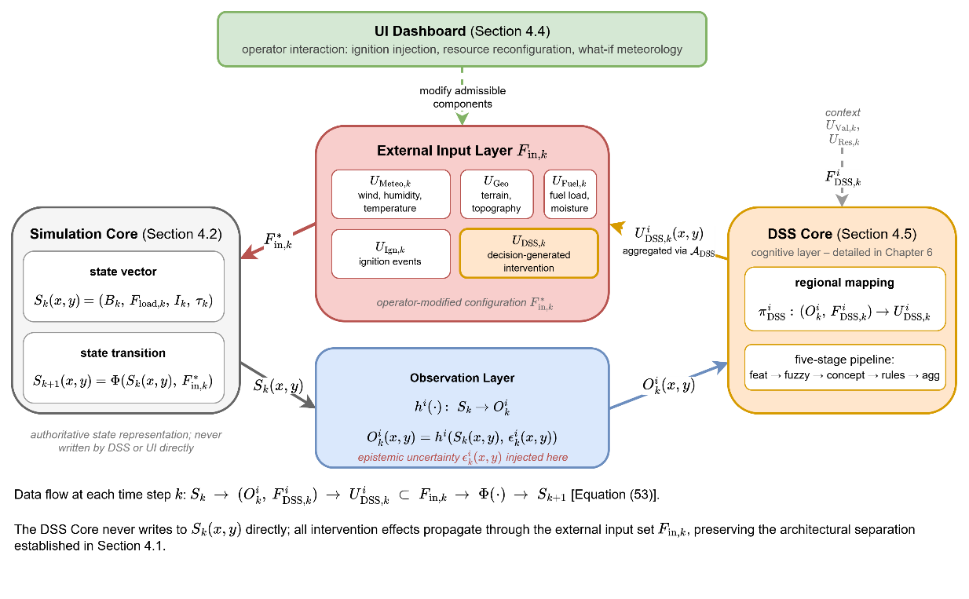
Figure 4.5 DSS–Simulation Core Interface
The Figure 4.5 decomposes the framework into five architectural elements and the data flow that connects them at every simulation time step $k$.
- The Simulation Core maintains the authoritative state vector $S_{k}\left(x,y\right)=\left(B_{k}, F_{load,k}, I_{k}, τ_{k}\right)$ and advances it through the state transition operator $Φ$.
- The Observation Layer applies the region-specific observation function $h^{i}\left(⋅\right)$ to project the state onto observable information $O_{k}^{i}\left(x,y\right)=h^{i}\left(S_{k}\left(x,y\right), ϵ_{k}^{i}\left(x,y\right)\right)$, injecting the epistemic uncertainty $ϵ_{k}^{i}\left(x,y\right)$ at this stage and at this stage only.
- The DSS Core executes the regional mapping $π_{DSS}^{i}: \left(O_{k}^{i}, F_{DSS,k}^{i}\right)→U_{DSS,k}^{i}$ on the region-specific observation and the contextual inputs $F_{DSS,k}^{i}=\left(U_{Val,k}, U_{Res,k}\right)$, producing the regional decision field $U_{DSS,k}^{i}\left(x,y\right)$; the detailed five-stage pipeline that realizes this mapping is the subject of Chapter 6.
- Regional decisions from the $N$ agents are aggregated through the coordination operator $A_{DSS}$ into the global intervention field, which is injected into the External Input Layer $F_{in,k}$ as the $U_{DSS,k}$ component alongside the four exogenous inputs $U_{Meteo,k}$, $U_{Geo}$, $U_{Fuel,k}$, and $U_{Ign,k}$.
- The UI Dashboard can modify admissible components of $F_{in,k}$ through the operator interaction operator $Θ_{UI}$, yielding the operator-modified configuration $F_{in,k}^{*}$ that drives the next state transition $S_{k+1}\left(x,y\right)=Φ\left(S_{k}\left(x,y\right), F_{in,k}^{*}\right)$.
The Figure 4.5 makes explicit the architectural principle established in Section 4.1 and reinforced throughout this chapter: the DSS Core never writes to $S_{k}\left(x,y\right)$ directly, reasoning exclusively from $O_{k}^{i}\left(x,y\right)$ and influencing evolution exclusively through the external input layer. This preserves the strict separation between physical dynamics and decision reasoning that underlies the subsequent design specifications of Chapter 5 and the runtime architecture of Chapter 6.
In summary, within the Simulation Framework, the DSS Core is a cognitively distinct module that interprets observable system representations and produces input-level intervention signals, maintaining modularity and interpretability.

Summary of the Simulation Framework
This chapter establishes the structural and mathematical foundations of the DisasterAware Simulation Framework, defining wildfire evolution as a discrete-time, grid-based state-space system coupled with an external DSS.
At the core of the framework, wildfire dynamics are represented by the state vector $S_{k}\left(x,y\right)$ defined over the spatial domain $G$, where each grid cell encodes combustion status, available fuel, intensity, and temporal progression. The system evolves according to the discrete-time transition model $S_{k+1}\left(x,y\right)= Φ\left(S_{k}\left(x,y\right), F_{in,k}\right)$ where $Φ\left(·\right)$ represents the physically grounded wildfire propagation dynamics, and $F_{in,k}$ denotes the structured external input set.
The external input structure integrates multiple categories of influence, including meteorological forcing, terrain constraints, fuel properties, ignition triggers, and decision-driven intervention parameters. These inputs are explicitly separated from the internal state variables, ensuring that wildfire evolution remains governed by physical processes rather than direct external manipulation.
The transition mechanism $Φ\left(·\right)$ combines burning persistence, spatial propagation, fuel consumption, and intensity evolution within a unified and deterministic update structure. Stochastic variability is introduced only through exogenous input fields, preserving numerical stability and interpretability of the system.
A key architectural principle established is the strict separation between simulation dynamics and decision-making. The Simulation Core maintains the authoritative system state, while all external influences, including human interaction and DSS outputs, are introduced exclusively through the input set $F_{in,k}$. This enforces the causal structure $S_{k}\left(x,y\right)→ O_{k}\left(x,y\right),F_{DSS,k} → U_{DSS,k}\left(x,y\right)⊂ F_{in,k} → Φ\left(·\right)→S_{k+1}\left(x,y\right)$ which ensures that DSS mechanisms do not directly alter the physical state but influence system evolution through structured input-level modifications.
The Decision Support System (DSS) is therefore positioned as a cognitively distinct layer that operates on observable information $O_{k}\left(x,y\right)$ together with contextual inputs $F_{DSS,k}$ and generates intervention-related inputs $U_{DSS,k}\left(x,y\right)$, while the Simulation Core remains responsible for physically consistent state evolution. Similarly, the UI layer provides controlled human interaction by modifying admissible input parameters without violating state immutability.
Through this formulation, the DisasterAware Simulation Framework achieves a clear separation between physical modeling, decision reasoning, and human interaction, while maintaining a unified and mathematically consistent system representation.

DISASTERAWARE SYSTEM SPECIFICATIONS
This chapter establishes the formal design specification of the DisasterAware DSS, which is defined through a structured sequence of transformations: observable wildfire information is mapped into scalar features, fuzzified into linguistic membership values, abstracted into situational concepts, evaluated through decision rules, and aggregated into intervention outputs. Each of these transformations involves explicit design choices, the selection of which features to extract, how to define the linguistic terms, which concepts to form, and how to construct the decision rules. These choices are not arbitrary; they follow from the operational requirements of wildfire management, the formal properties of the simulation environment defined in Chapter 4, and the decision-theoretic principles established in Chapter 2.
The purpose of this chapter is to establish the formal design specification of the DisasterAware DSS. While Chapter 6 addresses the question of how the system operates, this chapter addresses the question of why each design element was chosen. Every parameter, function, and structural decision presented here is grounded in one or more of three foundations: the operational context of wildfire response, the mathematical structure of the Chapter 4 simulation framework, or established principles from the fuzzy reasoning and decision support literature reviewed in Chapter 3. This chapter is organized as follows.
Section 5.1 establishes the operational decision context by characterizing temporal, spatial, and epistemic uncertainty dimensions of DSS decisions, defining four fundamental operational questions, and justifying fuzzy reasoning mechanism.
Section 5.2 derives the input space, specifies the fuzzy variable and membership functions, formalizes the four situational concepts and their construction mappings, and proves the rule complexity reduction achieved through concept abstraction.
Section 5.3 specifies the complete rule base, including concept construction rules for all concepts, intervention decision rules for each action types, the action aggregation mechanism $f_{agg}$, and the decision quality criteria with their evaluation weights.
Section 5.4 synthesizes the principal results of the chapter and positions the DisasterAware DSS specification as the formal foundation for the architectural realization presented in Chapter 6.

Operational Decision Context
Wildfire response operations unfold within a decision space that is simultaneously dynamic, spatially distributed, resource-constrained, and informationally partial. Incident commanders and field coordination units must evaluate rapidly evolving fire conditions, assess the exposure of high-value assets and human settlements, determine the operational feasibility of suppression interventions, and coordinate the deployment of limited resources across geographically dispersed areas.
These activities must be performed continuously, under strict time pressure, and on the basis of information that is inherently partial, temporally delayed, and subject to epistemic uncertainty. Understanding this operational context is essential because every design decision in the DisasterAware DSS, from the choice of features to the structure of the rule base, is grounded in the requirements that this context imposes.

The Temporal Structure of Wildfire Decisions
The formal problem statement introduced in Chapter 2 characterizes wildfire response as a discrete-time sequential decision process indexed by $k$. At each time step $k$, three events occur in succession. The wildfire system evolves from state $S_{k}\left(x,y\right)$ to state $S_{k+1}\left(x,y\right)$ through the state transition operator $Φ\left(S_{k}\left(x,y\right),F_{in,k}\right)$, reflecting the combined effect of environmental forcing and intervention inputs. The Observation Layer then derives, for each operational region $Ω_{i}$, a partial and uncertainty-affected representation of the current state as $O_{k}^{i}\left(x,y\right)=h^{i}\left(S_{k}\left(x,y\right),ϵ_{k}^{i}\right)$. Finally, the DSS generates intervention inputs $U_{DSS,k}\left(x,y\right)$ based on this observable information and the contextual decision inputs $F_{DSS,k}$, and these inputs re-enter the external input set $F_{in,k}$ to influence the subsequent state transition.
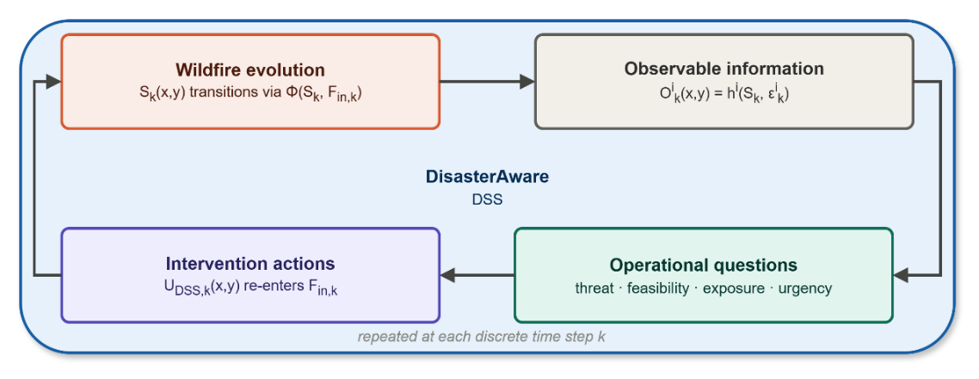
Figure 5.1 Sequential cycle of the DisasterAware DSS
This sequential structure, depicted in Figure 5.1, implies that the quality of each decision step directly conditions both the state of the wildfire system and the informational basis available for subsequent decisions.
A delayed or incorrect intervention at time step $k$ may allow fire spread that renders feasible containment positions inaccessible at time step $k+1$, or may consume suppression resources that would have been critical at a later stage. This temporal coupling means that the DSS must not optimize for a single time step in isolation but must generate adaptive guidance that remains consistent with the evolving operational context across successive time steps.

The Spatial Structure of Wildfire Decisions
In addition to its temporal dimension, wildfire response decision-making is inherently spatial. Fire propagation, asset distribution, terrain configuration, resource availability, and suppression effectiveness all vary continuously across the spatial domain $G$. A suppression strategy that is appropriate at one location may be infeasible or counterproductive at an adjacent location due to differences in terrain accessibility, fuel load, or proximity to high-value assets. This spatial heterogeneity has a direct consequence for system design: a single centralized decision mechanism that produces a uniform intervention policy for the entire domain cannot adequately capture the local variability that characterizes real wildfire incidents.
This observation is formalized in Chapter 2, Section 2.4, through the regional decomposition of the decision problem. The spatial domain is partitioned into $N$ operational regions $Ω=\bigcup_{i=1}^{N}{Ω_{i}}$, each associated with locally observable information $O_{k}^{i}\left(x,y\right)$ and region-specific decision context $F_{DSS,k}^{i}$. Local decisions are generated independently within each region and subsequently coordinated through the global coordination mechanism $A_{DSS}$. The distributed multi-agent DisasterAware DSS is the direct architectural realization of this requirement.

The Epistemic Uncertainty Challenge
A distinguishing characteristic of wildfire decision environments, compared to other planning or control domains, is the epistemic character of the uncertainty that pervades operational information. Walker et al. (2003) distinguish between aleatory uncertainty, which arises from inherent stochasticity in physical processes, and epistemic uncertainty, which arises from incomplete knowledge of the system state. In wildfire response, while both types of uncertainty are present, epistemic uncertainty is the more operationally consequential of the two.
Fire boundary estimates derived from satellite imagery or aerial reconnaissance are subject to temporal delays of minutes to hours, and to spatial resolution limitations that may obscure individual cell-level conditions. Fuel moisture content can only be estimated from meteorological models or remote sensing indices, not directly measured at the spatial resolution required for cell-level decision support. The operational status, location, and remaining capacity of suppression resources are often known only approximately at central coordination nodes, as field units may operate in areas with degraded communication coverage. Terrain accessibility is nominally defined through digital elevation data, but actual accessibility at a given moment may be affected by smoke conditions, fire proximity, or temporary route closures that have not been reported to the coordination center.
As established in Chapter 4, Section 4.2.1, the observation process $O_{k}^{i}\left(x,y\right)=h^{i}\left(S_{k}\left(x,y\right),ϵ_{k}^{i}(x,y)\right)$ makes this epistemic incompleteness explicit through the uncertainty term $ϵ_{k}^{i}(x,y)$. Importantly, $ϵ_{k}^{i}(x,y)$ is not modeled as a stochastic noise term with a known probability distribution. Such a characterization would itself require knowledge that is typically unavailable in operational settings, specifically the statistical properties of sensing uncertainties under field conditions. Rather, $ϵ_{k}^{i}(x,y)$ represents a structural form of incomplete knowledge that cannot be reduced to a probability distribution without additional assumptions.
This observation directly motivates the adoption of fuzzy inference as the primary reasoning mechanism: rather than requiring precise probabilistic models of observation uncertainty, fuzzy logic enables the system to represent and reason with graded degrees of belief derived directly from imprecise observations. This motivation is consistent with the theoretical background presented in Chapter 3 and with prior work on epistemic uncertainty management in decision support (Mendel, 2017; Walker, et al., 2003).

The Four Fundamental Operational Questions
Despite the apparent complexity of wildfire DSS, the decision-making activity of experienced field commanders is structured around a small number of fundamental operational questions. This observation is grounded in naturalistic decision-making research (Klein, 2017), which shows that expert practitioners in high-tempo environments do not engage in exhaustive multi-criteria optimization but rather rapidly classify situations according to recognizable patterns and generate responses appropriate to each pattern.
In the wildfire DSS literature, Thompson and Calkin (2011), Pacheco (2015), and Martell (2007) identify the core operational concerns of incident commanders as threat assessment, resource feasibility, asset prioritization, and response timing. The concerns can be categorized as four questions.

Q1: How severe is the fire threat at this location?
The first question concerns the current and projected destructive potential of the fire at a given grid cell within operational region $Ω_{i}$ at step $k$. A severe fire threat exists when local combustion intensity is high, when available fuel is sufficient to sustain prolonged burning, and when the propagation influence from neighboring burning cells is strong.
Each condition is observable, at least partially, through the state variables maintained by the Simulation Core: the local fire intensity proxy $I_{k}\left(x,y\right)$ reflects combustion strength as defined in Equation ( 51 ); and the propagation influence $Ψ_{k}\left(x,y\right)$ defined in Equation ( 46 ) captures the directional spread potential from the 8-connected neighborhood. A high fire threat level indicates that suppression or containment actions may be urgently required, while a low threat level permits resource conservation or reallocation to higher-priority locations.
In operational practice, this assessment is never expressed in precisely quantified terms. Field commanders and aerial observation crews report conditions such as "extreme fire behavior", "active crown fire involvement", or "moderate surface spread" rather than precise values of combustion rate or intensity.
This linguistic character of threat assessment is a fundamental feature of the operational context, not a deficiency to be corrected. It reflects the irreducible epistemic uncertainty of field observation and the limited time available for precise measurement. The fuzzy inference mechanism of DSS is designed to operate in this same linguistic register.

Q2: Can we effectively intervene at this location?
The second question concerns the operational feasibility of deploying available suppression resources to the location in question. Even when the fire threat at a grid cell $\left(x , y\right)$ is severe, intervention may be infeasible for several reasons. Resources may not be able to reach the location within an operationally meaningful time window, either because of physical distance or because of terrain obstacles that preclude safe access. The capacity of available resources may be insufficient relative to the suppression requirement implied by local fuel load and fire intensity. Resources may already be committed to other high-priority locations and therefore unavailable for redeployment.
The relevant information for this question is contained in the resource-related subset of the external input set $U_{DSS,k}$: the estimated travel time $R_{time,k}\left(x,y\right)$, the operational availability status $R_{avail,k}\left(x,y\right)$, and the suppression effectiveness parameter $R_{eff,k}\left(x,y\right)$ as defined in Section 4.2.1.
Additionally, the terrain accessibility index $G_{access}\left(x,y\right)$ from the topography data layer conditions the physical reachability of any given grid cell. The available fuel load $F_{load,k}\left(x,y\right)$ provides an indication of the suppression effort required. In combination, these quantities determine whether an intervention at location $\left(x , y\right)$ is feasible in the operational sense, that is, whether it can be executed with available resources within a time frame that is consistent with the fire dynamics.

Q3: What is the exposure of assets at this location?
The third question concerns the risk to high-value assets that may be threatened by fire spread originating at or propagating through the current location. Assets include residential and commercial structures, critical infrastructure facilities such as hospitals and power plants, water supply installations, and population centers. Their spatial distribution and protection priority are encoded in the value data layer $U_{Val,k}$, specifically through the protection priority score $V_{prio}\left(x,y\right)$ and the critical facility index $V_{crit}\left(x,y\right)$ defined in Chapter 4, Section 4.3.2.
The asset exposure at a given location depends not only on the presence of high-value assets in the immediate vicinity but also on the direction and momentum of fire spread. A fire front propagating rapidly in the direction of a populated area represents a higher exposure risk than a comparable fire front propagating away from it, even if the distance to the assets is the same. This directional dependence means that asset exposure cannot be assessed from asset distribution alone but requires information about fire propagation dynamics, specifically the propagation influence field $Ψ_{k}\left(x,y\right)$ and the burning status of neighboring cells.

Q4: How urgent must action be taken?
The fourth question synthesizes the responses to the preceding three questions in the context of temporal dynamics. Urgency depends not only on the current severity of the threat, the feasibility of intervention, and the exposure of assets, but also on how rapid conditions are changing and whether delays will substantially reduce the effectiveness of the available intervention options.
A fire front that has been burning continuously for many time steps may have progressively depleted local fuel reserves, causing the rate of spread to naturally decrease. A newly ignited fire front in an area with high fuel load and favorable wind conditions may be accelerating rapidly, with each time step of delay substantially reducing the accessible containment perimeter.
This temporal dimension of urgency is captured in the simulation framework by the ignition time variable $τ_{k}\left(x,y\right)$, defined in Chapter 4, Equation ( 52 ), which records the time elapsed since combustion was initiated at each grid cell. A high value of $τ_{k}\left(x,y\right)$ indicates a fire that has been burning for a sustained period, while a value near zero indicates a recently initiated fire front. The relationship between $τ_{k}\left(x,y\right)$ and intervention urgency is non-trivial and context-dependent, motivating the construction of a dedicated urgency concept rather than the use of $τ_{k}$ directly as a decision input.

Connecting Operational Questions to Design Decisions
The four operational questions identified above provide the complete motivational foundation for the design of the DisasterAware DSS. Table 5.1 summarizes the connection between each question, the information it requires, and the Chapter 4 state variables that provide this information.
Table 5.1 Operational questions, information requirements, and sources
 | Required Information | Source
Q1: Fire Threat Severity | Local combustion intensity, propagation influence | $I_{k}\left(x,y\right)$, $Ψ_{k}\left(x,y\right)$
Q2: Suppression Feasibility | Travel time, availability, accessibility, fuel resistance | $R_{time,k}$, $R_{avail,k}$, $G_{access}$, $F_{load,k}$
Q3: Asset Exposure Risk | Asset priority, fire spread direction and proximity | $V_{prio}\left(x,y\right)$, $Ψ_{k}\left(x,y\right)$, $B_{k}$
Q4: Intervention Urgency | Temporal fire progression, composite threat context | $τ_{k}\left(x,y\right)$, $c_{1},c_{2},c_{3}$

This table has two important structural properties. First, each question maps to a distinct and identifiable subset of the Chapter 4 state variables and contextual inputs. This one-to-one correspondence confirms that the information required to answer the four operational questions is fully contained within the simulation framework developed in Chapter 4, with no additional external data sources required. Second, the questions are not mutually independent of their information requirements: the spread potential $Ψ_{k}\left(x,y\right)$ contributes to both Q1 and Q3, and Q4 depends on the answers to Q1, Q2, and Q3 as well as on $τ_{k}\left(x,y\right)$. This interdependence motivates the hierarchical concept formation mechanism introduced in Section 5.2.3, in which Q4 is constructed as a second-order concept over the outputs of Q1, Q2, and Q3.
The four operational questions correspond directly to the four situational concepts of the DisasterAware DSS: Fire Threat Level ($c_{1}$), Suppression Feasibility ($c_{2}$), Asset Exposure Risk ($c_{3}$), and Intervention Urgency ($c_{4}$). This correspondence is not incidental. The concept space of the DSS is derived from a structured analysis of the operational questions that wildfire incident commanders must answer in order to make effective intervention decisions. By grounding the concept space in operational practice, the DSS ensures that its internal representations are semantically meaningful to the human operators who rely on its outputs.

Why Fuzzy Reasoning Is the Appropriate Mechanism
The four questions share a common characteristic: the answers are inherently imprecise and require graded assessments rather than binary classifications. A fire threat is not simply "high" or "low" but may exhibit intermediate degrees of severity that depend on the relative contributions of intensity, fuel, and spread potential. Suppression feasibility is not binary but varies continuously with resource travel time, terrain accessibility, and the ratio of suppression capacity to suppression requirement. Asset exposure risk depends on a gradient of proximity and directionality rather than on a sharp threshold. Intervention urgency combines multiple continuous factors through a context-dependent weighing mechanism.
These characteristics make threshold-based reasoning fundamentally inappropriate for this domain. A system that classifies fire threat as "high" if and only if $I_{k}\left(x,y\right)>θ$ for some fixed threshold $θ$ would fail to capture the graded nature of the underlying concept and would produce discontinuous decision outputs that are sensitive to small perturbations in the observed value near the threshold. This brittleness is particularly problematic when observations are subject to epistemic uncertainty, as small observation ambiguity could cause large discontinuities in decision outputs.
Fuzzy logic provides a reasoning paradigm that directly addresses these limitations. By representing operational concepts as graded membership values rather than binary classifications, FIS can reason over the continuous spectrum of wildfire conditions without requiring precise boundary definitions (Zadeh, Fuzzy sets, 1965; Mendel, 2017).
The membership values produced by fuzzification are inherently robust to small perturbations in observed values, as the membership functions provide a smooth mapping from observations to concept activations. Moreover, fuzzy reasoning is transparent and interpretable: the membership values and rule activations can be inspected by human operators at any point in the reasoning chain, providing a natural form of explainability that is difficult to achieve with optimization-based or machine learning approaches.
The selection of fuzzy logic as the primary reasoning mechanism is not arbitrary but follows from a structured evaluation of available uncertainty reasoning paradigms against the operational requirements established in Sections 5.1.1 through 5.1.4. Three principal alternatives are considered: Bayesian probabilistic reasoning, Dempster–Shafer evidence theory, and neural network–based approaches.
Bayesian probabilistic reasoning provides a mathematically rigorous framework for updating beliefs under uncertainty through conditional probability distributions (Pearl, 1988). However, its application to the wildfire DSS context presents two fundamental obstacles. First, Bayesian inference requires the specification of prior probability distributions over the state space, which presupposes statistical knowledge about the frequency and distribution of wildfire conditions that is rarely available at the spatial and temporal resolution required for cell-level decision support (Thompson & Calkin, 2011; Morgan & Henrion, 1990).
In the DisasterAware formulation, the epistemic uncertainty term $ϵ_{k}^{i}$ in the observation model $O_{k}^{i}\left(x,y\right)$ explicitly represents incomplete knowledge whose statistical properties are unknown, precisely the condition under which Bayesian inference loses its theoretical guarantees. Second, maintaining and updating joint probability distributions over the six-dimensional feature space at every grid cell and time step would impose computational costs that are incompatible with the real-time operational constraints of wildfire response, particularly in the distributed multi-agent architecture where each regional agent must independently generate intervention outputs within a single simulation time step.
Dempster–Shafer (D-S) evidence theory extends probabilistic reasoning by allowing the representation of ignorance through belief and plausibility intervals, rather than requiring point probability assignments (Shafer, 1976). While this capacity to represent partial ignorance aligns with the epistemic uncertainty challenge of wildfire decision-making, D-S theory introduces two practical limitations in the DSS context.
Dempster’s rule of combination can produce counterintuitive results when evidence sources are highly conflicting, a condition that arises naturally when regional agents observe the same fire front from different vantage points with different degrees of observational degradation (Zadeh, 1986). Furthermore, D-S theory does not provide a natural mechanism for linguistic representation of operational concepts such as “high fire threat” or “limited suppression feasibility,” which are central to the interpretability requirement (Contribution C4) and to the alignment of DSS outputs with the reasoning patterns of field commanders identified in Section 5.1.4.
Neural network–based approaches, including deep reinforcement learning and transformer architectures, have demonstrated strong predictive performance in wildfire spread modeling (Jain, et al., 2020). However, their application as decision reasoning mechanisms, rather than predictive components, conflicts directly with the explainability requirement that is central to this thesis (Gap G4, Contribution C4).
The internal representations of neural networks are opaque by design, and post-hoc explainability methods such as SHAP or LIME provide statistical attributions rather than the causal rule-level traceability that the DisasterAware governance layer requires (Ribeiro, Singh, & Guestrin, 2016). Moreover, training neural network–based decision policies requires large datasets of expert wildfire response decisions that are not systematically available, and the resulting policies cannot be inspected, validated, or overridden at the rule level, capabilities that are essential for the operator trust and regulatory compliance requirements of emergency management systems (McNeese, Schelble, Canonico, & Demir, 2021).
Fuzzy logic addresses all three limitations simultaneously. It operates without requiring prior probability distributions, representing epistemic uncertainty through graded membership values that are derived directly from observable information (Zadeh, Fuzzy sets, 1965; Mendel, 2017). Its rule-based structure provides intrinsic traceability: every intervention recommendation can be traced back through specific rule activations, concept values, and feature observations, as formalized in the Explainability Layer of Section 6.5.
Its computational cost scales linearly with the number of rules and grid cells, satisfying the real-time constraint of the distributed architecture. Finally, its linguistic variables align naturally with the operational vocabulary of wildfire incident commanders, supporting the human–machine collaboration objective that distinguishes DisasterAware from purely automated decision systems. Table 5.2 summarizes this comparative assessment.
Table 5.2 Comparative assessment of uncertainty reasoning paradigms for DSS
Criterion | Bayesian | Dempster–Shafer | Neural Networks | Fuzzy Logic
Operates without prior distributions | ✗ | ✓ | ✓ | ✓
Handles epistemic uncertainty explicitly | Partial | ✓ | ✗ | ✓
Rule-level traceability | ✗ | ✗ | ✗ | ✓
Linguistic interpretability | ✗ | ✗ | ✗ | ✓
Real-time computational feasibility | ✗ | ✓ | Partial | ✓
No training data requirement | ✓ | ✓ | ✗ | ✓
Operator override at rule level | ✗ | ✗ | ✗ | ✓

This comparison establishes that fuzzy logic is not merely a convenient modeling choice but the reasoning paradigm that most directly satisfies the architectural requirements of a distributed, explainable, and uncertainty-aware DSS operating under partial observability.
The applicability of fuzzy inference to wildfire decision support has been established in prior literature (Vásquez, 2021; Soualah, 2024). However, existing applications have typically applied fuzzy inference directly to raw environmental measurements, without the concept abstraction layer that is central to the DisasterAware design.
When fuzzy inference is applied directly over $N_{feat}$ features each with $N_{μ}$ linguistic terms, the number of rules required to characterize the decision space grows as $N_{μ}^{N_{feat}}$. For the feature space and linguistic variable design established in Sections 5.2.1 and 0, this would yield an unmanageably large rule base that is difficult to construct, validate, and maintain.
The concept abstraction mechanism introduced in Section 5.2.3 addresses this limitation directly by reducing the effective dimensionality of the rule base from $N_{feat}$ to $N_{concept}$, a reduction whose magnitude and significance are formally characterized through a complexity proposition.

Feature Space Design and Formal Derivation
The DSS processing pipeline involves three sequential design decisions: the selection and derivation of scalar features (feature extraction), the definition of linguistic variables and membership functions (fuzzification), and the construction of higher-level situational concepts from fuzzified inputs (concept construction). Each of these transformations involves formal design decisions that determine the informational content, linguistic expressiveness, and computational tractability of the DSS. The present section formalizes these decisions, provides analytical justification for each design choice, and establishes a formal result on the rule complexity reduction achieved through concept abstraction.

Feature Extraction Mapping and Scalar Indicators
The feature extraction mapping $f_{feat}$ transforms the observable information $O_{k}^{i}\left(x,y\right)$ into a vector of $N_{feat}$ scalar indicators. Each feature must satisfy three design criteria. First, it must be fully computable from the state variables and contextual inputs defined in Chapter 4, without requiring additional external data sources not already present in the simulation framework. Second, it must be bounded in the interval $\left[0 , 1\right]$, which enables a uniform fuzzy variable design in which a single parameterization framework applies to all features. Third, it must carry operationally meaningful information that directly contributes to answering one or more of the four operational questions identified in Section 5.1.4. These criteria collectively ensure that the feature space is complete with respect to the operational requirements, internally consistent with the Chapter 4 framework and appropriately scaled for fuzzy variable design.
The analysis of operational information requirements presented in Table 5.1 reveals that answering all four operational questions requires information from the full state vector $\left\{B_{k} , F_{load,k} , I_{k} , τ_{k}\right\}$, from the propagation dynamics captured by $Ψ_{k}$, and from the contextual inputs $U_{Val,k}$ and $U_{DSS,k}$. No single state variable is sufficient to answer any of the four questions in isolation; each question requires a combination of physical state information and operational context. The following six features are derived from this analysis.

Feature 1: Fire Intensity
The fire intensity feature is defined directly from the local fire intensity proxy maintained by the Simulation Core: $z_{k,1}^{i}\left(x,y\right)=I_{k}\left(x,y\right)$ where $I_{k}\left(x,y\right)$ is defined by Chapter 4, Equation ( 51 ) as $f_{intensity}\left(F_{load,k},W_{ws,k},G_{slope}\right)$. The intensity proxy is bounded in $\left[0 , 1\right]$ by construction through the normalization embedded in $f_{intensity}$, satisfying the boundedness criterion without additional transformation.
This feature directly addresses operational question Q1 (fire threat severity) by quantifying the local combustion strength at grid cell $\left(x , y\right)$. A high value of $z_{k,1}^{i}$ indicates intense fire behavior associated with high heat release rates and sustained combustion, which is a primary indicator of fire threat in operational classification schemes (Rothermel, 1972; Thompson & Calkin, 2011).

Feature 2: Fuel Load
The fuel load feature is defined as the currently available combustible mass: $z_{k,2}^{i}\left(x,y\right)=F_{load,k}\left(x,y\right)$ where $F_{load,k}\left(x,y\right)$ is maintained by the Simulation Core and updated according to Chapter 4, Equation ( 49 ). The variable is bounded in $\left[0 , 1\right]$ by construction.
Within the context of the four operational questions, fuel load carries dual informational content. In relation to Q1 (fire threat), a high fuel load indicates sustained combustion potential. In relation to Q2 (suppression feasibility), fuel load represents suppression effort: a cell with high remaining fuel requires greater suppression capacity to achieve meaningful fuel reduction, while a cell with depleted fuel may be approaching natural extinction. This dual role is resolved at the concept formation stage, where fuel load contributes with different weights and at different linguistic levels depending on the concept being formed.

Feature 3: Spread Potential
The spread potential feature is derived from the propagation influence field defined in Chapter 4, Equation ( 46 ): $z_{k,3}^{i}\left(x,y\right)=\min\left(1 , \frac{Ψ_{k}\left(x,y\right)}{Ψ_{ref}}\right)$ where $Ψ_{k}\left(x,y\right)=\frac{1}{8}\sum_{\left(i,j)∈N^{8}(x,y\right)}{B_{k}}\left(i,j\right)⋅R_{spread,k}\left(i,j\right)⋅g_{dir,k}^{\left(i,j)→(x,y\right)}$ is the weighted propagation influence from the 8-connected neighborhood, and $Ψ_{\text{ref}}$ is a reference normalization constant set to the characteristic propagation influence under high-wind, high-fuel conditions. The clipping operation $min\left(1, ⋅\right)$ ensures $z_{k,3}^{i}∈\left[0,1\right]$ whether or not $Ψ_{k}$ exceeds $Ψ_{\text{ref}}$ under extreme co-alignment of fuel, wind, slope, and aspect effects. The spread potential feature addresses both Q1 (fire threat severity, through the momentum of the advancing fire front) and Q3 (asset exposure risk, through the spatial direction of propagation relative to high-value assets). The directional weighting factor $g_{dir,k}^{\left(i,j)→(x,y\right)}$ defined in Chapter 4, Equation ( 48 ) ensures that $z_{k,3}^{i}$ captures not only the magnitude of spread potential but also its spatial orientation, which is essential for asset exposure assessment.

Feature 4: Asset Exposure
The asset exposure feature combines the spatial distribution of high-value assets with the proximity of active fire fronts: $z_{k,4}^{i}\left(x,y\right)=V_{prio}\left(x,y\right)⋅{\overset{ˉ}{B}}_{k}^{δ}\left(x,y\right)$ where $V_{prio}\left(x,y\right)∈\left[0,1\right]$ is the protection priority score from the value data layer $U_{Val,k}$, defined in Section 4.3.2, and ${\overset{ˉ}{B}}_{k}^{δ}\left(x,y\right)$ is the mean burning status over the $δ$-extended neighborhood of cell $\left(x , y\right)$: ${\overset{ˉ}{B}}_{k}^{δ}\left(x,y\right)=\frac{1}{∣N^{δ}\left(x,y\right)∣}\sum_{\left(i,j)∈N^{δ}(x,y\right)}{B_{k}}\left(i,j\right)$ with $N^{δ}\left(x,y\right)$ denoting the set of cells within radius $δ$ of $\left(x , y\right)$. The product structure of $z_{k,4}^{i}$ reflects the multiplicative nature of asset exposure risk: a high-priority asset located far from any burning cells carries low immediate exposure (${\overset{ˉ}{B}}_{k}^{δ}≈0$), while even a moderate-priority asset in the immediate vicinity of an active fire front carries significant exposure (${\overset{ˉ}{B}}_{k}^{δ}$ close to 1). The result is bounded in $\left[0 , 1\right]$ since both factors are bounded in $\left[0 , 1\right]$. This feature directly addresses Q3 (asset exposure risk).

Feature 5: Resource Accessibility
The resource accessibility feature aggregates three operational constraints on suppression deployment: $z_{k,5}^{i}\left(x,y\right)=R_{avail,k}\left(x,y\right)⋅\exp\left(-β_{t}⋅R_{time,k}\left(x,y\right)\right)⋅G_{access}\left(x,y\right)$ where $R_{avail,k}\left(x,y\right)∈\left\{0,1\right\}$ is the operational availability status of suppression resources define in Section 4.2.1, $R_{time,k}\left(x,y\right)$ is the estimated travel time to grid cell $\left(x , y\right)$, $β_{t}>0$ is a time-decay coefficient that controls how rapidly accessibility decreases with travel time, and $G_{access}\left(x,y\right)∈\left[0,1\right]$ is the terrain accessibility index from the topography data layer defined in Section 4.3.1.
The multiplicative structure of $z_{k,5}^{i}$ reflects the conjunction of three necessary conditions for effective suppression deployment: resources must be available ($R_{avail,k}=1$), must be reachable within an operationally meaningful time window (captured by the exponential decay), and the terrain must permit safe access ($G_{access}>0$). If any of these conditions are violated, the product approaches zero, indicating negligible suppression accessibility regardless of the other factors. The exponential decay model for travel time is consistent with the operational reality that suppression effectiveness decreases rapidly as travel time increases relative to the characteristic fire spread timescale. This feature directly addresses Q2 (suppression feasibility). The parameter $β_{t}$ is a calibration constant in units of inverse time steps.

Feature 6: Temporal Urgency
The temporal urgency feature transforms the ignition time variable $τ_{k}\left(x,y\right)$ into a bounded urgency indicator: $z_{k,6}^{i}\left(x,y\right)=1-\exp\left(-λ⋅\frac{τ_{k}\left(x,y\right)}{τ_{ref}}\right)$ where $τ_{k}\left(x,y\right)$ is defined by Chapter 4, Equation ( 52 ), $τ_{ref}$ is a reference time scale representing the characteristic duration of a fire spread event, and $λ>0$ is a shape parameter controlling the rate at which urgency saturates. The result is bounded in $\left[0 , 1\right]$: $z_{k,6}^{i}=0$ when $τ_{k}=0$(newly initiated fire) and $z_{k,6}^{i}→1$ as $τ_{k}→∞$.
The exponential transformation is motivated by the observation that urgency does not grow linearly with time. A fire that has been burning for a very short time ($τ_{k}≈0$) presents maximal urgency because it may still be containable with limited resources, whereas a fire that has been burning for an extended period ($τ_{k}≫τ_{ref}$) may have already expanded beyond containable limits, making urgency less sensitive to further delays.
The transformation $1-e^{-\frac{λτ}{τ_{ref}}}$ captures this saturating behavior while remaining monotonically increasing. This feature directly addresses Q4 (intervention urgency) by providing a temporally sensitive measure of how long the current fire front has been active at each grid cell.

Summary of the Feature Space
The six features are summarized in Table 5.3, together with their operational question mapping, source, and normalization method. The feature vector is therefore $N_{feat}=6$. This value is not chosen to minimize or maximize the number of features but is the minimum number of features required to provide sufficient information to answer all four operational questions identified in Section 5.1.4.
Formally, no proper subset of $\left\{z_{k,1}^{i},…,z_{k,6}^{i}\right\}$ can address all four operational questions simultaneously, since each question requires information from at least one feature that is not shared with the others through Q2-specific features $z_{k,5}^{i}$ and Q4-specific feature $z_{k,6}^{i}$.
Table 5.3 Feature definitions, sources, and operational question assignments
Feature | Symbol | Operational Question | Source | Normalization
Fire intensity | $$z_{k,1}^{i}$$ | Q1  (threat severity) | $$I_{k}$$ | Inherent $\left[0 , 1\right]$
Fuel load | $$z_{k,2}^{i}$$ | Q1, Q2  (threat, feasibility) | $$F_{load,k}$$ | Inherent $\left[0 , 1\right]$
Spread potential | $$z_{k,3}^{i}$$ | Q1, Q3  (threat, exposure) | $Ψ_{k}$, | Clipped normalization
Asset exposure | $$z_{k,4}^{i}$$ | Q3  (exposure risk) | $V_{prio}$, $B_{k}$ | Product structure
Resource accessibility | $$z_{k,5}^{i}$$ | Q2  (suppression feasibility) | $R_{avail}$, $R_{time}$, $G_{access}$ | Exponential product
Temporal urgency | $$z_{k,6}^{i}$$ | Q4  (intervention urgency) | $τ_{k}$, | Exponential transformation

Remark 5.1 (Exclusion of $R_{cap,k}$ and $R_{eff,k}$ from the Feature Space). Two parameters from the Resource Data Layer (Table 4.6), namely suppression capacity $R_{cap,k}(x,y)$ and suppression efficiency $R_{eff,k}(x,y)$, are deliberately excluded from the six-dimensional feature space. This exclusion reflects a structural design decision rather than an oversight and is motivated by three considerations.
Architectural separation of reasoning and execution. The feature space is designed to support decision reasoning: determining what type and intensity of intervention is appropriate given the current situational assessment. The parameters $R_{cap,k}$ and $R_{eff,k}$ govern decision execution: they determine the physical magnitude of fuel reduction achieved per unit of intervention intensity. Including execution parameters in the reasoning layer would conflate two functionally distinct stages and violate the separation between the DSS mapping $π_{DSS}^{i}$ and the suppression function $f_{supp}$ established in Chapter 4, Equation ( 50 ).
Operational role. Resource capacity and efficiency determine how much physical suppression is achieved for a given intervention signal, not whether intervention should be attempted. The question "Should we intervene at this location?" (answered by the rule base) is distinct from "How much fuel reduction does this intervention produce?" ($f_{supp}$).
The feature $z_{5}$ (resource accessibility) already captures the feasibility of intervention through $R_{avail,k}$, $R_{time,k}$, and $G_{access}$. Crucially, the binary deployability indicator $R_{avail,k}∈ \{0, 1\}$ (Table 4.6) reflects capacity constraints indirectly: when suppression capacity at or near a grid cell is exhausted or unavailable, the corresponding resource is not deployable and $R_{avail,k}= 0$, which drives $z_{5}$ to zero regardless of travel time or terrain conditions. The capacity signal therefore enters the feature space through the availability channel without requiring a dedicated feature dimension.
Adding $R_{cap,k}$ as a separate feature would introduce redundancy with this existing pathway while shifting the reasoning layer toward execution-level concerns. $R_{eff,k}$, by contrast, governs the translation of intervention intensity into physical fuel reduction (i.e., a mapping that varies by fuel type, moisture, and terrain) and is thus structurally aligned with the suppression function $f_{supp}$ ( 50 ) rather than with the situational assessment encoded in the feature space.
Computational role. $R_{cap,k}$ is utilized in the Global Coordination Layer (Section 6.4) during the resource normalization pass (Equations ( 102 )–( 107 )), where the aggregate intervention demand is scaled against available capacity $C_{k}$. $R_{eff,k}$ is utilized in the suppression-to-fuel-reduction mapping $f_{supp}$ (Equation ( 50 ) and Appendix B), where intervention intensity is translated into physical fuel load changes. Both parameters therefore enter the system at precisely the stage where their physical meaning is operationally relevant.

Calibration Parameters of the Feature Space
The feature extraction mappings defined in Sections 5.2.1.3 through 5.2.1.6 introduce four calibration parameters that govern the normalization and sensitivity of individual features. These parameters are not free variables; each has a physical interpretation grounded in the simulation framework of Chapter 4 and a default value derived from operational considerations.
The membership function parameters $(p_{1,l}, p_{2,l}, p_{3,l})$ are feature-specific and reflect the operational significance of different value ranges. The six features fall into three parameterization groups based on their skewness profile.
Symmetric parameterization. Fire intensity ($z_{1}$) and fuel load ($z_{2}$) use approximately symmetric configurations: $(p_{1}, p_{2}, p_{3}) = (0.20, 0.50, 0.80)$ and $(p_{1}, p_{2}, p_{3}) = (0.25, 0.50, 0.75)$, respectively. Both variables are already normalized within the simulation framework through physically meaningful scaling ( 49 )–( 51 ), making their operational interpretation approximately uniform across [0, 1]. The midpoint $p_{2} = 0.50$ centers the Medium term, reflecting the absence of asymmetric operational significance in these scales.
Left-skewed parameterization. Spread potential ($z_{3}$) and asset exposure ($z_{4}$) use left-skewed configurations: $(p_{1}, p_{2}, p_{3}) = (0.20, 0.40, 0.70)$ and $(p_{1}, p_{2}, p_{3}) = (0.15, 0.45, 0.75)$. The leftward shift of $p_{2}$ reflects the operational reality that even moderate values of these features warrant elevated attention: a spread potential of 0.4 already represents significant fire front momentum, and moderate asset proximity to an active fire front demands precautionary intervention rather than delayed response.
Right-skewed parameterization. Resource accessibility ($z_{5}$) and temporal urgency ($z_{6}$) share the same right-skewed configuration $(p_{1}, p_{2}, p_{3}) = (0.30, 0.60, 0.85)$. For resource accessibility, the rightward shift reflects the multiplicative constraint structure of the feature: because three independent conditions (availability, travel time, terrain access) must be simultaneously satisfied, achieving High accessibility requires favorable alignment across all three factors, which occurs only in a narrow upper range. For temporal urgency, the same configuration captures the saturating nature of the urgency signal: early fire fronts require high urgency even at moderate $τ$ values, while the distinction between Medium and High urgency becomes operationally meaningful only at advanced burn stages.
These parameters are design defaults derived from the operational analysis of Section 5.1. The critical design property is the relative ordering and skewness across features, which encodes operational judgment about which value ranges are significant. The absolute values are secondary to this structural property and may be refined through simulation-based sensitivity analysis as discussed in Chapter 7.
Remark 5.2 (Reproducibility). With the parameter values in Table 5.3, all six features $z_{k,1}^{i},…,z_{k,6}^{i}$ are fully computable from Chapter 4 state variables and contextual inputs, without any unspecified free parameters. The feature extraction mapping $f_{feat}$ is therefore completely defined.

Fuzzy Variable Design
The fuzzification stage transforms each scalar feature $z_{k,l}^{i}\left(x,y\right)∈\left[0,1\right]$ into a graded membership representation over a set of linguistic terms. The design of the fuzzy variables involves two decisions: the number of linguistic terms per feature and the shape and parameters of the membership functions. Each decision is grounded in both operational requirements and formal properties.

Choice of Linguistic Term Count
Each feature is assigned $N_{μ}=3$ linguistic terms, denoted Low ($L$), Medium ($M$), and High ($H$). This choice is motivated by the following considerations. From the operational perspective, three terms correspond to the natural granularity of operational assessments in wildfire response. Field commanders and coordination centers consistently classify operational conditions into three actionable categories: conditions that do not require immediate intervention (Low), conditions that warrant monitoring and preparatory action (Medium), and conditions that require immediate and prioritized intervention (High) (Thompson & Calkin, 2011; Klein, 2017). Adding a fourth or fifth term would introduce finer distinctions that are not operationally meaningful given the epistemic uncertainty of field observations.
From the formal perspective, increasing $N_{μ}$ has an exponential effect on rule base complexity, as established in the complexity analysis of Section 5.2.3. Specifically, the decision rule base complexity grows as $N_{μ}^{N_{concept}}$. With $N_{concept}=4$ and $N_{μ}=3$, the maximum rule base size is $81$ rules per intervention type. Increasing to $N_{μ}=4$ would yield $256$ rules per intervention type, a factor of more than three increase in rule base size for a marginal gain in representational granularity.

Membership Function Shapes
For a feature $l$ with parameter triplet $\left(p_{1,l} , p_{2,l} , p_{3,l}\right)$ satisfying $0≤p_{1,l}<p_{2,l}<p_{3,l}≤1$, the three membership functions are defined as ( 57 ).
$$μ_{L,l}\left(z\right)=\left\{\begin{matrix}1 & z≤p_{1,l} \\ \frac{p_{2,l}-z}{p_{2,l}-p_{1,l}} & p_{1,l}<z≤p_{2,l} \\ 0 & z>p_{2,l}\end{matrix}\right. \\ μ_{M,l}\left(z\right)=\left\{\begin{matrix}0 & z≤p_{1,l}\text{ or }z≥p_{3,l} \\ \frac{z-p_{1,l}}{p_{2,l}-p_{1,l}} & p_{1,l}<z≤p_{2,l} \\ \frac{p_{3,l}-z}{p_{3,l}-p_{2,l}} & p_{2,l}<z<p_{3,l}\end{matrix}\right. \\ μ_{H,l}\left(z\right)=\left\{\begin{matrix}0 & z<p_{2,l} \\ \frac{z-p_{2,l}}{p_{3,l}-p_{2,l}} & p_{2,l}≤z<p_{3,l} \\ 1 & z≥p_{3,l}\end{matrix}\right.$$ | ( 57 )
The Low function is a left-shoulder function that achieves full membership ($μ=1$) for all values below $p_{1,l}$ and decreases linearly to zero at $p_{2,l}$. The High function is the symmetric right-shoulder function. The Medium function is a symmetric triangular function peaking at $p_{2,l}$.
The choice of shoulder functions for Low and High, rather than triangular functions for all three terms, is formally justified by the following consideration. At the boundary values $z=0$ and $z=1$, a triangular Low or High function would produce $μ=1$ only at the apex, which may not coincide with the boundary. The shoulder formulation guarantees that $μ_{L,l}\left(z\right)=1$ for all $z≤p_{1,l}$ and $μ_{H,l}\left(z\right)=1$ for all $z≥p_{3,l}$, ensuring that extreme observations are assigned full membership to the appropriate extreme linguistic term. This is consistent with the recommendations for bounded universes of discourse (Mendel, 2017).
A fundamental formal property of this design is the partition of unity.
Proposition 5.1 (Partition of Unity): For any $z∈\left[0,1\right]$ and any feature $l$, the three membership functions satisfy
$$μ_{L,l}\left(z\right)+μ_{M,l}\left(z\right)+μ_{H,l}\left(z\right)=1$$ | ( 58 )
Proof: The proof follows direct verification over the four disjoint intervals defined by the parameters ( 59 ).
For $z≤p_{1,l}$: $μ_{L,l}=1$, $μ_{M,l}=0$, $μ_{H,l}=0$. Sum $=1$.  For $p_{1,l}<z≤p_{2,l}$: $μ_{L,l}=\frac{p_{2,l}-z}{p_{2,l}-p_{1,l}}$, $μ_{M,l}=\frac{z-p_{1,l}}{p_{2,l}-p_{1,l}}$, $μ_{H,l}=0$. Sum $=\frac{p_{2,l}-z+z-p_{1,l}}{p_{2,l}-p_{1,l}}=1$.  For $p_{2,l}<z<p_{3,l}$: $μ_{L,l}=0$, $μ_{M,l}=\frac{p_{3,l}-z}{p_{3,l}-p_{2,l}}$, $μ_{H,l}=\frac{z-p_{2,l}}{p_{3,l}-p_{2,l}}$. Sum $=1$.  For $z≥p_{3,l}$:$μ_{L,l}=0$, $μ_{M,l}=0$, $μ_{H,l}=1$. Sum $=1$. | ( 59 )
The partition of unity ensures that the total evidential weight assigned across the three linguistic terms is conserved for every observation. This prevents any feature value from being ambiguously unassigned and ensures that the fuzzified representation carries the same total information content as the original scalar observation. Figure 5.2 illustrates the three membership functions for a representative parameterization.
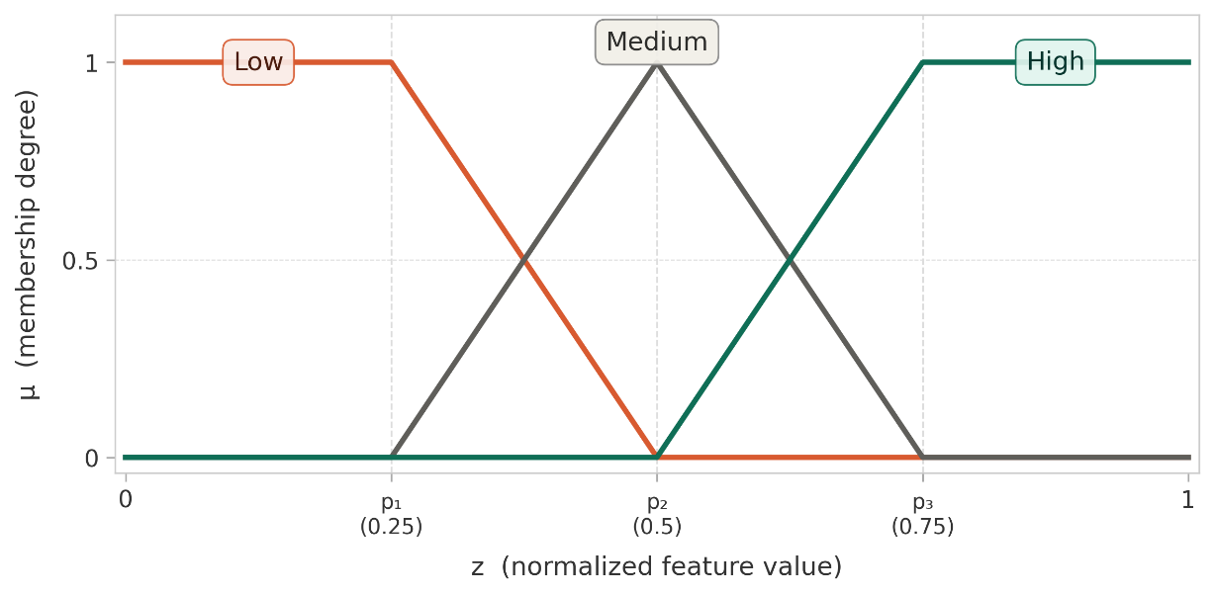
Figure 5.2 Membership functions for a representative feature parameterization
Left-shoulder (Low), triangular (Medium), and right-shoulder (High) membership functions for a feature $l$ with parameters $\left(p_{1},p_{2},p_{3})=(0.25,0.50,0.75\right)$. The partition of unity $μ_{L}+μ_{M}+μ_{H}=1$ holds for all $z∈\left[0,1\right]$.

Parameter Specification
The parameters $\left(p_{1,l} , p_{2,l} , p_{3,l}\right)$ are feature-specific and reflect the operational significance of different value ranges for each feature. Table 5.4 presents the default parameter values together with their justification.
Table 5.4 Membership function parameters for each feature
Feature | $$p_{1,l}$$ | $$p_{2,l}$$ | $$p_{3,l}$$ | Parameterization Rationale
$z_{1}$(fire intensity) | 0.20 | 0.50 | 0.80 | Symmetric: intensity scale is approximately uniform in $\left[0 , 1\right]$
$z_{2}$(fuel load) | 0.25 | 0.50 | 0.75 | Symmetric: fuel scale is approximately uniform; High above 0.75 implies ample combustion potential
$z_{3}$(spread potential) | 0.20 | 0.40 | 0.70 | Left-skewed: even moderate spread potential (0.4) represents significant fire front momentum operationally
$z_{4}$(asset exposure) | 0.15 | 0.45 | 0.75 | Left-skewed: conservative threshold; moderate asset proximity to fire warrants elevated attention
$z_{5}$(resource accessibility) | 0.30 | 0.60 | 0.85 | Right-skewed: multiplicative constraints make High accessibility rare; requires simultaneous availability, proximity, and terrain access.
$z_{6}$(temporal urgency) | 0.30 | 0.60 | 0.85 | Right-skewed: urgency signal saturates at advanced stages; early fire fronts require high urgency even at moderate $τ$ values

These parameters are design defaults derived from the operational analysis of Section 5.1. They are intended as calibration starting points and may be refined through simulation-based sensitivity analysis or expert elicitation, as discussed in Chapter 7. The critical design property is the relative ordering and skewness of the parameters across features, which encodes the operational judgment about which value ranges are operationally significant. The absolute parameter values are secondary to this structural property.

Parameter Calibration Methodology
The calibration parameters in Table 5.3 and the membership function parameters in Table 5.4 are established through a three-source calibration methodology that combines domain knowledge, operational literature, and structural analysis of the simulation framework. This methodology is consistent with established practice in FIS design, where parameter initialization is guided by expert knowledge and subsequently validated through sensitivity analysis (Mendel, 2017; Pedrycz, 1993).
Domain knowledge. The skewness patterns in Table 5.4 encode asymmetric operational significance: for spread potential ($z_{3}$), the left-skewed parameterization ($p_{1} =0.20, p_{2}=0.40$) reflects the operational reality that even moderate propagation influence constitutes significant tactical concern, because fire spread accelerates nonlinearly once a critical momentum threshold is exceeded (Rothermel, 1972). For resource accessibility ($z_{5}$), the right-skewed parameterization ($p_{2} = 0.60, p_{3} = 0.85$) reflects the multiplicative constraint structure of the feature itself: because three independent conditions (availability, travel time, terrain access) must be simultaneously satisfied, achieving High accessibility requires alignment across all three factors, which occurs only in a narrow range of the feature space.
Operational literature. The symmetric parameterizations for fire intensity ($z_{1}$) and fuel load ($z_{2}$) are grounded in the observation that these variables are already normalized within the simulation framework through physically meaningful scaling ( 49 ) and ( 51 ), making their operational interpretation approximately uniform across the [0, 1] range. The three-level classification (Low, Medium, High) with symmetric boundaries is consistent with the operational fire behavior assessment scales used in wildfire DSS (Thompson & Calkin, 2011; Finney, 2006).
Structural analysis. The reference parameters $Ψ_{\text{ref}}=1.0$ and $τ_{\text{ref}}=10Δt$ in Table 5.3 are calibration constants aligned with the operational linguistic scales of features $z_{3}$ and $z_{6}$. $Ψ_{\text{ref}}$ is the characteristic scale of $Ψ_{k}$ under high-wind, high-fuel conditions and serves as the operational saturation point for the “High” linguistic term on $z_{3}$. It is not an absolute upper bound on $Ψ_{k}$: under extreme co-alignment of fuel, wind, slope, and aspect effects, the unclipped rate of spread $R_{\text{spread},k}$ may exceed unity in cells per simulation step (Appendix A), and $Ψ_{k}$ can correspondingly exceed $Ψ_{\text{ref}}$. The clipping operation $min\left(1, Ψ_{k}/Ψ_{\text{ref}}\right)$ in the definition of $z_{3}$ absorbs such cases structurally, ensuring $z_{k,3}^{i}∈\left[0,1\right]$. The temporal reference $τ_{\text{ref}}$ is calibrated to the characteristic timescale over which a newly ignited cell reaches peak spread rate under nominal meteorological conditions in the Chapter 4 simulation model.
Importantly, the formal properties of the DSS pipeline, output boundedness (Proposition 5.3), partition of unity (Proposition 5.1), and Lipschitz continuity (Proposition 5.4), hold for any valid parameter assignment satisfying $0 ≤ p_{1,l} < p_{2,l} < p_{3,l} ≤ 1$, not only for the defaults presented here. The parameters affect the quantitative behavior of the system (which rules activate more strongly for a given observation) but do not alter its qualitative guarantees. The sensitivity of system performance to parameter variation is examined in Chapter 7, Section 7.6.

Concept Space Design and Rule Complexity Reduction
The fuzzification stage produces, for each grid cell $\left(x,y\right)$ within region $Ω_{i}$, a membership matrix ( 60 ). This matrix has $N_{μ}×N_{feat}=3×6=18$ entries per grid cell per region. The concept construction step reduces this 18-dimensional membership representation to a 4-dimensional concept vector $c_{k}^{i}(x,y)=\{c_{k,h}^{i}(x,y)\}_{h=1}^{4}$. This dimensionality reduction has both semantic and computational consequences, which are formalized in this section.
$$μ_{k}^{i}(x,y)=\{μ_{k,n,l}^{i}(x,y)\}_{n∈\left\{L,M,H\right\},l∈\left\{1,…,6\right\}}$$ | ( 60 )

Concept Construction Formulas
Each situational concept $c_{k,h}^{i}\left(x,y\right)$ is defined as a normalized weighted combination of selected membership values. Let $S_{h}$ denote the index set of $\left(n , l\right)$ pairs that contribute to concept $h$, and let $w_{h,n,l}>0$ denote the corresponding weights. The concept value is ( 61 ).
$$c_{k,h}^{i}\left(x,y\right)=\frac{\sum_{\left(n,l\right)∈S_{h}}{w_{h,n,l}}⋅μ_{k,n,l}^{i}\left(x,y\right)}{\sum_{\left(n,l\right)∈S_{h}}{w_{h,n,l}}}$$ | ( 61 )
Since $μ_{k,n,l}^{i}∈\left[0,1\right]$ and $w_{h,n,l}>0$, the normalized weighted average satisfies $c_{k,h}^{i}∈\left[0,1\right]$ for all parameter configurations.

Concept 1: Fire Threat Level
Fire Threat Level ( 62 ) is high when EITHER fire intensity is linguistically High OR spread potential is linguistically High, or both. Equal weighting reflects the operational judgment that both combustion intensity and propagation momentum are equally important indicators of fire threat. This formulation is consistent with the threat classification scheme of Thompson and Calkin (2011), in which threat is defined by the combined effect of fire behavior intensity and spread rate.
$$S_{1}=\left\{\left(H,1\right),\left(H,3\right)\right\},w_{1,H,1}=1.0,w_{1,H,3}=1.0$$ | ( 62 )

Concept 2: Suppression Feasibility
Suppression Feasibility is high when resource accessibility is High AND fuel load is Low. The inclusion of $μ_{L,2}$(Low fuel membership) reflects the operational reality that high fuel load increases the suppression effort required and therefore reduces effective suppression feasibility even when resources are accessible. The weight ratio of $1.0 :0.7$ reflects the judgment that resource accessibility is slightly more determinative of feasibility than fuel load, since resources that cannot reach the fire are ineffective regardless of fuel conditions (Martell, 2007).
$$S_{2}=\left\{\left(H,5\right),\left(L,2\right)\right\},w_{2,H,5}=1.0,w_{2,L,2}=0.7$$ | ( 63 )

Concept 3: Asset Exposure Risk
Asset Exposure Risk ( 64 ) is high when asset priority is High AND spread potential toward those assets is High. The weight 0.8 on spread potential reflects that asset exposure risk is primarily driven by asset presence (weight 1.0), with propagation dynamics as a modulating factor. A high-priority asset with moderate spread potential in its direction still warrants attention, but somewhat less urgently than one with high spread potential directly aligned toward it (Pacheco, 2015).
$$S_{3}=\left\{\left(H,4\right),\left(H,3\right)\right\},w_{3,H,4}=1.0,w_{3,H,3}=0.8$$ | ( 64 )

Concept 4: Intervention Urgency (Second-Order)
The Intervention Urgency concept ( 65 ) is a second-order concept that takes the first-order concept values as inputs together with the temporal urgency feature where $μ_{H}\left(c_{h}\right)$ and $μ_{L}\left(c_{h}\right)$ denote the High and Low memberships of the concept value $c_{k,h}^{i}$ using the same membership defined in Section 5.2.2, applied to the concept values directly. This is valid because concepts are bounded in $\left[0 , 1\right]$ by construction.
$$S_{4}=\left\{\left(H,c_{1}\right),\left(L,c_{2}\right),\left(H,c_{3}\right),\left(H,z_{6}\right)\right\},$$  $$w_{4,H,c_{1}}=w_{4,L,c_{2}}=w_{4,H,c_{3}}=w_{4,H,z_{6}}=1.0$$ | ( 65 )
The second-order structure reflects the operational logic of urgency: intervention is most urgent when (i) the fire threat is High, (ii) suppression feasibility is Low, meaning the window for effective intervention is closing, (iii) asset exposure risk is High, and (iv) the temporal urgency signal is High indicating an advancing or recently ignited fire front. The equal weights reflect the judgment that all four contributors to urgency are operationally equivalent in the default configuration.
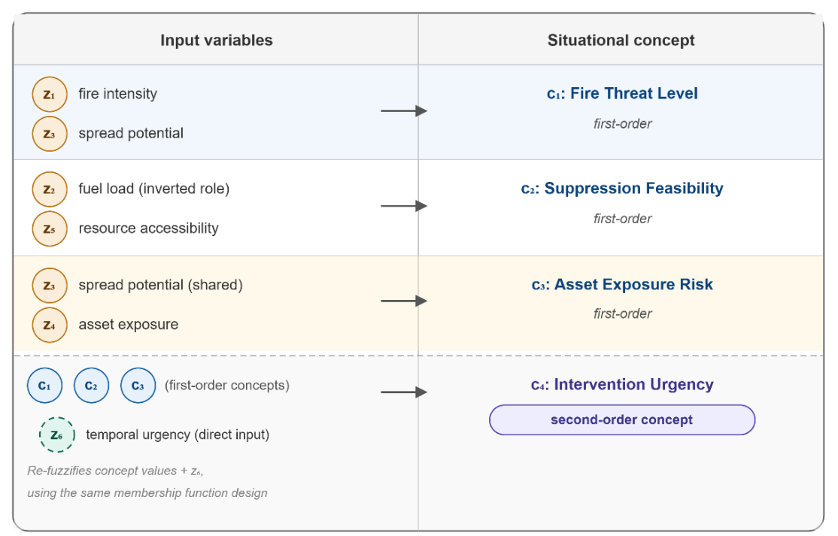
Figure 5.3 Concept formation structure
Figure 5.3 shows the concept formation structure, illustrating the two-tier hierarchy and the mapping from features to first-order concepts and from first-order concepts to the second-order urgency concept. It also shows the mapping from input features to first-order concepts ($c_{1}, c_{2}, c_{3}$) and from first-order concepts together with temporal urgency $z_{6}$ to the second-order concept $c_{4}$. Feature $z_{3}$ (spread potential) contributes to both $c_{1}$ and $c_{3}$ with different semantic roles.

Rule Complexity Reduction via Concept Abstraction
The rule complexity of a fuzzy DSS is measured by the total number of rules required across all decision rule bases. This section formalizes the reduction in rule complexity achieved by the concept abstraction architecture relative to direct fuzzy inference.
Definitions: Let $N_{feat}=6$ be the number of input features, $N_{μ}=3$ be the number of linguistic terms per variable, $N_{concept}=4$ be the number of situational concepts, and $M$ be the number of intervention types. In a fuzzy rule base, each rule specifies a linguistic term for every input variable. The number of possible antecedent combinations, the maximum number of rules required for complete coverage, grows exponentially with the number of input variables.

Direct Fuzzy Inference
Without concept abstraction, the decision mapping $π_{i,m}$ for each intervention type $m$ operates directly on the $N_{feat}=6$ features, each with $N_{μ}=3$ linguistic terms. The maximum rule base size for each intervention type is $N_{μ}^{N_{feat}}$. Across $M$ intervention types, the total rule base size is ( 66 ):
$$∣R^{direct}∣=M⋅N_{μ}^{N_{feat}}=M⋅3^{6}=729M$$ | ( 66 )

Concept-Mediated Fuzzy Inference
With concept abstraction, the decision rule bases operate over concepts rather than raw features. Concept construction itself admits two equivalent representations: for the first-order concepts $c_{1}, c_{2}, c_{3}$ the weighted aggregation formula of Equation ( 61 ) is used at runtime, and an inspectable rule form is provided by Table 5.6 - Table 5.8 (9 rules each) for human validation. The second-order concept $c_{4}$, whose inputs include three first-order concepts plus $z_{6}$, is constructed directly through the structured rule base of Table 5.9 (81 rules with a product fallback for non-enumerated combinations). The total concept-construction rule count is therefore $R_{CC} = 9 + 9 + 9 + 81 = 108$, invariant of M. The decision mapping $π_{i,m}$ for each intervention type m operates on the $N_{concept}=4$ concepts, each with $N_{μ}=3$ linguistic terms; the maximum decision-rule-base size per intervention type is $N_{μ}^{N_{concept}}$. Across M intervention types, the total decision rule base size is ( 67 ):
With concept abstraction, concept construction is performed analytically through the weighted aggregation formula, which requires no rules. The decision mapping $π_{i,m}$ for each intervention type $m$ operates on the $N_{concept}=4$ concepts, each with $N_{μ}=3$ linguistic terms. The maximum rule base size per intervention type is $N_{μ}^{N_{concept}}$. Across $M$ intervention types, the total decision rule base size is ( 67 ):
$$∣R^{concept}∣=M⋅N_{μ}^{N_{concept}}=M⋅3^{4}=81M$$ | ( 67 )
Proposition 5.2: (Per-Intervention-Type Rule Complexity Reduction). The concept-mediated architecture achieves a constant per-intervention-type (marginal) maximum rule complexity reduction ratio that is independent of the number of intervention types M ≥ 1, as given in ( 68 ). The overall reduction ratio, which accounts for the M-invariant concept-construction rule count $R_{CC}$, is given by Equation (68a) and monotonically approaches $κ_{marg}$ as M → ∞. For the DisasterAware configuration ($M = 3, R_{CC} = 108$),$κ_{marg}= 9$ and $κ_{total}\left(3\right)= \frac{2187}{351 } ≈ 6.2$.
$$κ_{marg} = N_{μ}^{N_{feat}- N_{concept}}= 3^{6-4}= 9$$ | ( 68 )
$$κ_{total}\left(M\right)=\frac{N_{μ}^{N_{feat}} · M}{R_{CC} + N_{μ}^{N_{concept}} · M}$$ | ( 69 )
This result has a significant implication for system scalability. The marginal cost of adding a new intervention type (i.e., the number of additional rules required to support a new $π_{i,m}$ rule base) decreases from $N_{μ}^{N_{feat}}=729$ rules in direct inference to $N_{μ}^{N_{concept}}=81$ rules in concept-mediated inference, a marginal reduction of exactly 9 per intervention type ( 68 ). The system is therefore marginally scalable with respect to the number of intervention types: each new intervention type can be supported by a compact, independently designable rule base operating in concept space, rather than a large rule base operating in raw feature space. The overall rule count, including the M-invariant concept-construction base $R_{CC}$, grows as $R_{CC}+ N_{μ}^{N_{concept}}·M$ ( 69 ). Table 5.5 shows the total rule base sizes.
Table 5.5 Rule base complexity comparison of varying number of interventions
Intervention types $M$ | $$∥R^{direct}∥$$ | $$∥R^{concept}∥$$ | Reduction ratio $κ$
1 | 729 | 81 | 9.0
3 | 2187 | 243 | 9.0
5 | 3645 | 405 | 9.0
10 | 7290 | 810 | 9.0
𝑀 | 729𝑀 | 81𝑀 | 9.0

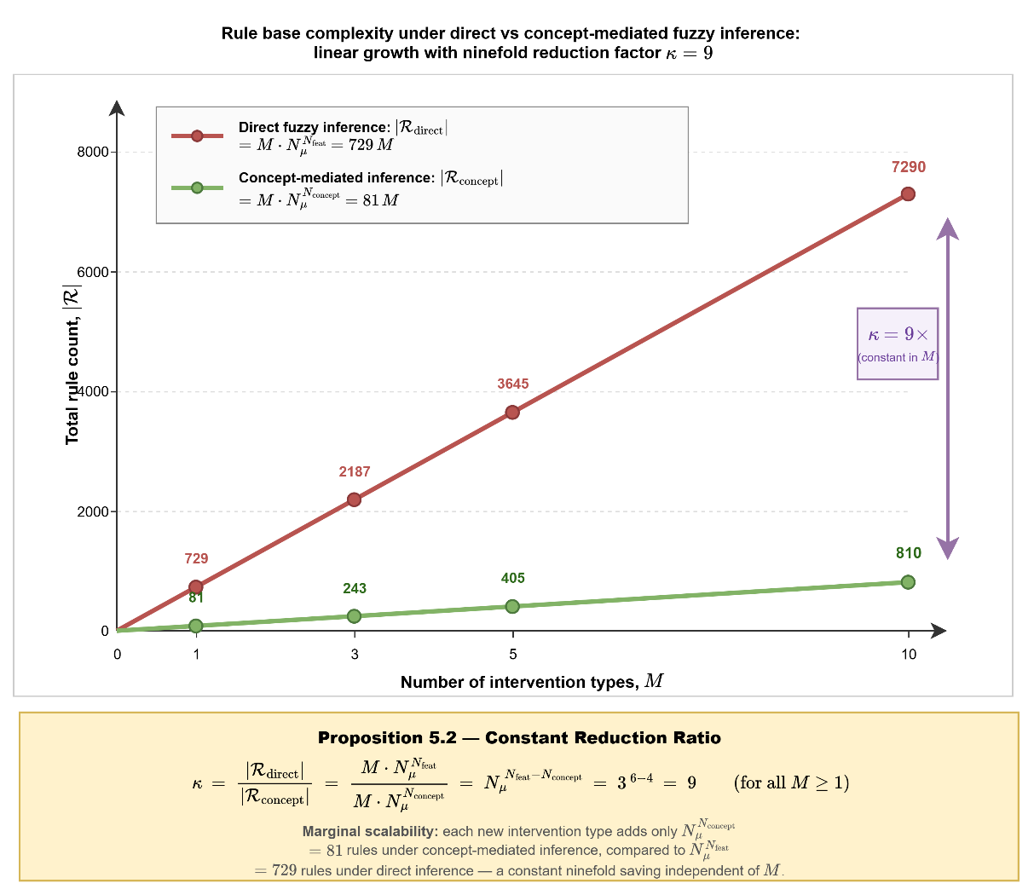
Figure 5.4 Rule base complexity under direct vs concept-mediated fuzzy inference
Figure 5.4 illustrates three structural properties of the concept-mediated architecture. First, both rule counts grow linearly in $M$, confirming that the architectural overhead of supporting additional intervention types scales gracefully in both formulations rather than super-linearly. Second, the vertical gap between the two curves grows in absolute terms as $M$ increases from $729 - 81 = 648$ rules at $M = 1$ to $7290 - 810 = 6480$ rules at $M = 10$ so the knowledge-engineering and validation burden avoided through concept abstraction grows proportionally to the operational scope of the DSS. Third, the reduction ratio $κ = \frac{|R_{direct}|}{|R_{concept}|}$ remains invariant at $9$ for all values of $M ≥ 1$, as proven in Proposition 5.2. This invariance is a direct consequence of the exponent difference $N_{feat} - N_{concept} = 2$ appearing identically in both numerator and denominator once $M$ is factored out, leaving $κ = N_{μ}^{N_{feat} - N_{concept}} = 3^{2} = 9$ independent of $M$. Operationally, the ninefold marginal saving (per-intervention-type decision rule base) is a structural property of the concept abstraction layer that is invariant of M. The overall saving, which includes the M-invariant concept-construction rule count $R_{CC}=108$, is $κ_{total}(3)≈6.2$ at $M = 3$ and approaches $κ_{marg} = 9$ asymptotically as the DSS is extended to richer intervention vocabularies in future work..
Remark 5.3 (Knowledge Engineering Modularity): An important secondary benefit of concept abstraction concerns the process of rule base construction and validation. Under complete antecedent coverage, direct fuzzy inference would require up to 729M rules defined over combinations of raw feature values such as "if fire intensity is High AND fuel load is Medium AND spread potential is Low AND asset exposure is High AND accessibility is Medium AND temporal urgency is High THEN...".
Such rules are difficult for human domain experts to evaluate and validate because the linguistic terms are defined over physically heterogeneous variables that are not directly comparable. In concept-mediated inference, the $81 M$ rules are defined over operationally meaningful concepts such as "if Fire Threat Level is High AND Suppression Feasibility is Low AND Asset Exposure Risk is High AND Intervention Urgency is High THEN deploy maximum suppression resources."
These rules correspond directly to the operational reasoning vocabulary of wildfire incident commanders, enabling domain-expert review and iterative refinement within the operational planning process.
Remark 5.4 (Shared Feature Contribution): Feature $z_{3}$ (spread potential) contributes to both concept $c_{1}$ and $c_{3}$, with different semantic roles and different weights in each context. This shared contribution is not redundant but reflects the dual operational significance of spread potential identified in Section 5.1.2.
The concept abstraction layer correctly encodes this dual role by constructing two distinct concept values from the same feature membership input, which would be impossible in a direct feature-to-decision mapping without explicitly encoding the duality in the rule base structure.

Rule Base Specification
The concept construction mechanism and the local decision mappings defined in Section 5.2 both rely on structured rule bases that encode operational knowledge in formal linguistic form. This section specifies these rule bases in their entirety. Throughout this chapter, the terms rule and decision carry distinct semantic and computational roles that must not be conflated. The 351 rules are not derived through a formal expert-elicitation protocol. They consolidate operational heuristics documented in the wildfire-management literature (Thompson & Calkin, 2011; Pacheco, 2015; Martell, 2007), and are treated here as a literature-synthesized operational doctrine that is subject to empirical validation in Chapter 7.
A rule is a static IF–THEN linguistic mapping that encodes operational doctrine: the conditional reasoning that an experienced incident commander would apply when assessing a given combination of situational conditions. For example, the rule “IF Fire Threat Level is High AND Suppression Feasibility is Low AND Intervention Urgency is High, THEN Direct Suppression is Medium” encodes the operational doctrine that deploying suppression resources to a location that is operationally inaccessible would waste limited capacity, regardless of the severity of the threat. Rules are design-time artifacts: they are defined prior to simulation execution, do not change at runtime, and collectively represent the complete operational knowledge base of the DSS. The full rule base of 351 rules (Table 5.19) constitutes the entirety of the literature-synthesized operational doctrine embedded in the system.
A decision, by contrast, is the runtime output of the DSS pipeline: a numerical intervention activation degree $u_{k,m}^{i}(x,y) ∈ [0, 1]$ generated dynamically at each time step k and each grid cell (x, y) by evaluating the full rule base against the current concept vector. Semantically, a decision answers the operational question “how much of each intervention type should be activated at this specific location at this specific moment.” For instance, an output vector $U_DSS= {\left[0.82, 0.10, 0.65\right]}^{T}$ directs that 82% of available suppression capacity should be allocated to this cell, preventive fuel reduction should remain minimal, and asset protection should be prioritized at 65% intensity. Decisions are ephemeral, context-dependent, and regenerated at every time step in response to the evolving wildfire state.
In summary, rules encode what to do under which conditions; decisions encode how much of each intervention type to activate here and now. The mapping from rules to decisions is mediated by the five-stage composition of $π_{DSS}^{i}$ (Definition 5.1): rules provide the reasoning structure, and the fuzzy inference mechanism produces graded, spatially distributed decisions by evaluating these rules against real-time observations.

Concept Construction Rule Base
Although the concept construction formulas presented in Section 5.2.3 define the weighted aggregation mechanism formally, the rule base provides an equivalent and complementary representation that makes the reasoning process transparent and inspectable by human operators. Each concept is defined by a set of IF-THEN rules in which the antecedent specifies linguistic conditions on fuzzified features, and the consequent specifies the resulting concept activation level. The rule base and the weighted aggregation formula are consistent representations of the same mapping; the rule base form supports human validation and explainability, while the formula form supports efficient computation.

Concept Construction Rules for Fire Threat Level
The concept $c_{1}$ reflects the severity of the fire threat at a grid cell $\left(x,y\right)$, drawing from fire intensity ($z_{1}$) and spread potential ($z_{3}$). Nine rules cover all combinations of the two input terms. The rules are presented in Table 5.6. The output term "Very High" corresponds to $c_{1}≈1$ and "Very Low" to $c_{1}≈0$, with intermediate terms mapped uniformly across $\left[0 , 1\right]$. The asymmetry between R1.3 and R1.7 reflects the operational judgment that high fire intensity with low spread is still a Medium threat (sustained combustion at fixed location requires attention), whereas low intensity with high spread is also a Medium threat (fast-moving but low-energy fire front). Both conditions warrant monitoring and preparatory action but not immediate maximum-priority response.
Table 5.6 Rule base for Fire Threat Level
Rule | IF $z_{1}$ is | AND $z_{3}$ is | THEN $c_{1}$ is
R1.1 | High | High | Very High
R1.2 | High | Medium | High
R1.3 | High | Low | Medium
R1.4 | Medium | High | High
R1.5 | Medium | Medium | Medium
R1.6 | Medium | Low | Low
R1.7 | Low | High | Medium
R1.8 | Low | Medium | Low
R1.9 | Low | Low | Very Low

Concept Construction Rules for Suppression Feasibility
The concept $c_{2}$ reflects how effectively suppression resources can be deployed at the target location, drawing from resource accessibility ($z_{5}$) and fuel load ($z_{2}$, inverted role, i.e., Low fuel means easier suppression). Nine rules cover all combinations. The rules are presented in Table 5.7.
The pattern encodes a two-factor feasibility model (Martell, 2007): High feasibility requires both high accessibility and low fuel resistance. When accessibility is Low but fuel load is also Low (R2.7), feasibility is Medium rather than Very Low because the suppression effort required is small. For instance, even limited resources can be effective against a fuel-depleted fire. In detail, this asymmetry is operationally motivated and distinguishes this rule based on symmetric product formulation.
Table 5.7 Rule base for Suppression Feasibility
Rule | IF $z_{5}$ is | AND $z_{2}$ is | THEN $c_{2}$ is
R2.1 | High | Low | Very High
R2.2 | High | Medium | High
R2.3 | High | High | Medium
R2.4 | Medium | Low | High
R2.5 | Medium | Medium | Medium
R2.6 | Medium | High | Low
R2.7 | Low | Low | Medium
R2.8 | Low | Medium | Low
R2.9 | Low | High | Very Low

Concept Construction Rules for Asset Exposure Risk
The concept $c_{3}$ reflects the risk of protecting assets, drawing them from asset exposure ($z_{4}$) and spread potential ($z_{3}$). Nine rules are presented in Table 5.8. The stronger asymmetry between R3.3 (High asset, Low spread $→$ Medium) and R3.7 (Low asset, High spread $→$ Low) reflects the asset-first prioritization in risk assessment (Pacheco, 2015): High-priority assets are protected even when spread is currently low, because conditions can change rapidly within a single time step.
Table 5.8 Rule base for Asset Exposure Risk
Rule | IF $z_{4}$ is | AND $z_{3}$ is | THEN $c_{3}$ is
R3.1 | High | High | Very High
R3.2 | High | Medium | High
R3.3 | High | Low | Medium
R3.4 | Medium | High | High
R3.5 | Medium | Medium | Medium
R3.6 | Medium | Low | Low
R3.7 | Low | High | Low
R3.8 | Low | Medium | Very Low
R3.9 | Low | Low | Very Low

Concept Construction Rules for Intervention Urgency (Second-Order)
The second-order concept $c_{4}$ takes the first-order concepts $c_{1}$, $c_{2}$, $c_{3}$ and the temporal urgency feature $z_{6}$ as inputs. With four inputs each at three linguistic levels, the maximum rule base size is $3^{4}=81$ rules. Rather than enumerating all 81, the rule base is structured around the operational logic identified in Section 5.1.4: urgency is highest when threat is high, feasibility is low (closing window), exposure is high, and time pressure is high.
Table 5.9 presents the dominant rules that determine $c_{4}$ under the most operationally consequential conditions. Rules not listed default to the product of the individual input concept values scaled to $\left[0 , 1\right]$. Rules R4.1 and R4.2 encode the critical scenario of maximum urgency: severe fire threat, infeasible suppression, high asset exposure, and active temporal pressure. Rule R4.5 captures the situation where threat is high but both exposure and spread toward assets are low, yielding only Medium urgency. Rule R4.8 captures the opposite extreme: low threat, high feasibility, and low temporal pressure, the classic scenario where controlled intervention is possible and not urgent.
Table 5.9 Rule base for Intervention Urgency
Rule | IF $c_{1}$ is | AND $c_{2}$ is | AND $c_{3}$ is | AND $z_{6}$ is | THEN $c_{4}$ is
R4.1 | High | Low | High | High | Very High
R4.2 | High | Low | High | Medium | High
R4.3 | High | Low | Medium | High | High
R4.4 | High | Medium | High | High | High
R4.5 | High | Low | Low | High | Medium
R4.6 | Medium | Low | High | High | High
R4.7 | Medium | Medium | Medium | High | Medium
R4.8 | Low | High | Low | Low | Very Low
R4.9 | Low | Low | Low | Low | Very Low

Intervention Decision Rule Base
The local decision mapping $π_{DSS,m}^{i}$ for each intervention type $m$ takes the concept vector $c_{k}^{i}\left(x,y\right)=\left\{c_{1},c_{2},c_{3},c_{4}\right\}$ and the contextual inputs $F_{DSS,k}$ as inputs and produces a candidate intervention degree $u_{k,m}^{i}\left(x,y\right)∈\left[0,1\right]$. The three intervention types defined below constitute the complete decision output space of the DisasterAware DSS. Each intervention type corresponds to an operationally distinct category of wildfire response action and maps to specific physical parameters within the Simulation Framework.
Table 5.10 specifies the operational meaning, the physical effect on the simulation state, and the Chapter 4 parameters through which each intervention modifies the system. The output of the DSS pipeline is not a binary activation of a single intervention type but a simultaneous, graded activation of all three types, represented as the multi-action vector $U_{DSS,k}^{i}(x,y) = {\left[u_{k,1}^{i}, u_{k,2}^{i}, u_{k,3}^{i}\right]}^{⊤} ∈ [0,1]³$, where each component specifies the activation intensity of the corresponding intervention type at the given grid cell and time step.
Table 5.10 Intervention type definitions and operational semantics
m | Intervention Type | Operational Meaning | Physical Effect on Simulation | Parameter Affected
1 | Direct Suppression | Deploy suppression resources (water, retardant, ground crews) to actively reduce combustion at the target location. | Fuel load is reduced through active suppression; fire intensity decreases at the intervention cell. | $F_{red,k}$ via $f_{supp}$; $R_{cap,k}, R_{eff,k}$
2 | Preventive Fuel Reduction | Pre-emptively reduce fuel load at locations not yet burning but at risk of ignition, through controlled burning or mechanical clearing. | Fuel load is reduced before fire arrival; effective containment perimeter is widened. | $F_{load,k}$  reduced directly
3 | Asset Protection Priority | Reallocate resources toward high-value assets: evacuation support, access route clearance, defensive perimeter establishment. | Resource allocation structure within the intervention field is modified to prioritize asset-proximate cells. | Resource reallocation within $U_{DSS,k}$

The linguistic output levels used in the decision rule bases (Table 5.12 - Table 5.16) correspond to singleton consequent values $v_{R}$ that anchor the defuzzified intervention degrees produced by the fuzzy inference engine ( 80 ). Table 5.11 specifies the numerical value and operational interpretation of each linguistic level.
These five levels define a uniform discretization of the [0,1] output space with equal spacing of 0.25, providing the semantic bridge between the linguistic rule structure and the numerical intervention output. The choice of five levels rather than three (Low, Medium, High) at the output stage reflects the need for finer-grained differentiation in intervention intensity: the distinction between "no action" (Very Low) and "preparatory standby" (Low), and between "priority deployment" (High) and "maximum commitment" (Very High), carries direct operational significance for resource dispatch decisions.
Table 5.11 Mapping of linguistic output levels to numerical singleton values
Linguistic Output | $$v_{R}$$ | Operational Interpretation
Very Low | 0.00 | No intervention or minimal monitoring. Resources are not allocated to this cell for this intervention type.
Low | 0.25 | Limited resource allocation. Preparatory-level engagement; standby or low-priority deployment.
Medium | 0.50 | Moderate intervention. Balanced resource commitment; standard operational response.
High | 0.75 | Priority intervention. Majority of available capacity directed to this cell for this type.
Very High | 1.00 | Maximum intervention. Full available capacity allocated; highest operational urgency.

Intervention Type Specification
The $M$ intervention types represent the operationally distinct categories of action available to wildfire response teams. Based on the operational literature (Thompson & Calkin, 2011; Martell, 2007; Pacheco, 2015), three primary intervention types are defined for the DisasterAware framework:
$m=1$: Direct Suppression: Deployment of available suppression resources (water, retardant, ground crews) to actively reduce fuel load and combustion at the target location. This corresponds to the suppression capacity parameters $R_{cap,k}$ and $R_{eff,k}$ in the Chapter 4 input structure.
$m=2$: Preventive Fuel Reduction: Pre-emptive reduction of fuel load at locations not yet burning but at risk of ignition, through controlled burning or mechanical treatment. This intervention reduces $F_{load,k}$ in advance of fire arrival and widens the effective containment perimeter.
$m=3$: Asset Protection Priority: Reallocation of resources toward the protection of high-value assets identified through $V_{prio}\left(x,y\right)$, including evacuation support, access route clearance, and defensive perimeter establishment. This intervention modifies the resource allocation structure within $U_{DSS,k}$.
These three types correspond to $M=3$, yielding a decision rule base of $3^{4}=81$ rules per intervention type and a total rule base of $243$ rules across all types, consistent with the complexity analysis of Proposition 5.2 ($81 M=81×3=243$).
The fixed cardinality M = 3 reflects an operational design choice, not a structural constraint of the framework; the rule base is modular and additional intervention types can be introduced by appending rule subsets without architectural modification.

Decision Rules for m=1 Direct Suppression
Table 5.12 presents the principal rules for direct suppression mapping $π_{i,1}$. Full High activation is indicated when both the fire threat and suppression feasibility are favorable, the threat is real and the resources can reach it. Rule D1.4 captures a critical operational constraint: even when fire threat is High and urgency is High, if suppression feasibility is Low, the recommended direct suppression degree is only Medium rather than High. Deploying resources to an inaccessible or highly fuel-loaded location wastes capacity that may be needed elsewhere. This rule encodes the operational principle of resource economy under infeasibility conditions. Operational interpretation of principal rules is listed in Table 5.13.
Table 5.12 Principal decision rules for Direct Suppression
Rule | IF $c_{1}$ is | AND $c_{2}$ is | AND $c_{4}$ is | THEN $u_{k,1}^{i}$ is
D1.1 | High | High | High | Very High
D1.2 | High | High | Medium | High
D1.3 | High | Medium | High | High
D1.4 | High | Low | High | Medium
D1.5 | Medium | High | Medium | Medium
D1.6 | Low | High | Low | Low
D1.7 | High | Low | Low | Low
D1.8 | Low | Low | Low | Very Low

Table 5.13 Operational interpretation for Direct Suppression
Rule | Operational Meaning
D1.1 | Fire threat is severe, suppression resources can reach the location, and the situation is urgent. Deploy maximum suppression capacity immediately; this is the ideal intervention scenario.
D1.2 | Fire threat is severe and resources are accessible, but urgency is moderate. Deploy at high level; the situation is serious but allows brief coordination before full commitment.
D1.3 | Fire threat is severe and urgency is high, but suppression feasibility is only moderate. Deploy at high level with awareness that operational constraints may limit effectiveness.
D1.4 | Fire threat is severe and urgency is high, but the location is operationally inaccessible (low feasibility). Reduce suppression to medium: deploying full capacity to an unreachable location wastes resources needed elsewhere.
D1.5 | Moderate fire threat with good accessibility and moderate urgency. Standard-level engagement; balanced resource commitment appropriate.
D1.6 | Low fire threat with good accessibility and low urgency. Minimal suppression: the fire poses little immediate danger and resources are better reserved.
D1.7 | Severe fire threat but inaccessible location and low urgency. Minimal suppression: despite the threat, resources cannot be effectively deployed and time permits alternative strategies.
D1.8 | Low threat, inaccessible location, low urgency. No meaningful suppression warranted; monitoring only.

Decision Rules for m=2: Preventive Fuel Reduction
Table 5.14 presents the principal rules for $π_{i,2}$. Preventive fuel reduction is most appropriate when threat is Medium-to-High, assets are exposed, but direct suppression feasibility is limited, the system recommends pre-emptive action ahead of the fire front.
The contrast between D2.4 (Medium output despite High threat and High exposure) and D2.1 (Very High output when feasibility is Low) reflects the substitution logic of fuel reduction: when direct suppression is feasible (D2.4), fuel reduction is less urgent because direct action can be taken. When direct suppression is infeasible (D2.1), preventive fuel reduction becomes the primary available option and is therefore given maximum priority.
Table 5.14 Principal decision rules for Preventive Fuel Reduction
Rule | IF $c_{1}$ is | AND $c_{3}$ is | AND $c_{2}$ is | THEN $u_{k,2}^{i}$ is
D2.1 | High | High | Low | Very High
D2.2 | High | Medium | Low | High
D2.3 | Medium | High | Low | High
D2.4 | High | High | High | Medium
D2.5 | Medium | Medium | Medium | Medium
D2.6 | Low | High | Low | Medium
D2.7 | Low | Low | High | Very Low
D2.8 | Low | Low | Low | Very Low

Operational interpretation of principal rules is listed in Table 5.15.
Table 5.15 Operational interpretation for Preventive Fuel Reduction
Rule | Operational Meaning
D2.1 | Fire threat is high, assets are highly exposed, but direct suppression is infeasible. Maximum preventive fuel reduction: since suppression cannot reach the area, removing fuel ahead of the fire front is the only viable intervention.
D2.2 | High threat, moderate asset exposure, low suppression feasibility. High fuel reduction as the primary available response; suppress fire momentum indirectly.
D2.3 | Moderate threat but high asset exposure with low suppression feasibility. High fuel reduction to create defensive barriers around exposed assets before conditions worsen.
D2.4 | High threat and high exposure, but suppression IS feasible. Only medium fuel reduction: since direct suppression can be deployed, fuel reduction serves as supplementary rather than primary strategy.
D2.5 | All conditions moderate. Standard fuel reduction engagement as part of balanced response.
D2.6 | Low threat but high exposure and low feasibility. Moderate fuel reduction as a precautionary measure: although threat is currently low, exposed assets justify preemptive preparation.
D2.7 | Low threat, low exposure, high feasibility. Minimal fuel reduction: direct suppression is available if needed, and current conditions do not warrant preemptive action.
D2.8 | Low threat, low exposure, low feasibility. No fuel reduction warranted; resources are better allocated elsewhere.

Decision Rules for m=3: Asset Protection Priority
Table 5.16 presents the principal rules for $π_{i,3}$. Asset protection priority is driven primarily by exposure risk and urgency, independently of current suppression feasibility. Rules D3.1 and D3.2 both yield Very High output regardless of whether fire threat is High or Medium, as long as asset exposure and urgency are both High. This reflects the unconditional protection priority for high-value assets under time pressure: the protection action must be initiated before the fire front arrives regardless of current combustion intensity, because once the fire reaches the asset area, the protection window will have closed.
Table 5.16 Principal decision rules for Asset Protection Priority
Rule | IF $c_{3}$ is | AND $c_{4}$ is | AND $c_{1}$ is | THEN $u_{k,3}^{i}$ is
D3.1 | High | High | High | Very High
D3.2 | High | High | Medium | Very High
D3.3 | High | Medium | High | High
D3.4 | High | Low | High | Medium
D3.5 | Medium | High | High | High
D3.6 | Medium | Medium | Medium | Medium
D3.7 | Low | High | High | Low
D3.8 | Low | Low | Low | Very Low

Operational interpretation of principal rules is listed in Table 5.17.
Table 5.17 Operational interpretation for Asset Protection Priority
Rule | Operational Meaning
D3.1 | Asset exposure is high, urgency is high, and fire threat is severe. Maximum asset protection: deploy evacuation support, establish defensive perimeters, and clear access routes immediately.
D3.2 | Asset exposure and urgency are both high, but fire threat is only moderate. Still maximum protection: the protection window is closing regardless of current fire intensity, and assets must be secured before the front arrives.
D3.3 | High asset exposure, moderate urgency, severe threat. High-level asset protection; urgency allows some coordination time but asset vulnerability demands priority action.
D3.4 | High asset exposure but low urgency despite severe threat. Medium protection: the extended time window permits a measured response rather than emergency deployment.
D3.5 | Moderate exposure, high urgency, severe threat. High protection: the time pressure combined with threat severity elevates protection priority even for moderately exposed assets.
D3.6 | All conditions moderate. Standard asset protection as part of balanced multi-type response.
D3.7 | Low asset exposure, high urgency, severe threat. Low protection: despite urgency and threat, the absence of high-value assets at this location means resources are better directed to higher-exposure cells.
D3.8 | Low exposure, low urgency, low threat. No asset protection needed; monitoring status only.

Action Aggregation Function
Having generated a candidate intervention degree $u_{k,m}^{i}\left(x,y\right)$ for each of the $M=3$ intervention types, the Local DSS Model must consolidate these into a single executable intervention parameter $U_{DSS,k}^{i}\left(x,y\right)$ through the aggregation function $f_{agg}$. The aggregation function addresses two sub-problems. The first is conflict resolution: different intervention types may recommend contradictory resource allocations for the same grid cell. The second is normalization: the output $U_{DSS,k}^{i}\left(x,y\right)$ must be expressed in units compatible with the external input structure $U_{DSS,k}$ defined in Chapter 4, specifically as parameters in the interval $\left[0 , 1\right]$ that can be mapped to physical suppression quantities through the suppression function $f_{supp}$.
The aggregation function is defined as a priority-weighted combination that respects the operational hierarchy of intervention types ( 70 ):
$$U_{DSS,k}^{i}\left(x,y\right)=\frac{\sum_{m=1}^{M}{α_{m}}⋅u_{k,m}^{i}\left(x,y\right)}{\sum_{m=1}^{M}{α_{m}}}$$ | ( 70 )
where $α_{m}>0$ is the priority weight assigned to intervention type $m$. Priority weights reflect the operational hierarchy: direct suppression is the primary response action, preventive fuel reduction is secondary, and asset protection priority is activated in parallel. The default configuration is ( 71 ):
$$α_{1}=1.0,α_{2}=0.7,α_{3}=0.9$$ | ( 71 )
The weight $α_{3}=0.9$ for asset protection is set below 1.0 but above $α_{2}$, reflecting the operational judgment that asset protection is nearly as urgent as direct suppression when triggered, but that direct suppression remains the primary operational objective when both are simultaneously active.
The weighted average formulation ensures that the output $U_{DSS,k}^{i}\left(x,y\right)$ remains bounded in $\left[0 , 1\right]$, since all inputs are bounded and the weights are strictly positive. It also ensures that the aggregated output responds continuously and proportionally to changes in any of the individual intervention degrees, avoiding the discontinuities that would result from a maximum or minimum operator.
A key property of the weighted average aggregation is that it naturally resolves conflicts between intervention types through proportional blending rather than winner-takes-all selection. Consider the case where direct suppression is infeasible ($u_{k,1}^{i}≈0$) but preventive fuel reduction is highly recommended ($u_{k,2}^{i}≈1$). In a maximum-based aggregation, the output would be dominated by fuel reduction. In the weighted average formulation, the output is ( 72 ):
$$U_{DSS,k}^{i}=\frac{1.0×0+0.7×1.0+0.9×u_{k,3}^{i}}{1.0+0.7+0.9}$$ | ( 72 )
which distributes the intervention signal proportionally, allowing the simulation engine to allocate the available resource capacity across feasible actions rather than committing entirely to a single type.
Remark 5.5 (Interpretability of $f_{agg}$): The weighted average formulation of $f_{agg}$ preserves the interpretability of the DSS output. Because each weight $α_{m}$ and each candidate degree $u_{k,m}^{i}$ are individually inspectable, the provenance of any aggregated output can be traced back through the intervention degrees and the rule evaluations that produced them. This traceability is a direct realization of the explainability requirement of Contribution C4 from Chapter 1.
Remark 5.6 (Design Justification of $f_{agg}$). The priority-weighted average formulation of Equation ( 70 ) was selected over three alternative aggregation operators on the basis of four design criteria: output boundedness, conflict resolution behavior, continuity, and interpretability.
A maximum operator $f_{agg}^{max}=\max_{m}u_{k,m}^{i}$ would select the dominant intervention type at each cell, producing a winner-takes-all output that discards the contributions of lower-ranked but operationally relevant intervention types. This violates the multi-action design intent, because wildfire response at a single cell may require a blend of suppression, fuel management, and asset protection actions rather than a single dominant action.
A minimum operator $f_{agg}^{min}=\min_{m}u_{k,m}^{i}$ would be excessively conservative, suppressing the overall intervention intensity whenever any single intervention type has low activation, even if the remaining types strongly recommend action. A softmax-based operator is ( 73 ).
$$f_{agg}^{sm}=\sum_{m}{u_{k,m}^{i} ⋅\frac{e^{βα_{m}u_{k,m}^{i}}}{\sum_{r}{e^{βα_{r}u_{k,r}^{i}}} }}$$ | ( 73 )
would introduce a nonlinear temperature-controlled blending that approaches the maximum operator as $β→∞$ and the uniform average as $β→0$. While mathematically flexible, this formulation introduces an additional hyperparameter $β$ whose calibration requires empirical tuning without a clear operational interpretation, and whose nonlinear weighting reduces the direct traceability of each intervention type’s contribution to the final output.
The priority-weighted average of Equation ( 70 ) satisfies all four design criteria simultaneously: it inherits boundedness from the boundedness of its inputs and positive weights (Proposition 5.3); it resolves conflicts through proportional blending rather than selection or suppression; it is Lipschitz-continuous in all inputs (Proposition 5.4); and it preserves full traceability because each weight $α_{m}$ and each candidate degree $u_{k,m}^{i}$ are individually inspectable. For these reasons, it is adopted as the default aggregation formulation. The sensitivity of the DSS output to variations in the priority weights $α_{1}$, $α_{2}$, $α_{3}$ is evaluated in Chapter 7.
Remark 5.7 (Calibration Rationale for Priority Weights). The default priority weights $α_{1} = 1.0, α_{2} = 0.7, α_{3} = 0.9$ are constrained by three operational ordering requirements rather than derived from a formal optimization procedure.
Constraint 1: $α_{1} > α_{3} > α_{2}$. Direct suppression ($α_{1}$) must dominate the aggregation because it is the primary operational action that directly reduces fire intensity at the intervention point. Asset protection ($α_{3}$) takes second priority because the consequences of failing to protect high-value assets are irreversible, whereas preventive fuel reduction ($α_{2}$) is a preparatory action whose benefit materializes over subsequent time steps rather than immediately. This ordering is consistent with the tactical priority structure documented in wildfire incident command protocols (Calkin, O’Connor, Thompson, & Stratton, 2021).
Constraint 2: $α_{3} / α_{1} ≥ 0.8$. The asset protection weight must remain close to the direct suppression weight, reflecting the operational principle that asset protection should not be significantly discounted relative to suppression when both are simultaneously active. A ratio below 0.8 would systematically under-prioritize asset protection in scenarios where high-value assets are threatened, which contradicts the protection mandate of wildfire incident management (Thompson & Calkin, 2011).
Constraint 3: $α_{2} / α_{1} ∈ [0.5, 0.8]$. Preventive fuel reduction must carry sufficient weight to influence the aggregation when its activation is high but must not compete equally with direct suppression. A ratio below 0.5 would render fuel reduction operationally negligible; a ratio above 0.8 would blur the distinction between immediate suppression and preparatory action.
The specific values (1.0, 0.7, 0.9) satisfy all three constraints and are positioned at the center of the admissible region defined by these inequalities. The qualitative behavior of the DSS, which intervention type dominates the aggregated output for a given concept vector, is invariant under perturbations that preserve the ordering $α_{1} > α_{3} > α_{2}$. The sensitivity to weight perturbation is evaluated in Section 7.6.3.

Decision Quality Criteria and Evaluation Weights
The decision quality evaluation function $f_{eval}$ assesses the DSS output against four operational criteria derived from the four operational questions of Section 5.1.4. Each criterion measures the alignment between the intervention field $U_{DSS,k}(x,y)$ and the corresponding situational concept. Table 5.18 specifies the criteria, their concept mappings, and the default weights.
Table 5.18 Partial criterion scores of evaluation function
$$j$$ | Criterion | Concept $c_{h_{j}}$ | Default weight $w_{j}$ | Operational rationale
1 | Fire spread mitigation | $c_{1}:$ Fire Threat Level | 0.35 | High-threat cells must receive proportional intervention
2 | Asset risk reduction | $c_{3}:$ Asset Exposure Risk | 0.30 | High-value assets must be covered under threat
3 | Resource efficiency | $c_{2}:$ Suppression Feasibility | 0.20 | Intervention deployed where operationally feasible
4 | Operational timeliness | $c_{4}:$ Intervention Urgency | 0.15 | Urgent cells treated before conditions deteriorate

The weight ordering reflects the operational priority hierarchy: fire spread mitigation ($w_{1}=0.35$) carries the highest weight as the primary safety objective, followed by asset risk reduction ($w_{2}=0.30$). Resource efficiency ($w_{3}=0.20$) and operational timeliness ($w_{4}=0.15$) are secondary but non-negligible. These weights are calibration defaults and may be adjusted through simulation-based sensitivity analysis as discussed in Chapter 7. The formal realization of $f_{eval}$ as a runtime evaluation mechanism is presented in Section 6.4.4.
Remark 5.8 (Design Justification of $f_{eval}$). The decision quality function $f_{eval}$ defined in Section 6.4.4, Equation ( 110 )–( 111 ), evaluates each partial criterion $q_{j,k}$ as the spatially averaged absolute deviation between the intervention field and the corresponding concept activation:
$$q_{j,k}=\frac{1}{\left|G_{k}^{+} \right|}\sum_{\left(x,y\right)∈G_{k}^{+}}{\left(1-\left|U_{DSS,k}\left(x,y\right)-c_{k,h_{j}}^{i}\left(x,y\right)\right|\right)}$$ | ( 74 )
Three design choices in this formulation require justification.
Choice of the L1 (absolute deviation) metric. The local satisfaction term $1-\left|U-c\right|$ was selected over the squared deviation $1-{\left(U-c\right)}^{2}$ on the basis of interpretability and sensitivity uniformity. The L1 formulation penalizes all deviations linearly, meaning that a 0.1 deviation at any operating point produces the same quality penalty regardless of whether it occurs near zero, near one, or at the midpoint. The L2 alternative would under-penalize small deviations and over-penalize large ones, introducing a nonlinear weighting across the deviation range that lacks a clear operational justification in this context. Moreover, the L1 metric preserves the $\left[0,1\right]$ output range without requiring additional normalization, since $\left|U-c\right|∈\left[0,1\right]$ when both operands are bounded in $\left[0,1\right]$.
Choice of spatial averaging. The spatial mean over the active domain $G_{k}^{+}$ produces a global summary score that reflects the average alignment between intervention and situational need across all operationally relevant cells. An alternative worst-case formulation would be dominated by the single cell with the largest deviation, making the global quality score fragile to localized outliers and insensitive to improvements across the rest of the domain. The spatial average ensures that quality improvements at any cell contribute proportionally to the global score, which is consistent with the distributed nature of the decision architecture.
$$q_{j,k}^{min}=\min_{\left(x,y\right)∈G_{k}^{+}}\left(1-\left|U_{DSS,k}\left(x,y\right)-c_{k,h_{j}}^{i}\left(x,y\right)\right|\right)$$ | ( 75 )
Choice of default weights. The default weight configuration $w_{1}=0.35$, $w_{2}=0.30$, $w_{3}=0.20$, $w_{4}=0.15$ reflects the operational priority hierarchy established in Section 5.1.4, in which fire spread mitigation (Q1) is the primary safety objective and intervention urgency (Q4) is a secondary timing concern. These weights are not derived from formal optimization but from the structured expert judgment codified in the operational question hierarchy. Their sensitivity to perturbation is evaluated through simulation-based parameter sweeps in Section 7.6.4.
Remark 5.9 (Calibration Rationale for Decision Quality Weights). The default evaluation weights $w_{1} = 0.35, w_{2} = 0.30, w_{3} = 0.20, w_{4} = 0.15$ are derived from two formal requirements and one operational principle.
Normalization requirement: $Σw_{j} = 1$. The weights form a convex combination, ensuring that $Q_{DSS,k} ∈ [0,1]$ without additional normalization, which preserves compatibility with the adaptive threshold $η_{k}$ defined in Definition 6.4.
Priority ordering: $w_{1} > w_{2} > w_{3} > w_{4}$. This ordering reflects the operational hierarchy codified in the four operational questions of Section 5.1.4. Fire spread mitigation ($w_{1}$) carries the highest weight because uncontrolled fire spread poses the most immediate and irreversible threat to life, property, and ecological systems. Asset risk reduction ($w_{2}$) is the second priority because asset losses, once realized, cannot be reversed. Resource efficiency ($w_{3}$) and operational timeliness ($w_{4}$) are enabling criteria that support the primary objectives but do not independently determine decision adequacy.
Non-dominance constraint: $w_{1} < 0.5$. No single criterion dominates the evaluation function. This ensures that a decision cannot achieve an acceptable quality score $Q_{DSS,k} ≥ η_{k}$ by satisfying only the fire spread mitigation criterion while neglecting asset protection, resource efficiency, and timeliness. In operational terms, a suppression strategy that mitigates fire spread but ignores threatened assets or depletes resources without regard to efficiency would not constitute an adequate operational decision.
Within the feasible region defined by these three constraints (normalization, ordering, non-dominance), the specific values (0.35, 0.30, 0.20, 0.15) are positioned to maintain a gradually decreasing priority gradient. The inter-weight spacing is deliberately narrow (0.05 between adjacent weights) to prevent any single criterion from overwhelming the quality assessment. The sensitivity of the decision acceptance condition $Q_{DSS,k} ≥ η_{k}$ to weight perturbation is evaluated through systematic parameter sweeps in Chapter 7, Section 7.6.4.

Complete Rule Base Summary
Table 5.19 summarizes the complete rule base structure of the DisasterAware DSS, confirming consistency with the complexity analysis of Proposition 5.2. The total rule count of 351 compares to the 2187-rule complete-coverage bound of direct fuzzy inference ($729×M=729×3$), representing a reduction factor of $6.2×$ for $M=3$ intervention types. As $M$ increases, the reduction ratio approaches the theoretical limit of $9×$ established by Proposition 5.2.
Table 5.19 Summary and complexity verification
Rule base component | Input  dimension | Rule count | Notes
$c_{1}$: Fire Threat Level | $$N_{μ}^{2}=9$$ | 9 | Full coverage
$c_{2}$: Suppression Feasibility | $$N_{μ}^{2}=9$$ | 9 | Full coverage
$c_{3}$: Asset Exposure Risk | $$N_{μ}^{2}=9$$ | 9 | Full coverage
$c_{4}$: Intervention Urgency | $$N_{μ}^{4}=81$$ | 81 | Principal rules shown; remainder by default
$π_{i,1}$: Direct Suppression | $$N_{μ}^{4}=81$$ | 81 | Principal rules shown
$π_{i,2}$: Preventive Fuel Reduction | $$N_{μ}^{4}=81$$ | 81 | Principal rules shown
$π_{i,3}$: Asset Protection | $$N_{μ}^{4}=81$$ | 81 | Principal rules shown
Total |  | 351 | $729 M=2187$ direct inference

Formal Composition of the Decision Mapping
This section defines the mathematical composition of the local DSS mapping. It does not describe runtime execution order as an architectural process; runtime realization is presented in Chapter 6. Sections 5.3.1 through 5.3.4 define all component functions of the local DSS mapping: the concept construction mappings $f_{concept,h}$ (Section 5.2.3), the fuzzification mapping $f_{fuzzy}$ (Section 5.2.2), the feature extraction mapping $f_{feat}$ (Section 5.2.1), the intervention decision mappings $π_{i,m}$ (Section 5.3.2), and the action aggregation function $f_{agg}$ (Section 5.3.3). This section ties these components together as the explicit closed-form realization of the DSS mapping $π_{DSS}^{i}$ introduced in Chapter 2.
Definition 5.1 (Formal Composition of $π_{DSS}^{i}$). For operational region $Ω_{i}$ at time step $k$, the regional DSS mapping is realized as the following five-stage sequential composition ( 76 ) where the concept vector $c_{k}^{i}\left(x,y\right)$ is itself the three-stage composition $c_{k}^{i}\left(x,y\right)={\left\{f_{concept,h}\left(f_{fuzzy}\left(f_{feat}\left(O_{k}^{i}\left(x,y\right)\right)\right)\right)\right\}}_{h=1}^{4}$.
$$U_{DSS,k}^{i}\left(x,y\right)=π_{DSS}^{i}\left(O_{k}^{i}\left(x,y\right), F_{DSS,k}\right)=f_{agg}\left({\left\{ π_{i,m}\left(c_{k}^{i}\left(x,y\right), F_{DSS,k}\right)\right\}}_{m=1}^{M}\right)$$  $$= f_{agg}\left({\left\{ π_{i,m}\left({\left\{f_{concept,h}\left(f_{fuzzy}\left(f_{feat}\left(O_{k}^{i}\left(x,y\right)\right)\right)\right)\right\} }_{h=1}^{4} , F_{DSS,k}\right)\right\} }_{m=1}^{M}\right)$$ | ( 76 )
The five stages, their input/output dimensions, and defining references are summarized in Table 5.20.
Table 5.20 Five-stage composition of decision mapping
Stage | Function | Input | Output | Codomain
1 | $$f_{feat}$$ | $$O_{k}^{i}\left(x,y\right)∈R^{4}$$ | $$z_{k}^{i}\left(x,y\right)$$ | $$\left[0 , 1]^{6}\right.$$  6 scalar features
2 | $$f_{fuzzy}$$ | $$z_{k}^{i}(x,y)∈[0,1]^{6}$$ | $$μ_{k}^{i}\left(x,y\right)$$ | $$\left[0 , 1]^{18}\right.$$  6 features × 3 terms = 18 membership values
3 | $$f_{concept,h}$$ | $$μ_{k}^{i}(x,y)∈[0,1]^{18}$$ | $$c_{k}^{i}\left(x,y\right)$$ | $$\left[0 , 1]^{4}\right.$$  4 situational concept values
4 | $$π_{i,m}$$ | $$c_{k}^{i}(x,y)∈[0,1]^{4}, F_{DSS,k}$$ | $$u_{k,m}^{i}\left(x,y\right)$$ | $$\left[0 , 1\right]$$  Candidate degree per intervention type
5 | $$f_{agg}$$ | $$\left\{u_{k,m}^{i}(x,y)\}_{m=1}^{M}∈[0,1]^{M}\right.$$ | $$U_{DSS,k}^{i}\left(x,y\right)$$ | $$\left[0 , 1\right]$$  Single aggregated intervention output

Feature Extraction
$f_{feat}:R^{4}→[0,1]^{6}$ maps the observable information vector $O_{k}^{i}(x,y)=[{\hat{B}}_{k}^{i}, {\hat{F}}_{load,k}^{i}, {\hat{I}}_{k}^{i}, {\hat{τ}}_{k}^{i}]^{⊤}$ to a six-dimensional feature vector $z_{k}^{i}(x,y)=[z_{k,1}^{i},…,z_{k,6}^{i}]^{⊤}$. Each component is a scalar indicator derived from the state variables and contextual inputs $F_{DSS,k}$ ( 77 ).
$$z_{k,1}^{i}={\hat{I}}_{k}^{i}\left(x,y\right)$$  $$z_{k,2}^{i}={\hat{F}}_{load,k}^{i}\left(x,y\right)$$  $$z_{k,3}^{i}=min\left(1 , \frac{Ψ_{k}\left(x,y\right)}{Ψ_{ref}}\right)$$  $$z_{k,4}^{i}=V_{prio}\left(x,y\right)⋅{\overset{ˉ}{B}}_{k}^{δ}\left(x,y\right)$$  $$z_{k,5}^{i}=R_{avail,k}\left(x,y\right)⋅\exp\left(-β_{t}⋅R_{time,k}\left(x,y\right)\right)⋅G_{access}\left(x,y\right)$$  $$z_{k,6}^{i}=1-exp\left(-λ⋅\frac{{\hat{τ}}_{k}^{i}\left(x,y\right)}{τ_{ref}}\right)$$ | ( 77 )
All six features are bounded in $\left[0 , 1\right]$ by construction or explicit normalization, as established in Section 5.2.1.

Fuzzification
$f_{fuzzy}:[0,1]^{6}→[0,1]^{18}$ maps each scalar feature $z_{k,l}^{i}\left(x,y\right)$ to a triplet of graded membership values over linguistic terms Low ($L$), Medium ($M$), and High ($H$) ( 78 ).
$$μ_{k,n,l}^{i}\left(x,y\right)=f_{fuzzy}\left(z_{k,l}^{i}\left(x,y\right)\right),n∈\left\{L,M,H\right\},l=1,…,6$$ | ( 78 )
The membership functions follow the piecewise-linear shoulder–triangular–shoulder design of Equation ( 57 ), parameterized by the feature-specific triplets $\left(p_{1,l} , p_{2,l} , p_{3,l}\right)$ from Table 5.4. The output is the $3×6$ membership matrix $μ_{k}^{i}\left(x,y\right)$ defined in Equation ( 60 ). The partition-of-unity property $μ_{L,l}+μ_{M,l}+μ_{H,l}=1$ holds for all $z∈\left[0,1\right]$ and all $l$, as established in Proposition 5.1.

Concept Construction
$f_{concept,h}:[0,1]^{18}→[0,1]$ ( 79 ) maps the membership matrix $μ_{k}^{i}\left(x,y\right)$ to the $h$-th situational concept value via the normalized weighted average of Equation ( 61 ):
$$c_{k,h}^{i}\left(x,y\right)=f_{concept,h} \left(μ_{k}^{i}\right)=\frac{\sum_{\left(n,l\right)∈S_{h}}{w_{h,n,l} ⋅μ_{k,n,l}^{i}\left(x,y\right)}}{\sum_{\left(n,l\right)∈S_{h}}{w_{h,n,l}} }$$ | ( 79 )
The index sets $S_{h}$ and weights $w_{h,n,l}$ for the four concepts, namely Fire Threat Level ($c_{1}$), Suppression Feasibility ($c_{2}$), Asset Exposure Risk ($c_{3}$), and Intervention Urgency ($c_{4}$) are specified in Equations ( 62 )–( 65 ). The concept vector $c_{k}^{i}(x,y)=\{c_{k,h}^{i}(x,y)\}_{h=1}^{4}∈[0,1]^{4}$ is defined in Equation ( 61 ).

Intervention Decision Mapping
$π_{i,m}:[0,1]^{4}×F_{DSS}→[0,1]$ maps the concept vector $c_{k}^{i}\left(x,y\right)$ and contextual inputs $F_{DSS,k}$ to a candidate intervention degree for type $m$. It is realized as a Mamdani-type fuzzy inference system over the 81-rule base $π_{i,m}$ defined in Section 5.3.2. Each rule $R$ fires with activation strength $α_{R}=\min_{h}{μ_{n_{h}}\left(c_{k,h}^{i}\right)}$ and carries singleton consequent $v_{R}∈\left\{0.0,0.25,0.50,0.75,1.0\right\}$. The output is the activation-weighted average is ( 80 ) where the activation strength of each rule $R$ with antecedent terms $n_{h}∈\left\{L,M,H\right\}$ is ( 81 ) and $v_{R}∈\left\{0.0, 0.25, 0.50, 0.75, 1.0\right\}$ is the singleton consequent of rule $R$.
$$u_{k,m}^{i}\left(x,y\right)=π_{i,m}\left(c_{k}^{i}\left(x,y\right), F_{DSS,k}\right)=\frac{\sum_{R ∈ π_{i,m}}{α_{R}}⋅v_{R}}{\sum_{R ∈ π_{i,m}}{α_{R}}}$$ | ( 80 )
$$α_{R}=\min_{h ∈ \left\{1,2,3,4\right\}}{μ_{n_{h}}\left(c_{k,h}^{i}\left(x,y\right)\right)}$$ | ( 81 )
The membership function $μ_{n_{h}}\left(⋅\right)$ is the same piecewise-linear design of Equation ( 57 ), applied to concept values $c_{k,h}^{i}∈\left[0,1\right]$ directly. The full 81-rule bases for $m∈\left\{1,2,3\right\}$ are specified in Table 5.12, Table 5.14 and Table 5.16.

Action Aggregation
$f_{agg}:[0,1]^{M}→[0,1]$ ( 82 ) maps the $M=3$ candidate degrees to a single executable intervention parameter via the priority-weighted average of Equation ( 70 ) with default weights $α_{1}=1.0$, $α_{2}=0.7$, $α_{3}=0.9$ as specified in Equation ( 71 ). The output is bounded in $\left[0 , 1\right]$ since all inputs and weights are positive, and continuous in all $u_{k,m}^{i}$.
$$U_{DSS,k}^{i}\left(x,y\right)=f_{agg}\left({\left\{u_{k,m}^{i}\left(x,y\right)\right\}}_{m=1}^{M}\right)=\frac{\sum_{m=1}^{M}{α_{m}}⋅u_{k,m}^{i}\left(x,y\right)}{\sum_{m=1}^{M}{α_{m}}}$$ | ( 82 )
Proposition 5.3 (Boundedness of $π_{DSS}^{i}$). For all $\left(x,y\right)∈Ω_{i}$, all time steps $k$, and all regions $i$, the output satisfies $U_{DSS,k}^{i}\left(x,y\right)∈\left[0,1\right]$.
Proof: Stage 1 produces $z_{k}^{i}∈[0,1]^{6}$ by construction, as established in Section 5.2.1 for all six features. Stage 2 maps $\left[0,1]→[0,1\right]$ by the definition of the membership functions in Equation ( 57 ). Stage 3 produces a normalized weighted average of values in $\left[0 , 1\right]$ with strictly positive weights via Equation ( 61 ), hence $c_{k,h}^{i}∈\left[0,1\right]$ for all $h$. Stage 4 produces the activation-weighted average of singleton consequent values $v_{R}∈\left\{0.0,0.25,0.50,0.75,1.0\right\}⊂\left[0,1\right]$ with non-negative activation strengths, hence $u_{k,m}^{i}∈\left[0,1\right]$. Stage 5 applies Equation ( 70 ) with strictly positive weights $α_{m}$, yielding a normalized weighted average of inputs in $\left[0 , 1\right]$, hence $U_{DSS,k}^{i}∈\left[0,1\right]$.
Proposition 5.4 (Lipschitz Continuity of $π_{DSS}^{i}$). The mapping $O_{k}^{i}\left(x,y\right)↦U_{DSS,k}^{i}\left(x,y\right)$ is Lipschitz-continuous with respect to the observable information, for fixed $F_{DSS,k}$.
Proof: Stages 1–3 are piecewise-linear by construction. $f_{\text{feat}}$ consists of bounded affine and product operations (Section 5.2.1); $f_{\text{fuzzy}}$ applies the piecewise-linear shoulder–triangular–shoulder functions of Equation ( 57 ); $f_{\text{concept},h}$ applies the normalized weighted average of Equation ( 61 ), whose denominator $\sum_{\left(n,l\right)∈S_{h}}{w_{h,n,l}}$ is a constant of design and whose numerator is linear in its inputs, yielding a linear mapping in the membership matrix.
For Stage 4, the candidate intervention degree $u_{k,m}^{i}$ of Equation (80) is a ratio whose denominator depends on the concept vector. By the partition-of-unity property (Proposition 5.1), $\sum_{n∈\left\{L,M,H\right\}}{μ_{n}}\left(c_{k,h}^{i} \right)=1$ for each concept $h∈\{1,2,3,4\}$. Because the rule base $π_{i,m}$ enumerates every antecedent combination $\left(n_{1},n_{2},n_{3},n_{4}\right)∈\{L,M,H\}^{4}$ (Table 5.19), and because $min\left(a,b\right)≥a⋅b$ for $a,b∈\left[0,1\right]$:
$$\sum_{R∈R_{π^{i,m}}}{α_{R}}=\sum_{\left(n_{1},…,n_{4}\right)}{\min_{h}}μ_{n_{h}}\left(c_{k,h}^{i}\right)≥\sum_{\left(n_{1},…,n_{4}\right)}{\prod_{h=1}^{4}{μ_{n_{h}}\left(c_{k,h}^{i}\right)}}=\prod_{h=1}^{4}{\left(\sum_{n_{h}}{μ_{n_{h}}\left(c_{k,h}^{i}\right)} \right)}$$  $$\prod_{h=1}^{4}{\left(\sum_{n_{h}}{μ_{n_{h}}\left(c_{k,h}^{i}\right)} \right)}= 1.$$ | ( 83 )
The denominator of Equation ( 80 ) is therefore bounded below by $1$, uniformly in the concept vector. Hence $u_{k,m}^{i}$ is the ratio of a Lipschitz-continuous numerator to a denominator strictly bounded away from zero, and is itself Lipschitz.
Stage 5 applies the priority-weighted average of Equation ( 70 ) with constant positive weights $α_{m}$; it is linear in its inputs and therefore Lipschitz. The finite composition of Lipschitz-continuous mappings is Lipschitz-continuous with constant bounded by the product of the individual stage constants.
Remark 5.10 (Partial Observability Compliance). The composed mapping $π_{DSS}^{i}$ receives $O_{k}^{i}\left(x,y\right)$ and $F_{DSS,k}$ as its only inputs. The true wildfire state $S_{k}\left(x,y\right)$ does not enter at any stage. This enforces the partial observability constraint structurally throughout the full pipeline, rather than only at the architectural boundary.

Summary of DisasterAware Decision Support System Specifications
This chapter establishes the formal design specification of the DisasterAware DSS, grounding every design decision in the operational context of wildfire response, the Chapter 4 simulation framework, and established fuzzy reasoning literature.
Section 5.1 characterizes wildfire incident management through four structural properties (temporal dynamics, spatial heterogeneity, epistemic uncertainty, and resource constraints) and identifies four fundamental operational questions (i.e., fire threat severity (Q1), suppression feasibility (Q2), asset exposure (Q3), and action urgency (Q4)) that map directly onto the four situational concepts of the DSS.
Section 5.2 formalizes the processing pipeline from raw observables to situational concepts. Six scalar features, each bounded in [0, 1], feed a three-term fuzzy variable design (Low, Medium, High) satisfying partition of unity. The resulting 18-dimensional membership representation is aggregated into four concept values, with Intervention Urgency operating as a second-order concept. Proposition 5.2 establishes a ninefold marginal rule complexity reduction per intervention type (729 → 81 rules), invariant of M; at $M = 3$ the overall reduction is $κ_{total}(3)≈ 6.2$ (351 = 108 concept-construction + 243 decision rules versus 2,187 under direct inference), approaching κ_marg = 9 asymptotically as M grows.
Section 5.3 specifies the complete rule base (351 rules confirmed by Table 5.19) and defines the action aggregation function $f_{agg}$ with priority weights $α_{1} = 1.0, α_{2} = 0.7, α_{3} = 0.9$. Section 5.3.5 unifies all components as the five-stage composition of $π_{DSS}^{i}$ (Definition 5.1), establishing output boundedness, Lipschitz continuity, and structural enforcement of partial observability. The decision quality function $f_{eval}$ evaluates four operational criteria with weights $w_{1} = 0.35, w_{2} = 0.30, w_{3} = 0.20, w_{4} = 0.15$; its runtime realization is presented in Section 6.4.4.
The present chapter establishes the complete mathematical specification of the DSS: every function, parameter, and rule base is fully defined here. Chapter 6 does not introduce new mathematical content; it describes the runtime organization of these specifications within a layered, distributed agent architecture. A reader seeking mathematical definitions should consult this chapter; a reader seeking execution sequence and coordination mechanisms should consult Chapter 6.

DISASTERAWARE IMPLEMENTATION
This chapter presents the DisasterAware Decision Support System as the cognitive layer of the overall framework. While Chapter 4 establishes the physically grounded Simulation Framework and Chapter 5 formalizes the design specifications of the DSS, the present chapter provides the architectural realization: it defines how observable wildfire information is transformed, step by step, into spatially distributed intervention guidance through a layered, distributed, concept-driven, and uncertainty-aware reasoning architecture. Chapter 5 answers what the DSS computes and why each design element is chosen; this chapter answers how those computations are sequenced across architectural layers, how data flows between them, and how distributed agents are coordinated at runtime. Chapter 5 remains the single authoritative source for every mathematical element; this chapter is the single authoritative source for layer decomposition, agent parallelism, data flow interfaces, global coordination, and closed-loop feedback.
The DSS is defined not merely as an implementation component but as a structured reasoning architecture operating under partial observability. It does not directly access or modify the underlying wildfire state and does not produce direct control actions. Instead, it generates spatially distributed intervention representations that influence system evolution indirectly through the external input layer, preserving the separation between physical dynamics and decision reasoning. The approach decomposes decision generation into interconnected layers: observable information is transformed into decision-relevant features, abstracted into a reduced concept space, spatially decomposed into regional contexts, and evaluated through distributed local decision mechanisms. These local evaluations are then coordinated to produce a globally consistent intervention structure. The remainder of this chapter is organized as follows.
Section 6.1 presents the overall layered architecture, introducing all principal components and the mathematical interfaces in a structural overview. It describes the Grid State Manager, Observation Layer, Concept Mapping and Abstraction Layer, Local DSS Model, Global DSS, and the closed-loop structure that connects them.
Section 6.2 details the runtime execution of the three-stage transformation from raw observable information to the concept vector $c_{k}^{i}\left(x,y\right)$. It establishes the formal properties of the transformation and provides an analytical treatment of how graded membership encoding achieves robustness under partial observability.
Section 6.3 describes the fuzzy inference execution over the concept vector, the evaluation of the intervention decision rule bases $\left\{π_{i,m}\}_{m=1}^{M}\right.$, and the action aggregation function $f_{agg}$ that consolidates multi-type candidate degrees into a single executable intervention signal per region.
Section 6.4 presents the global coordination mechanism $A_{DSS}$ and the construction of the spatial intervention $U_{DSS,k}\left(x,y\right)$ from the $N$ region-level outputs, including the resource normalization pass and the feedback injection into the Simulation Core.
Section 6.5 describes the auxiliary supervisory layer that provides traceability, auditability, and operator override mechanisms without modifying the core pipeline.
Section 6.6 consolidates the architectural contributions of the chapter and connects the established DSS structure and connects the DSS architecture to the simulation and performance evaluation in Chapter 7.
Through this progression, the chapter establishes the DisasterAware DSS as a layered and distributed reasoning architecture capable of generating adaptive, interpretable, and operationally consistent intervention guidance under uncertainty.

Architectural Overview of the DSS
The DisasterAware DSS is the cognitive layer of the framework, responsible for transforming observable wildfire information to spatially distributed, operationally feasible, and interpretable intervention guidance. The architecture of the DSS in Figure 6.1 illustrates the structural organization of the system, the formulation, and the closed-loop coupling with the Simulation Core established in Chapter 4.
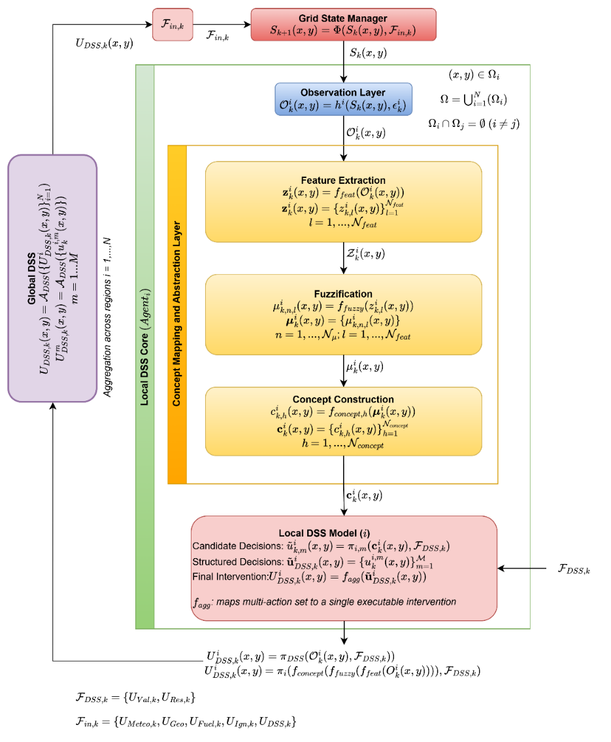
Figure 6.1 DSS system overview
The architectural design of the DSS is governed by three foundational principles that follow directly from the problem formulation of Chapter 2. First, the DSS operates under partial observability. In other words, it never accesses the true wildfire state $S_{k}\left(x,y\right)$ directly, but reasons exclusively from observable information subject to epistemic uncertainty. Second, the DSS generates intervention inputs rather than control actions; in other words, its outputs influence system evolution indirectly through the external input layer $F_{in,k}$, never by overwriting internal state variables. Third, the DSS supports multi-level decision generation; in other words, local context-aware reasoning is coordinated at a global level to produce a spatially consistent intervention structure. These principles collectively define the boundary conditions within which the DSS architecture is constructed.

Grid State Manager and the Simulation Interface
As shown in Figure 6.1, the architectural flow originates at the Grid State Manager, which maintains the authoritative wildfire state $S_{k}\left(x,y\right)$ over the spatial domain $G$ and governs its discrete-time evolution through the state transition $S_{k+1}\left(x,y\right)=Φ\left(S_{k}\left(x,y\right),F_{in,k}\right)$ where $F_{in,k}=\left\{U_{Meteo,k},U_{Geo},U_{Fuel,k},U_{Ign,k},U_{DSS,k}\right\}$ is the structured external input set defined in Chapter 4. The DSS interacts with this operator exclusively through the decision-driven subset $U_{DSS,k}\left(x,y\right)⊂F_{in,k}$, which represents the intervention parameters generated by the decision layer. This interface enforces the strict causal structure: $S_{k}\left(x,y\right)→O_{k}^{i}\left(x,y\right),F_{DSS,k}→U_{DSS,k}\left(x,y\right)⊂F_{in,k}→Φ\left(⋅\right)→S_{k+1}\left(x,y\right)$, which ensures that all decision effects propagate through physically consistent state transitions.

Observation Layer
Since the true wildfire state $S_{k}\left(x,y\right)$ is not directly accessible in operational conditions, the first functional boundary of the DSS is the Observation Layer, which produces a region-specific, uncertainty-affected representation of the current system state. For each operational region $Ω_{i}$, the observation process is formally defined as ( 84 ) where $h^{i}\left(⋅\right)$ is the region-specific observation function that maps internal state variables to measurable or estimable quantities, and $ϵ_{k}^{i}$ represents the epistemic uncertainty associated with region $Ω_{i}$ at time step $k$.
$$O_{k}^{i}\left(x,y\right)=h^{i}\left(S_{k}\left(x,y\right),ϵ_{k}^{i}\right)$$ | ( 84 )
The uncertainty term $ϵ_{k}^{i}$ captures the combined effect of sensing limitations, spatial coverage gaps, temporal delays in field reporting, and measurement noise. It is not modeled as a stochastic noise term with a known distribution rather, it represents the structural incompleteness of knowledge that motivates the use of fuzzy reasoning in subsequent layers. The observable information $O_{k}^{i}\left(x,y\right)$ provides the exclusive informational basis for all downstream reasoning within region $Ω_{i}$. It may include estimated burning extent, fire front propagation indicators, fuel depletion estimates, wind-adjusted spread potential, and proximity-to-value metrics derived from the state variables $\left\{B_{k} , F_{load,k} , I_{k} , τ_{k}\right\}$ together with the contextual inputs $F_{DSS,k}$.

Observation Function
The region-specific observation function $h^{i}\left(⋅\right)$ introduced in Equation ( 84 ) is formally defined as a structured state projection operator subject to spatially varying coverage weights and bounded epistemic disturbance. The function maps the four-dimensional wildfire state vector to an observable information vector of equal dimension, restricted to the spatial domain of region $Ω_{i}$ ( 85 ).
$$h^{i}:R^{4}×E^{i}⟶R^{4},\left(x,y\right)∈Ω_{i}$$ | ( 85 )
For each grid cell $\left(x,y\right)∈Ω_{i}$, the observable information vector is defined component-wise as ( 86 ):
$$O_{k}^{i}\left(x,y\right)=\left[\begin{aligned}{\hat{B}}_{k}^{i}\left(x,y\right) \\ {\hat{F}}_{load,k}^{i}\left(x,y\right) \\ {\hat{I}}_{k}^{i}\left(x,y\right) \\ {\hat{τ}}_{k}^{i}\left(x,y\right)\end{aligned}\right]=\left[\begin{aligned}θ_{B,k}^{i}\left(x,y\right)⋅B_{k}\left(x,y\right) + ϵ_{B,k}^{i}\left(x,y\right) \\ θ_{F,k}^{i}\left(x,y\right)⋅F_{load,k}\left(x,y\right) + ϵ_{F,k}^{i}\left(x,y\right) \\ θ_{I,k}^{i}\left(x,y\right)⋅I_{k}\left(x,y\right) + ϵ_{I,k}^{i}\left(x,y\right) \\ θ_{τ,k}^{i}\left(x,y\right)⋅τ_{k}\left(x,y\right) + ϵ_{τ,k}^{i}\left(x,y\right)\end{aligned}\right]$$ | ( 86 )
For cells outside the region, $O_{k}^{i}\left(x,y\right)=0_{4}$ for all $\left(x,y\right)∉Ω_{i}$, enforcing spatial locality of the observation process.

Observability Weights
Each scalar weight $θ_{j,k}^{i}\left(x,y\right)∈\left[0,1\right]$, for $j∈\left\{B,F,I,τ\right\}$, encodes the degree to which state component $j$ at cell $\left(x , y\right)$ is accessible to region $Ω_{i}$ at time step $k$. $θ_{j,k}^{i}\left(x,y\right)=1$ denotes full observability under nominal conditions; $θ_{j,k}^{i}\left(x,y\right)=0$ indicates complete inaccessibility due to coverage failure or data unavailability. Table 6.1 lists the physical interpretation and typical sensing source for each weight.
Table 6.1 Observability weights: interpretation and sensing source
Weight | State component | $θ=1$ (full observability) | $θ=0$ (no observation) | Typical source
$$θ_{B,k}^{i}$$ | Burning status $B_{k}$ | Active burning reliably detected | Complete coverage gap | Satellite or aerial imagery
$$θ_{F,k}^{i}$$ | Fuel load $F_{load,k}$ | Fuel state precisely known | No fuel data available | Pre-fire fuel maps, field survey
$$θ_{I,k}^{i}$$ | Fire intensity $I_{k}$ | Intensity directly measured | Sensor occlusion | Thermal infrared imaging
$$θ_{τ,k}^{i}$$ | Ignition time $τ_{k}$ | Time-since-ignition recorded | Unknown ignition time | Event log, field report

In the nominal simulation setting used throughout this thesis, all weights are set to unity, $θ_{j,k}^{i}\left(x,y\right)=1$ for all $\left(x,y\right)∈Ω_{i}$ and all $j$, representing ideal sensing conditions. Degraded coverage scenarios are encoded by reducing individual weights for affected cells.

Epistemic Disturbance Model
The disturbance vector $ϵ_{k}^{i}(x,y)=[ϵ_{B,k}^{i},ϵ_{F,k}^{i},ϵ_{I,k}^{i},ϵ_{τ,k}^{i}]^{⊤}$ represents the bounded epistemic uncertainty remaining after coverage scaling. It is not modeled as a stochastic noise process. Instead, each component is bounded by a maximum disturbance magnitude ${\overset{ˉ}{ϵ}}_{j}^{i}>0$ ( 87 ).
$$ϵ_{j,k}^{i}\left(x,y\right)∈\left[-{\overset{ˉ}{ϵ}}_{j}^{i}, {\overset{ˉ}{ϵ}}_{j}^{i}\right],j∈\left\{B, F, I, τ\right\}$$ | ( 87 )
Additionally, whenever $θ_{j,k}^{i}\left(x,y\right)=0$, the disturbance is defined to be zero, $ϵ_{j,k}^{i}\left(x,y\right)=0$, so that the $j$-th entry of $O_{k}^{i}\left(x,y\right)$ vanishes and unambiguously encodes loss of observability for state component $j$ at cell $\left(x,y\right)$ rather than generating a spurious noise reading.
The disturbance magnitude is governed by per-component observation confidence coefficients that aggregate four independent degradation factors: the spatially varying observability weight $θ_{j,k}^{i}\left(x,y\right)∈\left[0,1\right]$ of Section 6.1.2.2, the normalized sensor coverage density $ρ_{k}^{i}\left(x,y\right)∈\left[0,1\right]$ reflecting the fraction of active sensing assets providing data at cell $\left(x,y\right)$, an exponential decay $exp\left(-λ_{\text{conf}}⋅Δt_{\text{rep},k}^{i}\left(x,y\right)\right)$ in the elapsed time since the most recent field observation or sensor report at $\left(x,y\right)$ with $λ_{\text{conf}}>0$ governing the decay rate, and the regional communication reliability $γ_{k}^{i}∈\left[0,1\right]$ encoding data-link integrity between field sensors and the DSS:
$${conf}_{j,k}^{i}\left(x,y\right)=\min\left(θ_{j,k}^{i}\left(x,y\right), ρ_{k}^{i}\left(x,y\right), \exp\left(-λ_{conf}⋅Δt_{rep,k}^{i}\left(x,y\right)\right), γ_{k}^{i}\right)$$  $$j∈\left\{B,F,I,τ\right\}$$ | ( 88 )
The cell-level scalar confidence used by downstream layers is the minimum of the component-specific confidences, reflecting the conservative principle that the reliability of the observation vector is limited by its least reliable channel:
$${conf}_{k}^{i}\left(x,y\right)=\min_{j∈\{B,F,I,τ\}}{conf}_{j,k}^{i}\left(x,y\right)$$ | ( 89 )
The effective per-component disturbance magnitude decreases as component confidence increases,
$$\left|ϵ_{j,k}^{i}\left(x,y\right)\right|≤\left(1-{conf}_{j,k}^{i}\left(x,y\right)\right)⋅{\overset{‾}{ϵ}}_{j}^{i}.$$ | ( 90 )
When $θ_{j,k}^{i}\left(x,y\right)=1$ and all remaining factors equal unity, ${conf}_{j,k}^{i}=1$ and the disturbance vanishes. When $θ_{j,k}^{i}\left(x,y\right)=0$, ${conf}_{j,k}^{i}=0$ jointly with the structural constraint $ϵ_{j,k}^{i}=0$ introduced following Equation ( 87 ), so that the unreliability of component $j$ is signaled simultaneously through a zero $j$-th entry of the observation vector $O_{k}^{i}\left(x,y\right)$ and a zero component confidence ${conf}_{j,k}^{i}\left(x,y\right)$. In the nominal case $θ_{j,k}^{i}\left(x,y\right)=1$ for all $j$, ( 89 ) reduces to ${conf}_{k}^{i}\left(x,y\right)=min\left(ρ_{k}^{i}\left(x,y\right), exp\left(-λ_{\text{conf}}⋅Δt_{\text{rep},k}^{i}\left(x,y\right)\right), γ_{k}^{i}\right)$, recovering the strict-sensing baseline.
The global observation function $h\left(⋅\right)$ introduced in Chapter 2 is recovered from region-specific functions through spatial aggregation. Since the operational regions $\left\{Ω_{i}\}_{i=1}^{N}\right.$ form a disjoint partition of $G$, each grid cell belongs to exactly one region, and the global observable is ( 91 ):
$$O_{k}\left(x,y\right)=h\left(S_{k}\left(x,y\right), ϵ_{k}\right)=\sum_{i=1}^{N}{1_{\left(x,y\right)∈Ω_{i}}}⋅h^{i}\left(S_{k}\left(x,y\right), ϵ_{k}^{i}\right)$$ | ( 91 )
This relationship confirms that Equation ( 84 ) constitutes the architectural instantiation of the abstract observation model stated in Equation ( 1 ).
The four components of $O_{k}^{i}\left(x,y\right)$ serve as direct inputs to the feature extraction stage of Section 6.2.1. The mapping $z_{k}^{i}\left(x,y\right)=f_{feat}\left(O_{k}^{i}\left(x,y\right)\right)$ defined in ( 85 ) derives the six operational features used in all subsequent reasoning stages exclusively from $\left\{{\hat{B}}_{k}^{i} , {\hat{F}}_{load,k}^{i} , {\hat{I}}_{k}^{i} , {\hat{τ}}_{k}^{i}\right\}$ together with the contextual inputs $F_{DSS,k}$.

Local DSS Core
Each operational region $Ω_{i}$ is served by a dedicated reasoning unit, denoted ${Agent}_{i}$, which constitutes the Local DSS Core. As shown in Figure 6.1, the Local DSS Core is internally organized into two functionally distinct sublayers: the Concept Mapping and Abstraction Layer and the Local DSS Model. The separation between these sublayers reflects the fundamental distinction between situation understanding (what is happening?) and decision generation (what should be done?).
Remark 6.1 (Shared Policy Across Regions). The regional DSS mapping $π_{DSS}^{i}$ is functionally and parametrically identical across all regions i = 1, …, N: the feature extraction mapping $f_{feat}$, the fuzzification operator $f_{fuzzy}$, the concept construction mappings ${{\{f}_{concept,h}\}}_{h=1}^{4}$ (including all 108 concept-construction rules and the weights specified in Equations ( 62 )–( 65 ), the intervention decision mappings ${\left\{π_{i,m}\right\}}_{m=1}^{M}$ with their 243 rules, and the action aggregation function $f_{agg}$ are shared. The default membership parameters (Table 5.4), priority weights (Remark 5.7), and decision quality weights (Remark 5.9) are likewise common to all regional agents. Spatial variability in the generated global intervention field $U_{DSS,k}\left(x,y\right)$ arises exclusively from region-specific inputs: the regional observation $O_{k}^{i}\left(x,y\right)$, the contextual inputs $F_{DSS,k}^{i}$, the observation confidence $conf_{k}^{i}\left(x,y\right)$, and the region-local concept memory $c_{prior,h}^{i}\left(x,y\right)$ used in the confidence-gated modulation of Section 6.2.4. This shared-policy design is a deliberate architectural choice rather than a limitation: it yields a uniformly validatable decision system, supports third-party certification against a single rule base, and avoids the combinatorial tuning burden of region-specific rule tailoring. The architecture remains extensible to region-specific specialization (e.g., distinct rule sets for wildland–urban interface versus wilderness zones) through per-region instantiation of $π_{DSS}^{i}$, without modification to the global coordination mechanism $A_{DSS}^{sp}$ or the Simulation Core.

Concept Mapping and Abstraction Layer
The purpose of the Concept Mapping and Abstraction Layer is to transform the raw observable information $O_{k}^{i}\left(x,y\right)$ into a compact, interpretable, and reasoning-amenable situational description. This transformation proceeds through three sequential stages.

Feature Extraction
The first stage extracts a structured set of $N_{feat}$ scalar features from the observable information through the feature extraction mapping $f_{feat}$, defined in ( 77 ). Each feature $z_{k,l}^{i}(x,y)$ is a scalar-valued indicator that captures a specific operationally relevant aspect of the current wildfire situation within region $Ω_{i}$ at grid cell $\left(x , y\right)$. The feature vector $z_{k}^{i}$ is defined over the same spatial domain as the observable information and is evaluated at every active grid cell within $Ω_{i}$. The design of the feature set and the six feature definitions are presented in Section 5.2.1.

Fuzzification
The second stage transforms each scalar feature $z_{k,l}^{i}(x,y)$ into a graded membership representation over $N_{μ}$ linguistic terms through the fuzzification mapping $f_{fuzzy}$, defined in Equation ( 78 ). The membership value $μ_{k,n,l}^{i}(x,y)∈[0,1]$ expresses the degree to which the feature $z_{k,l}^{i}(x,y)$ belongs to linguistic term $n$ (e.g., the degree to which local fire intensity is high, or the degree to which suppression travel time is critical). This graded representation is the primary mechanism through which epistemic uncertainty $ϵ_{k}^{i}$ is encoded in the reasoning process: rather than requiring precise crisp thresholds that would be unreliable under uncertain observations, the fuzzy membership structure allows the system to reason over partial and ambiguous evidence in a principled manner. The membership function designs and linguistic variable definitions are presented in Section 5.2.2, Equation ( 57 ).

Concept Construction
The third stage aggregates the fuzzified feature memberships into a reduced set of $N_{concept}$ higher-level situational concepts through the concept construction mappings $f_{concept,h}$, defined in Equation ( 79 ), with index sets and weights specified in Equations ( 62 )–( 65 ). Each concept $c_{k,h}^{i}(x,y)∈[0,1]$ represents a composite situational assessment that captures a semantically meaningful operational condition such as imminent threat to high-value assets, suppression feasibility under current resource availability, or active fire front with high spread potential.
The concept vector $c_{k}^{i}(x,y)$ operates in a space of dimension $N_{concept}$, which is substantially smaller than the $N_{feat}×N_{μ}$ dimensional space of the full membership representation. This dimensionality reduction constitutes the architectural mechanism through which rule complexity of the subsequent decision layer is controlled. The analytical treatment of this reduction is provided in Section 5.2.3.

Local DSS Model
The concept vector $c_{k}^{i}\left(x,y\right)$ is passed to the Local DSS Model, which is responsible for generating region-level intervention guidance. The Local DSS Model operates through three sequential stages as shown in Figure 6.1.

Candidate Decision Generation
For each intervention type $m∈\{1,…,M\}$, a decision mapping $π_{i,m}$ evaluates the situational concept vector jointly with the contextual decision inputs $F_{DSS,k}$ to produce a candidate intervention degree $u_{k,m}^{i}(x,y)$, as defined in Equation ( 80 ). The contextual input set $F_{DSS,k}=\{U_{Val,k},U_{Res,k}\}$ encodes the value-at-risk distribution and the operational resource constraints as defined in Chapter 2. Its inclusion in the decision mapping ensures that intervention candidates are evaluated not only with respect to the current fire situation but also with respect to what is operationally feasible and strategically prioritized.
Each $π_{i,m}$ is realized as a fuzzy inference system whose rule base encodes domain knowledge about appropriate intervention responses to identified situational concepts. The candidate degree $u_{k,m}^{i}(x,y)∈[0,1]$ expresses the degree to which intervention type $m$ is warranted at grid cell $\left(x , y\right)$ within region $Ω_{i}$ at time step $k$. It does not constitute a binary decision but a graded recommendation, consistent with the satisfaction-based decision paradigm introduced in Chapter 2. The specification of $π_{i,m}$ and its associated rule base are presented in Section 5.3.2, and its runtime execution is detailed in Section 6.3.

Structured Decision Assembly
The candidate degrees across all $M$ intervention types are organized into a structured multi-action representation ( 92 ). This multi-action structure reflects the non-exclusive nature of wildfire response operations, where multiple intervention strategies (i.e., such as direct suppression, fuel reduction, and evacuation support) may need to be activated simultaneously with varying degrees of priority.
$$u_{DSS,k}^{i}(x,y)=\{u_{k,m}^{i}(x,y)\}_{m=1}^{M}$$ | ( 92 )

Final Intervention Generation
The multi-action vector is mapped to a single executable intervention parameter through the aggregation function $f_{agg}$, defined in ( 70 ), to resolve any conflicts or redundancies among simultaneously activated intervention types and produce an output $U_{DSS,k}^{i}(x,y)$ expressed in terms compatible with the external input $U_{DSS,k}$.

Global DSS Coordination
The region-level intervention parameters generated by all $N$ local agents are consolidated within the Global DSS coordination layer. As illustrated in Figure 6.1, the global coordination mechanism produces both a spatially distributed global intervention field and action-type-specific global outputs ( 93 ) where $A_{DSS}\left(⋅\right)$ is the global coordination and fusion mechanism that integrates locally generated decisions into a globally consistent intervention structure.
$$U_{DSS,k}(x,y)=A_{DSS}(\{U_{DSS,k}^{i}(x,y)\}_{i=1}^{N})$$  $$U_{DSS,k}^{m}(x,y)=A_{DSS}(\{u_{k,m}^{i}(x,y)\}_{i=1}^{N}),m=1,…,M$$ | ( 93 )
Global aggregation serves two purposes. First, it resolves spatial inconsistencies that arise when locally optimal decisions in neighboring regions conflict with one another. For example, when two adjacent regions independently request the same suppression resource that cannot be simultaneously deployed in both locations. Second, it ensures that the global intervention field $U_{DSS,k}\left(x,y\right)$ is defined over the entire spatial domain $G$, providing a complete spatially distributed intervention representation rather than a collection of disjoint regional outputs.
The formalization of $A_{DSS}$ and the spatial field generation mechanisms is presented in Section 6.4. The resulting global intervention field $U_{DSS,k}\left(x,y\right)$ is injected back into the external input set $F_{in,k}$, closing the feedback loop between the DSS and the Simulation Core.

Closed-Loop Structure
The complete decision cycle illustrated in Figure 6.1 constitutes a closed-loop interaction between the cognitive DSS layer and the physical simulation layer. At each discrete time step $k$, the cycle proceeds as follows. The Grid State Manager updates the wildfire state $S_{k}\left(x,y\right)$ through the transition operator $Φ\left(⋅\right)$. The Observation Layer derives partial, uncertainty-affected observations $O_{k}^{i}\left(x,y\right)$ for each region. Each ${Agent}_{i}$ processes its regional observation through the Concept Mapping and Abstraction Layer and the Local DSS Model, producing a region-level intervention output $U_{DSS,k}^{i}\left(x,y\right)$. The Global DSS aggregates these outputs into the intervention field $U_{DSS,k}\left(x,y\right)$, which is injected into $F_{in,k}$ to influence the next state transition $S_{k+1}\left(x,y\right)$.
This closed-loop structure enables the DSS to update intervention guidance at each time step in response to evolving wildfire conditions. Rather than converging to a fixed policy, the DSS generates context-sensitive guidance from updated observations under partial observability.

Concept Mapping and Abstraction Layer
This section describes the runtime execution of the Concept Mapping and Abstraction Layer within the DSS architecture. At each simulation time step k and for each spatial region $Ω_{i}$, the layer transforms observable information $O_{k}^{i}\left(x,y\right)$ into a structured concept vector $c_{k}^{i}\left(x,y\right)$ through a sequence of deterministic transformations. The transformation follows a three-stage pipeline consisting of feature extraction, fuzzification, and concept construction. All mappings, parameter definitions, and semantic interpretations of features and concepts are formally defined in Chapter 5. This section focuses exclusively on how these mappings are executed during runtime. The design rationale and parameter choices for each stage are established in Sections 5.2.1–5.2.3; this section specifies their runtime execution sequence and inter-layer data flow.

From Observation to Concept Vector: Runtime Execution
At each discrete time step $k$, every local DSS agent ${\text{Agent}}_{i}$ receives the observable information $O_{k}^{i}(x,y)$ from the Observation Layer for all grid cells $(x,y)∈Ω_{i}$ within its assigned region. The Concept Mapping and Abstraction Layer processes this input through three sequential computational stages that are applied independently at every active grid cell. Figure 6.2 illustrates this pipeline and its outputs at each stage.
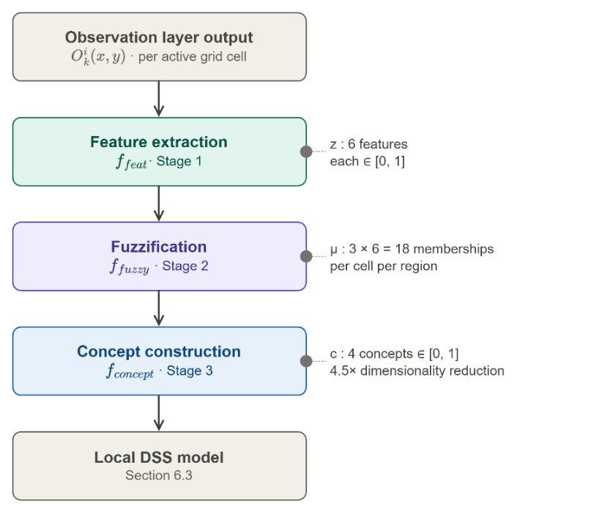
Figure 6.2 The 3-stage pipeline of the concept mapping and abstraction layer

Stage 1 Feature Extraction
The feature extraction mapping $f_{\text{feat}}$ projects the observable information onto the six-dimensional feature vector $z_{k}^{i}(x,y)∈[0,1]^{6}$ whose components and derivations are defined in Section 5.2.1 Equation ( 77 ). All six features are bounded in $\left[0 , 1\right]$ either by construction (for $z_{1}$, $z_{2}$) or by explicit normalization (for $z_{3}$ through $z_{6}$), which is a necessary precondition for the fuzzification stage that follows. This stage executes with no inter-agent communication and no memory of previous time steps: $f_{\text{feat}}$ is a stateless, spatially local mapping evaluated independently at each $\left(x , y\right)$. The computational cost scales linearly with the number of active cells in $Ω_{i}$.

Stage 2 Fuzzification
The fuzzification mapping $f_{\text{fuzzy}}$ transforms each scalar feature into a triplet of graded membership values over the linguistic terms Low ($L$), Medium ($M$), and High ($H$), producing the $3×6$ membership matrix $μ_{k}^{i}(x,y)$ with 18 entries per grid cell. The membership functions follow the piecewise-linear shoulder–triangular–shoulder design established in Section 5.2.2 Equation ( 57 ), parameterized by the feature-specific triplets $\left(p_{1,l} , p_{2,l} , p_{3,l}\right)$ from Table 5.4. Like feature extraction, fuzzification is a stateless per-cell operation. The partition-of-unity property $μ_{L,l}+μ_{M,l}+μ_{H,l}=1$ established in Proposition 5.1 holds at every grid cell and every time step, ensuring that no observation is left ambiguously unassigned.

Stage 3 Concept Construction
The concept construction mappings $\left\{f_{\text{concept},h}\}_{h=1}^{4}\right.$ aggregate selected entries of the membership matrix into four situational concepts via the normalized weighted average defined in Section 5.2.3 Equation ( 61 ). The index sets $S_{h}$ and weights $\left\{w_{h,n,l}\right\}$ for Fire Threat Level ($c_{1}$), Suppression Feasibility ($c_{2}$), Asset Exposure Risk ($c_{3}$), and Intervention Urgency ($c_{4}$) are specified in Equations ( 62 )–( 65 ). The concept vector $c_{k}^{i}(x,y)=\{c_{k,h}^{i}(x,y)\}_{h=1}^{4}$ is the output of the Concept Mapping and Abstraction Layer and serves as the input to the DSS Model described in Section 6.3.
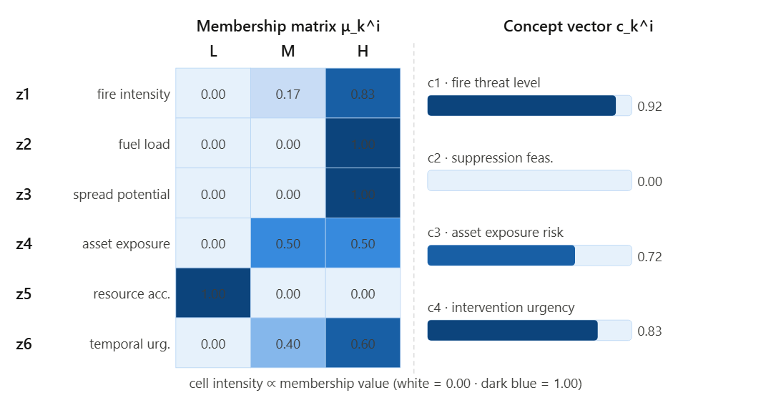
Figure 6.3 Membership matrix and concept vector
Figure 6.3 presents a worked numerical example of the complete pipeline, using a high-urgency wildfire scenario with parameter values $z_{1}=0.75$ (high fire intensity), $z_{2}=0.80$ (high fuel), $z_{3}=0.70$ (maximum spread potential), $z_{4}=0.60$ (moderate-high asset exposure), $z_{5}=0.20$ (low resource accessibility), and $z_{6}=0.75$ (high temporal urgency).

Formal Properties of the Transformation
The end-to-end transformation $O_{k}^{i}(x,y)↦c_{k}^{i}(x,y)$ satisfies three formal properties that are essential to the correctness and tractability of the DSS at runtime.
Property 6.1 (Output Boundedness). For all grid cells $(x,y)∈Ω_{i}$, all time steps $k$, and all agents $i$, the concept vector satisfies $c_{k,h}^{i}(x,y)∈[0,1]$ for $h=1,…,4$. This follows from the stage-by-stage boundedness argument established in the proof of Proposition 5.3. Its architectural consequence is that the Local DSS Model can apply the same membership function design to concept inputs as to feature inputs, without requiring additional normalization.
Property 6.2 (Partition of Unity). For each feature $l$ and any $z∈[0,1]$, the fuzzification stage satisfies $μ_{L,l}(z)+μ_{M,l}(z)+μ_{H,l}(z)=1$. This is Proposition 5.1, proven in Section 5.2.2. Within the runtime loop, this property guarantees that no feature value is ambiguously unassigned and no double-counting occurs, ensuring that the concept construction stage operates on a well-defined probability-like structure at every grid cell and every time step.
Property 6.3 (Dimensionality Reduction). The transformation reduces the per-cell representation from $N_{μ}×N_{\text{feat}}=18$ dimensions to $N_{\text{concept}}=4$ dimensions. The rule complexity reduction achieved by this architecture, from $3^{6}=729$ to $3^{4}=81$ rules per intervention type, is formally established in Proposition 5.2. Its architectural significance is that each local agent executes a compact 81-rule inference pass per intervention type rather than a 729-rule pass, directly controlling the per-step computational cost of the distributed DSS.

Epistemic Encoding Under Partial Observability
The Observation Layer introduces epistemic uncertainty $ϵ_{k}^{i}$ into $O_{k}^{i}\left(x,y\right)$ through sensor noise, coverage gaps, and estimation error, as formalized in Section 6.1.2. A central design requirement of the Concept Mapping and Abstraction Layer is that this uncertainty must be propagated into the concept vector in a principled manner, rather than suppressed through crisp thresholding.
A crisp alternative to fuzzification would assign each feature $z_{k,l}^{i}$ to exactly one linguistic term based on hard boundaries: for instance, $z_{k,1}^{i}>0.5⇒$ High fire intensity, otherwise Low or Medium. Under this approach, a feature value of $0.49$ and a value of $0.51$ would produce categorically different concept inputs, despite being indistinguishable within the margin of observational uncertainty $ϵ_{k}^{i}$. This sensitivity to boundary placement is precisely the failure mode that the graded membership representation is designed to avoid. Figure 6.4 contrasts this behavior with the fuzzy membership approach adopted in this system.
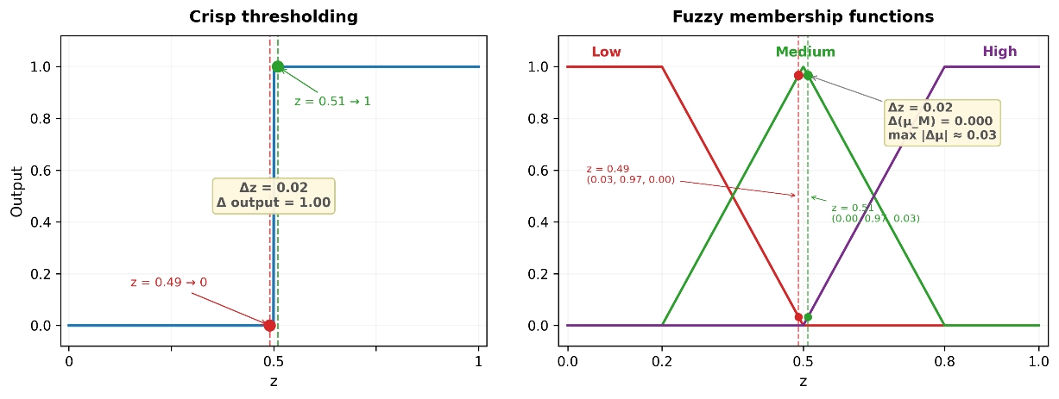
Figure 6.4 Crisp threshold and fuzzy membership
Crisp thresholding versus fuzzy membership functions for observations $z=0.49$ and $z=0.51$ are illustrated in Figure 6.4. Left: a $Δz=0.02$ difference at the crisp boundary at $z=0.50$ produces a categorical output jump of $Δ=1.00$. Right: the same input difference maps to a change of $Δ\left(μ_{M}\right)≈0.03$ under the fuzzy representation, preserving continuity in the concept space.
The fuzzy representation resolves this by assigning both values $0.49$ and $0.51$, to partially overlapping linguistic terms. At $z=0.49$ with parameters $\left(p_{1},p_{2},p_{3})=(0.20, 0.50, 0.80\right)$, the observation falls in the Low–Medium transition zone $\left(p^{1}< z < p^{2}\right)$, and the membership triplet evaluates to $\left(μ_{L},μ_{M},μ_{H})=(0.033, 0.967, 0.000\right)$; at $z=0.51$, the observation crosses into the Medium–High transition zone $(p₂ < z < p₃)$, yielding to $\left(0.000, 0.967, 0.033\right)$. The concept values computed from these two inputs differ by at most $0.02$ in any weighted average which is a smooth, bounded response to a small perturbation in the input. This smoothness is formalized by the Lipschitz continuity of the full pipeline established in Proposition 5.4, which guarantees that small observational uncertainties produce proportionally small perturbations in the concept vector. Crucially, the dominant membership $μ_{M}$ remains unchanged at 0.967, and the maximum change in any single component is $\max\left|Δμ\right|≈ 0.03$, a smooth, bounded response to a small perturbation in the input."
This Lipschitz property has a direct operational consequence for the DSS: the intervention guidance produced by the Local DSS Model is robust to sensor-level perturbations in $O_{k}^{i}\left(x,y\right)$. The system does not exhibit decision discontinuities at linguistic boundaries, and the degree of uncertainty in each feature is implicitly encoded in the distribution of membership values across the three terms. A feature observed with high confidence near its core region (e.g., $z_{k,1}^{i}=0.90$, giving $μ_{H}≈1.0$) produces a sharply concentrated concept contribution, while a feature with ambiguous value near a boundary (e.g., $z_{k,1}^{i}=0.50$, giving $μ_{M}=1.0$, $μ_{L}=μ_{H}=0$) produces a contribution that activates only the transitional term, naturally reducing its influence on strongly-polarized decision rules.
The concept abstraction layer therefore functions simultaneously as a dimensionality reducer, a linguistic encoder, and an epistemic buffer translating the uncertain, high-dimensional observational state into a compact, semantically interpretable, and uncertainty-aware representation that the Local DSS Model can act upon without requiring assumptions of precise measurement.

Confidence-Gated Concept Modulation
The concept vector $c_{k}^{i}\left(x,y\right)$ produced by the construction mappings of ( 62 )–( 65 ) is derived from the fuzzified membership matrix, which in turn depends on the observable information $O_{k}^{i}\left(x,y\right)$. However, the observation model of Section 6.1.2 introduces the observation confidence coefficient ${{conf}_{k}}^{i}\left(x,y\right)$ ∈ $\left[0,1\right]$ in Equation ( 89 ), which quantifies the reliability of the information available at each grid cell. The concept construction mappings of Equations ( 62 )–( 65 ) do not yet incorporate this reliability measure: they treat all cells identically regardless of whether their underlying observations are highly reliable or severely degraded.
To close this gap, the concept vector is modulated by a confidence-gating mechanism that blends the computed concept values with a persistence-based prior in proportion to the local observation confidence. This mechanism ensures that concept values derived from low-confidence observations are attenuated toward their most recent reliable estimate, while concept values derived from high-confidence observations are passed through without modification.
Definition 6.1 (Confidence-Gated Concept Vector). For each concept index $h$ ∈ {1,2,3,4}, region $Ω_{i}$, grid cell $\left(x,y\right)$, and time step $k$, the confidence-gated concept value is defined as:
$${\bar{c}}_{k,h}^{i}\left(x,y\right)={{conf}_{k}}^{i}\left(x,y\right) ⋅ c_{k,h}^{i}\left(x,y\right) + \left(1 - {{conf}_{k}}^{i}\left(x,y\right)\right) ⋅ c_{prior,h}^{i}\left(x,y\right)$$ | ( 94 )
where ${{conf}_{k}}^{i}\left(x,y\right)$ is the observation confidence coefficient of Equation (79), $c_{k,h}^{i}\left(x,y\right)$ is the concept value computed by Equations ( 62 )–( 65 ), and $c_{prior,h}^{i}\left(x,y\right)$ is the concept prior, defined as:
$$c_{prior,h}^{i}\left(x,y\right) = \left\{{\bar{c}}_{k-1,h}^{i}\left(x,y\right), if k ≥ 1\right\}$$ | ( 95 )
$$c_{prior,h}^{i}\left(x,y\right) = \left\{0.5, if k = 0\right\}$$ | ( 96 )
The prior is the previous-step confidence-gated concept value when available, and the neutral midpoint value 0.5 at the initial time step. This choice ensures that no prior information bias is introduced at initialization, and that the persistence mechanism carries forward the most recent reliable assessment when current observations are degraded.
Remark 6.2 (Boundedness Preservation). Since ${{conf}_{k}}^{i}\left(x,y\right) ∈ \left[0,1\right]$, $c_{k,h}^{i}\left(x,y\right) ∈ \left[0,1\right]$ by Proposition 5.3, and $c_{prior,h}^{i}\left(x,y\right) ∈ \left[0,1\right]$ by induction, the confidence-gated concept value satisfies ${\bar{c}}_{k,h}^{i}\left(x,y\right) ∈ \left[0,1\right]$ for all $k$, $h$, $i$, and $\left(x,y\right)$. The boundedness guarantee of Property 6.1 is therefore preserved.
Remark 6.3 (Operational Interpretation). When ${{conf}_{k}}^{i}\left(x,y\right) = 1$, the observation is fully reliable, and the concept value passes through unmodified: ${\bar{c}}_{k,h}^{i}\left(x,y\right) = c_{k,h}^{i}\left(x,y\right)$. When ${{conf}_{k}}^{i}\left(x,y\right) = 0$, the observation carries no information and the system falls back entirely to the previous assessment: ${\bar{c}}_{k,h}^{i}\left(x,y\right) = c_{prior,h}^{i}\left(x,y\right)$. In intermediate cases, the mechanism produces a smooth blend that degrades gracefully with decreasing confidence, consistent with the Lipschitz continuity established in Proposition 5.4. The confidence-gated concept vector is therefore:
$${\bar{c}}_{k}^{i}\left(x,y\right) = {\left[{\bar{c}}_{k,1}^{i} , {\bar{c}}_{k,2}^{i} , {\bar{c}}_{k,3}^{i} , {\bar{c}}_{k,4}^{i}\right]}^{T} ∈ {\left[0,1\right]}^{4}$$ | ( 97 )
All subsequent stages of the DSS pipeline, specifically the fuzzy inference of Section 6.3 and the decision quality evaluation of Section 6.4.4, operate on the confidence-gated concept vector ${\bar{c}}_{k}^{i}\left(x,y\right)$ rather than the raw concept vector $c_{k}^{i}\left(x,y\right)$. This substitution is transparent to the downstream stages because the boundedness, partition-of-unity compatibility, and dimensionality reduction properties established in Section 6.2.3 are all preserved under the gating operation.

Local Decision Generation and Action Aggregation
The Local DSS Model constitutes the inferential core of each local agent ${\text{Agent}}_{i}$. Receiving the concept vector $c_{k}^{i}(x,y)$ produced by the Concept Mapping and Abstraction Layer at every active grid cell, it executes two successive operations: a fuzzy inference pass that evaluates the intervention decision rule bases $\left\{π_{i,m}\}_{m=1}^{M}\right.$ defined in Section 5.3.2, and an action aggregation step that combines the resulting candidates through the function $f_{agg}$ (Section 5.3.3) into a single executable intervention parameter $U_{DSS,k}^{i}(x,y)$. The output of this section is the per-cell regional decision field that is passed to the Global Coordination Layer described in Section 6.4. The rule base structure and aggregation weights are defined in Sections 5.3.1–5.3.3; this section describes the inference execution, activation propagation, and output assembly within the local agent architecture.
Figure 6.5 illustrates the two-stage structure of the Local DSS Model. The concept vector $c_{k}^{i}(x,y)$ from Section 6.2 fans into three parallel fuzzy rule bases, each producing a candidate intervention degree $u_{k,m}^{i}$. The action aggregation function $f_{agg}$ combines these into the local output $U_{DSS,k}^{i}(x,y)$ passed to Global DSS described in Section 6.4.
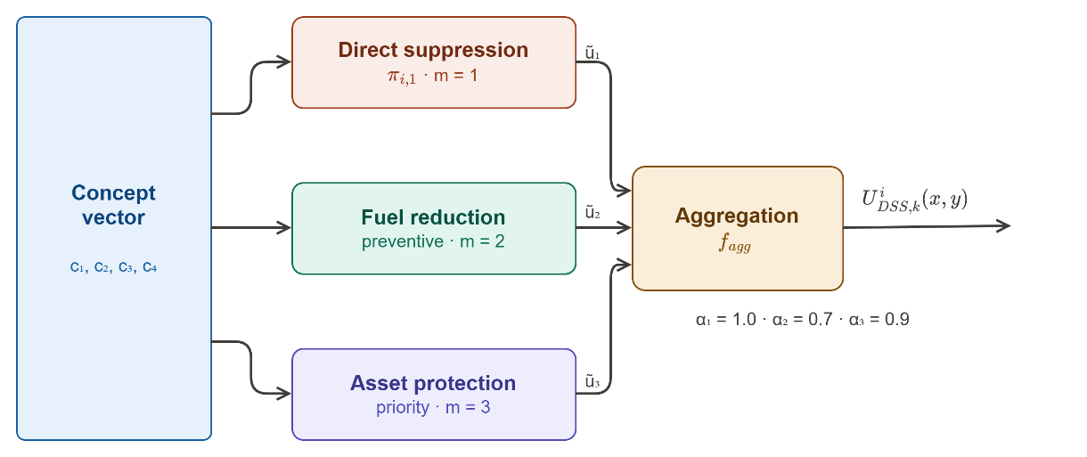
Figure 6.5 Runtime inference pipeline of the Local DSS Model

Fuzzy Inference over the Concept Vector
At each time step $k$, the inference engine processes every active cell $(x,y)∈Ω_{i}$ independently. For each intervention type $m$, the engine traverses the $3^{4}=81$-rule base $π_{i,m}$ and evaluates the activation strength of each rule $R$ given the current concept vector $c_{k}^{i}(x,y)=\{c_{1},c_{2},c_{3},c_{4}\}$.

Rule Activation
Each rule $R∈π_{i,m}$ has an antecedent that specifies a linguistic term $n_{h}∈\{L,M,H\}$ for each of the four concepts. The activation strength $α_{R}$ is computed via the min-operator conjunction defined in ( 81 ), applying the piecewise-linear membership functions used during fuzzification (Section 5.2.2) directly to concept values. This reuse is valid because concept values are bounded in $\left[0 , 1\right]$ by Property 6.1.

Aggregation to Candidate Degree
Each rule carries a singleton consequent value $v_{R}$ mapped from the five output terms defined in Section 5.3.2. The candidate intervention degree $u_{k,m}^{i}(x,y)$ is computed as the activation-weighted average over all rules in $π_{i,m}$ ( 80 ). The denominator is strictly positive because the partition-of-unity property (Property 6.2) guarantees that every concept value activates at least one linguistic term with nonzero degree, and the full 81-rule base ensures complete antecedent coverage.
This inference pass executes independently for each of the three intervention types, yielding three candidate degrees $u_{k,1}^{i}$, $u_{k,2}^{i}$, $u_{k,3}^{i}$ at every active cell $\left(x , y\right)$. The principal rules driving each intervention type under operationally critical scenarios are specified in Table 5.12, Table 5.14, and Table 5.16, respectively.

Action Aggregation and Local Output Formation
The three candidate degrees may recommend contradictory resource allocations for the same grid cell, and their combined physical realization must remain within the feasible intervention space $U_{DSS}$. The action aggregation function $f_{agg}$ resolves these conflicts through the priority-weighted combination defined in Equation ( 70 ) with the default weights specified in Equation ( 71 ). The weighted average formulation preserves $U_{DSS,k}^{i}(x,y)∈[0,1]$ and ensures that the aggregated output responds continuously and proportionally to changes in any individual candidate degree, avoiding the hard discontinuities that would result from a maximum- or threshold-based selector.
A key architectural property of this formulation is its interpretability. As noted in Remark 5.5, the provenance of any aggregated output $U_{DSS,k}^{i}(x,y)$ can be traced back through the three candidate degrees and the rule evaluations that produced them, satisfying the explainability requirement of Contribution C4 from Chapter 1. Each layer of the computation, from concept values to rule activations to candidate degrees to aggregated output, is expressed in the same $\left[0 , 1\right]$ space, enabling a consistent and human-readable audit trail.
The result of Section 6.3 is the per-cell decision field $U_{DSS,k}^{i}(x,y)$ over the region $Ω_{i}$. This field represents the local agent's intervention recommendation at every active grid cell at time step $k$, expressed as a normalized intensity in the feasible intervention space. It is passed to the Global Coordination Layer in Section 6.4, which aggregates the per-region fields $\left\{U_{DSS,k}^{i}\}_{i=1}^{N}\right.$ across all agents into the global intervention field $U_{DSS,k}(x,y)$ that is injected into the simulation.

Global Coordination and Spatial Field Generation
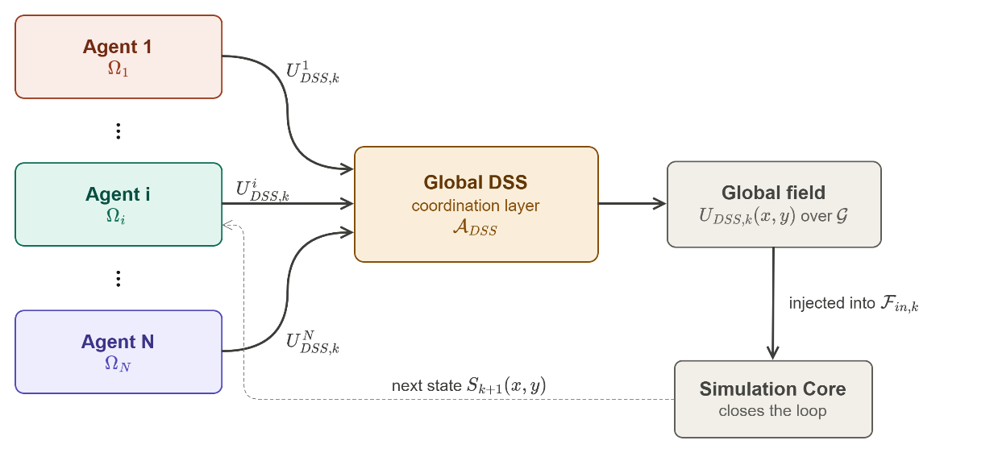
Figure 6.6 Global coordination pipeline
At each time step $k$, the $N$ local agents deliver their per-region intervention fields $\left\{U_{DSS,k}^{i}\left(x,y\right)\}_{i=1}^{N}\right.$ to the Global DSS coordination layer. The purpose of this layer is twofold: to assemble these disjoint regional fields into a single spatially complete intervention field $U_{DSS,k}\left(x,y\right)$ defined over the full domain $G$, and to resolve any resource conflicts that arise when the aggregate intervention demand exceeds the available physical capacity. Both operations are deterministic; $A_{DSS}$ itself is non-inferential, with all fuzzy reasoning performed upstream by the local agents. The output of this layer is the global intervention field that is injected into the external input set $F_{in,k}$, closing the feedback loop with the Simulation Core as illustrated in Figure 6.6, summarizing the global coordination. The formal definition of $f_{agg}$ and the decision quality function $f_{eval}$ are given in Sections 5.3.3 and 5.3.4; this section specifies the spatial assembly procedure, resource normalization pass, and feedback injection mechanism.
Definition 6.2 (Global Coordination and Spatial Assembly Mechanism). The global coordination mechanism $A_{DSS}$ maps the collection of $N$ regional intervention fields to a single spatially complete, resource-feasible global intervention field. It is defined as the sequential composition of three operations ( 98 ) where $A_{DSS}^{sp}\left(⋅\right)$ is the spatial assembly operator and $N_{Res,k}\left(∙\right)$ is the resource normalization operator, defined as follows.
$$U_{DSS,k}\left(x,y\right)=A_{DSS}\left(\{U_{DSS,k}^{i}(x,y)\}_{i=1}^{N}\right)$$  $$=N_{Res,k}\left(A_{DSS}^{sp}\left(\{U_{DSS,k}^{i}(x,y)\}_{i=1}^{N}\right)\right)$$ | ( 98 )
Spatial Assembly: For each grid cell $\left(x,y\right)∈G$, the assembled field is constructed via the bijective partition assignment ( 99 ).
$$A_{DSS}^{sp}\left({\{U}_{DSS,k}^{i}\}_{i=1}^{N}\right) \left(x,y\right)=\left\{\begin{matrix}U_{DSS,k}^{i}\left(x,y\right) & \left(x,y\right)∈Ω_{i}, i=1,…,N \\ 0 & \left(x,y\right)∉\bigcup_{i=1}^{N}{Ω_{i}}\end{matrix}\right.$$ | ( 99 )
Resource Normalization $N_{Res,k}$: Let $D_{k}=\sum_{\left(x,y\right)∈G}{U_{DSS,k}}\left(x,y\right)$ denote the integrated intervention demand and $C_{k}$ the available capacity. The normalization operator is ( 100 ).
$$N_{Res,k}\left(U_{DSS,k}\left(x,y\right)\right)=\left\{\begin{matrix}U_{DSS,k}\left(x,y\right) & D_{k}≤C_{k} \\ U_{DSS,k}\left(x,y\right)⋅\frac{C_{k}}{D_{k}} & D_{k}>C_{k}\end{matrix}\right.$$ | ( 100 )
$A_{DSS}$ produces per-intervention-type global fields through the type decomposition ( 101 ) applying the same spatial assembly and normalization operations independently for each intervention type $m$, as specified in Equation ( 93 ).
$$U_{DSS,k}^{m}\left(x,y\right)=A_{DSS}\left(\{u_{k,m}^{i}(x,y)\}_{i=1}^{N}\right),m=1,…,M$$ | ( 101 )
Remark 6.4 (Boundedness of $A_{DSS}$). The output satisfies $U_{DSS,k}\left(x,y\right)∈\left[0,1\right]$ everywhere. The assembly step inherits boundedness from the regional fields ($U_{DSS,k}^{i}∈\left[0,1\right]$ by Proposition 5.3). The normalization step multiplies by $\frac{C_{k}}{D_{k}}≤1$ when triggered, which cannot increase any cell value above 1, and preserves non-negativity.
Remark 6.5 (Spatial Completeness). The assembled field is defined over the entire domain $G$. Every cell receives exactly one regional value by the partition property $G=\bigcup_{i=1}^{N}{Ω_{i}}$, $Ω_{i}∩Ω_{j}=∅ for i≠j$. No cell is left undefined.
The following subsections formalize the three operational steps of the $A_{DSS}$ mechanism. The $N$ local agents deliver per-region intervention fields $U_{DSS,k}^{i}\left(x,y\right)$ to the Global DSS coordination layer, which assembles and normalizes them into the global intervention field $U_{DSS,k}\left(x,y\right)$ over the full domain $G$. This field is injected into the external input set $F_{in,k}$, closing the feedback loop with the Simulation Core.

Spatial Assembly of Regional Fields
The spatial partition of the operational domain satisfies $G=\bigcup_{i=1}^{N}{Ω_{i}}$, $Ω_{i}∩Ω_{j}=∅$ for $i≠j$, as established in Section 2.4. Because every active grid cell $\left(x , y\right)$ belongs to exactly one region $Ω_{i}$, the base assembly step of $A_{DSS}$ is a direct bijective assignment ( 102 ):
$$U_{DSS,k}\left(x,y\right)=U_{DSS,k}^{i}\left(x,y\right) \text{for all }\left(x,y\right)∈Ω_{i},i=1,…,N$$ | ( 102 )
This direct assembly is well-defined and produces a globally complete field without ambiguity or overlap, by virtue of the partition property. The assembled field inherits the boundedness property from its constituent regional fields: since $U_{DSS,k}^{i}\left(x,y\right)∈\left[0,1\right]$ for all $i$ and all $\left(x , y\right)$ by the action aggregation guarantee of Section 6.3, the global field satisfies $U_{DSS,k}\left(x,y\right)∈\left[0,1\right]$ everywhere.
In addition to the scalar global field, the assembly step produces action-type-specific global fields $U_{DSS,k}^{m}\left(x,y\right)$ for $m=1,…,M$ by decomposing each agent's candidate degrees prior to aggregation, as specified in Equation ( 93 ). These per-type fields support intervention-specific resource allocation in the simulation layer and serve as inputs to the explainability layer described in Section 6.4.5.

Resource Normalization and Conflict Resolution
The direct assembly of Section 6.4.1 guarantees spatial completeness but not physical feasibility. The aggregate intervention intensity requested across all regions may exceed the total available suppression capacity $C_{k}$ defined by the resource data layer $U_{Res,k}$. A normalization pass is therefore applied following assembly.
Let $D_{k}$ denote the integrated intervention intensity over the domain ( 103 ):
$$D_{k}=\sum_{\left(x,y\right)∈G}{U_{DSS,k}}\left(x,y\right)$$ | ( 103 )
If $D_{k}≤C_{k}$, the assembled field is feasible and is passed to the simulation unchanged. If $D_{k}>C_{k}$, the field is scaled uniformly by the ratio $\frac{C_{k}}{D_{k}}$ ( 104 ):
$$U_{DSS,k}\left(x,y\right)←U_{DSS,k}\left(x,y\right)⋅\frac{C_{k}}{D_{k}}$$ | ( 104 )
This uniform scaling preserves the relative spatial distribution of intervention intensity (i.e., cells that were assigned higher priority by the local agents continue to receive proportionally more intervention capacity after normalization) while ensuring that the total allocated resources remain within the physically available budget. The normalized field continues to satisfy $U_{DSS,k}\left(x,y\right)∈\left[0,1\right]$ since both $U_{DSS,k}\left(x,y\right)≤1$ and $\frac{C_{k}}{D_{k}}≤1$, when normalization is triggered.
Severity-based prioritization is embedded upstream in the local fuzzy inference of Section 6.3, where the candidate intervention $u_{k,m}^{i}(x,y)$ is already monotonic in the severity concepts $c_{k,1}, c_{k,3}$, and$c_{k,4}$. Uniform capacity scaling therefore preserves, rather than overrides, the severity-weighted prioritization produced by the regional agents; hard priority cutoffs that forcibly zero low-severity cells under capacity stress are outside the scope of the non-inferential coordination layer and are accessible through the operator override interface of Section 6.5.3.
The uniform scaling of Equation ( 104 ) ensures aggregate feasibility but does not distinguish between intervention types that may have independent resource pools or heterogeneous capacity constraints. When the operational scenario involves distinct resource categories (e.g., aerial assets for direct suppression versus ground crews for fuel management versus evacuation support units), a per-action-type conflict resolution step provides finer-grained capacity enforcement.
For each intervention type $m$ ∈ {1, …, $M$}, define the type-specific integrated demand over the active domain:
$$D_{k,m} = \sum_{(x,y)∈G}{U_{DSS,k}^{m}\left(x,y\right)}$$ | ( 105 )
and the type-specific available capacity, allocated from the total capacity $C_{k}$ proportionally to the priority weights $α_{m}$ of Equation ( 71 ):
$$C_{k,m} = C_{k} ⋅ {\bar{α}}_{m}, {\bar{α}}_{m} = \frac{α_{m}}{\sum_{r=1}^{M}{α_{r}}}$$ | ( 106 )
The conflict ratio for each intervention type is ( 107 )where $ϵ > 0$ is a small numerical stabilizer.
$$χ_{k,m} = min\left(1, \frac{C_{k,m}}{D_{k,m} + ϵ}\right)$$ | ( 107 )
The conflict-aware per-type field is ( 108 ).
$${\hat{u}}_{k,m}\left(x,y\right) = χ_{k,m} ⋅ U_{DSS,k}^{m}\left(x,y\right)$$ | ( 108 )
When $χ_{k,m} = 1$, the demand for action type $m$ is within capacity and no scaling is applied. When $χ_{k,m} < 1$, all cells requesting that action type are proportionally reduced, preserving the relative spatial distribution of the intervention within each type while ensuring type-level feasibility.
Remark 6.6 (Relation to Scalar Normalization). If a single shared capacity pool is used (i.e., all intervention types draw from the same resource), the per-type formulation reduces to the scalar normalization of Equation ( 104 ) when the priority weights are uniform. The per-type extension is therefore a strict generalization that collapses to the scalar case under homogeneous resource assumptions.
Remark 6.7 (Well-Posedness and Structural Properties of $A_{DSS}$). The global coordination operator $A_{DSS}$ defined in Definition 6.2 satisfies three structural properties that ensure its well-posedness as a single-step spatial assembly mechanism.
Existence and uniqueness. For any collection of regional fields $\{U_{DSS,k}^{i}\left(x,y\right)\}_{i=1}^{N}$ with $U_{DSS,k}^{i}∈\left[0,1\right]$ for all $i$ and all $\left(x,y\right)∈Ω_{i}$, the output $U_{DSS,k}\left(x,y\right)$ exists and is unique for every $\left(x,y\right)∈G$. Existence follows from the completeness of the partition $G=⋃_{i=1}^{N}Ω_{i}$ (every cell is assigned). Uniqueness follows from the disjointness $Ω_{i}∩Ω_{j}=⌀$ for $i≠j$ (no cell receives conflicting assignments). Together, these guarantee that $A_{DSS}^{sp}$ is a well-defined function, not a relation.
Input-output stability. The operator $A_{DSS}$ is non-expansive with respect to the $L^{∞}$ norm over the spatial domain:
$$∥U_{DSS,k}∥_{∞}≤\max_{i}∥U_{DSS,k}^{i}∥_{∞}≤1$$ | ( 109 )
The assembly step is a direct copy (non-expansive by construction), and the normalization step multiplies by a factor $\frac{C_{k}}{D_{k}}≤1$ when triggered, which can only reduce the supremum. Small perturbations in any regional field $U_{DSS,k}^{i}$ propagate to the global field with unit gain (assembly) and at most unit gain (normalization), ensuring that the operator does not amplify input uncertainty.
Degenerate case behavior. When all regional fields are identically zero ($U_{DSS,k}^{i}\left(x,y\right)=0$ for all $i$ and all $\left(x,y\right)$), the global field is zero and the normalization step is not triggered ($D_{k}=0≤C_{k}$), producing the well-defined no-intervention output. When a single region $Ω_{i}$ produces nonzero output while all others are zero, the global field inherits this regional output without distortion. When the aggregate demand $D_{k}$ exceeds capacity $C_{k}$ by an arbitrarily large factor, the normalization ratio $C_{k}/D_{k}$ approaches zero smoothly, producing a uniformly attenuated field rather than a discontinuous rejection.
It is important to note that $A_{DSS}$ is a single-step mapping executed once per time step $k$, not an iterative procedure. Consequently, convergence in the classical fixed-point sense does not apply. The closed-loop dynamics of the overall system, in which the DSS output influences the next state $S_{k+1}$ and thereby the next observation $O_{k+1}$, are characterized by the Lipschitz continuity of $π_{DSS}^{i}$ (Proposition 5.4) and the boundedness of the state transition operator $Φ$ established in Chapter 4, which together ensure that the feedback loop does not exhibit unbounded amplification.

Feedback Injection and Loop Closure
The normalized global intervention field $U_{DSS,k}\left(x,y\right)$ is injected into the external input set $F_{in,k}$ of the Simulation Core, as described in Section 4.2.1. Through the suppression function $f_{supp}$, the field is translated into physical intervention parameters (i.e., suppression capacity, fuel reduction rate, and resource reallocation) that influence the state transition $S_{k+1}\left(x,y\right)=Φ\left(S_{k}\left(x,y\right),F_{in,k}\right)$ at the next step.
This injection closes the feedback loop introduced in Section 6.1.5: the wildfire state evolves in response to the DSS-generated intervention, the updated state produces new observations through the Observation Layer, and the cycle repeats. The global field thereby constitutes the sole interface between the cognitive DSS layer and the physical simulation layer, ensuring that all intervention recommendations (regardless of which local agent generated them) reach the simulation through a single, normalized, and globally consistent channel.

Decision Quality Evaluation
Following the injection of the global intervention field into the Simulation Core, the decision quality evaluation function $f_{eval}$ computes the scalar quality score $Q_{DSS,k}∈\left[0,1\right]$ introduced in Chapter 2. This score measures how well the generated intervention $U_{DSS,k}\left(x,y\right)$ satisfies the four operational criteria identified in Section 5.1.4 and determines whether the satisfaction condition $Q_{DSS,k}≥η_{k}$ of (1) is met.
Definition 6.3 (Decision Quality Evaluation Function). The multi-criteria quality score is defined as the weighted average of four partial criterion scores ( 110 ) where $w_{j}>0$, $\sum_{j=1}^{4}{w_{j}}=1$, each partial score $q_{j,k}∈\left[0,1\right]$ measures local satisfaction over the active domain $G_{k}^{+}=\left\{\left(x,y\right)∈G:B_{k}\left(x,y\right)=1\text{ or }c_{k,1}^{i}\left(x,y\right)>0\right\}$.
$$Q_{DSS,k}=f_{eval}\left(O_{k}\left(x,y\right), F_{DSS,k}, U_{DSS,k}\left(x,y\right)\right)=\sum_{j=1}^{4}{w_{j}}⋅q_{j,k}$$ | ( 110 )
Each partial score is defined as the spatially averaged local satisfaction between the intervention field and the corresponding concept value ( 111 )
$$q_{j,k}=\frac{1}{∣G_{k}^{+}∣}\sum_{\left(x,y\right) ∈ G_{k}^{+}}{(1-∣}u_{k,m_{j}}^{i}\left(x,y\right)-c_{k,h_{j}}^{i}\left(x,y\right)∣)$$ | ( 111 )
The mapping from criterion $j$ to concept index $h_{j}$ and the default weights are specified in Table 5.18. The table specifies, for each criterion j, both the concept index $h_{j}$ and the intervention-type index $m_{j}∈ \left\{1, …, M\right\}$ against which satisfaction is measured. The scalar $q_{j,k}$ therefore compares per-type intervention components to the corresponding concept field, preserving type-consistency The local satisfaction term $1-\left|U_{DSS,k}\left(x,y\right)-c_{k,h_{j}}^{i}\left(x,y\right)\right|$ reaches its maximum value of 1 when the intervention intensity exactly matches the concept activation level and decreases linearly as the two diverge. This formulation is consistent with the satisfaction-based decision paradigm of Chapter 2: a decision is fully satisfactory at a cell when the deployed intervention degree equals the situational need encoded in the corresponding concept.
Remark 6.8 (Boundedness of $Q_{DSS,k}$). Since $U_{DSS,k}\left(x,y\right)∈\left[0,1\right]$ and $c_{k,h_{j}}^{i}\left(x,y\right)∈\left[0,1\right]$ by construction, the absolute difference $∣U_{DSS,k}-c_{k,h_{j}}^{i}∣∈\left[0,1\right]$, hence each local satisfaction term lies in $\left[0 , 1\right]$. Each $q_{j,k}$ is an average of values in $\left[0 , 1\right]$, so $q_{j,k}∈\left[0,1\right]$. The weighted average $Q_{DSS,k}$ hence satisfies $Q_{DSS,k}∈\left[0,1\right]$ for all $k$.
Definition 6.4 (Adaptive Satisfaction Threshold). The time-varying threshold $η_{k}$ is designed to become stricter when the operational environment permits higher-quality decisions and to relax when conditions are degraded or the incident demands rapid response under uncertainty. Define three global context indicators:
(i) Mean observation confidence: the spatial average of the confidence coefficient over the active domain:
$${\bar{ρ}}_{k} = \frac{1}{|G_{k}^{+}|}\sum_{(x,y)∈G_{k}^{+}}{{{conf}_{k}}^{i}\left(x,y\right)}$$ | ( 112 )
(ii) Mean resource sufficiency: the ratio of available capacity to aggregate demand, clamped to $\left[0,1\right]$:
$${\bar{s}}_{k}^{*} = min\left(1, \frac{C_{k}}{D_{k} +ϵ}\right)$$ | ( 113 )
(iii) Mean operational severity: the spatial average of the threat, exposure, and urgency concepts:
$${\bar{c}}_{sev,k} = \frac{1}{|G_{k}^{+}|}\sum_{(x,y)∈G_{k}^{+}}{\frac{{\bar{c}}_{k,1}^{i} + {\bar{c}}_{k,3}^{i} + {\bar{c}}_{k,4}^{i}}{3}}$$ | ( 114 )
The extended adaptive threshold is then defined as:
$$η_{k} = η_{min} + \left(η_{max} - η_{min}\right) ⋅ \left[γ_{1} ⋅ {\bar{ρ}}_{k} + γ_{2} ⋅ {\bar{s}}_{k}^{*} + γ_{3} ⋅ \left(1 - {\bar{c}}_{sev,k}\right)\right]$$  subject to  $$γ_{r} ≥ 0$$  $$\sum_{r=1}^{3}{γ_{r}} = 1$$  $$0 < η_{min} < η_{max} < 1$$ | ( 115 )
When mean observation confidence ${\bar{ρ}}_{k}$ is high, the DSS has access to reliable information and the threshold rises, demanding higher decision quality. When mean resource sufficiency ${\bar{s}}_{k}^{*}$ is high, operational slack is available and the threshold rises. When mean operational severity ${\bar{c}}_{sev,k}$ is high, the $\left(1 - {\bar{c}}_{sev,k}\right)$ term decreases, lowering the threshold to permit the acceptance of imperfect but urgent decisions during crisis phases.
Remark 6.9 (Reduction to Urgency-Driven Threshold). Setting $γ_{1} = γ_{2} = 0$, $γ_{3} = 1$, $η_{min} = 0$, and $η_{max} = 1$, and substituting the urgency-based severity with the pure urgency average, the extended threshold reduces to the urgency-driven threshold of Equation ( 115 ). The extended formulation is therefore a strict generalization. The threshold satisfies $η_{k} ∈ \left[η_{min}, η_{max}\right]$ for all $k$, ensuring that the satisfaction condition $Q_{DSS,k} ≥ η_{k}$ remains well-defined and bounded.

Decision Acceptance Rule and Fail-Safe Policy
The satisfaction condition $Q_{DSS,k} ≥ η_{k}$ is evaluated through Definition 6.3 determines whether the generated intervention field $U_{DSS,k}\left(x,y\right)$ is deemed operationally adequate. When the condition is met, the intervention field is injected into the Simulation Core without modification. When the condition is not met, the system must determine how to proceed: a full rejection of the intervention field would create a dangerous operational gap, while unconditional acceptance of a low-quality decision undermines the purpose of the evaluation layer. To resolve this, a soft fail-safe policy is defined that attenuates the generated intervention toward a conservative baseline in proportion to the degree of quality shortfall.
Definition 6.5 (Decision Acceptance and Fail-Safe). The final intervention field injected into $F_{in,k}$ is defined as ( 116 ) and ( 117 ) where the attenuation coefficient is ( 118 ) and $U_{safe,k}\left(x,y\right)$ is a conservative baseline intervention defined for the three-action configuration ($M = 3$) as ( 119 ).
$$U_{DSS,k}^{final}\left(x,y\right) = U_{DSS,k}\left(x,y\right), if Q_{DSS,k} ≥ η_{k}$$ | ( 116 )
$$U_{DSS,k}^{final}\left(x,y\right) = ζ_{k} ⋅ U_{DSS,k}\left(x,y\right) + \left(1 - ζ_{k}\right) ⋅ U_{safe,k}\left(x,y\right)$$  $$if Q_{DSS,k} < η_{k}$$ | ( 117 )
$$ζ_{k} = \frac{Q_{DSS,k}}{η_{k} + ϵ} ∈ \left[0,1\right]$$ | ( 118 )
$$U_{safe,k}\left(x,y\right) = {\left[{\bar{c}}_{k,4}^{i}\left(x,y\right), 0, {\bar{c}}_{k,3}^{i}\left(x,y\right)\right]}^{T}$$ | ( 119 )
The three components correspond to: ($m = 1$) direct suppression, set to the urgency concept ${\bar{c}}_{k,4}^{i}$ to concentrate intervention effort where urgency is highest; ($m = 2$) preventive fuel reduction, set to zero under fail-safe conditions to conserve resources; and ($m = 3$) asset protection, set to the asset exposure risk concept ${\bar{c}}_{k,3}^{i}$ to ensure that the most exposed assets receive protective attention regardless of overall decision quality.
Remark 6.10 (Graduated Response). When $Q_{DSS,k}$ is close to $η_{k}$, the attenuation coefficient $ζ_{k}$ is close to 1 and the intervention field is only marginally modified. When $Q_{DSS,k}$ is near zero, $ζ_{k}$ approaches zero and the system falls back almost entirely to the conservative baseline. This response avoids both the operational paralysis of binary rejection and the risk of executing a severely deficient decision.
Remark 6.11 (Boundedness). Since $ζ_{k} ∈ \left[0,1\right]$, $U_{DSS,k}\left(x,y\right) ∈ \left[0,1\right]$, and $U_{safe,k}\left(x,y\right) ∈ \left[0,1\right]$ by the boundedness of the concept values, the final intervention field satisfies $U_{DSS,k}^{final}\left(x,y\right) ∈ \left[0,1\right]$ for all $\left(x,y\right)$ and all $k$.

Explainability and AI Governance Layer
Explainability and governance mechanisms are not embedded directly within the core decision-generation pipeline. Instead, they are treated as an auxiliary supervisory layer that can be integrated on top of the DSS architecture without modifying the underlying reasoning structure. This design choice reflects the principle of separation of concerns: the reasoning mechanisms of Sections 6.2 through 6.4 operate independently of any governance logic, ensuring that explainability features can be added, modified, or disabled without affecting the functional correctness of the decision output.
The layer operates by inspecting the intermediate outputs produced at each stage of the pipeline (i.e., the concept vector $c_{k}^{i}\left(x,y\right)$ from Section 6.2, the candidate intervention degrees $\left\{u_{k,m}^{i}\right\}$ from Section 6.3, and the normalized global field $U_{DSS,k}\left(x,y\right)$ from Section 6.4) and generating human-readable justifications for the intervention recommendations issued at each time step. Because every computation in the pipeline is expressed in the same $\left[0 , 1\right]$ space with linguistic variables, the provenance of any output can be traced back to the specific feature values and rule activations that produced it.
Remark 6.12 (Scope of the Explainability Guarantee). The explainability guarantee provided by this layer is rule-level per decision. For any generated intervention at cell (x,y) and time step k, the activated rules and concept values are recoverable through the traceability mechanism of Section 6.5.1. It is not a systemic claim that the full 351-rule base is holistically comprehensible by a single human operator at a single point in time. Contribution C4 therefore refers to per-decision traceability and auditability, not to a cognitive claim about rule-base-wide human comprehensibility.
The governance layer addresses three distinct requirements identified in Chapter 1 (C4):
Traceability ensures that every intervention recommendation can be traced back through the rule activations, concept values, and feature observations that produced it. Given the fuzzy inference structure of Section 6.3, this traceability is intrinsic: the activation strength $α_{R}$ of each rule $R$ and its singleton output $v_{R}$ are individually inspectable at every time step and grid cell.
Auditability provides post-hoc access to the decision record across the full simulation timeline. The governance layer maintains a structured log of concept vectors, rule activations, and intervention outputs, enabling incident commanders and analysts to review how and why particular intervention recommendations were generated at any point during a wildfire event.
Override and constraint mechanisms allow human operators to impose hard constraints or soft preferences on the intervention field prior to injection into $F_{in,k}$. These mechanisms operate downstream of the global coordination layer and do not alter the DSS reasoning process; they act as a final filter between the system's autonomous recommendation and the physical simulation.
The specific implementation choices for each of these components, which includes the log structure, the natural-language generation method for traceability reports, and the interface design for operator overrides, are subject to ongoing discussion and will be elaborated in a subsequent revision of this section following advisory consultation.

Traceability Mechanism
The traceability mechanism provides a cell-level causal chain from the final intervention output back through the intermediate computational stages that produced it. At each time step $k$ and for each grid cell $\left(x,y\right)$, the mechanism identifies the dominant rule that contributed most strongly to each intervention type.
Definition 6.6 (Dominant Explanation Rule). For each intervention type $m ∈ \{1, …, M\}$ and each grid cell $\left(x,y\right)$, the dominant explanation rule is the rule with the highest activation strength in the corresponding rule base:
$$R_{m}^{*}\left(x,y\right) = \underset{R∈π_{i,m}}{argmax}{α_{R}\left(x,y\right)}$$ | ( 120 )
where $α_{R}\left(x,y\right)$ is the activation strength of rule $R$ computed by Equation ( 81 ). In the case of ties, the rule with the more extreme consequent value $v_{R}$ (i.e., the rule whose output is furthest from the neutral midpoint 0.5) is selected, as it has a larger influence on the aggregated candidate degree.
For each dominant rule $R_{m}^{*}\left(x,y\right)$, the traceability report includes: (a) the four antecedent linguistic terms of the rule and their corresponding concept membership values, identifying which concept conditions triggered the rule; (b) the consequent value $v_{R}$, identifying the recommended intervention intensity; and (c) the two highest-contributing concept-term pairs by membership magnitude, providing a concise natural-language explanation of the form: “Rule activated primarily because [Concept A] is [Term] and [Concept B] is [Term].”
This structure enables field operators to inspect any grid cell in the intervention map and obtain a human-readable explanation of why that particular intervention level was recommended, grounded in the specific feature observations, concept values, and rule activations at that cell.
Example 6.1 (Traceability Report for a High-Threat Scenario). To illustrate the traceability mechanism concretely, consider a grid cell (x, y) at time step k with the following observed concept vector: $c_{1}$ = 0.82 (Fire Threat Level: High), $c_{2}$ = 0.25 (Suppression Feasibility: Low), $c_{3}$ = 0.71 (Asset Exposure Risk: High), $c_{4}$ = 0.68 (Intervention Urgency: Medium–High). The traceability chain for intervention type m = 1 (Direct Suppression) proceeds as follows.
Step 1: Concept-level fuzzification. Each concept value is fuzzified over the same three-term design (Equation 53). For $c_{1}$ = 0.82 with parameters (0.20, 0.50, 0.80): $μ_{L} = 0, μ_{M} = 0, μ_{H} = 1.0$. For $c_{2}$ = 0.25 with parameters (0.30, 0.60, 0.85): $μ_{L} = 1.0, μ_{M} = 0, μ_{H} = 0$. For $c_{3}$ = 0.71 with parameters (0.15, 0.45, 0.75): $μ_{L} = 0, μ_{M} ≈ 0.13, μ_{H} ≈ 0.87$. For $c_{4}$ = 0.68 with parameters (0.30, 0.60, 0.85): $μ_{L} = 0, μ_{M} ≈ 0.68, μ_{H} ≈ 0.32$.
Step 2: Dominant rule identification. The rule with antecedent ($c_{1}$ = H, $c_{2}$ = L, $c_{3}$ = H, $c_{4}$ = M) fires with activation strength $α_{R} = min(1.0, 1.0, 0.87, 0.68) = 0.68$. Per Definition 6.6, this is identified as $R_{1}^{*}$ with consequent value $v_{R} = 0.25$ (low intervention recommended), reflecting the rule logic that high fire threat combined with low suppression feasibility warrants reduced direct suppression to avoid committing resources to infeasible positions.
Step 3: Top-2 contributing concepts. The two highest-contributing concept-term pairs by membership magnitude are ($c_{1}$, H) with $μ = 1.0$ and ($c_{2}$, L) with $μ = 1.0$. These two concepts jointly determine the dominant rule’s activation.
Step 4: Natural-language explanation. The traceability mechanism assembles the following explanation string from the dominant rule’s structure:
“Direct Suppression at cell (x, y) is recommended at intensity 0.25 (low). Rule activated primarily because Fire Threat Level is High (μ = 1.00) and Suppression Feasibility is Low (μ = 1.00). Despite severe fire conditions, resource constraints preclude effective direct intervention at this location.”
This explanation is operationally meaningful: it not only states what the DSS recommends but explains why through the concept values that drove the decision. A field commander reading this output can immediately verify whether the system’s assessment of fire threat and suppression feasibility matches ground-truth conditions, and can exercise the operator override mechanism (Section 6.5.3) if the assessment is judged to be inconsistent with field observations.
Definition 6.7 (Explanation Function). For each intervention type m and grid cell (x, y), the explanation function $E_{m}$ maps the dominant rule and its associated concept activations to a structured explanation record where $R_{m}^{*}$ is the dominant rule from Definition 6.6, $v_{R}$ is its consequent value, $α_{R}$ is its activation strength, and $P_{m}^{(1)}, P_{m}^{(2)}$ are the two highest-contributing (concept, term, membership) triples sorted by membership magnitude.
$$E_{m}(x,y) = \left(m, R_{m}^{*}, v_{R}, α_{R}, P_{m}^{(1)}, P_{m}^{(2)}\right)$$ | ( 121 )
The explanation function is deterministic, stateless, and computed in constant time per cell per intervention type (one pass over four concept memberships per rule). It requires no post-hoc approximation, no sampling, and no model-external attribution technique. This intrinsic explainability distinguishes the DisasterAware architecture from systems that require post-hoc methods such as SHAP or LIME to generate explanations, which provide statistical attributions rather than causal rule-level traceability (Ribeiro, Singh, & Guestrin, 2016).

Audit Log Structure
The audit log maintains a complete computational record of the DSS pipeline at every time step and every grid cell. This record enables post-hoc analysis of decision sequences, comparative evaluation of alternative parameter configurations, and external review of the system’s behavior over the course of a simulated event.
Definition 6.8 (Audit Record). For each time step $k$ and each grid cell $\left(x,y\right)$, the audit record is the ordered tuple:
$$L_{k}\left(x,y\right) = \left(\begin{matrix}z_{k}\left(x,y\right), μ_{k}\left(x,y\right), {\bar{c}}_{k}\left(x,y\right), \\ u_{DSS,k}^{i}\left(x,y\right), U_{DSS,k}\left(x,y\right), Q_{DSS,k}, η_{k}, R_{1}^{*}, …, R_{M}^{*}\end{matrix}\right)$$ | ( 122 )
where $z_{k}\left(x,y\right)$ is the six-dimensional feature vector from Section 6.2.1; $μ_{k}\left(x,y\right)$ is the 3×6 membership matrix from Section 6.2.2; ${\bar{c}}_{k}\left(x,y\right)$ is the confidence-gated concept vector from Section 6.2.4; $u_{DSS,k}^{i}\left(x,y\right)$ is the local multi-action vector from Section 6.3; $U_{DSS,k}\left(x,y\right)$ is the globally coordinated intervention vector from Section 6.4; $Q_{DSS,k}$ is the decision quality score from Definition 6.3; $η_{k}$ is the adaptive threshold from Definition 6.4; and $R_{1}^{*}, …, R_{M}^{*}$ are the dominant explanation rules from Definition 6.6.
The audit log over a full simulation run is the indexed collection {$L_{k}\left(x,y\right)$ : $\left(x,y\right) ∈ G$, $k = 0, …, K$}. It provides a complete, reproducible trace of the DSS computation that is independent of the visualization or reporting layer and can be serialized for external analysis without requiring access to the runtime system.

Operator Override Interface
The operator override interface provides human-in-the-loop control downstream of the global coordination layer. Override actions modify the final intervention field $U_{DSS,k}^{final}\left(x,y\right)$ after it has been produced by the decision acceptance mechanism of Section 6.4.5 but before it is injected into $F_{in,k}$. Three override modes are supported.
(i) Cell-level hard constraint. The operator specifies a set of grid cells $Ω_{lock} ⊆ G$ and a fixed intervention value $u_{lock} ∈ \left[0,1\right]$ for those cells. The override replaces the DSS output at the specified cells: $U_{DSS,k}^{final}\left(x,y\right) = u_{lock}$ for all $\left(x,y\right) ∈ Ω_{lock}$. This mode supports operational scenarios where certain locations must receive mandatory intervention (e.g., critical infrastructure) or where intervention must be withheld (e.g., areas declared unsafe for crew deployment).
(ii) Region-level soft preference. The operator assigns a weight $w_{op,i} ∈ (0, 2]$ to one or more regions $Ω_{i}$. The override scales the regional contribution: $U_{DSS,k}^{final}\left(x,y\right) ← min\left(1, w_{op,i} ⋅ U_{DSS,k}^{final}\left(x,y\right)\right)$ for all $\left(x,y\right) ∈ Ω_{i}$. This mode allows field commanders to increase or decrease the relative priority of specific regions based on tactical judgment without overriding individual cell decisions.
(iii) Global attenuation. The operator specifies a global scale factor $λ_{op} ∈ \left[0,1\right]$ that is applied uniformly to the entire intervention field: $U_{DSS,k}^{final}\left(x,y\right) ← λ_{op} ⋅ U_{DSS,k}^{final}\left(x,y\right)$. This mode supports precautionary reduction of DSS authority when the operator has reason to distrust the system’s outputs, for example during transition phases or when field conditions are known to deviate from the simulation model.
All override actions are recorded in the audit log with a timestamp, the affected cells or regions, and the operator identifier, ensuring that post-hoc analysis can distinguish between DSS-generated decisions and human-modified decisions at every point in the simulation timeline. Override actions do not modify the DSS reasoning pipeline; they act exclusively on the output layer, preserving the separation of concerns between autonomous reasoning and human supervisory control.

Summary of the DisasterAware Decision Support System
This chapter presents the complete architectural realization of the DisasterAware Decision Support System as a layered, distributed, and concept-driven reasoning architecture. The chapter addresses the central design challenge of this thesis: generating spatially distributed, operationally meaningful, and uncertainty-robust intervention guidance at every time step of a dynamic wildfire simulation, without direct access to the underlying system state and without requiring assumptions of precise or complete observability.
The architectural decomposition proceeds through five functional layers, each with a clearly defined input, output, and formal guarantee. The Observation Layer (Section 6.1.2) derives graded, uncertainty-affected observations $O_{k}^{i}\left(x,y\right)$ from the Grid State Manager for each agent region. The Concept Mapping and Abstraction Layer (Section 6.2) transforms these observations through feature extraction, fuzzification, and concept construction into a four-dimensional concept vector $c_{k}^{i}(x,y)∈[0,1]^{4}$, reducing the 18-dimensional membership representation by a factor of 4.5 while preserving its epistemic structure through the Lipschitz-continuous membership encoding. The Local DSS Model (Section 6.3) evaluates the 81-rule intervention rule base per intervention type against this concept vector, producing candidate degrees for three intervention types that are consolidated by the priority-weighted aggregation function $f_{agg}$ into a per-cell regional output $U_{DSS,k}^{i}\left(x,y\right)$. The Global Coordination Layer (Section 6.4) assembles the $N$ regional fields into a spatially complete global intervention field $U_{DSS,k}\left(x,y\right)$, normalizes it against the available resource capacity $C_{k}$, and injects it into the Simulation Core through the external input set $F_{in,k}$. Finally, the Explainability and AI Governance Layer (Section 6.5) provides traceability, auditability, and operator override mechanisms as a non-invasive supervisory overlay.
Three formal properties hold throughout the pipeline. First, all intermediate and final outputs are bounded in [0, 1], enabling concept and intervention spaces to share the same representational framework without inter-layer normalization. Second, the partition-of-unity property ensures that every observation is fully represented across the three linguistic terms with no evidential weight lost. Third, Lipschitz continuity of the concept formation mapping guarantees that small perturbations in observable information produce proportionally small changes in the intervention output. Together, these properties ensure that the DSS generates decisions that are feasible, consistent, and robust by construction.
The closed-loop structure operationalizes the decision formulation of Chapter 2: the intervention field $U_{DSS,k}$(x, y) influences the next state $S_{k+1}$(x, y) through the Simulation Core, whose updated output feeds back into the DSS as new observations. This realizes the dynamic decision formulation and addresses the structural gaps identified in Chapter 1. The architecture does not converge to a fixed policy but generates context-sensitive guidance that continuously tracks the evolving wildfire state under partial observability.

Algorithmic Summary of DisasterAware Execution Cycle
Figure 6.7 illustrates the complete execution cycle of the DisasterAware DSS within a single time step k. The cycle consists of six steps organized in two phases. Phase I (Steps 1–2) executes in parallel across N regional agents. Phase II (Steps 3–6) operates globally.
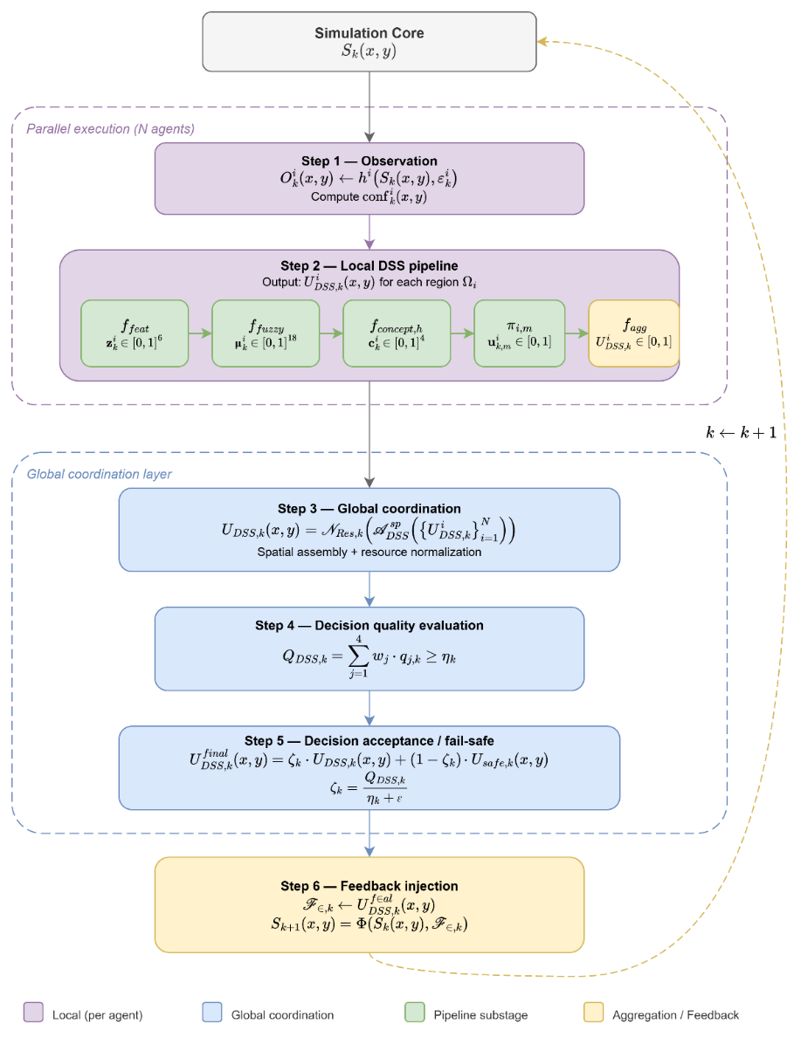
Figure 6.7 Overall algorithm of DisasterAware DSS
Phase I: Parallel Local Execution
Step 1 Observation. Each agent i derives its region-specific observation $O_{k}^{i}$(x,y) from the Simulation Core through the observation model ( 84 )–( 91 ). The confidence coefficient ${conf}_{k}^{i}(x,y)$ quantifies the reliability of each observation.
Step 2 Local DSS Pipeline. Each agent passes $O_{k}^{i}$(x,y) through the five-stage pipeline of Definition 5.1:
(a) Feature extraction. $f_{feat}$ maps the observation to a six-dimensional feature vector $z_{k}^{i}$(x,y) ∈ [0,1]⁶ ( 77 ).
(b) Fuzzification. $f_{fuzzy}$ transforms each feature into three membership values (Low, Medium, High), producing an 18-dimensional representation ( 78 ).
(c) Concept construction. $f_{concept,h}$ aggregates the membership values into four concept values $c_{k}^{i}$(x,y) ∈ [0,1]⁴ ( 79 ).
(d) Intervention inference. Each rule base $π_{m}^{i}$ evaluates 81 rules against the concept vector and produces a candidate degree $u_{k,m}^{i}$(x,y) per intervention type ( 80 )–( 81 ).
(e) Action aggregation. $f_{agg}$ consolidates the three candidate degrees into a single regional output $U_{DSS,k}^{i}$(x,y) via priority-weighted averaging ( 82 ).
Phase II: Global Coordination
Step 3 Spatial assembly and normalization. The global coordination operator $A_{DSS}$ assembles the N regional fields into a spatially complete intervention field $U_{DSS,k}$(x,y) ( 102 ). The resource normalization operator scales this field to respect the available capacity $C_{k}$ ( 103 )–( 108 ).
Step 4 Decision quality evaluation. The evaluation function $f_{eval}$ computes the quality score $Q_{DSS,k}$ as the weighted average of four partial criteria ( 110 ). The adaptive threshold $η_{k}$ adjusts based on observation confidence, resource sufficiency, and operational severity ( 115 ).
Step 5 Decision acceptance. If $Q_{DSS,k} ≥ η_{k}$, the intervention field is accepted without modification ( 116 ). The fail-safe policy blends the DSS output with the conservative baseline $U_{safe,k}$(x,y) using the coefficient $ζ_{k}$ ( 117 )–( 119 ).
Step 6 Feedback injection. The final intervention field $U_{DSS,k}^{final}(x,y)$ is injected into the external input set $F_{in,k}$. The Simulation Core computes the next state: $S_{k+1}(x,y) = Φ(S_{k}(x,y), F_{in,k})$.
This closes the feedback loop. The updated state $S_{k+1}$(x,y) feeds back into Step 1 at the next time step, as indicated by the dashed return arrow in Figure 6.7. The cycle repeats at every discrete time step throughout the simulation.

SIMULATION AND PERFORMANCE RESULTS

CONCLUSION AND FUTURE WORKS

Conclusions

Future Works

REFERENCES

Abdul, A., Vermeulen, J., Wang, D., Lim, B., & Kankanhalli, M. (2018). Trends and trajectories for explainable, accountable and intelligible systems: An HCI research agenda. CHI Conference on Human Factors in Computing Systems (pp. 1-18). ACM. doi:10.1145/3173574.3174156
Ager, A., Vaillant, N., & Finney, M. (2010). A comparison of landscape fuel treatment strategies to mitigate wildland fire risk in the urban interface and preserve old forest structure. Forest Ecology and Management, 259(8), pp. 1556-1570. doi:10.1016/j.foreco.2010.01.032
Amodei, D., Olah, C., Steinhardt, J., Christiano, P., Schulman, J., & Mané, D. (2016). Concrete problems in AI safety.
Anthony, R. (1965). Planning and control systems: A framework for analysis. Harvard University Press.
Arnott, D., & Pervan, G. (2005). A critical analysis of decision support systems research. Journal of Information Technology, 20(2), 67-87. doi:10.1057/palgrave.jit.2000035
Bellman, R., & Zadeh, L. (1970). Decision-making in a fuzzy environment. Management Science, 17(4), B141-B164. doi:10.1287/mnsc.17.4.B141
Bowman, D. M., Kolden, C. A., Abatzoglou, J. T., Johnston, F. H., van der Werf, G. R., & Flannigan, M. (2020). Vegetation fires in the Anthropocene. Nature Reviews Earth & Environment, 1(10), 500-515. doi:10.1038/s43017-020-0085-3
Calkin, D., O'Connor, C., Thompson, M., & Stratton, R. (2021). Strategic wildfire response decision support and the risk management assistance program. Forests, 12(10), p. 1407. doi:10.3390/f12101407
Chen, S., & Hwang, C. (1992). Fuzzy multiple attribute decision making: Methods and applications. Springer. doi:10.1007/978-3-642-46768-4
Comes, T. (2016). Cognitive biases in humanitarian sensemaking and decisionmaking. 2016 IEEE International Multi-Disciplinary Conference on Cognitive Methods in Situation Awareness and Decision Support (CogSIMA), (pp. 56-62).
Comes, T., Hiete, M., Wijngaards, N., & Schultmann, F. (2011). Decision maps: A framework for multi-criteria decision support under severe uncertainty. Decision Support Systems, 52(1), 108-118. doi:10.1016/j.dss.2011.05.008
Comfort, L., Boin, A., & Demchak, C. (2010). Designing Resilience: Preparing for Extreme Events. University of Pittsburgh Press.
CRED/UCLouvain. (2023). EM-DAT: The International Disaster Database. Retrieved from https://www.emdat.be
Duarte, V., Teodoro, A., Gonçalves, J., Soares, D., & Cunha, M. (2022). Wildfire risk mapping using GIS and fuzzy logic: Application to northwest Iberian Peninsula. Remote Sensing, 14(15), p. 3793. doi:10.3390/rs14153793
Dunn, C., Calkin, D., & Thompson, M. (2017). Towards enhanced risk management: Planning, decision making and monitoring of US wildfire response. International Journal of Wildland Fire, 26(7), pp. 615-625. doi:10.1071/WF16223
Endsley, M. R. (1995). Toward a Theory of Situation Awareness. Human Factors, 37(1), 32-64. doi:10.1518/001872095779049543
Endsley, M. R. (2015). Situation awareness misconceptions and misunderstandings. Journal of Cognitive Engineering and Decision Making, 9(1), 4-32. doi:10.1177/1555343415572631
Figueiredo, J., Macedo, J., Alves, J., & Figueiredo, A. (2024). Wildfire management decision support system for real-time fire behavior and weather analysis. Forests, 15(3), p. 509. doi:10.3390/f15030509
Fillmore, S., & Paveglio, T. (2023). Use of the Wildland Fire Decision Support System (WFDSS) for full suppression and managed fires within the Southwestern Region of the US Forest Service. International Journal of Wildland Fire, 32(4), pp. 562-574. doi:10.1071/WF22106
Finney, M. (2006). An overview of FlamMap fire modeling capabilities. Fuels Management — How to Measure Success: Conference Proceedings (pp. 213-220). USDA Forest Service, Rocky Mountain Research Station.
French, S., Maule, J., & Papamichail, N. (2019). Decision Behaviour, Analysis and Support (2 ed.). Cambridge University Press.
Gigerenzer, G., & Selten, R. (Eds.). (2001). Bounded rationality: The adaptive toolbox. Cambridge, MA: MIT Press.
Gorry, G., & Scott Morton, M. (1971). A framework for management information systems. Sloan Management Review, 13(1), 55-70.
Guidotti, R., Monreale, A., Ruggieri, S., Turini, F., Giannotti, F., & Pedreschi, D. (2018). A Survey of Methods for Explaining Black Box Models. ACM Computing Surveys, 51(5), 1-42. doi:10.1145/3236009
Hwang, C., & Yoon, K. (1981). Multiple attribute decision making: Methods and applications. Springer. doi:10.1007/978-3-642-48318-9
Jain, P., Coogan, S. C., Subramanian, S. G., Crowley, M., Taylor, S., & Flannigan, M. D. (2020). A review of machine learning applications in wildfire science and management. Environmental Reviews, 28(4), 478-505. doi:10.1139/er-2020-0019
Keeney, R., & Raiffa, H. (1976). Decisions with multiple objectives: preferences and value trade-offs. Wiley.
Klein, G. A. (2017). Sources of Power: How People Make Decisions. MIT Press.
Kyzirakos, K., Karpathiotakis, M., Garbis, G., Nikolaou, C., Bereta, K., Papoutsis, I., . . . Simantiris, N. (2012). Wildfire monitoring using satellite images, ontologies and linked geospatial data. Journal of Web Semantics, 16-32.
Malczewski, J. (1999). GIS and multicriteria decision analysis. John wiley & sons.
Mamdani, E. H. (1974). Application of fuzzy algorithms for control of simple dynamic plant. Proceedings of the Institution of Electrical Engineers, 121(12), 1585-1588. doi:10.1049/piee.1974.0328
Marakas, G. M., & O'Brien, J. A. (2013). Introduction to information systems. McGraw-Hill.
Martell, D. L. (2007). Forest fire management. Handbook of operations research in natural resources (pp. 489-509). Boston: MA: Springer US.
McNeese, N. J., Schelble, B. G., Canonico, L. B., & Demir, M. (2021). Who or what is my teammate? Team composition considerations in human–AI teaming. Human Factors, 63(3), 474-488. doi:10.1177/0018720820968694
Mendel, J. (2017). Uncertain rule-based fuzzy systems. Springer.
Mohammadi, M., Alesheikh, A., & Alimohammadi, A. (2025). Bridging spatiotemporal wildfire prediction and decision modeling using transformer networks and fuzzy inference systems. Applied Sciences, 15, p. 7542. doi:10.3390/app15137542
Morgan, M., & Henrion, M. (1990). Uncertainty: A Guide to Dealing with Uncertainty in Quantitative Risk and Policy Analysis. Cambridge university press.
Noonan-Wright, E., Opperman, T., Finney, M., Zimmerman, G., Seli, R., Elenz, L., . . . Fiedler, J. (2011). Developing the US wildland fire decision support system. Journal of Combustion, 2011, p. 168473. doi:10.1155/2011/168473
Oliveira, T., Barros, A., Ager, A., & Fernandes, P. (2022). Wildfire spread and resource allocation: Using spatially explicit models to address operational decision-making. Forest Ecology and Management, 506, p. 119952. doi:10.1016/j.foreco.2021.119952
Orphanoudakis, T., Betzelos, C., & Leligou, H. (2025). MORA: A multicriteria optimal resource allocation and decision support toolkit for wildfire management. Algorithms, 18(11), p. 677. doi:10.3390/a18110677
Pacheco, A. (2015). Cohesive Fire Management within an Uncertain Environment: A Review of Risk Handling and Decision Support Systems. Forest Ecology and Management, 347, 1-17. doi:10.1016/j.foreco.2015.02.033
Pais, C., Carrasco, J., Moudio, P., & Shen, Z.-J. (2021). Downstream protection value: Detecting critical zones for effective fuel-treatment under wildfire risk. Computers, Environment and Urban Systems, 90, p. 101703. doi:10.1016/j.compenvurbsys.2021.101703
Papadimitriou, C. H., & Tsitsiklis, J. N. (1987). The complexity of Markov decision processes. Mathematics of Operations Research, 12(3), 441-450.
Pearl, J. (1988). Probabilistic Reasoning in Intelligent Systems: Networks of Plausible Inference. Morgan Kaufmann. doi:10.1016/C2009-0-27609-4
Pedrycz, W. (1993). Fuzzy Control and Fuzzy Systems. Wiley.
Power. (2002). Decision support systems: Concepts and resources for managers. Quorum Books.
Power. (2007). A Brief History of Decision Support Systems. Retrieved from http://dssresources.com/history/dsshistory.html
Power, D. J., & Heavin, C. (2017). Decision Support, Analytics, and Business Intelligence (2 ed.). Business Expert Press.
Rapp, C., Rabung, E., Wilson, R., & Toman, E. (2020). Wildfire decision support tools: An exploratory study of use in the United States. International Journal of Wildland Fire, 29(7), pp. 581-594. doi:10.1071/WF19131
Ribeiro, M. T., Singh, S., & Guestrin, C. (2016). Why Should I Trust You? ACM SIGKDD Conference (pp. 1135–1144). ACM. doi:10.1145/2939672.2939778
Ross, K. G., Shafer, J. L., & Klein, G. (2006). Professional Judgments and Naturalistic Decision Making. In The Cambridge Handbook of Expertise and Expert Performance (pp. 403-420). Cambridge: Cambridge University Press.
Rothermel, R. C. (1972). A mathematical model for predicting fire spread in wildland fuels. Intermountain Forest & Range Experiment Station, Forest Service, US Department of Agriculture.
Saaty, T. (1980). The analytic hierarchy process: Planning, priority setting, resource allocation. McGraw-Hill.
Sanneman, L., & Shah, J. (2020). Explaining reward functions to humans for better human-robot collaboration. arXiv preprint arXiv:2006.10548. Retrieved from https://arxiv.org/abs/2006.10548
Schultz, C., Miller, L., Greiner, S., & Kooistra, C. (2021). A qualitative study on the US Forest Service's risk management assistance efforts to improve wildfire decision-making. Forests, 12(3), p. 344. doi:10.3390/f12030344
Seshia, S. A., Sadigh, D., & Sastry, S. S. (2022). Toward verified artificial intelligence. Communications of the ACM, 65(7), 46-55.
Shafer, G. (1976). A Mathematical Theory of Evidence. Princeton University Press.
Sharda, R., Delen, D., & Turban, E. (2018). Business Intelligence, Analytics, and Data Science: A Managerial Perspective. Pearson.
Shim, J. P., Warkentin, M., Courtney, J. F., Power, D. J., Sharda, R., & Carlsson, C. (2002). Past, present, and future of decision support technology. Decision support systems, 33(2), 111-126. doi:10.1016/S0167-9236(01)00139-7
Simon, H. (1960). The New Science of Management Decision. Englewood Cliffs: Prentice Hall.
Simon, H. (1996). The Sciences of the Artificial. Cambridge: MIT Press.
Simon, H. A. (1956). Rational choice and the structure of the environment. Psychological Review, 63(2), 129-138.
Soualah, L. (2024). Forecasting forest fire risk in Algeria using fuzzy logic and GIS. Trees, Forests and People, 17, 100614. doi:10.1016/j.tfp.2024.100614
Sprague, R. H., & Carlson, E. D. (1982). Building Effective Decision Support Systems. Englewood Cliffs: Prentice Hall.
Sugumaran, R., & Degroote, J. (2010). Spatial decision support systems: principles and practices. Crc Press.
Sullivan, A. L. (2009a). Wildland surface fire spread modelling 1: Physical and quasi-physical models. International Journal of Wildland Fire, 18(4), 349-368.
Sullivan, A. L. (2009b). Wildland surface fire spread modelling 2: Empirical and quasi-empirical models. International Journal of Wildland Fire, 18(4), 369-386.
Sullivan, A. L. (2009c). Wildland surface fire spread modelling 3: Simulation and mathematical analogue models. International Journal of Wildland Fire, 18(4), 387-403.
Sycara, K. (1998). Multiagent systems. AI Magazine, 19(2), 79-92. doi:10.1609/aimag.v19i2.1370
Takagi, T., & Sugeno, M. (1985). Fuzzy identification of systems and its applications to modeling and control. IEEE Transactions on Systems, Man, and Cybernetics, 15(1), 116-132. doi:10.1109/TSMC.1985.6313399
Thompson, M. P., & Calkin, D. E. (2011). Uncertainty and risk in wildland fire management. Journal of Environmental Management, 92(8), 1895-1909. doi:10.1016/j.jenvman.2011.03.015
Triantaphyllou, E. (2000). Multi-criteria decision making methods: A comparative study. Springer. doi:10.1007/978-1-4757-3157-6
Turban, E. (2011). Decision support and business intelligence systems (9 ed.). Upper Saddle River: Pearson Education.
Turoff, M. C. (2004). The design of a dynamic emergency response management information system (DERMIS). Journal of Information Technology Theory and Application (JITTA), 5(4), 3.
Tversky, A., & Kahneman, D. (1974). Judgment under uncertainty: Heuristics and biases. Science, 185(4157), 1124-1131. doi:10.1126/science.185.4157.1124
UNEP. (2022). Spreading like Wildfire: The Rising Threat of Extraordinary Landscape Fires. Geneva: United Nations Environment Programme (UNEP). Retrieved from https://www.unep.org/resources/report/spreading-wildfire
Vásquez, F. (2021). Decision support system development of wildland fire. Forests, 12(7), 943. doi:10.3390/f12070943
Walker, W., Harremoes, P., Rotmans, J., Van der Sluijs, J., Van Asselt, M., Janssen, P., & Krayer von Krauss, M. (2003). Defining uncertainty: a conceptual basis for uncertainty management in model-based decision support. Integrated Assessment, 4(1), 5-17.
Wooldridge, M. (2009). An introduction to multiagent systems (2 ed.). Wiley.
Xu, Z. (2015). Uncertain multi-attribute decision making: Methods and applications. Springer. doi:10.1007/978-3-662-45640-8
Zadeh, L. A. (1965). Fuzzy sets. Information and Control, 8(3), 338-353. doi:10.1016/S0019-9958(65)90241-X
Zadeh, L. A. (1986). A simple view of the Dempster–Shafer theory of evidence and its implication for the rule of combination. AI Magazine, 7(2), 85-90. doi:doi:10.1609/aimag.v7i2.542
Zavadskas, E., & Turskis, Z. (2011). Multiple criteria decision making (MCDM) methods in economics: An overview. Technological and Economic Development of Economy, 17(2), 397-427. doi:10.3846/20294913.2011.593291

APPENDICES
- Simulation Mathematics for Evolution of Burning Status
This appendix provides the mathematical formulations underlying the wildfire simulation model, ensuring consistency with the state transition framework defined in Chapter 4.
The rate of spread $R_{spread,k}\left(x,y\right)$ represents the forward propagation potential of wildfire at grid cell $\left(x,y\right)$ and time step $k$. It is not an externally supplied parameter; rather, it is computed internally within the hybrid fire spread model using meteorological forcing, terrain properties, fuel characteristics, and fuel moisture. The spread formulation is not intended to reproduce physical wildfire propagation in metric units. It provides a grid-consistent, DSS-oriented abstraction inspired by semi-empirical wildfire behavior models.
The formulation adopted in this work is a semi-empirical, Rothermel-like mapping designed to preserve structural interpretability (i.e., each multiplicative term maps to a physically meaningful effect (wind, slope, fuel) even though the output $R_{spread,k}$ is expressed in normalized cells-per-step rather than in metric units) while remaining computationally stable and easily calibratable for DSS simulation purposes (Rothermel, 1972). The formulation follows a semi-empirical wildfire spread abstraction inspired by Rothermel-type models rather than attempting to reproduce detailed physical fire dynamics. The rate of spread $R_{spread,k}\left(x,y\right)$ is calculated by $f_{ros}$ ( 47 ). Each multiplicative component of the rate-of-spread function $f_{ros}$ corresponds directly to a physically interpretable effect and is tied to an already-defined state or input variable ( 123 ). All terms are evaluated at $\left(x,y\right)$ and time $k$.
$$R_{spread,k} \left(x,y\right)=r_{base} \left(F_{type}\left(x,y\right)\right)×g_{moist}\left(x,y\right)×g_{wind}\left(x,y\right)×g_{slope}\left(x,y\right)× g_{aspect}\left(x,y\right)$$ | ( 123 )
Fuel-Type Base Spread Rate $r_{base} \left(∙\right)$ defines the baseline spread potential of each fuel class under nominal environmental conditions. It is calibrated in units of cell per simulation step.
Moisture damping factor $g_{moist}$ is ( 124 ). If fuel moisture equals the extinction threshold, spread is suppressed ( 125 ). The damping structure is selected for stability and interpretability; it prevents negative spread rates and ensures bounded behavior.
$$g_{moist}\left(x,y\right)=\max\left(0,1-\frac{F_{moist,k}\left(x,y\right)}{m_{ext}\left(F_{type}\left(x,y\right)\right)}\right)$$  $F_{moist,k}\left(x,y\right)$: surface fuel moisture fraction  $m_{ext}\left(F_{type}\right)$: extinction moisture threshold for the given fuel type | ( 124 )
$$F_{moist,k}≥m_{ext}⇒g_{moist}=0$$ | ( 125 )
Wind amplification factor $g_{wind}$ is ( 126 ). This factor models the acceleration of fire spread due to wind speed. The hyperbolic tangent ensures that spread increases with wind speed but does not grow unbounded for extreme winds. The use of $\tanh\left(⋅\right)$guarantees numerical stability. The wind scaling constant $w_{0}$ controls the saturation behavior of wind amplification. A value of 10 m/s is selected to reflect moderate-to-strong wind regimes while preserving numerical stability.
$$g_{wind}(x,y)=1+a_{w}(F_{type}(x,y))⋅tanh\left(\frac{W_{ws,k}\left(x,y\right)}{w_{0}}\right)$$  $W_{ws,k}\left(x,y\right)$ is the wind speed.  $a_{w}\left(F_{type}\right)$ is a wind sensitivity coefficient.  $w_{0}$ is a scaling constant. | ( 126 )
Slope acceleration term $g_{slope}$ is ( 127 ). Spread accelerates in uphill directions. Fire spreads faster uphill due to flame preheating of fuels. The tangent function reflects nonlinear growth with increasing slope angle.
$$g_{slope}\left(x,y\right)=1+a_{s}\left(F_{type}\left(x,y\right)\right)⋅\tan\left(G_{slope}\left(x,y\right)\right)$$  $G_{slope}\left(x,y\right)$: terrain slope (radians)  $a_{s}\left(F_{type}\right)$: slope sensitivity coefficient | ( 127 )
Aspect–wind orientation term $g_{aspect}$ is ( 128 ). This term captures interaction between terrain orientation and wind direction. If wind direction aligns with terrain orientation, $\cos\left(⋅\right)≈1$ and spread increases. If wind opposes terrain orientation, $\cos\left(⋅\right)<0$ and spread decreases.
$$g_{aspect}\left(x,y\right)=1+a_{asp}\left(F_{type}\left(x,y\right)\right)∙\cos\left(G_{aspect}\left(x,y\right)-W_{wd,k}\left(x,y\right)\right)$$  $G_{aspect}\left(x,y\right)$: terrain orientation angle  $W_{wd,k}\left(x,y\right)$: wind direction field  $a_{asp}\left(F_{type}\right)$: aspect sensitivity coefficient | ( 128 )
Different fuel types exhibit distinct intrinsic combustion and propagation characteristics due to variations in fuel structure, packing ratio, moisture retention capacity, and heat-release behavior. These differences are parameterized in Table A.1 through a fuel-dependent base spread rate and sensitivity coefficients that modulate environmental amplification effects. The base spread parameter $r_{base}$ is expressed in units of grid cells per simulation step and therefore must be interpreted relative to the spatial grid resolution $Δx$ and the discrete simulation time step $Δt$.
In contrast, the extinction moisture threshold $m_{ext}$ is a dimensionless mass fraction, representing the critical fuel moisture level above which sustained combustion is suppressed. The environmental sensitivity coefficients $a_{w}$, $a_{s}$, and $a_{asp}$ are also dimensionless parameters, governing the relative amplification of spread rate due to wind speed, terrain slope, and wind–aspect alignment, respectively. Together, these parameters provide a resolution-consistent, yet physically interpretable abstraction of fuel-dependent wildfire spread dynamics suitable for discrete-time grid-based simulation.
Table A.1 Spread rate parameters for each fuel type
$$Fuel Type$$ | $$r_{base}$$ | $$m_{ext}$$ | $$a_{w}$$ | $$a_{s}$$ | $$a_{asp}$$
Grass | 1.20 | 0.25 | 2.0 | 0.8 | 0.30
Shrub | 0.80 | 0.35 | 1.5 | 1.0 | 0.25
Pine litter | 0.60 | 0.45 | 1.2 | 1.2 | 0.20
Hardwood | 0.40 | 0.50 | 0.8 | 0.6 | 0.15

- Simulation Mathematics for Fuel Mass Evolution
This section provides detailed mathematical formulation and explanation for both the fractional burn rate calculation and the suppression of fuel reduction maps.
Fractional burn rate calculation
The discrete combustion consumption ratio $F_{burn,k}\left(x,y\right)$ represents the fraction of available fuel mass consumed at grid cell $\left(x,y\right)$ during a single simulation time step $Δt$ under active burning conditions. Unlike fuel load $F_{load,k}$, which is a dynamic state variable, $F_{burn,k}$ is not stored as part of the state vector. Instead, it is computed algebraically at each simulation step as a bounded function of fuel type and surface fuel moisture ( 129 ).
$$F_{burn,k}\left(x,y\right)={sat}_{\left[0 , 1\right]}\left(b_{base}\left(F_{type}\left(x,y\right)\right)⋅\left(1-F_{moist,k}\left(x,y\right)\right)\right)$$  $b_{base}\left(F_{type}\right)∈\left(0,1\right)$: the baseline combustion coefficient associated with the fuel class,  $F_{moist,k}\left(x,y\right)∈\left[0,1\right]$: the surface fuel moisture fraction,  ${sat}_{\left[0 , 1\right]}\left(⋅\right)$: the saturation operator ensuring boundedness.  The term $\left(1 − F_{moist,k}\right)$: a linear moisture damping factor, reducing combustion efficiency as moisture increases. | ( 129 )
The coefficient $b_{base}$ is expressed as a fraction of fuel consumed per simulation time step and therefore depends on the chosen time resolution $Δt$. It is not a universal physical constant but a calibrated simulation parameter. Different fuel classes exhibit distinct combustion rates due to structural density, packing ratio, and heat-release characteristics. These differences are abstracted through the fuel-dependent baseline coefficient $b_{base}$. Surface fuel moisture inhibits combustion efficiency. When $F_{moist,k}→1$, the burn fraction approaches zero. When $F_{moist,k}→0$, combustion proceeds at the baseline rate.
The baseline combustion coefficients used in this study are summarized in Table B.1. Values are selected to produce realistic burn residence times under nominal dry conditions for the adopted grid resolution and simulation time step.
Table B.1 Baseline combustion coefficients per fuel type
Fuel Type | $b_{base}$(fraction per step) | Typical Burn Duration (qualitative)
Grass | 0.25 | Short, fast consumption
Shrub | 0.15 | Moderate consumption
Pine litter | 0.10 | Sustained surface burn
Hardwood | 0.05 | Slow combustion
These coefficients are calibrated by such that, in dry conditions and absent suppression, fuel mass decreases significantly over several time steps without causing numerical instability.
Suppression of fuel reduction map
The suppression function $f_{supp}\left(⋅\right)$ produces a step-normalized fuel reduction fraction applied at grid cell $\left(x , y\right)$ during simulation step $k$. Unlike continuous-time rate formulations, the present model operates in discrete simulation steps. Therefore, the suppression term directly represents the fraction of fuel reduced within a single time step, consistent with the combustion fraction $F_{burn,k}$. The suppression-induced fuel reduction term is defined as ( 130 ). This multiplicative structure guarantees bounded and interpretable mitigation dynamics.
The suppression formulation is defined per simulation step and therefore represents the maximum achievable mitigation effect within a single discrete simulation interval. This design ensures compatibility with the discrete-time wildfire state transition model defined in Chapter 4.
$$F_{red,k}\left(x,y\right)=α_{s}⋅η_{cap,k}⋅η_{avail,k}⋅η_{reach,k}\left(x,y\right)⋅η_{eff,k}\left(x,y\right)$$  $α_{s}∈\left[0,1\right]$: global suppression scaling coefficient  $η_{cap,k}$: operational capa city factor  $η_{avail,k}$: operational availability factor  $η_{reach,k}\left(x,y\right)$: reachability factor  $η_{eff,k}\left(x,y\right)$: local suppression effectiveness factor | ( 130 )
Global scaling term $α_{s}∈\left[0,1\right]$ is a global suppression scaling coefficient representing overall doctrine or scenario-level mitigation strength per simulation step. In practical terms, $α_{s}$ absorbs the modeling choice of “how strong one step of suppression can be” under nominal conditions.
Suppression cannot exceed the operational capability that is actually present. This is captured by separating capacity magnitude $η_{cap,k}$ ( 131 )from availability gating $η_{avail,k}$ ( 132 ).
$$η_{cap,k}=\frac{R_{cap,k}}{R_{cap,max}}$$  $R_{cap,k}$: the available suppression capacity (e.g., water volume, manpower equivalent, sortie capability) at step $k$  $R_{cap,max}$: the maximum reference capacity used for normalization | ( 131 )
Thus $η_{cap,k}∈\left[0,1\right]$ expresses the fraction of maximal capability currently available.
$$η_{avail,k}=R_{avail,k}$$  $R_{avail,k}∈\left\{0,1\right\}$: availability of the suppression resources | ( 132 )
This factor encodes a strict necessary condition. If resources are not deployable, suppression impact is zero regardless of other terms.
Even if resources exist, mitigation effectiveness must decay with increasing travel time and poor accessibility. This is represented by a smooth reachability term:
$$η_{reach,k}\left(x,y\right)=exp\left(-β_{t} R_{time,k}\left(x,y\right)\right)⋅G_{access}\left(x,y\right)$$  $R_{time,k}\left(x,y\right)$: the estimated travel time to reach $\left(x , y\right)$ at step $k$  $G_{access}\left(x,y\right)∈\left[0,1\right]$: the static accessibility index of the terrain  $β_{t}>0$: the decay rate with travel delay | ( 133 )
The exponential structure ensures boundedness and numerical stability. Operationally, it implements the principle that interventions arriving late cannot mitigate near-term fire growth at the same step, and inaccessible terrain reduces the usable effectiveness of resources.
Suppression success is not independent of local fire severity. High intensity fires typically resist suppression, reducing the effective mitigation that can be achieved within a single step. This is modeled by:
$$η_{eff,k}\left(x,y\right)=\frac{R_{eff,k}\left(x,y\right)}{1+γ_{I} I_{k}\left(x,y\right)}$$  $R_{eff,k}\left(x,y\right)∈\left[0,1\right]$: the nominal suppression efficiency at $\left(x , y\right)$  $I_{k}\left(x,y\right)∈\left[0,1\right]$: the local fire intensity proxy  $γ_{I}≥0$: intensity resistance | ( 134 )
As $I_{k}$ increases, the denominator increases and $η_{eff,k}$ decreases. This captures the intuitive and operationally observed phenomenon that extreme fire behavior reduces the marginal impact of suppression. Suppression effectiveness is computed using the current-state intensity $I_{k}\left(x,y\right)$, ensuring that mitigation decisions are based on observable fire conditions at time step $k$, prior to state transition.
The final multiplicative formulation of $f_{supp}$ in ( 50 ) is explicitly written as ( 135 ). It encodes the following operational semantics in a compact and interpretable form:
- If resources are unavailable, mitigation becomes zero
- If the cell is unreachable, mitigation decays smoothly toward zero
- If accessibility is poor, mitigation is proportionally reduced
- If fire intensity is high, mitigation effectiveness decreases
- The overall effect remains bounded and suitable for discrete-time simulation
$$F_{red,k}^{raw}\left(x,y\right)=α_{s}⋅\left(\frac{R_{cap,k}}{R_{cap,max}}\right)⋅R_{avail,k}⋅\exp\left(-β_{t}R_{time,k}\left(x,y\right)\right)⋅G_{access}\left(x,y\right)⋅\frac{R_{eff,k}\left(x,y\right)}{1+γ_{I}I_{k}\left(x,y\right)}$$ | ( 135 )
The calibration parameters summarized in Table B.2 regulate the strength, spatial decay, and operational sensitivity of the suppression mapping. These parameters are not arbitrary numerical coefficients; rather, they encode interpretable characteristics of wildfire response systems under discrete-time grid simulation.
To preserve physical realism, suppression-driven fuel reduction cannot exceed available fuel mass $0≤F_{red,k}\left(x,y\right)≤F_{load,k}\left(x,y\right)$. Implementation uses the saturation rule $F_{red,k}\left(x,y\right)=\min\left\{F_{load,k}\left(x,y\right),F_{red,k}^{raw}\left(x,y\right)\right\}$ This prevents negative fuel states and ensures compatibility with the fuel evolution equation.
The global suppression gain $α_{s}$ represents the maximum achievable fuel reduction fraction within a single simulation step and is therefore dimensionless (fraction per step). The travel-time decay parameter $β_{t}$ has units of inverse time (e.g., 1/min or 1/hour depending on the chosen simulation time scale) and governs the exponential attenuation of suppression effectiveness as arrival time increases. The intensity resistance coefficient $γ_{I}$ is dimensionless and models the nonlinear reduction in suppression efficiency under increasing fire intensity.
All parameters are normalized to ensure compatibility with the discrete-time formulation of the model. Calibration may be performed using historical wildfire response data, operational doctrine constraints, or structured sensitivity analysis across scenario ensembles.
Table B.2 Suppression mapping calibration parameters
Parameter | Symbol | Typical Range | Effect When Increased
Global suppression gain | $$α_{s}$$ | 0.01 – 0.30 | Stronger overall mitigation per simulation step
Travel-time decay coefficient | $$β_{t}$$ | 0.05 – 0.50 | Faster decay of suppression effectiveness with increasing delay
Intensity resistance factor | $$γ_{I}$$ | 0.5 – 5.0 | High-intensity fires become progressively harder to suppress
This appendix provides a calibrated, decision-aware abstraction of suppression that influences wildfire evolution through physically interpretable state variables, without directly overwriting the burning state.

- Simulation Mathematics for Fire Intensity Evolution
The fire intensity proxy $I_{k}\left(x,y\right)$ is a bounded indicator representing local combustion strength. It does not model flame temperature or heat flux directly but provides a normalized scalar quantity suitable for suppression resistance modeling; risk prioritization; decision-layer feature extraction; and visualization. To ensure numerical stability, scale invariance, and resolution consistency, intensity is constructed using normalized inputs ( 136 ).
$${\tilde{F}}_{k}\left(x,y\right)=\frac{F_{load,k}\left(x,y\right)}{F_{load,\max{}}} \\ {\tilde{W}}_{k}\left(x,y\right)=\frac{W_{ws,k}\left(x,y\right)}{W_{ws,\max{}}} \\ \tilde{S}\left(x,y\right)=\frac{\tan\left(G_{slope}\left(x,y\right)\right)}{\tan\left(G_{slope,\max{}}\right)}$$$F_{load,\max{}}$: the maximum fuel load,  $W_{ws,\max{}}$: a reference maximum wind speed (e.g., 20 m/s),  $G_{slope,\max{}}$: the maximum slope angle allowed in the terrain model.  Thus: $0≤\tilde{F},\tilde{W},\tilde{S}≤1$ | ( 136 )
The local fire intensity proxy is defined as ( 137 ). The intensity proxy is normalized and bounded within the interval [0,1] in order to ensure numerical stability and consistent interpretation across grid cells.
$$I_{k+1}\left(x,y\right)=B_{k+1}\left(x,y\right)∙\tanh\left(β\left({\tilde{F}}_{k}\left(x,y\right)+γ_{W}{\tilde{W}}_{k}\left(x,y\right)+γ_{S}\tilde{S}\left(x,y\right)\right)\right)$$  $β>0$: the global intensity gain parameter,  $γ_{W}∈\left[0,1\right]$: the wind weighting coefficient,  $γ_{S}∈\left[0,1\right]$: the slope weighting coefficient.  $B_{k+1}$ ensures that non-burning cells have zero intensity. | ( 137 )
The normalized structure ensures that fuel load remains the dominant contributor; wind and slope act as amplifying modifiers; intensity remains bounded in $\left[0,1\right]$. The fire intensity evolution parameters are listed in Table C.1.
Table C.1 Fire intensity evolution parameters
Parameter | Range | Suggested Value | Interpretation
$$β$$ | $$1≤β≤3$$ | 2.0 | Moderate global intensity amplification
$$γ_{W}$$ | $$0≤γ_{W}≤0.7$$ | 0.5 | Wind moderately increases intensity
$$γ_{S}$$ | $$0≤γ_{S}≤0.5$$ | 0.3 | Slope has secondary influence

CURRICULUM VITAE

PERSONAL INFORMATION
Surname, Name: AKMAN, Çağlar

EDUCATION
Degree | Institution | Year of Graduation
MS | METU Electrical and Electronics Engineering | 2017
BS | METU Electrical and Electronics Engineering | 2008
High School | Yusuf Ziya Öner Fen Lisesi, Antalya | 2002

WORK EXPERIENCE
Year | Place | Enrollment
2014- Present | HAVELSAN | Modelling and Sensor Technologies Team Leader
2013-2014 | AYESAS | Senior Software Engineer
2008-2013 | KAREL | Senior Design Engineer
2007-2007 | TUBITAK | Part Time Engineer

FOREIGN LANGUAGES
Advanced English, Beginner German

PUBLICATIONS
- Kabak, Y., Kose, I. G., Akman, C., & Ramscar, D. (2023, December). TeamAware: Profile-Based Interoperability Framework for First Responders. In International Conference on Information Technology in Disaster Risk Reduction (pp. 98-111). Cham: Springer Nature Switzerland.
- Gunes, A., ihsan Gullu, A., Alam, M. S., Sucu, E. S., Köse, S., Göze, A. G., ... & Akman, Ç. (2023, July). NLoS Measurement Elimination in UWB Signals Using Anomaly Detection. In 2023 31st Signal Processing and Communications Applications Conference (SIU) (pp. 1-4). IEEE.
- AKMAN, Ç. (2022, May). Relative Localization for Swarm Aerial Vehicles. In 2022 30th Signal Processing and Communications Applications Conference (SIU).
- Korkmaz, I. O., Özateş, T., Koç, E., Aydın, E., Kor, E., Dilek, D., ... & Akman, Ç. (2022, May). Indoor localization with transfer learning. In 2022 30th Signal Processing and Communications Applications Conference (SIU) (pp. 1-4). IEEE.
- Aytekin, A., Bağcı, F., Bozdağ, M., Camuzcu, N., Duru, A., Elma, M. S., ... & Akman, Ç. (2022, May). Relative Localization for Swarm Aerial Vehicles. In 2022 30th Signal Processing and Communications Applications Conference (SIU) (pp. 1-4). IEEE.
- Akman, Ç., & Sönmez, T. (2021). Body Motion Capture and Applications. In Decision Support Systems and Industrial IoT in Smart Grid, Factories, and Cities (pp. 181-223). IGI Global.
- Akman, Ç., Demir, O., & Sönmez, T. (2021, June). Covid-19 SEIQR Spread Mathematical Model. In 2021 29th Signal Processing and Communications Applications Conference (SIU) (pp. 1-4). IEEE.
- Köse, S., Gökalp, İ., Dökme, Ç., Akman, Ç., Sönmez, T. (2019). Hybrid RSSI and fingerprinting method for indoor localization. In USMOS 19, National Defense Applications Modeling and Simulation Conference.
- Gökalp, İ., Köse, S., Narman, A., Hajizada E., Özbey, M., Can, S., Akman, Ç., Sönmez, T. (2019). Body motion analysis system. In USMOS 19, National Defense Applications Modeling and Simulation Conference.
- Akman, Ç., Sönmez, T., Özuğur, Ö., Başlı, A. B., & Leblebicioğlu, M. K. (2018). Sensor fusion, sensitivity analysis and calibration in shooter localization systems. Sensors and Actuators A: Physical, 271, 66-75.
- Akman, Ç. (2017). Multi shooter localization with acoustic sensors (Master's thesis, Middle East Technical University).
- Akman, Ç., Sönmez, T., Özuğur, Ö., & Leblebicioğlu, K. (2016, May). Shooter localization system calibration and implementation. In IEEE 24th Signal Processing and Communication Application Conference (SIU) (pp. 2025-2028)

PATENTS
- Akman, Ç. (Co-inventor), & HAVELSAN (Assignee). (2017, June 5). Ateşli silah yön ve konum tespit sistemi (Patent No. TR 2017/08288). Türk Patent ve Marka Kurumu.
- Akman, Ç. (Co-inventor), & HAVELSAN (Assignee). (2018, December 31). Hareket algılama, analiz ve takip için bir sistem (Patent No. TR 2018/21331). Türk Patent ve Marka Kurumu.
- Akman, Ç. (Co-inventor), & HAVELSAN (Assignee). (2021, April 7). Kapalı alanlarda kullanıcı konumlandırma için hibrit bir yöntem (Patent No. TR 2021/006182). Türk Patent ve Marka Kurumu.
- Akman, Ç. (Co-inventor), & HAVELSAN (Assignee). (2021, April 14). Acil durum ekiplerinin durumsal farkındalıklarının tespiti için bir düzenek ve bu düzeneğin çalıştırılması için bir yöntem (Patent No. TR 2021/006597). Türk Patent ve Marka Kurumu.
- Akman, Ç. (Co-inventor), & HAVELSAN (Assignee). (2022, September 23). Otonom sürülerde ultra geniş bant teknolojisi ile göreli konumlandırma yöntemi (Patent No. TR 2022/014693). Türk Patent ve Marka Kurumu.
- Akman, Ç. (Co-inventor), & HAVELSAN (Assignee). (2022, November 14). Ön kurulumsuz ultra geniş bant tabanlı iki referans noktalı iç-dış ortam konumlandırma yöntemi (Patent No. TR 2022/017180). Türk Patent ve Marka Kurumu.
- Akman, Ç. (Co-inventor), & HAVELSAN (Assignee). (2022, November 14). Tek referans noktalı ön kurulumsuz iç ortam konumlandırma yöntemi (Patent No. TR 2022/017194). Türk Patent ve Marka Kurumu.
- Akman, Ç. (Co-inventor), & HAVELSAN (Assignee). (2023, November 6). Ön kurulumsuz UGB tabanlı kapalı ortam haberleşme yöntemi (Patent No. TR 2023/014409). Türk Patent ve Marka Kurumu.
- Akman, Ç. (Co-inventor), & HAVELSAN (Assignee). (2023, December 5). GNSS verisi olmayan ortamlarda taşınabilir cihaz kamerası ile hedef konumlandırma yöntemi (Patent No. TR 2023/016496). Türk Patent ve Marka Kurumu.
- Akman, Ç. (Co-inventor), & HAVELSAN (Assignee). (2023, December 7). Askerî ekipler için modüler bir durumsal farkındalık sistemi (Patent No. TR 2023/016722). Türk Patent ve Marka Kurumu.
- Akman, Ç. (Co-inventor), & HAVELSAN (Assignee). (2023, December 22). Birden çok hareketli cihaz kamerası ile hedefin küresel sistemde konumlandırılması yöntemi (Patent No. TR 2023/018133). Türk Patent ve Marka Kurumu.
- Akman, Ç. (Co-inventor), & HAVELSAN (Assignee). (2023, December 22). Ultra geniş bant destekli yük tespit ve konumlandırma yöntemi (Patent No. TR 2023/018144). Türk Patent ve Marka Kurumu.
- Akman, Ç. (Co-inventor), & HAVELSAN (Assignee). (2023, December 22). Askerî ve acil durum operasyon ekiplerinin durumsal farkındalığı için bir akıllı saat sistemi (Patent No. TR 2023/018154). Türk Patent ve Marka Kurumu.
- Akman, Ç. (Co-inventor), & HAVELSAN (Assignee). (2023, December 22). Müşterek görev yapan otonom insansız hava araçları için göreli konumlandırma yöntemi (Patent No. TR 2023/018155). Türk Patent ve Marka Kurumu.

HOBBIES
Playing piano, playing chess, playing table tennis, and swimming

