A Distributed Decision Support Architecture With a Verified Open Decision Space for Wildfire Response
Çağlar Akman and Kemal Leblebicioğlu

Abstract—Decision support systems (DSSs) are systems of systems. Most decide inside a closed decision space, a set of rules fixed before the incident. Outside this set, the system cannot respond. This article presents the Verified Open Decision Architecture (VODA), an architecture with an open decision space. It defines the invariants of the space, a verified set of physical effects from which new interventions are composed, and a chain of gates. A generative model proposes candidate rules and blended or composed interventions, and the candidates are pre-selected on forecasts before they reach the gates. A proposal enters the rule base only after deterministic checks and a paired forecast test on reseeded futures. A simulation core holds the hazard state. A decision core reads it through confidence-rated observations. The decision core has a closed layer, a sparse Takagi-Sugeno rule base that tunes itself online, and an open layer that proposes new objects, selects them by forecast, and verifies them. The approach is applied to wildfire response and tested on paired worlds in various scenarios. Compared with the closed layer alone, the open layer reduces burned area by about half, affected population by about 70%, and committed response by about a third, with every order priced. It raises the share of extinguished incidents from about half to 87%. With one intervention family withheld from the doctrine, the open layer writes it back within the first hour and ends below the closed layer with the full doctrine. The decision core is distributed and suits real-time operation. Each agent reasons only over its own region, so computing cost grows slowly with the number of regions.

Index Terms— Decision support systems, open decision space, generative rule proposal, system-of-systems architecture, wildfire management.

I. INTRODUCTION
W
ILDFIRE response is carried out by a system of systems [1]. A hazard model turns the observations retrieved from heterogeneous sources into a forecast of where the fire will spread. Regional teams decide where to commit crews, aircraft, and evacuation orders. An operator supervises the whole under a clock set by the fire [2, 3]. Fire seasons are becoming longer and more severe [2]. Moreover, the decisions that matter most are taken in the first hours. In these hours observations are sparse, the forecast is uncertain, and a wrong commitment is costly [3, 4]. A recommendation after the fire has moved is useless, so the support has to adapt to the incident as it moves.
DSSs exist for parts of this task [5]. Spread simulators forecast fire behavior from fuel, terrain, and weather [6, 7]. Allocation tools assign crews and aircraft against a forecast [8, 9]. Integrated platforms bring these parts together for use in the field [4, 10]. However, field studies of these tools measure how widely they are used, not whether the decisions taken with them are better [11, 12]. A critical review of DSS research finds the same pattern across the field, many systems built and few shown to help [13]. VODA is therefore measured as the change in the outcome of the same incidents, with and without the system.
Three structural limits exist across these systems. First, the alternatives are predefined. A rule base, a menu of tactics, or an optimization model fixes the orders before the incident, so the system can only rank what it is given [10]. Decision analysis has long identified the generation of alternatives as the weakest step of the process [14, 15, 16]. The methods proposed for it either enumerate variations of a fixed model [17] or depend on the recall of the operator under time pressure [18]. Second, uncertainty is representable only through prior distributions or belief intervals. Real-time sensing cannot supply them [19, 20], and the reasoning behind a recommendation is exposed through post-hoc attribution [21]. Third, integrated platforms embed the forecast and the decision logic in one tool [4, 10]. Hence, the benefit of the decision mechanism is not measured separately from the quality of the forecast behind it.
VODA answers the first limit with an open decision space, its central contribution. The set of orders is not fixed. It grows during the incident, under verification by the hazard model. The decision core has two layers. The closed layer is a self-tuning fuzzy doctrine that maps decision concepts to intervention families through a sparse rule base. When it falls short, the open layer lets a pretrained large language model (LLM) propose candidate rules, blends of existing interventions, and new interventions composed from physical effects the simulator can execute. The candidates are pre-selected on forecasts of the hazard model, and only the best one is tested by the gates. Nothing enters the doctrine without a chain of algebraic gates and a paired forecast test. Hence, the space is closed at physical effects and open at interventions.
The second limit is answered in two steps. Each observation carries a confidence, and the confidence gates every concept that depends on it, so uncertainty is handled without a distribution. Moreover, every order is written over named decision concepts and every edit, rejection, and generated object is logged. Hence, the reason for a recommendation is read from the rule that produced it, not reconstructed afterwards. Under degraded observation the response of VODA degrades gradually and remains better than that of the closed layer.
The third limit is answered by the separation of two cores. A simulation core owns the hazard state, and a decision core reads it through confidence-rated observations. The simulation core is validated by blind hindcast against satellite records of documented fires, and the decision core by paired comparison on that validated core, so the benefit of opening the decision space is read as a difference on identical worlds. The decision core is distributed over regional agents, decides in a fraction of a second, and its cost grows slowly with the number of agents, so it suits real-time operation.
The remainder of the article is organized as follows. Section II reviews related work. Section III presents the architecture and Section IV the decision core. Section V reports the results, Section VI discusses them, and Section VII concludes.

II. Related Work and Background

A. Wildfire Dynamics and Decision Support
Rothermel-type models give the surface rate of spread from fuel, moisture, wind, and slope [6, 22]. These models are implemented in operational tools such as FlamMap [7] and in cellular simulators such as Cell2Fire [23]. The simulation core of VODA uses a model of the same family. Decision support built on these models ranges from strategic risk assessment [4, 8] and multi-criteria allocation [9] to the integrated platform [10], whose field use has been studied extensively [11, 12]. In all of them the decision logic is authored offline and the intervention menu is fixed. Fire management economics judges a response by the sum of two terms, the cost of the resources committed and the loss that still occurs [3]. The decision cost of VODA has the same two parts.

B. Observation Features and Fuzzy Reasoning Over Concepts
VODA reads 10 features extracted from observations of heterogeneous sources. Each is bounded, meaningful to an expert, and not redundant. They are fire intensity and spread potential, weather severity, ignition proximity, fuel load, asset exposure, resource accessibility, access and road status, suppression availability, and temporal urgency. Together they cover threat, exposure, feasibility, and timing.
Operational assessments are graded and linguistic, such as a high fire threat or a low suppression feasibility. Fuzzy set theory represents such judgments as partial membership in a linguistic term and lets domain knowledge be written as IF-THEN rules over these terms [24], so a graded observation becomes a decision without a crisp threshold. VODA uses the Takagi-Sugeno (TS) model, whose constant consequents [25] give a numeric intensity command the simulator can apply and let rules be tuned online with a predictable effect, as evolving TS models have shown [26]. Rules cannot be written over the features directly, since $N$ features with $T$ terms each need $T^{N}$ antecedents, about ${10}^{7}$ for 10 features and 5 terms. The remedy is a conceptual middle layer. Features are composed into decision concepts by weighted aggregation, and rules are written over the concepts only. VODA uses 5 concepts, each answering a question that recurs in response planning [3, 18], namely how severe the fire threat is, whether an intervention can feasibly be mounted, how exposed the assets are, how urgent action is, and whether evacuation pressure is building. The concepts are fire threat level, suppression feasibility, asset exposure risk, intervention urgency, and evacuation pressure. The count is a side benefit. The main reason for the concept layer is that a rule written over concepts reads as an operator statement, so a generated rule can be checked by an expert. The antecedent space of VODA falls to $5^{5} = 3125$.

C. Closed and Open Decision Spaces
Under time pressure, the weak point of decision support is that decision analysis evaluates a given set of alternatives [27]. Option generation precedes choice yet is a neglected phase [14], even though it can be formalized as a recursion of decision problems [16], and systems that hard-wire the open parts of a problem are not adopted [15]. Cognitive evidence agrees, since generating options in ill-structured problems requires ideation beyond memory retrieval and raises the quality of the best option [28], and operators build courses of action from recognized patterns rather than from menus [18]. Hence, a DSS should generate alternatives during operation and filter them by a strict, external evaluation.
Mechanisms that generate alternatives share one pattern. Some search a fixed model for structurally different solutions [17]. Some combine modules under compatibility constraints [29]. Some add new actions to the action model at run time [30, 31]. In every case the new alternatives are composed from parts the system already understands, so an open decision space is an open composition over a closed and verified basis. Mechanisms that change a rule base at run time follow the same pattern. Evolving TS models tune and add rules within the vocabulary [25, 26] Generative models draft rules outside the current structure [33]. VODA uses both, tuning in the closed layer and generation in the open layer, behind one satisficing acceptance rule [34] that keeps rejection cheap and the evaluator independent of the generator.

D. Generative Components in Disaster Decision Support
Recent DSSs add generative components but keep the intervention space closed or unchecked. Dubey and Dubey [35] map a Transformer forecast to four fixed response levels through expert rules. Chandra et al. [36] draw actions from a fixed ontology and check only their consistency. Cheng et al. [37] let LLMs weight a fixed set of indicators. Gerolimos et al. [38] call for open-world learning, but for recognizing unseen events rather than responding to them. Multi-agent LLMs write free-text plans whose hallucinations are contained by retrieval, schemas, or post-hoc grading [39]. Cui et al. [40] argue for verification by physics-based simulation yet confine their agent to a fixed tool library. WildfireKR [41] automates calibrated spread simulation but leaves intervention design to the analyst. None builds new interventions from effects a physical model can execute and lets that model decide admission. VODA is built to fill this gap.

III. System Architecture

A. Two Cores and the Interface
Fig. 1 shows four blocks, namely simulation core, decision core, external sources, and operator dashboard. The external sources feed the meteorological, geographic, and fuel fields; an operator edits the inputs through the dashboard $Θ_{UI}$ and never the state. The simulation core owns the state $S_{k}$ and advances it with the transition $Φ$, which takes the input set $F_{in,k}$ of (1) and returns $S_{k+1}=Φ\left(S_{k},F_{in,k}\right)$. The decision core reads an observation $O_{k}$ of the state and the decisional set $F_{DSS,k}$ and returns the intervention field $U_{DSS,k}$, the only member of $F_{in,k}$ that it writes.
$$F_{in,k}=\left\{U_{Meteo,k},U_{Geo},U_{Fuel,k},U_{Ign,k},U_{DSS,k}\right\} \\ F_{DSS,k}=\{U_{Val,k},U_{Res,k}\}$$ | (1)


In all equations, $k$ is the simulation step at $t_{k}=kΔt_{sim}$, and every field is defined per cell $\left(x,y\right)$ of the grid $G$. $U_{Meteo,k}$ holds the wind speed $W_{s,k}$ and direction $W_{d,k}$, air temperature, humidity, and precipitation. $U_{Geo}$ holds elevation, slope $G_{s}$, aspect $G_{a}$, and road access $G_{c}$. $U_{Fuel,k}$ holds the fuel type $F_{t}$ of a standard fuel model [42], the initial fuel load, and the dead fuel moisture $F_{m,k}$. $U_{Ign,k}∈\{0,1\}$ holds scenario ignitions. The decisional fields never enter $Φ$. $U_{Val,k}$ aggregates buildings, critical facilities, population, and evacuation access into a value at risk, and $U_{Res,k}$ describes crews and water sources by the capacity $R_{c,k}$ an order can draw on a cell, availability $R_{a,k}$, effectiveness $R_{e,k}$, and travel time $R_{t,k}$.
Fig. 1. The system architecture.
$$S_{k}→O_{k}=h\left(S_{k},ϵ_{k}\right)→U_{DSS,k}=π_{DSS}\left(O_{k},F_{DSS,k}\right) \\ →U_{DSS,k}⊂F_{in,k}→S_{k+1}=Φ\left(S_{k},F_{in,k}\right)$$  $$\left|ϵ_{k}\right|≤\left(1-γ_{k}\right)ϵ_{max}$$ | (2)

The two cores run the loop of (2) once per decision cycle. The observation function $h$ injects the epistemic uncertainty $ϵ_{k}$, bounded by the cell confidence $γ_{k}$ of Section IV as in (2), so a confident cell is observed exactly and an unobserved one admits the worst case $ϵ_{max}$. The decision map $π_{DSS}$ of Section IV maps the observation and the decisional fields to $U_{DSS,k}$, which enters $F_{in,k}$ and acts on the state only through $Φ$. Since the decision core never reads the state directly, any hazard model that exposes its state through $h$ and accepts interventions through $F_{in,k}$ can replace the simulation core. The core is seeded and replayed from a snapshot of its random state, so the same incident runs with and without a decision mechanism and the difference is due to the mechanism alone, the basis of every paired comparison in Section V.

B. State, Transition, and Spread
The state is the collection of per-cell states (3). The burning status $B_{k}∈\{0,1\}$ marks whether the cell burns. The available fuel mass $F_{L,k}∈\left[0,1\right]$ is the remaining fraction of the initial fuel load. The intensity proxy $I_{k}$ is a bounded measure of fireline intensity, and $τ_{k}$ is the time since ignition. One step of $Φ$ updates the four components by (4) to (8), where $\left[⋅\right]$ is the Iverson bracket, equal to one when its condition holds.
$$S_{k}=\{s_{k}\left(x,y\right)\}_{\left(x,y\right)∈G}, s_{k}=\left(B_{k},F_{L,k},I_{k},τ_{k}\right)$$ | (3)

Burning (4) is the maximum of four sources. It persists, $B^{pers}$, while the fuel exceeds the extinction load $ϵ_{L}$ and the moisture stays below the moisture of extinction $ϵ_{m}\left(F_{t}\right)$ of the fuel type [6]. It propagates, $B^{prop}$, when the neighbor impact $Ψ_{k}$ of (9) exceeds the threshold $Θ_{ign}$, the cellular rule of [23]. It starts by spotting, $B^{spot}$, when a seeded ember lands on fuel, or on the injected ignition $U_{Ign,k}$.
$$B_{k+1}=\max\left\{B^{pers},B^{prop},B^{spot},U_{Ign,k}\right\} \\ B^{pers}=B_{k}\left[F_{L,k}>ϵ_{L}\right]\left[F_{m,k}<ϵ_{m}\left(F_{t}\right)\right] \\ B^{prop}=\left[Ψ_{k}>Θ_{ign}\right] \\ B^{spot}=\left[\text{ember lands}\right]\left[F_{L,k}>ϵ_{L}\right]$$ | (4)

Fuel (5) falls through combustion by the fraction $F_{b,k}$ in burning cells and through the suppression term $F_{r,k}$ of (6). The map $f_{supp}$ follows the initial-attack productivity model of [43]. The fuel a crew removes per step grows with the fielded capacity $R_{c,k}⋅R_{a,k}$ and is discounted by the effectiveness $R_{e,k}$, which falls with the local intensity $I_{k}$, by the travel time $R_{t,k}$, and by the access $G_{c}$ of the cell. Hence, an order changes what the fire can burn and never the burning state.
$$F_{L,k+1}=max\{0, F_{L,k}-B_{k}F_{L,k}F_{b,k}-F_{r,k}\}$$ | (5)
$$F_{r,k}=f_{supp}\left(R_{c,k},R_{a,k},R_{e,k},R_{t,k},G_{c}\right)$$ | (6)

The intensity proxy (7) is a bounded map $f_{int}$ of fuel, wind speed, and slope after Byram [44] as parameterized in [6], and is zero where the cell does not burn.
$$I_{k+1}=B_{k+1}f_{int}\left(F_{L,k},W_{s,k},G_{s}\right)$$ | (7)

The ignition clock (8) counts active burning. It restarts at ignition, grows by $Δt_{sim}$ while the cell burns, and returns to zero when it burns out.
$$τ_{k+1}=\left\{\begin{matrix}0 & B_{k+1}=1∧B_{k}=0 \\ τ_{k}+Δt_{sim} & B_{k+1}=1∧B_{k}=1 \\ 0 & B_{k+1}=0\end{matrix}\right.$$ | (8)

Propagation (9) is anisotropic. Each burning neighbor $\left(i,j\right)$ in the eight-neighborhood $N_{8}$ contributes its rate of spread $ν_{k}$ weighted by the cosine of the angle between the wind direction $W_{d,k}$ and the direction $φ_{ij}$ to the target cell. The rate of spread $ν_{k}$ is the Rothermel map $f_{ros}$ [6] of (10) over wind, slope, aspect, moisture, and fuel type. The front advances in substeps of at most one cell, and spotting is the only stochastic element. Precipitation raises $F_{m,k}$ toward $ϵ_{m}$ gradually, so a front dies out rather than stopping at once.
$$Ψ_{k}=\frac{1}{8}\sum_{\left(i,j\right)∈N_{8}}{B_{k}}\left(i,j\right)ν_{k}\left(i,j\right)g_{k}\left(i,j\right) \\ g_{k}\left(i,j\right)=max\{0,cos\left(W_{d,k}\left(i,j\right)-φ_{ij}\right)\}$$ | (9)
$$ν_{k}=f_{ros}\left(W_{s,k},W_{d,k},G_{s},G_{a},F_{m,k},F_{t}\right)$$ | (10)

IV. The Decision Core
The decision core runs as $N$ regional agents over a partition of the grid into regions $G_{i}$. Agent $i$ reads the observation $O_{k}^{i}$ through four stages, feature extraction, the concept space, the closed decision layer, and the open decision layer, and returns an intervention candidate $U_{DSS,k}^{i}$. A local agent is this path confined to one region; the global coordinator allocates the shared pool and merges the regional candidates into $U_{DSS,k}$, as given in Section IV-E.

A. Sources, Features, and Confidence
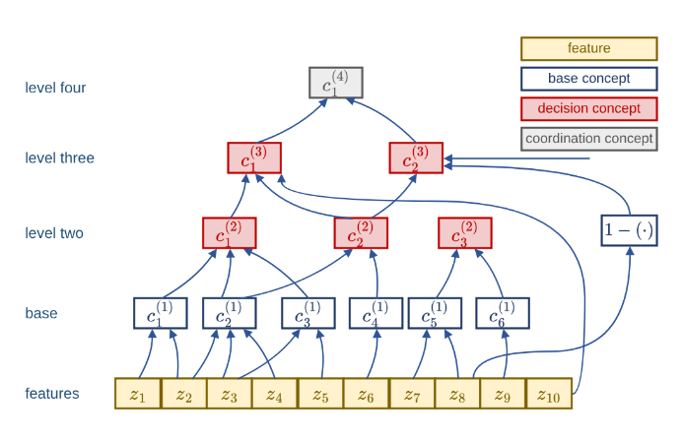
The sources are weather stations and forecasts, satellite and airborne imagery, terrain and fuel maps, road networks, resource status, asset and population layers, and field reports. The agent reduces them to 10 features in the unit interval (11), namely fire intensity $z_{1}$, spread potential $z_{2}$, weather severity $z_{3}$, ignition proximity $z_{4}$, fuel load $z_{5}$, asset exposure $z_{6}$, resource accessibility $z_{7}$, access and road status $z_{8}$, suppression availability $z_{9}$, and temporal urgency $z_{10}$. Every cell has a confidence composed from observability, coverage, freshness, and reliability by their minimum (12). The state is under-observed rather than noisy [19], and Bayesian or Dempster-Shafer treatments presuppose distributional knowledge that real-time sensing lacks [20].
Fig. 2. Observation and concept space of one agent.
Each extraction map normalizes a standard operational descriptor to the unit interval. Fire intensity and spread potential follow fireline intensity after Byram [44] and the Rothermel rate of spread [6] on the observed fire state; weather severity is a fire weather index of the Canadian type [45]; ignition proximity is the distance between the ignition points and the nearest roads and infrastructure; fuel load is the load of the standard fuel model [42]. Asset exposure follows values-at-risk mapping [4], resource accessibility a suppression difficulty index over terrain, fuel, and access [46], access and road status the road network and field reports, suppression availability the fireline production rate of the available crews [43], and temporal urgency the time elapsed since ignition. Each feature inherits its confidence from the observation fields its map reads.
$$z_{f,k}^{i}=ξ_{f}\left(O_{k}^{i}\right)∈\left[0,1\right], f=1,…,10$$ | (11)
$$γ_{k}=min\{γ_{obs},γ_{cov},γ_{fre},γ_{rel}\}$$ | (12)

In (11), $ξ_{f}$ is the extraction map of feature $f$. In (12), $γ_{obs}$ is observability, $γ_{cov}$ sensor coverage, $γ_{fre}$ freshness, and $γ_{rel}$ source reliability.

B. Concept Space
Fig. 2 shows the path from the sources to the 5 decision concepts. Each feature is fuzzified over a 5-term partition of unity. The concept space composes the features into 6 base concepts, these into 5 decision concepts on two levels, and two of these into one coordination concept, with the sets of (13). An activation is a normalized weighted sum of the memberships or activations below it (14). Each raw activation is gated by its confidence and blended with a persistence-carried prior (15), so a lost observation decays geometrically and returns with confidence. The decision concepts, fire threat level $c_{1}^{\left(2\right)}$, asset exposure risk $c_{2}^{\left(2\right)}$, suppression feasibility $c_{3}^{\left(2\right)}$, intervention urgency $c_{1}^{\left(3\right)}$, and evacuation pressure $c_{2}^{\left(3\right)}$, are the only variables rules are written over.
$$\begin{matrix}C_{1}^{\left(1\right)}=\{z_{1},z_{2}\} & C_{1}^{\left(2\right)}=\{c_{1}^{\left(1\right)},c_{2}^{\left(1\right)},c_{3}^{\left(1\right)}\} \\ C_{2}^{\left(1\right)}=\{z_{2},z_{3},z_{4}\} & C_{2}^{\left(2\right)}=\{c_{2}^{\left(1\right)},c_{4}^{\left(1\right)}\} \\ C_{3}^{\left(1\right)}=\{z_{3},z_{5}\} & C_{3}^{\left(2\right)}=\{c_{5}^{\left(1\right)},c_{6}^{\left(1\right)}\} \\ C_{4}^{\left(1\right)}=\{z_{6}\} & C_{1}^{\left(3\right)}=\{c_{1}^{\left(2\right)},c_{2}^{\left(2\right)},z_{10}\} \\ C_{5}^{\left(1\right)}=\{z_{7},z_{8}\} & C_{2}^{\left(3\right)}=\{c_{2}^{\left(2\right)},1-z_{8},z_{10}\} \\ C_{6}^{\left(1\right)}=\{z_{9}\} & C_{1}^{\left(4\right)}=\{c_{1}^{\left(2\right)},c_{2}^{\left(2\right)}\}\end{matrix}$$ | (13)
$$a_{n,k}^{\left(1\right)}=\sum_{f∈C_{n}^{\left(1\right)}}{ω_{n,f}}μ_{A_{n,f}}\left(z_{f,k}\right) \\ a_{n,k}^{\left(l\right)}=\sum_{m∈C_{n}^{\left(l\right)}}{ω_{n,m}^{\left(l\right)}}a_{m,k}^{\left(l-1\right)}, ∑ω=1$$ | (14)
$$a_{n,k}^{eff}=γ_{n,k} a_{n,k}^{obs}+\left(1-γ_{n,k}\right) ρ a_{n,k-1}^{eff} \\ γ_{n,k}=\min_{f∈C_{n}}γ_{f,k}$$ | (15)

In (13), $C_{n}^{\left(l\right)}$ is the input set of concept $n$ at level $l$, and $c_{1}^{\left(1\right)}$ to $c_{6}^{\left(1\right)}$ are fire severity, spread hazard, fuel hazard, asset value, crew reachability, and logistics support; $c_{1}^{\left(4\right)}$ is the operational priority of the coordinator. In (14), $a$ is an activation, $ω$ a nonnegative weight, and $μ_{A}$ a term membership. In (15), $a^{obs}$ is the observed activation, $a^{eff}$ the gated one that rules consume, and $ρ∈[0,1)$ the persistence decay.

C. The Closed Decision Layer
Fig. 3 gives the closed layer. Each rule has the TS form (16) over 5 decision concepts and a constant consequent over 6 intervention families $M$, namely suppression effort, resource deployment, containment line, asset protection, evacuation, and public warning, with inaction as the zero point of each. A rule fires with its weakest clause. The candidate is the firing-weighted average of the consequents, with the sum of firing strengths floored at one in the denominator, so that weak support gives a weak order. Five seed rules start the base and must cover every reachable reading above $α_{min}$.
$$R_{r}:\text{IF}a_{1,k}^{eff}\text{is }A_{r,1}\text{AND}⋯\text{AND} a_{5,k}^{eff}\text{ is }A_{r,5}\text{THEN}u_{k}=v_{r}$$  $$u_{m,k}=\frac{\sum_{r}{μ_{r,k}}v_{r,m}}{max\left(1,\sum_{r}{μ_{r,k}}\right)}, μ_{r,k}=\min_{n}μ_{A_{r,n}}\left(a_{n,k}^{eff}\right)$$  $$\min_{a^{eff}∈{\left[0,1\right]}^{5}}\max_{r}μ_{r}\left(a^{eff}\right)≥α_{min}$$ | (16)

In (16), $R_{r}$ is rule $r$, $A_{r,n}$ its term for concept $n$, $v_{r}$ its consequent vector, $u_{m,k}$ the ordered intensity of family $m∈M$, $μ_{r,k}$ the firing strength, and $α_{min}$ the coverage floor.

Every candidate is judged on a shadow copy of the simulation core over a horizon $H$. The decision cost (17) is a weighted sum of five bounded terms, namely burned area, lost asset value, population exposure, committed response, and dispatch delay. The first three form the physical cost $J_{phys}$, the measure read in every comparison across configurations, since a run without intervention carries no response cost.
Fig. 3. Decision layer 1, the closed decision space.
$$J=\frac{\sum_{j}{w_{j}}J_{j}}{\sum_{j}{w_{j}}},j∈\left\{burn,asset,pop,resp,delay\right\}$$  $$J_{phys}=\frac{J_{burn}+J_{asset}+J_{pop}}{3} \\ J_{burn}=\frac{N_{burned}}{1+ρ_{burn}N_{burnable}} \\ J_{asset}=\frac{V_{lost}}{V_{total}}, J_{pop}=min\left\{1,\frac{P_{steps}}{P_{total}N_{dec}}\right\} \\ J_{resp}=min\left\{1,\frac{C_{steps}}{C_{ref}N_{dec}}\right\}, J_{delay}=min\left\{1,\frac{τ_{disp}}{τ_{ref}}\right\}$$ | (17)
Acceptance follows the satisficing rule of (18). The forecast cost must stay under a ceiling and improve on inaction by a margin. The quality test in (18) compares each scored concept with the strongest intensity ordered for its answering family. Below $η$ the fail-safe scales the four offensive families $M_{off}$ by $λ_{k}$ and leaves the two life-safety families $M_{life}$, evacuation and warning, untouched, with $M=M_{off}∪M_{life}$.
$${\hat{J}}_{k}\left(u_{k}\right)≤min\left\{J_{TH},\left(1-δ_{gain}\right){\hat{J}}_{k}\left(0\right)\right\}$$  $$Q_{k}=1-\frac{1}{4}\sum_{n∈C_{Q}}{\left|a_{n,k}^{eff}-\max_{m∈M_{n}}u_{m,k}\right|}$$  $$λ_{k}=min\{1,Q_{k}/η\}, u_{m,k}←λ_{k}u_{m,k},m∈M_{off}$$ | (18)
In (17), $N_{burned}$ and $N_{burnable}$ count burned and burnable cells, $ρ_{burn}$ is the reference burned fraction, $V_{lost}$ and $V_{total}$ the lost and exposed asset value, $P_{steps}$ the person-steps in burning cells, $P_{total}$ the population at risk, $N_{dec}$ the decision steps of the horizon, $C_{steps}$ the fielded capacity summed over steps, $C_{ref}$ the reference capacity, $τ_{disp}$ the capacity-weighted dispatch time, and $τ_{ref}$ the reference dispatch time. Retardant coating, tactical ignition, and public warning do not field capacity, so each of them is charged to the same sum at a fixed price in capacity units. Hence, every order has a cost. The physical cost is the mean of its three terms, whereas the total cost is divided by the sum of the weights, 3.4, so the physical cost can exceed the total cost when the response terms are small. In (18), ${\hat{J}}_{k}\left(⋅\right)$ is the forecast cost, $J_{TH}$ the ceiling, $δ_{gain}$ the required gain over the no-action forecast ${\hat{J}}_{k}\left(0\right)$, $C_{Q}$ the four scored concepts, all but suppression feasibility, which gates the others, and $M_{n}$ the families that answer concept $n$.
When the standing decision falls short, the layer adapts within its vocabulary, in the evolving fuzzy tradition [26], by the four moves of (19). A step changes one consequent. A shift moves a term edge with the facing edge of its left neighbor, so the partition of unity is preserved. A new rule is written on the uncovered combination of the two most active concepts. A new term is inserted where no term reads the current value clearly. Every move is tried on a working copy and kept only when the forecast physical cost falls. After the last trial, the no-harm guard restricts the candidate to $M_{life}$ when it forecasts a higher physical cost than inaction. The result is the intervention field $U_{DSS,k}^{i}$ of region $i$, merged by the coordinator.
$$\text{step}\text{: }v_{r,m}←{clip}_{\left[0,1\right]}\left(v_{r,m}±δ\right)$$  $$\text{shift}\text{: }\left(a_{A},b_{A},c_{A^{-}},d_{A^{-}}\right)←\left(a_{A},b_{A},c_{A^{-}},d_{A^{-}}\right)-δ$$  $$\text{new rule}\text{: }A_{new}=\left\{\left(n_{1},t_{n_{1}}^{*}\right),\left(n_{2},t_{n_{2}}^{*}\right)\right\}$$  $$t_{n}^{*}=arg\max_{t∈T_{n}}μ_{t}\left(a_{n,k}^{eff}\right)$$  $$\text{new term}\text{: }\max_{t∈T_{n}}μ_{t}\left(x\right)<θ_{ins},x=a_{n,k}^{eff}⇒$$  $$T_{n}←T_{n}∪trap\left(x-2l,x-l,x+l,x+2l\right)$$  $$\text{keep: }Δ{\hat{J}}_{phys}<0$$ | (19)

In (19), $δ$ is the step, $a_{A}$ and $b_{A}$ the left corners of term $A$, $c_{A^{-}}$ and $d_{A^{-}}$ the right corners of its left neighbor $A^{-}$, $n_{1}$ and $n_{2}$ the two most active concepts, $T_{n}$ the term set of concept $n$, $t_{n}^{*}$ its dominant term, $θ_{ins}$ the insertion threshold, and $trap\left(⋅\right)$ a trapezoid of half-width $l$ centered on the crisp reading $x$.

D. The Open Decision Layer
Fig. 4 gives the open layer. It is entered when adaptation leaves a deficit, when a coverage gap opens while the fire is alive, or when spread renews under applied orders. The closed moves of (19) are tried first, a tuning and then a new rule, and a proposal is requested when they leave the deficit in place. The layer has three parts, a proposer, a pre-selection of its candidates on the shadow core, and a chain of gates. [32]SİL (20). SİL: The context $e_{k}$ is the deficit band and the coverage flag, the options $q$ are the two choices, and the reward $r_{k}$ is the forecast cost reduction of the cycle. The value table $V$ is updated with the step $α_{b}$, and a random option is tried with the exploration rate $ϵ_{b}$. The table is reset at the start of each incident, so the selector learns within one incident only, from a few dozen decisions. Whether it improves on a fixed order of trial is tested in the experiments.
$$q_{k}=arg\max_{q∈A\left(e_{k}\right)}V\left(e_{k},q\right) \text{ with probability }1-ϵ_{b} \\ V\left(e_{k},q_{k}\right)←V\left(e_{k},q_{k}\right)+α_{b}\left(r_{k}-V\left(e_{k},q_{k}\right)\right)$$ | (20)

The proposer is a pretrained LLM called through a command-line interface with default sampling settings and a 240 s timeout. Any model that returns objects of the form (21) can take this place; the architecture does not depend on which one is used. It is used in context only and is not fine-tuned. It receives the gated activations, the firing rules, the deficit, the resource state, and the vocabulary of effects, sectors, and bands, and returns six different candidate objects of (21). Each object is a rule in the form of (16), a macro $B$ that blends up to three families $b_{j}$ with weights $β_{j}$, or a composed intervention $A$ of up to three clauses. A clause names an effect $e$ from seven verified effects, a sector $s$ from seven sectors, a distance band $\left[ρ_{in},ρ_{out}\right]$ in cells, and an amount $α$.
$$B=\{\left(b_{j},β_{j}\right)\}_{j≤3}, \left(B,v\right)↦\left(b_{j}, β_{j}v\right) \\ A=\{\left(e,s,\left[ρ_{in},ρ_{out}\right],α\right)\}_{≤3} \\ e∈\left\{wet,clear,ignite,coat,draft,evacuate,prime\right\} \\ s∈\{head,flank,rear,ring,at_fire,assets,populated\}$$ | (21)


A clause is resolved on the simulation fields by the band geometry and the idempotent operators of (22). The band $B$ is the set of cells within four-neighbor distance $ρ_{out}$ of the sector core $C$ but not within $ρ_{in}-1$, and $D_{ρ}\left(C\right)$ denotes such a disk. The cosine $κ$ between a cell direction from the fire centroid $c_{F}$ and the mean wind ${\overset{‾}{W}}_{k}$ splits head, flank, and rear. The amount $a$ is the clause amount scaled by the firing intensity $u$ of the rule. It raises the retardant field $r_{ret}^{M}$ on the mask $M$ by a maximum and the capacity field $r_{cap}^{M}$ by a minimum, with the drafting gain $g_{w}\left(d_{w}\right)$ at water distance $d_{w}$ and the cap $c_{max}$, so that repeating a clause changes nothing. Hence, the space is open at interventions and closed at effects.
Fig. 4. Decision layer 2, the open decision space.
$$B\left(C,ρ_{in},ρ_{out}\right)=D_{ρ_{out}}\left(C\right)\backslash D_{ρ_{in}-1}\left(C\right) \\ κ\left(x\right)=\frac{\left(x-c_{F}\right)⋅{\overset{‾}{W}}_{k}}{∥x-c_{F}∥} a={clip}_{\left[0,1\right]}\left(αu\right) \\ r_{ret}^{M}←max\left(r_{ret}^{M},a\right) \\ r_{cap}^{M}←min\left(r_{cap}^{M} \left(1+g_{w}\left(d_{w}\right)\right), 1.5 c_{max}\right)$$ | (22)

Each proposal passes the gates in Fig. 4. The first four gates are algebraic. G1 rejects an object that does not parse into the vocabulary, G2 an unknown effect or sector, a duplicate of the base, or an object that lowers a life-safety family, G3 a rule that does not fire on the current reading, and G4 an order that exceeds the free pool. The last four run on the shadow core and read the physical cost, as the closed layer does (23). They run over the guard horizon, which is longer than the planning horizon so that a line or a coating has taken effect by the time it is judged. G5 and G6 demand a strict gain on two independent futures, G7 a margin $δ_{adm}$ for a package on each seed, and G8 attribution, a package must beat its own rule without the new object by the same margin. A rejection returns the gate name and both forecasts. An admitted object joins the base with its origin and gate values logged.
$$\text{G5, G6: }{\hat{J}}_{phys}^{ξ}\left(R∪\{p\}\right)<{\hat{J}}_{phys}^{ξ}\left(R\right) \\ \text{G7: }{\hat{J}}_{phys}^{ξ}\left(R\right)-{\hat{J}}_{phys}^{ξ}\left(R∪\left\{p\right\}\right)≥δ_{adm} \\ \text{G8: }{\hat{J}}_{phys}^{ξ}\left(R∪\{r\backslash A\}\right)-{\hat{J}}_{phys}^{ξ}\left(R∪\left\{r_{A}\right\}\right)≥δ_{adm} \\ \text{for both seeds }ξ∈\{ξ_{1},ξ_{2}\}$$ | (23)

In (23), $p$ is the proposal, $R$ the current base, $ξ_{1}$ and $ξ_{2}$ the two seeds, $r_{A}$ the rule carrying the new object $A$, and $r\backslash A$ the same rule without it.
The candidates of a call are pre-selected before any gate of (23) is run. Each candidate that passes G1 to G4 is priced on one shadow forecast over the guard horizon. The rest of the forecast budget of the call, 36 forecasts in all, is spent on local variations of the best candidates, a changed clause, amount, or antecedent, written by the grammar of (21). The three best candidates are priced on a second future, and the candidate with the larger gain on the worse of the two futures is handed to G5 to G8. When no candidate lowers the forecast on both futures, the call ends and nothing is handed to the gates. The origin of every admitted object, the model or a variation of a model candidate, is recorded. Hence, the gates judge one candidate per call, and the pre-selection absorbs most of the rejections.
Four properties follow from the acceptance rules alone and hold whatever the proposer produces. No order reaches the field whose forecast physical cost exceeds the no-action forecast over the guard horizon. The intensities of $M_{life}$ are never reduced, since neither the fail-safe nor the no-harm rule acts on them and a proposal that lowers them fails G2. At every reachable reading some rule fires above the coverage floor of (16), or the layer falls back to the watchful posture and adapts. Each admitted package lowers the forecast physical cost on both seeds by at least $δ_{adm}$, so the admissions in one incident are bounded and the extension halts once no proposal clears the gates. One risk remains, and it is statistical. A proposal with zero or harmful true effect passes G5 and G6 with probability at most $ψ^{2}$, where $ψ$ is the probability that one shadow forecast reports a gain by chance. Section V-E reports how often admitted objects paid off in the outcome.


E. Local Agents and Global Coordination
Fig. 5. Hindcast agreement maps.
Algorithm 1 gives one decision cycle of the decision core. The agents of one incident share one rule base, and each of the $N$ local agents runs the closed layer of Section IV-C with the open layer of Section IV-D inside its trial loop, and the coordinator performs no inference; it allocates the shared pool and merges the regional fields. Each agent sends up its operational priority $p_{i}$, its resource request, and a confidence summary, and receives the allocation, the priority weights, and the acceptance thresholds in force. Regions ranked by priority receive the attention share $σ_{i}$ of (24), which scales only the offensive families, and a monitored region faces a stricter quality threshold. The coordinator changes no order of an agent; it bounds what each region may draw from the pool. The merged field of (25) passes the no-harm guard once more against inaction. When the plan is worse, the field is restricted to $M_{life}$ and the life-safety orders stand.
$$σ_{i}=\left\{\begin{matrix}1 & p_{i}≥τ_{att} p_{max} \\ 0.5+0.5 p_{i}/p_{max} & \text{otherwise}\end{matrix}\right.$$ | (24)
$$U_{DSS,k}=A_{DSS}\left(\{σ_{i} U_{DSS,k}^{i}\}_{i=1}^{N}\right) \\ {\hat{J}}_{phys}\left(U_{DSS,k}\right)>{\hat{J}}_{phys}\left(0\right)⇒U_{DSS,k}←U_{DSS,k}|_{M_{life}}$$ | (25)

In (24), $p_{i}$ is the operational priority $c_{1}^{\left(4\right)}$ of region $i$, $p_{max}$ the highest priority, and $τ_{att}$ the attention threshold. In (25), $A_{DSS}$ merges the regional fields into one intervention field.
Algorithm 1 One decision cycle, $N$ local agents and the coordinator
1: Input: observations $O_{k}^{i}$, rule base $R$, snapshot of the core, seeds $ξ_{1}$, $ξ_{2}$, shares $σ_{i}$ and thresholds $η_{i}$ of the previous cycle
2: for each agent $i$ in parallel do
3: features and confidences (11), (12); activations $a^{eff}$ (14), (15)
4: fire $R$; candidate $u_{k}$ (16); if $Q_{k}<η_{i}$ then scale $M_{off}$ by $λ_{k}$
5: shadow forecasts over $H$ from the snapshot: ${\hat{J}}_{k}\left(u_{k}\right)$ and ${\hat{J}}_{k}\left(0\right)$
6: while (18) fails and trials remain do
7: closed move from (19) on a working copy of $R$; keep it if $Δ{\hat{J}}_{phys}<0$
8: if the closed moves leave the deficit in place then request a proposal; SİL: (20) selects a proposal then
9: $p←LLM\left(Σ_{k}\right)$; pre-select the candidates: G1-G4, one forecast each, variations within the budget, a second future for the best three; hand the best one to (23); SİL: forecast $R$ & $R∪\{p\}$ on $ξ_{1}$,$ξ_{2}$; test (23)
10: if all gates pass then $R←R∪\{p\}$ else return the gate name and both forecasts
11: refire $R$; update $u_{k}$ and the forecasts
12: if ${\hat{J}}_{phys}\left(u_{k}\right)>{\hat{J}}_{phys}\left(0\right)$ then $u_{k}←u_{k}|_{M_{life}}$ (no-harm)
13: send $U_{DSS,k}^{i}$ written from $σ_{i}u_{k}$, priority $p_{i}$, resource request, and confidence summary
14: coordinator: rank the regions by $p_{i}$; $p_{max}←\max_{i} p_{i}$
15: for each region $i$ do $σ_{i}$ (24); allocate from the shared pool in rank order; raise $η_{i}$ if region $i$ is monitored
16: $U_{DSS,k}←A_{DSS}\left(\{σ_{i}U_{DSS,k}^{i}\}\right)$ (25); forecast ${\hat{J}}_{phys}\left(U_{DSS,k}\right)$ and ${\hat{J}}_{phys}\left(0\right)$
17: if ${\hat{J}}_{phys}\left(U_{DSS,k}\right)>{\hat{J}}_{phys}\left(0\right)$ then $U_{DSS,k}←U_{DSS,k}|_{M_{life}}$ (no-harm)
18: Output: $U_{DSS,k}$ to the simulation core; $σ_{i}$, allocations, and $η_{i}$ to the agents; updated $R$; log of the cycle

V. Results

A. Validation of the Simulation Core
Every comparison in this section rests on the simulation core, so the core is validated first, by blind hindcast. The simulation core receives only the public inputs of a documented fire, with no tuning on that fire, and its output is compared with the satellite record. Terrain comes from Copernicus GLO-30, fuel from ESA WorldCover 2021, weather from ERA5 reanalysis, and ignition points and reference burn from NASA FIRMS VIIRS detections. Four fires in Türkiye cover different fuel, terrain, and wind conditions, namely Sc1 Çanakkale 2023, Sc2 Manavgat 2021, Sc3 Marmaris 2021, and Sc4 Milas 2021. The core models free spread without suppression, so a free run overpredicts the final area, and an area-overlap score would penalize the model for the suppression it does not represent. Three criteria that are robust to suppression are used instead, each reported as an agreement in Table I. The probability of detection (POD) is the share of the observed burn that the model reaches. It is not lowered by overprediction, and 0.70 is the level at which calibrated growth models are reported to agree with observed footprints [23]. The front agreement is $1-\overset{‾}{d}/R$, where $\overset{‾}{d}$ is the mean distance between the simulated and the observed fronts and $R$ the radius of a disk with the observed burned area, so that 0.9 means the fronts lie within one tenth of the fire size. The arrival-time agreement is $1-τ/T$, where $τ$ is the mean absolute difference between the simulated and the detected arrival times over the shared cells and $T$ the observed duration of the fire. It is the direct test of the rate of spread. The overall agreement is the mean of the three. Over 50 replicates the overall agreement is 86 to 94% and no single score falls below 0.70. The four fires differ in size, fuel, terrain, and duration, and none of them was used to tune the model, so the agreement supports the use of the core for Mediterranean summer fires of this size. The simulated windows are shorter than the observed durations in two cases, and the agreement is computed over the cells the two records share. Fig. 5 shows the agreement maps of the four fires.
TABLE I
Hindcast agreement per historical fire (50 replicates)
Score | Sc1 | Sc2 | Sc3 | Sc4
Front agreement $1-\overset{‾}{d}/R$ | 82% | 90% | 89% | 89%
Arrival-time agreement $1-τ/T$ | 90% | 98% | 71% | 96%
Probability of detection | 92% | 93% | 97% | 85%
Overall agreement | 88% | 94% | 86% | 90%

B. Experimental Design
Synthetic scenarios use 72 by 50 cell grids at 30 m with terrain, land cover, settlements, roads, and capacity-limited bases, under critical fire weather. The domain is about 2.2 km by 1.5 km, so a free burn can consume most of it within the episode and the no-action outcome is bounded by the domain rather than by the fire. The saving against no action is therefore a conservative figure, and the paired differences between the decision configurations are the measures to read. Weather is held fixed across worlds, so the comparison isolates the decision mechanism and does not test weather uncertainty. Table II lists the settings of the engine, the closed layer, the open layer, and the coordinator with the reason for each value. Five scenario families, listed in Table III, span remote forest and the wildland-urban interface under sufficient and limited resources, and the fifth repeats the hardest interface family under degraded observation. Each family is generated 30 times, and every world is replayed identically by every configuration. The no-decision-support configuration issues no orders and fixes the cost of inaction. The closed layer runs the five seed rules with their self-tuning. VODA is the full architecture, the closed layer with the open layer, the LLM proposer, and the full gate chain. Five further configurations of the open layer separate the role of the proposer from that of the pre-selection, listed in Table IV. A random proposer draws objects from the same grammar, with one object per call or with pre-selection at two budgets, and the LLM proposer is run with one object per call, with pre-selection of its own candidates only, and with pre-selection and variations, which is VODA. Since the proposer is not deterministic, VODA is run twice on the same worlds; the first replicate is reported and the second gives the run-to-run variance. Terrain, ignitions, weather, and the random stream are shared, so differences between configurations arise from the issued orders alone. All configurations run on the same code and the same 150 worlds. The withheld-family study of Section V-E adds runs in which one intervention family is removed from the seed rules of both layers, and a leave-one-out replay re-installs the admitted objects one at a time. Outcome is read at the end of the episode on burned area, affected population, the share of incidents extinguished within the episode, and the physical and total cost. Paired statistics report the mean difference on the same worlds with its 95% half-width and the number of worlds in which the first configuration is better.
TABLE II
Settings of the experiments and their justification
Setting | Value | Justification
Physical step, decision cycle | 2 min, 12 min | two-minute spread update, six updates per decision
Planning horizon $H$ | 24 min | two decision cycles ahead; the guard horizon of the gates is 45 min
Episode | to extinction or 12 h | first operational period of an incident
Fire weather | moisture 0.08, wind 8 m/s | critical fire weather
Cost weights $w$ | 1, 1, 1, 0.2, 0.2 | physical terms dominate, response cost breaks ties
Reference burned fraction $ρ_{burn}$ | 0.50 of burnable cells | normalizes the burned-area term of (17)
Satisficing bound $J_{TH}$ | 0.35 | bound on the forecast cost of an acceptable plan
Gain margin $δ_{gain}$, coverage floor $α_{min}$, adaptation step | 0.05 each | one twentieth of the unit interval, the resolution of the 5-term partition
Quality threshold $η$ | 0.60 | mean gap between a scored concept and its answer at most 0.4
Term insertion threshold, half-width $l$ | 0.62, 0.12 | membership level at which two neighbouring terms share a reading
Selector step $α_{b}$, exploration rate $ϵ_{b}$ | 0.05, 0.10 | one proposal in ten is tried regardless of the value table
Admission margin $δ_{adm}$ | 0.0001 per seed | excludes only a package without a measurable gain
Attention threshold $τ_{att}$ | 0.35 of the highest priority | a region below it gets a reduced offensive share
Degraded observation (S5) | outage 0.25, noise 0.10 | one in four readings missing, 10% noise on the rest

TABLE III
Scenario families, 30 paired worlds each
Family | Landscape | Pool | Ignitions | Observation
S1 | mountain forest, 2 settlements | full | 1, remote | full
S2 | mountain forest, 2 settlements | 0.6 | 2, remote | full
S3 | rolling interface, 12 settlements | full | 1, near interface | full
S4 | rolling interface, 12 settlements | 0.6 | 2, near interface | full
S5 | as S4 | 0.6 | 2, near interface | degraded

C. Outcome: No Decision Support, Closed Layer, VODA
Fig. 6 reports the outcome per family. Without decision support the fire consumes most of the domain in every family. The closed layer lowers the burned area by 70% and the affected population by 93%, and it is better in all 150 worlds. It extinguishes 52% of the incidents within the episode, whereas no incident is extinguished without decision support. The closed layer contains the fires that its doctrine covers, but it does not reach the fires that lie outside the doctrine. The order of the closed moves does not matter. With the two moves tried in a fixed order on the same 150 worlds, the burned area changes by 3%, a difference that does not separate from zero.
VODA reaches these fires. Against the closed layer on the same worlds it lowers the burned area by 54% and is better in 128 of 150 worlds, as Fig. 7(a) shows. The 11 ties are small fires the doctrine already contained. In 11 worlds VODA burned more, by 24 ha at most, since an admitted object can win its forecast and still lose in the realized fire. It raises the share extinguished from 52 to 87% and lowers the affected population by 71%. The gain holds in every family. It is largest in the remote forest family with one ignition, where the closed layer extinguishes 40% of the incidents and VODA 90%, and most consistent in the interface families with two ignitions, where VODA burns less in 30 and 29 of 30 worlds and extinguishes every incident. In the resource-limited forest family the closed layer extinguishes 7% of the incidents and VODA 43%, so the pool bounds what any order can achieve. Under degraded observation the burned area of VODA is 18% higher than with full observation, whereas the closed layer is unchanged, and VODA remains better than the closed layer in 29 of 30 worlds of that family. Reduced observation therefore degrades the open layer gradually rather than disabling it. Since the proposer is not deterministic, VODA was run twice on the same worlds. The second run ends within 1% of the first in burned area, so the mean outcome is reproducible, although single worlds differ between the runs.
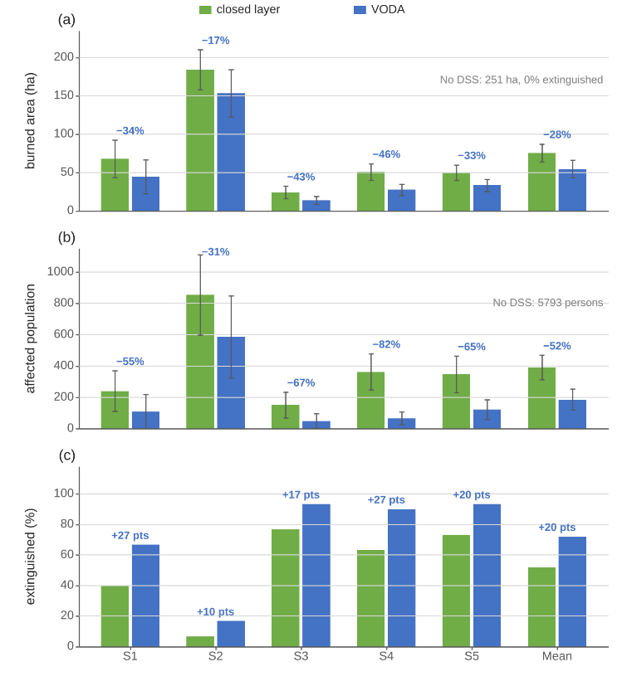
The gain does not come from a larger committed response. Fig. 7(b) sets the physical cost beside the five-term total cost of each configuration. VODA lowers the physical cost by 53% and the total cost by 42% against the closed layer, while its response term, in which every coating, ignition, and warning is paid for, stays 38% below that of the closed layer. The delay term rises by 31%, since part of the orders of the open layer is fielded later in the incident, after an object has been admitted. The saving sits in the physical terms with no growth in the response terms. The rule base reaches 10.0 active rules at the end of an episode under VODA against 10.3 under the closed layer alone, so the margin comes from what the rules say rather than from how many there are. The cost of the open layer is computation, about five model calls per episode. A cycle with a model call and its pre-selection takes 15 s at the ninetieth percentile and 55 s at the slowest, inside the twelve-minute cycle.
Fig. 6. Outcome per family, closed layer against VODA: (a) burned area, (b) affected population, (c) share extinguished.
Table IV separates the role of the proposer from that of the pre-selection on the same worlds. With one object per call and no pre-selection, the LLM proposer lowers the burned area by 28% against the closed layer, whereas a random proposer over the same grammar lowers it by 9%, a difference of 21 ± 10 points. Hence, without pre-selection, the objects of the model are much better than random ones. With pre-selection on the same forecast budget, the random proposer lowers the burned area by 46% and VODA by 54%, and the difference between the two does not separate from zero. With the pre-selection restricted to the six candidates of the model, without variations, the gain falls to 37%. The pre-selection and the gates therefore carry most of the gain, and the model raises the quality of the candidates they start from. The gain does not rest on the model. It rests on candidates that the hazard model has verified, whatever their source.

D. What the Open Layer Produced
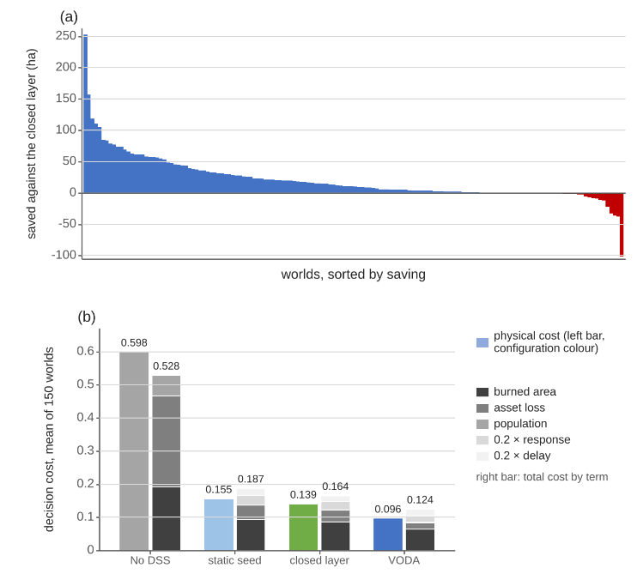
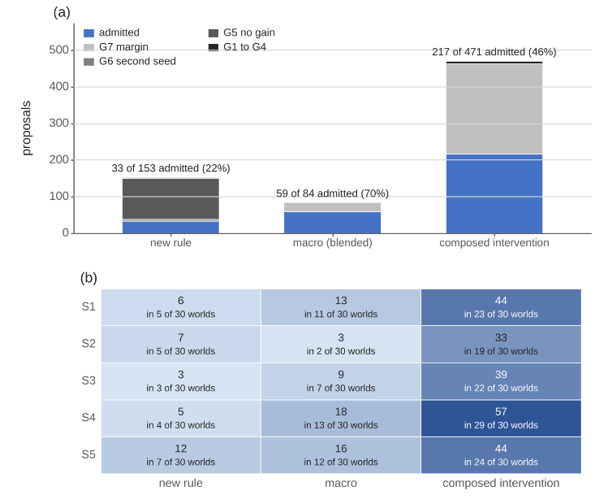
Adaptation runs only on demand. Hence, the volume of trials measures how often the standing decision fell short, and the admission rate measures how strictly the gates filtered the responses. The open layer was called 741 times over the 150 worlds. In 375 calls no candidate lowered the forecast on both futures and nothing was handed to the gates. Of the 339 candidates handed to the gates, 333 were admitted and 6 rejected. SİL: Fig. 8 Thus, the pre-selection absorbs the rejections, and the gates rarely reject what reaches them. Admission is decided by the simulation, not by the form of the proposal. Of the 333 admitted objects, 207 are composed interventions, 85 are macros, and 41 are rules. The model wrote 95 of them itself, and 238 are variations of model candidates found by the pre-selection. The admitted objects are therefore the product of the open layer as a whole, the model and the verified search together, rather than of the model alone.
Fig. 7. (a) Area saved by VODA against the closed layer, 150 worlds sorted. (b) Physical and total cost per configuration.
Fig. 8. (a) The 708 proposals by kind and gate verdict. (b) Admitted objects per family and kind, and worlds with one.
The admitted objects fall into a small number of tactics, each absent from the seed doctrine, as Fig. 9 shows. The macros reduce to two archetypes. The line-and-attack macro blends a containment line with suppression effort, in some cases with resource deployment (49 admissions). Interface hardening blends asset protection with a containment line (25 admissions). The composed interventions are dominated by coating. The asset collar coats the threatened assets and the populated cells within two to three cells before the fire arrives, in many cases with priming of the populated cells. The head coating lays retardant on the head within a few cells, in some cases with water drafting at the fire. Clauses that clear, wet, ignite, or evacuate enter only where the forecast rewards them.

E. Where the Gain Came From
Every world starts from the same five seed rules, and the proposer has no memory across worlds. Hence, an object that recurs in several worlds was rediscovered, not copied. Counting every variant that contains the defining clauses, the asset collar was admitted in 50 distinct worlds, the head coating in 39, the line-and-attack macro in 51, and the interface-hardening macro in 30. Recurrence across independent worlds is the first evidence that what the open layer learns is structural rather than incidental.
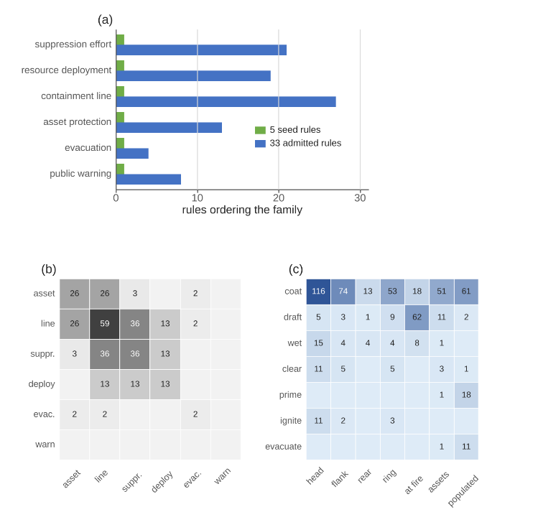
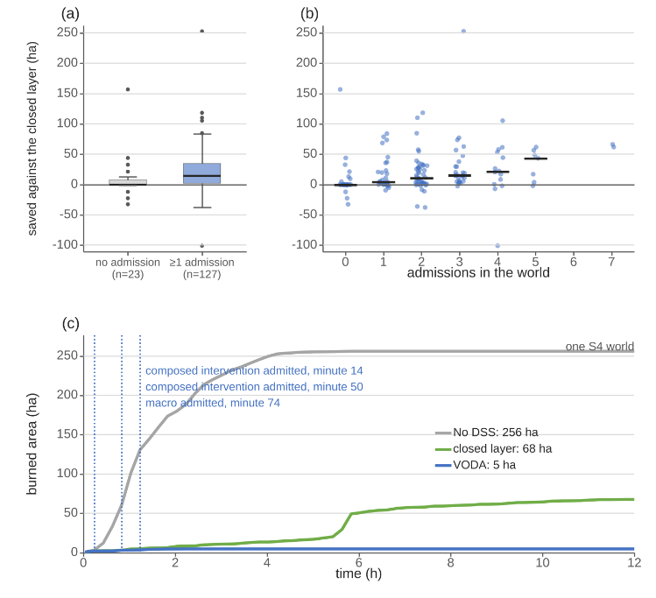
The realized outcome confirms the forecast that admitted the objects, as Fig. 10 shows. In the 17 worlds with no admission, VODA and the closed layer end close to each other, and 8 of them are identical. The margin of Section V-C comes from the 133 worlds with at least one admission, where the median saving grows from under one hectare with one admission to about 24 ha with two or more. A leave-one-out replay turns this into a causal account. Each world with an admission was replayed with the closed layer and the admitted objects re-installed at their recorded minutes, without the proposer. With every object re-installed the replay reproduces the VODA outcome within one hectare in 91 of 133 worlds, and with none it reproduces the closed layer exactly in every world. Removing all objects raises the burned area by 41 ha per world, and the objects are harmful in 10 worlds only. Removing one object at a time, 198 of the 333 objects raise the burned area when removed, 111 change it by less than half a hectare, and 24 lower it. The single effects do not add up to the joint effect, 31 against 41 ha per world, since the admitted objects of one world act together and a removed object also changes what the closed layer does afterwards. SİL: The single world in Fig. 10(c) shows the mechanism at the scale of one fire. It is an interface world in which the closed layer ends at 68 ha and VODA at 5 ha. The curves separate after minute 14, when a composed intervention coating the head and the flanks was admitted; two further objects followed at minutes 50 and 74.
Fig. 9. (a) Families ordered by seed and admitted rules, (b) blends in the macros, (c) clauses by effect and sector.
Fig. 10. Saving (a) without and with admissions and (b) by number of admissions, medians as bars; (c) one S4 world.
The dependence on the seeded doctrine was tested by withholding one family from the seed rules of both layers. Resource deployment is the family the closed layer depends on most. Without it the closed layer burns 40 ± 12% more than with the full doctrine, is worse in 115 of 150 worlds, and never writes the family back. VODA without the family burns 50% less than the closed layer without it, and 29 ± 14% less than the closed layer with the full doctrine. The open layer wrote the family back in 60 of 150 worlds, as plain rules and inside macros, at a median of 14 min after ignition. The containment line, by contrast, costs the closed layer only 2% when withheld, and VODA without it ends where VODA with the full doctrine ends. The open layer therefore closes a gap in the doctrine when there is one, and leaves the outcome unchanged when there is none.

F. Timeliness, Scalability, and Compliance
One decision covers the whole loop, including the two shadow forecasts of the acceptance test and any adaptation that runs. It takes a median 173 ms against a twelve-minute cycle, 526 ms at the ninetieth percentile and 942 ms at the slowest, measured on one process with no other load. The first offensive order is fielded at the first decision, two minutes after ignition. Fig. 11(a) reports the decision-layer cost for one to sixteen agents and for three grid sizes, as the median over five worlds. Sixteen times the agents cost 1.2 times the median of one agent, since each agent reasons over its own region. SİL: Fig. 11(b). Four times the grid raised the median by a factor of 2.9. Thus, scalability holds on the axis the architecture is built for, while domain size remains the binding limit; a domain of the order of 100 000 cells would move one decision to several seconds, still inside the cycle. A model call adds to this. A cycle in which the open layer calls the model and pre-selects its candidates takes 15 s at the ninetieth percentile and 55 s at the slowest, less than a tenth of the cycle. The outcome of the closed layer with one, four, and sixteen agents on the 150 worlds differs by less than 3% in burned area, a difference that does not separate from zero, so partitioning the domain costs no decision quality. The coordinator bounds the draw on the shared pool more often as the number of agents grows, in 2% of the cycles with four agents and in 40% with sixteen, without changing the outcome.
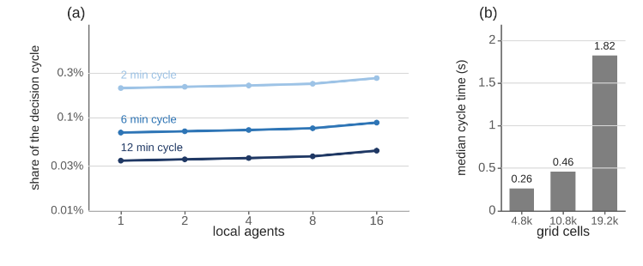
An architecture of this kind is not judged on outcome alone. Operators need a decision in time, under degraded observation, with an account of every order, and the system must hold as the incident grows. These requirements, together with the limits named in the Introduction, were turned into eight criteria before the experiments, namely predictive fidelity, decision quality, timeliness, robustness, uncertainty handling, adaptability, explainability, and scalability, so that the evidence is read against a fixed list rather than selected afterwards. Against them the picture is as follows. Predictive fidelity rests on four blind hindcasts with an overall agreement of 86 to 94%. Decision quality follows from the paired comparison, 86% less burned area than no action and 54% less than the closed layer, better in 128 of 150 paired worlds. Timeliness is met with 173 ms per decision and at most 55 s for a cycle with a model call. Scalability is met with 1.2 times the cost for sixteen times the agents and an unchanged outcome. Robustness is tested on one axis only, degraded observation, where the burned area rises by 18% and VODA remains better than the closed layer. Uncertainty handling is structural, since every feature carries a confidence that gates its concept. Adaptability shows in 333 admitted objects that recur across worlds and in the recovery of a withheld family within the first hour. Explainability is supported by the log, in which every edit, rejection, and generated object carries its trigger, gate, and consuming rule; operator-facing interpretability was not evaluated. Predictive fidelity, decision quality, timeliness, and scalability are measured directly. The other four rest on one axis each. The hindcast base covers four fires, outage and noise are tested at one level, uncertainty is carried into the decision but not propagated as an ensemble, and the withheld-family test removes one family at a time.
Fig. 11. Decision cost: (a) median cycle time as a share of the cycle against the number of agents, (b) against grid size.

VI. Discussion
Three lessons transfer beyond wildfire. First, separating an authoritative hazard model from the decision layer is what makes both testable. The model was validated against satellite records with no decision logic in the loop. The decision layers were then measured against each other on the same worlds. Hence, the benefit of opening the decision space is a paired difference rather than an absolute score. Second, a vocabulary of orders that grows at run time is safe only when admission is decided by gates that do not trust the proposer. Half of the calls handed nothing to the gates, since no candidate lowered the forecast on both futures, and a random proposer behind the same pre-selection and gates reached most of the gain. That selectivity is why the admitted objects could be fielded and why the outcome improved rather than merely changed, and it is why the architecture does not depend on the intelligence of the proposer. Third, the two layers divide the work by cost and determinism rather than by capability. The moves of the closed layer are deterministic and cheap, and they finish the fires the doctrine already holds. The proposals of the open layer are expensive and not bitwise reproducible, and they reach the fires the doctrine does not hold. A single generative mechanism could in principle write the tuning edits as rules, at the price of a model call for every edit. However, keeping the deterministic layer underneath minimizes the number of cycles in which the non-reproducible component acts. It also keeps the ledger able to say which change came from tuning and which from generation.
Four limitations bound the claims. The evaluation is carried out in simulation. The spread model is validated on real records, but the suppression model of Section III-B, the effect operators of Section IV-D, and their parameters are taken from the literature and were not validated against recorded suppression operations. Every saving reported here is measured through that model, so its absolute size should be read with caution; the paired differences between configurations are less sensitive, since all configurations act through the same model. No order was executed in a real incident and no fire officer took part in the loop. The gates judge a forecast, not the outcome. In 11 of 150 worlds VODA burned more than the closed layer, 24 of the 333 admitted objects lower the outcome when kept, and in the resource-limited forest family fewer than half of the incidents are extinguished, since no rearrangement of an insufficient pool contains the fire. The seed doctrine is deliberately minimal, five rules that cover the reading space, and the margin of the open layer is measured against that doctrine; a richer expert base would narrow the gap the open layer fills, and the withheld-family test shows the other direction only, that a poorer doctrine is recovered, for two families chosen by the loss they cause. With the same pre-selection budget, a random proposer over the same grammar comes close to VODA, and the model alone, without variations of its candidates, falls behind the random search with variations. Hence, the advantage of the model lies in the quality of its candidates rather than in an outcome that search alone cannot reach. The delay term of the cost rises under VODA, and the cause was not isolated. The attribution of the gain to object kinds is causal within the replay only; an ablation that admits the proposals of one kind under the live proposer would test the kinds directly. The proposals of an LLM are not bitwise reproducible. Nevertheless, the campaign is logged with pinned configuration and seeds, and no admission depends on the proposer. A second run of the same worlds ended within 1% of the first in mean burned area while the ranking of the families and the admission rate held. The results were measured with one proposer; the architecture asks of it only the object of (21), and the gates, not the proposer, decide what enters the rule base.

VII. Conclusion
This article presented VODA, a distributed decision support architecture for wildfire response built on two separated cores and two decision layers. The closed layer is a self-tuning fuzzy doctrine over 5 decision concepts and 6 intervention families. The open layer lets a pretrained LLM propose rules, blended interventions, and interventions composed from verified physical effects, pre-selects the candidates on the hazard model, and admits one per call through a gate chain. The gates preserve no-harm, life-safety invariance, coverage, and monotone descent in the forecast, whatever the proposer. On an independently validated core, 150 paired worlds in five scenario families were replayed with no decision support, with the closed layer alone, and with both layers. Against the closed layer, VODA lowered the burned area by 54% and was better in 128 of 150 worlds. It raised the share of incidents extinguished from 52 to 87% and left 71% fewer people affected, with every order priced and a smaller committed response. A random proposer behind the same pre-selection came close to this result, so the pre-selection and the gates carry most of the gain, and the model supplies better candidates. The admitted objects recur across independent worlds and reduce to a small set of tactics the seed doctrine did not contain, namely the asset collar, the head coating, interface hardening, and the line-and-attack macro. With the family the closed layer depends on most withheld, the open layer wrote it back within the first hour and ended below the closed layer with the full doctrine. A tabletop exercise with fire officers, and a transfer to another hazard in which only the simulation core and the intervention vocabulary change, are left to future work.

References

[1] | M. Turoff, M. Chumer, B. Van de Walle and X. Yao, "The design of a dynamic emergency response management information system (DERMIS)," J. Inf. Technol. Theory Appl., vol. 5, pp. 1-36, 2004.
[2] | D. M. Bowman, C. A. Kolden, J. T. Abatzoglou, F. H. Johnston, G. R. van der Werf and M. Flannigan, "Vegetation fires in the Anthropocene," Nat. Rev. Earth Environ., vol. 1, pp. 500-515, 2020.
[3] | M. P. Thompson and D. E. Calkin, "Uncertainty and risk in wildland fire management," J. Environ. Manage., vol. 92, pp. 1895-1909, 2011.
[4] | D. E. Calkin, C. D. O'Connor, M. P. Thompson and R. D. Stratton, "Strategic wildfire response decision support and the risk management assistance program," Forests, vol. 12, p. 1407, 2021.
[5] | F. Vásquez, A. Cravero, M. Castillo and F. Riquelme, "Decision support system development of wildland fire: A systematic mapping," Forests, vol. 12, p. 943, 2021.
[6] | R. C. Rothermel, "A mathematical model for predicting fire spread in wildland fuels," Res. Pap. INT-115, 1972.
[7] | M. A. Finney, "An overview of FlamMap fire modeling capabilities," in Fuels Management: How to Measure Success (RMRS-P-41), 2006.
[8] | C. Pais, J. Carrasco, P. E. Moudio and Z.-J. M. Shen, "Downstream protection value: Detecting critical zones for effective fuel-treatment under wildfire risk," vol. 90, p. 101703, 2021.
[9] | T. Orphanoudakis, C. Betzelos and H. C. Leligou, "MORA: A multicriteria optimal resource allocation and decision support toolkit for wildfire management," Algorithms, vol. 18, p. 677, 2025.
[10] | E. K. Noonan-Wright et al., "Developing the US wildland fire decision support system," J. Combust., vol. 2011, p. 168473, 2011.
[11] | C. Rapp, E. Rabung, R. Wilson and E. Toman, "Wildfire decision support tools: An exploratory study of use in the United States," Int. J. Wildland Fire, vol. 29, pp. 581-594, 2020.
[12] | C. Rapp, K. L. Courtney, S. T. Franz, M. M. Colavito, T. Aldworth and A. S. Cheng, "Wildfire decision support tools: barriers, facilitators, and future directions for effectiveness," Fire Ecol., 2026.
[13] | D. Arnott and G. Pervan, "A critical analysis of decision support systems research," J. Inf. Technol., vol. 20, pp. 67-87, 2005.
[14] | A. Arbel and R. M. Tong, "On the generation of alternatives in decision analysis problems," J. Oper. Res. Soc., vol. 33, pp. 377-387, 1982.
[15] | G. J. Hofstede, "Open problems, formal problems," J. Decis. Syst., vol. 4, pp. 155-165, 1995.
[16] | A. Colorni and A. Tsoukias, "Designing alternatives in decision problems," J. Multi-Criteria Decis. Anal., vol. 27, pp. 150-158, 2020.
[17] | E. D. Brill, J. M. Flach, L. D. Hopkins and S. Ranjithan, "MGA: A decision support system for complex, incompletely defined problems," IEEE Trans. Syst., Man, Cybern., vol. 20, pp. 745-757, 1990.
[18] | G. A. Klein, Sources of Power: How People Make Decisions, 2017.
[19] | M. G. Morgan and M. Henrion, Uncertainty: A Guide to Dealing with Uncertainty in Quantitative Risk and Policy Analysis, 1990.
[20] | G. Shafer, A Mathematical Theory of Evidence, 1976.
[21] | M. T. Ribeiro, S. Singh and C. Guestrin, ""Why should I trust you?" Explaining the predictions of any classifier," in Proc. ACM SIGKDD Int. Conf. Knowl. Discovery Data Mining, 2016.
[22] | A. L. Sullivan, "Wildland surface fire spread modelling 1: Physical and quasi-physical models," Int. J. Wildland Fire, vol. 18, pp. 349-368, 2009.
[23] | C. Pais, J. Carrasco, D. L. Martell, A. Weintraub and D. L. Woodruff, "Cell2Fire: A cell-based forest fire growth model to support strategic landscape management planning," Front. For. Glob. Change, vol. 4, 2021.
[24] | L. A. Zadeh, "Fuzzy sets," Inf. Control, vol. 8, pp. 338-353, 1965.
[25] | T. Takagi and M. Sugeno, "Fuzzy identification of systems and its applications to modeling and control," IEEE Trans. Syst., Man, Cybern., vol. 15, pp. 116-132, 1985.
[26] | P. P. Angelov and D. P. Filev, "An approach to online identification of Takagi-Sugeno fuzzy models," IEEE Trans. Syst., Man, Cybern. B, vol. 34, pp. 484-498, 2004.
[27] | S. French, J. Maule and N. Papamichail, Decision Behaviour, Analysis and Support, 2019.
[28] | F. Del Missier, M. Visentini and T. Mantyla, "Option generation in decision making: Ideation beyond memory retrieval," Front. Psychol., vol. 5, p. 1584, 2015.
[29] | P. Struss, "Model-based decision support systems: Conceptualization and general architecture," in Proc. Int. Workshop Qualitative Reasoning (QR), 2019.
[30] | Y. Ding et al., "Integrating action knowledge and LLMs for task planning and situation handling in open worlds," Auton. Robots, vol. 47, pp. 981-997, 2023.
[31] | E. Gizzi, H. Amel, W. W. Lin, K. Rhea and J. Sinapov, "Toward creative problem solving agents: Action discovery through behavior babbling," in Proc. IEEE Int. Conf. Develop. Learn. (ICDL), 2021.
[32] | R. S. Sutton and A. G. Barto, Reinforcement Learning: An Introduction, 2018.
[33] | Y. Xie, B. Jiang, T. Mallick, J. D. Bergerson, J. K. Hutchison and D. R. Verner, "WildfireGPT: Tailored large language model for wildfire analysis," arXiv:2402.07877, 2024.
[34] | H. A. Simon, "Rational choice and the structure of the environment," Psychol. Rev., vol. 63, pp. 129-138, 1956.
[35] | P. Dubey and P. Dubey, "Bridging spatiotemporal wildfire prediction and decision modeling using transformer networks and fuzzy inference systems," vol. 15, p. 103498, 2025.
[36] | R. Chandra, S. S. Kumar, R. Patra and S. Agarwal, "Decision support system for forest fire management using ontology with big data and LLMs," Cluster Comput., vol. 28, p. 548, 2025.
[37] | Y. Cheng et al., "Retrieval over response: Large language model-augmented decision strategies for hierarchical wildfire risk evaluation," Fire, vol. 9, p. 143, 2026.
[38] | N. Gerolimos et al., "Autonomous decision-making enhancing natural disaster management through open world machine learning: A systematic review," Hum.-Centric Intell. Syst., vol. 5, pp. 269-284, 2025.
[39] | A. Sandeep, S. Jayarathna, S. Sandaruwan, V. Samarappuli, D. Meedeniya and C. Perera, "Context-aware multi-agent architecture for wildfire insights," Sensors, vol. 26, p. 1070, 2026.
[40] | J. Cui, C. Zhai, Y. Wang and Y. Li, "Large language models and AI agents in disaster-resilient infrastructure: Concepts, applications, pathways, and challenges," Reliab. Eng. Syst. Saf., vol. 267, p. 111683, 2026.
[41] | E. Park, J. Park and T. Kim, "WildfireKR: An LLM-agent decision support framework for autonomous wildfire spread simulation in South Korea," IEEE Access, vol. 14, pp. 59185-59208, 2026.
[42] | J. H. Scott and R. E. Burgan, "Standard fire behavior fuel models: A comprehensive set for use with Rothermel's surface fire spread model," Gen. Tech. Rep. RMRS-GTR-153, 2005.
[43] | K. G. Hirsch and D. L. Martell, "A review of initial attack fire crew productivity and effectiveness," Int. J. Wildland Fire, vol. 6, pp. 199-215, 1996.
[44] | G. M. Byram, "Combustion of forest fuels," in Forest Fire: Control and Use, 1959, pp. 61-89.
[45] | C. E. Van Wagner, "Development and structure of the Canadian Forest Fire Weather Index System," For. Tech. Rep. 35, 1987.
[46] | F. Rodríguez y Silva, J. R. Molina Martínez and A. González-Cabán, "A methodology for determining operational priorities for prevention and suppression of wildland fires," Int. J. Wildland Fire, vol. 23, pp. 544-554, 2014.

Çağlar Akman received the B.S. and M.S. degrees in electrical and electronics engineering from Middle East Technical University (METU), Ankara, Türkiye, in 2008 and 2017, respectively, where he is currently pursuing the Ph.D. degree. He is a Senior Principal Team Manager with HAVELSAN, Ankara, where he manages research and development projects on advanced sensor systems, decision support architectures, and command and control software for defense and public-safety programs. His research interests include intelligent decision support systems, fuzzy inference, distributed architectures, and disaster management technologies.
Kemal Leblebicioğlu received the Ph.D. degree from the Department of Mathematics, METU, Ankara, Türkiye, in 1988. He has been a Full Professor with the Department of Electrical and Electronics Engineering, METU, since 1999. He has authored more than 40 journal papers and numerous book chapters and conference papers, and served as the Editor of the journal ELEKTRIK from 1996 to 2009. His research interests include optimization, optimal control, computer vision, intelligent systems, unmanned vehicles, and biomedical signal processing.

Manuscript received [Month DD, 2026]. (Corresponding author: Çağlar Akman.) Ç. Akman and M. K. Leblebicioğlu are with the Department of Electrical and Electronics Engineering, Middle East Technical University, 06800 Ankara, Türkiye (e-mail: caglar.1315akman@metu.edu.tr; kleb@metu.edu.tr).

