A Distributed Decision Support Architecture With a Verified Open Decision Space for Wildfire Response
Çağlar Akman and Kemal Leblebicioğlu

Abstract—Decision support systems (DSSs) are systems of systems. Most decide inside a closed decision space, a set of rules fixed before the incident. Outside this set, the system cannot respond. This article presents the Verified Open Decision Architecture (VODA), an architecture with an open decision space. It defines the invariants of the space, a verified set of physical effects from which new interventions are composed, and a chain of gates. A generative model proposes new rules and blended or composed interventions. A proposal enters the rule base only after deterministic checks and a paired forecast test on reseeded futures. A simulation core holds the hazard state. A decision core reads it through confidence-rated observations. The decision core has a closed layer, a sparse Takagi-Sugeno rule base that tunes itself online, and an open layer that proposes and verifies new objects. The approach is applied to wildfire response and tested on 150 paired worlds in 5 scenario families. Compared with the closed layer alone, the open layer reduces burned area by 40%, affected population by 70%, and committed response by 28%. It raises the share of extinguished incidents from 52 to 75%. The decision core is distributed and suits real-time operation. Each agent reasons only over its own region, so computing cost grows slowly with the number of regions.

Index Terms— Decision support systems, open decision space, generative rule proposal, system-of-systems architecture, wildfire management.

I. INTRODUCTION
W
ILDFIRE response is carried out by a system of systems [1]. A hazard model turns the observations retrieved from heterogeneous sources into a forecast of where the fire will spread. Regional teams decide where to commit crews, aircraft, and evacuation orders. An operator supervises the whole under a clock set by the fire [2, 3]. Fire seasons are becoming longer and more severe [2]. Moreover, the decisions that matter most are taken in the first hours. In these hours observations are sparse, the forecast is uncertain, and a wrong commitment is costly [3, 4]. A recommendation after the fire has moved is useless, so the support has to adapt to the incident as it moves.
DSSs exist for parts of this task [5]. Spread simulators forecast fire behavior from fuel, terrain, and weather [6, 7]. Allocation tools assign crews and aircraft against a forecast [8, 9]. Integrated platforms bring these parts together for use in the field [4, 10]. However, field studies of these tools measure how widely they are used, not whether the decisions taken with them are better [11, 12]. A critical review of DSS research finds the same pattern across the field, many systems built and few shown to help [13]. VODA is therefore measured as the change in the outcome of the same incidents, with and without the system.
Three structural limits exist across these systems. First, the alternatives are predefined. A rule base, a menu of tactics, or an optimization model fixes the orders before the incident, so the system can only rank what it is given [10]. Decision analysis has long identified the generation of alternatives as the weakest step of the process [14, 15, 16]. The methods proposed for it either enumerate variations of a fixed model [17] or depend on the recall of the operator under time pressure [18]. Second, uncertainty is representable only through prior distributions or belief intervals. Real-time sensing cannot supply them [19, 20], and the reasoning behind a recommendation is exposed through post-hoc attribution [21]. Third, integrated platforms embed the forecast and the decision logic in one tool [4, 10]. Hence, neither is validated on its own, and the benefit of a decision mechanism cannot be separated from the quality of the forecast behind it.
VODA answers the first limit with an open decision space, which is its central contribution. The set of orders is not fixed. It grows during the incident, under verification by the hazard model. The decision core has two layers. The closed layer is a self-tuning fuzzy doctrine that maps decision concepts to intervention families through a sparse rule base. When the standing decision falls short, the open layer lets a pretrained large language model (LLM) propose a new rule, a blend of existing interventions, or a new intervention composed from physical effects the simulator can execute. Nothing enters the doctrine unless it passes a chain of algebraic gates and a paired forecast test. Hence, the space is closed at physical effects and open at interventions, and its invariants are proved.
The second limit is answered in two steps. Each observation carries a confidence, and the confidence gates every concept that depends on it, so uncertainty is handled without a distribution. Moreover, every order is written over named decision concepts and every edit, rejection, and generated object is logged. Hence, the reason for a recommendation is read from the rule that produced it, not reconstructed afterwards. Under degraded observation the response of VODA degrades only slightly and remains the best tested.
The third limit is answered by the separation of two cores. A simulation core owns the hazard state, and a decision core reads it through confidence-rated observations. The simulation core is validated by blind hindcast against satellite records of documented fires, and the decision core by paired comparison on that validated core, so the benefit of opening the decision space is read as a difference on identical worlds. The decision core is distributed over regional agents, decides in a small fraction of a second, and its cost grows slowly with the number of agents, so it suits real-time operation.
The remainder of the article is organized as follows. Section II reviews related work. Section III presents the architecture and Section IV the decision core. Section V reports the results, Section VI discusses them, and Section VII concludes.

II. Related Work and Background

A. Wildfire Dynamics and Decision Support
Rothermel-type models give the surface rate of spread from fuel, moisture, wind, and slope [6, 22]. These models are implemented in operational tools such as FlamMap [7] and in cellular simulators such as Cell2Fire [23]. The simulation core of VODA uses a model of the same family. Decision support built on these models ranges from strategic risk assessment [4, 8] and multi-criteria allocation [9] to the integrated platform [10], whose field use has been studied extensively [11, 12]. In all of them the decision logic is authored offline and the intervention menu is fixed. Fire management economics judges a response by the sum of two terms, the cost of the resources committed and the loss that still occurs [3]. The decision cost of VODA has the same two parts.

B. Observation Features
VODA reads ten features extracted from observations of heterogeneous sources. Each is bounded, meaningful to an expert, and not redundant with the others. They are fire intensity and spread potential , weather severity , ignition proximity , fuel load , asset exposure , resource accessibility , access and road status , suppression availability , and temporal urgency . Together they cover threat, exposure, feasibility, and timing.

C. Fuzzy Reasoning Over Concepts
Operational assessments are graded and linguistic, such as a high fire threat or a low suppression feasibility. Fuzzy set theory represents such judgments as partial membership in a linguistic term and lets domain knowledge be written as IF-THEN rules over these terms [24], so a graded observation becomes a decision without a crisp threshold. VODA uses the Takagi-Sugeno (TS) model, whose rule consequents are constants [25]. This gives a numeric intensity command that the simulator can apply, and it lets rules be tuned online with a predictable effect, as evolving TS models have shown [26]. Rules cannot be written over the features directly. With $N$ features and $T$ terms per feature a complete rule base needs $T^{N}$ antecedents, which for ten features and five terms is $5^{10}$, about 10M. The remedy is a conceptual middle layer. Features are composed into decision concepts by weighted aggregation, and rules are written over the concepts only. VODA uses five concepts because each answers one of the five questions that operators ask during response [3, 18], namely how severe the fire threat is, whether an intervention can feasibly be mounted, how exposed the assets are, how urgent action is, and whether evacuation pressure is building. The concepts are fire threat level, suppression feasibility, asset exposure risk, intervention urgency, and evacuation pressure. Hence, the antecedent space of VODA falls to $5^{5} = 3125$.

D. Closed and Open Decision Spaces
Under time pressure, the weak point of decision support is that decision analysis evaluates a given set of alternatives [27]. Option generation precedes choice yet is a neglected phase [14], even though it can be formalized as a recursion of decision problems [16], and systems that hard-wire the open parts of a problem are not adopted [15]. Cognitive evidence agrees, since generating options in ill-structured problems requires ideation beyond memory retrieval and raises the quality of the best option [28], and operators build courses of action from recognized patterns rather than from menus [18]. Hence, a DSS should generate alternatives during operation and filter them by a strict, external evaluation.
Mechanisms that generate alternatives share one pattern. Some search a fixed model for structurally different solutions [17]. Some combine modules under compatibility constraints [29]. Some add new actions to the action model at run time [30, 31]. In every case the new alternatives are composed from parts the system already understands, so an open decision space is an open composition over a closed and verified basis. Mechanisms that change a rule base at run time follow the same pattern. Evolving TS models tune and add rules within the vocabulary [25, 26]. Value-based selectors learn when a structural change is needed [32]. Generative models draft rules outside the current structure [33]. VODA uses all three, with tuning and selection in the closed layer and generation in the open layer, behind one satisficing acceptance rule [34] that keeps generation cheap to reject and the evaluator independent of the generator.

E. Learned and Generative Components in Disaster Decision Support
Recent wildfire and disaster systems add learned and generative components but keep the intervention space closed or unchecked. Dubey and Dubey [35] map a Transformer forecast to four fixed response levels through expert rules. Chandra et al. [36] draw actions from a fixed ontology and check only their consistency. Cheng et al. [37] let LLMs weight a fixed set of indicators. Gerolimos et al. [38] call for open-world learning, but only for recognizing unseen events, not for responding to them. Multi-agent LLMs write free-text plans whose hallucinations are contained by retrieval, schemas, or post-hoc grading [39]. Cui et al. [40] argue for verification by physics-based simulation, yet confine their agent to a fixed tool library. WildfireKR [41] automates calibrated spread simulation but leaves intervention design to the analyst. None builds new interventions from effects a physical model can execute and lets that model decide admission. VODA fills this gap.

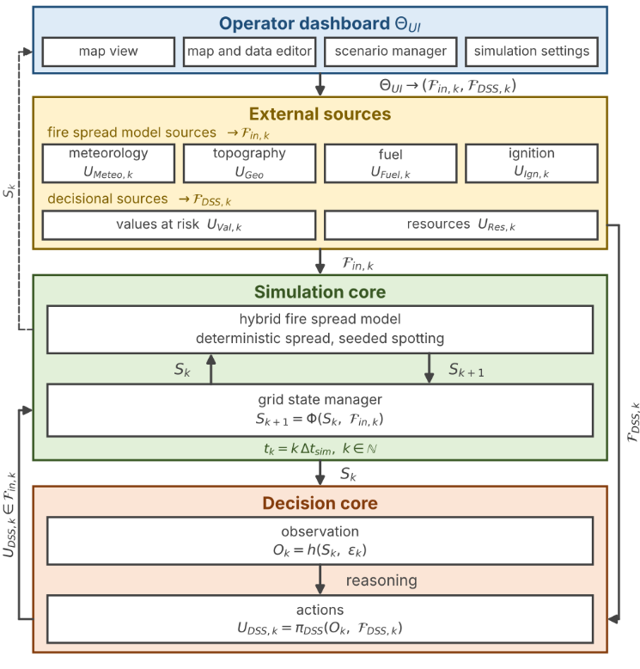
III. System Architecture
Fig. 1. The system architecture.

A. Two Cores and the Interface
Fig. 1 shows four blocks, namely simulation core, decision core, external sources, and operator dashboard. The external sources feed the meteorological, geographic, and fuel fields, and an operator edits the inputs through the dashboard $Θ_{UI}$ and never the state. The simulation core owns the state $S_{k}$ and advances it with the transition $Φ$, which takes the input set $F_{in,k}$ of (1) and returns $S_{k+1}=Φ\left(S_{k},F_{in,k}\right)$. The decision core reads an observation $O_{k}$ of the state together with the decisional set $F_{DSS,k}$ and returns the intervention field $U_{DSS,k}$, the only member of $F_{in,k}$ that it writes.
$$F_{in,k}=\left\{U_{Meteo,k}, U_{Geo}, U_{Fuel,k}, U_{Ign,k}, U_{DSS,k}\right\} \\ F_{DSS,k}=\{U_{Val,k}, U_{Res,k}\}$$ | (1)

In all equations, $k$ is the simulation step at $t_{k}=k Δt_{sim}$, and every field is defined per cell $\left(x,y\right)$ of the grid $G$. $U_{Meteo,k}$ holds the wind speed $W_{s,k}$ and direction $W_{d,k}$, air temperature, humidity, and precipitation. $U_{Geo}$ holds elevation, slope $G_{s}$, aspect $G_{a}$, and road access $G_{c}$. $U_{Fuel,k}$ holds the fuel type $F_{t}$ of a standard fuel model [42], the initial fuel load, and the dead fuel moisture $F_{m,k}$. $U_{Ign,k}∈\{0,1\}$ holds scenario ignitions. The decisional fields never enter $Φ$. $U_{Val,k}$ aggregates buildings, critical facilities, population, and evacuation access into a value at risk, and $U_{Res,k}$ describes the crews and water sources by the capacity $R_{c,k}$ an order can draw on a cell, its availability $R_{a,k}$, its effectiveness $R_{e,k}$, and its travel time $R_{t,k}$.
$$S_{k}→O_{k}=h\left(S_{k},ϵ_{k}\right)→U_{DSS,k}=π_{DSS}\left(O_{k},F_{DSS,k}\right) \\ →U_{DSS,k}⊂F_{in,k}→S_{k+1}=Φ\left(S_{k},F_{in,k}\right)$$  $$\left|ϵ_{k}\right|≤\left(1-γ_{k}\right) ϵ_{max}$$ | (2)

The two cores run the loop of (2) once per decision cycle. The observation function $h$ injects the epistemic uncertainty $ϵ_{k}$, bounded by the cell confidence $γ_{k}$ of Section IV as (2), so a confident cell is observed exactly and an unobserved one admits the worst case $ϵ_{max}$. The decision map $π_{DSS}$ of Section IV turns the observation and the decisional fields into $U_{DSS,k}$, which enters $F_{in,k}$ and acts on the state only through $Φ$. Since the decision core never reads the state directly, any hazard model that exposes its state through $h$ and accepts interventions through $F_{in,k}$ can take the place of the simulation core. The purpose-built core is seeded and replayed exactly from a snapshot of its random state, so the same incident runs with and without a decision mechanism and the difference is attributed to the mechanism alone. This is the basis of every paired comparison in Section V.

B. State, Transition, and Spread
The state is the collection of per-cell states (3). The burning status $B_{k}∈\{0,1\}$ marks whether the cell burns. The available fuel mass $F_{L,k}∈\left[0,1\right]$ is the fraction of the initial fuel load that remains. The intensity proxy $I_{k}$ is a bounded measure of fireline intensity, and the time since ignition $τ_{k}$ is the age of the fire in the cell. One step of $Φ$ updates the four components by (4) to (8), where $\left[⋅\right]$ is the Iverson bracket, equal to one when its condition holds.
$$S_{k}=\{s_{k}\left(x,y\right)\}_{\left(x,y\right)∈G}, s_{k}=\left(B_{k}, F_{L,k}, I_{k}, τ_{k}\right)$$ | (3)

Burning (4) is the maximum of four sources. It persists, $B^{pers}$, while the fuel exceeds the extinction load $ϵ_{L}$ and the moisture stays below the moisture of extinction $ϵ_{m}\left(F_{t}\right)$ of the fuel type [6]. It propagates, $B^{prop}$, when the neighbor impact $Ψ_{k}$ of (9) exceeds the threshold $Θ_{ign}$, the cellular rule of [23]. It starts by spotting, $B^{spot}$, when a seeded ember lands on fuel, and it starts on the injected ignition $U_{Ign,k}$.
$$B_{k+1}=\max\left\{B^{pers}, B^{prop}, B^{spot}, U_{Ign,k}\right\} \\ B^{pers}=B_{k} \left[F_{L,k}>ϵ_{L}\right] \left[F_{m,k}<ϵ_{m}\left(F_{t}\right)\right] \\ B^{prop}=\left[Ψ_{k}>Θ_{ign}\right] \\ B^{spot}=\left[\text{ember lands}\right] \left[F_{L,k}>ϵ_{L}\right]$$ | (4)

Fuel (5) falls through combustion by the fraction $F_{b,k}$ in burning cells and through the suppression term $F_{r,k}$ of (6). The map $f_{supp}$ follows the initial-attack productivity model of [43]. The fuel a crew removes per step grows with the fielded capacity $R_{c,k}⋅R_{a,k}$ and is discounted by the effectiveness $R_{e,k}$, which falls with the local intensity $I_{k}$, by the travel time $R_{t,k}$, and by the access $G_{c}$ of the cell. Hence, an order changes what the fire can burn and never the burning state.
$$F_{L,k+1}=max\{0, F_{L,k}-B_{k} F_{L,k} F_{b,k}-F_{r,k}\}$$ | (5)
$$F_{r,k}=f_{supp}\left(R_{c,k}, R_{a,k}, R_{e,k}, R_{t,k}, G_{c}\right)$$ | (6)

The intensity proxy (7) is a bounded map $f_{int}$ of fuel, wind speed, and slope after Byram [44] as parameterized in [6], and it is zero in a cell that does not burn.
$$I_{k+1}=B_{k+1} f_{int}\left(F_{L,k}, W_{s,k}, G_{s}\right)$$ | (7)

The ignition clock (8) counts active burning. It restarts when a cell ignites, grows by $Δt_{sim}$ while the cell keeps burning, and returns to zero when the cell burns out.
$$τ_{k+1}=\left\{\begin{matrix}0 & B_{k+1}=1∧B_{k}=0 \\ τ_{k}+Δt_{sim} & B_{k+1}=1∧B_{k}=1 \\ 0 & B_{k+1}=0\end{matrix}\right.$$ | (8)
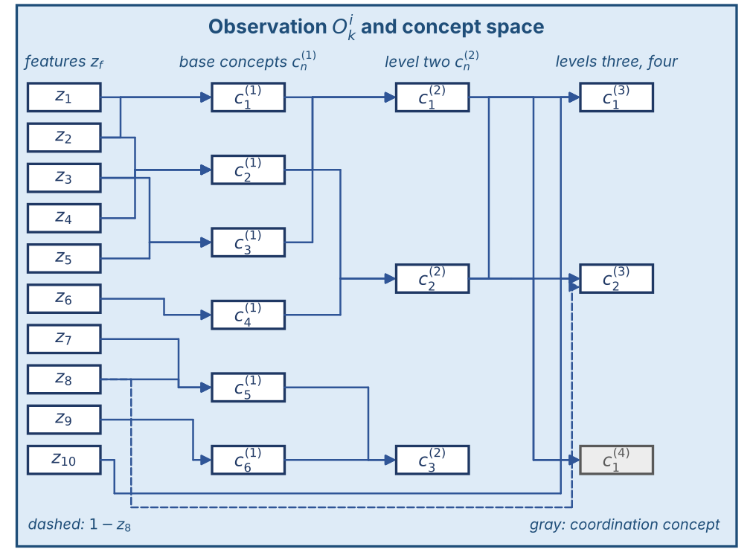
Fig. 2. The concept space of one agent.
Propagation (9) is anisotropic. Each burning neighbor $\left(i,j\right)$ in the eight-neighborhood $N_{8}$ contributes its rate of spread $ν_{k}$ weighted by the cosine of the angle between the wind direction $W_{d,k}$ and the direction $φ_{ij}$ to the target cell. The rate of spread $ν_{k}$ is the Rothermel map $f_{ros}$ [6] of (10) over wind, slope, aspect, moisture, and fuel type. The front advances in substeps, so spread never exceeds one cell per substep. Spotting is the only stochastic element and is driven by the seeded random stream. Precipitation raises $F_{m,k}$ toward $ϵ_{m}$ with a time constant, so a front dies out gradually.
$$Ψ_{k}=\frac{1}{8}\sum_{\left(i,j\right)∈N_{8}}{B_{k}}\left(i,j\right) ν_{k}\left(i,j\right) g_{k}\left(i,j\right) \\ g_{k}\left(i,j\right)=max\{0, cos\left(W_{d,k}\left(i,j\right)-φ_{ij}\right)\}$$ | (9)
$$ν_{k}=f_{ros}\left(W_{s,k}, W_{d,k}, G_{s}, G_{a}, F_{m,k}, F_{t}\right)$$ | (10)

IV. The Decision Core
The decision core runs as $N$ regional agents over a partition of the grid into regions $G_{i}$. Agent $i$ reads the observation $O_{k}^{i}$ and returns an intervention candidate $U_{DSS,k}^{i}$, which the global coordinator merges into $U_{DSS,k}$. The path of one agent has four stages, namely feature extraction, the concept space, the closed decision layer, and the open decision layer.

A. Sources, Features, and Confidence
The sources are weather stations and forecasts, satellite and airborne imagery, terrain and fuel maps, road networks, resource status, asset and population layers, and field reports. The agent reduces them to ten features in the unit interval (11), namely fire intensity $z_{1}$, spread potential $z_{2}$, weather severity $z_{3}$, ignition proximity $z_{4}$, fuel load $z_{5}$, asset exposure $z_{6}$, resource accessibility $z_{7}$, access and road status $z_{8}$, suppression availability $z_{9}$, and temporal urgency $z_{10}$. Every cell carries a confidence composed from observability, coverage, freshness, and reliability by their minimum (12). The state is under-observed rather than noisy [19]. Bayesian or Dempster-Shafer treatments presuppose distributional knowledge that real-time sensing lacks [20].
$$z_{f,k}^{i}=ξ_{f}\left(O_{k}^{i}\right)∈\left[0,1\right], f=1,…,10$$ | (11)
$$γ_{k}=min\{γ_{obs}, γ_{cov}, γ_{fre}, γ_{rel}\}$$ | (12)

In (11), $ξ_{f}$ is the extraction map of feature $f$. In (12), $γ_{obs}$ is observability, $γ_{cov}$ sensor coverage, $γ_{fre}$ freshness, and $γ_{rel}$ source reliability.

B. Concept Space
Fig. 2 shows the path from the sources to the five decision concepts. Each feature is fuzzified over a 5-term partition of unity. The concept space composes the features into 6 base concepts, the base concepts into 5 decision concepts on 2 levels, and 2 of these into one coordination concept, with the sets of (13). An activation is a normalized weighted sum of the memberships or activations below it (14). Raw activations are never consumed. Each is gated by its confidence and blended with a persistence-carried prior (15), so a lost observation decays geometrically and the activation snaps back when confidence returns. The 5 decision concepts, fire threat level $c_{1}^{\left(2\right)}$, asset exposure risk $c_{2}^{\left(2\right)}$, suppression feasibility $c_{3}^{\left(2\right)}$, intervention urgency $c_{1}^{\left(3\right)}$, and evacuation pressure $c_{2}^{\left(3\right)}$, are the only variables over which rules are written.
$$C_{1}^{\left(1\right)}=\left\{z_{1},z_{2}\right\},C_{2}^{\left(1\right)}=\left\{z_{2},z_{3},z_{4}\right\}, \\ C_{3}^{\left(1\right)}=\left\{z_{3},z_{5}\right\},C_{4}^{\left(1\right)}=\left\{z_{6}\right\},C_{5}^{\left(1\right)}=\left\{z_{7},z_{8}\right\}, \\ C_{6}^{\left(1\right)}=\left\{z_{9}\right\} \\ C_{1}^{\left(2\right)}=\left\{c_{1}^{\left(1\right)},c_{2}^{\left(1\right)},c_{3}^{\left(1\right)}\right\},C_{2}^{\left(2\right)}=\left\{c_{2}^{\left(1\right)},c_{4}^{\left(1\right)}\right\},C_{3}^{\left(2\right)}=\left\{c_{5}^{\left(1\right)},c_{6}^{\left(1\right)}\right\} \\ C_{1}^{\left(3\right)}=\left\{c_{1}^{\left(2\right)},c_{2}^{\left(2\right)},z_{10}\right\},C_{2}^{\left(3\right)}=\left\{c_{2}^{\left(2\right)},1-z_{8},z_{10}\right\}, \\ C_{1}^{\left(4\right)}=\{c_{1}^{\left(2\right)},c_{2}^{\left(2\right)}\}$$ | (13)
$$a_{n,k}^{\left(1\right)}=\sum_{f∈C_{n}^{\left(1\right)}}{ω_{n,f}} μ_{A_{n,f}}\left(z_{f,k}\right) \\ a_{n,k}^{\left(l\right)}=\sum_{m∈C_{n}^{\left(l\right)}}{ω_{n,m}^{\left(l\right)}} a_{m,k}^{\left(l-1\right)}, ∑ω=1$$ | (14)
$$a_{n,k}^{eff}=γ_{n,k} a_{n,k}^{obs}+\left(1-γ_{n,k}\right) ρ a_{n,k-1}^{eff} \\ γ_{n,k}=\min_{f∈C_{n}}γ_{f,k}$$ | (15)

In (13), $C_{n}^{\left(l\right)}$ is the input set of concept $n$ at level $l$, and $c_{1}^{\left(1\right)}$ to $c_{6}^{\left(1\right)}$ are fire severity, spread hazard, fuel hazard, asset value, crew reachability, and logistics support; $c_{1}^{\left(4\right)}$ is the operational priority used only by the coordinator. In (14), $a$ is an activation, $ω$ a nonnegative weight, and $μ_{A}$ a term membership. In (15), $a^{obs}$ is the observed activation, $a^{eff}$ the gated one that rules consume, and $ρ∈[0,1)$ the persistence decay.

C. The Closed Decision Layer
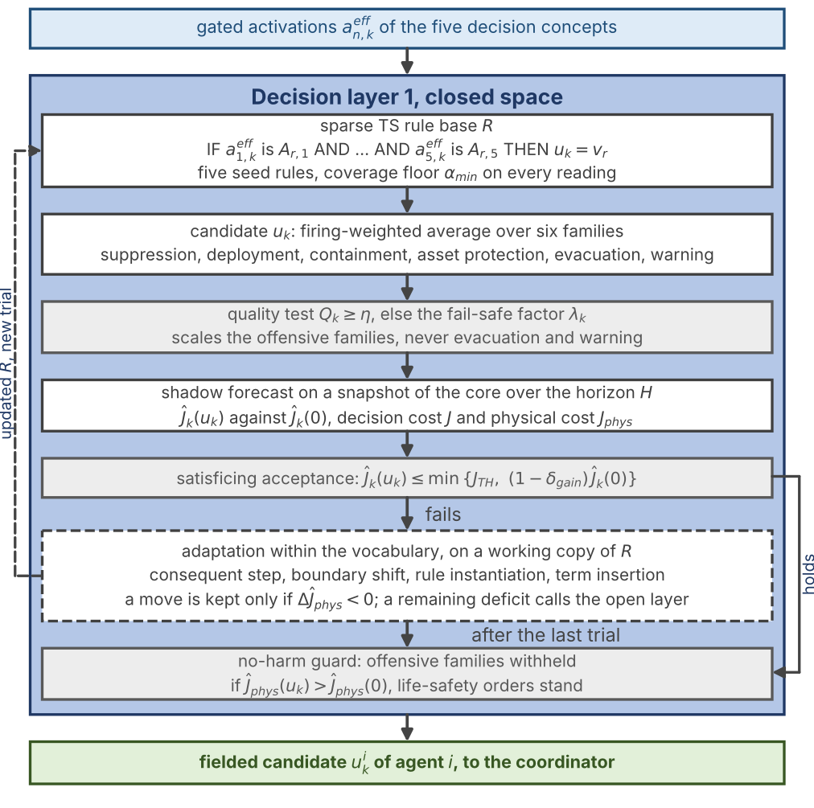
Fig. 4. The closed decision layer of one agent.
Fig. 3 gives the closed layer. Rules have the conjunctive TS form of (16) with constant consequents over six intervention families, namely suppression effort, resource deployment, containment line, asset protection, evacuation, and public warning. Inaction is the zero point of every family. A rule fires with its weakest clause, and the candidate is the firing-weighted average of (17), floored at one so a weakly supported conclusion gives a weak order. The base is sparse. It starts from five seed rules and must satisfy the coverage condition (18) on every reachable reading.
$$R_{r}: \text{IF }a_{1,k}^{eff}\text{ is }A_{r,1} \text{AND} ⋯ \text{AND} a_{5,k}^{eff}\text{ is }A_{r,5} \text{THEN} u_{k}=v_{r}$$ | (16)
um,k=r​μr,k vr,mmax1,r​μr,k, μr,k=minn∈antrμAr,nan,keff | (17)
$$\min_{a^{eff}∈{\left[0,1\right]}^{5}} \max_{r} μ_{r}\left(a^{eff}\right) ≥ α_{min}=0.05$$ | (18)

In (16) to (18), $R_{r}$ is rule $r$, $A_{r,n}$ the term it requires of concept $n$, $v_{r}$ its consequent vector, $u_{m,k}$ the ordered intensity of family $m$, $μ_{r,k}$ the firing strength, $ant\left(r\right)$ the set of concepts the rule tests, and $α_{min}$ the coverage floor.
Every candidate is judged on a shadow copy of the simulation core over a horizon $H$ before anything reaches the field. The decision cost is the weighted sum of (19) over the five terms of (20), with weights 1, 1, 1, 0.2, 0.2. The first three form the physical cost $J_{phys}$ that every cross-configuration comparison reads, because a run that never intervenes carries no response cost. Acceptance is satisficing, as in (21). The bound is the tighter of a fixed ceiling and a required gain over inaction. A quality test (22) compares each scored concept with the strongest intensity the candidate assigns to the family that answers it. Below the threshold $η$ the graduated fail-safe scales the offensive families by $λ$ and never touches evacuation and warning.
J=j​wjJjj​wj, j∈{burn,asset,pop,resp,delay}, Jphys=13Jburn+Jasset+Jpop | (19)
$$J_{burn}=\frac{x}{1+x}, x=\frac{N_{burned}}{ρ_{burn}N_{burnable}}, J_{asset}=\frac{V_{lost}}{V_{total}}, J_{pop}=min\left\{1,\frac{P_{steps}}{P_{total}N_{dec}}\right\}J_{resp}=min\left\{1,\frac{C_{steps}}{C_{ref}N_{dec}}\right\}, J_{delay}=min\left\{1,\frac{τ_{disp}}{τ_{ref}}\right\}$$ | (20)
$${\hat{J}}_{k}\left(U_{DSS,k}\right) ≤ min\left\{J_{TH}, \left(1-δ_{gain}\right) {\hat{J}}_{k}\left(0\right)\right\}, δ_{gain}=0.05$$ | (21)
Qk=1-14n∈CQ​|an,keff-maxf∈Fnuf,k|, λk=min{1, Qk/η} | (22)

In (20), $N_{burned}$ and $N_{burnable}$ count burned and burnable cells with $ρ_{burn}=0.05$ the reference fraction, $V_{lost}$ and $V_{total}$ are lost and exposed asset value, $P_{steps}$ the person-steps inside burning cells, $P_{total}$ the population at risk, $N_{dec}$ the decision steps of the horizon, $C_{steps}$ the fielded capacity summed over steps, $C_{ref}$ the reference capacity, $τ_{disp}$ the capacity-weighted dispatch time, and $τ_{ref}$ a sixty-minute reference. In (21), ${\hat{J}}_{k}\left(⋅\right)$ is the forecast cost, $J_{TH}$ the ceiling, and ${\hat{J}}_{k}\left(0\right)$ the no-action forecast. In (22), $C_{Q}$ holds the four scored concepts, $F\left(n\right)$ the families that answer concept $n$, and $λ_{k}$ the fail-safe factor.
When the standing decision falls short, the layer adapts within its vocabulary, in the evolving fuzzy tradition [26]. The consequent step and the boundary shift of (23) act on rules already in the base. Rule instantiation writes a rule on the uncovered combination of the two most active concepts (24), and term insertion refines an ambiguous reading (25). Every move is a trial on a working copy and is kept only when the forecast physical cost strictly falls (26). Algorithm 1 gives one decision cycle.
$$v_{r,m}←{clip}_{\left[0,1\right]}\left(v_{r,m}±δ\right)\left(a_{A},b_{A}\right)←\left(a_{A}-δ, b_{A}-δ\right), \left(c_{A^{-}},d_{A^{-}}\right)←\left(c_{A^{-}}-δ, d_{A^{-}}-δ\right)$$ | (23)
$$A_{new}=\left\{\left(c^{\left(1\right)},t_{c^{\left(1\right)}}^{*}\right), \left(c^{\left(2\right)},t_{c^{\left(2\right)}}^{*}\right)\right\}, t_{c}^{*}=arg\max_{t∈T_{c}}μ_{t}\left(a_{c}^{eff}\right)$$ | (24)
$$\max_{t∈T_{c^{\left(1\right)}}}μ_{t}\left(a_{c^{\left(1\right)}}^{eff}\right)<0.62 ⇒T_{c^{\left(1\right)}}←T_{c^{\left(1\right)}}∪trap\left(x-0.12, x-0.05, x+0.05, x+0.12\right), x=a_{c^{\left(1\right)}}^{eff}$$ | (25)
$$\text{kept}⇔Δ{\hat{J}}_{phys}<0$$ | (26)

In (23), $δ=0.05$ is the step, and $\left(a_{A},b_{A},c_{A},d_{A}\right)$ are the trapezoid corners of term $A$, whose rising edge coincides with the falling edge of its left neighbor $A^{-}$, so the partition of unity is preserved. In (24), $c^{\left(1\right)}$ and $c^{\left(2\right)}$ are the two most active concepts, $T_{c}$ the term set of concept $c$, and $t_{c}^{*}$ its dominant term. In (25), $trap\left(⋅\right)$ is a narrow trapezoid centered on the crisp reading $x$.
Algorithm 1 Closed layer, one decision cycle of agent $i$
1: Input: observation $O_{k}^{i}$, rule base $R$, snapshot of the core, threshold $η$
2: features $z$ and confidences $γ$ by (11), (12); activations $a^{eff}$ by (14), (15)
3: fire $R$; candidate $u_{k}$ by (17)
4: shadow forecasts over $H$ from the snapshot: ${\hat{J}}_{k}\left(u_{k}\right)$ and ${\hat{J}}_{k}\left(0\right)$
5: if $Q_{k}<η$ by (22) then scale the offensive families of $u_{k}$ by $λ_{k}$
6: if (21) fails then
7: for $t=1$ to $T_{max}$ do
8: pick a move from (23), (24), (25) on a working copy of $R$; forecast
9: if (26) then commit the move else roll back
10: if a deficit remains then call Algorithm 2
11: if ${\hat{J}}_{phys}\left(u_{k}\right)>{\hat{J}}_{phys}\left(0\right)$ then withhold the offensive families of $u_{k}$ (no-harm)
12: Output: fielded candidate $u_{k}$, updated $R$

D. The Open Decision Layer
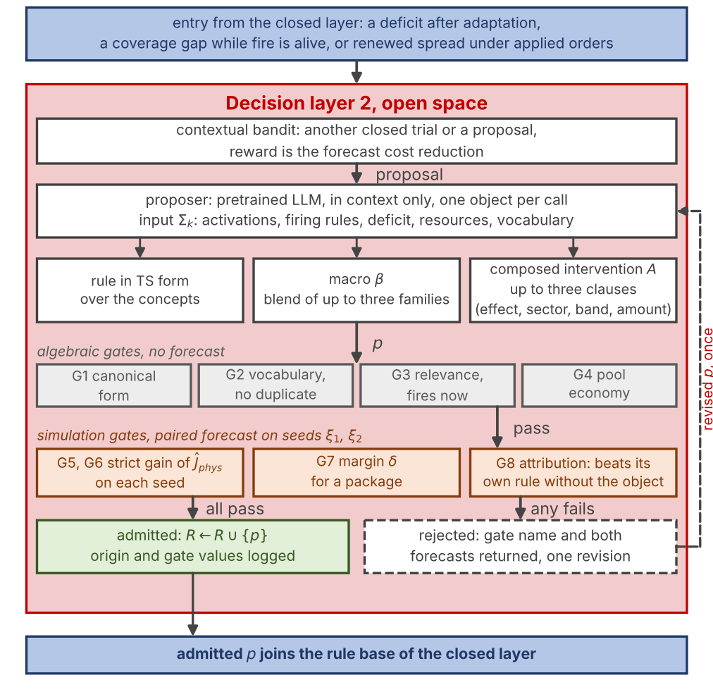
Fig. 5. The open decision layer of one agent. Algebraic gates reject without a forecast; simulation gates compare the forecast with and without $p$ on two seeds.
Fig. 4 gives the open layer. It is entered when tuning and instantiation leave a deficit, when a coverage gap opens while fire is alive, or when spread renews under applied orders. A contextual bandit [32] chooses between another closed trial and a proposal, as in (27), with the forecast cost reduction as reward. The proposer is a pretrained LLM used in context only. It receives the gated activations, the firing rules, the deficit, the resource state, and the vocabulary of effects, sectors, and bands, and it returns one object. The object is a plain rule in the form of (16), a macro that blends up to three families (28), or a composed intervention of up to three clauses over seven verified effects and seven sectors (29). The band geometry (30) and the idempotent operators (31) resolve a clause on the engine fields. Hence, the space is open at interventions and closed at effects.
$$q_{k}=arg\max_{q∈A\left(e_{k}\right)}H\left(e_{k},q\right) \text{with probability }1-ϵ_{b}H\left(e_{k},q_{k}\right)←H\left(e_{k},q_{k}\right)+α_{b}\left(r_{k}-H\left(e_{k},q_{k}\right)\right)$$ | (27)
$$β=\{\left(b_{j},β_{j}\right)\}_{j≤3}, \left(β,v\right)↦\left(b_{j}, β_{j}v\right)$$ | (28)
$$A=\{\left(e,s,\left[ρ_{in},ρ_{out}\right],α\right)\}_{≤3}, e∈\{wet,clear,ignite,coat,draft,evacuate,prime\}s∈\{head,flank,rear,ring,at_fire,assets,populated\}$$ | (29)
$$B\left(C,ρ_{in},ρ_{out}\right)=D_{ρ_{out}}\left(C\right)\backslash D_{ρ_{in}-1}\left(C\right), κ\left(x\right)=\frac{\left(x-c_{F}\right)⋅w}{∥x-c_{F}∥}$$ | (30)
$$a={clip}_{\left[0,1\right]}\left(αu\right), r_{ret}^{M}←max\left(r_{ret}^{M},a\right)r_{cap}^{M}←min\left(r_{cap}^{M} \left(1+β_{w}\left(d_{w}\right)\right), 1.5 c_{max}\right)$$ | (31)

In (27), $e_{k}$ is the context (deficit band and coverage flag), $q$ a stage, $A\left(e_{k}\right)$ the allowed stages, $H$ the value table, $r_{k}$ the reward, $α_{b}=0.05$ the step, and $ϵ_{b}=0.10$ the exploration rate. In (28), $b_{j}$ is a family and $β_{j}$ its weight. In (29), $e$ is an effect, $s$ a sector, $\left[ρ_{in},ρ_{out}\right]$ a distance band in cells, and $α$ an amount. In (30), $D_{ρ}\left(C\right)$ is the set of cells within four-neighbor distance $ρ$ of the core $C$ of the sector, $c_{F}$ the fire centroid, $w$ the mean wind, and $κ$ the cosine that splits head, flank, and rear. In (31), $u$ is the firing intensity of the rule, $r_{ret}^{M}$ and $r_{cap}^{M}$ the retardant and capacity fields on the mask $M$, $β_{w}\left(d_{w}\right)$ the drafting gain at water distance $d_{w}$, and $c_{max}$ the capacity cap.
Every proposal is untrusted by construction and passes the gate chain of Fig. 4. G1 to G4 are algebraic and cost no simulation step. They check canonical form, vocabulary and duplication, relevance, which means that the rule fires on the current reading, and pool economy. G5 to G8 are simulation gates, as in (32) and (33). They demand a strict forecast gain on two independently seeded futures, a margin $δ$ for a package, and attribution, which means that the package beats its own rule stripped of the new object. A rejection returns the gate name and both forecasts, and the proposer may revise once. Algorithm 2 gives the loop.
$$\text{G5: }{\hat{J}}_{phys}^{ξ_{1}}\left(R∪\{p\}\right)<{\hat{J}}_{phys}^{ξ_{1}}\left(R\right)\text{G6: }{\hat{J}}_{phys}^{ξ_{2}}\left(R∪\{p\}\right)<{\hat{J}}_{phys}^{ξ_{2}}\left(R\right)$$ | (32)
$$\text{G7: }\hat{J}\left(R∪\{p\}\right)-\hat{J}\left(R\right)≤-δ\text{G8: }\hat{J}\left(R∪\{r_{A}\}\right)<\hat{J}\left(R∪\{r\backslash A\}\right)$$ | (33)

In (32) and (33), $p$ is the proposal, $R$ the current base, $ξ_{1}$ and $ξ_{2}$ the two seeds, $r_{A}$ the rule carrying the new object $A$, and $r\backslash A$ the same rule without it.
Algorithm 2 Open layer, proposal and admission
1: Input: situation summary $Σ_{k}$ (activations, firing rules, deficit, resources, vocabulary), rule base $R$, seeds $ξ_{1}$, $ξ_{2}$
2: $p←LLM\left(Σ_{k}\right)$; $n←0$
3: repeat
4: for $g$ in G1, G2, G3, G4 do if $p$ fails $g$ then go to step 8
5: forecast $R$ and $R∪\{p\}$ on $ξ_{1}$ and $ξ_{2}$; test (32)
6: if $p$ is a package then test (33)
7: if all gates pass then $R←R∪\{p\}$; log origin and gate values; return admitted
8: if $n=0$ then send the gate name and both forecasts to the LLM; $p←$ revision; $n←1$ else return rejected
9: until $n>1$

E. Local Agents and Global Coordination
$N$ agents run Algorithms 1 and 2 over their own regions. The coordinator performs no inference. Each agent sends up its operational priority $p_{i}$, its resource request, and a confidence summary, and it receives the allocation, the priority weights, and the acceptance thresholds in force. Regions are ranked by priority and receive the attention share $σ_{i}$ of (34), which scales only the offensive families. A monitored region also faces a stricter quality threshold. The merged field of (35) is forecast by the no-harm guard against inaction. When the plan is worse, the offensive orders are withheld while the life-safety orders stand.
$$σ_{i}=\left\{\begin{matrix}1 & p_{i}≥τ_{att} p_{max} \\ 0.5+0.5 p_{i}/p_{max} & \text{otherwise}\end{matrix}\right., τ_{att}=0.35$$ | (34)
$$U_{DSS,k}=A_{DSS}\left(\{σ_{i} U_{DSS,k}^{i}\}_{i=1}^{N}\right){\hat{J}}_{phys}\left(U_{DSS,k}\right)>{\hat{J}}_{phys}\left(0\right) ⇒ \text{offensive families withheld}$$ | (35)

In (34), $p_{i}$ is the operational priority $c_{1}^{\left(4\right)}$ of region $i$, $p_{max}$ the highest priority, and $τ_{att}$ the attention threshold. In (35), $A_{DSS}$ merges the scaled regional fields into one intervention field.
The gates give the architecture four properties that hold whatever produced the candidate, because they are properties of the acceptance function and not of the proposer. Proposition 1 (no-harm). No order reaches the field whose forecast physical cost exceeds the no-action forecast over the guard horizon. Proposition 2 (life-safety invariance). Evacuation and warning intensities are never reduced by any gate, since neither the fail-safe nor the no-harm rule has the two families in its domain, and a proposal that lowers them fails G2. Proposition 3 (coverage). At every reachable reading either some rule fires above the coverage floor of (18), or the layer falls back to the watchful posture and triggers adaptation. Proposition 4 (monotone descent). Along any sequence of admissions the forecast physical cost on the first seed decreases by at least $δ$ per admitted package, so the number of admissions in one incident is bounded and the extension halts once no proposal clears the gates. A fifth property is probabilistic. A proposal whose true effect is zero or harmful passes G5 and G6 with probability at most $q^{2}$, where $q$ is the probability that one shadow forecast reports a gain by chance. Section V-E reports how often admitted objects paid off in the realized outcome.

V. Results

A. Evaluation Criteria and Validation of the Simulation Core
Eight criteria fixed in advance are audited at the end of this section, namely predictive fidelity, decision quality, timeliness, robustness, uncertainty handling, adaptability, explainability, and scalability, listed in Table I. Predictive fidelity is tested by blind hindcast. The simulation core receives only the real inputs of a documented fire, with no tuning on that fire. Its output is compared with the satellite record. Terrain comes from Copernicus GLO-30, fuel from ESA WorldCover 2021, weather from ERA5 reanalysis, and ignition points and reference burn from NASA FIRMS VIIRS detections. Four documented fires in Türkiye cover different fuel, terrain, and wind conditions, namely Sc1 Manavgat and Sc2 Marmaris (July 2021, 48 h), Sc3 Milas-Kemerköy (August 2021, 72 h), and Sc4 Çanakkale-Kayadere (August 2023, 48 h). The core models free spread without suppression. Hence, a free run overpredicts the final area, and three suppression-robust criteria are used. The first is the probability of detection, accepted at 0.70 for calibrated growth models [23]. The second is the front position error relative to the equivalent burn radius. The third is the arrival-time agreement, the direct rate-of-spread test. Table II reports the metrics over 50 replicates and Fig. 5 the agreement maps. Overall agreement is 86 to 94 percent and detection probability 85 to 97 percent.
TABLE I
Evaluation criteria and their measurement
Criterion | Measurement
Predictive fidelity | Blind hindcasts against historical fires; front and arrival-time agreement
Decision quality | Paired outcome differences against no action and reference doctrines on identical worlds
Timeliness | Decision-cycle wall time; time to first order
Robustness | Outcome under observation outage and noise
Uncertainty handling | Confidence propagation into every decision
Adaptability | Objects admitted; recurrence across independent worlds
Explainability | Trace completeness of every order, edit, and rejection
Scalability | Cost against agent count, horizon, and grid size

TABLE II
Hindcast agreement per historical fire (50 replicates)
Metric | Sc1 | Sc2 | Sc3 | Sc4
Front distance (m) | 329 | 305 | 113 | 391
Arrival-time MAE (h) | 1.46 | 1.39 | 4.04 | 2.58
Front agreement | 82 % | 90 % | 89 % | 89 %
Time agreement | 90 % | 98 % | 71 % | 96 %
Probability of detection | 92 % | 93 % | 97 % | 85 %
Overall agreement | 88 % | 94 % | 86 % | 90 %

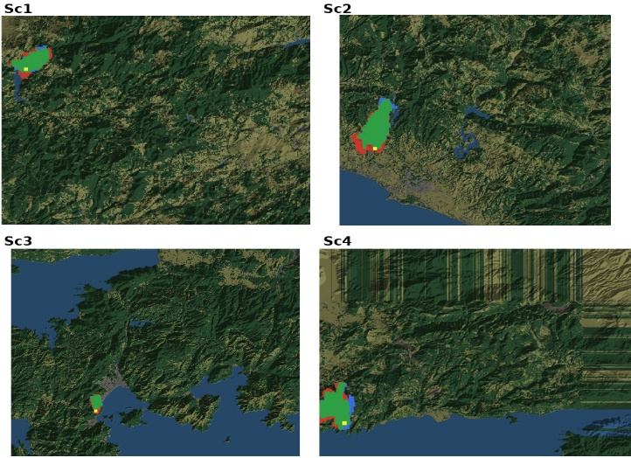
Fig. 6. Hindcast agreement maps for the four historical fires (green, predicted burn; red, satellite reference; dark, overlap).

B. Experimental Design
Synthetic scenarios use 72 by 50 cell grids at 30 m with terrain, land cover, settlements, roads, and capacity-limited bases. The engine runs with a two-minute physical step, a twelve-minute decision cycle, a 24-minute planning horizon, a satisficing bound of 0.35, and a quality gate of 0.60. Episodes run to extinction or to a twelve-hour cap, under critical fire weather (fuel moisture 0.08, wind 8 m/s). Five scenario families span remote forest and the wildland-urban interface under sufficient and limited resources, listed in Table III. The fifth repeats the hardest interface family under degraded observation, with an outage probability of 0.25 and observation noise of 0.10. Each family is generated 30 times from seeds 201 to 230. Every world is replayed identically by three configurations. T0 issues no orders and fixes the cost of inaction. L1 runs the closed layer alone, the five seed rules with their self-tuning. VODA is the full architecture, the closed layer with the open layer on top and the LLM proposer behind the full gate chain. The static seed base without any adaptation (F5) is run as a fourth reference. It is reported where it separates the contribution of the rule-based core from that of adaptation. Terrain, ignitions, weather, and the random stream are shared. Therefore, differences between configurations arise from the issued orders alone. In total there are 600 runs. Outcome is read at the end of the episode on burned area, affected population, the share of incidents extinguished within the episode, and the physical and total cost. Paired statistics report the mean difference on the same worlds with its 95 percent half-width and the number of worlds in which the first configuration is better.
TABLE III
Scenario families (72 × 50 cells at 30 m, 30 paired worlds each)
Family | Landscape | Pool | Ignitions | Observation
S1 | mountain forest, 2 settlements | full | 1, remote | full
S2 | mountain forest, 2 settlements | 0.6 | 2, remote | full
S3 | rolling interface, 12 settlements | full | 1, near interface | full
S4 | rolling interface, 12 settlements | 0.6 | 2, near interface | full
S5 | as S4 | 0.6 | 2, near interface | outage 0.25, noise 0.10

Sensitivity of the closed layer to its parameters was assessed one parameter at a time over five worlds, 880 runs in total. Observation quality decides light fire loads, and resources decide heavy ones. The satisficing bound sets how often adaptation engages, 42 percent of cycles at 0.35.

C. Outcome: No Decision Support, Closed Layer, VODA
Table IV and Fig. 6 report the outcome per family. Free burn consumes 250.7 ha on average and affects 5793 persons. The rule-based core alone changes this most. The static seed base lowers the burned area to 80.9 ha (paired saving 169.7 ± 10.3 ha, better in all 150 worlds) and the affected population to 494. This gain belongs to the doctrine, not to adaptation. The self-tuning of the closed layer changes the character of the response more than its extent. The share of incidents extinguished within the episode rises from 13 to 52 percent, and the delay term falls from 0.347 to 0.274, since tuned consequents commit the same resources sooner. However, the burned area moves only to 75.4 ha. This is a paired difference of 5.5 ± 7.0 ha that does not separate from zero (better in 73 of 150 worlds). In other words, tuning five rules finishes the fires the doctrine already holds. It does not reach the fires the doctrine does not hold.
TABLE IV
Outcome per scenario family and configuration at the end of the episode (mean over 30 paired worlds; ± is the 95 percent half-width)
Measure | No DSS | Closed layer | VODA
S1 burned area (ha) | 269.3 ± 4.5 | 67.9 ± 24.4 | 36.7 ± 19.1
S2 burned area (ha) | 269.6 ± 4.5 | 184.2 ± 25.9 | 120.6 ± 29.6
S3 burned area (ha) | 233.5 ± 9.8 | 24.1 ± 8.0 | 14.1 ± 5.9
S4 burned area (ha) | 240.5 ± 9.6 | 50.9 ± 10.7 | 27.2 ± 8.7
S5 burned area (ha) | 240.5 ± 9.6 | 49.9 ± 10.0 | 29.2 ± 7.7
Mean burned area (ha) | 250.7 | 75.4 | 45.6
Extinguished within episode | 0 % | 52 % | 75 %
Affected population (persons) | 5793 | 391 | 117
Mean J_phys | 0.598 | 0.139 | 0.081
Mean J_total | (0.528) | 0.164 | 0.110
Mean J_resp | - | 0.428 | 0.308

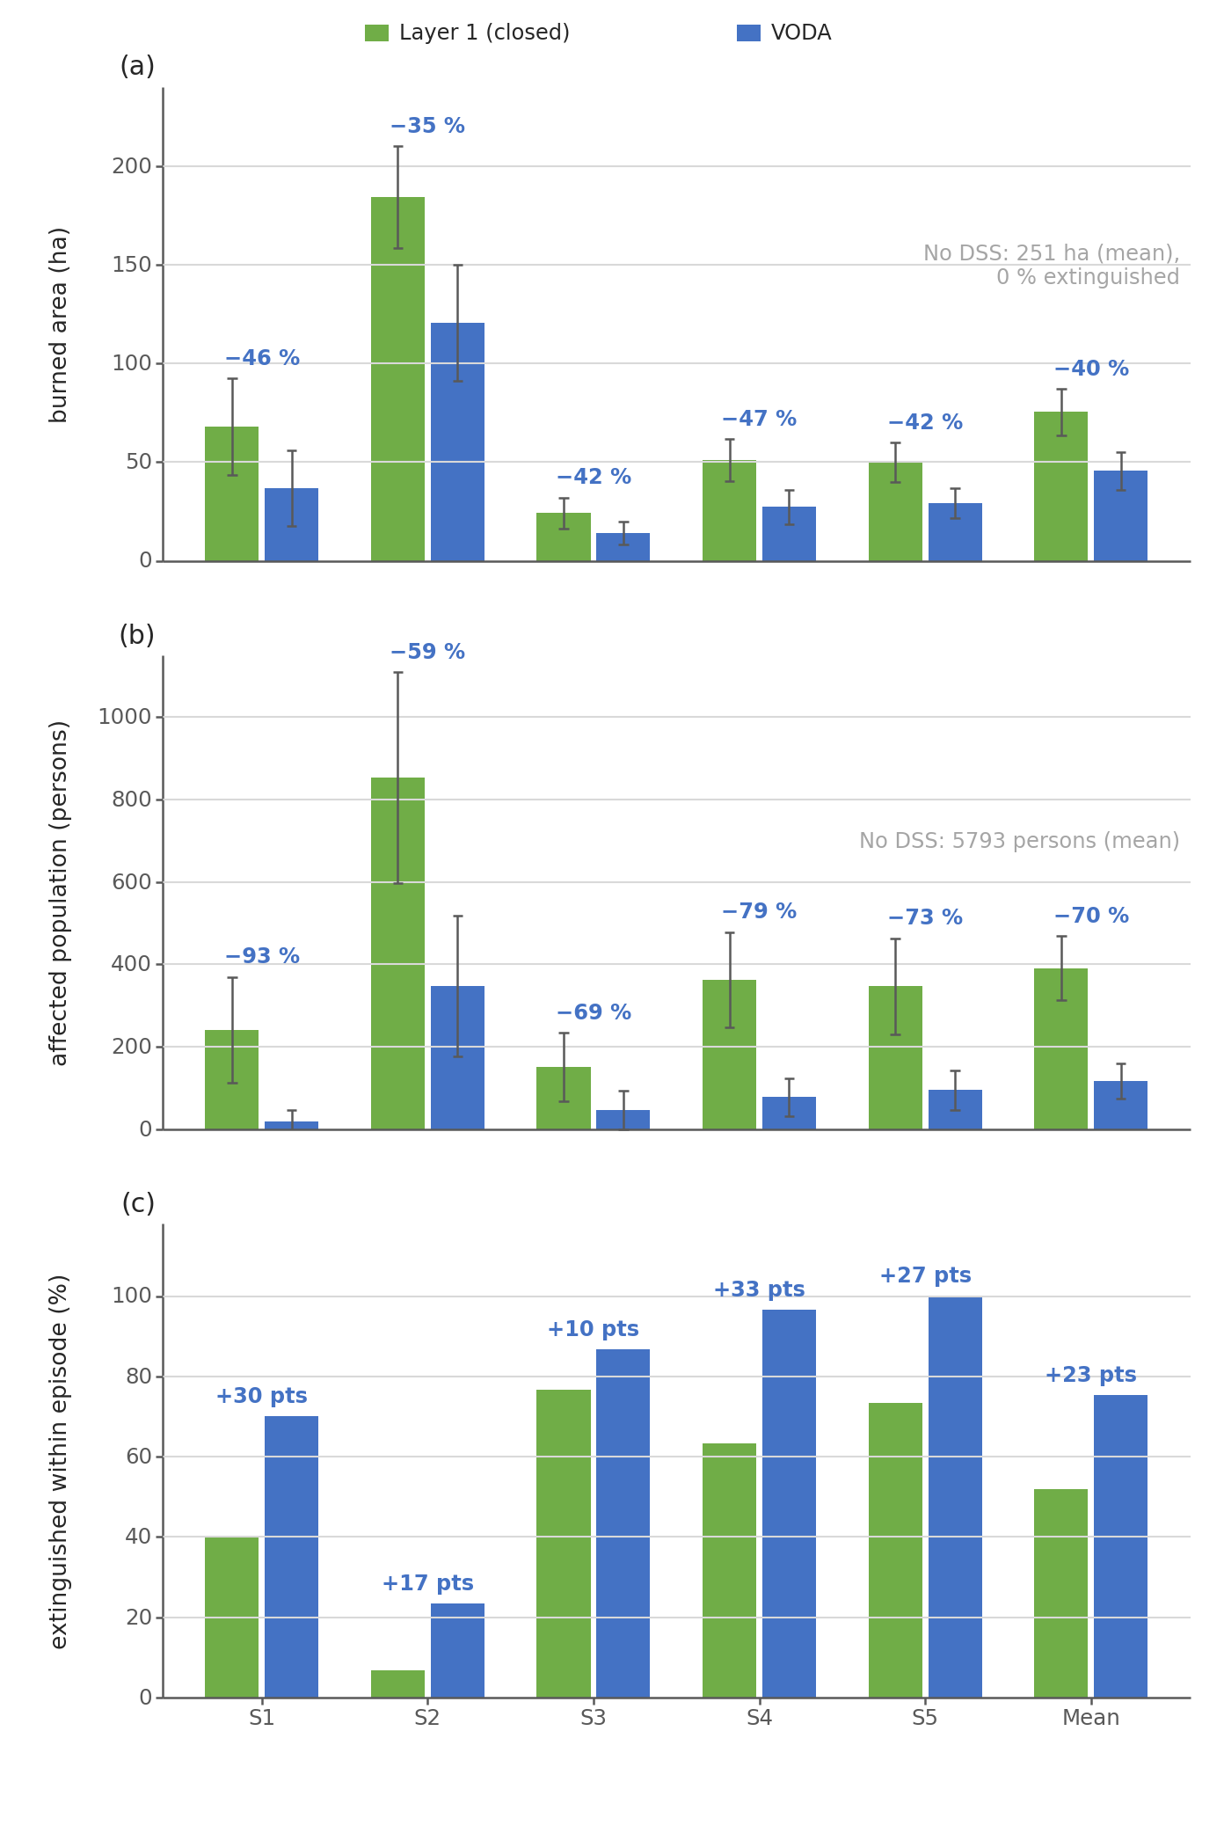
Fig. 7. Outcome at episode end per scenario family for the closed layer alone and for VODA, 30 paired worlds per family: (a) burned area with 95 percent confidence intervals, (b) affected population, (c) share of incidents extinguished within the episode. Labels give the change of VODA against the closed layer; the free-burn reference is printed in each panel.
VODA does. Against the closed layer on the same worlds it burns 29.9 ± 7.2 ha less and is better in 128 of 150 worlds, as shown in Fig. 7. There are 13 ties on small fires the doctrine already contained and nine worlds in which it burned more. It raises the share extinguished to 75 percent. It lowers the affected population to 117 persons (274 ± 61 fewer per world, 70 percent below the closed layer). Moreover, it reaches the lowest physical cost (0.081 against 0.139) and the lowest total cost (0.110 against 0.164) of the configurations. The gain is largest where the doctrine is weakest. In the forest family with a reduced pool and two ignitions (S2) the paired difference is 63.6 ± 27.6 ha. In the interface families with two ignitions (S4, S5) VODA burns less in 30 and 29 of 30 worlds and extinguishes 97 and 100 percent of the incidents. Under degraded observation (S5) its burned area moves from 27.2 to 29.2 ha. This is a change of 7 percent inside the confidence interval of either cell, and the configuration remains the best. Hence, reduced observation degrades the response instead of breaking it.
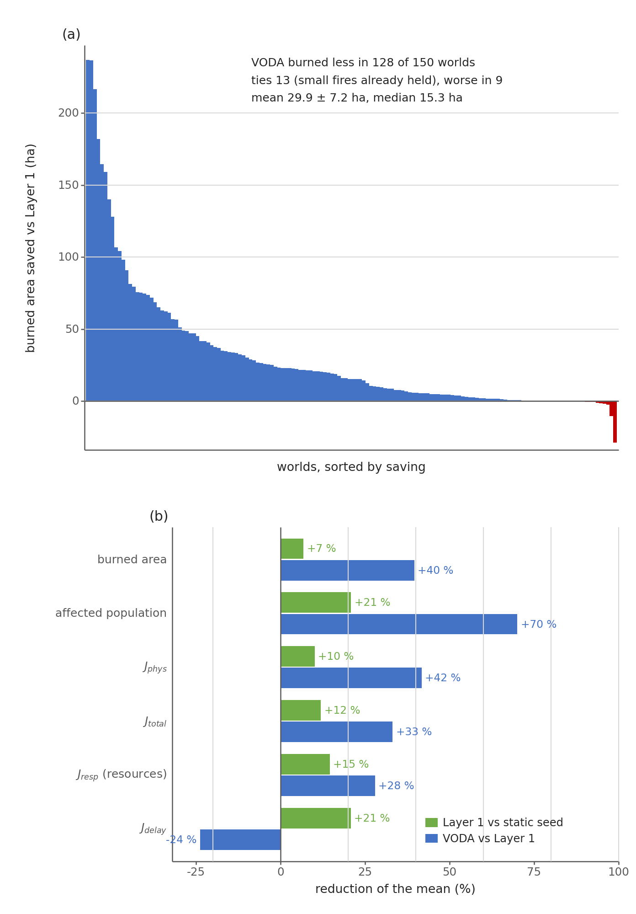
Fig. 8. (a) Burned area saved by VODA against the closed layer on each of the 150 worlds, sorted; gray bars are ties, dark bars the nine worlds in which it burned more. (b) Reduction of the mean on six measures, the closed layer against the static seed base, and VODA against the closed layer.
The gain is not bought with resources, as shown in Fig. 8. The response term of VODA (0.308) is below that of the closed layer (0.428) and that of the static doctrine (0.501). The five-term decomposition shows the saving in the physical terms with no growth in the response terms. The rule base reaches 10.4 active rules at the end of an episode under VODA against 10.3 under the closed layer alone. Thus, the margin comes from what the rules say rather than from how many there are. What the open layer costs is computation. An episode makes 10.3 model calls and takes 124 s of wall time against 22 s for the closed layer. This is about two seconds per decision cycle against the twelve minutes available.
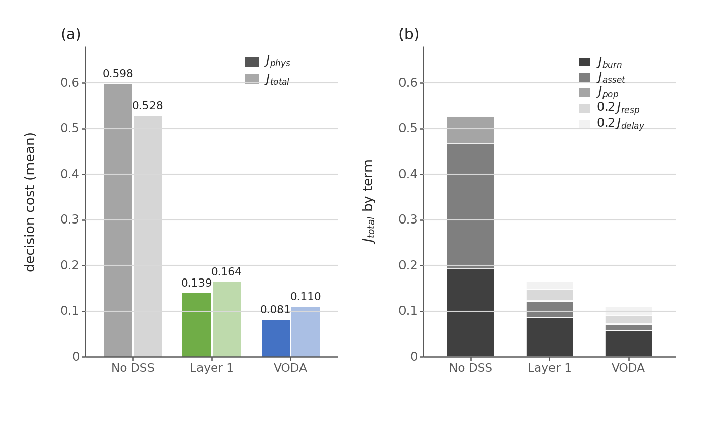
Fig. 9. Two cost types. (a) Physical cost and total decision cost per configuration, mean over 150 worlds. (b) Decomposition of the total cost into its five terms.

D. What the Open Layer Produced
Adaptation runs only on demand. Hence, the volume of trials measures how often the standing decision fell short, and the admission rate measures how strictly the gates filtered the responses. Over the 150 worlds the closed-layer mechanisms inside VODA kept 451 of 2093 consequent-step trials and 469 of 1411 resolution trials. The open layer received 710 proposals, one per call with a single revision, and admitted 309 (44 percent). Fig. 9 shows where the rejections fell. In all, 227 proposals passed the forecast tests but failed the package margin G7, 155 did not improve the forecast at G5, 12 failed the second seed at G6, and 7 were stopped by the syntactic gates. In other words, the model writes well-formed objects, and the simulator decides. Admission depends on the form of the proposal. Macros that blend existing families were admitted in 80 percent of 71 cases, composed interventions in 46 percent of 400, and plain rules over the existing vocabulary in 28 percent of 239. Thus, the objects that extend the vocabulary pass more often than new rules inside it.
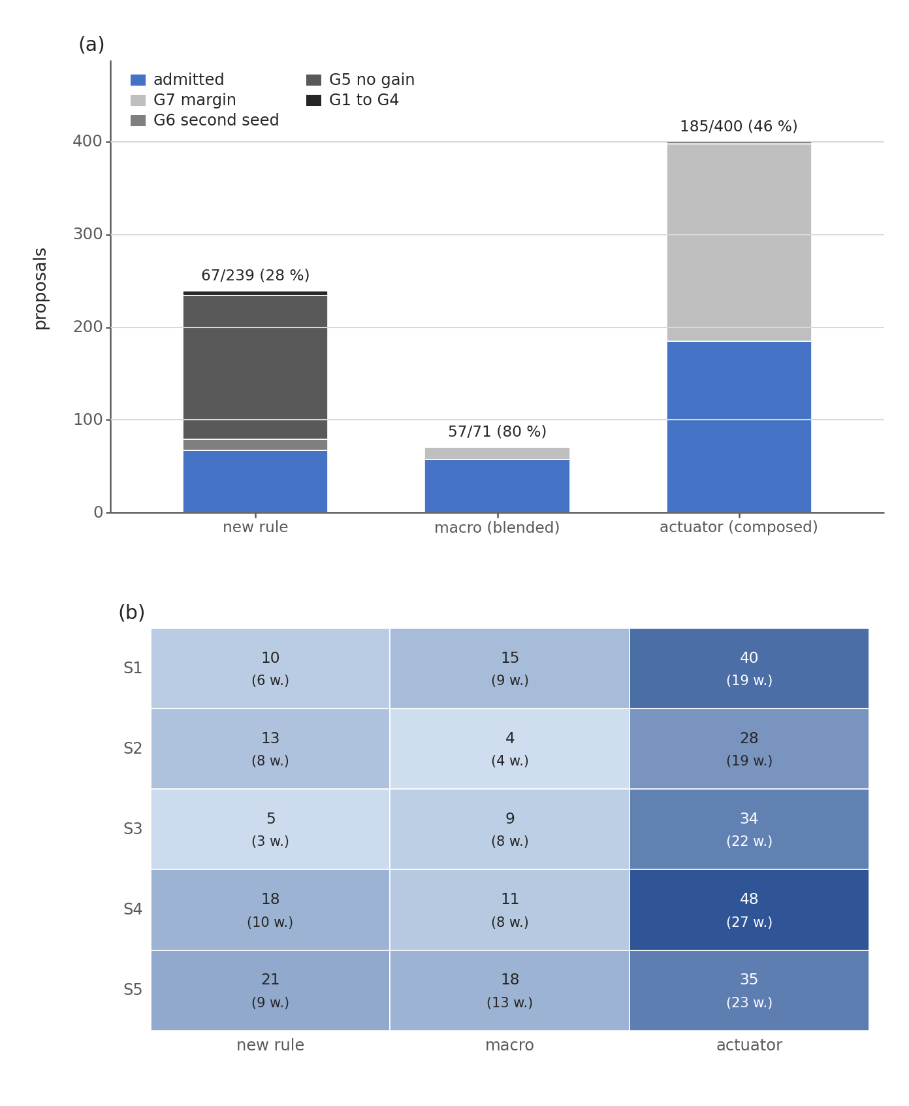
Fig. 10. (a) The 710 proposals by kind and verdict. (b) Admitted objects per scenario family, with the number of worlds (of 30) in which at least one was admitted.
What was written falls into a small number of tactics, each absent from the seed doctrine, as shown in Fig. 10 and Fig. 11. The 67 admitted rules order retardant drops (45), containment lines (39), water drafting (38), and suppression effort (35) far more than the seed base does. Retardant drop and water drafting are not ordered by any seed rule. Hence, the open layer added aerial attack to the doctrine. The 57 macros reduce to two archetypes. Interface hardening is asset protection with a containment line at 0.7 to 0.8 (14 admissions). The downwind backburn line is a containment line with suppression effort and, at times, resource deployment (15 admissions). The 185 composed interventions, 159 distinct clause sets, are dominated by two geometries. The asset collar is retardant coating of the threatened assets and of the populated cells within two to three cells before the fire arrives (26 admissions in its plain form, 42 with variants). The head-flank retardant band is coating of the head within six cells and of the flanks within three, with or without water drafting at the fire (41 in its two plain forms, 56 with variants). Backfire, wetting, and evacuation clauses are rare and enter only where the forecast rewards them.
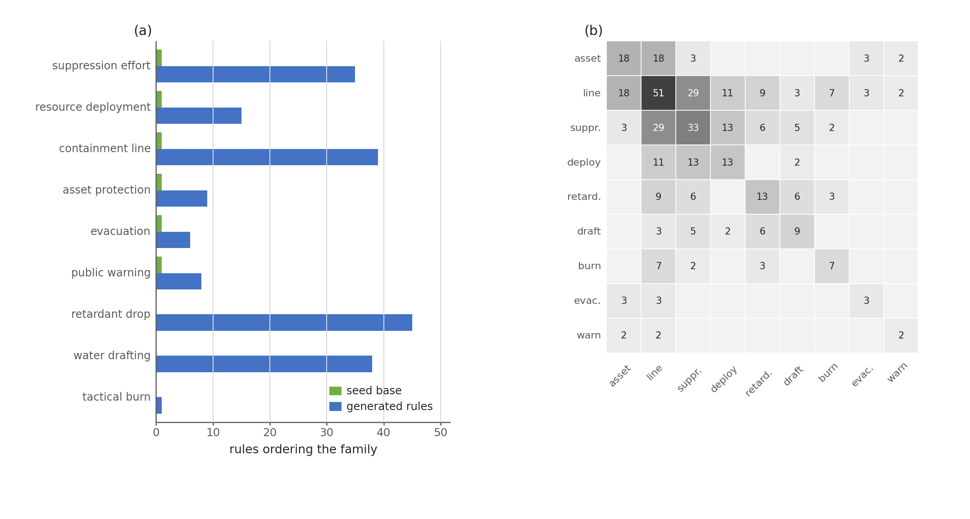
Fig. 11. What the open layer wrote. (a) Families ordered by the five seed rules against the 67 admitted rules. (b) Families bundled together in the 57 admitted macros.
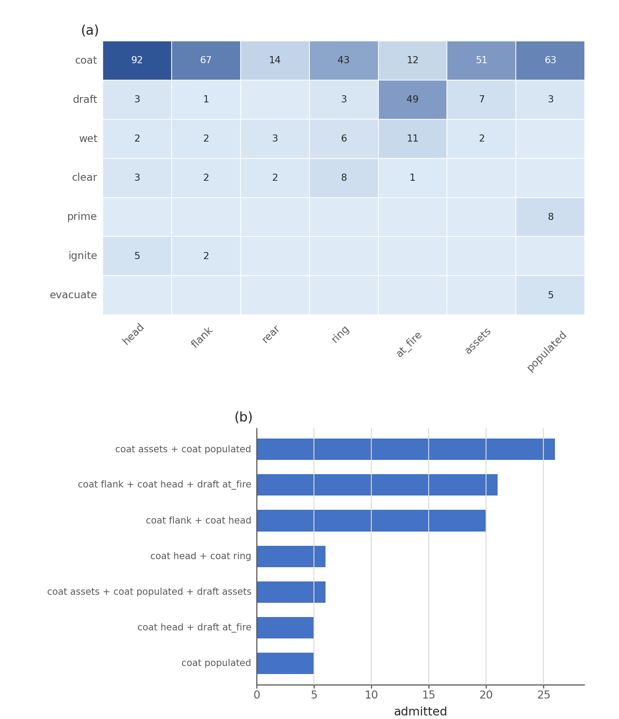
Fig. 12. The 185 admitted composed interventions. (a) Clauses by effect and sector. (b) The most frequent effect-sector archetypes.

E. Where the Gain Came From
Every world starts from the same five seed rules, and the proposer has no memory across worlds. Hence, an object that recurs in several worlds was rediscovered, not copied. Counting every variant that contains the defining clauses, the asset collar was admitted in 42 distinct worlds, the head-flank retardant band in 51, the interface-hardening macro in 18, and the downwind backburn line in 28. Recurrence across independent worlds is the first evidence that what the open layer learns is structural rather than incidental.
The realized outcome confirms the forecast that admitted the objects, as shown in Fig. 12. In the 21 worlds with no admission, VODA and the closed layer end within 16 ha of each other on average, and 11 of them are identical. The margin of Section V-C comes from the 129 worlds with at least one admission, where the mean saving is 32.2 ha. Moreover, the saving grows with the number of admissions in the world. This attribution is observational, since the admitted set is not assigned at random. The causal version, replaying each world with one admitted object removed, is left to future work. The single world in Fig. 12(c) shows the mechanism at the scale of one fire. It is an interface world in which the closed layer ends at 74 ha and VODA at 6 ha. The curves separate at minute 14, when one composed intervention coating the threatened assets and the head was admitted.
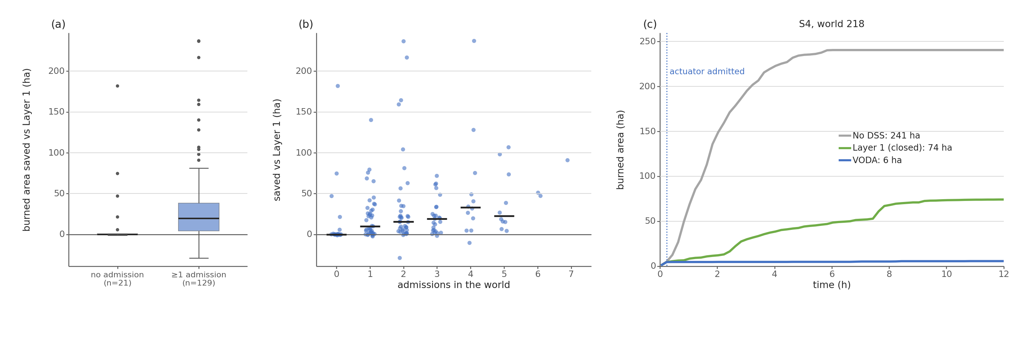
Fig. 13. Closed physics, open decision space. (a) Burned area saved against the closed layer in worlds with no admission and in worlds with at least one. (b) Saving against the number of admissions in the world; bars mark the median. (c) One S4 world replayed by the three configurations; the dotted line marks the admission of one composed intervention.

F. Timeliness, Scalability, and Compliance
One decision covers the whole loop, including the two shadow forecasts of the acceptance test and any adaptation that runs. It takes a median 274 ms against a twelve-minute cycle, 909 ms at the ninetieth percentile and 1.28 s at the slowest. The first offensive order is fielded at the first decision, two minutes after ignition. Fig. 13 reports the decision-layer cost for one to sixteen regions at cycles of two, six, and twelve minutes. Every point lies between 0.02 and 0.16 percent of the cycle. Sixteen times the agents cost 1.16 to 1.29 times the share, since each agent reasons over its own region. Six times the forecast horizon raised the median by 1.4 and four times the grid by 6.9. Thus, scalability holds on the axis the architecture is built for, while domain size remains the binding limit.
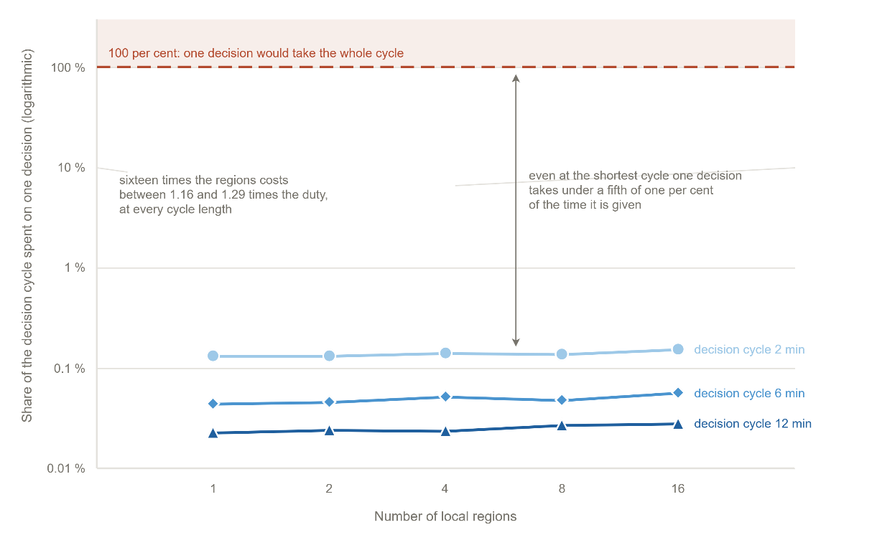
Fig. 14. Decision-layer cost against the number of local agents, as a share of the decision cycle.
Against the eight criteria, the picture is as follows. Predictive fidelity rests on four blind hindcasts with front agreement of 86 to 94 percent. Decision quality follows from the paired comparison, 82 percent less burned area than no action and 40 percent less than the closed layer, better in 128 of 150 paired worlds, with the lowest cost in every family. Timeliness is met with 274 ms per decision and about two seconds of proposer time per cycle. Scalability is met with at most 1.29 times the cost for sixteen times the agents. Robustness is met with a loss of 7 percent under degraded observation while the configuration remains the best tested. Uncertainty handling is structural, since every feature carries a confidence that gates its concept. Adaptability shows in 309 admitted objects that recur across worlds. Explainability shows in every edit, rejection, and generated object being logged with its trigger, gate, and consuming rule. Four criteria are met in full and four on the axis measured here. In detail, the hindcast base covers four fires, outage and noise are tested at one level only, operator-facing interpretability is not evaluated, and uncertainty is carried into the decision but not propagated as an ensemble.

VI. Discussion
Three lessons transfer beyond wildfire. First, separating an authoritative hazard model from the decision layer is what makes both testable. The model was validated against satellite records with no decision logic in the loop. The decision layers were then measured against each other on the same worlds. Hence, the benefit of opening the decision space is a paired difference rather than an absolute score. Second, a vocabulary of orders that grows at run time is safe only when admission is decided by gates that do not trust the proposer. More than half of the proposals were rejected, most of them at the package margin after they had passed the forecast tests. That selectivity is why the admitted objects could be fielded and why the outcome improved rather than merely changed. Third, the two layers divide the work by cost and determinism rather than by capability. The moves of the closed layer are deterministic, cheap, and numerous, 3504 trials against 710, and they finish the fires the doctrine already holds. The proposals of the open layer are expensive and not bitwise reproducible, and they reach the fires the doctrine does not hold. A single generative mechanism could in principle write the tuning edits as rules, at roughly four times the model calls of this campaign. However, keeping the deterministic layer underneath minimizes the number of cycles in which the non-reproducible component acts. It also keeps the ledger able to say which change came from tuning and which from generation.
Three limitations bound the claims. The evaluation is simulated. The hazard model is validated on real records, but no order was executed in a real incident and no fire officer took part in the loop. The attribution of the gain to object kinds is observational. A leave-one-out replay of each admitted object, and an ablation that admits the proposals of one kind only, would turn it into a causal account. The proposals of an LLM are not bitwise reproducible. Nevertheless, the campaign is logged with pinned configuration and seeds, and no admission depends on the proposer. A replication with a different model and a repeated run of the same worlds would measure the variance this introduces.

VII. Conclusion
This article presented VODA, a distributed decision support architecture for wildfire response built on two separated cores and two decision layers. The closed layer is a self-tuning fuzzy doctrine over five decision concepts and six intervention families. The open layer lets a pretrained LLM extend that doctrine with rules, blended interventions, and interventions composed from verified physical effects. A gate chain preserves no-harm, life-safety invariance, coverage, and monotone descent whatever the proposer. On an independently validated core, 150 paired worlds in five scenario families were replayed with no decision support, with the closed layer alone, and with both layers. The open layer admitted 309 of 710 proposals. It burned 29.9 ± 7.2 ha less per world than the closed layer and was better in 128 of 150 worlds. It raised the share of incidents extinguished from 52 to 75 percent and left 70 percent fewer people affected. This was achieved with a smaller committed response, no growth in rule count, and about two seconds of proposer time per decision cycle. The admitted objects recur across independent worlds and reduce to a small set of tactics the seed doctrine did not contain, namely aerial attack, the asset collar, the head-flank retardant band, interface hardening, and the downwind backburn line. Four studies follow. A leave-one-out replay will attribute the gain to each admitted object. A withheld-knowledge study will remove a known tactic from the doctrine and measure its rediscovery. A tabletop exercise will put fire officers in the loop. A transfer study will keep the decision core and replace the hazard model with another spreading hazard.

References

[1] | M. Turoff, M. Chumer, B. Van de Walle and X. Yao, "The design of a dynamic emergency response management information system (DERMIS)," J. Inf. Technol. Theory Appl., vol. 5, pp. 1-36, 2004.
[2] | D. M. Bowman, C. A. Kolden, J. T. Abatzoglou, F. H. Johnston, G. R. van der Werf and M. Flannigan, "Vegetation fires in the Anthropocene," Nat. Rev. Earth Environ., vol. 1, pp. 500-515, 2020.
[3] | M. P. Thompson and D. E. Calkin, "Uncertainty and risk in wildland fire management," J. Environ. Manage., vol. 92, pp. 1895-1909, 2011.
[4] | D. E. Calkin, C. D. O'Connor, M. P. Thompson and R. D. Stratton, "Strategic wildfire response decision support and the risk management assistance program," Forests, vol. 12, p. 1407, 2021.
[5] | F. Vásquez, A. Cravero, M. Castillo and F. Riquelme, "Decision support system development of wildland fire: A systematic mapping," Forests, vol. 12, p. 943, 2021.
[6] | R. C. Rothermel, "A mathematical model for predicting fire spread in wildland fuels," Res. Pap. INT-115, 1972.
[7] | M. A. Finney, "An overview of FlamMap fire modeling capabilities," in Fuels Management: How to Measure Success (RMRS-P-41), 2006.
[8] | C. Pais, J. Carrasco, P. E. Moudio and Z.-J. M. Shen, "Downstream protection value: Detecting critical zones for effective fuel-treatment under wildfire risk," vol. 90, p. 101703, 2021.
[9] | T. Orphanoudakis, C. Betzelos and H. C. Leligou, "MORA: A multicriteria optimal resource allocation and decision support toolkit for wildfire management," Algorithms, vol. 18, p. 677, 2025.
[10] | E. K. Noonan-Wright et al., "Developing the US wildland fire decision support system," J. Combust., vol. 2011, p. 168473, 2011.
[11] | C. Rapp, E. Rabung, R. Wilson and E. Toman, "Wildfire decision support tools: An exploratory study of use in the United States," Int. J. Wildland Fire, vol. 29, pp. 581-594, 2020.
[12] | C. Rapp, K. L. Courtney, S. T. Franz, M. M. Colavito, T. Aldworth and A. S. Cheng, "Wildfire decision support tools: barriers, facilitators, and future directions for effectiveness," Fire Ecol., 2026.
[13] | D. Arnott and G. Pervan, "A critical analysis of decision support systems research," J. Inf. Technol., vol. 20, pp. 67-87, 2005.
[14] | A. Arbel and R. M. Tong, "On the generation of alternatives in decision analysis problems," J. Oper. Res. Soc., vol. 33, pp. 377-387, 1982.
[15] | G. J. Hofstede, "Open problems, formal problems," J. Decis. Syst., vol. 4, pp. 155-165, 1995.
[16] | A. Colorni and A. Tsoukias, "Designing alternatives in decision problems," J. Multi-Criteria Decis. Anal., vol. 27, pp. 150-158, 2020.
[17] | E. D. Brill, J. M. Flach, L. D. Hopkins and S. Ranjithan, "MGA: A decision support system for complex, incompletely defined problems," IEEE Trans. Syst., Man, Cybern., vol. 20, pp. 745-757, 1990.
[18] | G. A. Klein, Sources of Power: How People Make Decisions, 2017.
[19] | M. G. Morgan and M. Henrion, Uncertainty: A Guide to Dealing with Uncertainty in Quantitative Risk and Policy Analysis, 1990.
[20] | G. Shafer, A Mathematical Theory of Evidence, 1976.
[21] | M. T. Ribeiro, S. Singh and C. Guestrin, ""Why should I trust you?" Explaining the predictions of any classifier," in Proc. ACM SIGKDD Int. Conf. Knowl. Discovery Data Mining, 2016.
[22] | A. L. Sullivan, "Wildland surface fire spread modelling 1: Physical and quasi-physical models," Int. J. Wildland Fire, vol. 18, pp. 349-368, 2009.
[23] | C. Pais, J. Carrasco, D. L. Martell, A. Weintraub and D. L. Woodruff, "Cell2Fire: A cell-based forest fire growth model to support strategic landscape management planning," Front. For. Glob. Change, vol. 4, 2021.
[24] | L. A. Zadeh, "Fuzzy sets," Inf. Control, vol. 8, pp. 338-353, 1965.
[25] | T. Takagi and M. Sugeno, "Fuzzy identification of systems and its applications to modeling and control," IEEE Trans. Syst., Man, Cybern., vol. 15, pp. 116-132, 1985.
[26] | P. P. Angelov and D. P. Filev, "An approach to online identification of Takagi-Sugeno fuzzy models," IEEE Trans. Syst., Man, Cybern. B, vol. 34, pp. 484-498, 2004.
[27] | S. French, J. Maule and N. Papamichail, Decision Behaviour, Analysis and Support, 2019.
[28] | F. Del Missier, M. Visentini and T. Mantyla, "Option generation in decision making: Ideation beyond memory retrieval," Front. Psychol., vol. 5, p. 1584, 2015.
[29] | P. Struss, "Model-based decision support systems: Conceptualization and general architecture," in Proc. Int. Workshop Qualitative Reasoning (QR), 2019.
[30] | Y. Ding et al., "Integrating action knowledge and LLMs for task planning and situation handling in open worlds," Auton. Robots, vol. 47, pp. 981-997, 2023.
[31] | E. Gizzi, H. Amel, W. W. Lin, K. Rhea and J. Sinapov, "Toward creative problem solving agents: Action discovery through behavior babbling," in Proc. IEEE Int. Conf. Develop. Learn. (ICDL), 2021.
[32] | R. S. Sutton and A. G. Barto, Reinforcement Learning: An Introduction, 2018.
[33] | Y. Xie, B. Jiang, T. Mallick, J. D. Bergerson, J. K. Hutchison and D. R. Verner, "WildfireGPT: Tailored large language model for wildfire analysis," arXiv:2402.07877, 2024.
[34] | H. A. Simon, "Rational choice and the structure of the environment," Psychol. Rev., vol. 63, pp. 129-138, 1956.
[35] | P. Dubey and P. Dubey, "Bridging spatiotemporal wildfire prediction and decision modeling using transformer networks and fuzzy inference systems," vol. 15, p. 103498, 2025.
[36] | R. Chandra, S. S. Kumar, R. Patra and S. Agarwal, "Decision support system for forest fire management using ontology with big data and LLMs," Cluster Comput., vol. 28, p. 548, 2025.
[37] | Y. Cheng et al., "Retrieval over response: Large language model-augmented decision strategies for hierarchical wildfire risk evaluation," Fire, vol. 9, p. 143, 2026.
[38] | N. Gerolimos et al., "Autonomous decision-making enhancing natural disaster management through open world machine learning: A systematic review," Hum.-Centric Intell. Syst., vol. 5, pp. 269-284, 2025.
[39] | A. Sandeep, S. Jayarathna, S. Sandaruwan, V. Samarappuli, D. Meedeniya and C. Perera, "Context-aware multi-agent architecture for wildfire insights," Sensors, vol. 26, p. 1070, 2026.
[40] | J. Cui, C. Zhai, Y. Wang and Y. Li, "Large language models and AI agents in disaster-resilient infrastructure: Concepts, applications, pathways, and challenges," Reliab. Eng. Syst. Saf., vol. 267, p. 111683, 2026.
[41] | E. Park, J. Park and T. Kim, "WildfireKR: An LLM-agent decision support framework for autonomous wildfire spread simulation in South Korea," IEEE Access, vol. 14, pp. 59185-59208, 2026.
[42] | J. H. Scott and R. E. Burgan, "Standard fire behavior fuel models: A comprehensive set for use with Rothermel's surface fire spread model," Gen. Tech. Rep. RMRS-GTR-153, 2005.
[43] | K. G. Hirsch and D. L. Martell, "A review of initial attack fire crew productivity and effectiveness," Int. J. Wildland Fire, vol. 6, pp. 199-215, 1996.
[44] | G. M. Byram, "Combustion of forest fuels," in Forest Fire: Control and Use, 1959.

Çağlar Akman received the B.S. and M.S. degrees in electrical and electronics engineering from Middle East Technical University (METU), Ankara, Türkiye, in 2008 and 2017, respectively, where he is currently pursuing the Ph.D. degree. He is a Senior Principal Team Manager with HAVELSAN, Ankara, where he manages research and development projects on advanced sensor systems, decision support architectures, and command and control software for defense and public-safety programs. His research interests include intelligent decision support systems, fuzzy inference, distributed architectures, and disaster management technologies.
Kemal Leblebicioğlu received the Ph.D. degree from the Department of Mathematics, METU, Ankara, Türkiye, in 1988. He has been a Full Professor with the Department of Electrical and Electronics Engineering, METU, since 1999. He has authored more than 40 journal papers and numerous book chapters and conference papers, and served as the Editor of the journal ELEKTRIK from 1996 to 2009. His research interests include optimization, optimal control, computer vision, intelligent systems, unmanned vehicles, and biomedical signal processing.

Manuscript received [Month DD, 2026]. (Corresponding author: Çağlar Akman.) Ç. Akman and M. K. Leblebicioğlu are with the Department of Electrical and Electronics Engineering, Middle East Technical University, 06800 Ankara, Türkiye (e-mail: caglar.1315akman@metu.edu.tr; kleb@metu.edu.tr).

