Concept-Based Fuzzy Reasoning for Scalable Wildfire Decision Support (DisasterAware)

Çağlar Akman, Hasan Furkan Öztürk and Kemal Leblebicioğlu

Abstract— Wildfire incident commanders act under time pressure and incomplete information, yet most decision support systems (DSS) still choose from a fixed catalogue of actions, assume complete observation, and expose their reasoning only through post-hoc attribution. This article presents DisasterAware, a wildfire DSS framework built on concept-based fuzzy reasoning that converts raw observations into a small set of domain-meaningful concepts before any action is formed. Four properties define the framework. The decision space is open: an evolving Fuzzy Inference System (evFIS) adapts the rule base by membership modification and resolution increase, a generative model proposes genuinely new rules, and a reinforcement learning (RL) optimizer tunes the admitted rules under cost minimization, with every candidate verified before it can act. Reasoning proceeds under partial observability, where epistemic uncertainty is propagated by confidence gating without any prior distribution, so the system degrades gracefully when inputs are missing. Each recommendation is intrinsically traceable to the concepts and rules that produced it, and a sensitivity analysis quantifies how the inputs drive the decision. The framework is demonstrated on an end-to-end wildfire response use-case that couples a spatio-temporal spread simulation with the decision pipeline and an operator dashboard.
Index Terms—Concept-based fuzzy reasoning, decision support systems, hierarchically distributed multi-agent systems, partial observability, wildfire response management.

I. INTRODUCTION
W
ildfires have become more frequent and more severe over recent decades, and the climatic and land-use conditions that drive them continue to intensify across most fire-prone regions [1, 2]. During an active incident, operators must decide where to send limited crews, which assets to protect first, and whether direct attack is feasible, and these calls are made quickly, under pressure, and on incomplete information. Decision support systems (DSS) exist to turn heterogeneous and fast-changing data into structured guidance for such choices [3, 4]. The operational value of a wildfire DSS depends less on raw predictive accuracy than on whether its recommendations stay meaningful when the situation shifts, when part of the observation is missing, and when responders need to understand why a given action is proposed.
A wide range of systems supports parts of this task. The U.S. Wildland Fire DSS couples weather, fire behavior, and economic information for incident-level decisions [5], while fire-behavior models such as FlamMap [6], built on the Rothermel spread model [7], predict how a front advances across a landscape. Operations research has produced optimization models for suppression-resource allocation and evacuation [8], together with multi-criteria toolkits [9] and classical methods that rank predefined alternatives against weighted criteria [10]. Integrated platforms link sensing, GIS, and decision logic for real-time suppression management [11], and machine learning has been applied to spread prediction over large remote-sensing archives [12, 13, 14, 15, 16], including hybrid designs that pair learned prediction with fuzzy rule bases [17]. More recently, large language models (LLMs) have entered the field as analysis and response agents: WildfireGPT adapts a general model to wildfire risk queries [18], and geospatially grounded agents retrieve terrain, infrastructure, and weather context to produce resource-allocation recommendations [19], and ontology-driven systems pair semantic rules with LLMs for forest-fire decision support [20]. Systematic reviews of this landscape report steady progress on individual capabilities, but also a persistent distance between what the literature emphasizes and what is actually adopted in the field [21].
Current DSS approaches share several recurring limitations. First, most systems reason over a closed catalogue of predefined actions, so any response outside that catalogue is unreachable, even though fire behavior evolves continuously and rarely matches a fixed strategy. Second, recommendations are commonly produced under an assumption of complete observation, or uncertainty is forced into probabilistic form or an evidence-theoretic one [22], although the missing information in an incident seldom carries known statistical properties [23, 24, 25]. Third, the reasoning behind a recommendation is often exposed only through post-hoc attribution [26, 27], which approximates a trained model after the fact rather than tracing a decision to its causes. DisasterAware is a wildfire DSS framework built on concept-based fuzzy reasoning that addresses these gaps within a single design. Raw observations are first mapped onto a small set of domain-meaningful concepts such as fire threat, suppression feasibility, asset exposure, and intervention urgency, and inference is then carried out over these concepts rather than over the raw signals [28]. The framework rests on fuzzy set theory [29], the theory of linguistic variables [30] and Mamdani-type inference [31], which together form the Fuzzy Inference System (FIS) at its core and have a long record in fire-risk assessment [32]. The contributions are as follows.
Open decision space through adaptive rule generation. Instead of selecting from a fixed menu, DisasterAware treats the intervention as a field that is reshaped online. An evolving FIS (evFIS) of the Takagi-Sugeno type [33] adapts the active rule base through two complementary operators, modification of membership-function parameters and increase of resolution by adding linguistic terms or splitting a region [34, 35]. When neither operator removes a persistent cost, a generative model proposes a genuinely new candidate rule [18], and a reinforcement learning (RL) optimizer tunes the admitted rule and decides when generation is warranted, with the whole loop driven by cost minimization [36, 37] under a satisficing acceptance rule [38]. Every candidate passes verification before it can act, so the realized response stays admissible while the decision space itself remains open. This combination of evolving fuzzy adaptation, generative proposal, and learned optimization extends the hierarchical decision-fusion principle of [39], which draws on multi-agent [40] and hierarchical fuzzy [41] traditions, from a fixed to an open action set.
Reasoning under partial observability and missing data. The decision core operates only on observation-derived quantities and never reads the true simulation state. Epistemic uncertainty is propagated without a prior distribution by blending each concept with a persistence-based estimate in proportion to observation confidence, so a low-confidence input is attenuated rather than trusted [24, 25]. Because concepts, not raw signals, drive the inference, the framework still returns a usable recommendation when an input is absent, which avoids the need for a separate model for every observable subset [23].
Sensitivity analysis and intrinsic traceability. Every decision is linked to the concept activations that produced it, the rules they fired, and the confidence of the underlying observations, so the reasoning can be inspected directly rather than approximated afterward [26, 27]. On top of this chain, a sensitivity analysis quantifies how a change in each input or concept propagates to the decision, which exposes the drivers of a recommendation and the conditions under which it would change. Traceability is therefore a structural property of the pipeline rather than an interpretation layer added later.
End-to-end use-case demonstration. The framework is exercised on a complete wildfire response scenario that couples a spatio-temporal spread simulation with the decision pipeline and an operator-facing dashboard, in the setting of the TeamAware project [42]. The use-case ties the preceding contributions to an operational workflow and responds to the research-to-practice distance reported in recent reviews [21].
Together, these contributions turn wildfire decision support from a predefined and centralized toolkit into an open, uncertainty-aware, and traceable reasoning system. The remainder of this article is organized as follows. Section II reviews background and related work on fuzzy reasoning, open and closed decision spaces, decision making under partial observability, and distributed architectures. Section III presents the DisasterAware method. Section IV reports the simulation study. Section V concludes and outlines directions for future work.

II. Background Work

A. Observation Space and Heterogeneous Field Data
Wildfire response begins with information that arrives from many sources in many forms. Field data are heterogeneous and spatio-temporal: meteorological stations and forecasts report wind, temperature, and humidity; terrain models supply slope and aspect; fuel and vegetation maps describe combustible load and moisture; satellite imagery, aerial platforms, ground cameras, and in-situ sensors detect active fire and hot spots; and first-responder reports and public calls add human observations [12, 19, 21]. Alongside these environmental streams, the response side contributes value-at-risk layers and resource availability. The framework groups the environmental drivers into the external input set and the value- and resource-related layers into a contextual set ( 1 ).
$$F_{in,k}=\left\{U_{Meteo,k}, U_{Geo}, U_{Fuel,k}, U_{Ign,k}, U_{DSS,k}\right\}, \\ F_{DSS,k}=\{U_{Val,k}, U_{Res,k}\}$$ | ( 1 )

$U_{Meteo,k}$ denotes the meteorological forcing, $U_Geo$ the static terrain, $U_{Fuel,k}$ the fuel state, $U_{Ign,k}$ the ignition input, and $U_{DSS,k}$ the suppression field that the decision layer injects into the environment; their composition is listed in Table A.II. The set $F_{DSS,k}$ is not part of the physical forcing but the decision-context set used by the DSS, made up of the value-at-risk field $U_{Val,k}$ and the resource field $U_{Res,k}$, with composition in Table A.III.
The true fire state is never observed directly. What reaches the decision layer is a region-restricted, uncertainty-affected projection of the state where the projection maps the state to observable quantities and the disturbance term is a bounded epistemic gap rather than a stochastic noise process with a known distribution [23, 24] as ( 2 ).
$$o_{k}^{ i}=h^{ i}(S_{k})⊕ε_{k}^{ i}, ∥ε_{k}^{ i}∥≤δ (1-γ_{k}^{ i})$$ | ( 2 )

Here $h^{i}$ is the region-restricted observation operator, $S_{k}$ the hidden wildfire state, and $ε_{k}^{i}$ a bounded epistemic disturbance whose magnitude is capped by $δ$ and shrinks with the observation confidence $c_{k}^{i} ∈ [0,1]$; this confidence is formed at each cell from sensor coverage, sensor density, and the age of the most recent report, and is taken conservatively as the weakest channel rather than an average.
This structural incompleteness, not statistical variability, is the dominant uncertainty in an incident, and it is the reason the later stages reason in graded rather than crisp terms. Because reliability varies by location and channel, each observation carries an observation confidence in the unit interval that aggregates sensor coverage, density, and the age of the most recent report, taken conservatively as the weakest channel. Fig. 1 places this input stage at the head of the pipeline that the rest of this section follows.

B. Feature Extraction and Observation Confidence
Raw observations are not used directly as decision inputs. A feature-extraction map converts them into a small set of bounded, normalized indicators with ten features: fire intensity, spread potential, weather severity, ignition proximity, fuel load, asset exposure, resource accessibility, access and road status, suppression availability, and temporal urgency, each a clamped scalar in the unit interval ( 3 ).
$$z_{k}^{ i}=Ψ\left(o_{k}^{ i}\right)∈[0,1]^{F}, F=10$$ | ( 3 )

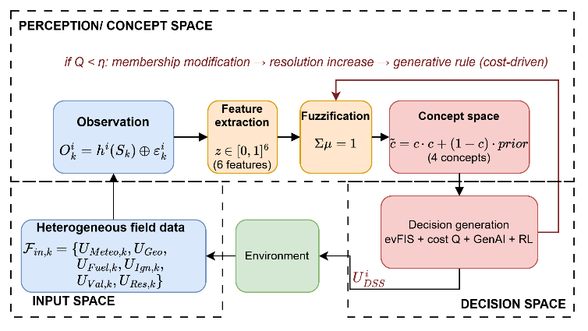
This set is chosen so that every operational question of Section II-C is supported by extracted features. Bounding each feature to the unit interval keeps the downstream fuzzification and concept construction well defined and comparable across features. Feature values inherit the reliability of the observations behind them, which is why observation confidence is retained as a first-class quantity rather than discarded after sensing. A feature computed from a stale or sparsely covered cell must not carry the same weight as one computed from a fresh, well-covered cell. Section II-D shows how this confidence gates the concepts so that the decision degrades gracefully when inputs are missing, which is the mechanism behind the partial-observability behavior promised in the introduction [24, 25].
Fig. 1. Pipeline of the DisasterAware background model.

The choice of variables follows established wildfire science rather than convenience. Fire intensity, spread potential, weather severity, ignition proximity, and fuel load are the behavioral drivers that govern how a front ignites and advances, as captured by semi-empirical spread models [6, 7] and confirmed by the input sets of data-driven spread predictors [12, 13, 14]. Asset exposure encodes the value at risk in the wildland-urban interface, while resource accessibility, access and road status, and suppression availability encode the operational feasibility that operations-research models of suppression and deployment treat as first-order [8, 43]. Temporal urgency adds the timing dimension. The ten variables therefore span the threat, exposure, feasibility, and timing that the four operational questions require, so that no question is left without a supporting feature and none of the ten is redundant.

C. Conceptualization and Operational Questions
Reasoning directly over the ten features still leaves the rule base large and the internal variables far from operational language. Naturalistic decision-making research shows that experienced commanders classify a situation by a few recognizable patterns rather than optimizing exhaustively [44]. Conceptualization follows this practice: it maps the feature vector onto a compact set of operational concepts before any rule fires, which both reduces the rule base and keeps the representation meaningful to the operator [28].
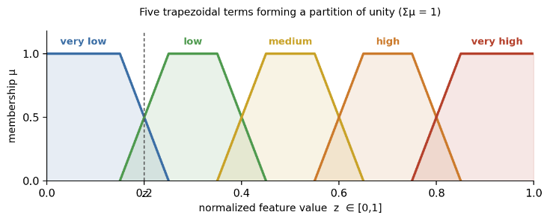
The concept set is derived from the questions a commander must answer at each location. The wildfire literature identifies four recurring concerns [23, 43], stated here as four questions: Q1, how severe is the fire threat here; Q2, can an intervention be carried out here; Q3, how exposed are the assets here; and Q4, how urgent is action here. Rather than a flat set, the concepts are organized as a four-level hierarchy: the ten fuzzified features feed six base concepts (fire severity, spread hazard, fuel hazard, asset value, crew reachability, and logistics support); these combine into three mid-level concepts (fire threat level, asset exposure risk, and suppression feasibility); two higher-level concepts, intervention urgency and evacuation pressure, follow; and a single top concept, operational priority, supports cross-region coordination. The mid- and higher-level concepts answer the four questions and fire the decision rules, while the base concepts act as interpretable intermediate hazards. Section III specifies the construction mappings; here it is enough that the concepts are grounded in operational questions, which is what makes the abstraction both compact and interpretable.
Fig. 2. Five trapezoidal linguistic terms.

The number of levels is set by the same evidence. A flat map from ten features to a single decision would need a rule base that grows with the product of the term counts, which is the scalability barrier that motivates abstraction in the first place [28]; organizing the concepts as base hazards, composite assessments, and a coordination concept keeps each rule local and small, in the spirit of hierarchical fuzzy reasoning [41]. The levels are not arbitrary tiers but the stages at which a commander reasons: raw hazards first, then the threat, exposure, and feasibility that answer the operational questions, then the urgency and evacuation pressure that weigh them, and finally a single operational priority for cross-region triage [44]. This keeps the concept count sufficient to answer every question while remaining interpretable.

D. Decision Generation: Evolving Fuzzy Inference, Cost-Driven Adaptation, and Generative AI
The decision layer is realized as a Fuzzy Inference System (FIS) that reasons over the concepts rather than the raw features [29, 31]. Each feature is first fuzzified into five trapezoidal linguistic terms, from very low to very high, that form a partition of unity ( 4 ) (Fig. 2).
$$\sum_{j=1}^{m}{μ_{ij}}(z_{i})=1, ∀ z_{i}, m=5$$ | ( 4 )

Concepts are then built by weighted aggregation of the fuzzified features, with the urgency concept formed at a second order,
$$c_{n}^{(1)}=\sum_{f=1}^{F}{a_{nf}} z_{f}, c_{m}^{(l)}=g_{m}\left(c^{(l-1)}\right),l=2,3,4$$ | ( 5 )

Here $f$ indexes the ten features and n a concept; $a_{nf}$ are the nonnegative first-level aggregation weights that build the base concepts $c^{1}$ from the features, and $g_{m}$ is the higher-level aggregation that forms a concept at level $l$ from the concepts at level $l-1$, so the four levels run from base hazards up to the single operational-priority concept.
Because observations carry varying reliability, each concept is gated by its observation confidence and blended with a persistence-based prior ( 6 ) so that a fully reliable observation passes through unchanged while an uninformative one falls back to the previous estimate [24]. The regional decision is the FIS output over the gated concept vector ( 7 ).
$${\tilde{c}}_{n,k}^{ i}=γ_{k}^{ i} c_{n,k}^{ i}+(1-γ_{k}^{ i}) c_{n,k}^{ i, prior}$$ | ( 6 )
where γ^i_k is the observation confidence of agent i at step k, c^i_{n,k} the raw activation of concept n, and c^{i,prior}_{n,k} its persistence-based prior carried from the previous step. The regional decision is then the concept-based fuzzy inference Π of agent i applied to the gated concept vector,
$$U_{k}^{ i}=Π​\left({\tilde{c}}_{k}^{ i}\right)$$ | ( 7 )

The superscript $i$ identifies one of the $N$ local decision managers, the regional DSS agents that reason in parallel over their own observations, and the subscript $k$ is the time step; the same convention applies throughout, so that a quantity written with superscript $i$ and subscript $k$ is the value held by local decision manager $i$ at step $k$.
A fixed rule base, however, fixes the set of expressible responses. DisasterAware treats the decision as an open space that is reshaped online by an evolving FIS (evFIS): it modifies membership-function parameters and increases resolution by adding terms or rules when an unfamiliar pattern appears [34, 45], an idea recently extended with dynamic rule adjustment for emergency response [46]. Approximating the optimal input-output mapping of a fuzzy reasoner has itself been studied as a way to keep this adaptation tractable [47]. These two operators, membership modification and resolution increase, are the first responses to a decision that is not good enough, and they keep the open space within the interpretable FIS structure rather than replacing it with an opaque model. Closed multi-criteria formulations, by contrast, can only rank a fixed list of alternatives [10].
What counts as good enough is set by a cost function. The wildfire decision problem does not reduce to a single objective optimized over a fixed action set: the action space grows exponentially with grid size and intervention types, the true state is partially observed, and exact policy computation over such a model is intractable even in finite partially observable cases [48, 24]. DisasterAware therefore evaluates rather than optimizes, scoring a candidate by a normalized, weighted multi-criteria quality and accepting it when the score meets an adaptive threshold,
Q=j=14wj qj, qj=1-1|G|(x,y)∈G​| uj-cj |, accept⇔Q≥η | ( 8 )
In (8) each q_j compares one component of the intervention to the concept it serves: q_1 the suppression effort against fire threat, q_2 asset protection against asset exposure risk, q_3 committed resources against suppression feasibility, and q_4 response timing against intervention urgency. The average is taken over the active grid G, so each q_j is a dimensionless satisfaction in the unit interval, and the weights, ordered 0.35, 0.30, 0.20, and 0.15, set their priority and sum to one. The field is accepted when the combined quality meets the threshold η.
The four criteria correspond to the four operational questions, and the weights encode the priority that fire-spread mitigation outranks asset protection, which in turn outranks efficiency and timing [38]. The absolute-deviation form and the spatial average are chosen so that a given error carries the same penalty everywhere and an improvement anywhere contributes to the score.
Each partial score $q_{j}$ in the quality function measures how closely the intervention component of type $m_{j}$ tracks the concept it is meant to serve, as one minus the spatially averaged absolute deviation over the active grid, so the four scores are dimensionless and lie in the unit interval. They cover four operational concerns: fire-spread mitigation, where the suppression field is matched against fire threat; asset-risk reduction, where protection is matched against asset exposure risk; resource efficiency, where committed effort is matched against suppression feasibility; and operational timeliness, where the response is matched against intervention urgency. These are combined by a priority-weighted additive value function with weights 0.35, 0.30, 0.20, and 0.15 that sum to one and are strictly ordered and non-dominant, so that no single concern can on its own make a deficient field acceptable; this weighted-criteria form is standard multi-criteria value analysis [10], and the acceptance test, accepting the field when the quality meets the threshold, is a satisficing rule rather than a search for an optimum [38].
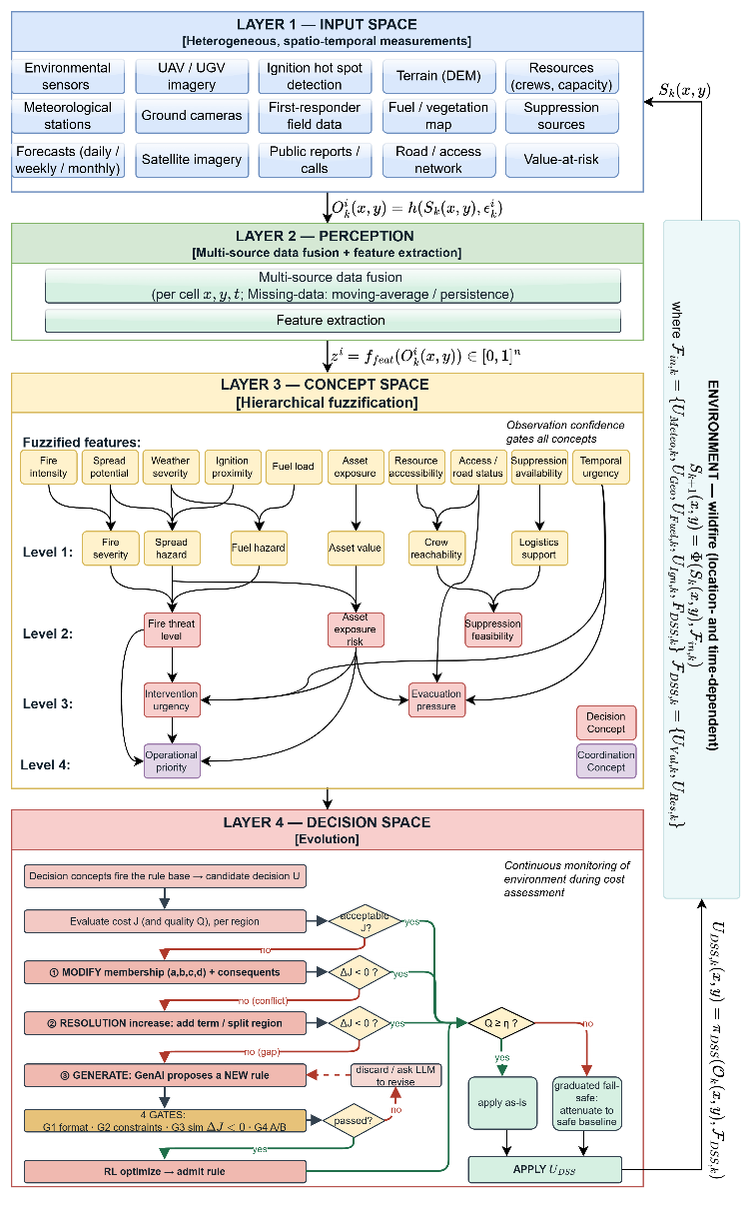
When membership modification and resolution increase still cannot bring the cost below the acceptance threshold, the gap signals that no adjustment of the existing rules suffices, and a genuinely new rule is required. At this point a generative model proposes a candidate rule, drawing on the use of large language models as proposers of structured content in decision support [18, 19, 20]; every proposal is admitted only after verification, so the realized response stays admissible. A reinforcement-learning (RL) optimizer tunes the parameters of an admitted rule and decides when generation is warranted, learning from cost feedback rather than from labeled decisions [36, 37]. Fig. 1 summarizes this cost-driven progression from membership modification to resolution increase to generative proposal. The mechanism that orchestrates these stages, together with the formal properties of the quality function and the fail-safe, is the subject of Section III.
Fig. 3 DisasterAware Framework.
Two learning components make this open adaptation reliable. The generative model is used as a proposer, not an authority: prompted with the uncovered concept pattern and the current rule base, it returns a candidate as a concept-pattern antecedent and an intervention consequent, which is then forced through verification before it can act, namely a format check, the hard safety and feasibility constraints, a simulator rollout that must lower the cost, and an A/B comparison against the unadapted base [18, 19, 20]. Reinforcement learning supplies the control that decides how the open space is searched: its reward is the realized cost reduction, its actions select which operator to apply next, namely membership modification, resolution increase, or a call to the generative proposer, and also tune the parameters of an admitted rule, and it learns the policy that sequences these operators from experience rather than from a fixed schedule [36, 37].

III. Method

A. DisasterAware Framework
DisasterAware is organized as the four-space pipeline of the framework figure: an input space that gathers the heterogeneous field data, a perception stage that extracts features, a concept space that abstracts them into a hierarchy of operational concepts, and a decision space that turns the concepts into an intervention. The pipeline is closed through the environment, because the intervention re-enters the external input set and drives the next state, so the framework runs as a closed loop rather than as a one-shot predictor.
Reasoning is hierarchically distributed. The domain is partitioned into N regions, each served by a local DSS agent that runs the full input-to-decision pipeline on its own observation; a non-inferential coordinator then assembles the regional interventions into a globally consistent field without performing any inference of its own [39]. Throughout this section the superscript i denotes the local DSS agent and the subscript k the step, so any quantity written with superscript i and subscript k is the value held by agent i at step k. Placing inference at the local level and keeping coordination free of reasoning is what lets the open, concept-based decision scale across a large domain.

B. Input Space to Concept Space
Each agent forms its observation under partial observability (2) and extracts the ten bounded features z^i_k of Section II (3). Every feature is fuzzified into five trapezoidal terms that form a partition of unity (4), so that a value activates at most two adjacent terms and the membership degrees sum to one; this keeps the mapping continuous and robust to the observation error that the partial-observability model admits [29], [31].
The fuzzified features are abstracted into the concept hierarchy of the framework figure. Ten features feed six base concepts (fire severity, spread hazard, fuel hazard, asset value, crew reachability, logistics support) by first-order weighted aggregation (5); these combine into three mid-level concepts (fire threat level, asset exposure risk, suppression feasibility); two higher-level concepts (intervention urgency, evacuation pressure) follow; and a single coordination concept, operational priority, sits at the top [28]. Because the abstraction is hierarchical, the rule base that the decision layer fires is defined over a few concepts rather than over the full feature product, which is the reduction that keeps the system scalable. Each concept is then gated by its observation confidence (6): a concept from a reliable observation passes through, while one from a degraded observation is pulled toward its persistence-based prior, so the concept vector degrades gracefully when inputs are missing.

C. Concept Space to Decision Space
The decision concepts, the mid- and higher-level concepts of the hierarchy, fire the rule base of agent i to produce a candidate intervention U^i_k (7), a field of intensities over the intervention types. The candidate is scored by the cost function Q (8), the priority-weighted match between the intervention and the concepts it should serve.
The decision space is open rather than closed. When Q falls below the adaptive threshold, the agent does not give up but reshapes its rule base in the order shown in the adaptation figure: it first modifies the membership parameters [34], [45], then increases resolution by adding a term or splitting a region, and only when neither closes the gap does a generative model propose a genuinely new rule [18], [19]. Every structural change passes four verification gates, and a reinforcement-learning controller selects which operator to apply next and tunes the admitted rule from cost feedback [36], [37], so adaptation continues only while the cost stays above threshold. The accepted regional fields are merged by the non-inferential coordinator under a shared resource constraint, and the result re-enters the environment.

D. Explainability and Fail-Safe Governance
Because every decision passes through the concept layer, it carries its own explanation: an intervention can be traced back to the concepts that drove it, the rules those concepts fired, and the confidence of the observations behind them, without any post-hoc attribution [27], [26]. This trace is logged for audit and is the level at which an operator can inspect or override a recommendation.
Acceptance is satisficing rather than optimal [38]. A field is applied when its quality meets the threshold, and when it does not, the system does not reject it outright but attenuates it toward a conservative baseline in proportion to the quality deficit, so that the most exposed assets still receive protection while a deficient decision is prevented from acting at full strength. Together, intrinsic traceability and this graduated fail-safe make the open, adaptive decision auditable and safe to deploy.

IV. Simulation Test

A. Simulation Environment

B. Baseline and Scenarios

C. Metrics and Acceptance Criteria

D. Results and Sensitivity Analysis

V. Conclusion and Future Work
This paper presented DisasterAware, a concept-based fuzzy decision architecture for wildfire response that treats the problem as distributed, partially observable, and satisficing rather than as a single global optimization. The framework extracts a small set of bounded features from each region, abstracts them into four situational concepts, and reasons over the concepts with a compact rule base, cutting the rule count from 15625 to 625 per intervention type while keeping every decision traceable to the concepts, rules, and observations that produced it. Regional decisions are merged by a non-inferential coordinator that projects the combined field onto a resource-feasible set, and a confidence-gated, satisficing evaluation accepts an intervention once it is good enough or attenuates it through a graduated fail-safe.
The architecture was given a formal basis: bounded outputs, Lipschitz continuity in the observation, compliance with partial observability, and a unique non-expansive coordination projection. A controlled simulation built on a Rothermel-type spread model confirmed the design. Against a no-decision baseline the framework lowered the mean burned area from 43.7 to 32.4 percent and the cumulative asset loss by 62 percent, scaled with linear communication and bounded per-region cost without changing the decision, and degraded gracefully as observation noise grew and resources tightened.
Several directions remain. The concept weights are currently set from domain knowledge and could be calibrated against historical incidents or learned under expert supervision. The spread model, though faithful to established fire behavior, should be validated against field data and remote-sensing observations, and the resource and value layers extended with operational logistics. The same concept-based, distributed satisficing pattern also appears applicable to other spatially distributed emergencies, such as floods and industrial hazards, which the authors intend to explore.

Appendix
Table A.I lists every symbol that appears in the conceptual architecture, together with a short description, so that each symbol is defined once and reused throughout Section III.

A. Notation
TABLE A.I
Notation for the DisasterAware Framework
Symbol | Meaning
$$Ω$$ | Spatial wildfire domain, defined as a subset of the plane; all fields are defined over the cells $(x, y)$.
$$k$$ | Discrete time-step index.
$$i, N$$ | Region index running from 1 to N; N is the number of disjoint regions.
$$S_{k}$$ | Wildfire system state field: combustion status, available fuel, fire intensity, and time since ignition.
$$Φ$$ | State transition operator; the state at step k+1 follows from the state and the external inputs at step k.
$$F_{in,k}$$ | External input set; gathers meteorological, terrain, fuel, and ignition forcing together with the system intervention.
$$h$$ | Observation operator mapping the hidden state to an observation.
$$ε_{k}$$ | Bounded, distribution-free epistemic disturbance that r epresents partial observability.
$$O_{k}$$ | Observation field formed from the state through the observation operator; the regional observation is its restriction to a region.
$$π_{DSS}$$ | Regional decision mapping, applied independently in every region.
$$U_{DSS,k}$$ | Coordinated global intervention field; the regional candidate of region i is its per-region counterpart.
$$A_{DSS}$$ | Non-inferential global coordination operator that merges the regional candidates into one field.
$$F_{DSS,k}$$ | Decision-related contextual inputs (value and resource information); kept distinct from the external inputs.
$$U_{DSS}$$ | Feasible (admissible) intervention space; the coordinated field is constrained to lie in it.
$$f_{eval}$$ | Multi-criteria evaluation function that scores a candidate field.
$$Q_{DSS,k}$$ | Decision-quality score of the coordinated field.
$$η_{k}$$ | Time-varying adequacy (satisficing) threshold; the field is accepted when its quality meets it.
$$U_{Meteo,k}$$ | Meteorological forcing component of the external input set.
$$U_{Geo}$$ | Terrain (static) forcing component of the external input set.
$$U_{Fuel,k}$$ | Fuel forcing component of the external input set.
$$U_{Ign,k}$$ | Ignition forcing component of the external input set.
$$z_{k}^{ i}$$ | Bounded feature vector at local decision manager i and step k; ten normalized indicators in the unit interval.
$$μ_{ij}$$ | Membership degree of feature i in its j-th linguistic term; five trapezoidal terms form a partition of unity.
$$c_{n}^{(l)}$$ | Concept at hierarchy level ℓ (1 to 4); built from features at level 1 and from lower-level concepts above it.
$$c_{k}^{ i}$$ | Observation confidence at decision manager i and step k; the weakest per-channel reliability, in the unit interval.
$$a_{nf}$$ | Nonnegative first-level aggregation weights that build the base concepts from the features.
$$U_{Val,k}$$ | Value-at-risk field, a component of the decision-context set.
$$U_{Res,k}$$ | Resource field (availability and capacity), a component of the decision-context set.
$$Π^{ i}$$ | Regional decision mapping of local decision manager i; the concept-based fuzzy inference that produces the local intervention.
$$γ_{k}^{ i}$$ | Observation confidence of agent i at step k; the weakest per-channel reliability in the unit interval, used to gate the concepts.
$${\left(·\right)}^{i} , {\left(·\right)}_{k}$$ | Index convention: a superscript i denotes the local DSS agent (one of N), a subscript k the discrete time step.
The two sets that feed the framework decompose as follows; the parameters are drawn from the simulation data layers.

B. External Input Set
The external input set drives the environment and is summarized in Table A.II; each layer is a field defined over the grid cells.
TABLE A.II
Composition of the External Input Set
Symbol | Content
$$U_{Meteo,k}$$ | Air temperature, relative humidity, wind speed, wind direction, wind gust, and precipitation.
$$U_{Geo}$$ | Elevation, slope, orientation (aspect), and accessibility level.
$$U_{Fuel,k}$$ | Vegetation/fuel class, available combustible mass, and surface fuel moisture content.
$$U_{Ign,k}$$ | Binary ignition-injection indicator per cell.
$$U_{DSS,k}$$ | Coordinated decision field fed back by the system; the only decision-controlled component.

C. Decision-Related Inputs
The decision-related inputs supply the value- and resource-related quantities used for evaluation and feasibility, summarized in Table A.III.
TABLE A.III
Composition of the Decision-Related Inputs
Layer | Content
$$Value$$  $$at risk$$ | Exposed assets and socio-economic elements (critical facilities, population, infrastructure), aggregated into a per-cell protection-priority score.
$$Resource$$ | Available suppression capacity, operational availability status, suppression effectiveness, and estimated travel time to each grid cell.
The ten bounded features of Section III-B and the situational concepts they feed are summarized below; the per-concept weights are set from domain knowledge.
TABLE A.IV
Ten Features and the Concepts They Feed
Feature | Symbol | Feeds concept(s) | Role
Fire intensity | $$x_{1}$$ | $$c_{1}$$ | Drives fire threat level
Fuel load | $$x_{2}$$ | $$c_{1}, c_{2}$$ | Raises threat; lowers feasibility
Spread potential | $$x_{3}$$ | $$c_{1}, c_{3}$$ | Shared by threat and exposure risk
Asset exposure | $$x_{4}$$ | $$c_{3}$$ | Drives asset exposure risk
Resource accessibility | $$x_{5}$$ | $$c_{2}$$ | Drives suppression feasibility
Temporal urgency | $$x_{6}$$ | $$c_{4}$$ | Feeds the second-order urgency concept

Acknowledgment
This work was informed by the authors’ experience in the TeamAware project, funded by the European Union’s Horizon 2020 research and innovation programme under Grant Agreement No. 101019808.

References

[1] | CRED and UCLouvain, "EM-DAT, The International Disaster Database," Brussels, Belgium, 2024.
[2] | W. M. Jolly, "Climate-induced variations in global wildfire danger from 1979 to 2013," Nature Communications, vol. 6, 2015.
[3] | J. P. Shim, "Past, present, and future of decision support technology," Decision Support Systems, vol. 33, no. 2, pp. 111-126, 2002.
[4] | G. Kostopoulos, G. Davrazos and S. Kotsiantis, "Explainable Artificial Intelligence-Based Decision Support Systems: A Recent Review," Electronics, vol. 13, no. 14, p. 2842, 2024.
[5] | E. K. Noonan-Wright, "Developing the U.S. Wildland Fire Decision Support System," Journal of Combustion, vol. 2011, 2011.
[6] | M. A. Finney, "An overview of FlamMap fire modeling capabilities," in Fuels Management - How to Measure Success, USDA Forest Service Proc. RMRS-P-41, 2006.
[7] | R. C. Rothermel, "A mathematical model for predicting fire spread in wildland fuels," 1972.
[8] | S. Zhou and A. Erdogan, "A spatial optimization model for resource allocation for wildfire suppression and resident evacuation," Computers & Industrial Engineering, vol. 138, 2019.
[9] | T. Orphanoudakis, C. Betzelos and H. C. Leligou, "MORA: A multicriteria optimal resource allocation and decision support toolkit for wildfire management," Algorithms, vol. 18, no. 11, 2025.
[10] | E. Triantaphyllou, Multi-Criteria Decision Making Methods: A Comparative Study, Dordrecht: Kluwer, 2000.
[11] | M. Lourenco, L. B. Oliveira and A. Mora, "An integrated decision support system for improving wildfire suppression management," ISPRS International Journal of Geo-Information, vol. 10, no. 8, 2021.
[12] | F. Huot, "Next day wildfire spread: A machine learning dataset to predict wildfire spreading from remote-sensing data," IEEE Transactions on Geoscience and Remote Sensing, vol. 60, pp. 1-13, 2022.
[13] | M. A. Akhloufi, "Machine learning and deep learning for wildfire spread prediction: A review," Fire, vol. 7, no. 12, p. 482, 2024.
[14] | J. G. Borges, "A systematic review of applications of machine learning techniques for wildfire management decision support," Inventions, vol. 7, no. 1, p. 15, 2022.
[15] | D. Shadrin, S. Illarionova, F. Gubanov, K. Evteeva, M. Mironenko, I. Levchunets, R. Belousov and E. Burnaev, "Wildfire spreading prediction using multimodal data and deep neural network approach," Scientific Reports, vol. 14, p. 2606, 2024.
[16] | A. M. Elshewey, A. M. Osman and R. Y. Youssef, "Enhancing forest fires classification using a hybrid convolutional and BiLSTM deep learning model," Modeling Earth Systems and Environment, vol. 11, p. 379, 2025.
[17] | P. Dubey, "Bridging spatiotemporal wildfire prediction and decision modeling using transformer networks and fuzzy inference systems," MethodsX, vol. 15, 2025.
[18] | Y. Xie, B. Jiang, T. Mallick, J. D. Bergerson, J. K. Hutchison and D. R. Verner, "WildfireGPT: Tailored large language model for wildfire analysis," arXiv:2402.07877, 2024.
[19] | Y. Chen, L. Li, Z. Ma, Q. Hu, Y. Zhu, M. Deng and R. Yu, "Empowering LLM agents with geospatial awareness: Toward grounded reasoning for wildfire response," arXiv:2510.12061, 2025.
[20] | R. Chandra, S. S. Kumar, R. Patra and S. Agarwal, "Decision support system for forest fire management using ontology with big data and LLMs," Cluster Computing, vol. 28, p. 548, 2025.
[21] | T. O’Mara, A. S. Sánchez Meador, M. Colavito, A. Waltz and E. Barton, "Navigating the evolving landscape of wildfire management: A systematic review of decision support tools," Trees, Forests and People, vol. 16, 2024.
[22] | G. Shafer, A Mathematical Theory of Evidence, Princeton, NJ: Princeton University Press, 1976.
[23] | M. P. Thompson and D. E. Calkin, "Uncertainty and risk in wildland fire management: A review," Journal of Environmental Management, vol. 92, no. 8, pp. 1895-1909, 2011.
[24] | L. P. Kaelbling, M. L. Littman and A. R. Cassandra, "Planning and acting in partially observable stochastic domains," Artificial Intelligence, vol. 101, pp. 99-134, 1998.
[25] | P. Walley, Statistical Reasoning with Imprecise Probabilities, London, U.K.: Chapman & Hall, 1991.
[26] | S. M. Lundberg and S. I. Lee, "A unified approach to interpreting model predictions," in Advances in Neural Information Processing Systems (NeurIPS), 2017.
[27] | M. T. Ribeiro, S. Singh and C. Guestrin, "Why should I trust you?: Explaining the predictions of any classifier," in Proc. ACM SIGKDD, 2016.
[28] | P. W. Koh, "Concept bottleneck models," in Proc. 37th Int. Conf. Machine Learning (ICML), 2020.
[29] | L. A. Zadeh, "Fuzzy sets," Information and Control, vol. 8, no. 3, pp. 338-353, 1965.
[30] | L. A. Zadeh, "Outline of a new approach to the analysis of complex systems and decision processes," IEEE Transactions on Systems, Man, and Cybernetics, Vols. SMC-3, no. 1, pp. 28-44, 1973.
[31] | E. H. Mamdani and S. Assilian, "An experiment in linguistic synthesis with a fuzzy logic controller," International Journal of Man-Machine Studies, vol. 7, no. 1, pp. 1-13, 1975.
[32] | T. Tsataltzinos, L. Iliadis and S. Spartalis, "An intelligent fuzzy inference system for risk estimation: The case of forest fires in Greece," in IFIP AIAI, 2009.
[33] | T. Takagi and M. Sugeno, "Fuzzy identification of systems and its applications to modeling and control," IEEE transactions on systems, man, and cybernetics, vol. 1, pp. 116-132, 1985.
[34] | P. P. Angelov and D. P. Filev, "An approach to online identification of Takagi-Sugeno fuzzy models," IEEE Transactions on Systems, Man, and Cybernetics, Part B, vol. 34, no. 1, pp. 484-498, 2004.
[35] | J. M. Mendel, "Fuzzy logic systems for engineering: a tutorial," Proceedings of the IEEE, vol. 83, no. 3, pp. 345-377, 1995.
[36] | R. S. Sutton and A. G. Barto, Reinforcement Learning: An Introduction, 2nd ed., Cambridge, MA, USA: MIT Press, 2018.
[37] | L. Murray, T. Castillo, J. Carrasco, A. Weintraub, R. Weber and I. M. de Diego, "Advancing forest fire prevention: Deep reinforcement learning for effective firebreak placement," arXiv:2404.08523, 2024.
[38] | H. A. Simon, "Rational choice and the structure of the environment," Psychological Review, vol. 63, no. 2, pp. 129-138, 1956.
[39] | U. Beldek and K. Leblebicioğlu, "Local decision making and decision fusion in hierarchical levels," TOP, vol. 17, no. 1, pp. 44-69, 2009.
[40] | M. Wooldridge, An Introduction to MultiAgent Systems, Chichester, U.K.: Wiley, 2009.
[41] | G. V. Raju, J. Zhou and R. A. Kisner, "Hierarchical fuzzy control," International Journal of Control, vol. 54, no. 5, pp. 1201-1216, 1991.
[42] | European Commission, "TEAMAWARE," Horizon 2020 Programme, Grant Agreement No. 101019808, 2021.
[43] | D. L. Martell, "Forest fire management: Current practices and new challenges for operational researchers," in Handbook of Operations Research in Natural Resources, Springer, 2007, pp. 489-509.
[44] | G. A. Klein, Sources of Power: How People Make Decisions, 20th Anniversary ed., Cambridge, MA, USA: MIT Press, 2017.
[45] | E. Lughofer, Evolving Fuzzy Systems: Methodologies, Advanced Concepts and Applications, Berlin, Germany: Springer, 2011.
[46] | Y. Tu, Z. Ma, J. Liu and X. Zhou, "Enhancing fuzzy evidential reasoning approach using a dynamic adjustment mechanism and new rule-based transformation for engineering emergency response evaluation," Engineering Applications of Artificial Intelligence, 2023.
[47] | A. Şahin and K. Leblebicioğlu, "Approximating the optimal mapping for weapon target assignment by fuzzy reasoning," Information Sciences, vol. 255, pp. 30-44, 2014.
[48] | C. H. Papadimitriou and J. N. Tsitsiklis, "The complexity of Markov decision processes," Mathematics of Operations Research, vol. 12, no. 3, pp. 441-450, 1987.
[49] | A. Virmaux and K. Scaman, "Lipschitz regularity of deep neural networks: Analysis and efficient estimation," in NeurIPS, 2018.
[50] | G. B. Folland, Real Analysis: Modern Techniques and Their Applications, New York, NY, USA: Wiley, 1999.
[51] | U. Beldek and K. Leblebicioğlu, "A new systematic and flexible method for developing hierarchical decision-making models," Turkish Journal of Electrical Engineering and Computer Sciences, vol. 23, no. 1, pp. 279-297, 2015.
[52] | U. Beldek and K. Leblebicioğlu, "Strategy creation, decomposition and distribution in particle navigation," Information Sciences, vol. 177, no. 3, pp. 755-770, 2007.

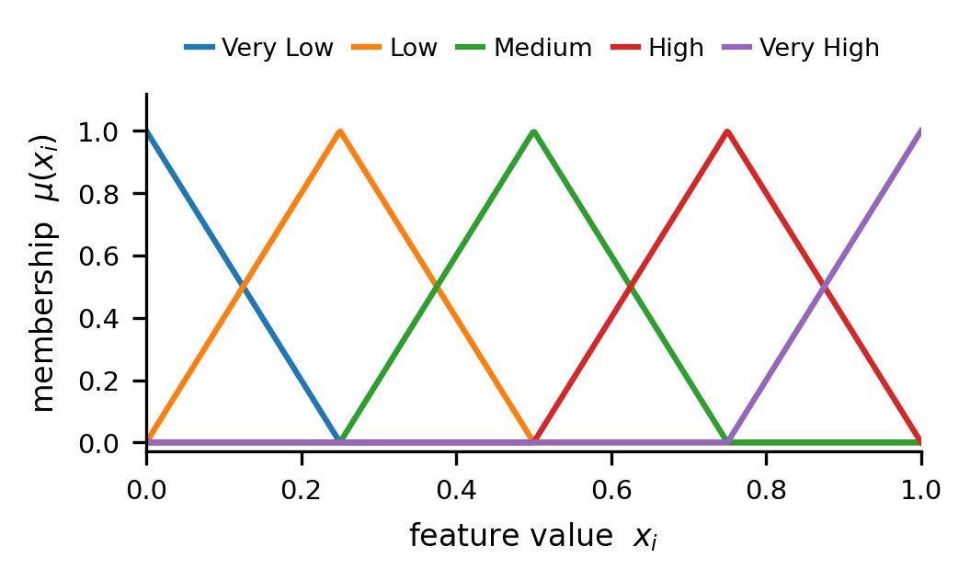
Çağlar Akman received the B.S. and M.S. degrees in Electrical and Electronics Engineering from the Middle East Technical University (METU), Ankara, Türkiye, in 2008 and 2017, respectively, where he is currently pursuing the Ph.D. degree.
He is currently the Senior Principal Team Manager of the Modeling and Sensor Technologies at HAVELSAN, Ankara, Türkiye, where he manages national and international research and development projects of advanced sensor systems, decision support architectures, and intelligent automation technologies. Over the past 10 years, he has acquired extensive experience in leading multidisciplinary R&D initiatives, managing national and international research collaborations, and coordinating complex technical projects across multiple organizations and consortia.
He serves as an Industrial Reviewer for TÜBİTAK (Turkish Scientific and Technical Research Council), evaluating research proposals across multiple research domains. He also performs peer review for IEEE Transactions and related journals, contributing to the quality assurance of peer-reviewed literature. Additionally, he has been a part-time lecturer at Atılım University. His research interests, expertise, and professional recognition reflect a strong commitment to advancing the fields of artificial intelligence, autonomous systems, decision support technologies, and sensor fusion in both civilian and defense applications.


Kemal Leblebicioğlu received his Ph.D. from the Department of Mathematics of the Middle East Technical University (METU), in 1988.
He has been a full professor in the Department of Electrical and Electronics Engineering of METU since 1999. He has a background in optimization, optimal control theory, computer vision, intelligent systems, flight control, walking robots, and unmanned vehicles.
Dr. Leblebicioğlu has been a member of numerous international program committees and has been (co-) author of more than 40 journal papers, book chapters, and numerous conference papers. He is on several IFAC technical committees. He was the editor of the journal ELEKTRIK published by TÜBİTAK (Turkish Scientific and Technical Research Council) from 1996 to 2009. He is on the editorial board of several Turkish technical journals. He organized an international workshop on computer vision and intelligent systems and two national conferences on control.
He conducted several R&D projects as project leader and researcher and gave consultancy to BİLTEN (TÜBİTAK’s Research Center on Electronics and Information Technologies), 3rd Supply and Maintenance Center of Turkish Air Forces (Ankara), TÜBİTAK-İltaren, and to ASELSAN on the topic of “real time automatic visual tracking of targets.” Now he is studying unmanned vehicles, in particular, unmanned air and underwater vehicles.
He completed a project (supported by TÜBİTAK) on the construction of a special unmanned under-sea vehicle, called ULISAR, which is a mixture of an ROV and a fully automated system. He completed a project, also supported by TÜBİTAK, on the coordinated guidance of multiple unmanned air vehicles.

Çağlar Akman and Kemal Leblebicioğlu are with the Department of Electrical and Electronics Engineering, Middle East Technical University, 06800 Ankara, Türkiye.

