DisasterAware: AI Enhanced Concept-Based Fuzzy Reasoning for Scalable Wildfire Decision Support

Çağlar Akman and Kemal Leblebicioğlu

Abstract— Wildfire incident commanders act under time pressure and incomplete information, yet most decision support systems (DSS) still choose from a fixed catalogue of actions, assume complete observation, and expose their reasoning only through post-hoc attribution. This article presents DisasterAware, a wildfire DSS framework built on concept-based fuzzy reasoning that converts raw observations into a small set of domain-meaningful concepts before any action is formed. Four properties define the framework. The decision space is open: an evolving Fuzzy Inference System (evFIS) adapts the rule base by membership modification and resolution increase, a generative model proposes genuinely new rules, and a value-based stage controller tunes the admitted rules under cost minimization, with every candidate verified before it can act. Reasoning proceeds under partial observability, where epistemic uncertainty is propagated by confidence gating without any prior distribution, so the system degrades gracefully when inputs are missing. Each recommendation is intrinsically traceable to the concepts and rules that produced it, and a sensitivity analysis quantifies how the inputs drive the decision. The framework is demonstrated on an end-to-end wildfire response use-case that couples a spatio-temporal spread simulation with the decision pipeline and an operator dashboard.
Index Terms—Concept-based fuzzy reasoning, decision support systems, hierarchically distributed multi-agent systems, partial observability, wildfire response management.

I. INTRODUCTION
Decision makers in disaster response must combine many streams of information under uncertainty, time pressure, and resource limits, and a poor decision can have irreversible consequences. Decision support systems (DSS) are designed to extend the range of information an operator can weigh under such pressure [1], [2], [3]. Classical DSS, however, assume full observability, stationary dynamics, and well defined objectives [4], assumptions that rarely hold in real operations, where epistemic uncertainty persists [5]. Artificial intelligence methods have raised predictive accuracy, but they often operate as opaque models whose reasoning is difficult to expose at the decision level [6]. In critical domains, decision outputs must be interpretable, traceable, and aligned with human reasoning [7].
Wildfire response makes these requirements concrete. Fig. 1 shows the steep rise in reported natural disasters since 1970, with weather and climate related events, including wildfires, taking a growing share [8]. Wildfire frequency, spatial extent, and intensity have risen under climate change, land use transformation, and the expansion of the wildland-urban interface [9], [10], and the resulting ecological, economic, and human impacts increasingly outpace conventional response capabilities [11]. Fire behavior evolves in space and time under the joint influence of weather, terrain, fuel, and suppression, and suppression actions feed back into the fire dynamics [12], [13]. Operational assessments are often incomplete and linguistically expressed, such as high spread potential or limited suppression feasibility. Fuzzy reasoning is well suited to this setting, since it supports approximate inference over partial and imprecise evidence without probability distributions, which are rarely available in real time [14], [15].
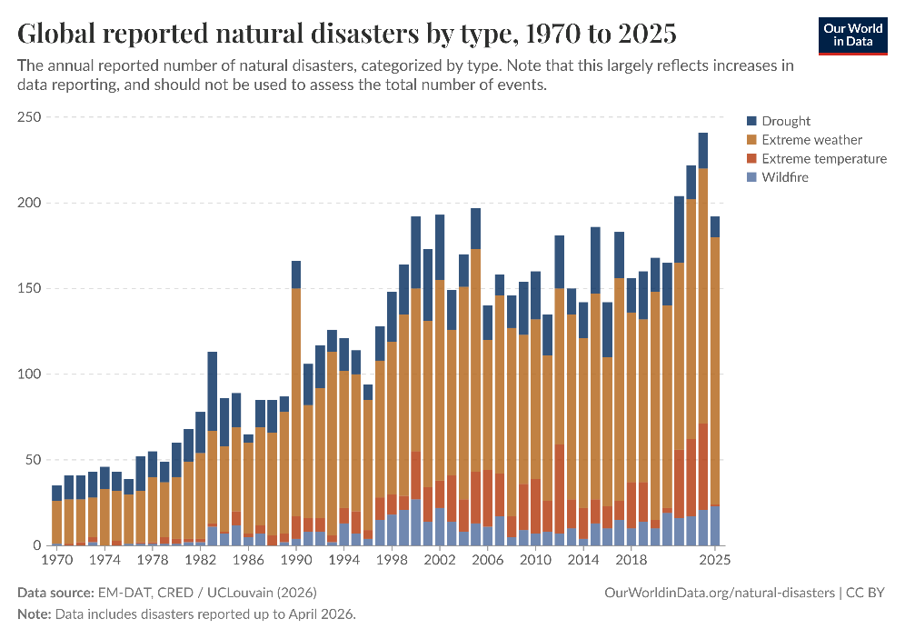
Fig. 1. Global trend in reported natural disasters.
Many systems support parts of this task, from optimization based resource allocation and simulation based platforms to geospatial risk assessment and fuzzy reasoning [11], [16], [17]. Mature deployed systems such as WFDSS [18] and FlamMap [13], together with recent hybrid predictive fuzzy models [19], [20], provide substantial operational value, yet each addresses only part of the requirements. The remaining challenge is architectural. No single framework simultaneously addresses adaptability under dynamic conditions, explainability of decision outputs, and support for distributed multi level coordination within one coherent design [11], [7]. Field studies confirm the distance between capability and adoption: practitioners use existing tools to validate decisions already made from experience rather than to generate new response options [21], [22].
These limitations are structural rather than incidental, and they consolidate into three gaps, summarized in Table I. The first gap concerns closed decision spaces in centralized architectures. Many classical frameworks assume that decision alternatives can be enumerated before reasoning begins [2], [23], while fire behavior evolves continuously with wind shifts, fuel variability, and terrain interactions, producing conditions that no fixed strategy set can represent [24]. Centralized architectures concentrate observation aggregation, evaluation, and response generation in a single analytical core, which bottlenecks when the state changes rapidly or the domain expands [25], and most systems treat decision support as a single layer process although wildfire operations span local intervention, regional coordination, and strategic prioritization [26], [27].
The second gap concerns unrepresented epistemic uncertainty and limited explainability. Wildfire decisions are shaped more strongly by incomplete or unreliable information than by stochastic variability in fire dynamics [28], [11], yet existing uncertainty aware approaches require prior probability distributions or pre-calibrated belief intervals, which are rarely available at cell level resolution in real time [29], [30]. Fuzzy logic offers a graded representation of operational evidence without distributional assumptions [15], [31], but its systematic integration into wildfire DSS architectures remains limited. At the same time, post-hoc attribution methods such as SHAP and LIME approximate model behavior statistically rather than tracing a decision to its causes [6], and managers override or ignore recommendations whose reasoning is opaque [32], although recent hybrid designs show that accuracy and interpretability are not mutually exclusive [19].
The third gap concerns simulation-decision coupling without an end-to-end operational workflow. Modular architectures are essential for traceability and independent validation [33], yet many wildfire DSS merge fire behavior modeling and decision logic in one platform, so neither component can be updated or verified in isolation [18], [19], [20]. Optimization based formulations represent operational constraints through formal cost functions [4], [34], but they presuppose complete state information, which is rarely available during active response [35]. Mechanisms that integrate constraints into real-time, cell level reasoning under incomplete and evolving observations are missing [36], and complete workflows that connect observation, reasoning, and operator interaction in a single demonstrable pipeline remain rare.
TABLE I
Structural gaps in wildfire decision support architectures
Structural Gaps of Existing Wildfire DSS Architectures
G1 | Existing DSS frameworks rely on predefined decision alternatives evaluated within centralized, level-undifferentiated architectures, preventing adaptation to dynamic, unforeseen conditions and limiting scalability, local responsiveness, and level-appropriate coordination.
G2 | Current systems cannot represent epistemic uncertainty without probability distributions or calibrated belief intervals, and expose the reasoning behind a recommendation only through post-hoc attribution, leaving decision sensitivity unquantified and eroding operator trust.
G3 | Simulation dynamics and decision reasoning remain tightly coupled, and operational constraints are managed through offline optimization requiring complete state information, so no end-to-end operational workflow demonstrates real-time, cell-level decision support under operational conditions.

DisasterAware is a wildfire DSS framework built on concept-based fuzzy reasoning that addresses these gaps within a single design. The framework answers one question: how a wildfire DSS can generate adaptive intervention guidance over an open decision space, expose the reasoning and the sensitivity behind every recommendation derived from incomplete observations, and demonstrate the resulting pipeline end to end against a strictly separated simulation core. The mapping from this question through the contributions to the gaps is illustrated in Fig. 2 and summarized in Table II. The contributions are as follows.
Open decision space through adaptive, concept-driven reasoning. To address G1, the fixed menu of predefined alternatives is replaced with an open, concept-driven decision field. Raw observations are first mapped onto a small set of domain-meaningful decision concepts, so rules are written in operational language rather than over raw signals. The field is then reshaped online: an evolving Takagi-Sugeno rule base adapts membership functions and term resolution [37], a generative model proposes genuinely new candidate rules when adaptation is exhausted, and every candidate passes a satisficing verification gate before it may act [38]. Reasoning is confined to local fuzzy agents, while a non-inferential global layer only assigns resources and normalizes priorities, which keeps the open field scalable. The action space therefore stays closed at the level of physical effects, which the model may not invent, yet open at the level of interventions composed from those effects.
Sensitivity analysis with traceability and confidence-gated uncertainty. To address G2, explanation and uncertainty handling are structural rather than retrofitted. Epistemic uncertainty is propagated without prior distributions by blending each concept activation with a persistence-based estimate in proportion to observation confidence. Every decision remains traceable to the concepts that fired it, the rules involved, and the confidence behind them, and a sensitivity analysis quantifies how features, membership parameters, and priority weights propagate to the decision, in contrast to post-hoc attribution [6].
End-to-end use-case demonstration. To address G3, a strict separation is enforced between the simulation core and the decision core, which allows either side to be validated independently. On this foundation the framework is exercised in an end-to-end use case that couples the spread simulation, the decision pipeline, and an operator dashboard, with satisficing acceptance and a graduated fail-safe keeping every realized intervention admissible. The with and without DSS results rest on counterfactual replay of the identical fire history, so reported differences are attributable to the issued orders alone. The use case responds to the research-to-practice distance reported in field studies [21], [22].
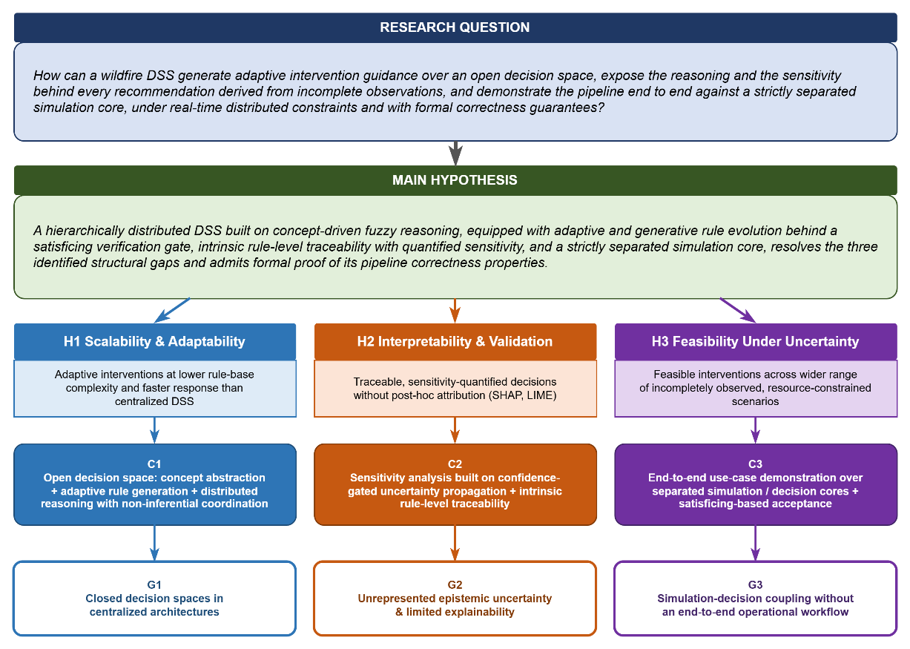
Fig. 2. Research question, structural gaps, and the contributions that address them.
TABLE II
Mapping of contributions to identified gaps
 | Addressed Gap | Contribution
C1 | G1: Closed decision spaces in centralized architectures | Open decision space through concept-based abstraction, adaptive rule generation, and hierarchically distributed reasoning with non-inferential global coordination
C2 | G2: Unrepresented epistemic uncertainty and limited explainability | Sensitivity analysis built on confidence-gated uncertainty propagation and intrinsic rule-level traceability
C3 | G3: Simulation-decision coupling without an end-to-end operational workflow | End-to-end use-case demonstration over analytically separated simulation and decision cores with satisficing-based acceptance

The remainder of this article is organized as follows. Section II reviews the background and the design rationale of the framework. Section III develops the method: the layered architecture, the concept hierarchy, the decision cost, and the staged adaptation of the decision space. Section IV reports the simulation test. Section V concludes the article and outlines future work.

II. Background

III. Method

IV. Simulation Test

V. Conclusion and Future Work

Acknowledgment
This work was informed by the authors' experience in the TeamAware project, funded by the European Union's Horizon 2020 research and innovation programme under Grant Agreement No. 101019808. The research reported in this paper was carried out independently and received no specific grant from any funding agency in the public, commercial, or not-for-profit sectors.

References
[1] R. H. Sprague and E. D. Carlson, "Building Effective Decision Support Systems," Englewood Cliffs: Prentice Hall, 1982.
[2] Power, "Decision support systems: Concepts and resources for managers," Quorum Books, 2002.
[3] R. Sharda, D. Delen and E. Turban, "Business Intelligence, Analytics, and Data Science: A Managerial Perspective," Pearson, 2018.
[4] R. L. Keeney and H. Raiffa, "Decisions with multiple objectives: preferences and value trade-offs," Wiley, 1976.
[5] S. French, J. Maule and N. Papamichail, "Decision Behaviour, Analysis and Support," Cambridge University Press, 2019.
[6] M. T. Ribeiro, S. Singh and C. Guestrin, "Why Should I Trust You?," ACM SIGKDD Conference, pp. 1135–1144, 2016.
[7] N. J. McNeese, B. G. Schelble, L. B. Canonico and M. Demir, "Who or what is my teammate? Team composition considerations in human–AI teaming," Human Factors, vol. 63, pp. 474-488, 2021.
[8] CRED/UCLouvain, "EM-DAT: The International Disaster Database," 2026.
[9] D. M. Bowman, C. A. Kolden, J. T. Abatzoglou, F. H. Johnston, G. R. van der Werf and M. Flannigan, "Vegetation fires in the Anthropocene," Nature Reviews Earth & Environment, vol. 1, pp. 500-515, 2020.
[10] UNEP, "Spreading like Wildfire: The Rising Threat of Extraordinary Landscape Fires," Geneva: United Nations Environment Programme (UNEP), 2022.
[11] M. P. Thompson and D. E. Calkin, "Uncertainty and risk in wildland fire management," Journal of Environmental Management, vol. 92, pp. 1895-1909, 2011.
[12] R. C. Rothermel, "A mathematical model for predicting fire spread in wildland fuels," Intermountain Forest & Range Experiment Station, Forest Service, US Department of Agriculture., 1972.
[13] M. A. Finney, "An overview of FlamMap fire modeling capabilities," Fuels Management — How to Measure Success: Conference Proceedings, pp. 213-220, 2006.
[14] R. E. Bellman and L. A. Zadeh, "Decision-making in a fuzzy environment," Management Science, vol. 17, pp. B141-B164, 1970.
[15] L. A. Zadeh, "Fuzzy sets," Information and Control, vol. 8, pp. 338-353, 1965.
[16] A. P. Pacheco, "Cohesive Fire Management within an Uncertain Environment: A Review of Risk Handling and Decision Support Systems," Forest Ecology and Management, vol. 347, pp. 1-17, 2015.
[17] F. Vásquez, "Decision support system development of wildland fire," Forests, vol. 12, pp. 943, 2021.
[18] E. K. Noonan-Wright et al., "Developing the US wildland fire decision support system," vol. 2011, pp. 168473, 2011.
[19] M. Mohammadi, A. A. Alesheikh and A. Alimohammadi, "Bridging spatiotemporal wildfire prediction and decision modeling using transformer networks and fuzzy inference systems," vol. 15, pp. 7542, 2025.
[20] J. Figueiredo, J. Macedo, J. Alves and A. Figueiredo, "Wildfire management decision support system for real-time fire behavior and weather analysis," vol. 15, pp. 509, 2024.
[21] S. D. Fillmore and T. B. Paveglio, "Use of the Wildland Fire Decision Support System (WFDSS) for full suppression and managed fires within the Southwestern Region of the US Forest Service," vol. 32, pp. 562-574, 2023.
[22] C. Rapp, E. Rabung, R. Wilson and E. Toman, "Wildfire decision support tools: An exploratory study of use in the United States," vol. 29, pp. 581-594, 2020.
[23] J. Malczewski, "GIS and multicriteria decision analysis," John wiley & sons, 1999.
[24] D. E. Calkin, C. D. O'Connor, M. P. Thompson and R. Stratton, "Strategic wildfire response decision support and the risk management assistance program," vol. 12, pp. 1407, 2021.
[25] D. Arnott and G. Pervan, "A critical analysis of decision support systems research," Journal of Information Technology, vol. 20, pp. 67-87, 2005.
[26] R. N. Anthony, "Planning and control systems: A framework for analysis," Harvard University Press, 1965.
[27] M. C. M. d. W. B. V. &. Y. X. Turoff, "The design of a dynamic emergency response management information system (DERMIS)," Journal of Information Technology Theory and Application (JITTA), vol. 5, pp. 3, 2004.
[28] M. Morgan and M. Henrion, "Uncertainty: A Guide to Dealing with Uncertainty in Quantitative Risk and Policy Analysis.," Cambridge university press, 1990.
[29] G. Shafer, "A Mathematical Theory of Evidence," Princeton University Press, 1976.
[30] T. Comes, M. Hiete, N. Wijngaards and F. Schultmann, "Decision maps: A framework for multi-criteria decision support under severe uncertainty," Decision Support Systems, vol. 52, pp. 108-118, 2011.
[31] J. M. Mendel, "Uncertain rule-based fuzzy systems," Springer, 2017.
[32] C. A. Schultz, L. F. Miller, S. M. Greiner and C. Kooistra, "A qualitative study on the US Forest Service's risk management assistance efforts to improve wildfire decision-making," vol. 12, pp. 344, 2021.
[33] R. Sugumaran and J. Degroote, "Spatial decision support systems: principles and practices," Crc Press, 2010.
[34] C. Pais, J. Carrasco, P. E. Moudio and Z. M. Shen, "Downstream protection value: Detecting critical zones for effective fuel-treatment under wildfire risk," vol. 90, pp. 101703, 2021.
[35] D. L. Martell, "Forest fire management," Handbook of operations research in natural resources, pp. 489-509, 2007.
[36] T. M. Oliveira, A. M. G. Barros, A. A. Ager and P. M. Fernandes, "Wildfire spread and resource allocation: Using spatially explicit models to address operational decision-making," vol. 506, pp. 119952, 2022.
[37] T. Takagi and M. Sugeno, "Fuzzy identification of systems and its applications to modeling and control," IEEE Transactions on Systems, Man, and Cybernetics, vol. 15, pp. 116-132, 1985.
[38] H. A. Simon, "Rational choice and the structure of the environment," Psychological Review, vol. 63, pp. 129-138, 1956.


Çağlar Akman received the B.S. and M.S. degrees in Electrical and Electronics Engineering from the Middle East Technical University (METU), Ankara, Türkiye, in 2008 and 2017, respectively, where he is currently pursuing the Ph.D. degree.
He is currently the Senior Principal Team Manager of the Modeling and Sensor Technologies at HAVELSAN, Ankara, Türkiye, where he manages national and international research and development projects of advanced sensor systems, decision support architectures, and intelligent automation technologies. Over the past 10 years, he has acquired extensive experience in leading multidisciplinary R&D initiatives, managing national and international research collaborations, and coordinating complex technical projects across multiple organizations and consortia.
He serves as an Industrial Reviewer for TÜBİTAK (Turkish Scientific and Technical Research Council), evaluating research proposals across multiple research domains. He also performs peer review for IEEE Transactions and related journals, contributing to the quality assurance of peer-reviewed literature. Additionally, he has been a part-time lecturer at Atılım University. His research interests, expertise, and professional recognition reflect a strong commitment to advancing the fields of artificial intelligence, autonomous systems, decision support technologies, and sensor fusion in both civilian and defense applications.

Kemal Leblebicioğlu received his Ph.D. from the Department of Mathematics of the Middle East Technical University (METU), in 1988.
He has been a full professor in the Department of Electrical and Electronics Engineering of METU since 1999. He has a background in optimization, optimal control theory, computer vision, intelligent systems, flight control, walking robots, and unmanned vehicles.
Dr. Leblebicioğlu has been a member of numerous international program committees and has been (co-) author of more than 40 journal papers, book chapters, and numerous conference papers. He is on several IFAC technical committees. He was the editor of the journal ELEKTRIK published by TÜBİTAK (Turkish Scientific and Technical Research Council) from 1996 to 2009. He is on the editorial board of several Turkish technical journals. He organized an international workshop on computer vision and intelligent systems and two national conferences on control.
He conducted several R&D projects as project leader and researcher and gave consultancy to BİLTEN (TÜBİTAK’s Research Center on Electronics and Information Technologies), 3rd Supply and Maintenance Center of Turkish Air Forces (Ankara), TÜBİTAK-İltaren, and to ASELSAN on the topic of “real time automatic visual tracking of targets.” Now he is studying unmanned vehicles, in particular, unmanned air and underwater vehicles.
He completed a project (supported by TÜBİTAK) on the construction of a special unmanned under-sea vehicle, called ULISAR, which is a mixture of an ROV and a fully automated system. He completed a project, also supported by TÜBİTAK, on the coordinated guidance of multiple unmanned air vehicles.

Çağlar Akman and Kemal Leblebicioğlu are with the Department of Electrical and Electronics Engineering, Middle East Technical University, 06800 Ankara, Türkiye.

