TEZ ŞABLONU ONAY FORMU
THESIS TEMPLATE CONFIRMATION FORM.

- Şablonda verilen yerleşim ve boşluklar değiştirilmemelidir. |  |  | - Do not change the spacing and placement in the template.
- Jüri tarihi Başlık Sayfası, İmza Sayfası, Abstract ve Öz’de ilgili yerlere yazılmalıdır. |  |  | - Write defense date to the related places given on Title page, Approval page, Abstract and Öz.
- İmza sayfasında jüri üyelerinin unvanları doğru olarak yazılmalıdır. Tüm imzalar mavi pilot kalemle atılmalıdır. |  |  | - Write the titles of the examining committee members correctly on Approval Page. Blue ink must be used for all signatures.
- Disiplinlerarası programlarda görevlendirilen öğretim üyeleri için jüri üyeleri kısmında tam zamanlı olarak çalıştıkları anabilim dalı başkanlığının ismi yazılmalıdır. Örneğin: bir öğretim üyesi Biyoteknoloji programında görev yapıyor ve biyoloji bölümünde tam zamanlı çalışıyorsa, İmza sayfasına biyoloji bölümü yazılmalıdır. |  |  | - For faculty members working in interdisciplinary programs, the name of the department that they work full-time should be written on the Approval page. For example, if a faculty member staffs in the biotechnology program and works full-time in the biology department, the department of biology should be written on the approval page.
- Tezin son sayfasının sayfa numarası Abstract ve Öz’de ilgili yerlere yazılmalıdır. |  |  | - Write the page number of the last page in the related places given on Abstract and Öz pages.
- Bütün chapterlar, referanslar, ekler ve CV sağ sayfada başlamalıdır. Bunun için kesmeler kullanılmıştır. Kesmelerin kayması fazladan boş sayfaların oluşmasına sebep olabilir. Bu gibi durumlarda paragraf (¶) işaretine tıklayarak kesmeleri görünür hale getirin ve yerlerini kontrol edin. |  |  | - All chapters, references, appendices and CV must be started on the right page. Section Breaks were used for this. Change in the placement of section breaks can result in extra blank pages. In such cases, make the section breaks visible by clicking paragraph (¶) mark and check their position.
- Figürler ve tablolar kenar boşluklarına taşmamalıdır. |  |  | - All figures and tables must be given inside the page. Nothing must appear in the margins.
- Şablonda yorum olarak eklenen uyarılar dikkatle okunmalı ve uygulanmalıdır. |  |  | - All the warnings given on the comments section through the thesis template must be read and applied.
- Tez yazdırılmadan önce PDF olarak kaydedilmelidir. Şablonda yorum olarak eklenen uyarılar PDF dokümanında yer almamalıdır. |  |  | - Save your thesis as pdf and Disable all the comments before taking the printout.
- Tez taslaklarının kontrol işlemleri tamamlandığında, bu durum öğrencilere METU uzantılı öğrenci e-posta adresleri aracılığıyla duyurulacaktır. |  |  | - This will be announced to the students via their METU students e-mail addresses when the control of the thesis drafts has been completed.
- Tez yazım süreci ile ilgili herhangi bir sıkıntı yaşarsanız, Sıkça Sorulan Sorular (SSS) sayfamızı ziyaret ederek yaşadığınız sıkıntıyla ilgili bir çözüm bulabilirsiniz. |  |  | - If you have any problems with the thesis writing process, you may visit our Frequently Asked Questions (FAQ) page and find a solution to your problem.

☒ | Yukarıda bulunan tüm maddeleri okudum, anladım ve kabul ediyorum. / I have read, understand and accept all of the items above.  Name : Çağlar  Surname : Akman  E-Mail : caglar.akman@metu.edu.tr; e134113@metu.edu.tr  Date :  Signature : ________________________

ENHANCED DECISION SUPPORT SYSTEM FOR WILDFIRE DISASTER RESPONSE AND MANAGEMENT (DISASTERAWARE)

A THESIS SUBMITTED TO
THE GRADUATE SCHOOL OF NATURAL AND APPLIED SCIENCES
OF
MIDDLE EAST TECHNICAL UNIVERSITY

BY

ÇAĞLAR AKMAN

IN PARTIAL FULFILLMENT OF THE REQUIREMENTS
FOR
THE DEGREE OF DOCTOR OF PHILOSOPHY
IN
ELECTRICAL AND ELECTRONIC ENGINEERING

[DEFENSE DATE]
Approval of the thesis:

ENHANCED DECISION SUPPORT SYSTEM FOR WILDFIRE DISASTER RESPONSE AND MANAGEMENT (DISASTERAWARE)

submitted by NAME SURNAME in partial fulfillment of the requirements for the degree of Doctor of Philosophy in Electrical and Electronic Engineering, Middle East Technical University by,

Prof. Dr. Naci Emre Altun
Dean, Graduate School of Natural and Applied Sciences

Prof. Dr. Nevzat Güneri Gençer
Head of the Department, Electrical and Electronics Engineering

Prof. Dr. Mehmet Kemal Leblebicioğlu
Supervisor, Electrical and Electronics Engineering, METU

Examining Committee Members:

Prof. Dr. Nevzat Güneri Gençer
Electrical and Electronics Engineering, METU

Prof. Dr. Mehmet Kemal Leblebicioğlu
Electrical and Electronics Engineering, METU

Prof. Dr. XYZ
Electrical and Electronics Engineering, METU

Prof. Dr. XYZ
Electrical and Electronics Engineering, METU

Assoc. Prof. Dr. Ahmet Güneş
Electrical and Electronics Engineering, XYZ

Date: ...

I hereby declare that all information in this document has been obtained and presented in accordance with academic rules and ethical conduct. I also declare that, as required by these rules and conduct, I have fully cited and referenced all material and results that are not original to this work.

Name Last name : Çağlar Akman
Signature :

ABSTRACT

ENHANCED DECISION SUPPORT SYSTEM FOR WILDFIRE DISASTER RESPONSE AND MANAGEMENT (DISASTERAWARE)

Akman, Çağlar
Doctor of Philosophy, Electrical and Electronic Engineering
Supervisor : Prof. Dr. Mehmet Kemal Leblebicioğlu

[Defense Date], 181

Wildfire response demands rapid decisions over a large, fast-changing area under incomplete and delayed observation, where centralized fixed-rule systems scale poorly and cannot adapt as a fire evolves. This thesis develops DisasterAware, a distributed, concept-driven fuzzy decision support framework for wildfire response. The domain is split into local agents that perform all inference on their own region, coordinated by a non-inferential global layer that ranks regions by operational priority and allocates shared capacity. Each agent turns ten confidence-gated observation features into five decision concepts through a feature-concept hierarchy, and a sparse zero-order Takagi-Sugeno rule base maps them to six intervention families, which cuts the antecedent space from millions of combinations to hundreds. A staged adaptation loop keeps the decision space open by tuning rules, increasing linguistic resolution, and, where the base has no answer, calling a pretrained large language model as a schema-constrained proposer, admitting each proposal only after verification gates and a satisficing test. A graduated fail-safe and a no-harm guard protect life-safety orders and withhold any plan forecast to worsen the outcome, while explicit concepts and rules make every decision traceable and auditable with operator override. The framework is built on a coupled wildfire simulation environment designed for testability. [Placeholder: quantitative results against a centralized baseline and a sensitivity analysis, to be added once the simulation study is complete.]

Keywords: Wildfire decision support system, Distributed multi-agent reasoning, Concept-driven Takagi-Sugeno fuzzy inference, Open decision space with generative rule proposal and verification, Explainable and uncertainty-aware decision support system

ÖZ

ORMAN YANGINI AFET MÜDAHALE VE YÖNETİMİ İÇİN GELİŞTİRİLMİŞ KARAR DESTEK SİSTEMİ (DISASTERAWARE)

Akman, Çağlar
Doktora, Elektrik ve Elektronik Mühendisliği
Tez Yöneticisi: Prof. Dr. Mehmet Kemal Leblebicioğlu

[Jüri Tarihi], 181

Orman yangını müdahalesi, eksik ve gecikmeli gözlem altında hızla değişen geniş bir alanda hızlı kararlar gerektirir; merkezi ve sabit-kurallı sistemler bu ölçekte iyi çalışmaz ve yangın geliştikçe uyum sağlayamaz. Bu tez, orman yangını müdahalesi için dağıtık, kavram-güdümlü bulanık bir karar destek çerçevesi olan DisasterAware'i geliştirir. Alan, tüm çıkarımı kendi bölgesinde yapan yerel ajanlara bölünür; bunları, bölgeleri operasyonel önceliğe göre sıralayıp ortak kapasiteyi paylaştıran, çıkarım yapmayan bir küresel katman koordine eder. Her ajan, güven-kapılı on gözlem özniteliğini bir öznitelik-kavram hiyerarşisi üzerinden beş karar kavramına dönüştürür; seyrek, sıfırıncı dereceden bir Takagi-Sugeno kural tabanı bu kavramları altı müdahale ailesine eşler ve öncül uzayını milyonlarca bileşimden yüzlere indirir. Aşamalı bir uyarlama döngüsü karar uzayını açık tutar: kuralları ayarlar, dilsel çözünürlüğü artırır ve tabanın yanıtı olmadığında önceden eğitilmiş büyük bir dil modelini şema-kısıtlı bir öneri üreticisi olarak çağırır; her öneri yalnızca doğrulama kapıları ve bir satisficing testinden sonra kabul edilir. Kademeli bir fail-safe ve bir no-harm koruması can güvenliği emirlerini korur ve sonucu kötüleştirmesi öngörülen planları geri çeker; açık kavramlar ve kurallar her kararı izlenebilir ve denetlenebilir kılar, operatör geçersiz kılabilir. Çerçeve, test edilebilirlik için tasarlanmış eşleşik bir orman yangını simülasyon ortamı üzerine kuruludur. [Yer tutucu: merkezi bir temel yöntemle karşılaştırma ve duyarlılık analizi sonuçları, simülasyon çalışması tamamlandığında eklenecektir.]

Anahtar Kelimeler: Orman yangını karar destek sistemi, Dağıtık çok-ajanlı akıl yürütme, Kavram-güdümlü Takagi-Sugeno bulanık çıkarım, Üretken kural önerisi ve doğrulama ile açık karar uzayı, Açıklanabilir ve belirsizliğe duyarlı karar destek sistemi

To my beloved wife Emine and our sons Kuzey, Rüzgar, and Atlas for their endless love, patience, and encouragement. You are my calm after every storm.

ACKNOWLEDGMENTS

I would like to express my deepest gratitude to my supervisor, Prof. Dr. Mehmet Kemal Leblebicioğlu, for his invaluable guidance, patience, and continuous support throughout this research. His insightful feedback, constructive criticism, and calm mentorship have shaped both this dissertation and my professional perspective. His encouragement, especially during times of fatigue and uncertainty, always inspired me to stand up again and move forward with renewed determination.
I would also like to express my sincere appreciation to Dr. Tolga Sönmez for his thoughtful suggestions, constructive approach, and valuable guidance throughout this study. His perspective and contributions have greatly enhanced the academic and methodological depth of this work.
I would also like to extend my heartfelt thanks to İlayda and Furkan for their sincere support and companionship throughout this journey. They believed in me and inspired me with their trust and shared vision. I see them not only as colleagues but as true siblings walking the same path toward growth and purpose.
Finally, and most importantly, I owe my deepest gratitude to my wife, Emine, and my sons, Kuzey, Rüzgar, and Atlas. This achievement would not have been possible without their love, patience, and sacrifices.
Emine, the love of my life, not only stood beside me but also organized, managed, and coordinated every aspect of our family life so that I could devote myself fully to this doctoral journey. Her unwavering support and understanding kept everything together when the demands of research were overwhelming.
To my sons, Kuzey, Rüzgar, and Atlas, I hope this dissertation serves as an example that perseverance and discipline can turn even the most challenging dreams into reality. You are my greatest inspiration and the true meaning behind this effort.
Thank you all, this accomplishment belongs as much to you as it does to me.

TABLE OF CONTENTS
ABSTRACT v
ÖZ vii
ACKNOWLEDGMENTS x
TABLE OF CONTENTS xi
LIST OF TABLES xv
LIST OF FIGURES xvii
LIST OF ABBREVIATIONS xx
LIST OF SYMBOLS xxii
1 INTRODUCTION 1
1.1 Gap Analysis 3
1.2 Research Question and Hypothesis 7
1.3 Main Contributions of the Thesis 8
1.4 Organization of the Thesis 12
2 BACKGROUND INFORMATION 15
2.1 Wildfire Dynamics and Spread Modeling 15
2.1.1 Drivers of Fire Behavior 15
2.1.2 Families of Spread Models 16
2.1.3 Requirements of the Decision Layer on the Spread Model 17
2.2 Decision Support Foundations 18
2.2.1 Core Elements of Decision Support Systems 18
2.2.2 Closed versus Open Decision Spaces 20
2.2.3 Centralized and Distributed Decision Support Architectures 21
2.3 The Input Space: Heterogeneous Sensing to Observation Features 22
2.4 Concept-Driven Fuzzy Reasoning 25
2.4.1 Linguistic Uncertainty and Fuzzy Inference 26
2.4.2 Mamdani and Takagi-Sugeno Inference: Mechanism and Choice 28
2.4.3 The Rule Explosion Problem 31
2.4.4 Concepts as an Intermediate Abstraction 31
2.5 The Decision Space: Actions and Their Evaluation 33
2.5.1 Actions and Interventions in Wildfire Decision Support 34
2.5.2 Decision Cost and Its Components 36
2.5.3 Satisficing Acceptance and the Graduated Fail-Safe 39
2.5.4 Epistemic Uncertainty, Traceability, and Sensitivity 40
2.5.5 Generative Models and Large Language Models 41
2.5.6 Adaptive and Generative Decision Loops 42
3 DISASTERAWARE SIMULATION FRAMEWORK 45
3.1 Overall System Block Diagram 46
3.2 Simulation Input and External Sources 49
3.2.1 Meteorology Data Layer 50
3.2.2 Topography Data Layer 51
3.2.3 Fuel Data Layer 52
3.2.4 Ignition Layer 53
3.2.5 Decisional Data Layers 53
3.3 Simulation Core 57
3.3.1 Spatio-Temporal State Transition 57
3.3.2 Hybrid Fire Spread Model 58
3.3.3 Mathematical Formulation of Interaction and Scenario Control 66
3.4 Decision Support System Core 69
4 DISASTERAWARE DECISION SUPPORT FRAMEWORK 71
4.1 Decision Support System Block Diagram 72
4.2 Layer 1: Input Space 73
4.3 Layer 2: Observation, Features, and Confidence 74
4.4 Layer 3: Concept Space and the Feature-Concept Hierarchy 76
4.5 Layer 4: Decision Generation and Coordination 81
4.5.1 Rule Base and Candidate Intervention 85
4.5.2 Cost, Quality, and the Satisficing Test 88
4.5.3 Open Decision Space: Staged Adaptation 92
4.6 Local Layer, Graduated Fail-Safe, Global Coordination 104
5 SIMULATION AND PERFORMANCE RESULTS 109
5.1 Evaluation Criteria for Wildfire Decision Support Systems 109
5.2 Simulation Environment, Parameters, and Assumptions 111
5.3 Validation of the Simulation Core Against Historical Fires 114
5.4 Performance of the Decision Layer 118
5.4.1 Evaluation Scenarios 119
5.4.2 Improvement Ladder: Cost and Suppression Performance 122
5.4.3 Evolving-Fuzzy Adaptation: What Changed and What It Bought 136
5.4.4 Generative Adaptation: What Was Produced and What It Bought 139
5.5 Sensitivity Analysis 143
5.6 Compliance with the Evaluation Criteria and Chapter Summary 146
6 CONCLUSION AND FUTURE WORKS 147
6.1 Conclusions 147
6.2 Future Works 147
REFERENCES 149
APPENDICES 161
A. Simulation Mathematics for Evolution of Burning Status 161
B. Simulation Mathematics for Fuel Mass Evolution 164
C. Simulation Mathematics for Fire Intensity Evolution 169
D. Complete Concept Mapping Specification 171
E. Representative Decision Rules 173
F. Generative AI Prompt Specifications 175
CURRICULUM VITAE 179

LIST OF TABLES
Table 1.1 DSS gaps identified in wildfire decision support literature 4
Table 1.2 Mapping of thesis contributions to identified gaps 9
Table 2.1 The ten observation features, their sources, and their rationale 23
Table 2.2 Mamdani and zero-order Takagi-Sugeno inference compared 29
Table 2.3 Operational questions and the decision concepts derived from them 32
Table 2.4 Intervention types, representative orders, and input-level effects 34
Table 2.5 Decision cost components, their scope, and their rationale 37
Table 2.6 Scope of traceability and sensitivity analysis 41
Table 3.1 Meteorology data layer parameters 51
Table 3.2 Geometry (topography) data layer parameters 52
Table 3.3 Fuel data layer parameters 53
Table 3.4 Value data layer parameters 55
Table 3.5 Resource data layer parameters 56
Table 3.6 Admissible transformations of interaction operator 67
Table 4.1 Confidence factors: definition, range, and determination 74
Table 4.2 Full enumeration versus the sparse evolving base 87
Table 4.3 Designated mapping between decision concepts and intervention types 87
Table 4.4 The two acceptance tests and the consequence of failure. 92
Table 5.1 Evaluation criteria for wildfire DSS 110
Table 5.2 Simulation and decision parameters of all experiments 112
Table 5.3 Environment and decision layer assumptions 113
Table 5.4 Historical validation cases and their configuration 115
Table 5.5 Hindcast agreement metrics per historical case (mean over stochastic replicates) 117
Table 5.6 DSS test configurations 118
Table 5.7 Evaluation scenarios 120
Table 5.8 Physical outcome per scenario and configuration before the six-hour checkpoint per scenario 123
Table 5.9 Decision-cost terms at the six-hour checkpoint per scenario and configuration; the response and delay terms of $Test0$ are undefined by construction 128
Table 5.10 Representative rows of the evFIS modification records 136
Table 5.11 The generative product ledger: every vocabulary object created in the recorded runs, its definition over the closed basis, its birth moment and cost deficit, and the admitted rule that uses it. 141
Table 5.12 Five of the forty-two admitted generative rules, verbatim. G4–G9 consume generated macro interventions; G13 fires on the generated concept interface_exposure. 142
Table 5.15 Sensitivity design: parameters, symbols, base values, and ranges. 144
Table A.1 Spread rate parameters for each fuel type 163
Table B.1 Baseline combustion coefficients per fuel type 165
Table B.2 Suppression mapping calibration parameters 168
Table C.1 Fire intensity evolution parameters 169
Table D.1 Level 1 to 4 aggregation weights over the previous levels 171
Table D.2 Parameters of the concept layer 172
Table D.3 Trapezoidal parameters 172
Table E.1 Representative decision rules by operational regime 174

LIST OF FIGURES
Figure 1.1 Global trend in reported natural disasters, 1900 to 2022 2
Figure 1.2 Research question, hypothesis, gaps and contributions 12
Figure 2.1 Coupling between fire behavior, the grid state, and the decision layer 18
Figure 2.2 Information flow in centralized and distributed DSS architectures 22
Figure 2.3 Five-term trapezoidal membership partition with an example reading 27
Figure 2.4 Mamdani and zero-order Takagi-Sugeno inference pipelines 30
Figure 2.5 Staged adaptation loop with generative proposal and verification 43
Figure 3.1 DisasterAware system block diagram (simulation focused) 47
Figure 3.2 Grid domain representation and per-cell state structure 58
Figure 3.3 State transition block diagram 59
Figure 3.4 Wind-dependent directional propagation into target cell 61
Figure 3.5 DSS Simulation Core Interface 69
Figure 4.1 DisasterAware system block diagram (DSS focused) 72
Figure 4.2 Feature-concept hierarchy 77
Figure 4.3 Hierarchical concept activation example. 79
Figure 4.4 Confidence gating (a) persistence decay (b) 80
Figure 4.5 Layer 4 decision and adaptation flow 81
Figure 4.6 Consequent step and boundary shift 95
Figure 4.7 Resolution increase, rule instantiation and term insertion 96
Figure 4.8 Generative proposal and the verification gates 97
Figure 4.9 Package objects: (a) macro intervention and (b) intermediate concept 99
Figure 4.10 Local decision and graduated fail-safe 104
Figure 4.11 Global coordination and the no-harm fail-safe 106
Figure 4.12 Example of local decisions, global coordination, and the fail-safe 107
Figure 5.1 Agreement maps for the historical hindcasts (Green: Correctly predicted burn, Red: Simulated only, Blue: observed only, Yellow: Ignition) 118
Figure 5.2 Representative world of S1 (left) and S2 (right) 121
Figure 5.3 Representative world of S3 (left) S4 (right) 121
Figure 5.4 Sample interventions (full set) on a representative world 121
Figure 5.5 Legends for representative world 122
Figure 5.6 Burned-area, burned-forest, and affected population evolution of the five configurations under the five scenarios for S1 124
Figure 5.7 Burned-area, burned-forest, and affected population evolution of the five configurations under the five scenarios forS2 125
Figure 5.8 Burned-area, burned-forest, and affected population evolution of the five configurations under the five scenarios for S3 126
Figure 5.9 Burned-area, burned-forest, and affected population evolution of the five configurations under the five scenarios for S4 127
Figure 5.10 Burned-area, burned-forest, and affected population evolution of the five configurations under the five scenarios for S5 128
Figure 5.11 Total cost evolution of the five configurations under the five scenarios for S1 130
Figure 5.11 Total cost evolution of the five configurations under the five scenarios for S2 130
Figure 5.11 Total cost evolution of the five configurations under the five scenarios for S3 131
Figure 5.11 Total cost evolution of the five configurations under the five scenarios for S4 131
Figure 5.11 Total cost evolution of the five configurations under the five scenarios for S5 132
Figure 5.11 Physical cost evolution of the five configurations under the five scenarios for S1 132
Figure 5.11 Physical cost evolution of the five configurations under the five scenarios for S2 133
Figure 5.11 Physical cost evolution of the five configurations under the five scenarios for S3 133
Figure 5.11 Physical cost evolution of the five configurations under the five scenarios for S4 134
Figure 5.11 Physical cost evolution of the five configurations under the five scenarios for S5 134
Figure 5.11 Average physical cost evolution of the five configurations under the five scenarios 135
Figure 5.11 Average total cost evolution of the five configurations under the five scenarios 135
Figure 5.8 Anatomy of acceptance in one recorded run (154 decision cycles, minimal five-rule seed, full staged adaptation). At every cycle the candidate orders are tested against the no-action forecast; the vertical marks are the fourteen accepted trials (twelve stage-① consequent steps, two stage-② instantiations). The candidate total cost may sit above the no-action total because it is charged for its own response; the realized physical cost is what the orders buy, which is exactly the two-basis rule of Section 5.4. 138
Figure 5.9 Adaptation funnels over the recorded runs. Left: evolving-fuzzy trials and acceptances per stage. Right: the generative gate cascade over 230 proposals; every rejection is logged with its gate and reason. 139
Figure 5.10 Left: composition weights of the seven generated macro interventions over the base physical channels. Right: cumulative forecast improvement of accepted trials by stage over the recorded runs (stage ①: −1.61 over 119 acceptances; stage ②: −0.67 over 40; stage ③: −0.15 over 47). 142
Figure 5.17 Sensitivity of the physical cost to each parameter, ranked by the spread over its range. 144
Figure 5.18 Physical cost against (a) resource level and (b) fire load, showing the capacity-limited transition. 145
Figure 5.19 (a) Physical cost is robust to the decision thresholds; (b) the fail-safe engagement responds to η. 146

LIST OF ABBREVIATIONS
AAR | : | After action review
AI | : | Artificial intelligence
DEM | : | Digital elevation model
CI | : | Confidence interval
DSS | : | Decision support system
evFIS | : | Evolving fuzzy inference system
FAR | : | False alarm ratio
FIS | : | Fuzzy inference system
GIS | : | Geographic information system
HIL | : | Human-in-the-loop
IoU | : | Intersection over union (Jaccard index)
MAE | : | Mean absolute time
MF | : | Membership function
ML | : | Machine learning
LIME | : | Local interpretable model-agnostic explanations
LLM | : | Large language model
LoS | : | Line of sight
OAT | : | One-at-a-time (sensitivity design)
POD | : | Probability of detection
RCA | : | Root cause analysis
RL | : | Reinforcement learning
ROS | : | Rate of spread
SHAP | : | Shapley additive explanations
UI | : | User interface
VIIRS | : | Visible infrared imaging radiometer suite
WFDSS | : | Wildfire decision support system
WUI | : | Wildland-urban interface

LIST OF SYMBOLS
The following list defines all symbols used in this thesis, organized by functional category. Four notational conventions apply throughout: subscript k denotes the discrete time step; arguments (x, y) denote the grid cell; superscript i identifies the operational region; a hat accent (̂) indicates an observed estimate; and an overbar (̅) indicates a confidence-gated or spatially averaged quantity.
1. Fire State and Propagation Variables
$$B_{k}(x,y)$$ | Burning status indicator
$$B_{k+1}^{pers}(x,y)$$ | Burning persistence term
$$B_{k+1}^{prop}(x,y)$$ | Burning propagation term
$$F_{burn,k}(x,y)$$ | Fractional burn rate
$$I_{k}(x,y)$$ | Local fire intensity proxy
$$I_{Ign,k}(x,y)$$ | External ignition injection indicator
$$R_{spread,k}(x,y)$$ | Rate of spread at time step $k$
$$τ_{k}(x,y)$$ | Time since ignition
$$Ψ_{k}(x,y)$$ | Propagation influence
$$Θ_{ign}$$ | Ignition threshold
$$Φ$$ | State transition operator
2. Fuel Variables
$$F_{load,k}(x,y)$$ | Available combustible fuel mass
$$F_{moist,k}(x,y)$$ | Surface fuel moisture
$$F_{red,k}(x,y)$$ | Suppression-induced fuel reduction
$$F_{type}(x,y)$$ | Fuel type classification
$$U_{Fuel,k}(x,y)$$ | Fuel-related input
$$ε_{fuel_load}$$ | Fuel extinction threshold
3. Terrain / Geographic Variables
$$G_{access}(x,y)$$ | Terrain accessibility index
$$G_{aspect}(x,y)$$ | Terrain orientation (aspect)
$$G_{elev}(x,y)$$ | Terrain elevation
$$G_{slope}(x,y)$$ | Terrain slope
$$U_{Geo}(x,y)$$ | Terrain-related input
4. Meteorological Variables
$$W_{gust,k}(x,y)$$ | Wind gust field
$$W_{prec,k}$$ | Precipitation (domain-uniform scalar, no spatial variation)
$$W_{rh,k}(x,y)$$ | Relative humidity field
$$W_{temp,k}(x,y)$$ | Air temperature field
$$W_{wd,k}(x,y)$$ | Wind direction field
$$W_{ws,k}(x,y)$$ | Wind speed field
$$U_{Meteo,k}(x,y)$$ | Meteorological input
$$δ_{Meteo}$$ | Meteorological perturbation applied by operator
5. Value / Asset Variables
$$V_{bld}(x,y)$$ | Building footprint indicator
$$V_{crit}(x,y)$$ | Critical facility index
$$V_{evac}^{norm}(x,y)$$ | Accessibility to evacuation routes
$$V_{pop}^{norm}(x,y)$$ | Population density at grid cell (person/km²)
$$V_{prio}(x,y)$$ | Asset priority index
$$U_{Val,k}(x,y)$$ | Value-related contextual input
$$σ_{Val}$$ | Value priority scaling factor in $Θ_{UI}$
6. Resource / Suppression Variables
$$C_{k}$$ | Total available resource capacity
$$D_{k}$$ | Total integrated intervention demand over the domain at step $k$
$$M$$ | Number of intervention types
$$R_{avail,k}(x,y)$$ | Operational availability of suppression resources
$$R_{cap,k}(x,y)$$ | Available suppression capacity
$$R_{eff,k}(x,y)$$ | Nominal suppression effectiveness
$$R_{time,k}(x,y)$$ | Estimated travel time for suppression resources
$$U_{Res,k}(x,y)$$ | Resource-related contextual input
$$u_{k,m}^{i}(x,y)$$ | Candidate intervention degree for type m in region i
$$α_{m}$$ | Priority weight for intervention type m
$${\bar{α}}_{m}$$ | Normalized priority weight for intervention type m
$$δ_{Res}(x,y)$$ | Resource availability perturbation applied by operator
$$η_{cap,k}$$ | Normalized suppression capacity factor
$$η_{avail,k}$$ | Normalized resource availability factor
$$η_{reach,k}$$ | Reachability (travel-time) factor
$$η_{eff,k}$$ | Suppression effectiveness factor
$$E_{int}$$ | Expected intervention effectiveness of the staged resource pool (risk-weighted reach × capacity product)
7. Observation / Sensing Variables
$$O_{k}^{i}(x,y)$$ | Region-specific observable information at time step k
$$O_{k}(x,y)$$ | Observable information at time step $k$
$$h(•)$$ | Observation process
$$h^{i}(•)$$ | Region-specific observation function for $Ωᵢ$
$$γ_{k}^{i}$$ | Communication reliability factor for region i
$$ε_{k}^{i}\left(x,y\right)$$ | Observation uncertainty
8. Spatial Domain / Grid Variables
$$G$$ | Spatial grid domain
$$N$$ | Total number of operational regions / local agents
$$N_{x}$$ | Number of grid cells along the horizontal axis
$$N_{y}$$ | Number of grid cells along the vertical axis
$$N^{8}(x,y)$$ | 8-connected neighborhood
$$S_{k}(x,y)$$ | Wildfire system state over spatial grid at time step k
9. Decision Support System (DSS) Variables
$$F_{DSS,k}$$ | Contextual input set
$$F_{DSS,k}^{*}$$ | UI-modified decision-context set at step k
$$F_{in,k}$$ | External input set
$$F_{in,k}^{*}$$ | UI-modified external input set at step k
$$U_{DSS,k}(x,y)$$ | DSS-generated intervention input parameters
$$U_{DSS,k}^{i}\left(x,y\right)$$ | Regional intervention output from agent $i$
$$U_{DSS,k}^{m}\left(x,y\right)$$ | Per-intervention-type global intervention field
$$U_{DSS,k}^{final}\left(x,y\right)$$ | Final intervention
$$U_{DSS,safe}$$ | Conservative baseline intervention under fail-safe policy
$$U_{DSS}$$ | Feasible intervention space
$$U_{Ign,k}(x,y)$$ | Ignition input
$$π_{DSS}^{i}$$ | Regional decision-support mapping
$$ζ_{k}$$ | Mean resource sufficiency ratio
$${\bar{s}}_{k}^{*}$$ | Mean resource sufficiency ratio
$$δ_{DSS}(x,y)$$ | Resource parameter perturbation applied by operator
$$δ_{Ign}(x,y)$$ | Ignition perturbation applied by operator
$$λ_{k}$$ | Fail-safe blending factor between the DSS decision and the conservative baseline
$$Θ_{UI}$$ | User interaction operator
$$θ_{k}$$ | Satisficing acceptance threshold
$$θ_{min}$$ | Lower bound of adaptive acceptance threshold
$$θ_{max}$$ | Upper bound of adaptive acceptance threshold
10. Fuzzy Logic Variables
$$N_{concept}$$ | Number of situational concepts
$$N_{feature}$$ | Number of input features
$$μ_{k}^{i}$$ | Membership matrix for region $i$ at step k
$$μ_{k,n,l}^{i}$$ | Membership degree
$$v_{R}$$ | Singleton consequent value for rule R
$$α_{R}$$ | Activation strength of rule R = min over antecedent membership
$$w_{j}$$ | Criterion weight for $f_{eval}$
11. Functions / Mappings
$$f_{intensity}$$ | Fire intensity approximation function
$$f_{ros}$$ | Rate-of-spread mapping function
$$f_{supp}$$ | Suppression-to-mitigation mapping
$$g_{dir,k}$$ | Directional spread weighting factor
12. Feature Variables and Parameters
$$z_{k,l}^{i}(x,y)$$ | $l^{th}$ feature at $(x,y)$, region $i$, step $k$; $z ∈ [0,1]$, $l = 1…10$
$$β_{t}$$ | Travel-time decay coefficient
$$Δt$$ | Simulation time step
$$δ$$ | Admission margin of the generative verification gates (δ ≥ 0)
13. Decision Cost and Quality Variables
$$J$$ | Total normalized decision cost (weighted sum of cost terms)
$$J_{phys}$$ | Physical decision cost (burned area, asset loss, population)
$$J_{burn}$$ | Burned-area cost term
$$J_{asset}$$ | Asset-loss cost term
$$J_{pop}$$ | Population-exposure cost term
$$J_{resp}$$ | Response cost term
$$J_{delay}$$ | Response-delay cost term
$$Q_{k}$$ | Decision quality at step k
$$N_{term}$$ | Number of linguistic terms per fuzzy variable
$$N_{input}$$ | Number of rule antecedent inputs
$$a_{k}^{eff}$$ | Gated concept activation at step k
$$a_{k}^{obs}$$ | Observation-based concept activation at step k
$$a_{k}^{per}$$ | Persistence-prior concept activation at step k
$$e_{k}$$ | Contextual-bandit state (deficit band and coverage-gap flag)
$$q_{k}$$ | Selected adaptation stage (contextual-bandit action)
$$η$$ | Quality gate for the graduated fail-safe (accept if $Q_{k} ≥ η$)
$$φ_{(i,j)}$$ | Bearing angle from cell (i,j) toward (x,y) in directional spread

INTRODUCTION
Decision makers in disaster response and other critical domains must combine many streams of information under uncertainty, time pressure, and resource limits, and a poor decision can have irreversible consequences. Decision Support Systems (DSS) are designed to extend the range of information an operator can weigh under such pressure (Sprague & Carlson, 1982; Power, 2002; Turban, 2011; Sharda, Delen, & Turban, 2018). Despite decades of development alongside data analytics and computational intelligence (Power & Heavin, 2017; Sharda, Delen, & Turban, 2018; Arnott & Pervan, 2005), classical DSS still assume full observability, stationary dynamics, and well-defined objectives (Keeney & Raiffa, 1976), assumptions that rarely hold in real operations, where epistemic uncertainty persists (French, Maule, & Papamichail, 2019; Walker, et al., 2003).
DSS research has therefore shifted toward hybrid architectures that combine simulation, expert knowledge, and uncertainty-aware reasoning (Marakas & O'Brien, 2013; Arnott & Pervan, 2005). At the same time, artificial intelligence (AI) methods have raised predictive accuracy but often operate as opaque systems whose reasoning is difficult to expose at the decision level (Ribeiro, Singh, & Guestrin, 2016; Abdul, Vermeulen, Wang, Lim, & Kankanhalli, 2018; Sanneman & Shah, 2020). In critical domains such as disaster management, decision outputs must be interpretable, traceable, and aligned with human reasoning (McNeese, Schelble, Canonico, & Demir, 2021); hence, next-generation DSS must reason with incomplete and unreliable observations, preserve interpretability, and adapt as conditions evolve (French, Maule, & Papamichail, 2019; Thompson & Calkin, 2011; Comfort, Boin, & Demchak, 2010; Walker, et al., 2003).
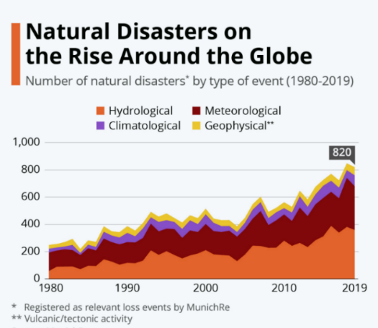
Figure 1.1 Global trend in reported natural disasters, 1900 to 2022
Figure 1.1 shows the steep rise in reported natural disasters since 1900, with weather- and climate-related events, including wildfires, taking a growing share (CRED/UCLouvain, 2023; UNEP, 2022). Wildfire frequency, spatial extent, and intensity have all risen under climate change, land-use transformation, and the expansion of the wildland-urban interface (Bowman, et al., 2020; UNEP, 2022), and the resulting ecological, economic, and human impacts increasingly outpace conventional response capabilities (Thompson & Calkin, 2011; Pacheco, 2015; Finney, An overview of FlamMap fire modeling capabilities, 2006).
Wildfire management is a demanding decision domain because fire behavior evolves in space and time under the joint influence of weather, terrain, fuel, and suppression. Wind and humidity set ignition probability and spread rate, slope and aspect steer propagation, fuel structure determines intensity and burn duration, and suppression actions feed back into the fire dynamics (Rothermel, 1972; Finney, An overview of FlamMap fire modeling capabilities, 2006; Sullivan, 2009a; Sullivan, 2009b; Sullivan, 2009c).
Operational wildfire response relies not only on numerical indicators, but also on incomplete and linguistically expressed situational assessments such as “high spread potential,” “limited suppression feasibility,” or “uncertain fire boundary.” Fuzzy reasoning is well suited to this setting (Bellman & Zadeh, 1970), since it supports approximate inference over partial and imprecise evidence without probability distributions, which are rarely available in real time (Thompson & Calkin, 2011; Pacheco, 2015).
Many DSS approaches exist for wildfire management, from optimization-based resource allocation and simulation-based systems to geospatial risk assessment and fuzzy reasoning (Thompson & Calkin, 2011; Pacheco, 2015; Finney, An overview of FlamMap fire modeling capabilities, 2006; Vásquez, 2021; Figueiredo, Macedo, Alves, & Figueiredo, 2024; Soualah, 2024). Mature deployed systems such as WFDSS and FlamMap, together with recent ML-based hybrids, provide substantial operational value, yet each addresses only part of these requirements. The remaining challenge is therefore architectural. No single framework simultaneously addresses adaptability under dynamic conditions, explainability of decision outputs, and support for distributed multi-level coordination within one coherent design (Thompson & Calkin, 2011; Vásquez, 2021; McNeese, Schelble, Canonico, & Demir, 2021). The DisasterAware framework is motivated not by a single methodological deficiency but by a set of structural limitations that recur across existing DSS. The next section examines these limitations, and the thesis contributions are then mapped to them.

Gap Analysis
Despite advances in DSS research, the literature still exhibits several unresolved limitations that constrain operational effectiveness. Existing systems have delivered important capabilities in fire spread prediction, geospatial risk analysis, resource planning, and situation monitoring. However, many of these contributions are built on assumptions that are difficult to sustain under dynamic conditions: predefined decision alternatives, centralized reasoning, limited treatment of uncertain observations, weak explainability, and constraint handling that presumes complete information (Arnott & Pervan, 2005; Turban, 2011). These limitations consolidate into three structural gaps, summarized in Table 1.1,each reflecting a structural rather than incidental shortcoming of current architectures.
Table 1.1 DSS gaps identified in wildfire decision support literature
 | Gaps of Existing Wildfire DSS Architectures
G1 | Existing DSS frameworks rely on predefined decision alternatives evaluated within centralized, level-undifferentiated architectures, preventing adaptation to dynamic, unforeseen conditions and limiting scalability, local responsiveness, and level-appropriate coordination.
G2 | Current systems cannot represent epistemic uncertainty without probability distributions or calibrated belief intervals, and expose the reasoning behind a recommendation only through post-hoc attribution, leaving decision sensitivity unquantified and eroding operator trust.
G3 | Simulation dynamics and decision reasoning remain tightly coupled, and operational constraints are handled through offline optimization requiring complete state information, so no end-to-end operational workflow demonstrates real-time, cell-level decision support under operational conditions.

G1 Closed Decision Spaces in Centralized Architectures
Many classical DSS frameworks assume decision alternatives can be enumerated before reasoning begins (Power, 2002; Pacheco, 2015; Sprague & Carlson, 1982). Multi-criteria frameworks similarly require a fixed alternative set ranked against pre-defined criteria (Malczewski, 1999; Keeney & Raiffa, 1976). Wildfire management violates this assumption. Fire behavior evolves continuously with wind shifts, fuel variability, and terrain interactions, producing operational conditions that no fixed strategy set can represent (Pacheco, 2015; Vásquez, 2021; Calkin, O'Connor, Thompson, & Stratton, 2021). Field studies confirm the mismatch. Practitioners rely on existing DSS to validate decisions already made from experience rather than to generate new response options (Fillmore & Paveglio, 2023; Rapp, Rabung, Wilson, & Toman, 2020). The closed decision space is therefore not an incidental limitation but a structural barrier to adaptive operational use.
Centralized DSS architecture concentrates observation aggregation, decision evaluation, and response generation within a single analytical core. This structure exhibits computational bottlenecks when the operational state changes rapidly or the spatial domain expands (Arnott & Pervan, 2005; Shim, et al., 2002). Recent reviews call for distributed mechanisms that preserve local responsiveness while maintaining global coordination (Vásquez, 2021). A related limitation is the absence of explicit hierarchical differentiation between decision levels (Anthony, 1965). Wildfire operations span local intervention, regional coordination, and strategic prioritization (Turoff, 2004; Comfort, Boin, & Demchak, 2010), but most DSS treat decision support as a single-layer process, conflating inferential responsibilities with coordinative ones. Post-incident analyses of U.S. wildfire events show that centralized, level-undifferentiated coordination delays localized action by routing regional requests through central nodes (Calkin, O'Connor, Thompson, & Stratton, 2021; Orphanoudakis, Betzelos, & Leligou, 2025).
G2 Unrepresented Epistemic Uncertainty and Limited Explainability
Wildfire decisions are shaped more strongly by epistemic uncertainty, arising from incomplete or unreliable information, than by stochastic variability in fire dynamics (Morgan & Henrion, 1990; Walker, et al., 2003; Thompson & Calkin, 2011). Existing uncertainty-aware DSS approaches (Comes, Hiete, Wijngaards, & Schultmann, 2011) typically require either prior probability distributions (Bayesian) or pre-calibrated belief intervals (Dempster-Shafer), both of which are rarely available at cell-level resolution in real-time operational settings (Shafer, 1976; Pearl, 1988). Fuzzy logic has been proposed as a principled alternative for graded representation of operational evidence without distributional assumptions (Zadeh, Fuzzy sets, 1965; Mendel, 2017; Duarte, Teodoro, Gonçalves, Soares, & Cunha, 2022), yet its systematic integration into wildfire DSS architectures remains limited. Operators routinely distrust DSS outputs precisely because existing tools do not expose the degree of observational uncertainty underlying recommendations (Rapp, Rabung, Wilson, & Toman, 2020).
AI-based wildfire models increasingly operate as black boxes whose internal reasoning is difficult to interpret (Ribeiro, Singh, & Guestrin, 2016; Guidotti, et al., 2018). Emergency response requires traceable recommendations that operators can justify to multiple stakeholders (McNeese, Schelble, Canonico, & Demir, 2021). Post-hoc attribution methods such as SHAP and LIME provide statistical approximations of model behavior rather than causal rule-level traceability (Ribeiro, Singh, & Guestrin, 2016). Empirical studies (Schultz, Miller, Greiner, & Kooistra, 2021) show that wildfire managers override or ignore DSS recommendations when the underlying reasoning is opaque, reducing operational value (Fillmore & Paveglio, 2023; Rapp, Rabung, Wilson, & Toman, 2020). Recent hybrid predictive-fuzzy frameworks demonstrate that accuracy and interpretability are not mutually exclusive (Mohammadi, Alesheikh, & Alimohammadi, 2025),but such architectures remain absent from mainstream DSS.
G3 Sim-Decision Coupling without an End-to-End Operational Workflow
Many wildfire DSS tightly integrate fire-spread simulation with decision reasoning. Modular architectures are essential for traceability and independent validation of system components (Sugumaran & Degroote, 2010), yet tight coupling prevents either component from being updated or verified in isolation (Pacheco, 2015; Vásquez, 2021). WFDSS exemplifies this pattern. Its fire-behavior subsystems and decision documentation are architecturally merged within a single platform, constraining substitutability (Noonan-Wright, et al., 2011). Recent hybrid architectures reinforce the same coupling. The transformer-fuzzy decision model of Mohammadi, Alesheikh, & Alimohammadi (2025) and the real-time DSS of Figueiredo, Macedo, Alves, & Figueiredo (2024) both embed decision logic within the prediction pipeline, so their reasoning outputs cannot be validated independently of the underlying simulator. As wildfire simulation science advances separately from DSS research, this coupling increasingly blocks the incorporation of new modeling capabilities into operational decision frameworks.
Optimization-based DSS represent operational constraints such as resources, travel time, and suppression effectiveness through formal cost functions (Keeney & Raiffa, 1976; Pais, Carrasco, Moudio, & Shen, 2021). These formulations presuppose complete state information, which is rarely available during active wildfire response (Martell D. L., 2007; Finney, An overview of FlamMap fire modeling capabilities, 2006). The gap is therefore not lack of awareness but the absence of mechanisms that integrate constraints into real-time, cell-level reasoning under incomplete and evolving observations (Oliveira, Barros, Ager, & Fernandes, 2022). Distributed wildfire response further breaks the completeness assumption. Resources are dispersed, availability changes continuously during an incident, and local accessibility depends on conditions that can only be estimated from partial observations. Existing DSS lack operational mechanisms for constraint-sensitive reasoning at this granularity. These constraints compound the coupling problem. Without separable components and constraint-aware reasoning, complete workflows that connect observation, reasoning, and operator interaction in a single demonstrable pipeline remain rare, sustaining the distance between published capability and field adoption.

Research Question and Hypothesis
Formally, this thesis addresses the following research question:
How can a wildfire decision support system generate adaptive intervention guidance over an open decision space, expose the reasoning and the sensitivity behind every recommendation it derives from incomplete observations, and demonstrate the resulting pipeline end to end against a strictly separated simulation core, under real-time distributed constraints and with formal correctness guarantees?
This question gives rise to the following main hypothesis:
A hierarchically distributed DSS architecture built on concept-driven fuzzy reasoning, equipped with adaptive and generative rule evolution behind a satisficing verification gate, intrinsic rule-level traceability with quantified sensitivity, and a strictly separated simulation core, resolves the three identified structural gaps within a single coherent framework and admits formal mathematical proof of its pipeline correctness properties that are absent from existing operational DSS.
This hypothesis is decomposed into three testable sub-claims:
H1 (Scalability and Adaptability): A hierarchically distributed architecture with concept-abstracted local fuzzy agents and non-inferential global coordination generates adaptive interventions over an open decision space with lower rule base complexity and faster response times than centralized, closed-alternative DSS under evolving wildfire conditions.
H2 (Interpretability and Independent Validation): The combination of concept-driven fuzzy reasoning, intrinsic rule-level traceability, confidence-gated uncertainty encoding, and systematic sensitivity analysis produces interpretable and independently verifiable decision outputs that do not require post-hoc attribution methods such as SHAP or LIME.
H3 (Operational Feasibility Under Uncertainty): An end-to-end workflow that couples the strictly separated simulation core, decision core, and operator dashboard, together with satisficing-based decision acceptance and cost-aware constraint integration, produces operationally feasible interventions across a wider range of incompletely observed, resource-constrained wildfire scenarios than probabilistic or optimization-based alternatives.

Main Contributions of the Thesis
The thesis makes three architectural and methodological contributions that collectively address the structural gaps identified in Section 1.1. Each contribution is self-contained and addresses a distinct gap, as summarized in Table 1.2. The contributions are realized across the background in Chapter 2, the DisasterAware framework and its simulation core in Chapter 3, the decision support system design and formal analysis in Chapter 4, and the empirical evaluation in Chapter 5.
Table 1.2 Mapping of thesis contributions to identified gaps
 | Addressed Gap | Contribution
C1 | G1: Closed decision spaces in centralized architectures | Open decision space through concept-based abstraction, adaptive rule generation, and hierarchically distributed reasoning with non-inferential global coordination
C2 | G2: Unrepresented epistemic uncertainty and limited explainability | Sensitivity analysis built on confidence-gated uncertainty propagation and intrinsic rule-level traceability
C3 | G3: Simulation-decision coupling without an end-to-end operational workflow | End-to-end use-case demonstration over analytically separated simulation and decision cores with satisficing-based acceptance

C1 Open Decision Space through Adaptive, Concept-Driven Reasoning
To address G1, this thesis replaces the fixed menu of predefined alternatives with an open, concept-driven decision field. Raw observations are first mapped onto five domain-meaningful decision concepts, so that rules are written in operational language rather than over raw signals. The field is then reshaped online. An evolving Takagi-Sugeno rule base adapts membership functions (MF) and term resolution (Takagi & Sugeno, 1985; Angelov & Filev, 2004), a generative model proposes genuinely new candidate rules when adaptation is exhausted, and every candidate passes a satisficing verification gate before it may act (Simon H. A., 1956). Reasoning itself is confined to local fuzzy agents, while a non-inferential global layer only assigns resources and normalizes priorities, which keeps the open field scalable. The reshaping acts on three nested levels, the consequents of existing rules, the resolution of their term sets, and the vocabulary itself, since a generative proposal may introduce intermediate concepts and macro interventions along with the rule that uses them; nothing enters the base without passing the gate chain, which ends in a reseeded forecast comparison on the simulator.
C2 Sensitivity Analysis with Traceability and Confidence-Gated Uncertainty
To address G2, the reasoning pipeline is built so that explanation and uncertainty handling are structural rather than retrofitted. Epistemic uncertainty is propagated without prior distributions by blending each concept activation with a persistence-based estimate in proportion to observation confidence. Every decision remains traceable to the concepts that fired it, the rules involved, and the confidence behind them, and a sensitivity analysis quantifies how features, membership parameters, and priority weights propagate to the decision, in contrast to post-hoc attribution methods such as SHAP or LIME.
C3 End-to-End Use-Case Demonstration
To address G3, the thesis enforces a strict separation between the simulation core and the decision core, which grounds formal pipeline properties under incomplete observation and allows either side to be validated independently. On this foundation the framework is exercised in an end-to-end use case that couples the spread simulation, the decision pipeline, and an operator dashboard, with satisficing acceptance and a graduated fail-safe keeping every realized intervention admissible; the use case addresses the research-to-practice distance reported in field studies (Fillmore & Paveglio, 2023; Rapp, Rabung, Wilson, & Toman, 2020). The with and without DSS results of that use case rest on the counterfactual replay of the identical fire history, so the reported differences are attributable to the issued orders alone.
Collectively, these three contributions transform wildfire DSS from a predefined and centralized decision toolkit into an open, distributed, and uncertainty-aware reasoning system whose operational properties are analytically established rather than empirically assumed.
The research question articulates four simultaneous requirements that a wildfire DSS must satisfy under incomplete observation and distributed real-time constraints, and the main hypothesis posits that a hierarchically distributed, concept-driven, confidence-gated, and satisficing-based architecture meets these requirements while admitting formal proof of its pipeline correctness properties. This hypothesis is decomposed into three testable sub-claims arranged as vertical threads: H1 addresses scalability and adaptability, H2 addresses interpretability and independent validation, and H3 addresses operational feasibility under uncertainty. Each sub-claim is realized by one contribution (C1 under H1, C2 under H2, C3 under H3) that in turn addresses one of the three structural gaps identified in Section 1.1, establishing a one-to-one correspondence between every gap and a targeted architectural contribution. The flow from research question through hypothesis and contributions to gaps can therefore be read as one continuous argument as illustrated in Figure 1.2.
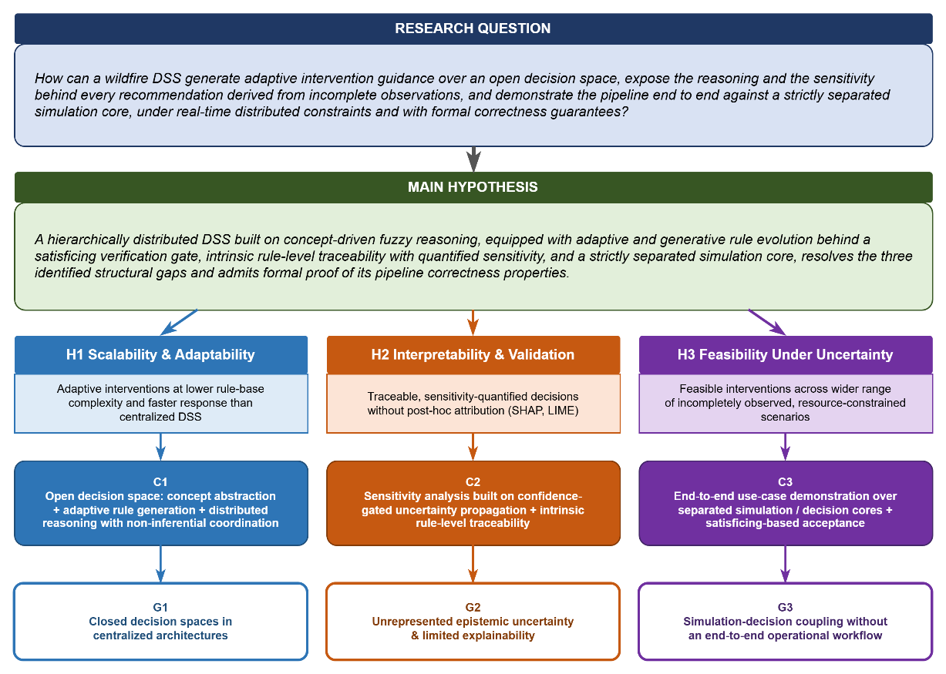
Figure 1.2 Research question, hypothesis, gaps and contributions

Organization of the Thesis
Chapter 2 assembles the background the rest of the thesis builds on, following the path a decision travels: wildfire dynamics and spread modeling, the foundations of decision support, the input space from heterogeneous sensing to observation features, concept-driven fuzzy reasoning with the rule-explosion argument, and the decision space with its interventions, evaluation, and adaptive-generative loops.
Chapter 3 introduces the DisasterAware framework as the computational foundation: the system architecture, the external input layers for meteorology, topography, fuel, ignition, and decisional data, and the simulation core with its state transition and hybrid spread model coupled to the decision support core. Its design criterion is testability rather than maximal fidelity.
Chapter 4 develops the decision support system. It derives the feature space, specifies the fuzzy variables and membership functions, builds the five decision concepts and the intervention rule base, and presents the layered architecture, which is the observation, concept mapping, local DSS, and global coordination layers, together with the epistemic encoding of incomplete observations and the explainability overlay for traceability, auditability, and operator override.
Chapter 5 reports the simulation and performance results, comparing DisasterAware with a functionally equivalent centralized baseline over scenarios of increasing complexity, and closes with a sensitivity analysis over features, membership functions, and priority weights.
Chapter 6 summarizes the contributions and outlines directions for future research.

BACKGROUND INFORMATION
This chapter presents the background on which the remainder of the thesis builds. Its purpose is twofold: To introduce the concepts on which the design chapters rely, and to justify, on the basis of the literature, the choices that shape DisasterAware. The chapter is organized as follows. Section 2.1 reviews wildfire dynamics and spread modeling. Section 2.2 introduces the foundations of decision support,including closed versus open decision spaces and centralized versus distributed architectures. Section 2.3 presents the input space, from heterogeneous sensing sources to the ten observation features. Section 2.4 develops concept-driven fuzzy reasoning. Section 2.5 defines the decision space: The admissible interventions, the cost, acceptance, and uncertainty machinery by which candidate decisions are judged, and the adaptive and generative loops that keep the decision space open.

Wildfire Dynamics and Spread Modeling
This section reviews the mechanisms of wildfire spread and the principal approaches to modeling it. The treatment is confined to the material required by the subsequent chapters: The physical drivers of fire behavior, the families of spread models, and the properties a decision layer requires from the model to which it is coupled.

Drivers of Fire Behavior
Fire behavior at any point of a landscape is governed by three groups of drivers, namely weather, terrain, and fuel. Weather contributes the most rapidly varying quantities: air temperature, relative humidity, wind speed and direction, wind gusts, and precipitation. Wind pushes the flame front toward unburned fuel, while humidity and precipitation set the moisture content of fine fuels and, with it, the ease of ignition (Rothermel, 1972). Terrain contributes elevation, slope, aspect, and accessibility. A front burning upslope preheats the fuel above it and accelerates, aspect determines how much solar radiation dries the fuel over the day, and accessibility bounds where crews can act. Fuel contributes the most slowly varying quantities. The vegetation type, the available fuel load, and the fuel moisture determine how intense the combustion becomes and how long a cell keeps burning (Scott & Burgan, 2005).
These drivers are summarized operationally by a small set of quantities: the rate of spread (ROS) of the front, its direction, and the fire line intensity. The Rothermel model expresses ROS as a function of fuel properties, fuel moisture, wind, and slope, and it still underlies most operational tools (Rothermel, 1972; Andrews, 2018); the detailed parameterization used in this thesis is given in Appendix A. The significance of the model for this thesis lies not in its exact functional form but in the causal chain it encodes. Weather, terrain, and fuel jointly determine local spread, and any intervention that modifies one of these inputs alters the behavior of the fire.

Families of Spread Models
The literature groups spread models into three families. Physical and quasi-physical models resolve combustion chemistry and heat transfer; they are the most detailed and the most expensive to run (Sullivan, Wildland surface fire spread modelling 1: Physical and quasi-physical models, 2009a). Empirical and quasi-empirical models fit observed spread rates to environmental variables; they are fast and robust within the conditions for which they were calibrated (Sullivan, Wildland surface fire spread modelling 2: Empirical and quasi-empirical models, 2009b). Simulation models propagate a fire front across a landscape by applying one of the former families as a local kernel; FlamMap is the best-known operational example (Sullivan, Wildland surface fire spread modelling 3: Simulation and mathematical analogue models, 2009c; Finney, An overview of FlamMap fire modeling capabilities, 2006).
Grid-based simulation discretizes the landscape into cells, each holding fuel, moisture, and burn state. A cell ignites with a probability that grows with the number of burning neighbors, their alignment with the wind, and the local fuel condition, and it stops burning when its fuel is consumed or suppressed. This representation matches the resolution at which incident decisions are made, which is why it is preferred when the model is coupled to a decision layer. DisasterAware follows this pattern. A grid-based simulation model whose local spread kernel belongs to the Rothermel-type quasi-empirical family.

Requirements of the Decision Layer on the Spread Model
A wildfire DSS does not require the highest-fidelity fire simulator available; it requires a testable environment. Testability comprises four properties: Scenarios can be reproduced exactly, the per-cell state can be observed and logged, the inputs through which interventions act can be controlled, and the outcome of a decision can be measured against the outcome of not deciding. Any spread model that offers these four properties, at any level of fidelity, is sufficient to run and evaluate the decision layer; higher fidelity refines the numerical results but alters neither the architecture nor the claims of this thesis. Beyond testability, the spread model must satisfy three operational requirements: A per-cell state that observation can plausibly estimate, controllable inputs through which interventions act, and an update rate compatible with the decision cycle. DisasterAware therefore adopts a hybrid grid model, formalized in Chapter 3, that combines Rothermel-type local spread with explicit per-cell state tracking, in which every grid cell carries its remaining fuel, its moisture, and its burn status, is driven by external weather and terrain layers, and accepts interventions only at the input level, so the decision core never manipulates the physical state directly.
Figure 2.1 summarizes this coupling: weather, terrain, and fuel drive fire behavior; fire behavior updates the cell states; the DSS observes cell states and issues interventions; and interventions feed back into the model inputs.
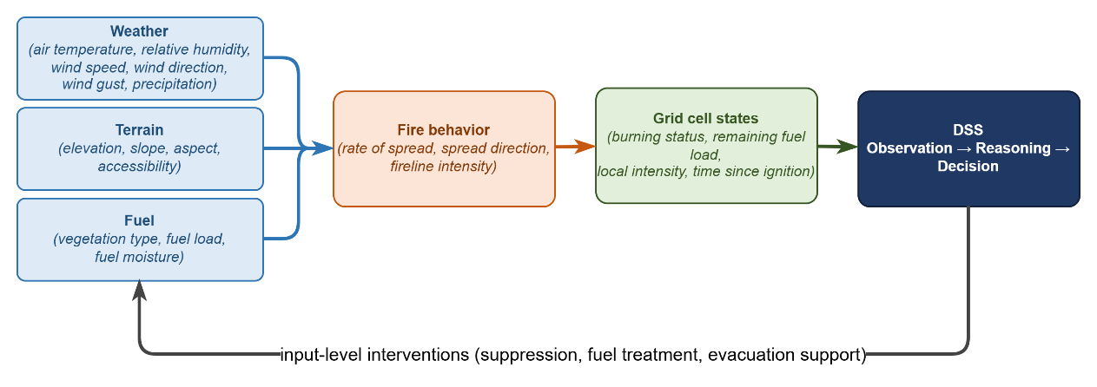
Figure 2.1 Coupling between fire behavior, the grid state, and the decision layer

Decision Support Foundations
This section establishes DSS foundations on which the remainder of the thesis rests. It first reviews the core elements that any operational DSS must supply and, in doing so, introduces the two spaces the framework mediates between, namely the input space of observable quantities and the decision space of orderable actions. It then examines the distinction between closed and open decision spaces, which motivates the central contribution of this thesis, and closes with a comparison of centralized and distributed architectures, which determines where reasoning takes place. Together these discussions supply the vocabulary in which the input space, the reasoning machinery, and the decision space of the subsequent sections are defined.

Core Elements of Decision Support Systems
A DSS mediates between two spaces, namely the input space and decision space. The input space comprises everything the system can observe or estimate: Sensor fields, forecasts, terrain and fuel maps, resource states, and the quantities derived from them. The decision space comprises everything the system is authorized to decide, namely the set of actions, with their intensities, locations, and timings, that can be ordered at a given moment.
A DSS is a software system that assists an operator in choosing among actions whose consequences are uncertain (Sprague & Carlson, 1982; Power, Decision support systems: Concepts and resources for managers, 2002). Decision support occupies a deliberate middle ground between full automation and unaided judgment (Power, A Brief History of Decision Support Systems, 2007). In the classical framework of Gorry and Scott Morton it targets semi-structured decisions, those for which parts of the reasoning can be modeled while the remainder requires human judgment (Gorry & Scott Morton, 1971; Simon H. , The New Science of Management Decision, 1960). Wildfire response is a canonical instance of this class. The physics of spread can be modeled, and candidate responses can be scored, yet accountability, values, and situational judgment remain with the incident commander; the system therefore recommends, while the decision authority remains with the operator. Independent of domain, a working DSS supplies the same core elements (Turban, 2011; Sharda, Delen, & Turban, 2018): Input interface, which transforms raw observations into usable, bounded variables; Knowledge base, which encodes the behavior of the domain, represented in this thesis in the form of fuzzy rules; Reasoning engine, which produces candidate decisions from the current inputs; Decision evaluation, which scores every candidate before it is allowed to act; Presentation and oversight, which enable the operator to inspect, question, and override the outcome.
In time-critical domains two further elements become essential: Explicit uncertainty handling, since inputs are incomplete and unreliable, and timeliness, since a correct recommendation that arrives late has no operational value (French, Maule, & Papamichail, 2019).

Closed versus Open Decision Spaces
In a closed decision space, the alternatives are enumerated before reasoning begins, and the system can only rank them. This structure characterizes classical multi-criteria decision making (Chen & Hwang, 1992; Zavadskas & Turskis, 2011), in which a fixed alternative set is scored against weighted criteria (Hwang & Yoon, 1981; Triantaphyllou, 2000; Malczewski, 1999). The approach fails in wildfire response for a structural reason. Fire behavior evolves continuously, and an incident routinely produces conditions that no predefined alternative covers. Field studies document the consequence. Commanders use existing tools to justify decisions they have already made, not to generate new options (Fillmore & Paveglio, 2023; Rapp, Rabung, Wilson, & Toman, 2020).
An open decision space requires three capabilities: (i) modification of existing alternatives during operation, (ii) construction of genuinely new alternatives, and (iii) verification of every new alternative before it acts, since an unchecked generated action constitutes an operational hazard (Seshia, Sadigh, & Sastry, 2022).
Naturalistic decision research established early that experienced commanders do not select from menus at all. In the recognition-primed model, a decision maker constructs a single plausible course of action from recognized patterns, evaluates it by mental simulation, and repairs or replaces it when the simulation fails, so that option generation rather than option ranking is the expert behavior a support system should serve (Klein, 2017; Ross, Shafer, & Klein, 2006). The same expert behavior has a direct computational counterpart. The evolving fuzzy systems literature made rule structure itself adaptive. Evolving Takagi-Sugeno models create a new rule online whenever incoming data are poorly represented by the existing base, and subsequent variants supplied principled mechanisms for splitting, merging, and pruning rules on streaming data (Angelov & Filev, 2004; Lughofer, 2011). An online value-based selector contributes the timing of openness, learning from the outcomes of past trials when to invoke the structure-changing stages rather than discovering new actions itself (Sutton & Barto, 2018). Most recently, generative models, including large-language-model agents applied to wildfire analysis and response, have been used to draft candidate rules or actions that lie outside the current structure altogether (Xie, ve diğerleri, 2024; Chen, ve diğerleri, 2025; Chandra, Kumar, Patra, & Agarwal, 2025).
DisasterAware combines the three mechanisms: an evolving Takagi-Sugeno (1985) rule base for modification, a generative proposer for construction, and a satisficing acceptance gate for verification (Simon H. A., 1956), so that the decision space remains open while every realized action remains admissible.

Centralized and Distributed Decision Support Architectures
In centralized architecture every observation flows to a single reasoning core and every decision flows back out of it. This pattern offers simplicity and global consistency, but the reasoning core constitutes a bottleneck. Communication grows with the size of the domain, latency grows with communication, and a failure of the core silences the whole system (Shim, et al., 2002; Arnott & Pervan, 2005).
In a distributed architecture reasoning moves to local nodes and information flows in both directions. Local nodes send compact summaries upward when regional balance is needed, and the upper layer returns allocations and priorities downward. Multi-agent systems research provides the coordination mechanisms (Sycara, 1998; Wooldridge, 2009), and wildfire DSS reviews explicitly call for such designs (Vásquez, 2021).
DisasterAware follows the distributed pattern with one restriction that later chapters exploit. Local DSS agents perform all inference on region-level observations, while the global layer performs no inference at all; it only assigns resources and normalizes priorities across regions. Upward flow, from each Local DSS agent to the global coordination layer, carries three compact quantities, namely the region priority derived from the top-level operational priority concept, the resource request implied by the proposed interventions, and a confidence summary of the observations behind them. Downward flow, from the global layer back to every Local DSS agent, returns the resource allocation, the normalized priority weights, and the acceptance thresholds in force. Neither direction carries raw sensor fields or rule activations, which keeps the channel narrow, the coordination auditable, and the local decision path short. Figure 2.2 contrasts the two patterns and marks the restriction that keeps the global layer non-inferential, which preserves scalability.
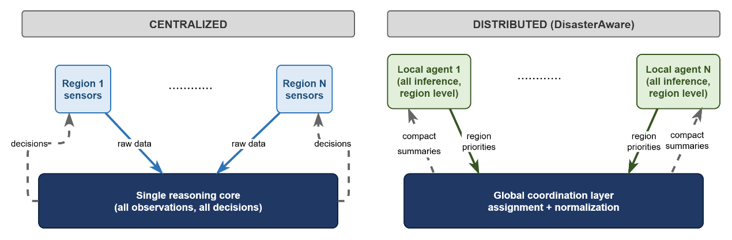
Figure 2.2 Information flow in centralized and distributed DSS architectures

The Input Space: Heterogeneous Sensing to Observation Features
A wildfire DSS draws on heterogeneous sensing sources: Weather stations and forecast services, satellite and aerial imagery, in-situ sensors and unmanned aerial platforms tasked over the incident, geographic information layers for terrain, fuel, assets, and roads, and the resource tracking and field reports of the response organization itself. None of these sources observe the fire state directly; each delivers a partial view with its own refresh cycle. For this reason, the features are defined as bounded, observation-derived quantities rather than raw signals.
Concretely, five families of sources feed the framework. Meteorological networks and numerical forecasts deliver gridded temperature, humidity, wind, and precipitation at a fixed cadence. Spaceborne and airborne imagery provides active-fire detections, burned-area mapping, and periodic vegetation and fuel updates, with wide coverage but coarse revisit intervals (Jain, et al., 2020). In-situ sensing, including ground stations and unmanned aerial platforms tasked over the incident, offers high-rate local observations with narrow footprints. Geographic information layers contribute the quasi-static context, namely terrain, fuel models, road networks, assets, and population (Duarte, Teodoro, Gonçalves, Soares, & Cunha, 2022; Scott & Burgan, 2005). Finally, the response organization itself constitutes an information source. Resource tracking, dispatch logs, and field reports carry the evolving state of crews, equipment, and access (Martell D. L., 2007).
These sources are heterogeneous in every operationally relevant respect. They differ in modality, spatial coverage, refresh rate, and reliability, and they produce information of different kinds, from continuous physical fields to categorical status reports. No single raw signal can drive decision rules directly. The heterogeneous stream is therefore reduced by feature extraction to a small set of bounded, observation-derived quantities, and it is exactly this set that constitutes the input space of the framework.
The ten features and the reasoning behind each are compiled in Table 2.1; their formal derivation from the simulation state, together with the full literature grounding, is given in the design specification. The set spans threat, exposure, feasibility, and timing, so no operational question of Section 2.4 is left without a supporting feature and none of the ten is redundant.
Table 2.1 The ten observation features, their sources, and their rationale
Feature | Primary source | Rationale
Fire intensity $z_{1}$ | Fire state estimation from imagery and in-situ sensing | Fireline intensity in the tradition of Byram and the Rothermel model is the standard descriptor of how intensely a front is burning
Spread potential $z_{2}$ | Fire state and weather | Rate of spread from fuel, wind, and slope in the Rothermel tradition remains the operational basis of spread assessment
Weather severity $z_{3}$ | Weather stations and forecasts | Fire-weather index systems condense a small set of weather observations into spread and intensity potential
Ignition proximity $z_{4}$ | GIS road and infrastructure layers | Human-caused ignitions cluster near roads and infrastructure, so distance to them drives ignition probability
Fuel load $z_{5}$ | Fuel model layers | Standard fuel models parameterize combustible load and drive every surface-fire prediction
Asset exposure $z_{6}$ | GIS asset and urban interface layers | Values-at-risk mapping quantifies what a fire threatens and supports risk-based response
Resource accessibility $z_{7}$ | Terrain, fuel, and access layers | Suppression difficulty combines the terrain, fuel, and access conditions of a site
Access and road status $z_{8}$ | GIS road status and field reports | Access governs both suppression logistics and evacuation egress
Suppression availability $z_{9}$ | Resource tracking | Fireline production rates and available capacity determine whether suppression can be mounted
Temporal urgency $z_{10}$ | Ignition timing and incident clock | Incident command is time-critical; recognition-primed decision research formalizes acting under urgency

Heterogeneity also imposes admission criteria on the input space. A quantity is admitted to the feature set only if it satisfies four conditions.
- Observability. It must be computable from what sensors and reports actually deliver, never from hidden simulator state.
- Boundedness. It must admit normalization to a fixed interval, so that membership functions remain stable across scenarios.
- Operational meaning. An expert must be able to read it and phrase rules over it without translation.
- Non-redundancy. It must contribute discriminative information that the remaining features do not already carry.
Sufficiency of the resulting set is argued on three grounds and then tested. By construction the ten features span the threat, exposure, feasibility, and timing dimensions of the operational questions, so no question lacks a supporting feature; each feature carries established wildfire-science grounding rather than convenience, as the table records; and none duplicates information carried by the others. The design chapters show that the concept mappings require no further inputs, and the sensitivity analysis of the evaluation chapter confirms empirically that the decision output responds to every feature and is dominated by none.

Concept-Driven Fuzzy Reasoning
This section assembles the reasoning machinery of DisasterAware. Fuzzy reasoning is chosen for three reasons established in the preceding sections. The evidence reaching a wildfire DSS is graded and linguistic rather than crisp; the knowledge that binds observations to interventions exists chiefly as expert phrasing, which fuzzy rules encode without translation; and the resulting inference chain remains inspectable, which the traceability requirement of this thesis makes mandatory. The section first recalls how fuzzy inference turns linguistic expertise into computable rules, then confronts the combinatorial obstacle that arises when such inference is attempted over the full observation vector and finally introduces the conceptual middle layer that resolves the obstacle while preserving interpretability. The section thereby introduces the two design questions addressed in the design chapters: Which features are admitted to the input space, and over which concepts the decision rules are written.

Linguistic Uncertainty and Fuzzy Inference
Operational assessments in wildfire response arrive as graded, linguistic judgments. A spread potential is high, a suppression opportunity is marginal, a boundary estimate is uncertain. Fuzzy set theory supplies the formal counterpart of such judgments by admitting partial membership (Zadeh, Fuzzy sets, 1965; Mendel, 2017). A fuzzy set over a universe of discourse is characterized by a membership function that assigns each element a degree of membership, as formalized in ( 1 ); under this semantics a single wind reading may simultaneously hold membership 0.7 in strong and 0.3 in moderate. In ( 1 ), $Z$ denotes the universe of discourse of an input, $A$ a linguistic term over it, and $μ_{A}(z)$ the degree to which a reading $z$ belongs to $A$. This graded semantics removes the brittle thresholds of crisp classification and preserves expert phrasing under formalization (Pedrycz, 1993).
Domain knowledge enters through linguistic rules of the canonical conjunctive form ( 2 ), whose activation strength is the conjunction of its antecedent memberships, computed as in ( 3 ).
$$μ_{A}:Z→[0,1], L=\{(z,μ_{A}(z)):z∈Z\}$$ | ( 1 )
$$R_{r}: IF z_{1} is A_{r,1} AND … AND z_{n} is A_{r,n} THEN u is B_{r}$$ | ( 2 )
$$α_{r}=\min_{i}⁡μ_{A_{r,i}}(z_{i})$$ | ( 3 )
In ( 2 ) and ( 3 ), $z_{1},…,z_{n}$ denote the input variables, $A_{r,i}$ the linguistic terms selected by rule $R_{r}$, $B_{r}$ the consequent term over the output $u$, and $α_{r}$ the firing strength of rule $r$, with the minimum operator realizing the conjunction of the antecedents.
Mamdani inference aggregates the consequents of the active rules and defuzzifies the aggregate into a crisp output (Mamdani, 1974), with the centroid form of ( 4 ) as the standard choice.
$u^{*}=\frac{∫u⋅μ_{agg}(u)du}{∫μ_{agg}(u)du}$, where $μ_{agg}(u)=\max_{r}{min(α_{r},μ_{B_{r}}(u))}⁡$ | ( 4 )
In ( 4 ), $μ_{agg}$ is the aggregated output membership, obtained by clipping each active consequent at its firing strength and taking the pointwise maximum, and $u^{*}$ is the resulting crisp output. The Takagi-Sugeno variant replaces the fuzzy consequent with a functional one and combines outputs as an activation-weighted average ( 5 ).
$$u=\frac{\sum_{r}{α_{r}⋅g_{r}(z)}}{\sum_{r}{α_{r}}}$$ | ( 5 )
In ( 5 ), $g_{r}(z)$ is the functional consequent of rule $r$, typically affine in the inputs. The identification theory behind this form is presented in (Takagi & Sugeno, 1985). DisasterAware adopts the zero-order Takagi-Sugeno form throughout the decision layer. Each rule consequent is a singleton intensity, and the candidate intervention is the activation-weighted average of the singletons of the rules that fire, so the inference stays interpretable while the consequents remain exposed as numeric parameters that the adaptation loop can tune.
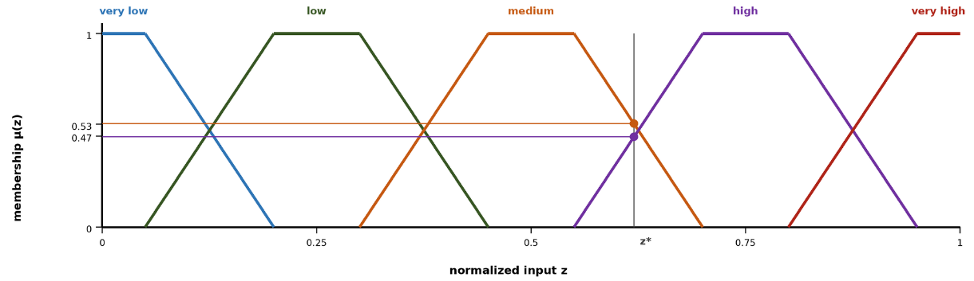
Figure 2.3 Five-term trapezoidal membership partition with an example reading
Figure 2.3 illustrates the five-term trapezoidal partition of a normalized input used throughout the design chapters. Adjacent terms overlap so that every reading activates at most two terms;. Suppose the normalized spread potential of a cell reads $z_{2}=0.62$. Fuzzification against the partition of the figure yields membership 0.53 in medium and 0.47 in high, and every other term stays at zero. Two rules fire, IF spread potential is medium THEN suppression effort is moderate with strength 0.53, and IF spread potential is high THEN suppression effort is high with strength 0.47. The zero-order Takagi-Sugeno aggregation weights each singleton consequent by the strength of the rule that carries it, so the recommendation is 0.53 times 0.5 plus 0.47 times 0.8, which yields a suppression effort of 0.64 on the normalized intensity scale, and every intermediate quantity remains visible to the operator.

Mamdani and Takagi-Sugeno Inference: Mechanism and Choice
Two classical mechanisms called Mamdani (1974) and Takagi-Sugeno (1985) turn the activations of ( 3 ) into one crisp action. The difference between them define how it decides what an online learner can touch, what a verification gate can compare, and what a forecast loop can afford. In both mechanisms, crisp inputs are fuzzified against the term partitions, and each rule fires with the strength of its weakest antecedent. The methods differ at the consequent.
Mamdani inference keeps the consequent linguistic. Each active rule clips or scales a consequent membership set at its firing strength, the clipped sets are aggregated pointwise, and the aggregate is defuzzified into a crisp value, typically by the centroid of ( 4 ). The strengths of this construction are real: the knowledge remains linguistic end to end, the output set makes the ambiguity of a decision visible, and the scheme reads naturally for expert elicitation. Its costs are equally real. Every evaluation carries a numeric integration over the output universe; the output surface is piecewise and develops plateaus between rule cores, so nearby situations can read identically; and adaptation can act only on membership geometry, because the consequents are sets rather than parameters.
Takagi-Sugeno inference replaces the consequent set with a function of the inputs, as in ( 5 ), and obtains the crisp output directly as the firing-strength weighted average of the rule consequents. This thesis uses the zero-order special case, in which every consequent is a constant intensity:
$$u=\frac{\sum_{r∈R}{w_{r}⋅v_{r}}}{max\left(\sum_{r∈R}{w_{r}}, 1\right)}, v_{r}∈\left[0,1\right]$$ | ( 6 )
In ( 6 ), $R$ is the set of active rules, $w_{r}$ is the firing strength of rule $r$ from ( 3 ), and $v_{r}$ is its constant consequent, read directly as an intervention intensity on the unit interval. The lower bound of one in the denominator implements the coverage discipline of the framework. When the whole base fires weakly, the output is attenuated rather than renormalized upward, so a barely covered situation cannot masquerade as a confident command. The output is crisp by construction, no defuzzification step exists, and the value interpolates smoothly between the actions of the rules that share the situation.
Figure 2.4 contrasts the two pipelines stage by stage, and Table 2.2 condenses the comparison. The front of the pipeline is identical; everything that differs follows from the consequent form.
Table 2.2 Mamdani and zero-order Takagi-Sugeno inference compared
Aspect | Mamdani | Takagi-Sugeno (zero-order)
Consequent form | Fuzzy set over the output universe | Crisp value in [0,1] per rule
Output computation | Clip, aggregate, then defuzzify by centroid | Firing-strength weighted average, closed form
Cost per evaluation | Numeric integration over the output universe | One multiply-add per active rule
Output surface | Piecewise, plateaus between rule cores | Smooth interpolation between rule actions
Adaptation surface | Membership geometry only | Memberships and consequent values; consequents are bounded numbers a learner can nudge
Verification of a generated rule | Requires defuzzification semantics per proposal | Consequents are auditable numbers; simulation gates compare scalars
Interpretability | Linguistic input and output | Linguistic antecedents; numeric output read as an intensity command

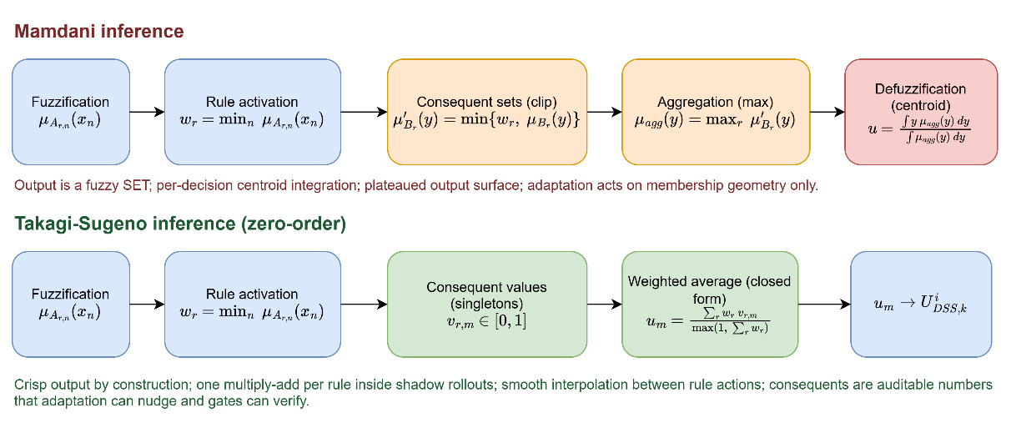
Figure 2.4 Mamdani and zero-order Takagi-Sugeno inference pipelines
The choice of Takagi-Sugeno in DisasterAware follows from four requirements of the architecture:
- Evaluation economics: Every candidate decision and every adaptation trial is judged inside shadow forecasts, so the inference closed form of ( 6 ) is executed thousands of times per incident; a per-evaluation centroid integration would price the forecast loop out of its decision cycle.
- Actuation semantics: The outputs of the decision layer are intensity commands on the six intervention types, and a zero-order consequent is exactly such a command; Mamdani would compute a linguistic output only to defuzzify it back into the number the actuator needed all along.
- Adaptivity: The evolving-fuzzy stage nudges consequents by bounded steps and inserts terms into partitions, and the generative stage proposes rules whose consequents must be audited by simulation gates; both demand consequents that are numbers with predictable effect on the output, which is precisely what the weighted average provides and what the identification theory behind Takagi-Sugeno models was built for.
- Interpretability is retained where it matters. The antecedents remain linguistic over the concept vocabulary, so every decision still reads as a sentence, while the numeric consequent is the part a commander audits as a dosage rather than a word.
Mamdani inference remains the right tool where the output itself must stay linguistic, for advisory displays, elicitation sessions, and human-facing summaries, and nothing in the architecture forbids attaching such a presentation layer downstream. The decision path, by contrast, is Takagi-Sugeno throughout. It takes crisp inputs and produces crisp outputs, it is differentiable in its parameters, and it is inexpensive enough to run inside the shadow forecasts that test a candidate before it is trusted.

The Rule Explosion Problem
The obstacle to applying fuzzy inference directly over a rich observation vector is combinatorial. A complete rule base over the full feature set, with each feature partitioned into a fixed number of linguistic terms, contains the number of rules given in ( 7 ), where $N_{feature}$ denotes the number of features and $N_{term}$ the number of linguistic terms per feature. As an example, ten features with five linguistic terms each would demand $5^{10}=9765625$ rules, close to ten million, and even a modest three terms per feature already yields $3^{10}=59049$ rules. A base of this size cannot be elicited from experts, maintained by engineers, or audited by operators (Mendel, 2017).
$$|R|={N_{term}}^{N_{feature}}$$ | ( 7 )

Concepts as an Intermediate Abstraction
The decisive reduction is achieved through a conceptual middle layer. Rather than writing rules over raw features, DisasterAware first composes the features into a compact, four-level concept hierarchy. Six base concepts summarize physically related features; three mid-level and two higher-level decision concepts built on them answer, each exactly once, the recurring operational questions; and a single top concept, operational priority, serves cross-region coordination. The questions, the decision concepts, and what constructs each are listed in Table 2.3.
Table 2.3 Operational questions and the decision concepts derived from them
Operational question | Decision concept
How severe is the fire threat in this cell? | Fire Threat Level
Can an intervention feasibly be mounted here? | Suppression Feasibility
How exposed are the assets here? | Asset Exposure Risk
How urgent is action here? | Intervention Urgency
Is evacuation pressure building here? | Evacuation Pressure

The derivation follows two principles Each question must be one that incident commanders demonstrably ask during response operations (Thompson & Calkin, 2011; Klein, 2017), and each concept must answer its question completely while answering no other, which keeps the concept set complementary and free of redundancy.
Rules are then written over these concepts, while features only feed the concept mappings. With $N_{feature}$ features grouped into $N_{concept}$ concepts drawing on at most $N_{input}$ features each, the rule burden collapses from a product to a sum, as summarized in ( 8 ). The active rule base itself stays compact: the evolving mechanism instantiates only the concept combinations that observed situations activate, and representative rules, together with the complete concept construction mappings, are enumerated in the decision support system chapter and its appendix, so every rule that can act in the field is stated explicitly.
$${N_{term}}^{N_{feature}} ⇢ N_{concept}⋅{N_{term}}^{N_{input}}+{N_{term}}^{N_{concept}}$$ | ( 8 )
Here $N_{concept}$ is the number of decision concepts at the top of the hierarchy and $N_{input}$ the largest number of features feeding a single concept; a reduction whose exact magnitude for the configuration of this thesis is established in the decision support system chapter. The intermediate layer provides more than combinatorial economy. Concepts constitute the traceability vocabulary of the entire framework. Every recommendation can be read back as a statement over fire threat, suppression feasibility, asset exposure, intervention urgency, and evacuation pressure, and it is precisely this granularity that the evaluation machinery of Section 2.5 and the operator-facing explanations exploit. The magnitude of the reduction is substantial. Directly over $N_{feature}=10$ features with $N_{term}=5$ linguistic terms, a flat rule base would span $5^{10}≈9.8⋅{10}^{6}$ antecedent combinations. Over the $N_{concept}=5$ decision concepts at the top of the hierarchy the antecedent space shrinks to $5^{5}=3125$ combinations, and the evolving rule base instantiates only the small active subset that observed situations require.
The base layer itself draws directly on the features. Fire severity combines fire intensity $z_{1}$ and spread potential $z_{2}$; spread hazard combines spread potential, weather severity, and ignition proximity; fuel hazard combines weather severity and fuel load; asset value derives from asset exposure; crew reachability combines resource accessibility with access and road status; and logistics support derives from suppression availability. One derivation chain then runs end to end. Fire severity, spread hazard, and fuel hazard combine into fire threat level, the quantity that answers the first operational question and fires decision rules. Base concepts thus act as interpretable intermediate hazards, while the five decision concepts at the top of the hierarchy carry the operational meaning.

The Decision Space: Actions and Their Evaluation
The concept hierarchy of the previous section supplies the vocabulary over which decision rules are written; the output of those rules is ultimately an assignment of intensities to concrete actions. This section therefore fixes the decision space in two steps: first the vocabulary of interventions that can be ordered at all, then the cost model, the acceptance rule, and the uncertainty treatment by which candidate assignments over that vocabulary are judged.

Actions and Interventions in Wildfire Decision Support
A wildfire DSS is operationally useful only if its outputs correspond to orders that an incident commander can issue. The decision space of DisasterAware is therefore built from a fixed vocabulary of intervention types, each applied with an intensity over the grid, so that every rule developed in the later chapters binds to a concrete, executable action (Thompson & Calkin, 2011; Pacheco, 2015). Six intervention types cover the levers reported in the wildfire response literature.
Table 2.4 lists each type, the concrete orders it represents, the channel through which it acts on the simulation inputs, and the literature that grounds it. The list is short and closed at the level of types, which keeps the action vocabulary interpretable and allows every recommendation to be read as an executable order; openness enters not through the invention of new types but through the generation of new rules over the same types.
Table 2.4 Intervention types, representative orders, and input-level effects
Intervention | Representative orders | Input-level effect
Suppression effort (Martell D. L., 2007) | Direct attack on the active front; indirect attack with backburns and aerial retardant drops | Reduces local fire intensity and the ignition probability of neighboring cells
Resource deployment (Oliveira, Barros, Ager, & Fernandes, 2022; Pais, Carrasco, Moudio, & Shen, 2021) | Dispatch, staging, and repositioning of crews, engines, and aircraft across regions | Changes the suppression capacity available to each region
Containment line (Ager, Vaillant, & Finney, 2010) | Firebreak construction and control-line placement along selected boundaries | Removes fuel along the line and blocks propagation paths
Asset protection (Calkin, O'Connor, Thompson, & Stratton, 2021; Noonan-Wright, et al., 2011) | Point protection of structures and critical infrastructure in the fire path | Lowers the loss suffered by a protected asset if the fire reaches it
Evacuation (Turoff, 2004) | Evacuation orders, shelter-in-place, staging of the exposed population | Reduces population exposure in threatened cells
Public warning (Comfort, Boin, & Demchak, 2010) | Alerts and information updates issued to the affected public | Raises preparedness and shortens evacuation lead time

Inaction is not modeled as a seventh type. No-intervention is the zero-intensity point of every type rather than a separate alternative, which keeps the decision space continuous and lets the cost model of this section price inaction the same way it prices action. The design has two practical consequences. First, deliberate restraint becomes an explicit, costed recommendation rather than a silent default, and the operator can verify that action was evaluated and that restraint carried the lower expected cost. Second, the adaptation loop can move continuously between restraint and engagement, since raising an intensity from zero requires no structural change to the decision but only a different point in the same intervention field.
A decision layer requires an explicit evaluation criterion before it can adapt, since every candidate intervention must reduce to a scalar measure of expected cost. This section grounds the cost model of DisasterAware; the acceptance mechanism, the uncertainty treatment, and the sensitivity analysis that build on it are developed in the design and evaluation chapters.

Decision Cost and Its Components
A candidate intervention is evaluated through its expected cost. Wildfire economics quantifies this through the cost-plus-loss principle. The total cost of a response comprises the expenditure on suppression and the net value lost to the fire (Martell D. L., 2007; Thompson & Calkin, 2011). DisasterAware adopts the same additive form, so the cost of a decision is the weighted sum of the response effort it spends and the losses it fails to prevent, in the form given in ( 9 ).
$$J\left(U_{DSS,k}\right)=\sum_{j}{w_{j}⋅J_{j}(U_{DSS,k})}, \sum_{j}{w_{j}}=1, J_{j}∈[0,1]$$ | ( 9 )
In ( 9 ), $U_{DSS,k}$ denotes the intervention field at decision step $k$, realized in the implementation chapters as the DSS output $U_{DSS,k}$, $J_{j}$ the individual loss and response terms, each normalized to [0,1], and $w_{j}$ their non-negative priority weights. The loss terms are the recognized values at risk in wildfire response. Burned area captures land and ecological loss; asset loss captures, in a single term, both the property of the wildland-urban interface and the power, roads and facilities whose failure cascades beyond the fire (Pais, Carrasco, Moudio, & Shen, 2021); population exposure captures life safety; a response cost captures the resources committed by every ordered action, not only suppression; deployment, evacuation logistics, and public warning all contribute in proportion to the intensity at which they are applied, and deployed capacity is priced regardless of its eventual effectiveness, so that protective actions carry a nonzero cost for the adaptation loop; and a response-delay term penalizes slow action, measured as the average number of decision steps between a cell first exceeding the threat threshold and the first intervention reaching that cell. The components, their scope, and the rationale for their inclusion are compiled in Table 2.5.
The weights $w_{j}$ are not free parameters. Their initial ordering follows the priority-setting literature (Dunn, Calkin, & Thompson, 2017), using pairwise comparison in the tradition of the analytic hierarchy process over the doctrine of wildfire risk management (Saaty, 1980; Thompson & Calkin, 2011); the vector is then normalized to sum to one, as ( 9 ) requires, and the evaluation chapter subjects the choice to a sensitivity analysis so that no conclusion of this thesis hinges on a particular weighting. The initial vector used in this thesis is $w_{pop} = 0.30, w_{asset} = 0.25, w_{area} = 0.15, w_{resp} = 0.15, and w_{del}= 0.15$, which places life safety first and asset protection second, in line with published incident-management priority orderings; the evaluation chapter perturbs each weight to confirm that the qualitative conclusions remain stable.
Table 2.5 Decision cost components, their scope, and their rationale
Cost | What it prices | Normalization
Burned area $J_{area}$ | Land and ecological loss over the affected cells. (Martell D. L., 2007; Thompson & Calkin, 2011) cost-plus-loss tradition | Burned cells divided by the burnable cells of the scenario
Asset loss $J_{asset}$ | Structures in the wildland-urban interface together with power, transport, and facilities whose failure cascades beyond the fire. (Calkin, O'Connor, Thompson, & Stratton, 2021; Pais, Carrasco, Moudio, & Shen, 2021) values-at-risk doctrine and downstream protection value | Value lost divided by the total exposed value
Population exposure $J_{pop}$ | Life safety of the exposed population. (Turoff, 2004; Comfort, Boin, & Demchak, 2010) emergency management priority | Person-steps exposed divided by the population at risk times the horizon
Response cost $J_{resp}$ | Every ordered action, priced by applied intensity, including deployment, evacuation logistics, and warning. Prevents the adaptation loop from treating protective actions as free | Committed capacity divided by the total available capacity
Response delay $J_{del}$ | Mean number of decision steps between threat onset in a cell and the first intervention reaching it. (French, Maule, & Papamichail, 2019) timeliness affects every other loss | Delay steps divided by the scenario horizon

The terms are expressed in different units, such as area, monetary value, persons, and time; each term is therefore normalized to [0,1] with respect to a scenario reference scale before weighing. Without this normalization the weighted sum, and any sensitivity analysis over the weights, would lose meaning; the sensitivity analysis reported in the evaluation chapter relies on this property. The burned-area and asset-loss terms are disjoint by construction. Burned area prices land and ecological loss only, while structure and infrastructure values are counted exclusively in their own terms, so no value is counted twice. The reference scales are stated per component in the last column of the cost table, so the terms become dimensionless and mutually summable before the weights apply.
These reference scales also make the model transferable to a live incident. In the field the static scenario totals are replaced by a rolling reference envelope, namely the burned area, the exposed value, and the exposed population that the spread forecast predicts for the current operational period if no intervention is ordered, which is the operational counterpart of probabilistic spread products already in use. Two safeguards keep the construction sound. All denominators are frozen at the start of each operational period, so the adaptation loop cannot improve its apparent score by shrinking its own reference, and every denominator is bounded below, so the ratios stay defined when little or no spread is forecast. Life safety is subject to one further safeguard. Beyond its weight in ( 9 ), any candidate whose predicted population exposure exceeds a hard ceiling is rejected at the acceptance gate outright, which aligns the weighted model with the doctrine that treats life safety as an inviolable constraint.
The component set is deliberately compact. Fewer terms would conceal trade-offs that commanders must weigh, while additional terms are unnecessary at operational granularity, since finer losses aggregate within the structure and infrastructure terms and are separated by the weights rather than by new components. A compact, interpretable sum allows the decision layer to evaluate candidates online and enables the operator to see why one intervention outranks another.

Satisficing Acceptance and the Graduated Fail-Safe
The cost model of the previous subsection serves as an acceptance criterion rather than as an objective for global optimization. Global minimization over a spatial decision field is computationally intractable under real-time constraints (Papadimitriou & Tsitsiklis, 1987) and presupposes information that incomplete observation cannot supply. DisasterAware follows the satisficing principle of bounded rationality (Simon H. A., 1956; Gigerenzer & Selten, 2001; Simon H. , The Sciences of the Artificial, 1996). A candidate intervention is accepted as its expected cost clears an adaptive threshold, as ( 10 ).
$$accept(U_{DSS,k}) ⇔ J(U_{DSS,k})≤θ_{k}$$ | ( 10 )
In ( 10 ), $θ_{k}$ denotes the acceptance threshold at step $k$. Its initial value derives from the reference envelope that normalizes the cost terms. The cost of the uncontrolled, do-nothing forecast over the operational period sets the scale, and the threshold is a fixed fraction of it, 0.35 by default in this thesis. In operation the bound is the tighter of that fraction and a required relative gain over the no-action forecast, so a situation in which inaction is already cheap demands a stronger candidate; the exact form is given in the design chapters. When no candidate clears the threshold, the framework does not force a binary choice between acting and abstaining. A graduated fail-safe attenuates the best available intervention toward a conservative baseline, ( 11 ).
$${U_{DSS,k}}^{'}=λ_{k}⋅U_{DSS,k}+(1-λ_{k})⋅U_{DSS,safe}, λ_{k}∈[0,1]$$ | ( 11 )
In ( 11 ), $U_{DSS,safe}$ is the conservative fallback intervention and $λ_{k}$ the attenuation weight set by decision quality. A value of 1 realizes the intervention in full, intermediate values yield a proportionally reduced commitment, and 0 corresponds to complete fallback to the safe posture. The transition from full intervention through partial intervention to fallback is therefore continuous, auditable, and reversible as observation quality recovers.
The fallback $U_{DSS,safe}$ is not the absence of a decision but a pre-authorized conservative posture. Under it, monitoring and public warning remain active, deployed units hold their current safe positions, and no new offensive commitment is made. When, for instance, an indirect attack fails the acceptance test because confidence has collapsed over the target sector, attenuation drives the offensive component toward zero while the protection and warning components are retained; the original intensity returns once fresh observations restore confidence.

Epistemic Uncertainty, Traceability, and Sensitivity
The uncertainty that dominates an active incident is epistemic rather than aleatory. The state is under-observed, not merely noisy (Morgan & Henrion, 1990; Walker, et al., 2003). Bayesian updating and Dempster-Shafer belief calibration both presuppose distributional knowledge that cell-level, real-time sensing does not supply (Pearl, 1988; Shafer, 1976; Zadeh, 1986). DisasterAware instead employs confidence gating. Every concept activation is blended with a persistence-based estimate in proportion to the confidence of the observations that produced it, following ( 12 ). $a_{k}^{obs}$ is the concept activation computed from current observations, $a_{k-1}^{per}$ its persistence-based estimate, and $γ_{k}$ the observation confidence; a low-confidence input is thus attenuated toward the most recent trustworthy estimate rather than trusted outright.
$${a_{k}}^{eff}=γ_{k}⋅{a_{k}}^{obs}+(1-γ_{k})⋅{a_{k-1}}^{per}, γ_{k}∈[0,1]$$ | ( 12 )
Inference runs over explicit concepts and rules, so every decision remains traceable to the concept activations that produced it, the rules they fired, and the confidence behind them. Explanation is thus a structural property of the pipeline, in contrast to post-hoc attribution methods (Ribeiro, Singh, & Guestrin, 2016; Guidotti, et al., 2018). On this chain, a sensitivity analysis quantifies how a perturbation of an input, a membership parameter, or a priority weight propagates to the decision, as in ( 13 ) where ${Sens}_{i,k}$ measures the change of the decision cost $J_{k}$ induced by a change of feature $z_{k,i}$. Table 2.6 summarizes what the pipeline traces for every decision, what is actually sensed, and which quantities the sensitivity analysis varies and observes.
$$Sens_{i,k}=(ΔJ_{k})/(Δz_{k,i} )$$ | ( 13 )
Table 2.6 Scope of traceability and sensitivity analysis
Scope | Content
Traced for every decision | Concept activations, the rules they fired with their firing strengths, and the observation confidence behind each input
Sensed from the field | Feature values $z_{f}$ with per-cell confidence $γ_{k}$; nothing hidden from observation enters the decision path
Sensitivity inputs (what is varied) | Features $z$, membership-function parameters, and priority weights $w_{j}$
Sensitivity outputs (what is observed) | Decision cost $J_{k}$, intervention intensities $U_{DSS,k}$, and the acceptance outcome

Generative Models and Large Language Models
Generative models produce new content rather than only classifying or scoring existing content. The form most relevant to decision support is the large language model (LLM). An LLM is a neural network, usually a transformer, trained on large text corpora to predict the next token in a sequence (Vaswani, et al., 2017; Brown, et al., Language models are few-shot learners, 2020) Through this pre-training it acquires broad linguistic competence and a wide store of world knowledge, which it can recombine into text that follows the structure and the vocabulary asked of it.
A pre-trained model can be applied to a new task without further training, through in-context learning. The task, the relevant context, and often a few examples are placed in the prompt, and the model answers from its fixed weights (Brown, et al., 2020). Domain knowledge can be supplied at query time instead of being written into the weights, and the model is steered by instructions and examples rather than retrained. This is what lets a single general model act as a task-specific component.
In DSS, generative models are used as proposers. They draft candidate actions, rules, or plans that a separate mechanism then evaluates. Their strength is the ability to suggest options that a fixed, hand-written repertoire does not contain. Their weakness is that they can produce fluent output that is factually wrong or unsafe (Amodei, et al., 2016), a failure often called hallucination (Ji, et al., 2023), and their internal reasoning is not directly auditable. A generated artifact is treated as untrusted by construction and is admitted only after explicit verification. Recent work in wildfire analysis and response has begun to use LLM agents as such proposers inside verified pipelines (Mohammadi, Alesheikh, & Alimohammadi, 2025).

Adaptive and Generative Decision Loops
The preceding sections defined the admissible interventions, the reasoning that produces candidate decisions, and the criteria by which candidates are judged. This section presents the mechanism that keeps the decision space open without compromising safety. DisasterAware organizes this as a staged adaptation loop that escalates only when cheaper corrections have demonstrably failed. The first two stages follow the evolving-fuzzy-systems literature (Angelov & Filev, 2004; Lughofer, 2011), the third extends it with generation (Xie, ve diğerleri, 2024; Chen, ve diğerleri, 2025; Chandra, Kumar, Patra, & Agarwal, 2025).
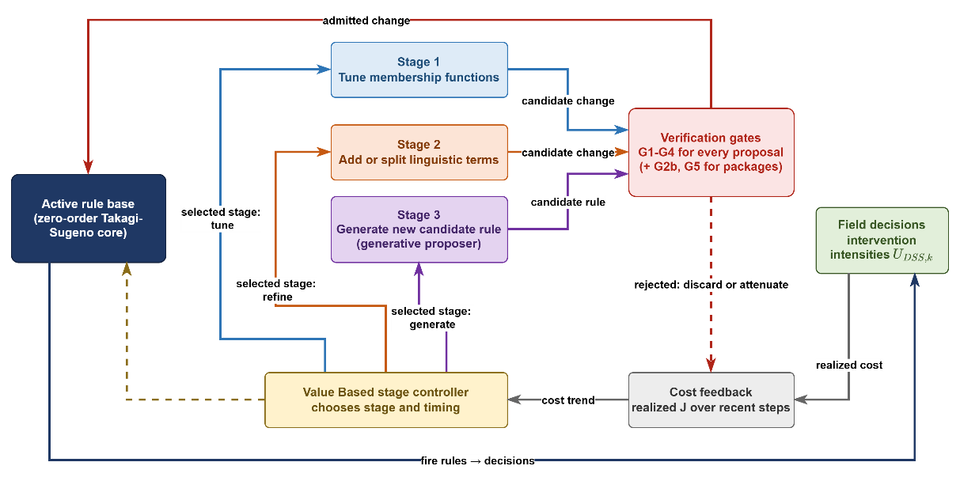
Figure 2.5 Staged adaptation loop with generative proposal and verification
Figure 2.5 depicts the complete loop. The rule base issues decisions, the realized cost is fed back, the value based stage controller selects the least invasive stage that promises improvement, and every output of a stage must pass the verification gate before it returns to the rule base.
- Parameter tuning: an evFIS first adjusts the membership-function parameters of existing rules, the least invasive correction
- Resolution increase: where residual cost concentrates, the term set is refined by adding linguistic terms or splitting a region of the input space
- Generative proposal: when neither of the preceding operations removes a persistent cost, a generative model drafts a genuinely new candidate rule; large-language-model agents have recently begun to serve as such proposers in wildfire analysis and response
The loop is disciplined by two safeguards. Value based stage controller tunes admitted rules and decides when escalation is warranted, driven by the same cost function that evaluates decisions (Sutton & Barto, 2018). Every candidate, regardless of its origin, must pass the satisficing acceptance gate before it may act, according to the admission condition in ( 14 ).
$$R^{'} admitted ⇔J_{R∪\{R'\}}≤J_{R}-δ, δ≥0$$ | ( 14 )
In ( 14 ), $J_{R}$ denotes the cost achieved under rule base $R$ and $δ$ a non-negative improvement margin; an unverified generated rule therefore never reaches the field (Seshia, Sadigh, & Sastry, 2022).The action vocabulary of Section 2.5 remains fixed and interpretable, the rule structure over it evolves and is occasionally extended by generation, and everything that acts has been verified. The design chapters formalize each stage of the loop; the evaluation chapter measures its effect.
The adaptation loop is governed by a value-based, contextual-bandit formulation defined over the following elements. The state vector comprises the recent trajectory of the decision cost, aggregate statistics of the rule base such as the rule count and the mean firing strength, and a summary measure of observation confidence. The action set consists of the three adaptation stages: tuning the consequents and the membership parameters of existing rules, growing the rule base, and requesting a generative proposal. The reward is the realized reduction of the physical cost confirmed by the forecast, diminished by a penalty proportional to structural growth, so that improvements confirmed by field outcomes are favored while superfluous structural complexity is discouraged.
The three stages also admit a direct interpretation in decision-space terms, and this interpretation is adopted throughout the subsequent chapters. Parameter tuning reshapes the boundaries of decision regions that already exist, so the same rules fire over slightly shifted conditions. Resolution increases partitions a region more finely, so situations that previously received one response can now be distinguished. Generative proposal opens a region that no existing rule could reach, extending the reachable part of the decision space itself, and the verification gate decides whether that new region becomes part of the admissible space. Openness therefore does not imply arbitrariness. Every enlargement of the space is priced by the cost model and admitted only through the verification gate.

DISASTERAWARE SIMULATION FRAMEWORK
This chapter defines the structural, computational, and physical foundations of the DisasterAware framework, which serves as the physical backbone of the entire architecture. Its objective is to formalize how wildfire dynamics are represented and computed before the cognitive reasoning mechanisms of the Decision Support System are introduced in the next chapter.
Wildfire evolution is modeled as a spatio-temporal process over a discretized spatial domain partitioned into grid cells. Each cell represents a localized fire condition described by structured state variables: whether combustion is active, the amount of remaining combustible fuel, local fire intensity, and combustion duration. This state-based representation treats fire propagation as a constrained dynamical system rather than a purely geometric spread.
System evolution is driven by several categories of external forcing. Meteorological drivers such as wind speed and humidity affect spread acceleration and combustion sustainability; terrain properties such as slope and aspect introduce directional bias; fuel characteristics regulate ignition thresholds and burn duration; and operational intervention parameters alter local fuel availability through suppression actions. These influences are kept architecturally separate from the internal wildfire state to preserve clarity and computational stability.
A key design principle is the strict separation between physical state evolution and decision logic. The simulation layer models wildfire behavior under environmental and operational inputs without performing reasoning, optimization, or policy selection. Human interaction and scenario manipulation are permitted only through controlled input-level modifications, never through direct state overwriting.
The Decision Support System is introduced here only to clarify its structural interface with the simulation environment; its internal fuzzy reasoning, layered decision synthesis, and optimization mechanisms are deferred to the next chapter. The remainder of this chapter is organized as follows:
Section 3.1 presents the layered architectural structure and inter-layer data flow of the DisasterAware framework.
Section 3.2 formalizes the external input structure: The simulation input set together with its meteorological, topographic, fuel, ignition, and decisional data layers, and the contextual inputs used by the DSS.
Section 3.3 formalizes the simulation core: The discrete-time state representation and its state variables, the hybrid fire spread transition mechanism, and the interaction and scenario control operator.
Section 3.4 introduces the observation interface that exposes the state to the Decision Support System, states the structural positioning of the DSS Core within the framework, and defers its design specification to the next chapter.
Through this structured progression, Chapter 3 establishes the physically grounded computational environment required for reliable, interpretable, and scalable decision support in wildfire management.

Overall System Block Diagram
Figure 3.1 presents the architectural structure of the DisasterAware framework. The system is designed as a discrete-time, state-driven, layered DSS architecture with a clear separation between input acquisition, physical state evolution, decision evaluation, and human interaction. The architectural objective is to preserve physical consistency within wildfire simulation while enabling adaptive and interpretable decision-making.
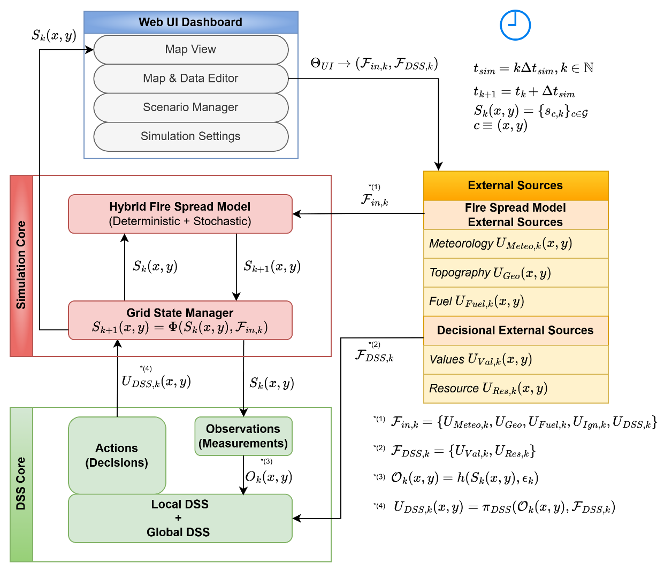
Figure 3.1 DisasterAware system block diagram (simulation focused)
The architecture is organized into four principal layers: External Data Sources, Simulation Core, Decision Support System (DSS) Core, and Web UI Dashboard. Each layer performs a strictly defined function and communicates through structured interfaces rather than direct state manipulation. This separation ensures physical consistency, operational robustness, and architectural transparency.
The External Data Sources layer provides structured exogenous inputs including meteorological, terrain, fuel, and decisional parameters. These inputs act as boundary conditions for the simulation. Environmental inputs are independent of the system state, while decision-driven inputs generated by the DSS depend on observable quantities derived from the system state.
At the center of the framework lies the Simulation Core, which serves as the authoritative computational engine. Wildfire propagation is modeled over a spatial grid where each cell contains a structured representation of local fire conditions. The complete wildfire state includes burning status, available combustible mass, local fire intensity proxy, and time since ignition. This state is maintained and updated at every simulation time step. The Grid State Manager enforces physical constraints such as non-negativity of fuel load and bounded combustion behavior. No external module, including the DSS or the UI, is permitted to directly overwrite internal state variables. All modifications must occur through controlled parameter influence, preserving simulation integrity.
The Decision Support System Core operates as a cognitive layer built on top of the Simulation Core. The DSS operates on observable quantities $O_{k}\left(x,y\right)$ derived from the system state through the observation process. This observation layer extracts structured indicators from the raw state variables, such as fire front behavior, acceleration zones, exposure metrics, and operational accessibility conditions.
The DSS can evaluate conditions at every simulation time step, but decision activation may follow event-triggered conditions. It may operate in an event-driven manner, producing intervention strategies only when predefined thresholds or risk conditions are triggered. When a decision is generated, it is translated into operational parameters that influence subsequent state transitions indirectly through the simulation engine.
The Web UI Dashboard forms the operational boundary between human operators and the computational layers. Unlike the Simulation Core, which is time-synchronous, the UI layer operates asynchronously. The operator can pause the simulation; resume execution; roll back to a stored checkpoint; restart from initial conditions; inject new ignition scenarios; modify operational resource availability; and cancel an active simulation.
The UI never directly modifies internal state variables. Instead, it adjusts permissible configuration parameters that affect future simulation steps. This ensures that human intervention remains controlled, traceable, and reversible. The data flow between layers follows a strict directional structure. External inputs feed the Simulation Core at each time step. The Simulation Core updates the authoritative wildfire state. The DSS observes the current state through observable information $O_{k}\left(x,y\right)$, uses contextual decision inputs $F_{DSS,k}$, evaluates risk, and generates structured intervention recommendations when required. The UI visualizes both physical state evolution and DSS outputs while allowing controlled scenario manipulation.
As shown in Figure 3.1, this layered organization enforces a clear separation between wildfire physics, decision cognition, and human supervision. The architecture is designed to ensure: (i) Physical consistency of fire propagation; (ii) Modular extensibility; (iii) Horizontal scalability; (iv) Traceable intervention logic; (v) Robust human-in-the-loop (HIL) control.
By maintaining strict boundaries between simulation dynamics and decision reasoning, the framework establishes a stable computational foundation upon which distributed fuzzy reasoning and adaptive coordination mechanisms can be constructed in subsequent chapters.

Simulation Input and External Sources
$F_{in,k}$ represents all parameters that influence wildfire evolution at discrete time step $k$. These inputs include both exogenous environmental factors and decision-driven intervention parameters generated by the DSS. These inputs act as boundary conditions and forcing mechanisms for the state transition process. Environmental inputs are updated independently of the system state, whereas decision-driven inputs depend on observable quantities derived from the state. At each discrete simulation step $k$, the external input set is updated and provided to the Simulation Core.
External inputs can be categorized into three distinct groups: (i) Environmental input: including meteorological, terrain, and fuel-related factors that govern physical wildfire dynamics; (ii) Exogenous event inputs: such as ignition events, which trigger fire initiation independently of system evolution; (iii) Decision-driven inputs: intervention parameters generated by the DSS, representing operational actions influencing wildfire evolution.
$F_{in,k}$ ( 15 ) represents all external parameters that influence wildfire dynamics, namely meteorology $U_{Meteo,k}$ ( 16 ), topography $U_{Geo}$ ( 17 ), fuel $U_{Fuel\text{,k}}$ ( 18 ), ignition $U_{Ign,k}$ ( 19 ) and inputs generated by DSS $U_{DSS,k}$ ( 20 ). This structured separation ensures that environmental forcing, ignition triggering, and operational intervention remain conceptually and functionally distinct.
$$F_{in,k}=\left\{U_{Meteo,k},U_{Geo}, {U_{Fuel\text{,k}}, U_{Ign,k}, U}_{DSS,k}\right\}$$ | ( 15 )
In addition to the simulation input set $F_{in,k}$, the DSS process relies on a distinct contextual input set defined as $F_{DSS,k}= \{U_{Val,k}, U_{Res,k}$}. This set represents value-related and resource-related information used by the DSS for decision evaluation. Unlike $F_{in,k}$, which directly influences the state transition operator, $F_{DSS,k}$ does not affect wildfire dynamics directly. Instead, it provides contextual information that guides decision-generation within the DSS layer.

Meteorology Data Layer
Meteorological inputs $U_{Meteo,k}$ ( 16 ) are spatio-temporal environmental drivers that influence ignition sustainability, rate of spread, fuel drying, and fire intensity.
$$U_{Meteo,k}\left(x,y\right)=\left[\begin{aligned}W_{temp,k}\left(x,y\right) \\ W_{rh,k}\left(x,y\right) \\ W_{ws,k}\left(x,y\right) \\ W_{wd,k}\left(x,y\right) \\ W_{gust,k}\left(x,y\right) \\ W_{prec,k}\end{aligned}\right]$$ | ( 16 )
These fields are updated at every discrete simulation step to ensure dynamic adaptation of wildfire behavior to evolving environmental conditions. These variables listed in Table 3.1 are primarily time-dependent and may optionally be spatially dependent when high-resolution gridded weather fields are available.
Table 3.1 Meteorology data layer parameters
Parameter | Type | Unit | Purpose in Simulation
Air Temperature  $$W_{\text{temp,k}}\left(x,y\right)$$ | Spatio-temporal | °C | Represents ambient air temperature, influencing fuel drying rate, ignition thresholds, and fire intensity potential.
Relative Humidity  $$W_{\text{rh,k}}\left(x,y\right)$$ | Spatio-temporal | % | Represents atmospheric moisture content and directly regulates live and dead fuel moisture levels.
Wind Speed  $$W_{\text{ws,k}}\left(x,y\right)$$ | Spatio-temporal | m/s | Serves as the primary driver of fire spread rate and significantly increases the rate of spread under high-speed conditions.
Wind Direction  $$W_{\text{wd,k}}\left(x,y\right)$$ | Spatio-temporal | rad | Determines the directional propagation of the fire front and controls anisotropic spread behavior.
Wind Gust Speed  $$W_{\text{gust,k}}\left(x,y\right)$$ | Spatio-temporal | m/s | Represents short-term wind fluctuations and stochastic acceleration in fire propagation.
Precipitation  $$W_{\text{prec,k}}\left(x,y\right)$$ | Temporal | mm/h | Increases fuel moisture and can suppress, delay, or weaken active combustion processes.

Topography Data Layer
Terrain parameters $U_{Geo}$ ( 17 ) define static spatial constraints over which wildfire propagation occurs. Unlike meteorological variables, these parameters remain constant during short-horizon simulation but modulate directional spread, acceleration, and accessibility. The geometry parameters are listed in Table 3.2.
$$U_{Geo}\left(x,y\right)=\left[\begin{aligned}G_{elev}\left(x,y\right) \\ G_{slope}\left(x,y\right) \\ G_{aspect}\left(x,y\right) \\ G_{access}\left(x,y\right)\end{aligned}\right]$$ | ( 17 )
Table 3.2 Geometry (topography) data layer parameters
Parameter | Type | Unit | Purpose in Simulation
Elevation  $$G_{\text{elev}}\left(x,y\right)$$ | Spatial | m | Represents the altitude of each grid cell and influences local wind behavior, vegetation type distribution and environment gradients.
Slope  $$G_{\text{slope}}\left(x,y\right)$$ | Spatial | rad | Represents terrain inclination and increases fire spread rate in the uphill direction due to flame heat transfer effects.
Aspect  $$G_{\text{aspect}}\left(x,y\right)$$ | Spatial | rad | Represents slope orientation and influences solar radiation exposure, fuel drying patterns, and directional fire propagation.
Accessibility Index  $$G_{\text{access}}\left(x,y\right)$$ | Spatial | -{0,1} | Represents terrain traversability and influences responder mobility, intervention timing, and operational feasibility.

Fuel Data Layer
Fuel-related inputs $U_{Fuel,k}$ ( 18 ) describe the combustible material available at each grid cell. $F_{\text{type}}\left(x,y\right)$ is the vegetation class and $F_{load,k}\left(x,y\right)$ is the available combustible mass at initial time. Fuel moisture $F_{moist,k}\left(x,y\right)$ is treated as an exogenous spatio-temporal input field updated from meteorological drivers or scenario configurations. The fuel parameters are listed in Table 3.3.
$$U_{Fuel,k}\left(x,y\right)=\left[\begin{aligned}F_{\text{type}}\left(x,y\right) \\ F_{load,k}\left(x,y\right) \\ F_{\text{moist,k}}\left(x,y\right)\end{aligned}\right]$$ | ( 18 )
Table 3.3 Fuel data layer parameters
Parameter | Type | Unit | Purpose in Simulation
Fuel Type  $F_{\text{type}}\left(x,y\right)$ | Spatial | – | Defines the vegetation within each grid cell and determines combustion characteristics such as burn rate and heat release behavior.
Fuel Load  $F_{\text{load,k}}\left(x,y\right)$ | Spatio-temporal | {0,1}$\frac{kg}{m^{2}}$ (norm.) | Represents the available combustible mass in each grid cell and directly controls fire intensity, burn duration, and energy release.
Fuel Moisture  $$F_{\text{moist,k}}\left(x,y\right)$$ | Spatio-temporal | – (mass fraction) | Represents moisture of surface fuels and determines ignition probability and combustion sustainability.

Ignition Layer
Ignition is separate from fire intensity. It is the activation of combustion at a specific grid cell and time step. Ignition may originate from predefined initial conditions, external events, or spotting effects. It functions as a triggering mechanism within the transition dynamics and does not constitute a persistent state variable. The ignition input is defined in ( 19 ) where $I_{Ign,k} (x,y)$ is a binary ignition injection indicator.
$$U_{Ign,k}\left(x,y\right)=\left[\begin{aligned}I_{Ign,k}\left(x,y\right)\end{aligned}\right]$$ | ( 19 )

Decisional Data Layers
The Decisional External Sources ($F_{DSS,k})$ layer represents the non-physical inputs that shape decision making within the distributed DSS. Unlike the meteorological, topographic, and fuel layers that govern fire dynamics, this layer carries the contextual information needed to evaluate operational priorities and constraints, and it therefore determines how simulation outcomes are interpreted and acted upon.
The DSS generates decision-driven intervention parameters $U_{DSS,k}$ ( 20 ) based on observed system states $S_{k}\left(x,y\right)$and $F_{DSS,k}$. $R_{cap,k}\left(x,y\right)$ is available suppression capacity, $R_{avail,k}\left(x,y\right)$ is operational availability status of resources, $R_{eff,k}\left(x,y\right)$ is suppression effectiveness, and $R_{time,k}\left(x,y\right)$ is estimated travel time to reach grid cell $\left(x, y\right)$. These parameters do not represent physical measurements but structured representations of operational actions, which are incorporated into the external input set to influence wildfire dynamics.
$$U_{DSS,k}\left(x,y\right)= \left[\begin{aligned}R_{cap,k}\left(x,y\right) \\ R_{avail,k}\left(x,y\right) \\ R_{eff,k}\left(x,y\right) \\ R_{time,k}\left(x,y\right)\end{aligned}\right]$$ | ( 20 )
$F_{DSS,k}$ has two components: the Value Data and the Resource Data layers. The Value layer defines spatial exposure and asset importance, which supports risk-based prioritization. The Resource layer defines the available suppression capabilities and logistical constraints, which support feasible intervention planning. Together they turn the physical fire propagation output of the Simulation Core into actionable decision variables, keeping fire behavior modeling and decision reasoning separate.

Value Data Layer
The Values-at-Risk Data layer represents exposed assets, infrastructure, and socio-economic elements that may be affected by wildfire propagation. The value data layer parameters are listed in Table 3.4. All variables in this layer are spatially dependent and static during short-term operational simulations, although their priority weights may be dynamically adjusted based on operational objectives.
Table 3.4 Value data layer parameters
Parameter | Type | Unit | Purpose in Simulation
Building Footprint  $$V_{\text{bld}}\left(x,y\right)$$ | Spatial | {0,1} | Represents the presence of residential or commercial structures and enables identification of wildland-urban zones.
Critical Facility Index  $$V_{\text{crit}}\left(x,y\right)$$ | Spatial | {0,1} | Identifies high-priority assets such as hospitals, power plants, fuel depots, and water infrastructure.
Population Density  $$V_{\text{pop}}\left(x,y\right)$$ | Spatial | person/km² | Represents exposed population per grid cell and supports evacuation and safety prioritization.
Accessibility to Evacuation Routes  $$V_{\text{evac}}\left(x,y\right)$$ | Spatial | m | Indicates proximity to evacuation infrastructure and supports emergency planning decisions.
Protection Priority Score  $$V_{\text{prio}}\left(x,y\right)$$ | Spatial | – | Aggregated weighting factor combining multiple exposure indicators to rank cells by importance.

The protection priority score $V_{prio}(x,y)$ aggregates the four value indicators into a single scalar index that ranks each grid cell by its overall protection importance. The aggregation is as a normalized weighted sum ( 21 ) where $V_{pop}^{norm} =\frac{V_{pop}}{max V_{pop}}$ is the min-max normalized population density, and $V_{evac}^{norm} =\frac{V_{evac}}{max V_{evac}}$ is the inverted and normalized evacuation distance (higher value indicates closer proximity to evacuation routes, hence higher priority).
$$V_{prio}(x,y) = w_{bld} · V_{bld}(x,y) + w_{crit} · V_{crit}(x,y) + w_{pop} · V_{pop}^{norm}(x,y) + w_{evac} · V_{evac}^{norm}(x,y)$$ | ( 21 )
The weights satisfy $w_{bld} + w_{crit} + w_{pop} + w_{evac} = 1$. The weight assignment reflects the operational priority. Critical facilities ($w_{crit} = 0.40$) receive the highest weight because their loss has cascading consequences (e.g., hospitals, power infrastructure, water supply). Population density ($w_{pop} = 0.30$) ranks second because human life exposure scales with density. Building footprint ($w_{bld} = 0.20$) captures structural asset density. Evacuation accessibility ($w_{evac} = 0.15$) receives the lowest weight because it represents a logistical constraint rather than a direct measure of asset value; however, it remains non-zero because locations with poor evacuation access require protective intervention earlier in the decision timeline.

Resource Data Layer
The Resource Data layer represents the operational capabilities available for wildfire intervention. While the fire behavior model estimates how fire evolves under environmental conditions, this layer defines the constraints and effectiveness of suppression actions. The resource data layer parameters are listed in Table 3.5.
Table 3.5 Resource data layer parameters
Parameter | Type | Unit | Purpose in Simulation
Suppression Capacity  $$R_{\text{cap,k}}\left(x,y\right)$$ | Spatio-temporal | m³ / step | Represents available suppression capability (i.e., water volume or manpower at grid cell at time step k).
Travel Time  $$R_{\text{time,k}}\left(x,y\right)$$ | Spatio-temporal | min or h | Represents estimated time required to reach a grid cell from current position.
Suppression Efficiency  $$R_{\text{eff,k}}\left(x,y\right)$$ | Spatio-temporal | {0,1} | Quantifies how effectively a resource reduces fuel load or fire intensity.
Resource Availability  $$R_{\text{avail,k}}\left(x,y\right)$$ | Spatio-temporal | {0,1} | Indicates whether the resource is currently deployable.

Simulation Core
The Simulation Core is the computational foundation of the framework. It represents the wildfire as a state defined over a spatial grid and advances it in discrete time through a single transition operator built on a hybrid fire spread model. Each cell carries its burning status, fuel load, fire intensity, and time since ignition, and these evolve together under the meteorological, topographic, and fuel inputs that govern fire dynamics. The operator is deterministic; stochastic effects such as wind gusts and ember spotting enter only through the external input fields and never write to the state directly. The Simulation Core estimates only how the fire behaves over space and time and leaves the interpretation of that behavior to the DSS, which keeps fire modeling and decision making clearly separated. Its design criterion is testability and reproducibility rather than maximal physical fidelity.

Spatio-Temporal State Transition
Each grid cell in $G$ corresponds to a spatial coordinate pair $\left(x, y\right)$ and represents a localized fire condition ( 22 ). $N_{x}$ is the number of grid cells along the horizontal spatial axis, and $N_{y}$ is the number of grid cells along the vertical spatial axis.
$$G=\left\{\left(x,y\right) ∣ x=1,…,N_{x}, y=1,…,N_{y}\right\}$$ | ( 22 )
At each simulation step, the wildfire state over the grid is represented by $S_{k}$. The system state is defined as the collection of local cell states over the domain ( 23 ). $B_{k}\left(x,y\right)$ is the burning status of cell $\left(x,y\right)$, $F_{load,k}\left(x,y\right)$ is available combustible mass, $I_{k}\left(x,y\right)$ is local fire intensity proxy, and $τ_{k}\left(x,y\right)$ is time since ignition.
$$S_{k}=\left\{s_{k}\left(x,y\right)|(x,y)∈G\right\} \\ s_{k}=\left[\begin{aligned}B_{k}\left(x,y\right) \\ F_{load,k}\left(x,y\right) \\ I_{k}\left(x,y\right) \\ τ_{k}\left(x,y\right)\end{aligned}\right]$$ | ( 23 )
The state vector includes only internal wildfire variables. Environmental factors and operational interventions are not part of the state and are represented as external inputs influencing the state transition. Grid domain and the cell state vector representation is illustrated in Figure 3.2.
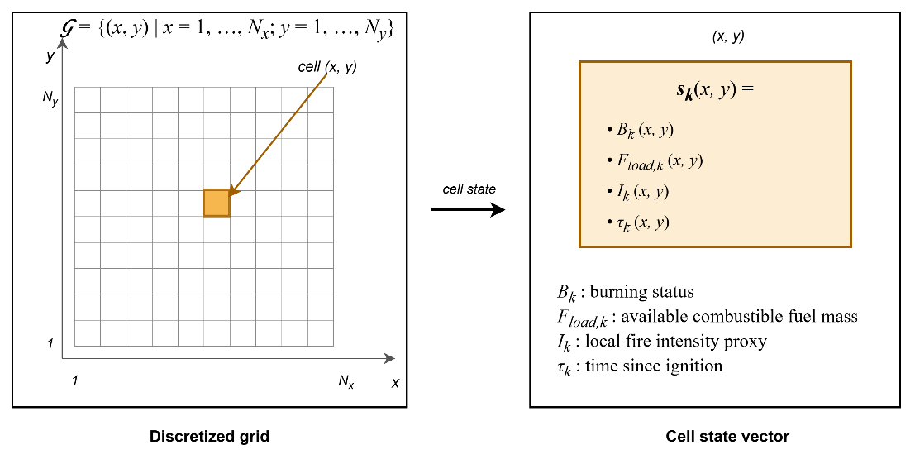
Figure 3.2 Grid domain representation and per-cell state structure

Hybrid Fire Spread Model
The hybrid model integrates deterministic combustion dynamics with stochastic variability to represent realistic wildfire behavior. The global state evolution ( 24 ) is governed by the transition operator where $F_{in,k}$ ( 15 ) includes meteorological forcing, topography, fuel conditions, ignition injection, and DSS-generated intervention parameters. $Φ$ denotes the structured state transition operator composed of burning status evolution, fuel mass evolution, and fire intensity update as defined in the subsequent subsections. The transition operator itself is deterministic. Stochastic variability may arise only through exogenous input fields (e.g., wind gust fluctuations), which are treated as externally provided spatio-temporal inputs.
$$S_{k+1}\left(x,y\right)=Φ\left(S_{k}\left(x,y\right),F_{in,k}\right)$$  $$F_{in,k}=\left\{U_{Meteo,k},U_{Geo}, {U_{Fuel\text{,k}}, U_{Ign,k}, U}_{DSS,k}\right\}$$ | ( 24 )
The overall state transition and hybrid fire spread model is illustrated in Figure 3.3. The state transition operations are described in the next subsections.
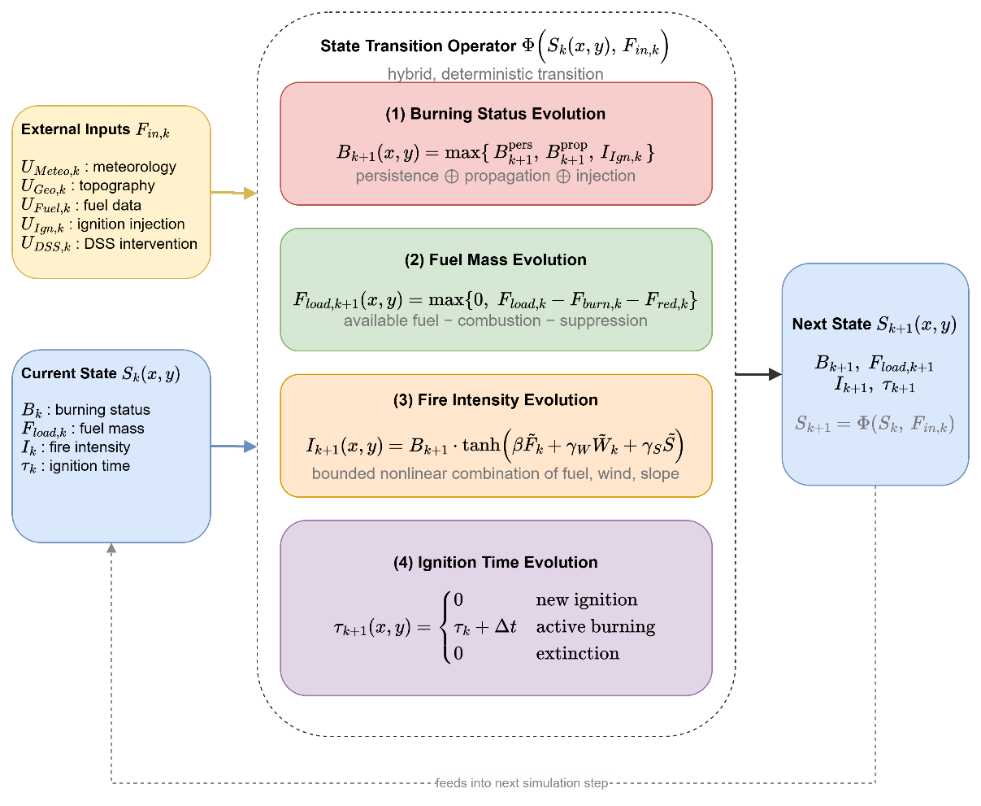
Figure 3.3 State transition block diagram

Burning Status Evolution
The burning status $B_{k}\left(x,y\right)∈\left\{0,1\right\}$ indicates whether the cell is actively burning at time step $k$. The burning status at the next step $B_{k+1}$ ( 25 ) is determined by three mechanisms: persistence of ongoing burning $B_{k+1}^{pers}$ ( 26 ), propagation from neighboring burning cells, and external ignition injection $I_{Ign,k}\left(x,y\right)$. Combining these three mechanisms, the burning status update rule is defined as ( 25 ).
$$B_{k+1}\left(x,y\right)=\max\left(B_{k+1}^{pers}\left(x,y\right),B_{k+1}^{prop}\left(x,y\right),I_{Ign,k}\left(x,y\right)\right)$$ | ( 25 )
This formulation ensures that a burning cell persists while fuel remains available; neighboring burning cells may activate a new cell if sufficient spread influence accumulates; external ignition acts as an independent triggering mechanism.
The persistence term $B_{k+1}^{pers}$ ensures that a cell that is already burning remains burning as long as fuel exists, as stated in ( 26 ) where $1\left[∙\right]$ denotes the indicator function. To avoid numerical persistence under vanishing residual fuel mass, a small extinction threshold $ϵ_{fuel_{load}}$ is used.
$$B_{k+1}^{pers}\left(x,y\right)=B_{k}\left(x,y\right)⋅1\left[F_{load,k}\left(x,y\right)>ϵ_{fuel_{load}} \right]$$  $$ϵ_{fuel_{load}}={10}^{-4}$$ | ( 26 )
Propagation to cell $\left(x,y\right)$ occurs if the accumulated influence exceeds a critical ignition threshold $Θ_{ign}$, where $Θ_{ign}$ is a model parameter representing the minimum spread intensity required to activate combustion in a new cell ( 27 ).
$$B_{k+1}^{prop}\left(x,y\right)=1\left[Ψ_{k}\left(x,y\right)> Θ_{ign}\right]$$  $Θ_{ign}∈\left(0,1\right)$: calibrated threshold relative to base spread rate | ( 27 )
Wildfire spread to neighboring cells is modeled through local propagation influence. $N^{8}\left(x,y\right)$ denotes the 8-connected neighborhood of cell $\left(x,y\right)$. The total propagation influence received by cell $\left(x,y\right)$ at time step $k$ $Ψ_{k}\left(x,y\right)$ is defined in ( 28 ), where the rate of spread $R_{spread,k}\left(x,y\right)$ is ( 29 ). The rate-of-spread mapping $f_{ros}\left(⋅\right)$ is instantiated using a semi-empirical Rothermel-type formulation (Rothermel, 1972). Detailed parameterization is provided in Appendix A. $W_{ws,k}\left(x,y\right)$ is the wind speed field, $W_{wd,k}\left(x,y\right)$ is the wind direction field, $G_{slope}\left(x,y\right)$ is the terrain slope, $G_{aspect}\left(x,y\right)$ is the terrain orientation, $F_{moist,k}\left(x,y\right)$ is the fuel surface moisture, and $F_{type}\left(x,y\right)$ is the fuel type.
$$Ψ_{k}\left(x,y\right)=\frac{1}{8}\sum_{\left(i,j)∈N^{8}(x,y\right)}{B_{k}}\left(i,j\right)⋅R_{spread,k}\left(i,j\right)⋅ g_{dir,k}^{\left(i,j)→(x,y\right)}$$ | ( 28 )
$$R_{spread,k}\left(x,y\right)=f_{ros}\left(\begin{aligned}W_{ws,k}\left(x,y\right), W_{wd,k}\left(x,y\right), \\ {G_{slope}\left(x,y\right),G}_{aspect}\left(x,y\right), \\ F_{moist,k}\left(x,y\right),F_{type}\left(x,y\right) \end{aligned}\right)$$ | ( 29 )
The scalar magnitude $R_{spread,k}\left(x,y\right)$ does not determine spread direction. Directional influence ( 30 ) is introduced when propagating fire from a burning neighbor $\left(i , j\right)$ to target cell $\left(x,y\right)$. $φ_{\left(i,j)→(x,y\right)}$ is the geometric direction between cells. This ensures anisotropic spread aligned with wind direction.
$$g_{dir,k}^{\left(i,j)→(x,y\right)}=\max\left(0,\cos\left(W_{wd,k}\left(i,j\right)-φ_{\left(i,j)→(x,y\right)}\right)\right)$$ | ( 30 )
Figure 3.4 depicts the spatial structure of the propagation influence accumulation. The 3×3 stencil centered on the target cell $(x,y)$ represents the 8-connected neighborhood $N_{8\left(x,y\right)}$ defined in ( 28 ); the three cells shaded in red denote burning neighbors with $B_{k}\left(i,j\right) = 1$, while the remaining five are non-burning. The wind direction $W_{wd,k}$, represented by the large arrow in the upper-right region of the figure, establishes the axis of anisotropy.
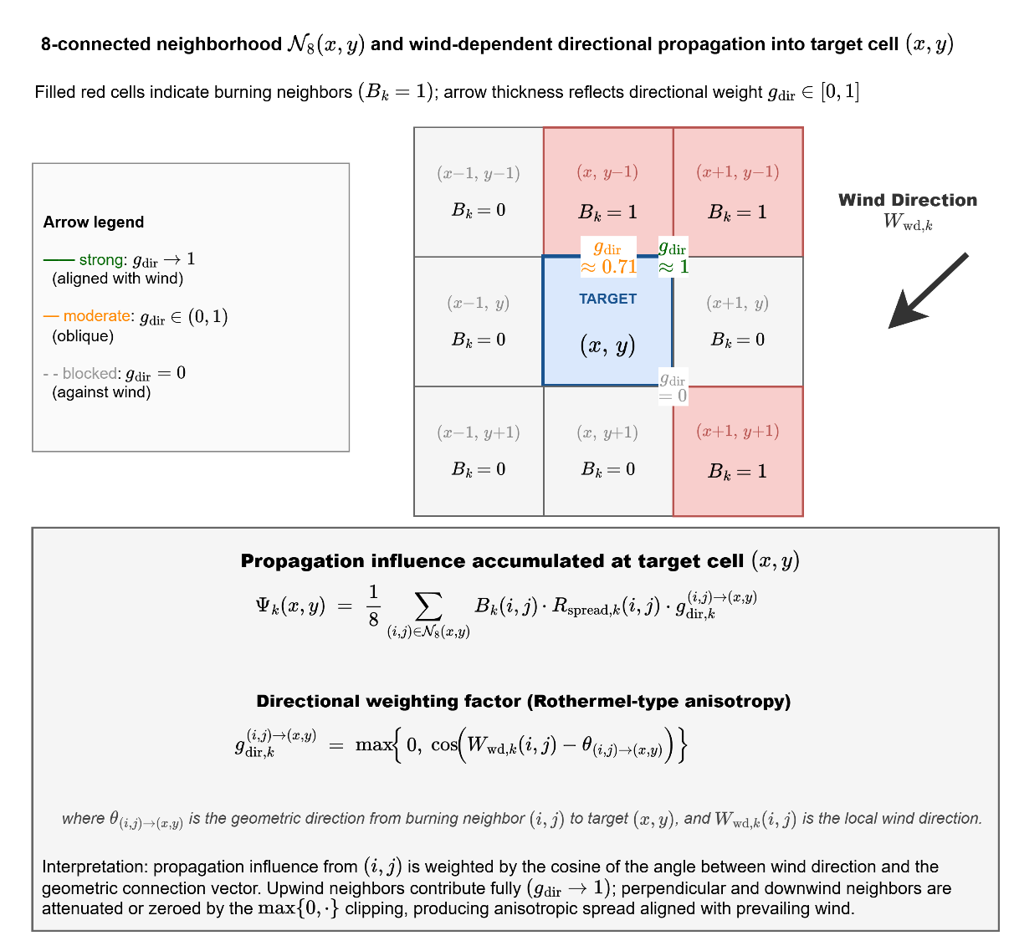
Figure 3.4 Wind-dependent directional propagation into target cell
For each burning neighbor, a propagation arrow is drawn toward the target cell with line weight proportional to its directional weight $g_{dir,k}^{\left(i,j\right)→\left(x,y\right)}$: the arrow from the northeast neighbor is aligned with the wind vector and therefore receives full weight $g_{dir} → 1$; the arrow from the northern neighbor is oblique and receives an intermediate weight $g_{dir} ≈ 0.71$; and the arrow from the southeastern neighbor is oriented opposite to the wind and is entirely eliminated, $g_{dir} = 0$, by the $max\left\{0, ·\right\}$ clipping. The aggregate propagation influence $Ψ_{k}\left(x,y\right)$ computed through ( 28 ) is therefore not a symmetric average over the 8-neighborhood but a wind-aligned weighted sum, and the ignition condition $Ψ_{k}(x,y) > Θ_{ign}$ $REF _Ref223041204 \backslash h$( 27 ) is consequently satisfied preferentially along the direction of prevailing wind. This mechanism realizes the Rothermel-type directional bias that is central to operationally realistic wildfire propagation.
External ignition injection $I_{Ign,k}\left(x,y\right)∈\left\{0,1\right\}$ directly activates combustion independent of neighbor influence. Ignition injection may represent lightning strikes, human-caused ignition, or scenario-based ignition input from the UI layer. Ignition injection is a scenario-level forcing that sets $B_{k+1}\left(x,y\right)=1$ regardless of local conditions; if $F_{load,k}\left(x,y\right)$ is insufficient, extinction follows naturally via the persistence condition in the next step. In contrast, the local fire intensity proxy $I_{k}\left(x,y\right)$ represents combustion strength after ignition has occurred and does not participate in the activation condition. This separation preserves conceptual clarity between fire initiation and fire magnitude.
Ember spotting extends ignition beyond the resolved front. Each burning cell whose intensity exceeds 0.6, under wind above 3 m/s and precipitation below 1 mm/h, releases an ember with probability 0.02 per reference step, compounded consistently across substeps. The ember lands six cells downwind and ignites the target cell only if fuel remains there and the local fuel moisture is below the extinction threshold. Spotting is the only stochastic element of the transition operator, is driven by the seeded random stream of the scenario, and allows the fire to cross narrow barriers such as rivers, roads, and containment lines under strong and dry winds.
Precipitation acts on the dynamics through the dead fuel moisture. While it rains, $F_{moist}$ relaxes toward at least 0.35, a level above every extinction threshold, with a time constant of roughly thirty minutes scaled by the rain intensity; under sustained rain of at least 3 mm/h a burning cell is quenched once its fuel moisture has reached that level, so a front dies out gradually rather than instantaneously. When the optional equilibrium moisture mode is active, the dead fuel moisture follows the Simard equilibrium moisture content computed from air temperature and relative humidity, so diurnal weather cycles modulate flammability in the manner of operational fire behavior tools.
Propagation dynamics are governed exclusively by the rate-of-spread mapping $R_{spread,k}\left(x,y\right)$. The local fire intensity proxy does not directly influence activation conditions; instead, it modulates suppression effectiveness and decision-layer interpretation. This separation preserves structural clarity between spread mechanics and combustion strength representation. Thus, intensity affects wildfire dynamics indirectly through suppression resistance and decision-layer interpretation, rather than directly controlling fire propagation.
The rate-of-spread mapping $R_{spread,k}\left(x,y\right)$ is independent of instantaneous fuel mass $F_{load,k}\left(x,y\right)$. Fuel availability influences spread only indirectly through the burning persistence condition, preventing propagation from fuel-depleted cells. This structural separation avoids double- counting mitigation effects.

Fuel Mass Evolution
Fuel mass evolution governs the depletion of combustible material within each cell as a consequence of two distinct mechanisms: combustion-driven consumption and intervention-driven suppression. Unlike the burning status variable, which represents the activation of combustion, the fuel mass variable represents the remaining energy potential available for future fire propagation. Therefore, accurate modeling of fuel evolution is essential to ensure physical consistency, numerical stability, and interpretable interaction between wildfire dynamics and decision-driven mitigation. Combustion-driven consumption and suppression-driven reduction are applied within the same discrete step $k$ as a simultaneous update, represented by the combined terms in ( 31 ) where $B_{k}\left(x,y\right)∈\left\{0,1\right\}$ is the burning status indicator, $F_{burn,k}\left(x,y\right)∈\left[0,1\right]$ is the fractional burn rate (Appendix B), $F_{load,k}\left(x,y\right)$ is the currently available fuel mass, and $F_{red,k}\left(x,y\right)∈\left[0,1\right]$ is intervention-based fuel reduction.
$$F_{load,k+1}\left(x,y\right)=\max\left(\begin{aligned}0, \left(\begin{aligned}F_{load,k}\left(x,y\right) \\ -F_{load,k}\left(x,y\right) B_{k}\left(x,y\right) F_{burn,k}\left(x,y\right) \\ -F_{red,k}\left(x,y\right)\end{aligned}\right)\end{aligned}\right)$$ | ( 31 )
Fuel cannot become negative and cannot increase unless explicitly modeled, $0≤F_{load,k+1}\left(x,y\right)≤1$. This formulation explicitly separates combustion-induced depletion from suppression-induced reduction while enforcing non-negativity of fuel mass. Fuel consumption due to combustion occurs only when the cell is actively burning. The term $B_{k}\left(x,y\right) F_{load,k}\left(x,y\right) F_{burn,k}\left(x,y\right)$ represents the fraction of available fuel consumed during the current simulation step. The multiplication by $B_{k}\left(x,y\right)$ ensures that fuel depletion due to combustion occurs only in actively burning cells. If the cell is not burning, no combustion-driven reduction takes place. This preserves physical realism and prevents unintended fuel decay in inactive regions. The burn fraction $F_{burn,k}\left(x,y\right)$ captures the local combustion intensity per time step and can be interpreted as a discretized approximation of heat-release-driven fuel consumption. The suppression-induced fuel reduction term $F_{red,k}\left(x,y\right)$ is computed from decision-driven inputs $U_{DSS,k}\left(x,y\right)$ and is not an independent external input.
On the other hand, operational intervention modifies the fuel state through the suppression term ( 32 ). This mapping converts operational capability and reachability into a normalized fuel reduction effect. The suppression term may represent water or retardant application; mechanical fuel removal; controlled burn operations; and resource-constrained mitigation strategies. $f_{supp}$ is Suppression to fuel reduction map (Appendix B), $R_{cap,k}$ is available suppression capacity, $R_{avail,k}$ is operational availability status of resources, $R_{eff,k}\left(x,y\right)$ is suppression effectiveness at cell $\left(x , y\right)$, $R_{time,k}\left(x,y\right)$ is estimated travel time to reach $\left(x , y\right)$, and $G_{access}\left(x,y\right)$ is accessibility level at grid cell $\left(x , y\right)$.
$$F_{red,k}\left(x,y\right)=f_{supp} \left(\begin{aligned}R_{cap,k}\left(x,y\right),R_{avail,k}\left(x,y\right),R_{eff,k}\left(x,y\right), \\ R_{time,k}\left(x,y\right),G_{access}\left(x,y\right)\end{aligned}\right)$$ | ( 32 )
Suppression does not directly overwrite the burning state. Instead, it modifies the available fuel mass, which subsequently influences combustion persistence and propagation through the transition operator. This separation guarantees architectural clarity between physical wildfire dynamics and decision-driven intervention mechanisms.

Fire Intensity Evolution
The local fire intensity proxy evolves according to ( 33 ). The function $f_{intensity}\left(⋅\right)$ approximates local fire strength as a function of available fuel, wind forcing, and terrain gradient. $I_{k+1}\left(x,y\right)$ denotes the updated intensity at the next time step; $I_{k}$ does not appear as an argument of $f_{intensity}$. $f_{intensity}$ is local fire strength function (Appendix C), $F_{load,k}\left(x,y\right)$ is the available combustible mass, $W_{ws,k}\left(x,y\right)$ is wind speed, and $G_{slope}\left(x,y\right)$ is terrain slope.
$$I_{k+1}\left(x,y\right)=f_{intensity}\left(F_{load,k}\left(x,y\right),W_{ws,k}\left(x,y\right),G_{slope}\left(x,y\right)\right)$$ | ( 33 )
The fire intensity proxy serves as an intermediate physical-descriptive variable with the following roles: it does not control ignition activation; it does not directly modify the spread operator; it influences suppression effectiveness through the intervention mapping; and it provides structured features to the Decision Support System. Thus, intensity is a bounded combustion-strength indicator that links environmental forcing to operational response without introducing thermodynamic complexity.

Ignition Time Evolution
The ignition time variable $τ_{k}\left(x,y\right)$ represents the time elapsed since the most recent ignition event at grid cell $\left(x , y\right)$. Unlike fuel mass or intensity, $τ_{k}$ does not influence combustion physics directly. Instead, it serves as a temporal memory state that preserves the burning history of the cell. $τ_{k}$ is a useful state for decision features and explainability within the DSS layer. A deterministic update is ( 34 ).
$$τ_{k+1}\left(x,y\right)=\left\{\begin{matrix}0, & B_{k+1}=1∧B_{k}=0 \\ τ_{k}+Δt, & B_{k+1}=1∧B_{k}=1 \\ 0, & B_{k+1}=0\end{matrix}\right.$$ | ( 34 )
This update has three distinct operational meanings:
- Ignition Initialization: When a cell transitions from non-burning to burning $B_{k}=0, B_{k+1}=1,$ the ignition clock is initialized: $τ_{k+1}=0$. This marks the start of a new combustion phase.
- Active Burning Progression: When a cell remains in the burning state $B_{k}=1, B_{k+1}=1$, the ignition time increases linearly: $τ_{k+1}=τ_{k}+Δt.$ Thus, $τ_{k}$ measures the residence time of active combustion at the cell.
- Extinction Reset: When combustion ceases $B_{k+1}=0,$ the ignition clock resets to 0. It ensures extinguished cells carry no residual temporal memory.
$τ_{k}$ does not feed back into the burning activation condition in the present model, preserving the separation between physical fire dynamics and temporal descriptors.

Mathematical Formulation of Interaction and Scenario Control
The Interaction and Scenario Control mechanism enables controlled human intervention within the DisasterAware framework while preserving the physical consistency of wildfire dynamics. The external simulation input set is $F_{in,k}=\left\{U_{Meteo,k},U_{Geo},U_{Fuel,k},U_{Ign,k},U_{DSS,k}\right\}$ and decision-context set is $F_{DSS,k}=\left\{U_{Val,k},U_{Res,k}\right\}$. The user interaction operator $Θ_{UI}$ is a structured input transformation mapping that produces admissible modifications of the external input set and decision-context set ( 35 ).
$$Θ_{UI}:F_{in}×F_{DSS} ⟶ F_{in}^{*}×F_{DSS}^{*}$$  $$\left(F_{in,k}^{*}, F_{DSS,k}^{*})=Θ_{UI}(F_{in,k}, F_{DSS,k}\right)$$ | ( 35 )
The operator acts independently on five admissible inputs. For each component, the admissible transformation is defined by a bounded perturbation set in Table 3.6. All unmodified components pass through unchanged: $U_{Geo}^{*}=U_{Geo}$, $U_{Fuel,k}^{*}=U_{Fuel,k}$.
Table 3.6 Admissible transformations of interaction operator
Component | Admissible transformation | Constraint
Ignition injection $U_{Ign,k}$ | $$U_{Ign,k}^{*}\left(x,y\right)=U_{Ign,k}\left(x,y\right)+δ_{Ign}\left(x,y\right)$$ | $$U_{Ign,k}^{*}∈\left\{0,1\right\}$$
Meteorological input $U_{Meteo,k}$ | $$U_{Meteo,k}^{*}=U_{Meteo,k}+δ_{Meteo}$$ | $$U_{Meteo,k}^{*}∈U_{Meteo}$$
Resource parameters $U_{DSS,k}$ | $$U_{DSS,k}^{*}\left(x,y\right)=U_{DSS,k}\left(x,y\right)+δ_{DSS}\left(x,y\right)$$ | $$U_{DSS,k}^{*}∈\left[0,1\right]$$
Value context $U_{Val,k}$ | $$U_{Val,k}^{*}\left(x,y\right)=σ_{Val}⋅U_{Val,k}\left(x,y\right)$$ | $σ_{Val}∈\left[0,1\right]$, $U_{Val,k}^{*}∈\left[0,1\right]$
Resource availability $U_{Res,k}$ | $$U_{Res,k}^{*}\left(x,y\right)=U_{Res,k}\left(x,y\right)+δ_{Res}\left(x,y\right)$$ | $$U_{Res,k}^{*}∈\left[0,1\right]$$

The operator $Θ_{UI}$ acts exclusively on the external input set $F_{in,k}$ and decision-context set $F_{DSS,k}$. The system state $S_{k}\left(x,y\right)$ is not in the domain of $Θ_{UI}$, $\frac{∂S_{k}}{∂Θ_{UI}}=0$. All operator influence therefore propagates through physically consistent state transitions $S_{k+1}=Φ\left(S_{k},F_{in,k}^{*}\right)$, preserving the causal structure and state immutability.
$Θ_{UI}$ modifies only future state transitions. It does not alter the current state $S_{k}$ or any previously realized state $S_{j}$, $j<k$. This ensures that scenario exploration and operational overrides are prospective, not retrospective. The modified decision-context set influences decision generation $U_{DSS,k}=π_{DSS}\left(O_{k},F_{DSS,k}^{*}\right)$ and the modified simulation input set governs system evolution $S_{k+1}=Φ\left(S_{k},F_{in,k}^{*}\right)$
Within this formulation, user interaction supports multiple operational functions: Scenario intervention is modification of ignition inputs $U_{Ign,k}$ to inject or alter fire events. Environmental what-if analysis is controlled perturbation of meteorological inputs $U_{Meteo,k}$. Operational override is adjustment of resource-related parameters $U_{DSS,k}$. Priority reconfiguration is modification of value-based context $U_{Val,k}$. Resource reallocation is modification of resource availability $U_{Res,k}$. These interaction capabilities allow the system to operate as a HIL DSS, where the operator can dynamically influence both the operational context and the evolution of the simulated environment.
Interaction does not bypass the DSS. Any modification applied to $F_{DSS,k}$ is incorporated into the decision-generation process through $π_{DSS}\left(⋅\right)$, ensuring that all intervention signals remain consistent with the decision architecture. This design preserves three key architectural principles.
- State immutability: Wildfire dynamics remain governed exclusively by the transition operator.
- Layer separation: Simulation, decision reasoning, and interaction remain structurally distinct
- Traceability: All operator interventions are explicitly represented as input-level transformations.
The Simulation Core additionally maintains per-step state snapshots under a bounded memory budget, enabling counterfactual replay. The operator can rewind the incident to any recorded step, modify the conditions or the intervention, and re-simulate. This mechanism underlies the with and without DSS comparisons on identical fire histories reported later. The replay is exact rather than approximate. A snapshot carries every mutable part of the state, including the fuel moisture altered by suppression, the evacuated population, the accumulated cost integrals, and the state of the random number generator, and the exogenous weather driver is replayed unchanged. Two runs started from the same snapshot therefore differ only in the orders under test, and any difference in their outcomes is attributable to those orders alone. The comparison is a controlled experiment on the incident itself, not a statistical estimate over an ensemble.

Decision Support System Core
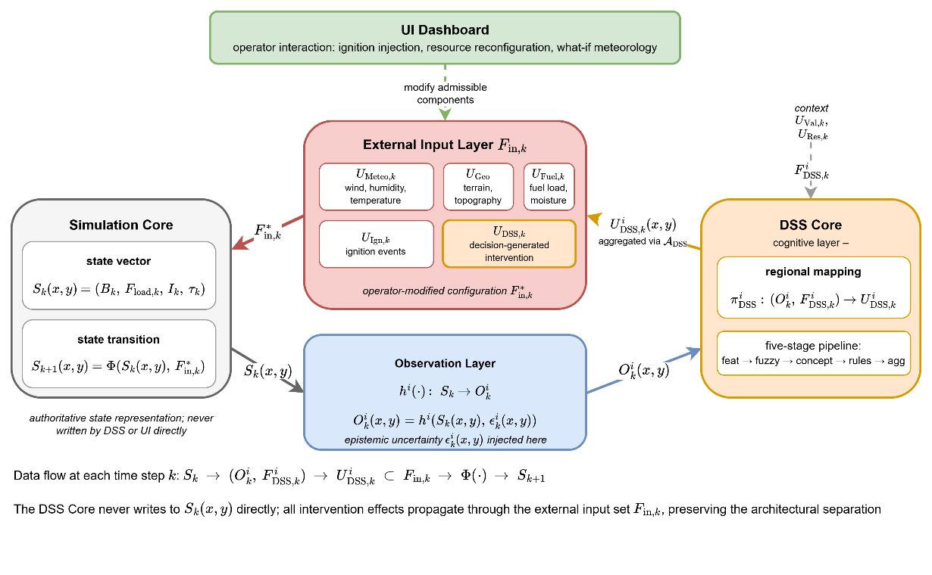
Figure 3.5 DSS Simulation Core Interface
This section defines only the structural role and interface of the DSS within the Simulation Core. Its internal specification and architectural realization are presented in the next chapter. While the Simulation Core governs the physical evolution of wildfire dynamics through the state transition operator $S_{k+1}\left(x,y\right)=Φ\left(S_{k}\left(x,y\right),F_{in,k}\right)$, the DSS operates on observable quantities $O_{k}\left(x,y\right)=h\left(S_{k}\left(x,y\right),ϵ_{k}\right)$ derived from the simulation state through the observation process, rather than directly accessing the full system state. Observation uncertainty $ϵ_{k}\left(x,y\right)$ is incorporated within the DSS through uncertainty-aware reasoning mechanisms operating on $O_{k}\left(x,y\right)$. The DSS evaluates decision-relevant indicators derived from $O_{k}\left(x,y\right)$ and contextual inputs $F_{DSS,k}$ to generate structured intervention inputs $U_{DSS,k}$ that influence subsequent system evolution. The DSS interaction follows the ( 36 ). This preserves the architectural separation between state evolution and decision generation. All decision impact must propagate through admissible modifications of the external input set. The information and control flow captured by Equation ( 36 ) is summarized in Figure 3.5.
$$S_{k}\left(x,y\right)→ O_{k}\left(x,y\right),F_{DSS,k}→U_{DSS,k}\left(x,y\right)→Φ\left(∙\right)→S_{k+1}\left(x,y\right)$$  $$O_{k}\left(x,y\right)=h\left(S_{k}\left(x,y\right), ϵ_{k}\right)$$  $$U_{DSS,k}\left(x,y\right) = π_{DSS}^{i}\left(O_{k}\left(x,y\right),F_{DSS,k}\right) ⊂ F_{in,k}$$ | ( 36 )
The Simulation Core maintains the authoritative state vector $S_{k}\left(x,y\right)=\left(B_{k}, F_{load,k}, I_{k}, τ_{k}\right)$ and advances it through the state transition operator $Φ$. The Observation Layer applies the region-specific observation function $h^{i}\left(⋅\right)$ to project the state onto observable information $O_{k}^{i}\left(x,y\right)=h^{i}\left(S_{k}\left(x,y\right), ϵ_{k}^{i}\left(x,y\right)\right)$, injecting the epistemic uncertainty $ϵ_{k}^{i}\left(x,y\right)$ at this stage and at this stage only. The DSS Core executes the regional mapping $π_{DSS}^{i}: \left(O_{k}^{i}, F_{DSS,k}^{i}\right)→U_{DSS,k}^{i}$ on the region-specific observation and the contextual inputs $F_{DSS,k}^{i}=\left(U_{Val,k}, U_{Res,k}\right)$, producing the regional decision field $U_{DSS,k}^{i}\left(x,y\right)$; the detailed five-stage pipeline that realizes this mapping is the subject of Chapter 4. Regional decisions from the $N$ agents are aggregated through the coordination operator $A_{DSS}$ into the global intervention field, which is injected into the External Input Layer $F_{in,k}$ as the $U_{DSS,k}$ component alongside the four exogenous inputs $U_{Meteo,k}$, $U_{Geo}$, $U_{Fuel,k}$, and $U_{Ign,k}$. The UI Dashboard can modify admissible components of $F_{in,k}$ through the interaction operator $Θ_{UI}$, yielding the operator-modified configuration $F_{in,k}^{*}$ that drives the next state transition $S_{k+1}\left(x,y\right)=Φ\left(S_{k}\left(x,y\right), F_{in,k}^{*}\right)$.

DISASTERAWARE DECISION SUPPORT FRAMEWORK
This chapter involves the DisasterAware DSS, the cognitive layer that operates on top of the simulation core. While the simulation core governs the physical evolution of the wildfire state, the DSS interprets the observable part of that state and produces intervention decisions. All equations of the decision layer are developed in this chapter; together they constitute the complete mathematical specification of the decision pipeline.
The pipeline is organized as a four-layer flow from observation to decision. Regional observations are first reduced to bounded features carrying explicit confidence; the features are abstracted into a compact set of decision concepts; decision rules written over the concepts generate a candidate intervention field; and every candidate is evaluated before acceptance or rejection. Reasoning is hierarchically distributed. A Local DSS agent executes this pipeline over the combinations of its own region, while a single Global DSS coordinates the Local DSS agents without performing inference of its own. The remainder of this chapter is organized as follows:
Section 4.1 introduces the DSS framework: The four-layer pipeline and its hierarchically distributed organization, the observation interface with the feature and confidence model, and the concept space with the feature-concept hierarchy.
Section 4.2 develops decision generation and coordination: The rule base and the candidate intervention field, the cost and quality measures by which candidates are judged, the staged adaptation mechanism that keeps the decision space open, the local decision with its graduated fail-safe, and the global coordination across regions.
Section 4.3 establishes the explainability and traceability properties of the decision pipeline, together with its governance behavior under degraded observation confidence.

Decision Support System Block Diagram
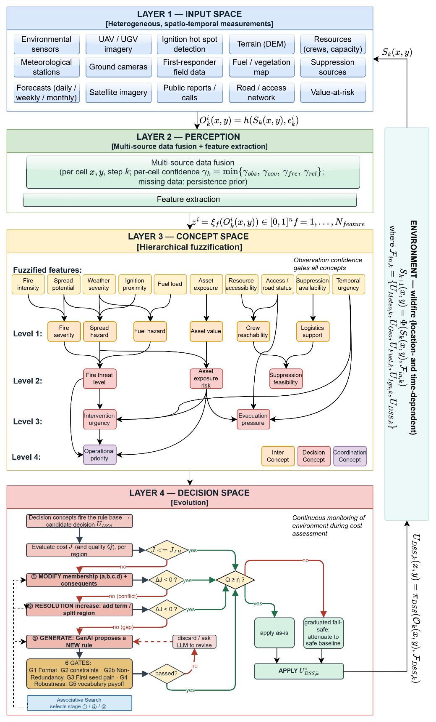
Figure 4.1 DisasterAware system block diagram (DSS focused)
Figure 4.1 presents the complete framework of a Local DSS agent and governs the organization of this section. Unlike Figure 3.1, which emphasizes the simulation-relevant layers, this block diagram focuses on the layers relevant to the DSS. According to this block diagram:
- The input space (Layer 1) collects heterogeneous, spatio-temporal measurements;
- The perception layer (Layer 2) fuses them into per-combination features with explicit confidence;
- The concept space (Layer 3) that abstracts the features into the four-level concept hierarchy;
- The decision space (Layer 4) includes rule generate, adaptation reshapes, and evaluation of interventions.
- The output of the local DSS ( $U_{DSS,k}^{i}$) feeds the simulator core and $S_{k+1}$ is obtained as described in Chapter 3.
In operation, N agents execute this loop concurrently, each restricted to the cells of its own region, while the Global DSS coordinates them by normalizing priorities, allocating the shared resource pool, and enacting cross-region decisions where necessary. The environment band on the right is common to all agents; each agent sees only its own regional projection of it. The cost evaluation of Layer 4 monitors the environment continuously during assessment, so a candidate is always judged against the current situation rather than the one in which it was generated.

Layer 1: Input Space
The input space of the DSS is the heterogeneous collection of spatio-temporal measurements shown at the top of Figure 4.1: Meteorological stations and forecasts, satellite, aerial, and ground imagery, ignition detections, terrain, fuel, road, and value-at-risk layers, and the resource and field reports of the response organization. These sources coincide with the external data layers formalized in Chapter 3 and are therefore not restated here; the single property that matters for the decision layer is that none of them observes the fire state directly, so everything the DSS consumes is a partial, differently refreshed projection of a hidden situation.

Layer 2: Observation, Features, and Confidence
The perception layer turns the raw input space into the quantities on which reasoning operates. Any Local DSS agent $i$ receives at step $k$ the region-restricted observation defined in ( 37 ). The region-specific observation function projects the authoritative state onto the cells of region $i$ and injects the epistemic uncertainty at this stage.
The term epistemic denotes that this uncertainty stems from missing knowledge rather than from randomness. A camera may be occluded by smoke, a satellite product may arrive only at revisit intervals of several hours, a road sensor may be offline, and a field report may be delayed or absent; the state is under-observed, not merely noisy. No probability distribution over the error is assumed anywhere in the pipeline, which is why the treatment that follows is a bounded, confidence-driven one rather than a probabilistic one.
$$O_{k}^{i}\left(x,y\right)=h^{i}\left(S_{k}\left(x,y\right), ε_{k}^{i}\left(x,y\right)\right), \left(x,y\right)∈G^{i}$$ | ( 37 )
Every observed cell carries an observation confidence composed from four factor properties: Observability ($γ_{obs}$), coverage ($γ_{cov}$), freshness ($γ_{fre}$), and reliability ($γ_{rel}$) as summarized in Table 4.1.
Table 4.1 Confidence factors: definition, range, and determination
Term | Determination
$$γ_{obs}$$ | Degree to which the underlying quantity is sensible at the cell; set from the sensor model of the channel (occlusion, LoS, product availability).
$$γ_{cov}$$ | Computed per cell from the covering footprints of satellite, aerial, and in-situ assets and averaged over the region.
$$γ_{fre}$$ | Decays exponentially with the age of the most recent report, with a half-life of 90 minutes; one for a report from the current step, decaying toward zero as the report ages.
$$γ_{rel}$$ | Trust assigned to the reporting channel from its characterization; calibrated sensors near one, unproven public reports substantially lower.

The composition is conservative; the confidence equals the weakest factor rather than an average, as stated in ( 38 ). Satellite products realize wide coverage with coarse freshness, aerial platforms high freshness over narrow footprints, in-situ sensors high reliability at fixed points, and field reports contextual observability with variable reliability.
$$γ_{k}^{i}\left(x,y\right)=min⁡\{γ_{obs},γ_{cov},γ_{fre},γ_{rel}\}$$ | ( 38 )
Confidence bounds the disturbance instead of describing it statistically. The observation error magnitude is limited by the complement of the confidence, as expressed in ( 39 ); a fully confident observation is exact, a vanishing confidence admits the worst-case disturbance, and intermediate values degrade gracefully between these poles. Missing observations are bridged by the persistence prior of the concept layer rather than by imputation.
$$|ε_{k}^{i}\left(x,y\right)|≤(1-γ_{k}^{i}\left(x,y\right))⋅ε_{max}$$ | ( 39 )
From the regional observation, the agent computes the ten features of the input space through bounded extraction maps, as in ( 40 ). Each feature inherits a feature-level confidence from the observation fields its extraction map consumes, so the pair of feature value and feature confidence is the complete interface between perception and reasoning.
$$z_{f,k}^{i}=ξ_{f}\left(O_{k}^{i}\right)∈[0,1], f=1,…,N_{feature}$$ | ( 40 )
The ten features are listed in Table 2.1: Fire intensity, spread potential, weather severity, ignition proximity, fuel load, asset exposure, resource accessibility, access and road status, suppression availability, and temporal urgency. Each feature carries established wildfire-science grounding rather than convenience, as documented source by source in the background chapter; by construction the ten features span the threat, exposure, feasibility, and timing dimensions of the operational questions, so no question lacks a supporting feature; and none duplicates information carried by the others, since each is admitted only under the observability, boundedness, operational meaning, and non-redundancy conditions. A larger set would not add discriminative information but would enlarge the antecedent space of every downstream mapping, and the sensitivity analysis of the evaluation chapter confirms empirically that the decision output responds to every feature and is dominated by none. The set is therefore critical, in that removing a feature leaves an operational question unsupported, and sufficient, in that adding one is not justified by any unanswered question.

Layer 3: Concept Space and the Feature-Concept Hierarchy
The concept space exists because rules cannot be written over the features directly. With ten features and five linguistic terms per feature, a flat rule base spans 9.765.625 antecedent combinations, which can neither be elicited from experts nor audited by operators.
The conceptualization layer maps physically related features into six base concepts, the base concepts into three mid-level and two higher-level decision concepts, and finally into the single coordination concept; decision rules are then written over the five decision concepts only, whose antecedent space contains $5^{5}=3.125$ combinations, of which the evolving rule base instantiates only the small subset that observed situations activate. Figure 4.2 illustrates the solution of this problem by hierarchical conceptualization.
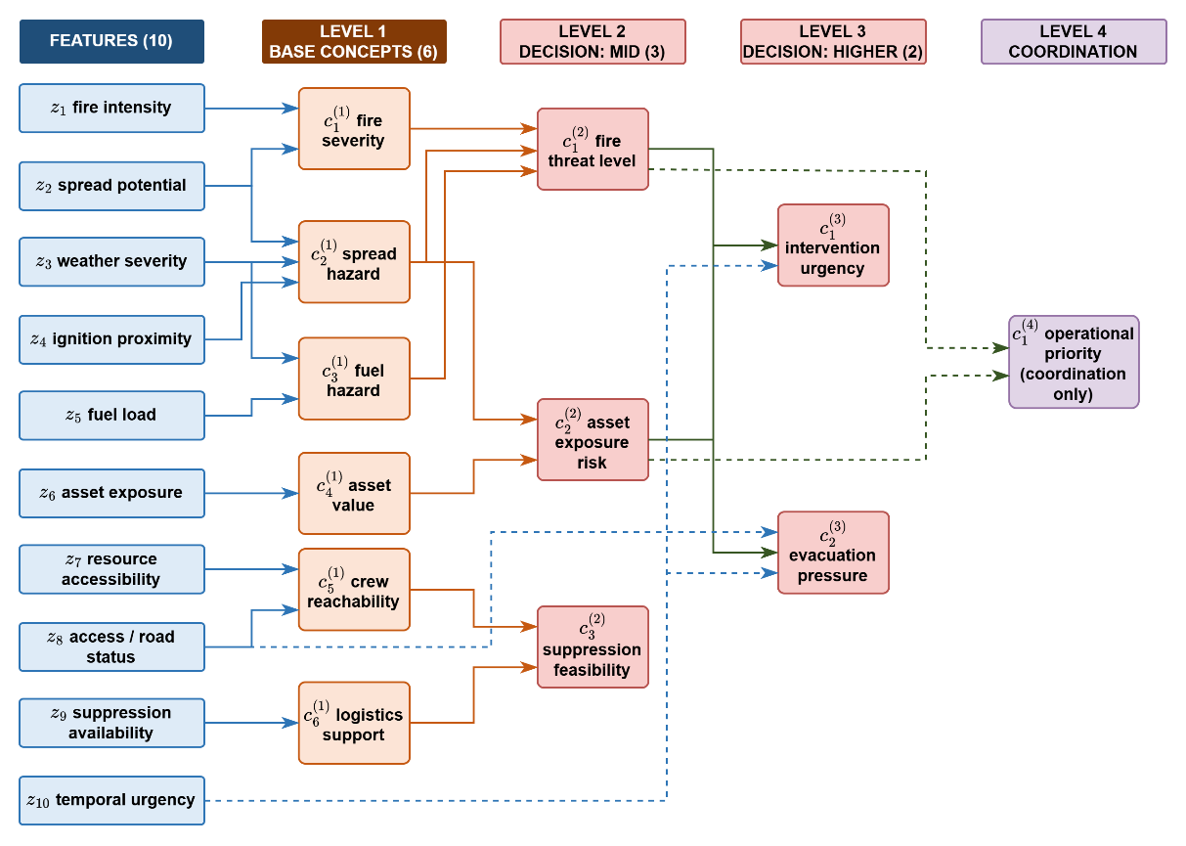
Figure 4.2 Feature-concept hierarchy
The recognition-primed decision literature shows that experienced commanders reason over exactly such condensed situation descriptors rather than over raw measurements. The concept set is sufficient for management because the five decision concepts answer the five canonical questions completely and non-redundantly: How severe is the threat, how exposed are the assets, whether an intervention can feasibly be mounted, how urgent action is, and whether evacuation pressure is building as listed in Table 2.3.
The mapping between features and concepts is fully specified by the sets of ( 41 ) Each concept is written in the positional notation c with a lower index for its place within a level and an upper index for its level, so that fire severity, spread hazard, fuel hazard, asset value, crew reachability, and logistics support are the six base concepts of level one, fire threat level, asset exposure risk, and suppression feasibility occupy level two, intervention urgency and evacuation pressure occupy level three, and operational priority is the single concept of level four (Appendix D).
Base Concepts | Decisional Concepts | ( 41 )
$$C_{1}^{(1)}=\left\{z_{1},z_{2}\right\} \\ C_{2}^{(1)}=\left\{z_{2},z_{3},z_{4}\right\} \\ C_{3}^{(1)}=\left\{z_{3},z_{5}\right\}, \\ C_{4}^{(1)}=\left\{z_{6}\right\}, \\ C_{5}^{(1)}=\left\{z_{7},z_{8}\right\}, \\ C_{6}^{(1)}=\left\{z_{9}\right\}$$ | $$C_{1}^{(2)}=\left\{c_{1}^{(1)},c_{2}^{(1)},c_{3}^{(1)}\right\} \\ C_{2}^{(2)}=\left\{c_{2}^{(1)},c_{4}^{(1)}\right\}, \\ C_{3}^{(2)}=\left\{c_{5}^{(1)},c_{6}^{(1)}\right\} \\ C_{1}^{(3)}=\left\{c_{1}^{(2)},c_{2}^{(2)},z_{10}\right\}, \\ C_{2}^{(3)}=\left\{c_{2}^{(2)},1-z_{8},z_{10}\right\} \\ C_{1}^{(4)}=\{c_{1}^{(2)},c_{2}^{(2)}\}$$ | ( 41 )
The activation of a base concept is the weighted sum of the term memberships of the features in its set, and the activation of every higher concept is the weighted sum of the activations of the concepts in its set, with the nonnegative weights of each concept normalized to one ( 42 ).
$$a_{n,k}^{(1),i}=\sum_{f∈Z_{n}}{ω_{n,f}⋅μ_{A_{n,f}}\left(z_{f,k}^{i}\right)} \\ a_{n,k}^{(l),i}=\sum_{m∈C_{n}^{(l)}}{ω_{n,m}^{(l)}⋅a_{m,k}^{(l-1),i}}, l=2,3,4$$ | ( 42 )
In ( 42 ), $a$ denotes a concept activation, with the subscripts giving the concept index $n$ and the step $k$ and the superscripts giving the level $l$ and the region $i$; $ω$ are the nonnegative aggregation weights, normalized to sum to one for each concept; 𝒵 is the index set of the features assigned to a base concept, and 𝒞 the index set of the concepts one level below that feed a higher concept; μ is the term membership of the fuzzified feature introduced in the background chapter; and $z$ is the feature value.
An example is illustrated in Figure 4.3. At level one, consider fire severity with feature set $\{z_{1}, z_{2}\}$, aggregation weights $0.6$ and $0.4$, and the severity-oriented term high of each feature. A fire intensity reading of $0.70$ lies on the core of high, giving membership 1.00, and a spread potential reading of $0.62$ lies on its lower shoulder, giving membership $0.47$; the aggregation of ( 42 ) therefore yields the activation$0.6 × 1.00 + 0.4 × 0.47=0.79$. Level two repeats the same operation over activations instead of memberships. Fire threat level draws on fire severity, spread hazard, and fuel hazard with weights $0.5$, $0.3$, and $0.2$; with the fire severity of $0.79$ just computed, a spread hazard of $0.55$, and a fuel hazard of $0.30$, the activation is $0.5 ×0.79+ 0.3 ×0.55+ 0.2 ×0.30=0.62$. Intervention urgency draws on fire threat level, asset exposure risk, and the feature temporal urgency with weights $0.4$, $0.35$, and $0.25$; with the $0.62$ just computed, an asset exposure risk of $0.61$, and a temporal urgency reading of $0.72$ whose high membership is $1.00$, the activation is $0.71$. One sensor-level number has now propagated through three levels, and at every step the intermediate value remains readable as an operational statement.
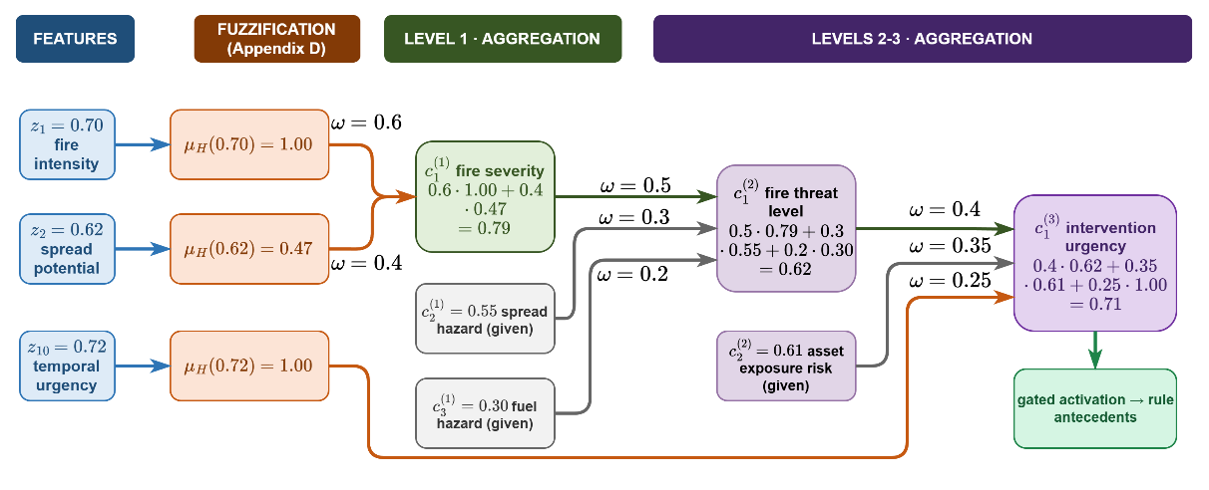
Figure 4.3 Hierarchical concept activation example.
Raw activations are never consumed directly. Every activation is gated by its observation confidence and blended with a persistence-carried prior ( 43 ). A reliable observation passes through essentially unchanged, while an uninformative one falls back to the decayed previous estimate.
$$a_{n,k}^{eff,i}=γ_{n,k}^{i}⋅a_{n,k}^{obs,i}+\left(1-γ_{n,k}^{i}\right)⋅ρ⋅a_{n,k-1}^{eff,i}, \\ γ_{n,k}^{i}=min⁡\{γ_{f,k}^{i}:f∈Z_{n}\}$$ | ( 43 )
In ( 43 ), the superscripts distinguish three activations of the same concept: The observed activation computed through ( 42 ), the persistence prior carried from the previous step, and the effective activation that the decision rules consume. The gate γ is the observation confidence of ( 38 ), composed at concept level as the minimum of the feature confidences feeding the concept, and the decay factor $ρ ∈ [0, 1)$ discounts the previous effective activation, so a concept that ceases to be observed fades over successive steps instead of persisting indefinitely.
In Figure 4.4, the plot (a) shows the effective activation against the confidence for an observed activation of $0.80$, a carried prior of $0.72$, and $ρ = 0.9$: At $γ = 0.9$ the effective value is $0.78$, at $γ = 0.2$ it is $0.68$, and the transition between trust and caution is linear, with no threshold to tune. The plot (b) shows the temporal role of the prior. When observation is lost, the effective activation decays geometrically by $ρ$ per step and snaps back to the observation as soon as confidence returns.
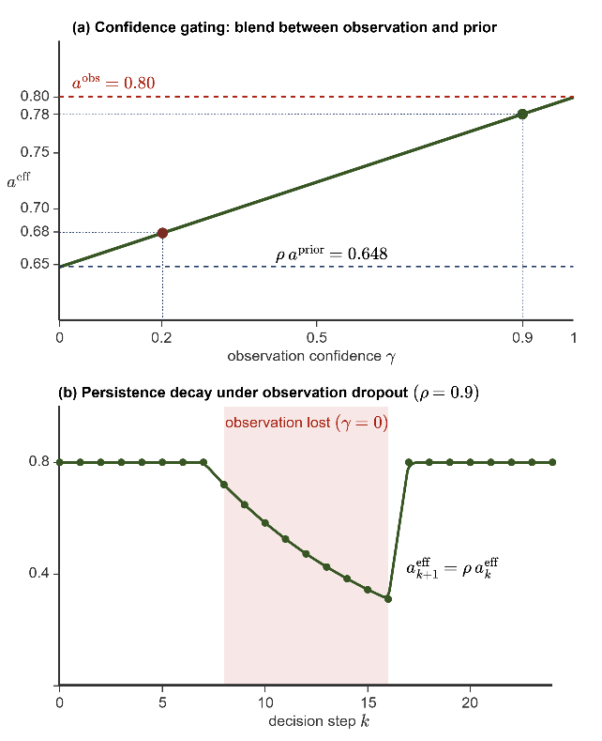
Figure 4.4 Confidence gating (a) persistence decay (b)

Layer 4: Decision Generation and Coordination
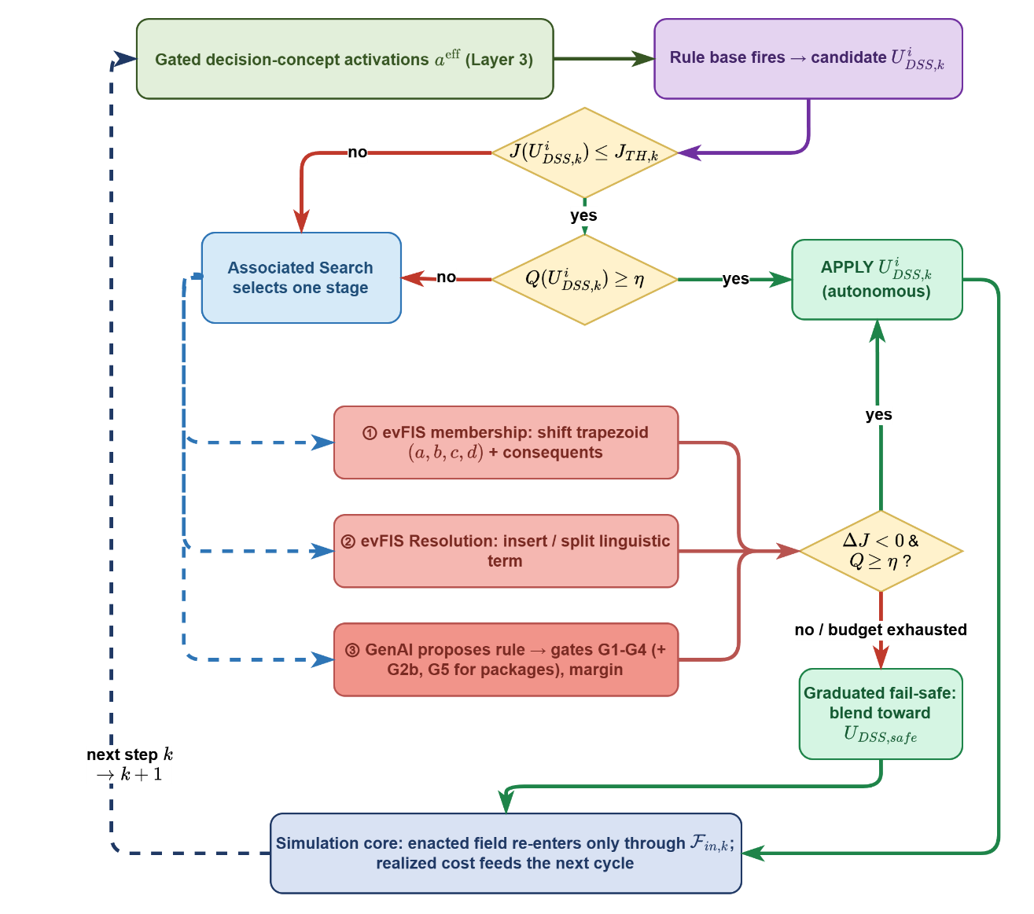
Figure 4.5 Layer 4 decision and adaptation flow
The decision space is where the gated concept activations of Table 2.3 become the executable interventions of Table 2.4. The layer operates once per decision cycle and follows a fixed order. The rule base fires on the gated activations and produces a candidate intensity vector per region; the quality measure checks the candidate against the concepts that demanded it, and the graduated fail-safe attenuates an unbalanced candidate; the coordinator converts the regional operational priorities into attention shares; the composed allocation is forecast on a shadow copy of the simulation and accepted if it satisfices; a rejected forecast engages exactly one stage of the staged adaptation loop, selected by a learned controller; and a no-harm rule withholds the offensive part of any allocation that is forecast to worsen the physical outcome. Each element is developed in the following subsections, and the value of every threshold is stated where its mechanism is defined.
As illustrated in Figure 4.5, Layer 4 receives the gated decision-concept activations $a^{eff}$ of Layer 3, five bounded values in [0,1] that already carry the confidence gating and the persistence prior of the concept layer, and it returns $U_{DSS,k}^{i},$ an intensity vector over the six intervention families for region $i$ at cycle $k$. Nothing else crosses the boundary. The layer never reads the physical state directly and never writes to it.
The rule base fires first. Antecedents are written over the five gated decision concepts, each partitioned into the five linguistic terms of Layer 3, and consequents are numeric intervention intensities in $[0,1]$, that is, zero-order Takagi-Sugeno singletons, which is the form the adaptation loop can tune. Intensities are combined per intervention family by an activation-weighted average with a unit floor on the denominator, so a weakly supported conclusion yields a weak order and only a fully fired rule delivers its full intensity.
The base is deliberately sparse and evolving. The antecedent space admits $5^{5} = 3125$ combinations, yet only situation-activated rules are ever instantiated, and the base grows through the adaptation loop instead of being enumerated in advance. The seed rules, the adaptation-born rules and their provenance are catalogued in Appendix E. A situation whose strongest firing stays below the coverage floor $α_{min} = 0.05$ is flagged as a coverage gap, which falls back to the watchful posture and at the same time triggers adaptation.
The candidate is then judged by what it is expected to cost. The candidate allocation is applied over the forecast horizon, and the normalized decision cost $J$ of the end state is compared against a no-action shadow run started from the same state. The acceptance threshold $J_{TH}$ is not entered by hand for an individual decision. It is recomputed every cycle as the tighter of a fixed normalized ceiling of $0.35$ and a required relative gain over the no-action forecast, so a situation in which doing nothing is already cheap automatically demands a stronger candidate. If $J ≤ J_{TH}$ the cycle proceeds to the quality gate, and if not it enters the staged adaptation loop.
The quality gate measures not how much the candidate costs but whether it serves the concepts that demanded it. Each scored decision concept is paired with the intervention family that answers it, fire threat level with suppression effort, asset exposure risk with asset protection, intervention urgency with resource deployment, and evacuation pressure with evacuation and public warning. Suppression feasibility is the gatekeeper concept and modulates the others rather than being scored against a family of its own.
A failed cost test hands the cycle to the value based stage controller, which invokes exactly one stage per cycle, selected from three:
- The first stage is evFIS membership modification, which shifts the trapezoidal parameters (a, b, c, d) of the active terms together with the rule consequents.
- The second grows the rule base. It writes a rule on an antecedent combination that no rule covers and, where a covered combination is linguistically ambiguous, it inserts a narrow term to separate the two situations that share the combination.
- The third is the generative proposal, in which a language model drafts one new rule in the framework's own vocabulary of concepts, terms and admissible interventions.
The value based stage controller is epsilon-greedy over a state that buckets the cost deficit and flags a coverage gap, its reward is the realized improvement of the physical forecast, and it therefore learns which stage pays off in which situation. The result of a trial is kept only when the shadow forecast improves.
A generated rule is a suggestion and never acts on its own. It must pass four verification gates before it can enter the base. $G1$ checks format, that the antecedent and the consequent are well formed. $G2$ checks constraints, that the arity, the vocabulary and the numeric ranges are admissible and that the rule does not duplicate an antecedent combination that is already occupied. $G3$ checks simulation, that the rule lowers the forecast cost, $ΔJ < 0$, on the shadow copy. $G4$ is an $A/B$ check that the improvement holds on two independent seeds rather than on a single lucky draw. A proposal that fails any gate is discarded and the failing gate is recorded, so a rejected suggestion remains auditable. If a rule that clears all four gates (extra two gates for packages) is admitted, with its provenance, into the base of Appendix E.
The loop then returns the possibly repaired candidate to the same two tests. If $ΔJ < 0$ and $Q ≥ η$, the candidate is applied. Otherwise, or when the adaptation budget is exhausted, the graduated fail-safe blends the candidate toward $U_{DSS,safe}$ in proportion to the quality deficit. The offensive families, suppression effort, resource deployment, containment line and asset protection, are attenuated by the factor $Q/η$, while the life-safety orders, evacuation and public warning, are never reduced.
If even the adapted candidate is forecast to end worse than doing nothing on the physical part of the cost, that is, burned area, asset loss and population exposure, without crediting the response and delay bookkeeping, the no-harm rule withholds the offensive allocation for the cycle. No capacity is fielded, no response cost is paid, and only the life-safety orders stand. Wetting and line construction take effect thirty to sixty minutes ahead; hence, this comparison is always re-run over a lookahead, and orders are withheld only when the candidate is forecast clearly worse rather than merely equal. Whichever exit is taken, the enacted field re-enters the simulation core only through the external input layer $F_{in,k}$, and the realized cost of the step feeds the next cycle.

Rule Base and Candidate Intervention
Layer 4 converts concept activations into orders through a rule base written exclusively over the five gated decision concepts. Every rule takes the canonical conjunctive form of ( 44 ). Each antecedent clause tests one decision concept against one linguistic term, and the consequent assigns a singleton intensity to each intervention family, so a concept triggers an intervention precisely by the degree to which it satisfies the clause that names it.
$$R_{r}: IF a_{1,k}^{eff,i} is A_{r,1} AND … AND a_{5,k}^{eff,i} is A_{r,5} THEN U_{DSS,k}^{i} is B_{r}$$ | ( 44 )
In ( 44 ), $R_{r}$ denotes rule r, $a_{n,k}^{eff,i}$ the gated activation of decision concept $n$ in region $i$ at cycle $k$, $A_{r,n}$ the linguistic term the rule requires of that concept, and $B_{r}$ the consequent, read as the singleton intensity profile of the rule together with its optional effects. The candidate of the region is the vector $U_{DSS,k}^{i}$, whose components $u_{m,k}^{i}$ are the intensities ordered for the six intervention families indexed by m. A concept absent from an antecedent is left unconstrained, so a rule may refer to a single concept or about all five.
A rule fires with the strength of its weakest satisfied clause, and the candidate is assembled family by family from every rule that fires, as stated in ( 45 ). Here $w_{r}$ is the firing strength of rule $r$, taken as the minimum membership over its antecedent clauses, $μ_{A_{r,n}}$ is the membership function of the term the clause names, and $v_{r,m}$ is the intensity that the rule assigns to family $m$. The denominator is floored at one, so a weakly supported conclusion yields a weak order rather than a full-strength one, and only rules that together fire with unit strength deliver their full intensity.
$$u_{m,k}^{i} = \frac{\sum_{r}{w_{r} v_{r,m}}}{max(1, \sum_{r}{w_{r}})}, w_{r} = \min_{n ∈ ant(r)} μ_{A_{r,n}}(a_{n,k}^{eff,i})$$ | ( 45 )
The base is sparse by construction. The antecedent space admits $5^{5}$ = 3125 combinations, but this is the catalogue of conditions the vocabulary can express, not a list of rules to be authored. The base holds the seeded doctrine and whatever the adaptation loop later adds. Sparsity costs no coverage, because adjacent linguistic terms overlap. Equation ( 46 ) counts what a single rule already covers, where $N_{term}$ is the number of linguistic terms partitioning each concept, $N_{concept}$ is the number of decision concepts and$N_{antecedent,r}$ is the number of antecedent clauses of rule $r$. While 2-clause rule covers $5^{5-2}=125$ combinations, full-clause covers $5^{5-5} = 1$.
$$N_{cover}\left(R_{r}\right)=N_{term}^{N_{concept}-N_{antecedent,r}}$$ | ( 46 )
The seeded base must satisfy, where $a^{eff} ∈ [0,1]⁵$is any reachable vector of gated concept activations, $α_{r}(a^{eff})$ is the firing strength of rule $r$ at that reading, and $α_{min}=0.05$ is the coverage floor. The condition requires that even the worst reading of the whole space still leave some rule firing with strength at least $α_{min}$, so no reachable situation is met with silence. A reading that falls below the floor marks a coverage gap. The layer falls back to the watchful posture and adaptation is triggered.
A rule with $N_{antecedent,r}$ clauses refer to the combinations of the catalogue counted in ( 46 ), those that agree with it on its clauses and are free on the rest, and the seeded base satisfies the coverage condition of ( 47 ), so at every reachable reading some rule fires with strength at least $α_{min}$ = 0.05.
$$\min_{a^{eff}∈[0,1]^{5}} \max_{r} α_{r}\left(a^{eff}\right)≥α_{min}>0$$ | ( 47 )
As an example for illustration is that a fire threat activation of $0.55$ belongs to the term medium with membership $0.75$ and to the term high with membership $0.25$. If the base prescribes suppression effort $0.5$ for the first and $0.8$ for the second, both rules fire and ( 45 ) returns $0.575$, a value no rule states explicitly. Coverage is therefore graded rather than binary, and it carries two calibrated thresholds. Below the floor of $0.05$ no rule runs meaningfully and the layer falls back to the watchful posture, while a strongest firing that stays under the gap threshold marks a coverage gap and triggers adaptation.
Full enumeration is rejected on principle, and the comparison of Table 4.2 is the argument. A catalogue of 3125 rules cannot be audited from an expert and freezes a guess into every combination that operations have never visited. It also fixes the alternatives in advance, which is precisely the closed decision space this thesis sets out to leave behind. The sparse base is authored where doctrine exists, interpolates where it does not, and grows only where realized cost proves that it must.
Table 4.2 Full enumeration versus the sparse evolving base
Property | Full enumeration | Sparse evolving base
Authorship | Cannot be elicited by experts; most rows describe unrealizable situations | Expert-seeded doctrine plus adaptation-born rules, each individually validated
Auditability | Thousands of rows, no operator can inspect them | Tens of rules, every one traceable and readable
Coverage | Exhaustion by construction | Complete through overlap and interpolation, guaranteed by
Unvisited regions | Frozen guesses written in advance | Left to interpolation until the field demands a rule there
Novel situations | Cannot be represented; the catalog is closed | Adjusted, refined, or generated on demand through Algorithm 1

Table 4.3 states how each concept has a primary family that answers its operational question and a set of secondary families that it modulates.
Table 4.3 Designated mapping between decision concepts and intervention types
Concept | Primary intervention | Secondary interventions and modulation role
Fire threat level | Suppression effort | Containment line when direct attack is insufficient; resource deployment scaled with the threat level
Asset exposure risk | Asset protection | Containment line placed to shield exposed assets; evacuation when exposure combines with high threat
Suppression feasibility | Resource deployment | In the gatekeeper role, high feasibility commands resource deployment toward the front, while low feasibility caps suppression effort and shifts intensity toward containment line and evacuation.
Intervention urgency | Resource deployment | Scales the intensities of all active families; triggers cross-region priority preemption at very high activation
Evacuation pressure | Evacuation | Public warning raised jointly; offensive intensities withdrawn at very high activation

A run starts from the minimal profile of that base in Appendix E: a single strongest seed per intervention family, five rules in all, so the system starts almost without doctrine and must learn its base by trial. The full forty-rule base is retained only as the reference doctrine.

Cost, Quality, and the Satisficing Test
Every candidate is judged by two complementary measures, both computed on a shadow copy of the simulation before anything reaches the field. The cost asks what the candidate is expected to cost the incident. The quality asks whether it serves the concepts that demanded it. A candidate must clear both, and the two tests appear as the two decision diamonds of Figure 4.5.

Cost of an Intervention
The cost measures what the candidate is expected to cost the incident. This is not evaluated on the current state, the candidate allocation is held constant on the simulation over a forecast basis of at least $τ_{horizon}$ stepping at $τ_{resolution}$ resolution, and the cost of the forecast end state is compared with a no-action shadow run started from the same state. The cost itself is the weighted five-term ( 48 ) with the exact normalizations of the implementation; all five weights are set to one in this work, so the weighting is a calibration surface rather than an assumption.
$$J=\frac{\sum_{j}{w_{j}J_{j}}}{\sum_{j}{w_{j}}}, j∈\left\{burn, asset, pop, resp, delay\right\} \\ J_{burn}=\frac{\frac{N_{burned}}{ρ_{burn}⋅N_{burnable}}}{1+ \frac{N_{burned}}{ρ_{burn}⋅N_{burnable}}} \\ J_{asset}=\frac{V_{lost}}{V_{total}} \\ J_{pop}=\min\left(1, \frac{P_{steps}}{P_{total}⋅N_{decisions}}\right) \\ J_{resp}=\min\left(1, \frac{C_{steps}}{C_{ref}⋅N_{decisions}}\right) \\ J_{delay}=min(1, \frac{τ̅}{τ_{reference}})$$ | ( 48 )
In ( 48 ), $w_{j}$ are the non-negative priority weights, and the sum is divided by their total so that $J$ remains in the unit interval and the weights encode relative priority rather than scale. Each term is an actual quantity divided by a scenario reference, which is what makes five quantities of different units summable.
$J_{burn}$ charges the burned area against a major-fire reference rather than against the whole landscape. $N_{burned}$ is the number of cells that have burned and $N_{burnable}$ the number of burnable cells of the scenario, with $ρ_{burn}=0.05$. The product $ρ_{burn}·N_{burnable}$ is the reference area whose loss is treated as a full-scale fire. The rational form $x/(1+x)$ with $x = N_{burned}/(ρ_{burn}·N_{burnable})$ is nearly linear near the origin, reads exactly 0.5 at the reference fire, and approaches one without reaching it; its slope decays only quadratically, so every saved cell keeps a measurable worth at any fire size.
$J_{asset}$ is the fraction of exposed value that the fire has taken, where $V_{lost}$ is the value of the structures and critical infrastructure standing on burned cells and $V_{total}$ the total value exposed in the scenario.
$J_{pop}$ integrates exposure rather than counting heads. $P_{steps}$ accumulates the persons present inside actively burning cells (not evacuated people) at every decision step, $P_{total}$ is the total population of the scenario at risk and $N_{decisions}$ the number of decision steps of the horizon, so the denominator is the worst case in which the entire population is exposed for the whole horizon. A brief exposure of many people and a long exposure of a few therefore become commensurable.
$J_{resp}$ prices effort in the same way. $C_{steps}$ is the fielded capacity summed over the decision steps, that is the time integral of the committed force, and $C_{ref}$ is the reference capacity of the scenario, so the denominator is the reference force kept in the field for the whole horizon. An army held on the line for hours is therefore charged more than a short decisive strike of the same size.
$J_{delay}$ prices timeliness. $\overline{τ}$ is the capacity-weighted mean dispatch time of the resources actually fielded, so a large force that arrives late weighs more than a single late unit, and $τ_{reference}$ is the reference response time of sixty minutes. Each of the last three terms is capped at one, so no single term can dominate the sum once its reference is exceeded.
The five-term sum is the criterion by which a candidate is accepted, but it is not the measure by which two runs are compared. The response and delay terms price the decision itself, so a run that never intervenes carries neither of them, and a comparison on the total cost would reward inaction. Cross-run comparisons, the with and without DSS studies of Chapter 5 and the trial verdicts of the adaptation stages, therefore read the physical cost, the burned-area, asset, and population terms with their weights renormalized. The physical cost measures only what the fire did to the land, the assets, and the people, and it is indifferent to how much effort the decision spent, which makes it a fair basis between a run that fought and a run that watched.

Acceptance Tests
Acceptance on cost is satisficing rather than optimizing. The candidate is held on the shadow copy over the forecast horizon, and the resulting cost ${\hat{J}}_{k}\left(U_{DSS,k}\right)$ is compared with the forecast of taking no action from the same state, ${\hat{J}}_{k}\left(0\right)$.
$${\hat{J}}_{k}\left(U_{DSS,k}\right) ≤ min(J_{TH}, (1-δ_{gain})⋅{Ĵ}_{k}(0))$$ | ( 49 )
The acceptance bound is the smaller of two quantities, and each one protects against a different mistake. The first is the fixed ceiling $J_{TH}$. It sets the highest cost at which the incident may be left. On a large fire this is the binding condition. A candidate is rejected if it leaves the incident expensive, even when it is far better than doing nothing. The second is $(1 - δ_{gain})·Ĵ_{k}(0)$, a fixed fraction of the no-action forecast. On a small fire this is the binding condition. When doing nothing already costs less than the ceiling, the ceiling alone would accept every candidate, including one that changes nothing. The margin $δ_{gain}$ prevents this by requiring the candidate to beat the no-action forecast. Without it, the incidents that are easiest to improve would be the ones the adaptation stages never touch.
Failing the cost test does not suspend action. The orders already produced by the standing rule base remain in force and are applied while adaptation runs, so an acceptable decision is never withdrawn in the hope of a better one.
The quality measures what the cost cannot. A concept demands an action; the quality asks whether the candidate supplied it. For each scored concept, the gated activation is compared with the strongest intensity the candidate assigns to the intervention family that answers that concept, and the quality is one minus the mean of these mismatches ( 50 ). $F\left(n\right)$ is the intervention family that answers concept $n$, ${a_{n}}^{eff}$ is the gated activation of that concept and $u_{f}$ the intensity the candidate orders for family $f$.
$$Q_{k}=1-\frac{1}{4}\sum_{n∈C_{Q}}{|{a_{n}}^{eff}-\max_{f∈F(n)} u_{f}|}, accept ⇔ Q_{k}≥η$$ | ( 50 )
$C_{Q}$ is the set of the four scored decision concepts. Suppression feasibility is excluded from $C_{Q}$ although it does issue orders of its own. It is a modulator rather than a demander. In other words, its activation states whether action is possible, not how much action is required. A high feasibility permits a strong response without calling for one, so a region with workable terrain and no fire would be penalized by a match test even though a null response is correct. A low feasibility calls instead for a reduction of the intensities that the other concepts demand, and a reduction is not something a match test can score. The family through which it acts, resource deployment, already answers intervention urgency in ( 50 ).
A candidate that “suppresses heavily while the fire threat is low” is penalized as much as one that ignores a high evacuation pressure, even though only the second failure would raise the cost within the horizon. This is why quality is kept separate from cost. It detects a misdirected response before its consequences appear. The two tests are in Table 4.4. When the quality falls below the gate, the graduated fail-safe attenuates the offensive intensities in proportion to the deficit, and a quality failure is itself one of the symptoms that summon adaptation.
Table 4.4 The two acceptance tests and the consequence of failure.
Test | Condition | If it fails
Cost | $${\hat{J}}_{k}\left(U\right) ≤ min\left(J_{TH}, \left(1 - δ_{gain}\right)·{\hat{J}}_{k}\left(0\right)\right)$$$J_{TH} = 0.35$, $δ_{gain} = 0.05$ | Staged adaptation is engaged; the standing orders remain in force.
Quality | $Q_{k} ≥ η$  $η = 0.60$ | The graduated fail-safe attenuates the offensive intensities by $\frac{Q_{k}}{η}$.

Open Decision Space: Staged Adaptation
Adaptation is organized as three stages of strictly increasing invasiveness, namely parameter adjustment inside the existing rules, growth of the rule base into ground it does not cover, and generative proposal of a new rule and, where a package is admitted, of a new element of the vocabulary. A stage engages only when the standing decision demonstrably falls short. Every trial it produces is judged by a single criterion, namely the physical cost, namely the burned-area, asset and population terms with their weights renormalized, evaluated on a shadow forecast. The total cost of ( 48 ) continues to assess the standing decision, but it is deliberately not the criterion by which a trial is judged. On a small fire the response cost of any additional commitment exceeds the physical gain that a short horizon can reveal, so a trial criterion built on the total cost would reject every proposal at the very moment when the base most needs to grow.
Three symptoms engage the stages, and each is measurable on the running incident. The first is a cost deficit, the forecast cost of the candidate exceeds the satisficing bound. The second is a coverage gap, fire is alive on the ground while the strongest firing of the base stays below the gap threshold, so the base does not cover the situation at hand. The third is spread, the burned area grew since the previous decision even though the orders were applied, which means a formally satisficing decision is losing the fire; the growth itself is treated as a coverage gap rather than as a cost deficit. Consecutive trials are separated by a cooldown period, so the shadow forecasts do not delay the decision cycle. When a coverage gap appears alone, with no cost deficit and no spread, only the two stages that create rules are allowed. An empty combination has no rule to tune, so a rule must first be made.

EVFIS: Parameter Adaptation
The first stage tunes the rules already in the base and adds none. It has two moves, namely consequent step and boundary shift. While the consequent step changes the output value of a rule, the boundary shift moves the edge that two neighboring antecedent terms share.
The Consequent step: The consequent of a rule $v_{r,m}$ is the intensity that the rule assigns to intervention $m$. The consequent step adds or subtracts δ, fixed at 0.05, from that number and clips the result to the unit interval ( 51 ).
$$v_{r,m}←clip_{0,1} \left(v_{r,m}±δ\right), m∈cons\left(r\right)$$ | ( 51 )
It changes one rule only and is easy to undo, so it is tried first. It is applied to the two rules with the highest firing strength, not to the strongest rule alone, because with a small base one rule dominates every cycle and the second would otherwise never be tuned. The field decision is the firing-weighted average of the rule consequents, so moving one consequent slides that average toward the new value in proportion to the firing strength of the rule.
Boundary shift step: Two neighboring antecedent terms share their transition interval. where the left term stops being fully true the right one starts, so the falling edge of the left term $A^{-}$ is the rising edge of the right term $A$, and the two coincide, $\left(a_{A},b_{A}\right)=\left(c_{A^{-}},d_{A^{-}}\right)$ ( 52 ). The boundary shift moves this shared edge. The edge belongs to both terms, both move together, so the memberships still sum to one at every reading and the partition of unity required by ( 45 ) is preserved. Moving the edge changes the reading of every rule that uses either term, which is why this move is tried only after the consequent trials are spent. The step is bounded by the width of the core it narrows, $δ≤c_{A^{-}}-b_{A^{-}}$, because a larger step would erase that core and turn the trapezoid inside out.
$$\left(a_{A},b_{A}\right)←\left(a_{A}-δ,b_{A}-δ\right), \left(c_{A^{-}},d_{A^{-}}\right)←\left(c_{A^{-}}-δ,d_{A^{-}}-δ\right)$$  $$\left(a_{A},b_{A}\right)=\left(c_{A^{-}},d_{A^{-}}\right), 0<δ≤c_{A^{-}}-b_{A^{-}}$$ | ( 52 )
Every trial is a hypothesis. It is judged on the forecast physical cost at a basis, it is kept only when that cost strictly falls, and it is rolled back otherwise ( 53 ).
$$kept ⇔ Δ{\hat{J}}_{phys}<0$$ | ( 53 )
All trials act on a working copy of the rule base, so the seed base of Appendix E is never modified. Both adaptations are shown in Figure 4.6 .
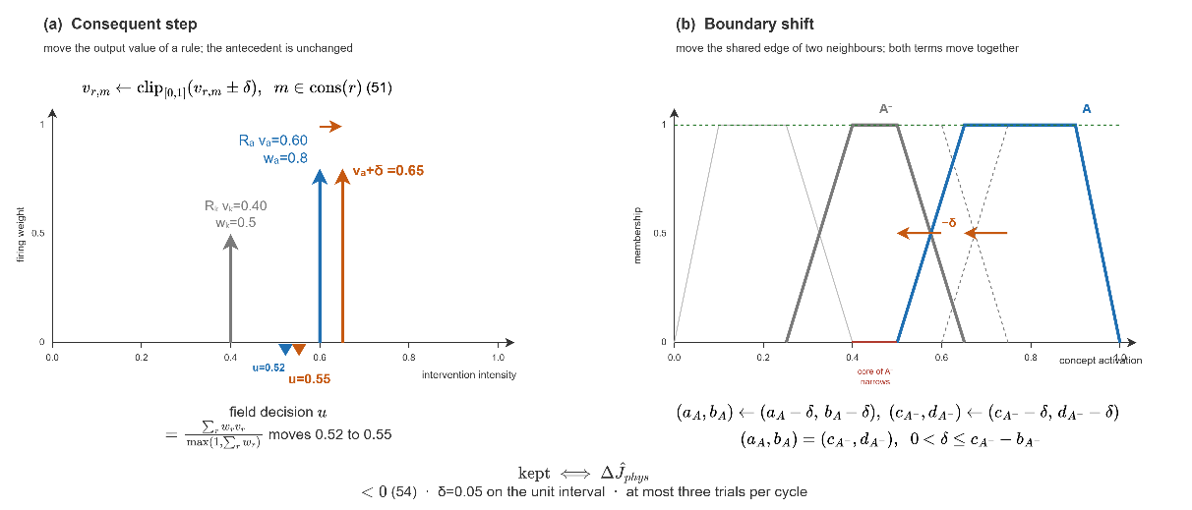
Figure 4.6 Consequent step and boundary shift

EVFIS: Rule Instantiation and Resolution Increase
The second stage grows the rule base. It works in two modes. The first mode writes a rule on an empty combination. The two decision concepts with the highest activation, $c^{(1)}$ and $c^{(2)}$, with their dominant terms $t^{*}$, define the combination that describes the current situation, as given in ( 55 ).
$$A_{new}=\left\{\left(c^{(1)},t^{*}\left(c^{(1)}\right)\right),\left(c^{(2)},t^{*}\left(c^{(2)}\right)\right)\right\} \\ t^{*}\left(c\right)=\underset{t∈T_{c}}{argmax}μ_{t}\left({a_{c}}^{eff}\right)$$ | ( 54 )
When a combination of concept values has no active rule, a new rule is added for it, and its outputs are set to what the strongest concepts ask for. Since the slot was empty, the new rule is accepted as long as it does not make the forecast worse, so the rule base grows to cover more cases. If a combination already has a rule, no second rule is added for it. Adjusting the numbers of an existing rule is the job of the first stage, so a proposal of that kind is rejected here.
The second mode grows the term set itself. A situation is ambiguous when no term of the strongest concept reaches a membership of 0.62. The reading then lies between two term cores, and no change of consequents can separate the two situations that share the same combination. A narrow term $X$ is inserted into the partition of that concept, centred on the crisp reading $x$, as given in ( 55 ). The rule is then written on the refined combination.
$$\max_{t∈T_{c^{(1)}}}{μ_{t}\left(a_{c^{\left(1\right)}}^{eff}\right)}<0.62 ⇒ T_{c^{(1)}}←T_{c^{(1)}}∪\left\{X\right\}$$$X=\text{trap}\left(x-0.12, x-0.05, x+0.05, x+0.12\right)$, $x={a_{c^{(1)}}}^{eff}$ | ( 55 )
The number of expressible combinations is the product of the term counts of the decision concepts, and the first insertion raises it from 3125 to 3750 ( 56 ).
$$\left|C\right|=\prod_{c∈dec}{\left|T_{c}\right|} : 5^{5}=3125 → 6⋅5^{4}=3750$$ | ( 56 )
An inserted term stays outside the aggregation of Layer 3. It never enters the activation vectors, and it is read on the crisp activation of its own concept against its own trapezoid, so the five-term algebra of Layer 3 is untouched, and the growth remains on the rule side. Inserted terms are dropped when the vocabulary is reset and are restored from the lineage store otherwise. Both modes are shown in Figure 4.7.
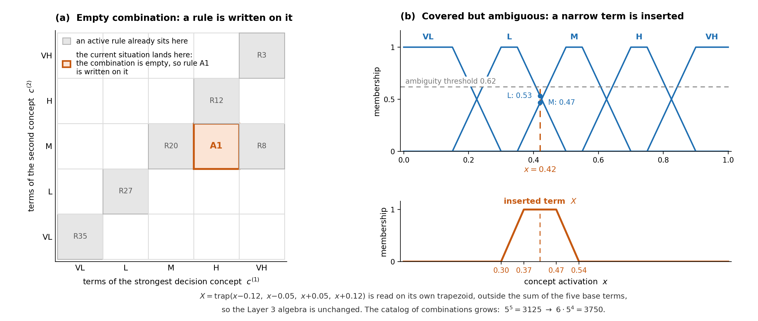
Figure 4.7 Resolution increase, rule instantiation and term insertion

Generative Proposals and Vocabulary Packages
The third stage adds knowledge that neither tuning nor instantiation can produce. The stage engages when the evidence of the cycle shows that the base itself has fallen short. The standing decision falls short in one of two ways. Either its forecast cost exceeds the satisficing bound, or fire is alive while no rule fires above the gap threshold. When one of these is true, stage runs as shown in Figure 4.8.
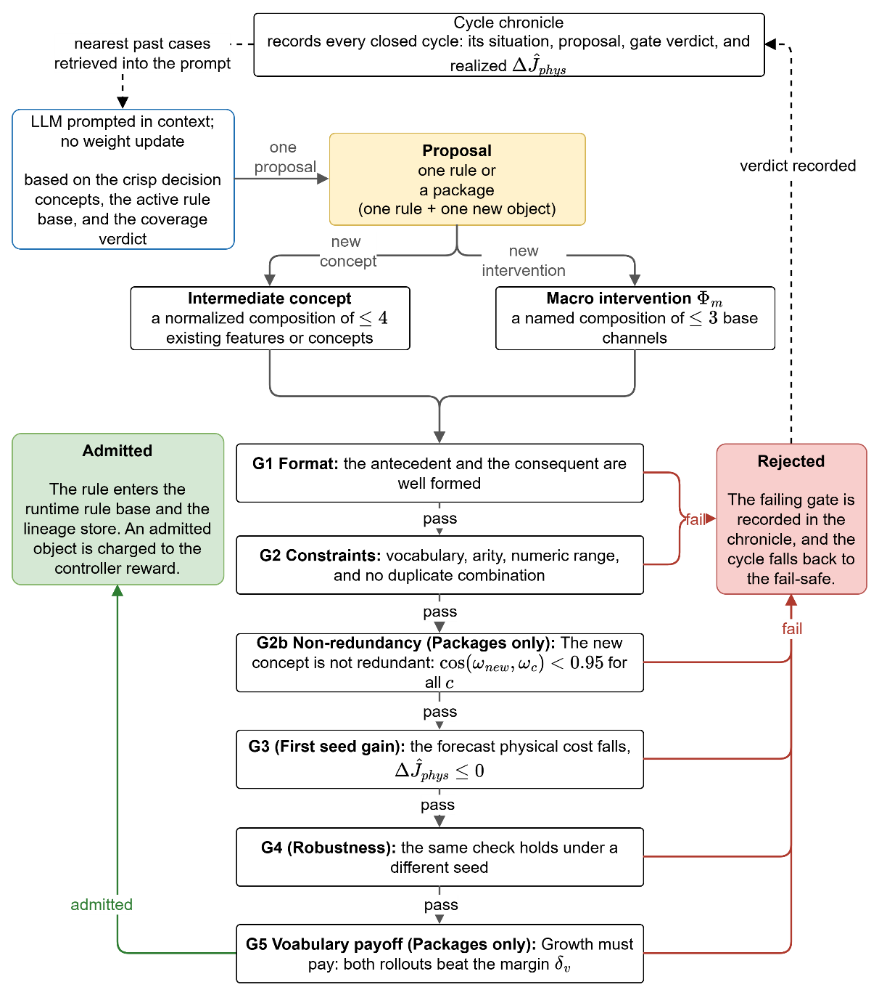
Figure 4.8 Generative proposal and the verification gates
The large language model (LLM) is the proposer. When this stage runs, the model is given the situation of the cycle, which holds the crisp value of every decision concept, the whole active rule base in its IF-THEN form, and the coverage verdict. It is used in context only, with no training and no weight update. From this input it returns exactly one proposal, written in the canonical rule form. The proposal is untrusted by construction so it passes four gates (G1-G4) and additional two gates (G2b and G5) for packages before it can act.
The model is a pretrained general-purpose large language model, used without any task-specific training or fine-tuning, and its weights never change. It is conditioned at inference time in three ways, which are a system instruction that fixes its role, the compact structured summary of the decision situation described above, and a schema-constrained tool-use output that forces every proposal into the framework's own vocabulary, that is, the five decision concepts, the six interventions, and the VL to VH terms. The model therefore proposes in a zero-shot, constrained form rather than learning from data. A proposal is used only after it clears the verification gates G1 to G4 and the satisficing test, so the guarantee comes from validation rather than from training. The domain adaptation of the model is achieved through prompting and output constraints, not through parameter training.
A proposal takes one of two forms. It is a single rule, or it is a package, which is one rule together with one new vocabulary object that the rule uses. An object that no rule cites is inert and cannot be verified, so an object is never admitted on its own. Every proposal, whether a rule or a package, enters the gate sequence as a whole.
A package may carry one of two kinds of object, and both stay inside the semantics that the simulator can execute, and the cost model can price. As illustrated in Figure 4.9 (a), a macro intervention $Φ_{m}$ is a named composition of at most three base interventions listed in Table 2.4, defined in ( 57 ). A consequent on the macro with intensity $v$ expands, inside the aggregation of ( 45 ), into base-intervention consequents with intensities $β_{j}v$.
Macro intervention: $Φ_{m}=\left\langle \left(b_{1},β_{1}\right),…,\left(b_{p},β_{p}\right)\right\rangle , p≤3,$  $$(m,v)↦(b_{j},β_{j}v)$$  Intermediate concept: $a_{c'}=\sum_{i}{ω_{i}a_{i}}, \sum_{i}{ω_{i}}=1, n≤4$ | ( 57 )
A backburn is the example. It is not new physics, but a containment-weighted cut ahead of the front with suppression on the flanks, so it runs through the existing resource fields and is priced by the response term. An intermediate concept is a normalized composition of at most four existing features or concepts, also defined in ( 57 ). As illustrated in Figure 4.9 (b), it joins the hierarchy at the intermediate level, receives a five-term activation and a confidence gate like every native concept, and reaches the decision only through rules that cite it.
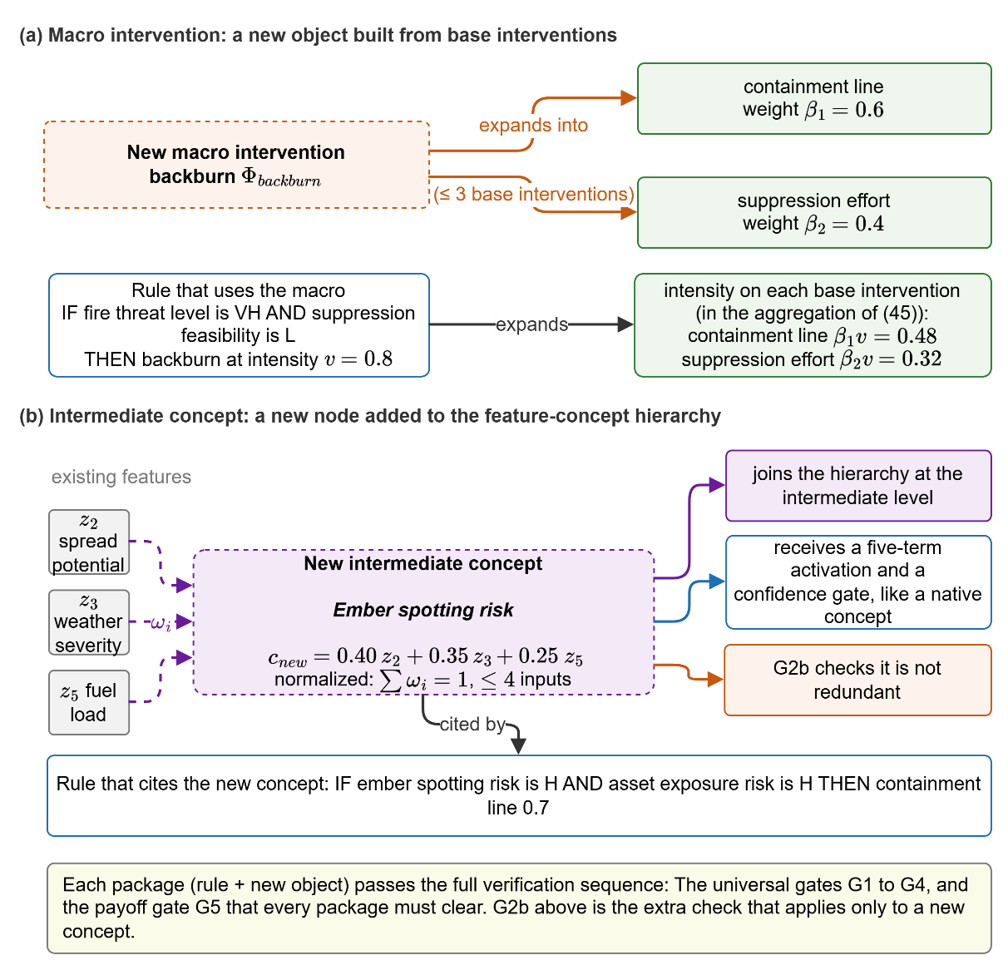
Figure 4.9 Package objects: (a) macro intervention and (b) intermediate concept
G1 checks format. The reply must parse into an antecedent list of concept-term pairs and a consequent list of intervention-intensity pairs. A well-formed reply reads, for example, IF fire threat level is VH AND suppression feasibility is L THEN evacuation 0.80 and public warning 0.60. Some examples show what G1 rejects:
- A reply that arrives as free prose, such as 'the fire is severe, so the crew should begin evacuating'.
- A reply that names an antecedent combination with no consequent.
G1 exists because the proposer is a text generator, so a reply must first be a rule before anything else can be checked.
G2 checks the constraints, the content of a well-formed rule against the closed vocabulary and its boundaries. Every antecedent must name an existing decision concept and one of its linguistic terms. Every consequent must name one of the six base intervention types listed in Table 2.4, or a previously admitted macro, with an intensity in [0, 1]. The number of antecedents and consequents limits stated above must hold. And the antecedent combination must not already carry an active rule. Neither G1 nor G2 costs a simulation step. Some examples show what G2 rejects:
- A proposal of suppression effort 1.3 fails on range.
- A proposal that orders an aerial retardant drop fails on vocabulary, because no such intervention exists in the action space.
- A proposal that re-issues the combination of the active rule R26 (fire threat level is VH) with different numbers fails on duplication, since renumbering an existing rule belongs to the first stage, not to growth.
G2b applies only to a package that proposes a new intermediate concept to check the non-redundancy. A new concept is a normalized weighted combination of existing features or concepts, so it is fully described by its weight vector $ω_{new}$ over those inputs. G2b compares this vector against the weight vector $ω_{c}$ of every existing concept defined over the same inputs, through the cosine of the angle between them, as given in (58).
$$G2b: cos(ω_{new},ω_{c})<0.95 ∀c$$ | ( 58 )
If the cosine reaches 0.95 for any existing concept, the two vectors point in almost the same direction. The new concept is then a near-duplicate, and the package is rejected. Such a concept adds no new direction. It only enlarges the antecedent space and the search, without adding information. This is the concept-level counterpart of the duplicate-combination check in G2. Like G1 and G2, G2b is an algebraic test and costs no simulation step.
An example of G2b rejection:
- A proposed concept built from fire threat and asset exposure with weights (0.60, 0.40) is checked against an existing concept with weights (0.62, 0.38). Their cosine is almost 1.0, so the proposal is rejected at G2b.
G3 is the first gate that costs a simulation and checks the first seed gain. The candidate rule is appended to a working copy of the base. The decision that this new base now composes is played on a shadow copy of the simulator, and its forecast is read at the common trial basis of the adaptation loop. The cost here is the physical cost, that is the burned area, asset, and population terms with their weights renormalized, taken at the trial horizon. G3 runs the same rollout again without the candidate and compares the two, as given in ( 59 ). The forecast physical cost must not rise. A stage-three rule always lands on an uncovered combination, since any duplicate has already died at G2, so a forecast that is merely no worse is admitted as well, on the ground that an empty part of the antecedent space must be answered before it can be tuned. An example of G3 rejection:
- A candidate that orders a heavy resource deployment on a cell where the fire is already contained does not lower the burned area but raises the response-cost term. The cost rises, G3 fails, and the rule is discarded.
G4 repeats the same comparison once more with a different random seed driving the shadow weather to check the redundancy. The two runs are the two cases $V_{a}$ and $V_{b}$ of ( 59 ), an A/B test on two independently drawn futures. It exists because a single rollout can favor a candidate by chance, which is stochastic flattery. G3 and G4 are kept as two gates, not one, because each records a distinct verdict. A failure at G3 means the candidate did not help even once. A failure at G4 means it helped on one future but not on a fresh one.. An example of G4 rejection:
- A candidate that passes G3 but raises the cost on the second seed fails at G4, because a gain that does not survive a fresh future is not admitted.
$$ΔJ_{phys}^{(ν)}=J_{phys}^{\left(ν\right)}(R∪\{r'\})-J_{phys}^{\left(ν\right)}(R), ν∈\{V_{a},V_{b}\}$$  $G3: ΔJ_{phys}^{(V_{a})}≤0$ ; $G4: ΔJ_{phys}^{(V_{b})}≤0$ | ( 59 )
In ( 59 ), $R$ is current rule base, $r'$ is the candidate rule while $V_{a}$ and $V_{b}$ are random seeds. The seeds $V_{a}$ and $V_{b}$ are two independently drawn futures. Seed $V_{a}$ draws one future, in which the wind holds from the west at a moderate speed and the fire keeps to its predicted line. Seed $V_{b}$ draws a different future, in which the wind swings to the north and gusts, and the fire runs in a new direction. G3 scores the candidate on seed $V_{a}$, and G4 scores it again on seed $b$.
G5 is the last gate and applies only to a package to check vocabulary payoff. A package must earn its vocabulary growth. G5 requires that both reseeded rollouts reduce the physical cost by more than the vocabulary margin $δ_{v}$, not merely reduce it, as given in ( 60 ). As a negative example, a package whose new object lowers the cost by less than $δ_{v}$ on either seed fails here, since the growth does not pay for itself. Every admitted object is also charged to the controller reward, so the vocabulary grows only when growth clearly pays.
$$G5: ΔJ_{phys}^{(a)}<-δ_{v} ∧ ΔJ_{phys}^{\left(b\right)}<-δ_{v} δ_{v}=0.001$$ | ( 60 )
A proposal is rejected the moment it fails a gate that applies to it, and the failing gate is named. A plain rule faces G1 to G4. A package faces those four gates and, in addition, G2b and G5. A proposal is admitted only when it clears every gate that applies to it. A rejection at G1 or G2 costs no simulation, so the proposal is returned to the model with the failing gate named, within a bounded revision budget. A rejection at G3, G4, or G5 has already spent a rollout, so it ends the stage for this cycle, and the controller may select the stage again later.
Either way the cycle falls back to the graduated fail-safe. Every closed cycle is written in the cycle chronicle. Each record holds the situation that entered the cycle, the proposal it produced, the gate that admitted or rejected it, and the realized change in the physical forecast. The chronicle is not only a log. Before the next proposal is requested, the records whose situations are nearest to the current one are retrieved and placed in the prompt, each with its verdict, so the model sees what has already worked and what has already been refused in similar situations and stops repeating a recorded rejection. Nothing in this channel is opaque, since the retrieved records are the same objects the audit trail exposes.
Grounding by construction, not by retrieval. The generative stage receives a deterministic context assembled from the simulation such as the decision-concept activations, the observation confidence, the recent cost trajectory, the rule-base statistics, and the location where residual cost concentrates together with the complete closed vocabulary of the framework (i.e., every decision concept, every admissible intervention, and the five fuzzy terms) as in Appendix F.

Value Based Stage Selection
The stage selector works by associative search, which is a contextual bandit that reads the current state and chooses one of the three adaptation stages (Sutton & Barto, 2018). It keeps a small table of action values, one value for each pairing of a state with a stage, and each value estimates the reward that the stage earns in that state. In each cycle the controller reads the state, looks up the action value of every allowed stage for that state, and applies a greedy rule, so the stage with the highest value is run with probability 1 − ε and a random allowed stage is run with probability ε. Once the stage is selected and evaluated its trial, an immediate reward is read and the value of that state and stage is moved a small step toward the reward, ( 61 ).
$$\begin{aligned}q_{k}=\underset{q∈A\left(e_{k}\right)}{\text{argmax}}H\left(e_{k},q\right) with probability 1-ϵ \\ otherwise a unfiormly random stage in A\left(e_{k}\right) with probability ϵ \\ H\left(e_{k},q_{k}\right)←H\left(e_{k},q_{k}\right)+α\left(r_{k}-H\left(e_{k},q_{k}\right)\right) \\ α=0.05, ε=0.10\end{aligned}$$ | ( 61 )
The context that the selector reads is small. It combines how large the current shortfall of the standing decision is, placed in a low, mid, or high band, with a flag that marks whether fire is still active on the ground while the rule base stays effectively silent. For an ordinary shortfall all three stages are available, which are the evolving fuzzy adjustment, the resolution increase, and the generative proposal. When the context is a pure coverage gap, the choice is limited to the two stages that can create rules, since an empty situation has nothing to tune. Any stage that has not yet been tried in a context is tried once before the greedy rule takes over, so no stage is starved at the start of an incident.
The reward that a stage earns is the reduction in the forecast physical cost. This keeps the selector from favoring stages that enlarge the vocabulary without a clear gain. After each trial the value of the chosen stage in the current context is moved toward this reward, so across the few trials an incident allows the selector settles on the stage that helps most in each context.

Local Layer, Graduated Fail-Safe, Global Coordination
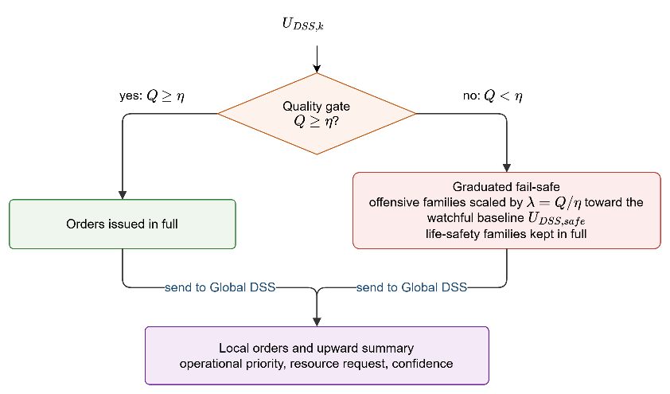
Figure 4.10 Local decision and graduated fail-safe
A Local DSS agent, shown in Figure 4.10, decides only for the cells inside one region. It runs the whole decision path of the previous sections on its own region and turns the gated concept activations into a candidate intervention. All inference stays inside the region, so the decision path is short, and every order can be traced back to the concepts that raised it.
The graduated fail-safe checks the candidate and scores it with a decision quality that measures how well it serves the concepts that demanded it, then compares the quality with a threshold. If it is above the threshold, the candidate is issued in full; otherwise, the offensive families are scaled to the watchful baseline in proportion to the shortfall, ( 11 ), while evacuation and public warning are never reduced. The response is continuous and reversible, so the offensive commitment shrinks as the quality falls and returns to full strength once fresh observations restore it, and a weak reading never stops a warning or avoids evacuation.
As an example, take a region where smoke has degraded the optical channel over one sector. The features that feed suppression feasibility lose confidence, the gate on that concept closes, and its activation falls back toward the decayed prior. The rule base still calls for a strong suppression effort from the fire threat level, but suppression feasibility no longer supports it, so the candidate is unbalanced and the quality drops below the gate. The graduated fail-safe attenuates the suppression effort and resource deployment toward the watchful baseline, while the public warning that the same cycle raised for the exposed settlement is issued at full strength. When the wind clears the sector two cycles later, confidence recovers, the quality rises above the gate, and the suppression order returns to full strength without any external action.
The Global DSS coordinates the regions and performs no inference of its own. It runs no features, concepts, or rules, and it only ranks the regions and shares the capacity between them. Each Local DSS sends up three small values, which are its operational priority, its resource request, and a short confidence summary, and nothing else leaves the region, so the channel stays narrow and easy to audit. In return the coordinator sends back the allocation, the normalized priority weights, and the acceptance thresholds.
The coordinator ranks the regions by operational priority, the concept at the top of the hierarchy that blends a region's fire threat level and asset exposure risk and fires no local rule. It marks the highest as the focus and gives each region an attention share. A region whose operational priority is at least a set fraction of the highest priority, or above an absolute threshold, is attended and keeps the full share; a region well below the top is monitored, and its share decreases with its relative priority, as ( 62 ). The attention threshold is 0.35.
$$σ_{i}=\left\{\begin{aligned}1,\text{ if }p_{i}≥τp_{\text{max}}\text{ or }p_{i}≥τ \\ 0.5+0.5\frac{p_{i}}{p_{\text{max}}},\text{ otherwise}\end{aligned}\right.$$ | ( 62 )
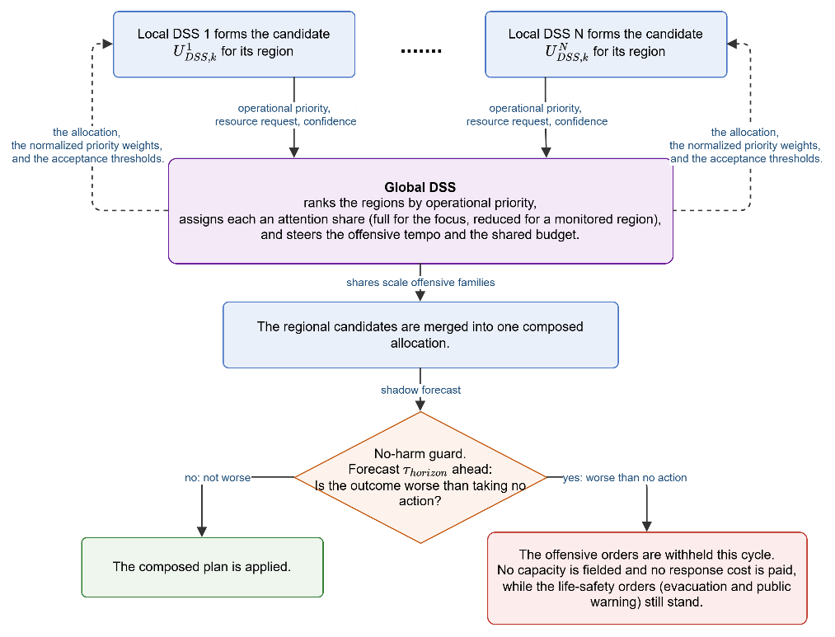
Figure 4.11 Global coordination and the no-harm fail-safe
The share acts on the offensive side only. It scales the suppression effort and resource deployment and puts more of the shared budget on the focus, while evacuation and public warning are left untouched. The share also sets how good an order must be to be accepted. An attended region keeps the normal quality threshold, but a monitored region must clear a higher one, so an offensive order in a low-priority region needs stronger decision quality before it uses shared capacity. The regional candidates are then merged into one plan, which the no-harm guard forecasts. When the plan is forecast worse than taking no action, its offensive orders are withheld for the cycle while the life-safety orders still stand. Figure 4.11 summarizes global coordination and the guard.
Turning the merged intensities into field orders follows three allocation principles. A committed direct attack is dispatched at no less than 0.85 of unit capacity, since a diluted attack wets fuel without extinguishing it and spends the same travel time; below that commitment a unit serves better staged than sent. The containment effort is placed as a band across the forecast downwind path of the front rather than around the whole perimeter, which concentrates the cut where the spread will arrive. The shared budget follows the attention shares, so the focus region draws first on the airborne capacity that can reach any cell of the map.
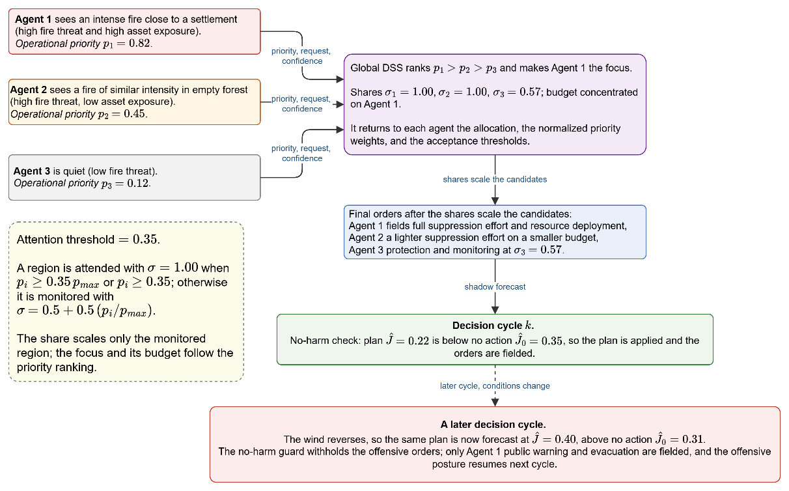
Figure 4.12 Example of local decisions, global coordination, and the fail-safe
Figure 4.12 follows one decision cycle with representative numbers. The priorities come from observations. Agent 1 sees an intense fire close to a settlement, so its fire threat level and its asset exposure risk are both high and its operational priority is 0.82; Agent 2 sees a fire of similar intensity in empty forest, so its asset exposure risk is low and its priority is only 0.45; Agent 3 is quiet at 0.12. Each agent sends up its priority, its resource request, and a confidence summary.
The coordinator ranks the three, makes Agent 1 the focus, sets the attention shares to 1.00 for Agent 1 and Agent 2 and 0.57 for the monitored Agent 3, and returns to each agent the allocation, the normalized priority weights, and the acceptance thresholds. The budget concentrates on the highest priority, the final orders are a full suppression effort and resource deployment for Agent 1, a lighter suppression effort on a smaller budget for Agent 2, and protection with monitoring for Agent 3. In this cycle the composed plan is forecast at 0.22 against 0.35 for taking no action, so it clears the no-harm check and the orders are fielded. In a later cycle the wind reverses and the same plan is forecast at 0.40 against 0.31, so the no-harm guard withholds the offensive orders; only Agent 1's public warning and evacuation are fielded, and the offensive posture resumes once the forecast turns favorable again.

SIMULATION AND PERFORMANCE RESULTS
This chapter evaluates the DisasterAware framework empirically and demonstrates that the three contributions C1–C3 hold not only analytically but under simulated operations, and that the simulation environment on which this demonstration rests is itself a faithful proxy of real fire behavior.
The chapter proceeds in six steps. Section 5.1 derives, from the wildfire decision-support literature, the performance criteria that any operational DSS must demonstrate, and turns them into the evaluation rubric of this chapter. Section 5.2 describes the simulation environment, its parameters, and its assumptions. Section 5.3 validates the simulation core against documented wildfires, using blind hindcasts driven by real terrain, fuel, and weather data. Section 5.4 reports the performance of the decision layer. Section 5.5 benchmarks the framework against established baselines and positions with respect to published systems. Section 5.6 quantifies the sensitivity of the closed loop to its design parameters, and Section 5.7 returns to the rubric of Section 5.1 and shows criterion by criterion where each requirement is met.

Evaluation Criteria for Wildfire Decision Support Systems
What a wildfire DSS must demonstrate has not been established by a single, agreed method. The literature divides into two loosely connected traditions. The technical tradition evaluates the predictive models inside a tool and states that they should be assessed on their intended use, the spatial progression of real fires, before their results are used (Cruz, Alexander, & Wakimoto, 2003; Alexander & Cruz, 2013). Rate-of-spread predictions fall within about ±35% of observations in roughly half to two-thirds of cases, which is treated there as a reasonable standard (Alexander & Cruz, 2013). The decision-support tradition evaluates the tool's effect on the decision itself (Martell D. , 2015), and its most recent review reports a concerning finding. Most wildfire DSS evaluations so far have measured adoption and use rather than whether the tool improves the decision, which the review identifies as the main gap in the field (Rapp, Franz, Colavito, Aldworth, & Cheng, 2026). An evaluation chapter must therefore address both traditions together. It must validate the model core as required by the technical tradition, and it must measure the decision effect as required by the decision-support tradition. Table 5.1 lists eight criteria, S1 to S8, with the measurement used for each in the literature. Section 5.3 validates the model core against the technical tradition, Sections 5.4 to 5.6 measure the decision effect, and Section 5.7 audits the evidence against these criteria.
Table 5.1 Evaluation criteria for wildfire DSS
# | Criterion | Measurement in the literature
S1 | Predictive fidelity:  The simulation core reproduces observed fire behavior from real inputs | Retrospective hindcasts against historical fires; spatial-overlap and arrival-time scores (Duff, et al., 2016; Fox-Hughes, Bridge, & Faggian, 2024; Filippi, Mallet, & Nader, 2014)
S2 | Decision quality:  Recommended interventions improve the outcome relative to a no-tool alternative | Outcome deltas against no-action and baseline policies on matched scenarios (Rapp, Franz, Colavito, Aldworth, & Cheng, 2026; Duff & Tolhurst, 2015).
S3 | Timeliness: Decision latency compatible with operational tempo | Decision-cycle wall time; detection-to-first-order time (Noonan-Wright, et al., 2011)
S4 | Robustness under degraded observation: Graceful behavior under sensor loss, noise, and communication failure | Performance versus outage and noise level; fail-safe engagement statistics (Comes, Hiete, Wijngaards, & Schultmann, 2011)
S5 | Uncertainty handling: Input uncertainty is represented and propagated to the decision | Ensemble and input-uncertainty propagation studies (Benali, et al., 2017; Cruz & Alexander, 2013)
S6 | Adaptability: The system extends its own knowledge when it does not cover the situation | Learning curves; coverage growth; rediscovery of withheld knowledge (Angelov & Filev, 2004)
S7 | Explainability and auditability: Every recommendation is traceable to its evidence | Trace completeness; interpretability as an adoption gate (Fillmore & Paveglio, 2023)
S8 | Scalability: Cost grows manageably with domain size and number of regions | Runtime and quality versus grid size and agent count (Pais, Carrasco, Moudio, & Shen, 2021).

Simulation Environment, Parameters, and Assumptions
All experiments run on the DisasterAware testbed, whose two cores were presented in Chapters 3 and 4 and are kept analytically separated by design: the simulation core advances the physical state of the fire, and the decision core reads that state only through the observation model and acts on it only through the intervention channels.
Two scenario families are used. Synthetic scenarios are generated procedurally on grids of 200×200 cells at 90 m resolution with terrain presets (rolling hills, Mediterranean coast), seeded settlements and road networks, and capacity-limited resource bases; ignition points are chosen among burnable cells farthest from the bases, so that trivial fires do not mask parameter effects. Historical scenarios reconstruct documented fires on 90 m grids from real terrain, fuel, and weather data. Unless stated otherwise, the decision engine runs with the thresholds of Chapter 4, and the full seed rule base of Appendix E; deviations (thin seed profiles, adaptation off, perturbed observation) are the controlled variables of the individual experiments and are stated per experiment. Table 5.2 lists the parameters of all runs in one place, grouped by subsystem.
Table 5.2 Simulation and decision parameters of all experiments
Parameter | Sym | Value / range | Unit
Grid size (synthetic) | $$-$$ | $$200 × 200$$ | cells
Cell size (synthetic / hindcast) | $$-$$ | $$90$$ | m
Simulation step (synthetic / hindcast) | $$Δt$$ | $$2 / 30$$ | min
Decision cycle | $$-$$ | $$1-8 (def: 1)$$ | min
Satisficing bound | $$J_{TH}$$ | $$0.35$$ | —
Relative satisficing margin | $$δ_{gain}$$ | $$0.05$$ | —
Quality gate | $$η$$ | $$0.60$$ | —
Persistence decay | $$ρ$$ | $$0.90$$ | —
Coverage / gap threshold | $$-$$ | $$0.45$$ | —
Coverage floor | $$α_{min}$$ | $$0.05$$ | —
Adaptation cooldown | $$-$$ | $$10$$ | min
Trial basis (shadow forecast) | $$-$$ | $$≥ 45$$ | min
Bandit exploration ε / step size $α$ | $$ε / α$$ | $$0.10 / 0.05$$ | —
Package gates | $$-$$ | $$cos⁡(ω_{1},ω_{2})<0.95 \\ δ_{v}=0.001$$ | —
Seed profiles | $$-$$ | $$min 5$$ | rules
Monte Carlo runs per condition | $$N$$ | $$50$$ | runs
Random seed policy | $$-$$ | $$1-30$$ | —
Hardware / wall time per run | $$-$$ | Intel Core i9-10900K, 32 GB RAM | —

Modeling and decision layer assumptions, common at operational-scale fire simulation (Sullivan, Wildland surface fire spread modelling 1: Physical and quasi-physical models, 2009a), are listed in Table 5.3.
Table 5.3 Environment and decision layer assumptions
Environment layer assumptions
- Precipitation is a single domain-uniform value.
- Dead-fuel moisture follows the equilibrium-moisture model, not measured fuel sticks.
- Fuel classes come from a land-cover product through a fixed mapping, which flattens within-class variability.
- Ember transport and crown-fire transitions enter only through the spread terms.
- Crews and aircraft are modeled as capacity fields, not individual units.
Decision layer assumptions
- Decisions are taken on a fixed decision cycle rather than continuously.
- Sensing and inter-region communication are reliable, except where an experiment perturbs them.
- The cost priorities that weight J are fixed and known for a given run.
- Any change proposed by the generative component takes effect only after passing the verification gates.
- The no-harm guard treats the shadow forecast as the proxy for the no-action outcome over its horizon.
- Evacuation is charged only through the response capacity it consumes; the societal cost of displacement lies outside the objective.
- The population term counts exposure inside actively burning cells only; smoke and proximity exposure outside the fire front are not modeled.
- Fire duration is priced only through the burned area and the accumulated exposure it produces, not as a separate cost term.
- Evacuation is charged only through the response capacity it consumes; the societal cost of displacement lies outside the objective.
- The population term counts exposure inside actively burning cells only; smoke and proximity exposure outside the fire front are not modeled.
- Fire duration is priced only through the burned area and the accumulated exposure it produces, not as a separate cost term.

Validation of the Simulation Core Against Historical Fires
In DisasterAware, the simulation core is a close enough model of real fire behavior to support the decision-layer results. The test is a blind hindcast. The simulator is given only the real inputs of a documented fire, with no tuning on that fire. It runs for the recorded duration, and its burned area is compared with the observed burned area. The inputs come from independent public data.
- Terrain is taken from the Copernicus GLO-30 elevation model (DEM, 2026).
- Fuel is taken from the ESA WorldCover 2021 land-cover product and mapped to the internal fuel classes (v200, 2026).
- Weather is taken from the ERA5 hourly at the ignition point, and dead-fuel moisture is set by the equilibrium-moisture model (Open-Meteo, 2026).
- The ignition point and the reference burned area come from NASA FIRMS VIIRS 375 m active-fire detections (S-NPP, 2026).
The reference mask is limited to the simulated time window and to the main detection cluster. This approach follows the common practice of testing fire models on independent, observed fires rather than on the data used to build them. The validation set has four documented fires in Turkey, chosen to cover different fuel, terrain, and wind conditions: Manavgat (Antalya, July 2021), Marmaris (Muğla, July 2021), Milas–Kemerköy (Muğla, August 2021), and Çanakkale–Kayadere (August 2023). Their case definitions are given in Table 5.4.
Table 5.4 Historical validation cases and their configuration
Case | Bounding box (°E, °N) | Start date | Duration (h)
Sc1: Manavgat (Antalya) 2021 | 31.30–31.80 E,  36.72–37.08 N | 2021-07-28 | 48
Sc2: Marmaris (Muğla) 2021 | 28.10–28.55 E,  36.75–37.05 N | 2021-07-29 | 48
Sc3: Milas (Muğla) 2021 | 27.70–28.35 E,  36.95–37.35 N | 2021-08-01 | 72
Sc4: Kayadere (Çanakkale) 2023 | 26.50–27.00 E,  39.90–40.20 N | 2023-08-22 | 48
The simulation core models free fire spread and does not represent suppression. A free run therefore overpredicts the final burned area, so area-overlap scores are not used as the primary measure, because they would conflate the spread error with the missing suppression and with the sparse satellite footprint. The core is instead evaluated on how the fire front propagates. Let ${FR}_{Sim}$ be the set of cells the model burns and ${FR}_{Re}$ the set of cells the satellite records as burned, and let $∂{FR}_{Sim}$ and $∂{FR}_{Re}$ be their fronts, the outer boundary cells of each set. Three criteria are used, each robust to suppression and to the length of the run: coverage, front position error, and arrival-time agreement.
Coverage is represented as the probability of detection (POD). It is the share of the observed burn that the model reaches, the number of cells common to ${FR}_{Mod}$ and ${FR}_{Re}$ divided by the size of ${FR}_{Sat}$, ( 63 ). It stays informative even when the free run overshoots, because extra simulated cells do not lower it.
$$POD=\frac{|{FR}_{Sim}∩{FR}_{Re}|}{|{FR}_{Re}|}$$ | ( 63 )
The acceptance level of 0.70 on the probability of detection is taken from the level at which the wildfire-simulation literature reports good agreement between simulated and observed footprints. Parameterizing FARSITE with vegetation-derived fuel maps raised the Sorensen coefficient from 0.38 for standard inputs to 0.70 (Price, 2022), and calibrated cell-based growth models reach 0.7 to 0.9 while uncalibrated semi-empirical models typically fall between 0.5 and 0.7 (Pais, Carrasco, Martell, Weintraub, & Woodruff, 2021). A probability of detection of at least 0.70 therefore marks the boundary of a reproduction of the observed extent that is as reliable as a well-behaved uncalibrated model.
Front position error measures how far the simulated front lies from the observed one. With $D(x,G_{Set})$ the distance from a cell $x∈G$ to the nearest cell of a set $G_{set}$, as in ( 64 ), the front-to-front distances have a mean $\overline{d_{Front}}$, given in ( 65 ) and reported as front mean.
$$D(x,G_{Set})=\min_{y∈G_{Set}}‖x-y‖$$ | ( 64 )
$$\overline{d_{Front}}=\frac{Σ_{x∈∂{FR}_{Sim}}D(x,∂{FR}_{Re})+Σ_{y∈∂{FR}_{Re}}D(y,∂{FR}_{Sim})}{|∂{FR}_{Sim}|+|∂{FR}_{Re}|}$$ | ( 65 )
Front position error expressed in meters is a standard output of FARSITE-style validation (Finney, 1998). In this study each distance is judged relative to the equivalent radius of the observed burn area ( 66 ), where $N_{burned}$ is the number of burned cells and $A_{cell}$ is the area of a cell. The error of front position should be less than 0.3 (success greater than 0.7 similar to POD).
$$R =\sqrt{\left(\left|N_{burned}\right| A_{cell}\right)/π}, {TH}_{Front}=1-\frac{\overline{d_{Front}}}{R}$$ | ( 66 )
Arrival-time agreement tests the rate of spread directly. Over the $N_cells$ common to ${FR}_{Sim}$ and ${FR}_{Re}$, it compares the simulated arrival time at each cell with the first satellite detection time there. The mean absolute time (MAE) difference between them is $τ_{MAE}$ ( 67 ).
$$τ_{MAE}=\frac{1}{N_{cells}}Σ_{c∈{FR}_{Sim}∩{FR}_{Re}}\left|t_{c}^{Sim}-t_{c}^{Re}\right| \\ N_{cells}=|{FR}_{Sim}∩{FR}_{Re}|$$ | ( 67 )
The arrival-time error is the mean absolute difference between the time at which the simulated front reaches each cell and the first satellite detection time of that cell, taken over the cells that both burned. It is the direct rate-of-spread test and is the least sensitive to suppression and to the length of the run. The error is judged relative to the observed fire duration $T$, the span of the satellite detections, and is accepted below one quarter of $T$. The error of MAE ( 68 ) should be less than 0.3 (success greater than 0.7 similar to POD).
$${TH}_{MAE}=1-\frac{τ_{MAE}}{T}$$ | ( 68 )
Table 5.5 reports the agreement metrics per case, averaged over 50 stochastic replicates; Figure 5.1shows the corresponding agreement maps, in which correctly predicted burn, overprediction, and missed burn are distinguished. It shows that the simulation core has an acceptable overall success rate over real scenarios.
Table 5.5 Hindcast agreement metrics per historical case (mean over stochastic replicates)
 | Sc1 | Sc2 | Sc3 | Sc4
$$A_{cell} \left(m^{2}\right)$$ | $$8100$$ | $$8100$$ | $$8100$$ | $$8100$$
$$N_{burned}$$ | $$1288$$ | $$3922$$ | $$387$$ | $$4915$$
$$R (m)$$ | $$1823.03$$ | $$3179.96$$ | $$1000.19$$ | $$3559.83$$
$$T (hr)$$ | $$14.00$$ | $$72.80$$ | $$14.00$$ | $$58.70$$
$\overline{d_{Front}}$ (m) | $$329.00$$ | $$305.00$$ | $$113.00$$ | $$391.00$$
$τ_{MAE}$ (h) | $$1.46$$ | $$1.39$$ | $$4.04$$ | $$2.58$$
$$\frac{1-\overline{d_{Front}}}{R}$$ | $$82\%$$ | $$90\%$$ | $$89\%$$ | $$89\%$$
$$\frac{1-τ_{MAE}}{T}$$ | $$90\%$$ | $$98\%$$ | $$71\%$$ | $$96\%$$
$POD$ (–) | $$92\%$$ | $$93\%$$ | $$97\%$$ | $$85\%$$
Overall Success | $$88\%$$ | $$94\%$$ | $$86\%$$ | $$90\%$$

Sc1 | 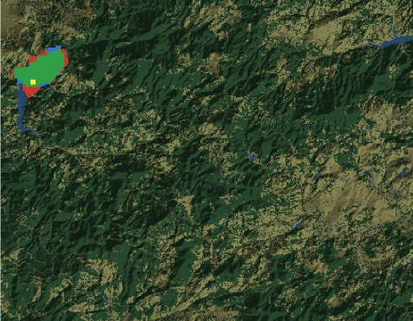 | Sc3 | 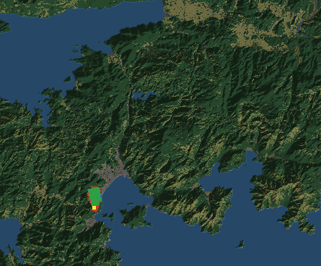
Sc2 | 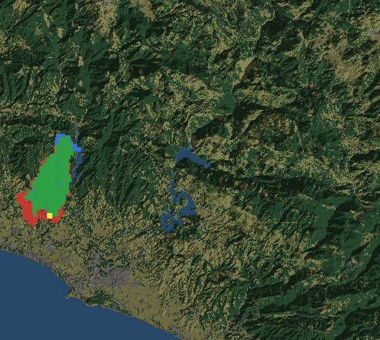 | Sc4 | 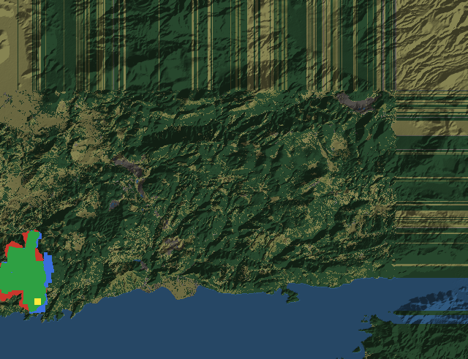
Figure 5.1 Agreement maps for the historical hindcasts (Green: Correctly predicted burn, Red: Simulated only, Blue: observed only, Yellow: Ignition)

Performance of the Decision Layer
The decision layer is evaluated as an ablation ladder under one shared protocol, so that every comparison stays fair and every difference is attributable. Seven configurations face identical fires as listed in Table 5.6.
Table 5.6 DSS test configurations
$T_{0}$ issues no orders and fixes the cost of inaction.
$T_{F5}$ runs the decision layer on the minimal seed base of five rules with all adaptation off, the closed decision space.
$T_{F5+Ev}$ adds the evFIS stages, consequent tuning and resolution growth.
$T_{DisasterAware}$ runs the full staged adaptation, the open decision space in full.

The reading is stepwise. ${Test}_{F5}$ against ${Test}_{0}$ prices the minimum decision layer itself; ${Test}_{F5+Ev}$ against ${Test}_{F5}$ prices evFIS based parametric adaptation; the full configuration ${Test}_{F5+Ev+AI}$ against all three prices the open decision space; and its remaining distance to $Test_{F40}$ states how much of the withheld doctrine the adaptation recovered without ever being handed it.
Each configuration is a Monte Carlo campaign of N = 50 runs per scenario. Every seed generates one scenario-conformant world, the map, the ignitions, and the weather drawn to the specification of the scenario in question, and all seven configurations replay that identical world, so the outcome differences come from the decision mechanism alone; ${Test}_{0}$, run on the same history, additionally serves as the exact no-action counterfactual. Evaluation seeds are disjoint from every seed used during development and calibration. Episodes run until extinction or a defined interval (i.e., 12 hours). Because the cost terms accumulate over time, cross-configuration cost comparisons are read at a common checkpoint (i.e., 6 hours), while suppression success and time to extinction are reported over the full episode. Unresolved episodes are censored. Results are reported as the mean with a 95% confidence interval, and paired differences carry a paired significance test.
Comparisons are based on two costs. Physical cost $J_{Phy}$ is against the no-intervention reference and is using renormalized cost of assets, people, and burned area because ${Test}_{0}$ pays no response cost by definition and a comparison on the total cost would reward inaction. The total cost $J_{Tot}$ is reported for other configurations. $J_{Phy}$ and $J_{Tot}$ ( 69 ) are based on ( 48 ).
$$J_{Phy}=\frac{\sum_{j}{w_{j}J_{j}}}{\sum_{j}{w_{j}}}, j∈\left\{burn, asset, pop\right\} \\ J_{Tot}= \frac{\sum_{j}{w_{j}J_{j}}}{\sum_{j}{w_{j}}}, j∈\left\{burn, asset, pop, resp, delay\right\}$$ | ( 69 )

Evaluation Scenarios
The tests run on five scenario families built from the landscape type and the resource sufficiency, and one degraded-observation space. The landscape axis separates the two operational faces of the problem, namely remote forest, where the burned-area term dominates and suppression and containment are focused, and the wildland-urban interface (WUI), where assets and population dominate and protection, evacuation, and warning are focused. The resource axis separates the comfortable regime, in which almost any allocation succeeds, from the capacity-limited regime, in which allocation quality is what separates the configurations; the realized resource sufficiency ratio is reported with the results. Weather is held at critical fire weather, dry fuels and strong wind, in all scenarios, so that the scenario axes remain the only controlled difference.
For each scenario, fifty distinct worlds are generated; Table 5.7 defines the five scenarios, and one representative world of each is illustrated in Figure 5.2, Figure 5.3 and Figure 5.4. The intervention and the layers are illustrated in Figure 5.5, respectively.
Table 5.7 Evaluation scenarios
ID | Landscape | Resource* | Ignitions | What it tests
S1 | Remote Forest  (≈2 small settlements) | Sufficient | 1 remote | Baseline suppression competence when capacity is not the constraint
S2 | Remote Forest  (≈2 small settlements) | Limited | 3 remote | Area protection under scarcity; allocation quality
S3 | WUI  (≈ 15 settlements, high assets) | Sufficient | 2 near the interface | Life/asset prioritization; evacuation and warning discipline
S4 | WUI  (≈ 15 settlements, high assets) | Limited | 2 near the interface | Full operational stress; the demonstrative scenario
S5 | as S4 | as S4 | as S4 | S4 under degraded observation
Resource effectiveness exceeds 50% when resources are sufficient and drops below 50% when they are limited.

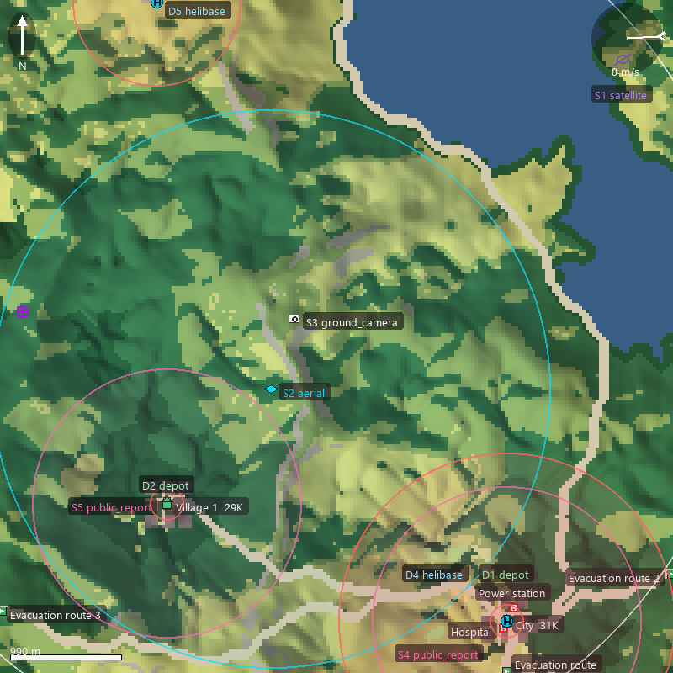 | 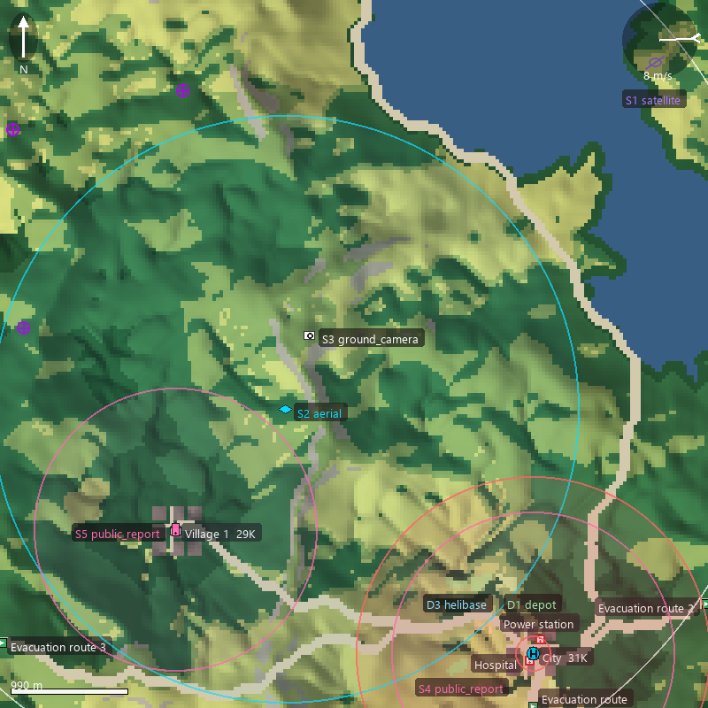
Figure 5.2 Representative world of S1 (left) and S2 (right)
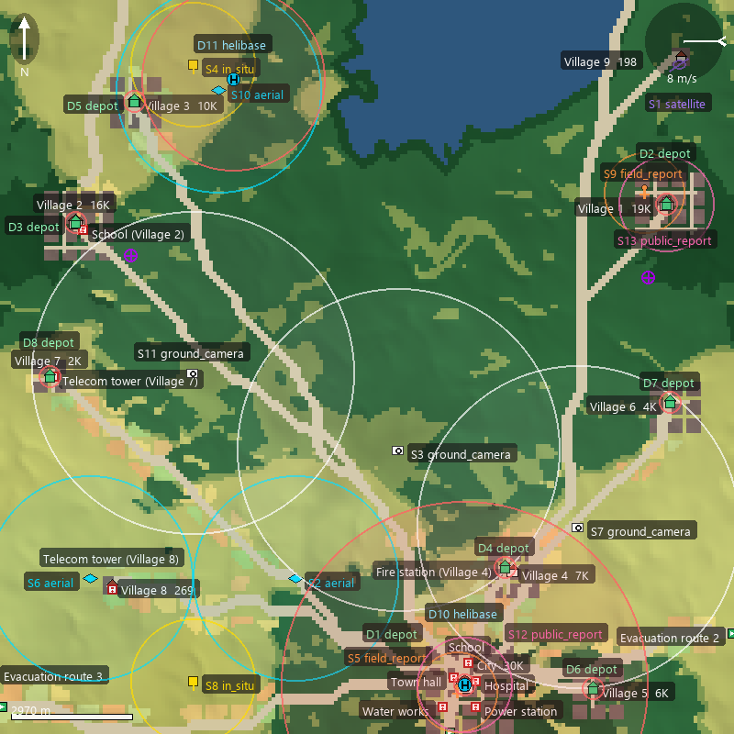 | 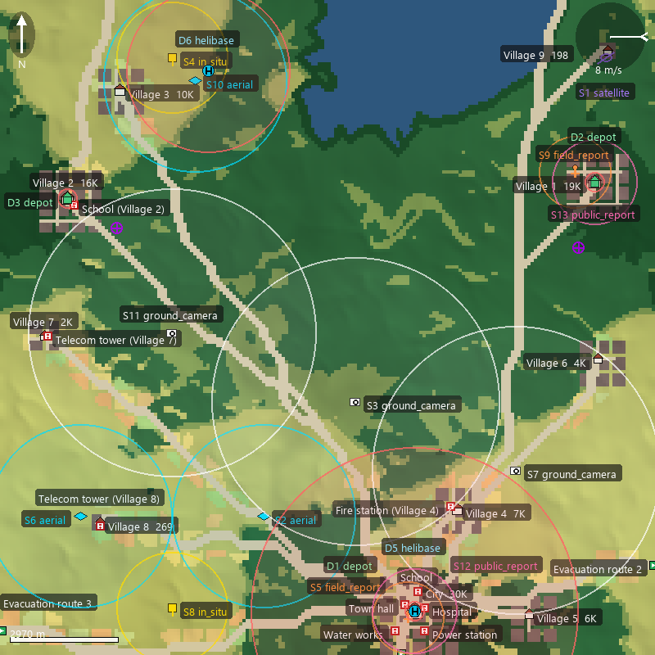
Figure 5.3 Representative world of S3 (left) S4 (right)
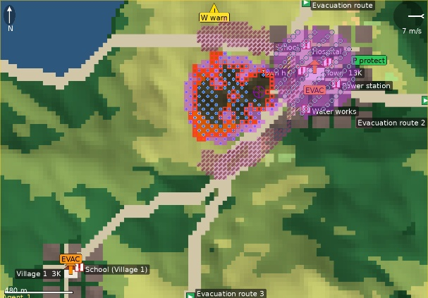
Figure 5.4 Sample interventions (full set) on a representative world
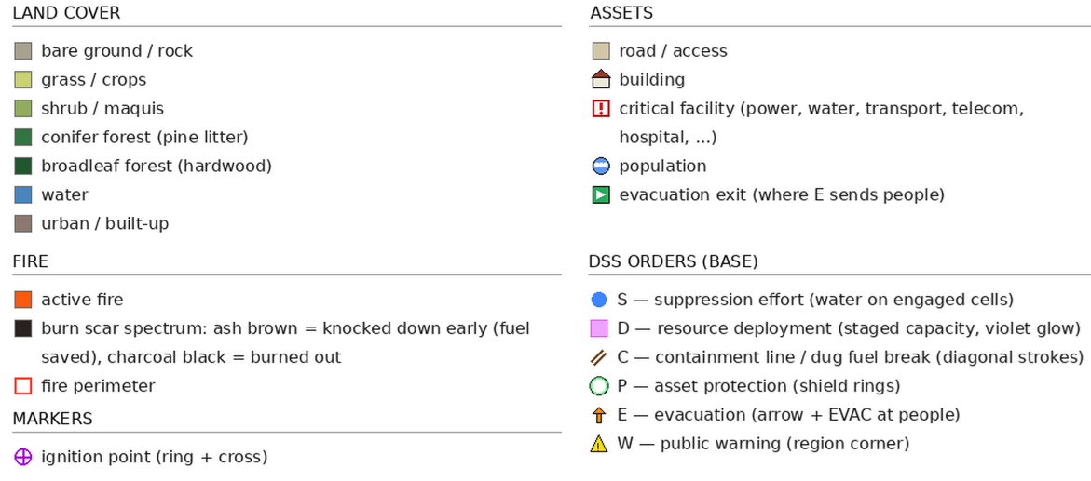
Figure 5.5 Legends for representative world

Improvement Ladder Performance
Table 5.8 reports the physical outcome of the four configurations per scenario, and Table 5.9 the matching decision-cost terms at the six-hour horizon. The reading is a ladder, where each added capability is asked to buy a visible gain over the rung below it as depicted in Figure 5.6 - Figure 5.10. The static five-rule layer lowers the mean burned area from 226 ha under free burn to 79 ha, a 65% reduction, and cuts the mean total decision cost from 0.446 to 0.191. The evFIS stage yields a marginal and mixed change over the static rules. It lowers the mean affected population from 487 to 431 and reduces burned area in three of the five scenarios, yet the mean burned area near 77 ha and the mean total decision cost of 0.202 against 0.191 stay essentially level, because the added adaptation spends response effort for a physical gain that does not clearly separate it from the static baseline. The generative stage supplies the decisive second step: it halves the burned area again to 40 ha, an 82% reduction against free burn, lowers the mean affected population from about 4890 to 131, and brings the mean total decision cost to 0.142, the lowest of the four configurations after its own response effort is charged. The total cost evolution is illustrated per scenarios in Figure 5.11 - Figure 5.15. The physical cost evolution is illustrated in Figure 5.16 - Figure 5.20. The average cost evolution is depicted in Figure 5.21 and Figure 5.22.
Table 5.8 Physical outcome per scenario and configuration before the six-hour checkpoint per scenario
 | Burned (ha) | Burned Forest (ha) | Affected  Pop. | Evac.  Pop. | Out (min) <360 min
S1
$T_{0}$
$T_{F5}$
$T_{F5+Ev}$
$T_{DisasterAware}$
S2
$T_{0}$
$T_{F5}$
$T_{F5+Ev}$
$T_{DisasterAware}$
S3
$T_{0}$
$T_{F5}$
$T_{F5+Ev}$
$T_{DisasterAware}$
S4
$T_{0}$
$T_{F5}$
$T_{F5+Ev}$
$T_{DisasterAware}$
S5
$T_{0}$
$T_{F5}$
$T_{F5+Ev}$
$T_{DisasterAware}$
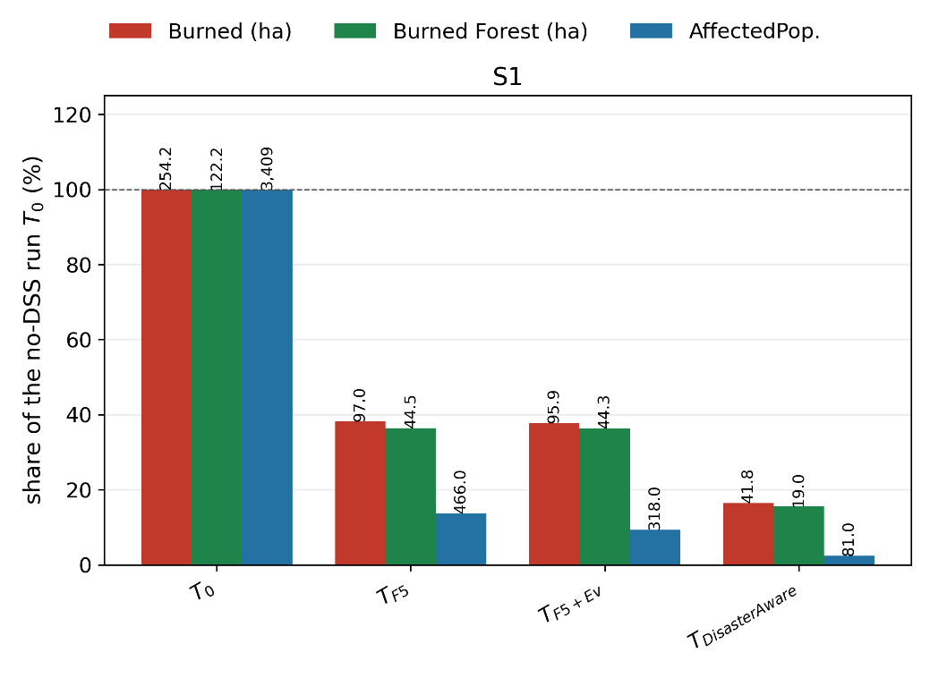
Figure 5.6 Burned-area, burned-forest, and affected population evolution of the five configurations under the five scenarios for S1
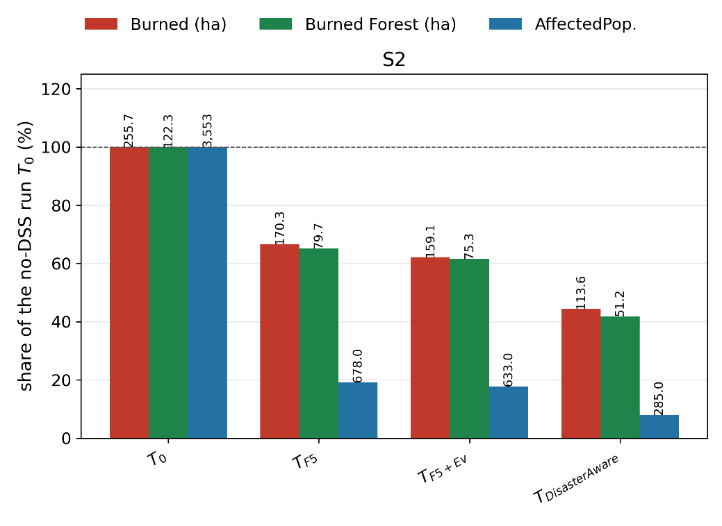
Figure 5.7 Burned-area, burned-forest, and affected population evolution of the five configurations under the five scenarios forS2
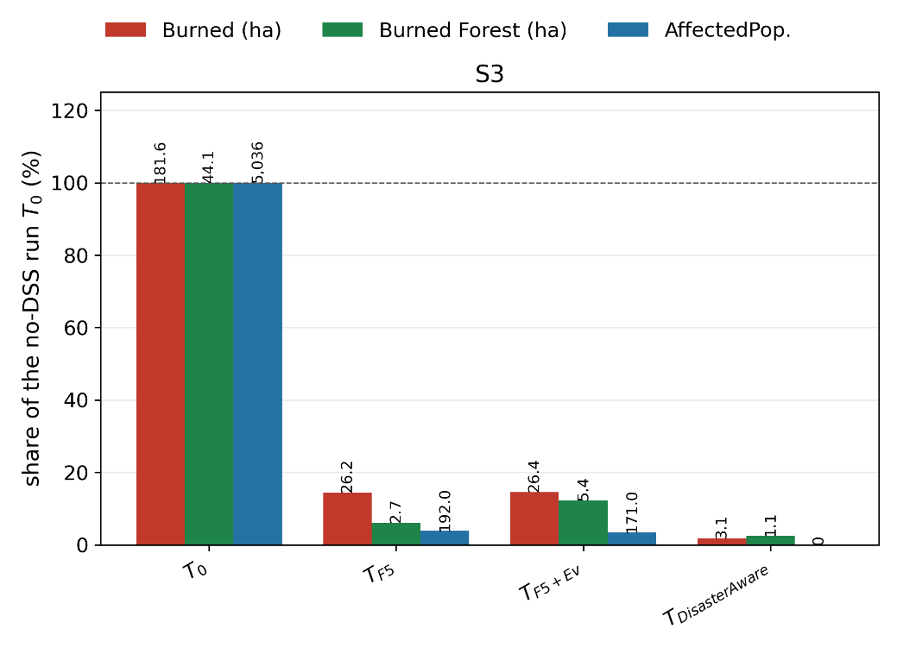
Figure 5.8 Burned-area, burned-forest, and affected population evolution of the five configurations under the five scenarios for S3
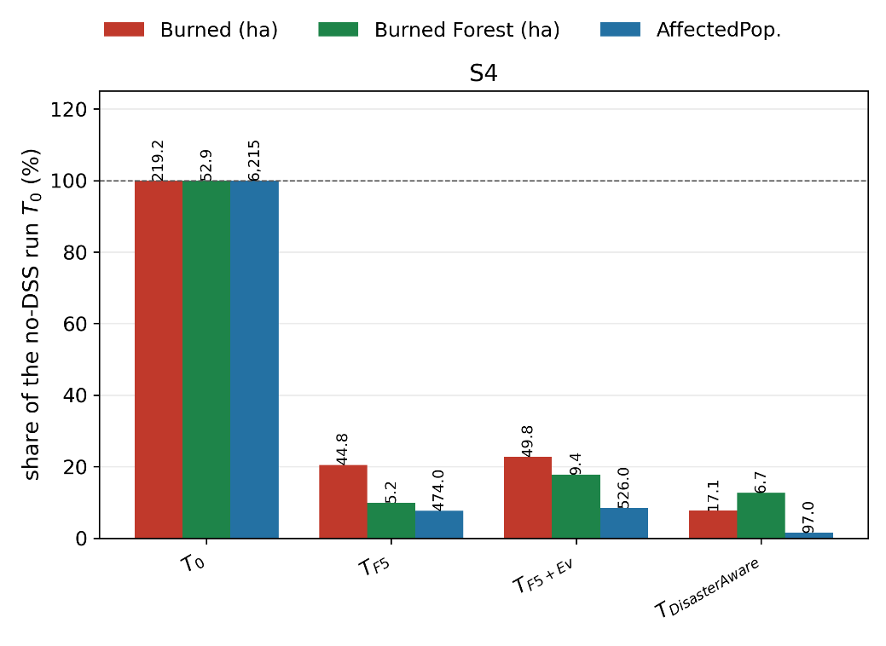
Figure 5.9 Burned-area, burned-forest, and affected population evolution of the five configurations under the five scenarios for S4
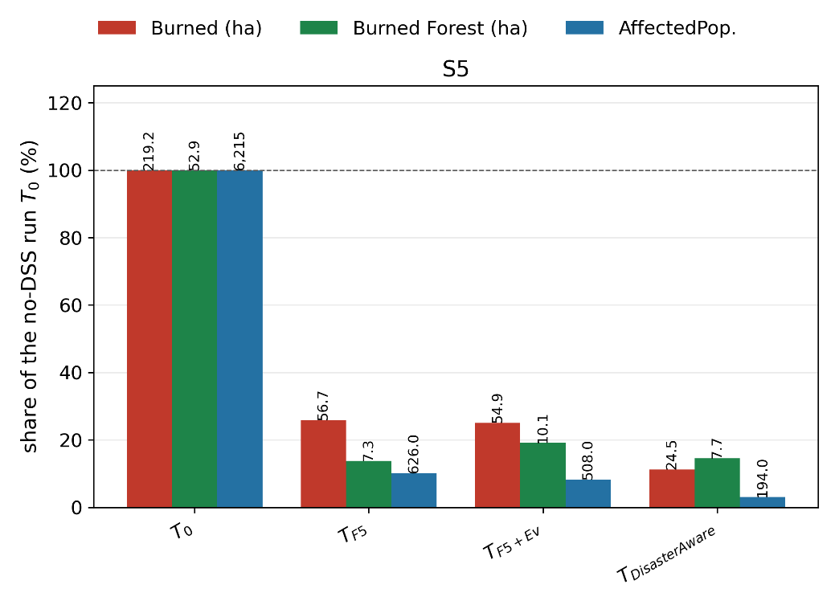
Figure 5.10 Burned-area, burned-forest, and affected population evolution of the five configurations under the five scenarios for S5
Table 5.9 Decision-cost terms at the six-hour checkpoint per scenario and configuration; the response and delay terms of ${Test}_{0}$ are undefined by construction
Scenario | $$J_{burn}$$ | $$J_{asset}$$ | $$J_{pop}$$ | $$J_{resp}$$ | $$J_{delay}$$ | $$J_{total}$$ | $$J_{phys}$$
S1
$T_{0}$ | 0.64 | 0.804 | 0.107 | — | — | 0.456 | 0.517
$T_{F5}$ | 0.419 | 0.116 | 0.002 | 0.553 | 0.344 | 0.211 | 0.179
$T_{F5+Ev}$ | 0.45 | 0.109 | 0.002 | 0.617 | 0.254 | 0.216 | 0.187
$T_{DisasterAware}$ | 0.309 | 0.084 | 0.001 | 0.425 | 0.353 | 0.162 | 0.131
S2
$T_{0}$ | 0.636 | 0.839 | 0.131 | — | — | 0.473 | 0.536
$T_{F5}$ | 0.502 | 0.248 | 0.011 | 0.766 | 0.235 | 0.283 | 0.254
$T_{F5+Ev}$ | 0.489 | 0.221 | 0.01 | 0.779 | 0.25 | 0.272 | 0.24
$T_{DisasterAware}$ | 0.386 | 0.113 | 0.006 | 0.793 | 0.315 | 0.214 | 0.168
S3
$T_{0}$ | 0.565 | 0.639 | 0.089 | — | — | 0.38 | 0.431
$T_{F5}$ | 0.155 | 0.046 | 0.0 | 0.086 | 0.355 | 0.085 | 0.067
$T_{F5+Ev}$ | 0.226 | 0.08 | 0.001 | 0.108 | 0.197 | 0.108 | 0.102
$T_{DisasterAware}$ | 0.123 | 0.033 | 0.0 | 0.081 | 0.272 | 0.066 | 0.052
S4
$T_{0}$ | 0.624 | 0.808 | 0.137 | — | — | 0.461 | 0.523
$T_{F5}$ | 0.312 | 0.185 | 0.003 | 0.31 | 0.304 | 0.183 | 0.167
$T_{F5+Ev}$ | 0.389 | 0.206 | 0.002 | 0.367 | 0.218 | 0.21 | 0.199
$T_{DisasterAware}$ | 0.226 | 0.089 | 0.005 | 0.258 | 0.241 | 0.124 | 0.107
S5
$T_{0}$ | 0.624 | 0.808 | 0.137 | — | — | 0.461 | 0.523
$T_{F5}$ | 0.33 | 0.195 | 0.003 | 0.311 | 0.293 | 0.191 | 0.176
$T_{F5+Ev}$ | 0.382 | 0.193 | 0.002 | 0.312 | 0.234 | 0.202 | 0.192
$T_{DisasterAware}$ | 0.264 | 0.108 | 0.003 | 0.314 | 0.22 | 0.142 | 0.125

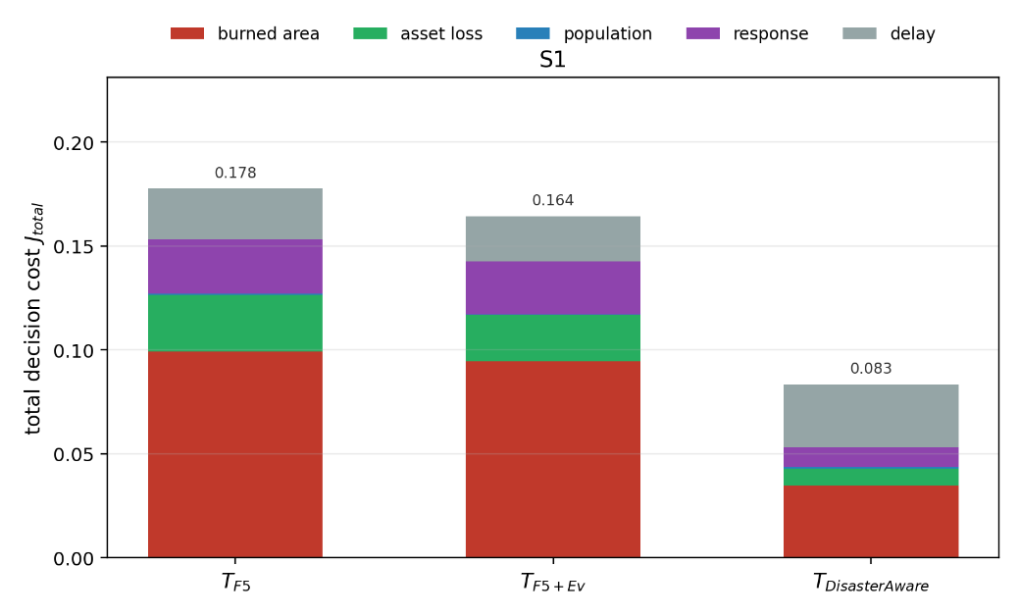
Figure 5.11 Total cost evolution of the five configurations under the five scenarios for S1
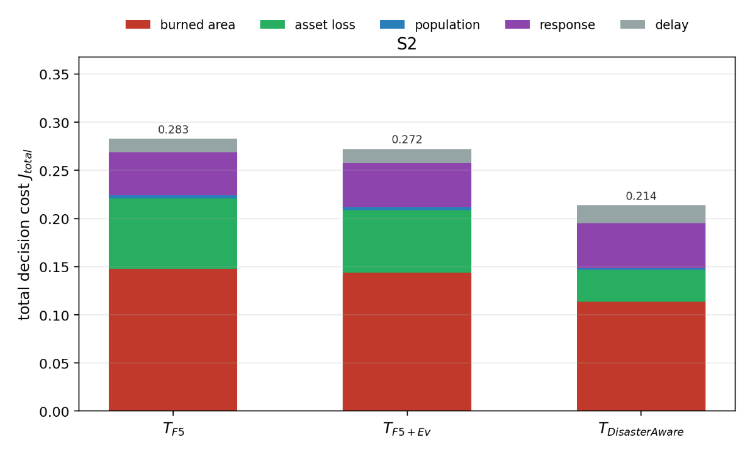
Figure 5.12 Total cost evolution of the five configurations under the five scenarios for S2
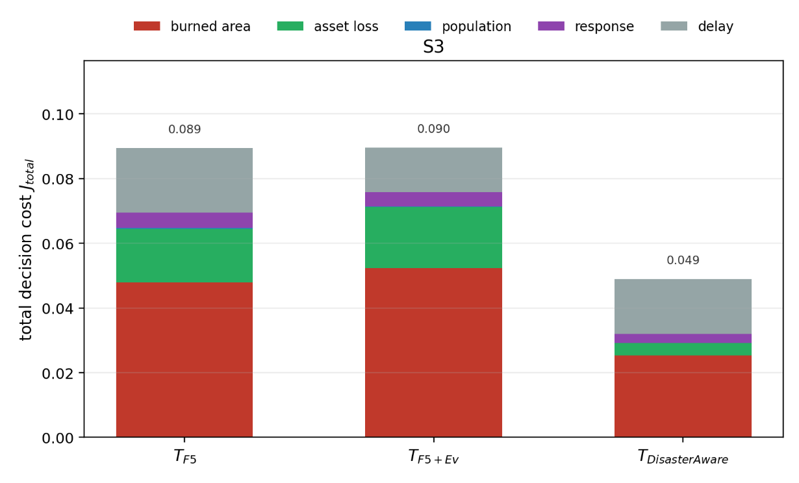
Figure 5.13 Total cost evolution of the five configurations under the five scenarios for S3
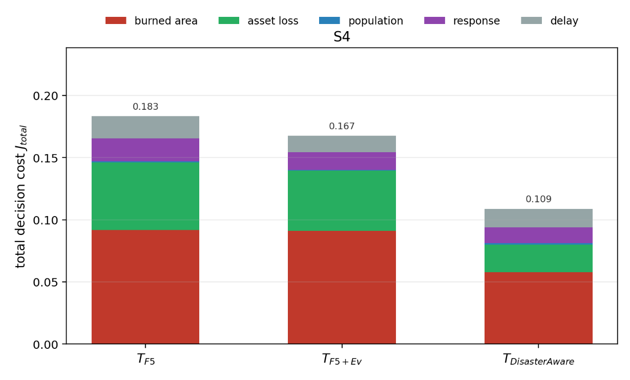
Figure 5.14 Total cost evolution of the five configurations under the five scenarios for S4
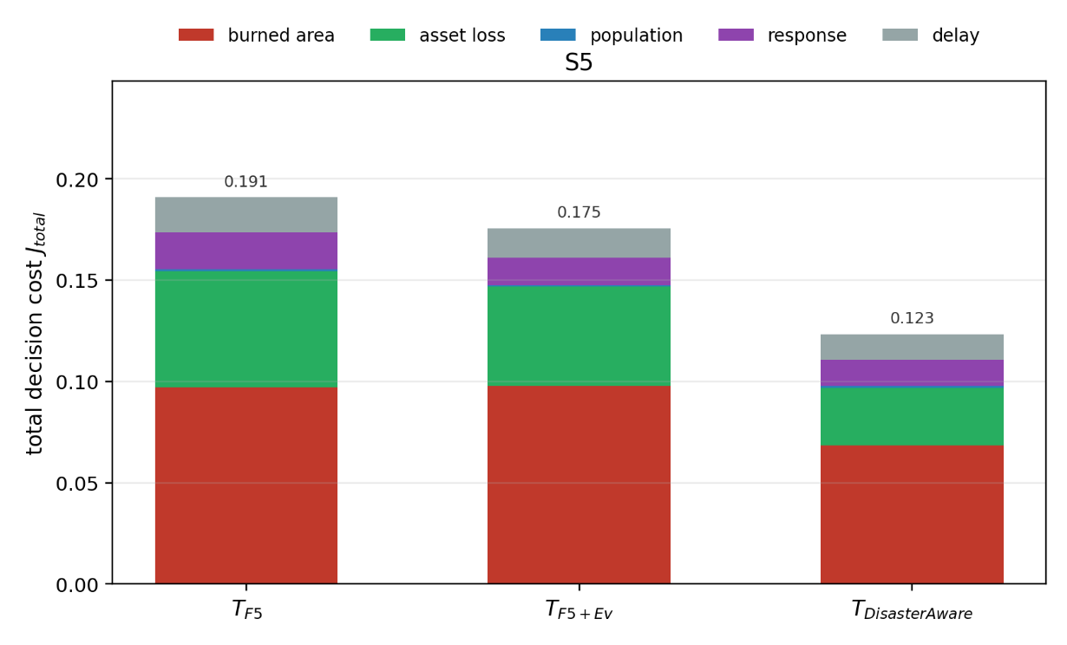
Figure 5.15 Total cost evolution of the five configurations under the five scenarios for S5
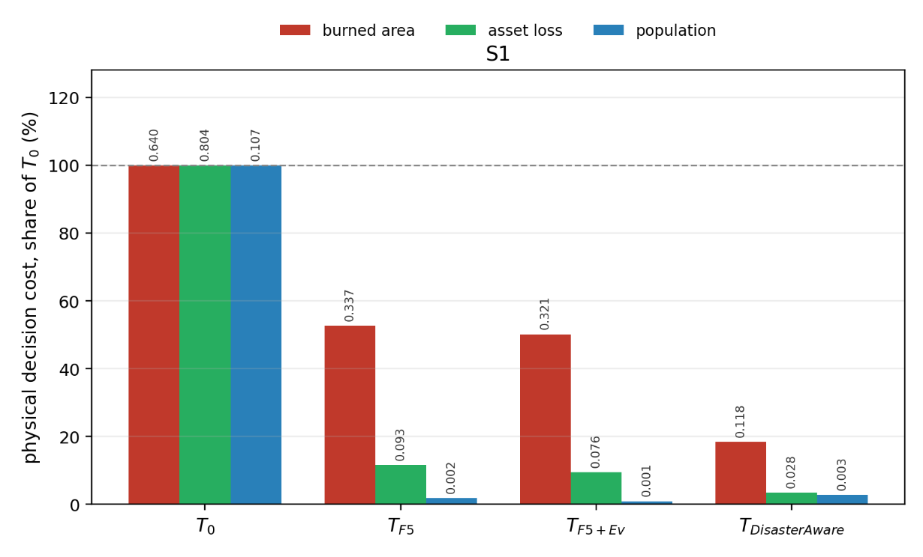
Figure 5.16 Physical cost evolution of the five configurations under the five scenarios for S1
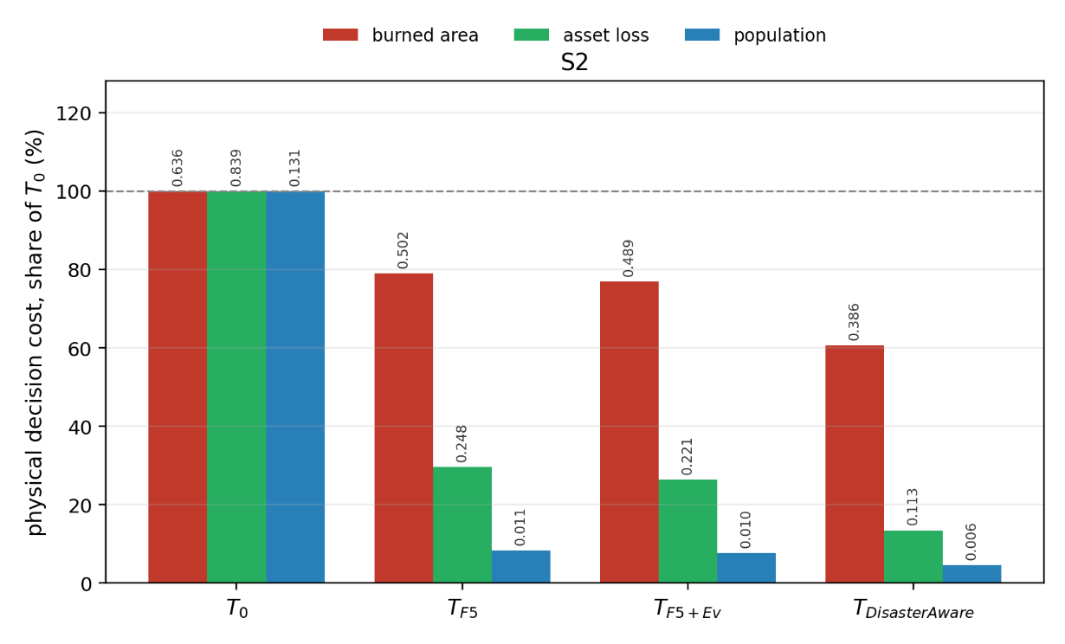
Figure 5.17 Physical cost evolution of the five configurations under the five scenarios for S2
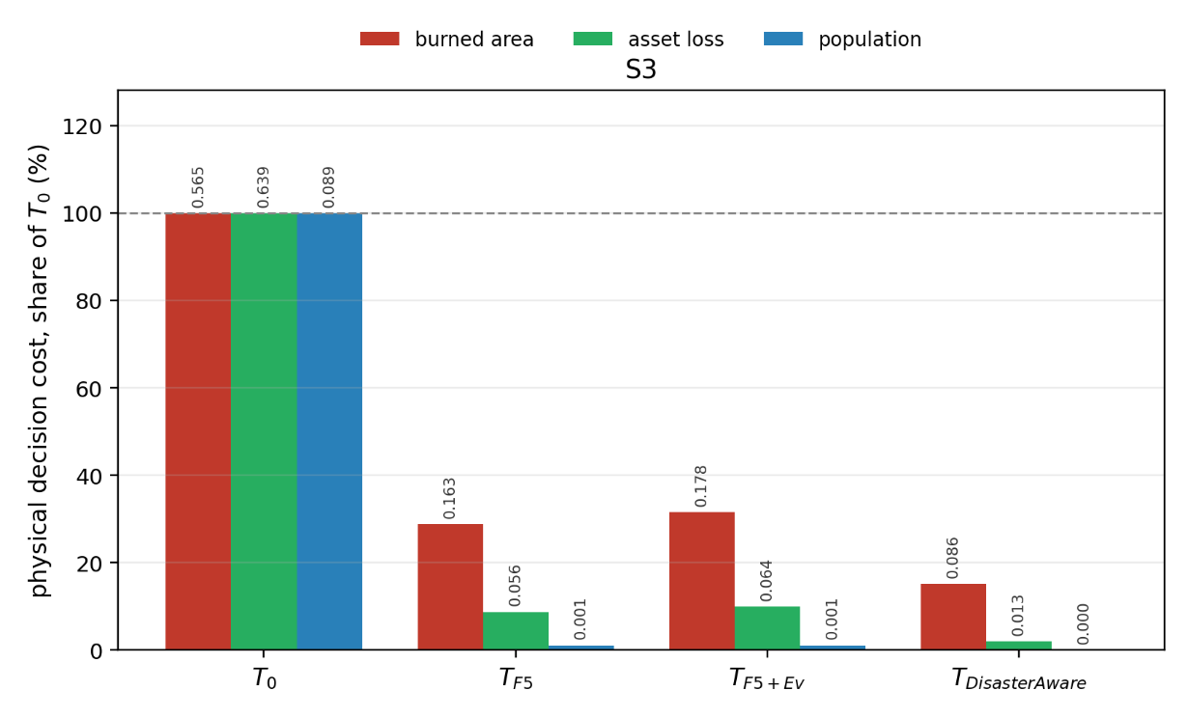
Figure 5.18 Physical cost evolution of the five configurations under the five scenarios for S3
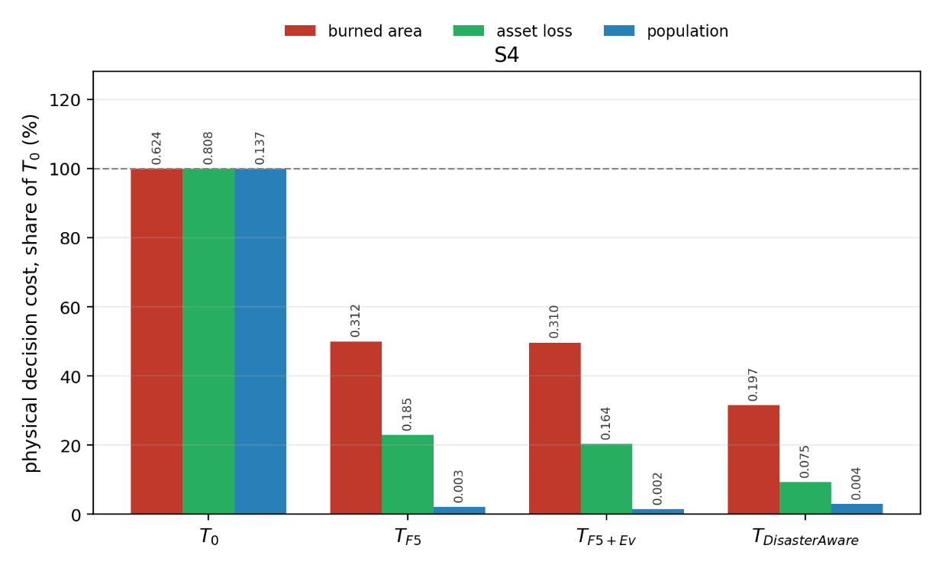
Figure 5.19 Physical cost evolution of the five configurations under the five scenarios for S4
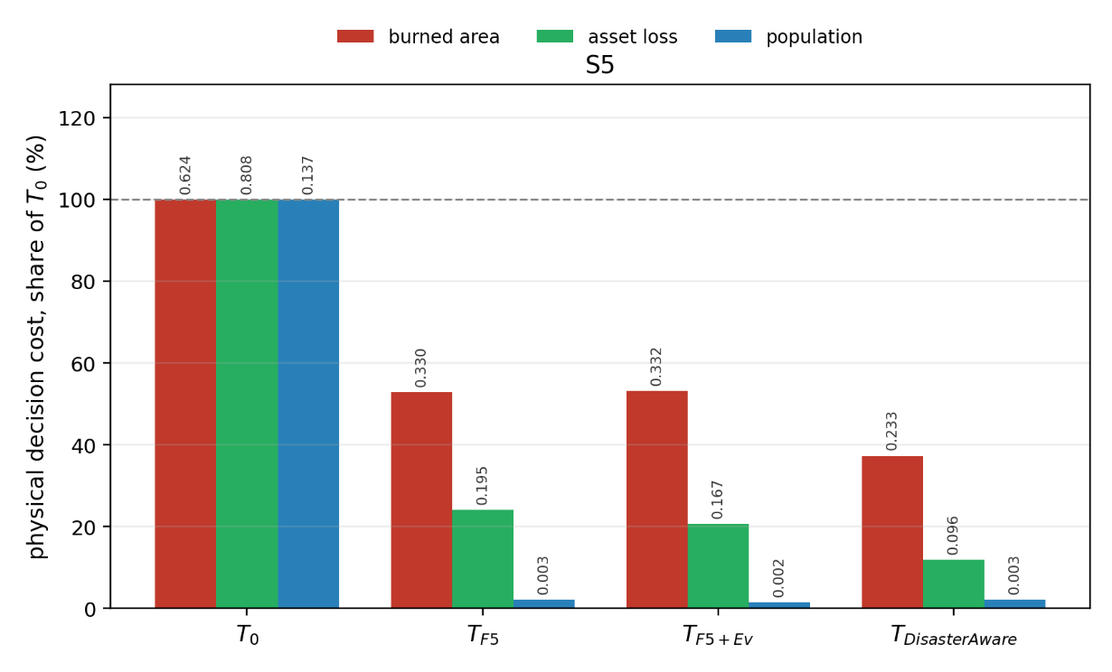
Figure 5.20 Physical cost evolution of the five configurations under the five scenarios for S5
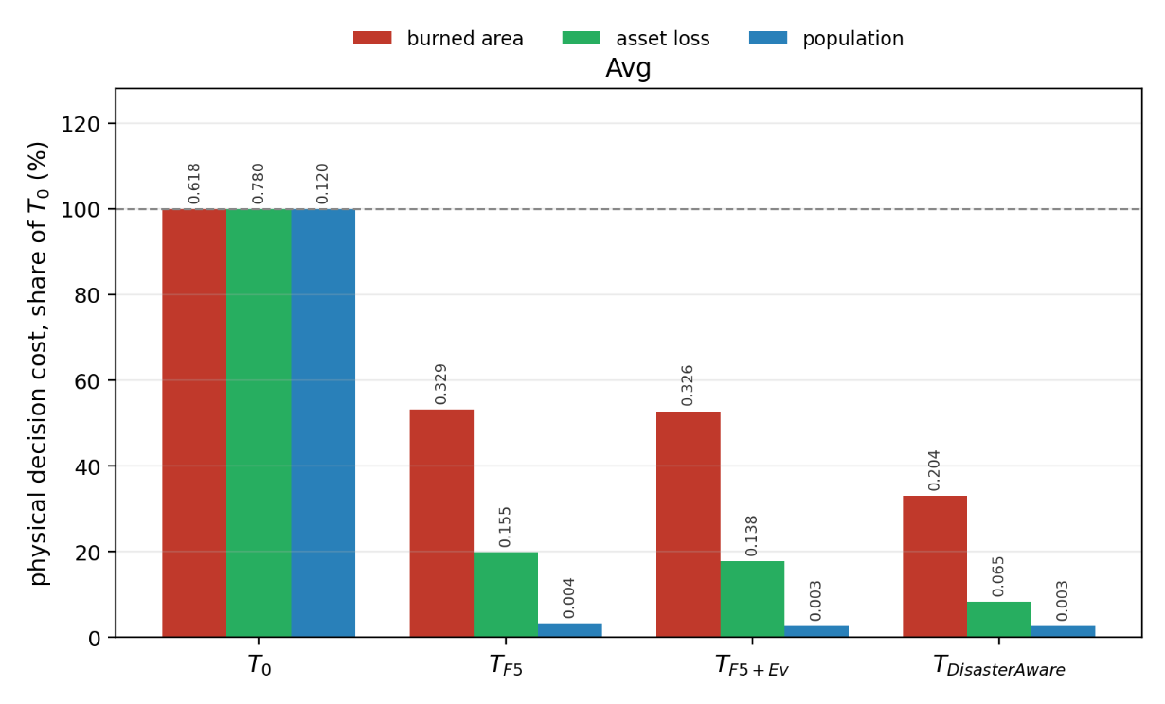
Figure 5.21 Average physical cost evolution of the five configurations under the five scenarios
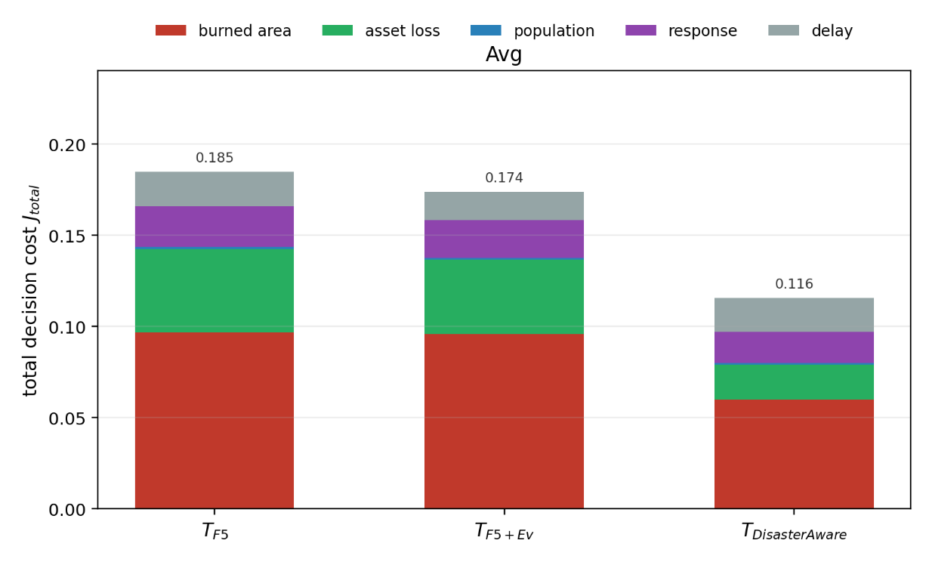
Figure 5.22 Average total cost evolution of the five configurations under the five scenarios

Rule Modification and Generation Performance

The evolving-fuzzy stages engage only when the standing decision demonstrably falls short. Over the recorded simulations (~1K logged runs, ~10K decision cycles), the satisficing test failed and adaptation was demanded in 80% of cycles; stage ① attempted ~500 consequent-step trials and the acceptance test passed ~120 of them (~25%), while stage ② attempted 400 resolution trials and passed ~40 (~10%). In parallel, the no-harm guard withheld the proposed orders outright in ~100 cycles. Nothing in the ledger is a parameter drift: each row is an accepted, bounded, reversible edit that beat its own forecast test at the moment it was admitted. Table 5.10 shows representative rows of the ledger; in total it records 157 consequent updates (89 distinct transitions), 5 membership-boundary shifts, 4 term insertions, and 41 rules instantiated on empty antecedent cells.
Table 5.10 Representative rows of the evFIS modification records
Rule | Modification | Before → after | Trigger | Recorded repeats
G5 | consequent step | downwind_retardant_shield 0.90 → 0.95; asset_protection 0.70 → 0.75; resource_deployment 0.70 → 0.75 | t = 10 min, deficit 0.05 | 78
A1 | consequent step | asset_protection 0.88 → 0.93; evacuation 0.60 → 0.65 | t = 20 min, deficit 0.30 | 13
A5 | consequent step (de-escalation) | evacuation 0.63 → 0.58; asset_protection 0.60 → 0.55 | t = 101 min, deficit 0.16 | 17
A7 | consequent step | asset_protection 0.75 → 0.80; evacuation 0.62 → 0.67 | t = 11 min, deficit 0.30 | 14
G27 | consequent step | retardant_drop 0.80 → 0.85; containment_line 0.70 → 0.75 | t = 5 min, deficit 0.30 | 13
G33 | consequent step (de-escalation) | suppression_effort 0.90 → 0.85; water_drafting 0.80 → 0.75; containment_line 0.70 → 0.65 | t = 90 min, deficit 0.30 | 9
R26 (seed) | consequent step | retardant_drop 0.80 → 0.95; resource_deployment 0.80 → 0.90; containment_line 0.70 → 0.80 | early attack phase | 2
suppression_ feasibility | boundary shift (stage ①) | shared membership edge moved inside the H–VH band (0.67–0.84) | coverage gap | 5 shifts total
suppression_ feasibility | term insertion (stage ②) | new term inserted at 0.74, splitting the H–VH band | coverage gap | 4 insertions total
A1–A41 | rule instantiation (stage ②) | e.g. A1: IF suppression_feasibility VH ∧ asset_exposure_risk VH THEN asset_protection 0.56, resource_deployment 0.23 | empty antecedent cell, fire alive | 41 rules
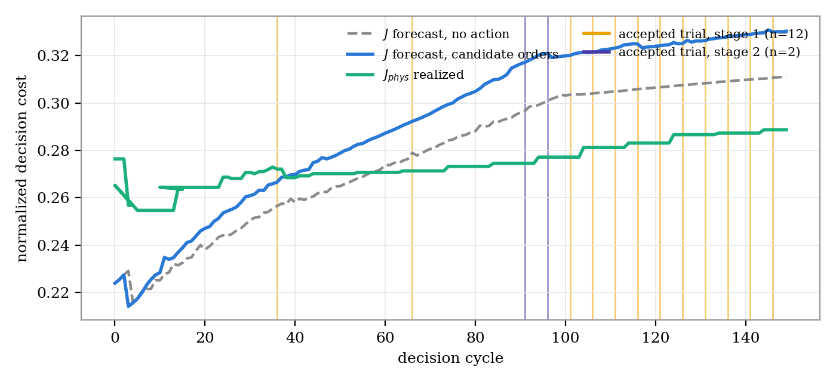
Figure 5.23 Anatomy of acceptance in one recorded run (154 decision cycles, minimal five-rule seed, full staged adaptation). At every cycle the candidate orders are tested against the no-action forecast; the vertical marks are the fourteen accepted trials (twelve stage-① consequent steps, two stage-② instantiations). The candidate total cost may sit above the no-action total because it is charged for its own response; the realized physical cost is what the orders buy, which is exactly the two-basis rule of Section 5.4.
The ledger carries a structural finding beyond the individual rows. The most-tuned rules are not the seed doctrine but the adaptation-born ones: G5, an offspring of the generative stage, absorbed 78 recorded consequent tunes, and the next most-edited rules (A5, A7, A1, G27, G33) are all stage-② or stage-③ births, while the five seed rules were touched only twice (R26). The staged design’s division of labor is therefore observable in the data: the expensive stages create new structure, and the cheap parametric stage then refines that structure incident by incident. The ledger also shows the response-cost term doing its job in both directions: A5 and G33 were de-escalated late in long incidents, lowering evacuation and suppression intensities once the situation no longer justified their cost — adaptation is not a monotone escalation machine.
The generative stage runs under the closed contract of Section 4.5: a deterministic situation summary goes out, one candidate rule — optionally carrying one new vocabulary object — comes back, and five gates stand between the reply and the rule base. Over the recorded runs the stage was invoked 230 times. Figure 5.24 shows the full cascade: 48 proposals died at the G1–G2 checks of format, vocabulary, duplicate antecedent cells, and present-situation relevance; 18 were lost to transport failures (timeouts and an unreachable model), absorbed as skipped stages rather than errors; 94 were rejected by G3, the forecast gate, and 4 more by the reseeded robustness test G4; 19 packages failed the additional G5 margin that new vocabulary must clear; and 47 were admitted — 36 plain rules and 11 packages. The busiest gate is G3: most of what the model proposes reads plausibly and still does not survive the physics forecast, which is the reason the gates exist.
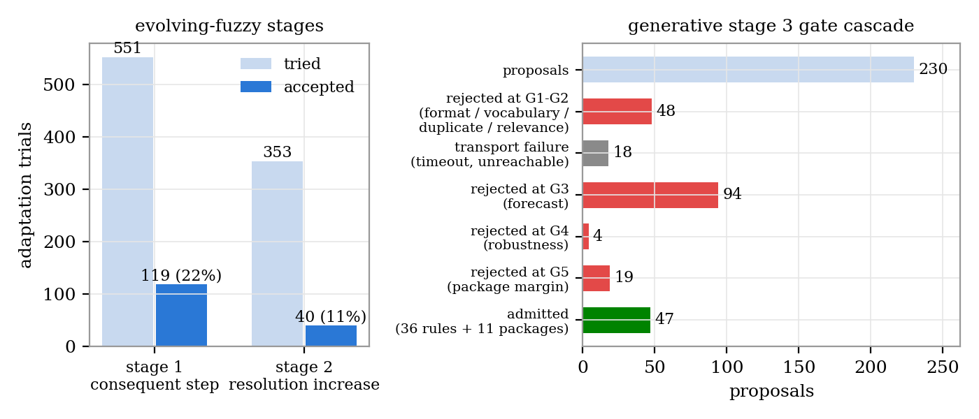
Figure 5.24 Adaptation funnels over the recorded runs. Left: evolving-fuzzy trials and acceptances per stage. Right: the generative gate cascade over 230 proposals; every rejection is logged with its gate and reason.
What the admitted packages contain is the substantive answer of this section. Table 5.11 lists every vocabulary object the generative stage created in the recorded runs: seven named macro interventions and one intermediate concept, each born at a specific moment of a specific incident, under a logged cost deficit, and each consumed by the rule admitted with it. The names are not decorative: downwind_backburn and counterfire_strip are recognizable indirect-attack doctrine, head_knockdown and wet_containment_line are recognizable water-supported tactics — and none of them was ever given to the system. The pre-registered vocabulary target of the evaluation design, the backburn family, was met from a five-rule seed that contains no indirect attack at all.
Product | Kind | Definition | Born at | Consumed by
downwind_backburn | macro | containment_line 1.0 + suppression_effort 0.7 | t = 25 min, deficit 0.30 | G4
downwind_retardant_shield | macro | retardant_drop 1.0 + containment_line 0.8 | t = 5 min, deficit 0.12 | G5
drafting_sustained_attack | macro | water_drafting 1.0 + suppression_effort 0.9 | t = 10 min, deficit 0.10 | G6
head_knockdown | macro | water_drafting 1.0 + suppression_effort 0.9 + retardant_drop 0.6 | t = 10 min, deficit 0.08 | G7
wet_containment_line | macro | water_drafting 1.0 + containment_line 0.8 | t = 15 min, deficit 0.16 | G8
counterfire_strip | macro | tactical_burn 1.0 + containment_line 0.6 | early attack phase | G9
drafting_retardant_shuttle | macro | retardant_drop 1.0 + water_drafting 0.6 | t = 750 min, deficit 0.30 | G37
interface_exposure | concept | 0.5 · asset_exposure_risk + 0.5 · evacuation_pressure | t = 5 min, deficit 0.30 | G13
Table 5.11 The generative product ledger: every vocabulary object created in the recorded runs, its definition over the closed basis, its birth moment and cost deficit, and the admitted rule that uses it.
The rules that carry these products are ordinary, auditable fuzzy rules. Table 5.12 reproduces five of the forty-two admitted generative rules verbatim: every antecedent is a decision concept with a linguistic term, every consequent an intervention with an intensity, and G13 shows the composed pattern — a generated rule firing on a generated concept to protect the wildland-urban interface.
Rule | IF | THEN
G4 | suppression_feasibility VH ∧ intervention_urgency VH ∧ fire_threat_level M | downwind_backburn 0.9; retardant_drop 0.8; asset_protection 0.6
G7 | fire_threat_level ≥ H ∧ suppression_feasibility VH | head_knockdown 0.95; resource_deployment 0.8
G8 | suppression_feasibility VH ∧ fire_threat_level ≥ H ∧ evacuation_pressure VH | wet_containment_line 0.9; resource_deployment 0.8
G9 | suppression_feasibility VH ∧ fire_threat_level H | counterfire_strip 0.9; resource_deployment 0.8
G13 | interface_exposure VH ∧ suppression_feasibility VH | asset_protection 0.9; containment_line 0.8; resource_deployment 0.7
Table 5.12 Five of the forty-two admitted generative rules, verbatim. G4–G9 consume generated macro interventions; G13 fires on the generated concept interface_exposure.
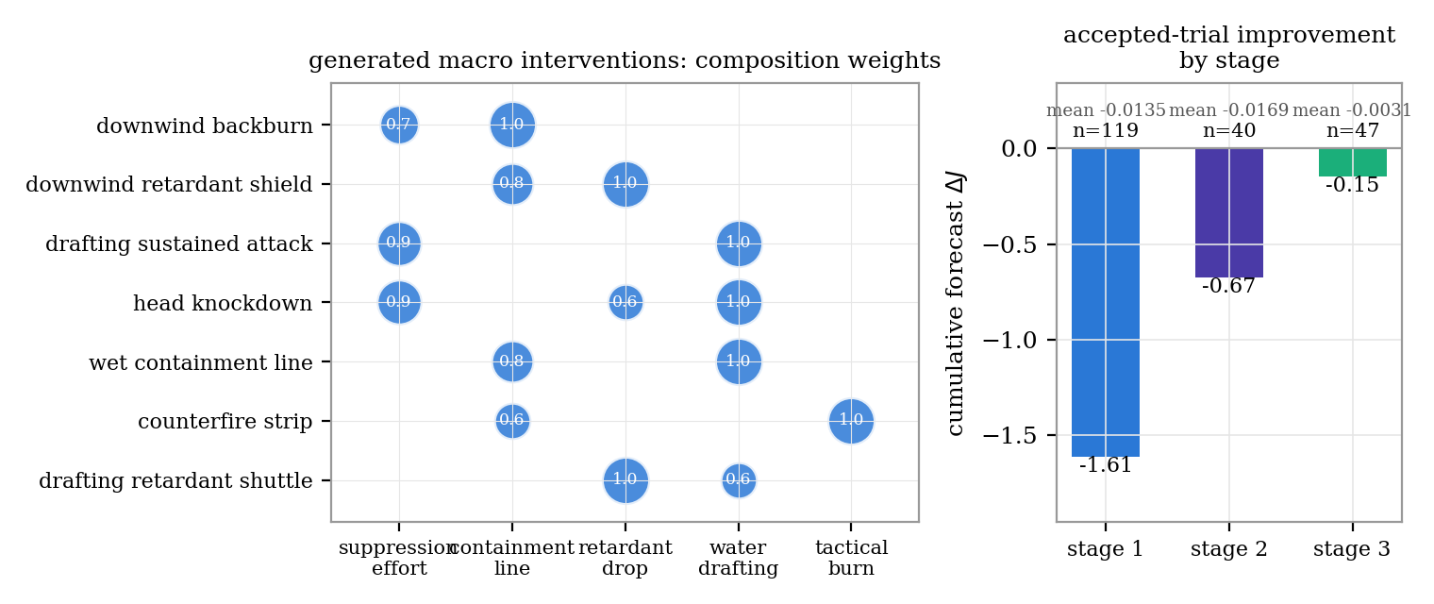
Figure 5.25 Left: composition weights of the seven generated macro interventions over the base physical channels. Right: cumulative forecast improvement of accepted trials by stage over the recorded runs (stage ①: −1.61 over 119 acceptances; stage ②: −0.67 over 40; stage ③: −0.15 over 47).
Attribution follows two independent routes that must agree. At the outcome level, the paired ladder margins of Section 5.4.2 price each mechanism against the arm below it on identical worlds. At the mechanism level, every acceptance in this section carries its own logged forecast improvement, and the per-stage totals of Figure 5.25 decompose the within-run gains: the parametric stage contributes many small, cheap corrections, the resolution stage fewer but larger structural ones, and the generative stage the rarest and most expensive moves — new vocabulary whose value is realized through the many subsequent stage-① tunes it enables, as the G5 row of the modification ledger shows. Two honesty notes bound the claim. All seven generated interventions are compositional macros; the clause-actuator form — a genuinely new targeting tactic rather than a blend — remained unused in the recorded runs, so the expressible space of the generative stage is wider than what these incidents demanded. And the numbers of this section describe the recorded development runs; the scenario-controlled Monte Carlo evidence for the same mechanisms is the ladder of Section 5.4.2, read at identical seeds and frozen thresholds.

Sensitivity Analysis
The decision layer carries several tuning parameters, and this section reports how sensitive its outcome is to each of them. The one-at-a-time method is used: every parameter is varied across its range while the others stay at their base value, and the resulting physical cost is recorded (Morris, 1991; Saltelli et al., 2008). The runs use the compact capacity-limited synthetic testbed, in which a set of simultaneous ignitions is fought by a fixed resource pool over four local regions, so that the decision layer is genuinely stretched rather than trivially winning. Table 5.13 lists the parameters, their symbols, base values, and ranges.
Parameter | Symbol | Base | Range
Simultaneous ignitions | — | 3 | 2–12
Resource level | — | 0.025 | 0.015–0.10 (fraction of nominal)
Local regions | N | 4 | 1–8
Satisficing bound | J_TH | 0.35 | 0.15–0.60
Fail-safe quality gate | η | 0.60 | 0.30–0.90
Attention threshold | τ | 0.35 | 0.15–0.70
Persistence decay | ρ | 0.90 | 0.70–0.99
No-harm horizon | — | 15 | 5–45 min
Decision cycle | — | 1 | 1–8 min
Cost weights | w_burn, w_asset, w_pop | 1.0 | 0.5–2.0
Table 5.13 Sensitivity design: parameters, symbols, base values, and ranges.
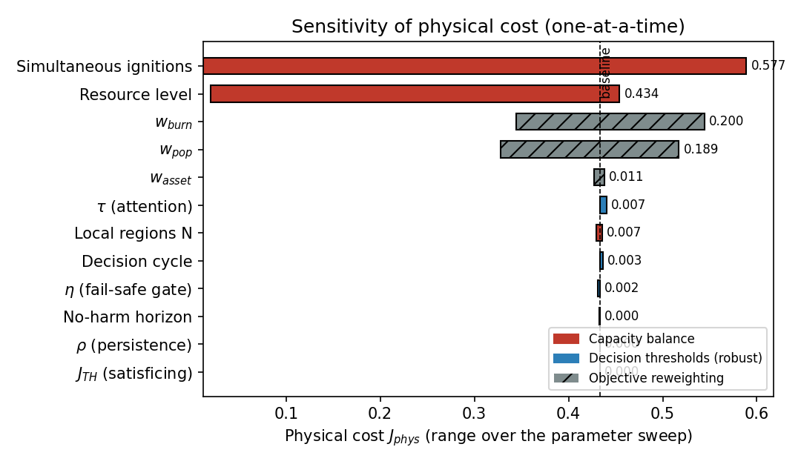
Figure 5.26 Sensitivity of the physical cost to each parameter, ranked by the spread over its range.
Figure 5.26 ranks the parameters by the spread they induce in the physical cost. Two quantities dominate, and both describe the balance between the fire and the resources: the number of simultaneous ignitions and the level of available resources. Figure 5.27 shows the mechanism. When the resource level falls below about three percent of the nominal pool, or when the ignition count rises, the fire crosses from controllable to uncontrolled and the cost climbs sharply. This is the expected behavior of a capacity-limited system, and it matches the multi-ignition regime that drives extreme fire years, where simultaneous starts disperse and overwhelm suppression resources.
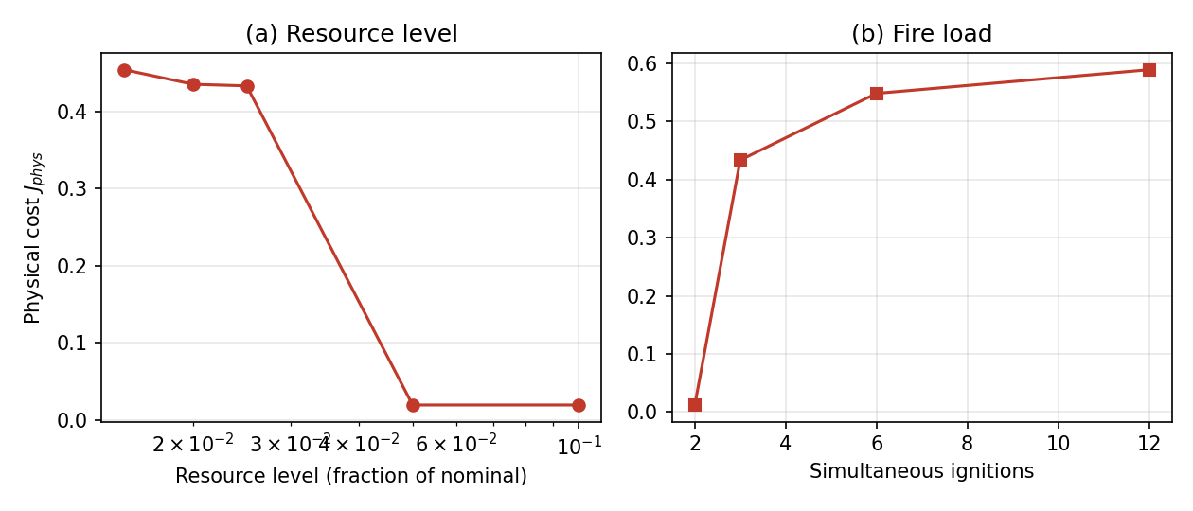
Figure 5.27 Physical cost against (a) resource level and (b) fire load, showing the capacity-limited transition.
The decision thresholds, by contrast, leave the physical cost almost unchanged across their full ranges, as Figure 5.28(a) shows. The satisficing bound J_TH, the attention threshold τ, the persistence decay ρ, the no-harm horizon, and the decision cycle each move the cost by less than one percent. The reason is structural. When resources are overwhelmed the cost sits far above the satisficing bound, so the bound is never the binding constraint, and when the fire is easily controlled the cost sits far below it. The fail-safe quality gate η is the one threshold with a visible internal effect, Figure 5.28(b): a stricter gate makes the fail-safe engage in every cycle by η equal to 0.90, yet the physical cost still barely moves, because the conservative fallback protects the outcome without a cost penalty here. The cost weights change the reported cost by construction, since they reweight the objective, but the physical behavior is unchanged, and the burned area is identical across the weight sweep.
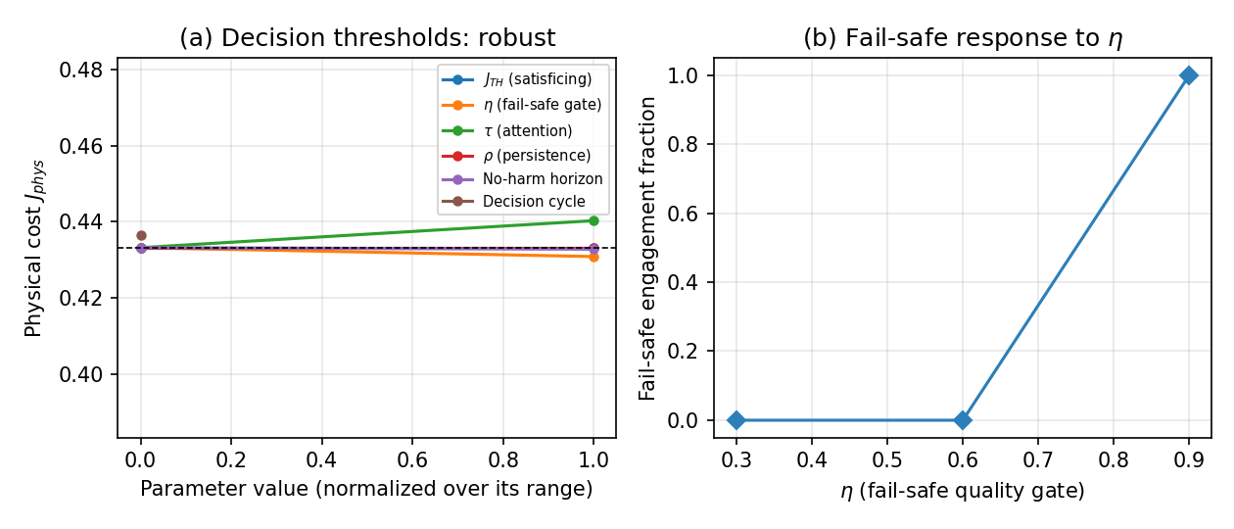
Figure 5.28 (a) Physical cost is robust to the decision thresholds; (b) the fail-safe engagement responds to η.
The overall finding is that the outcome of the decision layer is governed by the capacity balance between the fire load and the available resources, and is robust to its internal tuning. This robustness is a useful property, because the layer does not rely on delicate hyperparameter tuning to perform, and it directs planning attention toward resourcing rather than toward threshold choice. The number of local regions N has only a small effect, with the single-region setting the weakest and the two to eight region settings close together, which confirms that the distributed decomposition does not cost performance.

Compliance with the Evaluation Criteria and Chapter Summary

CONCLUSION AND FUTURE WORKS

Conclusions

Future Works

REFERENCES

Abdul, A., Vermeulen, J., Wang, D., Lim, B., & Kankanhalli, M. (2018). Trends and trajectories for explainable, accountable and intelligible systems: An HCI research agenda. CHI Conference on Human Factors in Computing Systems (pp. 1-18). ACM. doi:10.1145/3173574.3174156
Ager, A., Vaillant, N., & Finney, M. (2010). A comparison of landscape fuel treatment strategies to mitigate wildland fire risk in the urban interface and preserve old forest structure. Forest Ecology and Management, 259(8), pp. 1556-1570. doi:10.1016/j.foreco.2010.01.032
Alexander, M., & Cruz, M. (2013). Are the applications of wildland fire behaviour models getting ahead of their evaluation again? Environmental Modelling & Software, 41, 65-71.
Amodei, D., Olah, C., Steinhardt, J., Christiano, P., Schulman, J., & Mané, D. (2016). Concrete problems in AI safety.
Andrews, P. L. (2018). The Rothermel surface fire spread model and associated developments: A comprehensive explanation. USDA Forest Service, Rocky Mountain Res. Stn., Fort Collins, CO, USA.
Angelov, P. P., & Filev, D. P. (2004). An approach to online identification of Takagi-Sugeno fuzzy models. IEEE Transactions on Systems, Man, and Cybernetics, Part B, 34(1), 484-498.
Anthony, R. (1965). Planning and control systems: A framework for analysis. Harvard University Press.
Arnott, D., & Pervan, G. (2005). A critical analysis of decision support systems research. Journal of Information Technology, 20(2), 67-87. doi:10.1057/palgrave.jit.2000035
Bellman, R., & Zadeh, L. (1970). Decision-making in a fuzzy environment. Management Science, 17(4), B141-B164. doi:10.1287/mnsc.17.4.B141
Benali, A., Sá, A., Ervilha, A., Trigo, R., Fernandes, P., & Pereira, J. (2017). Fire spread predictions: sweeping uncertainty under the rug. Science of the Total Environment, 592, 187-196.
Bowman, D. M., Kolden, C. A., Abatzoglou, J. T., Johnston, F. H., van der Werf, G. R., & Flannigan, M. (2020). Vegetation fires in the Anthropocene. Nature Reviews Earth & Environment, 1(10), 500-515. doi:10.1038/s43017-020-0085-3
Brown, T., Mann, B., Ryder, N., Subbiah, M., Kaplan, J., & Dhariwal, P. (2020). Language models are few-shot learners. Advances in Neural Information Processing Systems (NeurIPS).
Brown, T., Mann, B., Ryder, N., Subbiah, M., Kaplan, J., & Dhariwal, P. (2020). Language models are few-shot learners. Advances in Neural Information Processing Systems (NeurIPS).
Calkin, D., O'Connor, C., Thompson, M., & Stratton, R. (2021). Strategic wildfire response decision support and the risk management assistance program. Forests, 12(10), p. 1407. doi:10.3390/f12101407
Chandra, R., Kumar, S. S., Patra, R., & Agarwal, S. (2025). Decision support system for forest fire management using ontology with big data and LLMs. Cluster Computing, 28, 548.
Chen, S., & Hwang, C. (1992). Fuzzy multiple attribute decision making: Methods and applications. Springer. doi:10.1007/978-3-642-46768-4
Chen, Y., Li, L., Ma, Z., Hu, Q., Zhu, Y., Deng, M., & Yu, R. (2025). Empowering LLM agents with geospatial awareness: Toward grounded reasoning for wildfire response. arXiv:2510.12061.
Comes, T., Hiete, M., Wijngaards, N., & Schultmann, F. (2011). Decision maps: A framework for multi-criteria decision support under severe uncertainty. Decision Support Systems, 52(1), 108-118. doi:10.1016/j.dss.2011.05.008
Comfort, L., Boin, A., & Demchak, C. (2010). Designing Resilience: Preparing for Extreme Events. University of Pittsburgh Press.
CRED/UCLouvain. (2023). EM-DAT: The International Disaster Database. Retrieved from https://www.emdat.be
Cruz, M., & Alexander, M. (2013). Uncertainty associated with model predictions of surface and crown fire rates of spread. Environmental Modelling & Software, 47, 16-28.
Cruz, M., Alexander, M., & Wakimoto, R. (2003). Definition of a fire behavior model evaluation protocol: a case study application to crown fire behavior models. Fire, Fuel Treatments, and Ecological Restoration (USDA Forest Service Proceedings RMRS-P-29).
DEM, C. G.-3. (2026). https://registry.opendata.aws/copernicus-dem.
Duarte, V., Teodoro, A., Gonçalves, J., Soares, D., & Cunha, M. (2022). Wildfire risk mapping using GIS and fuzzy logic: Application to northwest Iberian Peninsula. Remote Sensing, 14(15), p. 3793. doi:10.3390/rs14153793
Duff, T., & Tolhurst, K. (2015). Operational wildfire suppression modelling: a review evaluating development, state of the art and future directions. International Journal of Wildland Fire, 24, 735-748.
Duff, T., Cawson, J., Cirulis, B., Nyman, P., Sheridan, G., & Tolhurst, K. (2016). Conditional performance evaluation: using wildfire observations for systematic fire simulator development. Forests, 9, 189.
Dunn, C., Calkin, D., & Thompson, M. (2017). Towards enhanced risk management: Planning, decision making and monitoring of US wildfire response. International Journal of Wildland Fire, 26(7), pp. 615-625. doi:10.1071/WF16223
Figueiredo, J., Macedo, J., Alves, J., & Figueiredo, A. (2024). Wildfire management decision support system for real-time fire behavior and weather analysis. Forests, 15(3), p. 509. doi:10.3390/f15030509
Filippi, J.-B., Mallet, V., & Nader, B. (2014). Representation and evaluation of wildfire propagation simulations. International Journal of Wildland Fire, 23, 46-57.
Fillmore, S., & Paveglio, T. (2023). Use of the Wildland Fire Decision Support System (WFDSS) for full suppression and managed fires within the Southwestern Region of the US Forest Service. International Journal of Wildland Fire, 32(4), pp. 562-574. doi:10.1071/WF22106
Finney, M. (1998). FARSITE: Fire Area Simulator - model development and evaluation. USDA Forest Service, Rocky Mountain Research Station.
Finney, M. (2006). An overview of FlamMap fire modeling capabilities. Fuels Management — How to Measure Success: Conference Proceedings (pp. 213-220). USDA Forest Service, Rocky Mountain Research Station.
Fox-Hughes, P., Bridge, C., & Faggian, N. (2024). An evaluation of wildland fire simulators used operationally in Australia. International Journal of Wildland Fire, 33.
French, S., Maule, J., & Papamichail, N. (2019). Decision Behaviour, Analysis and Support (2 ed.). Cambridge University Press.
Gigerenzer, G., & Selten, R. (Eds.). (2001). Bounded rationality: The adaptive toolbox. Cambridge, MA: MIT Press.
Gorry, G., & Scott Morton, M. (1971). A framework for management information systems. Sloan Management Review, 13(1), 55-70.
Guidotti, R., Monreale, A., Ruggieri, S., Turini, F., Giannotti, F., & Pedreschi, D. (2018). A Survey of Methods for Explaining Black Box Models. ACM Computing Surveys, 51(5), 1-42. doi:10.1145/3236009
Hwang, C., & Yoon, K. (1981). Multiple attribute decision making: Methods and applications. Springer. doi:10.1007/978-3-642-48318-9
Jain, P., Coogan, S. C., Subramanian, S. G., Crowley, M., Taylor, S., & Flannigan, M. D. (2020). A review of machine learning applications in wildfire science and management. Environmental Reviews, 28(4), 478-505. doi:10.1139/er-2020-0019
Ji, Z., Lee, N., Frieske, R., Yu, T., Su, D., Xu, Y., . . . Fung, P. (2023). Survey of hallucination in natural language generation. ACM Computing Surveys, 55, pp. 1-38.
Kalabokidis, K., Ager, A., Finney, M., Athanasis, N., Palaiologou, P., & Vasilakos, C. (2016). AEGIS: a wildfire prevention and management information system. Natural Hazards and Earth System Sciences, 16, 643-661.
Keeney, R., & Raiffa, H. (1976). Decisions with multiple objectives: preferences and value trade-offs. Wiley.
Klein, G. A. (2017). Sources of Power: How People Make Decisions. MIT Press.
Lughofer, E. (2011). Evolving Fuzzy Systems: Methodologies, Advanced Concepts and Applications. Berlin, Germany: Springer.
Malczewski, J. (1999). GIS and multicriteria decision analysis. John wiley & sons.
Mamdani, E. H. (1974). Application of fuzzy algorithms for control of simple dynamic plant. Proceedings of the Institution of Electrical Engineers, 121(12), 1585-1588. doi:10.1049/piee.1974.0328
Marakas, G. M., & O'Brien, J. A. (2013). Introduction to information systems. McGraw-Hill.
Martell, D. (2015). A review of recent forest and wildland fire management decision support systems research. Current Forestry Reports, 1, 128-137.
Martell, D. L. (2007). Forest fire management. Handbook of operations research in natural resources (pp. 489-509). Boston: MA: Springer US.
McNeese, N. J., Schelble, B. G., Canonico, L. B., & Demir, M. (2021). Who or what is my teammate? Team composition considerations in human–AI teaming. Human Factors, 63(3), 474-488. doi:10.1177/0018720820968694
Mendel, J. (2017). Uncertain rule-based fuzzy systems. Springer.
Mohammadi, M., Alesheikh, A., & Alimohammadi, A. (2025). Bridging spatiotemporal wildfire prediction and decision modeling using transformer networks and fuzzy inference systems. Applied Sciences, 15, p. 7542. doi:10.3390/app15137542
Morgan, M., & Henrion, M. (1990). Uncertainty: A Guide to Dealing with Uncertainty in Quantitative Risk and Policy Analysis. Cambridge university press.
Morris, M. (1991). Factorial sampling plans for preliminary computational experiments. Technometrics, 33, 161-174.
Noonan-Wright, E., Opperman, T., Finney, M., Zimmerman, G., Seli, R., Elenz, L., . . . Fiedler, J. (2011). Developing the US wildland fire decision support system. Journal of Combustion, 2011, p. 168473. doi:10.1155/2011/168473
Oliveira, T., Barros, A., Ager, A., & Fernandes, P. (2022). Wildfire spread and resource allocation: Using spatially explicit models to address operational decision-making. Forest Ecology and Management, 506, p. 119952. doi:10.1016/j.foreco.2021.119952
Open-Meteo, E. v. (2026). https://open-meteo.com.
Orphanoudakis, T., Betzelos, C., & Leligou, H. (2025). MORA: A multicriteria optimal resource allocation and decision support toolkit for wildfire management. Algorithms, 18(11), p. 677. doi:10.3390/a18110677
Pacheco, A. (2015). Cohesive Fire Management within an Uncertain Environment: A Review of Risk Handling and Decision Support Systems. Forest Ecology and Management, 347, 1-17. doi:10.1016/j.foreco.2015.02.033
Pais, C., Carrasco, J., Martell, D. L., Weintraub, A., & Woodruff, D. L. (2021). Cell2Fire: A cell-based forest fire growth model to support strategic landscape management planning. Frontiers in Forests and Global Change, 4(692706).
Pais, C., Carrasco, J., Moudio, P., & Shen, Z.-J. (2021). Downstream protection value: Detecting critical zones for effective fuel-treatment under wildfire risk. Computers, Environment and Urban Systems, 90, p. 101703. doi:10.1016/j.compenvurbsys.2021.101703
Papadimitriou, C. H., & Tsitsiklis, J. N. (1987). The complexity of Markov decision processes. Mathematics of Operations Research, 12(3), 441-450.
Pearl, J. (1988). Probabilistic Reasoning in Intelligent Systems: Networks of Plausible Inference. Morgan Kaufmann. doi:10.1016/C2009-0-27609-4
Pedrycz, W. (1993). Fuzzy Control and Fuzzy Systems. Wiley.
Power. (2002). Decision support systems: Concepts and resources for managers. Quorum Books.
Power. (2007). A Brief History of Decision Support Systems. Retrieved from http://dssresources.com/history/dsshistory.html
Power, D. J., & Heavin, C. (2017). Decision Support, Analytics, and Business Intelligence (2 ed.). Business Expert Press.
Price, S. (2022). Modeling of fire spread in sagebrush steppe using FARSITE: an approach to improving input data and simulation accuracy. Fire Ecology, 18, 22., 18(22).
Rapp, C., Franz, S., Colavito, M., Aldworth, T., & Cheng, A. (2026). Wildfire decision support tools: barriers, facilitators, and future directions for effectiveness. Fire Ecology.
Rapp, C., Rabung, E., Wilson, R., & Toman, E. (2020). Wildfire decision support tools: An exploratory study of use in the United States. International Journal of Wildland Fire, 29(7), pp. 581-594. doi:10.1071/WF19131
Ribeiro, M. T., Singh, S., & Guestrin, C. (2016). Why Should I Trust You? ACM SIGKDD Conference (pp. 1135–1144). ACM. doi:10.1145/2939672.2939778
Ross, K. G., Shafer, J. L., & Klein, G. (2006). Professional Judgments and Naturalistic Decision Making. In The Cambridge Handbook of Expertise and Expert Performance (pp. 403-420). Cambridge: Cambridge University Press.
Rothermel, R. C. (1972). A mathematical model for predicting fire spread in wildland fuels. Intermountain Forest & Range Experiment Station, Forest Service, US Department of Agriculture.
Saaty, T. (1980). The analytic hierarchy process: Planning, priority setting, resource allocation. McGraw-Hill.
Saltelli, A., Ratto, M., Andres, T., Campolongo, F., Cariboni, J., Gatelli, D., . . . Tarantola, S. (2008). Global Sensitivity Analysis: The Primer. Chichester: Wiley.
Sanneman, L., & Shah, J. (2020). Explaining reward functions to humans for better human-robot collaboration. arXiv preprint arXiv:2006.10548. Retrieved from https://arxiv.org/abs/2006.10548
Schultz, C., Miller, L., Greiner, S., & Kooistra, C. (2021). A qualitative study on the US Forest Service's risk management assistance efforts to improve wildfire decision-making. Forests, 12(3), p. 344. doi:10.3390/f12030344
Scott, J. H., & Burgan, R. E. (2005). Standard fire behavior fuel models: A comprehensive set for use with Rothermel’s surface fire spread model. USDA Forest Service, Rocky Mountain Res. Stn., Fort Collins, CO, USA.
Seshia, S. A., Sadigh, D., & Sastry, S. S. (2022). Toward verified artificial intelligence. Communications of the ACM, 65(7), 46-55.
Shafer, G. (1976). A Mathematical Theory of Evidence. Princeton University Press.
Sharda, R., Delen, D., & Turban, E. (2018). Business Intelligence, Analytics, and Data Science: A Managerial Perspective. Pearson.
Shim, J. P., Warkentin, M., Courtney, J. F., Power, D. J., Sharda, R., & Carlsson, C. (2002). Past, present, and future of decision support technology. Decision support systems, 33(2), 111-126. doi:10.1016/S0167-9236(01)00139-7
Simon, H. (1960). The New Science of Management Decision. Englewood Cliffs: Prentice Hall.
Simon, H. (1996). The Sciences of the Artificial. Cambridge: MIT Press.
Simon, H. A. (1956). Rational choice and the structure of the environment. Psychological Review, 63(2), 129-138.
S-NPP, N. F. (2026). https://firms.modaps.eosdis.nasa.gov.
Sobol′, I. (2001). Global sensitivity indices for nonlinear mathematical models and their Monte Carlo estimates. Mathematics and Computers in Simulation, 55, 271-280.
Soualah, L. (2024). Forecasting forest fire risk in Algeria using fuzzy logic and GIS. Trees, Forests and People, 17, 100614. doi:10.1016/j.tfp.2024.100614
Sprague, R. H., & Carlson, E. D. (1982). Building Effective Decision Support Systems. Englewood Cliffs: Prentice Hall.
Sugumaran, R., & Degroote, J. (2010). Spatial decision support systems: principles and practices. Crc Press.
Sullivan, A. L. (2009a). Wildland surface fire spread modelling 1: Physical and quasi-physical models. International Journal of Wildland Fire, 18(4), 349-368.
Sullivan, A. L. (2009b). Wildland surface fire spread modelling 2: Empirical and quasi-empirical models. International Journal of Wildland Fire, 18(4), 369-386.
Sullivan, A. L. (2009c). Wildland surface fire spread modelling 3: Simulation and mathematical analogue models. International Journal of Wildland Fire, 18(4), 387-403.
Sutton, R. S., & Barto, A. G. (2018). Reinforcement Learning: An Introduction (2nd ed.). Cambridge, MA, USA: MIT Press.
Sycara, K. (1998). Multiagent systems. AI Magazine, 19(2), 79-92. doi:10.1609/aimag.v19i2.1370
Takagi, T., & Sugeno, M. (1985). Fuzzy identification of systems and its applications to modeling and control. IEEE Transactions on Systems, Man, and Cybernetics, 15(1), 116-132. doi:10.1109/TSMC.1985.6313399
Thompson, M. P., & Calkin, D. E. (2011). Uncertainty and risk in wildland fire management. Journal of Environmental Management, 92(8), 1895-1909. doi:10.1016/j.jenvman.2011.03.015
Triantaphyllou, E. (2000). Multi-criteria decision making methods: A comparative study. Springer. doi:10.1007/978-1-4757-3157-6
Turban, E. (2011). Decision support and business intelligence systems (9 ed.). Upper Saddle River: Pearson Education.
Turoff, M. C. (2004). The design of a dynamic emergency response management information system (DERMIS). Journal of Information Technology Theory and Application (JITTA), 5(4), 3.
Tymstra, C., Bryce, R., Wotton, B., Taylor, S., & Armitage, O. (2010). Development and Structure of Prometheus: the Canadian Wildland Fire Growth Simulation Model. Canadian Forest Service, Northern Forestry Centre.
UNEP. (2022). Spreading like Wildfire: The Rising Threat of Extraordinary Landscape Fires. Geneva: United Nations Environment Programme (UNEP). Retrieved from https://www.unep.org/resources/report/spreading-wildfire
v200, E. W. (2026). https://esa-worldcover.org/.
Vásquez, F. (2021). Decision support system development of wildland fire. Forests, 12(7), 943. doi:10.3390/f12070943
Vaswani, A., Shazeer, N., Parmar, N., Uszkoreit, J., Jones, L., Gomez, A., . . . Polosukhin, I. (2017). Attention is all you need. Advances in Neural Information Processing Systems (NeurIPS).
Walker, W., Harremoes, P., Rotmans, J., Van der Sluijs, J., Van Asselt, M., Janssen, P., & Krayer von Krauss, M. (2003). Defining uncertainty: a conceptual basis for uncertainty management in model-based decision support. Integrated Assessment, 4(1), 5-17.
Wooldridge, M. (2009). An introduction to multiagent systems (2 ed.). Wiley.
Xie, Y., Jiang, B., Mallick, T., Bergerson, J. D., Hutchison, J. K., & Verner, D. R. (2024). WildfireGPT: Tailored large language model for wildfire analysis. arXiv:2402.07877.
Zadeh, L. A. (1965). Fuzzy sets. Information and Control, 8(3), 338-353. doi:10.1016/S0019-9958(65)90241-X
Zadeh, L. A. (1986). A simple view of the Dempster–Shafer theory of evidence and its implication for the rule of combination. AI Magazine, 7(2), 85-90. doi:doi:10.1609/aimag.v7i2.542
Zavadskas, E., & Turskis, Z. (2011). Multiple criteria decision making (MCDM) methods in economics: An overview. Technological and Economic Development of Economy, 17(2), 397-427. doi:10.3846/20294913.2011.593291

APPENDICES
- Simulation Mathematics for Evolution of Burning Status
This appendix provides the formulations underlying the simulation in Chapter 3. The rate of spread $R_{spread,k}\left(x,y\right)$ is the forward propagation of wildfire at grid cell $\left(x,y\right)$ and time step $k$. It is computed internally within the hybrid fire spread model using meteorological forcing, terrain properties, fuel characteristics, and fuel moisture. The spread formulation is not intended to reproduce physical wildfire propagation in metric units. It provides a grid-consistent, DSS-oriented abstraction inspired by semi-empirical wildfire behavior models.
The formulation adopted in this work is a semi-empirical, Rothermel-like mapping designed to preserve structural interpretability (i.e., the output $R_{spread,k}$ is expressed in normalized cells-per-step rather than in metric units) while remaining computationally stable and easily calibratable for DSS simulation purposes (Rothermel, 1972). The rate of spread $R_{spread,k}\left(x,y\right)$ is calculated by $f_{ros}$ ( 29 ). Each multiplicative component of the rate-of-spread function $f_{ros}$ corresponds directly to a physically interpretable effect and is tied to an already-defined state or input variable ( 70 ). All terms are evaluated at $\left(x,y\right)$ and time $k$.
$$R_{spread,k} \left(x,y\right)=r_{base} \left(F_{type}\left(x,y\right)\right)×g_{moist}\left(x,y\right)×g_{wind}\left(x,y\right)×g_{slope}\left(x,y\right)× g_{aspect}\left(x,y\right)$$ | ( 70 )
Fuel-Type Base Spread Rate $r_{base} \left(∙\right)$ defines the baseline spread potential of each fuel class under nominal environmental conditions. It is calibrated in units of cell per simulation step. Moisture damping factor $g_{moist}$ is ( 71 ) where $F_{moist,k}\left(x,y\right)$ is surface fuel moisture fraction and $m_{ext}\left(F_{type}\right)$ is extinction moisture threshold for the given fuel type
$$g_{moist}\left(x,y\right)=\max\left(0,1-\frac{F_{moist,k}\left(x,y\right)}{m_{ext}\left(F_{type}\left(x,y\right)\right)}\right)$$ | ( 71 )
If fuel moisture equals the extinction threshold, spread is suppressed ( 72 ). The damping structure is selected for stability and interpretability; it prevents negative spread rates and ensures bounded behavior.
$$F_{moist,k}≥m_{ext}⇒g_{moist}=0$$ | ( 72 )
Wind amplification factor $g_{wind}$ is ( 73 ) where $W_{ws,k}\left(x,y\right)$ is the wind speed, $a_{w}\left(F_{type}\right)$ is a wind sensitivity coefficient and $w_{0}$ is a scaling constant.. This factor models the acceleration of fire spread due to wind speed. The hyperbolic tangent ensures that spread increases with wind speed but does not grow unbounded for extreme winds. The use of $\tanh\left(⋅\right)$guarantees numerical stability. The wind scaling constant $w_{0}$ controls the saturation behavior of wind amplification. A value of 10 m/s is selected to reflect moderate-to-strong wind regimes while preserving numerical stability.
$$g_{wind}(x,y)=1+a_{w}(F_{type}(x,y))⋅tanh\left(\frac{W_{ws,k}\left(x,y\right)}{w_{0}}\right)$$ | ( 73 )
Slope acceleration term $g_{slope}$ is ( 74 ) where $G_{slope}\left(x,y\right)$ is terrain slope (radians) and $a_{s}\left(F_{type}\right)$ is slope sensitivity. Spread accelerates in uphill directions. Fire spreads faster uphill due to flame preheating of fuels. The tangent function reflects nonlinear growth with increasing slope angle.
$$g_{slope}\left(x,y\right)=1+a_{s}\left(F_{type}\left(x,y\right)\right)⋅\tan\left(G_{slope}\left(x,y\right)\right)$$ | ( 74 )
Aspect-wind orientation term $g_{aspect}$ is ( 75 ) where $G_{aspect}\left(x,y\right)$ is terrain orientation angle, $W_{wd,k}\left(x,y\right)$ is wind direction field, $a_{asp}\left(F_{type}\right)$ is aspect coefficient. This term captures interaction between terrain orientation and wind direction. If wind direction aligns with terrain orientation, $\cos\left(⋅\right)≈1$ and spread increases. If wind opposes terrain orientation, $\cos\left(⋅\right)<0$ and spread decreases.
$$g_{aspect}\left(x,y\right)=1+a_{asp}\left(F_{type}\left(x,y\right)\right)∙\cos\left(G_{aspect}\left(x,y\right)-W_{wd,k}\left(x,y\right)\right)$$ | ( 75 )
Different fuel types exhibit distinct intrinsic combustion and propagation characteristics due to variations in fuel structure, packing ratio, moisture retention capacity, and heat-release behavior. These differences are parameterized in Table A.1 through a fuel-dependent base spread rate and sensitivity coefficients that modulate environmental amplification effects. The base spread parameter $r_{base}$ is expressed in units of grid cells per simulation step and therefore must be interpreted relative to the spatial grid resolution $Δx$ and the discrete simulation time step $Δt$.
In contrast, the extinction moisture threshold $m_{ext}$ is a dimensionless mass fraction, representing the critical fuel moisture level above which sustained combustion is suppressed. The environmental coefficients $a_{w}$, $a_{s}$, and $a_{asp}$ are dimensionless parameters, governing the relative amplification of spread rate due to wind speed, terrain slope, and wind-aspect alignment, respectively. Together, these parameters provide a resolution-consistent, yet physically interpretable abstraction of fuel-dependent wildfire spread dynamics suitable for discrete-time grid-based simulation.
Table A.1 Spread rate parameters for each fuel type
$$Fuel Type$$ | $$r_{base}$$ | $$m_{ext}$$ | $$a_{w}$$ | $$a_{s}$$ | $$a_{asp}$$
Grass | 2.00 | 0.15 | 25.0 | 2.0 | 0.30
Shrub | 0.80 | 0.20 | 15.0 | 2.0 | 0.25
Pine litter | 0.80 | 0.25 | 6.0 | 2.2 | 0.20
Hardwood | 0.30 | 0.30 | 4.0 | 1.8 | 0.15

The parameter values of Table A.1 are calibrated against the standard fire-behavior literature rather than chosen ad hoc. At the reference discretization of 30 m cells and 30 min steps, one cell per step corresponds to 1 m/min, so the base rates carry a direct metric interpretation. With the wind amplification factor, the calibrated values reproduce the benchmark head-fire rates of the standard fuel models: grass reaching tens of m/min, shrub 5-10 m/min, long-needle litter 2-4 m/min and compact hardwood litter below 1 m/min Invalid source specified.. The slope acceleration term is additionally saturated at three times the base rate, since the tangent term otherwise diverges on the near-vertical cells of real digital elevation models.

- Simulation Mathematics for Fuel Mass Evolution
This section provides detailed mathematical formulation and explanation for both the fractional burn rate calculation and the suppression of fuel reduction maps.
Fractional burn rate calculation
The discrete combustion consumption ratio $F_{burn,k}\left(x,y\right)$ represents the fraction of available fuel mass consumed at grid cell $\left(x,y\right)$ during a single simulation time step $Δt$ under active burning conditions. Unlike fuel load $F_{load,k}$, which is a dynamic state variable, $F_{burn,k}$ is not stored as part of the state vector. Instead, it is computed algebraically at each simulation step as a bounded function of fuel type and surface fuel moisture ( 76 ) where $b_{base}\left(F_{type}\right)∈\left(0,1\right)$ is the baseline combustion coefficient associated with the fuel class, $F_{moist,k}\left(x,y\right)∈\left[0,1\right]$ is the surface fuel moisture fraction, ${sat}_{\left[0 , 1\right]}\left(⋅\right)$ is the saturation operator ensuring boundedness. The term $\left(1 − F_{moist,k}\right)$: a linear moisture damping factor, reducing combustion efficiency as moisture increases..
$$F_{burn,k}\left(x,y\right)={sat}_{\left[0 , 1\right]}\left(b_{base}\left(F_{type}\left(x,y\right)\right)⋅\left(1-F_{moist,k}\left(x,y\right)\right)\right)$$ | ( 76 )
The coefficient $b_{base}$ is expressed as a fraction of fuel consumed per simulation time step and therefore depends on the chosen time resolution $Δt$. It is not a universal physical constant but a calibrated simulation parameter. Different fuel classes exhibit distinct combustion rates due to structural density, packing ratio, and heat-release characteristics. These differences are abstracted through the fuel-dependent baseline coefficient $b_{base}$. Surface fuel moisture inhibits combustion efficiency. When $F_{moist,k}→1$, the burn fraction approaches zero. When $F_{moist,k}→0$, combustion proceeds at the baseline rate.
The baseline combustion coefficients used in this study are summarized in Table B.1. Values are selected to produce realistic burn residence times under nominal dry conditions for the adopted grid resolution and simulation time step.
Table B.1 Baseline combustion coefficients per fuel type
Fuel Type | $b_{base}$(fraction per step) | Typical Burn Duration (qualitative)
Grass | 0.85 | Short, fast consumption
Shrub | 0.35 | Moderate consumption
Pine litter | 0.15 | Sustained surface burn
Hardwood | 0.08 | Slow combustion

These coefficients are calibrated such that, in dry conditions and absent suppression, fuel mass decreases significantly over several time steps without causing numerical instability.
Suppression of fuel reduction map
The suppression function $f_{supp}\left(⋅\right)$ produces a step-normalized fuel reduction fraction applied at grid cell $\left(x , y\right)$ during simulation step $k$. Unlike continuous-time rate formulations, the present model operates in discrete simulation steps. Therefore, the suppression term directly represents the fraction of fuel reduced within a single time step, consistent with the combustion fraction $F_{burn,k}$. The suppression-induced fuel reduction term is defined as ( 77 ) where $α_{s}∈\left[0,1\right]$ is global suppression scaling coefficient, $η_{cap,k}$ is operational capa city factor, $η_{avail,k}$ is operational availability factor, $η_{reach,k}\left(x,y\right)$ is reachability factor, $η_{eff,k}\left(x,y\right)$ is local suppression effectiveness factor. This multiplicative structure guarantees bounded and interpretable mitigation dynamics.
$$F_{red,k}\left(x,y\right)=α_{s}⋅η_{cap,k}⋅η_{avail,k}⋅η_{reach,k}\left(x,y\right)⋅η_{eff,k}\left(x,y\right)$$ | ( 77 )
Global scaling term $α_{s}∈\left[0,1\right]$ is a global suppression scaling coefficient representing overall doctrine or scenario-level mitigation strength per simulation step. In practical terms, $α_{s}$ absorbs the modeling choice of “how strong one step of suppression can be” under nominal conditions.
Suppression cannot exceed the operational capability that is actually present. This is captured by separating capacity magnitude $η_{cap,k}$ ( 78 ) where from availability gating $η_{avail,k}$ ( 79 ). $R_{cap,k}$ is the available suppression capacity (e.g., water volume, manpower equivalent, sortie capability) at step $k$ and $R_{cap,max}$ is the maximum reference capacity used for normalization
$$η_{cap,k}=\frac{R_{cap,k}}{R_{cap,max}}$$ | ( 78 )
Thus $η_{cap,k}∈\left[0,1\right]$ expresses the fraction of maximal capability currently available. $R_{avail,k}∈\left\{0,1\right\}$ is availability of the suppression resources
$$η_{avail,k}=R_{avail,k}$$ | ( 79 )
This factor encodes a strict necessary condition. If resources are not deployable, suppression impact is zero regardless of other terms.
Even if resources exist, mitigation effectiveness must decay with increasing travel time and poor accessibility. This is represented by a smooth reachability term ( 80 ) where $R_{time,k}\left(x,y\right)$ is the estimated travel time to reach $\left(x , y\right)$ at step $k$, $G_{access}\left(x,y\right)∈\left[0,1\right]$ is the static accessibility index of the terrain and $β_{t}>0$ is the decay rate with travel delay
$$η_{reach,k}\left(x,y\right)=exp\left(-β_{t} R_{time,k}\left(x,y\right)\right)⋅G_{access}\left(x,y\right)$$ | ( 80 )
The exponential structure ensures boundedness and numerical stability. Operationally, it implements the principle that interventions arriving late cannot mitigate near-term fire growth at the same step, and inaccessible terrain reduces the usable effectiveness of resources.
Suppression success is not independent of local fire severity. High intensity fires typically resist suppression, reducing the effective mitigation that can be achieved within a single step. This is modeled by ( 81 ). $R_{eff,k}\left(x,y\right)∈\left[0,1\right]$ is the nominal suppression efficiency at $\left(x , y\right)$, $I_{k}\left(x,y\right)∈\left[0,1\right]$ is the local fire intensity proxy and $γ_{I}≥0$ is intensity resistance.
$$η_{eff,k}\left(x,y\right)=\frac{R_{eff,k}\left(x,y\right)}{1+γ_{I} I_{k}\left(x,y\right)}$$ | ( 81 )
As $I_{k}$ increases, the denominator increases and $η_{eff,k}$ decreases. This captures the intuitive and operationally observed phenomenon that extreme fire behavior reduces the marginal impact of suppression. Suppression effectiveness is computed using the current-state intensity $I_{k}\left(x,y\right)$, ensuring that mitigation decisions are based on observable fire conditions at time step $k$, prior to state transition.
The final multiplicative formulation of $f_{supp}$ in ( 32 ) is explicitly written as ( 82 ). Each factor enters multiplicatively, so a vanishing capacity, availability, or reachability annuls the mitigation, high intensity attenuates it, and the product remains bounded for discrete-time simulation.
$$F_{red,k}^{raw}\left(x,y\right)=α_{s}⋅\left(\frac{R_{cap,k}}{R_{cap,max}}\right)⋅R_{avail,k}⋅\exp\left(-β_{t}R_{time,k}\left(x,y\right)\right)⋅G_{access}\left(x,y\right)⋅\frac{R_{eff,k}\left(x,y\right)}{1+γ_{I}I_{k}\left(x,y\right)}$$ | ( 82 )
The calibration parameters summarized in Table B.2 regulate the strength, spatial decay, and operational sensitivity of the suppression mapping. These parameters are not arbitrary numerical coefficients; rather, they encode interpretable characteristics of wildfire response systems under discrete-time grid simulation.
To preserve physical realism, suppression-driven fuel reduction cannot exceed available fuel mass $0≤F_{red,k}\left(x,y\right)≤F_{load,k}\left(x,y\right)$. Implementation uses the saturation rule $F_{red,k}\left(x,y\right)=\min\left\{F_{load,k}\left(x,y\right),F_{red,k}^{raw}\left(x,y\right)\right\}$. This prevents negative fuel states and ensures compatibility with the fuel evolution equation.
The global suppression gain $α_{s}$ represents the maximum achievable fuel reduction fraction within a single simulation step and is therefore dimensionless (fraction per step). The travel-time decay parameter $β_{t}$ has units of inverse minutes; the reference value 0.03 per minute halves suppression effectiveness after roughly 23 minutes of delay. It governs the exponential attenuation of suppression effectiveness as arrival time increases. The intensity resistance coefficient $γ_{I}$ is dimensionless and models the nonlinear reduction in suppression efficiency under increasing fire intensity.
Calibration may be performed using historical wildfire response data, operational doctrine constraints, or structured sensitivity analysis across scenario ensembles.
Table B.2 Suppression mapping calibration parameters
Parameter | Typical Range | Effect When Increased
Global suppression gain $α_{s}$ | 0.01 – 0.30 | Stronger overall mitigation per simulation step
Travel-time decay coefficient $β_{t}$ | 0.01 – 0.10 (per minute) | Faster decay of suppression effectiveness with increasing delay
Intensity resistance factor $γ_{I}$ | 0.5 – 5.0 | High-intensity fires become progressively harder to suppress

- Simulation Mathematics for Fire Intensity Evolution
The fire intensity proxy $I_{k}\left(x,y\right)$ is a bounded indicator representing local combustion strength. It does not model flame temperature or heat flux directly but provides a normalized scalar quantity suitable for suppression resistance modeling; risk prioritization; decision-layer feature extraction; and visualization. To ensure numerical stability, scale invariance, and resolution consistency, intensity is constructed using normalized inputs ( 83 ). $F_{load,\max{}}$ is the maximum fuel load, $W_{ws,\max{}}$ is a reference maximum wind speed (e.g., 20 m/s), $G_{slope,\max{}}$ is the maximum slope angle allowed in the terrain model.
$$0≤\tilde{F},\tilde{W},\tilde{S}≤1$$
${\tilde{F}}_{k}\left(x,y\right)=\frac{F_{load,k}\left(x,y\right)}{F_{load,\max{}}}$,${\tilde{W}}_{k}\left(x,y\right)=\frac{W_{ws,k}\left(x,y\right)}{W_{ws,\max{}}}$, $\tilde{S}\left(x,y\right)=\frac{\tan\left(G_{slope}\left(x,y\right)\right)}{\tan\left(G_{slope,\max{}}\right)}$ | ( 83 )
The local fire intensity proxy is defined as ( 84 ). The intensity proxy is normalized and bounded within the interval [0,1] in order to ensure numerical stability and consistent interpretation across grid cells. $β>0$ is the global intensity gain parameter, $γ_{W}∈\left[0,1\right]$ is the wind weighting coefficient, $γ_{S}∈\left[0,1\right]$ is the slope weighting coefficient. $B_{k+1}$ ensures that non-burning cells have zero intensity.
$$I_{k+1}\left(x,y\right)=B_{k+1}\left(x,y\right)∙\tanh\left(β\left({\tilde{F}}_{k}\left(x,y\right)+γ_{W}{\tilde{W}}_{k}\left(x,y\right)+γ_{S}\tilde{S}\left(x,y\right)\right)\right)$$ | ( 84 )
The normalized structure ensures that fuel load remains the dominant contributor; wind and slope act as amplifying modifiers; intensity remains bounded in $\left[0,1\right]$. The fire intensity evolution parameters are listed in Table C.1.
Table C.1 Fire intensity evolution parameters
 | Range | Value | Interpretation
$$β$$ | $$1≤β≤3$$ | 2.0 | Moderate global intensity amplification
$$γ_{W}$$ | $$0≤γ_{W}≤0.7$$ | 0.5 | Wind moderately increases intensity
$$γ_{S}$$ | $$0≤γ_{S}≤0.5$$ | 0.3 | Slope has secondary influence

- Complete Concept Mapping Specification
This appendix states every numerical constant of the concept layer involving the wiring of the hierarchy ( 41 ); the aggregation rule ( 42 ); the gating rule ( 43 ). The term partitions of all features and concepts are the five-term trapezoidal partitions of the background chapter, applied to the unit interval. The saturated end terms carry full membership at the boundaries of the unit interval.
Table D.1 Level 1 to 4 aggregation weights over the previous levels
Concept | Contributor set | Weights $ω$
$c_{1}^{(1)}$ fire severity | $z_{1}$ fire intensity, $z_{2}$ spread potential | 0.60, 0.40
$c_{2}^{(1)}$ spread hazard | $z_{2}$ spread potential, $z_{3}$ weather severity, $z_{4}$ ignition proximity | 0.45, 0.35, 0.20
$c_{3}^{(1)}$ fuel hazard | $z_{3}$ weather severity, $z_{5}$ fuel load | 0.40, 0.60
$c_{4}^{(1)}$ asset value | $z_{6}$ asset exposure | 1.00
$c_{5}^{(1)}$ crew reachability | $z_{7}$ resource accessibility, $z_{8}$ access and road status | 0.55, 0.45
$c_{6}^{(1)}$ logistics support | $z_{9}$ suppression availability | 1.00
$c_{1}^{(2)}$ fire threat level | $c_{1}^{(1)}$, $c_{2}^{(1)}$, $c_{3}^{(1)}$ | 0.50, 0.30, 0.20
$c_{2}^{(2)}$ asset exposure risk | $c_{2}^{(1)}$, $c_{4}^{(1)}$ | 0.40, 0.60
$c_{3}^{(2)}$ suppression feasibility | $c_{5}^{(1)}$, $c_{6}^{(1)}$ | 0.50, 0.50
$c_{1}^{(3)}$ intervention urgency | $c_{1}^{(2)}$, $c_{2}^{(2)}$, $z_{10}$ temporal urgency | 0.40, 0.35, 0.25
$c_{2}^{(3)}$ evacuation pressure | $c_{2}^{(2)}$, $1-z_{8}$ (inverted access and road status), $z_{10}$ temporal urgency | 0.45, 0.25, 0.30
$c_{1}^{(4)}$ operational priority | $c_{1}^{(2)}$, $c_{2}^{(2)}$ | 0.55, 0.45

Table D.2 Parameters of the concept layer
Constant | Value | Role
$ρ$ persistence decay | 0.90 | Geometric forgetting rate of the prior in ( 43 )
$α_{min}$ coverage floor | 0.05 | Lower bound of the aggregate firing strength guaranteed by the overlapping partitions

Table D.3 Trapezoidal parameters
Term | Trapezoidal edge values (a, b, c, d)
very low | (0.00, 0.00, 0.15, 0.30)
low | (0.15, 0.30, 0.35, 0.50)
medium | (0.35, 0.50, 0.55, 0.70)
high | (0.55, 0.70, 0.75, 0.90)
very high | (0.70, 0.90, 1.00, 1.00)

The membership side of equation ( 42 ) is computed with vectors, exactly as in the code. Each feature value is fuzzified into a five-term membership vector over the partition of Table D.3, and the aggregation in ( 42 ) combines these vectors term by term. A concept activation is therefore a five-term membership vector, not a single number. Rule antecedents use this vector directly, because the membership of a linguistic term is just the matching component of the vector. A single scalar is needed only in three places: the priority sent to the coordinator, the quality measure, and reporting. In those cases the vector is reduced to its expected value over the term centers. The worked examples in the decision chapter follow the highest component of each vector. Since every component passes through the same weighted sums, this component is a faithful sample of the full computation. There is one exception in the wiring. Evacuation pressure uses the complement of access and road status, as given in the wiring equation. With Table D.3 and these conventions, the membership side of ( 42 ) is fully defined. Per-pair term tables are not required, and adaptation can later refine the shared partition by splitting terms where the field needs it.

- Representative Decision Rules
The evaluation runs the decision layer on the minimal profile. Table E.1 includes only the strongest seed of that family per intervention family. There are five rules: R1 for asset protection, R2 for evacuation and public warning, R3 for containment line, R4 for resource deployment, and R5 for suppression effort. These five rules are the irreducible core of the doctrine. Every intervention family remains reachable, coverage of the term space is deliberately surrendered, and everything else must be recovered by the staged adaptation of the decision layer.
Each rule follows the canonical form of ( 44 ). The antecedent is a conjunction over the gated activations of the decision concepts, namely fire threat level, asset exposure risk, suppression feasibility, intervention urgency, and evacuation pressure. Each concept is described by one of the five terms very low, low, medium, high, and very high; a concept absent from the antecedent is a do-not-care condition. The consequent assigns normalized intensities in the unit interval to one or more of the six intervention types, namely suppression effort, resource deployment, containment line, asset protection, evacuation, and public warning.
Each intensity reaches the simulation only through the resource input layer, and the channel differs by family: suppression effort, containment line and asset protection place capacity with different spatial patterns, namely on the active front, on a band ahead of it and around the protected assets; resource deployment raises availability and shortens response time; and evacuation and public warning are population-side orders that move no suppression resource and act on the cost alone. Rule effects are of two kinds. A raise adds one linguistic term, that is 0.25 on the normalized intensity scale, whereas a cap bounds the intensity from above at the value the rule states. Both are blended by the firing strength of the rule, so a weakly fired effect shifts the intensity only slightly. Rule identifiers are stable across the thesis, so a rule cited in the evaluation chapter can be looked up here.
Table E.1 Representative decision rules by operational regime
ID | Antecedent  (IF, over gated decision concepts) | Consequent  (THEN, intervention intensities)
Asset protection regime
R1 | asset exposure risk is very high AND suppression feasibility is low | asset protection 0.9, containment line 0.6
Evacuation and warning regime
R2 | evacuation pressure is very high AND suppression feasibility is very low | evacuation 1.0, public warning 1.0, resource deployment 0.7 for evacuation support (offensive intensities withdrawn)
Feasibility-limited regime
R3 | fire threat level is very high AND suppression feasibility is very low | containment line 0.9, evacuation 0.6, public warning 0.8
Life-safety boundary
R4 | intervention urgency is very high | resource deployment 1.0 (priority preemption across regions)
Backbone coverage rules: fire threat level (primary: suppression effort)
R5 | fire threat level is very high | suppression effort 1.0, resource deployment 0.8

Every rule in the operational base carries one of three provenance classes, recorded in its explanation trail. Expert-seeded rules constitute the initial base and encode doctrine; evFIS-tuned rules are expert-seeded rules whose membership shoulders or consequent coefficients have been modified by the first adaptation operator, with the modification history retained; generative rules entered the base through the four verification gates and the admission margin of ( 59 ), and remain permanently marked as machine-proposed. The evaluation chapter reports, per scenario, the size of the instantiated active base and the share of each provenance class, which quantifies how far the open decision space is actually exercised.

- Generative AI Prompt Specifications
Two interfaces couple the framework to the LLM: the stage-③ generative proposer, which runs inside the live decision cycle. Neither interface carries free-form instructions. Each is a fixed content: a fixed system instruction, a deterministic situation context assembled by the engine, and a machine-readable reply whose grammar is closed over the framework’s own vocabulary, so that anything outside the admissible decision space is unparseable. The model identifier and the transport are pinned per campaign and recorded in every run log.
G.1 The stage-③ proposer: inputs and admissible outputs
At each invocation the proposer receives a compact, auditable summary of the current situation (i.e., the decision-concept activations, the observation confidence, the recent decision-cost trajectory, the rule-base statistics, and the location where residual cost concentrates) together with the complete current vocabulary: all decision concepts including learned intermediate concepts, all interventions including learned macros, the five fuzzy terms, and an actuator library annotated with map availability (a water-dependent tactic is declared unavailable on a map without a water body, so it cannot be ordered by construction).
The reply is one candidate rule: at most three antecedents, each pairing a decision concept with a fuzzy term, and at most three consequents, each pairing an intervention with an intensity in [0,1]. Optionally, the proposal may be a package that grows the vocabulary by exactly one new object, which the accompanying rule is required to use. Three package forms exist. A new intermediate concept is a named, weighted composition of at most four existing features or concepts, with the weights normalized on installation. A new macro intervention is a named, weighted bundle of at most three base channels, the weights read as relative proportions of the bundle. A new clause actuator is a genuinely new tactic rather than a blend: an ordered set of clauses, each applying one verified physical effect (i.e., wetting, clearing, igniting, coating, evacuating, priming, or drafting) to a named sector of the fire (head, flank, rear, ring, at-fire, assets, populated) over a radial cell band with an amount. The instruction requires the tactic to be drawn from wildfire practice and named honestly; a backburn, for example, is the igniting effect applied to a ring sector ahead of the head, a maneuver no weighted blend of the base channels can express.
What remains fixed is the physical basis itself: the observation features, the decision axes, and the seven verified physical effects are the surface the simulation core can actually execute, so the generative stage is combinatorially open but physically closed; in other words, new observables and new tactics over the existing physics, never new physics. Every proposal, packaged or not, then passes the verification gates G1–G5 of Section 4.5 before any order can be influenced by it.
G.2 Reply discipline and transport
The proposer runs under a system instruction that admits exactly one minified JSON object and nothing else, with no tools enabled and a bounded wall-clock budget (ninety seconds by default): a slow call becomes a skipped stage recorded in the log, never a stalled decision cycle. Obvious notation slips — a numeric threshold written where the grammar wants a linguistic term — are translated to the nearest term, and every such repair is stamped into the resulting rule’s provenance note so the audit trail states what the model actually wrote. When the transport or the model is unavailable, the stage reports itself unavailable and the staged adaptation simply never escalates beyond the evolving-fuzzy stages.
G.3 System instruction (abstract)
You are a rule proposer for a wildfire response framework. You will be given a snapshot summary of the current fire situation and the framework’s complete vocabulary. Your task is to propose a single candidate rule that reduces residual decision cost. Constraints are as follows:
- Use only the decision concepts, interventions, fuzzy terms, and map-available actuators given to you.
- At most three antecedents and three consequents; intensities lie in [0,1].
- You may optionally extend the vocabulary by exactly one new object (intermediate concept, macro intervention, or clause actuator); if you do, the proposed rule must use it.
- A new clause actuator may compose only the verified physical effects, must be drawn from real wildfire practice, and must be named honestly.
- Do not invent new observables, new physical effects, or any object not on the supplied lists.
- Output: one minified JSON object on a single line. No explanation, no rationale, no code fences, no other text.

- Full Set of Generated and Modified Rules

CURRICULUM VITAE

PERSONAL INFORMATION
Surname, Name: AKMAN, Çağlar

EDUCATION
Degree | Institution | Year of Graduation
MS | METU Electrical and Electronics Engineering | 2017
BS | METU Electrical and Electronics Engineering | 2008
High School | Yusuf Ziya Öner Fen Lisesi, Antalya | 2002

WORK EXPERIENCE
Year | Place | Enrollment
2014- Present | HAVELSAN | Modelling and Sensor Technologies Team Leader
2013-2014 | AYESAS | Senior Software Engineer
2008-2013 | KAREL | Senior Design Engineer
2007-2007 | TUBITAK | Part Time Engineer

FOREIGN LANGUAGES
Advanced English, Beginner German

PUBLICATIONS
- Kabak, Y., Kose, I. G., Akman, C., & Ramscar, D. (2023, December). TeamAware: Profile-Based Interoperability Framework for First Responders. In International Conference on Information Technology in Disaster Risk Reduction (pp. 98-111). Cham: Springer Nature Switzerland.
- Gunes, A., ihsan Gullu, A., Alam, M. S., Sucu, E. S., Köse, S., Göze, A. G., ... & Akman, Ç. (2023, July). NLoS Measurement Elimination in UWB Signals Using Anomaly Detection. In 2023 31st Signal Processing and Communications Applications Conference (SIU) (pp. 1-4). IEEE.
- AKMAN, Ç. (2022, May). Relative Localization for Swarm Aerial Vehicles. In 2022 30th Signal Processing and Communications Applications Conference (SIU).
- Korkmaz, I. O., Özateş, T., Koç, E., Aydın, E., Kor, E., Dilek, D., ... & Akman, Ç. (2022, May). Indoor localization with transfer learning. In 2022 30th Signal Processing and Communications Applications Conference (SIU) (pp. 1-4). IEEE.
- Aytekin, A., Bağcı, F., Bozdağ, M., Camuzcu, N., Duru, A., Elma, M. S., ... & Akman, Ç. (2022, May). Relative Localization for Swarm Aerial Vehicles. In 2022 30th Signal Processing and Communications Applications Conference (SIU) (pp. 1-4). IEEE.
- Akman, Ç., & Sönmez, T. (2021). Body Motion Capture and Applications. In Decision Support Systems and Industrial IoT in Smart Grid, Factories, and Cities (pp. 181-223). IGI Global.
- Akman, Ç., Demir, O., & Sönmez, T. (2021, June). Covid-19 SEIQR Spread Mathematical Model. In 2021 29th Signal Processing and Communications Applications Conference (SIU) (pp. 1-4). IEEE.
- Köse, S., Gökalp, İ., Dökme, Ç., Akman, Ç., Sönmez, T. (2019). Hybrid RSSI and fingerprinting method for indoor localization. In USMOS 19, National Defense Applications Modeling and Simulation Conference.
- Gökalp, İ., Köse, S., Narman, A., Hajizada E., Özbey, M., Can, S., Akman, Ç., Sönmez, T. (2019). Body motion analysis system. In USMOS 19, National Defense Applications Modeling and Simulation Conference.
- Akman, Ç., Sönmez, T., Özuğur, Ö., Başlı, A. B., & Leblebicioğlu, M. K. (2018). Sensor fusion, sensitivity analysis and calibration in shooter localization systems. Sensors and Actuators A: Physical, 271, 66-75.
- Akman, Ç. (2017). Multi shooter localization with acoustic sensors (Master's thesis, Middle East Technical University).
- Akman, Ç., Sönmez, T., Özuğur, Ö., & Leblebicioğlu, K. (2016, May). Shooter localization system calibration and implementation. In IEEE 24th Signal Processing and Communication Application Conference (SIU) (pp. 2025-2028)

PATENTS
- Akman, Ç. (Co-inventor), & HAVELSAN (Assignee). (2017, June 5). Ateşli silah yön ve konum tespit sistemi (Patent No. TR 2017/08288). Türk Patent ve Marka Kurumu.
- Akman, Ç. (Co-inventor), & HAVELSAN (Assignee). (2018, December 31). Hareket algılama, analiz ve takip için bir sistem (Patent No. TR 2018/21331). Türk Patent ve Marka Kurumu.
- Akman, Ç. (Co-inventor), & HAVELSAN (Assignee). (2021, April 7). Kapalı alanlarda kullanıcı konumlandırma için hibrit bir yöntem (Patent No. TR 2021/006182). Türk Patent ve Marka Kurumu.
- Akman, Ç. (Co-inventor), & HAVELSAN (Assignee). (2021, April 14). Acil durum ekiplerinin durumsal farkındalıklarının tespiti için bir düzenek ve bu düzeneğin çalıştırılması için bir yöntem (Patent No. TR 2021/006597). Türk Patent ve Marka Kurumu.
- Akman, Ç. (Co-inventor), & HAVELSAN (Assignee). (2022, September 23). Otonom sürülerde ultra geniş bant teknolojisi ile göreli konumlandırma yöntemi (Patent No. TR 2022/014693). Türk Patent ve Marka Kurumu.
- Akman, Ç. (Co-inventor), & HAVELSAN (Assignee). (2022, November 14). Ön kurulumsuz ultra geniş bant tabanlı iki referans noktalı iç-dış ortam konumlandırma yöntemi (Patent No. TR 2022/017180). Türk Patent ve Marka Kurumu.
- Akman, Ç. (Co-inventor), & HAVELSAN (Assignee). (2022, November 14). Tek referans noktalı ön kurulumsuz iç ortam konumlandırma yöntemi (Patent No. TR 2022/017194). Türk Patent ve Marka Kurumu.
- Akman, Ç. (Co-inventor), & HAVELSAN (Assignee). (2023, November 6). Ön kurulumsuz UGB tabanlı kapalı ortam haberleşme yöntemi (Patent No. TR 2023/014409). Türk Patent ve Marka Kurumu.
- Akman, Ç. (Co-inventor), & HAVELSAN (Assignee). (2023, December 5). GNSS verisi olmayan ortamlarda taşınabilir cihaz kamerası ile hedef konumlandırma yöntemi (Patent No. TR 2023/016496). Türk Patent ve Marka Kurumu.
- Akman, Ç. (Co-inventor), & HAVELSAN (Assignee). (2023, December 7). Askerî ekipler için modüler bir durumsal farkındalık sistemi (Patent No. TR 2023/016722). Türk Patent ve Marka Kurumu.
- Akman, Ç. (Co-inventor), & HAVELSAN (Assignee). (2023, December 22). Birden çok hareketli cihaz kamerası ile hedefin küresel sistemde konumlandırılması yöntemi (Patent No. TR 2023/018133). Türk Patent ve Marka Kurumu.
- Akman, Ç. (Co-inventor), & HAVELSAN (Assignee). (2023, December 22). Ultra geniş bant destekli yük tespit ve konumlandırma yöntemi (Patent No. TR 2023/018144). Türk Patent ve Marka Kurumu.
- Akman, Ç. (Co-inventor), & HAVELSAN (Assignee). (2023, December 22). Askerî ve acil durum operasyon ekiplerinin durumsal farkındalığı için bir akıllı saat sistemi (Patent No. TR 2023/018154). Türk Patent ve Marka Kurumu.
- Akman, Ç. (Co-inventor), & HAVELSAN (Assignee). (2023, December 22). Müşterek görev yapan otonom insansız hava araçları için göreli konumlandırma yöntemi (Patent No. TR 2023/018155). Türk Patent ve Marka Kurumu.

HOBBIES
Playing piano, playing chess, playing table tennis, and swimming

