DisasterAware: A Distributed Decision-Support Architecture with a Verified Open Intervention Space for Wildfire Response
Çağlar Akman and Kemal Leblebicioğlu

Abstract—Wildfire response is a system-of-systems problem: data providers, a hazard model, decision agents, and an incident commander must act together, under time pressure, on a partly observed fire. Existing decision support systems choose from closed catalogues of predefined actions, cannot revise their logic during an incident, and rarely expose their reasoning. DisasterAware is a distributed decision support architecture that separates a simulation core from a decision core reading the hazard state only through confidence-rated observations. Per region a local agent maps ten observation features onto five decision concepts and, through a sparse Takagi-Sugeno rule base, onto six intervention families, so every order is readable by an officer; a non-inferential coordination layer ranks regions and shares capacity. The central contribution is the open intervention space. When a decision falls short, a staged loop tunes rules, writes rules for uncovered situations, and lets a proposer compose new interventions from seven physical effects the simulator implements, placed on named sectors of the fire. Every proposal must clear deterministic gates and a paired forecast test on two reseeded futures before it acts, so doctrine grows only as the incident demands, life-safety orders are never attenuated, and every order stays traceable; the commander keeps a tool that still answers when the fire leaves the playbook. With three library tactics withheld from the doctrine, the loop re-composed an equivalent of at least one of them from the effect primitives in 47 to 54 percent of the incidents, and with the library available the open space reduced burned area by 43 percent against the same adaptive rule base over eight scenario families, on every family and with the largest gains where the doctrine is structurally short. An evolutionary search and a random sampler were admitted through the same gates at a similar rate and reached similar outcomes, which shows that the guarantees rest on the verifier and not on the proposer.
Index Terms—System-of-systems architecture, distributed decision support, open intervention space, fuzzy concept-based reasoning, generative rule proposal, verification and fail-safe design, wildfire emergency management.

I. INTRODUCTION
Wildfire response is carried out by a system of systems: satellites and weather services deliver observations, a hazard model projects the fire, dispatch and field units execute orders, and a commander decides under uncertainty, time pressure, and resource limits, where a poor decision is irreversible. Decision support systems (DSS) extend what an operator can weigh [1], yet they assume full observability, stationary dynamics, and defined objectives [2], which rarely hold under persistent epistemic uncertainty [3], and AI methods raise accuracy but reason opaquely where critical domains demand traceable outputs [4]. Wildfire makes this concrete: fire frequency, extent, and intensity grow under climate change and the expanding wildland-urban interface [5], impacts outpace conventional response [6], and behavior evolves under weather, terrain, fuel, and suppression feedback [7, 8]. Operational assessments are incomplete and linguistic, which suits fuzzy inference over partial evidence without probability distributions [9].
Many systems cover parts of this task, from optimization based allocation and simulation platforms to geospatial risk assessment and fuzzy reasoning [6, 10]. Mature deployed systems such as WFDSS [11] and FlamMap [8], and recent hybrid predictive fuzzy models [12], deliver operational value, yet none unites adaptability, explainability, and distributed coordination, and practitioners report using such tools to validate decisions already made rather than to generate options [13, 14].
These limitations consolidate into the three gaps of Table I. The first is documented for closed alternative sets in centralized, single-layer cores [1, 15, 16, 17, 18], where a recent review finds effectiveness evaluation largely absent [19]. The second follows from uncertainty treatments presupposing prior distributions or belief intervals unavailable at cell level in real time [20, 21, 22], from limited use of fuzzy representations in wildfire DSS [9], and from post-hoc attribution that approximates behavior instead of tracing decisions to causes [4, 12]. The third follows from platforms that merge fire modeling with decision logic [11] and from constraint formulations presupposing complete state information [2, 23, 24, 25].
TABLE I
Structural gaps in wildfire decision support architectures
Structural Gaps of Existing Wildfire DSS Architectures
G1 | Predefined alternatives in centralized, level-undifferentiated architectures, preventing adaptation to unforeseen conditions and limiting scalability.
G2 | Epistemic uncertainty representable only through prior distributions or belief intervals; reasoning exposed only through post-hoc attribution.
G3 | Simulation and decision reasoning tightly coupled, constraints managed by offline optimization requiring complete state information; no end-to-end workflow demonstrates real-time, cell-level support.

DisasterAware answers these gaps with an architecture whose central contribution is the open intervention space: the set of orders the system may issue is not fixed in advance but grows during the incident, under verification by the physical model. This article asks three questions about that space. Can a decision layer compose, from the physical effects a simulator can execute, interventions that its doctrine does not contain, and can it do so where the doctrine is structurally insufficient rather than merely untuned? Does the safety of the result depend on who proposes, or on what verifies? And what does the layer learn from the simulator about which compositions help? Three contributions follow, matched to the gaps of Table I.
Open intervention space over a verified basis. To address G1, the fixed menu of alternatives becomes an open composition over a closed and verified basis. Ten observation features aggregate into five decision concepts, so rules are written in operational language, and the field of orders is reshaped online on three levels: an evolving Takagi-Sugeno base adapts memberships and consequents [26, 27], term resolution grows where situations are ambiguous, and a generative stage may add intermediate concepts, bundle existing families, and compose seven verified physical effects into sited interventions that carry their own geometry. The proposer behind the generative stage is interchangeable; two search proposers are compared here and a language-model proposer is carried through the same interface. Nothing enters the base without a gate chain that ends in a paired forecast on two independently seeded futures [28].
Rediscovery as the test of openness. To address G2, the claim that the space is open is tested against a reference that is not the system itself. Three tactics of the written doctrine are withheld from the vocabulary, the brief, the schema, and the allocator, leaving only the effect primitives, and the campaign measures whether the loop writes an equivalent of each on its own, how soon, and what it buys. Explanation remains structural, since every admitted object is logged with the deficit that triggered it, the gate that judged it, and the rule that consumes it.
End-to-end measurement over scenario families built for the question. To address G3, the two cores are strictly separated and validated independently, and the decision layer is measured on eight scenario families, five from earlier work and three in which the closed doctrine cannot win by tuning: a lakeside fire where only drafting adds capacity, a fast interface fire where only coating prevents ignition in time, and a long incident on a spent pool. Paired with and without runs share world, ignitions, and random stream, so differences arise from the issued orders alone.
This work is a systems contribution rather than a new inference algorithm. It defines the open intervention space as an architectural object, namely the set of orders the system may issue at a given time together with the grammar and the gates under which that set may be extended, states the invariants this object preserves, proves them for the acceptance and fail-safe gates of Section IV-H, and measures the resulting architecture end to end. The concept-based rule layer and the proposers are components inside the architecture; either can be replaced without affecting the invariants, and the proposer comparison of Section VII-C shows this empirically.

II. Related Work and Background

A. Wildfire Dynamics and Spread Modeling
Fire behavior is governed by weather, terrain, and fuel: wind drives the front, humidity and precipitation set fine-fuel moisture, terrain adds slope and aspect, and fuel type and load set combustion intensity [7, 29]. They are summarized by the rate of spread, its direction, and the fire line intensity, which the Rothermel model still expresses in most operational tools[7].
Spread models are physical, empirical, or simulation based, the last propagating a front with an empirical kernel, as in [30] FlamMap [8]. A wildfire DSS needs a testable environment rather than maximal fidelity: reproducible scenarios, observable per-cell state, controllable intervention inputs, and outcomes measurable against not deciding. DisasterAware therefore adopts the hybrid grid model of Section III, which applies Rothermel-type local spread with per-cell state tracking and accepts interventions only at the input level.

B. Closed and Open Decision Spaces
Decision analysis has long assumed that the set of alternatives is given before evaluation begins. Arbel and Tong [35] identified options generation as a neglected phase that precedes choice resolution and proposed an interactive aid in which hierarchical prioritization and sensitivity analysis prompt the decision maker to enlarge the option set, while leaving generation itself to the human. Colorni and Tsoukias [36, 37] later formalized the construction of the alternative set as a recursion of decision problems, distinguished known, partially known, and unknown decision spaces, and argued that unknown alternatives arise only through backtracking and through revision of the separable dimensions that describe the set. Hofstede [38] placed the same distinction at the level of system design: a planner faces an open problem whose boundaries are decided at planning time, whereas a developer builds a formal problem with no loose ends, and planning systems that hard-wire the open aspects are not adopted. Cognitive evidence points the same way. Del Missier et al. [39] show that option generation in ill-structured problems depends on ideation beyond memory retrieval, that individuals cover only part of the available option space, and that generating more options raises the quality of the best option while lowering the mean quality of the set. Together these works motivate a decision support system that generates alternatives during operation, and they also set the condition under which such generation is safe: broad generation must be paired with strict, external evaluation.

C. Mechanisms That Open a Decision Space
Three families of mechanisms have been used to open a decision space. The first searches a fixed parameter space for structurally different solutions. Fazlollahi and Vahidov [40] argued that an active DSS should generate diverse alternatives and keep their generation separate from their evaluation, and operationalized this with a genetic algorithm whose fuzzy fitness was computed through a Monte Carlo business simulator; modeling to generate alternatives follows the same idea in mathematical programming [41]. The second composes alternatives from modules. Levin [42] characterizes the shift from choosing among given alternatives to synthesizing composite alternatives, in which a solution is assembled from design alternatives for each component under compatibility constraints, and Struss [43] realizes therapy proposal as model composition over a library of processes whose causal completion is bounded by action triggers, with plan evaluation kept as a separate, prediction-based step. The third extends the action model itself at run time, as in open-world planning and action discovery [44, 45]. In all three families the space that is opened remains bounded by a basis the system already understands: a decision vector, a module library, or a set of action schemas. The open space is an open composition over a closed and verified basis, and this is the sense in which the present work uses the term. Two consequences follow for the design. Generation must be cheap to reject, because most of the composition space leaves the outcome unchanged, and the evaluator must be independent of the generator, because a generator that grades itself cannot support a safety claim.

D. Wildfire and Disaster Decision Support With Learned and Generative Components
Recent wildfire and disaster systems have added learned and generative components, but the intervention space has stayed closed or unchecked. Dubey and Dubey [12] couple a Transformer forecaster with a Mamdani rule base of fifteen expert-defined rules that maps predicted risk to four fixed response levels, and they name the handcrafted rule base as a limitation under unusual conditions. Chandra et al. [46] combine an ontology of 110 SWRL rules with stream processing and a retrieval-based language model, so that suggested actions are drawn from a predefined rule base and checked only for consistency with the ontology. Cheng et al. [47] use language models to assign AHP weights over a fixed hierarchy of sixteen indicators and verify them only by correlation with a single expert table. Gerolimos et al. [48] argue for open world machine learning in disaster management, but the openness concerns the recognition of previously unseen event classes, while the response stage remains an unspecified mapping to familiar actions. At the other extreme, Sandeep et al. [49] and Tan [50] let multi-agent language models produce free-text response plans; hallucination is contained by retrieval grounding, output schemas, self-correction, or a post-hoc statistical grading of descriptive claims, and plan quality is assessed qualitatively or after generation. Cui et al. [51] survey this landscape and conclude that hallucination risk calls for external verification through physics-based constraints and deterministic simulation, yet their own decision-support case confines the agent to a fixed library of engineering tools. Simulator-centred systems are the closest neighbours. WildfireKR [52] uses a language-model agent with schema-constrained tool calls to automate calibrated cellular-automaton spread simulation, reducing scenario setup from hours to minutes, but it produces suppression-free envelopes and leaves intervention design to the analyst. The gap that remains is a system in which the intervention space is open at run time, every new intervention is built from effects a physical model can execute, and admission is decided by the physical model rather than by the proposer, by a schema, or by the decision maker alone. DisasterAware fills this gap, and Section VII tests it against a reference outside the system: the doctrine it was not given.

E. The Input Space: Heterogeneous Sensing to Observation Features
Five families of sources feed the framework: meteorological networks, spaceborne and airborne imagery with coarse revisit, in-situ sensing with narrow footprints, geographic layers for terrain, fuel, assets, and roads [29], and resource tracking and field reports from the response organization [25]. None observes the fire state directly and they differ in coverage, refresh, and reliability, so the stream is reduced to the ten bounded features of Table II. A quantity is admitted only if observable, bounded, operationally meaningful, and non-redundant; the ten span threat, exposure, feasibility, and timing, so removing one leaves an operational question unsupported.
TABLE II
The ten observation features, their sources, and their rationale
Feature | Source and rationale
Fire intensity | Imagery and in-situ sensing; how intensely a front burns
Spread potential | Fire state and weather; Rothermel rate of spread
Weather severity | Stations and forecasts; fire-weather indices for spread potential
Ignition proximity | GIS road and infrastructure layers; human ignitions cluster nearby
Fuel load | Fuel model layers parameterizing combustible load
Asset exposure | GIS asset and urban interface layers; values-at-risk mapping
Resource accessibility | Terrain, fuel, and access layers; suppression difficulty
Access and road status | GIS road status and field reports; logistics and evacuation egress
Suppression availability | Resource tracking; fireline production rates and available capacity
Temporal urgency | Ignition timing and incident clock

F. Concept-Driven Fuzzy Reasoning
Operational assessments arrive as graded, linguistic judgments, whose formal counterpart is partial membership [9]. A fuzzy set is characterized by a membership function assigning each element a degree of membership, ( 1 ). Domain knowledge enters as linguistic rules of the canonical conjunctive form ( 2 ), whose activation strength is the conjunction of its antecedent memberships ( 3 ).
$$μ_{A}:Z→[0,1], L=\{(z,μ_{A}(z)):z∈Z\}$$ | ( 1 )
$$R_{r}: IF z_{1} is A_{r,1} AND … AND z_{n} is A_{r,n} THEN u is B_{r}$$ | ( 2 )
$$α_{r}=\min_{i}⁡μ_{A_{r,i}}(z_{i})$$ | ( 3 )
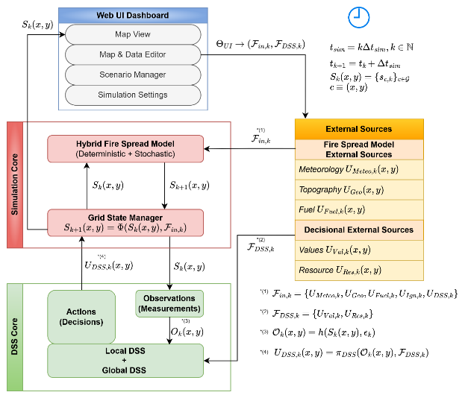
Takagi-Sugeno inference turns rule activations into a crisp action, replacing the consequent set with a function of the inputs and taking the output as a firing-strength weighted average [26]. DisasterAware adopts the zero-order Takagi-Sugeno form, every consequent a constant intensity on the unit interval, stated in full in Section IV. The choice is architectural: candidates are judged inside shadow forecasts run thousands of times per incident, so centroid integration per evaluation would be too costly, the outputs are intensity commands, and adaptation needs numeric consequents with predictable effect while antecedents stay linguistic. Fig. 1 depicts 5-term trapezoidal partition; adjacent terms overlap so every reading activates at most two terms.
Fig. 1. DisasterAware system block diagram (simulation focused).
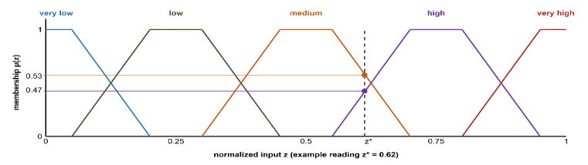
Applying fuzzy inference directly over a rich observation vector is combinatorially infeasible: a complete rule base over the full feature set has the size given in ( 4 ): ten features with five terms each demand nearly ten million rules, which no expert can author or audit. A conceptual middle layer reduces this, six base concepts summarizing physically related features and five decision concepts answering, each exactly once, the operational questions commanders ask [6, 31]; a single top concept, operational priority, serves cross-region coordination. Rules are written over the five decision concepts only, so the rule burden collapses from a product to a sum ( 5 ). The antecedent space shrinks to 3125 combinations, only the active subset instantiated, and the concepts double as the traceability vocabulary: every recommendation reads back over fire threat level, suppression feasibility, asset exposure risk, intervention urgency, and evacuation pressure.
Fig. 2. Five-term trapezoidal membership partition with an example reading.
$$|R|={N_{term}}^{N_{feature}}$$ | ( 4 )
$${N_{term}}^{N_{feature}} ⇢ N_{concept}⋅{N_{term}}^{N_{input}}+{N_{term}}^{N_{concept}}$$ | ( 5 )

G. The Decision Space: Interventions and Their Evaluation
The rules assign intensities to concrete actions. The decision space is built from six intervention families, each applied with an intensity over the grid, so every rule binds to an executable order [6]: suppression effort [25], resource deployment [23], containment line, asset protection [16], evacuation, and public warning [18]. The list is closed, keeping the vocabulary interpretable; openness enters through new rules and compositions over the same families. Beneath them the simulator verifies physical effects (wet, clear, ignite, coat, draft, evacuate, prime) and three channels built on them, water drafting, retardant drop, and tactical burn. Inaction is the zero-intensity point of every family, so the cost prices restraint as it prices action.
A candidate intervention is evaluated through its expected cost, following the cost-plus-loss principle of wildfire economics [6, 25]. Global minimization over a spatial decision field is intractable under real-time constraints and needs information incomplete observation cannot supply, so acceptance is satisficing [28]. The dominant uncertainty is epistemic, the state under-observed rather than noisy [20], and Bayesian or Dempster-Shafer treatments presuppose distributional knowledge that real-time sensing lacks [21]. Explanation is structural, over explicit concepts and rules, not post-hoc attribution [4]. Generative proposers may be wrong or unsafe, so proposals are untrusted by construction and admitted only after verification, as Section IV develops.

III. System Architecture and Interface Contracts

A. Entities, Responsibilities, and Interfaces
Fig. 2 presents DisasterAware as a system of systems with five kinds of participant: external providers that supply weather, imagery, terrain, and resource status; a simulation core that owns the hazard state; N local decision agents, each responsible for one region; a coordination layer that allocates capacity without performing inference; and a commander who supervises through the dashboard. Participants meet only at declared interfaces. The simulation core is authoritative, since cells carry burning status, fuel mass, an intensity proxy, and time since ignition and no other participant may write this state; the decision agents read derived observations, and the dashboard admits only reversible, input-level actions such as pause, rollback, ignition injection, and resource changes.

B. External Inputs and Decision Context
The external input set ( 6 ) collects the parameters that influence wildfire evolution at step k: meteorological forcing (temperature, humidity, wind, gusts, precipitation), topography (elevation, slope, aspect, accessibility), fuel conditions (class, load, moisture), ignition injection, and the DSS intervention parameters (capacity, availability, effectiveness, travel time). A separate contextual set guides decision generation only: a value layer aggregating buildings, critical facilities, population, and evacuation access into a protection priority score, and a resource layer of available capabilities. It never touches fire dynamics, keeping modeling and reasoning separate.
$$F_{in,k}=\left\{U_{Meteo,k},U_{Geo}, {U_{Fuel\text{,k}}, U_{Ign,k}, U}_{DSS,k}\right\}$$ | ( 6 )

C. State Representation and Transition
The landscape is discretized into a rectangular grid, and at each simulation step the wildfire state is the collection of local cell states ( 7 ), each cell carrying burning status, fuel mass, an intensity proxy, and time since ignition, with environment and interventions entering only as external inputs. The global evolution ( 8 ) is a structured transition operator over burning status, fuel mass, and intensity, illustrated in Fig. 3. The operator is deterministic; stochastic variability enters only through exogenous fields such as wind gusts and, in one controlled channel, seeded ember spotting.
$S_{k}=\left\{s_{k}\left(x,y\right)|(x,y)∈G\right\}$; $s_{k}=\left[\begin{aligned}B_{k}\left(x,y\right) \\ F_{load,k}\left(x,y\right) \\ I_{k}\left(x,y\right) \\ τ_{k}\left(x,y\right)\end{aligned}\right]$ | ( 7 )
$$S_{k+1}\left(x,y\right)=Φ\left(S_{k}\left(x,y\right),F_{in,k}\right)$$ | ( 8 )

D. Hybrid Fire Spread Model
A cell burns through persistence while fuel remains, through propagation from burning neighbors, or through external ignition. Propagation fires when the influence accumulated over the 8-connected neighborhood exceeds a calibrated threshold, each neighbor contributing a Rothermel-type rate of spread from wind, slope, aspect, moisture, and fuel type [7], weighted toward the wind. Ember spotting, the only stochastic element, carries fire several cells downwind and across narrow barriers such as rivers, roads, and containment lines. Precipitation raises dead fuel moisture above the extinction level so a front dies out gradually, and the equilibrium moisture mode lets diurnal weather modulate flammability.

E. Fuel Mass, Suppression, and Intensity
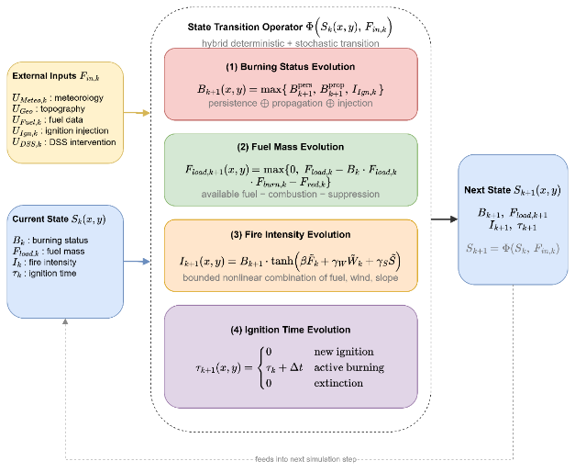
Fuel mass decreases through combustion and suppression, never below zero. Suppression converts capability into a normalized fuel reduction, gated by capacity and availability, decaying with travel time and poor access, and attenuated by local fire intensity; it never overwrites the burning state but acts on the fuel, which shapes persistence and propagation. A local intensity proxy from fuel, wind, and slope modulates suppression effectiveness and feeds the decision layer without controlling ignition or spread.
Fig. 3. State transition block diagram.

F. Interaction, Counterfactual Replay, and the DSS Interface
The commander acts only through bounded input modifications, never through the state, so interaction stays prospective and reversible. Per-step snapshots, including the random number generator, enable exact counterfactual replay: runs from the same snapshot differ only in the orders under test, which is the basis of the paired comparisons of Section V. The decision layer reads the state through the observation interface ( 9 ): the observation function projects the state onto observable information, injecting epistemic uncertainty at this point only, and the aggregated intervention field re-enters the simulation as one component of the external input set.
$$S_{k}\left(x,y\right)→ O_{k}\left(x,y\right),F_{DSS,k}→U_{DSS,k}\left(x,y\right)→Φ\left(∙\right)→S_{k+1}\left(x,y\right)U_{DSS,k}\left(x,y\right) = π_{DSS}^{i}\left(O_{k}\left(x,y\right),F_{DSS,k}\right) ⊂ F_{in,k}$$ | ( 9 )

IV. Distributed Decision Layer and Its Guarantees

A. Four-Layer Pipeline
Fig. 4 presents a Local DSS agent as a four-layer flow: the input space collects the measurements of Section II-C, the perception layer fuses them into bounded features with explicit confidence, the concept space abstracts them, and the decision space generates, adapts, and evaluates interventions. N agents run this loop over their own regions, coordinated by the Global DSS through priorities and shared resource pool.
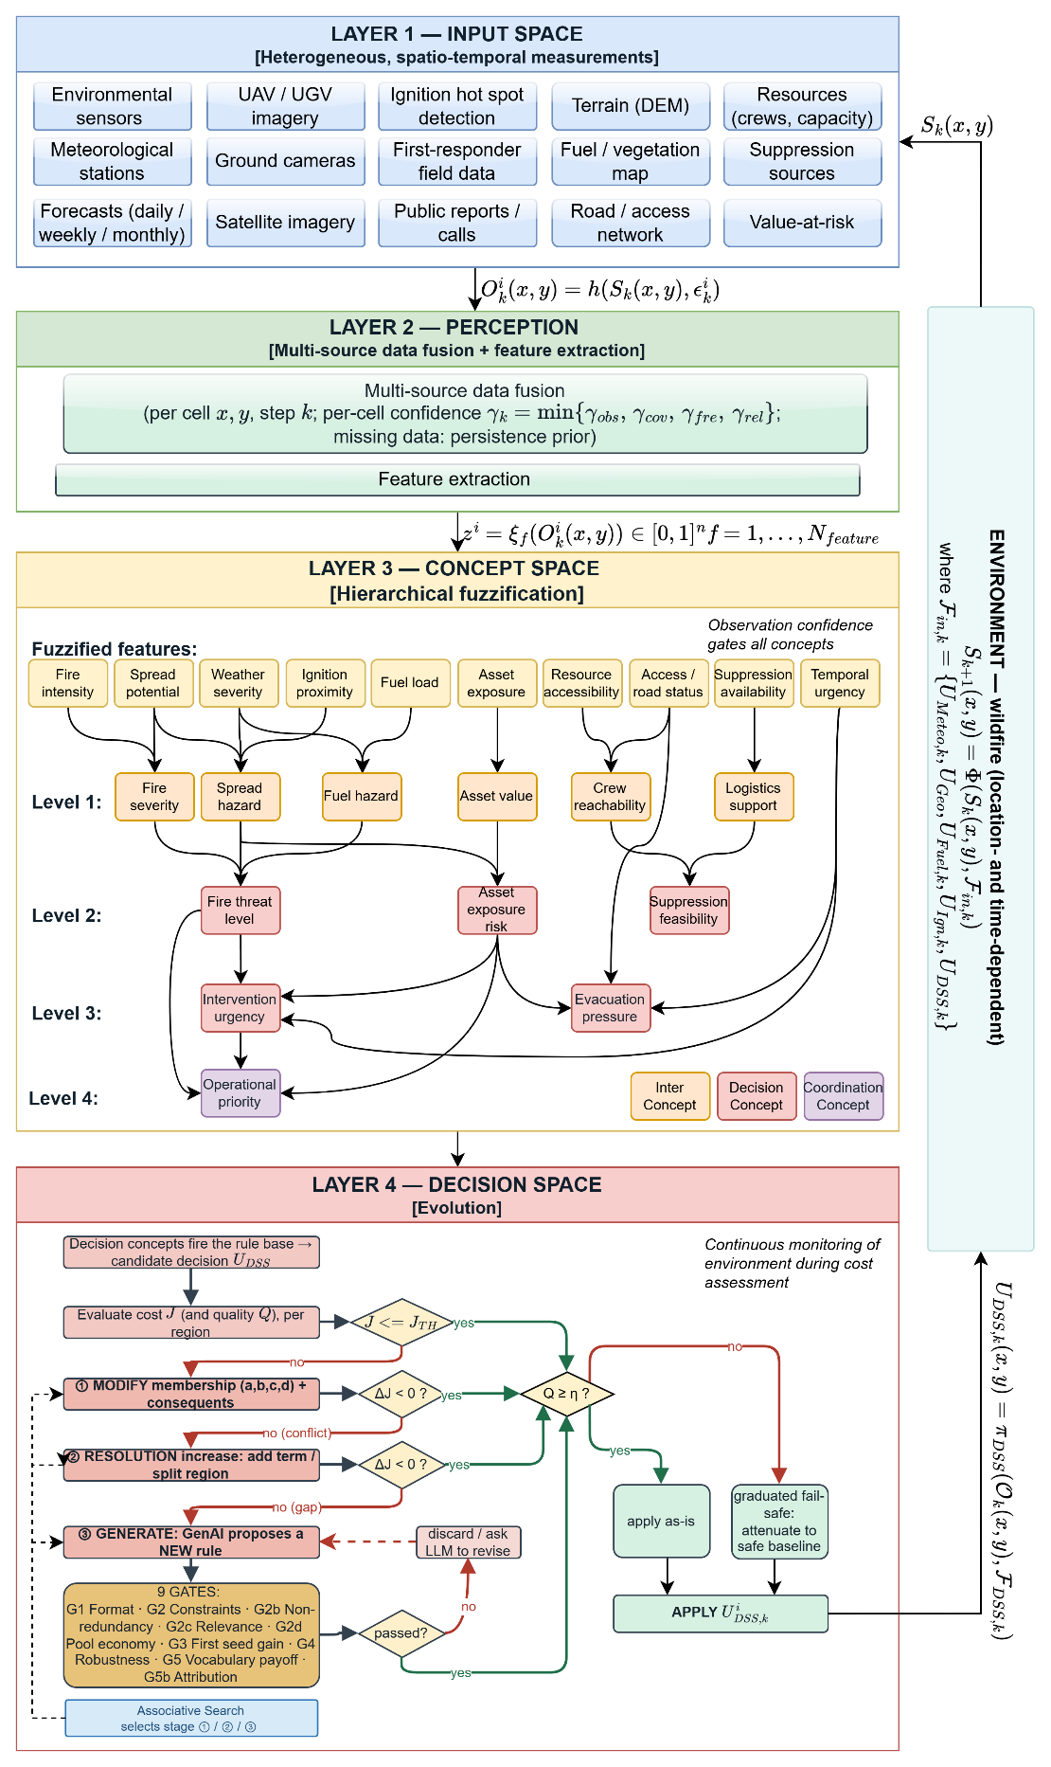
Fig. 4. DisasterAware system block diagram (DSS focused).

B. Observation, Features, and Confidence
Each Local DSS agent receives at step k the region-restricted observation ( 10 ), where the observation function projects the authoritative state onto the cells of the region and injects epistemic uncertainty. That uncertainty comes from missing knowledge rather than randomness, such as an occluded camera or a revisit gap, and no distribution over the error is assumed. Every observed cell carries a confidence composed from observability, coverage, freshness, and reliability as their minimum ( 11 ) rather than their average. Confidence bounds the error instead of describing it statistically: its magnitude is limited by the complement of the confidence ( 12 ), so full confidence is exact and vanishing confidence admits the worst case. The agent then computes the ten features ( 13 ), each inheriting a feature-level confidence from the observation fields its extraction consumes, so the pair of feature value and feature confidence is the complete interface between perception and reasoning.
$$O_{k}^{i}\left(x,y\right)=h^{i}\left(S_{k}\left(x,y\right), ε_{k}^{i}\left(x,y\right)\right), \left(x,y\right)∈G^{i}$$ | ( 10 )
$$γ_{k}^{i}\left(x,y\right)=min⁡\{γ_{obs},γ_{cov},γ_{fre},γ_{rel}\}$$ | ( 11 )
$$|ε_{k}^{i}\left(x,y\right)|≤(1-γ_{k}^{i}\left(x,y\right))⋅ε_{max}$$ | ( 12 )
$$z_{f,k}^{i}=ξ_{f}\left(O_{k}^{i}\right)∈[0,1], f=1,…,N_{feature}$$ | ( 13 )

C. Concept Space and Confidence Gating
The conceptualization layer of Fig. 5 maps physically related features into six base concepts, the base concepts into three mid-level and two higher-level decision concepts, and finally into the single coordination concept. The activation of a base concept is the weighted sum of the term memberships of its features, and the activation of every higher concept is the weighted sum of the activations of the concepts in its set, with nonnegative weights normalized to one ( 14 ). Raw activations are never consumed directly. Every activation is gated by its observation confidence and blended with a persistence-carried prior ( 15 ): a reliable observation passes unchanged, an uninformative one falls back to the decayed previous estimate, and an unobserved concept fades geometrically. The trust-caution transition is linear with no threshold to tune, and the activation snaps back as soon as confidence returns.
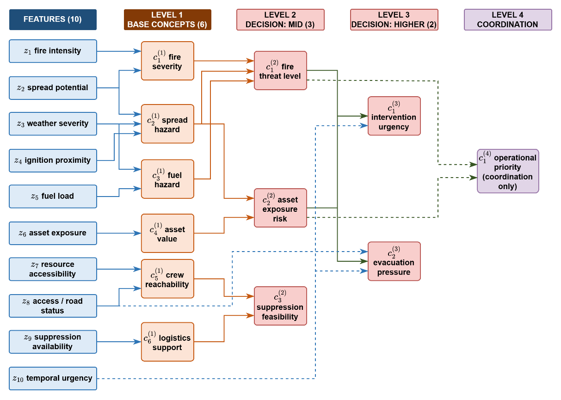
Fig. 5. Feature-concept hierarchy.
$$a_{n,k}^{(1),i}=\sum_{f∈Z_{n}}{ω_{n,f}⋅μ_{A_{n,f}}\left(z_{f,k}^{i}\right)} \\ a_{n,k}^{(l),i}=\sum_{m∈C_{n}^{(l)}}{ω_{n,m}^{(l)}⋅a_{m,k}^{(l-1),i}}, l=2,3,4$$ | ( 14 )
$$a_{n,k}^{eff,i}=γ_{n,k}^{i}⋅a_{n,k}^{obs,i}+\left(1-γ_{n,k}^{i}\right)⋅ρ⋅a_{n,k-1}^{eff,i}, \\ γ_{n,k}^{i}=min⁡\{γ_{f,k}^{i}:f∈Z_{n}\}$$ | ( 15 )

D. Rule Base and Candidate Intervention
Decision rules are written exclusively over the five gated decision concepts in the canonical conjunctive form ( 16 ): each antecedent clause tests one concept against one linguistic term and the consequent assigns a singleton intensity to each family. A rule fires with the strength of its weakest satisfied clause, and the candidate is assembled family by family from the rules that fire ( 17 ), with the denominator floored at one so a weakly supported conclusion yields a weak order. The base is sparse: of 3125 combinations it holds only the seeded doctrine and what adaptation adds, at no cost to coverage, since adjacent terms overlap. The seeded base satisfies the coverage condition ( 18 ), so some rule fires above the coverage floor of 0.05 at every reachable reading; below the floor the layer falls back to the watchful posture and adaptation is triggered. Each concept has a primary family, suppression feasibility acting as gatekeeper, and a run starts from five seed rules.
$$R_{r}: IF a_{1,k}^{eff,i} is A_{r,1} AND … AND a_{5,k}^{eff,i} is A_{r,5} THEN U_{DSS,k}^{i} is B_{r}$$ | ( 16 )
$$u_{m,k}^{i} = \frac{\sum_{r}{α_{r} v_{r,m}}}{max(1, \sum_{r}{α_{r}})} \\ α_{r} = \min_{n ∈ ant(r)} μ_{A_{r,n}}(a_{n,k}^{eff,i})$$ | ( 17 )
$$\min_{a^{eff}∈[0,1]^{5}} \max_{r} α_{r}\left(a^{eff}\right)≥α_{min}>0$$ | ( 18 )

E. Cost, Quality, and Satisficing Acceptance
The decision and adaptation flow of Layer 4 is summarized in Fig. 6. Every candidate is judged on a shadow copy of the simulation before anything reaches the field: the cost asks what it is expected to cost the incident, the quality whether it serves the concepts that demanded it.
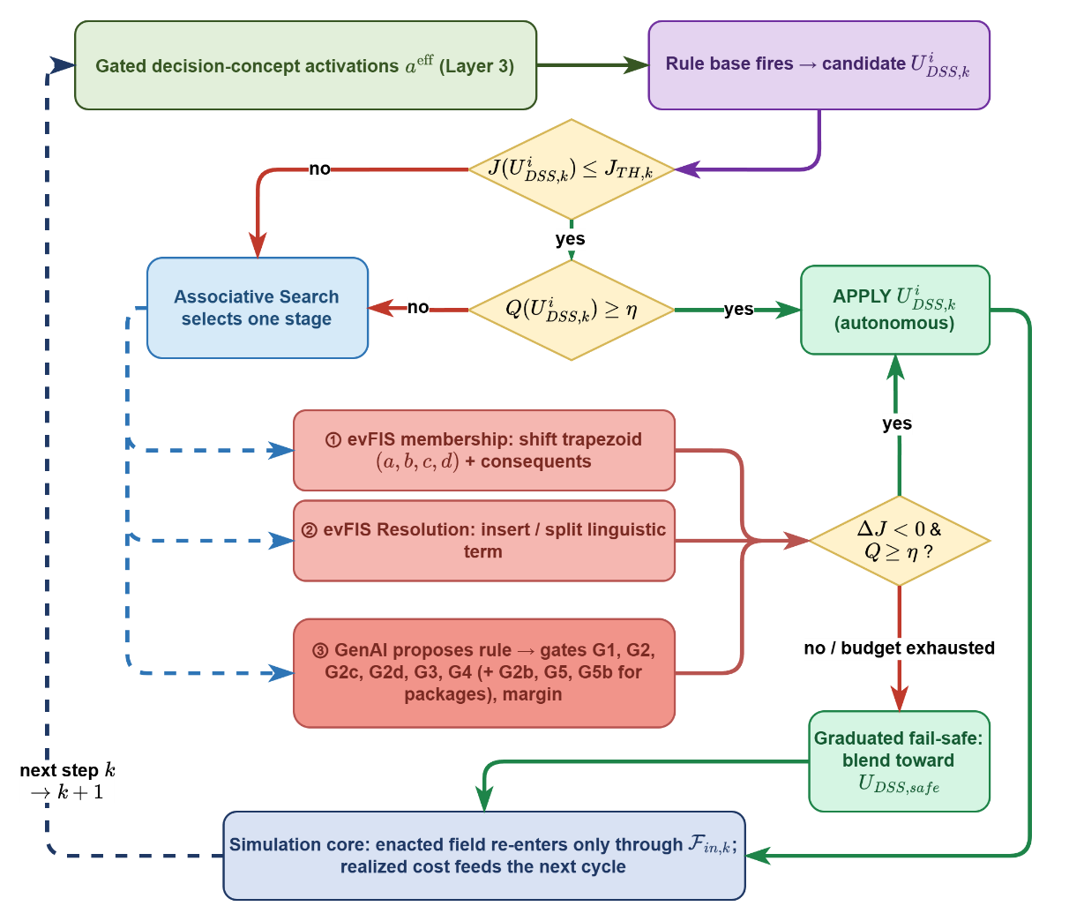
Fig. 6. Layer 4 decision and adaptation flow.
The cost is the weighted five-term sum over burned area, asset loss, population exposure, response effort, and response delay, each normalized by a scenario reference: burned area through a rational form that keeps every saved cell worth saving, population as person-steps inside burning cells, response as the time integral of committed force, and delay against a sixty-minute reference. The candidate is held constant over a forecast horizon and compared with a no-action shadow run from the same state, and acceptance is satisficing ( 19 )( 20 ): the bound is the tighter of a fixed ceiling of 0.35 and a required relative gain over the no-action forecast, so cheap inaction demands a stronger candidate; failing the test leaves the standing orders in force while adaptation runs. Cross-run comparisons read the physical cost only, because a run that never intervenes carries no response cost and a total-cost comparison would reward inaction.
$$J=\frac{\sum_{j}{w_{j}J_{j}}}{\sum_{j}{w_{j}}}, j∈\left\{burn, asset, pop, resp, delay\right\} \\ J_{burn}=\frac{\frac{N_{burned}}{ρ_{burn}⋅N_{burnable}}}{1+ \frac{N_{burned}}{ρ_{burn}⋅N_{burnable}}} \\ J_{asset}=\frac{V_{lost}}{V_{total}}J_{pop}=\min\left(1, \frac{P_{steps}}{P_{total}⋅N_{decisions}}\right) \\ J_{resp}=\min\left(1, \frac{C_{steps}}{C_{ref}⋅N_{decisions}}\right) \\ J_{delay}=min(1, \frac{\overline{τ}}{τ_{reference}})$$ | ( 19 )
$${\hat{J}}_{k}\left(U_{DSS,k}\right) ≤ min(J_{TH}, (1-δ_{gain})⋅{\hat{J}}_{k}(0))$$ | ( 20 )
The quality measures what the cost cannot. For each scored concept, the gated activation is compared with the strongest intensity the candidate assigns to the family that answers it, and the quality is one minus the mean mismatch ( 21 ). Over-suppression at low threat is penalized as much as ignoring high evacuation pressure, so misdirection is caught before its consequences appear; suppression feasibility modulates rather than demands. Below the quality gate of 0.60 the graduated fail-safe attenuates the candidate toward a pre-authorized conservative posture in proportion to the deficit: the offensive families, suppression effort, resource deployment, containment line, and asset protection, are scaled down, while evacuation and public warning are never reduced. The transition is reversible as observation quality recovers, and if the adapted candidate is still forecast worse than inaction, a no-harm rule withholds the offensive allocation over a lookahead, so interventions maturing in thirty to sixty minutes are not punished prematurely.( 22 )
$$Q_{k}=1-\frac{1}{4}\sum_{n∈C_{Q}}{|{a_{n}}^{eff}-\max_{f∈F(n)} u_{f}|}, accept ⇔ Q_{k}≥η$$ | ( 21 )
$${U_{DSS,k}}^{'}=λ_{k}⋅U_{DSS,k}+\left(1-λ_{k}\right)⋅U_{DSS,safe} , λ_{k}∈[0,1]$$ | ( 22 )

F. Open Intervention Space
The fourth layer may change its own rule base when the standing decision demonstrably falls short. The three stages of that change, the grammar of the objects they may add, the proposers that supply candidates, and the gates that admit them form the open intervention space and are developed in Section V.
$$v_{r,m}←clip_{0,1} \left(v_{r,m}±δ\right), m∈cons\left(r\right)$$ | ( 23 )
$$kept ⇔ Δ{\hat{J}}_{phys}<0$$ | ( 24 )

$$Δ{\hat{J}}_{phys}^{\left(ν\right)}={\hat{J}}_{phys}^{\left(ν\right)}\left(R∪\left\{r^{'}\right\}\right)-{\hat{J}}_{phys}^{\left(ν\right)}\left(R\right), ν∈\left\{V_{a},V_{b}\right\}$$  $$G3: Δ{\hat{J}}_{phys}^{(V_{a})}<0;G4: Δ{\hat{J}}_{phys}^{(V_{b})}<0$$ | ( 25 )

G. Global Coordination and the No-Harm Guard
The coordinator performs no inference: each agent sends up its operational priority, its resource request, and a confidence summary, and receives back the allocation, the normalized priority weights, and the acceptance thresholds in force. Regions are ranked by operational priority, and each receives an attention share ( 26 ): a region near the top priority keeps the full share, a monitored region gets a reduced share floored at 0.50 and a stricter quality threshold for offensive orders; evacuation and warning are untouched. The merged plan is forecast by the no-harm guard against inaction, and offensive orders are withheld when it is worse while life-safety orders stand. Every decision remains traceable end to end, with fired concepts, rules, strengths, input confidences, and gate verdicts recorded, so explanation is structural rather than post-hoc.
$$σ_{i}=\left\{\begin{aligned}1,\text{ if }p_{i}≥τ_{att}p_{\text{max}} \\ 0.5+0.5\frac{p_{i}}{p_{\text{max}}},\text{ otherwise}\end{aligned}\right.$$ | ( 26 )

H. Guarantees
The gates of this section give the architecture four properties that hold whatever produced the candidate order. All four are stated over the forecast physical cost of Section IV-E, evaluated on a shadow copy of the simulation against the no-action forecast from the same state.
Proposition 1 (no-harm). No order reaches the field whose forecast physical cost exceeds the no-action forecast over the guard horizon. Acceptance admits a candidate only below the satisficing bound, and the no-harm rule withholds the offensive allocation whenever the adapted candidate is still forecast worse than doing nothing. Both tests read the same forecast, so an admitted order is never predicted to cost more than inaction.
Proposition 2 (life-safety invariance). Evacuation and public warning intensities are never reduced by any gate. The graduated fail-safe scales the offensive families only, and the no-harm rule withholds the offensive allocation only; neither map has the two life-safety families in its domain.
Proposition 3 (coverage). At every reachable reading either some rule fires above the coverage floor, or the layer falls back to the pre-authorized watchful posture and triggers adaptation. The seeded base satisfies the coverage condition, and a reading below the floor is detected by the same test that reports the gap, so the system is never without a defined response.
Proposition 4 (bounded growth and termination). The objects admitted during one incident are finite in number and the adaptation ladder terminates. Stage 1 acts on a finite rule set with a fixed step, stage 2 inserts at most one term per ambiguous combination, and stage 3 runs only on a logged deficit under a revision budget. Every stage is a monotone test on a working copy, so the ladder halts once no trial improves the forecast.

V. The Open Intervention Space

A. Levels of Novelty and the Grammar
What counts as a new intervention is stated before it is measured. Four levels are distinguished. At level zero the layer changes the intensity of one of the six families; this is the closed space of the deployed tools. At level one it bundles existing families at fixed weights, a composite alternative in the sense of [42]; a bundle is a convenience and is not counted as new. At level two it writes a sited intervention: a named list of at most three clauses, each applying one of seven physical effects (wet, clear, ignite, coat, evacuate, prime, draft) to one of seven sectors of the incident (head, flank, rear, ring, at-fire, assets, populated) over a distance band in cells with an amount. The band is measured from the sector's reference cells, the burning cells for the first five sectors, the threatened asset footprints, or the populated cells, and a band starting at zero includes the reference cells themselves, so two clauses that differ in range never compile to the same cells. A sited intervention states where and how, in terms no base family expresses; it is the object the claim of this article rests on. At level three the layer adds an intermediate concept, a normalized weighted sum of at most four existing features or concepts, which adds an antecedent axis to the space and corresponds to the expansion of separable dimensions in [36]. The seven effects are the fields the engine already writes and the cost model already prices; the generative stage never defines a new physical effect. Three library tactics are built on the same effects and validated in the engine, tactical burn (ignite on the band ahead of the head), retardant drop (coat on the band ahead of the head), and water drafting (draft on committed cells), and they share their physics with the corresponding clause effects through common operators, so a clause that re-composes a library tactic is measured on the same physics as the tactic itself.

B. Staged Adaptation
Adaptation is engaged only when the standing decision demonstrably falls short: a cost deficit, a coverage gap while fire is alive, or renewed spread under applied orders. Stage 1 tunes rules already in the base with two bounded moves: the consequent step ( 23 ) nudges the intensity of a rule by a fixed 0.05 within the unit interval, and the boundary shift moves the shared edge of two neighboring terms while preserving the partition of unity. Stage 2 grows the base: it writes a rule on the uncovered combination of the two most active concepts, and where a covered combination is ambiguous it inserts a narrow term at the crisp reading. Stage 3 asks a proposer for a rule the current vocabulary cannot express, alone or as a package with exactly one new object of level one, two, or three that the rule must use. Which stage runs in a cycle is chosen by a contextual bandit over the deficit band and the coverage flag [32]; a stage that keeps failing loses value in its own table. Every trial of every stage is judged on a working copy of the base by the same quantity, the forecast physical cost on the shadow simulator over a basis of at least 45 minutes, and is kept only when that cost falls ( 24 ).

C. Proposers and the Trial Context
The generative stage is a function from a situation to a candidate, and nothing that decides admission depends on which function is used. Three proposers are placed behind the same hook. The language-model proposer sends a standing mission brief and the situation of the cycle to a pretrained model used in context only, with a fixed reply schema and a revision budget of two corrected retries. The evolutionary proposer searches the grammar of Section V-A directly: a population of twelve candidates, three generations, tournament selection, mutation of effects, sectors, ranges, amounts, terms, and intensities, and crossover by clause exchange. The random proposer samples the grammar uniformly. Both search proposers apply the cheap gates of Section V-D as a filter before any forecast is spent, price each surviving candidate by the gain of one seeded shadow forecast, re-price their finalists on the second seed, and return the candidate with the better worse-seed gain; when no candidate lowers the forecast on both futures they return nothing and the stage records a search miss without spending the four gate forecasts. Every proposer is charged the same currency, the number of shadow forecasts it spends per cycle, capped at 36 for the search proposers, so the comparison of Section VII-C is at equal budget. The stage leaves a trial context on the engine for the duration of the call, the current base, the gated activations, and the build function the gates themselves use, so a search proposer prices candidates exactly as the gates will; it cannot admit anything.

D. Verification Gates
A proposal is rejected the moment it fails a gate that applies to it. G1 checks form and G2 arity, vocabulary, and range. G2c requires every antecedent to fire in the present situation; a term that fails only by its form is repaired to the nearest reading that still holds and the repair is recorded. G2 availability refuses water-dependent effects on a map without water, G2d refuses capacity-spending orders on a saturated pool, and G2b refuses a duplicate antecedent cell, a redundant concept (cosine above 0.95 with an existing one), or a clause signature already admitted. None of these costs a simulation. G3 and G4 are one paired comparison on two independently seeded futures: the base extended by the candidate against the base without it, and the forecast physical cost must fall on both ( 25 ). G5 asks a package to clear a vocabulary margin on both futures, and G5b, when the new object is ordered beside ordinary interventions, repeats the two futures with the object struck out and admits the package only if the cost rises without it, so the vocabulary does not grow on borrowed credit. The gates contain no model. They are the same for the language model, the search, and the random sampler, which is what makes the proposer comparison meaningful.

E. Learning From the Simulator
What the layer learns is kept in three places. The lineage store holds every admitted rule and object, so a later rule in the same incident may order a generated intervention or cite a generated concept, and a later incident restores them unless the vocabulary is reset. The cycle chronicle holds every closed stage-3 attempt with its situation, proposal, gate, and measured change, and the nearest past cases are placed in the next proposal request. The composition prior is a table over context buckets (pool saturated or not, water present or not, assets within reach of the fire or not) and effect-sector pairs, holding the number of trials, the number of positive forecast gains, and the mean gain; it is updated from every priced candidate and every gate verdict, it seeds half of the evolutionary population, and it is the measurable form of the statement that the decision layer learns from the simulator which compositions of its physical primitives help. Section VII-C switches it off to measure what it adds.

VI. Evaluation Design

A. Evaluation Criteria
The technical tradition evaluates the predictive models inside a tool on real fires, while the decision-support tradition evaluates its effect on the decision itself, and most wildfire DSS evaluations measure adoption rather than decision improvement [19]. Both are addressed through the eight criteria of Table III, fixed in advance and audited at the end of this section.
TABLE III
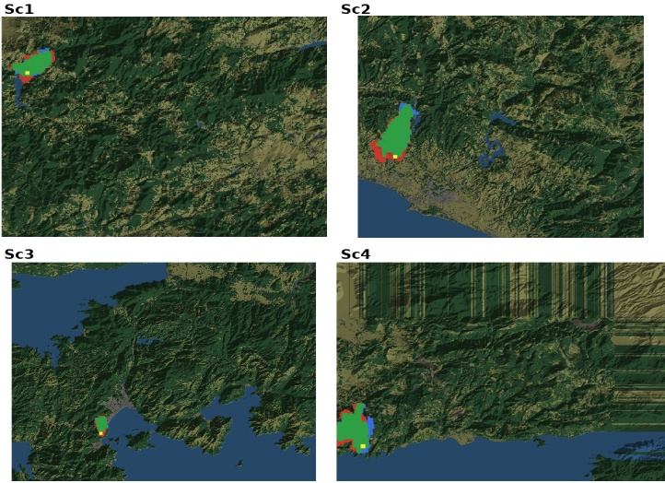
Evaluation criteria for wildfire decision support systems

Fig. 8. Hindcast agreement maps (green: predicted burn; red: simulated only; blue: observed only; yellow: ignition).

Criterion | Measurement in the literature
Predictive fidelity | Retrospective hindcasts against historical fires; spatial-overlap and arrival-time scores
Decision quality | Outcome deltas against no-action and baseline policies on matched scenarios
Timeliness | Decision-cycle wall time; detection-to-first-order time
Robustness | Performance versus outage and noise level; fail-safe engagement statistics
Uncertainty handling | Ensemble and input-uncertainty propagation studies
Adaptability | Learning curves; coverage growth; rediscovery of withheld knowledge
Explainability and auditability | Trace completeness; interpretability as an adoption gate
Scalability | Runtime and quality versus grid size and agent count

B. Validation of the Simulation Core

The simulation is tested by blind hindcast: it receives only the real inputs of a documented fire, with no tuning on that fire, and its output is compared with the satellite record. Terrain comes from the Copernicus GLO-30 model, fuel from ESA WorldCover 2021, weather from ERA5 reanalysis, and ignition points and reference burn from NASA FIRMS VIIRS detections. Four documented fires in Türkiye cover different fuel, terrain, and wind conditions: Sc1 Manavgat and Sc2 Marmaris (July 2021, 48 h), Sc3 Milas-Kemerköy (August 2021, 72 h), and Sc4 Çanakkale-Kayadere (August 2023, 48 h). Because the core models free spread without suppression, a free run overpredicts the final area, so three suppression-robust criteria are used: the probability of detection ( 27 ), accepted at 0.70 for calibrated growth models [34]; the front position error relative to the equivalent burn radius ( 28 ), ( 29 ); and the arrival-time agreement ( 30 ), the direct rate-of-spread test. Table IV reports the metrics over 50 replicates in Fig. 8 the agreement maps: overall agreement is 86 to 94 % and detection probability 85 to 97 %, the reliability of a well-behaved
$$POD=\frac{|{FR}_{Sim}∩{FR}_{Re}|}{|{FR}_{Re}|}$$ | ( 27 )
$$D(x,G_{Set})=\min_{y∈G_{Set}}‖x-y‖\overline{d_{Front}}=\frac{Σ_{x∈∂{FR}_{Sim}}D(x,∂{FR}_{Re})+Σ_{y∈∂{FR}_{Re}}D(y,∂{FR}_{Sim})}{|∂{FR}_{Sim}|+|∂{FR}_{Re}|}$$ | ( 28 )
$$R =\sqrt{\left(\left|N_{burned}\right| A_{cell}\right)/π}, {TH}_{Front}=1-\frac{\overline{d_{Front}}}{R}$$ | ( 29 )
$$τ_{MAE}=\frac{1}{N_{cells}}Σ_{c∈{FR}_{Sim}∩{FR}_{Re}}\left|t_{c}^{Sim}-t_{c}^{Re}\right|; N_{cells}=|{FR}_{Sim}∩{FR}_{Re}|{TH}_{MAE}=1-τ_{MAE}/T$$ | ( 30 )
TABLE IV
Hindcast agreement metrics per historical case
Metric | Sc1 | Sc2 | Sc3 | Sc4
Front distance (m) | 329 | 305 | 113 | 391
Arrival-time MAE (h) | 1.46 | 1.39 | 4.04 | 2.58
Front agreement | 82% | 90% | 89% | 89%
Time agreement | 90% | 98% | 71% | 96%
Probability of detection | 92% | 93% | 97% | 85%
Overall success | 88% | 94% | 86% | 90%

C. Scenario Families
Eight scenario families are used, all on 72 by 50 cell grids at 30 m with a two-minute step, four regions, a twelve-minute decision cycle, a 24-minute planning horizon, a satisficing bound of 0.35, a quality gate of 0.60, the five-rule seed profile, one adaptation window per cycle, and episodes to extinction or a twelve-hour cap (eighteen hours on S8). Table V defines them. S1 to S5 are the families of the earlier ladder campaign: remote forest and wildland-urban interface, each with a sufficient and a limited pool, and the interface case under degraded observation. S6 to S8 are built so that the closed doctrine is structurally insufficient rather than merely untuned. In S6 a lake lies eight to eleven cells downwind of the first ignition and the pool is at 40 percent, so the only way to add capacity is to draft from the water; in S7 the interface burns under 12 m/s wind and dry fuel from two ignitions near twelve settlements, so protection that raises a defensive posture cannot prevent ignition while coating ahead of the head can; in S8 three remote ignitions run for up to eighteen hours on a 40 percent pool, so the capacity-spending effects are rationed away and only drafting or counter-fire remain. The coordinator's doctrine-free drafting directive is switched off in every arm, so a tactic reaches the field only through a rule.
TABLE V
Scenario families
ID | Landscape | Pool | Ignitions | Weather | What it tests
S1 | Remote forest, 2 settlements | full | 1 remote | 8 m/s, fuel moisture 0.08 | baseline competence
S2 | Remote forest | 0.6 | 2 remote | same | allocation under scarcity
S3 | WUI, 12 settlements | full | 1 near the interface | same | life and asset priority
S4 | WUI | 0.6 | 2 near the interface | same | full operational stress
S5 | as S4 | 0.6 | as S4 | same, outage 0.25, noise 0.10 | degraded observation
S6 | River valley, lake 8 to 11 cells downwind | 0.4 | 2 remote | 9 m/s, 0.08 | drafting as the only extra capacity
S7 | Mediterranean coast, 12 settlements | full | 2 near the interface | 12 m/s, 0.06 | pre-emptive coating
S8 | Rolling hills, 18 h cap | 0.4 | 3 remote | 8 m/s, 0.08 | spent pool, substitution tactics

D. Arms, Experiments, and Measures
Five arms share every world: T0 issues no orders; F5 runs the five seed rules without adaptation; F5+Ev adds stages 1 and 2 and is the closed reference, since it may tune and grow the rule base but never the vocabulary; Open/Evo and Open/Random add stage 3 with the evolutionary and the random proposer at the same budget of 36 shadow forecasts per cycle. The language-model proposer is implemented behind the same hook and schema, but its arm needs an interactive model session per run and is not part of the campaign reported here; the comparison therefore concerns the two reproducible search proposers. Four experiments follow. E1 withholds tactical burn, retardant drop, and water drafting together from every arm on S6 to S8 and measures rediscovery: a run rediscovers a tactic when it admits a sited intervention whose effect matches it (draft on a fire-referenced sector within four cells, coat on head or ring within six cells, ignite on head, ring, or flank within eight cells); the share of runs, the minute of first admission, and the paired burned area against F5+Ev are reported over 30 seeds. E2 runs the five arms on all eight families with the full library available, 12 seeds each, and reports outcome, cost, and the paired difference against the closed reference. E3 compares the two search proposers with and without the composition prior on S6 to S8 at an equal forecast budget, 30 seeds each, by attempts, admissions, forecasts per admission, object kinds, and outcome. E4 sweeps the vocabulary margin of G5 over three decades, 10⁻⁴ to 10⁻², on the same families with the evolutionary proposer, 10 seeds per margin. Every stage-3 attempt is written with its proposer, kind, gate, and measured futures, and every admitted object with its clauses and the minute of admission.

VII. Results

A. Rediscovery of the Withheld Doctrine
Table VI reports E1. With the three library tactics removed from everything the layer can see or order, the closed reference F5+Ev cannot produce them by construction and does not; the two open arms re-composed an equivalent of at least one withheld tactic in 15, 16, and 11 of 30 runs with the evolutionary proposer and 18, 15, and 16 with the random sampler on S6, S7, and S8. Drafting was the most frequent rediscovery on every family (9 to 11 of 30 runs per cell, median first admission between 26 and 108 minutes), which matches the fact that two of the three families were built around a spent pool. Coating ahead of the head, the retardant drop the doctrine had lost, was rediscovered most often on the interface fire (6 of 30 runs with the evolutionary proposer, median first admission at 128 minutes). Counter-fire, the riskiest tactic, was admitted least often (4 of 30 on S7 with the random proposer), which is the behaviour of a gate chain that forecasts fire before it lights it. The rediscovered objects are not copies of the library tactics: the 373 sited interventions admitted in E1 carry 2.2 clauses on average, 73 percent of them more than one, so the withheld effect usually arrives paired with a clearing, wetting, or evacuation clause on another sector, and each clause names its own range (median 3 to 6 cells for a draft, 4 to 8 for a coat) where the library tactic applies one fixed band. The admitted objects are not decorative. On the three families the open arms burned 44 ± 24, 26 ± 9, and 45 ± 24 hectares less than the closed reference on the same seeds with the evolutionary proposer (paired means with 95 percent half-widths; open arm better in 81 of 90 pairs), and 41 ± 33, 17 ± 10, and 28 ± 22 hectares less with the random sampler. Fig. 9 shows the cumulative share of runs in which each tactic had been rediscovered against incident time.
TABLE VI
Rediscovery of the withheld tactics (E1): runs out of 30 that admitted an equivalent sited intervention, with the median minute of first admission, and paired burned area against the closed reference
Family | Arm | draft | coat | ignite | any | vs closed (ha)
S6 | Evo | 9 @108 | 3 @14 | 3 @14 | 15 | -44 ± 24
S6 | F5Ev | 0 | 0 | 0 | 0 | ref.
S6 | Random | 11 @50 | 5 @86 | 4 @40 | 18 | -41 ± 33
S7 | Evo | 10 @80 | 6 @128 | 3 @134 | 16 | -26 ± 9
S7 | F5Ev | 0 | 0 | 0 | 0 | ref.
S7 | Random | 9 @74 | 5 @26 | 4 @104 | 15 | -17 ± 10
S8 | Evo | 9 @26 | 2 @104 | 1 @230 | 11 | -45 ± 24
S8 | F5Ev | 0 | 0 | 0 | 0 | ref.
S8 | Random | 9 @62 | 5 @2 | 2 @8 | 16 | -28 ± 22
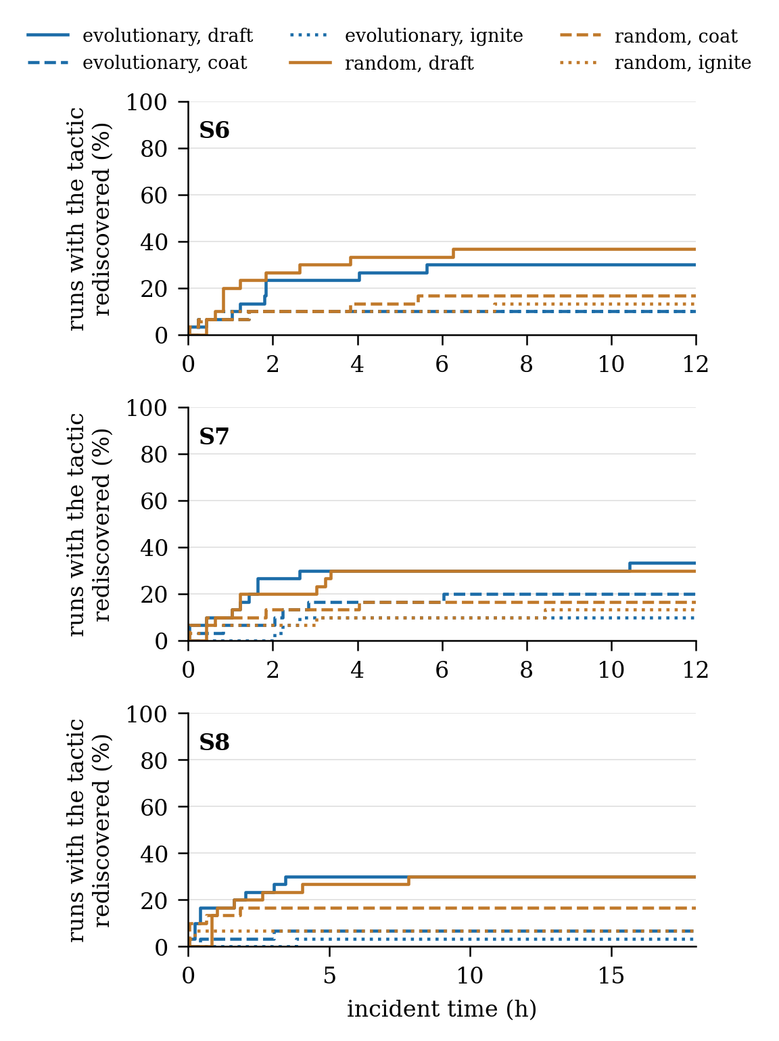
Fig. 9. Cumulative share of runs in which each withheld tactic had been rediscovered, against incident time, for the two search proposers on S6 to S8 (E1).

B. Closed and Open Space Across Scenario Families
Table VII reports E2 with the full library available to every adaptive arm. Two results stand out. First, the closed adaptation changes little: F5+Ev and the static F5 differ by at most 12 hectares on any family, so tuning memberships and writing rules over the existing families does not move the fire much once the seed profile is competent. Second, the open space changes much, and on every family: with the evolutionary proposer the open arm burned less than the closed reference on all 8 families, by 59 ± 37 hectares on S1, 46 ± 45 on S2, 15 ± 11 on S3, 22 ± 12 on S4, 22 ± 9 on S5, 55 ± 36 on S6, 29 ± 11 on S7, and 37 ± 24 on S8 (paired means with 95 percent half-widths, open arm better in 12 of 12 pairs on S4 and 12 of 12 on S7), a pooled reduction of 43 percent against a closed mean of 83 hectares; the random sampler was better on 7 of the eight families and worse on S4, with a pooled reduction of 34 percent. The share of incidents brought to extinction within the cap rose from 49 to 73 percent. The gain is of the same size on the five earlier families as on the three built for this article (43 against 44 percent), which corrects an expectation formed in the earlier ladder campaign, where the generative stage wrote rules and intermediate concepts only and added little over stages 1 and 2. What is new in the open space is the sited intervention: an effect placed on a sector of the fire at a range, instead of an intensity raised over a whole region, and the admission ledger shows that sited interventions are the object kind the gates accept most often. The three families built for the test remain the only ones on which rediscovery can be measured, since there the closed doctrine lacks the tactic rather than its placement. The greedy value-weighted allocation reported in earlier work remains a strong reference on raw burned area where immediate full commitment is affordable; it issues no life-safety order and composes no sited intervention, and on the spent-pool and lakeside families it has no capacity to commit, so the comparison bounds what undivided aggression buys rather than what the architecture is for.
TABLE VII
Outcome per scenario family and arm with the full library available (E2): mean and 95 percent half-width over 12 seeds, and paired difference in burned area against the closed reference; the static F5 arm is within 12 ha of F5+Ev on every family and is omitted
Family | Arm | burned (ha) | J_phys | ext. % | vs closed (ha)
S1 | T0 | 268 ± 6 | 0.624 | 0 | +192 ± 46
S1 | F5Ev | 75 ± 41 | 0.138 | 33 | ref.
S1 | Evo | 16 ± 13 | 0.031 | 92 | -59 ± 37
S1 | Random | 13 ± 10 | 0.032 | 92 | -61 ± 35
S2 | T0 | 267 ± 10 | 0.618 | 0 | +84 ± 32
S2 | F5Ev | 183 ± 33 | 0.280 | 0 | ref.
S2 | Evo | 136 ± 53 | 0.222 | 25 | -46 ± 45
S2 | Random | 101 ± 52 | 0.172 | 42 | -82 ± 63
S3 | T0 | 235 ± 14 | 0.565 | 0 | +209 ± 18
S3 | F5Ev | 27 ± 15 | 0.062 | 92 | ref.
S3 | Evo | 11 ± 10 | 0.024 | 100 | -15 ± 11
S3 | Random | 14 ± 10 | 0.032 | 100 | -13 ± 10
S4 | T0 | 245 ± 13 | 0.598 | 0 | +194 ± 20
S4 | F5Ev | 50 ± 20 | 0.113 | 67 | ref.
S4 | Evo | 28 ± 12 | 0.066 | 100 | -22 ± 12
S4 | Random | 60 ± 37 | 0.136 | 83 | +10 ± 38
S5 | T0 | 245 ± 13 | 0.598 | 0 | +193 ± 17
S5 | F5Ev | 52 ± 18 | 0.117 | 83 | ref.
S5 | Evo | 30 ± 17 | 0.066 | 100 | -22 ± 9
S5 | Random | 35 ± 17 | 0.082 | 92 | -17 ± 19
S6 | T0 | 222 ± 42 | 0.536 | 0 | +103 ± 43
S6 | F5Ev | 119 ± 47 | 0.236 | 17 | ref.
S6 | Evo | 63 ± 36 | 0.125 | 50 | -55 ± 36
S6 | Random | 89 ± 51 | 0.183 | 58 | -30 ± 35
S7 | T0 | 188 ± 6 | 0.619 | 0 | +116 ± 13
S7 | F5Ev | 72 ± 13 | 0.203 | 0 | ref.
S7 | Evo | 42 ± 14 | 0.124 | 17 | -29 ± 11
S7 | Random | 52 ± 20 | 0.157 | 33 | -20 ± 11
S8 | T0 | 249 ± 17 | 0.584 | 0 | +163 ± 32
S8 | F5Ev | 86 ± 28 | 0.160 | 100 | ref.
S8 | Evo | 48 ± 25 | 0.095 | 100 | -37 ± 24
S8 | Random | 76 ± 46 | 0.152 | 83 | -10 ± 45
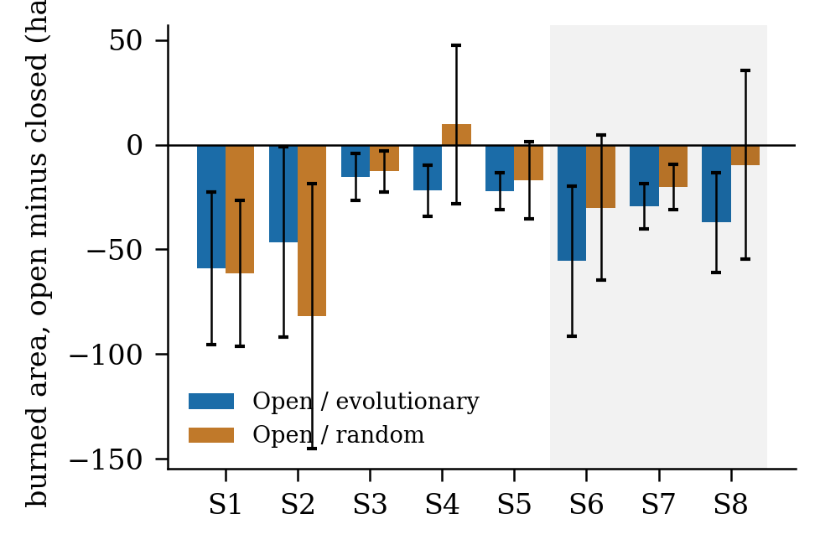
Fig. 10. Paired difference in burned area between the open arms and the closed adaptive reference per scenario family (E2); negative is better for the open arm, bars are means with 95 percent confidence intervals; S6 to S8 are the families built so that the closed doctrine is structurally insufficient.

C. Proposers at Equal Budget and the Composition Prior
Table VIII reports E3. At the same forecast budget per cycle, the evolutionary proposer admitted 37 percent of its attempts and the random sampler 39 percent, at 121 and 111 forecasts per admission. Sited interventions were admitted at 85 and 97 percent of the attempts that proposed one, plain rules at 15 and 17 percent, because a plain rule on a cell the doctrine already covers has little left to gain; more than half of all attempts ended in a search miss, where no candidate lowered the forecast on both futures and nothing was submitted to the gates. The two proposers reach similar outcomes (62 against 72 hectares on average over the three families); what separates them is cost and the mix of objects, not safety, since nothing either of them admitted was admitted by anything but the gates. The composition prior is consulted only when the evolutionary proposer seeds its population, so the random arm is identical with and without it and serves as a control. For the evolutionary proposer the prior shifted the search towards sited interventions (222 proposed against 128 without the prior, 2.1 against 1.4 admitted per run), lowered forecasts per admission from 126 to 121, and improved the outcome on the long incident by 19 ± 22 hectares on the same seeds (better in 21 of 30 pairs) while leaving S6 and S7 within noise. The prior therefore changes where the proposer looks and what it finds first, not what the gates let through. The language-model proposer is wired to the same brief, schema, and gates; its distinctive contribution is the naming and the rationale that accompany each object, which the search proposers do not supply, and its benchmark is left to a follow-up run. Across both search proposers the invariants of Section IV-H held in every run: no fielded order was forecast worse than inaction, and no life-safety intensity was reduced by any gate.
TABLE VIII
Proposer accounting at an equal forecast budget of 36 shadow forecasts per cycle, with and without the composition prior (E3)
Proposer | prior | attempts | admitted | sited adm. | forec./adm. | misses | burned (ha)
Evo | on | 880 | 325 | 188/222 | 121 | 501 | 62
Evo | off | 1016 | 348 | 124/128 | 126 | 604 | 72
Random | on | 978 | 382 | 185/191 | 111 | 532 | 72
Random | off | 978 | 382 | 185/191 | 111 | 532 | 72

D. Gate Margin, Timeliness, and Scalability
Table IX reports E4. Raising the vocabulary margin of G5 from 10⁻⁴ to 10⁻² lowered the admission rate of the evolutionary proposer from 37 to 19 percent of attempts, raised the forecasts spent per admission from 116 to 312, cut the sited interventions admitted per run from 1.9 to 0.5, and cut the share of runs that rediscovered a withheld tactic from 47 to 17 percent, while the mean burned area over the three families moved by 3 hectares (56 against 59). A wide margin therefore buys a smaller vocabulary at the price of most of the rediscovery and almost none of the outcome; the default of 10⁻⁴ is kept because the paired test on two futures already rejects a chance gain, and a margin is not a substitute for a second future. One decision covers the whole loop, including the two shadow forecasts of the acceptance test and any adaptation stage that runs, and takes a median 274 ms against a twelve-minute cycle; sixteen times the agents cost at most 1.29 times the share, since each agent reasons over its own region, while six times the forecast horizon raised the median by 1.4 and four times the grid by 6.9, so domain size remains the binding limit. A search proposer adds its forecast budget to the cycle: a proposer call with its 36 shadow forecasts of 45 minutes on a 72 by 50 grid cost at most 4 seconds of wall time on the two-core reference machine, including the share of the simulation step that falls in the same window, which is under one percent of the twelve-minute cycle.
TABLE IX
Vocabulary margin of G5 swept over three decades with the evolutionary proposer on S6 to S8, three library tactics withheld (E4; 10 seeds per margin and family)
G5 margin | admitted / attempts | forec./adm. | sited / run | redisc. % | burned (ha)
10⁻⁴ | 103 / 278 (37%) | 116 | 1.9 | 47 | 56
10⁻³ | 86 / 296 (29%) | 171 | 1.3 | 40 | 57
10⁻² | 69 / 366 (19%) | 312 | 0.5 | 17 | 59

E. Compliance With the Evaluation Criteria
Predictive fidelity rests on four blind hindcasts on real inputs, with front agreement of 86 to 94 percent and detection probability of 85 to 97 percent. Decision quality is met against the closed adaptive reference on all eight families, with paired gains in burned area and a higher share of incidents brought to extinction. Adaptability is met on the axis the literature names, rediscovery of withheld knowledge, with 47 to 54 percent of incidents re-composing a withheld tactic. Timeliness and scalability carry over from the earlier measurements and hold with the search budget added. Robustness is shown for observation loss on S5 and not for sensor noise or communication failure. Explainability holds at the level of the ledger: every attempt, verdict, and object is logged with its trigger, gate, and consuming rule; interpretability to the operator is not evaluated. Uncertainty is carried into every decision as a confidence weight and is not propagated as an ensemble.

$$J_{Phy}=\frac{\sum_{j}{w_{j}J_{j}}}{\sum_{j}{w_{j}}}, j∈\left\{burn, asset, pop\right\} \\ J_{Tot}= \frac{\sum_{j}{w_{j}J_{j}}}{\sum_{j}{w_{j}}}, j∈\left\{burn, asset, pop, resp, delay\right\}$$

VIII. Discussion: Systems Lessons and Limitations
Three lessons transfer beyond wildfire. First, openness is a property of the verifier, not of the generator. Two proposers of very different character, one that searches and one that merely samples the grammar, were admitted through the same gates at a similar rate, reached similar outcomes, and never fielded an order the forecast judged harmful; what the proposer changes is how many forecasts an admission costs and which objects are found first. A system that lets its generator grade its own output cannot make this statement, and most of the systems reviewed in Section II-D cannot. Second, the claim that a space is open needs a reference outside the system. Rediscovery of withheld doctrine supplies one: the tactics the layer re-composed were written by fire officers, not by the authors, and the layer was given only the effects beneath them. Third, the value of an open space lies in geometry as much as in vocabulary. The closed adaptation, which tunes and writes rules over region-wide intensities, moved the outcome by a few hectares; the sited intervention, which puts an effect on a sector of the fire at a range, moved it by a third to a half on every family, including those where the doctrine already held the fire. A benchmark that wants to separate the two effects needs families in which the doctrine lacks the tactic itself, and the three built here are what make the rediscovery claim measurable.
Three limitations bound the claims. The evaluation is entirely simulated; the hazard model is validated on real records, but no order was executed in a real incident and no fire officer took part in the loop, and the life-safety channels were rarely exercised because the scenario families place the fire away from the settlements for most of the episode. The open space is bounded by its basis of seven effects and seven sectors; it cannot discover a new physical effect, and a composition the engine cannot price returns a forecast identical to the baseline and is rejected for that reason. Finally, the search proposers are reproducible from their seeds, whereas the language-model proposer is not bitwise reproducible and was not benchmarked in this campaign; it is carried through the same hook, schema, and gates, so no admission can depend on it, and its comparison is left to a run with an interactive model session.

IX. Conclusion and Future Work
This article presented DisasterAware, a distributed decision support architecture for wildfire response built on two separated cores, and asked whether its decision layer can compose, from the physical effects a simulator can execute, interventions its doctrine does not contain. It can, under three conditions that the architecture enforces: the objects are built from a verified basis, the admission test is a paired forecast on two reseeded futures that no proposer can influence, and the loop is given situations in which the doctrine is structurally short. With three library tactics withheld, the layer re-composed an equivalent of at least one in about half of the incidents and reduced burned area against the closed adaptive reference on all three families built for the test; with the library available, the open space reduced burned area by 43 percent over eight families and on every one of them, while the closed adaptation alone moved it by a few hectares. Two search proposers were compared at equal budget and admitted through the same gates at a similar rate, and a learned composition prior steered the evolutionary search towards sited interventions and lowered the cost of an admission without changing what the gates let through. Four studies follow. A tabletop exercise will place fire officers in the loop with and without the framework and will put the generated objects, with their names and rationales, in front of the people who would have to order them. A transfer study will keep the decision layer and the grammar and replace the simulation core with another spreading hazard, the rewriting cost separating what is architecture from what is wildfire. Inside the simulator, an ensemble study will test the stability of admissions across plausible forecasts, and a scenario study will place population in the path of the fire so that the life-safety channels and the evacuation effects of the grammar are exercised as hard as the suppression effects were here.

Acknowledgment
This work was informed by the authors' experience in the TeamAware project, funded by the European Union's Horizon 2020 research and innovation programme under Grant Agreement No. 101019808. The research reported in this article was carried out independently and received no specific grant from any funding agency in the public, commercial, or not-for-profit sectors.

References
[1] Power, "Decision support systems: Concepts and resources for managers," Quorum Books, 2002.
[2] R. L. Keeney and H. Raiffa, "Decisions with multiple objectives: preferences and value trade-offs," Wiley, 1976.
[3] S. French, J. Maule and N. Papamichail, "Decision Behaviour, Analysis and Support," Cambridge University Press, 2019.
[4] M. T. Ribeiro, S. Singh and C. Guestrin, "Why Should I Trust You?," ACM SIGKDD Conference, pp. 1135–1144, 2016.
[5] D. M. Bowman, C. A. Kolden, J. T. Abatzoglou, F. H. Johnston, G. R. van der Werf and M. Flannigan, "Vegetation fires in the Anthropocene," Nature Reviews Earth & Environment, vol. 1, pp. 500-515, 2020.
[6] M. P. Thompson and D. E. Calkin, "Uncertainty and risk in wildland fire management," Journal of Environmental Management, vol. 92, pp. 1895-1909, 2011.
[7] R. C. Rothermel, "A mathematical model for predicting fire spread in wildland fuels," Intermountain Forest & Range Experiment Station, Forest Service, US Department of Agriculture., 1972.
[8] M. A. Finney, "An overview of FlamMap fire modeling capabilities," Fuels Management — How to Measure Success: Conference Proceedings, pp. 213-220, 2006.
[9] L. A. Zadeh, "Fuzzy sets," Information and Control, vol. 8, pp. 338-353, 1965.
[10] F. Vásquez, "Decision support system development of wildland fire," Forests, vol. 12, pp. 943, 2021.
[11] E. K. Noonan-Wright et al., "Developing the US wildland fire decision support system," vol. 2011, pp. 168473, 2011.
[12] P. Dubey and P. Dubey, "Bridging spatiotemporal wildfire prediction and decision modeling using transformer networks and fuzzy inference systems," vol. 15, pp. 103498, 2025.
[13] S. D. Fillmore and T. B. Paveglio, "Use of the Wildland Fire Decision Support System (WFDSS) for full suppression and managed fires within the Southwestern Region of the US Forest Service," vol. 32, pp. 622-635, 2023.
[14] C. Rapp, E. Rabung, R. Wilson and E. Toman, "Wildfire decision support tools: An exploratory study of use in the United States," vol. 29, pp. 581-594, 2020.
[15] J. Malczewski, "GIS and multicriteria decision analysis," John wiley & sons, 1999.
[16] D. E. Calkin, C. D. O'Connor, M. P. Thompson and R. Stratton, "Strategic wildfire response decision support and the risk management assistance program," vol. 12, pp. 1407, 2021.
[17] D. Arnott and G. Pervan, "A critical analysis of decision support systems research," Journal of Information Technology, vol. 20, pp. 67-87, 2005.
[18] M. Turoff, M. Chumer, B. Van de Walle and X. Yao, "The design of a dynamic emergency response management information system (DERMIS)," Journal of Information Technology Theory and Application (JITTA), vol. 5, pp. 1-36, 2004.
[19] C. Rapp, K. L. Courtney, S. T. Franz, M. M. Colavito, T. Aldworth and A. S. Cheng, "Wildfire decision support tools: barriers, facilitators, and future directions for effectiveness," Fire Ecology, 2026.
[20] M. Morgan and M. Henrion, "Uncertainty: A Guide to Dealing with Uncertainty in Quantitative Risk and Policy Analysis.," Cambridge university press, 1990.
[21] G. Shafer, "A Mathematical Theory of Evidence," Princeton University Press, 1976.
[22] T. Comes, M. Hiete, N. Wijngaards and F. Schultmann, "Decision maps: A framework for multi-criteria decision support under severe uncertainty," Decision Support Systems, vol. 52, pp. 108-118, 2011.
[23] C. Pais, J. Carrasco, P. E. Moudio and Z. M. Shen, "Downstream protection value: Detecting critical zones for effective fuel-treatment under wildfire risk," vol. 90, pp. 101703, 2021.
[24] T. Orphanoudakis, C. Betzelos and H. C. Leligou, "MORA: A multicriteria optimal resource allocation and decision support toolkit for wildfire management," vol. 18, pp. 677, 2025.
[25] D. L. Martell, "Forest fire management," Handbook of operations research in natural resources, pp. 489-509, 2007.
[26] T. Takagi and M. Sugeno, "Fuzzy identification of systems and its applications to modeling and control," IEEE Transactions on Systems, Man, and Cybernetics, vol. 15, pp. 116-132, 1985.
[27] P. P. Angelov and D. P. Filev, "An approach to online identification of Takagi-Sugeno fuzzy models," IEEE Transactions on Systems, Man, and Cybernetics, Part B, vol. 34, pp. 484-498, 2004.
[28] H. A. Simon, "Rational choice and the structure of the environment," Psychological Review, vol. 63, pp. 129-138, 1956.
[29] J. H. Scott and R. E. Burgan, "Standard fire behavior fuel models: A comprehensive set for use with Rothermel’s surface fire spread model," 2005.
[30] A. L. Sullivan, "Wildland surface fire spread modelling 1: Physical and quasi-physical models," International Journal of Wildland Fire, vol. 18, pp. 349-368, 2009a.
[31] G. A. Klein, "Sources of Power: How People Make Decisions," MIT Press, 2017.
[32] R. S. Sutton and A. G. Barto, "Reinforcement Learning: An Introduction," Cambridge, MA, USA: MIT Press, 2018.
[33] Y. Xie, B. Jiang, T. Mallick, J. D. Bergerson, J. K. Hutchison and D. R. Verner, "WildfireGPT: Tailored large language model for wildfire analysis," arXiv:2402.07877, 2024.
[34] C. Pais, J. Carrasco, D. L. Martell, A. Weintraub and D. L. Woodruff, "Cell2Fire: A cell-based forest fire growth model to support strategic landscape management planning," Frontiers in Forests and Global Change, vol. 4, 2021.
[35] A. Arbel and R. M. Tong, "On the generation of alternatives in decision analysis problems," Journal of the Operational Research Society, vol. 33, no. 4, pp. 377-387, 1982. [36] A. Colorni and A. Tsoukias, "What is a decision problem? Designing alternatives," in Preference Disaggregation in Multiple Criteria Decision Analysis, N. Matsatsinis and E. Grigoroudis, Eds. Cham: Springer, 2018, pp. 1-15. [37] A. Colorni and A. Tsoukias, "Designing alternatives in decision problems," Journal of Multi-Criteria Decision Analysis, vol. 27, no. 3-4, pp. 150-158, 2020. [38] G. J. Hofstede, "Open problems, formal problems," Journal of Decision Systems, vol. 4, no. 2, pp. 155-165, 1995. [39] F. Del Missier, M. Visentini, and T. Mantyla, "Option generation in decision making: Ideation beyond memory retrieval," Frontiers in Psychology, vol. 5, art. 1584, 2015. [40] B. Fazlollahi and R. Vahidov, "A method for generation of alternatives by decision support systems," Journal of Management Information Systems, vol. 18, no. 2, pp. 229-250, 2001. [41] E. D. Brill, J. M. Flach, L. D. Hopkins, and S. Ranjithan, "MGA: A decision support system for complex, incompletely defined problems," IEEE Transactions on Systems, Man, and Cybernetics, vol. 20, no. 4, pp. 745-757, 1990. [42] M. S. Levin, "Towards decision support technology platform for modular systems," arXiv:1408.5492, 2014. [43] P. Struss, "Model-based decision support systems: Conceptualization and general architecture," in Proc. 32nd Int. Workshop on Qualitative Reasoning (QR), 2019. [44] Y. Ding, X. Zhang, S. Amiri, N. Cao, H. Yang, A. Kaminski, C. Esselink, and S. Zhang, "Integrating action knowledge and LLMs for task planning and situation handling in open worlds," Autonomous Robots, vol. 47, pp. 981-997, 2023. [45] E. Gizzi, H. Amel, W. W. Lin, K. Rhea, and J. Sinapov, "Toward creative problem solving agents: Action discovery through behavior babbling," in Proc. IEEE Int. Conf. Development and Learning (ICDL), 2021. [46] R. Chandra, S. S. Kumar, R. Patra, and S. Agarwal, "Decision support system for forest fire management using ontology with big data and LLMs," Cluster Computing, vol. 28, art. 548, 2025. [47] Y. Cheng, Y. Lin, Y. Wu, L. Huang, T. Chen, W. Weng, and X. Zhang, "Retrieval over response: Large language model-augmented decision strategies for hierarchical wildfire risk evaluation," Fire, vol. 9, art. 143, 2026. [48] N. Gerolimos, V. Alevizos, S. Edralin, C. Xu, G. Priniotakis, G. A. Papakostas, and Z. Yue, "Autonomous decision-making enhancing natural disaster management through open world machine learning: A systematic review," Human-Centric Intelligent Systems, vol. 5, pp. 269-284, 2025. [49] A. Sandeep, S. Jayarathna, S. Sandaruwan, V. Samarappuli, D. Meedeniya, and C. Perera, "Context-aware multi-agent architecture for wildfire insights," Sensors, vol. 26, art. 1070, 2026. [50] Y. Tan, "Trustworthy intelligence fusion for search and rescue: Designing grounded and secure multi-agent AI for mission decision support," M.S. thesis, California Polytechnic State Univ., San Luis Obispo, CA, USA, 2026. [51] J. Cui, C. Zhai, Y. Wang, and Y. Li, "Large language models and AI agents in disaster-resilient infrastructure: Concepts, applications, pathways, and challenges," Reliability Engineering and System Safety, vol. 272, art. 112497, 2026. [52] E. Park, J. Park, and T. Kim, "WildfireKR: An LLM-agent decision support framework for autonomous wildfire spread simulation in South Korea," IEEE Access, vol. 14, pp. 59185-59208, 2026.
Çağlar Akman received the B.S. and M.S. degrees in electrical and electronics engineering from Middle East Technical University (METU), Ankara, Türkiye, in 2008 and 2017, respectively, where he is currently pursuing the Ph.D. degree. He is a Senior Principal Team Manager with HAVELSAN, Ankara, where he manages research and development projects on advanced sensor systems, decision support architectures, and command and control software for defense and public-safety programs. His research interests include intelligent decision support systems, fuzzy inference, distributed architectures, and disaster management technologies.
Kemal Leblebicioğlu received the Ph.D. degree from the Department of Mathematics, METU, Ankara, Türkiye, in 1988. He has been a Full Professor with the Department of Electrical and Electronics Engineering, METU, since 1999. He has authored more than 40 journal papers and numerous book chapters and conference papers, and served as the Editor of the journal ELEKTRIK from 1996 to 2009. His research interests include optimization, optimal control, computer vision, intelligent systems, unmanned vehicles, and biomedical signal processing.

Çağlar Akman and Kemal Leblebicioğlu are with the Department of Electrical and Electronics Engineering, Middle East Technical University, 06800 Ankara, Türkiye (e-mail: caglar.akman@metu.edu.tr; kleb@metu.edu.tr).

