DisasterAware: A Distributed Decision-Support Architecture with a Verified Open Intervention Space for Wildfire Response
Çağlar Akman and Kemal Leblebicioğlu

Abstract—Wildfire response is a system-of-systems problem in which data providers, a hazard model, distributed decision agents, and a commander must act together under time pressure. Operational decision support systems choose from closed catalogues of predefined actions, cannot revise their decision logic during an incident, and rarely expose the reasoning behind a recommendation. This article presents DisasterAware, a distributed decision support architecture built on two separated cores: a simulation core that owns the hazard state and a decision core that reads it only through confidence-rated observations. Local agents turn ten observation features into five decision concepts, a sparse Takagi-Sugeno rule base maps the concepts to six intervention families, and a coordination layer ranks regions and shares capacity while the commander supervises through bounded, reversible inputs. The central contribution is an open decision space. When the standing decision falls short, a staged loop tunes the rules, writes rules for uncovered situations, and lets a pretrained language model propose new rules, intermediate concepts, and interventions composed from verified physical effects. Every proposal must clear deterministic gates and a paired forecast test on two reseeded futures before it acts, so the doctrine grows only as the incident demands, life-safety orders are never attenuated, and every order stays traceable to its concepts, rules, and confidences. The simulation core reproduces four historical fires with 86 to 94 percent agreement. On that ground, over 50 paired worlds per scenario family, DisasterAware extinguishes 52 percent of the incidents within the episode where the static doctrine extinguishes 10 percent, leaves 28 percent fewer people affected, cuts the burned area by 70 percent against no action, and carries sixteen times more agents at under 1.3 times the cost per decision.
Index Terms—System-of-systems architecture, distributed decision support, open decision space, generative rule proposal, verification and fail-safe design, human-supervised emergency response, wildfire management.

I. INTRODUCTION
Wildfire response is carried out by a system of systems: satellites and weather services deliver observations, a hazard model projects the fire, dispatch and field units execute orders, and a commander decides under uncertainty, time pressure, and resource limits, where a poor decision is irreversible. Decision support systems (DSS) extend what an operator can weigh [1], yet they assume full observability, stationary dynamics, and defined objectives [2], which rarely hold under persistent epistemic uncertainty [3], and AI methods raise accuracy but reason opaquely where critical domains demand traceable outputs [4]. Wildfire makes this concrete: fire frequency, extent, and intensity grow under climate change and the expanding wildland-urban interface [5], impacts outpace conventional response [6], and behavior evolves under weather, terrain, fuel, and suppression feedback [7, 8]. Operational assessments are incomplete and linguistic, which suits fuzzy inference over partial evidence without probability distributions [9].
Many systems cover parts of this task, from optimization based allocation and simulation platforms to geospatial risk assessment and fuzzy reasoning [6, 10]. Mature deployed systems such as WFDSS [11] and FlamMap [8], and recent hybrid predictive fuzzy models [12], deliver operational value, yet none unites adaptability, explainability, and distributed coordination, and practitioners report using such tools to validate decisions already made rather than to generate options [13, 14].
These limitations consolidate into the three gaps of Table I. The first is documented for closed alternative sets in centralized, single-layer cores [1, 15, 16, 17, 18], where a recent review finds effectiveness evaluation largely absent [19]. The second follows from uncertainty treatments presupposing prior distributions or belief intervals unavailable at cell level in real time [20, 21, 22], from limited use of fuzzy representations in wildfire DSS [9], and from post-hoc attribution that approximates behavior instead of tracing decisions to causes [4, 12]. The third follows from platforms that merge fire modeling with decision logic [11] and from constraint formulations presupposing complete state information [2, 23, 24, 25].
TABLE I
Structural gaps in wildfire decision support architectures
Structural Gaps of Existing Wildfire DSS Architectures
G1 | Predefined alternatives in centralized, level-undifferentiated architectures, preventing adaptation to unforeseen conditions and limiting scalability.
G2 | Epistemic uncertainty representable only through prior distributions or belief intervals; reasoning exposed only through post-hoc attribution.
G3 | Simulation and decision reasoning tightly coupled, constraints managed by offline optimization requiring complete state information; no end-to-end workflow demonstrates real-time, cell-level support.
DisasterAware answers these gaps with an architecture whose central contribution is the open decision space: the set of orders the system may issue is not fixed in advance but grows during the incident, under verification by the hazard model. This article asks what that architecture is worth to the commander, and it answers with paired measurements: the same fires are replayed without decision support, with a static doctrine, with a doctrine that tunes itself, and with DisasterAware, so that the benefit of each capability is read from the difference it makes on identical worlds. Three contributions match the gaps of Table I one to one.
Open decision space through staged, verified adaptation. To address G1, the fixed menu of alternatives becomes an open field of orders: ten observation features aggregate into five decision concepts, so rules are written in operational language. The field is reshaped online on three levels: an evolving Takagi-Sugeno base adapts memberships and consequents [26, 27], term resolution grows where situations are ambiguous, and a generative stage driven by a pretrained language model may add rules, intermediate concepts, bundles of existing interventions, and new interventions composed from verified physical effects; nothing enters the base without a gate chain ending in a reseeded forecast comparison [28]. Local agents do all reasoning, while a non-inferential global layer ranks priorities, assigns resources, and adjusts acceptance gates.
Sensitivity analysis with traceability and confidence-gated uncertainty. To address G2, explanation and uncertainty handling are structural. Epistemic uncertainty is propagated without prior distributions by blending each concept activation with a persistence-based estimate in proportion to observation confidence. Every decision traces to its concepts, rules, and confidences, every admitted edit to the deficit that triggered it and the gate that judged it, and a sensitivity analysis quantifies how the loop parameters affect the outputs, in contrast to post-hoc attribution [4].
End-to-end measurement over separated cores. To address G3, the two cores are strictly separated, validated independently, and exercised end to end with an operator dashboard, every intervention screened before fielding. The decision layer is then measured on five scenario families against three references that share the world, the ignitions, and the random stream: no decision support, the static seed doctrine, and the self-tuning doctrine. Differences arise from the issued orders alone [13, 14].
This work is a systems contribution rather than a new inference algorithm. It defines the open decision space as an architectural object, namely the set of orders the system may issue at a given time together with the rules under which that set may be extended, states the invariants this object preserves, proves them for the acceptance and fail-safe gates of Section IV-H, and measures what the resulting architecture buys on an independently validated hazard model. The concept-driven inference and the generative proposer are components inside the architecture; either can be replaced without affecting the invariants.

II. Related Work and Background

A. Wildfire Dynamics and Spread Modeling
Fire behavior is governed by weather, terrain, and fuel: wind drives the front, humidity and precipitation set fine-fuel moisture, terrain adds slope and aspect, and fuel type and load set combustion intensity [7, 29]. They are summarized by the rate of spread, its direction, and the fire line intensity, which the Rothermel model still expresses in most operational tools[7].
Spread models are physical, empirical, or simulation based, the last propagating a front with an empirical kernel, as in [30] FlamMap [8]. A wildfire DSS needs a testable environment rather than maximal fidelity: reproducible scenarios, observable per-cell state, controllable intervention inputs, and outcomes measurable against not deciding. DisasterAware therefore adopts the hybrid grid model of Section III, which applies Rothermel-type local spread with per-cell state tracking and accepts interventions only at the input level.

B. Closed and Open Decision Spaces
Decision analysis has long assumed that the set of alternatives is given before evaluation begins. Arbel and Tong [35] identified options generation as a neglected phase that precedes choice, Colorni and Tsoukias [36, 37] formalized the construction of the alternative set as a recursion of decision problems and distinguished known, partially known, and unknown decision spaces, and Hofstede [38] observed that planning systems which hard-wire the open aspects of a problem are not adopted. Cognitive evidence points the same way: option generation in ill-structured problems depends on ideation beyond memory retrieval, individuals cover only part of the available option space, and generating more options raises the quality of the best option while lowering the mean quality of the set [39]. Fire produces conditions no predefined alternative covers, and commanders build courses of action from recognized patterns [31]; a closed space can only rank what it was given [15]. These works motivate a decision support system that generates alternatives during operation, and they set the condition under which generation is safe: broad generation must be paired with strict, external evaluation.

C. Mechanisms That Open a Decision Space
Three families of mechanisms open a decision space. The first searches a fixed parameter space for structurally different solutions, as in the active DSS of Fazlollahi and Vahidov [40], whose genetic generator was kept separate from a Monte Carlo evaluator, and in modeling to generate alternatives [41]. The second composes alternatives from modules, in Levin's synthesis of composite alternatives under compatibility constraints [42] and in Struss's model composition over a library of processes with a separate, prediction-based evaluation [43]. The third extends the action model itself at run time, as in open-world planning and action discovery [44, 45]. In all three the space that is opened stays bounded by a basis the system already understands, so the open space is an open composition over a closed and verified basis, which is the sense used here. Two design consequences follow: generation must be cheap to reject, because most of the composition space leaves the outcome unchanged, and the evaluator must be independent of the generator. Evolving Takagi-Sugeno models create rules online within the existing vocabulary [27], value-based selectors learn when to change structure [32], and generative models draft rules outside the current structure [33]; DisasterAware combines the three behind a satisficing acceptance gate [28].

D. Wildfire and Disaster Decision Support With Learned and Generative Components
Recent wildfire and disaster systems have added learned and generative components, but the intervention space has stayed closed or unchecked. Dubey and Dubey [12] couple a Transformer forecaster with fifteen expert rules that map predicted risk to four fixed response levels and name the handcrafted rule base as a limitation under unusual conditions; Chandra et al. [46] draw suggested actions from a predefined ontology of 110 rules and check them only for consistency; Cheng et al. [47] let language models weight a fixed hierarchy of indicators and verify the weights only against one expert table; Gerolimos et al. [48] call for open-world learning in disaster management, but the openness concerns the recognition of unseen event classes while the response stays a mapping to familiar actions. At the other extreme, multi-agent language models produce free-text response plans whose hallucinations are contained by retrieval grounding, output schemas, or post-hoc grading, and whose quality is assessed qualitatively or after generation [49, 50]; Cui et al. [51] conclude that external verification through physics-based simulation is required, yet confine their own agent to a fixed tool library. WildfireKR [52] is the closest neighbour, a language-model agent that automates calibrated spread simulation, but it produces suppression-free envelopes and leaves intervention design to the analyst. The gap that remains is a system in which the intervention space is open at run time, every new intervention is built from effects a physical model can execute, and admission is decided by the physical model rather than by the proposer, by a schema, or by the decision maker alone. DisasterAware fills this gap, and Section V measures what it is worth against the doctrine alone.

E. The Input Space: Heterogeneous Sensing to Observation Features
Five families of sources feed the framework: meteorological networks, spaceborne and airborne imagery with coarse revisit, in-situ sensing with narrow footprints, geographic layers for terrain, fuel, assets, and roads [29], and resource tracking and field reports from the response organization [25]. None observes the fire state directly and they differ in coverage, refresh, and reliability, so the stream is reduced to the ten bounded features of Table II. A quantity is admitted only if observable, bounded, operationally meaningful, and non-redundant; the ten span threat, exposure, feasibility, and timing, so removing one leaves an operational question unsupported.
TABLE II
The ten observation features, their sources, and their rationale
Feature | Source and rationale
Fire intensity | Imagery and in-situ sensing; how intensely a front burns
Spread potential | Fire state and weather; Rothermel rate of spread
Weather severity | Stations and forecasts; fire-weather indices for spread potential
Ignition proximity | GIS road and infrastructure layers; human ignitions cluster nearby
Fuel load | Fuel model layers parameterizing combustible load
Asset exposure | GIS asset and urban interface layers; values-at-risk mapping
Resource accessibility | Terrain, fuel, and access layers; suppression difficulty
Access and road status | GIS road status and field reports; logistics and evacuation egress
Suppression availability | Resource tracking; fireline production rates and available capacity
Temporal urgency | Ignition timing and incident clock

F. Concept-Driven Fuzzy Reasoning
Operational assessments arrive as graded, linguistic judgments, whose formal counterpart is partial membership [9]. A fuzzy set is characterized by a membership function assigning each element a degree of membership, ( 1 ). Domain knowledge enters as linguistic rules of the canonical conjunctive form ( 2 ), whose activation strength is the conjunction of its antecedent memberships ( 3 ).
$$μ_{A}:Z→[0,1], L=\{(z,μ_{A}(z)):z∈Z\}$$ | ( 1 )
$$R_{r}: IF z_{1} is A_{r,1} AND … AND z_{n} is A_{r,n} THEN u is B_{r}$$ | ( 2 )
$$α_{r}=\min_{i}⁡μ_{A_{r,i}}(z_{i})$$ | ( 3 )
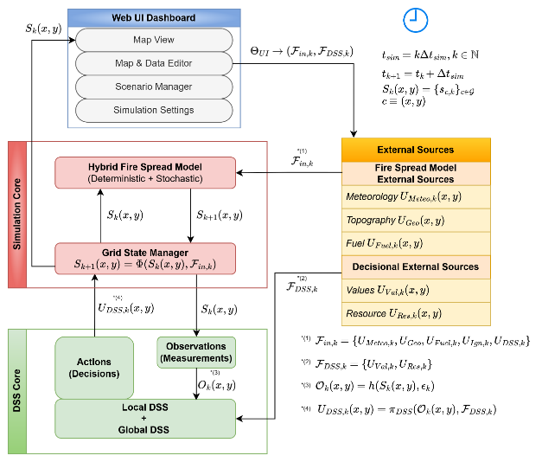
Takagi-Sugeno inference turns rule activations into a crisp action, replacing the consequent set with a function of the inputs and taking the output as a firing-strength weighted average [26]. DisasterAware adopts the zero-order Takagi-Sugeno form, every consequent a constant intensity on the unit interval, stated in full in Section IV. The choice is architectural: candidates are judged inside shadow forecasts run thousands of times per incident, so centroid integration per evaluation would be too costly, the outputs are intensity commands, and adaptation needs numeric consequents with predictable effect while antecedents stay linguistic. Fig. 1 depicts 5-term trapezoidal partition; adjacent terms overlap so every reading activates at most two terms.
Fig. 1. DisasterAware system block diagram (simulation focused).
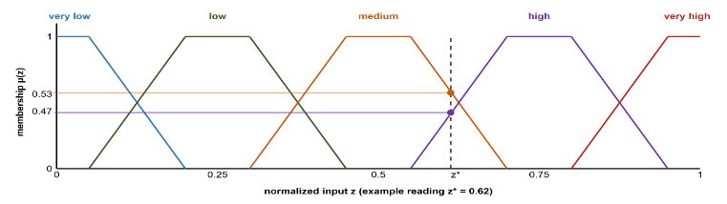
Applying fuzzy inference directly over a rich observation vector is combinatorially infeasible: a complete rule base over the full feature set has the size given in ( 4 ): ten features with five terms each demand nearly ten million rules, which no expert can author or audit. A conceptual middle layer reduces this, six base concepts summarizing physically related features and five decision concepts answering, each exactly once, the operational questions commanders ask [6, 31]; a single top concept, operational priority, serves cross-region coordination. Rules are written over the five decision concepts only, so the rule burden collapses from a product to a sum ( 5 ). The antecedent space shrinks to 3125 combinations, only the active subset instantiated, and the concepts double as the traceability vocabulary: every recommendation reads back over fire threat level, suppression feasibility, asset exposure risk, intervention urgency, and evacuation pressure.
Fig. 2. Five-term trapezoidal membership partition with an example reading.
$$|R|={N_{term}}^{N_{feature}}$$ | ( 4 )
$${N_{term}}^{N_{feature}} ⇢ N_{concept}⋅{N_{term}}^{N_{input}}+{N_{term}}^{N_{concept}}$$ | ( 5 )

G. The Decision Space: Interventions and Their Evaluation
The rules assign intensities to concrete actions. The decision space is built from six intervention families, each applied with an intensity over the grid, so every rule binds to an executable order [6]: suppression effort [25], resource deployment [23], containment line, asset protection [16], evacuation, and public warning [18]. The list is closed, keeping the vocabulary interpretable; openness enters through new rules and compositions over the same families. Beneath them the simulator verifies physical effects (wet, clear, ignite, coat, draft, evacuate, prime) and three channels built on them, water drafting, retardant drop, and tactical burn. Inaction is the zero-intensity point of every family, so the cost prices restraint as it prices action.
A candidate intervention is evaluated through its expected cost, following the cost-plus-loss principle of wildfire economics [6, 25]. Global minimization over a spatial decision field is intractable under real-time constraints and needs information incomplete observation cannot supply, so acceptance is satisficing [28]. The dominant uncertainty is epistemic, the state under-observed rather than noisy [20], and Bayesian or Dempster-Shafer treatments presuppose distributional knowledge that real-time sensing lacks [21]. Explanation is structural, over explicit concepts and rules, not post-hoc attribution [4]. Generative proposers may be wrong or unsafe, so proposals are untrusted by construction and admitted only after verification, as Section IV develops.

III. System Architecture and Interface Contracts

A. Entities, Responsibilities, and Interfaces
Fig. 2 presents DisasterAware as a system of systems with five kinds of participant: external providers that supply weather, imagery, terrain, and resource status; a simulation core that owns the hazard state; N local decision agents, each responsible for one region; a coordination layer that allocates capacity without performing inference; and a commander who supervises through the dashboard. Participants meet only at declared interfaces. The simulation core is authoritative, since cells carry burning status, fuel mass, an intensity proxy, and time since ignition and no other participant may write this state; the decision agents read derived observations, and the dashboard admits only reversible, input-level actions such as pause, rollback, ignition injection, and resource changes.

B. External Inputs and Decision Context
The external input set ( 6 ) collects the parameters that influence wildfire evolution at step k: meteorological forcing (temperature, humidity, wind, gusts, precipitation), topography (elevation, slope, aspect, accessibility), fuel conditions (class, load, moisture), ignition injection, and the DSS intervention parameters (capacity, availability, effectiveness, travel time). A separate contextual set guides decision generation only: a value layer aggregating buildings, critical facilities, population, and evacuation access into a protection priority score, and a resource layer of available capabilities. It never touches fire dynamics, keeping modeling and reasoning separate.
$$F_{in,k}=\left\{U_{Meteo,k},U_{Geo}, {U_{Fuel\text{,k}}, U_{Ign,k}, U}_{DSS,k}\right\}$$ | ( 6 )

C. State Representation and Transition
The landscape is discretized into a rectangular grid, and at each simulation step the wildfire state is the collection of local cell states ( 7 ), each cell carrying burning status, fuel mass, an intensity proxy, and time since ignition, with environment and interventions entering only as external inputs. The global evolution ( 8 ) is a structured transition operator over burning status, fuel mass, and intensity, illustrated in Fig. 3. The operator is deterministic; stochastic variability enters only through exogenous fields such as wind gusts and, in one controlled channel, seeded ember spotting.
$S_{k}=\left\{s_{k}\left(x,y\right)|(x,y)∈G\right\}$; $s_{k}=\left[\begin{aligned}B_{k}\left(x,y\right) \\ F_{load,k}\left(x,y\right) \\ I_{k}\left(x,y\right) \\ τ_{k}\left(x,y\right)\end{aligned}\right]$ | ( 7 )
$$S_{k+1}\left(x,y\right)=Φ\left(S_{k}\left(x,y\right),F_{in,k}\right)$$ | ( 8 )

D. Hybrid Fire Spread Model
A cell burns through persistence while fuel remains, through propagation from burning neighbors, or through external ignition. Propagation fires when the influence accumulated over the 8-connected neighborhood exceeds a calibrated threshold, each neighbor contributing a Rothermel-type rate of spread from wind, slope, aspect, moisture, and fuel type [7], weighted toward the wind. Ember spotting, the only stochastic element, carries fire several cells downwind and across narrow barriers such as rivers, roads, and containment lines. Precipitation raises dead fuel moisture above the extinction level so a front dies out gradually, and the equilibrium moisture mode lets diurnal weather modulate flammability.

E. Fuel Mass, Suppression, and Intensity
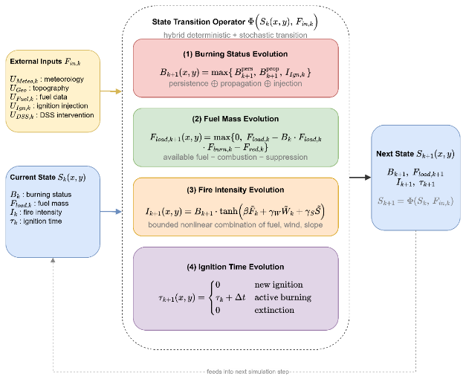
Fuel mass decreases through combustion and suppression, never below zero. Suppression converts capability into a normalized fuel reduction, gated by capacity and availability, decaying with travel time and poor access, and attenuated by local fire intensity; it never overwrites the burning state but acts on the fuel, which shapes persistence and propagation. A local intensity proxy from fuel, wind, and slope modulates suppression effectiveness and feeds the decision layer without controlling ignition or spread.
Fig. 3. State transition block diagram.

F. Interaction, Counterfactual Replay, and the DSS Interface
The commander acts only through bounded input modifications, never through the state, so interaction stays prospective and reversible. Per-step snapshots, including the random number generator, enable exact counterfactual replay: runs from the same snapshot differ only in the orders under test, which is the basis of the paired comparisons of Section V. The decision layer reads the state through the observation interface ( 9 ): the observation function projects the state onto observable information, injecting epistemic uncertainty at this point only, and the aggregated intervention field re-enters the simulation as one component of the external input set.
$$S_{k}\left(x,y\right)→ O_{k}\left(x,y\right),F_{DSS,k}→U_{DSS,k}\left(x,y\right)→Φ\left(∙\right)→S_{k+1}\left(x,y\right)U_{DSS,k}\left(x,y\right) = π_{DSS}^{i}\left(O_{k}\left(x,y\right),F_{DSS,k}\right) ⊂ F_{in,k}$$ | ( 9 )

IV. Distributed Decision Layer and Its Guarantees

A. Four-Layer Pipeline
Fig. 4 presents a Local DSS agent as a four-layer flow: the input space collects the measurements of Section II-E, the perception layer fuses them into bounded features with explicit confidence, the concept space abstracts them, and the decision space generates, adapts, and evaluates interventions. N agents run this loop over their own regions, coordinated by the Global DSS through priorities and shared resource pool.
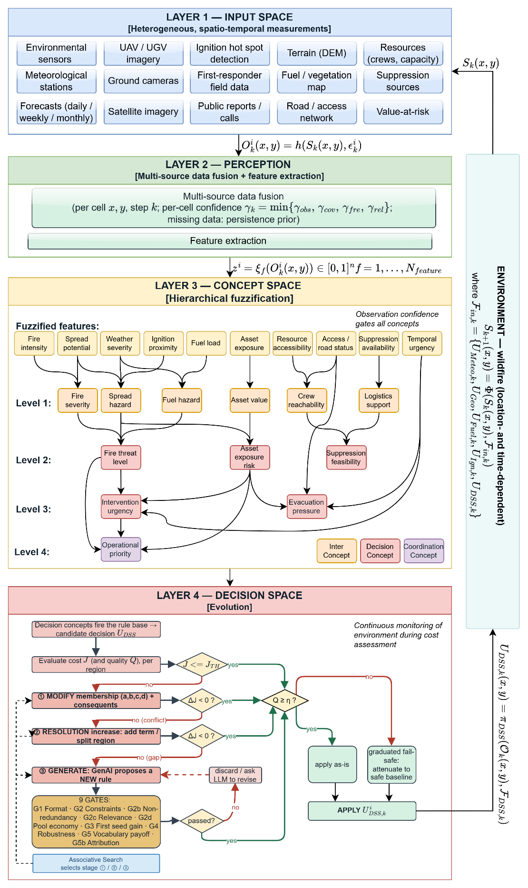
Fig. 4. DisasterAware system block diagram (DSS focused).

B. Observation, Features, and Confidence
Each Local DSS agent receives at step k the region-restricted observation ( 10 ), where the observation function projects the authoritative state onto the cells of the region and injects epistemic uncertainty. That uncertainty comes from missing knowledge rather than randomness, such as an occluded camera or a revisit gap, and no distribution over the error is assumed. Every observed cell carries a confidence composed from observability, coverage, freshness, and reliability as their minimum ( 11 ) rather than their average. Confidence bounds the error instead of describing it statistically: its magnitude is limited by the complement of the confidence ( 12 ), so full confidence is exact and vanishing confidence admits the worst case. The agent then computes the ten features ( 13 ), each inheriting a feature-level confidence from the observation fields its extraction consumes, so the pair of feature value and feature confidence is the complete interface between perception and reasoning.
$$O_{k}^{i}\left(x,y\right)=h^{i}\left(S_{k}\left(x,y\right), ε_{k}^{i}\left(x,y\right)\right), \left(x,y\right)∈G^{i}$$ | ( 10 )
$$γ_{k}^{i}\left(x,y\right)=min⁡\{γ_{obs},γ_{cov},γ_{fre},γ_{rel}\}$$ | ( 11 )
$$|ε_{k}^{i}\left(x,y\right)|≤(1-γ_{k}^{i}\left(x,y\right))⋅ε_{max}$$ | ( 12 )
$$z_{f,k}^{i}=ξ_{f}\left(O_{k}^{i}\right)∈[0,1], f=1,…,N_{feature}$$ | ( 13 )

C. Concept Space and Confidence Gating
The conceptualization layer of Fig. 5 maps physically related features into six base concepts, the base concepts into three mid-level and two higher-level decision concepts, and finally into the single coordination concept. The activation of a base concept is the weighted sum of the term memberships of its features, and the activation of every higher concept is the weighted sum of the activations of the concepts in its set, with nonnegative weights normalized to one ( 14 ). Raw activations are never consumed directly. Every activation is gated by its observation confidence and blended with a persistence-carried prior ( 15 ): a reliable observation passes unchanged, an uninformative one falls back to the decayed previous estimate, and an unobserved concept fades geometrically. The trust-caution transition is linear with no threshold to tune, and the activation snaps back as soon as confidence returns.
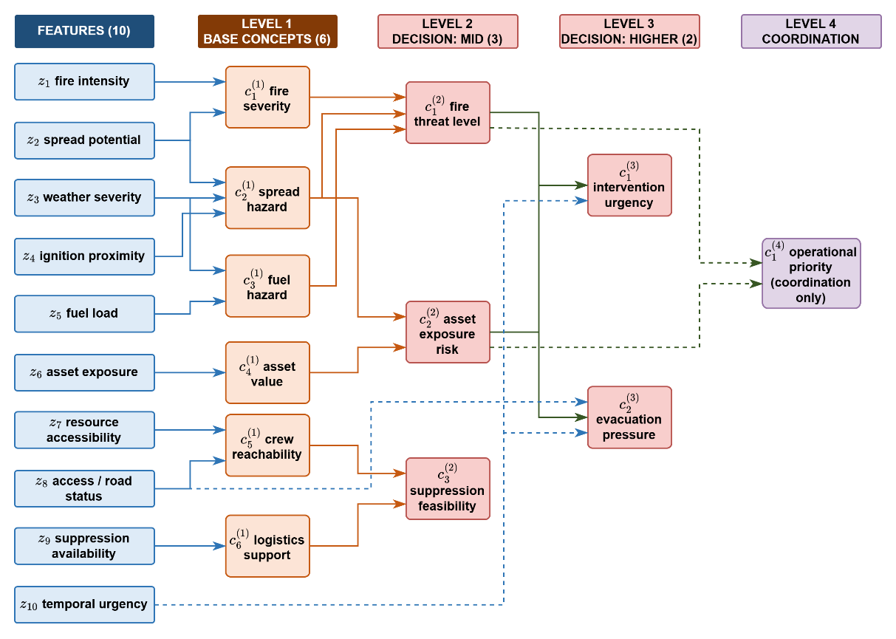
Fig. 5. Feature-concept hierarchy.
$$a_{n,k}^{(1),i}=\sum_{f∈Z_{n}}{ω_{n,f}⋅μ_{A_{n,f}}\left(z_{f,k}^{i}\right)} \\ a_{n,k}^{(l),i}=\sum_{m∈C_{n}^{(l)}}{ω_{n,m}^{(l)}⋅a_{m,k}^{(l-1),i}}, l=2,3,4$$ | ( 14 )
$$a_{n,k}^{eff,i}=γ_{n,k}^{i}⋅a_{n,k}^{obs,i}+\left(1-γ_{n,k}^{i}\right)⋅ρ⋅a_{n,k-1}^{eff,i}, \\ γ_{n,k}^{i}=min⁡\{γ_{f,k}^{i}:f∈Z_{n}\}$$ | ( 15 )

D. Rule Base and Candidate Intervention
Decision rules are written exclusively over the five gated decision concepts in the canonical conjunctive form ( 16 ): each antecedent clause tests one concept against one linguistic term and the consequent assigns a singleton intensity to each family. A rule fires with the strength of its weakest satisfied clause, and the candidate is assembled family by family from the rules that fire ( 17 ), with the denominator floored at one so a weakly supported conclusion yields a weak order. The base is sparse: of 3125 combinations it holds only the seeded doctrine and what adaptation adds, at no cost to coverage, since adjacent terms overlap. The seeded base satisfies the coverage condition ( 18 ), so some rule fires above the coverage floor of 0.05 at every reachable reading; below the floor the layer falls back to the watchful posture and adaptation is triggered. Each concept has a primary family, suppression feasibility acting as gatekeeper, and a run starts from five seed rules.
$$R_{r}: IF a_{1,k}^{eff,i} is A_{r,1} AND … AND a_{5,k}^{eff,i} is A_{r,5} THEN U_{DSS,k}^{i} is B_{r}$$ | ( 16 )
$$u_{m,k}^{i} = \frac{\sum_{r}{α_{r} v_{r,m}}}{max(1, \sum_{r}{α_{r}})} \\ α_{r} = \min_{n ∈ ant(r)} μ_{A_{r,n}}(a_{n,k}^{eff,i})$$ | ( 17 )
$$\min_{a^{eff}∈[0,1]^{5}} \max_{r} α_{r}\left(a^{eff}\right)≥α_{min}>0$$ | ( 18 )

E. Cost, Quality, and Satisficing Acceptance
The decision and adaptation flow of Layer 4 is summarized in Fig. 6. Every candidate is judged on a shadow copy of the simulation before anything reaches the field: the cost asks what it is expected to cost the incident, the quality whether it serves the concepts that demanded it.
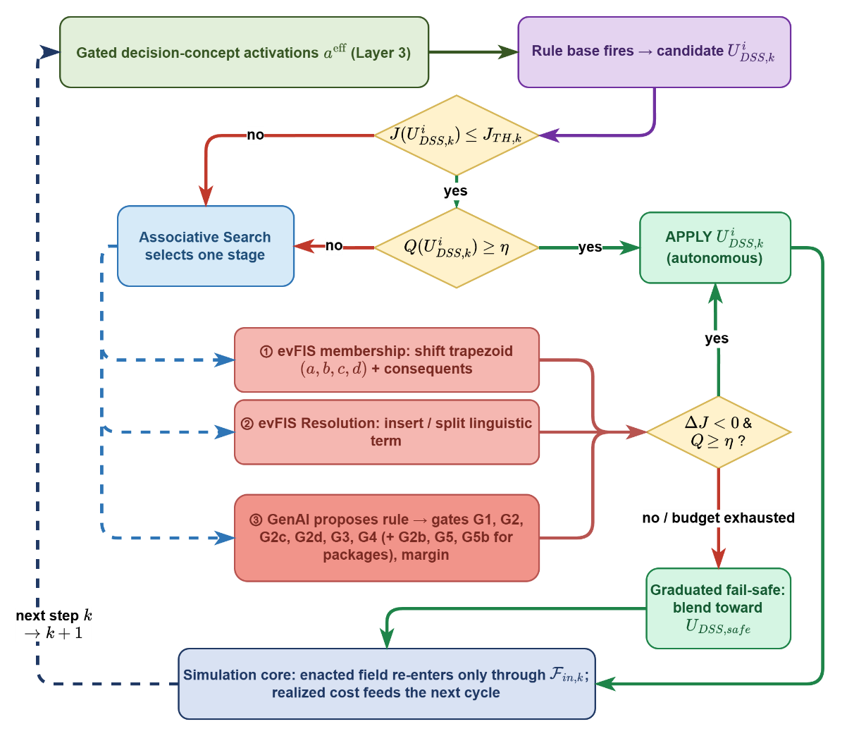
Fig. 6. Layer 4 decision and adaptation flow.
The cost is the weighted five-term sum over burned area, asset loss, population exposure, response effort, and response delay, each normalized by a scenario reference: burned area through a rational form that keeps every saved cell worth saving, population as person-steps inside burning cells, response as the time integral of committed force, and delay against a sixty-minute reference. The candidate is held constant over a forecast horizon and compared with a no-action shadow run from the same state, and acceptance is satisficing ( 19 )( 20 ): the bound is the tighter of a fixed ceiling of 0.35 and a required relative gain over the no-action forecast, so cheap inaction demands a stronger candidate; failing the test leaves the standing orders in force while adaptation runs. Cross-run comparisons read the physical cost only, because a run that never intervenes carries no response cost and a total-cost comparison would reward inaction.
$$J=\frac{\sum_{j}{w_{j}J_{j}}}{\sum_{j}{w_{j}}}, j∈\left\{burn, asset, pop, resp, delay\right\} \\ J_{burn}=\frac{\frac{N_{burned}}{ρ_{burn}⋅N_{burnable}}}{1+ \frac{N_{burned}}{ρ_{burn}⋅N_{burnable}}} \\ J_{asset}=\frac{V_{lost}}{V_{total}}J_{pop}=\min\left(1, \frac{P_{steps}}{P_{total}⋅N_{decisions}}\right) \\ J_{resp}=\min\left(1, \frac{C_{steps}}{C_{ref}⋅N_{decisions}}\right) \\ J_{delay}=min(1, \frac{\overline{τ}}{τ_{reference}})$$ | ( 19 )
$${\hat{J}}_{k}\left(U_{DSS,k}\right) ≤ min(J_{TH}, (1-δ_{gain})⋅{\hat{J}}_{k}(0))$$ | ( 20 )
The quality measures what the cost cannot. For each scored concept, the gated activation is compared with the strongest intensity the candidate assigns to the family that answers it, and the quality is one minus the mean mismatch ( 21 ). Over-suppression at low threat is penalized as much as ignoring high evacuation pressure, so misdirection is caught before its consequences appear; suppression feasibility modulates rather than demands. Below the quality gate of 0.60 the graduated fail-safe attenuates the candidate toward a pre-authorized conservative posture in proportion to the deficit: the offensive families, suppression effort, resource deployment, containment line, and asset protection, are scaled down, while evacuation and public warning are never reduced. The transition is reversible as observation quality recovers, and if the adapted candidate is still forecast worse than inaction, a no-harm rule withholds the offensive allocation over a lookahead, so interventions maturing in thirty to sixty minutes are not punished prematurely.( 22 )
$$Q_{k}=1-\frac{1}{4}\sum_{n∈C_{Q}}{|{a_{n}}^{eff}-\max_{f∈F(n)} u_{f}|}, accept ⇔ Q_{k}≥η$$ | ( 21 )
$${U_{DSS,k}}^{'}=λ_{k}⋅U_{DSS,k}+\left(1-λ_{k}\right)⋅U_{DSS,safe} , λ_{k}∈[0,1]$$ | ( 22 )

F. Open Intervention Space: Staged Adaptation
Adaptation has three stages of increasing invasiveness, engaged only when the standing decision demonstrably falls short: a cost deficit, a coverage gap while fire is alive, or renewed spread under applied orders. Stage 1 tunes rules already in the base with two bounded moves illustrated in Fig. 7: the consequent step ( 23 ) nudges the intensity of a rule by a fixed 0.05 within the unit interval, and the boundary shift moves the shared edge of two neighboring terms while preserving the partition of unity. Every trial is kept only when the forecast physical cost strictly falls and rolled back otherwise; trials act on a working copy, so the seed base is never modified. Stage 2 grows the base: it writes a rule on the uncovered combination of the two most active concepts, and where a covered combination is ambiguous it inserts a narrow term at the crisp reading; inserted terms stay outside the Layer-3 aggregation.( 24 )
$$v_{r,m}←clip_{0,1} \left(v_{r,m}±δ\right), m∈cons\left(r\right)$$ | ( 23 )
$$kept ⇔ Δ{\hat{J}}_{phys}<0$$ | ( 24 )
Stage 3, the generative layer, adds knowledge that neither tuning nor instantiation can produce. The proposer is a pretrained language model used in context only, with no task-specific training: it receives a deterministic situation summary, the active rule base in IF-THEN form, and the coverage verdict, and returns exactly one proposal in the canonical rule form. The stage produces four kinds of output: a plain rule, a macro intervention blending existing interventions, an intermediate concept that joins the hierarchy like a native one, and a clause actuator carrying its own map geometry. Its vocabulary is deliberately primitive, the verified action list, a geometry of sectors and distance bands, and the map affordances, so an intervention is composed rather than picked from a menu: given a lake near the front, the stage can compose an actuator that drafts from it and wets the fuel ahead of the head, which no seed rule contains; the basis itself is not proposable, so the space stays closed at effects yet open at interventions. Every proposal is untrusted by construction and passes the applicable gates of Fig. 8: G1 format, G2 vocabulary, ranges, and duplication, G2b concept non-redundancy, G2c relevance, and G2d pool economy, all without a simulation step; G3 and G4 then demand that the forecast physical cost strictly fall on two independently seeded rollouts ( 25 ), G5 requires a package to clear an additional
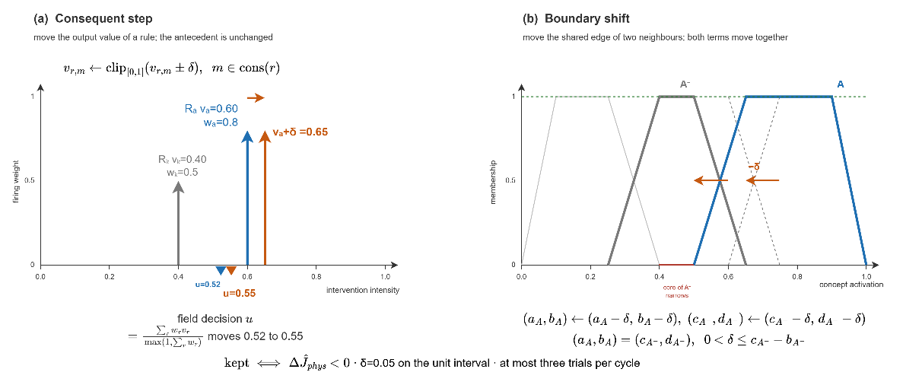
Fig. 7. Consequent step and boundary shift.
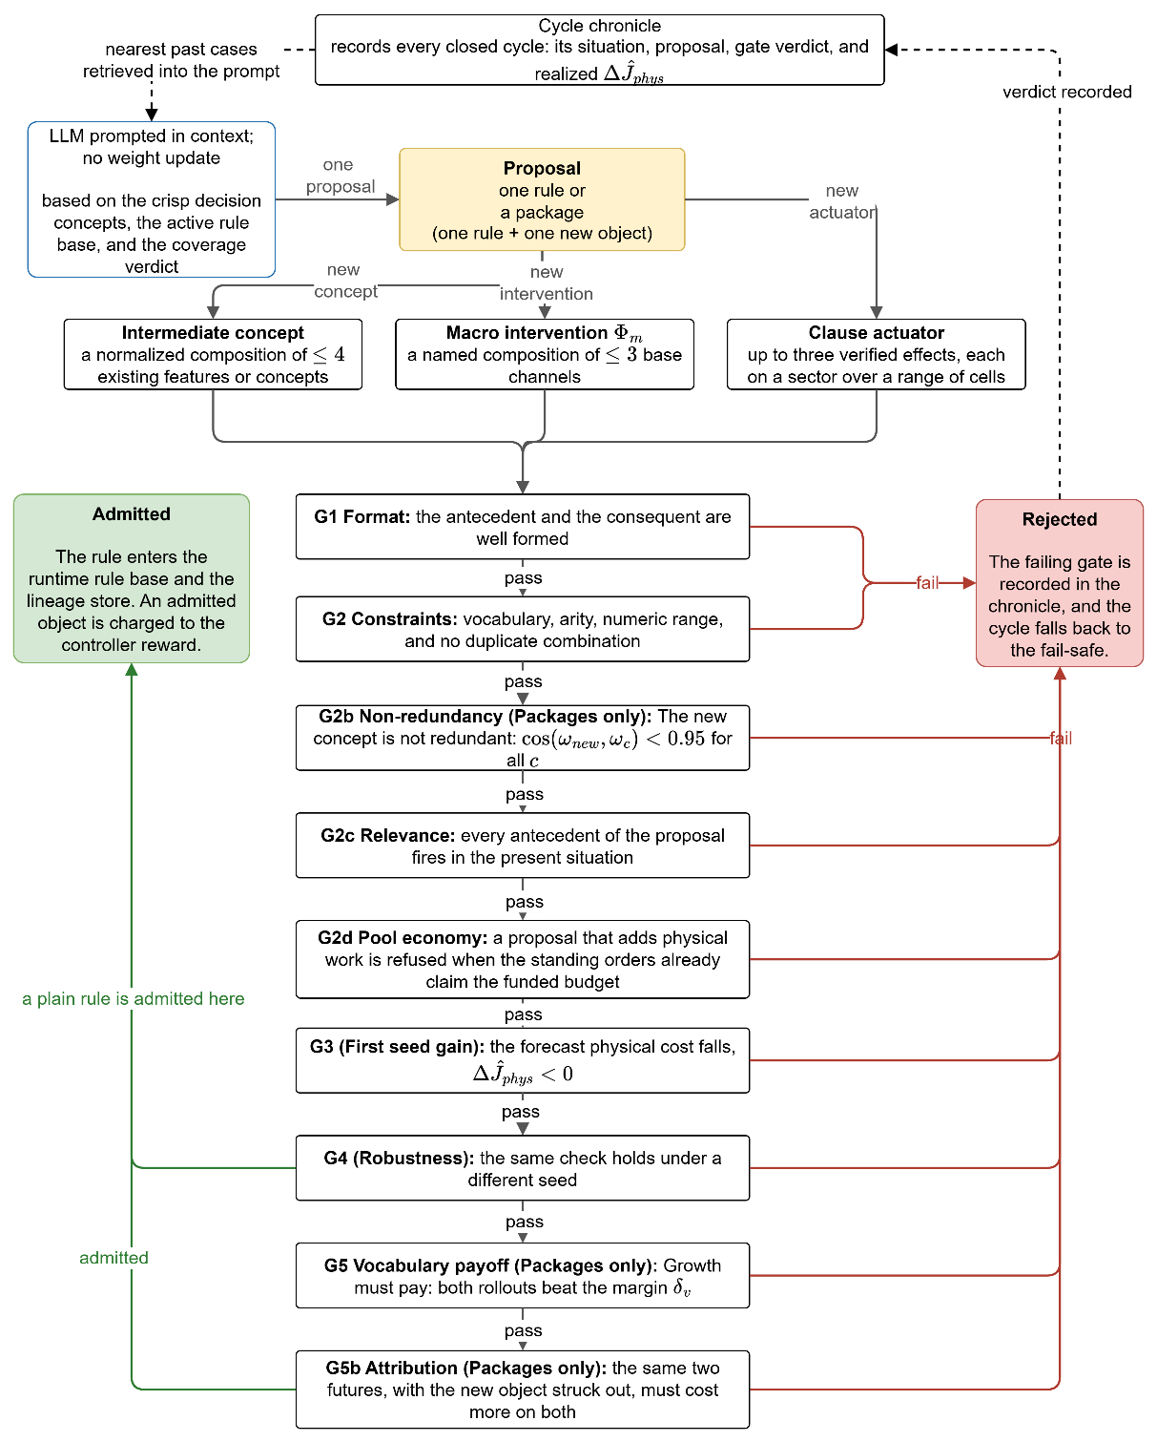
Fig. 8. Generative proposal and the verification gates.
$$Δ{\hat{J}}_{phys}^{\left(ν\right)}={\hat{J}}_{phys}^{\left(ν\right)}\left(R∪\left\{r^{'}\right\}\right)-{\hat{J}}_{phys}^{\left(ν\right)}\left(R\right), ν∈\left\{V_{a},V_{b}\right\}$$  $$G3: Δ{\hat{J}}_{phys}^{(V_{a})}<0;G4: Δ{\hat{J}}_{phys}^{(V_{b})}<0$$ | ( 25 )

G. Global Coordination and the No-Harm Guard
The coordinator performs no inference: each agent sends up its operational priority, its resource request, and a confidence summary, and receives back the allocation, the normalized priority weights, and the acceptance thresholds in force. Regions are ranked by operational priority, and each receives an attention share ( 26 ): a region near the top priority keeps the full share, a monitored region gets a reduced share floored at 0.50 and a stricter quality threshold for offensive orders; evacuation and warning are untouched. The merged plan is forecast by the no-harm guard against inaction, and offensive orders are withheld when it is worse while life-safety orders stand. Every decision remains traceable end to end, with fired concepts, rules, strengths, input confidences, and gate verdicts recorded, so explanation is structural rather than post-hoc.
$$σ_{i}=\left\{\begin{aligned}1,\text{ if }p_{i}≥τ_{att}p_{\text{max}} \\ 0.5+0.5\frac{p_{i}}{p_{\text{max}}},\text{ otherwise}\end{aligned}\right.$$ | ( 26 )

H. Guarantees
The gates of this section give the architecture four properties that hold whatever produced the candidate order. All four are stated over the forecast physical cost of Section IV-E, evaluated on a shadow copy of the simulation against the no-action forecast from the same state.
Proposition 1 (no-harm). No order reaches the field whose forecast physical cost exceeds the no-action forecast over the guard horizon. Acceptance admits a candidate only below the satisficing bound, and the no-harm rule withholds the offensive allocation whenever the adapted candidate is still forecast worse than doing nothing. Both tests read the same forecast, so an admitted order is never predicted to cost more than inaction.
Proposition 2 (life-safety invariance). Evacuation and public warning intensities are never reduced by any gate. The graduated fail-safe scales the offensive families only, and the no-harm rule withholds the offensive allocation only; neither map has the two life-safety families in its domain.
Proposition 3 (coverage). At every reachable reading either some rule fires above the coverage floor, or the layer falls back to the pre-authorized watchful posture and triggers adaptation. The seeded base satisfies the coverage condition, and a reading below the floor is detected by the same test that reports the gap, so the system is never without a defined response.
Proposition 4 (bounded growth and termination). The objects admitted during one incident are finite in number and the adaptation ladder terminates. Stage 1 acts on a finite rule set with a fixed step, stage 2 inserts at most one term per ambiguous combination, and stage 3 runs only on a logged deficit under a revision budget. Every stage is a monotone test on a working copy, so the ladder halts once no trial improves the forecast.

V. Results

A. Evaluation Criteria
The technical tradition evaluates the predictive models inside a tool on real fires, while the decision-support tradition evaluates its effect on the decision itself, and most wildfire DSS evaluations measure adoption rather than decision improvement [19]. Both are addressed through the eight criteria of Table III, fixed in advance and audited at the end of this section.
TABLE III
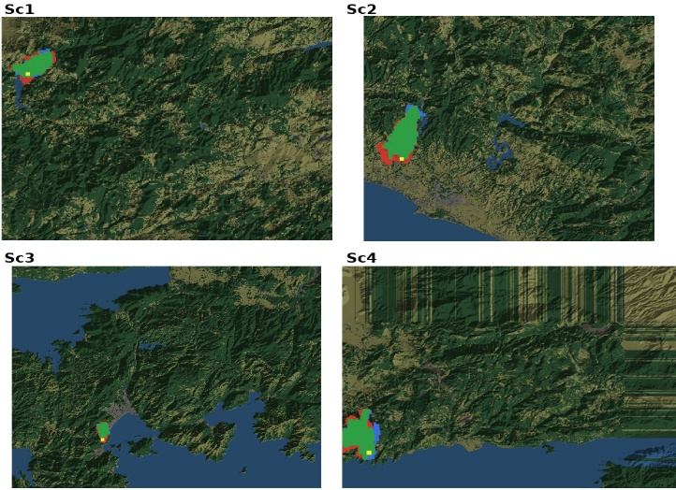
Evaluation criteria for wildfire decision support systems
Fig. 9. Hindcast agreement maps (green: predicted burn; red: simulated only; blue: observed only; yellow: ignition).

Criterion | Measurement in the literature
Predictive fidelity | Retrospective hindcasts against historical fires; spatial-overlap and arrival-time scores
Decision quality | Outcome deltas against no-action and baseline policies on matched scenarios
Timeliness | Decision-cycle wall time; detection-to-first-order time
Robustness | Performance versus outage and noise level; fail-safe engagement statistics
Uncertainty handling | Ensemble and input-uncertainty propagation studies
Adaptability | Learning curves; coverage growth; rediscovery of withheld knowledge
Explainability and auditability | Trace completeness; interpretability as an adoption gate
Scalability | Runtime and quality versus grid size and agent count

B. Validation of the Simulation Core
The simulation is tested by blind hindcast: it receives only the real inputs of a documented fire, with no tuning on that fire, and its output is compared with the satellite record. Terrain comes from the Copernicus GLO-30 model, fuel from ESA WorldCover 2021, weather from ERA5 reanalysis, and ignition points and reference burn from NASA FIRMS VIIRS detections. Four documented fires in Türkiye cover different fuel, terrain, and wind conditions: Sc1 Manavgat and Sc2 Marmaris (July 2021, 48 h), Sc3 Milas-Kemerköy (August 2021, 72 h), and Sc4 Çanakkale-Kayadere (August 2023, 48 h). Because the core models free spread without suppression, a free run overpredicts the final area, so three suppression-robust criteria are used: the probability of detection ( 27 ), accepted at 0.70 for calibrated growth models [34]; the front position error relative to the equivalent burn radius ( 28 ), ( 29 ); and the arrival-time agreement ( 30 ), the direct rate-of-spread test. Table IV reports the metrics over 50 replicates in Fig. 9 the agreement maps: overall agreement is 86 to 94 % and detection probability 85 to 97 %, the reliability of a well-behaved
$$POD=\frac{|{FR}_{Sim}∩{FR}_{Re}|}{|{FR}_{Re}|}$$ | ( 27 )
$$D(x,G_{Set})=\min_{y∈G_{Set}}‖x-y‖\overline{d_{Front}}=\frac{Σ_{x∈∂{FR}_{Sim}}D(x,∂{FR}_{Re})+Σ_{y∈∂{FR}_{Re}}D(y,∂{FR}_{Sim})}{|∂{FR}_{Sim}|+|∂{FR}_{Re}|}$$ | ( 28 )
$$R =\sqrt{\left(\left|N_{burned}\right| A_{cell}\right)/π}, {TH}_{Front}=1-\frac{\overline{d_{Front}}}{R}$$ | ( 29 )
$$τ_{MAE}=\frac{1}{N_{cells}}Σ_{c∈{FR}_{Sim}∩{FR}_{Re}}\left|t_{c}^{Sim}-t_{c}^{Re}\right|; N_{cells}=|{FR}_{Sim}∩{FR}_{Re}|{TH}_{MAE}=1-τ_{MAE}/T$$ | ( 30 )
TABLE IV
Hindcast agreement metrics per historical case
Metric | Sc1 | Sc2 | Sc3 | Sc4
Front distance (m) | 329 | 305 | 113 | 391
Arrival-time MAE (h) | 1.46 | 1.39 | 4.04 | 2.58
Front agreement | 82% | 90% | 89% | 89%
Time agreement | 90% | 98% | 71% | 96%
Probability of detection | 92% | 93% | 97% | 85%
Overall success | 88% | 94% | 86% | 90%

C. Experimental Setup and Sensitivity Analysis
Synthetic scenarios use 72 by 50 cell grids at 30 m with terrain, land cover, settlements, roads, and capacity-limited bases; historical scenarios reconstruct the documented fires. Unless stated otherwise the engine runs with the thresholds of Section IV, a two-minute physical step, a twelve-minute decision cycle, a 24-minute planning horizon, a satisficing bound of 0.35, and a quality gate of 0.60, with episodes run to extinction or a twelve-hour cap. Sensitivity is assessed one parameter at a time over five worlds, 880 runs in total. Fig. 10 maps the physical cost as a share of the free burn: at a tenth of the pool the fire is lost (77 to 83 %) and with a full pool and few ignitions it is held (14 to 32 %), so the sweeps run at the decidable midpoint, four ignitions with a quarter of the pool. Observation decides light fire loads and resources heavy ones, and the satisficing bound sets how often the ladder engages, 42 % of cycles at 0.35.

D. Performance of the Decision Layer
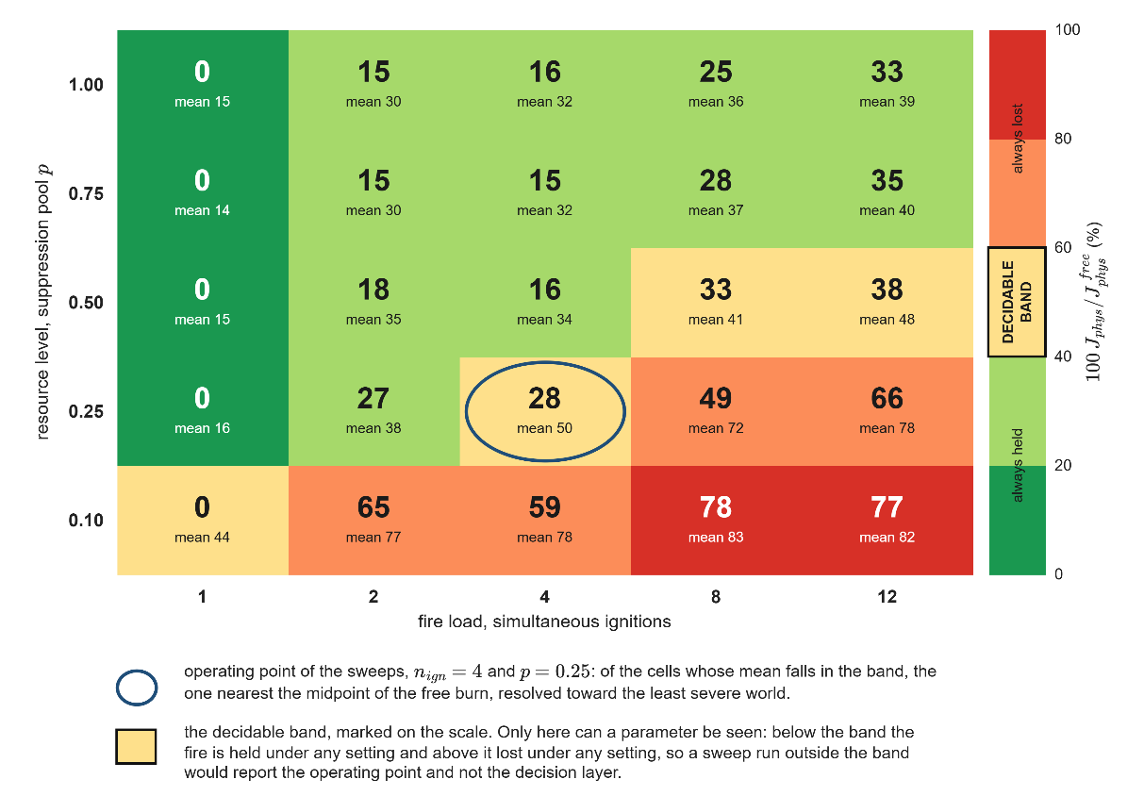
Fig. 10. Physical cost over ignitions and resource level, as a share of the free burn.
Four configurations face identical fires: T0 issues no orders and fixes the cost of inaction; F5 runs the decision layer on the minimal seed base of five rules and never changes it; F5+Ev adds the evolving-fuzzy stages 1 and 2, so the doctrine tunes its parameters and grows its resolution but never its vocabulary; and DisasterAware runs the complete staged adaptation, the open decision space in full. Every seed generates one world that all four configurations replay identically, so the differences come from the decision mechanism alone, and evaluation seeds are disjoint from development. Five scenario families span remote forest and the wildland-urban interface under sufficient and limited resources, the fifth repeating the full stress scenario under degraded observation, all at critical fire weather; each family is run on 50 worlds, and the outcome is read at the end of the episode on the burned area, the affected population, the share of incidents extinguished within the episode, and the two costs of ( 31 ). In this campaign the generative stage of DisasterAware was fed by a deterministic stand-in proposer that writes rules over the existing vocabulary and one macro package through the same gate chain, so the margin of the last rung measures the open decision mechanism with the least capable proposer; the objects the language-model proposer composes are read from the recorded runs of Section V-E. Table V reports the ladder and Fig. 11 the burned area per family with 95 percent confidence intervals.
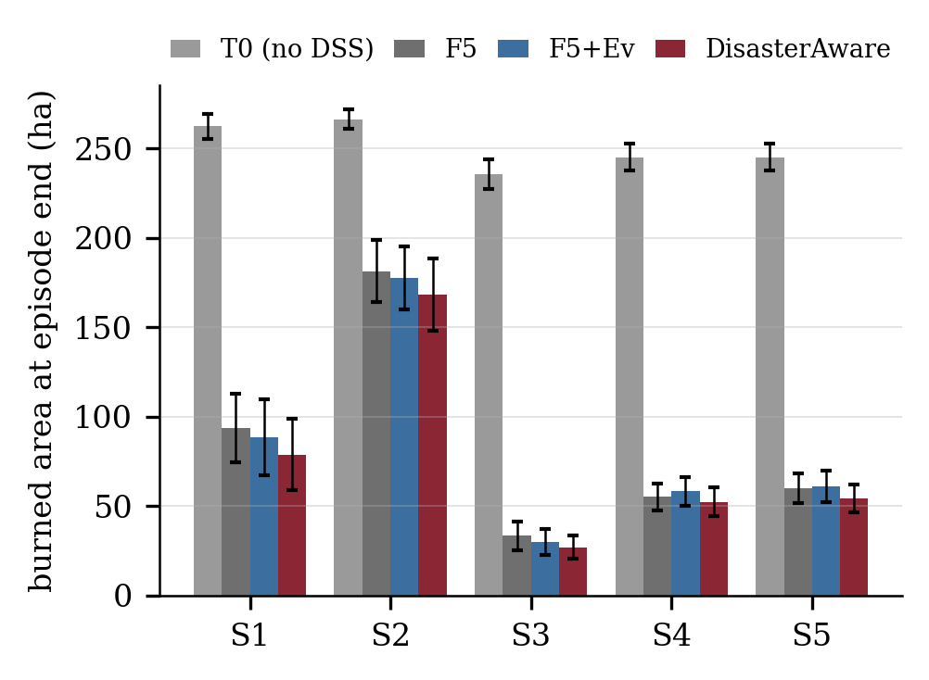
Fig. 11. Burned area at the end of the episode per scenario family and configuration; bars are means over 50 paired worlds with 95 percent confidence intervals.
F5 lowers the mean burned area from 251 ha under free burn to 85 ha, a 66 percent reduction, and the mean physical cost from 0.596 to 0.160; this gain belongs to the rule-based core itself, and the adaptation stages are read on top of it. F5+Ev adds a small but consistent gain: the burned area moves to 83 ha, the affected population from 498 to 396, and the share of incidents extinguished within the episode from 10 to 46 percent; the saving in total cost comes from the delay term (0.353 to 0.251), since tuned consequents commit the same resources sooner rather than committing more of them. DisasterAware supplies the next step. It raises the share of incidents extinguished to 52 percent, 5.0 times the static doctrine, lowers the affected population to 358 (28 percent below F5), lowers the burned area to 76 ha (70 percent below free burn and 10 percent below F5), and reaches the lowest physical cost (0.140) and total cost (0.168) of the four configurations, at a response cost no higher than that of the static doctrine (0.503 against 0.530). The margin over F5+Ev is consistent: DisasterAware burns less in 5 of the five families, and the paired difference in burned area against F5+Ev is 7 ± 4 ha (mean with 95 percent half-width over 250 paired worlds, DisasterAware better in 153), against F5 9 ± 4 ha, and against free burn 175 ± 8 ha. Under degraded observation (S5) the burned area of DisasterAware moves from 52.3 to 54.3 ha, a change of 4 percent that stays inside the confidence interval of either cell, and the configuration remains the best of the four, so reduced observation degrades the response instead of breaking it.
$$J_{Phy}=\frac{\sum_{j}{w_{j}J_{j}}}{\sum_{j}{w_{j}}}, j∈\left\{burn, asset, pop\right\} \\ J_{Tot}= \frac{\sum_{j}{w_{j}J_{j}}}{\sum_{j}{w_{j}}}, j∈\left\{burn, asset, pop, resp, delay\right\}$$ | ( 31 )
TABLE V
Outcome per scenario family and configuration at the end of the episode (mean over 50 paired worlds; ± is the 95 percent half-width)
Scenario / measure | T0 | F5 | F5+Ev | DisasterAware
S1 burned (ha) | 262.3 ± 7.1 | 93.5 ± 19.2 | 88.6 ± 21.1 | 78.7 ± 20.0
S2 burned (ha) | 266.4 ± 5.2 | 181.4 ± 17.6 | 177.5 ± 17.5 | 168.2 ± 20.0
S3 burned (ha) | 235.4 ± 8.2 | 33.5 ± 8.0 | 29.8 ± 7.3 | 27.0 ± 6.4
S4 burned (ha) | 245.1 ± 7.6 | 55.1 ± 7.3 | 58.2 ± 8.1 | 52.3 ± 8.1
S5 burned (ha) | 245.1 ± 7.6 | 60.0 ± 8.1 | 61.0 ± 8.9 | 54.3 ± 7.9
Mean burned (ha) | 250.8 | 84.7 | 83.0 | 76.1
Extinguished within episode | 0 % | 10 % | 46 % | 52 %
Affected population | 5775 | 498 | 396 | 358
Mean Jphys | 0.596 | 0.160 | 0.151 | 0.140
Mean Jtotal | (0.526) | 0.193 | 0.176 | 0.168

E. Open Intervention Space in Operation
Adaptation runs only on demand: it is triggered by a forecast cost above the satisficing bound or by a coverage gap while fire is alive, so the volume of trials measures how often the standing decision fell short and the acceptance rate how strictly the gates filtered the responses. In the recorded runs with the language-model proposer, 160 runs over 7130 decision cycles, stage 1 kept 129 of 616 consequent-step trials (21 %), stage 2 kept 40 of 359 (11 %) on antecedent cells left empty while fire was alive, and stage 3 was invoked 232 times with 47 admissions, 36 plain rules and 11 vocabulary packages. Of 157247 candidate interventions 151745 reached the field: the fail-safe engaged in 5338 region cycles and the no-harm veto held the offensive channels in 113. Fig. 12 shows the two evolving-fuzzy funnels and the generative cascade. The rule base grows from the five seed rules to 8.8 active rules on average at the end of an episode, and the rules born of adaptation carry 52 percent of the firing strength of the fielded decisions, so the orders behind Table V come in near equal measure from doctrine and from what the loop wrote during the incident.
Low acceptance rates are intended: trials are cheap and rejected safely on the forecast, and the selectivity of the gates is what makes the admitted edits trustworthy. Table VI lists the generative products: seven macro interventions and one intermediate concept, each born at a stated moment of a specific incident under a logged cost deficit. The three base channels they draw on, water drafting, aerial retardant drop, and tactical burn, are validated by the physics although no seed rule orders them, so a macro composes a capability the seed doctrine ignored rather than a new physical effect. The names describe intent rather than composition, and one product is listed under a corrected name, downwind_containment_shield, since its logged definition carries no igniting channel. The generated concept interface_exposure names the pressure building where exposed assets and evacuation demand meet, joins the hierarchy like a native concept, and is consumed by an admitted rule protecting the wildland-urban interface, so a concept the system introduced and a rule that uses it enter through the same gates.
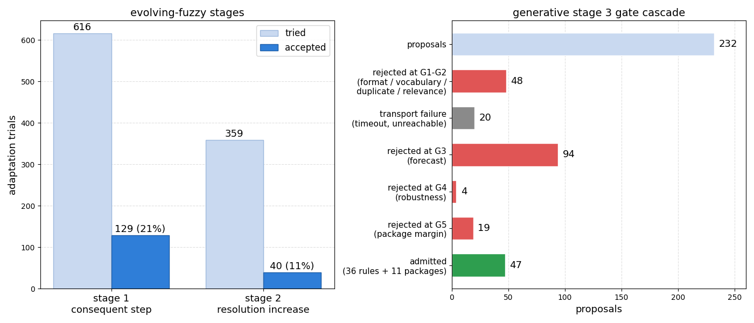
Fig. 12. Left: evFIS trials and acceptances at stages 1 and 2. Right: the generative gates over proposals.
TABLE VI
The generative product ledger: every object created, with its definition
Product | Definition
Action-list channels (3) | tactical burn (counter-fire strip ahead of the front); water drafting (capacity near water); retardant drop (coats fuel ahead)
Macros (7) | downwind_containment_shield: containment 1.0 + suppression 0.7; downwind_retardant_shield: retardant 1.0 + containment 0.8; drafting_sustained_attack: drafting 1.0 + suppression 0.9; head_knockdown: drafting 1.0 + suppression 0.9 + retardant 0.6; wet_containment_line: drafting 1.0 + containment 0.8; counterfire_strip: tactical burn 1.0 + containment 0.6; drafting_retardant_shuttle: retardant 1.0 + drafting 0.6
Concept (1) | interface_exposure = 0.5 asset_exposure_risk + 0.5 evacuation_pressure; consumed by admitted rule G14 (IF interface_exposure VH AND suppression_feasibility VH THEN asset_protection 0.9, containment_line 0.8, resource_deployment 0.7)
A second campaign tests whether the stage can create sited interventions, orders that carry their own map geometry and state where to act and how, in terms no base family expresses. Five seeds ran in two arms over 205 decision cycles under the same gates; the stage was entered 35 times and admitted 19 proposals, among them 7 of 14 sited interventions, 5 further intermediate concepts, and 1 further macro. They form two families: first-cycle orders coat assets and populated cells before the fire arrives, a preventive tactic absent from the seed doctrine, and minute-48 orders draft from the water body and evacuate behind the front, raising the yield of committed crews on a spent pool. One was later issued by a separately admitted rule and another through a concept the same campaign created.

F. Timeliness and Scalability
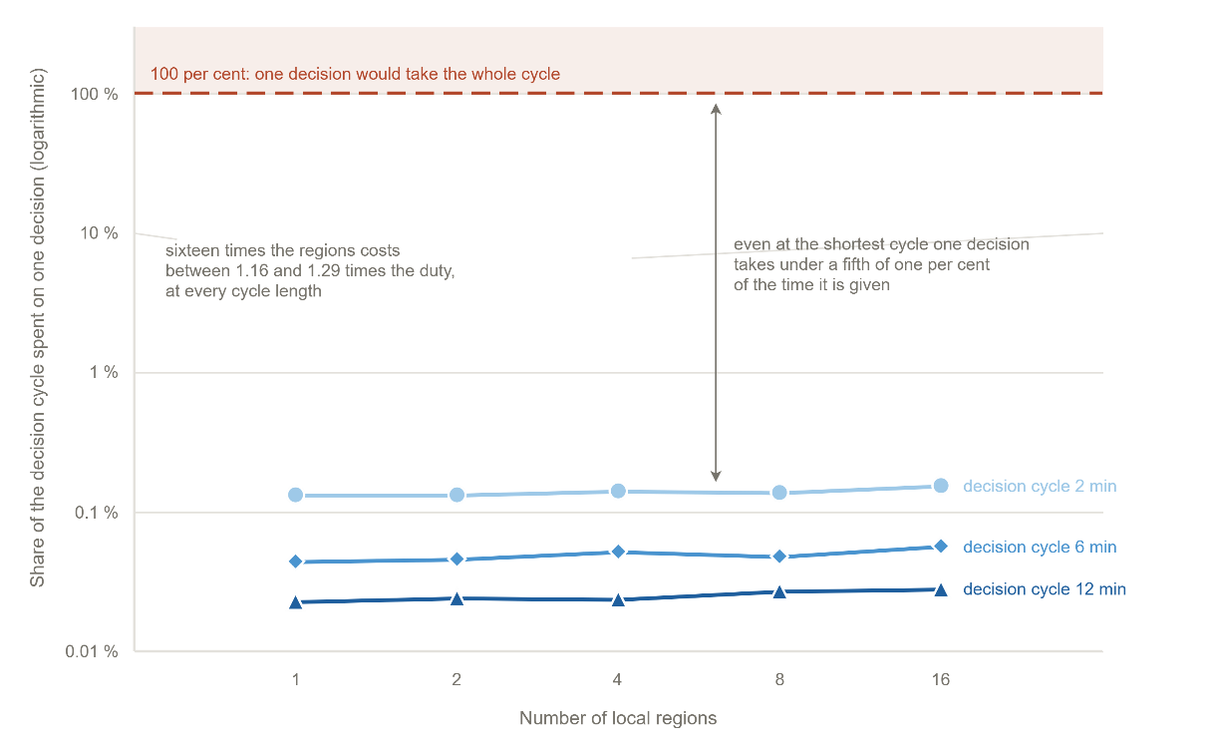
Fig. 13. Decision-layer cost against the number of local agents, as a share of the cycle.
One decision covers the whole loop, including the two shadow forecasts of the acceptance test and any adaptation stage that runs, and takes a median 274 ms against a twelve-minute cycle, 909 ms at the ninetieth %ile and 1.28 s at the slowest, under two thousandths of the time available; the first offensive order is fielded at the first decision, two minutes after ignition. reports the decision-layer cost for one to sixteen regions at cycles of two, six, and twelve minutes: every point lies between 0.02 and 0.16 % of the cycle, and sixteen times the agents cost only 1.16 to 1.29 times the share, since each agent reasons over its own region. Six times the forecast horizon raised the median by 1.4 and four times the grid by 6.9, so scalability holds on the axis the architecture is built for while domain size remains the binding limit.Fig. 13
The decision layer is also compared with an external reference: a value-weighted greedy allocation that shares the simulator, the worlds, the seeds, the resource pool, and the actuation mapping, and differs only in the decision. Every cycle it commits the pool toward the regions carrying the highest value at risk near the fire, at full intensity, with no forecast, no acceptance test, and no life-safety channel. Fig. 14 places it beside the internal configurations on the five scenarios. On raw burned area the greedy reference is strong: with the same fire location every arm of this campaign receives, an immediate full commitment ends most episodes early, and the response term prices only the time integral of committed force, so the early surge is barely charged. Its margin narrows on the capacity-limited scenarios, and it issues no evacuation or warning order in any of the fifty runs, since it has no channel for them. The comparison therefore bounds what undivided aggression buys in this cost model, and locates the contribution of the architecture in what the reference cannot produce: screened orders that remain auditable, restraint under a capacity or observation deficit, and the life-safety channels.
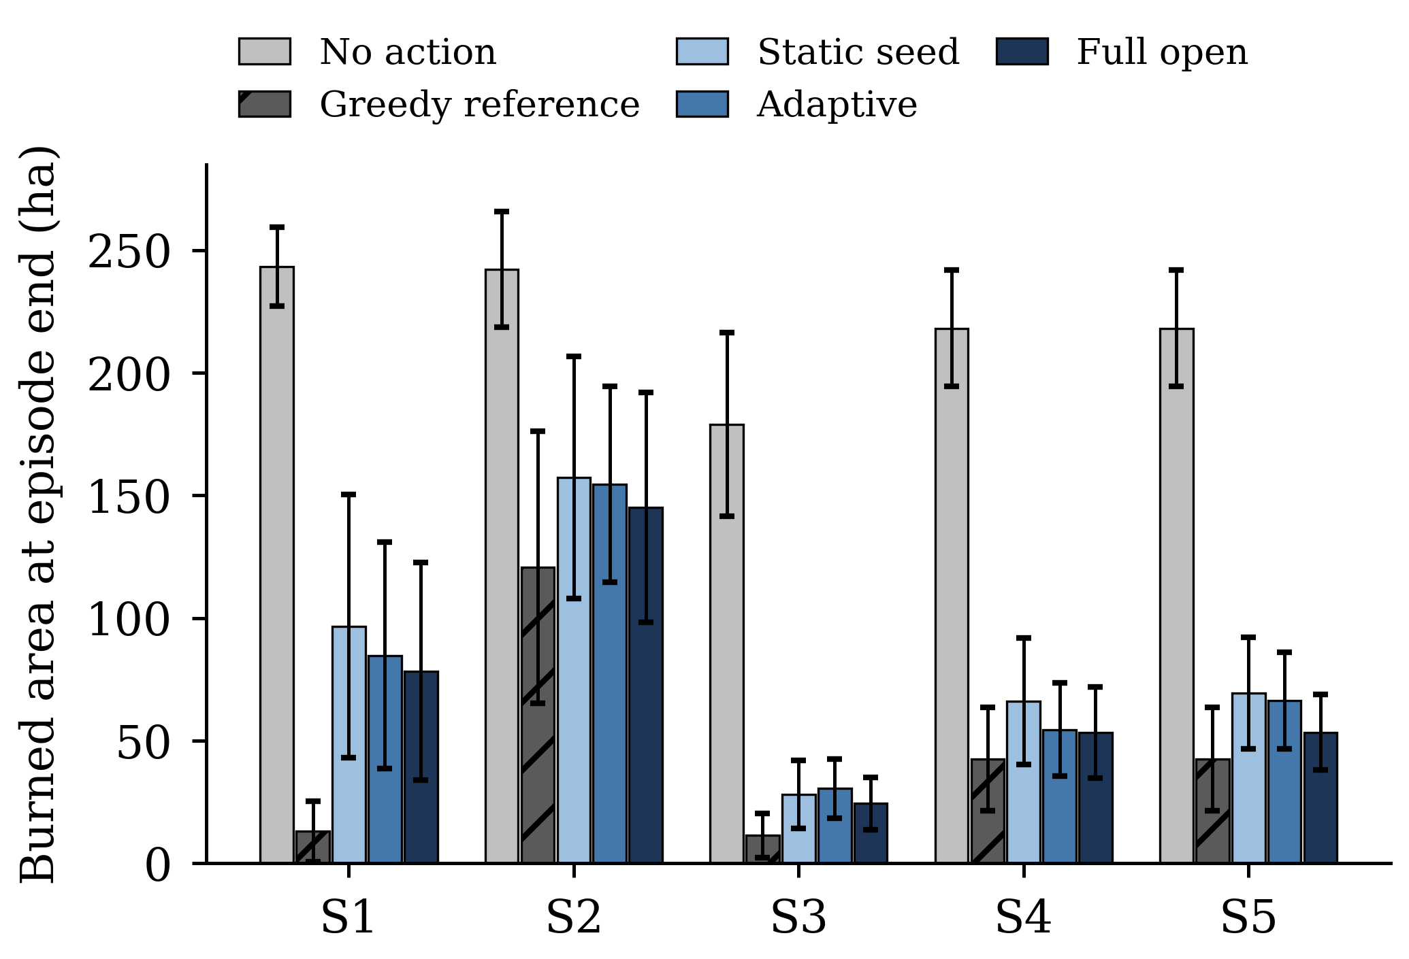
Fig. 14. Burned area at episode end for the external greedy reference and the internal configurations over the five scenarios; bars are means over ten worlds with 95 % confidence intervals.

G. Compliance with the Evaluation Criteria
Predictive fidelity rests on four blind hindcasts on real inputs, with front agreement of 86 to 94 % and detection probability of 85 to 97 %. Decision quality follows from the paired ladder: against no action DisasterAware lowers the burned area by 70 percent and the physical cost from 0.596 to 0.140; against the static doctrine it extinguishes 5.0 times as many incidents within the episode and leaves 28 percent fewer people affected, with the lowest cost of the four configurations in every family. Timeliness is met with a median decision of 274 ms against a twelve-minute cycle, scalability with one decision costing 0.02 to 0.16 % of the cycle and sixteen times the agents costing at most 1.29 times, and robustness with DisasterAware losing 4 percent under degraded observation while remaining the best tested. Uncertainty handling is structural, every feature carrying a confidence that gates its concept; adaptability shows in 129 of 616 stage-1 and 40 of 359 stage-2 trials kept and 47 generative admissions plus seven sited interventions; explainability in every edit, rejection, and generated object being logged with its trigger, gate, and consuming rule. Four criteria are met in full and four on the axis measured here: the hindcast base covers four fires, noise and communication failure are untested, operator-facing interpretability is not evaluated, and uncertainty is carried into the decision but not propagated as an ensemble.

VI. Discussion: Systems Lessons and Limitations
Three lessons transfer beyond wildfire. First, separating an authoritative hazard model from the decision layer is what makes both testable: the model was validated against satellite records with no decision logic in the loop, and the decision layer was then measured against fixed references on the same worlds, so the benefit of each capability is a paired difference rather than an absolute score. Second, a vocabulary of orders that grows at runtime is safe only when admission is decided by gates that do not trust the proposer; four proposals in five are rejected here, and that selectivity is why the admitted objects can be fielded and why the outcome improves rather than merely changes. Third, keeping inference in the regional agents and out of the coordinator held the cost per decision almost flat as the number of agents grew, which is the property an incident of national scale requires.
Three limitations bound the claims. The evaluation is entirely simulated: the hazard model is validated on real records, but no order was executed in a real incident and no fire officer took part in the loop. The comparison base is internal, since no deployed tool generates interventions over an open space; the paired ladder isolates the contribution of each capability, and the greedy allocation of Section V-F bounds what undivided aggression buys in this cost model. Finally, the proposals of a language model are not bitwise reproducible, although the campaign is logged with pinned configuration and seeds, and no admission depends on the proposer.

VII. Conclusion and Future Work
This article presented DisasterAware, a distributed decision support architecture for wildfire response built on two separated cores. Ten confidence-gated features feed five decision concepts, a sparse Takagi-Sugeno rule base sets intervention intensities, satisficing acceptance and a graduated fail-safe screen every order, and a non-inferential coordinator ranks the local agents. When the standing decision falls short, a three-stage ladder adapts the parameters, the resolution, and finally the vocabulary of the base, the last through a pretrained language model whose every proposal passes the same gates, which preserve the four invariants of Section IV-H. On an independently validated core, whose four blind hindcasts agree with the satellite record at 86 to 94 percent, the benefit was measured on paired worlds: DisasterAware extinguishes 52 percent of the incidents within the episode against 10 percent for the static doctrine, leaves 28 percent fewer people affected, lowers the burned area by 70 percent against no action and by 10 percent against the static doctrine, and does so at 274 ms per decision and at most 1.29 times the cost for sixteen times the agents, while every fielded order traces to its concepts, rules, and confidences. Four studies follow. A tabletop exercise will place fire officers in the loop with and without the framework. A transfer study will keep the decision layer and replace the simulation core with another spreading hazard, the rewriting cost separating what is architecture from what is wildfire. Inside the simulator, an ensemble study will test decision stability across plausible forecasts, and a scenario study will build families in which the seed doctrine is structurally insufficient, so that the tactics the open space composes can be measured against the tactics it was not given.

Acknowledgment
This work was informed by the authors' experience in the TeamAware project, funded by the European Union's Horizon 2020 research and innovation programme under Grant Agreement No. 101019808. The research reported in this article was carried out independently and received no specific grant from any funding agency in the public, commercial, or not-for-profit sectors.

References
[1] Power, "Decision support systems: Concepts and resources for managers," Quorum Books, 2002.
[2] R. L. Keeney and H. Raiffa, "Decisions with multiple objectives: preferences and value trade-offs," Wiley, 1976.
[3] S. French, J. Maule and N. Papamichail, "Decision Behaviour, Analysis and Support," Cambridge University Press, 2019.
[4] M. T. Ribeiro, S. Singh and C. Guestrin, "Why Should I Trust You?," ACM SIGKDD Conference, pp. 1135–1144, 2016.
[5] D. M. Bowman, C. A. Kolden, J. T. Abatzoglou, F. H. Johnston, G. R. van der Werf and M. Flannigan, "Vegetation fires in the Anthropocene," Nature Reviews Earth & Environment, vol. 1, pp. 500-515, 2020.
[6] M. P. Thompson and D. E. Calkin, "Uncertainty and risk in wildland fire management," Journal of Environmental Management, vol. 92, pp. 1895-1909, 2011.
[7] R. C. Rothermel, "A mathematical model for predicting fire spread in wildland fuels," Intermountain Forest & Range Experiment Station, Forest Service, US Department of Agriculture., 1972.
[8] M. A. Finney, "An overview of FlamMap fire modeling capabilities," Fuels Management — How to Measure Success: Conference Proceedings, pp. 213-220, 2006.
[9] L. A. Zadeh, "Fuzzy sets," Information and Control, vol. 8, pp. 338-353, 1965.
[10] F. Vásquez, "Decision support system development of wildland fire," Forests, vol. 12, pp. 943, 2021.
[11] E. K. Noonan-Wright et al., "Developing the US wildland fire decision support system," vol. 2011, pp. 168473, 2011.
[12] P. Dubey and P. Dubey, "Bridging spatiotemporal wildfire prediction and decision modeling using transformer networks and fuzzy inference systems," vol. 15, pp. 103498, 2025.
[13] S. D. Fillmore and T. B. Paveglio, "Use of the Wildland Fire Decision Support System (WFDSS) for full suppression and managed fires within the Southwestern Region of the US Forest Service," vol. 32, pp. 622-635, 2023.
[14] C. Rapp, E. Rabung, R. Wilson and E. Toman, "Wildfire decision support tools: An exploratory study of use in the United States," vol. 29, pp. 581-594, 2020.
[15] J. Malczewski, "GIS and multicriteria decision analysis," John wiley & sons, 1999.
[16] D. E. Calkin, C. D. O'Connor, M. P. Thompson and R. Stratton, "Strategic wildfire response decision support and the risk management assistance program," vol. 12, pp. 1407, 2021.
[17] D. Arnott and G. Pervan, "A critical analysis of decision support systems research," Journal of Information Technology, vol. 20, pp. 67-87, 2005.
[18] M. Turoff, M. Chumer, B. Van de Walle and X. Yao, "The design of a dynamic emergency response management information system (DERMIS)," Journal of Information Technology Theory and Application (JITTA), vol. 5, pp. 1-36, 2004.
[19] C. Rapp, K. L. Courtney, S. T. Franz, M. M. Colavito, T. Aldworth and A. S. Cheng, "Wildfire decision support tools: barriers, facilitators, and future directions for effectiveness," Fire Ecology, 2026.
[20] M. Morgan and M. Henrion, "Uncertainty: A Guide to Dealing with Uncertainty in Quantitative Risk and Policy Analysis.," Cambridge university press, 1990.
[21] G. Shafer, "A Mathematical Theory of Evidence," Princeton University Press, 1976.
[22] T. Comes, M. Hiete, N. Wijngaards and F. Schultmann, "Decision maps: A framework for multi-criteria decision support under severe uncertainty," Decision Support Systems, vol. 52, pp. 108-118, 2011.
[23] C. Pais, J. Carrasco, P. E. Moudio and Z. M. Shen, "Downstream protection value: Detecting critical zones for effective fuel-treatment under wildfire risk," vol. 90, pp. 101703, 2021.
[24] T. Orphanoudakis, C. Betzelos and H. C. Leligou, "MORA: A multicriteria optimal resource allocation and decision support toolkit for wildfire management," vol. 18, pp. 677, 2025.
[25] D. L. Martell, "Forest fire management," Handbook of operations research in natural resources, pp. 489-509, 2007.
[26] T. Takagi and M. Sugeno, "Fuzzy identification of systems and its applications to modeling and control," IEEE Transactions on Systems, Man, and Cybernetics, vol. 15, pp. 116-132, 1985.
[27] P. P. Angelov and D. P. Filev, "An approach to online identification of Takagi-Sugeno fuzzy models," IEEE Transactions on Systems, Man, and Cybernetics, Part B, vol. 34, pp. 484-498, 2004.
[28] H. A. Simon, "Rational choice and the structure of the environment," Psychological Review, vol. 63, pp. 129-138, 1956.
[29] J. H. Scott and R. E. Burgan, "Standard fire behavior fuel models: A comprehensive set for use with Rothermel’s surface fire spread model," 2005.
[30] A. L. Sullivan, "Wildland surface fire spread modelling 1: Physical and quasi-physical models," International Journal of Wildland Fire, vol. 18, pp. 349-368, 2009a.
[31] G. A. Klein, "Sources of Power: How People Make Decisions," MIT Press, 2017.
[32] R. S. Sutton and A. G. Barto, "Reinforcement Learning: An Introduction," Cambridge, MA, USA: MIT Press, 2018.
[33] Y. Xie, B. Jiang, T. Mallick, J. D. Bergerson, J. K. Hutchison and D. R. Verner, "WildfireGPT: Tailored large language model for wildfire analysis," arXiv:2402.07877, 2024.
[34] C. Pais, J. Carrasco, D. L. Martell, A. Weintraub and D. L. Woodruff, "Cell2Fire: A cell-based forest fire growth model to support strategic landscape management planning," Frontiers in Forests and Global Change, vol. 4, 2021.
[35] A. Arbel and R. M. Tong, "On the generation of alternatives in decision analysis problems," Journal of the Operational Research Society, vol. 33, no. 4, pp. 377-387, 1982. [36] A. Colorni and A. Tsoukias, "What is a decision problem? Designing alternatives," in Preference Disaggregation in Multiple Criteria Decision Analysis, N. Matsatsinis and E. Grigoroudis, Eds. Cham, Switzerland: Springer, 2018, pp. 1-15. [37] A. Colorni and A. Tsoukias, "Designing alternatives in decision problems," Journal of Multi-Criteria Decision Analysis, vol. 27, no. 3-4, pp. 150-158, 2020. [38] G. J. Hofstede, "Open problems, formal problems," Journal of Decision Systems, vol. 4, no. 2, pp. 155-165, 1995. [39] F. Del Missier, M. Visentini, and T. Mantyla, "Option generation in decision making: Ideation beyond memory retrieval," Frontiers in Psychology, vol. 5, art. 1584, 2015. [40] B. Fazlollahi and R. Vahidov, "A method for generation of alternatives by decision support systems," Journal of Management Information Systems, vol. 18, no. 2, pp. 229-250, 2001. [41] E. D. Brill, J. M. Flach, L. D. Hopkins, and S. Ranjithan, "MGA: A decision support system for complex, incompletely defined problems," IEEE Transactions on Systems, Man, and Cybernetics, vol. 20, no. 4, pp. 745-757, 1990. [42] M. S. Levin, "Towards decision support technology platform for modular systems," arXiv:1408.5492, 2014. [43] P. Struss, "Model-based decision support systems: Conceptualization and general architecture," in Proc. 32nd Int. Workshop on Qualitative Reasoning (QR), 2019. [44] Y. Ding, X. Zhang, S. Amiri, N. Cao, H. Yang, A. Kaminski, C. Esselink, and S. Zhang, "Integrating action knowledge and LLMs for task planning and situation handling in open worlds," Autonomous Robots, vol. 47, pp. 981-997, 2023. [45] E. Gizzi, H. Amel, W. W. Lin, K. Rhea, and J. Sinapov, "Toward creative problem solving agents: Action discovery through behavior babbling," in Proc. IEEE Int. Conf. Development and Learning (ICDL), 2021, pp. 1-7. [46] R. Chandra, S. S. Kumar, R. Patra, and S. Agarwal, "Decision support system for forest fire management using ontology with big data and LLMs," Cluster Computing, vol. 28, art. 548, 2025. [47] Y. Cheng, Y. Lin, Y. Wu, L. Huang, T. Chen, W. Weng, and X. Zhang, "Retrieval over response: Large language model-augmented decision strategies for hierarchical wildfire risk evaluation," Fire, vol. 9, no. 4, art. 143, 2026. [48] N. Gerolimos, V. Alevizos, S. Edralin, C. Xu, G. Priniotakis, G. A. Papakostas, and Z. Yue, "Autonomous decision-making enhancing natural disaster management through open world machine learning: A systematic review," Human-Centric Intelligent Systems, vol. 5, pp. 269-284, 2025. [49] A. Sandeep, S. Jayarathna, S. Sandaruwan, V. Samarappuli, D. Meedeniya, and C. Perera, "Context-aware multi-agent architecture for wildfire insights," Sensors, vol. 26, art. 1070, 2026. [50] Y. Tan, "Trustworthy intelligence fusion for search and rescue: Designing grounded and secure multi-agent AI for mission decision support," M.S. thesis, California Polytechnic State Univ., San Luis Obispo, CA, USA, 2025. [51] J. Cui, C. Zhai, Y. Wang, and Y. Li, "Large language models and AI agents in disaster-resilient infrastructure: Concepts, applications, pathways, and challenges," Reliability Engineering and System Safety, vol. 267, art. 111683, 2026. [52] E. Park, J. Park, and T. Kim, "WildfireKR: An LLM-agent decision support framework for autonomous wildfire spread simulation in South Korea," IEEE Access, vol. 14, pp. 59185-59208, 2026.
Çağlar Akman received the B.S. and M.S. degrees in electrical and electronics engineering from Middle East Technical University (METU), Ankara, Türkiye, in 2008 and 2017, respectively, where he is currently pursuing the Ph.D. degree. He is a Senior Principal Team Manager with HAVELSAN, Ankara, where he manages research and development projects on advanced sensor systems, decision support architectures, and command and control software for defense and public-safety programs. His research interests include intelligent decision support systems, fuzzy inference, distributed architectures, and disaster management technologies.
Kemal Leblebicioğlu received the Ph.D. degree from the Department of Mathematics, METU, Ankara, Türkiye, in 1988. He has been a Full Professor with the Department of Electrical and Electronics Engineering, METU, since 1999. He has authored more than 40 journal papers and numerous book chapters and conference papers, and served as the Editor of the journal ELEKTRIK from 1996 to 2009. His research interests include optimization, optimal control, computer vision, intelligent systems, unmanned vehicles, and biomedical signal processing.

Çağlar Akman and Kemal Leblebicioğlu are with the Department of Electrical and Electronics Engineering, Middle East Technical University, 06800 Ankara, Türkiye (e-mail: caglar.akman@metu.edu.tr; kleb@metu.edu.tr).

