TEZ ŞABLONU ONAY FORMU
THESIS TEMPLATE CONFIRMATION FORM.

- Şablonda verilen yerleşim ve boşluklar değiştirilmemelidir. |  |  | - Do not change the spacing and placement in the template.
- Jüri tarihi Başlık Sayfası, İmza Sayfası, Abstract ve Öz’de ilgili yerlere yazılmalıdır. |  |  | - Write defense date to the related places given on Title page, Approval page, Abstract and Öz.
- İmza sayfasında jüri üyelerinin unvanları doğru olarak yazılmalıdır. Tüm imzalar mavi pilot kalemle atılmalıdır. |  |  | - Write the titles of the examining committee members correctly on Approval Page. Blue ink must be used for all signatures.
- Disiplinlerarası programlarda görevlendirilen öğretim üyeleri için jüri üyeleri kısmında tam zamanlı olarak çalıştıkları anabilim dalı başkanlığının ismi yazılmalıdır. Örneğin: bir öğretim üyesi Biyoteknoloji programında görev yapıyor ve biyoloji bölümünde tam zamanlı çalışıyorsa, İmza sayfasına biyoloji bölümü yazılmalıdır. |  |  | - For faculty members working in interdisciplinary programs, the name of the department that they work full-time should be written on the Approval page. For example, if a faculty member staffs in the biotechnology program and works full-time in the biology department, the department of biology should be written on the approval page.
- Tezin son sayfasının sayfa numarası Abstract ve Öz’de ilgili yerlere yazılmalıdır. |  |  | - Write the page number of the last page in the related places given on Abstract and Öz pages.
- Bütün chapterlar, referanslar, ekler ve CV sağ sayfada başlamalıdır. Bunun için kesmeler kullanılmıştır. Kesmelerin kayması fazladan boş sayfaların oluşmasına sebep olabilir. Bu gibi durumlarda paragraf (¶) işaretine tıklayarak kesmeleri görünür hale getirin ve yerlerini kontrol edin. |  |  | - All chapters, references, appendices and CV must be started on the right page. Section Breaks were used for this. Change in the placement of section breaks can result in extra blank pages. In such cases, make the section breaks visible by clicking paragraph (¶) mark and check their position.
- Figürler ve tablolar kenar boşluklarına taşmamalıdır. |  |  | - All figures and tables must be given inside the page. Nothing must appear in the margins.
- Şablonda yorum olarak eklenen uyarılar dikkatle okunmalı ve uygulanmalıdır. |  |  | - All the warnings given on the comments section through the thesis template must be read and applied.
- Tez yazdırılmadan önce PDF olarak kaydedilmelidir. Şablonda yorum olarak eklenen uyarılar PDF dokümanında yer almamalıdır. |  |  | - Save your thesis as pdf and Disable all the comments before taking the printout.
- Tez taslaklarının kontrol işlemleri tamamlandığında, bu durum öğrencilere METU uzantılı öğrenci e-posta adresleri aracılığıyla duyurulacaktır. |  |  | - This will be announced to the students via their METU students e-mail addresses when the control of the thesis drafts has been completed.
- Tez yazım süreci ile ilgili herhangi bir sıkıntı yaşarsanız, Sıkça Sorulan Sorular (SSS) sayfamızı ziyaret ederek yaşadığınız sıkıntıyla ilgili bir çözüm bulabilirsiniz. |  |  | - If you have any problems with the thesis writing process, you may visit our Frequently Asked Questions (FAQ) page and find a solution to your problem.

☒ | Yukarıda bulunan tüm maddeleri okudum, anladım ve kabul ediyorum. / I have read, understand and accept all of the items above.  Name : Çağlar  Surname : Akman  E-Mail : caglar.akman@metu.edu.tr; e134113@metu.edu.tr  Date :  Signature : ________________________

ENHANCED DECISION SUPPORT SYSTEM FOR WILDFIRE DISASTER RESPONSE AND MANAGEMENT (DISASTERAWARE)

A THESIS SUBMITTED TO
THE GRADUATE SCHOOL OF NATURAL AND APPLIED SCIENCES
OF
MIDDLE EAST TECHNICAL UNIVERSITY

BY

ÇAĞLAR AKMAN

IN PARTIAL FULFILLMENT OF THE REQUIREMENTS
FOR
THE DEGREE OF DOCTOR OF PHILOSOPHY
IN
ELECTRICAL AND ELECTRONIC ENGINEERING

[DEFENSE DATE]

TABLE OF CONTENTS
TABLE OF CONTENTS iv
LIST OF TABLES v
LIST OF FIGURES vi
LIST OF ABBREVIATIONS vii
LIST OF SYMBOLS ix
1 INTRODUCTION 1
2 FIRE SPREAD SIMULATOR 5
2.1 Purpose and Scope of the Decision Support Framework 5
REFERENCES 7
APPENDICES 11
A. Appendix Title 11
B. Appendix Title 12
CURRICULUM VITAE 13

LIST OF TABLES
TABLES
No table of figures entries found.

LIST OF FIGURES
FIGURES
Figure 1.1. Number of recorded natural disaster events, 1900 to 2023 (Our World in Data, 2024) 1
Figure 1.2. Global average surface temperature, 1901 - 2000 2

LIST OF ABBREVIATIONS
AI | : | Artificial Intelligence
DSS | : | Decision Support System
FIS | : | Fuzzy Inference System
GIS | : | Geographical Information System
XAI | : | Explainable Artificial Intelligence
 | :
 | :
 | :
 | :
 | :
 | :
 | :
 | :
 | :

LIST OF SYMBOLS

INTRODUCTION
At no point in recorded history has humanity faced such a relentless sequence of natural disasters. Droughts scorch regions that once flourished, megafires consume forests once considered fire-resistant, and storms of record-breaking power strike coastlines already weakened by rising seas. The world is not merely witnessing more disasters—it is living in a new era of compound and cascading hazards where events interact, amplify one another, and overwhelm the capacity of governments and communities to respond. The Emergency Event Database (EM-DAT) global disaster database, maintained by the Centre for Research on the Epidemiology of Disasters, documents this transformation clearly: annual natural disaster events have climbed from fewer than 50 in 1900 to over 400 in recent years (Our World in Data, 2024) as illustrated in Figure 1.1.
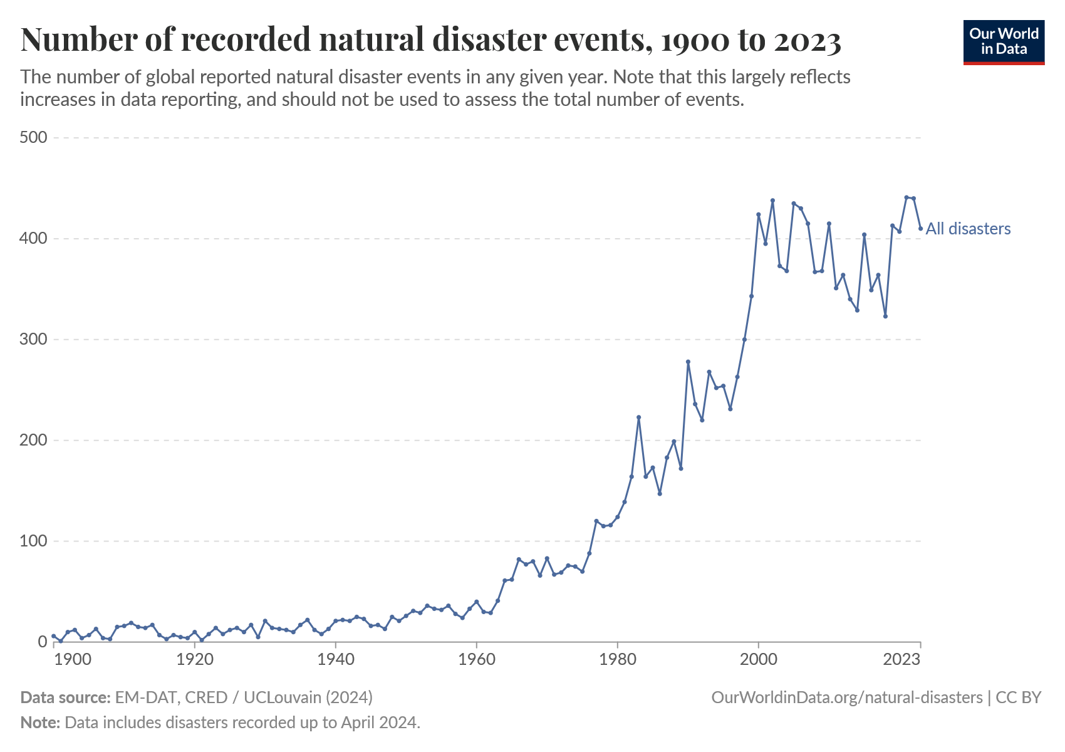
Figure 1.1. Number of recorded natural disaster events, 1900 to 2023 (Our World in Data, 2024)
While better reporting partly explains the curve, the acceleration since the 1970s corresponds with a warming climate, urban sprawl, and the expansion of high-risk human settlements. As the United Nations Environment Programme (2022) observes, “the planet is entering an era of extraordinary wildfires and heat extremes” that traditional response frameworks were never designed to manage.
EM-DAT contains data on the occurrence and impacts of mass disasters worldwide from 1900 to the present day. EM-DAT data includes all categories classified as "natural disasters" (distinguished from technological disasters, such as oil spills and industrial accidents). This includes those from drought, earthquakes, extreme temperatures, extreme weather, floods, glacial lake outburst floods, mass movements, volcanic activity, and wildfires.

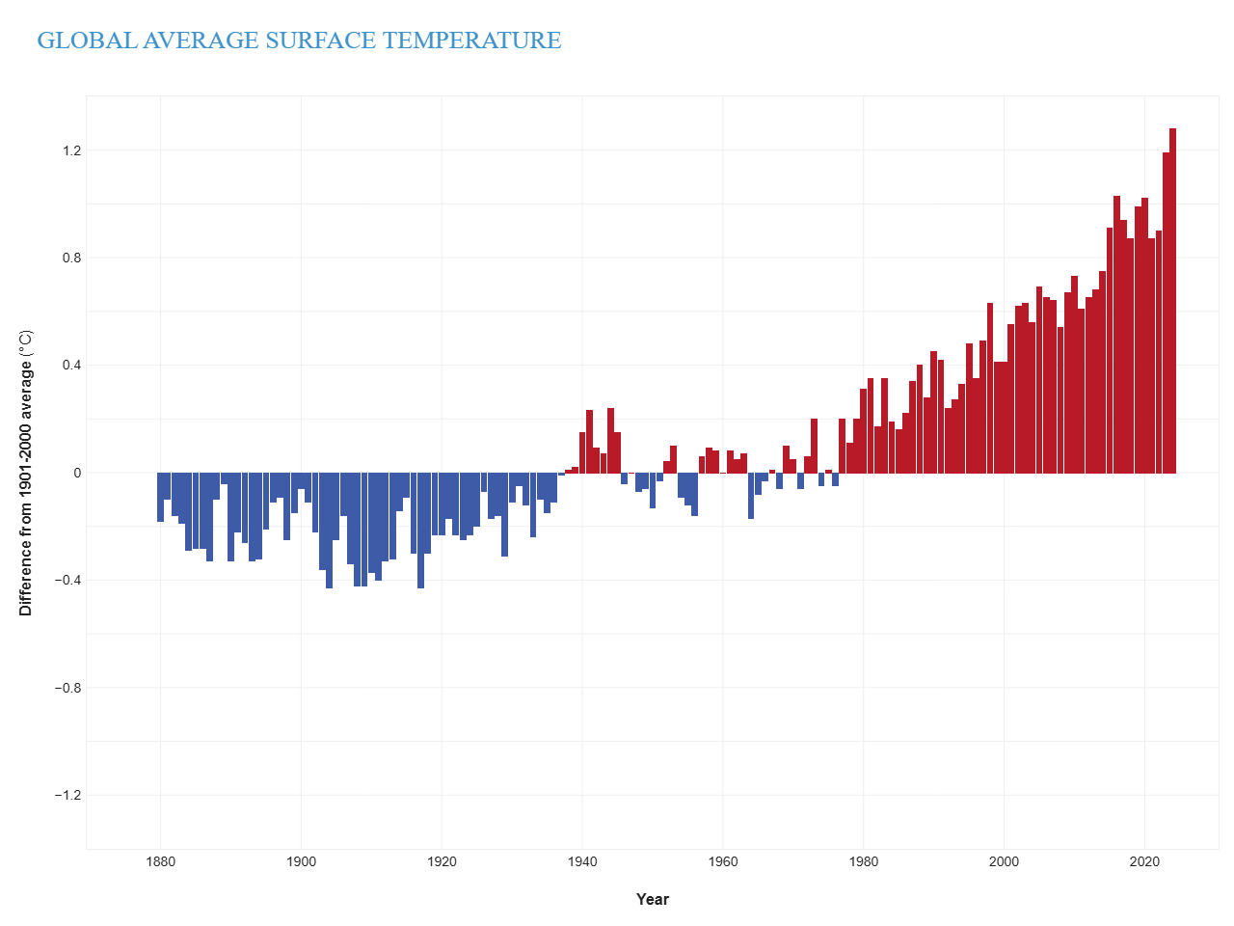
Figure 1.2. Global average surface temperature, 1901 - 2000

Wildfires are among the most destructive natural hazards, producing steep environmental, economic, and social losses. The problem is intensifying as climate change amplifies fire weather and as human exposure grows in the wildland–urban interface. Traditional response models remain largely reactive, relying on static plans, delayed coordination, and suppression-first culture—yielding slow and sub-optimal decisions under uncertainty. Decision Support Systems (DSSs) can integrate heterogeneous data and uncertainty, enabling timely, explainable, and risk-aware wildfire decisions
This research focuses on the design and implementation of a Fuzzy Logic-based Decision Support System (DISASTERAWARE) for wildfire response and management. The system integrates real-world simulation, fuzzy rule-based reasoning, and human-in-the-loop decision-making to provide adaptive and explainable intervention recommendations.
(Arnott & Pervan, 2016) bu referans çok önemli.
Arnott and Pervan (2016) provide a critical review of the Decision Support Systems (DSS) research field, arguing that it has lost coherence, practical relevance, and cumulative scientific progress. They observe that DSS research is highly fragmented, with studies scattered across disparate topics and lacking a shared theoretical foundation. As a result, the field struggles to build cumulative knowledge.
A central critique is the growing gap between academic DSS research and real-world decision-making practice. Many DSS studies focus on abstract models, algorithms, or laboratory-style evaluations, while neglecting real organizational contexts and actual decision-makers. This leads to systems that are analytically sophisticated but rarely adopted or impactful in practice.
The authors also criticize the dominance of method-driven research, where novelty in techniques is prioritized over understanding decision contexts, organizational constraints, and human factors. They emphasize that DSS should be viewed as socio-technical systems, not merely technical artifacts, and should explicitly account for users, organizations, and institutional settings.
Finally, Arnott and Pervan propose a renewed research agenda for DSS, calling for greater emphasis on real decision environments, design science, field studies, and research that examines how DSS influence decision processes over time. Their work positions relevance, contextual grounding, and socio-technical integration as essential for the future development of DSS research.

FIRE SPREAD SIMULATOR
Wildfire management represents a decision-making domain in which uncertainty is not an exception but a defining characteristic. Decisions must be taken under incomplete knowledge, conflicting observations, and rapidly changing environmental conditions that vary both spatially and temporally. In such contexts, conventional decision support systems exhibit clear limitations, as they are typically built upon static representations, closed sets of predefined alternatives, and crisp models that assume precise and complete information. These assumptions are fundamentally misaligned with the operational realities of wildfire management.

REFERENCES

Abdul, A., Vermeulen, J., Wang, D., Lim, B., & Kankanhalli, M. (2018). Trends and Trajectories for Explainable, Accountable and Intelligible Systems. Proceedings of the 2018 CHI Conference on Human Factors in Computing Systems, (p. Paper 582).
Arnott, D., & Pervan, G. (2016). A Critical Analysis of Decision Support Systems Research. Journal of Information Technology, 31(2), 131-146. doi:10.1057/jit.2016.2
Endsley, M. (1995). Toward a Theory of Situation Awareness. Human Factors, 37(1), 32-64.
Endsley, M. (2015). Situation Awareness Misconceptions and Misunderstandings. Journal of Cognitive Engineering and Decision Making, 9(1), 4-32. doi:10.1177/1555343415572631
French, S., Maule, J., & Papamichail, N. (2019). Decision Behaviour, Analysis and Support (2 ed.). Cambridge University Press.
Guidotti, R., Monreale, A., Ruggieri, S., Turini, F., Giannotti, F., & Pedreschi, D. (2018). A Survey of Methods for Explaining Black Box Models. ACM Computing Surveys, 51(5), 1-42. doi:10.1145/3236009
Keeney, R., & Raiffa, H. (1976). Decisions with Multiple Objectives. Wiley.
Klein, G. (1998). Sources of Power: How People Make Decisions. MIT Press.
Mamdani, E. (1974). Application of Fuzzy Algorithms for Control of a Simple Dynamic Plant. Proceedings of the Institution of Electrical Engineers, 121(12), 1585-1588.
McNeese, N. (2021). Understanding the Role of Human–AI Interaction in Decision-Making under Uncertainty.
McNeese, N., Demir, M., Chiou, E., Cooke, N., & Yen, J. (2021). Human–Machine Teaming in Artificial Intelligence–Enabled Systems: A Review and Agenda for Future Research. Human Factors, 63(5), 852-867. doi:10.1177/0018720820964550
Mendel, J. (2017). Uncertain Rule-Based Fuzzy Systems. Springer.
Our World in Data. (2024). Number of recorded natural disaster events, 1900 to 2023 [Graph]. Based on EM-DAT, CRED / UCLouvain. Retrieved 10 19, 2025, from https://ourworldindata.org/natural-disasters
Pacheco, A. (2015). Cohesive Fire Management within an Uncertain Environment: A Review of Risk Handling and Decision Support Systems. Forest Ecology and Management, 347, 1-17. doi:10.1016/j.foreco.2015.02.033
Power, D. (2002). Decision Support Systems: Concepts and Resources for Managers. Westport: Quorum Books.
Power, D. (2015). Decision Support, Analytics, and Business Intelligence (2 ed.). Business Expert Press.
Power, D. J. (2007). A Brief History of Decision Support Systems. Retrieved from http://dssresources.com/history/dsshistory.html
Ribeiro, M., Singh, S., & Guestrin, C. (2016). Why Should I Trust You? Proceedings of the 22nd ACM SIGKDD International Conference on Knowledge Discovery and Data Mining (KDD).
Ross, K., Shafer, J., & Klein, G. (2006). Professional Judgments and Naturalistic Decision Making. In The Cambridge Handbook of Expertise and Expert Performance (pp. 403-420). Cambridge: Cambridge University Press.
Sanneman, L., & Shah, J. (2020). The Role of Explanations in Human–AI Collaboration: A Survey. Retrieved from https://arxiv.org/abs/2006.10548
Sharda, R., Delen, D., & Turban, E. (2018). Business Intelligence, Analytics, and Data Science: A Managerial Perspective. Pearson.
Simon, H. (1977). The New Science of Management Decision. Englewood Cliffs: Prentice Hall.
Simon, H. (1996). The Sciences of the Artificial. Cambridge: MIT Press.
Soualah, L. (2024). Hoping the Best, Expecting the Worst: Forecasting Forest Fire Risk in Algeria Using Fuzzy Logic and GIS. Trees, Forests and People, 17, 100614. doi:10.1016/j.tfp.2024.100614
Sprague, R., & Carlson, E. (1982). Building Effective Decision Support Systems. Englewood Cliffs: Prentice Hall.
(2022). Spreading like Wildfire: The Rising Threat of Extraordinary Landscape Fires. Geneva: United Nations Environment Programme (UNEP). Retrieved 10 19, 2025, from https://www.unep.org/resources/report/spreading-wildfire
Takagi, T., & Sugeno, M. (1985). Fuzzy Identification of Systems and Its Applications to Modeling and Control. IEEE Transactions on Systems, Man, and Cybernetics, 15(1), 116-132.
Thompson, M., & Calkin, D. (2011). Uncertainty and Risk in Wildland Fire Management: A Review. Journal of Environmental Management, 92(8), 1895-1909. doi:10.1016/j.jenvman.2011.03.015
Turban, E., Sharda, R., Aronson, J., & King, D. (2011). Decision Support and Business Intelligence Systems (9 ed.). Upper Saddle River: Pearson Education.
Vásquez, F. (2021). Decision Support System Development of Wildland Fire: A Systematic Mapping. Forests, 12(7), 943. doi:10.3390/f12070943
Walker, W., Harremoes, P., Rotmans, J., Van der Sluijs, J., Van Asselt, M., Janssen, P., & Krayer von Krauss, M. (2003). Defining uncertainty: a conceptual basis for uncertainty management in model-based decision support. Integrated Assessment, 4(1), 5-17.
Zadeh, L. (1965). Fuzzy Sets. Information and Control, 8(3), 338-353. doi:10.1016/S0019-9958(65)90241-X

Adıyaman, Ö. And Chorowicz, J. 2002. Late Cenozoic tectonics and volcanics in the northwestern corner of the Arabian plate: a consequence of the strike-slip Dead Sea Fault Zone and lateral escape of Anatolia, Journal of Volcanology and Geothermal Research, 117. 327-345.

APPENDICES
- Appendix Title
Add appendix here

- Appendix Title
Add appendix here

CURRICULUM VITAE

PERSONAL INFORMATION
Surname, Name: Akman, Çağlar

EDUCATION
Degree | Institution | Year of Graduation
MS | METU Electrical and Electronics Engineering | 2017
BS | METU Electrical and Electronics Engineering | 2008
High School | Yusuf Ziya Öner Fen Lisesi, Antalya | 2002

WORK EXPERIENCE
Year | Place | Enrollment
2014- Present | HAVELSAN | Modelling and Sensor Technologies Team Leader
2013-2014 | AYESAS | Senior Software Engineer
2008-2013 | KAREL | Senior Design Engineer
2007-2007 | TUBITAK | Part Time Engineer

FOREIGN LANGUAGES
Advanced English, Beginner German

PUBLICATIONS
- Kabak, Y., Kose, I. G., Akman, C., & Ramscar, D. (2023, December). TeamAware: Profile-Based Interoperability Framework for First Responders. In International Conference on Information Technology in Disaster Risk Reduction (pp. 98-111). Cham: Springer Nature Switzerland.
- Gunes, A., ihsan Gullu, A., Alam, M. S., Sucu, E. S., Köse, S., Göze, A. G., ... & Akman, Ç. (2023, July). NLoS Measurement Elimination in UWB Signals Using Anomaly Detection. In 2023 31st Signal Processing and Communications Applications Conference (SIU) (pp. 1-4). IEEE.
- AKMAN, Ç. (2022, May). Relative Localization for Swarm Aerial Vehicles. In 2022 30th Signal Processing and Communications Applications Conference (SIU).
- Korkmaz, I. O., Özateş, T., Koç, E., Aydın, E., Kor, E., Dilek, D., ... & Akman, Ç. (2022, May). Indoor localization with transfer learning. In 2022 30th Signal Processing and Communications Applications Conference (SIU) (pp. 1-4). IEEE.
- Aytekin, A., Bağcı, F., Bozdağ, M., Camuzcu, N., Duru, A., Elma, M. S., ... & Akman, Ç. (2022, May). Relative Localization for Swarm Aerial Vehicles. In 2022 30th Signal Processing and Communications Applications Conference (SIU) (pp. 1-4). IEEE.
- Akman, Ç., & Sönmez, T. (2021). Body Motion Capture and Applications. In Decision Support Systems and Industrial IoT in Smart Grid, Factories, and Cities (pp. 181-223). IGI Global.
- Akman, Ç., Demir, O., & Sönmez, T. (2021, June). Covid-19 SEIQR Spread Mathematical Model. In 2021 29th Signal Processing and Communications Applications Conference (SIU) (pp. 1-4). IEEE.
- Köse, S., Gökalp, İ., Dökme, Ç., Akman, Ç., Sönmez, T. (2019). Hybrid RSSI and fingerprinting method for indoor localization. In USMOS 19, National Defense Applications Modeling and Simulation Conference.
- Gökalp, İ., Köse, S., Narman, A., Hajizada E., Özbey, M., Can, S., Akman, Ç., Sönmez, T. (2019). Body motion analysis system. In USMOS 19, National Defense Applications Modeling and Simulation Conference.
- Akman, Ç., Sönmez, T., Özuğur, Ö., Başlı, A. B., & Leblebicioğlu, M. K. (2018). Sensor fusion, sensitivity analysis and calibration in shooter localization systems. Sensors and Actuators A: Physical, 271, 66-75.
- Akman, Ç. (2017). Multi shooter localization with acoustic sensors (Master's thesis, Middle East Technical University).
- Akman, Ç., Sönmez, T., Özuğur, Ö., & Leblebicioğlu, K. (2016, May). Shooter localization system calibration and implementation. In IEEE 24th Signal Processing and Communication Application Conference (SIU) (pp. 2025-2028)

PATENTS
- Akman, Ç. (Co-inventor), & HAVELSAN (Assignee). (2017, June 5). Ateşli silah yön ve konum tespit sistemi (Patent No. TR 2017/08288). Türk Patent ve Marka Kurumu.
- Akman, Ç. (Co-inventor), & HAVELSAN (Assignee). (2018, December 31). Hareket algılama, analiz ve takip için bir sistem (Patent No. TR 2018/21331). Türk Patent ve Marka Kurumu.
- Akman, Ç. (Co-inventor), & HAVELSAN (Assignee). (2021, April 7). Kapalı alanlarda kullanıcı konumlandırma için hibrit bir yöntem (Patent No. TR 2021/006182). Türk Patent ve Marka Kurumu.
- Akman, Ç. (Co-inventor), & HAVELSAN (Assignee). (2021, April 14). Acil durum ekiplerinin durumsal farkındalıklarının tespiti için bir düzenek ve bu düzeneğin çalıştırılması için bir yöntem (Patent No. TR 2021/006597). Türk Patent ve Marka Kurumu.
- Akman, Ç. (Co-inventor), & HAVELSAN (Assignee). (2022, September 23). Otonom sürülerde ultra geniş bant teknolojisi ile göreli konumlandırma yöntemi (Patent No. TR 2022/014693). Türk Patent ve Marka Kurumu.
- Akman, Ç. (Co-inventor), & HAVELSAN (Assignee). (2022, November 14). Ön kurulumsuz ultra geniş bant tabanlı iki referans noktalı iç-dış ortam konumlandırma yöntemi (Patent No. TR 2022/017180). Türk Patent ve Marka Kurumu.
- Akman, Ç. (Co-inventor), & HAVELSAN (Assignee). (2022, November 14). Tek referans noktalı ön kurulumsuz iç ortam konumlandırma yöntemi (Patent No. TR 2022/017194). Türk Patent ve Marka Kurumu.
- Akman, Ç. (Co-inventor), & HAVELSAN (Assignee). (2023, November 6). Ön kurulumsuz UGB tabanlı kapalı ortam haberleşme yöntemi (Patent No. TR 2023/014409). Türk Patent ve Marka Kurumu.
- Akman, Ç. (Co-inventor), & HAVELSAN (Assignee). (2023, December 5). GNSS verisi olmayan ortamlarda taşınabilir cihaz kamerası ile hedef konumlandırma yöntemi (Patent No. TR 2023/016496). Türk Patent ve Marka Kurumu.
- Akman, Ç. (Co-inventor), & HAVELSAN (Assignee). (2023, December 7). Askerî ekipler için modüler bir durumsal farkındalık sistemi (Patent No. TR 2023/016722). Türk Patent ve Marka Kurumu.
- Akman, Ç. (Co-inventor), & HAVELSAN (Assignee). (2023, December 22). Birden çok hareketli cihaz kamerası ile hedefin küresel sistemde konumlandırılması yöntemi (Patent No. TR 2023/018133). Türk Patent ve Marka Kurumu.
- Akman, Ç. (Co-inventor), & HAVELSAN (Assignee). (2023, December 22). Ultra geniş bant destekli yük tespit ve konumlandırma yöntemi (Patent No. TR 2023/018144). Türk Patent ve Marka Kurumu.
- Akman, Ç. (Co-inventor), & HAVELSAN (Assignee). (2023, December 22). Askerî ve acil durum operasyon ekiplerinin durumsal farkındalığı için bir akıllı saat sistemi (Patent No. TR 2023/018154). Türk Patent ve Marka Kurumu.
- Akman, Ç. (Co-inventor), & HAVELSAN (Assignee). (2023, December 22). Müşterek görev yapan otonom insansız hava araçları için göreli konumlandırma yöntemi (Patent No. TR 2023/018155). Türk Patent ve Marka Kurumu.

HOBBIES
Playing piano, playing chess, playing table tennis, and swimming

