DisasterAware: AI Enhanced Concept-Based Fuzzy Reasoning for Scalable Wildfire Decision Support

Çağlar Akman and Kemal Leblebicioğlu

Abstract—Wildfire incident commanders act under time pressure and incomplete information, yet most decision support systems (DSS) still choose from a fixed catalogue of actions, assume complete observation, and expose their reasoning only through post-hoc attribution. This article presents DisasterAware, a wildfire DSS framework built on concept-based fuzzy reasoning that converts raw observations into a small set of domain-meaningful concepts before any action is formed. Four properties define the framework. The decision space is open: an evolving Fuzzy Inference System (evFIS) adapts the rule base by membership modification and resolution increase, a generative model proposes genuinely new rules, and a value-based stage controller tunes the admitted rules under cost minimization, with every candidate verified before it can act. Reasoning proceeds under partial observability, where epistemic uncertainty is propagated by confidence gating without any prior distribution, so the system degrades gracefully when inputs are missing. Each recommendation is intrinsically traceable to the concepts and rules that produced it, and a sensitivity analysis quantifies how the inputs drive the decision. The framework is demonstrated on an end-to-end wildfire response use-case that couples a spatio-temporal spread simulation with the decision pipeline and an operator dashboard.
Index Terms—Concept-based fuzzy reasoning, decision support systems, hierarchically distributed multi-agent systems, partial observability, wildfire response management.

I. INTRODUCTION
Wildfire commanders must weigh many streams of information under uncertainty, time pressure, and resource limits, and a poor decision can have irreversible consequences. Decision support systems (DSS) extend the range of information an operator can weigh under such pressure [1], [2], [3], yet classical DSS assume full observability, stationary dynamics, and well defined objectives [4], assumptions that rarely hold where epistemic uncertainty persists [5], and AI methods, while raising predictive accuracy, often reason opaquely although critical domains demand interpretable and traceable outputs [6], [7]. Wildfire makes these requirements concrete: reported natural disasters have risen steeply since 1970 (Fig. 1) [8], wildfire frequency, extent, and intensity are growing under climate change and the expanding wildland-urban interface [9], [10], impacts increasingly outpace conventional response [11], and fire behavior evolves in space and time under weather, terrain, fuel, and suppression feedback [12], [13]. Operational assessments are incomplete and linguistically expressed, which makes fuzzy reasoning a natural fit: approximate inference over partial evidence without probability distributions [14], [15].
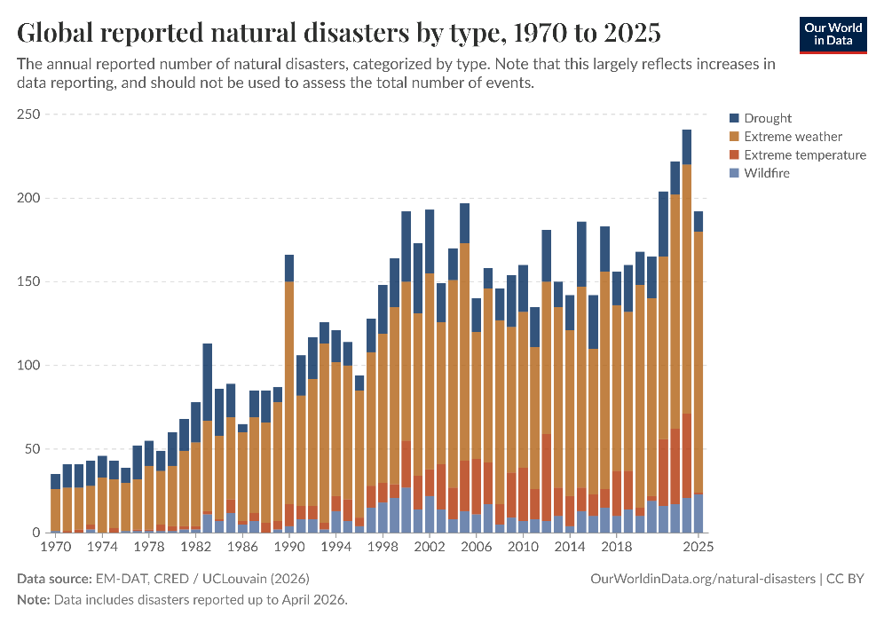
Fig. 1. Global trend in reported natural disasters.
Many systems support parts of this task, from optimization based allocation and simulation platforms to geospatial risk assessment and fuzzy reasoning [11], [16], [17]. Mature deployed systems such as WFDSS [18] and FlamMap [13], together with recent hybrid predictive fuzzy models [19], [20], provide substantial operational value, yet no single framework simultaneously addresses adaptability, explainability, and distributed multi level coordination within one coherent design [7], and field studies report that practitioners use existing tools to validate decisions already made rather than to generate new response options [21], [22].
These limitations are structural rather than incidental and consolidate into the three gaps of Table I. G1: many classical frameworks enumerate the decision alternatives before reasoning begins [2], [23] although fire routinely produces conditions no fixed strategy set can represent [24], and they concentrate reasoning in a centralized, single layer core that bottlenecks under rapid change and ignores the local, regional, and strategic levels wildfire operations actually span [25], [26], [27]. G2: wildfire decisions are dominated by incomplete rather than merely noisy information [28], yet existing uncertainty aware approaches require prior distributions or calibrated belief intervals unavailable at cell level in real time [29], [30]; fuzzy logic offers a graded representation without such assumptions [15], [31], while post-hoc attribution methods approximate model behavior instead of tracing a decision to its causes [6], opaque recommendations are overridden or ignored [32], and hybrid designs show accuracy and interpretability can coexist [19]. G3: modular separation is essential for traceability [33], yet many wildfire DSS merge fire modeling and decision logic in one platform [18], [20]; optimization based formulations presuppose complete state information [4], [34], [35], mechanisms integrating constraints into real-time cell level reasoning are missing [36], and complete observation-to-operator workflows remain rare.
TABLE I
Structural gaps in wildfire decision support architectures
Structural Gaps of Existing Wildfire DSS Architectures
G1 | Existing DSS frameworks rely on predefined decision alternatives evaluated within centralized, level-undifferentiated architectures, preventing adaptation to dynamic, unforeseen conditions and limiting scalability, local responsiveness, and level-appropriate coordination.
G2 | Current systems cannot represent epistemic uncertainty without probability distributions or calibrated belief intervals, and expose the reasoning behind a recommendation only through post-hoc attribution, leaving decision sensitivity unquantified and eroding operator trust.
G3 | Simulation dynamics and decision reasoning remain tightly coupled, and operational constraints are managed through offline optimization requiring complete state information, so no end-to-end operational workflow demonstrates real-time, cell-level decision support under operational conditions.

DisasterAware is a wildfire DSS framework built on concept-based fuzzy reasoning that addresses these gaps within a single design. Its three contributions answer the gaps of Table I one to one, as follows.
Open decision space through adaptive, concept-driven reasoning. To address G1, the fixed menu of predefined alternatives is replaced with an open, concept-driven decision field. Raw observations are first mapped onto a small set of domain-meaningful decision concepts, so rules are written in operational language rather than over raw signals. The field is then reshaped online: an evolving Takagi-Sugeno rule base adapts membership functions and term resolution [37], a generative model proposes genuinely new candidate rules when adaptation is exhausted, and every candidate passes a satisficing verification gate before it may act [38]. Reasoning is confined to local fuzzy agents, while a non-inferential global layer only assigns resources and normalizes priorities, which keeps the open field scalable. The action space therefore stays closed at the level of physical effects, which the model may not invent, yet open at the level of interventions composed from those effects.
Sensitivity analysis with traceability and confidence-gated uncertainty. To address G2, explanation and uncertainty handling are structural rather than retrofitted. Epistemic uncertainty is propagated without prior distributions by blending each concept activation with a persistence-based estimate in proportion to observation confidence. Every decision remains traceable to the concepts that fired it, the rules involved, and the confidence behind them, and a sensitivity analysis quantifies how features, membership parameters, and priority weights propagate to the decision, in contrast to post-hoc attribution [6].
End-to-end use-case demonstration. To address G3, a strict separation is enforced between the simulation core and the decision core, which allows either side to be validated independently. On this foundation the framework is exercised in an end-to-end use case that couples the spread simulation, the decision pipeline, and an operator dashboard, with satisficing acceptance and a graduated fail-safe keeping every realized intervention admissible. The with and without DSS results rest on counterfactual replay of the identical fire history, so reported differences are attributable to the issued orders alone. The use case responds to the research-to-practice distance reported in field studies [21], [22].
The remainder of this article is organized as follows. Section II reviews the background. Section III introduces the DisasterAware framework and its simulation core. Section IV develops the decision support system. Section V reports the results. Section VI concludes the article and outlines future work.

II. Background

A. Wildfire Dynamics and Spread Modeling
Fire behavior at any point of a landscape is governed by three groups of drivers: weather, terrain, and fuel. Wind pushes the flame front toward unburned fuel, while humidity and precipitation set the moisture content of fine fuels and, with it, the ease of ignition [12]. Terrain contributes elevation, slope, aspect, and accessibility, and fuel contributes the vegetation type, the available load, and the moisture that together determine how intense combustion becomes and how long a cell keeps burning [39]. These drivers are summarized operationally by the rate of spread, its direction, and the fire line intensity; the Rothermel model expresses the rate of spread as a function of fuel properties, fuel moisture, wind, and slope, and it still underlies most operational tools [12], [40].
The literature groups spread models into three families: physical and quasi-physical models that resolve combustion chemistry [41], empirical and quasi-empirical models that fit observed spread rates to environmental variables [42], and simulation models that propagate a front across a landscape by applying one of the former families as a local kernel, with FlamMap as the best-known operational example [43], [13]. Grid-based simulation discretizes the landscape into cells and matches the resolution at which incident decisions are made, so it is preferred when the model is coupled to a decision layer. A wildfire DSS does not require the highest-fidelity simulator available; it requires a testable environment in which scenarios can be reproduced exactly, the per-cell state can be observed and logged, the inputs through which interventions act can be controlled, and the outcome of a decision can be measured against the outcome of not deciding. DisasterAware therefore adopts a hybrid grid model, formalized in Section III, that combines Rothermel-type local spread with explicit per-cell state tracking and accepts interventions only at the input level, so the decision core never manipulates the physical state directly.

B. Decision Support Foundations
A DSS mediates between two spaces: the input space of everything the system can observe or estimate, and the decision space of everything it is authorized to decide. A DSS assists an operator in choosing among actions whose consequences are uncertain [1], [2], occupying a deliberate middle ground between full automation and unaided judgment [44]. In the classical framework it targets semi-structured decisions, those for which parts of the reasoning can be modeled while the remainder requires human judgment [45], [46]. Wildfire response is a canonical instance: the physics of spread can be modeled and candidate responses can be scored, yet accountability remains with the incident commander. Independent of domain, a working DSS supplies an input interface, a knowledge base, a reasoning engine, decision evaluation, and presentation with oversight [47], [3]; in time-critical domains explicit uncertainty handling and timeliness become essential [5].
In a closed decision space the alternatives are enumerated before reasoning begins and the system can only rank them, the structure of classical multi-criteria decision making [48], [49], [23]. The approach fails in wildfire response for a structural reason: fire behavior evolves continuously, and an incident routinely produces conditions that no predefined alternative covers. Field studies document the consequence, with commanders using existing tools to justify decisions already made rather than to generate new options [21], [22]. An open decision space requires modification of existing alternatives during operation, construction of genuinely new alternatives, and verification of every new alternative before it acts [50]. Naturalistic decision research shows that experienced commanders construct a single plausible course of action from recognized patterns rather than selecting from menus [51], [52]. The computational counterpart exists: evolving Takagi-Sugeno models create rules online when incoming data are poorly represented [53], [54], value-based selectors learn when to invoke structure-changing stages [55], and generative models, including LLM agents applied to wildfire analysis, draft candidate rules that lie outside the current structure [56], [57], [58]. DisasterAware combines the three mechanisms with a satisficing acceptance gate [38], so the decision space remains open while every realized action remains admissible.
In a centralized architecture every observation flows to a single reasoning core, which constitutes a bottleneck: communication grows with the domain, latency with communication, and a failure of the core silences the system [59], [25]. In a distributed architecture reasoning moves to local nodes, with multi-agent systems research providing the coordination mechanisms [60], [61] and wildfire DSS reviews explicitly calling for such designs [17]. DisasterAware follows the distributed pattern with one restriction: local agents perform all inference on region-level observations, while the global layer performs no inference at all, only assigning resources and normalizing priorities. Upward flow carries three compact quantities per region, and neither direction carries raw sensor fields or rule activations, which keeps the channel narrow, the coordination auditable, and the local decision path short.

C. The Input Space: Heterogeneous Sensing to Observation Features
Five families of sources feed the framework: meteorological networks and forecasts, spaceborne and airborne imagery with wide coverage but coarse revisit intervals [62], in-situ sensing with narrow footprints, geographic information layers for terrain, fuel, assets, and roads [63], [39], and the resource tracking and field reports of the response organization itself [35]. None of these sources observes the fire state directly, and they differ in modality, coverage, refresh rate, and reliability, so no single raw signal can drive decision rules. The heterogeneous stream is therefore reduced to ten bounded, observation-derived features, compiled with their sources and rationale in Table II. A quantity is admitted only if it is observable from what sensors actually deliver, bounded so that membership functions remain stable, operationally meaningful so that experts can phrase rules over it, and non-redundant. By construction the ten features span the threat, exposure, feasibility, and timing dimensions of the operational questions, and the sensitivity analysis of Section V confirms empirically that the decision output responds to every feature and is dominated by none.
TABLE II
The ten observation features, their sources, and their rationale
Feature | Primary source | Rationale
Fire intensity | Fire state estimation from imagery and in-situ sensing | Fireline intensity is the standard descriptor of how intensely a front is burning
Spread potential | Fire state and weather | Rate of spread in the Rothermel tradition remains the operational basis of spread assessment
Weather severity | Weather stations and forecasts | Fire-weather indices condense weather observations into spread and intensity potential
Ignition proximity | GIS road and infrastructure layers | Human-caused ignitions cluster near roads and infrastructure
Fuel load | Fuel model layers | Standard fuel models parameterize combustible load
Asset exposure | GIS asset and urban interface layers | Values-at-risk mapping quantifies what a fire threatens
Resource accessibility | Terrain, fuel, and access layers | Suppression difficulty combines terrain, fuel, and access conditions
Access and road status | GIS road status and field reports | Access governs suppression logistics and evacuation egress
Suppression availability | Resource tracking | Fireline production rates and available capacity determine whether suppression can be mounted
Temporal urgency | Ignition timing and incident clock | Incident command is time-critical; recognition-primed research formalizes acting under urgency

D. Concept-Driven Fuzzy Reasoning
Operational assessments in wildfire response arrive as graded, linguistic judgments: a spread potential is high, a suppression opportunity is marginal. Fuzzy set theory supplies the formal counterpart by admitting partial membership [15], [31]. A fuzzy set over a universe of discourse is characterized by a membership function that assigns each element a degree of membership, as formalized in ( 1 ). This graded semantics removes the brittle thresholds of crisp classification and preserves expert phrasing under formalization [64]. Domain knowledge enters through linguistic rules of the canonical conjunctive form ( 2 ), whose activation strength is the conjunction of its antecedent memberships ( 3 ).
$$μ_{A}:Z→[0,1], L=\{(z,μ_{A}(z)):z∈Z\}$$ | ( 1 )
$$R_{r}: IF z_{1} is A_{r,1} AND … AND z_{n} is A_{r,n} THEN u is B_{r}$$ | ( 2 )
$$α_{r}=\min_{i}⁡μ_{A_{r,i}}(z_{i})$$ | ( 3 )
Two classical mechanisms turn these activations into a crisp action. Mamdani inference keeps the consequent linguistic and defuzzifies an aggregated output set [65], while Takagi-Sugeno inference replaces the consequent set with a function of the inputs and obtains the output directly as a firing-strength weighted average [37]. DisasterAware adopts the zero-order Takagi-Sugeno form throughout the decision layer, ( 4 ), in which every consequent is a constant intensity on the unit interval. The choice follows from four requirements of the architecture. Every candidate decision is judged inside shadow forecasts executed thousands of times per incident, so a per-evaluation centroid integration would price the forecast loop out of its decision cycle; the outputs are intensity commands, which a zero-order consequent is exactly; the adaptation loop demands consequents that are numbers with predictable effect on the output; and interpretability is retained where it matters, since the antecedents remain linguistic while the numeric consequent is audited as a dosage. The lower bound of one in the denominator implements the coverage discipline of the framework: when the whole base fires weakly, the output is attenuated rather than renormalized upward, so a barely covered situation cannot masquerade as a confident command. Fig. 2 illustrates the five-term trapezoidal partition of a normalized input used throughout; adjacent terms overlap so that every reading activates at most two terms.
$$u=\frac{\sum_{r∈R}{α_{r}⋅v_{r}}}{max\left(\sum_{r∈R}{α_{r}}, 1\right)}, v_{r}∈\left[0,1\right]$$ | ( 4 )
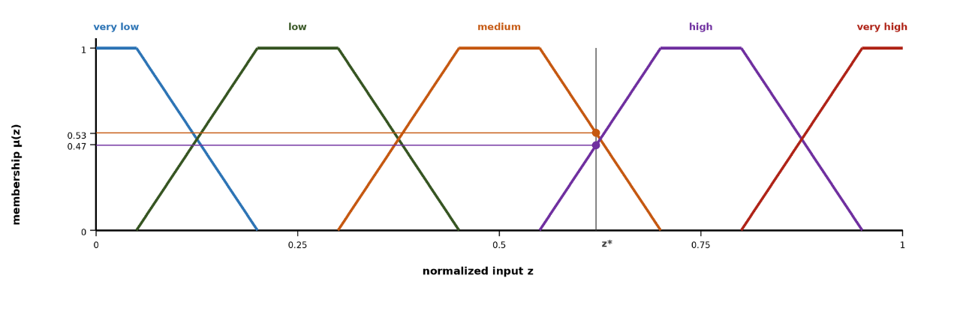
Fig. 2. Five-term trapezoidal membership partition with an example reading.
The obstacle to applying fuzzy inference directly over a rich observation vector is combinatorial. A complete rule base over the full feature set contains the number of rules given in ( 5 ): ten features with five linguistic terms each would demand nearly ten million rules, a base that cannot be elicited from experts, maintained by engineers, or audited by operators [31]. The decisive reduction is achieved through a conceptual middle layer. Rather than writing rules over raw features, DisasterAware first composes the features into a compact four-level concept hierarchy: six base concepts summarize physically related features; three mid-level and two higher-level decision concepts answer, each exactly once, the recurring operational questions that incident commanders demonstrably ask [11], [51]; and a single top concept, operational priority, serves cross-region coordination. Rules are then written over the five decision concepts only, and the rule burden collapses from a product to a sum, as summarized in ( 6 ). The antecedent space shrinks from about 9.8 million combinations to 3125, of which the evolving rule base instantiates only the small active subset that observed situations require. The intermediate layer provides more than combinatorial economy: concepts constitute the traceability vocabulary of the entire framework, since every recommendation can be read back as a statement over fire threat level, suppression feasibility, asset exposure risk, intervention urgency, and evacuation pressure.
$$|R|={N_{term}}^{N_{feature}}$$ | ( 5 )
$${N_{term}}^{N_{feature}} ⇢ N_{concept}⋅{N_{term}}^{N_{input}}+{N_{term}}^{N_{concept}}$$ | ( 6 )

E. The Decision Space: Interventions and Their Evaluation
The output of the decision rules is an assignment of intensities to concrete actions. The decision space is built from a fixed vocabulary of six intervention families, each applied with an intensity over the grid, so that every rule binds to a concrete, executable order [11], [16]: suppression effort [35], resource deployment [36], [34], containment line [66], asset protection [24], [18], evacuation [27], and public warning [67]. The list is closed at the level of families, which keeps the action vocabulary interpretable; openness enters through the generation of new rules over the same types. Beyond the six doctrine families, the simulator implements a small library of discoverable actuators, water drafting, aerial retardant drop, and tactical burn, whose physical effects are validated in the engine but which no seed rule orders; they are announced to the generative stage together with their map availability. Inaction is not modeled as a seventh type but as the zero-intensity point of every type, which keeps the decision space continuous and lets the cost model price restraint the same way it prices action.
A candidate intervention is evaluated through its expected cost, following the cost-plus-loss principle of wildfire economics: the total cost of a response comprises the expenditure on suppression and the net value lost to the fire [35], [11]. The weights of the cost terms follow the priority-setting literature [68], using pairwise comparison in the tradition of the analytic hierarchy process [69]. Global minimization over a spatial decision field is computationally intractable under real-time constraints [70] and presupposes information that incomplete observation cannot supply, so acceptance follows the satisficing principle of bounded rationality [38], [71]. The uncertainty that dominates an active incident is epistemic rather than aleatory: the state is under-observed, not merely noisy [28], and Bayesian updating or Dempster-Shafer belief calibration presuppose distributional knowledge that cell-level real-time sensing does not supply [72], [29], [73]. Explanation, finally, is a structural property of reasoning over explicit concepts and rules, in contrast to post-hoc attribution methods [6], [74]. Generative models are used in DSS as proposers whose fluent output can be factually wrong or unsafe [75], [76], so a generated artifact is treated as untrusted by construction and admitted only after explicit verification [77], [78]. The formal machinery that realizes these principles, the five-term cost, the satisficing acceptance, the confidence gating, and the staged adaptation loop, is developed in Section IV in its final form.

III. DisasterAware Framework and Simulation Core

A. Overall Architecture
Fig. 3 presents the architectural structure of the DisasterAware framework: a discrete-time, state-driven, layered architecture organized into four principal layers, namely external data sources, the simulation core, the DSS core, and the operator dashboard. Each layer performs a strictly defined function and communicates through structured interfaces rather than direct state manipulation. The external data sources provide structured exogenous inputs that function as boundary conditions. At the center lies the simulation core, the authoritative computational engine: wildfire propagation is modeled over a spatial grid whose cells carry burning status, available combustible mass, a local fire intensity proxy, and time since ignition, and a grid state manager enforces physical constraints. No external module, including the DSS and the dashboard, is permitted to overwrite internal state variables; all modifications occur through controlled parameter influence. The DSS core operates as a cognitive layer on observable quantities derived from the state, and the dashboard forms the asynchronous operational boundary through which the operator can pause, resume, roll back to a checkpoint, inject ignition scenarios, and modify resource availability, always through admissible input-level modifications. This layered organization enforces a clear separation between wildfire physics, decision cognition, and human supervision.
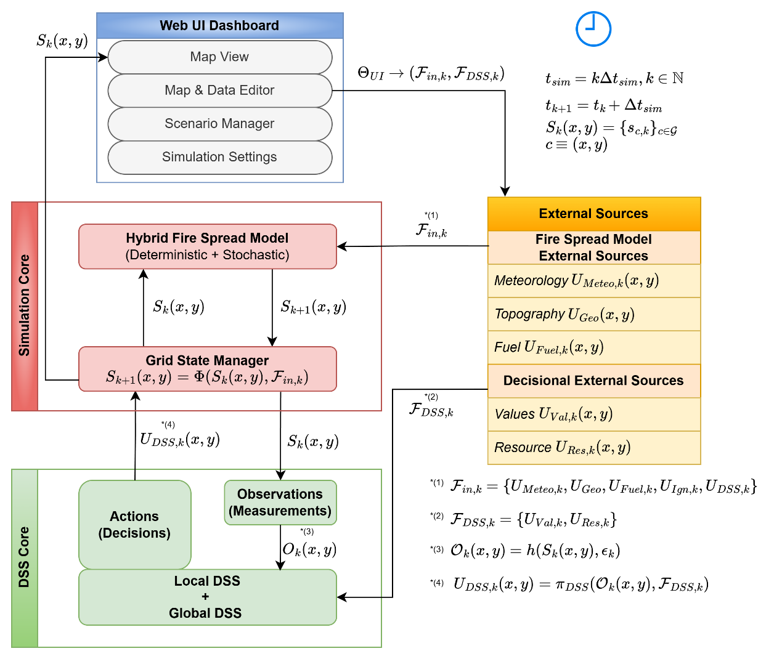
Fig. 3. DisasterAware system block diagram (simulation focused).

B. External Inputs and Decision Context
The external input set ( 7 ) collects all parameters that influence wildfire evolution at discrete step k: meteorological forcing (temperature, humidity, wind speed and direction, gusts, and precipitation), static topography (elevation, slope, aspect, and an accessibility index), fuel conditions (vegetation class, available combustible mass, and moisture), ignition injection, and the intervention parameters generated by the DSS (suppression capacity, availability, effectiveness, and travel time). Environmental inputs are updated independently of the system state, whereas decision-driven inputs depend on observable quantities derived from it. In addition, the DSS relies on a distinct contextual set comprising a value layer, which aggregates building footprints, critical facilities, population density, and evacuation accessibility into a protection priority score, and a resource layer describing the operational capabilities available for intervention. The contextual set does not affect wildfire dynamics directly; it only guides decision generation, keeping fire behavior modeling and decision reasoning separate.
$$F_{in,k}=\left\{U_{Meteo,k},U_{Geo}, {U_{Fuel\text{,k}}, U_{Ign,k}, U}_{DSS,k}\right\}$$ | ( 7 )

C. State Representation and Transition
The landscape is discretized into a rectangular grid, and at each simulation step the wildfire state is the collection of local cell states ( 8 ), where each cell carries its burning status, its available combustible mass, a local fire intensity proxy, and the time since ignition. The state vector includes only internal wildfire variables; environmental factors and operational interventions are represented exclusively as external inputs. The global evolution ( 9 ) is governed by a structured transition operator composed of burning status evolution, fuel mass evolution, and fire intensity update, as illustrated in Fig. 4. The operator itself is deterministic; stochastic variability enters only through exogenous input fields such as wind gusts, and, in one controlled channel, through seeded ember spotting.
$$S_{k}=\left\{s_{k}\left(x,y\right)|(x,y)∈G\right\} \\ s_{k}=\left[\begin{aligned}B_{k}\left(x,y\right) \\ F_{load,k}\left(x,y\right) \\ I_{k}\left(x,y\right) \\ τ_{k}\left(x,y\right)\end{aligned}\right]$$ | ( 8 )
$$S_{k+1}\left(x,y\right)=Φ\left(S_{k}\left(x,y\right),F_{in,k}\right)$$ | ( 9 )
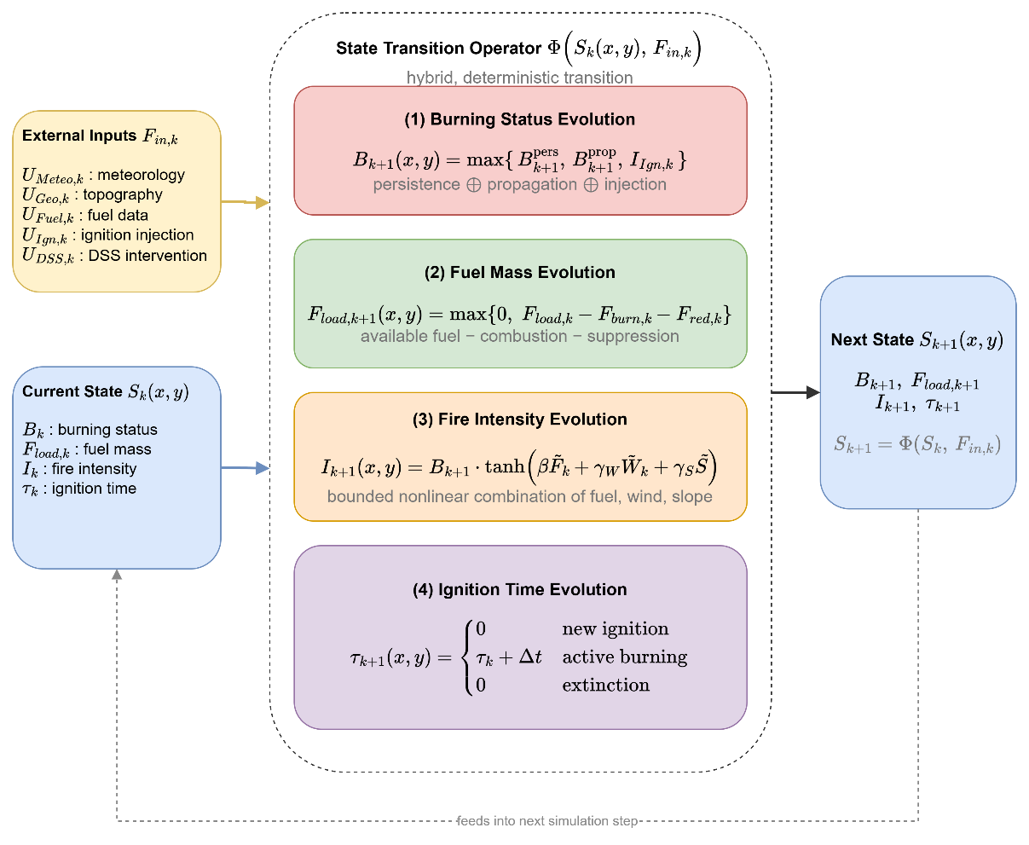
Fig. 4. State transition block diagram.

D. Hybrid Fire Spread Model
The burning status at the next step ( 10 ) is determined by three mechanisms: persistence of ongoing burning while fuel remains above an extinction threshold, propagation from neighboring burning cells, and external ignition injection. Propagation occurs when the accumulated influence over the 8-connected neighborhood exceeds a calibrated ignition threshold. The influence ( 11 ) accumulates the rate of spread of each burning neighbor, instantiated by a semi-empirical Rothermel-type mapping of wind, slope, aspect, fuel moisture, and fuel type [12], weighted by the directional factor ( 12 ) that aligns spread with the wind vector, as depicted in Fig. 5. The aggregate influence is therefore not a symmetric average but a wind-aligned weighted sum, and the ignition condition is satisfied preferentially along the prevailing wind, which realizes the directional bias central to operationally realistic propagation.
$$B_{k+1}\left(x,y\right)=\max\left(B_{k+1}^{pers}\left(x,y\right),B_{k+1}^{prop}\left(x,y\right),I_{Ign,k}\left(x,y\right)\right)$$ | ( 10 )
$$Ψ_{k}\left(x,y\right)=\frac{1}{8}\sum_{\left(i,j)∈N^{8}(x,y\right)}{B_{k}}\left(i,j\right)⋅R_{spread,k}\left(i,j\right)⋅ g_{dir,k}^{\left(i,j)→(x,y\right)}$$$$R_{spread,k}\left(x,y\right)=f_{ros}\left(\begin{aligned}W_{ws,k}\left(x,y\right), W_{wd,k}\left(x,y\right), \\ {G_{slope}\left(x,y\right),G}_{aspect}\left(x,y\right), \\ F_{moist,k}\left(x,y\right),F_{type}\left(x,y\right) \end{aligned}\right)$$ | ( 11 )
$$g_{dir,k}^{\left(i,j)→(x,y\right)}=\max\left(0,\cos\left(W_{wd,k}\left(i,j\right)-φ_{\left(i,j)→(x,y\right)}\right)\right)$$ | ( 12 )
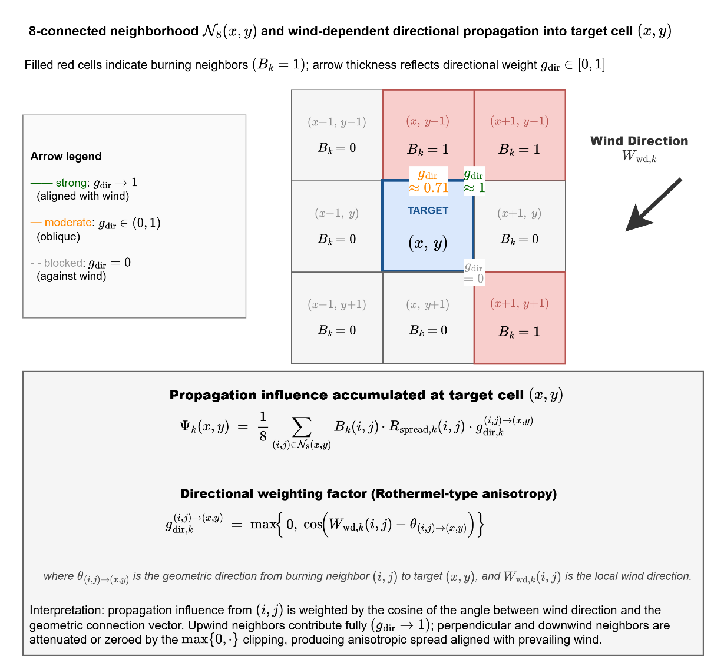
Fig. 5. Wind-dependent directional propagation into a target cell.
Two further mechanisms complete the spread model. Ember spotting extends ignition beyond the resolved front: a burning cell whose intensity exceeds 0.6, under wind above 3 m/s and precipitation below 1 mm/h, releases an ember with probability 0.02 per reference step that lands six cells downwind and ignites the target only if fuel remains and moisture is below the extinction threshold. Spotting is the only stochastic element of the transition operator, is driven by the seeded random stream of the scenario, and allows the fire to cross narrow barriers such as rivers, roads, and containment lines. Precipitation acts through the dead fuel moisture, which relaxes under rain toward a level above every extinction threshold with a time constant of roughly thirty minutes, so a front dies out gradually rather than instantaneously; when the equilibrium moisture mode is active, dead fuel moisture follows the equilibrium content computed from temperature and humidity, so diurnal weather cycles modulate flammability in the manner of operational fire behavior tools.

E. Fuel Mass, Suppression, and Intensity
Fuel mass evolution ( 13 ) separates combustion-driven consumption, active only in burning cells, from intervention-driven reduction, while enforcing non-negativity. The suppression term ( 14 ) converts operational capability and reachability into a normalized fuel reduction effect: capacity and availability gate the magnitude, reachability decays exponentially with travel time and accessibility, and effectiveness is attenuated by local fire intensity, so extreme fire behavior reduces the marginal impact of suppression. Suppression never overwrites the burning state; it modifies the available fuel, which subsequently influences persistence and propagation through the transition operator. The local fire intensity proxy ( 15 ) approximates combustion strength from available fuel, wind forcing, and terrain gradient; it does not control ignition activation or the spread operator, but it modulates suppression effectiveness and provides structured features to the decision layer. This structural separation between spread mechanics and combustion strength prevents double-counting of mitigation effects.
$$F_{load,k+1}\left(x,y\right)=\max\left(\begin{aligned}0, \left(\begin{aligned}F_{load,k}\left(x,y\right) \\ -F_{load,k}\left(x,y\right) B_{k}\left(x,y\right) F_{burn,k}\left(x,y\right) \\ -F_{red,k}\left(x,y\right)\end{aligned}\right)\end{aligned}\right)$$ | ( 13 )
$$F_{red,k}\left(x,y\right)=f_{supp} \left(\begin{aligned}R_{cap,k}\left(x,y\right),R_{avail,k}\left(x,y\right),R_{eff,k}\left(x,y\right), \\ R_{time,k}\left(x,y\right),G_{access}\left(x,y\right)\end{aligned}\right)$$ | ( 14 )
$$I_{k+1}\left(x,y\right)=f_{intensity}\left(F_{load,k}\left(x,y\right),W_{ws,k}\left(x,y\right),G_{slope}\left(x,y\right)\right)$$ | ( 15 )

F. Interaction, Counterfactual Replay, and the DSS Interface
Human interaction is formalized by an interaction operator that produces admissible, bounded modifications of the external input set and the decision context: ignition injection for scenario intervention, meteorological perturbation for what-if analysis, resource adjustment for operational override, and value re-weighting for priority reconfiguration. The system state is not in the domain of this operator, so all operator influence propagates through physically consistent state transitions, and interaction remains prospective, traceable, and reversible. The simulation core additionally maintains per-step state snapshots under a bounded memory budget, enabling exact counterfactual replay: a snapshot carries every mutable part of the state, including the state of the random number generator, and the exogenous weather driver is replayed unchanged, so two runs started from the same snapshot differ only in the orders under test. The with and without DSS comparisons of Section V rest on this mechanism, a controlled experiment on the incident itself rather than a statistical estimate over an ensemble. The DSS closes the loop through the observation interface ( 16 ): the observation function projects the authoritative state onto observable information, injecting epistemic uncertainty at this point and this point only; the regional decision mapping produces the intervention field; and the aggregated field re-enters the simulation exclusively as one component of the external input set.
$$S_{k}\left(x,y\right)→ O_{k}\left(x,y\right),F_{DSS,k}→U_{DSS,k}\left(x,y\right)→Φ\left(∙\right)→S_{k+1}\left(x,y\right)$$$$U_{DSS,k}\left(x,y\right) = π_{DSS}^{i}\left(O_{k}\left(x,y\right),F_{DSS,k}\right) ⊂ F_{in,k}$$ | ( 16 )

IV. Decision Support System

A. Four-Layer Pipeline
Fig. 6 presents the complete framework of a Local DSS agent as a four-layer flow from observation to decision. Layer 1, the input space, collects the heterogeneous spatio-temporal measurements of Section II-C. Layer 2, the perception layer, fuses them into bounded features with explicit confidence. Layer 3, the concept space, abstracts the features into the four-level concept hierarchy. Layer 4, the decision space, generates, adapts, and evaluates interventions. In operation, N agents execute this loop concurrently, each restricted to the cells of its own region, while the Global DSS coordinates them by normalizing priorities, allocating the shared resource pool, and enacting cross-region decisions where necessary.
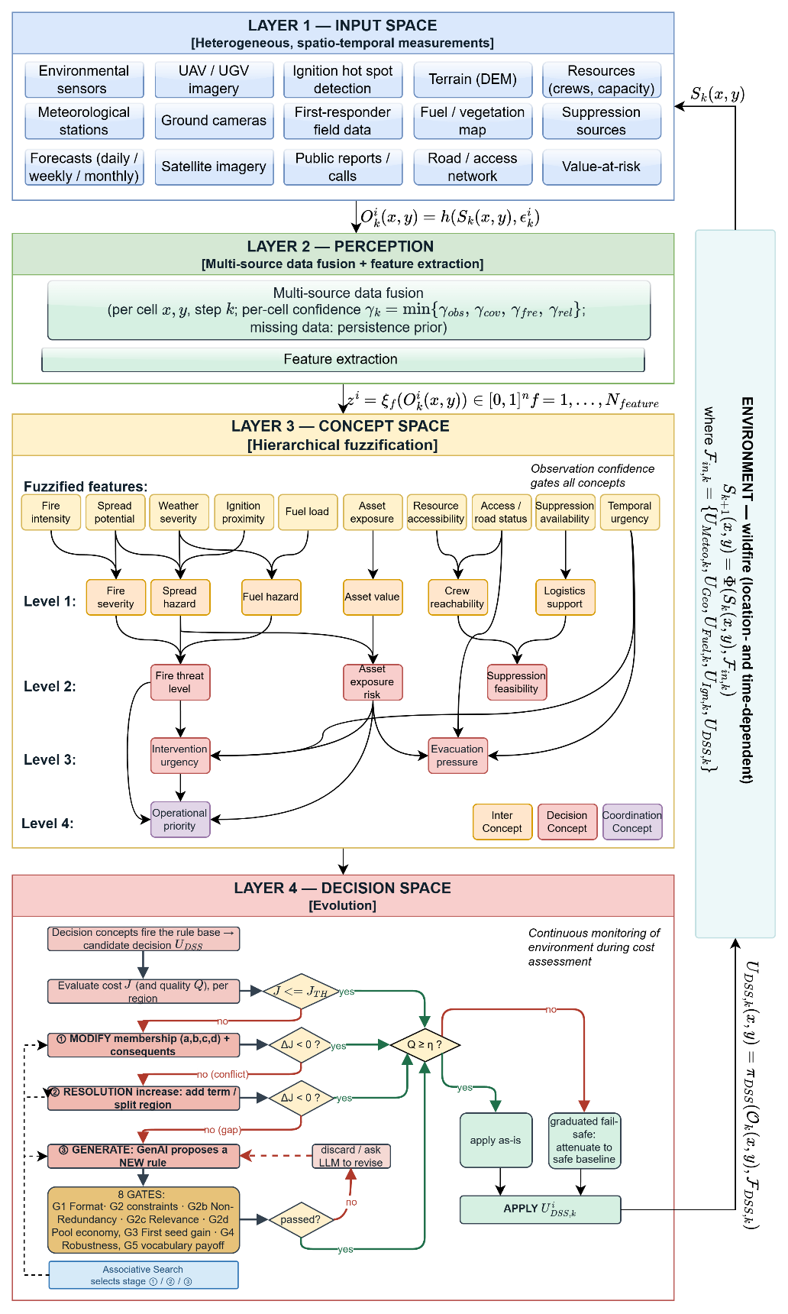
Fig. 6. DisasterAware system block diagram (DSS focused).

B. Observation, Features, and Confidence
Each Local DSS agent receives at step k the region-restricted observation ( 17 ), where the observation function projects the authoritative state onto the cells of the region and injects the epistemic uncertainty. The term epistemic denotes that this uncertainty stems from missing knowledge rather than randomness: a camera may be occluded by smoke, a satellite product arrives at revisit intervals, a road sensor may be offline. No probability distribution over the error is assumed anywhere in the pipeline. Every observed cell carries a confidence composed conservatively from four factors, observability, coverage, freshness, and reliability, as the minimum ( 18 ) rather than an average. Confidence bounds the disturbance instead of describing it statistically: the observation error magnitude is limited by the complement of the confidence ( 19 ), so a fully confident observation is exact, a vanishing confidence admits the worst-case disturbance, and intermediate values degrade gracefully. From the regional observation the agent computes the ten features ( 20 ), each inheriting a feature-level confidence from the observation fields its extraction consumes, so the pair of feature value and feature confidence is the complete interface between perception and reasoning.
$$O_{k}^{i}\left(x,y\right)=h^{i}\left(S_{k}\left(x,y\right), ε_{k}^{i}\left(x,y\right)\right), \left(x,y\right)∈G^{i}$$ | ( 17 )
$$γ_{k}^{i}\left(x,y\right)=min⁡\{γ_{obs},γ_{cov},γ_{fre},γ_{rel}\}$$ | ( 18 )
$$|ε_{k}^{i}\left(x,y\right)|≤(1-γ_{k}^{i}\left(x,y\right))⋅ε_{max}$$ | ( 19 )
$$z_{f,k}^{i}=ξ_{f}\left(O_{k}^{i}\right)∈[0,1], f=1,…,N_{feature}$$ | ( 20 )

C. Concept Space and Confidence Gating
The conceptualization layer of Fig. 7 maps physically related features into six base concepts, the base concepts into three mid-level and two higher-level decision concepts, and finally into the single coordination concept. The activation of a base concept is the weighted sum of the term memberships of its features, and the activation of every higher concept is the weighted sum of the activations of the concepts in its set, with nonnegative weights normalized to one ( 21 ). Raw activations are never consumed directly. Every activation is gated by its observation confidence and blended with a persistence-carried prior ( 22 ): a reliable observation passes through unchanged, while an uninformative one falls back to the decayed previous estimate, and a concept that ceases to be observed fades geometrically over successive steps instead of persisting indefinitely. The transition between trust and caution is linear, with no threshold to tune, and the effective activation snaps back to the observation as soon as confidence returns.
$$a_{n,k}^{(1),i}=\sum_{f∈Z_{n}}{ω_{n,f}⋅μ_{A_{n,f}}\left(z_{f,k}^{i}\right)} \\ a_{n,k}^{(l),i}=\sum_{m∈C_{n}^{(l)}}{ω_{n,m}^{(l)}⋅a_{m,k}^{(l-1),i}}, l=2,3,4$$ | ( 21 )
$$a_{n,k}^{eff,i}=γ_{n,k}^{i}⋅a_{n,k}^{obs,i}+\left(1-γ_{n,k}^{i}\right)⋅ρ⋅a_{n,k-1}^{eff,i}, \\ γ_{n,k}^{i}=min⁡\{γ_{f,k}^{i}:f∈Z_{n}\}$$ | ( 22 )
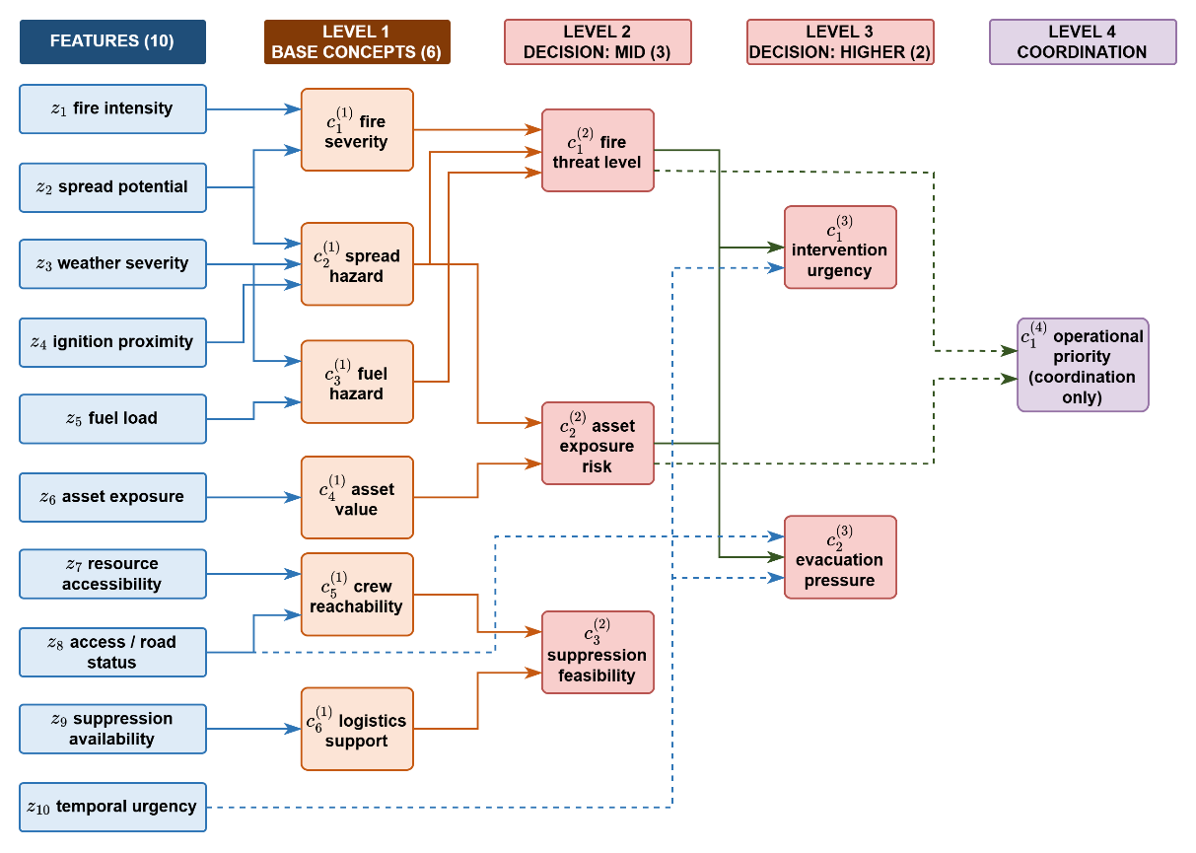
Fig. 7. Feature-concept hierarchy.

D. Rule Base and Candidate Intervention
Decision rules are written exclusively over the five gated decision concepts in the canonical conjunctive form ( 23 ): each antecedent clause tests one concept against one linguistic term, and the consequent assigns a singleton intensity to each intervention family. A rule fires with the strength of its weakest satisfied clause, and the candidate is assembled family by family from every rule that fires ( 24 ), with the denominator floored at one so that a weakly supported conclusion yields a weak order. The base is sparse by construction: the antecedent space admits 3125 combinations, but the base holds only the seeded doctrine and whatever the adaptation loop later adds, and sparsity costs no coverage because adjacent terms overlap and the aggregation interpolates between the rules that share a situation. The seeded base satisfies the coverage condition ( 25 ), so at every reachable reading some rule fires above the coverage floor of 0.05; a reading that falls below the floor marks a coverage gap, upon which the layer falls back to the watchful posture and adaptation is triggered. Full enumeration is rejected on principle: a catalogue of 3125 rules cannot be audited, freezes a guess into every combination that operations have never visited, and fixes the alternatives in advance, which is precisely the closed decision space this work sets out to leave behind. Each concept has a primary intervention family that answers its operational question, with suppression feasibility acting as a gatekeeper that modulates the others; a run starts from a minimal profile of five seed rules, so the system starts without doctrine and must learn its base by trial.
$$R_{r}: IF a_{1,k}^{eff,i} is A_{r,1} AND … AND a_{5,k}^{eff,i} is A_{r,5} THEN U_{DSS,k}^{i} is B_{r}$$ | ( 23 )
$$u_{m,k}^{i} = \frac{\sum_{r}{α_{r} v_{r,m}}}{max(1, \sum_{r}{α_{r}})} \\ α_{r} = \min_{n ∈ ant(r)} μ_{A_{r,n}}(a_{n,k}^{eff,i})$$ | ( 24 )
$$\min_{a^{eff}∈[0,1]^{5}} \max_{r} α_{r}\left(a^{eff}\right)≥α_{min}>0$$ | ( 25 )

E. Cost, Quality, and Satisficing Acceptance
The decision and adaptation flow of Layer 4 is summarized in Fig. 8. Every candidate is judged by two complementary measures, both computed on a shadow copy of the simulation before anything reaches the field: the cost asks what the candidate is expected to cost the incident, and the quality asks whether it serves the concepts that demanded it.
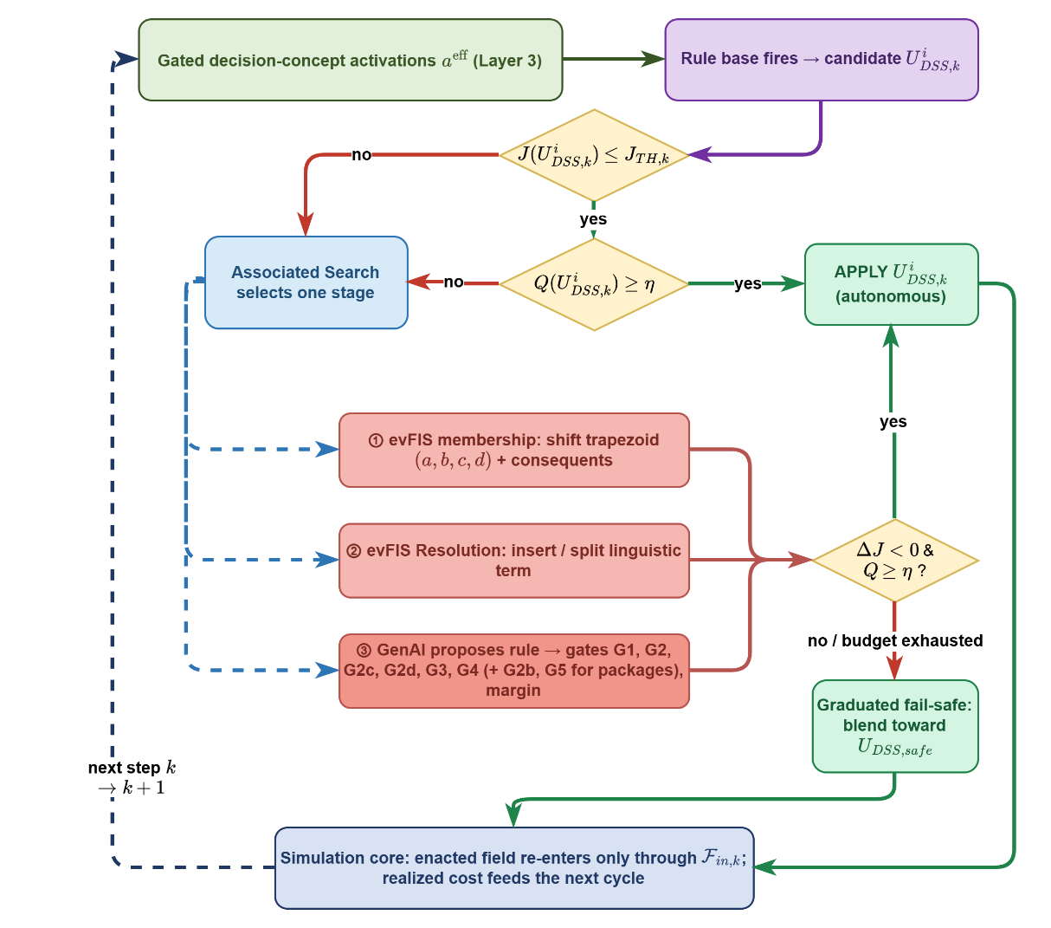
Fig. 8. Layer 4 decision and adaptation flow.
The cost is the weighted five-term sum ( 26 ) over burned area, asset loss, population exposure, response effort, and response delay, each term an actual quantity divided by a scenario reference so that five quantities of different units become summable. Burned area is charged against a major-fire reference through a rational form that keeps every saved cell measurably worth saving at any fire size; population exposure integrates person-steps inside actively burning cells; response cost prices the time integral of the committed force, so protective actions are never free for the adaptation loop; and delay prices the capacity-weighted mean dispatch time against a sixty-minute reference. The candidate allocation is held constant over a forecast horizon and compared against a no-action shadow run started from the same state, and acceptance is satisficing rather than optimizing ( 27 ): the bound is the tighter of a fixed normalized ceiling of 0.35 and a required relative gain over the no-action forecast, so a situation in which doing nothing is already cheap automatically demands a stronger candidate. Failing the cost test does not suspend action; the standing orders remain in force while adaptation runs. Cross-run comparisons read the physical cost only, the burned-area, asset, and population terms renormalized, because a run that never intervenes carries no response cost and a comparison on the total would reward inaction.
$$J=\frac{\sum_{j}{w_{j}J_{j}}}{\sum_{j}{w_{j}}}, j∈\left\{burn, asset, pop, resp, delay\right\} \\ J_{burn}=\frac{\frac{N_{burned}}{ρ_{burn}⋅N_{burnable}}}{1+ \frac{N_{burned}}{ρ_{burn}⋅N_{burnable}}} \\ J_{asset}=\frac{V_{lost}}{V_{total}} \\ J_{pop}=\min\left(1, \frac{P_{steps}}{P_{total}⋅N_{decisions}}\right) \\ J_{resp}=\min\left(1, \frac{C_{steps}}{C_{ref}⋅N_{decisions}}\right) \\ J_{delay}=min(1, \frac{τ̅}{τ_{reference}})$$ | ( 26 )
$${\hat{J}}_{k}\left(U_{DSS,k}\right) ≤ min(J_{TH}, (1-δ_{gain})⋅{Ĵ}_{k}(0))$$ | ( 27 )
The quality measures what the cost cannot. For each scored concept, the gated activation is compared with the strongest intensity the candidate assigns to the intervention family that answers it, and the quality is one minus the mean of these mismatches ( 28 ). A candidate that suppresses heavily while the fire threat is low is penalized as much as one that ignores a high evacuation pressure, so a misdirected response is detected before its consequences appear. Suppression feasibility is excluded from the scored set: it states whether action is possible, not how much action is required, so it modulates rather than demands. When the quality falls below the gate of 0.60, the graduated fail-safe attenuates the candidate toward a pre-authorized conservative posture ( 29 ) in proportion to the deficit: the offensive families, suppression effort, resource deployment, containment line, and asset protection, are scaled down, while the life-safety orders, evacuation and public warning, are never reduced. The transition from full intervention through partial intervention to fallback is continuous, auditable, and reversible as observation quality recovers. If even the adapted candidate is forecast to end worse than doing nothing on the physical cost, a no-harm rule withholds the offensive allocation for the cycle, evaluated over a lookahead so that interventions whose effects mature in thirty to sixty minutes are not punished prematurely.
$$Q_{k}=1-\frac{1}{4}\sum_{n∈C_{Q}}{|{a_{n}}^{eff}-\max_{f∈F(n)} u_{f}|}, accept ⇔ Q_{k}≥η$$ | ( 28 )
$${U_{DSS,k}}^{'}=λ_{k}⋅U_{DSS,k}+(1-λ_{k})⋅U_{DSS,safe}, λ_{k}∈[0,1]$$ | ( 29 )

F. Open Decision Space: Staged Adaptation
Adaptation is organized as three stages of strictly increasing invasiveness, engaged only when the standing decision demonstrably falls short: a cost deficit, a coverage gap while fire is alive, or renewed spread under applied orders. Stage 1, the evolving-fuzzy parameter layer, tunes the rules already in the base with two bounded moves illustrated in Fig. 9: the consequent step ( 30 ) nudges the intensity of a rule by a fixed 0.05 and clips to the unit interval, and the boundary shift moves the shared edge of two neighboring terms while preserving the partition of unity. Every trial is a hypothesis, kept only when the forecast physical cost strictly falls ( 31 ) and rolled back otherwise; all trials act on a working copy, so the seed base is never modified. Stage 2 grows the rule base: it writes a rule on the uncovered antecedent combination defined by the two most active concepts and their dominant terms, and, where a covered combination is linguistically ambiguous, inserts a narrow term centered on the crisp reading, raising the number of expressible combinations from 3125 to 3750 at the first insertion. An inserted term stays outside the aggregation of Layer 3, so the five-term algebra remains untouched and the growth stays on the rule side.
$$v_{r,m}←clip_{0,1} \left(v_{r,m}±δ\right), m∈cons\left(r\right)$$ | ( 30 )
$$kept ⇔ Δ{\hat{J}}_{phys}<0$$ | ( 31 )
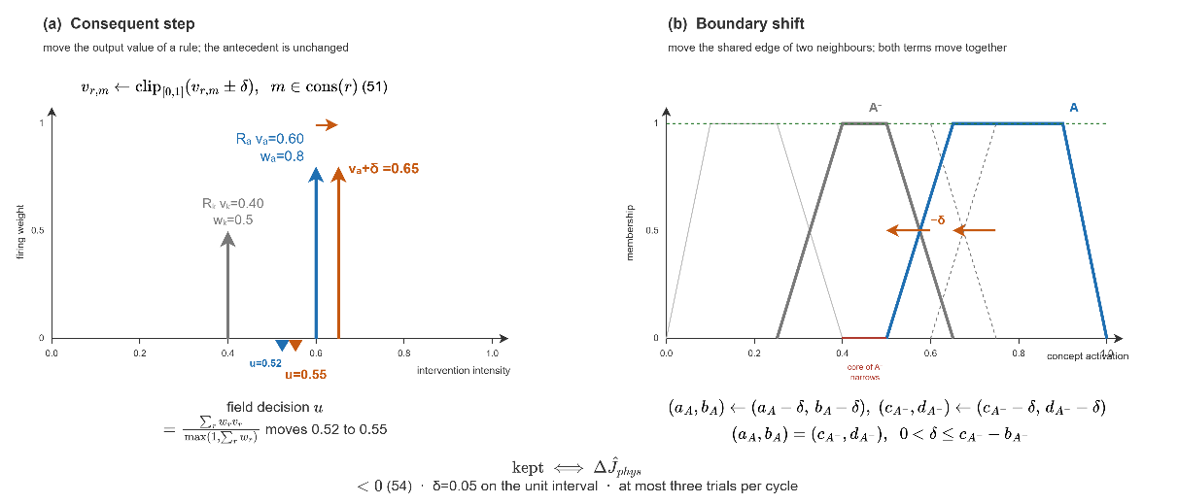
Fig. 9. Consequent step and boundary shift.
Stage 3, the generative layer, adds knowledge that neither tuning nor instantiation can produce. A pretrained large language model is used in context only, with no training and no weight update: it receives a deterministic situation summary, the crisp value of every decision concept, the whole active rule base in IF-THEN form, and the coverage verdict, and returns exactly one proposal in the canonical rule form, either a single rule or a package of one rule with one new vocabulary object, a macro intervention composed of at most three base interventions, an intermediate concept, or a clause actuator with its own geometry. The vocabulary the stage receives is deliberately primitive, a basis of verified physical effects (wet, clear, ignite, coat, draft, evacuate, prime), a geometry of target sectors and distance bands, and a reading of the map affordances, so a new intervention is composed from this basis rather than selected from a menu; when the map reports a lake near the front, the stage can compose an actuator that drafts from the water body and wets the fuel ahead of the head, an intervention no seed rule contains. The action space stays closed at the level of physical effects yet open at the level of interventions. Every proposal is untrusted by construction and passes the verification gates of Fig. 10: G1 checks format, G2 vocabulary, ranges, and duplication, G2b non-redundancy of a proposed concept by cosine similarity, G2c relevance to the present situation, and G2d pool economy against the funded budget, all without a simulation step; G3 and G4 then demand that the forecast physical cost not rise on two independently seeded rollouts ( 32 ), an A/B test that rejects stochastic flattery, and G5 requires a package to clear an additional vocabulary margin. A rejection is returned to the model with the failing gate named, every closed cycle is written to a chronicle whose nearest records are retrieved into the next prompt, and an admitted rule enters the base with its provenance. The stage selector is a contextual bandit [55] that reads the shortfall band and the coverage flag, applies an epsilon-greedy rule over the allowed stages, and learns from the realized reduction of the forecast physical cost which stage pays off in which situation.
$$ΔJ_{phys}^{(ν)}=J_{phys}^{\left(ν\right)}(R∪\{r'\})-J_{phys}^{\left(ν\right)}(R), ν∈\{V_{a},V_{b}\}$$$G3: ΔJ_{phys}^{(V_{a})}≤0$$G4: ΔJ_{phys}^{(V_{b})}≤0$ | ( 32 )
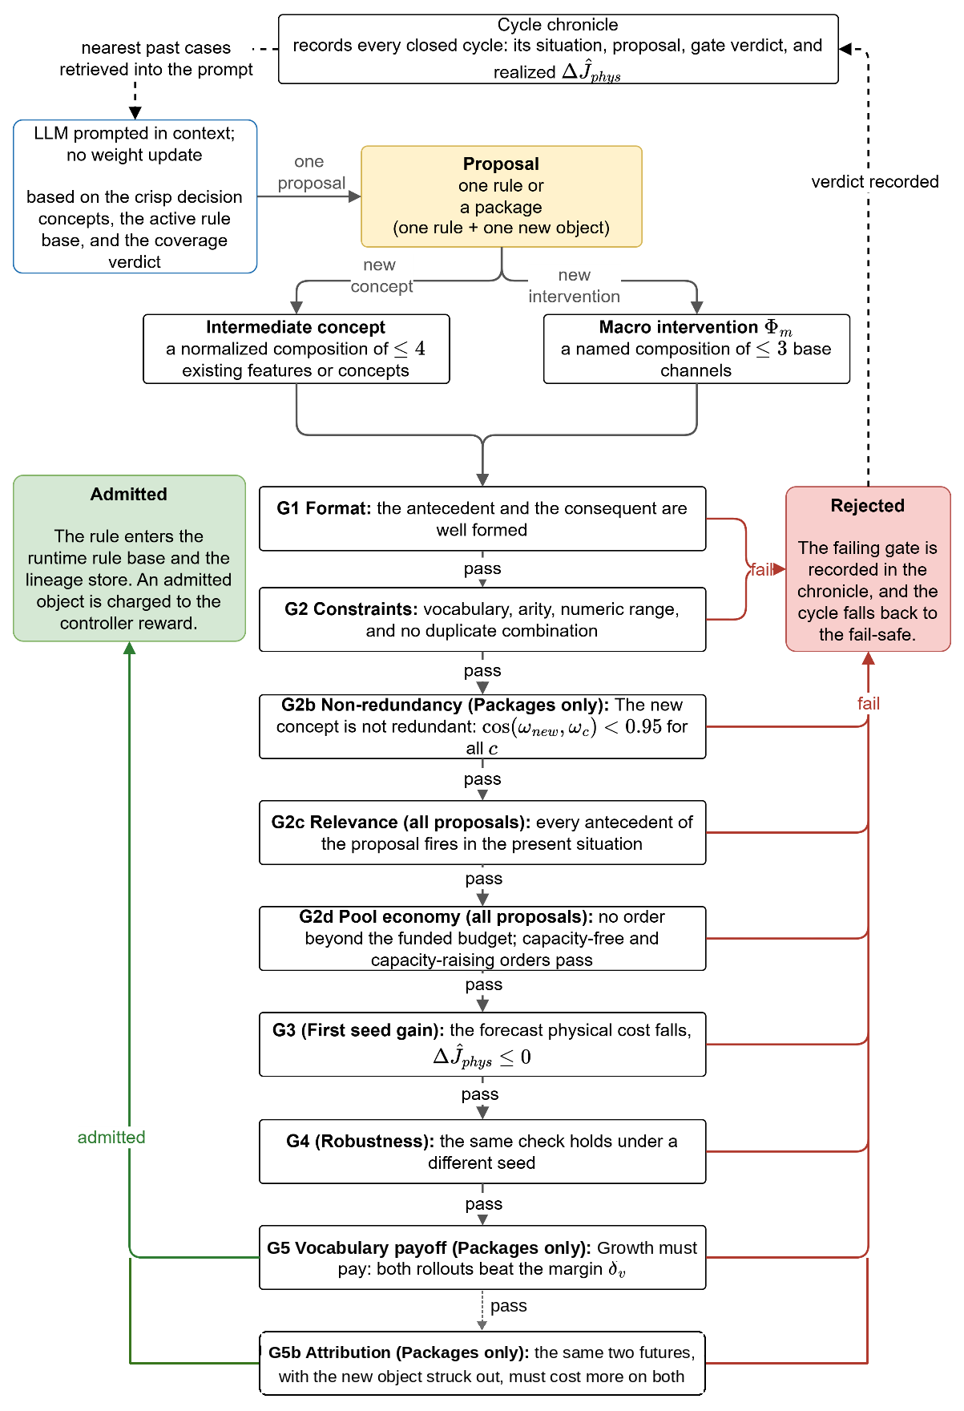
Fig. 10. Generative proposal and the verification gates.

G. Global Coordination and the No-Harm Guard
The Global DSS coordinates the regions and performs no inference of its own: it runs no features, concepts, or rules, and only ranks the regions and shares the capacity between them. Each Local DSS sends up three small values, its operational priority, its resource request, and a confidence summary; the coordinator returns the allocation, the normalized priority weights, and the acceptance thresholds in force. Regions are ranked by operational priority, and each receives an attention share ( 33 ): a region whose priority reaches a fixed fraction of the highest keeps the full share, while a monitored region receives a reduced share floored at 0.50 and must clear a higher quality threshold before its offensive orders use shared capacity. The share acts on the offensive side only; evacuation and public warning are left untouched. The regional candidates are merged into one plan, which the no-harm guard forecasts against taking no action, withholding the offensive orders when the plan is forecast clearly worse while the life-safety orders still stand. Fig. 11 summarizes the coordination and the guard. Every decision remains traceable end to end: the concepts that fired, the rules involved, their firing strengths, the confidence behind each input, and the gate verdicts of every adaptation trial are all recorded, so explanation is a structural property of the pipeline rather than a post-hoc attribution.
$$σ_{i}=\left\{\begin{aligned}1,\text{ if }p_{i}≥τ_{att}p_{\text{max}}\text{ or }p_{i}≥τ_{att} \\ 0.5+0.5\frac{p_{i}}{p_{\text{max}}},\text{ otherwise}\end{aligned}\right.$$ | ( 33 )
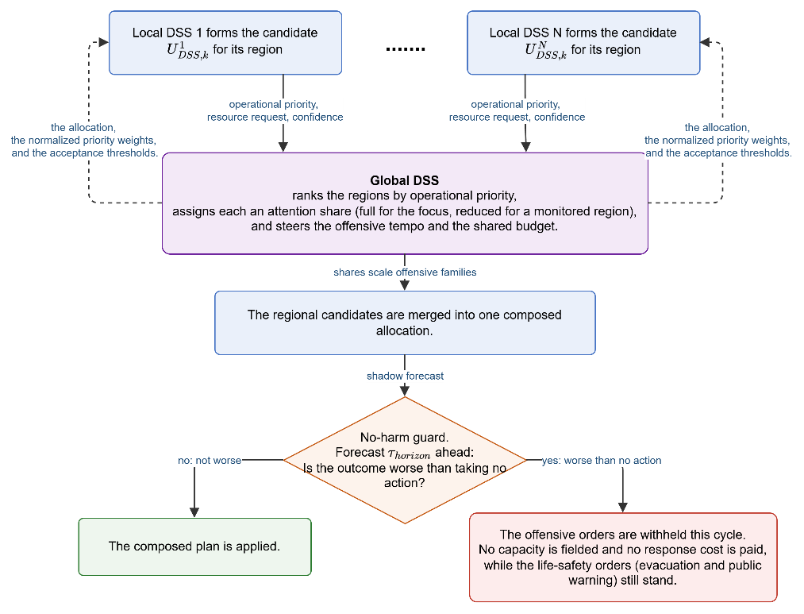
Fig. 11. Global coordination and the no-harm fail-safe.

V. Results

A. Evaluation Criteria
What a wildfire DSS must demonstrate has not been established by a single agreed method. The technical tradition evaluates the predictive models inside a tool on their intended use, the spatial progression of real fires [79], [80], while the decision-support tradition evaluates the effect of the tool on the decision itself [81]; its most recent review reports that most wildfire DSS evaluations have measured adoption rather than decision improvement [82]. The evaluation therefore addresses both traditions through the eight criteria of Table III, from predictive fidelity to scalability, fixed in advance and audited at the end of this section.
TABLE III
Evaluation criteria for wildfire decision support systems
Criterion | Measurement in the literature
Predictive fidelity: the core reproduces observed fire behavior from real inputs | Retrospective hindcasts against historical fires; spatial-overlap and arrival-time scores
Decision quality: recommendations improve the outcome relative to a no-tool alternative | Outcome deltas against no-action and baseline policies on matched scenarios
Timeliness: decision latency compatible with operational tempo | Decision-cycle wall time; detection-to-first-order time
Robustness under degraded observation | Performance versus outage and noise level; fail-safe engagement statistics
Uncertainty handling: input uncertainty is represented and propagated to the decision | Ensemble and input-uncertainty propagation studies
Adaptability: the system extends its own knowledge when it does not cover the situation | Learning curves; coverage growth; rediscovery of withheld knowledge
Explainability and auditability: every recommendation is traceable to its evidence | Trace completeness; interpretability as an adoption gate
Scalability: cost grows manageably with domain size and number of regions | Runtime and quality versus grid size and agent count

The measurements draw on the hindcast, outcome, latency, robustness, uncertainty, adaptability, interpretability, and scaling methodologies of the wildfire evaluation literature [83], [84], [85], [86], [30], [87], [88].

B. Validation of the Simulation Core
The test of the simulation core is a blind hindcast: the simulator is given only the real inputs of a documented fire, with no tuning on that fire, runs for the recorded duration, and its burned area is compared with the satellite record. Terrain is taken from the Copernicus GLO-30 elevation model [89], fuel from the ESA WorldCover 2021 land-cover product mapped to the internal fuel classes [90], weather from ERA5 hourly reanalysis at the ignition point [91], and the ignition points and reference burned area from NASA FIRMS VIIRS 375 m active-fire detections [92]. The validation set comprises four documented fires in Türkiye chosen to cover different fuel, terrain, and wind conditions: Manavgat (Antalya, July 2021, 48 h), Marmaris (Muğla, July 2021, 48 h), Milas-Kemerköy (Muğla, August 2021, 72 h), and Çanakkale-Kayadere (August 2023, 48 h). Because the core models free fire spread without suppression, a free run overpredicts the final area, so the evaluation uses three criteria robust to suppression: the probability of detection ( 34 ), the share of the observed burn that the model reaches, accepted at 0.70 following the agreement levels reported for calibrated growth models [93], [94]; the front position error ( 35 ), the symmetric mean front-to-front distance judged relative to the equivalent radius of the observed burn ( 36 ), in the tradition of FARSITE-style validation [95]; and the arrival-time agreement ( 37 ), the mean absolute difference between simulated arrival and first satellite detection over the cells that both burned, the direct rate-of-spread test. Table IV reports the metrics per case averaged over 50 stochastic replicates, and Fig. 12 shows the agreement maps. Overall agreement lies between 86 and 94 percent and the probability of detection between 85 and 97 percent, so the core reproduces the observed extent at the reliability of a well-behaved uncalibrated spread model.
$$POD=\frac{|{FR}_{Sim}∩{FR}_{Re}|}{|{FR}_{Re}|}$$ | ( 34 )
$$D(x,G_{Set})=\min_{y∈G_{Set}}‖x-y‖$$$$\overline{d_{Front}}=\frac{Σ_{x∈∂{FR}_{Sim}}D(x,∂{FR}_{Re})+Σ_{y∈∂{FR}_{Re}}D(y,∂{FR}_{Sim})}{|∂{FR}_{Sim}|+|∂{FR}_{Re}|}$$ | ( 35 )
$$R =\sqrt{\left(\left|N_{burned}\right| A_{cell}\right)/π}, {TH}_{Front}=1-\frac{\overline{d_{Front}}}{R}$$ | ( 36 )
$$τ_{MAE}=\frac{1}{N_{cells}}Σ_{c∈{FR}_{Sim}∩{FR}_{Re}}\left|t_{c}^{Sim}-t_{c}^{Re}\right|; N_{cells}=|{FR}_{Sim}∩{FR}_{Re}|$$$${TH}_{MAE}=1-\frac{τ_{MAE}}{T}$$ | ( 37 )
TABLE IV
Hindcast agreement metrics per historical case
Metric | Sc1 Manavgat | Sc2 Marmaris | Sc3 Milas | Sc4 Kayadere
Front distance (m) | 329 | 305 | 113 | 391
Arrival-time MAE (h) | 1.46 | 1.39 | 4.04 | 2.58
Front agreement | 82% | 90% | 89% | 89%
Time agreement | 90% | 98% | 71% | 96%
Probability of detection | 92% | 93% | 97% | 85%
Overall success | 88% | 94% | 86% | 90%

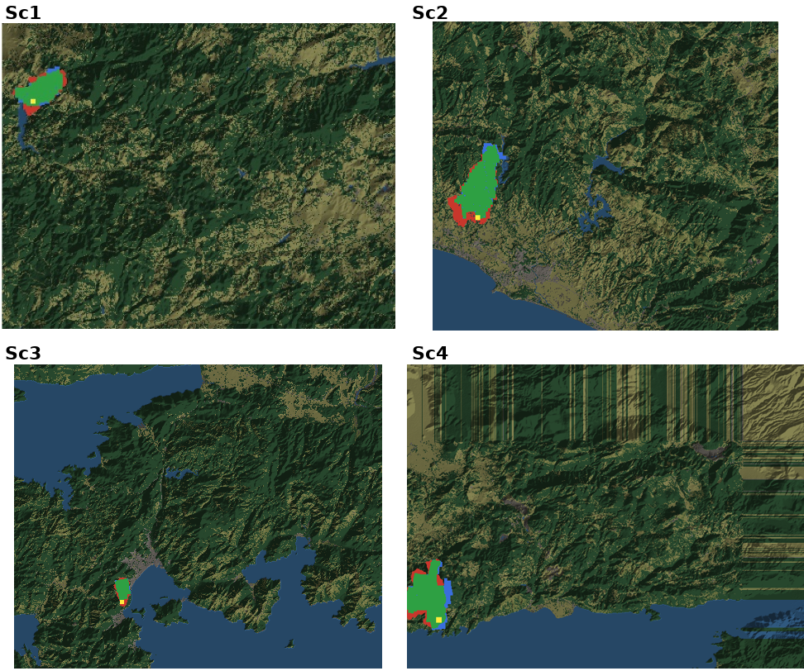
Fig. 12. Agreement maps for the historical hindcasts (green: correctly predicted burn; red: simulated only; blue: observed only; yellow: ignition).

C. Experimental Setup and Sensitivity Analysis
All experiments run on the DisasterAware testbed with its two cores kept analytically separated. Synthetic scenarios are generated procedurally on 200 by 200 grids at 90 m resolution with terrain presets, seeded settlements and road networks, and capacity-limited resource bases; historical scenarios reconstruct the documented fires above. Unless stated otherwise the decision engine runs with the thresholds of Section IV, a decision cycle of twelve minutes, a shadow forecast basis of at least 45 minutes, and 50 Monte Carlo runs per condition. Sensitivity is assessed one at a time [96], [97]: one parameter is varied across its range while the others hold their base value, each setting repeated over five independent worlds, 880 runs in total. A sweep can only show what its operating point allows, so the study first locates an operating point at which the decision layer is neither winning nor losing outright. Fig. 13 maps the physical cost over fire load and suppression pool as a share of the free burn: at a tenth of the pool the fire is lost throughout (77 to 83 percent), with a full pool and few ignitions it is held throughout (14 to 32 percent), and the sweeps run at the decidable point nearest the midpoint, four simultaneous ignitions with a quarter of the pool. The companion sweeps show that observation decides the outcome at light fire load while resources decide it at heavy load, and that the two are complementary rather than interchangeable: a blind map is not recovered by resources, and a scarce pool is not recovered by observation. The decision cycle is set so that the front advances no more than half a cell between decisions and the plan is revised at least five times within the no-harm horizon; the satisficing bound governs how often the adaptation ladder is engaged (42 percent of cycles at the configured 0.35), and the quality gate governs how often offensive orders are derated, each threshold acting only over the range where the distribution it cuts actually varies.
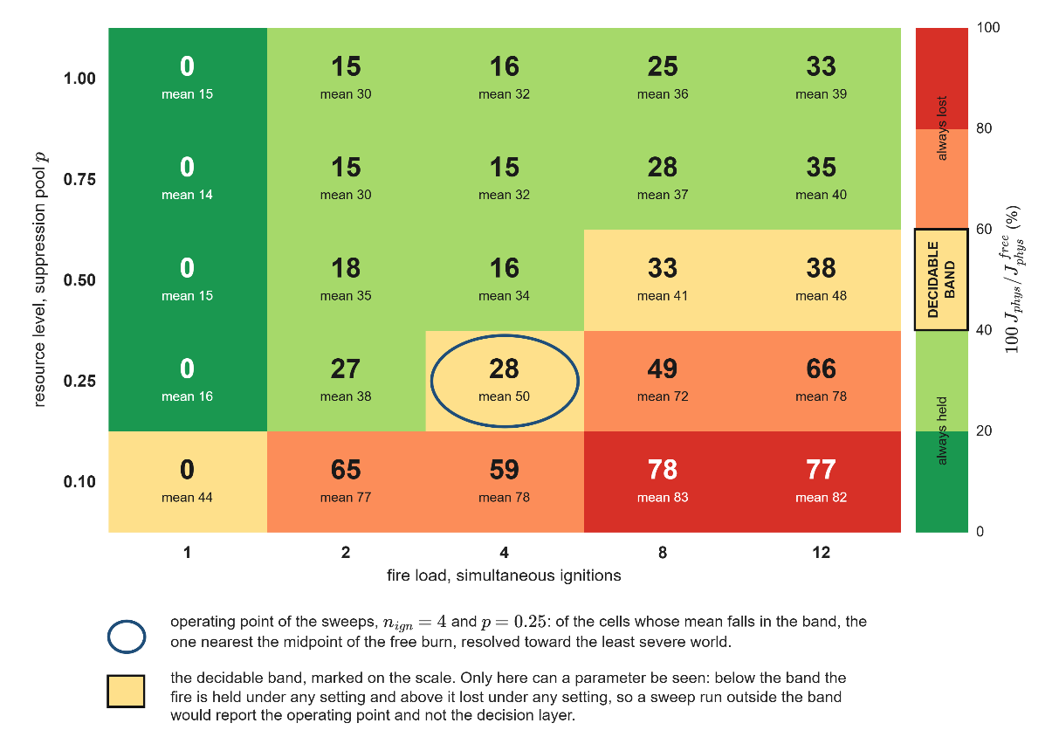
Fig. 13. Physical cost over simultaneous ignitions and resource level, as a share of the free burn.

D. Performance of the Decision Layer
Four configurations face identical fires: T0 issues no orders and fixes the cost of inaction; TF5 runs the decision layer on the minimal seed base of five rules; TF5+Ev adds the evolving-fuzzy stages 1 and 2; and the full configuration runs the complete staged adaptation, the open decision space in full. Every seed generates one scenario-conformant world and all configurations replay that identical world, so outcome differences come from the decision mechanism alone; evaluation seeds are disjoint from every seed used during development. Comparisons are read at a common six-hour checkpoint on two costs ( 38 ): the physical cost against the no-intervention reference, and the total cost including response and delay. Five scenario families span remote forest and the wildland-urban interface under sufficient and limited resources, with the fifth repeating the full stress scenario under degraded observation; weather is held at critical fire weather throughout. Table V reports the ladder, and Fig. 14 the average evolution. TF5 lowers the mean burned area from 220 ha under free burn to 84 ha, a 62 percent reduction, and cuts the mean total decision cost from 0.446 to 0.185. TF5+Ev adds a small but consistent gain, bringing the burned area to 78 ha and lowering the cost to 0.169, with the saving coming from the delay term: the tuned consequents commit the same resources sooner. The full configuration supplies the decisive second step: it halves the burned area again to 39 ha, an 82 percent reduction against free burn, lowers the mean affected population from about 511 to 300, and brings the mean total cost to 0.112, the lowest of the four after its own response effort is charged. The ordering holds in every scenario family, and under degraded observation the full configuration loses ten percent of its performance and remains the best of the four, the confidence gates derating offensive orders instead of cancelling them.
$$J_{Phy}=\frac{\sum_{j}{w_{j}J_{j}}}{\sum_{j}{w_{j}}}, j∈\left\{burn, asset, pop\right\} \\ J_{Tot}= \frac{\sum_{j}{w_{j}J_{j}}}{\sum_{j}{w_{j}}}, j∈\left\{burn, asset, pop, resp, delay\right\}$$ | ( 38 )
TABLE V
Burned area per scenario and mean decision costs at the six-hour checkpoint
Scenario | T0 | TF5 | TF5+Ev | Full
S1 burned (ha) | 243.3 | 96.7 | 84.7 | 22.8
S2 burned (ha) | 242.2 | 157.3 | 154.6 | 84.8
S3 burned (ha) | 178.9 | 28.0 | 30.5 | 11.4
S4 burned (ha) | 218.1 | 66.2 | 54.6 | 35.7
S5 burned (ha) | 218.1 | 69.3 | 66.3 | 39.3
Mean Jphys | 0.506 | 0.163 | 0.151 | 0.090
Mean Jtotal | 0.446 | 0.185 | 0.169 | 0.112

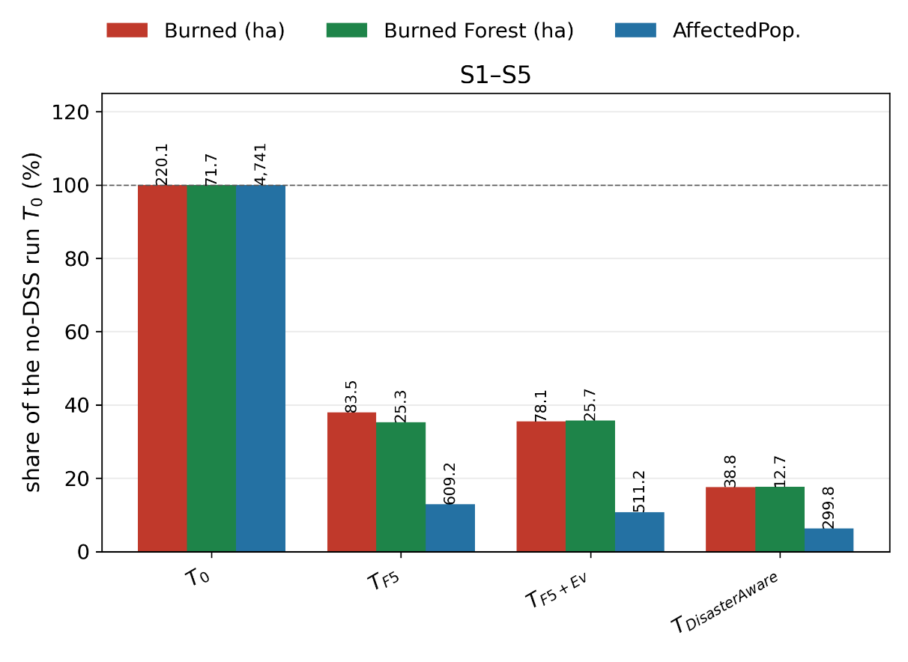
Fig. 14. Average burned-area, burned-forest, and affected-population evolution of the four configurations under the five scenarios.

E. Open Decision Space in Operation
Adaptation runs only on demand, and the record over about 200 logged runs (roughly ten thousand decision cycles) measures how often the standing decision fell short and how strictly the tests filtered the responses. Stage 1 made 551 consequent-step trials and kept 119 (22 percent); stage 2 made 353 trials and kept 40 (11 percent), instantiating rules on antecedent cells that were empty while fire was alive; stage 3 was invoked 230 times, and 47 proposals were admitted through the verification gates, 36 as plain rules and 11 as packages that brought new vocabulary. Fig. 15 shows the two evolving-fuzzy funnels and the generative cascade; low acceptance rates are the intended behavior of a gated design, since trials are cheap and rejected safely on the forecast, and the selectivity of the gates is what makes the admitted edits trustworthy. The generative products are listed in Table VI: seven named macro interventions and one intermediate concept, each born at a stated moment of a specific incident under a logged cost deficit. Three of the base channels the macros draw on, water drafting, aerial retardant drop, and tactical burn, are discoverable actuators that the physics validates but no seed rule orders, so a macro that recruits them records the system reaching beyond its seeded doctrine into a validated capability. The generated concept interface_exposure names the pressure that builds where exposed assets and evacuation demand meet, joins the hierarchy like a native concept, and is consumed by an admitted rule that protects the wildland-urban interface, so a concept the system invented and a rule that uses it enter through the same gates.
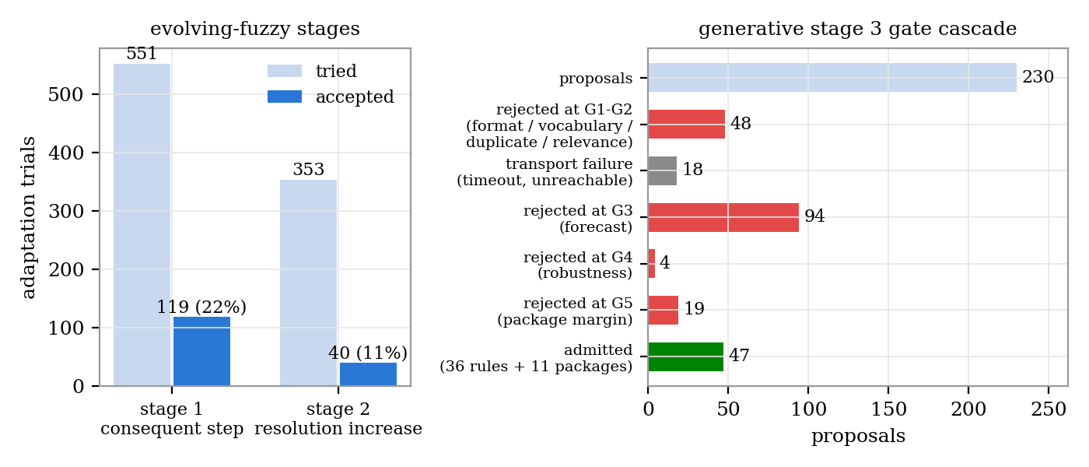
Fig. 15. Left: evFIS trials and acceptances at stages 1 and 2. Right: the generative gates over proposals.
TABLE VI
The generative product ledger: every object created, with its definition
Product | Definition
Actuator: tactical burn | A firing crew ignites a strip ahead of the front, so a counter-fire consumes the fuel the head is running toward
Actuator: water drafting | Engines and aircraft draft from the nearest water body, raising sustained capacity near water
Actuator: retardant drop | Aircraft coat the fuel ahead of the head with long-term retardant
Macro: downwind_backburn | containment_line 1.0 + suppression_effort 0.7
Macro: downwind_retardant_shield | retardant_drop 1.0 + containment_line 0.8
Macro: drafting_sustained_attack | water_drafting 1.0 + suppression_effort 0.9
Macro: head_knockdown | water_drafting 1.0 + suppression_effort 0.9 + retardant_drop 0.6
Macro: wet_containment_line | water_drafting 1.0 + containment_line 0.8
Macro: counterfire_strip | tactical_burn 1.0 + containment_line 0.6
Macro: drafting_retardant_shuttle | retardant_drop 1.0 + water_drafting 0.6
Concept: interface_exposure | 0.5 asset_exposure_risk + 0.5 evacuation_pressure; consumed by admitted rule G14: IF interface_exposure VH AND suppression_feasibility VH THEN asset_protection 0.9, containment_line 0.8, resource_deployment 0.7

F. Timeliness and Scalability
One decision covers the whole loop: the features and their confidences, the concept gates, the rule base, the global coordination, the two shadow forecasts of the acceptance test, and any adaptation stage that runs. The median decision takes 274 ms against a decision cycle of twelve minutes, the ninetieth percentile 909 ms, and the slowest observed decision 1.28 s, so even the slowest decision uses less than two thousandths of the time available; in all test worlds the first offensive order is fielded two minutes after ignition, at the first decision. Fig. 16 reports the cost of the decision layer for one to sixteen local regions at cycles of two, six, and twelve minutes: every point lies between 0.02 and 0.16 percent of the cycle, and sixteen times the agents cost only 1.16 to 1.29 times the share, because each agent reasons only over its own region, so more regions split the same work instead of multiplying it. Two further sweeps locate the real driver: six times the forecast horizon raised the median decision by a factor of 1.4, and four times the grid raised it by 6.9. Scalability is therefore met on the axis the architecture is built for, while the size of the domain remains the binding limit.
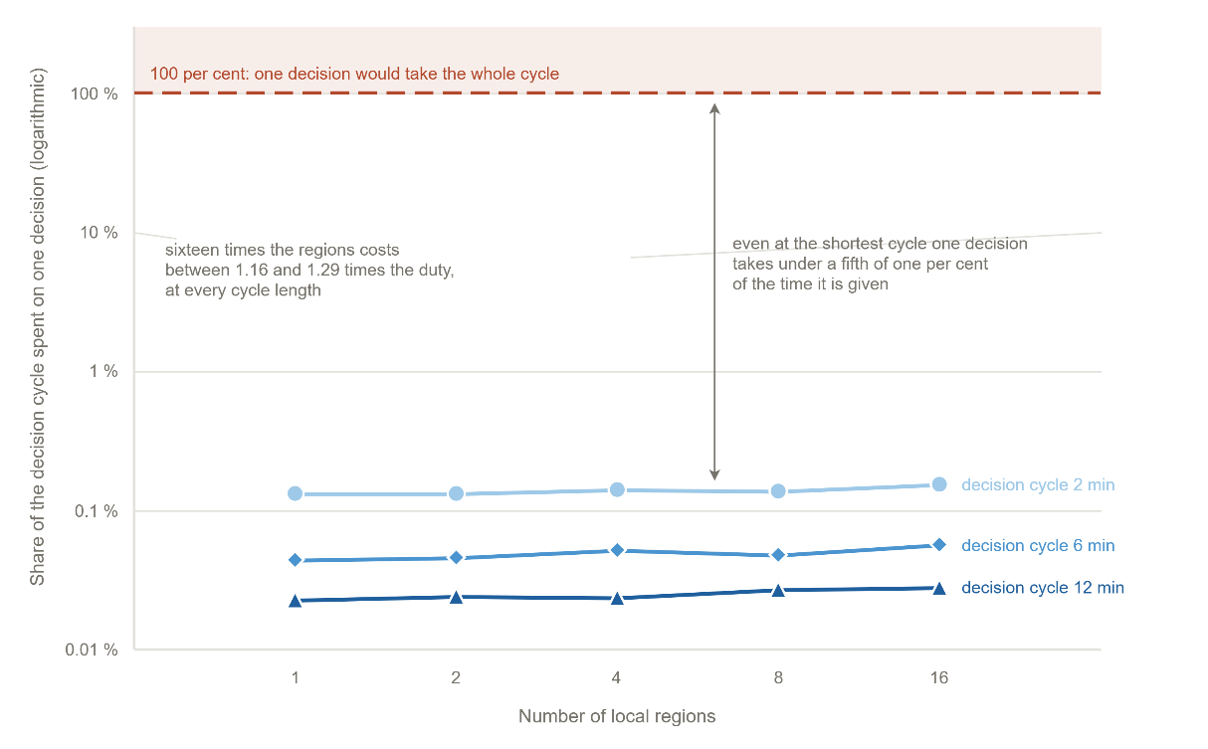
Fig. 16. Cost of the decision layer against the number of local agents, as a share of the decision cycle.

G. Compliance with the Evaluation Criteria
TABLE VII
Compliance with the evaluation criteria
Criterion | Evidence
Predictive fidelity | Four blind hindcasts driven by real terrain, fuel, and weather; overall agreement 86-94%, probability of detection 85-97%
Decision quality | Mean burned area reduced from 220 to 39 ha (82%) and mean total decision cost from 0.446 to 0.112 against no action; each rung of the ladder improves on the one below
Timeliness | Median decision 274 ms against a twelve-minute cycle; first offensive order fielded two minutes after ignition
Robustness | Under degraded observation the full configuration loses 10% and remains the best of the four; the quality gate derates offensive orders instead of cancelling them
Uncertainty handling | Every feature carries a confidence that gates its concept, and every outcome carries the spread over replicates; ensemble propagation of weather and fuel uncertainty was not run
Adaptability | 119 of 551 stage-1 and 40 of 353 stage-2 trials kept; 47 generative admissions including seven macros and one concept, each with a logged birth moment
Explainability | Every admitted edit recorded with the deficit that triggered it, every rejected proposal with the gate and reason, every generated object with its definition and consuming rule
Scalability | One decision costs 0.02-0.16% of the cycle; sixteen times the agents costs 1.16-1.29 times the share; domain size, not agent count, is the binding limit

Six criteria are met in full. Two are met on the axis measured here and left open on another: uncertainty is represented and carried into the decision but not propagated as an ensemble, and scalability is demonstrated against the number of agents but not bounded against the size of the domain. Both are taken up in Section VI.

VI. Conclusion and Future Work
This article presented DisasterAware, a distributed wildfire decision support framework built on concept-based fuzzy reasoning. Ten confidence-carrying observation features are abstracted into five decision concepts, a sparse zero-order Takagi-Sugeno rule base written over the concepts produces intervention intensities, a satisficing acceptance test and a graduated fail-safe decide whether a candidate may be fielded, and a non-inferential global coordinator ranks the local agents and shares the resource pool. When the standing decision falls short, a three-stage ladder adapts the rule base, first its parameters, then its resolution, and finally its vocabulary, where a generative stage proposes new rules, macro interventions, and concepts that must pass the same verification gates before they act. The whole framework runs against a simulation core kept strictly separate from the decision core, so each side is validated on its own.
The three contributions are delivered against criteria fixed in advance. The open decision space starts from five seeded rules and adds only what the field demands, 41 instantiated rules, seven generated macro interventions, and one generated concept over about two hundred logged incidents, every addition passing a forecast test before admission, and the additions matter, since the full open decision space halves the burned area of the static rule base; sixteen times the number of agents raises the cost of a decision by a factor of at most 1.29. Uncertainty handling with built-in explanation is structural: every fielded order traces to the concepts that demanded it, the rules that fired, and the confidence behind each feature, without any post-hoc attribution, and under degraded observation the framework loses ten percent of its performance while remaining the best configuration tested. The end-to-end demonstration rests on a simulation core validated first and independently, with four blind hindcasts agreeing with the satellite record between 86 and 94 percent, on which the decision core lowers the mean burned area from 220 to 39 hectares and the mean total decision cost from 0.446 to 0.112 while spending 274 milliseconds per decision at the median.
The evaluation is entirely in a simulated setting, which is both its strength and its boundary, and two directions follow. The first is validation with operators in the field: the traceability record is designed to be read, so a tabletop study should place it before experienced fire officers, managing a simulated incident once with and once without the framework, to test whether the concepts speak the language of the field, whether the pace of the interface matches the pace of command, and whether an operator accepts an order that a machine has adapted during the incident. The second is transfer to other hazards: nothing in the decision layer is specific to fire, since the concepts, the confidence gates, the satisficing acceptance, and the graduated fail-safe are defined over an abstract state and an abstract set of interventions. Floods, industrial plumes, and search and rescue pose the same kind of problem, and a transfer study would keep the decision layer unchanged, replace the simulation core, and rewrite only the feature definitions and the seed rules; the cost of that rewriting is itself the result, measuring how much of the framework is architecture and how much is wildfire.

Acknowledgment
This work was informed by the authors' experience in the TeamAware project, funded by the European Union's Horizon 2020 research and innovation programme under Grant Agreement No. 101019808. The research reported in this paper was carried out independently and received no specific grant from any funding agency in the public, commercial, or not-for-profit sectors.

References
[1] R. H. Sprague and E. D. Carlson, "Building Effective Decision Support Systems," Englewood Cliffs: Prentice Hall, 1982.
[2] Power, "Decision support systems: Concepts and resources for managers," Quorum Books, 2002.
[3] R. Sharda, D. Delen and E. Turban, "Business Intelligence, Analytics, and Data Science: A Managerial Perspective," Pearson, 2018.
[4] R. L. Keeney and H. Raiffa, "Decisions with multiple objectives: preferences and value trade-offs," Wiley, 1976.
[5] S. French, J. Maule and N. Papamichail, "Decision Behaviour, Analysis and Support," Cambridge University Press, 2019.
[6] M. T. Ribeiro, S. Singh and C. Guestrin, "Why Should I Trust You?," ACM SIGKDD Conference, pp. 1135–1144, 2016.
[7] N. J. McNeese, B. G. Schelble, L. B. Canonico and M. Demir, "Who or what is my teammate? Team composition considerations in human–AI teaming," Human Factors, vol. 63, pp. 474-488, 2021.
[8] CRED/UCLouvain, "EM-DAT: The International Disaster Database," 2026.
[9] D. M. Bowman, C. A. Kolden, J. T. Abatzoglou, F. H. Johnston, G. R. van der Werf and M. Flannigan, "Vegetation fires in the Anthropocene," Nature Reviews Earth & Environment, vol. 1, pp. 500-515, 2020.
[10] UNEP, "Spreading like Wildfire: The Rising Threat of Extraordinary Landscape Fires," Geneva: United Nations Environment Programme (UNEP), 2022.
[11] M. P. Thompson and D. E. Calkin, "Uncertainty and risk in wildland fire management," Journal of Environmental Management, vol. 92, pp. 1895-1909, 2011.
[12] R. C. Rothermel, "A mathematical model for predicting fire spread in wildland fuels," Intermountain Forest & Range Experiment Station, Forest Service, US Department of Agriculture., 1972.
[13] M. A. Finney, "An overview of FlamMap fire modeling capabilities," Fuels Management — How to Measure Success: Conference Proceedings, pp. 213-220, 2006.
[14] R. E. Bellman and L. A. Zadeh, "Decision-making in a fuzzy environment," Management Science, vol. 17, pp. B141-B164, 1970.
[15] L. A. Zadeh, "Fuzzy sets," Information and Control, vol. 8, pp. 338-353, 1965.
[16] A. P. Pacheco, "Cohesive Fire Management within an Uncertain Environment: A Review of Risk Handling and Decision Support Systems," Forest Ecology and Management, vol. 347, pp. 1-17, 2015.
[17] F. Vásquez, "Decision support system development of wildland fire," Forests, vol. 12, pp. 943, 2021.
[18] E. K. Noonan-Wright et al., "Developing the US wildland fire decision support system," vol. 2011, pp. 168473, 2011.
[19] M. Mohammadi, A. A. Alesheikh and A. Alimohammadi, "Bridging spatiotemporal wildfire prediction and decision modeling using transformer networks and fuzzy inference systems," vol. 15, pp. 7542, 2025.
[20] J. Figueiredo, J. Macedo, J. Alves and A. Figueiredo, "Wildfire management decision support system for real-time fire behavior and weather analysis," vol. 15, pp. 509, 2024.
[21] S. D. Fillmore and T. B. Paveglio, "Use of the Wildland Fire Decision Support System (WFDSS) for full suppression and managed fires within the Southwestern Region of the US Forest Service," vol. 32, pp. 562-574, 2023.
[22] C. Rapp, E. Rabung, R. Wilson and E. Toman, "Wildfire decision support tools: An exploratory study of use in the United States," vol. 29, pp. 581-594, 2020.
[23] J. Malczewski, "GIS and multicriteria decision analysis," John wiley & sons, 1999.
[24] D. E. Calkin, C. D. O'Connor, M. P. Thompson and R. Stratton, "Strategic wildfire response decision support and the risk management assistance program," vol. 12, pp. 1407, 2021.
[25] D. Arnott and G. Pervan, "A critical analysis of decision support systems research," Journal of Information Technology, vol. 20, pp. 67-87, 2005.
[26] R. N. Anthony, "Planning and control systems: A framework for analysis," Harvard University Press, 1965.
[27] M. C. M. d. W. B. V. &. Y. X. Turoff, "The design of a dynamic emergency response management information system (DERMIS)," Journal of Information Technology Theory and Application (JITTA), vol. 5, pp. 3, 2004.
[28] M. Morgan and M. Henrion, "Uncertainty: A Guide to Dealing with Uncertainty in Quantitative Risk and Policy Analysis.," Cambridge university press, 1990.
[29] G. Shafer, "A Mathematical Theory of Evidence," Princeton University Press, 1976.
[30] T. Comes, M. Hiete, N. Wijngaards and F. Schultmann, "Decision maps: A framework for multi-criteria decision support under severe uncertainty," Decision Support Systems, vol. 52, pp. 108-118, 2011.
[31] J. M. Mendel, "Uncertain rule-based fuzzy systems," Springer, 2017.
[32] C. A. Schultz, L. F. Miller, S. M. Greiner and C. Kooistra, "A qualitative study on the US Forest Service's risk management assistance efforts to improve wildfire decision-making," vol. 12, pp. 344, 2021.
[33] R. Sugumaran and J. Degroote, "Spatial decision support systems: principles and practices," Crc Press, 2010.
[34] C. Pais, J. Carrasco, P. E. Moudio and Z. M. Shen, "Downstream protection value: Detecting critical zones for effective fuel-treatment under wildfire risk," vol. 90, pp. 101703, 2021.
[35] D. L. Martell, "Forest fire management," Handbook of operations research in natural resources, pp. 489-509, 2007.
[36] T. M. Oliveira, A. M. G. Barros, A. A. Ager and P. M. Fernandes, "Wildfire spread and resource allocation: Using spatially explicit models to address operational decision-making," vol. 506, pp. 119952, 2022.
[37] T. Takagi and M. Sugeno, "Fuzzy identification of systems and its applications to modeling and control," IEEE Transactions on Systems, Man, and Cybernetics, vol. 15, pp. 116-132, 1985.
[38] H. A. Simon, "Rational choice and the structure of the environment," Psychological Review, vol. 63, pp. 129-138, 1956.
[39] J. H. Scott and R. E. Burgan, "Standard fire behavior fuel models: A comprehensive set for use with Rothermel’s surface fire spread model," 2005.
[40] P. L. Andrews, "The Rothermel surface fire spread model and associated developments: A comprehensive explanation," 2018.
[41] A. L. Sullivan, "Wildland surface fire spread modelling 1: Physical and quasi-physical models," International Journal of Wildland Fire, vol. 18, pp. 349-368, 2009a.
[42] A. L. Sullivan, "Wildland surface fire spread modelling 2: Empirical and quasi-empirical models," International Journal of Wildland Fire, vol. 18, pp. 369-386, 2009b.
[43] A. L. Sullivan, "Wildland surface fire spread modelling 3: Simulation and mathematical analogue models," International Journal of Wildland Fire, vol. 18, pp. 387-403, 2009c.
[44] Power, "A Brief History of Decision Support Systems," 2007.
[45] G. A. Gorry and M. S. Scott Morton, "A framework for management information systems," Sloan Management Review, vol. 13, pp. 55-70, 1971.
[46] H. A. Simon, "The New Science of Management Decision," Englewood Cliffs: Prentice Hall, 1960.
[47] E. Turban, "Decision support and business intelligence systems," Upper Saddle River: Pearson Education, 2011.
[48] S. J. Chen and C. L. Hwang, "Fuzzy multiple attribute decision making: Methods and applications," Springer, 1992.
[49] C. L. Hwang and K. Yoon, "Multiple attribute decision making: Methods and applications," Springer, 1981.
[50] S. A. Seshia, D. Sadigh and S. S. Sastry, "Toward verified artificial intelligence," Communications of the ACM, vol. 65, pp. 46-55, 2022.
[51] G. A. Klein, "Sources of Power: How People Make Decisions," MIT Press, 2017.
[52] K. G. Ross, J. L. Shafer and G. Klein, "Professional Judgments and Naturalistic Decision Making," The Cambridge Handbook of Expertise and Expert Performance, pp. 403-420, 2006.
[53] P. P. Angelov and D. P. Filev, "An approach to online identification of Takagi-Sugeno fuzzy models," IEEE Transactions on Systems, Man, and Cybernetics, Part B, vol. 34, pp. 484-498, 2004.
[54] E. Lughofer, "Evolving Fuzzy Systems: Methodologies, Advanced Concepts and Applications," Berlin, Germany: Springer, 2011.
[55] R. S. Sutton and A. G. Barto, "Reinforcement Learning: An Introduction," Cambridge, MA, USA: MIT Press, 2018.
[56] Y. Xie, B. Jiang, T. Mallick, J. D. Bergerson, J. K. Hutchison and D. R. Verner, "WildfireGPT: Tailored large language model for wildfire analysis," arXiv:2402.07877, 2024.
[57] Y. Chen et al., "Empowering LLM agents with geospatial awareness: Toward grounded reasoning for wildfire response," arXiv:2510.12061, 2025.
[58] R. Chandra, S. S. Kumar, R. Patra and S. Agarwal, "Decision support system for forest fire management using ontology with big data and LLMs," Cluster Computing, vol. 28, pp. 548, 2025.
[59] J. P. Shim, M. Warkentin, J. F. Courtney, D. J. Power, R. Sharda and C. Carlsson, "Past, present, and future of decision support technology," Decision support systems, vol. 33, pp. 111-126, 2002.
[60] K. P. Sycara, "Multiagent systems," AI Magazine, vol. 19, pp. 79-92, 1998.
[61] M. Wooldridge, "An introduction to multiagent systems," Wiley, 2009.
[62] P. Jain, S. C. P. Coogan, S. G. Subramanian, M. Crowley, S. Taylor and M. D. Flannigan, "A review of machine learning applications in wildfire science and management," Environmental Reviews, vol. 28, pp. 478-505, 2020.
[63] V. Duarte, A. C. Teodoro, J. A. Gonçalves, D. Soares and M. Cunha, "Wildfire risk mapping using GIS and fuzzy logic: Application to northwest Iberian Peninsula," vol. 14, pp. 3793, 2022.
[64] W. Pedrycz, "Fuzzy Control and Fuzzy Systems," Wiley, 1993.
[65] E. H. Mamdani, "Application of fuzzy algorithms for control of simple dynamic plant," Proceedings of the Institution of Electrical Engineers, vol. 121, pp. 1585-1588, 1974.
[66] A. A. Ager, N. M. Vaillant and M. A. Finney, "A comparison of landscape fuel treatment strategies to mitigate wildland fire risk in the urban interface and preserve old forest structure," vol. 259, pp. 1556-1570, 2010.
[67] L. Comfort, A. Boin and C. Demchak, "Designing Resilience: Preparing for Extreme Events," University of Pittsburgh Press, 2010.
[68] C. J. Dunn, D. E. Calkin and M. P. Thompson, "Towards enhanced risk management: Planning, decision making and monitoring of US wildfire response," vol. 26, pp. 615-625, 2017.
[69] T. L. Saaty, "The analytic hierarchy process: Planning, priority setting, resource allocation," McGraw-Hill, 1980.
[70] C. H. Papadimitriou and J. N. Tsitsiklis, "The complexity of Markov decision processes," Mathematics of Operations Research, vol. 12, pp. 441-450, 1987.
[71] G. Gigerenzer and R. Selten, "Bounded rationality: The adaptive toolbox," Cambridge, MA: MIT Press, 2001.
[72] J. Pearl, "Probabilistic Reasoning in Intelligent Systems: Networks of Plausible Inference," Morgan Kaufmann, 1988.
[73] L. A. Zadeh, "A simple view of the Dempster–Shafer theory of evidence and its implication for the rule of combination," AI Magazine, vol. 7, pp. 85-90, 1986.
[74] R. Guidotti, A. Monreale, S. Ruggieri, F. Turini, F. Giannotti and D. Pedreschi, "A Survey of Methods for Explaining Black Box Models," ACM Computing Surveys, vol. 51, pp. 1-42, 2018.
[75] D. Amodei, C. Olah, J. Steinhardt, P. Christiano, J. Schulman and D. Mané, "Concrete problems in AI safety," 2016.
[76] Z. Ji et al., "Survey of hallucination in natural language generation," vol. 55, pp. 1-38, 2023.
[77] A. Vaswani et al., "Attention is all you need," 2017.
[78] T. B. Brown, B. Mann, N. Ryder, M. Subbiah, J. Kaplan and P. Dhariwal, "Language models are few-shot learners," 2020.
[79] M. G. Cruz, M. E. Alexander and R. H. Wakimoto, "Definition of a fire behavior model evaluation protocol: a case study application to crown fire behavior models," Fire, Fuel Treatments, and Ecological Restoration (USDA Forest Service Proceedings RMRS-P-29), 2003.
[80] M. E. Alexander and M. G. Cruz, "Are the applications of wildland fire behaviour models getting ahead of their evaluation again?," Environmental Modelling & Software, vol. 41, pp. 65-71, 2013.
[81] D. L. Martell, "A review of recent forest and wildland fire management decision support systems research," Current Forestry Reports, vol. 1, pp. 128-137, 2015.
[82] C. Rapp, S. T. Franz, M. M. Colavito, T. Aldworth and A. S. Cheng, "Wildfire decision support tools: barriers, facilitators, and future directions for effectiveness," Fire Ecology, 2026.
[83] T. J. Duff, J. G. Cawson, B. Cirulis, P. Nyman, G. J. Sheridan and K. G. Tolhurst, "Conditional performance evaluation: using wildfire observations for systematic fire simulator development," Forests, vol. 9, pp. 189, 2016.
[84] P. Fox-Hughes, C. Bridge and N. Faggian, "An evaluation of wildland fire simulators used operationally in Australia," International Journal of Wildland Fire, vol. 33, 2024.
[85] J. Filippi, V. Mallet and B. Nader, "Representation and evaluation of wildfire propagation simulations," International Journal of Wildland Fire, vol. 23, pp. 46-57, 2014.
[86] T. J. Duff and K. G. Tolhurst, "Operational wildfire suppression modelling: a review evaluating development, state of the art and future directions," International Journal of Wildland Fire, vol. 24, pp. 735-748, 2015.
[87] A. Benali, A. C. L. Sá, A. R. Ervilha, R. M. Trigo, P. M. Fernandes and J. M. C. Pereira, "Fire spread predictions: sweeping uncertainty under the rug," Science of the Total Environment, vol. 592, pp. 187-196, 2017.
[88] M. G. Cruz and M. E. Alexander, "Uncertainty associated with model predictions of surface and crown fire rates of spread," Environmental Modelling & Software, vol. 47, pp. 16-28, 2013.
[89] C. G. DEM, "https://registry.opendata.aws/copernicus-dem," 2026.
[90] E. W. 2. v200, "https://esa-worldcover.org/," 2026.
[91] E. v. Open-Meteo, "https://open-meteo.com," 2026.
[92] N. F. V. S-NPP, "https://firms.modaps.eosdis.nasa.gov," 2026.
[93] S. Price, "Modeling of fire spread in sagebrush steppe using FARSITE: an approach to improving input data and simulation accuracy," Fire Ecology, 18, 22., vol. 18, 2022.
[94] C. Pais, J. Carrasco, D. L. Martell, A. Weintraub and D. L. Woodruff, "Cell2Fire: A cell-based forest fire growth model to support strategic landscape management planning," Frontiers in Forests and Global Change, vol. 4, 2021.
[95] M. A. Finney, "FARSITE: Fire Area Simulator - model development and evaluation," USDA Forest Service, Rocky Mountain Research Station, 1998.
[96] M. D. Morris, "Factorial sampling plans for preliminary computational experiments," Technometrics, vol. 33, pp. 161-174, 1991.
[97] A. Saltelli et al., "Global Sensitivity Analysis: The Primer," Chichester: Wiley, 2008.


Çağlar Akman received the B.S. and M.S. degrees in Electrical and Electronics Engineering from the Middle East Technical University (METU), Ankara, Türkiye, in 2008 and 2017, respectively, where he is currently pursuing the Ph.D. degree.
He is currently the Senior Principal Team Manager of the Modeling and Sensor Technologies at HAVELSAN, Ankara, Türkiye, where he manages national and international research and development projects of advanced sensor systems, decision support architectures, and intelligent automation technologies. Over the past 10 years, he has acquired extensive experience in leading multidisciplinary R&D initiatives, managing national and international research collaborations, and coordinating complex technical projects across multiple organizations and consortia.
He serves as an Industrial Reviewer for TÜBİTAK (Turkish Scientific and Technical Research Council), evaluating research proposals across multiple research domains. He also performs peer review for IEEE Transactions and related journals, contributing to the quality assurance of peer-reviewed literature. Additionally, he has been a part-time lecturer at Atılım University. His research interests, expertise, and professional recognition reflect a strong commitment to advancing the fields of artificial intelligence, autonomous systems, decision support technologies, and sensor fusion in both civilian and defense applications.

Kemal Leblebicioğlu received his Ph.D. from the Department of Mathematics of the Middle East Technical University (METU), in 1988.
He has been a full professor in the Department of Electrical and Electronics Engineering of METU since 1999. He has a background in optimization, optimal control theory, computer vision, intelligent systems, flight control, walking robots, and unmanned vehicles.
Dr. Leblebicioğlu has been a member of numerous international program committees and has been (co-) author of more than 40 journal papers, book chapters, and numerous conference papers. He is on several IFAC technical committees. He was the editor of the journal ELEKTRIK published by TÜBİTAK (Turkish Scientific and Technical Research Council) from 1996 to 2009. He is on the editorial board of several Turkish technical journals. He organized an international workshop on computer vision and intelligent systems and two national conferences on control.
He conducted several R&D projects as project leader and researcher and gave consultancy to BİLTEN (TÜBİTAK’s Research Center on Electronics and Information Technologies), 3rd Supply and Maintenance Center of Turkish Air Forces (Ankara), TÜBİTAK-İltaren, and to ASELSAN on the topic of “real time automatic visual tracking of targets.” Now he is studying unmanned vehicles, in particular, unmanned air and underwater vehicles.
He completed a project (supported by TÜBİTAK) on the construction of a special unmanned under-sea vehicle, called ULISAR, which is a mixture of an ROV and a fully automated system. He completed a project, also supported by TÜBİTAK, on the coordinated guidance of multiple unmanned air vehicles.

Çağlar Akman and Kemal Leblebicioğlu are with the Department of Electrical and Electronics Engineering, Middle East Technical University, 06800 Ankara, Türkiye.
It is recommended that footnotes be avoided (except for the unnumbered footnote with the receipt date on the first page). Instead, try to integrate the footnote information into the text.

