TEZ ŞABLONU ONAY FORMU
THESIS TEMPLATE CONFIRMATION FORM.

- Şablonda verilen yerleşim ve boşluklar değiştirilmemelidir. |  |  | - Do not change the spacing and placement in the template.
- Jüri tarihi Başlık Sayfası, İmza Sayfası, Abstract ve Öz’de ilgili yerlere yazılmalıdır. |  |  | - Write defense date to the related places given on Title page, Approval page, Abstract and Öz.
- İmza sayfasında jüri üyelerinin unvanları doğru olarak yazılmalıdır. Tüm imzalar mavi pilot kalemle atılmalıdır. |  |  | - Write the titles of the examining committee members correctly on Approval Page. Blue ink must be used for all signatures.
- Disiplinlerarası programlarda görevlendirilen öğretim üyeleri için jüri üyeleri kısmında tam zamanlı olarak çalıştıkları anabilim dalı başkanlığının ismi yazılmalıdır. Örneğin: bir öğretim üyesi Biyoteknoloji programında görev yapıyor ve biyoloji bölümünde tam zamanlı çalışıyorsa, İmza sayfasına biyoloji bölümü yazılmalıdır. |  |  | - For faculty members working in interdisciplinary programs, the name of the department that they work full-time should be written on the Approval page. For example, if a faculty member staffs in the biotechnology program and works full-time in the biology department, the department of biology should be written on the approval page.
- Tezin son sayfasının sayfa numarası Abstract ve Öz’de ilgili yerlere yazılmalıdır. |  |  | - Write the page number of the last page in the related places given on Abstract and Öz pages.
- Bütün chapterlar, referanslar, ekler ve CV sağ sayfada başlamalıdır. Bunun için kesmeler kullanılmıştır. Kesmelerin kayması fazladan boş sayfaların oluşmasına sebep olabilir. Bu gibi durumlarda paragraf (¶) işaretine tıklayarak kesmeleri görünür hale getirin ve yerlerini kontrol edin. |  |  | - All chapters, references, appendices and CV must be started on the right page. Section Breaks were used for this. Change in the placement of section breaks can result in extra blank pages. In such cases, make the section breaks visible by clicking paragraph (¶) mark and check their position.
- Figürler ve tablolar kenar boşluklarına taşmamalıdır. |  |  | - All figures and tables must be given inside the page. Nothing must appear in the margins.
- Şablonda yorum olarak eklenen uyarılar dikkatle okunmalı ve uygulanmalıdır. |  |  | - All the warnings given on the comments section through the thesis template must be read and applied.
- Tez yazdırılmadan önce PDF olarak kaydedilmelidir. Şablonda yorum olarak eklenen uyarılar PDF dokümanında yer almamalıdır. |  |  | - Save your thesis as pdf and Disable all the comments before taking the printout.
- Tez taslaklarının kontrol işlemleri tamamlandığında, bu durum öğrencilere METU uzantılı öğrenci e-posta adresleri aracılığıyla duyurulacaktır. |  |  | - This will be announced to the students via their METU students e-mail addresses when the control of the thesis drafts has been completed.
- Tez yazım süreci ile ilgili herhangi bir sıkıntı yaşarsanız, Sıkça Sorulan Sorular (SSS) sayfamızı ziyaret ederek yaşadığınız sıkıntıyla ilgili bir çözüm bulabilirsiniz. |  |  | - If you have any problems with the thesis writing process, you may visit our Frequently Asked Questions (FAQ) page and find a solution to your problem.

☒ | Yukarıda bulunan tüm maddeleri okudum, anladım ve kabul ediyorum. / I have read, understand and accept all of the items above.  Name : Çağlar  Surname : Akman  E-Mail : caglar.akman@metu.edu.tr; e134113@metu.edu.tr  Date :  Signature : ________________________

ENHANCED DECISION SUPPORT SYSTEM FOR WILDFIRE DISASTER RESPONSE AND MANAGEMENT (DISASTERAWARE)

A THESIS SUBMITTED TO
THE GRADUATE SCHOOL OF NATURAL AND APPLIED SCIENCES
OF
MIDDLE EAST TECHNICAL UNIVERSITY

BY

ÇAĞLAR AKMAN

IN PARTIAL FULFILLMENT OF THE REQUIREMENTS
FOR
THE DEGREE OF DOCTOR OF PHILOSOPHY
IN
ELECTRICAL AND ELECTRONIC ENGINEERING

[DEFENSE DATE]
Approval of the thesis:

ENHANCED DECISION SUPPORT SYSTEM FOR WILDFIRE DISASTER RESPONSE AND MANAGEMENT (DISASTERAWARE)

submitted by NAME SURNAME in partial fulfillment of the requirements for the degree of Doctor of Philosophy in Electrical and Electronic Engineering, Middle East Technical University by,

Prof. Dr. Naci Emre Altun
Dean, Graduate School of Natural and Applied Sciences

Prof. Dr. Nevzat Güneri Gençer
Head of the Department, Electrical and Electronics Engineering

Prof. Dr. Mehmet Kemal Leblebicioğlu
Supervisor, Electrical and Electronics Engineering, METU

Examining Committee Members:

Prof. Dr. Nevzat Güneri Gençer
Electrical and Electronics Engineering, METU

Prof. Dr. Mehmet Kemal Leblebicioğlu
Electrical and Electronics Engineering, METU

Prof. Dr. XYZ
Electrical and Electronics Engineering, METU

Prof. Dr. XYZ
Electrical and Electronics Engineering, METU

Assoc. Prof. Dr. Ahmet Güneş
Electrical and Electronics Engineering, XYZ

Date: ...

I hereby declare that all information in this document has been obtained and presented in accordance with academic rules and ethical conduct. I also declare that, as required by these rules and conduct, I have fully cited and referenced all material and results that are not original to this work.

Name Last name : Çağlar Akman
Signature :

ABSTRACT

ENHANCED DECISION SUPPORT SYSTEM FOR WILDFIRE DISASTER RESPONSE AND MANAGEMENT (DISASTERAWARE)

Akman, Çağlar
Doctor of Philosophy, Electrical and Electronic Engineering
Supervisor : Prof. Dr. Mehmet Kemal Leblebicioğlu

[Defense Date], 125

Existing wildfire decision support systems are constrained by closed decision spaces, centralized reasoning, tight simulation–decision coupling, and weak representation of epistemic uncertainty. This thesis proposes DisasterAware, a hierarchically distributed, explainable, and uncertainty-aware framework in which six bounded features are fuzzified under partition of unity into a four-dimensional situational concept vector (Fire Threat, Suppression Feasibility, Asset Exposure, Intervention Urgency) that drives a Mamdani-type inference pipeline distributed across regional agents. Concept abstraction yields a proven ninefold rule complexity reduction (729 → 81 rules per intervention type; 351 vs. 2,187 total), enabling improved scalability. Formal guarantees of output boundedness, Lipschitz continuity, and structural partial-observability compliance are established, together with confidence-gated concept modulation that encodes epistemic uncertainty without probabilistic assumptions. A non-inferential global coordination operator assembles resource-normalized regional fields into an intervention input strictly separated from the simulation state, while an Explainability and AI Governance Layer provides audit logging, and operator override. Comparative simulation against a centralized baseline validates adaptability, interpretability, and operational feasibility, positioning DisasterAware as a reproducible alternative to optimization-based and black-box AI wildfire decision support.

Keywords: Wildfire decision support, Hierarchically distributed multi-agent systems, Concept-based fuzzy reasoning, Explainable AI, Partial observability

ÖZ

ORMAN YANGINI AFET MÜDAHALE VE YÖNETİMİ İÇİN GELİŞTİRİLMİŞ KARAR DESTEK SİSTEMİ (DISASTERAWARE)

Akman, Çağlar
Doktora, Elektrik ve Elektronik Mühendisliği
Tez Yöneticisi: Prof. Dr. Mehmet Kemal Leblebicioğlu

[Jüri Tarihi], 125

Mevcut orman yangını karar destek sistemleri; kapalı karar uzayları, merkezi akıl yürütme, simülasyon–karar arasındaki sıkı bağlılaşım ve epistemik belirsizliğin yetersiz temsili nedeniyle kısıtlanmaktadır. Bu tez; hiyerarşik olarkdağıtık, açıklanabilir ve belirsizliğe duyarlı bir çerçeve olan DisasterAware'i önermektedir. Çerçevede, altı sınırlı öznitelik birim bölüşümü altında bulanıklaştırılarak dört boyutlu bir durumsal kavram vektörüne (Yangın Tehdidi, Bastırma Uygunluğu, Varlık Maruziyeti, Müdahale Aciliyeti) dönüştürülmekte ve bu vektör, bölgesel ajanlar arasında dağıtılmış bir Mamdani tipi çıkarım hattını beslemektedir. Kavram soyutlaması, kanıtlanmış dokuz kat kural karmaşıklığı azaltımı sağlar (müdahale tipi başına 729 → 81 kural; toplamda 351'e karşı 2.187 kural); bu da ölçeklenebilirlikte belirgin iyileşme sağlar. Çıktı sınırlılığı, Lipschitz sürekliliği ve yapısal kısmi gözlemlenebilirlik uyumluluğu biçimsel olarak garanti altına alınmış; ayrıca, olasılıksal varsayımlara gerek duymadan epistemik belirsizliği kodlayan güven kapılı kavram modülasyonu tanımlanmıştır. Çıkarımsal olmayan küresel bir koordinasyon işleci, kaynak-normalize bölgesel alanları simülasyon durumundan kesin biçimde ayrılmış bir müdahale girdisi olarak birleştirirken, Açıklanabilirlik ve Yapay Zekâ (YZ) Yönetişim Katmanı denetim kaydı ve operatör geçersiz kılma işlevlerini sağlar. Merkezi bir temel çizgiye karşı yapılan karşılaştırmalı simülasyon; uyarlanabilirliği, yorumlanabilirliği ve operasyonel uygulanabilirliği doğrulayarak, DisasterAware'i optimizasyon tabanlı ve kara kutu yapay zekâ yaklaşımlarına yeniden üretilebilir bir alternatif olarak konumlandırır.

Anahtar Kelimeler: Orman yangını karar desteği, Hiyerarşik dağıtık çok-ajanlı sistemler, Kavram tabanlı bulanık mantık, Açıklanabilir yapay zekâ, Kısmi gözlemlenebilirlik

To my beloved wife Emine and our sons Kuzey, Rüzgar, and Atlas for their endless love, patience, and encouragement. You are my calm after every storm.

ACKNOWLEDGMENTS

I would like to express my deepest gratitude to my supervisor, Prof. Dr. Mehmet Kemal Leblebicioğlu, for his invaluable guidance, patience, and continuous support throughout this research. His insightful feedback, constructive criticism, and calm mentorship have shaped both this dissertation and my professional perspective. His encouragement, especially during times of fatigue and uncertainty, always inspired me to stand up again and move forward with renewed determination.
I would also like to express my sincere appreciation to Dr. Tolga Sönmez for his thoughtful suggestions, constructive approach, and valuable guidance throughout this study. His perspective and contributions have greatly enhanced the academic and methodological depth of this work.
I would also like to extend my heartfelt thanks to İlayda and Furkan for their sincere support and companionship throughout this journey. They believed in me and inspired me with their trust and shared vision. I see them not only as colleagues but as true siblings walking the same path toward growth and purpose.
Finally, and most importantly, I owe my deepest gratitude to my wife, Emine, and my sons, Kuzey, Rüzgar, and Atlas. This achievement would not have been possible without their love, patience, and sacrifices.
Emine, the love of my life, not only stood beside me but also organized, managed, and coordinated every aspect of our family life so that I could devote myself fully to this doctoral journey. Her unwavering support and understanding kept everything together when the demands of research were overwhelming.
To my sons, Kuzey, Rüzgar, and Atlas, I hope this dissertation serves as an example that perseverance and discipline can turn even the most challenging dreams into reality. You are my greatest inspiration and the true meaning behind this effort.
Thank you all, this accomplishment belongs as much to you as it does to me.

TABLE OF CONTENTS
ABSTRACT v
ÖZ vii
ACKNOWLEDGMENTS x
TABLE OF CONTENTS xi
LIST OF TABLES xv
LIST OF FIGURES xvi
LIST OF ABBREVIATIONS xvii
LIST OF SYMBOLS xviii
1 INTRODUCTION 1
1.1 Gap Analysis 3
1.2 Research Question and Hypothesis 7
1.3 Main Contributions of the Thesis 8
1.4 Organization of the Thesis 13
2 BACKGROUND INFORMATION 15
2.1 Wildfire Dynamics and Spread Modeling 15
2.1.1 Drivers of Fire Behavior 15
2.1.2 Families of Spread Models 16
2.1.3 Requirements of the Decision Layer on the Spread Model 17
2.2 Decision Support Foundations 18
2.2.1 Core Elements of Decision Support Systems 18
2.2.2 Closed versus Open Decision Spaces 20
2.2.3 Centralized and Distributed Decision Support Architectures 21
2.3 The Input Space: Heterogeneous Sensing to Observation Features 22
2.4 Concept-Driven Fuzzy Reasoning 25
2.4.1 Linguistic Uncertainty and Fuzzy Inference 26
2.4.2 The Rule Explosion Problem 28
2.4.3 Concepts as an Intermediate Abstraction 28
2.5 The Decision Space: Actions and Their Evaluation 30
2.5.1 Actions and Interventions in Wildfire Decision Support 30
2.5.2 Decision Cost and Its Components 32
2.5.3 Satisficing Acceptance and the Graduated Fail-Safe 36
2.5.4 Epistemic Uncertainty, Traceability, and Sensitivity 37
2.5.5 Adaptive and Generative Decision Loops 38
3 DISASTERAWARE SIMULATION FRAMEWORK 41
3.1 Overall System Block Diagram 42
3.2 Inputs and External Sources 45
3.2.1 Meteorology Data Layer 46
3.2.2 Topography Data Layer 48
3.2.3 Fuel Data Layer 49
3.2.4 Ignition Layer 49
3.2.5 Decisional Data Layers 50
3.3 Simulation Core 53
3.3.1 Spatio-Temporal State Transition 53
3.3.2 Hybrid Fire Spread Model 54
3.3.3 Mathematical Formulation of Interaction and Scenario Control 63
3.4 Decision Support System Core 65
4 DISASTERAWARE DECISION SUPPORT FRAMEWORK 67
4.1 Decision Support System Block Diagram 68
4.2 Layer 1: Input Space 69
4.3 Layer 2: Observation, Features, and Confidence 70
4.4 Layer 3: Concept Space and the Feature–Concept Hierarchy 72
4.5 Layer 4: Decision Generation and Coordination 76
4.5.1 Rule Base and Candidate Intervention 78
4.5.2 Sparse Rule Base and Coverage by Interpolation 79
4.5.3 Concept-Intervention Mapping 81
4.5.4 Cost and Quality Evaluation 83
4.5.5 Open Decision Space: Staged Adaptation 84
4.5.6 Local Decision and Graduated Fail-Safe 87
4.5.7 Global Coordination 88
4.6 Explainability and Traceability 88
5 SIMULATION AND PERFORMANCE RESULTS 89
6 CONCLUSION AND FUTURE WORKS 91
6.1 Conclusions 91
6.2 Future Works 91
REFERENCES 93
APPENDICES 103
A. Simulation Mathematics for Evolution of Burning Status 103
B. Simulation Mathematics for Fuel Mass Evolution 106
C. Simulation Mathematics for Fire Intensity Evolution 111
D. Complete Concept Mapping Specification 113
E. Representative Decision Rules 117
CURRICULUM VITAE 123

LIST OF TABLES
Table 1.1 DSS gaps identified in wildfire decision support literature 4
Table 1.2 Mapping of thesis contributions to identified gaps 9
Table 2.1 The ten observation features, their sources, and their rationale 23
Table 2.2 Operational questions and the decision concepts derived from them 28
Table 2.3 Intervention types, representative orders, and input-level effects 31
Table 2.4 Decision cost components, their scope, and their rationale 34
Table 2.5 Scope of traceability and sensitivity analysis 38
Table 3.1 Meteorology data layer parameters 47
Table 3.2 Geometry (topography) data layer parameters 48
Table 3.3 Fuel data layer parameters 49
Table 3.4 Value data layer parameters 51
Table 3.5 Resource data layer parameters 52
Table 3.6 Admissible transformations of interaction operator 63
Table 4.1 Confidence channels: definition, range, and determination 70
Table 4.2 Full enumeration versus the sparse evolving base 80
Table 4.3 Designated mapping between decision concepts and intervention types 82
Table A.1 Spread rate parameters for each fuel type 105
Table B.1 Baseline combustion coefficients per fuel type 107
Table B.2 Suppression mapping calibration parameters 110
Table C.1 Fire intensity evolution parameters 111
Table D.1 Level 1 to 4 aggregation weights over the previous levels 113
Table D.2 Parameters of the concept layer 114
Table D.3 Trapezoidal parameters 114
Table E.1 Representative decision rules by operational regime 118

LIST OF FIGURES
Figure 1.1 Global trend in reported natural disasters, 1900–2022 2
Figure 1.2 Research question, hypothesis, gaps and contributions 12
Figure 2.1 Coupling between fire behavior, the grid state, and the decision layer 18
Figure 2.2 Information flow in centralized and distributed DSS architectures 22
Figure 2.3 Five-term trapezoidal membership partition with an example reading 27
Figure 2.4 Staged adaptation loop with generative proposal and verification 39
Figure 3.1 DisasterAware system block diagram (simulation focused) 43
Figure 3.2 Grid domain representation and per-cell state structure 54
Figure 3.3 State transition block diagram 55
Figure 3.4 Wind-dependent directional propagation into target cell 57
Figure 3.5 DSS–Simulation Core Interface 66
Figure 4.1 DisasterAware system block diagram (DSS focused) 68
Figure 4.2 Feature-concept hierarchy 72
Figure 4.3 Hierarchical concept activation example. Df xzv cxv cxv cxv xcv xcv xcv xcv xcv xcv xcv cxv cx 74
Figure 4.4 Confidence gating: Blend between observation and prior (a) and persistence decay under observation dropout (b) 76
Figure 4.5 Layer 4 decision and adaptation flow 77

LIST OF ABBREVIATIONS
AHP | : | Analytic Hierarchy Process
AI | : | Artificial Intelligence
COP | : | Common Operational Picture
DM | : | Decision Maker
DSS | : | Decision Support System
ELECTRE | : | ELimination Et Choix Traduisant la REalité
FIS | : | Fuzzy Inference System
GIS | : | Geographic Information System
HIL | : | Human-in-the-loop
LIME | : | Local Interpretable Model-agnostic Explanations
MAGDM | : | Multi-Attribute Group Decision Making
MCDM | : | Multi-Criteria Decision Making
POMDP | : | Partially Observable Markov Decision Process
SHAP | : | SHapley Additive exPlanations
TOPSIS | : | Technique for Order of Preference by Similarity to Ideal Solution
UI | : | User Interface
VIKOR | : | Visekriterijumska Optimizacija i Kompromisno Resenje
XAI | : | Explainable Artificial Intelligence
WFDSS | : | Wildfire Decision Support System

LIST OF SYMBOLS
The following list defines all symbols used in this thesis, organized by functional category. Four notational conventions apply throughout: subscript k denotes the discrete time step; arguments (x, y) denote the grid cell; superscript i identifies the operational region; a hat accent (̂) indicates an observed estimate; and an overbar (̅) indicates a confidence-gated or spatially averaged quantity.
1. Fire State and Propagation Variables
$$B_{k}(x,y)$$ | Burning status indicator
$$B_{k+1}^{pers}(x,y)$$ | Burning persistence term
$$B_{k+1}^{prop}(x,y)$$ | Burning propagation term
$${\hat{B}}_{k}^{i}(x,y)$$ | Observed estimate of burning status in region $i$
$${\overline{B}}_{k}^{δ}(x,y)$$ | Mean burning status over δ-extended neighborhood of $(x,y)$
$$F_{burn,k}(x,y)$$ | Fractional burn rate
$$I_{k}(x,y)$$ | Local fire intensity proxy
$${\hat{I}}_{k}^{i}(x,y)$$ | Observed estimate of fire intensity in region $i$
$$I_{Ign,k}(x,y)$$ | External ignition injection indicator
$$R_{spread,k}(x,y)$$ | Rate of spread at time step $k$
$$τ_{k}(x,y)$$ | Time since ignition
$${\hat{τ}}_{k}^{i}(x,y)$$ | Observed estimate of ignition time in region $i$
$$Ψ_{k}(x,y)$$ | Propagation influence
$$Ψ_{ref}$$ | Reference normalization constant for spread potential feature z₃
$$Θ_{ign}$$ | Ignition threshold
$$Φ$$ | State transition operator
2. Fuel Variables
$$F_{load,k}(x,y)$$ | Available combustible fuel mass
$${\hat{F}}_{load,k}^{i}(x,y)$$ | Observed estimate of fuel load in region$i$
$$F_{moist,k}(x,y)$$ | Surface fuel moisture
$$F_{red,k}(x,y)$$ | Suppression-induced fuel reduction
$$F_{type}(x,y)$$ | Fuel type classification
$$U_{Fuel,k}(x,y)$$ | Fuel-related input
$$ε_{fuel_load}$$ | Fuel extinction threshold
3. Terrain / Geographic Variables
$$G_{access}(x,y)$$ | Terrain accessibility index
$$G_{aspect}(x,y)$$ | Terrain orientation (aspect)
$$G_{elev}(x,y)$$ | Terrain elevation
$$G_{slope}(x,y)$$ | Terrain slope
$$U_{Geo}(x,y)$$ | Terrain-related input
4. Meteorological Variables
$$W_{gust,k}(x,y)$$ | Wind gust field
$$W_{prec,k}$$ | Precipitation (domain-uniform scalar, no spatial variation)
$$W_{rh,k}(x,y)$$ | Relative humidity field
$$W_{temp,k}(x,y)$$ | Air temperature field
$$W_{wd,k}(x,y)$$ | Wind direction field
$$W_{ws,k}(x,y)$$ | Wind speed field
$$U_{Meteo,k}(x,y)$$ | Meteorological input
$$δ_{Meteo}$$ | Meteorological perturbation applied by operator
5. Value / Asset Variables
$$V_{bld}(x,y)$$ | Building footprint indicator
$$V_{crit}(x,y)$$ | Critical facility index
$$V_{evac}^{norm}(x,y)$$ | Accessibility to evacuation routes
$$V_{pop}^{norm}(x,y)$$ | Population density at grid cell (person/km²)
$$V_{prio}(x,y)$$ | Asset priority index
$$U_{Val,k}(x,y)$$ | Value-related contextual input
$$σ_{Val}$$ | Value priority scaling factor in $Θ_{UI}$
6. Resource / Suppression Variables
$$C_{k}$$ | Total available resource capacity
$$C_{k,m}$$ | Type-specific available capacity for type m
$$D_{k}$$ | Total integrated intervention demand over the domain at step $k$
$$D_{k,m}$$ | Type-specific integrated intervention demand for type m
$$M$$ | Number of intervention types
$$R_{avail,k}(x,y)$$ | Operational availability of suppression resources
$$R_{cap,k}(x,y)$$ | Available suppression capacity
$$R_{eff,k}(x,y)$$ | Nominal suppression effectiveness
$$R_{time,k}(x,y)$$ | Estimated travel time for suppression resources
$$U_{Res,k}(x,y)$$ | Resource-related contextual input
$$u_{k,m}^{i}(x,y)$$ | Candidate intervention degree for type m in region i
$$α_{m}$$ | Priority weight for intervention type m
$${\bar{α}}_{m}$$ | Normalized priority weight for intervention type m
$$δ_{Res}(x,y)$$ | Resource availability perturbation applied by operator
$$N_{Res,k}(•)$$ | Resource normalization operator
$$χ_{k,m}$$ | Conflict ratio for intervention type m
$${\hat{u}}_{k,m}\left(x,y\right)$$ | Conflict-aware per-type intervention field
7. Observation / Sensing Variables
$$O_{k}^{i}(x,y)$$ | Region-specific observable information at time step k
$$O_{k}(x,y)$$ | Observable information at time step $k$
$$h(•)$$ | Observation process
$$h^{i}(•)$$ | Region-specific observation function for $Ωᵢ$
$${conf}_{k}^{i}(x,y)$$ | Observation confidence coefficient
$$ρ_{k}^{i}(x,y)$$ | Normalized sensor coverage density at $(x,y)$
$$γ_{k}^{i}$$ | Communication reliability factor for region i
$$ε_{k}^{i}\left(x,y\right)$$ | Observation uncertainty
$${Δt}_{rep,k}^{i}(x,y)$$ | Elapsed time since last observation report at $(x,y)$
$$θ_{j,k}^{i}(x,y)$$ | Observability weight for state component$j$, region $i$, step $k$
$$λ_{conf}$$ | Confidence decay rate with reporting delay
8. Spatial Domain / Grid Variables
$$G$$ | Spatial grid domain
$$G_{k}^{+}$$ | Active domain at step k: burning or fire-threatened cells
$$N$$ | Total number of operational regions / local agents
$$N_{x}$$ | Number of grid cells along the horizontal axis
$$N_{y}$$ | Number of grid cells along the vertical axis
$$N^{8}(x,y)$$ | 8-connected neighborhood
$$N^{δ}(x,y)$$ | Set of cells within radius δ of cell $(x,y)$
$$Ω$$ | Full spatial domain
$$Ω_{i}$$ | Operational region of agent i
$$S_{k}(x,y)$$ | Wildfire system state over spatial grid at time step k
9. Decision Support System (DSS) Variables
$$A_{DSS}$$ | Global coordination and spatial field assembly operator
$$A_{DSS}^{sp}$$ | Spatial assembly operator for regional intervention fields
$${\bar{c}}_{sev,k}$$ | Mean operational severity
$$F_{DSS,k}$$ | Contextual input set
$$F_{DSS,k}^{*}$$ | UI-modified decision-context set at step k
$$F_{in,k}$$ | External input set
$$F_{in,k}^{*}$$ | UI-modified external input set at step k
$$L_{k}\left(x,y\right)$$ | Audit record tuple at time step k and cell $(x,y)$
$$R_{m}^{*}\left(x,y\right)$$ | Dominant explanation rule for intervention type m
$$U_{DSS,k}(x,y)$$ | DSS-generated intervention input parameters
$$U_{DSS,k}^{i}\left(x,y\right)$$ | Regional intervention output from agent $i$
$$U_{DSS,k}^{m}\left(x,y\right)$$ | Per-intervention-type global intervention field
$$U_{DSS,k}^{final}\left(x,y\right)$$ | Final intervention field after decision acceptance or fail-safe attenuation
$$U_{safe,k}\left(x,y\right)$$ | Conservative baseline intervention under fail-safe policy
$$U_{DSS}$$ | Feasible intervention space
$$U_{Ign,k}(x,y)$$ | Ignition input
$$Q_{DSS,k}$$ | Multi-criteria decision quality score
$$π_{DSS}^{i}$$ | Regional decision-support mapping
$$π_{i,m}$$ | Local decision mapping for intervention type m
$${\bar{ρ}}_{k}$$ | Mean observation confidence overactive domain
$${\bar{s}}_{k}^{*}$$ | Mean resource sufficiency ratio
$$δ_{DSS}(x,y)$$ | Resource parameter perturbation applied by operator
$$δ_{Ign}(x,y)$$ | Ignition perturbation applied by operator
$$Θ_{UI}$$ | User interaction operator
$$η_{k}$$ | Decision satisfaction threshold
$$η_{min}$$ | Lower bound of adaptive satisfaction threshold
$$η_{max}$$ | Upper bound of adaptive satisfaction threshold
$$ζ_{k}$$ | Decision attenuation coefficient (fail-safe blending weight)
10. Fuzzy Logic Variables
$$N_{concept}$$ | Number of situational concepts
$$N_{feat}$$ | Number of input features
$$N_{μ}$$ | Number of linguistic terms per fuzzy variable
$$R^{concept}$$ | Max rule base size with concept abstraction
$$R^{direct}$$ | Max rule base size without concept abstraction
$$κ$$ | Rule complexity reduction ratio
$$c_{k}^{i}(x,y)$$ | Concept vector at time step k
$${\bar{c}}_{k}^{i}\left(x,y\right)$$ | Confidence-gated concept vector
$$c_{k,h}^{i}(x,y)$$ | Concept vector component (h-th concept at time step k)
$${\bar{c}}_{k,h}^{i}\left(x,y\right)$$ | Confidence-gated concept value for concept $h$, region $i$
$$c_{prior,h}^{i}\left(x,y\right)$$ | Concept prior: persistence-based estimate from previous step
$$μ_{k}^{i}$$ | Membership matrix for region $i$ at step k
$$μ_{k,n,l}^{i}$$ | Membership degree
$$S_{h}$$ | Index set of $(n,l)$ membership pairs contributing to concept h
$$v_{R}$$ | Singleton consequent value for rule R
$$α_{R}$$ | Activation strength of rule R = min over antecedent membership degrees
$$w_{h,n,l}$$ | Weight assigned to (n,l) membership pair contributing to concept h
$$w_{j}$$ | Criterion weight for $f_{eval}$
11. Functions / Mappings
$$f_{agg}$$ | Action aggregation function
$$f_{concept,h}$$ | Concept construction mapping
$$f_{eval}$$ | Multi-criteria decision evaluation function
$$f_{feat}$$ | Feature extraction mapping
$$f_{fuzzy}$$ | Fuzzification mapping
$$f_{intensity}$$ | Fire intensity approximation function
$$f_{ros}$$ | Rate-of-spread mapping function
$$f_{supp}$$ | Suppression-to-mitigation mapping
$$g_{dir,k}$$ | Directional spread weighting factor
$$q_{j,k}$$ | Partial criterion score for criterion j at step k
12. Feature Variables and Parameters
$$z_{k,l}^{i}(x,y)$$ | l-th scalar feature at (x,y), region i, step k; z ∈ [0,1], l = 1…6
$$β_{t}$$ | Travel-time decay coefficient
$$Δt$$ | Simulation time step
$$δ$$ | Neighborhood radius for asset exposure feature z₄ (cells)
$$ε_{j,k}^{i}(x,y)$$ | Epistemic disturbance for component j, region i
$${\overline{ε}}_{j}^{i}$$ | Maximum epistemic disturbance bound for component j, region i
$$λ$$ | Saturation shape parameter for temporal urgency feature z₆
$$τ_{ref}$$ | Reference time scale for temporal urgency feature z₆ (simulation steps)

INTRODUCTION
Decision makers in disaster response and other critical domains must combine many streams of information under uncertainty, time pressure, and resource limits, and a poor decision can have irreversible consequences. Decision Support Systems (DSS) are designed to extend the range of information an operator can weigh under such pressure (Sprague & Carlson, 1982; Power, 2002; Turban, 2011; Sharda, Delen, & Turban, 2018). Despite decades of development alongside data analytics and computational intelligence (Power & Heavin, 2017; Sharda, Delen, & Turban, 2018; Arnott & Pervan, 2005), classical DSS still assume full observability, stationary dynamics, and well-defined objectives (Keeney & Raiffa, 1976), assumptions that rarely hold in real operations, where epistemic uncertainty persists (French, Maule, & Papamichail, 2019; Walker, et al., 2003).
DSS research has therefore shifted toward hybrid architectures that combine simulation, expert knowledge, and uncertainty-aware reasoning (Marakas & O'Brien, 2013; Arnott & Pervan, 2005). At the same time, artificial intelligence (AI) methods have raised predictive accuracy but often operate as opaque systems whose reasoning is difficult to expose at the decision level (Ribeiro, Singh, & Guestrin, 2016; Abdul, Vermeulen, Wang, Lim, & Kankanhalli, 2018; Sanneman & Shah, 2020). In critical domains such as disaster management, decision outputs must be interpretable, traceable, and aligned with human reasoning (McNeese, Schelble, Canonico, & Demir, 2021); hence, next-generation DSS must reason with incomplete and unreliable observations, preserve interpretability, and adapt as conditions evolve (French, Maule, & Papamichail, 2019; Thompson & Calkin, 2011; Comfort, Boin, & Demchak, 2010; Walker, et al., 2003).
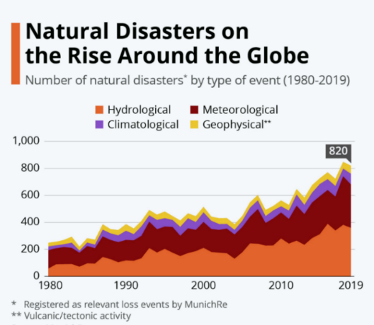
Figure 1.1 Global trend in reported natural disasters, 1900–2022
Figure 1.1 shows the steep rise in reported natural disasters since 1900, with weather- and climate-related events, including wildfires, taking a growing share (CRED/UCLouvain, 2023; UNEP, 2022). Wildfire frequency, spatial extent, and intensity have all risen under climate change, land-use transformation, and the expansion of the wildland-urban interface (Bowman, et al., 2020; UNEP, 2022), and the resulting ecological, economic, and human impacts increasingly outpace conventional response capabilities (Thompson & Calkin, 2011; Pacheco, 2015; Finney, 2006).
Wildfire management is a demanding decision domain because fire behavior evolves in space and time under the joint influence of weather, terrain, fuel, and suppression. Wind and humidity set ignition probability and spread rate, slope and aspect steer propagation, fuel structure determines intensity and burn duration, and suppression actions feed back into the fire dynamics (Rothermel, 1972; Finney, 2006; Sullivan, 2009a; Sullivan, 2009b; Sullivan, 2009c).
Operational wildfire response relies not only on numerical indicators, but also on incomplete and linguistically expressed situational assessments such as “high spread potential,” “limited suppression feasibility,” or “uncertain fire boundary.” Fuzzy reasoning is well suited to this setting, since it supports approximate inference over partial and imprecise evidence without probability distributions, which are rarely available in real time (Thompson & Calkin, 2011; Pacheco, 2015).
Many DSS approaches exist for wildfire management, from optimization-based resource allocation and simulation-based systems to geospatial risk assessment and fuzzy reasoning (Thompson & Calkin, 2011; Pacheco, 2015; Finney, 2006; Vásquez, 2021; Figueiredo, Macedo, Alves, & Figueiredo, 2024). Mature deployed systems such as WFDSS and FlamMap, together with recent ML-based hybrids, provide substantial operational value, yet each addresses only part of these requirements. The remaining challenge is therefore architectural: no single framework simultaneously addresses adaptability under dynamic conditions, explainability of decision outputs, and support for distributed multi-level coordination within one coherent design (Thompson & Calkin, 2011; Vásquez, 2021; McNeese, Schelble, Canonico, & Demir, 2021). The DisasterAware framework is motivated not by a single methodological deficiency but by a set of structural limitations that recur across existing DSS. The next section examines these limitations, and the thesis contributions are then mapped to them.

Gap Analysis
Despite advances in DSS research, the literature still exhibits several unresolved limitations that constrain operational effectiveness. Existing systems have delivered important capabilities in fire spread prediction, geospatial risk analysis, resource planning, and situation monitoring. However, many of these contributions are built on assumptions that are difficult to sustain under dynamic conditions: predefined decision alternatives, centralized reasoning, limited treatment of uncertain observations, weak explainability, and constraint handling that presumes complete information (Arnott & Pervan, 2005; Turban, 2011). These limitations consolidate into three structural gaps, summarized in Table 1.1,each reflecting a structural rather than incidental shortcoming of current architectures.
Table 1.1 DSS gaps identified in wildfire decision support literature
 | Gaps of Existing Wildfire DSS Architectures
G1 | Existing DSS frameworks rely on predefined decision alternatives evaluated within centralized, level-undifferentiated architectures, preventing adaptation to dynamic, unforeseen conditions and limiting scalability, local responsiveness, and level-appropriate coordination.
G2 | Current systems cannot represent epistemic uncertainty without probability distributions or calibrated belief intervals, and expose the reasoning behind a recommendation only through post-hoc attribution, leaving decision sensitivity unquantified and eroding operator trust.
G3 | Simulation dynamics and decision reasoning remain tightly coupled, and operational constraints are handled through offline optimization requiring complete state information, so no end-to-end operational workflow demonstrates real-time, cell-level decision support under operational conditions.

G1 Closed Decision Spaces in Centralized Architectures
Many classical DSS frameworks assume decision alternatives can be enumerated before reasoning begins (Power, 2002; Pacheco, 2015; Sprague & Carlson, 1982). Multi-criteria frameworks similarly require a fixed alternative set ranked against pre-defined criteria (Malczewski, 1999; Keeney & Raiffa, 1976). Wildfire management violates this assumption: fire behavior evolves continuously with wind shifts, fuel variability, and terrain interactions, producing operational conditions that no fixed strategy set can represent (Pacheco, 2015; Vásquez, 2021; Calkin, O'Connor, Thompson, & Stratton, 2021). Field studies confirm the mismatch. Practitioners rely on existing DSS to validate decisions already made from experience rather than to generate new response options (Fillmore & Paveglio, 2023; Rapp, Rabung, Wilson, & Toman, 2020). The closed decision space is therefore not an incidental limitation but a structural barrier to adaptive operational use.
Centralized DSS architecture concentrates observation aggregation, decision evaluation, and response generation within a single analytical core. This structure exhibits computational bottlenecks when the operational state changes rapidly or the spatial domain expands (Arnott & Pervan, 2005; Shim, et al., 2002). Recent reviews call for distributed mechanisms that preserve local responsiveness while maintaining global coordination (Vásquez, 2021). A related limitation is the absence of explicit hierarchical differentiation between decision levels. Wildfire operations span local intervention, regional coordination, and strategic prioritization (Turoff, 2004; Comfort, Boin, & Demchak, 2010), but most DSS treat decision support as a single-layer process, conflating inferential responsibilities with coordinative ones. Post-incident analyses of U.S. wildfire events show that centralized, level-undifferentiated coordination delays localized action by routing regional requests through central nodes (Calkin, O'Connor, Thompson, & Stratton, 2021; Orphanoudakis, Betzelos, & Leligou, 2025).
G2Unrepresented Epistemic Uncertainty and Limited Explainability
Wildfire decisions are shaped more strongly by epistemic uncertainty, arising from incomplete or unreliable information, than by stochastic variability in fire dynamics (Morgan & Henrion, 1990; Walker, et al., 2003; Thompson & Calkin, 2011). Existing uncertainty-aware DSS approaches typically require either prior probability distributions (Bayesian) or pre-calibrated belief intervals (Dempster-Shafer), both of which are rarely available at cell-level resolution in real-time operational settings (Shafer, 1976; Pearl, 1988). Fuzzy logic has been proposed as a principled alternative for graded representation of operational evidence without distributional assumptions (Zadeh, Fuzzy sets, 1965; Mendel, 2017; Duarte, Teodoro, Gonçalves, Soares, & Cunha, 2022), yet its systematic integration into wildfire DSS architectures remains limited. Operators routinely distrust DSS outputs precisely because existing tools do not expose the degree of observational uncertainty underlying recommendations (Rapp, Rabung, Wilson, & Toman, 2020).
AI-based wildfire models increasingly operate as black boxes whose internal reasoning is difficult to interpret (Ribeiro, Singh, & Guestrin, 2016; Guidotti, et al., 2018). Emergency response requires traceable recommendations that operators can justify to multiple stakeholders (McNeese, Schelble, Canonico, & Demir, 2021). Post-hoc attribution methods such as SHAP and LIME provide statistical approximations of model behavior rather than causal rule-level traceability (Ribeiro, Singh, & Guestrin, 2016). Empirical studies show that wildfire managers override or ignore DSS recommendations when the underlying reasoning is opaque, reducing operational value (Fillmore & Paveglio, 2023; Rapp, Rabung, Wilson, & Toman, 2020). Recent hybrid predictive-fuzzy frameworks demonstrate that accuracy and interpretability are not mutually exclusive (Mohammadi, Alesheikh, & Alimohammadi, 2025),but such architectures remain absent from mainstream DSS.
G3 Tight Simulation-Decision Coupling without an End-to-End Operational Workflow
Many wildfire DSS tightly integrate fire-spread simulation with decision reasoning. Modular architectures are essential for traceability and independent validation of system components (Sugumaran & Degroote, 2010), yet tight coupling prevents either component from being updated or verified in isolation (Pacheco, 2015; Vásquez, 2021). WFDSS exemplifies this pattern: its fire-behavior subsystems and decision documentation are architecturally merged within a single platform, constraining substitutability (Noonan-Wright, et al., 2011). Recent hybrid architectures reinforce the same coupling. The transformer-fuzzy decision model of Mohammadi, Alesheikh, & Alimohammadi (2025) and the real-time DSS of Figueiredo, Macedo, Alves, & Figueiredo (2024) both embed decision logic within the prediction pipeline, so their reasoning outputs cannot be validated independently of the underlying simulator. As wildfire simulation science advances separately from DSS research, this coupling increasingly blocks the incorporation of new modeling capabilities into operational decision frameworks.
Optimization-based DSS represent operational constraints such as resources, travel time, and suppression effectiveness through formal cost functions (Keeney & Raiffa, 1976; Pais, Carrasco, Moudio, & Shen, 2021). These formulations presuppose complete state information, which is rarely available during active wildfire response (Martell, 2007; Finney, 2006). The gap is therefore not lack of awareness but the absence of mechanisms that integrate constraints into real-time, cell-level reasoning under incomplete and evolving observations (Oliveira, Barros, Ager, & Fernandes, 2022). Distributed wildfire response further breaks the completeness assumption. Resources are dispersed, availability changes continuously during an incident, and local accessibility depends on conditions that can only be estimated from partial observations. Existing DSS lack operational mechanisms for constraint-sensitive reasoning at this granularity. These constraints compound the coupling problem: without separable components and constraint-aware reasoning, complete workflows that connect observation, reasoning, and operator interaction in a single demonstrable pipeline remain rare, sustaining the distance between published capability and field adoption.

Research Question and Hypothesis
Formally, this thesis addresses the following research question:
How can a wildfire decision support system generate adaptive intervention guidance over an open decision space, expose the reasoning and the sensitivity behind every recommendation it derives from incomplete observations, and demonstrate the resulting pipeline end to end against a strictly separated simulation core, under real-time distributed constraints and with formal correctness guarantees?
This question gives rise to the following main hypothesis:
A hierarchically distributed DSS architecture built on concept-driven fuzzy reasoning, equipped with adaptive and generative rule evolution behind a satisficing verification gate, intrinsic rule-level traceability with quantified sensitivity, and a strictly separated simulation core, resolves the three identified structural gaps within a single coherent framework and admits formal mathematical proof of its pipeline correctness properties that are absent from existing operational DSS.
This hypothesis is decomposed into three testable sub-claims:
H1 (Scalability and Adaptability): A hierarchically distributed architecture with concept-abstracted local fuzzy agents and non-inferential global coordination generates adaptive interventions over an open decision space with lower rule-base complexity and faster response times than centralized, closed-alternative DSS under evolving wildfire conditions.
H2 (Interpretability and Independent Validation): The combination of concept-driven fuzzy reasoning, intrinsic rule-level traceability, confidence-gated uncertainty encoding, and systematic sensitivity analysis produces interpretable and independently verifiable decision outputs that do not require post-hoc attribution methods such as SHAP or LIME.
H3 (Operational Feasibility Under Uncertainty): An end-to-end workflow that couples the strictly separated simulation core, decision core, and operator dashboard, together with satisficing-based decision acceptance and cost-aware constraint integration, produces operationally feasible interventions across a wider range of incompletely observed, resource-constrained wildfire scenarios than probabilistic or optimization-based alternatives.

Main Contributions of the Thesis
The thesis makes three architectural and methodological contributions that collectively address the structural gaps identified in Section 1.1. Each contribution is self-contained and addresses a distinct gap, as summarized in Table 1.2. The contributions are realized across the background in Chapter 2, the DisasterAware framework and its simulation core in Chapter 3, the decision support system design and formal analysis in Chapter 4, and the empirical evaluation in Chapter 5.
Table 1.2 Mapping of thesis contributions to identified gaps
 | Addressed Gap | Contribution
C1 | G1: Closed decision spaces in centralized architectures | Open decision space through concept-based abstraction, adaptive rule generation, and hierarchically distributed reasoning with non-inferential global coordination
C2 | G2: Unrepresented epistemic uncertainty and limited explainability | Sensitivity analysis built on confidence-gated uncertainty propagation and intrinsic rule-level traceability
C3 | G3: Simulation-decision coupling without an end-to-end operational workflow | End-to-end use-case demonstration over analytically separated simulation and decision cores with satisficing-based acceptance

C1 Open Decision Space through Adaptive, Concept-Driven Distributed Reasoning
To address G1, this thesis replaces the fixed menu of predefined alternatives with an open, concept-driven decision field. Raw observations are first mapped onto five domain-meaningful decision concepts, so that rules are written in operational language rather than over raw signals. The field is then reshaped online: an evolving Takagi-Sugeno rule base adapts membership functions and term resolution (Takagi & Sugeno, 1985; Angelov & Filev, 2004), a generative model proposes genuinely new candidate rules when adaptation is exhausted, and every candidate passes a satisficing verification gate before it may act (Simon H. A., 1956). Reasoning itself is confined to local fuzzy agents, while a non-inferential global layer only assigns resources and normalizes priorities, which keeps the open field scalable.
C2 Sensitivity Analysis with Intrinsic Traceability and Confidence-Gated Uncertainty
To address G2, the reasoning pipeline is built so that explanation and uncertainty handling are structural rather than retrofitted. Epistemic uncertainty is propagated without prior distributions by blending each concept activation with a persistence-based estimate in proportion to observation confidence. Every decision remains traceable to the concepts that fired it, the rules involved, and the confidence behind them, and a sensitivity analysis quantifies how features, membership parameters, and priority weights propagate to the decision, in contrast to post-hoc attribution methods such as SHAP or LIME.
C3 End-to-End Use-Case Demonstration over Separated Simulation and Decision Cores
To address G3, the thesis enforces a strict separation between the simulation core and the decision core, which grounds formal pipeline properties under incomplete observation and allows either side to be validated independently. On this foundation the framework is exercised in an end-to-end use case that couples the spread simulation, the decision pipeline, and an operator dashboard, with satisficing acceptance and a graduated fail-safe keeping every realized intervention admissible; the use case addresses the research-to-practice distance reported in field studies (Fillmore & Paveglio, 2023; Rapp, Rabung, Wilson, & Toman, 2020).
Collectively, these three contributions transform wildfire DSS from a predefined and centralized decision toolkit into an open, distributed, and uncertainty-aware reasoning system whose operational properties are analytically established rather than empirically assumed.
The three structural gaps G1 to G3 identified above are not uniformly distributed across the wildfire DSS literature. Individual frameworks address some gaps while remaining constrained by others, and no single existing system resolves all three in combination. Six representative frameworks, spanning the principal methodological families currently in operational use or active academic development, make this distribution concrete: an operationally deployed incident support platform (WFDSS), a widely used fire-behavior simulation system (FlamMap), a recent multi-criteria optimization toolkit (MORA), a real-time operational DSS (Figueiredo, Macedo, Alves, & Figueiredo, 2024), a deep-learning and fuzzy hybrid prediction framework (Mohammadi, Alesheikh, & Alimohammadi, 2025), and the proposed DisasterAware framework.
Operationally deployed systems such as WFDSS (Noonan-Wright, et al., 2011) offer mature incident-support capabilities but remain constrained by closed decision spaces, centralized reasoning, and tight coupling between fire-behavior modeling and decision documentation. Pure fire-behavior simulators such as FlamMap (Finney, 2006) provide high-fidelity physical modeling but do not constitute decision support systems in the operational sense, as they lack structured decision-generation mechanisms and are therefore not assessable against most of the identified gaps. Recent optimization-based toolkits such as MORA (Orphanoudakis, Betzelos, & Leligou, 2025) advance resource-allocation reasoning but retain a centralized, closed-alternative paradigm with limited explainability. Real-time DSS implementations (Figueiredo, Macedo, Alves, & Figueiredo, 2024) improve responsiveness under dynamic conditions but do not integrate concept-level abstraction or distributed coordination. The hybrid fuzzy and transformer framework of Mohammadi et al. (2025) advances explainable AI for wildfire management, but its focus remains on prediction rather than on the generation of structured, operationally feasible intervention fields under operational uncertainty. Against this landscape, DisasterAware is positioned not as superior along any single dimension, but as the first framework to resolve all three structural gaps within a single coherent architecture. This positioning reflects design intent rather than validated operational maturity; on uncertainty in particular, the confidence-gated treatment adopted here is one of several principled paradigms, and Bayesian, Dempster-Shafer, and type-2 fuzzy approaches remain complementary alternatives rather than superseded approaches.
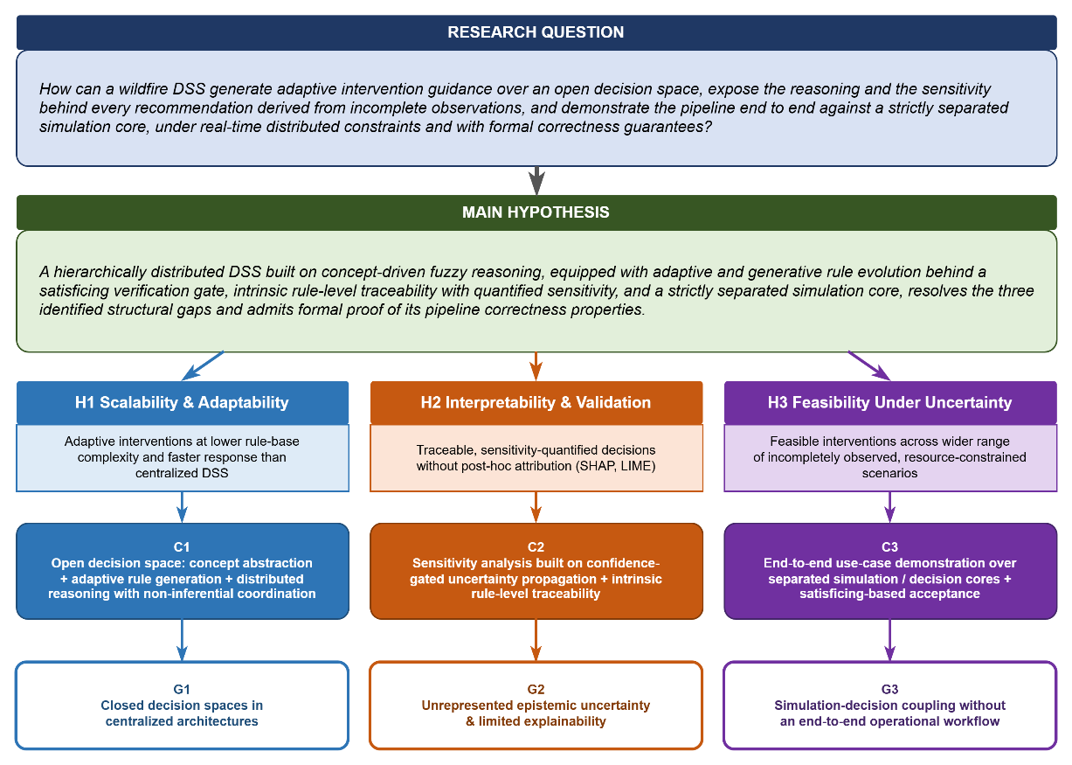
Figure 1.2 Research question, hypothesis, gaps and contributions
Figure 1.2 presents the logical structure of the thesis as a single integrated schema, linking the research question at the top to the three structural gaps at the bottom through an intermediate layer of hypotheses and contributions. The research question articulates four simultaneous requirements that a wildfire DSS must satisfy under incomplete observation and distributed real-time constraints, and the main hypothesis posits that a hierarchically distributed, concept-driven, confidence-gated, and satisficing-based architecture meets these requirements while admitting formal proof of its pipeline correctness properties. This hypothesis is decomposed into three testable sub-claims arranged as vertical threads: H1 addresses scalability and adaptability, H2 addresses interpretability and independent validation, and H3 addresses operational feasibility under uncertainty. Each sub-claim is realized by one contribution (C1 under H1, C2 under H2, C3 under H3) that in turn addresses one of the three structural gaps identified in Section 1.1, establishing a one-to-one correspondence between every gap and a targeted architectural contribution. The flow from research question through hypothesis and contributions to gaps can therefore be read as one continuous argument.

Organization of the Thesis
Chapter 2 assembles the background required by the remainder of the thesis, moving along the path a decision travels: Wildfire dynamics and spread modeling, the foundations of decision support, the input space from heterogeneous sensing to the observation features, concept-driven fuzzy reasoning together with the rule-explosion argument, and the decision space with its admissible interventions, the evaluation machinery, and the adaptive and generative loops that keep it open.
Chapter 3 introduces the DisasterAware framework as the computational foundation of the study. It presents the overall system architecture, the external input layers for meteorology, topography, fuel, ignition, and decisional data, the simulation core with its spatio-temporal state transition and hybrid fire spread model, and the decision support system core coupled to it. Testability rather than maximal fidelity is its design criterion.
Chapter 4 develops the DisasterAware decision support system. It derives the feature space from the observable state, specifies the fuzzy variables and membership functions, constructs the five decision concepts and their mappings, and defines the intervention rule base together with the action aggregation function. On this specification, it presents the layered decision architecture comprising observation, concept mapping and abstraction, local DSS, and global coordination layers, and details the epistemic encoding of incomplete observations, the formal properties of the pipeline, and the explainability and governance overlay that provides traceability, auditability, and operator override.
Chapter 5 reports the simulation and performance results, evaluating DisasterAware against a functionally equivalent centralized baseline over scenarios of increasing complexity, and closes with a sensitivity analysis over features, membership functions, and priority weights.
Chapter 6 summarizes the contributions and outlines directions for future research.
Together, these chapters form a coherent argument that proceeds from problem formulation through theoretical grounding and system design to empirical evaluation and synthesis, each chapter building on the preceding one.

BACKGROUND INFORMATION
This chapter presents the background on which the remainder of the thesis builds. Its purpose is twofold: To introduce the concepts on which the design chapters rely, and to justify, on the basis of the literature, the choices that shape DisasterAware. The chapter is organized as follows. Section 2.1 reviews wildfire dynamics and spread modeling. Section 2.2 introduces the foundations of decision support,including closed versus open decision spaces and centralized versus distributed architectures. Section 2.3 presents the input space, from heterogeneous sensing sources to the ten observation features. Section 2.4 develops concept-driven fuzzy reasoning. Section 2.5 defines the decision space: The admissible interventions, the cost, acceptance, and uncertainty machinery by which candidate decisions are judged, and the adaptive and generative loops that keep the decision space open.

Wildfire Dynamics and Spread Modeling
This section reviews the mechanisms of wildfire spread and the principal approaches to modeling it. The treatment is confined to the material required by the subsequent chapters: The physical drivers of fire behavior, the families of spread models, and the properties a decision layer requires from the model to which it is coupled.

Drivers of Fire Behavior
Fire behavior at any point of a landscape is governed by three groups of drivers, namely weather, terrain, and fuel. Weather contributes the most rapidly varying quantities: air temperature, relative humidity, wind speed and direction, wind gusts, and precipitation. Wind pushes the flame front toward unburned fuel, while humidity and precipitation set the moisture content of fine fuels and, with it, the ease of ignition (Rothermel, 1972). Terrain contributes elevation, slope, aspect, and accessibility: a front burning upslope preheats the fuel above it and accelerates, aspect determines how much solar radiation dries the fuel over the day, and accessibility bounds where crews can act. Fuel contributes the most slowly varying quantities: the vegetation type, the available fuel load, and the fuel moisture determine how intense the combustion becomes and how long a cell keeps burning (Scott & Burgan, 2005).
These drivers are summarized operationally by a small set of quantities: the rate of spread (ROS) of the front, its direction, and the fire line intensity. The Rothermel model expresses ROS as a function of fuel properties, fuel moisture, wind, and slope, and it still underlies most operational tools (Rothermel, 1972; Andrews, 2018); the detailed parameterization used in this thesis is given in Appendix A. The significance of the model for this thesis lies not in its exact functional form but in the causal chain it encodes: Weather, terrain, and fuel jointly determine local spread, and any intervention that modifies one of these inputs alters the behavior of the fire.

Families of Spread Models
The literature groups spread models into three families. Physical and quasi-physical models resolve combustion chemistry and heat transfer; they are the most detailed and the most expensive to run (Sullivan, Wildland surface fire spread modelling 1: Physical and quasi-physical models, 2009a). Empirical and quasi-empirical models fit observed spread rates to environmental variables; they are fast and robust within the conditions for which they were calibrated (Sullivan, Wildland surface fire spread modelling 2: Empirical and quasi-empirical models, 2009b). Simulation models propagate a fire front across a landscape by applying one of the former families as a local kernel; FlamMap is the best-known operational example (Sullivan, Wildland surface fire spread modelling 3: Simulation and mathematical analogue models, 2009c; Finney, 2006).
Grid-based simulation discretizes the landscape into cells, each holding fuel, moisture, and burn state. A cell ignites with a probability that grows with the number of burning neighbors, their alignment with the wind, and the local fuel condition, and it stops burning when its fuel is consumed or suppressed. This representation matches the resolution at which incident decisions are made, which is why it is preferred when the model is coupled to a decision layer. DisasterAware follows this pattern: A grid-based simulation model whose local spread kernel belongs to the Rothermel-type quasi-empirical family.

Requirements of the Decision Layer on the Spread Model
A wildfire DSS does not require the highest-fidelity fire simulator available; it requires a testable environment. Testability comprises four properties: Scenarios can be reproduced exactly, the per-cell state can be observed and logged, the inputs through which interventions act can be controlled, and the outcome of a decision can be measured against the outcome of not deciding. Any spread model that offers these four properties, at any level of fidelity, is sufficient to run and evaluate the decision layer; higher fidelity refines the numerical results but alters neither the architecture nor the claims of this thesis. Beyond testability, the spread model must satisfy three operational requirements: A per-cell state that observation can plausibly estimate, controllable inputs through which interventions act, and an update rate compatible with the decision cycle. DisasterAware therefore adopts a hybrid grid model, formalized in Chapter 3, that combines Rothermel-type local spread with explicit per-cell state tracking, in which every grid cell carries its remaining fuel, its moisture, and its burn status, is driven by external weather and terrain layers, and accepts interventions only at the input level, so the decision core never manipulates the physical state directly.
Figure 2.1 summarizes this coupling: weather, terrain, and fuel drive fire behavior; fire behavior updates the cell states; the DSS observes cell states and issues interventions; and interventions feed back into the model inputs.
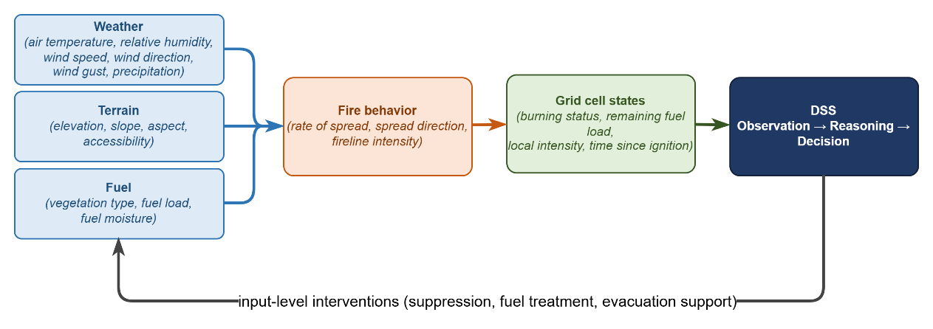
Figure 2.1 Coupling between fire behavior, the grid state, and the decision layer

Decision Support Foundations
This section establishes DSS foundations on which the remainder of the thesis rests. It first reviews the core elements that any operational DSS must supply and, in doing so, introduces the two spaces the framework mediates between, namely the input space of observable quantities and the decision space of orderable actions. It then examines the distinction between closed and open decision spaces, which motivates the central contribution of this thesis, and closes with a comparison of centralized and distributed architectures, which determines where reasoning takes place. Together these discussions supply the vocabulary in which the input space, the reasoning machinery, and the decision space of the subsequent sections are defined.

Core Elements of Decision Support Systems
A DSS mediates between two spaces, namely the input space and decision space. The input space comprises everything the system can observe or estimate: Sensor fields, forecasts, terrain and fuel maps, resource states, and the quantities derived from them. The decision space comprises everything the system is authorized to decide: The set of actions, with their intensities, locations, and timings, that can be ordered at a given moment.
A DSS is a software system that assists an operator in choosing among actions whose consequences are uncertain (Sprague & Carlson, 1982; Power, Decision support systems: Concepts and resources for managers, 2002). Decision support occupies a deliberate middle ground between full automation and unaided judgment. In the classical framework of Gorry and Scott Morton it targets semi-structured decisions, those for which parts of the reasoning can be modeled while the remainder requires human judgment (Gorry & Scott Morton, 1971; Simon H. , The New Science of Management Decision, 1960). Wildfire response is a canonical instance of this class. The physics of spread can be modeled, and candidate responses can be scored, yet accountability, values, and situational judgment remain with the incident commander; the system therefore recommends, while the decision authority remains with the operator. Independent of domain, a working DSS supplies the same core elements (Turban, 2011; Sharda, Delen, & Turban, 2018):
- Input interface, which transforms raw observations into usable, bounded variables.
- Knowledge base, which encodes the behavior of the domain, represented in this thesis in the form of fuzzy rules.
- Reasoning engine, which produces candidate decisions from the current inputs.
- Decision evaluation, which scores every candidate before it is allowed to act.
- Presentation and oversight, which enable the operator to inspect, question, and override the outcome.
In time-critical domains two further elements become essential: Explicit uncertainty handling, since inputs are incomplete and unreliable, and timeliness, since a correct recommendation that arrives late has no operational value (French, Maule, & Papamichail, 2019).

Closed versus Open Decision Spaces
In a closed decision space, the alternatives are enumerated before reasoning begins, and the system can only rank them. This structure characterizes classical multi-criteria decision making, in which a fixed alternative set is scored against weighted criteria (Hwang & Yoon, 1981; Triantaphyllou, 2000; Malczewski, 1999). The approach fails in wildfire response for a structural reason: fire behavior evolves continuously, and an incident routinely produces conditions that no predefined alternative covers. Field studies document the consequence: commanders use existing tools to justify decisions they have already made, not to generate new options (Fillmore & Paveglio, 2023; Rapp, Rabung, Wilson, & Toman, 2020).
An open decision space requires three capabilities: (i) modification of existing alternatives during operation, (ii) construction of genuinely new alternatives, and (iii) verification of every new alternative before it acts, since an unchecked generated action constitutes an operational hazard (Seshia, Sadigh, & Sastry, 2022).
Naturalistic decision research established early that experienced commanders do not select from menus at all. In the recognition-primed model, a decision maker constructs a single plausible course of action from recognized patterns, evaluates it by mental simulation, and repairs or replaces it when the simulation fails, so that option generation rather than option ranking is the expert behavior a support system should serve (Klein, 2017; Ross, Shafer, & Klein, 2006). The same expert behavior has a direct computational counterpart. The evolving fuzzy systems literature made rule structure itself adaptive. Evolving Takagi-Sugeno models create a new rule online whenever incoming data are poorly represented by the existing base, and subsequent variants supplied principled mechanisms for splitting, merging, and pruning rules on streaming data (Angelov & Filev, 2004; Lughofer, 2011). Reinforcement learning (RL) contributes the exploratory side of openness, since policy improvement discovers actions beyond those ever demonstrated (Sutton & Barto, 2018). Most recently, generative models, including large-language-model agents applied to wildfire analysis and response, have been used to draft candidate rules or actions that lie outside the current structure altogether (Xie, ve diğerleri, 2024; Chen, ve diğerleri, 2025; Chandra, Kumar, Patra, & Agarwal, 2025).
DisasterAware combines the three mechanisms: an evolving Takagi-Sugeno (1985) rule base for modification, a generative proposer for construction, and a satisficing acceptance gate for verification (Simon H. A., 1956), so that the decision space remains open while every realized action remains admissible.

Centralized and Distributed Decision Support Architectures
In a centralized architecture every observation flows to a single reasoning core and every decision flows back out of it. This pattern offers simplicity and global consistency, but the reasoning core constitutes a bottleneck. Communication grows with the size of the domain, latency grows with communication, and a failure of the core silences the whole system (Shim, et al., 2002; Arnott & Pervan, 2005).
In a distributed architecture reasoning moves to local nodes and information flows in both directions. Local nodes send compact summaries upward when regional balance is needed, and the upper layer returns allocations and priorities downward. Multi-agent systems research provides the coordination mechanisms (Sycara, 1998; Wooldridge, 2009), and wildfire DSS reviews explicitly call for such designs (Vásquez, 2021).
DisasterAware follows the distributed pattern with one restriction that later chapters exploit. Local agents perform all inference on region-level observations, while the global layer performs no inference at all; it only assigns resources and normalizes priorities across regions. Upward flow, from each local agent to the global coordination layer, carries three compact quantities, namely the region priority derived from the top-level operational priority concept, the resource request implied by the proposed interventions, and a confidence summary of the observations behind them. Downward flow, from the global layer back to every local agent, returns the resource allocation, the normalized priority weights, and the acceptance thresholds in force. Neither direction carries raw sensor fields or rule activations, which keeps the channel narrow, the coordination auditable, and the local decision path short. Figure 2.2 contrasts the two patterns and marks the restriction that keeps the global layer non-inferential, which preserves scalability.
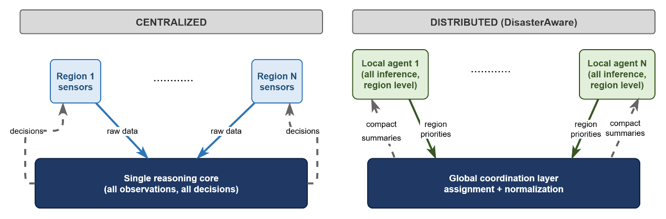
Figure 2.2 Information flow in centralized and distributed DSS architectures

The Input Space: Heterogeneous Sensing to Observation Features
A wildfire DSS draws on heterogeneous sensing sources: Weather stations and forecast services, satellite and aerial imagery, in-situ sensors and unmanned aerial platforms tasked over the incident, geographic information layers for terrain, fuel, assets, and roads, and the resource tracking and field reports of the response organization itself. None of these sources observe the fire state directly; each delivers a partial view with its own refresh cycle. For this reason, the features are defined as bounded, observation-derived quantities rather than raw signals.
Concretely, five families of sources feed the framework. Meteorological networks and numerical forecasts deliver gridded temperature, humidity, wind, and precipitation at a fixed cadence. Spaceborne and airborne imagery provides active-fire detections, burned-area mapping, and periodic vegetation and fuel updates, with wide coverage but coarse revisit intervals (Jain, et al., 2020). In-situ sensing, including ground stations and unmanned aerial platforms tasked over the incident, offers high-rate local observations with narrow footprints. Geographic information layers contribute the quasi-static context, namely terrain, fuel models, road networks, assets, and population (Duarte, Teodoro, Gonçalves, Soares, & Cunha, 2022; Scott & Burgan, 2005). Finally, the response organization itself constitutes an information source: Resource tracking, dispatch logs, and field reports carry the evolving state of crews, equipment, and access (Martell, 2007).
These sources are heterogeneous in every operationally relevant respect: They differ in modality, spatial coverage, refresh rate, and reliability, and they produce information of different kinds, from continuous physical fields to categorical status reports. No single raw signal can drive decision rules directly. The heterogeneous stream is therefore reduced by feature extraction to a small set of bounded, observation-derived quantities, and it is exactly this set that constitutes the input space of the framework.
The ten features and the reasoning behind each are compiled in Table 2.1; their formal derivation from the simulation state, together with the full literature grounding, is given in the design specification. The set spans threat, exposure, feasibility, and timing, so no operational question of Section 2.4 is left without a supporting feature and none of the ten is redundant.
Table 2.1 The ten observation features, their sources, and their rationale
Feature | Primary source | Rationale
Fire intensity $z_{1}$ | Fire state estimation from imagery and in-situ sensing | Fireline intensity in the tradition of Byram and the Rothermel model is the standard descriptor of how hard a front is burning
Spread potential $z_{2}$ | Fire state and weather | Rate of spread from fuel, wind, and slope in the Rothermel tradition remains the operational basis of spread assessment
Weather severity $z_{3}$ | Weather stations and forecasts | Fire-weather index systems condense a small set of weather observations into spread and intensity potential
Ignition proximity $z_{4}$ | GIS road and infrastructure layers | Human-caused ignitions cluster near roads and infrastructure, so distance to them drives ignition probability
Fuel load $z_{5}$ | Fuel model layers | Standard fuel models parameterize combustible load and drive every surface-fire prediction
Asset exposure $z_{6}$ | GIS asset and urban interface layers | Values-at-risk mapping quantifies what a fire threatens and supports risk-based response
Resource accessibility $z_{7}$ | Terrain, fuel, and access layers | Suppression difficulty combines the terrain, fuel, and access conditions of a site
Access and road status $z_{8}$ | GIS road status and field reports | Access governs both suppression logistics and evacuation egress
Suppression availability $z_{9}$ | Resource tracking | Fireline production rates and available capacity determine whether suppression can actually be mounted
Temporal urgency $z_{10}$ | Ignition timing and incident clock | Incident command is time-critical; recognition-primed decision research formalizes acting under urgency

Heterogeneity also imposes admission criteria on the input space. A quantity is admitted to the feature set only if it satisfies four conditions.
- Observability. It must be computable from what sensors and reports actually deliver, never from hidden simulator state.
- Boundedness. It must admit normalization to a fixed interval, so that membership functions remain stable across scenarios.
- Operational meaning. An expert must be able to read it and phrase rules over it without translation.
- Non-redundancy. It must contribute discriminative information that the remaining features do not already carry.
Sufficiency of the resulting set is argued on three grounds and then tested. By construction the ten features span the threat, exposure, feasibility, and timing dimensions of the operational questions, so no question lacks a supporting feature; each feature carries established wildfire-science grounding rather than convenience, as the table records; and none duplicates information carried by the others. The design chapters show that the concept mappings require no further inputs, and the sensitivity analysis of the evaluation chapter confirms empirically that the decision output responds to every feature and is dominated by none.

Concept-Driven Fuzzy Reasoning
This section assembles the reasoning machinery of DisasterAware. Fuzzy reasoning is chosen for three reasons established in the preceding sections. The evidence reaching a wildfire DSS is graded and linguistic rather than crisp; the knowledge that binds observations to interventions exists chiefly as expert phrasing, which fuzzy rules encode without translation; and the resulting inference chain remains inspectable, which the traceability requirement of this thesis makes mandatory. The section first recalls how fuzzy inference turns linguistic expertise into computable rules, then confronts the combinatorial obstacle that arises when such inference is attempted over the full observation vector and finally introduces the conceptual middle layer that resolves the obstacle while preserving interpretability. The section thereby introduces the two design questions addressed in the design chapters: Which features are admitted to the input space, and over which concepts the decision rules are written.

Linguistic Uncertainty and Fuzzy Inference
Operational assessments in wildfire response arrive as graded, linguistic judgments. A spread potential is high, a suppression opportunity is marginal, a boundary estimate is uncertain. Fuzzy set theory supplies the formal counterpart of such judgments by admitting partial membership (Zadeh, Fuzzy sets, 1965; Mendel, 2017). A fuzzy set over a universe of discourse is characterized by a membership function that assigns each element a degree of membership, as formalized in ( 1 ); under this semantics a single wind reading may simultaneously hold membership 0.7 in strong and 0.3 in moderate. In ( 1 ), $Z$ denotes the universe of discourse of an input, $A$ a linguistic term over it, and $μ_{A}(z)$ the degree to which a reading $z$ belongs to $A$. This graded semantics removes the brittle thresholds of crisp classification and preserves expert phrasing under formalization (Pedrycz, 1993).
Domain knowledge enters through linguistic rules of the canonical conjunctive form ( 2 ), whose activation strength is the conjunction of its antecedent memberships, computed as in ( 3 ).
$$μ_{A}:Z→[0,1], L=\{(z,μ_{A}(z)):z∈Z\}$$ | ( 1 )
$$R_{r}: IF z_{1} is A_{r,1} AND … AND z_{n} is A_{r,n} THEN u is B_{r}$$ | ( 2 )
$$α_{r}=\min_{i}⁡μ_{A_{r,i}}(z_{i})$$ | ( 3 )
In ( 2 ) and ( 3 ), $z_{1},…,z_{n}$ denote the input variables, $A_{r,i}$ the linguistic terms selected by rule $R_{r}$, $B_{r}$ the consequent term over the output $u$, and $α_{r}$ the firing strength of rule $r$, with the minimum operator realizing the conjunction of the antecedents.
Mamdani inference aggregates the consequents of the active rules and defuzzifies the aggregate into a crisp output (Mamdani, 1974), with the centroid form of ( 4 ) as the standard choice.
$u^{*}=\frac{∫u⋅μ_{agg}(u)du}{∫μ_{agg}(u)du}$, where $μ_{agg}(u)=\max_{r}{min(α_{r},μ_{B_{r}}(u))}⁡$ | ( 4 )
In ( 4 ), $μ_{agg}$ is the aggregated output membership, obtained by clipping each active consequent at its firing strength and taking the pointwise maximum, and $u^{*}$ is the resulting crisp output. The Takagi-Sugeno variant replaces the fuzzy consequent with a functional one and combines outputs as an activation-weighted average ( 5 ).
$$u=\frac{\sum_{r}{α_{r}⋅g_{r}(z)}}{\sum_{r}{α_{r}}}$$ | ( 5 )
In ( 5 ), $g_{r}(z)$ is the functional consequent of rule $r$, typically affine in the inputs. The identification theory behind this form is presented in (Takagi & Sugeno, 1985). DisasterAware employs both variants deliberately. Mamdani rules constitute the interpretable decision core, whereas the Takagi-Sugeno form carries the adaptation loop, where consequents must be tuned numerically.
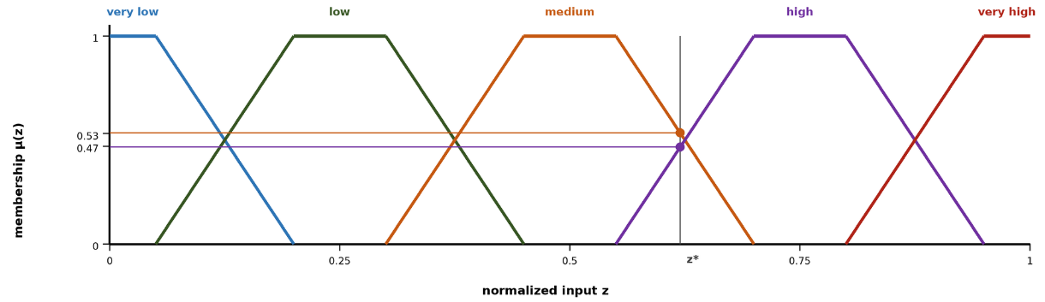
Figure 2.3 Five-term trapezoidal membership partition with an example reading
Figure 2.3 illustrates the five-term trapezoidal partition of a normalized input used throughout the design chapters. Adjacent terms overlap so that every reading activates at most two terms;. Suppose the normalized spread potential of a cell reads $z_{2}=0.62$. Fuzzification against the partition of the figure yields membership 0.53 in medium and 0.47 in high, and every other term stays at zero. Two rules fire, IF spread potential is medium THEN suppression effort is moderate with strength 0.53, and IF spread potential is high THEN suppression effort is high with strength 0.47. Mamdani inference clips the moderate consequent at 0.53 and the high consequent at 0.47, aggregates the two clipped sets, and the centroid of the aggregate lies near 0.62 of the normalized effort scale. The resulting recommendation is therefore a suppression effort of approximately 0.62 intensity, and every intermediate quantity remains visible to the operator.

The Rule Explosion Problem
The obstacle to applying fuzzy inference directly over a rich observation vector is combinatorial. A complete rule base over the full feature set, with each feature partitioned into a fixed number of linguistic terms, contains the number of rules given in ( 6 ), where $N_{feature}$ denotes the number of features and $N_{term}$ the number of linguistic terms per feature. As an example, ten features with five linguistic terms each would demand $5^{10}=9765625$ rules, close to ten million, and even a modest three terms per feature already yields $3^{10}=59049$ rules. A base of this size cannot be elicited from experts, maintained by engineers, or audited by operators (Mendel, 2017).
$$|R|={N_{term}}^{N_{feature}}$$ | ( 6 )

Concepts as an Intermediate Abstraction
The decisive reduction is achieved through a conceptual middle layer. Rather than writing rules over raw features, DisasterAware first composes the features into a compact, four-level concept hierarchy. Six base concepts summarize physically related features; three mid-level and two higher-level decision concepts built on them answer, each exactly once, the recurring operational questions; and a single top concept, operational priority, serves cross-region coordination. The questions, the decision concepts, and what constructs each are listed in Table 2.2.
Table 2.2 Operational questions and the decision concepts derived from them
Operational question | Decision concept
How severe is the fire threat in this cell? | Fire Threat Level
Can an intervention feasibly be mounted here? | Suppression Feasibility
How exposed are the assets here? | Asset Exposure Risk
How urgent is action here? | Intervention Urgency
Is evacuation pressure building here? | Evacuation Pressure
The derivation follows two principles Each question must be one that incident commanders demonstrably ask during response operations (Thompson & Calkin, 2011; Klein, 2017), and each concept must answer its question completely while answering no other, which keeps the concept set complementary and free of redundancy.
Rules are then written over these concepts, while features only feed the concept mappings. With $N_{feature}$ features grouped into $N_{concept}$ concepts drawing on at most $N_{input}$ features each, the rule burden collapses from a product to a sum, as summarized in ( 7 ). The active rule base itself stays compact: the evolving mechanism instantiates only the concept combinations that observed situations activate, and representative rules, together with the complete concept construction mappings, are enumerated in the decision support system chapter and its appendix, so every rule that can act in the field is stated explicitly.
$${N_{term}}^{N_{feature}} ⇢ N_{concept}⋅{N_{term}}^{N_{input}}+{N_{term}}^{N_{concept}}$$ | ( 7 )
Here $N_{concept}$ is the number of decision concepts at the top of the hierarchy and $N_{input}$ the largest number of features feeding a single concept; a reduction whose exact magnitude for the configuration of this thesis is established in the decision support system chapter. The intermediate layer provides more than combinatorial economy. Concepts constitute the traceability vocabulary of the entire framework: every recommendation can be read back as a statement over fire threat, suppression feasibility, asset exposure, intervention urgency, and evacuation pressure, and it is precisely this granularity that the evaluation machinery of Section 2.5 and the operator-facing explanations exploit. The magnitude of the reduction is substantial: Directly over $N_{feature}=10$ features with $N_{term}=5$ linguistic terms, a flat rule base would span $5^{10}≈9.8⋅{10}^{6}$ antecedent combinations. Over the $N_{concept}=5$ decision concepts at the top of the hierarchy the antecedent space shrinks to $5^{5}=3125$ combinations, and the evolving rule base instantiates only the small active subset that observed situations require.
The base layer itself draws directly on the features. Fire severity combines fire intensity $z_{1}$ and spread potential $z_{2}$; spread hazard combines spread potential, weather severity, and ignition proximity; fuel hazard combines weather severity and fuel load; asset value derives from asset exposure; crew reachability combines resource accessibility with access and road status; and logistics support derives from suppression availability. One derivation chain then runs end to end: Fire severity, spread hazard, and fuel hazard combine into fire threat level, the quantity that answers the first operational question and fires decision rules. Base concepts thus act as interpretable intermediate hazards, while the five decision concepts at the top of the hierarchy carry the operational meaning.

The Decision Space: Actions and Their Evaluation
The concept hierarchy of the previous section supplies the vocabulary over which decision rules are written; the output of those rules is ultimately an assignment of intensities to concrete actions. This section therefore fixes the decision space in two steps: first the vocabulary of interventions that can be ordered at all, then the cost model, the acceptance rule, and the uncertainty treatment by which candidate assignments over that vocabulary are judged.

Actions and Interventions in Wildfire Decision Support
A wildfire DSS is operationally useful only if its outputs correspond to orders that an incident commander can issue. The decision space of DisasterAware is therefore built from a fixed vocabulary of intervention types, each applied with an intensity over the grid, so that every rule developed in the later chapters binds to a concrete, executable action (Thompson & Calkin, 2011; Pacheco, 2015). Six intervention types cover the levers reported in the wildfire response literature.
Table 2.3 lists each type, the concrete orders it represents, the channel through which it acts on the simulation inputs, and the literature that grounds it. The list is short and closed at the level of types, which keeps the action vocabulary interpretable and allows every recommendation to be read as an executable order; openness enters not through the invention of new types but through the generation of new rules over the same types.
Table 2.3 Intervention types, representative orders, and input-level effects
Intervention | Representative orders | Input-level effect
Suppression effort (Martell, 2007) | Direct attack on the active front; indirect attack with backburns and aerial retardant drops | Reduces local fire intensity and the ignition probability of neighboring cells
Resource deployment (Oliveira, Barros, Ager, & Fernandes, 2022; Pais, Carrasco, Moudio, & Shen, 2021) | Dispatch, staging, and repositioning of crews, engines, and aircraft across regions | Changes the suppression capacity available to each region
Containment line (Ager, Vaillant, & Finney, 2010) | Firebreak construction and control-line placement along selected boundaries | Removes fuel along the line and blocks propagation paths
Asset protection (Calkin, O'Connor, Thompson, & Stratton, 2021; Noonan-Wright, et al., 2011) | Point protection of structures and critical infrastructure in the fire path | Lowers the loss suffered by a protected asset if the fire reaches it
Evacuation (Turoff, 2004) | Evacuation orders, shelter-in-place, staging of the exposed population | Reduces population exposure in threatened cells
Public warning (Comfort, Boin, & Demchak, 2010) | Alerts and information updates issued to the affected public | Raises preparedness and shortens evacuation lead time

Inaction is not modeled as a seventh type. No-intervention is the zero-intensity point of every type rather than a separate alternative, which keeps the decision space continuous and lets the cost model of this section price inaction the same way it prices action. The design has two practical consequences. First, deliberate restraint becomes an explicit, costed recommendation rather than a silent default, and the operator can verify that action was evaluated and that restraint carried the lower expected cost. Second, the adaptation loop can move continuously between restraint and engagement, since raising an intensity from zero requires no structural change to the decision but only a different point in the same intervention field.
A decision layer requires an explicit evaluation criterion before it can adapt, since every candidate intervention must reduce to a scalar measure of expected cost. This section grounds the cost model of DisasterAware; the acceptance mechanism, the uncertainty treatment, and the sensitivity analysis that build on it are developed in the design and evaluation chapters.

Decision Cost and Its Components
A candidate intervention is evaluated through its expected cost. Wildfire economics quantifies this through the cost-plus-loss principle: The total cost of a response comprises the expenditure on suppression and the net value lost to the fire (Martell, 2007; Thompson & Calkin, 2011). DisasterAware adopts the same additive form, so the cost of a decision is the weighted sum of the response effort it spends and the losses it fails to prevent, in the form given in ( 8 ).
$$J\left(U_{DSS,k}\right)=\sum_{j}{w_{j}⋅J_{j}(U_{DSS,k})}, \sum_{j}{w_{j}}=1, J_{j}∈[0,1]$$ | ( 8 )
In ( 8 ), $U_{DSS,k}$ denotes the intervention field at decision step $k$, realized in the implementation chapters as the DSS output $U_{DSS,k}$, $J_{j}$ the individual loss and response terms, each normalized to [0,1], and $w_{j}$ their non-negative priority weights. The loss terms are the recognized values at risk in wildfire response. Burned area captures land and ecological loss; structure loss captures property in the wildland-urban interface; critical-infrastructure loss captures power, roads, and facilities whose failure cascades beyond the fire (Pais, Carrasco, Moudio, & Shen, 2021); population exposure captures life safety; a response cost captures the resources committed by every ordered action, not only suppression; deployment, evacuation logistics, and public warning all contribute in proportion to the intensity at which they are applied, and deployed capacity is priced regardless of its eventual effectiveness, so that protective actions carry a nonzero cost for the adaptation loop; and a response-delay term penalizes slow action, measured as the average number of decision steps between a cell first exceeding the threat threshold and the first intervention reaching that cell. The components, their scope, and the rationale for their inclusion are compiled in Table 2.4.
The weights $w_{j}$ are not free parameters. Their initial ordering follows the priority-setting literature, using pairwise comparison in the tradition of the analytic hierarchy process over the doctrine of wildfire risk management (Saaty, 1980; Thompson & Calkin, 2011); the vector is then normalized to sum to one, as ( 8 ) requires, and the evaluation chapter subjects the choice to a sensitivity analysis so that no conclusion of this thesis hinges on a particular weighting. The initial vector used in this thesis is $w_{pop} = 0.30, w_{asset} = 0.25, w_{area} = 0.15, w_{resp} = 0.15, and w_{del}= 0.15$, which places life safety first and asset protection second, in line with published incident-management priority orderings; the evaluation chapter perturbs each weight to confirm that the qualitative conclusions remain stable.

Table 2.4 Decision cost components, their scope, and their rationale
Cost | What it prices | Normalization
Burned area $J_{area}$ | Land and ecological loss over the affected cells. (Martell, 2007; Thompson & Calkin, 2011) cost-plus-loss tradition | Burned cells divided by the burnable cells of the scenario
Asset loss $J_{asset}$ | Structures in the wildland-urban interface together with power, transport, and facilities whose failure cascades beyond the fire. (Calkin, O'Connor, Thompson, & Stratton, 2021; Pais, Carrasco, Moudio, & Shen, 2021) values-at-risk doctrine and downstream protection value | Value lost divided by the total exposed value
Population exposure $J_{pop}$ | Life safety of the exposed population. (Turoff, 2004; Comfort, Boin, & Demchak, 2010) emergency management priority | Person-steps exposed divided by the population at risk times the horizon
Response cost $J_{resp}$ | Every ordered action, priced by applied intensity, including deployment, evacuation logistics, and warning. Prevents the adaptation loop from treating protective actions as free | Committed capacity divided by the total available capacity
Response delay $J_{del}$ | Mean number of decision steps between threat onset in a cell and the first intervention reaching it. (French, Maule, & Papamichail, 2019) timeliness affects every other loss | Delay steps divided by the scenario horizon

The terms are expressed in different units, such as area, monetary value, persons, and time; each term is therefore normalized to [0,1] with respect to a scenario reference scale before weighing. Without this normalization the weighted sum, and any sensitivity analysis over the weights, would lose meaning; the sensitivity analysis reported in the evaluation chapter relies on this property. The burned-area and asset-loss terms are disjoint by construction: burned area prices land and ecological loss only, while structure and infrastructure values are counted exclusively in their own terms, so no value is counted twice. The reference scales are stated per component in the last column of the cost table, so the terms become dimensionless and mutually summable before the weights apply.
These reference scales also make the model transferable to a live incident. In the field the static scenario totals are replaced by a rolling reference envelope, namely the burned area, the exposed value, and the exposed population that the spread forecast predicts for the current operational period if no intervention is ordered, which is the operational counterpart of probabilistic spread products already in use. Two safeguards keep the construction sound. All denominators are frozen at the start of each operational period, so the adaptation loop cannot improve its apparent score by shrinking its own reference, and every denominator is bounded below, so the ratios stay defined when little or no spread is forecast. Life safety is subject to one further safeguard: Beyond its weight in ( 8 ), any candidate whose predicted population exposure exceeds a hard ceiling is rejected at the acceptance gate outright, which aligns the weighted model with the doctrine that treats life safety as an inviolable constraint.
The component set is deliberately compact. Fewer terms would conceal trade-offs that commanders must weigh, while additional terms are unnecessary at operational granularity, since finer losses aggregate within the structure and infrastructure terms and are separated by the weights rather than by new components. A compact, interpretable sum allows the decision layer to evaluate candidates online and enables the operator to see why one intervention outranks another.

Satisficing Acceptance and the Graduated Fail-Safe
The cost model of the previous subsection serves as an acceptance criterion rather than as an objective for global optimization. Global minimization over a spatial decision field is computationally intractable under real-time constraints (Papadimitriou & Tsitsiklis, 1987) and presupposes information that incomplete observation cannot supply. DisasterAware therefore follows the satisficing principle of bounded rationality (Simon H. A., 1956; Gigerenzer & Selten, 2001): a candidate intervention is accepted as soon as its expected cost clears an adaptive threshold, as stated in ( 9 ).
$$accept(U_{DSS,k}) ⇔ J(U_{DSS,k})≤θ_{k}$$ | ( 9 )
In ( 9 ), $θ_{k}$ denotes the acceptance threshold at step $k$. Its initial value derives from the reference envelope that normalizes the cost terms: the cost of the uncontrolled, do-nothing forecast over the operational period sets the scale, and the threshold is a fixed fraction of it, 0.35 by default in this thesis. In operation it tightens while observation confidence and available capacity are high and relaxes as they degrade; the exact schedule is calibrated in the design chapters. When no candidate clears the threshold, the framework does not force a binary choice between acting and abstaining. A graduated fail-safe attenuates the best available intervention toward a conservative baseline, according to ( 10 )
$${U_{DSS,k}}^{'}=λ_{k}⋅U_{DSS,k}+(1-λ_{k})⋅U_{DSS,safe}, λ_{k}∈[0,1]$$ | ( 10 )
In ( 10 ), $U_{DSS,safe}$ is the conservative fallback intervention and $λ_{k}$ the attenuation weight set by decision quality: A value of 1 realizes the intervention in full, intermediate values yield a proportionally reduced commitment, and 0 corresponds to complete fallback to the safe posture. The transition from full intervention through partial intervention to fallback is therefore continuous, auditable, and reversible as observation quality recovers.
The fallback $U_{DSS,safe}$ is not the absence of a decision but a pre-authorized conservative posture. Under it, monitoring and public warning remain active, deployed units hold their current safe positions, and no new offensive commitment is made. When, for instance, an indirect attack fails the acceptance test because confidence has collapsed over the target sector, attenuation drives the offensive component toward zero while the protection and warning components are retained; the original intensity returns once fresh observations restore confidence.

Epistemic Uncertainty, Traceability, and Sensitivity
The uncertainty that dominates an active incident is epistemic rather than aleatory: the state is under-observed, not merely noisy (Morgan & Henrion, 1990; Walker, et al., 2003). Bayesian updating and Dempster-Shafer belief calibration both presuppose distributional knowledge that cell-level, real-time sensing does not supply (Pearl, 1988; Shafer, 1976; Zadeh, A simple view of the Dempster–Shafer theory of evidence and its implication for the rule of combination, 1986). DisasterAware instead employs confidence gating. Every concept activation is blended with a persistence-based estimate in proportion to the confidence of the observations that produced it, following ( 11 ). $a_{k}^{obs}$ is the concept activation computed from current observations, $a_{k-1}^{per}$ its persistence-based estimate, and $γ_{k}$ the observation confidence; a low-confidence input is thus attenuated toward the most recent trustworthy estimate rather than trusted outright.
$${a_{k}}^{eff}=γ_{k}⋅{a_{k}}^{obs}+(1-γ_{k})⋅{a_{k-1}}^{per}, γ_{k}∈[0,1]$$ | ( 11 )
Inference runs over explicit concepts and rules, so every decision remains traceable to the concept activations that produced it, the rules they fired, and the confidence behind them. Explanation is thus a structural property of the pipeline, in contrast to post-hoc attribution methods, which approximate an opaque model statistically after the fact (Ribeiro, Singh, & Guestrin, 2016; Guidotti, et al., 2018). On this chain, a sensitivity analysis quantifies how a perturbation of an input, a membership parameter, or a priority weight propagates to the decision, as in ( 12 ).
$$Sens_{i,k}=\frac{ΔJ_{k}}{Δz_{k,i}}$$ | ( 12 )
In ( 12 ), ${Sens}_{i,k}$ measures the change of the decision cost $J_{k}$ induced by a perturbation of feature $z_{k,i}$. The analysis exposes the drivers of every recommendation and the conditions under which it would change; the evaluation chapter reports it over features, membership functions, and weights. Table 2.5 summarizes what the pipeline traces for every decision, what is actually sensed, and which quantities the sensitivity analysis varies and observes.
Table 2.5 Scope of traceability and sensitivity analysis
Scope | Content
Traced for every decision | Concept activations, the rules they fired with their firing strengths, and the observation confidence behind each input
Sensed from the field | Feature values $z_{f}$ with per-cell confidence $γ_{k}$; nothing hidden from observation enters the decision path
Sensitivity inputs (what is varied) | Features $z$, membership-function parameters, and priority weights $w_{j}$
Sensitivity outputs (what is observed) | Decision cost $J_{k}$, intervention intensities $U_{DSS,k}$, and the acceptance outcome

Adaptive and Generative Decision Loops
The preceding sections defined the admissible interventions, the reasoning that produces candidate decisions, and the criteria by which candidates are judged. This section presents the mechanism that keeps the decision space open without compromising safety. DisasterAware organizes this as a staged adaptation loop that escalates only when cheaper corrections have demonstrably failed. The first two stages follow the evolving-fuzzy-systems literature (Angelov & Filev, 2004; Lughofer, 2011), the third extends it with generation (Xie, ve diğerleri, 2024; Chen, ve diğerleri, 2025; Chandra, Kumar, Patra, & Agarwal, 2025).
Figure 2.4 depicts the complete loop. The rule base issues decisions, the realized cost is fed back, the RL controller selects the least invasive stage that promises improvement, and every output of a stage must pass the verification gate before it returns to the rule base.
- Parameter tuning: an evFIS first adjusts the membership-function parameters of existing rules, the least invasive correction
- Resolution increase: where residual cost concentrates, the term set is refined by adding linguistic terms or splitting a region of the input space
- Generative proposal: when neither of the preceding operations removes a persistent cost, a generative model drafts a genuinely new candidate rule; large-language-model agents have recently begun to serve as such proposers in wildfire analysis and response
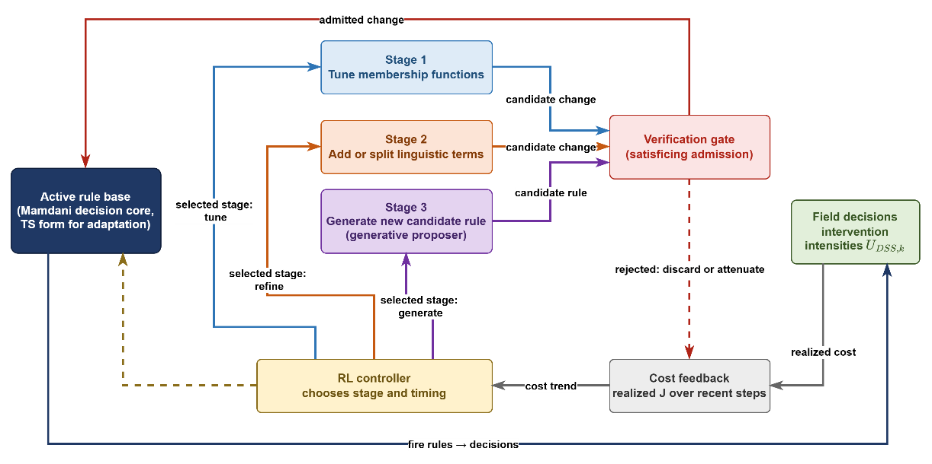
Figure 2.4 Staged adaptation loop with generative proposal and verification
The loop is disciplined by two safeguards. RL controller tunes admitted rules and decides when escalation is warranted, driven by the same cost function that evaluates decisions (Sutton & Barto, 2018). Furthermore, every candidate, regardless of its origin, must pass the satisficing acceptance gate before it may act, according to the admission condition in ( 13 ).
$$R^{'} admitted ⇔J_{R∪\{R'\}}≤J_{R}-δ, δ≥0$$ | ( 13 )
In ( 13 ), $J_{R}$ denotes the cost achieved under rule base $R$ and $δ$ a non-negative improvement margin; an unverified generated rule therefore never reaches the field (Seshia, Sadigh, & Sastry, 2022).The action vocabulary of Section 2.5 remains fixed and interpretable, the rule structure over it evolves and is occasionally extended by generation, and everything that acts has been verified. The design chapters formalize each stage of the loop; the evaluation chapter measures its effect.
The adaptation loop is governed by a reinforcement learning formulation defined over the following elements. The state vector comprises the recent trajectory of the decision cost, aggregate statistics of the rule base such as the rule count and the mean firing strength, and a summary measure of observation confidence. The action set consists of the available adaptation operations: Tuning a membership function, refining a term set, requesting a generative proposal, or leaving the rule base unchanged. The reward is defined as the realized reduction in decision cost, diminished by a penalty proportional to structural growth, so that improvements confirmed by field outcomes are reinforced while superfluous structural complexity is discouraged. The complete formulation is presented in the design chapters.
The three stages also admit a direct interpretation in decision-space terms, and this interpretation is adopted throughout the subsequent chapters. Parameter tuning reshapes the boundaries of decision regions that already exist, so the same rules fire over slightly shifted conditions. Resolution increase partitions a region more finely, so situations that previously received one response can now be distinguished. Generative proposal opens a region that no existing rule could reach, extending the reachable part of the decision space itself, and the verification gate decides whether that new region becomes part of the admissible space. Openness therefore does not imply arbitrariness: Every enlargement of the space is priced by the cost model and admitted only through the verification gate.

DISASTERAWARE SIMULATION FRAMEWORK
This chapter defines the structural, computational, and physical foundations of the DisasterAware framework, which serves as the physical backbone of the entire architecture. Its objective is to formalize how wildfire dynamics are represented and computed before the cognitive reasoning mechanisms of the Decision Support System are introduced in the next chapter.
Wildfire evolution is modeled as a spatio-temporal process over a discretized spatial domain partitioned into grid cells. Each cell represents a localized fire condition described by structured state variables: whether combustion is active, the amount of remaining combustible fuel, local fire intensity, and combustion duration. This state-based representation treats fire propagation as a constrained dynamical system rather than a purely geometric spread.
System evolution is driven by several categories of external forcing. Meteorological drivers such as wind speed and humidity affect spread acceleration and combustion sustainability; terrain properties such as slope and aspect introduce directional bias; fuel characteristics regulate ignition thresholds and burn duration; and operational intervention parameters alter local fuel availability through suppression actions. These influences are kept architecturally separate from the internal wildfire state to preserve clarity and computational stability.
A key design principle is the strict separation between physical state evolution and decision logic. The simulation layer models wildfire behavior under environmental and operational inputs without performing reasoning, optimization, or policy selection. Human interaction and scenario manipulation are permitted only through controlled input-level modifications, never through direct state overwriting.
The Decision Support System is introduced here only to clarify its structural interface with the simulation environment; its internal fuzzy reasoning, layered decision synthesis, and optimization mechanisms are deferred to the next chapter. The remainder of this chapter is organized as follows:
Section 3.1 presents the layered architectural structure and inter-layer data flow of the DisasterAware framework.
Section 3.2 formalizes the external input structure: The simulation input set together with its meteorological, topographic, fuel, ignition, and decisional data layers, and the contextual inputs used by the DSS.
Section 3.3 formalizes the simulation core: The discrete-time state representation and its state variables, the hybrid fire spread transition mechanism, and the interaction and scenario control operator.
Section 3.4 introduces the observation interface that exposes the state to the Decision Support System, states the structural positioning of the DSS Core within the framework, and defers its design specification to the next chapter.
Through this structured progression, Chapter 3 establishes the physically grounded computational environment required for reliable, interpretable, and scalable decision support in wildfire management.

Overall System Block Diagram
Figure 3.1 presents the architectural structure of the DisasterAware framework. The system is designed as a discrete-time, state-driven, layered DSS architecture with a clear separation between input acquisition, physical state evolution, decision evaluation, and human interaction. The architectural objective is to preserve physical consistency within wildfire simulation while enabling adaptive and interpretable decision-making.
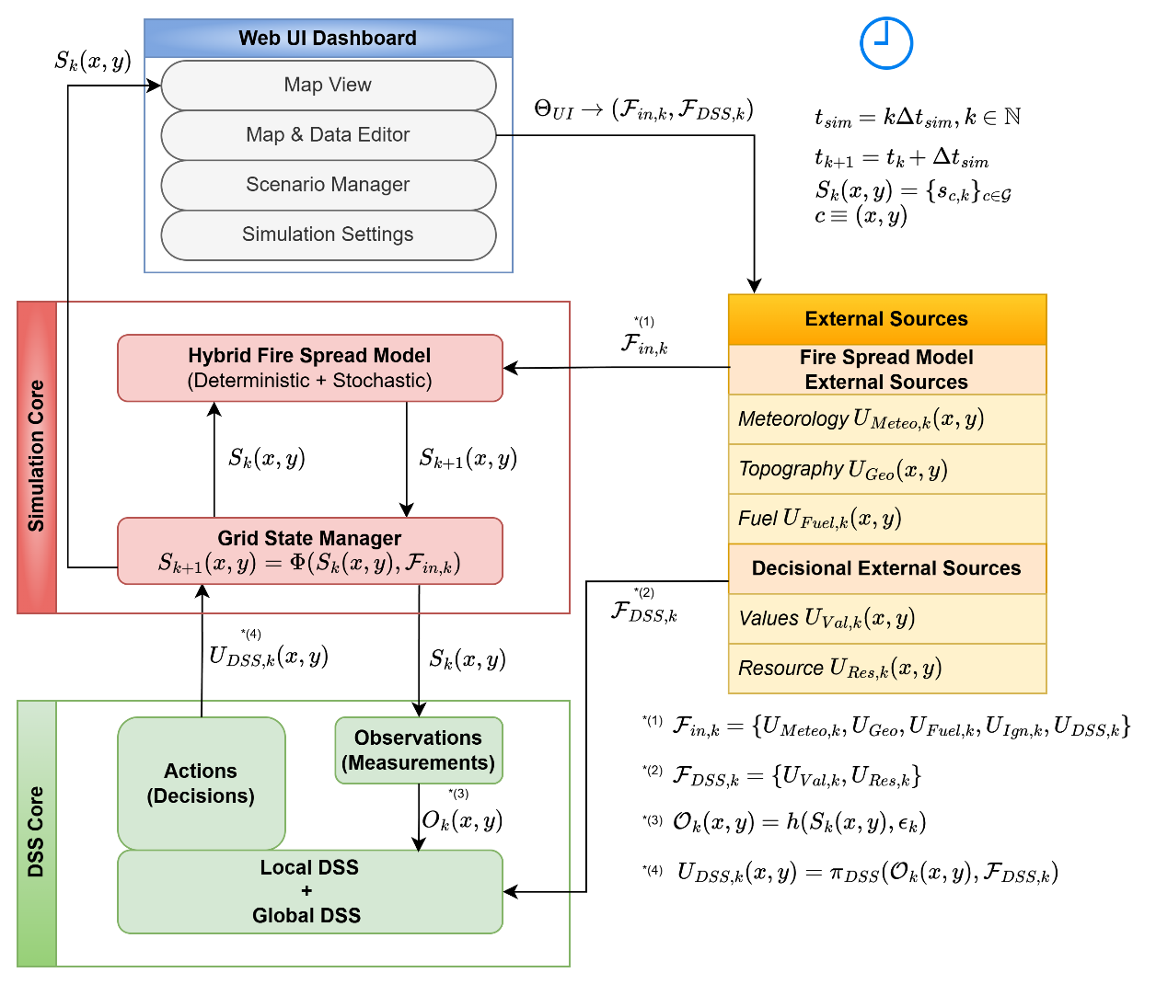
Figure 3.1 DisasterAware system block diagram (simulation focused)
The architecture is organized into four principal layers: External Data Sources, Simulation Core, Decision Support System (DSS) Core, and Web UI Dashboard. Each layer performs a strictly defined function and communicates through structured interfaces rather than direct state manipulation. This separation ensures physical consistency, operational robustness, and architectural transparency.
The External Data Sources layer provides structured exogenous inputs including meteorological, terrain, fuel, and decisional parameters. These inputs act as boundary conditions for the simulation. Environmental inputs are independent of the system state, while decision-driven inputs generated by the DSS depend on observable quantities derived from the system state.
At the center of the framework lies the Simulation Core, which serves as the authoritative computational engine. Wildfire propagation is modeled over a spatial grid where each cell contains a structured representation of local fire conditions. The complete wildfire state includes burning status, available combustible mass, local fire intensity proxy, and time since ignition. This state is maintained and updated at every simulation time step. The Grid State Manager enforces physical constraints such as non-negativity of fuel load and bounded combustion behavior. No external module, including the DSS or the UI, is permitted to directly overwrite internal state variables. All modifications must occur through controlled parameter influence, preserving simulation integrity.
The Decision Support System Core operates as a cognitive layer built on top of the Simulation Core. The DSS operates on observable quantities $O_{k}\left(x,y\right)$ derived from the system state through the observation process. This observation layer extracts structured indicators from the raw state variables, such as fire front behavior, acceleration zones, exposure metrics, and operational accessibility conditions.
The DSS can evaluate conditions at every simulation time step, but decision activation may follow event-triggered conditions. It may operate in an event-driven manner, producing intervention strategies only when predefined thresholds or risk conditions are triggered. When a decision is generated, it is translated into operational parameters that influence subsequent state transitions indirectly through the simulation engine.
The Web UI Dashboard forms the operational boundary between human operators and the computational layers. Unlike the Simulation Core, which is time-synchronous, the UI layer operates asynchronously. The operator can pause the simulation; resume execution; roll back to a stored checkpoint; restart from initial conditions; inject new ignition scenarios; modify operational resource availability; and cancel an active simulation.
Importantly, the UI never directly modifies internal state variables. Instead, it adjusts permissible configuration parameters that affect future simulation steps. This ensures that human intervention remains controlled, traceable, and reversible.
The data flow between layers follows a strict directional structure:
- External inputs feed the Simulation Core at each time step.
- The Simulation Core updates the authoritative wildfire state.
- The DSS observes the current state through observable information $O_{k}\left(x,y\right)$, uses contextual decision inputs $F_{DSS,k}$, evaluates risk, and generates structured intervention recommendations when required.
- The UI visualizes both physical state evolution and DSS outputs while allowing controlled scenario manipulation.
As shown in Figure 3.1, this layered organization enforces a clear separation between wildfire physics, decision cognition, and human supervision. The architecture is designed to ensure: (i) Physical consistency of fire propagation; (ii) Modular extensibility; (iii) Horizontal scalability; (iv) Traceable intervention logic; (v) Robust human-in-the-loop (HIL) control.
By maintaining strict boundaries between simulation dynamics and decision reasoning, the framework establishes a stable computational foundation upon which distributed fuzzy reasoning and adaptive coordination mechanisms can be constructed in subsequent chapters.

Inputs and External Sources
The external input $F_{in,k}$ represents all parameters that influence wildfire evolution at discrete time step $k$. These inputs include both exogenous environmental factors and decision-driven intervention parameters generated by the DSS. These inputs act as boundary conditions and forcing mechanisms for the state transition process. Environmental inputs are updated independently of the system state, whereas decision-driven inputs depend on observable quantities derived from the state. At each discrete simulation step $k$, the external input set is updated and provided to the Simulation Core.
External inputs can be categorized into three distinct groups: (i) Environmental input: including meteorological, terrain, and fuel-related factors that govern physical wildfire dynamics; (ii) Exogenous event inputs: such as ignition events, which trigger fire initiation independently of system evolution; (iii) Decision-driven inputs: intervention parameters generated by the DSS, representing operational actions influencing wildfire evolution.
$F_{in,k}$ ( 14 ) represents all external parameters that influence wildfire dynamics, namely meteorology $U_{Meteo,k}$ ( 15 ), topography $U_{Geo}$ ( 16 ), fuel $U_{Fuel\text{,k}}$ ( 17 ), ignition $U_{Ign,k}$ ( 18 ) and inputs generated by DSS $U_{DSS,k}$ ( 19 ). This structured separation ensures that environmental forcing, ignition triggering, and operational intervention remain conceptually and functionally distinct.
$$F_{in,k}=\left\{U_{Meteo,k},U_{Geo}, {U_{Fuel\text{,k}}, U_{Ign,k}, U}_{DSS,k}\right\}$$ | ( 14 )
In addition to the simulation input set $F_{in,k}$, the DSS process relies on a distinct contextual input set defined as $F_{DSS,k}= \{U_{Val,k}, U_{Res,k}$}. This set represents value-related and resource-related information used by the DSS for decision evaluation. Unlike $F_{in,k}$, which directly influences the state transition operator, $F_{DSS,k}$ does not affect wildfire dynamics directly. Instead, it provides contextual information that guides decision-generation within the DSS layer.

Meteorology Data Layer
Meteorological inputs $U_{Meteo,k}$ ( 15 ) are spatio-temporal environmental drivers that directly influence ignition sustainability, rate of spread, fuel drying, and combustion intensity. These fields are updated at every discrete simulation step to ensure dynamic adaptation of wildfire behavior to evolving environmental conditions.
$$U_{Meteo,k}\left(x,y\right)=\left[\begin{aligned}W_{temp,k}\left(x,y\right) \\ W_{rh,k}\left(x,y\right) \\ W_{ws,k}\left(x,y\right) \\ W_{wd,k}\left(x,y\right) \\ W_{gust,k}\left(x,y\right) \\ W_{prec,k}\end{aligned}\right]$$ | ( 15 )
These variables listed in Table 3.1 are primarily time-dependent and may optionally be spatially dependent when high-resolution gridded weather fields are available.
Table 3.1 Meteorology data layer parameters
Parameter | Type | Unit | Purpose in Simulation
Air Temperature  $$W_{\text{temp,k}}\left(x,y\right)$$ | Spatio-temporal | °C | Represents ambient air temperature, influencing fuel drying rate, ignition thresholds, and fire intensity potential.
Relative Humidity  $$W_{\text{rh,k}}\left(x,y\right)$$ | Spatio-temporal | % | Represents atmospheric moisture content and directly regulates live and dead fuel moisture levels.
Wind Speed  $$W_{\text{ws,k}}\left(x,y\right)$$ | Spatio-temporal | m/s | Serves as the primary driver of fire spread rate and significantly increases the rate of spread under high-speed conditions.
Wind Direction  $$W_{\text{wd,k}}\left(x,y\right)$$ | Spatio-temporal | rad | Determines the directional propagation of the fire front and controls anisotropic spread behavior.
Wind Gust Speed  $$W_{\text{gust,k}}\left(x,y\right)$$ | Spatio-temporal | m/s | Represents short-term wind fluctuations and stochastic acceleration in fire propagation.
Precipitation  $$W_{\text{prec,k}}\left(x,y\right)$$ | Temporal | mm/h | Increases fuel moisture and can suppress, delay, or weaken active combustion processes.

Topography Data Layer
Terrain parameters $U_{Geo}$ ( 16 ) define static spatial constraints over which wildfire propagation occurs. Unlike meteorological variables, these parameters remain constant during short-horizon simulation but modulate directional spread, acceleration, and accessibility. The geometry parameters are listed in Table 3.2.
$$U_{Geo}\left(x,y\right)=\left[\begin{aligned}G_{elev}\left(x,y\right) \\ G_{slope}\left(x,y\right) \\ G_{aspect}\left(x,y\right) \\ G_{access}\left(x,y\right)\end{aligned}\right]$$ | ( 16 )
Table 3.2 Geometry (topography) data layer parameters
Parameter | Type | Unit | Purpose in Simulation
Elevation  $$G_{\text{elev}}\left(x,y\right)$$ | Spatial | m | Represents the altitude of each grid cell and influences local wind behavior, vegetation type distribution and environment gradients.
Slope  $$G_{\text{slope}}\left(x,y\right)$$ | Spatial | rad | Represents terrain inclination and increases fire spread rate in the uphill direction due to flame heat transfer effects.
Aspect  $$G_{\text{aspect}}\left(x,y\right)$$ | Spatial | rad | Represents slope orientation and influences solar radiation exposure, fuel drying patterns, and directional fire propagation.
Accessibility Index  $$G_{\text{access}}\left(x,y\right)$$ | Spatial | -{0,1} | Represents terrain traversability and influences responder mobility, intervention timing, and operational feasibility.

Fuel Data Layer
Fuel-related inputs $U_{Fuel,k}$ ( 17 ) describe the combustible material available at each grid cell. $F_{\text{type}}\left(x,y\right)$ is the vegetation class and $F_{load,k}\left(x,y\right)$ is the available combustible mass at initial time. Fuel moisture $F_{moist,k}\left(x,y\right)$ is treated as an exogenous spatio-temporal input field updated from meteorological drivers or scenario configurations. The fuel parameters are listed in Table 3.3.
$$U_{Fuel,k}\left(x,y\right)=\left[\begin{aligned}F_{\text{type}}\left(x,y\right) \\ F_{load,k}\left(x,y\right) \\ F_{\text{moist,k}}\left(x,y\right)\end{aligned}\right]$$ | ( 17 )
Table 3.3 Fuel data layer parameters
Parameter | Type | Unit | Purpose in Simulation
Fuel Type  $F_{\text{type}}\left(x,y\right)$ | Spatial | – | Defines the vegetation within each grid cell and determines combustion characteristics such as burn rate and heat release behavior.
Fuel Load  $F_{\text{load,k}}\left(x,y\right)$ | Spatio-temporal | {0,1}$\frac{kg}{m^{2}}$ (norm.) | Represents the available combustible mass in each grid cell and directly controls fire intensity, burn duration, and energy release.
Fuel Moisture  $$F_{\text{moist,k}}\left(x,y\right)$$ | Spatio-temporal | – (mass fraction) | Represents moisture of surface fuels and determines ignition probability and combustion sustainability.

Ignition Layer
Ignition is modeled separately from fire intensity. It represents the activation of combustion at a specific grid cell and time step. Ignition may originate from predefined initial conditions, external events, or spotting effects. It functions as a triggering mechanism within the transition dynamics and does not constitute a persistent state variable. The ignition input is defined in ( 18 ) where $I_{Ign,k} (x,y)$ is a binary ignition injection indicator.
$$U_{Ign,k}\left(x,y\right)=\left[\begin{aligned}I_{Ign,k}\left(x,y\right)\end{aligned}\right]$$ | ( 18 )

Decisional Data Layers
The Decisional External Sources ($F_{DSS,k})$ layer represents the non-physical inputs that shape decision making within the distributed DSS. Unlike the meteorological, topographic, and fuel layers that govern fire dynamics, this layer carries the contextual information needed to evaluate operational priorities and constraints, and it therefore determines how simulation outcomes are interpreted and acted upon.
The DSS generates decision-driven intervention parameters $U_{DSS,k}$ ( 19 ) based on observed system states $S_{k}\left(x,y\right)$and $F_{DSS,k}$. $R_{cap,k}\left(x,y\right)$ is available suppression capacity, $R_{avail,k}\left(x,y\right)$ is operational availability status of resources, $R_{eff,k}\left(x,y\right)$ is suppression effectiveness, and $R_{time,k}\left(x,y\right)$ is estimated travel time to reach grid cell $\left(x, y\right)$. These parameters do not represent physical measurements but structured representations of operational actions, which are incorporated into the external input set to influence wildfire dynamics.
$$U_{DSS,k}\left(x,y\right)= \left[\begin{aligned}R_{cap,k}\left(x,y\right) \\ R_{avail,k}\left(x,y\right) \\ R_{eff,k}\left(x,y\right) \\ R_{time,k}\left(x,y\right)\end{aligned}\right]$$ | ( 19 )
$F_{DSS,k}$ has two components: the Value Data and the Resource Data layers. The Value layer defines spatial exposure and asset importance, which supports risk-based prioritization. The Resource layer defines the available suppression capabilities and logistical constraints, which supports feasible intervention planning. Together they turn the physical fire propagation output of the Simulation Core into actionable decision variables, keeping fire behavior modeling and decision reasoning separated.

Value Data Layer
The Values-at-Risk Data layer represents exposed assets, infrastructure, and socio-economic elements that may be affected by wildfire propagation. The value data layer parameters are listed in Table 3.4. All variables in this layer are spatially dependent and static during short-term operational simulations, although their priority weights may be dynamically adjusted based on operational objectives.
Table 3.4 Value data layer parameters
Parameter | Type | Unit | Purpose in Simulation
Building Footprint  $$V_{\text{bld}}\left(x,y\right)$$ | Spatial | {0,1} | Represents the presence of residential or commercial structures and enables identification of wildland–urban zones.
Critical Facility Index  $$V_{\text{crit}}\left(x,y\right)$$ | Spatial | – {0,1} | Identifies high-priority assets such as hospitals, power plants, fuel depots, and water infrastructure.
Population Density  $$V_{\text{pop}}\left(x,y\right)$$ | Spatial | person/km² | Represents exposed population per grid cell and supports evacuation and safety prioritization.
Accessibility to Evacuation Routes  $$V_{\text{evac}}\left(x,y\right)$$ | Spatial | m | Indicates proximity to evacuation infrastructure and supports emergency planning decisions.
Protection Priority Score  $$V_{\text{prio}}\left(x,y\right)$$ | Spatial | – | Aggregated weighting factor combining multiple exposure indicators to rank cells by importance.

The protection priority score $V_{prio}(x,y)$ aggregates the four value indicators into a single scalar index that ranks each grid cell by its overall protection importance. The aggregation is defined as a normalized weighted sum ( 20 ) where $V_{pop}^{norm} =\frac{V_{pop}}{max V_{pop}}$ is the min–max normalized population density, and $V_{evac}^{norm} =\frac{V_{evac}}{max V_{evac}}$ is the inverted and normalized evacuation distance (higher value indicates closer proximity to evacuation routes, hence higher priority).
$$V_{prio}(x,y) = w_{bld} · V_{bld}(x,y) + w_{crit} · V_{crit}(x,y) + w_{pop} · V_{pop}^{norm}(x,y) + w_{evac} · V_{evac}^{norm}(x,y)$$ | ( 20 )
The weights satisfy $w_{bld} + w_{crit} + w_{pop} + w_{evac} = 1$, with default values $w_{bld} = 0.20, w_{crit} = 0.40, w_{pop} = 0.25, w_{evac} = 0.15$. The weight assignment reflects the operational priority hierarchy: critical facilities ($w_{crit} = 0.40$) receive the highest weight because their loss has cascading systemic consequences (e.g., hospitals, power infrastructure, water supply). Population density ($w_{pop} = 0.25$) ranks second because human life exposure scales with density. Building footprint ($w_{bld} = 0.20$) captures structural asset density. Evacuation accessibility ($w_{evac} = 0.15$) receives the lowest weight because it represents a logistical constraint rather than a direct measure of asset value; however, it remains non-zero because locations with poor evacuation access require protective intervention earlier in the decision timeline.

Resource Data Layer
The Resource Data layer represents the operational capabilities available for wildfire intervention. While the fire behavior model estimates how fire evolves under environmental conditions, this layer defines the constraints and effectiveness of suppression actions. The resource data layer parameters are listed in Table 3.5.
Table 3.5 Resource data layer parameters
Parameter | Type | Unit | Purpose in Simulation
Suppression Capacity  $$R_{\text{cap,k}}\left(x,y\right)$$ | Spatio-temporal | m³ water equivalent / step | Represents available suppression capability (i.e., water volume or manpower at grid cell at time step k).
Travel Time  $$R_{\text{time,k}}\left(x,y\right)$$ | Spatio-temporal | min or h | Represents estimated time required to reach a grid cell from current position.
Suppression Efficiency  $$R_{\text{eff,k}}\left(x,y\right)$$ | Spatio-temporal | – {0,1} | Quantifies how effectively a resource reduces fuel load or fire intensity.
Resource Availability  $$R_{\text{avail,k}}\left(x,y\right)$$ | Spatio-temporal | {0,1} | Indicates whether the resource is currently deployable.

Simulation Core
The Simulation Core is the computational foundation of the framework. It represents the wildfire as a state defined over a spatial grid and advances it in discrete time through a single transition operator built on a hybrid fire spread model. Each cell carries its burning status, fuel load, fire intensity, and time since ignition, and these evolve together under the meteorological, topographic, and fuel inputs that govern fire dynamics. The operator is deterministic; stochastic effects such as wind gusts and ember spotting enter only through the external input fields and never write to the state directly. The Simulation Core estimates only how the fire behaves over space and time and leaves the interpretation of that behavior to the DSS, which keeps fire modeling and decision making clearly separated. Its design criterion is testability and reproducibility rather than maximal physical fidelity.

Spatio-Temporal State Transition
Each grid cell in $G$ corresponds to a spatial coordinate pair $\left(x, y\right)$ and represents a localized fire condition ( 21 ). $N_{x}$ is the number of grid cells along the horizontal spatial axis, and $N_{y}$ is the number of grid cells along the vertical spatial axis.
$$G=\left\{\left(x,y\right) ∣ x=1,…,N_{x}, y=1,…,N_{y}\right\}$$ | ( 21 )
At each simulation step, the wildfire state over the grid is represented by $S_{k}$. The system state is defined as the collection of local cell states over the domain ( 22 ). $B_{k}\left(x,y\right)$ is the burning status of cell $\left(x,y\right)$, $F_{load,k}\left(x,y\right)$ is available combustible mass, $I_{k}\left(x,y\right)$ is local fire intensity proxy, and $τ_{k}\left(x,y\right)$ is time since ignition.
$$S_{k}=\left\{s_{k}\left(x,y\right)|(x,y)∈G\right\} \\ s_{k}=\left[\begin{aligned}B_{k}\left(x,y\right) \\ F_{load,k}\left(x,y\right) \\ I_{k}\left(x,y\right) \\ τ_{k}\left(x,y\right)\end{aligned}\right]$$ | ( 22 )
The state vector includes only internal wildfire variables. Environmental factors and operational interventions are not part of the state and are represented as external inputs influencing the state transition. Grid domain and the cell state vector representation is illustrated in Figure 3.2.
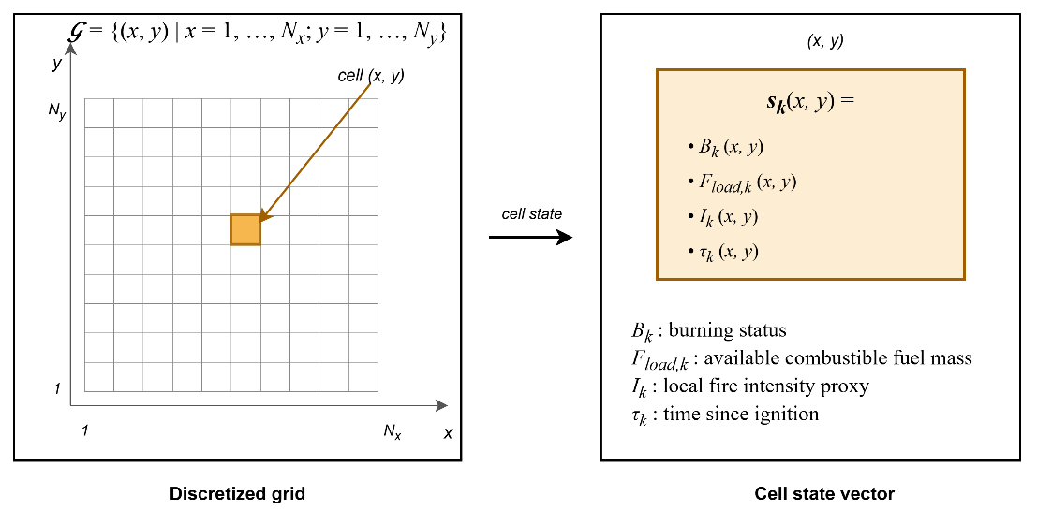
Figure 3.2 Grid domain representation and per-cell state structure

Hybrid Fire Spread Model
The hybrid model integrates deterministic combustion dynamics with stochastic variability to represent realistic wildfire behavior. The global state evolution ( 23 ) is governed by the transition operator where $F_{in,k}$ ( 14 ) includes meteorological forcing, topography, fuel conditions, ignition injection, and DSS-generated intervention parameters. $Φ$ denotes the structured state transition operator composed of burning status evolution, fuel mass evolution, and fire intensity update as defined in the subsequent subsections. The transition operator itself is deterministic. Stochastic variability may arise only through exogenous input fields (e.g., wind gust fluctuations), which are treated as externally provided spatio-temporal inputs.
$$S_{k+1}\left(x,y\right)=Φ\left(S_{k}\left(x,y\right),F_{in,k}\right)$$  $$F_{in,k}=\left\{U_{Meteo,k},U_{Geo}, {U_{Fuel\text{,k}}, U_{Ign,k}, U}_{DSS,k}\right\}$$ | ( 23 )
The overall state transition and hybrid fire spread model is illustrated in Figure 3.3. The state transition operations are described in the next subsections.
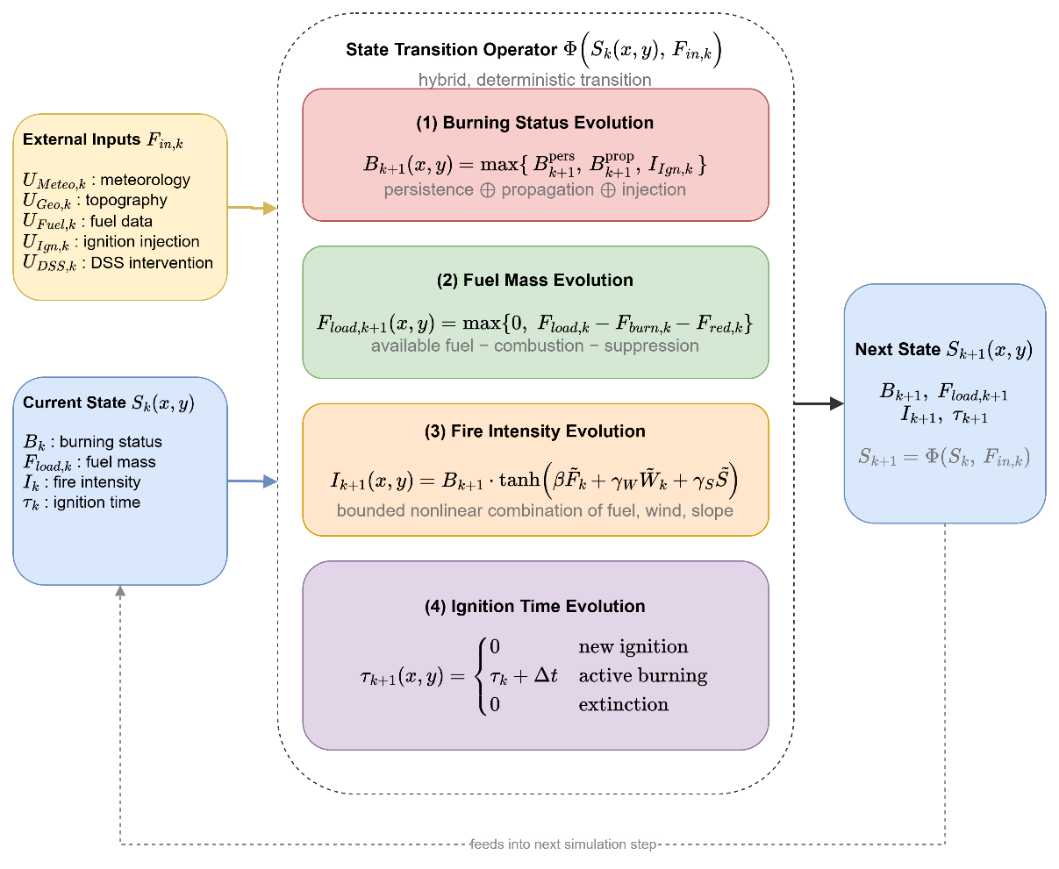
Figure 3.3 State transition block diagram

Burning Status Evolution
The burning status $B_{k}\left(x,y\right)∈\left\{0,1\right\}$ indicates whether the cell is actively burning at time step $k$. The burning status at the next step $B_{k+1}$ ( 24 ) is determined by three mechanisms: persistence of ongoing burning $B_{k+1}^{pers}$ ( 25 ), propagation from neighboring burning cells, and external ignition injection $I_{Ign,k}\left(x,y\right)$. Combining these three mechanisms, the burning status update rule is defined as ( 24 ).
$$B_{k+1}\left(x,y\right)=\max\left(B_{k+1}^{pers}\left(x,y\right),B_{k+1}^{prop}\left(x,y\right),I_{Ign,k}\left(x,y\right)\right)$$ | ( 24 )
This formulation ensures that a burning cell persists while fuel remains available; neighboring burning cells may activate a new cell if sufficient spread influence accumulates; external ignition acts as an independent triggering mechanism.
The persistence term $B_{k+1}^{pers}$ ensures that a cell that is already burning remains burning as long as fuel exists, as stated in ( 25 ) where $1\left[∙\right]$ denotes the indicator function. To avoid numerical persistence under vanishing residual fuel mass, a small extinction threshold $ϵ_{fuel_{load}}$ is used.
$$B_{k+1}^{pers}\left(x,y\right)=B_{k}\left(x,y\right)⋅1\left[F_{load,k}\left(x,y\right)>ϵ_{fuel_{load}} \right]$$  $$ϵ_{fuel_{load}}={10}^{-4}$$ | ( 25 )
Propagation to cell $\left(x,y\right)$ occurs if the accumulated influence exceeds a critical ignition threshold $Θ_{ign}$, where $Θ_{ign}$ is a model parameter representing the minimum spread intensity required to activate combustion in a new cell ( 26 ).
$$B_{k+1}^{prop}\left(x,y\right)=1\left[Ψ_{k}\left(x,y\right)> Θ_{ign}\right]$$  $Θ_{ign}∈\left(0,1\right)$: calibrated threshold relative to base spread rate | ( 26 )
Wildfire spread to neighboring cells is modeled through local propagation influence. $N^{8}\left(x,y\right)$ denotes the 8-connected neighborhood of cell $\left(x,y\right)$. The total propagation influence received by cell $\left(x,y\right)$ at time step $k$ $Ψ_{k}\left(x,y\right)$ is defined in ( 27 ), where the rate of spread $R_{spread,k}\left(x,y\right)$ is ( 28 ). The rate-of-spread mapping $f_{ros}\left(⋅\right)$ is instantiated using a semi-empirical Rothermel-type formulation (Rothermel, 1972). Detailed parameterization is provided in Appendix A. $W_{ws,k}\left(x,y\right)$ is the wind speed field, $W_{wd,k}\left(x,y\right)$ is the wind direction field, $G_{slope}\left(x,y\right)$ is the terrain slope, $G_{aspect}\left(x,y\right)$ is the terrain orientation, $F_{moist,k}\left(x,y\right)$ is the fuel surface moisture, and $F_{type}\left(x,y\right)$ is the fuel type.
$$Ψ_{k}\left(x,y\right)=\frac{1}{8}\sum_{\left(i,j)∈N^{8}(x,y\right)}{B_{k}}\left(i,j\right)⋅R_{spread,k}\left(i,j\right)⋅ g_{dir,k}^{\left(i,j)→(x,y\right)}$$ | ( 27 )
$$R_{spread,k}\left(x,y\right)=f_{ros}\left(\begin{aligned}W_{ws,k}\left(x,y\right), W_{wd,k}\left(x,y\right), \\ {G_{slope}\left(x,y\right),G}_{aspect}\left(x,y\right), \\ F_{moist,k}\left(x,y\right),F_{type}\left(x,y\right) \end{aligned}\right)$$ | ( 28 )
The scalar magnitude $R_{spread,k}\left(x,y\right)$ does not determine spread direction. Directional influence ( 29 ) is introduced when propagating fire from a burning neighbor $\left(i , j\right)$ to target cell $\left(x,y\right)$. $θ_{\left(i,j)→(x,y\right)}$ is the geometric direction between cells. This ensures anisotropic spread aligned with wind direction.
$$g_{dir,k}^{\left(i,j)→(x,y\right)}=\max\left(0,\cos\left(W_{wd,k}\left(i,j\right)-θ_{\left(i,j)→(x,y\right)}\right)\right)$$ | ( 29 )
Figure 3.4 Wind-dependent directional propagation into target cell
Figure 3.4 depicts the spatial structure of the propagation influence accumulation. The 3×3 stencil centered on the target cell $(x,y)$ represents the 8-connected neighborhood $N_{8\left(x,y\right)}$ defined in ( 27 ); the three cells shaded in red denote burning neighbors with $B_{k}\left(i,j\right) = 1$, while the remaining five are non-burning. The wind direction $W_{wd,k}$, represented by the large arrow in the upper-right region of the figure, establishes the axis of anisotropy.
For each burning neighbor, a propagation arrow is drawn toward the target cell with line weight proportional to its directional weight $g_{dir,k}^{\left(i,j\right)→\left(x,y\right)}$: the arrow from the northeast neighbor is aligned with the wind vector and therefore receives full weight $g_{dir} → 1$; the arrow from the northern neighbor is oblique and receives an intermediate weight $g_{dir} ≈ 0.71$; and the arrow from the southeastern neighbor is oriented opposite to the wind and is entirely eliminated, $g_{dir} = 0$, by the $max\left\{0, ·\right\}$ clipping. The aggregate propagation influence $Ψ_{k}\left(x,y\right)$ computed through ( 27 ) is therefore not a symmetric average over the 8-neighborhood but a wind-aligned weighted sum, and the ignition condition $Ψ_{k}(x,y) > Θ_{ign}$ $REF _Ref223041204 \backslash h$( 26 ) is consequently satisfied preferentially along the direction of prevailing wind. This mechanism realizes the Rothermel-type directional bias that is central to operationally realistic wildfire propagation.
External ignition injection $I_{Ign,k}\left(x,y\right)∈\left\{0,1\right\}$ directly activates combustion independent of neighbor influence. Ignition injection may represent lightning strikes, human-caused ignition, or scenario-based ignition input from the UI layer. Ignition injection is a scenario-level forcing that sets $B_{k+1}\left(x,y\right)=1$ regardless of local conditions; if $F_{load,k}\left(x,y\right)$ is insufficient, extinction follows naturally via the persistence condition in the next step. In contrast, the local fire intensity proxy $I_{k}\left(x,y\right)$ represents combustion strength after ignition has occurred and does not participate in the activation condition. This separation preserves conceptual clarity between fire initiation and fire magnitude.
Ember spotting extends ignition beyond the resolved front. Each burning cell whose intensity exceeds 0.6, under wind above 3 m/s and precipitation below 1 mm/h, releases an ember with probability 0.02 per reference step, compounded consistently across substeps. The ember lands six cells downwind and ignites the target cell only if fuel remains there and the local fuel moisture is below the extinction threshold. Spotting is the only stochastic element of the transition operator, is driven by the seeded random stream of the scenario, and allows the fire to cross narrow barriers such as rivers, roads, and containment lines under strong and dry winds.
Precipitation acts on the dynamics through the dead fuel moisture. While it rains, $F_{moist}$ relaxes toward at least 0.35, a level above every extinction threshold, with a time constant of roughly thirty minutes scaled by the rain intensity; under sustained rain of at least 3 mm/h a burning cell is quenched once its fuel moisture has reached that level, so a front dies out gradually rather than instantaneously. When the optional equilibrium moisture mode is active, the dead fuel moisture follows the Simard equilibrium moisture content computed from air temperature and relative humidity, so diurnal weather cycles modulate flammability in the manner of operational fire behavior tools.
Propagation dynamics are governed exclusively by the rate-of-spread mapping $R_{spread,k}\left(x,y\right)$. The local fire intensity proxy does not directly influence activation conditions; instead, it modulates suppression effectiveness and decision-layer interpretation. This separation preserves structural clarity between spread mechanics and combustion strength representation. Thus, intensity affects wildfire dynamics indirectly through suppression resistance and decision-layer interpretation, rather than directly controlling fire propagation.
The rate-of-spread mapping $R_{spread,k}\left(x,y\right)$ is independent of instantaneous fuel mass $F_{load,k}\left(x,y\right)$. Fuel availability influences spread only indirectly through the burning persistence condition, preventing propagation from fuel-depleted cells. This structural separation avoids double- counting mitigation effects.

Fuel Mass Evolution
Fuel mass evolution governs the depletion of combustible material within each cell as a consequence of two distinct mechanisms: combustion-driven consumption and intervention-driven suppression. Unlike the burning status variable, which represents the activation of combustion, the fuel mass variable represents the remaining energy potential available for future fire propagation. Therefore, accurate modeling of fuel evolution is essential to ensure physical consistency, numerical stability, and interpretable interaction between wildfire dynamics and decision-driven mitigation. Combustion-driven consumption and suppression-driven reduction are applied within the same discrete step $k$ as a simultaneous update, represented by the combined terms in ( 30 ) where $B_{k}\left(x,y\right)∈\left\{0,1\right\}$ is the burning status indicator, $F_{burn,k}\left(x,y\right)∈\left[0,1\right]$ is the fractional burn rate (Appendix B), $F_{load,k}\left(x,y\right)$ is the currently available fuel mass, and $F_{red,k}\left(x,y\right)∈\left[0,1\right]$ is intervention-based fuel reduction.
$$F_{load,k+1}\left(x,y\right)=\max\left(\begin{aligned}0, \left(\begin{aligned}F_{load,k}\left(x,y\right) \\ -F_{load,k}\left(x,y\right) B_{k}\left(x,y\right) F_{burn,k}\left(x,y\right) \\ -F_{red,k}\left(x,y\right)\end{aligned}\right)\end{aligned}\right)$$ | ( 30 )
Fuel cannot become negative and cannot increase unless explicitly modeled, $0≤F_{load,k+1}\left(x,y\right)≤1$. This formulation explicitly separates combustion-induced depletion from suppression-induced reduction while enforcing non-negativity of fuel mass. Fuel consumption due to combustion occurs only when the cell is actively burning. The term $B_{k}\left(x,y\right) F_{load,k}\left(x,y\right) F_{burn,k}\left(x,y\right)$ represents the fraction of available fuel consumed during the current simulation step. The multiplication by $B_{k}\left(x,y\right)$ ensures that fuel depletion due to combustion occurs only in actively burning cells. If the cell is not burning, no combustion-driven reduction takes place. This preserves physical realism and prevents unintended fuel decay in inactive regions. The burn fraction $F_{burn,k}\left(x,y\right)$ captures the local combustion intensity per time step and can be interpreted as a discretized approximation of heat-release-driven fuel consumption. The suppression-induced fuel reduction term $F_{red,k}\left(x,y\right)$ is computed from decision-driven inputs $U_{DSS,k}\left(x,y\right)$ and is not an independent external input.
On the other hand, operational intervention modifies the fuel state through the suppression term ( 31 ). This mapping converts operational capability and reachability into a normalized fuel reduction effect. The suppression term may represent water or retardant application; mechanical fuel removal; controlled burn operations; and resource-constrained mitigation strategies. $f_{supp}$ is Suppression to fuel reduction map (Appendix B), $R_{cap,k}$ is available suppression capacity, $R_{avail,k}$ is operational availability status of resources, $R_{eff,k}\left(x,y\right)$ is suppression effectiveness at cell $\left(x , y\right)$, $R_{time,k}\left(x,y\right)$ is estimated travel time to reach $\left(x , y\right)$, and $G_{access}\left(x,y\right)$ is accessibility level at grid cell $\left(x , y\right)$.
$$F_{red,k}\left(x,y\right)=f_{supp} \left(\begin{aligned}R_{cap,k}\left(x,y\right),R_{avail,k}\left(x,y\right),R_{eff,k}\left(x,y\right), \\ R_{time,k}\left(x,y\right),G_{access}\left(x,y\right)\end{aligned}\right)$$ | ( 31 )
Importantly, suppression does not directly overwrite the burning state. Instead, it modifies the available fuel mass, which subsequently influences combustion persistence and propagation through the transition operator. This separation guarantees architectural clarity between physical wildfire dynamics and decision-driven intervention mechanisms.

Fire Intensity Evolution
The local fire intensity proxy evolves according to ( 32 ). The function $f_{intensity}\left(⋅\right)$ approximates local fire strength as a function of available fuel, wind forcing, and terrain gradient. $I_{k+1}\left(x,y\right)$ denotes the updated intensity at the next time step; $I_{k}$ does not appear as an argument of $f_{intensity}$. $f_{intensity}$ is local fire strength function (Appendix C), $F_{load,k}\left(x,y\right)$ is the available combustible mass, $W_{ws,k}\left(x,y\right)$ is wind speed, and $G_{slope}\left(x,y\right)$ is terrain slope.
$$I_{k+1}\left(x,y\right)=f_{intensity}\left(F_{load,k}\left(x,y\right),W_{ws,k}\left(x,y\right),G_{slope}\left(x,y\right)\right)$$ | ( 32 )
The fire intensity proxy serves as an intermediate physical-descriptive variable with the following roles: it does not control ignition activation; it does not directly modify the spread operator; it influences suppression effectiveness through the intervention mapping; and it provides structured features to the Decision Support System. Thus, intensity is a bounded combustion-strength indicator that links environmental forcing to operational response without introducing thermodynamic complexity.

Ignition Time Evolution
The ignition time variable $τ_{k}\left(x,y\right)$ represents the time elapsed since the most recent ignition event at grid cell $\left(x , y\right)$. Unlike fuel mass or intensity, $τ_{k}$ does not influence combustion physics directly. Instead, it serves as a temporal memory state that preserves the burning history of the cell. $τ_{k}$ is a useful state for decision features and explainability within the DSS layer. A deterministic update is ( 33 ).
$$τ_{k+1}\left(x,y\right)=\left\{\begin{matrix}0, & B_{k+1}=1∧B_{k}=0 \\ τ_{k}+Δt, & B_{k+1}=1∧B_{k}=1 \\ 0, & B_{k+1}=0\end{matrix}\right.$$ | ( 33 )
This update has three distinct operational meanings:
- Ignition Initialization: When a cell transitions from non-burning to burning $B_{k}=0, B_{k+1}=1,$ the ignition clock is initialized: $τ_{k+1}=0$. This marks the start of a new combustion phase.
- Active Burning Progression: When a cell remains in the burning state $B_{k}=1, B_{k+1}=1$, the ignition time increases linearly: $τ_{k+1}=τ_{k}+Δt.$ Thus, $τ_{k}$ measures the residence time of active combustion at the cell.
- Extinction Reset: When combustion ceases $B_{k+1}=0,$ the ignition clock resets to 0. It ensures extinguished cells carry no residual temporal memory.
$τ_{k}$ does not feed back into the burning activation condition in the present model, preserving the separation between physical fire dynamics and temporal descriptors.

Mathematical Formulation of Interaction and Scenario Control
The Interaction and Scenario Control mechanism enables controlled human intervention within the DisasterAware framework while preserving the physical consistency of wildfire dynamics. The external simulation input set is $F_{in,k}=\left\{U_{Meteo,k},U_{Geo},U_{Fuel,k},U_{Ign,k},U_{DSS,k}\right\}$ and decision-context set is $F_{DSS,k}=\left\{U_{Val,k},U_{Res,k}\right\}$. The user interaction operator $Θ_{UI}$ is a structured input transformation mapping that produces admissible modifications of the external input set and decision-context set ( 34 ).
$$Θ_{UI}:F_{in}×F_{DSS} ⟶ F_{in}^{*}×F_{DSS}^{*}$$  $$\left(F_{in,k}^{*}, F_{DSS,k}^{*})=Θ_{UI}(F_{in,k}, F_{DSS,k}\right)$$ | ( 34 )
The operator acts independently on five admissible inputs. For each component, the admissible transformation is defined by a bounded perturbation set in Table 3.6. All unmodified components pass through unchanged: $U_{Geo}^{*}=U_{Geo}$, $U_{Fuel,k}^{*}=U_{Fuel,k}$.
Table 3.6 Admissible transformations of interaction operator
Component | Admissible transformation | Constraint
Ignition injection $U_{Ign,k}$ | $$U_{Ign,k}^{*}\left(x,y\right)=U_{Ign,k}\left(x,y\right)+δ_{Ign}\left(x,y\right)$$ | $$U_{Ign,k}^{*}∈\left\{0,1\right\}$$
Meteorological input $U_{Meteo,k}$ | $$U_{Meteo,k}^{*}=U_{Meteo,k}+δ_{Meteo}$$ | $$U_{Meteo,k}^{*}∈U_{Meteo}$$
Resource parameters $U_{DSS,k}$ | $$U_{DSS,k}^{*}\left(x,y\right)=U_{DSS,k}\left(x,y\right)+δ_{DSS}\left(x,y\right)$$ | $$U_{DSS,k}^{*}∈\left[0,1\right]$$
Value context $U_{Val,k}$ | $$U_{Val,k}^{*}\left(x,y\right)=σ_{Val}⋅U_{Val,k}\left(x,y\right)$$ | $σ_{Val}∈\left[0,1\right]$, $U_{Val,k}^{*}∈\left[0,1\right]$
Resource availability $U_{Res,k}$ | $$U_{Res,k}^{*}\left(x,y\right)=U_{Res,k}\left(x,y\right)+δ_{Res}\left(x,y\right)$$ | $$U_{Res,k}^{*}∈\left[0,1\right]$$

The operator $Θ_{UI}$ acts exclusively on the external input set $F_{in,k}$ and decision-context set $F_{DSS,k}$. The system state $S_{k}\left(x,y\right)$ is not in the domain of $Θ_{UI}$, $\frac{∂S_{k}}{∂Θ_{UI}}=0$. All user influence therefore propagates through physically consistent state transitions $S_{k+1}=Φ\left(S_{k},F_{in,k}^{*}\right)$, preserving the causal structure and state immutability.
$Θ_{UI}$ modifies only future state transitions. It does not alter the current state $S_{k}$ or any previously realized state $S_{j}$, $j<k$. This ensures that scenario exploration and operational overrides are prospective, not retrospective.
The modified decision-context set influences decision generation $U_{DSS,k}=π_{DSS}\left(O_{k},F_{DSS,k}^{*}\right)$ and the modified simulation input set governs system evolution $S_{k+1}=Φ\left(S_{k},F_{in,k}^{*}\right)$
Within this formulation, user interaction supports multiple operational functions: Scenario intervention is modification of ignition inputs $U_{Ign,k}$ to inject or alter fire events. Environmental what-if analysis is controlled perturbation of meteorological inputs $U_{Meteo,k}$. Operational override is adjustment of resource-related parameters $U_{DSS,k}$. Priority reconfiguration is modification of value-based context $U_{Val,k}$. Resource reallocation is modification of resource availability $U_{Res,k}$. These interaction capabilities allow the system to operate as a HIL DSS, where the user can dynamically influence both the operational context and the evolution of the simulated environment.
Importantly, interaction does not bypass the DSS. Any modification applied to $F_{DSS,k}$ is incorporated into the decision-generation process through $π_{DSS}\left(⋅\right)$, ensuring that all intervention signals remain consistent with the decision architecture. This design preserves three key architectural principles: State immutability: wildfire dynamics remain governed exclusively by the transition operator Layer separation: simulation, decision reasoning, and interaction remain structurally distinct Traceability: all user interventions are explicitly represented as input-level transformations. Through this formulation, the Interaction and Scenario Control mechanism enables flexible scenario exploration and operational override while maintaining the integrity, interpretability, and modularity of the DisasterAware.
The Simulation Core additionally maintains per-step state snapshots under a bounded memory budget, enabling counterfactual replay: the operator can rewind the incident to any recorded step, modify the conditions or the intervention, and re-simulate. This mechanism underlies the with and without DSS comparisons on identical fire histories reported later.

Decision Support System Core
This section defines only the structural role and interface of the DSS within the Simulation Core. Its internal specification and architectural realization are presented in the next chapter. While the Simulation Core governs the physical evolution of wildfire dynamics through the state transition operator $S_{k+1}\left(x,y\right)=Φ\left(S_{k}\left(x,y\right),F_{in,k}\right)$, the DSS operates on observable quantities $O_{k}\left(x,y\right)=h\left(S_{k}\left(x,y\right),ϵ_{k}\right)$ derived from the simulation state through the observation process, rather than directly accessing the full system state. Observation uncertainty $ϵ_{k}\left(x,y\right)$ is incorporated within the DSS through uncertainty-aware reasoning mechanisms operating on $O_{k}\left(x,y\right)$. The DSS evaluates decision-relevant indicators derived from $O_{k}\left(x,y\right)$ and contextual inputs $F_{DSS,k}$ to generate structured intervention inputs $U_{DSS,k}$ that influence subsequent system evolution. The DSS interaction follows the ( 35 ). This preserves the architectural separation between state evolution and decision generation. All decision impact must propagate through admissible modifications of the external input set. The information and control flow captured by Equation ( 35 ) is summarized in Figure 3.5.
$$S_{k}\left(x,y\right)→ O_{k}\left(x,y\right),F_{DSS,k}→U_{DSS,k}\left(x,y\right)→Φ\left(∙\right)→S_{k+1}\left(x,y\right)$$  $$O_{k}\left(x,y\right)=h\left(S_{k}\left(x,y\right), ϵ_{k}\right)$$  $$U_{DSS,k}\left(x,y\right) = π_{DSS}^{i}\left(O_{k}\left(x,y\right),F_{DSS,k}\right) ⊂ F_{in,k}$$ | ( 35 )
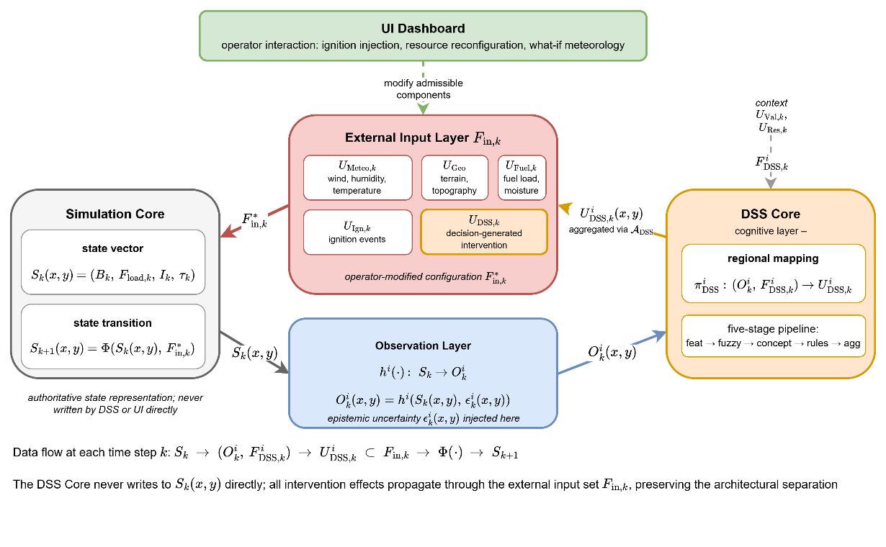
Figure 3.5 DSS–Simulation Core Interface
The Simulation Core maintains the authoritative state vector $S_{k}\left(x,y\right)=\left(B_{k}, F_{load,k}, I_{k}, τ_{k}\right)$ and advances it through the state transition operator $Φ$. The Observation Layer applies the region-specific observation function $h^{i}\left(⋅\right)$ to project the state onto observable information $O_{k}^{i}\left(x,y\right)=h^{i}\left(S_{k}\left(x,y\right), ϵ_{k}^{i}\left(x,y\right)\right)$, injecting the epistemic uncertainty $ϵ_{k}^{i}\left(x,y\right)$ at this stage and at this stage only. The DSS Core executes the regional mapping $π_{DSS}^{i}: \left(O_{k}^{i}, F_{DSS,k}^{i}\right)→U_{DSS,k}^{i}$ on the region-specific observation and the contextual inputs $F_{DSS,k}^{i}=\left(U_{Val,k}, U_{Res,k}\right)$, producing the regional decision field $U_{DSS,k}^{i}\left(x,y\right)$; the detailed five-stage pipeline that realizes this mapping is the subject of Chapter 4. Regional decisions from the $N$ agents are aggregated through the coordination operator $A_{DSS}$ into the global intervention field, which is injected into the External Input Layer $F_{in,k}$ as the $U_{DSS,k}$ component alongside the four exogenous inputs $U_{Meteo,k}$, $U_{Geo}$, $U_{Fuel,k}$, and $U_{Ign,k}$. The UI Dashboard can modify admissible components of $F_{in,k}$ through the interaction operator $Θ_{UI}$, yielding the operator-modified configuration $F_{in,k}^{*}$ that drives the next state transition $S_{k+1}\left(x,y\right)=Φ\left(S_{k}\left(x,y\right), F_{in,k}^{*}\right)$.

DISASTERAWARE DECISION SUPPORT FRAMEWORK
This chapter involves the DisasterAware DSS, the cognitive layer that operates on top of the simulation core. While the simulation core governs the physical evolution of the wildfire state, the DSS interprets the observable part of that state and produces intervention decisions. All equations of the decision layer are developed in this chapter; together they constitute the complete mathematical specification of the decision pipeline.
The pipeline is organized as a four-layer flow from observation to decision. Regional observations are first reduced to bounded features carrying explicit confidence; the features are abstracted into a compact set of decision concepts; decision rules written over the concepts generate a candidate intervention field; and every candidate is evaluated before acceptance or rejection. Reasoning is hierarchically distributed: A Local DSS agent executes this pipeline over the cells of its own region, while a single Global DSS coordinates the regional agents without performing inference of its own. The remainder of this chapter is organized as follows:
Section 4.1 introduces the DSS framework: The four-layer pipeline and its hierarchically distributed organization, the observation interface with the feature and confidence model, and the concept space with the feature–concept hierarchy.
Section 4.2 develops decision generation and coordination: The rule base and the candidate intervention field, the cost and quality measures by which candidates are judged, the staged adaptation mechanism that keeps the decision space open, the local decision with its graduated fail-safe, and the global coordination across regions.
Section 4.3 establishes the explainability and traceability properties of the decision pipeline, together with its governance behavior under degraded observation confidence.

Decision Support System Block Diagram
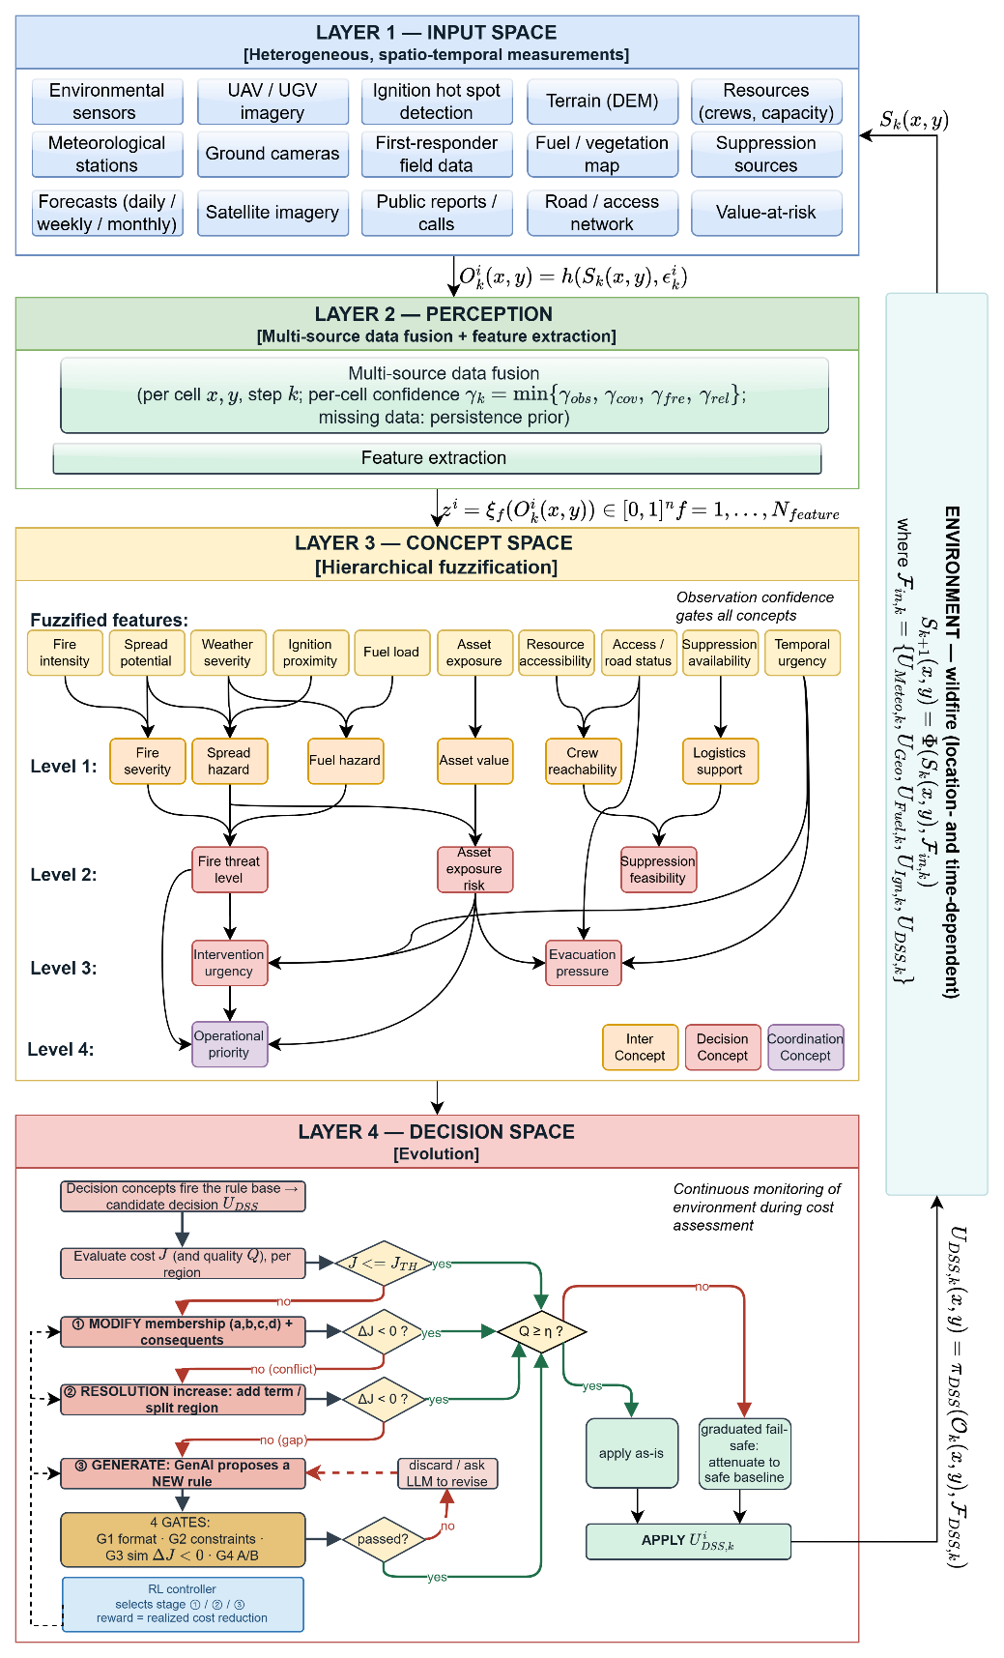
Figure 4.1 DisasterAware system block diagram (DSS focused)
Figure 4.1 presents the complete framework of a Local DSS agent and governs the organization of this section. Unlike Figure 3.1, which emphasizes the simulation-relevant layers, this block diagram focuses on the layers relevant to the DSS. According to this block diagram, the input space (Layer 1) collects heterogeneous, spatio-temporal measurements; the perception layer (Layer 2) fuses them into per-cell features with explicit confidence; the concept space (Layer 3) that abstracts the features into the four-level concept hierarchy; and the decision space (Layer 4) includes rule generate, adaptation reshapes, and evaluation of interventions. The output of the local DSS ( $U_{DSS,k}^{i}$) feeds the simulator core and $S_{k+1}$ is obtained as described in previous chapter. Each layer is specified in the following subsections, in the order in which information traverses them.
In operation, N agents execute this loop concurrently, each restricted to the cells of its own region, while the Global DSS coordinates them by normalizing priorities, allocating the shared resource pool, and enacting cross-region decisions where necessary. The environment band on the right is common to all agents; each agent sees only its own regional projection of it. The cost evaluation of Layer 4 monitors the environment continuously during assessment, so a candidate is always judged against the current situation rather than the one in which it was generated.

Layer 1: Input Space
The input space of the DSS is the heterogeneous collection of spatio-temporal measurements shown at the top of Figure 4.1: Meteorological stations and forecasts, satellite, aerial, and ground imagery, ignition detections, terrain, fuel, road, and value-at-risk layers, and the resource and field reports of the response organization. These sources coincide with the external data layers formalized in Chapter 3 and are therefore not restated here; the single property that matters for the decision layer is that none of them observes the fire state directly, so everything the DSS consumes is a partial, differently refreshed projection of a hidden situation.

Layer 2: Observation, Features, and Confidence
The perception layer turns the raw input space into the quantities on which reasoning operates. Any local agent $i$ receives at step $k$ the region-restricted observation defined in ( 36 ): The region-specific observation function projects the authoritative state onto the cells of region $i$ and injects the epistemic uncertainty at this stage.
The term epistemic denotes that this uncertainty stems from missing knowledge rather than from randomness. A camera may be occluded by smoke, a satellite product may arrive only at revisit intervals of several hours, a road sensor may be offline, and a field report may be delayed or absent; the state is under-observed, not merely noisy. No probability distribution over the error is assumed anywhere in the pipeline, which is why the treatment that follows is a bounded, confidence-driven one rather than a probabilistic one.
$$O_{k}^{i}\left(x,y\right)=h^{i}\left(S_{k}\left(x,y\right), ε_{k}^{i}\left(x,y\right)\right), \left(x,y\right)∈G^{i}$$ | ( 36 )
Every observed cell carries an observation confidence composed from four channel properties: Observability ($γ_{obs}$), coverage ($γ_{cov}$), freshness ($γ_{fre}$), and reliability ($γ_{rel}$) as summarized in Table 4.1.
Table 4.1 Confidence channels: definition, range, and determination
Term | Determination
$$γ_{obs}$$ | Degree to which the underlying quantity is sensible at the cell; set from the sensor model of the channel (occlusion, LoS, product availability).
$$γ_{cov}$$ | Computed per cell from the covering footprints of satellite, aerial, and in-situ assets and averaged over the region.
$$γ_{fre}$$ | Decays exponentially with the age of the most recent report, with a half-life of 90 minutes; one for a report from the current step, decaying toward zero as the report ages.
$$γ_{rel}$$ | Trust assigned to the reporting channel from its characterization; calibrated sensors near one, unproven public reports substantially lower.
The composition is conservative; the confidence equals the weakest channel rather than an average, as stated in ( 37 ). Satellite products realize wide coverage with coarse freshness, aerial platforms high freshness over narrow footprints, in-situ sensors high reliability at fixed points, and field reports contextual observability with variable reliability.
$$γ_{k}^{i}\left(x,y\right)=min⁡\{γ_{obs},γ_{cov},γ_{fre},γ_{rel}\}$$ | ( 37 )
Confidence bounds the disturbance instead of describing it statistically. The observation error magnitude is limited by the complement of the confidence, as expressed in ( 38 ); a fully confident observation is exact, a vanishing confidence admits the worst-case disturbance, and intermediate values degrade gracefully between these poles. Missing observations are bridged by the persistence prior of the concept layer rather than by imputation.
$$|ε_{k}^{i}\left(x,y\right)|≤(1-γ_{k}^{i}\left(x,y\right))⋅ε_{max}$$ | ( 38 )
From the regional observation, the agent computes the ten features of the input space through bounded extraction maps, as in ( 39 ). Each feature inherits a feature-level confidence from the observation fields its extraction map consumes, so the pair of feature value and feature confidence is the complete interface between perception and reasoning.
$$z_{f,k}^{i}=ξ_{f}\left(O_{k}^{i}\right)∈[0,1], f=1,…,N_{feature}$$ | ( 39 )
The ten features are listed in Table 2.1: Fire intensity, spread potential, weather severity, ignition proximity, fuel load, asset exposure, resource accessibility, access and road status, suppression availability, and temporal urgency. Each feature carries established wildfire-science grounding rather than convenience, as documented source by source in the background chapter; by construction the ten features span the threat, exposure, feasibility, and timing dimensions of the operational questions, so no question lacks a supporting feature; and none duplicates information carried by the others, since each is admitted only under the observability, boundedness, operational meaning, and non-redundancy conditions. A larger set would not add discriminative information but would enlarge the antecedent space of every downstream mapping, and the sensitivity analysis of the evaluation chapter confirms empirically that the decision output responds to every feature and is dominated by none. The set is therefore critical, in that removing a feature leaves an operational question unsupported, and sufficient, in that adding one is not justified by any unanswered question.

Layer 3: Concept Space and the Feature–Concept Hierarchy
The concept space exists because rules cannot be written over the features directly. With ten features and five linguistic terms per feature, a flat rule base spans 9.765.625 antecedent combinations, which can neither be elicited from experts nor audited by operators. Figure 4.2 illustrates the solution of this problem by hierarchical conceptualization.
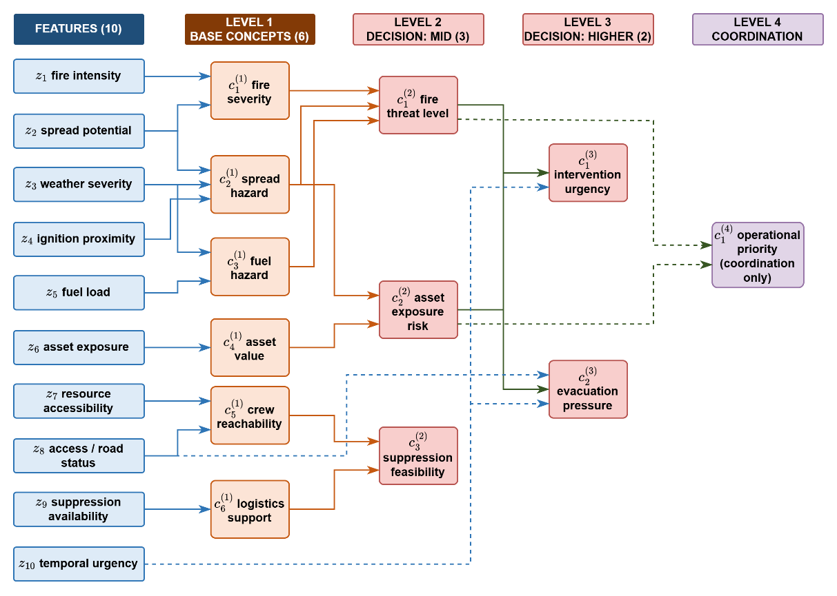
Figure 4.2 Feature-concept hierarchy
The conceptualization layer maps physically related features into six base concepts, the base concepts into three mid-level and two higher-level decision concepts, and finally into the single coordination concept; decision rules are then written over the five decision concepts only, whose antecedent space contains $5^{5}=3.125$ combinations, of which the evolving rule base instantiates only the small subset that observed situations activate.
The recognition-primed decision literature shows that experienced commanders reason over exactly such condensed situation descriptors rather than over raw measurements. The concept set is sufficient for management because the five decision concepts answer the five canonical questions completely and non-redundantly: How severe is the threat, how exposed are the assets, whether an intervention can feasibly be mounted, how urgent action is, and whether evacuation pressure is building as listed in Table 2.2.
The mapping between features and concepts is fully specified by the sets of ( 40 ) Each concept is written in the positional notation c with a lower index for its place within a level and an upper index for its level, so that fire severity, spread hazard, fuel hazard, asset value, crew reachability, and logistics support are the six base concepts of level one, fire threat level, asset exposure risk, and suppression feasibility occupy level two, intervention urgency and evacuation pressure occupy level three, and operational priority is the single concept of level four (Appendix D).
Base Concepts | Decisional Concepts | ( 40 )
$$C_{1}^{(1)}=\left\{z_{1},z_{2}\right\} \\ C_{2}^{(1)}=\left\{z_{2},z_{3},z_{4}\right\} \\ C_{3}^{(1)}=\left\{z_{3},z_{5}\right\}, \\ C_{4}^{(1)}=\left\{z_{6}\right\}, \\ C_{5}^{(1)}=\left\{z_{7},z_{8}\right\}, \\ C_{6}^{(1)}=\left\{z_{9}\right\}$$ | $$C_{1}^{(2)}=\left\{c_{1}^{(1)},c_{2}^{(1)},c_{3}^{(1)}\right\} \\ C_{2}^{(2)}=\left\{c_{2}^{(1)},c_{4}^{(1)}\right\}, \\ C_{3}^{(2)}=\left\{c_{5}^{(1)},c_{6}^{(1)}\right\} \\ C_{1}^{(3)}=\left\{c_{1}^{(2)},c_{2}^{(2)},z_{10}\right\}, \\ C_{2}^{(3)}=\left\{c_{2}^{(2)},1-z_{8},z_{10}\right\} \\ C_{1}^{(4)}=\{c_{1}^{(2)},c_{2}^{(2)}\}$$ | ( 40 )
The activation of a base concept is the weighted sum of the term memberships of the features in its set, and the activation of every higher concept is the weighted sum of the activations of the concepts in its set, with the nonnegative weights of each concept normalized to one ( 41 ).
$$a_{n,k}^{(1),i}=\sum_{f∈Z_{n}}{ω_{n,f}⋅μ_{A_{n,f}}\left(z_{f,k}^{i}\right)} \\ a_{n,k}^{(l),i}=\sum_{m∈C_{n}^{(l)}}{ω_{n,m}^{(l)}⋅a_{m,k}^{(l-1),i}}, l=2,3,4$$ | ( 41 )
In ( 41 ), $a$ denotes a concept activation, with the subscripts giving the concept index $n$ and the step $k$ and the superscripts giving the level $l$ and the region $i$; $ω$ are the nonnegative aggregation weights, normalized to sum to one for each concept; 𝒵 is the index set of the features assigned to a base concept, and 𝒞 the index set of the concepts one level below that feed a higher concept; μ is the term membership of the fuzzified feature introduced in the background chapter; and $z$ is the feature value.
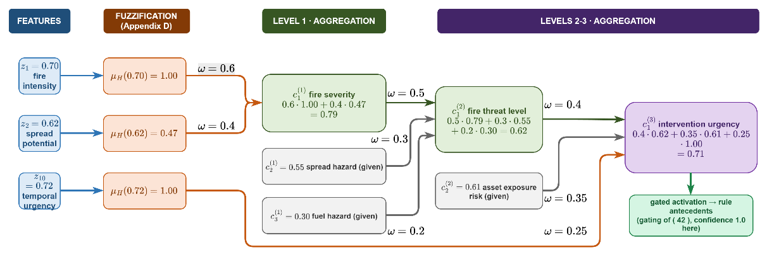
Figure 4.3 Hierarchical concept activation example. Df xzv cxv cxv cxv xcv xcv xcv xcv xcv xcv xcv cxv cx
An example is illustrated in Figure 4.3. At level one, consider fire severity with feature set $\{z_{1}, z_{2}\}$, aggregation weights $0.6$ and $0.4$, and the severity-oriented term high of each feature. A fire intensity reading of $0.70$ lies on the core of high, giving membership 1.00, and a spread potential reading of $0.62$ lies on its lower shoulder, giving membership $0.47$; the aggregation of ( 41 ) therefore yields the activation$0.6 × 1.00 + 0.4 × 0.47=0.79$. Level two repeats the same operation over activations instead of memberships. Fire threat level draws on fire severity, spread hazard, and fuel hazard with weights $0.5$, $0.3$, and $0.2$; with the fire severity of $0.79$ just computed, a spread hazard of $0.55$, and a fuel hazard of $0.30$, the activation is $0.5 ×0.79+ 0.3 ×0.55+ 0.2 ×0.30=0.62$. Intervention urgency draws on fire threat level, asset exposure risk, and the feature temporal urgency with weights $0.4$, $0.35$, and $0.25$; with the $0.62$ just computed, an asset exposure risk of $0.61$, and a temporal urgency reading of $0.72$ whose high membership is $1.00$, the activation is $0.71$. One sensor-level number has now propagated through three levels, and at every step the intermediate value remains readable as an operational statement.
Raw activations are never consumed directly. Every activation is gated by its observation confidence and blended with a persistence-carried prior ( 42 ): A reliable observation passes through essentially unchanged, while an uninformative one falls back to the decayed previous estimate.
$$a_{n,k}^{eff,i}=γ_{n,k}^{i}⋅a_{n,k}^{obs,i}+\left(1-γ_{n,k}^{i}\right)⋅ρ⋅a_{n,k-1}^{eff,i}, \\ γ_{n,k}^{i}=min⁡\{γ_{f,k}^{i}:f∈Z_{n}\}$$ | ( 42 )
In ( 42 ), the superscripts distinguish three activations of the same concept: The observed activation computed through ( 41 ), the persistence prior carried from the previous step, and the effective activation that the decision rules consume. The gate γ is the observation confidence of ( 37 ), composed at concept level as the minimum of the feature confidences feeding the concept, and the decay factor $ρ ∈ [0, 1)$ discounts the previous effective activation, so a concept that ceases to be observed fades over successive steps instead of persisting indefinitely.
In Figure 4.4, the plot (a) shows the effective activation against the confidence for an observed activation of $0.80$, a carried prior of $0.72$, and $ρ = 0.9$: At $γ = 0.9$ the effective value is $0.78$, at $γ = 0.2$ it is $0.68$, and the transition between trust and caution is linear, with no threshold to tune. The plot (b) shows the temporal role of the prior: When observation is lost, the effective activation decays geometrically by $ρ$ per step and snaps back to the observation as soon as confidence returns.
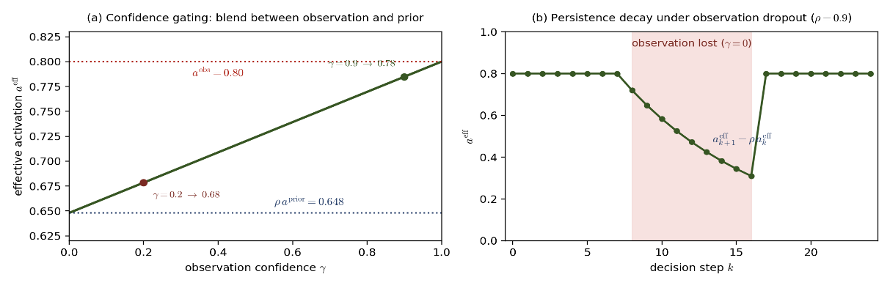
Figure 4.4 Confidence gating: Blend between observation and prior (a) and persistence decay under observation dropout (b)

Layer 4: Decision Generation and Coordination
The decision space is where the gated concept activations listed in Table 2.2 become executable interventions listed in Table 2.3. This layer contains the intervention rule base, the cost and quality measures that judge every candidate, the staged adaptation mechanism that keeps the decision space open, the graduated fail-safe that guarantees an admissible action, and the coordination interface toward the Global DSS as illustrated in Figure 4.5.
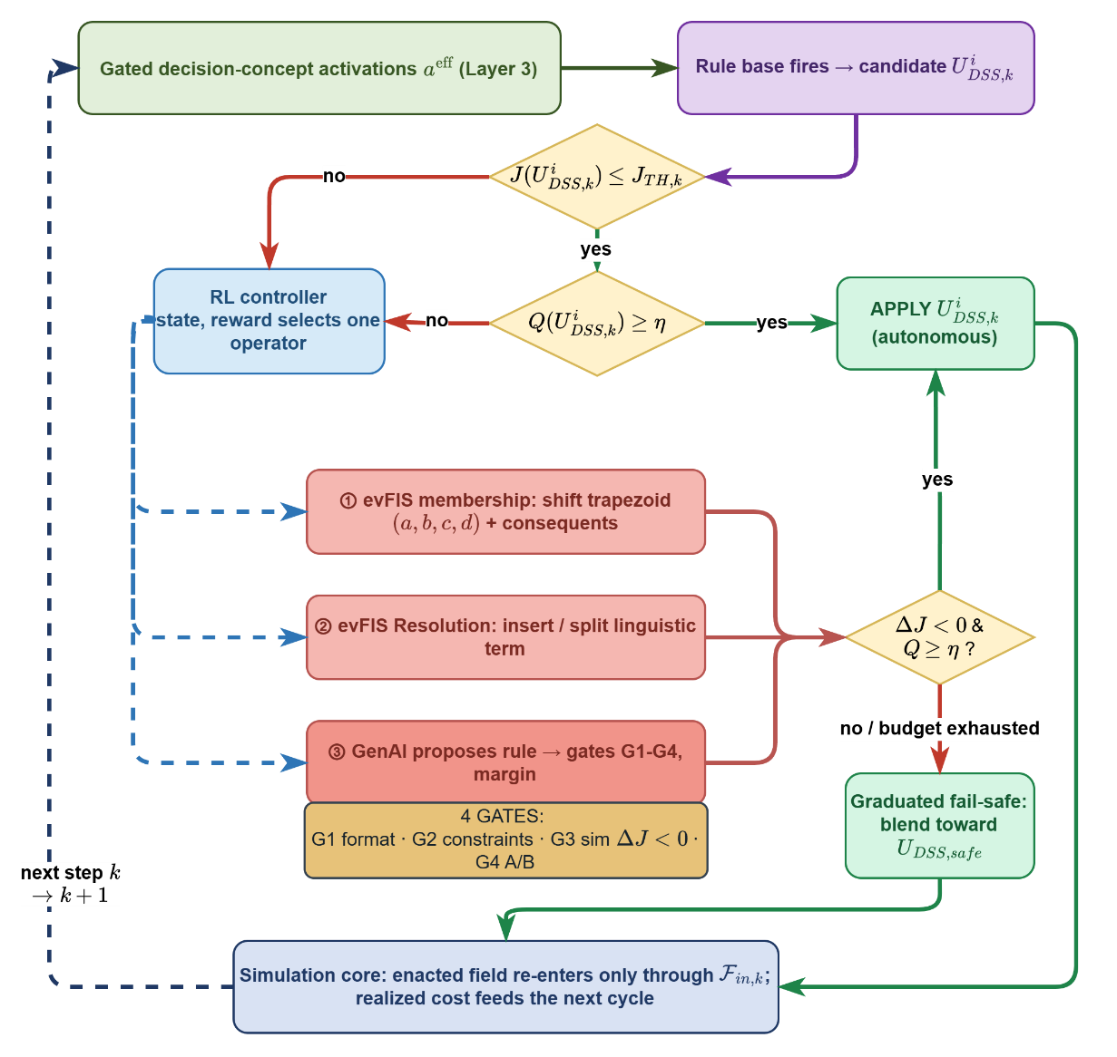
Figure 4.5 Layer 4 decision and adaptation flow
The gated decision-concept activations arriving from the concept space fire the rule base and produce the regional candidate; the candidate meets the cost test and then the quality test, and a candidate that clears both is applied immediately, which is the nominal path that dominates routine operation. A failed test routes the step into the staged adaptation loop, where the reinforcement learning controller invokes membership adjustment, term refinement, or generative proposal, always the cheapest operator its estimates justify; whatever a stage produces re-enters the two tests. The graduated fail-safe reached when no candidate can be made acceptable within the cycle, and every exit of the chart converges on the enactment block, whose output re-enters the simulation core exclusively through the input set. The subsections that follow specify each block of this chart in the order in which a decision traverses them.

Rule Base and Candidate Intervention
Intervention rules are written exclusively over the gated activations of the five decision concepts, in the canonical conjunctive form of ( 43 ). The antecedent terms are the five linguistic labels of the concept partitions, and the consequent assigns intensities of the six intervention types established in the background chapter: Suppression effort, resource deployment, containment line, asset protection, evacuation, and public warning. Because the antecedent space over five concepts with five terms contains 3,125 combinations, and the evolving rule base instantiates only the combinations that observed situations activate, the base remains elicitable and auditable at all times (Appendix E).
$$R_{r}: IF a_{1,k}^{eff,i} is A_{r,1} AND … AND a_{5,k}^{eff,i} is A_{r,5} THEN U_{DSS,k}^{i} is B_{r}$$ | ( 43 )
In ( 43 ), $R_{r}$ denotes rule $r$, the script letters denote the linguistic terms selected by the rule over the effective concept activations, and the consequent is a fuzzy set over the intervention intensities.
The candidate intervention field is obtained by the activation-weighted aggregation of the fired consequents, as in ( 44 ), where $α_{r}$ is the firing strength of rule $r$ computed by the minimum over its antecedent memberships, exactly as in the background chapter, and $g_{r}$ is the consequent intensity profile of rule r over the cells of the region. The result is one candidate field per region and step, denoted $U^{i}$, which becomes the enacted decision only after evaluation.
$$U_{DSS,k}^{i}\left(x,y\right)=\frac{\sum_{r}{α_{r}⋅g_{r}\left(x,y\right)}}{\sum_{r}{α_{r}}}$$ | ( 44 )

Sparse Rule Base and Coverage by Interpolation
The rule base of this framework is deliberately sparse. The $5^{5}=3125$ combinations of the antecedent space form the catalog of expressible conditions, not a list of rules to be authored; the base itself contains only the expert-seeded doctrine and whatever the adaptation mechanism has added. This section states why full enumeration is rejected on principle, and why sparsity loses nothing.
The first reason is physical:.Most points of the catalog correspond to situations that never occur or that contradict the construction of the hierarchy: A very high fire threat cannot coexist with a very low activation of every base hazard that feeds it, and an extreme evacuation pressure without any asset exposure is operationally void. Writing rules for unrealizable regions answers questions nobody can ask, and it destroys the two properties on which the reasoning core rests, since no expert can validate and no operator can audit thousands of rows; this is the elicitation argument formalized around ( 6 ) in Chapter 2.
The second reason is that fuzzy inference covers the space without enumeration. Adjacent terms overlap, so every reading activates at least one term of every concept, several rules fire with partial strengths, and the aggregation of ( 44 ) blends their consequents. The coverage a single rule provides grows exponentially with the concepts it leaves unspecified, as in ( 45 ), where $N_{ant,r}$ is the number of concepts named in the antecedent of rule $r$; a two-antecedent rule alone covers $\min_{a^{eff}∈[0,1]^{5}} \max_{r} α_{r}\left(a^{eff}\right)≥α_{min}>0$ combinations. Overlapping partitions further guarantee that the aggregate firing strength never vanishes, as expressed by the coverage condition ( 46 ), so the candidate of ( 44 ) is defined at every point of the activation space even where no rule matches exactly.
$$N_{cover}\left(R_{r}\right)=N_{term}^{N_{concept}-N_{ant,r}}$$ | ( 45 )
$$min{}_{a^{eff}∈[0,1]^{5}} max{}_{r} α_{r}\left(a^{eff}\right)≥α_{min}>0$$ | ( 46 )
Suppose the fire threat activation reads 0.55, activating the term medium with membership 0.75 and the term high with membership 0.25, and suppose the base contains only two relevant rules, one prescribing suppression effort 0.5 for a medium threat and one prescribing 0.8 for a high threat. No rule addresses the threat value 0.55, yet the aggregation of ( 44 ) yields $u=\frac{0.75⋅0.5+0.25⋅0.8}{0.75+0.25}=0.575$, a proportionate response synthesized from the neighboring rules. Densifying the base around 0.55 would change this outcome only marginally while multiplying the audit burden.
The third reason is architecture. Enumerating all alternatives in advance is precisely the closed decision space criticized as the first structural gap of this thesis; a pre-filled catalog can only be ranked, never extended. The sparse base inverts this: It starts from doctrine, and the staged mechanism of Algorithm 1 adjusts, refines, or generates rules exactly where the field exposes a deficiency, so the base is a living structure rather than a catalog.
The representative rules of Table E.1 in Appendix E document this base, including its adaptation-born members, and the evaluation chapter reports the size of the instantiated active base per scenario, a number that remains orders of magnitude below $5^{5}$ and thereby quantifies how sparingly the open decision space needs to be populated. Table 4.2 lists the comparison.
Table 4.2 Full enumeration versus the sparse evolving base
Property | Full enumeration  (3125 rules) | Sparse evolving base
Authorship | Cannot be elicited from experts; most rows describe unrealizable situations | Expert-seeded doctrine plus adaptation-born rules, each individually validated
Auditability | Thousands of rows, no operator can inspect them | Tens of rules, every one traceable and readable
Coverage | Exhaustive by construction | Complete through overlap and interpolation, guaranteed by ( 46 )
Unvisited regions | Frozen guesses written in advance | Left to interpolation until the field demands a rule there
Novel situations | Cannot be represented; the catalog is closed | Adjusted, refined, or generated on demand through Algorithm 1

Even the figure of $5^{5}=3125$ overstates the burden, because it describes the worst case of a single full-factorial inference over all five decision concepts at once. The additive construction of ( 7 ) operates inside this layer as well: The concept mappings of the hierarchy are blocks over at most $N_{input}$ inputs each, and the decision rules are written with small antecedent arities, so the total burden is a sum of small blocks rather than one product. Instantiated over the wiring of the hierarchy, the mapping blocks contribute at most $5^{2}=25$ combinations for a two-input concept such as fire severity and $5^{3}=125$ for a three-input concept such as spread hazard, fewer than seven hundred mapping combinations across all twelve concepts, and the sparse decision rules of the seed base add tens rather than thousands. The full-factorial figures therefore bound scenarios this architecture never constructs; the operative quantity is the additive sum, and the evolving mechanism keeps even that sum populated only where cost accumulates.

Concept-Intervention Mapping
The rule base binds the five decision concepts to the six intervention types through a designated mapping: Every decision concept has a primary intervention family that answers its operational question, and a set of secondary families it modulates. This mapping is what makes the quality measure computable, since the concordance test of ( 48 ) compares each concept activation with the normalized intensity of exactly its primary family, and it is also the discipline imposed on generated rules, whose consequents must respect the designated families to pass the constraint gate. The mapping is many-to-many by design; an intervention type may serve several concepts, but each concept owns one primary channel through which its demand must be answered.
Table 4.3 Designated mapping between decision concepts and intervention types
Decision concept | Primary intervention | Secondary interventions and modulation role
Fire threat level | Suppression effort | Containment line when direct attack is insufficient; resource deployment scaled with the threat level
Asset exposure risk | Asset protection | Containment line placed to shield exposed assets; evacuation when exposure combines with high threat
Suppression feasibility | Resource deployment | Gatekeeper role: low feasibility shifts intensity away from suppression effort toward containment line and evacuation rather than commanding a channel of its own
Intervention urgency | Resource deployment (tempo and preemption) | Scales the intensities of all active families; triggers cross-region priority preemption at very high activation
Evacuation pressure | Evacuation | Public warning raised jointly; offensive intensities withdrawn at very high activation
Two consequences of the mapping deserve statement. First, the quality measure acquires an unambiguous reading: The normalized response intensity of concept n in ( 48 ) is the intensity of its primary family, with the gatekeeper concept evaluated on the redistribution it commands rather than on a channel of its own. Second, the complete seed rule base of Appendix E is organized along exactly these ownership lines, so every rule can be traced to the concept whose demand it answers, and a generated rule that assigns an intervention outside the designated families of its antecedent concepts is rejected at the constraint gate before simulation is ever consulted.

Cost and Quality Evaluation
Every candidate is judged by two complementary measures. The cost measures what the candidate is expected to cost the incident: It is the weighted five-term sum established in the background chapter, evaluated regionally over the forecast horizon, and a candidate is cost-acceptable when it clears the satisficing threshold, as in ( 47 ). The threshold is the adaptive acceptance bound of the framework; it inherits its reference envelope construction and its default fraction from the background chapter and tightens as observation confidence and available capacity rise.
$$J^{i}\left(U_{DSS,k}^{i}\right)=\sum_{j}{w_{j}⋅J_{j}\left(U_{DSS,k}^{i}\right)}, accept ⇔ J^{i}\left(U_{DSS,k}^{i}\right)≤J_{TH,k}$$ | ( 47 )
The quality measures something the cost cannot: Whether the candidate serves the concepts that demanded it. It compares, per decision concept, the effective activation with the normalized intensity of the intervention family that answers that concept, as in ( 48 ); a candidate that suppresses heavily while fire threat is low, or that ignores a high evacuation pressure, is penalized even if its cost is acceptable. In ( 48 ), u denotes the normalized response intensity assigned to concept n by the candidate, the sum runs over the five decision concepts, and η is the quality threshold. Cost gates admission; quality triggers adaptation: A candidate with acceptable cost but deficient quality signals that the rule base no longer matches the situation, which is precisely the condition under which the staged adaptation of the next subsection is invoked.
The two acceptance tests appear as the two decision diamonds of Figure 4.5.
$$Q^{i}\left(U_{DSS,k}^{i}\right)=1-\frac{1}{5}\sum_{n∈dec}{|a_{n,k}^{eff,i}-u_{n,k}^{i}|, accept ⇔ Q^{i}\left(U_{DSS,k}^{i}\right)≥η}$$ | ( 48 )

Open Decision Space: Staged Adaptation
Adaptation is organized as three operators of strictly increasing invasiveness, invoked only when the quality test of ( 48 ) fails or the cost of ( 47 ) cannot be met, and always evaluated against the same cost that judges decisions.
A rule must change when the situation it was written for drifts away from the situation in the field. Three symptoms trigger adaptation, all of them measurable inside the layer: The accepted candidates stop clearing the cost threshold of ( 47 ); the quality of ( 48 ) falls below its threshold, meaning the interventions no longer match the concept activations that demanded them; or a residual cost persists over consecutive steps although every fired rule behaves as designed. The first two symptoms are per-step signals, the third is a windowed one, and together they define the entry condition of the staged mechanism.
The mechanism is best seen on one concrete pass throughFigure 4.5. Suppose the fire threat activation reads 0.62 and the rule IF fire threat is high THEN suppression effort is high fires with strength 0.47, because 0.62 sits on the lower shoulder of the term high. The aggregated candidate applies suppression at intensity 0.47 while evacuation pressure stands at 0.80; the cost of ( 47 ) passes, but the quality of ( 48 ) evaluates to 0.55, below a threshold of 0.70, so the candidate is not applied and adaptation is invoked. The first operator shifts the lower shoulder of high from 0.55 toward 0.50 by one bounded step of ( 49 ); the membership of the reading 0.62 rises from 0.47 to 0.60, the rule fires more strongly, the re-aggregated candidate raises suppression and its simulated cost decreases, so the modification is kept. Had two operationally distinct readings, say 0.58 and 0.78, activated the same term so that no shoulder position served both, the second operator would instead split high at 0.68 into high and very high and duplicate the affected rules over the refined partition. Only if neither operation removes the residual cost does the third operator ask the generative model for a rule that does not exist yet, for example one that couples high evacuation pressure with low access status to an early evacuation order, and that proposal enters the field only through the four gates and the margin of ( 50 ).
At every point of this pass the reinforcement learning controller is the component that chooses the operator. It reads the state of ( 51 ), estimates which operator will buy the largest cost reduction at the smallest structural growth under the reward of ( 52 ), and invokes exactly that operator; escalation to generation is therefore not a fixed schedule but a learned last resort.
The first operator is the evolving fuzzy adjustment. It perturbs the trapezoidal membership parameters of the terms involved in the deficient rules and the Takagi-Sugeno consequent coefficients, using a derivative-free local search: A bounded perturbation step is applied in the direction that reduced cost in the recent window, the modified base is evaluated in simulation, and the modification is kept only if the realized cost decreases, as stated in ( 49 ). In ( 49 ), θ ranges over the four trapezoid parameters of the affected terms and the consequent coefficients, δ_θ is the bounded step size, and e_k is the sign of the most recent cost-reducing direction. No gradient is required, which matters because the cost is evaluated through the simulation core and is not differentiable.
$$θ^{new}=θ^{old}+δ_{θ}⋅e_{k}, θ∈\{a,b,c,d\}∪\{g_{r}\}, accepted ⇔ ΔJ<0$$ | ( 49 )
The second operator increases resolution. When parameter adjustment stalls because two operationally distinct situations activate the same term, the term set of the responsible concept is refined: A term is inserted where the residual cost concentrates, or an existing term is split, and the affected rules are duplicated over the refined partition. This enlarges the expressible decision space without inventing new knowledge; the rules still say what they said, but over a finer vocabulary.
The third operator is generative. When adjustment and refinement are both exhausted while a persistent cost remains, a large language model is prompted with the current situation summary, the active rule base, and the residual cost pattern, and it proposes a candidate rule in the canonical form of ( 43 ). The proposal is untrusted by construction and must pass four gates in sequence: G1 checks syntactic form against ( 43 ); G2 checks constraint compliance, namely intensity bounds, resource limits, and the life-safety ceiling; G3 requires a simulated cost improvement over the current base; and G4 subjects the surviving proposal to an A/B evaluation against the incumbent base over perturbed replays. Only then is the rule admitted, under the margin condition of ( 50 ), which restates the admission condition of the background chapter; a rejected proposal is either discarded or returned to the model with the failing gate as feedback, within a bounded revision budget whose exhaustion routes the step to the fail-safe.
$$R_{r'} admitted ⇔ J_{R∪\{r'\}}≤J_{R}-δ, δ≥0, after G1∧G2∧G3∧G4$$ | ( 50 )
A reinforcement learning controller decides which operator to invoke. Its state, given in ( 51 ), collects what adaptation can legitimately observe: The recent cost trajectory over a window of W steps, the rule count, the mean firing strength of the active rules, the mean observation confidence, and the current quality score. Its action set contains four elements, namely the three operators and the null action. Its reward, given in ( 52 ), is the realized cost reduction penalized by structural growth, with κ the complexity penalty weight; the controller is therefore paid for improvements that the field confirms and charged for every rule it adds. The controller is trained with standard temporal-difference updates and, in operation, selects the cheapest operator that its value estimates predict will reduce cost, which reproduces the escalation discipline as learned rather than hard-coded behavior.
$$s_{k}^{RL}=[ΔJ{}_{k-W:k}, |R|, \bar{α}, \bar{γ}, Q^{i}\left(U_{DSS,k}^{i}\right)]$$ | ( 51 )
$$r_{k}=J_{k-1}-J_{k}-κ⋅Δ|R|$$ | ( 52 )
The complete control flow is summarized in Algorithm 1. The nominal path exits at the second line; the adaptation path escalates through the operators under the RL controller; and every exit applies an admissible action, either an accepted candidate or the fail-safe blend, so the procedure terminates within the decision cycle by construction.
Algorithm 1 Staged adaptation with satisficing acceptance and fail-safe
Input: gated activations a_eff, rule base R, thresholds J_TH,k and η, revision budget B
1: U ← aggregate fired rules of R via ( 44 )
2: if J(U) ≤ J_TH,k and Q(U) ≥ η then apply U; return
3: for stage in [① adjust ( 49 ), ② refine, ③ generate] selected by RL state ( 51 ):
4: U ← re-evaluate candidate after stage; if ΔJ < 0 and Q(U) ≥ η then apply U; return
5: if stage = ③: repeat proposal ≤ B times through gates G1–G4 and ( 50 )
6: apply graduated fail-safe blend toward U_DSS,safe; return

Local Decision and Graduated Fail-Safe
The Local DSS enacts the first candidate that clears both tests of ( 47 ) and ( 48 ). When Algorithm 1 exhausts its operators without producing such a candidate, the decision is not withheld; it is attenuated. The enacted field is the convex blend of the best available candidate with the pre-authorized safe posture, as in ( 53 ), where the attenuation weight is set by the weaker of the mean observation confidence and the achieved quality. Under the safe posture, monitoring and public warning remain active, deployed units hold their positions, and no new offensive commitment is made; full intensity returns continuously as confidence and quality recover. Enactment is autonomous: No clearance from the coordinator is required for a decision confined to the cells of the region.
The fail-safe corresponds to the right-hand branch of Figure 4.5, and the enactment block that all paths reach closes the chart.
$${U_{DSS,k}^{i}}^{'}=λ_{k}⋅U_{DSS,k}^{i}+\left(1-λ_{k}\right)⋅U_{DSS,safe}, λ_{k}=min⁡\{\bar{γ}, Q^{i}\left(U_{DSS,k}^{i}\right)\}$$ | ( 53 )

Global Coordination
The Global DSS closes the loop across regions without performing inference. Each Local DSS reports its operational priority activation, its resource request, and its confidence summary; the coordinator normalizes the priorities into allocation shares and distributes the shared capacity accordingly, as in ( 54 ), where p is the normalized priority of region i, the sum runs over the N regions, A is the capacity allocated to region i, and C_total is the total deployable capacity of the resource pool. Conflicting requests are resolved by the same shares: When two regions demand the same unit, the higher share prevails and the loser receives the nearest equivalent capacity or a deferred slot.
$$p_{k}^{i}=\frac{a_{1,k}^{(4),i}}{\sum_{j}{a_{1,k}^{(4),j}}}, A_{k}^{i}=p_{k}^{i}⋅C_{total}$$ | ( 54 )
Coordination also carries the two global enactment channels shown in Figure 4.1. The coordinator may reassign capacity across regions, which reaches the field as a change of the resource layers, and it may tighten the acceptance thresholds or override a regional commitment when cross-region priorities demand it. Both channels obey the discipline of every other decision in the framework: They are priced by the cost model, they are recorded in the explanation trail, and they re-enter the simulation exclusively through the input set. The aggregation of the regional fields into the global intervention field completes the step, and the next observation begins the cycle again.

Explainability and Traceability

SIMULATION AND PERFORMANCE RESULTS

CONCLUSION AND FUTURE WORKS

Conclusions

Future Works

REFERENCES

Abdul, A., Vermeulen, J., Wang, D., Lim, B., & Kankanhalli, M. (2018). Trends and trajectories for explainable, accountable and intelligible systems: An HCI research agenda. CHI Conference on Human Factors in Computing Systems (pp. 1-18). ACM. doi:10.1145/3173574.3174156
Ager, A., Vaillant, N., & Finney, M. (2010). A comparison of landscape fuel treatment strategies to mitigate wildland fire risk in the urban interface and preserve old forest structure. Forest Ecology and Management, 259(8), pp. 1556-1570. doi:10.1016/j.foreco.2010.01.032
Amodei, D., Olah, C., Steinhardt, J., Christiano, P., Schulman, J., & Mané, D. (2016). Concrete problems in AI safety.
Anderson, H. E. (1982). Aids to Determining Fuel Models for Estimating Fire Behavior. USDA Forest Service, General Technical Report INT-122.
Andrews, P. L. (2018). The Rothermel surface fire spread model and associated developments: A comprehensive explanation. USDA Forest Service, Rocky Mountain Res. Stn., Fort Collins, CO, USA.
Angelov, P. P., & Filev, D. P. (2004). An approach to online identification of Takagi-Sugeno fuzzy models. IEEE Transactions on Systems, Man, and Cybernetics, Part B, 34(1), 484-498.
Anthony, R. (1965). Planning and control systems: A framework for analysis. Harvard University Press.
Arnott, D., & Pervan, G. (2005). A critical analysis of decision support systems research. Journal of Information Technology, 20(2), 67-87. doi:10.1057/palgrave.jit.2000035
Bellman, R., & Zadeh, L. (1970). Decision-making in a fuzzy environment. Management Science, 17(4), B141-B164. doi:10.1287/mnsc.17.4.B141
Bowman, D. M., Kolden, C. A., Abatzoglou, J. T., Johnston, F. H., van der Werf, G. R., & Flannigan, M. (2020). Vegetation fires in the Anthropocene. Nature Reviews Earth & Environment, 1(10), 500-515. doi:10.1038/s43017-020-0085-3
Calkin, D., O'Connor, C., Thompson, M., & Stratton, R. (2021). Strategic wildfire response decision support and the risk management assistance program. Forests, 12(10), p. 1407. doi:10.3390/f12101407
Chandra, R., Kumar, S. S., Patra, R., & Agarwal, S. (2025). Decision support system for forest fire management using ontology with big data and LLMs. Cluster Computing, 28, 548.
Chen, S., & Hwang, C. (1992). Fuzzy multiple attribute decision making: Methods and applications. Springer. doi:10.1007/978-3-642-46768-4
Chen, Y., Li, L., Ma, Z., Hu, Q., Zhu, Y., Deng, M., & Yu, R. (2025). Empowering LLM agents with geospatial awareness: Toward grounded reasoning for wildfire response. arXiv:2510.12061.
Comes, T. (2016). Cognitive biases in humanitarian sensemaking and decisionmaking. 2016 IEEE International Multi-Disciplinary Conference on Cognitive Methods in Situation Awareness and Decision Support (CogSIMA), (pp. 56-62).
Comes, T., Hiete, M., Wijngaards, N., & Schultmann, F. (2011). Decision maps: A framework for multi-criteria decision support under severe uncertainty. Decision Support Systems, 52(1), 108-118. doi:10.1016/j.dss.2011.05.008
Comfort, L., Boin, A., & Demchak, C. (2010). Designing Resilience: Preparing for Extreme Events. University of Pittsburgh Press.
CRED/UCLouvain. (2023). EM-DAT: The International Disaster Database. Retrieved from https://www.emdat.be
Duarte, V., Teodoro, A., Gonçalves, J., Soares, D., & Cunha, M. (2022). Wildfire risk mapping using GIS and fuzzy logic: Application to northwest Iberian Peninsula. Remote Sensing, 14(15), p. 3793. doi:10.3390/rs14153793
Dunn, C., Calkin, D., & Thompson, M. (2017). Towards enhanced risk management: Planning, decision making and monitoring of US wildfire response. International Journal of Wildland Fire, 26(7), pp. 615-625. doi:10.1071/WF16223
Endsley, M. R. (1995). Toward a Theory of Situation Awareness. Human Factors, 37(1), 32-64. doi:10.1518/001872095779049543
Endsley, M. R. (2015). Situation awareness misconceptions and misunderstandings. Journal of Cognitive Engineering and Decision Making, 9(1), 4-32. doi:10.1177/1555343415572631
Figueiredo, J., Macedo, J., Alves, J., & Figueiredo, A. (2024). Wildfire management decision support system for real-time fire behavior and weather analysis. Forests, 15(3), p. 509. doi:10.3390/f15030509
Fillmore, S., & Paveglio, T. (2023). Use of the Wildland Fire Decision Support System (WFDSS) for full suppression and managed fires within the Southwestern Region of the US Forest Service. International Journal of Wildland Fire, 32(4), pp. 562-574. doi:10.1071/WF22106
Finney, M. (2006). An overview of FlamMap fire modeling capabilities. Fuels Management — How to Measure Success: Conference Proceedings (pp. 213-220). USDA Forest Service, Rocky Mountain Research Station.
French, S., Maule, J., & Papamichail, N. (2019). Decision Behaviour, Analysis and Support (2 ed.). Cambridge University Press.
Gigerenzer, G., & Selten, R. (Eds.). (2001). Bounded rationality: The adaptive toolbox. Cambridge, MA: MIT Press.
Gorry, G., & Scott Morton, M. (1971). A framework for management information systems. Sloan Management Review, 13(1), 55-70.
Guidotti, R., Monreale, A., Ruggieri, S., Turini, F., Giannotti, F., & Pedreschi, D. (2018). A Survey of Methods for Explaining Black Box Models. ACM Computing Surveys, 51(5), 1-42. doi:10.1145/3236009
Hwang, C., & Yoon, K. (1981). Multiple attribute decision making: Methods and applications. Springer. doi:10.1007/978-3-642-48318-9
Jain, P., Coogan, S. C., Subramanian, S. G., Crowley, M., Taylor, S., & Flannigan, M. D. (2020). A review of machine learning applications in wildfire science and management. Environmental Reviews, 28(4), 478-505. doi:10.1139/er-2020-0019
Keeney, R., & Raiffa, H. (1976). Decisions with multiple objectives: preferences and value trade-offs. Wiley.
Klein, G. A. (2017). Sources of Power: How People Make Decisions. MIT Press.
Kyzirakos, K., Karpathiotakis, M., Garbis, G., Nikolaou, C., Bereta, K., Papoutsis, I., . . . Simantiris, N. (2012). Wildfire monitoring using satellite images, ontologies and linked geospatial data. Journal of Web Semantics, 16-32.
Lughofer, E. (2011). Evolving Fuzzy Systems: Methodologies, Advanced Concepts and Applications. Berlin, Germany: Springer.
Malczewski, J. (1999). GIS and multicriteria decision analysis. John wiley & sons.
Mamdani, E. H. (1974). Application of fuzzy algorithms for control of simple dynamic plant. Proceedings of the Institution of Electrical Engineers, 121(12), 1585-1588. doi:10.1049/piee.1974.0328
Marakas, G. M., & O'Brien, J. A. (2013). Introduction to information systems. McGraw-Hill.
Martell, D. L. (2007). Forest fire management. Handbook of operations research in natural resources (pp. 489-509). Boston: MA: Springer US.
McNeese, N. J., Schelble, B. G., Canonico, L. B., & Demir, M. (2021). Who or what is my teammate? Team composition considerations in human–AI teaming. Human Factors, 63(3), 474-488. doi:10.1177/0018720820968694
Mendel, J. (2017). Uncertain rule-based fuzzy systems. Springer.
Mohammadi, M., Alesheikh, A., & Alimohammadi, A. (2025). Bridging spatiotemporal wildfire prediction and decision modeling using transformer networks and fuzzy inference systems. Applied Sciences, 15, p. 7542. doi:10.3390/app15137542
Morgan, M., & Henrion, M. (1990). Uncertainty: A Guide to Dealing with Uncertainty in Quantitative Risk and Policy Analysis. Cambridge university press.
Noonan-Wright, E., Opperman, T., Finney, M., Zimmerman, G., Seli, R., Elenz, L., . . . Fiedler, J. (2011). Developing the US wildland fire decision support system. Journal of Combustion, 2011, p. 168473. doi:10.1155/2011/168473
Oliveira, T., Barros, A., Ager, A., & Fernandes, P. (2022). Wildfire spread and resource allocation: Using spatially explicit models to address operational decision-making. Forest Ecology and Management, 506, p. 119952. doi:10.1016/j.foreco.2021.119952
Orphanoudakis, T., Betzelos, C., & Leligou, H. (2025). MORA: A multicriteria optimal resource allocation and decision support toolkit for wildfire management. Algorithms, 18(11), p. 677. doi:10.3390/a18110677
Pacheco, A. (2015). Cohesive Fire Management within an Uncertain Environment: A Review of Risk Handling and Decision Support Systems. Forest Ecology and Management, 347, 1-17. doi:10.1016/j.foreco.2015.02.033
Pais, C., Carrasco, J., Moudio, P., & Shen, Z.-J. (2021). Downstream protection value: Detecting critical zones for effective fuel-treatment under wildfire risk. Computers, Environment and Urban Systems, 90, p. 101703. doi:10.1016/j.compenvurbsys.2021.101703
Papadimitriou, C. H., & Tsitsiklis, J. N. (1987). The complexity of Markov decision processes. Mathematics of Operations Research, 12(3), 441-450.
Pearl, J. (1988). Probabilistic Reasoning in Intelligent Systems: Networks of Plausible Inference. Morgan Kaufmann. doi:10.1016/C2009-0-27609-4
Pedrycz, W. (1993). Fuzzy Control and Fuzzy Systems. Wiley.
Power. (2002). Decision support systems: Concepts and resources for managers. Quorum Books.
Power. (2007). A Brief History of Decision Support Systems. Retrieved from http://dssresources.com/history/dsshistory.html
Power, D. J., & Heavin, C. (2017). Decision Support, Analytics, and Business Intelligence (2 ed.). Business Expert Press.
Rapp, C., Rabung, E., Wilson, R., & Toman, E. (2020). Wildfire decision support tools: An exploratory study of use in the United States. International Journal of Wildland Fire, 29(7), pp. 581-594. doi:10.1071/WF19131
Ribeiro, M. T., Singh, S., & Guestrin, C. (2016). Why Should I Trust You? ACM SIGKDD Conference (pp. 1135–1144). ACM. doi:10.1145/2939672.2939778
Ross, K. G., Shafer, J. L., & Klein, G. (2006). Professional Judgments and Naturalistic Decision Making. In The Cambridge Handbook of Expertise and Expert Performance (pp. 403-420). Cambridge: Cambridge University Press.
Rothermel, R. C. (1972). A mathematical model for predicting fire spread in wildland fuels. Intermountain Forest & Range Experiment Station, Forest Service, US Department of Agriculture.
Saaty, T. (1980). The analytic hierarchy process: Planning, priority setting, resource allocation. McGraw-Hill.
Sanneman, L., & Shah, J. (2020). Explaining reward functions to humans for better human-robot collaboration. arXiv preprint arXiv:2006.10548. Retrieved from https://arxiv.org/abs/2006.10548
Schultz, C., Miller, L., Greiner, S., & Kooistra, C. (2021). A qualitative study on the US Forest Service's risk management assistance efforts to improve wildfire decision-making. Forests, 12(3), p. 344. doi:10.3390/f12030344
Scott, J. H., & Burgan, R. E. (2005). Standard fire behavior fuel models: A comprehensive set for use with Rothermel’s surface fire spread model. USDA Forest Service, Rocky Mountain Res. Stn., Fort Collins, CO, USA.
Seshia, S. A., Sadigh, D., & Sastry, S. S. (2022). Toward verified artificial intelligence. Communications of the ACM, 65(7), 46-55.
Shafer, G. (1976). A Mathematical Theory of Evidence. Princeton University Press.
Sharda, R., Delen, D., & Turban, E. (2018). Business Intelligence, Analytics, and Data Science: A Managerial Perspective. Pearson.
Shim, J. P., Warkentin, M., Courtney, J. F., Power, D. J., Sharda, R., & Carlsson, C. (2002). Past, present, and future of decision support technology. Decision support systems, 33(2), 111-126. doi:10.1016/S0167-9236(01)00139-7
Simon, H. (1960). The New Science of Management Decision. Englewood Cliffs: Prentice Hall.
Simon, H. (1996). The Sciences of the Artificial. Cambridge: MIT Press.
Simon, H. A. (1956). Rational choice and the structure of the environment. Psychological Review, 63(2), 129-138.
Soualah, L. (2024). Forecasting forest fire risk in Algeria using fuzzy logic and GIS. Trees, Forests and People, 17, 100614. doi:10.1016/j.tfp.2024.100614
Sprague, R. H., & Carlson, E. D. (1982). Building Effective Decision Support Systems. Englewood Cliffs: Prentice Hall.
Sugumaran, R., & Degroote, J. (2010). Spatial decision support systems: principles and practices. Crc Press.
Sullivan, A. L. (2009a). Wildland surface fire spread modelling 1: Physical and quasi-physical models. International Journal of Wildland Fire, 18(4), 349-368.
Sullivan, A. L. (2009b). Wildland surface fire spread modelling 2: Empirical and quasi-empirical models. International Journal of Wildland Fire, 18(4), 369-386.
Sullivan, A. L. (2009c). Wildland surface fire spread modelling 3: Simulation and mathematical analogue models. International Journal of Wildland Fire, 18(4), 387-403.
Sutton, R. S., & Barto, A. G. (2018). Reinforcement Learning: An Introduction (2nd ed.). Cambridge, MA, USA: MIT Press.
Sycara, K. (1998). Multiagent systems. AI Magazine, 19(2), 79-92. doi:10.1609/aimag.v19i2.1370
Takagi, T., & Sugeno, M. (1985). Fuzzy identification of systems and its applications to modeling and control. IEEE Transactions on Systems, Man, and Cybernetics, 15(1), 116-132. doi:10.1109/TSMC.1985.6313399
Thompson, M. P., & Calkin, D. E. (2011). Uncertainty and risk in wildland fire management. Journal of Environmental Management, 92(8), 1895-1909. doi:10.1016/j.jenvman.2011.03.015
Triantaphyllou, E. (2000). Multi-criteria decision making methods: A comparative study. Springer. doi:10.1007/978-1-4757-3157-6
Turban, E. (2011). Decision support and business intelligence systems (9 ed.). Upper Saddle River: Pearson Education.
Turoff, M. C. (2004). The design of a dynamic emergency response management information system (DERMIS). Journal of Information Technology Theory and Application (JITTA), 5(4), 3.
Tversky, A., & Kahneman, D. (1974). Judgment under uncertainty: Heuristics and biases. Science, 185(4157), 1124-1131. doi:10.1126/science.185.4157.1124
UNEP. (2022). Spreading like Wildfire: The Rising Threat of Extraordinary Landscape Fires. Geneva: United Nations Environment Programme (UNEP). Retrieved from https://www.unep.org/resources/report/spreading-wildfire
Vásquez, F. (2021). Decision support system development of wildland fire. Forests, 12(7), 943. doi:10.3390/f12070943
Walker, W., Harremoes, P., Rotmans, J., Van der Sluijs, J., Van Asselt, M., Janssen, P., & Krayer von Krauss, M. (2003). Defining uncertainty: a conceptual basis for uncertainty management in model-based decision support. Integrated Assessment, 4(1), 5-17.
Wooldridge, M. (2009). An introduction to multiagent systems (2 ed.). Wiley.
Xie, Y., Jiang, B., Mallick, T., Bergerson, J. D., Hutchison, J. K., & Verner, D. R. (2024). WildfireGPT: Tailored large language model for wildfire analysis. arXiv:2402.07877.
Xu, Z. (2015). Uncertain multi-attribute decision making: Methods and applications. Springer. doi:10.1007/978-3-662-45640-8
Zadeh, L. A. (1965). Fuzzy sets. Information and Control, 8(3), 338-353. doi:10.1016/S0019-9958(65)90241-X
Zadeh, L. A. (1986). A simple view of the Dempster–Shafer theory of evidence and its implication for the rule of combination. AI Magazine, 7(2), 85-90. doi:doi:10.1609/aimag.v7i2.542
Zavadskas, E., & Turskis, Z. (2011). Multiple criteria decision making (MCDM) methods in economics: An overview. Technological and Economic Development of Economy, 17(2), 397-427. doi:10.3846/20294913.2011.593291

APPENDICES
- Simulation Mathematics for Evolution of Burning Status
This appendix provides the formulations underlying the simulation in Chapter 3. The rate of spread $R_{spread,k}\left(x,y\right)$ is the forward propagation of wildfire at grid cell $\left(x,y\right)$ and time step $k$. It is computed internally within the hybrid fire spread model using meteorological forcing, terrain properties, fuel characteristics, and fuel moisture. The spread formulation is not intended to reproduce physical wildfire propagation in metric units. It provides a grid-consistent, DSS-oriented abstraction inspired by semi-empirical wildfire behavior models.
The formulation adopted in this work is a semi-empirical, Rothermel-like mapping designed to preserve structural interpretability (i.e., the output $R_{spread,k}$ is expressed in normalized cells-per-step rather than in metric units) while remaining computationally stable and easily calibratable for DSS simulation purposes (Rothermel, 1972). The rate of spread $R_{spread,k}\left(x,y\right)$ is calculated by $f_{ros}$ ( 28 ). Each multiplicative component of the rate-of-spread function $f_{ros}$ corresponds directly to a physically interpretable effect and is tied to an already-defined state or input variable ( 55 ). All terms are evaluated at $\left(x,y\right)$ and time $k$.
$$R_{spread,k} \left(x,y\right)=r_{base} \left(F_{type}\left(x,y\right)\right)×g_{moist}\left(x,y\right)×g_{wind}\left(x,y\right)×g_{slope}\left(x,y\right)× g_{aspect}\left(x,y\right)$$ | ( 55 )
Fuel-Type Base Spread Rate $r_{base} \left(∙\right)$ defines the baseline spread potential of each fuel class under nominal environmental conditions. It is calibrated in units of cell per simulation step. Moisture damping factor $g_{moist}$ is ( 56 ) where $F_{moist,k}\left(x,y\right)$ is surface fuel moisture fraction and $m_{ext}\left(F_{type}\right)$ is extinction moisture threshold for the given fuel type
$$g_{moist}\left(x,y\right)=\max\left(0,1-\frac{F_{moist,k}\left(x,y\right)}{m_{ext}\left(F_{type}\left(x,y\right)\right)}\right)$$ | ( 56 )
If fuel moisture equals the extinction threshold, spread is suppressed ( 57 ). The damping structure is selected for stability and interpretability; it prevents negative spread rates and ensures bounded behavior.
$$F_{moist,k}≥m_{ext}⇒g_{moist}=0$$ | ( 57 )
Wind amplification factor $g_{wind}$ is ( 58 ) where $W_{ws,k}\left(x,y\right)$ is the wind speed, $a_{w}\left(F_{type}\right)$ is a wind sensitivity coefficient and $w_{0}$ is a scaling constant.. This factor models the acceleration of fire spread due to wind speed. The hyperbolic tangent ensures that spread increases with wind speed but does not grow unbounded for extreme winds. The use of $\tanh\left(⋅\right)$guarantees numerical stability. The wind scaling constant $w_{0}$ controls the saturation behavior of wind amplification. A value of 10 m/s is selected to reflect moderate-to-strong wind regimes while preserving numerical stability.
$$g_{wind}(x,y)=1+a_{w}(F_{type}(x,y))⋅tanh\left(\frac{W_{ws,k}\left(x,y\right)}{w_{0}}\right)$$ | ( 58 )
Slope acceleration term $g_{slope}$ is ( 59 ) where $G_{slope}\left(x,y\right)$ is terrain slope (radians) and $a_{s}\left(F_{type}\right)$ is slope sensitivity. Spread accelerates in uphill directions. Fire spreads faster uphill due to flame preheating of fuels. The tangent function reflects nonlinear growth with increasing slope angle.
$$g_{slope}\left(x,y\right)=1+a_{s}\left(F_{type}\left(x,y\right)\right)⋅\tan\left(G_{slope}\left(x,y\right)\right)$$ | ( 59 )
Aspect–wind orientation term $g_{aspect}$ is ( 60 ) where $G_{aspect}\left(x,y\right)$ is terrain orientation angle, $W_{wd,k}\left(x,y\right)$ is wind direction field, $a_{asp}\left(F_{type}\right)$ is aspect coefficient. This term captures interaction between terrain orientation and wind direction. If wind direction aligns with terrain orientation, $\cos\left(⋅\right)≈1$ and spread increases. If wind opposes terrain orientation, $\cos\left(⋅\right)<0$ and spread decreases.
$$g_{aspect}\left(x,y\right)=1+a_{asp}\left(F_{type}\left(x,y\right)\right)∙\cos\left(G_{aspect}\left(x,y\right)-W_{wd,k}\left(x,y\right)\right)$$ | ( 60 )
Different fuel types exhibit distinct intrinsic combustion and propagation characteristics due to variations in fuel structure, packing ratio, moisture retention capacity, and heat-release behavior. These differences are parameterized in Table A.1 through a fuel-dependent base spread rate and sensitivity coefficients that modulate environmental amplification effects. The base spread parameter $r_{base}$ is expressed in units of grid cells per simulation step and therefore must be interpreted relative to the spatial grid resolution $Δx$ and the discrete simulation time step $Δt$.
In contrast, the extinction moisture threshold $m_{ext}$ is a dimensionless mass fraction, representing the critical fuel moisture level above which sustained combustion is suppressed. The environmental coefficients $a_{w}$, $a_{s}$, and $a_{asp}$ are dimensionless parameters, governing the relative amplification of spread rate due to wind speed, terrain slope, and wind–aspect alignment, respectively. Together, these parameters provide a resolution-consistent, yet physically interpretable abstraction of fuel-dependent wildfire spread dynamics suitable for discrete-time grid-based simulation.
Table A.1 Spread rate parameters for each fuel type
$$Fuel Type$$ | $$r_{base}$$ | $$m_{ext}$$ | $$a_{w}$$ | $$a_{s}$$ | $$a_{asp}$$
Grass | 2.00 | 0.15 | 25.0 | 2.0 | 0.30
Shrub | 0.80 | 0.20 | 15.0 | 2.0 | 0.25
Pine litter | 0.80 | 0.25 | 6.0 | 2.2 | 0.20
Hardwood | 0.30 | 0.30 | 4.0 | 1.8 | 0.15

The parameter values of Table A.1 are calibrated against the standard fire-behavior literature rather than chosen ad hoc. At the reference discretization of 30 m cells and 30 min steps, one cell per step corresponds to 1 m/min, so the base rates carry a direct metric interpretation. With the wind amplification factor, the calibrated values reproduce the benchmark head-fire rates of the standard fuel models: grass reaching tens of m/min, shrub 5-10 m/min, long-needle litter 2-4 m/min and compact hardwood litter below 1 m/min (Anderson, 1982). The slope acceleration term is additionally saturated at three times the base rate, since the tangent term otherwise diverges on the near-vertical cells of real digital elevation models.

- Simulation Mathematics for Fuel Mass Evolution
This section provides detailed mathematical formulation and explanation for both the fractional burn rate calculation and the suppression of fuel reduction maps.
Fractional burn rate calculation
The discrete combustion consumption ratio $F_{burn,k}\left(x,y\right)$ represents the fraction of available fuel mass consumed at grid cell $\left(x,y\right)$ during a single simulation time step $Δt$ under active burning conditions. Unlike fuel load $F_{load,k}$, which is a dynamic state variable, $F_{burn,k}$ is not stored as part of the state vector. Instead, it is computed algebraically at each simulation step as a bounded function of fuel type and surface fuel moisture ( 61 ) where $b_{base}\left(F_{type}\right)∈\left(0,1\right)$ is the baseline combustion coefficient associated with the fuel class, $F_{moist,k}\left(x,y\right)∈\left[0,1\right]$ is the surface fuel moisture fraction, ${sat}_{\left[0 , 1\right]}\left(⋅\right)$ is the saturation operator ensuring boundedness. The term $\left(1 − F_{moist,k}\right)$: a linear moisture damping factor, reducing combustion efficiency as moisture increases..
$$F_{burn,k}\left(x,y\right)={sat}_{\left[0 , 1\right]}\left(b_{base}\left(F_{type}\left(x,y\right)\right)⋅\left(1-F_{moist,k}\left(x,y\right)\right)\right)$$ | ( 61 )
The coefficient $b_{base}$ is expressed as a fraction of fuel consumed per simulation time step and therefore depends on the chosen time resolution $Δt$. It is not a universal physical constant but a calibrated simulation parameter. Different fuel classes exhibit distinct combustion rates due to structural density, packing ratio, and heat-release characteristics. These differences are abstracted through the fuel-dependent baseline coefficient $b_{base}$. Surface fuel moisture inhibits combustion efficiency. When $F_{moist,k}→1$, the burn fraction approaches zero. When $F_{moist,k}→0$, combustion proceeds at the baseline rate.
The baseline combustion coefficients used in this study are summarized in Table B.1. Values are selected to produce realistic burn residence times under nominal dry conditions for the adopted grid resolution and simulation time step.
Table B.1 Baseline combustion coefficients per fuel type
Fuel Type | $b_{base}$(fraction per step) | Typical Burn Duration (qualitative)
Grass | 0.85 | Short, fast consumption
Shrub | 0.35 | Moderate consumption
Pine litter | 0.15 | Sustained surface burn
Hardwood | 0.08 | Slow combustion

These coefficients are calibrated such that, in dry conditions and absent suppression, fuel mass decreases significantly over several time steps without causing numerical instability.
Suppression of fuel reduction map
The suppression function $f_{supp}\left(⋅\right)$ produces a step-normalized fuel reduction fraction applied at grid cell $\left(x , y\right)$ during simulation step $k$. Unlike continuous-time rate formulations, the present model operates in discrete simulation steps. Therefore, the suppression term directly represents the fraction of fuel reduced within a single time step, consistent with the combustion fraction $F_{burn,k}$. The suppression-induced fuel reduction term is defined as ( 62 ) where $α_{s}∈\left[0,1\right]$ is global suppression scaling coefficient, $η_{cap,k}$ is operational capa city factor, $η_{avail,k}$ is operational availability factor, $η_{reach,k}\left(x,y\right)$ is reachability factor, $η_{eff,k}\left(x,y\right)$ is local suppression effectiveness factor. This multiplicative structure guarantees bounded and interpretable mitigation dynamics.
$$F_{red,k}\left(x,y\right)=α_{s}⋅η_{cap,k}⋅η_{avail,k}⋅η_{reach,k}\left(x,y\right)⋅η_{eff,k}\left(x,y\right)$$ | ( 62 )
Global scaling term $α_{s}∈\left[0,1\right]$ is a global suppression scaling coefficient representing overall doctrine or scenario-level mitigation strength per simulation step. In practical terms, $α_{s}$ absorbs the modeling choice of “how strong one step of suppression can be” under nominal conditions.
Suppression cannot exceed the operational capability that is actually present. This is captured by separating capacity magnitude $η_{cap,k}$ ( 63 ) where from availability gating $η_{avail,k}$ ( 64 ). $R_{cap,k}$ is the available suppression capacity (e.g., water volume, manpower equivalent, sortie capability) at step $k$ and $R_{cap,max}$ is the maximum reference capacity used for normalization
$$η_{cap,k}=\frac{R_{cap,k}}{R_{cap,max}}$$ | ( 63 )
Thus $η_{cap,k}∈\left[0,1\right]$ expresses the fraction of maximal capability currently available. $R_{avail,k}∈\left\{0,1\right\}$ is availability of the suppression resources
$$η_{avail,k}=R_{avail,k}$$ | ( 64 )
This factor encodes a strict necessary condition. If resources are not deployable, suppression impact is zero regardless of other terms.
Even if resources exist, mitigation effectiveness must decay with increasing travel time and poor accessibility. This is represented by a smooth reachability term ( 65 ) where $R_{time,k}\left(x,y\right)$ is the estimated travel time to reach $\left(x , y\right)$ at step $k$, $G_{access}\left(x,y\right)∈\left[0,1\right]$ is the static accessibility index of the terrain and $β_{t}>0$ is the decay rate with travel delay
$$η_{reach,k}\left(x,y\right)=exp\left(-β_{t} R_{time,k}\left(x,y\right)\right)⋅G_{access}\left(x,y\right)$$ | ( 65 )
The exponential structure ensures boundedness and numerical stability. Operationally, it implements the principle that interventions arriving late cannot mitigate near-term fire growth at the same step, and inaccessible terrain reduces the usable effectiveness of resources.
Suppression success is not independent of local fire severity. High intensity fires typically resist suppression, reducing the effective mitigation that can be achieved within a single step. This is modeled by ( 66 ). $R_{eff,k}\left(x,y\right)∈\left[0,1\right]$ is the nominal suppression efficiency at $\left(x , y\right)$, $I_{k}\left(x,y\right)∈\left[0,1\right]$ is the local fire intensity proxy and $γ_{I}≥0$ is intensity resistance.
$$η_{eff,k}\left(x,y\right)=\frac{R_{eff,k}\left(x,y\right)}{1+γ_{I} I_{k}\left(x,y\right)}$$ | ( 66 )
As $I_{k}$ increases, the denominator increases and $η_{eff,k}$ decreases. This captures the intuitive and operationally observed phenomenon that extreme fire behavior reduces the marginal impact of suppression. Suppression effectiveness is computed using the current-state intensity $I_{k}\left(x,y\right)$, ensuring that mitigation decisions are based on observable fire conditions at time step $k$, prior to state transition.
The final multiplicative formulation of $f_{supp}$ in ( 31 ) is explicitly written as ( 67 ). Each factor enters multiplicatively, so a vanishing capacity, availability, or reachability annuls the mitigation, high intensity attenuates it, and the product remains bounded for discrete-time simulation.
$$F_{red,k}^{raw}\left(x,y\right)=α_{s}⋅\left(\frac{R_{cap,k}}{R_{cap,max}}\right)⋅R_{avail,k}⋅\exp\left(-β_{t}R_{time,k}\left(x,y\right)\right)⋅G_{access}\left(x,y\right)⋅\frac{R_{eff,k}\left(x,y\right)}{1+γ_{I}I_{k}\left(x,y\right)}$$ | ( 67 )
The calibration parameters summarized in Table B.2 regulate the strength, spatial decay, and operational sensitivity of the suppression mapping. These parameters are not arbitrary numerical coefficients; rather, they encode interpretable characteristics of wildfire response systems under discrete-time grid simulation.
To preserve physical realism, suppression-driven fuel reduction cannot exceed available fuel mass $0≤F_{red,k}\left(x,y\right)≤F_{load,k}\left(x,y\right)$. Implementation uses the saturation rule $F_{red,k}\left(x,y\right)=\min\left\{F_{load,k}\left(x,y\right),F_{red,k}^{raw}\left(x,y\right)\right\}$. This prevents negative fuel states and ensures compatibility with the fuel evolution equation.
The global suppression gain $α_{s}$ represents the maximum achievable fuel reduction fraction within a single simulation step and is therefore dimensionless (fraction per step). The travel-time decay parameter $β_{t}$ has units of inverse minutes; the reference value 0.03 per minute halves suppression effectiveness after roughly 23 minutes of delay. It governs the exponential attenuation of suppression effectiveness as arrival time increases. The intensity resistance coefficient $γ_{I}$ is dimensionless and models the nonlinear reduction in suppression efficiency under increasing fire intensity.
Calibration may be performed using historical wildfire response data, operational doctrine constraints, or structured sensitivity analysis across scenario ensembles.
Table B.2 Suppression mapping calibration parameters
Parameter | Typical Range | Effect When Increased
Global suppression gain $α_{s}$ | 0.01 – 0.30 | Stronger overall mitigation per simulation step
Travel-time decay coefficient $β_{t}$ | 0.01 – 0.10 (per minute) | Faster decay of suppression effectiveness with increasing delay
Intensity resistance factor $γ_{I}$ | 0.5 – 5.0 | High-intensity fires become progressively harder to suppress

- Simulation Mathematics for Fire Intensity Evolution
The fire intensity proxy $I_{k}\left(x,y\right)$ is a bounded indicator representing local combustion strength. It does not model flame temperature or heat flux directly but provides a normalized scalar quantity suitable for suppression resistance modeling; risk prioritization; decision-layer feature extraction; and visualization. To ensure numerical stability, scale invariance, and resolution consistency, intensity is constructed using normalized inputs ( 68 ). $F_{load,\max{}}$ is the maximum fuel load, $W_{ws,\max{}}$ is a reference maximum wind speed (e.g., 20 m/s), $G_{slope,\max{}}$ is the maximum slope angle allowed in the terrain model.
$$0≤\tilde{F},\tilde{W},\tilde{S}≤1$$
${\tilde{F}}_{k}\left(x,y\right)=\frac{F_{load,k}\left(x,y\right)}{F_{load,\max{}}}$,${\tilde{W}}_{k}\left(x,y\right)=\frac{W_{ws,k}\left(x,y\right)}{W_{ws,\max{}}}$, $\tilde{S}\left(x,y\right)=\frac{\tan\left(G_{slope}\left(x,y\right)\right)}{\tan\left(G_{slope,\max{}}\right)}$ | ( 68 )
The local fire intensity proxy is defined as ( 69 ). The intensity proxy is normalized and bounded within the interval [0,1] in order to ensure numerical stability and consistent interpretation across grid cells. $β>0$ is the global intensity gain parameter, $γ_{W}∈\left[0,1\right]$ is the wind weighting coefficient, $γ_{S}∈\left[0,1\right]$ is the slope weighting coefficient. $B_{k+1}$ ensures that non-burning cells have zero intensity.
$$I_{k+1}\left(x,y\right)=B_{k+1}\left(x,y\right)∙\tanh\left(β\left({\tilde{F}}_{k}\left(x,y\right)+γ_{W}{\tilde{W}}_{k}\left(x,y\right)+γ_{S}\tilde{S}\left(x,y\right)\right)\right)$$ | ( 69 )
The normalized structure ensures that fuel load remains the dominant contributor; wind and slope act as amplifying modifiers; intensity remains bounded in $\left[0,1\right]$. The fire intensity evolution parameters are listed in Table C.1.
Table C.1 Fire intensity evolution parameters
 | Range | Value | Interpretation
$$β$$ | $$1≤β≤3$$ | 2.0 | Moderate global intensity amplification
$$γ_{W}$$ | $$0≤γ_{W}≤0.7$$ | 0.5 | Wind moderately increases intensity
$$γ_{S}$$ | $$0≤γ_{S}≤0.5$$ | 0.3 | Slope has secondary influence

- Complete Concept Mapping Specification
This appendix states every numerical constant of the concept layer involving the wiring of the hierarchy ( 40 ); the aggregation rule ( 41 ); the gating rule ( 42 ). The term partitions of all features and concepts are the five-term trapezoidal partitions of the background chapter, applied to the unit interval. The saturated end terms carry full membership at the boundaries of the unit interval.
Table D.1 Level 1 to 4 aggregation weights over the previous levels
Concept | Contributor set | Weights $ω$
$c_{1}^{(1)}$ fire severity | $z_{1}$ fire intensity, $z_{2}$ spread potential | 0.60, 0.40
$c_{2}^{(1)}$ spread hazard | $z_{2}$ spread potential, $z_{3}$ weather severity, $z_{4}$ ignition proximity | 0.45, 0.35, 0.20
$c_{3}^{(1)}$ fuel hazard | $z_{3}$ weather severity, $z_{5}$ fuel load | 0.40, 0.60
$c_{4}^{(1)}$ asset value | $z_{6}$ asset exposure | 1.00
$c_{5}^{(1)}$ crew reachability | $z_{7}$ resource accessibility, $z_{8}$ access and road status | 0.55, 0.45
$c_{6}^{(1)}$ logistics support | $z_{9}$ suppression availability | 1.00
$c_{1}^{(2)}$ fire threat level | $c_{1}^{(1)}$, $c_{2}^{(1)}$, $c_{3}^{(1)}$ | 0.50, 0.30, 0.20
$c_{2}^{(2)}$ asset exposure risk | $c_{2}^{(1)}$, $c_{4}^{(1)}$ | 0.40, 0.60
$c_{3}^{(2)}$ suppression feasibility | $c_{5}^{(1)}$, $c_{6}^{(1)}$ | 0.50, 0.50
$c_{1}^{(3)}$ intervention urgency | $c_{1}^{(2)}$, $c_{2}^{(2)}$, $z_{10}$ temporal urgency | 0.40, 0.35, 0.25
$c_{2}^{(3)}$ evacuation pressure | $c_{2}^{(2)}$, $1-z_{8}$ (inverted access and road status), $z_{10}$ temporal urgency | 0.45, 0.25, 0.30
$c_{1}^{(4)}$ operational priority | $c_{1}^{(2)}$, $c_{2}^{(2)}$ | 0.55, 0.45

Table D.2 Parameters of the concept layer
Constant | Value | Role
$ρ$ persistence decay | 0.90 | Geometric forgetting rate of the prior in ( 42 )
$α_{min}$ coverage floor | 0.05 | Lower bound of the aggregate firing strength guaranteed by the overlapping partitions

Table D.3 Trapezoidal parameters
Term | Trapezoidal edge values (a, b, c, d)
very low | (0.00, 0.00, 0.15, 0.30)
low | (0.15, 0.30, 0.35, 0.50)
medium | (0.35, 0.50, 0.55, 0.70)
high | (0.55, 0.70, 0.75, 0.90)
very high | (0.70, 0.85, 1.00, 1.00)

The membership side of ( 41 ) is realized vectorially, exactly as in the implementation. Every feature value is fuzzified into its five-term membership vector over the partition of Table D.3, and the aggregation of ( 41 ) combines these vectors component wise, so the activation of a concept is itself a five-term membership vector rather than a single number. Rule antecedents consume this vector directly, since the membership of a linguistic term in an antecedent is exactly the corresponding component. Where a single scalar is required, for the priority reported to the coordinator, for the quality measure, and for reporting, the vector is read out as its expected value over the term centers. The worked examples of the decision chapter track the high component of these vectors; every component propagates through the same weighted sums, so the tracked component is a faithful slice of the full computation. One orientation exception exists in the wiring: Evacuation pressure consumes the complement of access and road status, as stated in the wiring equation. With Table D.3 and these conventions, the membership side of ( 41 ) is fully determined; per-pair term tables are not needed, and adaptation may later refine the shared partition by splitting terms where the field demands it.
The worked examples of the decision support chapter are reproducible from these tables alone: The level-1 example uses the fire severity row of Table D.1, the level-2 and level-3 examples use the fire threat level and intervention urgency rows of Table D.1, and the gating example uses the decay of Table D.2, and every membership value follows from Table D.3 under the componentwise vector aggregation with expected-value readout. An implementation that reads ( 40 ) to ( 42 ) together with this appendix requires no further design decision at the concept layer.

- Representative Decision Rules
This appendix lists the complete expert-seeded base of forty rules, grouped by operational regime, with the backbone rules organized by the owning concept of the designated mapping, together with two adaptation-born examples and the provenance classes from which rules originate. The reasons for which the antecedent space is not enumerated in full are established in the sparse-base subsection of the decision layer and are not repeated here; this appendix confines itself to the rules themselves and to what is needed to read them.
Each rule follows the canonical form of ( 43 ). The antecedent is a conjunction over the gated activations of the decision concepts, namely fire threat level, asset exposure risk, suppression feasibility, intervention urgency, and evacuation pressure. Each concept is described by one of the five terms very low, low, medium, high, and very high; a concept absent from the antecedent is a do-not-care condition. The consequent assigns normalized intensities in the unit interval to one or more of the six intervention types, namely suppression effort, resource deployment, containment line, asset protection, evacuation, and public warning.
Each intensity acts on the simulation exclusively through the input channel of its type. A consequent that caps an intensity or raises it by one term shifts it by 0.25 on the normalized intensity scale. Rule identifiers are stable across the thesis, so a rule cited in the evaluation chapter can be looked up here. Representative decision rules by operational regime are listed in Table E.1. The connective structure of the table deserves explicit statement. Conjunction is present wherever doctrine requires it: Most doctrine rules bind two concepts with AND, rules R4, R5, R8, R12, R16, R17, and R21 bind three, and the canonical form of ( 43 ) admits up to all five. Disjunction, in contrast, never appears inside a rule, for a structural reason rather than a limitation: In a fuzzy rule base, IF A OR B THEN X is written as two rows with the same consequent, and the aggregation of ( 44 ) combines their firing strengths, which realizes the disjunction across rules. This keeps every antecedent a pure conjunction, keeps the firing strength the plain minimum over memberships, and keeps every fired row individually attributable in the explanation record; a disjunctive antecedent would entangle precisely the attribution on which the traceability claim rests. The remaining disjunction, that over adjacent terms of a single variable, is absorbed by the at-least-high reading, the union of high and very high. The backbone rules R23 to R40 are single-antecedent not because conjunction is unavailable but because their role is coverage; the doctrine rules above them carry the conjunctive structure.
Table E.1 Representative decision rules by operational regime
ID | Antecedent (IF, over gated decision concepts) | Consequent (THEN, intervention intensities)
Nominal suppression regime
R1 | fire threat level is high AND suppression feasibility is high | suppression effort 0.8, resource deployment 0.6
R2 | fire threat level is medium AND suppression feasibility is medium | suppression effort 0.6
R3 | fire threat level is very low | suppression effort 0.1 (watchful posture; monitoring only)
R4 | fire threat level is high AND suppression feasibility is high AND intervention urgency is high | suppression effort 0.9, resource deployment 0.8
R5 | fire threat level is medium AND suppression feasibility is high AND asset exposure risk is low | suppression effort 0.6, resource deployment 0.4
Asset protection regime
R6 | asset exposure risk is high AND fire threat level is medium | asset protection 0.7, suppression effort 0.4
R7 | asset exposure risk is very high AND suppression feasibility is low | asset protection 0.9, containment line 0.6
R8 | asset exposure risk is high AND fire threat level is high AND suppression feasibility is medium | asset protection 0.8, suppression effort 0.6, containment line 0.4
R9 | asset exposure risk is medium AND fire threat level is high | asset protection 0.5, suppression effort 0.6
Evacuation and warning regime
R10 | evacuation pressure is medium AND intervention urgency is high | public warning 0.7, evacuation 0.4
R11 | evacuation pressure is very high AND suppression feasibility is very low | evacuation 1.0, public warning 1.0, resource deployment 0.7 for evacuation support (offensive intensities withdrawn)
R12 | evacuation pressure is high AND asset exposure risk is very high AND intervention urgency is high | evacuation 0.9, public warning 0.9, asset protection 0.5
R13 | evacuation pressure is medium AND fire threat level is very high | public warning 0.8, evacuation 0.5
Feasibility-limited regime
R14 | fire threat level is high AND suppression feasibility is low | containment line 0.7, resource deployment 0.8
R15 | fire threat level is very high AND suppression feasibility is very low | containment line 0.9, evacuation 0.6, public warning 0.8
R16 | fire threat level is high AND suppression feasibility is low AND asset exposure risk is high | containment line 0.8, asset protection 0.7, resource deployment 0.6
R17 | fire threat level is medium AND suppression feasibility is very low AND intervention urgency is medium | containment line 0.5, resource deployment 0.3
R18 | suppression feasibility is medium AND intervention urgency is high | resource deployment 0.6, containment line 0.4
Life-safety boundary
R19 | fire threat level is high AND asset exposure risk is very high | evacuation 0.9 regardless of cost ranking (hard ceiling active)
R20 | intervention urgency is very high | resource deployment 1.0 (priority preemption across regions)
R21 | fire threat level is very high AND evacuation pressure is high AND suppression feasibility is low | evacuation 1.0, public warning 1.0, containment line 0.6
R22 | asset exposure risk is very high AND intervention urgency is very high | asset protection 0.9, evacuation 0.8, resource deployment 0.9
Backbone coverage rules: fire threat level (primary: suppression effort)
R23 | fire threat level is low | suppression effort 0.2
R24 | fire threat level is medium | suppression effort 0.5
R25 | fire threat level is high | suppression effort 0.8
R26 | fire threat level is very high | suppression effort 1.0, resource deployment 0.8
Backbone coverage rules: asset exposure risk (primary: asset protection)
R27 | asset exposure risk is low | asset protection 0.1
R28 | asset exposure risk is medium | asset protection 0.4
R29 | asset exposure risk is high | asset protection 0.7
R30 | asset exposure risk is very high | asset protection 0.9, containment line 0.5
Backbone coverage rules: suppression feasibility (gatekeeper: redistribution)
R31 | suppression feasibility is very low | suppression effort capped at 0.2; containment line 0.6, evacuation raised one term
R32 | suppression feasibility is low | suppression effort capped at 0.4; containment line 0.5
R33 | suppression feasibility is high | resource deployment 0.6 toward the active front
R34 | suppression feasibility is very high | suppression effort raised one term; resource deployment 0.8 toward direct attack
Backbone coverage rules: intervention urgency (primary: deployment tempo)
R35 | intervention urgency is medium | resource deployment 0.4
R36 | intervention urgency is high | resource deployment 0.7; all active intensities scaled by 1.2 within bounds
Backbone coverage rules: evacuation pressure (primary: evacuation)
R37 | evacuation pressure is low | public warning 0.3
R38 | evacuation pressure is medium | public warning 0.6, evacuation 0.3
R39 | evacuation pressure is high | evacuation 0.7, public warning 0.8
R40 | evacuation pressure is very high | evacuation 1.0, public warning 1.0, offensive intensities withdrawn
Adaptation-born rules (illustrative, marked by provenance)
R41 | fire threat level is high (term shoulder tuned by evFIS from 0.55 to 0.50) | suppression effort 0.85 (consequent coefficient retuned from 0.80)
R42 | evacuation pressure is high AND suppression feasibility is very low (GenAI-admitted through gates G1-G4) | evacuation 0.8, public warning 0.9, staged withdrawal of crews

Rules R1 to R22 encode the doctrine of the multi-concept regimes and the life-safety boundary; rules R23 to R40 form the single-antecedent backbone that guarantees the coverage condition of ( 46 ), since every actionable term of every decision concept appears in at least one antecedent. Together they constitute the complete seed base of forty rules with which every scenario starts; all further rules present at the end of a run are adaptation-born and carry the provenance marks. Rows R41 and R42 illustrate this class with the identifiers they receive when created during a run.
Every rule in the operational base carries one of three provenance classes, recorded in its explanation trail. Expert-seeded rules constitute the initial base and encode doctrine; evFIS-tuned rules are expert-seeded rules whose membership shoulders or consequent coefficients have been modified by the first adaptation operator, with the modification history retained; generative rules entered the base through the four verification gates and the admission margin of ( 50 ), and remain permanently marked as machine-proposed. The evaluation chapter reports, per scenario, the size of the instantiated active base and the share of each provenance class, which quantifies how far the open decision space is actually exercised.

CURRICULUM VITAE

PERSONAL INFORMATION
Surname, Name: AKMAN, Çağlar

EDUCATION
Degree | Institution | Year of Graduation
MS | METU Electrical and Electronics Engineering | 2017
BS | METU Electrical and Electronics Engineering | 2008
High School | Yusuf Ziya Öner Fen Lisesi, Antalya | 2002

WORK EXPERIENCE
Year | Place | Enrollment
2014- Present | HAVELSAN | Modelling and Sensor Technologies Team Leader
2013-2014 | AYESAS | Senior Software Engineer
2008-2013 | KAREL | Senior Design Engineer
2007-2007 | TUBITAK | Part Time Engineer

FOREIGN LANGUAGES
Advanced English, Beginner German

PUBLICATIONS
- Kabak, Y., Kose, I. G., Akman, C., & Ramscar, D. (2023, December). TeamAware: Profile-Based Interoperability Framework for First Responders. In International Conference on Information Technology in Disaster Risk Reduction (pp. 98-111). Cham: Springer Nature Switzerland.
- Gunes, A., ihsan Gullu, A., Alam, M. S., Sucu, E. S., Köse, S., Göze, A. G., ... & Akman, Ç. (2023, July). NLoS Measurement Elimination in UWB Signals Using Anomaly Detection. In 2023 31st Signal Processing and Communications Applications Conference (SIU) (pp. 1-4). IEEE.
- AKMAN, Ç. (2022, May). Relative Localization for Swarm Aerial Vehicles. In 2022 30th Signal Processing and Communications Applications Conference (SIU).
- Korkmaz, I. O., Özateş, T., Koç, E., Aydın, E., Kor, E., Dilek, D., ... & Akman, Ç. (2022, May). Indoor localization with transfer learning. In 2022 30th Signal Processing and Communications Applications Conference (SIU) (pp. 1-4). IEEE.
- Aytekin, A., Bağcı, F., Bozdağ, M., Camuzcu, N., Duru, A., Elma, M. S., ... & Akman, Ç. (2022, May). Relative Localization for Swarm Aerial Vehicles. In 2022 30th Signal Processing and Communications Applications Conference (SIU) (pp. 1-4). IEEE.
- Akman, Ç., & Sönmez, T. (2021). Body Motion Capture and Applications. In Decision Support Systems and Industrial IoT in Smart Grid, Factories, and Cities (pp. 181-223). IGI Global.
- Akman, Ç., Demir, O., & Sönmez, T. (2021, June). Covid-19 SEIQR Spread Mathematical Model. In 2021 29th Signal Processing and Communications Applications Conference (SIU) (pp. 1-4). IEEE.
- Köse, S., Gökalp, İ., Dökme, Ç., Akman, Ç., Sönmez, T. (2019). Hybrid RSSI and fingerprinting method for indoor localization. In USMOS 19, National Defense Applications Modeling and Simulation Conference.
- Gökalp, İ., Köse, S., Narman, A., Hajizada E., Özbey, M., Can, S., Akman, Ç., Sönmez, T. (2019). Body motion analysis system. In USMOS 19, National Defense Applications Modeling and Simulation Conference.
- Akman, Ç., Sönmez, T., Özuğur, Ö., Başlı, A. B., & Leblebicioğlu, M. K. (2018). Sensor fusion, sensitivity analysis and calibration in shooter localization systems. Sensors and Actuators A: Physical, 271, 66-75.
- Akman, Ç. (2017). Multi shooter localization with acoustic sensors (Master's thesis, Middle East Technical University).
- Akman, Ç., Sönmez, T., Özuğur, Ö., & Leblebicioğlu, K. (2016, May). Shooter localization system calibration and implementation. In IEEE 24th Signal Processing and Communication Application Conference (SIU) (pp. 2025-2028)

PATENTS
- Akman, Ç. (Co-inventor), & HAVELSAN (Assignee). (2017, June 5). Ateşli silah yön ve konum tespit sistemi (Patent No. TR 2017/08288). Türk Patent ve Marka Kurumu.
- Akman, Ç. (Co-inventor), & HAVELSAN (Assignee). (2018, December 31). Hareket algılama, analiz ve takip için bir sistem (Patent No. TR 2018/21331). Türk Patent ve Marka Kurumu.
- Akman, Ç. (Co-inventor), & HAVELSAN (Assignee). (2021, April 7). Kapalı alanlarda kullanıcı konumlandırma için hibrit bir yöntem (Patent No. TR 2021/006182). Türk Patent ve Marka Kurumu.
- Akman, Ç. (Co-inventor), & HAVELSAN (Assignee). (2021, April 14). Acil durum ekiplerinin durumsal farkındalıklarının tespiti için bir düzenek ve bu düzeneğin çalıştırılması için bir yöntem (Patent No. TR 2021/006597). Türk Patent ve Marka Kurumu.
- Akman, Ç. (Co-inventor), & HAVELSAN (Assignee). (2022, September 23). Otonom sürülerde ultra geniş bant teknolojisi ile göreli konumlandırma yöntemi (Patent No. TR 2022/014693). Türk Patent ve Marka Kurumu.
- Akman, Ç. (Co-inventor), & HAVELSAN (Assignee). (2022, November 14). Ön kurulumsuz ultra geniş bant tabanlı iki referans noktalı iç-dış ortam konumlandırma yöntemi (Patent No. TR 2022/017180). Türk Patent ve Marka Kurumu.
- Akman, Ç. (Co-inventor), & HAVELSAN (Assignee). (2022, November 14). Tek referans noktalı ön kurulumsuz iç ortam konumlandırma yöntemi (Patent No. TR 2022/017194). Türk Patent ve Marka Kurumu.
- Akman, Ç. (Co-inventor), & HAVELSAN (Assignee). (2023, November 6). Ön kurulumsuz UGB tabanlı kapalı ortam haberleşme yöntemi (Patent No. TR 2023/014409). Türk Patent ve Marka Kurumu.
- Akman, Ç. (Co-inventor), & HAVELSAN (Assignee). (2023, December 5). GNSS verisi olmayan ortamlarda taşınabilir cihaz kamerası ile hedef konumlandırma yöntemi (Patent No. TR 2023/016496). Türk Patent ve Marka Kurumu.
- Akman, Ç. (Co-inventor), & HAVELSAN (Assignee). (2023, December 7). Askerî ekipler için modüler bir durumsal farkındalık sistemi (Patent No. TR 2023/016722). Türk Patent ve Marka Kurumu.
- Akman, Ç. (Co-inventor), & HAVELSAN (Assignee). (2023, December 22). Birden çok hareketli cihaz kamerası ile hedefin küresel sistemde konumlandırılması yöntemi (Patent No. TR 2023/018133). Türk Patent ve Marka Kurumu.
- Akman, Ç. (Co-inventor), & HAVELSAN (Assignee). (2023, December 22). Ultra geniş bant destekli yük tespit ve konumlandırma yöntemi (Patent No. TR 2023/018144). Türk Patent ve Marka Kurumu.
- Akman, Ç. (Co-inventor), & HAVELSAN (Assignee). (2023, December 22). Askerî ve acil durum operasyon ekiplerinin durumsal farkındalığı için bir akıllı saat sistemi (Patent No. TR 2023/018154). Türk Patent ve Marka Kurumu.
- Akman, Ç. (Co-inventor), & HAVELSAN (Assignee). (2023, December 22). Müşterek görev yapan otonom insansız hava araçları için göreli konumlandırma yöntemi (Patent No. TR 2023/018155). Türk Patent ve Marka Kurumu.

HOBBIES
Playing piano, playing chess, playing table tennis, and swimming

