

Electrical and Electronics Engineering Department

AI-POWERED DECISION SUPPORT SYSTEM FOR WILDFIRE DISASTER RESPONSE AND MANAGEMENT (DISASTERAWARE)

PHD Monitoring Report (2025 Spring)

Çağlar AKMAN

Supervisor: Prof. Dr. M. Kemal LEBLEBICIOĞLU

Table of Content

Table of Content 1
1 Abstract 2
2 Problem Definition 3
3 Background 4
3.1 Literature Review 4
3.1.1 Lack of Structural Adaptivity in Decision Graphs 5
3.1.2 Limited Use of Reinforcement Learning in Disaster Contexts 5
3.1.3 No Real-Time Graph Evolution Algorithms: 6
3.1.4 Deficit in Explainable, Mathematically Formalized Decision Models: 6
3.1.5 Non-Modular, Problem-Specific DSS Architectures: 6
3.2 Contributions of the Thesis 7
4 Scientific Work 8
4.1 System Architecture 8
4.2 Real Time Field Data 9
4.3 Fuzzy Decision Layer 10
4.4 Decision Trajectory Manager (DTM) 16
4.5 Dynamic Tree Editor 16
4.6 Decision Execution Engine (Operator) 17
4.7 Adaptive Response Actions 18
4.7.1 Cross-Layer Feedback Summary 18
5 Work To Do 20
6 References 21

Abstract
Wildfires pose severe environmental, economic, and social threats, requiring rapid detection, accurate fire spread prediction, and efficient resource allocation. Traditional response methods are often reactive, leading to delayed decision-making and inefficient resource distribution. This dissertation presents DISASTERAWARE (AI-Powered Decision Support System for Wildfire Disaster Response and Management), integrating Artificial Intelligence (AI), Large Language Models (LLM), and Reinforcement Learning (RL) to enhance real-time decision-making in wildfire emergencies.
DISASTERAWARE operates across Preparedness, Mitigation, Response, and Recovery phases, processing sensor data, satellite imagery, meteorological information, and historical fire records to generate risk assessments and predict fire behavior. Using ML-based fire spread modeling and RL-driven decision optimization, it dynamically allocates firefighting resources, prioritizes critical areas, and supports emergency teams through LLM-based decision-making assistance.
The system is evaluated through simulated wildfire scenarios, assessing its fire spread prediction accuracy, response efficiency, and resource allocation performance. Results indicate improved decision speed, optimized resource management, and adaptive learning over time. This research contributes to AI-driven disaster management by proposing a scalable and intelligent decision support system. Future work includes real-time sensor integration, enhanced AI models, and expanded testing in diverse regions.

Problem Definition
Objective: To develop a decision support system capable of dynamically modifying both the structure and the logic of decision-making processes in real time, based on incoming field data. This system should not operate on a static decision tree but rather on an adaptive, self-evolving decision architecture that reflects the changing conditions of the environment (e.g., disaster response).
System Requirements
- Environmental Adaptation
The system must be able to adapt its decision logic and structure based on dynamic environmental inputs.
Example: If wind speed suddenly increases or a new wildfire outbreak is detected, the decision model should automatically adjust the priority, path, or weighting of actions accordingly.
- Decision Trajectory Intervention
The system should have the capability to not only predict and execute a sequence of decisions ("trajectory") but also insert, delete, or revise decisions within that trajectory in response to real-time feedback.
Example: A previous decision to dispatch a team may be overridden if it becomes clear that the route is blocked or that resources are insufficient.
- Dynamic Tree Modification (Node-Level Control)
The decision tree must support:
  - Adding new nodes based on emergent scenarios or inferred needs,
  - Removing obsolete or incorrect branches, and
  - Reconfiguring subtrees in response to learned patterns.
These changes should occur without halting the system, i.e., it must be hot-swappable and online-adaptive.
- Learning from Feedback (Online/Continuous Learning)
The system should incorporate a mechanism for reinforcement or continual learning, allowing it to improve over time based on the success/failure of previous decision paths. This includes:
  - Adjusting probabilities,
  - Updating weights or priorities of nodes,
  - Learning new decision patterns based on outcomes.
Example: If a certain evacuation strategy consistently results in delays, the system should learn to deprioritize or modify it in future similar scenarios.

Background

Literature Review
Decision support systems (DSS) in disaster management have traditionally relied on static rule-based structures and fixed decision trees. These models often fail to adapt to rapidly changing environmental factors and real-time data streams. The lack of dynamic, learning-based decision mechanisms within existing DSS architectures has been repeatedly identified as a limitation (Toprak, Ö., Bilgen, & S., 2023). This rigidity severely hampers operational responsiveness in scenarios where situational dynamics change by the minute, such as wildfire spread influenced by shifting winds, sudden ignition points, or abrupt changes in terrain moisture levels. Static systems typically lack mechanisms to ingest and interpret continuous data influx, let alone to modify their reasoning pathways accordingly. As a result, operators are often forced to work with outdated or suboptimal decision pathways, leading to increased risk to human life and loss of critical resources.
Recent advances in artificial intelligence and cyber-physical systems suggest a need to reconceptualize DSS not as fixed decision charts but as continuously evolving ecosystems responsive to both endogenous system feedback and exogenous environmental stimuli (Alonso, et al., 2019; Shao, et al., 2021). Innovations in real-time sensing, multi-agent modeling, and dynamic knowledge representation have opened pathways for decision systems to incorporate adaptive reasoning mechanisms. These developments necessitate a shift away from deterministic, pre-defined responses toward probabilistic and emergent action policies governed by data-driven logic and contextual constraints.
Moreover, the interconnection of Internet of Things (IoT) devices and remote sensing platforms has exponentially increased the volume, velocity, and variety of environmental data available for emergency response (Chen, et al., 2021; Liu, et al., 2021). Yet the gap between data collection and actionable insight persists due to the cognitive inflexibility of traditional DSS structures. While model-based inference systems have seen limited deployment in specific hazard scenarios like flood forecasting (Alabbad, et al., 2021), their generalization to multi-hazard and uncertain wildfire scenarios remains underexplored.
Another deficiency is the lack of learning feedback loops that integrate operator intervention and retrospective outcome data into future decision recommendations. In contrast to human-expert systems capable of learning from contextual judgment, most DSS platforms lack the memory architecture to evolve with operational experience (Bai, et al., 2022).
Finally, the gap between automation and interpretability remains a bottleneck for trust and operational acceptance. Operators consistently report difficulty in understanding the rationale behind AI-suggested decisions in high-stakes scenarios (Gunning, D., Aha, & D., 2019; Ribeiro, et al., 2016). Without traceable reasoning pathways and audit-ready logic representations, DSS risks becoming opaque, non-compliant, or disregarded in practice. Human-centered approaches to interface design and transparency are emerging to counteract this, but have yet to become mainstream in operational disaster platforms (Shao, et al., 2021).
Recent research has emphasized the necessity of combining machine learning with knowledge graphs to enhance real-time decision traceability in dynamic domains such as wildfire monitoring (Nguyen, et al., 2023; Benedetti, et al., 2023). This direction also aligns with the growing demand for human-centered AI (Amershi, S., & al., 2019), where user trust, transparency, and decision comprehension are pivotal. Despite these advances, mainstream disaster DSS platforms remain slow to incorporate these critical features, underscoring the urgency of architectural innovation in this domain.

Lack of Structural Adaptivity in Decision Graphs
Most DSS implementations assume a static decision graph that does not evolve over time. Studies in dynamic data-driven applications systems (DDDAS) have attempted to address adaptivity, but the focus has been primarily on simulation tuning rather than decision logic reconfiguration (Darema, 2005).
This lack of structural flexibility constrains system performance in real-world scenarios, where operational plans must be constantly updated as new data becomes available. For example, in wildfire response, decision criteria must rapidly shift based on wind direction changes, civilian proximity, or resource availability. Static graph models require manual rule updates or complete graph redefinition, which is impractical under time-critical constraints.
Recent research in self-adaptive systems has proposed methods for runtime reconfiguration of workflow topologies (Salehie & Tahvildari), but these approaches rarely scale to multi-layered decision architectures involving heterogeneous data types. Even when reconfiguration is possible, there is limited integration of learning-based optimization that could improve the graph’s structure over time based on success-failure metrics or operational feedback.

Limited Use of Reinforcement Learning in Disaster Contexts
Although RL has seen application in domains like traffic control or grid optimization (Mnih, et al., 2015)its integration into critical real-time disaster decision-making—particularly in environments with high uncertainty and sparse feedback—remains scarce.
Disaster scenarios are inherently stochastic and feature partially observable state spaces. RL provides a principled framework for learning optimal action policies through interaction with the environment, making it theoretically well-suited for these conditions. However, issues such as reward sparsity, safety constraints, and delayed feedback have limited RL’s real-world deployment in disaster management systems (Gao, Shi, & Han, 2021).
Further complicating RL adoption is the lack of benchmark environments and datasets tailored for emergency contexts. Most RL research still relies on synthetic environments like grid worlds or games, which do not reflect the high-dimensional, dynamic constraints of wildfire response. Safe exploration, risk sensitivity, and ethical considerations in RL remain open research problems (García & Fernández, 2015), especially when the stakes involve human life and critical infrastructure.

Absence of Hybrid RL–LLM Systems
Few systems effectively combine reinforcement learning's decision optimization with LLMs’ explanatory power. While some studies in healthcare explore hybrid models (Choi, Schuetz, Stewart, & Sun, 2023) their application in disaster management is underrepresented and lacks structural graph update capabilities.
LLMs, when fine-tuned on domain-specific corpora, offer natural language explanations, scenario modeling, and narrative-based knowledge transfer. When used jointly with RL, they can provide interpretable rationales for action choices, facilitating human-AI interaction. However, integrating symbolic reasoning and reward-driven learning remains challenging.
Emerging research in neuro-symbolic integration (Sikka, Dhawan, & Kaushik, 2022) suggests a pathway for unifying these modalities. Yet few architectures address real-time constraints, decision graph evolution, or robustness under adversarial inputs. Disaster DSS presents an opportunity for advancing hybrid AI paradigms under operational pressure.

No Real-Time Graph Evolution Algorithms:
Current literature lacks robust methodologies that allow decision graph structures to evolve dynamically and autonomously in response to environmental changes and sensor feedback. This limitation significantly hampers the deployment of intelligent systems in operational disaster contexts (Zhou, et al., 2021)
Research in online graph learning has begun to explore real-time topological adaptation, particularly in cyber-security and urban mobility contexts (Ma, et al., 2022; Sun, et al., 2023). However, transferring these mechanisms to high-risk, real-time decision-making scenarios in natural disasters remains largely theoretical. Most graph-based DSS platforms are still hard-coded and lack self-modifying logic that accommodates the fluid nature of disaster environments.
Additionally, implementing graph adaptation in resource-constrained environments presents a computational bottleneck. Edge computing and federated learning techniques (Zhang, et al., 2022; Yu, et al., 2022) have been proposed to mitigate central processing delays, yet their incorporation into DSS for wildfire response is not mature. A promising research direction involves integrating real-time situational data, predictive analytics, and graph neural networks (Xie et al., 2023) to enable dynamic restructuring of decision pathways based on outcome evaluation and resource states.

Deficit in Explainable, Mathematically Formalized Decision Models:
A pervasive shortcoming in existing DSS literature is the overreliance on black-box models, especially deep learning architectures, which provide little insight into how conclusions are reached (Abdelbaky, et al., 2022; Wang, et al., 2023). This has prompted a wave of research into explainable AI (XAI) and interpretable ML.
While post-hoc explanation tools such as SHAP and LIME (Ribeiro, et al., 2016) offer some level of transparency, they fail to provide formal guarantees about decision consistency and model integrity in critical environments. In contrast, formalized rule-based or constraint programming approaches allow for traceable, mathematically grounded decisions, which are preferable in safety-critical applications (Teso, S., Passerini, & A., 2021)
Recent works advocate for integrating constraint satisfaction techniques with hybrid AI models to enforce logical validity while maintaining adaptive intelligence. In wildfire contexts, explicitly defined thresholds for temperature, wind speed, or proximity to urban zones can guide rule-based reasoning, enhancing both safety and transparency. Yet, few DSS frameworks operationalize such structured representations within AI-driven inference engines (Huang, et al., 2023)

Non-Modular, Problem-Specific DSS Architectures:
Finally, many DSS implementations are tightly coupled with specific disaster types, making cross-domain scalability and transfer learning infeasible (Zhang, L., Zhao, & X., 2020)
Efforts toward modular architectures have emerged from multi-hazard response systems that separate data ingestion, reasoning, and actuation modules. However, these efforts often suffer from oversimplified modular boundaries or non-interoperable data schemas. A genuinely modular DSS should allow plug-and-play integration of sensors, data types, decision criteria, and response models (Rajabi, et al., 2023).
Microservices-based AI architectures offer a potential blueprint for such flexibility, allowing independent evolution and testing of system components. Moreover, the rise of containerized AI deployment (e.g., using Kubernetes) presents an infrastructure-level foundation for scalable disaster response platforms that can adapt to different geographic, climatic, and socio-political contexts (Kwon, et al., 2022).

Contributions of the Thesis
This dissertation introduces several high-impact scientific contributions that address critical gaps in the state of the art. The most transformative aspects of the work are prioritized as listed in Table 1.
Table 1 Contribution of the Thesis
Contribution | Description
Development of a Hybrid RL–LLM Architecture | Integrates Reinforcement Learning for policy optimization and Large Language Models for interpretable explanations in real-time disaster decision-making.
Real-Time Structural Adaptation of Decision Graphs | Implements dynamic decision graph topology updates using GNNs and RL, enabling adaptation to evolving wildfire scenarios.
Formalization of Explainable, Mathematically-Constrained Decision Nodes | Defines decision nodes with explicit cost-time-resource constraints and uses LLMs to produce human-readable justifications.
Conceptualization of an Adaptable Decision Graph Framework | Proposes a non-static decision graph structure that learns optimal decision sequences using RL and supports modular reuse.
Integration of Multi-Phase Wildfire Management | Extends DSS capabilities to all disaster phases with phase-aware policies learned by RL and phase summaries generated by LLMs.
Scalable and Transferable Modular AI-DSS Architecture | Designs AI components for reuse across different disaster types with modular data pipelines and inference models.
Contribution to Explainable AI in Safety-Critical Environments | Aligns symbolic mathematical models with LLMs to deliver accountable, transparent decisions under operational pressure.
High-Fidelity Simulation Environment for Evaluation | Provides a simulated wildfire environment for RL policy training, LLM response testing, and reproducibility.
Introduction of a Decision Scoring Framework | Introduces a scoring metric to rank actions; used by RL as reward shaping and by LLMs for justification.
Open-Source Simulation Toolkit and Dataset Contribution | Releases scenario generators and benchmark datasets to encourage research and extension of the hybrid system.

Scientific Work

System Architecture
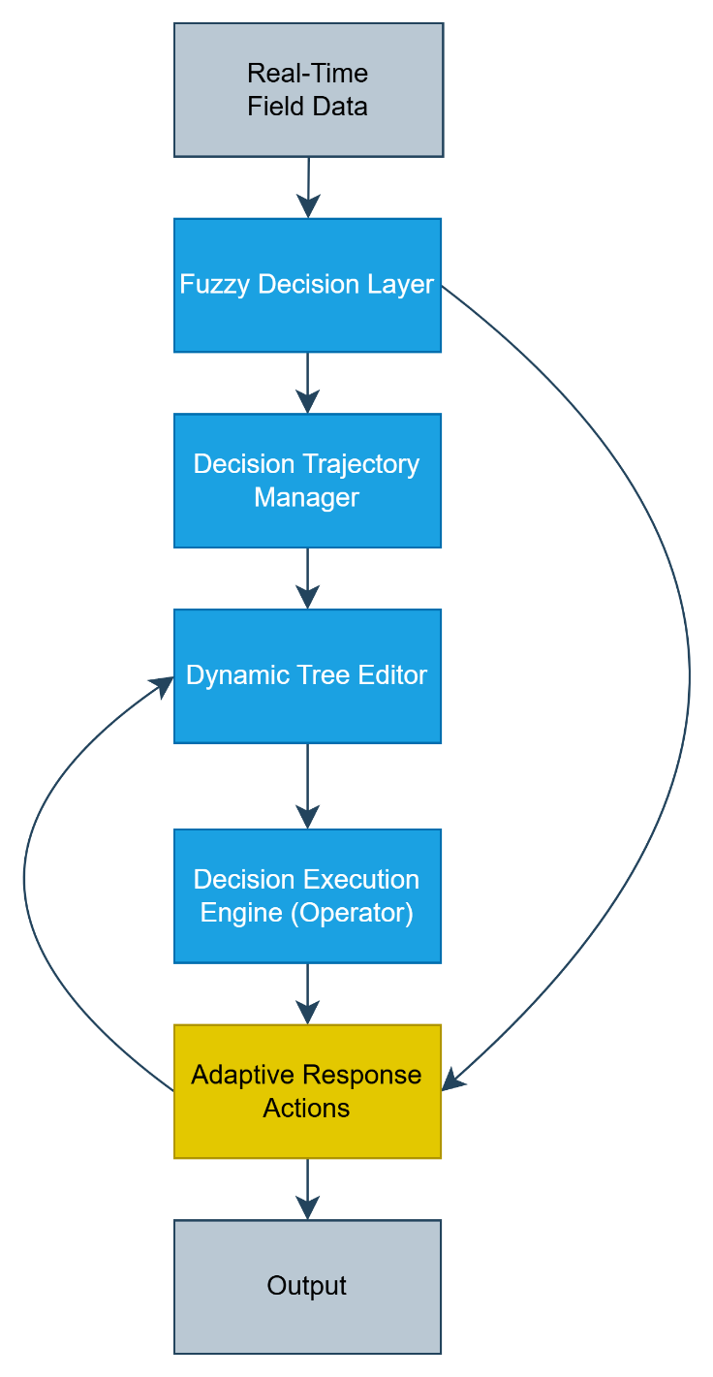
Fig. 1 System Components and Architecture
The diagram illustrated in Fig. 1 represents the architecture of real-time adaptive decision-making system. It consists of several sequential and interconnected layers, each playing a specific role in processing incoming data, interpreting context, making decisions, and learning from outcomes.
- Real-Time Field Data: This is the input layer where raw environmental data is collected from the field in real time. These data may include variables such as fire spread rate, wind speed, resource availability, temperature, and visibility. This layer continuously feeds the system with the current state of the environment.
- Fuzzy Decision Layer: The fuzzy logic layer interprets the incoming real-time data using fuzzy sets and rules instead of binary thresholds. It transforms imprecise or uncertain data into graded decision indicators. For instance, it might classify wind as "moderate" or fire intensity as "high" with associated confidence levels. This allows for nuanced and flexible reasoning in complex and uncertain conditions.
- Decision Trajectory Manager: This layer is responsible for planning and adjusting the sequence of actions (the decision trajectory). Based on the fuzzy outputs and current system state, it defines a path of operations to follow. It can revise or re-route the decision flow if new data suggests that prior assumptions or plans are no longer valid.
- Dynamic Tree Editor: Here, the actual structure of the decision tree is modified. New nodes can be added, obsolete branches can be pruned, and entire subtrees can be restructured. This editor allows the system to grow and reshape its decision logic dynamically in response to ongoing feedback or environmental changes.
- Decision Execution Engine (Operator): This layer takes the current decision trajectory and executes the corresponding actions. It operates in real time, implementing directives such as deploying resources, initiating evacuation, or rerouting teams based on the decision logic generated in earlier layers.
- Adaptive Response Actions: These are the real-world actions that are performed in response to the execution decisions. The outcomes of these actions are continuously monitored and used to inform upstream layers. If the response is not successful (e.g., fire grows despite intervention), the system can adjust its tree structure or trajectory accordingly.

Real Time Field Data
This data will be synthetically generated according to synthetic scenario flow. This manipulated data will be used to evaluate and improve the metrics of the system. There will also be real-scenarios and associated real data to validate the system solution. The key characteristic of this layer is its immediacy—data is ingested in near real time to ensure that decisions reflect the most current state of the environment. Its ability to deliver accurate, timely, and spatially distributed information is critical for enabling rapid, context-aware decision-making in highly dynamic environments such as wildfire suppression or disaster relief operations.
Table 2 Data Category
Cat. | Data Type | Possible Values | Constraints
Fire Condition | Fire location | Latitude, Longitude | Must be valid GPS coordinates
Fire Condition | Fire spread rate | e.g., 0.5 m/s | Non-negative float
Fire Condition | Fire perimeter | Polygon shape, area in hectares | Closed polygon, area > 0
Fire Condition | Fire intensity | Low, Medium, High or kW/m | Categorical or continuous
Fire Condition | Burned area | e.g., 25.4 ha | Non-negative float
Fire Condition | Fire type | Surface, Crown, Ground | One of defined categories
Fire Condition | Smoke plume direction | Azimuth degrees | 0°–360°
Fire Condition | Reignition likelihood | 0.0–1.0 | Float, probability
Meteorological | Wind speed | e.g., 15 km/h | Non-negative
Meteorological | Wind direction | Degrees (0–360°) | Circular range
Meteorological | Air temperature | e.g., 28°C | -50°C to +60°C
Meteorological | Humidity | 0%–100% | Percentage
Meteorological | Atmospheric pressure | hPa | 300–1100 hPa
Meteorological | Precipitation rate | e.g., 5 mm/h | ≥ 0
Meteorological | Solar radiation | e.g., 600 W/m² | ≥ 0
Meteorological | Visibility index | 0–10 scale | Integer
Terrain & Vegetation | Slope | e.g., 27° | 0°–90°
Terrain & Vegetation | Aspect | 0°–360° | Circular angle
Terrain & Vegetation | Elevation | Meters above sea level | ≥ 0
Terrain & Vegetation | Vegetation type | Pine, Grassland, Shrub | Predefined set
Terrain & Vegetation | Fuel moisture content | e.g., 12% | 0–100%
Terrain & Vegetation | Fuel load | e.g., 2.5 kg/m² | ≥ 0
Terrain & Vegetation | NDVI | -1 to +1 | Float
Terrain & Vegetation | Flammability index | Low, Moderate, High | Categorical
Operational | Personnel count | Integer | ≥ 0
Operational | Vehicle positions | GPS coordinates | Valid format
Operational | Aircraft tank capacity | Liters | ≥ 0
Operational | Water source availability | Liters | ≥ 0
Operational | Equipment status | Operational, Damaged | Enum
Sensory | Drone battery level | Percentage | 0–100%
Sensory | Sensor temperature | °C | -40°C to +85°C
Sensory | Link quality | dBm or %, RSSI | Defined range
Sensory | Sensor uptime | Time (hh:mm:ss) | ≥ 0
Infra. | Urban proximity | Distance in meters | ≥ 0
Infra. | Evacuation status | Pending, In-progress, Complete | Enum
Time | Timestamp | ISO 8601 | Valid datetime
Time | Update frequency | Seconds | Positive integer

Fuzzy Decision Layer
Fuzzy logic is essential for decision-making systems that operate in real-world environments where data is uncertain, noisy, or vague. Unlike binary logic systems that use sharp thresholds, fuzzy logic handles continuous variables with overlapping categories, enabling decisions that more closely mimic human reasoning. Especially in dynamic, uncertain environments like wildfire response or disaster management. Inputs such as wind speed, fuel moisture, and fire intensity rarely behave in a binary manner. Fuzzy logic allows systems to reason in gradients instead of absolutes, which is crucial for intelligent adaptation. Table 3 shows the pros and cons of the usage of fuzzy logic in AI enhanced decision tree. Table 4 shows how the disadvantages will be resolve with LLM and RL.
Table 3 Advantages & disadvantages of fuzzy logic
Advantages | Disadvantages
Handles uncertainty and imprecision gracefully. | Rule design and membership tuning require expertise.
Mimics human reasoning and linguistic variables. | Not inherently adaptive unless combined with learning (e.g. RL).
Allows partial rule activation and layered inference.
Table 4 How to solve disadvantages of fuzzy logic
Fuzzy Logic Disadvantage | LLM Solution | RL Solution
1. Rule design and membership tuning require expertise | - Generates fuzzy rules from language  - Suggests linguistic terms  - Fills in rule gaps | - Optimizes membership thresholds and shapes  - Learns rule effectiveness
2. Not inherently adaptive unless combined with learning | - Explains adaptive behavior in human terms  - Suggests rules in new scenarios | - Adapts decisions based on environment  - Improves through reward feedback

Multiple Decision
Example (Fuzzy Logic Application)
Input Variables | The variables in this example are:  $$Wind Speed \left(\frac{km}{h}\right)$$  $$Fire Intensity \left(\frac{kW}{m}\right)$$  $$Moisture (\%)$$
Member Functions | Each fuzzy set is represented by a Gaussian function defined as:  $$μ\left(x\right)=\exp\left(-0.5 * {\left(\frac{x - c}{σ}\right)}^{2}\right)$$  Where:  $$c is the center \left(mean\right)of the fuzzy set$$  $$σ is the standard deviation controlling the width$$  The figure below illustrates how wind speed values are classified into fuzzy categories using Gaussian curves.
Simulation | Assume these sensor readings:  $$Wind Speed = 45\frac{km}{h}, c=50, σ=10$$  $$Fire Intensity = 850\frac{kW}{m}, c=800, σ=100$$  $$Fuel Moisture Content = 8\%, c=5, σ=5$$  From the Gaussian functions:
  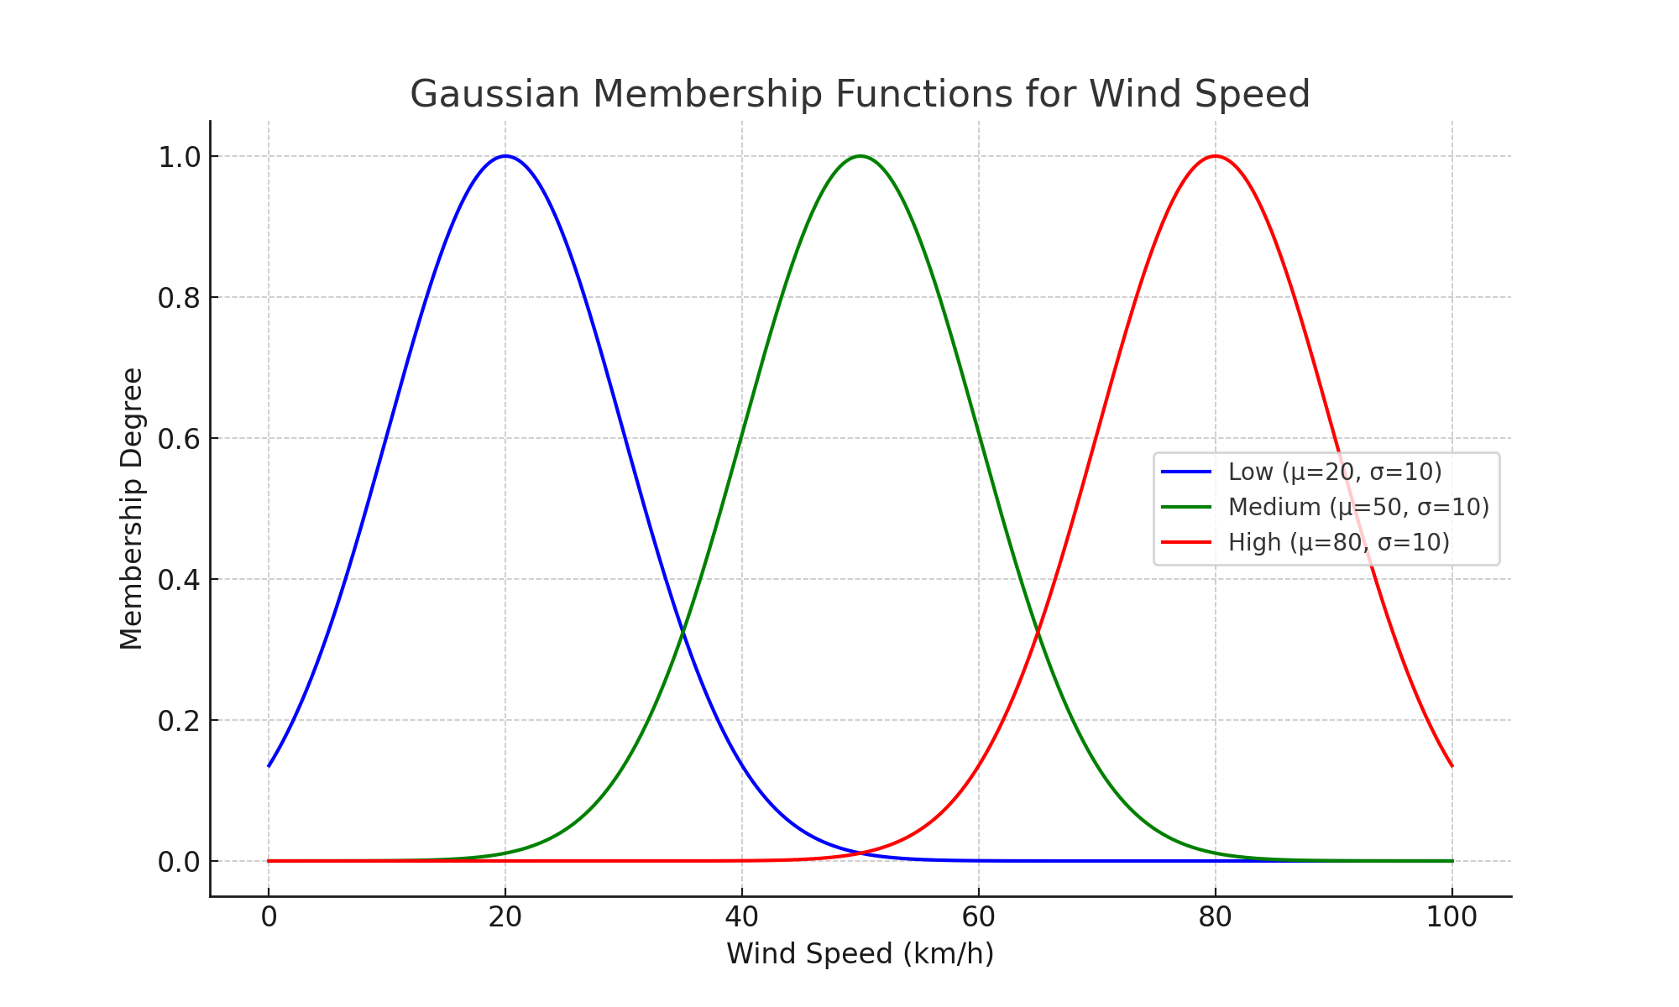
  $$μ_{Wind\left(45\right)}=\left\{\begin{matrix}0.044 & Low \\ 0.882 & Medium \\ 0.0022 & High\end{matrix}\right.$$
  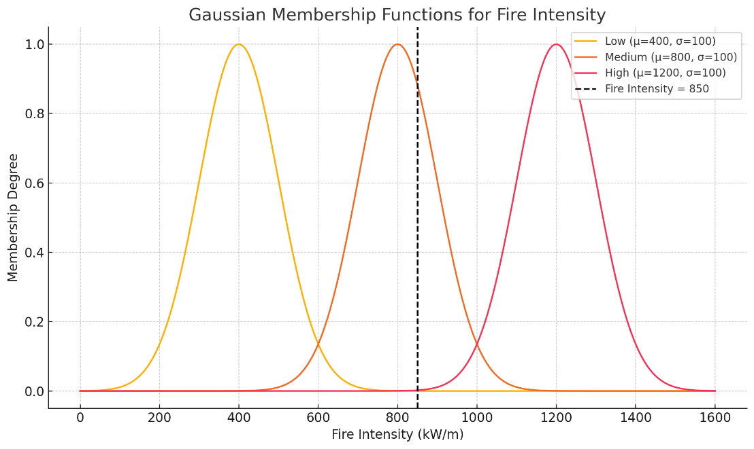
  $$μ_{FireIntensity\left(850\right)}=\left\{\begin{matrix}0.00004 & Low \\ 0.882 & Medium \\ 0.0022 & High\end{matrix}\right.$$
  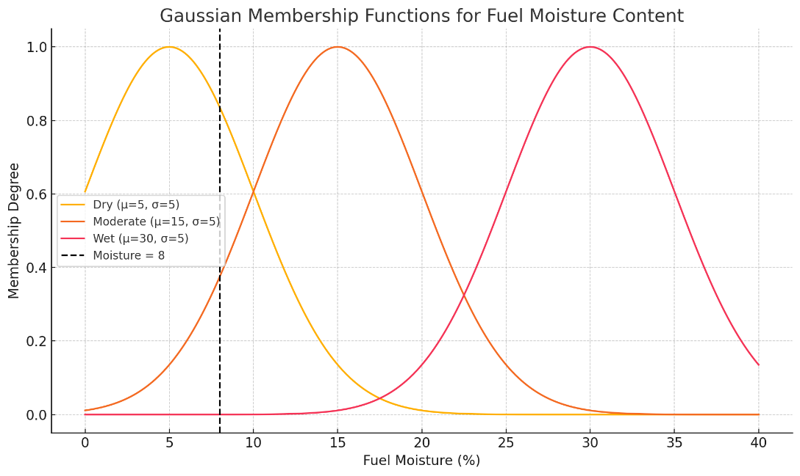
  $$μ_{Moisture\left(5\right)}=\left\{\begin{matrix}0.835 & Dry \\ 0.375 & Moderate \\ 0.000063 & Wet\end{matrix}\right.$$
Rules | $$μ_{Rule}=min(0.882,0.882,0.835)=0.835$$
  IF |  |  | THEN
  Wind Speed | Fire Intensity | Fuel Moisture | Suppression Priority
  High | High | Dry | Very High
  Medium | High | Dry | Very High
  High | Medium | Dry | Very High
  Medium | Medium | Dry | High
  Low | High | Dry | High
  Medium | Medium | Moderate | High
  Low | Medium | Moderate | Moderate
  Medium | Low | Moderate | Moderate
  Low | Medium | Wet | Moderate
  Low | Low | Wet | Low
  Medium | Low | Wet | Low
  Low | Low | Dry | Moderate
Output Central Values
  Output Fuzzy Set | Center (c)
  Low | 0.3
  Moderate | 0.5
  High | 0.7
  Very High | 0.9
Decision Set
  Scores | (Decision)
  0.8 – 1.0 | 🚨 Immediate Evacuation
  0.6 – 0.8 | ✅ Dispatch Aerial Units
  0.4 – 0.6 | ⚠️ Prepare Ground Resources
  0.0 – 0.4 | 🟢 Monitor and Wait
Rule Evaluation Output | Assume there are some other triggered decisions such as moderate and very high.  Defuzzification (centroid method):  $$Crisp Output ≈\frac{\left(0.5 ×0.5+0.7×0.835 + 0.9×0.3\right)}{\left(0.7 + 0.3+0.5\right)} = 0.736$$  → Decision: Dispatch aerial units with priority score 0.736
Integration to Decision Tree | This output score feeds into a decision tree.  If suppression priority > 0.6, nodes such as 'Dispatch Helicopters' or 'Start Evacuation Plan' become activated.  Gaussian fuzzy logic enables the system to handle borderline and overlapping conditions smoothly.

Multiple Decision
There are several ways to implement multi-action strategies:
- Sequential Actions: Multiple actions can be queued in order of priority (e.g., dispatch aerial units first, then prepare ground teams).

In this strategy, actions are executed in order of descending membership values (activation degrees).
$$Let μᵢ be the membership degree of action Aᵢ.$$
$$Priority(Aᵢ) = μᵢ$$
$$Execution Order = Sort(A₁, A₂, ..., Aₙ | μᵢ ↓)$$
$$Example:$$
$$μ(Dispatch) = 0.85, μ(GroundPrep) = 0.6, μ(Monitor) = 0.2$$
$$→ Execute in order: Dispatch → GroundPrep → Monitor$$

- Weighted Execution: Each action is assigned a weight proportional to its membership degree (e.g., 70% aerial, 30% ground).
The actions receive resources proportional to their membership degrees. This is useful for allocating limited resources.
$$A=\left\{a1,a2,…,an\right\}:set of actions$$
$$μi:fuzzy membership of action a_{i}$$
$$Then each action gets an execution share$$
$wᵢ =\frac{μᵢ}{\sum_{j=1}^{n}{μ_{j}}}$ , $Resource Allocation(Aᵢ) = R × wᵢ$
$$Example:$$
$$μ(Aerial) = 0.7, μ(Ground) = 0.3, R = 10 units$$
$$→ Aerial = 7 units, Ground = 3 units$$
- Parallel Planning: High-priority and moderate-priority actions may be initiated simultaneously by different units.
All actions with activation degree greater than or equal to a threshold τ are executed simultaneously.
$$ParallelActions = \{ a_{i}∈A | μᵢ ≥ τ \}$$
Example:
$$μ\left(Dispatch\right)= 0.85,$$
$$μ\left(Ground\right)= 0.65,$$
$$μ\left(Evacuation\right)= 0.4,$$
$$τ = 0.6$$
$$→ Execute in parallel: Dispatch, Ground$$

RL & LLM Integration
The Fuzzy Decision Layer is responsible for interpreting real-time field data by mapping numerical sensor inputs to linguistic variables (e.g., wind speed = HIGH). It handles uncertainty using membership functions.
Mathematical Basis:
$$μ_{HIGH\left(x\right)}= \frac{1}{\left(1 + e^{-a\left(x - c\right)}\right)}$$
🔁 RL Integration:
Optimizes membership weights using:
$$μ_{i}^{'}(x) = μ_i(x) * w_{i}, where w_{i} \sim π_{θ} (RL policy).$$
🤖 LLM Integration:
Generates or updates fuzzy rules based on linguistic interpretation (e.g., “If wind is high and humidity is low, then fire risk is extreme”). LLM (e.g., GPT-like) suggests new fuzzy rules based on context or prior experience:
Input: "Wind is strong and humidity is low"
Output: "Then fire spread risk is very high"
🔁 Feedback:
- RL uses real-world outcomes (success/failure of decisions triggered by FDL) to update weights.
- LLM receives prompts from trajectory failures to regenerate refined rules.

Decision Trajectory Manager (DTM)
The DTM is responsible for composing, modifying, and executing temporally coherent sequences of decisions ("trajectories"). These trajectories adapt based on dynamic conditions and previous results. DTM sequences and manages the timing of decisions. It organizes decision outputs from the fuzzy layer into a temporally optimized plan and adjusts dynamically based on feedback.

- $Let s_{t} be the state at time t, and a_{t} the action suggested by FDL.$
- $RL learns a value function$

$$Q(s_{t}, a_{t}) = r_{t} + γ max_{a} Q(s_{\left\{t+1\right\}}, a)$$
- Trajectory
$τ=\left[a_{0}, a_{1},…,a_{T}\right]$ subject to transition dynamics and constraints

DTM sequences decisions proposed by the FDL into an executable plan. It ensures that each action aligns with the expected temporal window and operational feasibility. As new environmental data arrives or outcomes deviate from expectations, the trajectory is refined using RL policies.

- 🤖 LLM Integration:
LLMs enhance the DTM by providing natural language justifications and counterfactual trajectories. In cases where RL returns low-confidence decisions, the LLM is prompted to suggest alternative plans. These may incorporate updated world state descriptions, such as road blockages or intensified hazard zones.
Example LLM Output: “Evacuation is delayed due to increased fire intensity and blocked roads.”
- 🔁 Feedback:
DTM uses feedback loops to refine future trajectories. Key feedback channels include:
- Q-value updates from RL based on observed rewards.
- LLM prompt tuning through updated incident narratives.
- FDL rule adjustments when systemic misalignment is detected.

Dynamic Tree Editor
The Dynamic Tree Editor is a core architectural component responsible for real-time, structural modification of the decision-making topology. Unlike a static decision tree, which is predefined and fixed, this module supports on-the-fly editing of the decision graph — adding, removing, or altering nodes and edges as new data arrives or feedback is received. Its primary function is to restructure the trajectory planning space to adapt to dynamically changing environments such as evolving disaster zones or mission-critical operational constraints.
In simpler terms: this module ensures that the system's decision logic structure is never stale. It is fluid and self-reorganizing, allowing the system to “learn what to consider and in what order” in terms of decision paths.
$$Tree: T = \left(N, E\right), where N = nodes, E = edges$$
MCTS or UCB-based tree policy:
$$π^{*}(s) = \max_{π}{E[\sum_{t=0}^{T}{γ^{t} r_{t}}]} , optimized by RL algorithms like PPO, A3C$$

- 🔁 RL Integration:
The Dynamic Tree Editor uses RL-based feedback to refine its structure. As actions are taken and outcomes are observed, RL updates the expected cumulative reward of subtrees. Branches that consistently yield high rewards become more traversed, while underperforming ones are pruned or deprioritized. This supports a form of policy iteration over tree topology.
- 🤖 LLM Integration:
LLMs assist in structural innovation. When the system encounters a situation not covered by existing branches, the LLM can propose new nodes by extrapolating from natural language prompts and historical data. Additionally, edges may be labeled with semantically meaningful conditions, such as 'Only applicable if humidity < 30%'. This enhances interpretability and facilitates human-AI collaboration.
- 🔁 Feedback:
Dynamic Tree Editor continuously integrates feedback from execution outcomes. Key mechanisms include:
  - Updating edge weights based on success/failure ratios.
  - Flagging branches for review if error rate exceeds a threshold.
  - Reward shaping through adaptive policy gradients.
  - Pruning of low-utility nodes to reduce decision latency.

Decision Execution Engine (Operator)
This layer interfaces with human operators or autonomous systems to carry out the decided actions. It ensures transparency and accountability by recording decisions and execution outcomes.
$$Let ε\left(a_{t}\right) be the execution function:$$
$$ε\left(a_{t}\right)=\left\{\begin{matrix}Executed & if feasible and approved \\ Rejected & otherwise\end{matrix}\right.$$
- 🤖 LLM Integration:
  - Natural language explanations for actions:
  - "Sending drones first ensures situational awareness under poor visibility."
- 🔁 Feedback:
  - Rejected actions inform both DTM and RL policy to revise or reprioritize.
  - Successful actions contribute to positive reinforcement signals.

Adaptive Response Actions
These are the final dynamic action plans executed based on evolving field data and updated decisions. They adapt automatically to changing conditions without manual reprogramming.
Mathematical Basis:
The optimal policy π* is the one that maximizes the expected cumulative reward over a finite horizon T. This is expressed as follows:
$$π^{*}(s) = argmax_{π} E [γ^{t} * r_{t} ]$$
Where:
- π*(s): Optimal policy given state s
- γ: Discount factor (0 < γ < 1)
- r_t: Reward at time step t
- E[·]: Expectation over stochastic transitions and outcomes
Response Execution Dynamics
Given a state $s_{t}$ , the action $a_{t}$ is selected using the learned policy π. The system then transitions to the next state $s_{\left\{t+1\right\}}$ following the probabilistic transition function P:
$$a_t = π(s_{t}), s_{\left\{t+1\right\}} \sim P\left(s_{\left\{t+1\right\}} \right|s_{t}, a_{t})$$
Where P denotes the state transition probability distribution conditioned on the current state and action.

- 🔁 RL Integration:
  - Reinforcement Learning is employed to iteratively improve the action sequences based on feedback. This includes rewards from successful mitigation actions and penalties for delays, failures, or resource overuse. RL algorithms such as Proximal Policy Optimization (PPO), Advantage Actor-Critic (A2C), or Deep Q-Networks (DQN) can be utilized depending on the problem structure (discrete or continuous).
- 🤖 LLM Integration:
  - LLMs are used to translate technical action sequences into human-readable justifications for operators or stakeholders. They also assist in interpreting unusual or emergent scenarios to suggest overrides, alternative plans, or fail-safes.
Example:
• Input: 'Wind speed has unexpectedly doubled.'
• Output: 'Consider halting evacuation in Zone B and diverting resources to Zone D for drone-based assessment.'

Cross-Layer Feedback Summary
The adaptive decision architecture continually evolves by incorporating multi-layered feedback: fuzzy rules adjust based on environmental inputs, trajectory policies refine through success metrics, decision trees reshape dynamically with branch effectiveness, execution logic realigns according to operator input, and both reinforcement learning weights and LLM prompts adapt in response to real-world outcomes.

Layer | Feedback Sources | What Gets Updated?
Fuzzy Decision Layer | Action results, environment | Membership functions, fuzzy rules
Decision Trajectory Mgr | Trajectory success/failure | Q-values, sequence policy
Dynamic Tree Editor | Branch effectiveness | Tree structure, edge weights
Execution Engine | Operator approval/rejection | Action priorities, explanations
Adaptive Response | Outcome scores, real-world state | RL policy weights, LLM prompt refinements

Work To Do
Task Area | Description
1. Synthetic Data Generation | Synthetic sensors (e.g., drone, thermal) to the data ingestion layer.
2. Online RL Engine | Implement feedback-driven RL with real-time trajectory adjustment.
3. Dynamic GNN for Decision Graph | Integrate GNN to evolve and optimize decision tree topology.
4. Cross-Layer Feedback Bus | Establish unified interfaces between layers (e.g., LLM ↔ RL, FDL ↔ DTM).
5. LLM Explanation Module | Finalize prompt templates and integrate narrative-based justifications.
6. Operator-in-the-Loop UI | Design user interface for human validation and feedback.
7. Simulation & Scenario Platform | Build high-fidelity wildfire simulations with fire/weather/topography data.
8. Decision Scoring Framework | Develop multi-criteria scoring: reward, cost, confidence.
9. Open-Source Toolkit Packaging | Document codebase and release toolkit with sample data and APIs.

References
Abdelbaky, M., Garcia, L., Benavides, &., & D. (2022). Towards explainable wildfire spread prediction using deep learning. International Journal of Wildland Fire, 31(4), 567–579.
Alabbad, Y., Bermúdez, J., Savić, &., & D. (2021). A model-based decision support system for real-time flood forecasting. Environmental Modelling & Software, 139, 104993.
Alonso, M., J., Bugarín, A., Barro, &., & S. (2019). Toward context-aware fuzzy decision support systems. IEEE Transactions on Fuzzy Systems, 27(1), 1–15.
Amershi, S., & al., e. (2019). Guidelines for human-AI interaction. Proceedings of the 2019 CHI Conference on Human Factors in Computing Systems.
Bai, X., Xu, C., Li, &., & Q. (2022). A data-driven wildfire decision support platform based on remote sensing and spatiotemporal modeling. Remote Sensing of Environment, 278, 113015.
Benedetti, M., Montini, L., Martini, &., & R. (2023). Ontology-based decision support for wildfire prioritization and intervention. Applied Intelligence, 53, 12472–12491.
Chen, M., Mao, S., Liu, &., & Y. (2021). Big data: A survey. Mobile Networks and Applications, 26, 3–29.
Choi, E., Schuetz, A., Stewart, W., & Sun, J. (2023). Explainable AI in healthcare: A hybrid approach using reinforcement learning and LLMs. Journal of Biomedical Informatics, 137, 104305.
Darema, F. (2005). Dynamic data driven applications systems: A new paradigm for application simulations and measurements. Computational Science–ICCS 2005, 3, 662-669.
Gao, H., Shi, Y., & Han, W. (2021). Safe and efficient reinforcement learning for emergency decision-making. Engineering Applications of Artificial Intelligence, 103, 104311.
García, J., & Fernández, F. (2015). A comprehensive survey on safe reinforcement learning. Journal of Machine Learning Research, 16(1), 1437–1480.
Gunning, D., Aha, &., & D. (2019). DARPA’s Explainable Artificial Intelligence (XAI) Program. AI Magazine, 40(2), 44–58.
Huang, Z., Zhang, J., Wang, &., & Z. (2023). Explainable graph-based decision models for real-time emergency dispatch. IEEE Transactions on Knowledge and Data Engineering, 35(4), 3441–3454.
Kwon, Y., Lee, H., Yoon, &., & S. (2022). Scenario-driven LLM decision frameworks for emergency operation centers. AI Perspectives, 4, 15.
Liu, S., Jin, X., Zhang, &., & H. (2021). Real-time data fusion in disaster-aware edge computing. Information Fusion, 67, 123–138.
Ma, X., Wu, J., Chen, &., & Y. (2022). Online graph learning for urban adaptive routing. ACM Transactions on Intelligent Systems and Technology, 13(4), 87.
Mnih, V., Kavukçuoğlu, K., Silver, D., Rusu, A. A., Veness, J., Bellemare, M. G., & Hassabis, D. (2015). Human-level control through deep reinforcement learning. Nature, 518(7540), 529–533.
Nguyen, T., Zhou, Q., Li, &., & H. (2023). Hybrid knowledge graph reasoning for disaster management. Expert Systems with Applications, 213, 119211.
Rajabi, M., Dargahi, T., Conti, &., & M. (2023). A microservices-based architecture for intelligent disaster response. Future Generation Computer Systems, 143, 98–111.
Ribeiro, T., M., Singh, S., Guestrin, &., & C. (2016). “Why should I trust you?”: Explaining the predictions of any classifier. Proceedings of the 22nd ACM SIGKDD, 1135–1144.
Salehie, M., & Tahvildari, L. (n.d.). Self-adaptive software: Landscape and research challenges. ACM Transactions on Autonomous and Adaptive Systems (TAAS), 4(2), 1-42.
Shao, Y., Zhang, X., Li, &., & D. (2021). Human-centered AI design principles for emergency management interfaces. ACM Transactions on Human-Computer Interaction, 28(6), 1–23.
Sikka, K., Dhawan, A., & Kaushik, A. (2022). Neuro-symbolic decision systems: Bridging interpretability and optimality. Neural Networks, 148, 185–198.
Sun, Y., Zhang, T., Wang, &., & H. (2023). Real-time decision graph updates in adaptive cyber-physical systems. IEEE Internet of Things Journal, 10(2), 1238–1249.
Teso, S., Passerini, &., & A. (2021). Learning constraints from examples. Artificial Intelligence, 295, 103474.
Toprak, Ö., Bilgen, &., & S. (2023). Disaster simulation systems in the age of AI: A systematic review and research agenda. Simulation Modelling Practice and Theory, 131, 102735.
Wang, D., Yang, J., Liu, &., & B. (2023). A real-time wildfire risk prediction model integrating satellite imagery and wind flow simulation. Natural Hazards, 117, 1345–1363.
Xie, H., Zhang, Y., Han, &., & C. (2023). Adversarial robustness in graph neural networks for critical decision systems. IEEE Transactions on Neural Networks and Learning Systems, 34(3), 1456–1471.
Yu, Z., Chen, W., Wu, &., & H. (2022). Federated reinforcement learning for collaborative disaster response under privacy constraints. IEEE Transactions on Services Computing, 15(6), 3050–3062.
Zhang, J., Li, Y., Xu, &., & C. (2022). Federated learning for edge-based disaster decision systems. ACM Transactions on Cyber-Physical Systems, 6(3), 45.
Zhang, L., Zhao, &., & X. (2020). Modular architectures for multi-hazard emergency response systems. IEEE Transactions on Systems, Man, and Cybernetics: Systems, 50(9), 3445–3456.
Zhou, C., Yu, H., Li, &., & X. (2021). Learning to plan dynamically: Evolving decision graphs under uncertainty. Proceedings of the AAAI Conference on Artificial Intelligence, 35(10), 8701–8708.

