TEZ ŞABLONU ONAY FORMU
THESIS TEMPLATE CONFIRMATION FORM.

- Şablonda verilen yerleşim ve boşluklar değiştirilmemelidir. |  |  | - Do not change the spacing and placement in the template.
- Jüri tarihi Başlık Sayfası, İmza Sayfası, Abstract ve Öz’de ilgili yerlere yazılmalıdır. |  |  | - Write defense date to the related places given on Title page, Approval page, Abstract and Öz.
- İmza sayfasında jüri üyelerinin unvanları doğru olarak yazılmalıdır. Tüm imzalar mavi pilot kalemle atılmalıdır. |  |  | - Write the titles of the examining committee members correctly on Approval Page. Blue ink must be used for all signatures.
- Disiplinlerarası programlarda görevlendirilen öğretim üyeleri için jüri üyeleri kısmında tam zamanlı olarak çalıştıkları anabilim dalı başkanlığının ismi yazılmalıdır. Örneğin: bir öğretim üyesi Biyoteknoloji programında görev yapıyor ve biyoloji bölümünde tam zamanlı çalışıyorsa, İmza sayfasına biyoloji bölümü yazılmalıdır. |  |  | - For faculty members working in interdisciplinary programs, the name of the department that they work full-time should be written on the Approval page. For example, if a faculty member staffs in the biotechnology program and works full-time in the biology department, the department of biology should be written on the approval page.
- Tezin son sayfasının sayfa numarası Abstract ve Öz’de ilgili yerlere yazılmalıdır. |  |  | - Write the page number of the last page in the related places given on Abstract and Öz pages.
- Bütün chapterlar, referanslar, ekler ve CV sağ sayfada başlamalıdır. Bunun için kesmeler kullanılmıştır. Kesmelerin kayması fazladan boş sayfaların oluşmasına sebep olabilir. Bu gibi durumlarda paragraf (¶) işaretine tıklayarak kesmeleri görünür hale getirin ve yerlerini kontrol edin. |  |  | - All chapters, references, appendices and CV must be started on the right page. Section Breaks were used for this. Change in the placement of section breaks can result in extra blank pages. In such cases, make the section breaks visible by clicking paragraph (¶) mark and check their position.
- Figürler ve tablolar kenar boşluklarına taşmamalıdır. |  |  | - All figures and tables must be given inside the page. Nothing must appear in the margins.
- Şablonda yorum olarak eklenen uyarılar dikkatle okunmalı ve uygulanmalıdır. |  |  | - All the warnings given on the comments section through the thesis template must be read and applied.
- Tez yazdırılmadan önce PDF olarak kaydedilmelidir. Şablonda yorum olarak eklenen uyarılar PDF dokümanında yer almamalıdır. |  |  | - Save your thesis as pdf and Disable all the comments before taking the printout.
- Tez taslaklarının kontrol işlemleri tamamlandığında, bu durum öğrencilere METU uzantılı öğrenci e-posta adresleri aracılığıyla duyurulacaktır. |  |  | - This will be announced to the students via their METU students e-mail addresses when the control of the thesis drafts has been completed.
- Tez yazım süreci ile ilgili herhangi bir sıkıntı yaşarsanız, Sıkça Sorulan Sorular (SSS) sayfamızı ziyaret ederek yaşadığınız sıkıntıyla ilgili bir çözüm bulabilirsiniz. |  |  | - If you have any problems with the thesis writing process, you may visit our Frequently Asked Questions (FAQ) page and find a solution to your problem.

☒ | Yukarıda bulunan tüm maddeleri okudum, anladım ve kabul ediyorum. / I have read, understand and accept all of the items above.  Name : Çağlar  Surname : Akman  E-Mail : caglar.akman@metu.edu.tr; e134113@metu.edu.tr  Date :  Signature : ________________________

ENHANCED DECISION SUPPORT SYSTEM FOR WILDFIRE DISASTER RESPONSE AND MANAGEMENT (DISASTERAWARE)

A THESIS SUBMITTED TO
THE GRADUATE SCHOOL OF NATURAL AND APPLIED SCIENCES
OF
MIDDLE EAST TECHNICAL UNIVERSITY

BY

ÇAĞLAR AKMAN

IN PARTIAL FULFILLMENT OF THE REQUIREMENTS
FOR
THE DEGREE OF DOCTOR OF PHILOSOPHY
IN
ELECTRICAL AND ELECTRONIC ENGINEERING

[DEFENSE DATE]
Approval of the thesis:

ENHANCED DECISION SUPPORT SYSTEM FOR WILDFIRE DISASTER RESPONSE AND MANAGEMENT (DISASTERAWARE)

submitted by NAME SURNAME in partial fulfillment of the requirements for the degree of Doctor of Philosophy in Electrical and Electronic Engineering, Middle East Technical University by,

Prof. Dr. Naci Emre Altun
Dean, Graduate School of Natural and Applied Sciences

Prof. Dr. Nevzat Güneri Gençer
Head of the Department, Electrical and Electronics Engineering

Prof. Dr. Mehmet Kemal Leblebicioğlu
Supervisor, Electrical and Electronics Engineering, METU

Examining Committee Members:

Prof. Dr. Nevzat Güneri Gençer
Electrical and Electronics Engineering, METU

Prof. Dr. Mehmet Kemal Leblebicioğlu
Electrical and Electronics Engineering, METU

Prof. Dr. XYZ
Electrical and Electronics Engineering, METU

Prof. Dr. XYZ
Electrical and Electronics Engineering, METU

Assoc. Prof. Dr. Ahmet Güneş
Electrical and Electronics Engineering, XYZ

Date: ...

I hereby declare that all information in this document has been obtained and presented in accordance with academic rules and ethical conduct. I also declare that, as required by these rules and conduct, I have fully cited and referenced all material and results that are not original to this work.

Name Last name : Çağlar Akman
Signature :

ABSTRACT

ANSWERING THAT PROVERBIAL QUESTION:
"HOW MUCH LONGER WILL YOU BE IN SCHOOL?"

Akman, Çağlar
Doctor of Philosophy, Electrical and Electronic Engineering
Supervisor : Prof. Dr. Kemal Leblebicioğlu

[Defense Date], # pages

Wildfire causes major environmental and socio-economic losses, demanding rapid detection and well-coordinated response. Conventional methods are often reactive, resulting in suboptimal decisions. DisasterAware is a Fuzzy Logic-based decision support framework aimed at improving real-time decision support in wildfire management. Spanning all phases—preparedness, mitigation, response, and recovery—it integrates environmental, terrain, and resource data for comprehensive risk assessment. Using Fuzzy inference systems (FIS) and Multi-criteria decision-making (MCDM), DisasterAware recommends the most effective intervention strategies for dynamic operation management. Simulated fire scenarios demonstrate enhanced decision speed, improved resource efficiency, and robust adaptability under uncertain conditions, validating DisasterAware’s scalability and explainability as an intelligent decision-support framework for disaster management.

Keywords: Wildfire Management, Decision Support Systems, Fuzzy Logic, Multi-Criteria Decision-Making, Disaster Response Optimization

ÖZ

DİLLERE DESTAN BİR SORUYU CEVAPLAMAK
OKUL NE ZAMAN BİTECEK?

Akman, Çağlar
Doktora, Elektrik ve Elektronik Mühendisliği
Tez Yöneticisi: Prof. Dr. Kemal Leblebicioğlu

[Jüri Tarihi], # sayfa

Orman yangınları, hızlı tespit ve iyi koordine edilmiş müdahale gerektiren çevresel ve sosyoekonomik kayıplara yol açmaktadır. Geleneksel yöntemler tepkisel olduğundan, optimal olmayan kararlara neden olur. DisasterAware, orman yangını yönetiminde gerçek zamanlı karar desteğini amaçlayan bulanık mantık tabanlı bir karar destek sistemidir. Hazırlık, zarar azaltma, müdahale ve iyileştirme aşamalarını kapsayan sistem, çevre, arazi ve kaynak verilerini entegre ederek kapsamlı bir risk değerlendirmesi yapar. Bulanık çıkarım ve çok kriterli karar verme yaklaşımlarını kullanarak DisasterAware, operasyonun dinamik biçimde yönetilmesi için en uygun müdahale stratejilerini önerir. Simüle edilmiş yangın senaryoları, daha hızlı karar alma, daha verimli kaynak kullanımı ve belirsizlik şartlarında güçlü uyarlanabilirlik sağladığını göstererek, DisasterAware’ın ölçeklenebilir ve açıklanabilir bir akıllı afet yönetimi karar destek sistemi olduğunu doğrular.

Anahtar Kelimeler: Orman Yangını Yönetimi, Karar Destek Sistemleri, Bulanık Mantık, Çok Kriterli Karar Verme, Afet Müdahale Optimizasyonu

To my beloved wife Emine and our sons Kuzey, Rüzgar, and Atlas — for their endless love, patience, and encouragement. You are my calm after every storm.

ACKNOWLEDGMENTS

I would like to express my deepest gratitude to my supervisor, Prof. Dr. Mehmet Kemal Leblebicioğlu, for his invaluable guidance, patience, and continuous support throughout this research. His insightful feedback, constructive criticism, and calm mentorship have shaped both this dissertation and my professional perspective. His encouragement, especially during times of fatigue and uncertainty, always inspired me to stand up again and move forward with renewed determination.
I would also like to express my sincere appreciation to Dr. Tolga Sönmez for his thoughtful suggestions, constructive approach, and valuable guidance throughout this study. His perspective and contributions have greatly enhanced the academic and methodological depth of this work.
I would also like to extend my heartfelt thanks to İlayda and Furkan for their sincere support and companionship throughout this journey. They believed in me and inspired me with their trust and shared vision. I see them not only as colleagues but as true siblings walking the same path toward growth and purpose.
Finally, and most importantly, I owe my deepest gratitude to my wife, Emine, and my sons, Kuzey, Rüzgar, and Atlas. This achievement would not have been possible without their love, patience, and sacrifices.
Emine, the love of my life, not only stood beside me but also organized, managed, and coordinated every aspect of our family life so that I could devote myself fully to this doctoral journey. Her unwavering support and understanding kept everything together when the demands of research were overwhelming.
To my sons, Kuzey, Rüzgar, and Atlas, I hope this dissertation serves as an example that perseverance and discipline can turn even the most challenging dreams into reality. You are my greatest inspiration and the true meaning behind this effort.
Thank you all — this accomplishment belongs as much to you as it does to me.

TABLE OF CONTENTS
ABSTRACT v
ÖZ vi
ACKNOWLEDGMENTS viii
TABLE OF CONTENTS ix
LIST OF TABLES xi
LIST OF FIGURES xii
LIST OF ABBREVIATIONS xiii
LIST OF SYMBOLS xiv
1 INTRODUCTION 1
1.1 Heading 1.1 2
2 LITERATURE REVIEW 5
3 DECISION SUPPORT FRAMEWORK 7
3.1 Heading 1 7
3.1.1 Heading 1.1 8
3.2 Heading 2 8
3.3 Heading 3 8
4 CONCLUSION 9
4.1 Heading 1 9
4.1.1 Heading 1.1 9
4.2 Heading 2 9
REFERENCES 11
5 References 11
A. Appendix Title 13
B. Appendix Title 14
CURRICULUM VITAE 15

LIST OF TABLES
TABLES
No table of figures entries found.

LIST OF FIGURES
FIGURES
Figure 1.1. Number of recorded natural disaster events, 1900 to 2023 (Our World in Data, 2024) 1

LIST OF ABBREVIATIONS
DSF | : | Decision Support Framework
FIS-SIT | : | Fuzzy Situation Assessment
FIS-SPREAD | : | Fuzzy Fire Spread Estimator
FIS-ACT | : | Fuzzy Intervention Effect Model
FIS-MCDM | : | Fuzzy Multi-Criteria Decision Making
RWS | : | Real World Simulator
 | :
 | :
 | :
 | :
 | :
 | :
 | :
 | :
 | :

LIST OF SYMBOLS
EM-DAT | : | Emergency Management Database
FIS-SIT | : | Fuzzy Situation Assessment
FIS-SPREAD | : | Fuzzy Fire Spread Estimator
FIS-ACT | : | Fuzzy Intervention Effect Model
FIS-MCDM | : | Fuzzy Multi-Criteria Decision Making
RWS | : | Real World Simulator

INTRODUCTION
At no point in recorded history has humanity faced such a relentless sequence of natural disasters. Droughts scorch regions that once flourished, megafires consume forests once considered fire-resistant, and storms of record-breaking power strike coastlines already weakened by rising seas. The world is not merely witnessing more disasters—it is living in a new era of compound and cascading hazards where events interact, amplify one another, and overwhelm the capacity of governments and communities to respond. The Emergency Event Database (EM-DAT) global disaster database, maintained by the Centre for Research on the Epidemiology of Disasters, documents this transformation clearly: annual natural disaster events have climbed from fewer than 50 in 1900 to over 400 in recent years (Our World in Data, 2024) as illustrated in Figure 1.1.
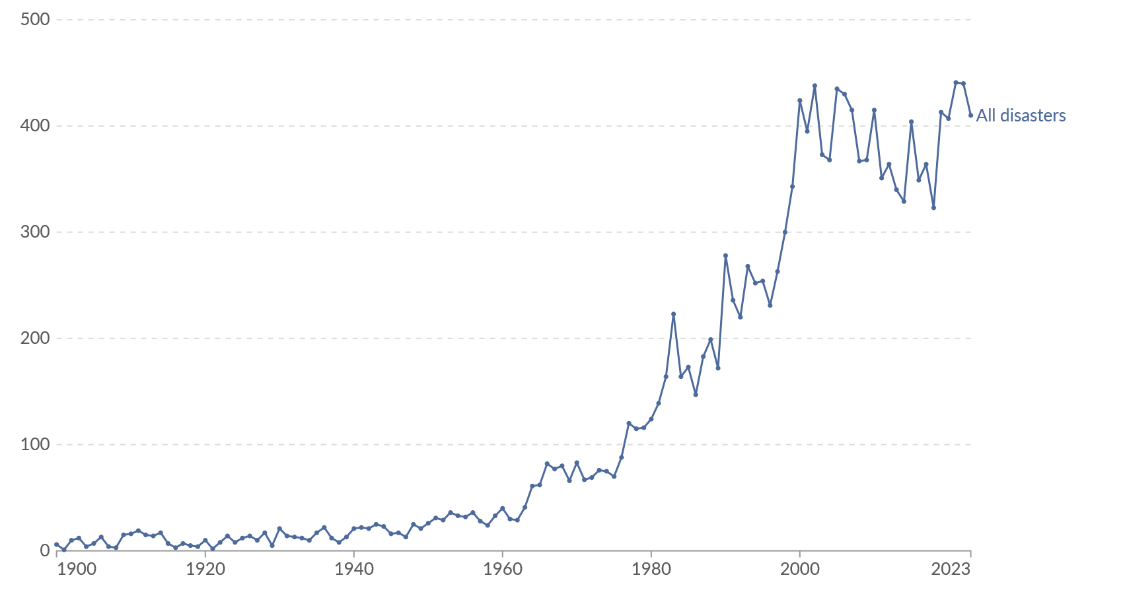
Figure 1.1. Number of recorded natural disaster events, 1900 to 2023 (Our World in Data, 2024)
While better reporting partly explains the curve, the acceleration since the 1970s corresponds with a warming climate, urban sprawl, and the expansion of high-risk human settlements. As the United Nations Environment Programme (2022) observes, “the planet is entering an era of extraordinary wildfires and heat extremes” that traditional response frameworks were never designed to manage.
EM-DAT contains data on the occurrence and impacts of mass disasters worldwide from 1900 to the present day. EM-DAT data includes all categories classified as "natural disasters" (distinguished from technological disasters, such as oil spills and industrial accidents). This includes those from drought, earthquakes, extreme temperatures, extreme weather, floods, glacial lake outburst floods, mass movements, volcanic activity, and wildfires.

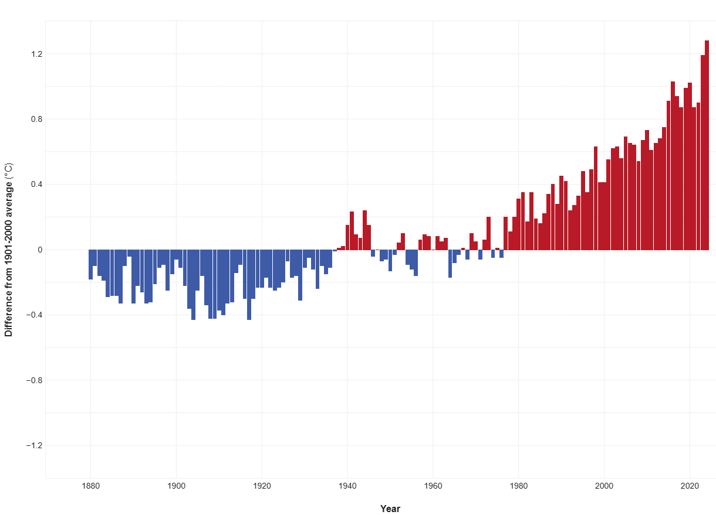
Figure 1.2. Global average surface temperature, 1901 - 2000

Wildfires are among the most destructive natural hazards, producing steep environmental, economic, and social losses. The problem is intensifying as climate change amplifies fire weather and as human exposure grows in the wildland–urban interface. Traditional response models remain largely reactive, relying on static plans, delayed coordination, and suppression-first culture—yielding slow and sub-optimal decisions under uncertainty. Decision Support Systems (DSSs) can integrate heterogeneous data and uncertainty, enabling timely, explainable, and risk-aware wildfire decisions
This research focuses on the design and implementation of a Fuzzy Logic-based Decision Support System (DISASTERAWARE) for wildfire response and management. The system integrates real-world simulation, fuzzy rule-based reasoning, and human-in-the-loop decision-making to provide adaptive and explainable intervention recommendations.

Heading 1.1
Lorem ipsum dolor sit amet, consectetuer adipiscing elit. Maecenas porttitor congue massa. Fusce posuere, magna sed pulvinar ultricies, purus lectus malesuada libero, sit amet commodo magna eros quis urna. Nunc viverra imperdiet enim. Fusce est. Vivamus a tellus. Pellentesque habitant morbi tristique senectus et netus et malesuada fames ac turpis egestas. Proin pharetra nonummy pede. Mauris et orci.
Aenean nec lorem. In porttitor. Donec laoreet nonummy augue. Suspendisse dui purus, scelerisque at, vulputate vitae, pretium mattis, nunc. Mauris eget neque at sem venenatis eleifend. Ut nonummy.
Lorem ipsum dolor sit amet, consectetuer adipiscing elit. Maecenas porttitor congue massa. Fusce posuere, magna sed pulvinar ultricies, purus lectus malesuada libero, sit amet commodo magna eros quis urna. Nunc viverra imperdiet enim. Fusce est. Vivamus a tellus. Pellentesque habitant morbi tristique senectus et netus et malesuada fames ac turpis egestas. Proin pharetra nonummy pede. Mauris et orci.

Lorem ipsum dolor sit amet, consectetuer adipiscing elit. Maecenas porttitor congue massa. Fusce posuere, magna sed pulvinar ultricies, purus lectus malesuada libero, sit amet commodo magna eros quis urna. Nunc viverra imperdiet enim. Fusce est. Vivamus a tellus. Pellentesque habitant morbi tristique senectus et netus et malesuada fames ac turpis egestas. Proin pharetra nonummy pede. Mauris et orci. Aenean nec lorem. In porttitor. Donec laoreet nonummy augue. Suspendisse dui purus, scelerisque at, vulputate vitae, pretium mattis, nunc. Mauris eget neque at sem ven

Lorem ipsum dolor sit amet, consectetuer adipiscing elit. Maecenas porttitor congue massa. Fusce posuere, magna sed pulvinar ultricies, purus lectus malesuada libero, sit amet commodo magna eros quis urna. Nunc viverra imperdiet enim. Fusce est. Vivamus a tellus. Pellentesque habitant morbi tristique senectus et netus et malesuada fames ac turpis egestas. Proin pharetra nonummy pede. Mauris et orci.
Aenean nec lorem. In porttitor. Donec laoreet nonummy augue. Suspendisse dui purus, scelerisque at, vulputate vitae, pretium mattis, nunc. Mauris eget neque at sem venenatis eleifend. Heading 1.1.1
Lorem ipsum dolor sit amet, consectetuer adipiscing elit. Maecenas porttitor congue massa. Fusce posuere, magna sed pulvinar ultricies, purus lectus malesuada libero, sit amet commodo magna eros quis urna. Nunc viverra imperdiet enim.

Heading 1.1.1.1
Fusce est. Vivamus a tellus. Pellentesque habitant morbi tristique senectus et netus et malesuada fames ac turpis egestas. Proin pharetra nonummy pede. Mauris et orci.

LITERATURE REVIEW
Lorem ipsum dolor sit amet, consectetuer adipiscing elit. Maecenas porttitor congue massa. Fusce posuere, magna sed pulvinar ultricies, purus lectus malesuada libero, sit amet commodo magna eros quis urna. Nunc viverra imperdiet enim. Fusce est.

DECISION SUPPORT FRAMEWORK

Question Set
The proposed question set is intentionally designed to be sufficient and minimal, rather than exhaustive, capturing the complete operational decision space without redundancy.
These questions are not copied from any individual paper. They are the result of abstracting what decision makers repeatedly need to know across different wildfire management and DSS frameworks.
An inductive literature synthesis approach was employed, in which operational decision needs were extracted, clustered, and reformulated into a unified question set representing the minimal sufficient decision space for wildfire intervention and control.
Rather than adopting a single existing model, the proposed question set was derived through a synthesis of wildfire behavior theory, incident command doctrine, risk-based fire management, and decision support system literature.

Level 1
Level 1 is structured as a detailed observational schema rather than a categorical list, explicitly capturing measurement scale, uncertainty, and reliability in order to support many-to-many mappings between data and decision questions.
Level 1 is modeled as an evidence layer rather than a categorical data list, explicitly encoding measurement scale, uncertainty, and applicability in order to support composite reasoning and multi-source decision questions.
All Level-1 variables were reviewed for fuzzy feasibility; inherently categorical or logical variables were explicitly transformed into scored fuzzy inputs using physically and operationally meaningful normalization.

Heading 1.1.1
Lorem ipsum dolor sit amet, consectetuer adipiscing elit. Maecenas porttitor congue massa. Fusce posuere, magna sed pulvinar ultricies, purus lectus malesuada libero, sit amet commodo magna eros quis urna.

Heading 2
Lorem ipsum dolor sit amet, consectetuer adipiscing elit. Maecenas porttitor congue massa. Fusce posuere, magna sed pulvinar ultricies, purus lectus malesuada libero, sit amet commodo magna eros quis urna.

Heading 3
Lorem ipsum dolor sit amet, consectetuer adipiscing elit. Maecenas porttitor congue massa. Fusce posuere, magna sed pulvinar ultricies, purus lectus malesuada libero, sit amet commodo magna eros quis urna.

CONCLUSION
Lorem ipsum dolor sit amet, consectetuer adipiscing elit. Maecenas porttitor congue massa.

Heading 1
Lorem ipsum dolor sit amet, consectetuer adipiscing elit. Maecenas porttitor congue massa. Fusce posuere, magna sed pulvinar ultricies, purus lectus malesuada libero, sit amet commodo magna eros quis urna.

Heading 1.1
Lorem ipsum dolor sit amet, consectetuer adipiscing elit. Maecenas porttitor congue massa. Fusce posuere, magna sed pulvinar ultricies, purus lectus malesuada libero, sit amet commodo magna eros quis urna.

Heading 1.1.1
Lorem ipsum dolor sit amet, consectetuer adipiscing elit. Maecenas porttitor congue massa. Fusce posuere, magna sed pulvinar ultricies, purus lectus malesuada libero, sit amet commodo magna eros quis urna.

Heading 2
Lorem ipsum dolor sit amet, consectetuer adipiscing elit. Maecenas porttitor congue massa. Fusce posuere, magna sed pulvinar ultricies, purus lectus malesuada libero,

REFERENCES

References
Our World in Data2024Number of recorded natural disaster events, 1900 to 2023 [Graph]. Based on EM-DAT, CRED / UCLouvain

Adıyaman, Ö. And Chorowicz, J. 2002. Late Cenozoic tectonics and volcanics in the northwestern corner of the Arabian plate: a consequence of the strike-slip Dead Sea Fault Zone and lateral escape of Anatolia, Journal of Volcanology and Geothermal Research, 117. 327-345.

APPENDICES
- Appendix Title
Add appendix here

- Appendix Title
Add appendix here

CURRICULUM VITAE

PERSONAL INFORMATION
Surname, Name: Akman, Çağlar

EDUCATION
Degree | Institution | Year of Graduation
MS | METU Electrical and Electronics Engineering | 2017
BS | METU Electrical and Electronics Engineering | 2008
High School | Yusuf Ziya Öner Fen Lisesi, Antalya | 2002

WORK EXPERIENCE
Year | Place | Enrollment
2014- Present | HAVELSAN | Modelling and Sensor Technologies Team Leader
2013-2014 | AYESAS | Senior Software Engineer
2008-2013 | KAREL | Senior Design Engineer
2007-2007 | TUBITAK | Part Time Engineer

FOREIGN LANGUAGES
Advanced English, Beginner German

PUBLICATIONS
- Kabak, Y., Kose, I. G., Akman, C., & Ramscar, D. (2023, December). TeamAware: Profile-Based Interoperability Framework for First Responders. In International Conference on Information Technology in Disaster Risk Reduction (pp. 98-111). Cham: Springer Nature Switzerland.
- Gunes, A., ihsan Gullu, A., Alam, M. S., Sucu, E. S., Köse, S., Göze, A. G., ... & Akman, Ç. (2023, July). NLoS Measurement Elimination in UWB Signals Using Anomaly Detection. In 2023 31st Signal Processing and Communications Applications Conference (SIU) (pp. 1-4). IEEE.
- AKMAN, Ç. (2022, May). Relative Localization for Swarm Aerial Vehicles. In 2022 30th Signal Processing and Communications Applications Conference (SIU).
- Korkmaz, I. O., Özateş, T., Koç, E., Aydın, E., Kor, E., Dilek, D., ... & Akman, Ç. (2022, May). Indoor localization with transfer learning. In 2022 30th Signal Processing and Communications Applications Conference (SIU) (pp. 1-4). IEEE.
- Aytekin, A., Bağcı, F., Bozdağ, M., Camuzcu, N., Duru, A., Elma, M. S., ... & Akman, Ç. (2022, May). Relative Localization for Swarm Aerial Vehicles. In 2022 30th Signal Processing and Communications Applications Conference (SIU) (pp. 1-4). IEEE.
- Akman, Ç., & Sönmez, T. (2021). Body Motion Capture and Applications. In Decision Support Systems and Industrial IoT in Smart Grid, Factories, and Cities (pp. 181-223). IGI Global.
- Akman, Ç., Demir, O., & Sönmez, T. (2021, June). Covid-19 SEIQR Spread Mathematical Model. In 2021 29th Signal Processing and Communications Applications Conference (SIU) (pp. 1-4). IEEE.
- Köse, S., Gökalp, İ., Dökme, Ç., Akman, Ç., Sönmez, T. (2019). Hybrid RSSI and fingerprinting method for indoor localization. In USMOS 19, National Defense Applications Modeling and Simulation Conference.
- Gökalp, İ., Köse, S., Narman, A., Hajizada E., Özbey, M., Can, S., Akman, Ç., Sönmez, T. (2019). Body motion analysis system. In USMOS 19, National Defense Applications Modeling and Simulation Conference.
- Akman, Ç., Sönmez, T., Özuğur, Ö., Başlı, A. B., & Leblebicioğlu, M. K. (2018). Sensor fusion, sensitivity analysis and calibration in shooter localization systems. Sensors and Actuators A: Physical, 271, 66-75.
- Akman, Ç. (2017). Multi shooter localization with acoustic sensors (Master's thesis, Middle East Technical University).
- Akman, Ç., Sönmez, T., Özuğur, Ö., & Leblebicioğlu, K. (2016, May). Shooter localization system calibration and implementation. In IEEE 24th Signal Processing and Communication Application Conference (SIU) (pp. 2025-2028)

PATENTS
- Akman, Ç. (Co-inventor), & HAVELSAN (Assignee). (2017, June 5). Ateşli silah yön ve konum tespit sistemi (Patent No. TR 2017/08288). Türk Patent ve Marka Kurumu.
- Akman, Ç. (Co-inventor), & HAVELSAN (Assignee). (2018, December 31). Hareket algılama, analiz ve takip için bir sistem (Patent No. TR 2018/21331). Türk Patent ve Marka Kurumu.
- Akman, Ç. (Co-inventor), & HAVELSAN (Assignee). (2021, April 7). Kapalı alanlarda kullanıcı konumlandırma için hibrit bir yöntem (Patent No. TR 2021/006182). Türk Patent ve Marka Kurumu.
- Akman, Ç. (Co-inventor), & HAVELSAN (Assignee). (2021, April 14). Acil durum ekiplerinin durumsal farkındalıklarının tespiti için bir düzenek ve bu düzeneğin çalıştırılması için bir yöntem (Patent No. TR 2021/006597). Türk Patent ve Marka Kurumu.
- Akman, Ç. (Co-inventor), & HAVELSAN (Assignee). (2022, September 23). Otonom sürülerde ultra geniş bant teknolojisi ile göreli konumlandırma yöntemi (Patent No. TR 2022/014693). Türk Patent ve Marka Kurumu.
- Akman, Ç. (Co-inventor), & HAVELSAN (Assignee). (2022, November 14). Ön kurulumsuz ultra geniş bant tabanlı iki referans noktalı iç-dış ortam konumlandırma yöntemi (Patent No. TR 2022/017180). Türk Patent ve Marka Kurumu.
- Akman, Ç. (Co-inventor), & HAVELSAN (Assignee). (2022, November 14). Tek referans noktalı ön kurulumsuz iç ortam konumlandırma yöntemi (Patent No. TR 2022/017194). Türk Patent ve Marka Kurumu.
- Akman, Ç. (Co-inventor), & HAVELSAN (Assignee). (2023, November 6). Ön kurulumsuz UGB tabanlı kapalı ortam haberleşme yöntemi (Patent No. TR 2023/014409). Türk Patent ve Marka Kurumu.
- Akman, Ç. (Co-inventor), & HAVELSAN (Assignee). (2023, December 5). GNSS verisi olmayan ortamlarda taşınabilir cihaz kamerası ile hedef konumlandırma yöntemi (Patent No. TR 2023/016496). Türk Patent ve Marka Kurumu.
- Akman, Ç. (Co-inventor), & HAVELSAN (Assignee). (2023, December 7). Askerî ekipler için modüler bir durumsal farkındalık sistemi (Patent No. TR 2023/016722). Türk Patent ve Marka Kurumu.
- Akman, Ç. (Co-inventor), & HAVELSAN (Assignee). (2023, December 22). Birden çok hareketli cihaz kamerası ile hedefin küresel sistemde konumlandırılması yöntemi (Patent No. TR 2023/018133). Türk Patent ve Marka Kurumu.
- Akman, Ç. (Co-inventor), & HAVELSAN (Assignee). (2023, December 22). Ultra geniş bant destekli yük tespit ve konumlandırma yöntemi (Patent No. TR 2023/018144). Türk Patent ve Marka Kurumu.
- Akman, Ç. (Co-inventor), & HAVELSAN (Assignee). (2023, December 22). Askerî ve acil durum operasyon ekiplerinin durumsal farkındalığı için bir akıllı saat sistemi (Patent No. TR 2023/018154). Türk Patent ve Marka Kurumu.
- Akman, Ç. (Co-inventor), & HAVELSAN (Assignee). (2023, December 22). Müşterek görev yapan otonom insansız hava araçları için göreli konumlandırma yöntemi (Patent No. TR 2023/018155). Türk Patent ve Marka Kurumu.

HOBBIES
Playing piano, playing chess, playing table tennis, and swimming

