Concept-Based Fuzzy Reasoning for Scalable Wildfire Decision Support (DisasterAware)

Çağlar Akman and Kemal Leblebicioğlu

Abstract—Wildfire decision support systems (DSS) today remain limited in several ways. They typically operate within a fixed set of predefined options, concentrate reasoning in a single central unit, tie the decision logic tightly to one specific simulation model, and cope poorly with uncertain or missing information. DisasterAware is a decision support framework that addresses these limitations through a hierarchically distributed and uncertainty-aware design based on concept-based fuzzy reasoning. Six bounded environmental features are first converted into fuzzy membership values under a partition-of-unity scheme and then abstracted into a compact four-dimensional situational concept vector (fire threat, suppression feasibility, asset exposure, and intervention urgency). This concept vector feeds a Mamdani-type inference process that runs independently on each regional agent. Organizing the rules around concepts rather than raw features reduces the rule count 25-fold for every intervention type, from 15625 to 625 rules (2500 instead of 62500 rules in total, across the four intervention types), which keeps the system scalable as the problem grows. The framework also provides formal guarantees on the boundedness and Lipschitz continuity of its outputs and on its compliance with partial observability, and it represents incomplete knowledge through a confidence-gated modulation of the concepts that requires no probabilistic assumptions. A non-inferential global coordination operator then combines the resource-normalized regional outputs into a single intervention input that stays strictly separate from the simulation state. Tested in simulation against a comparable centralized baseline, DisasterAware shows strong adaptability and operational feasibility, offering a reproducible alternative to optimization-based and black-box approaches to wildfire decision support.

Index Terms—Concept-based fuzzy reasoning, decision support systems, hierarchically distributed multi-agent systems, partial observability, wildfire response management.

I. INTRODUCTION
W
ildfires have grown more frequent and more destructive over recent decades, and the conditions that drive them are intensifying across most fire-prone regions of the world [1, 2]. When a large fire is active, incident commanders must decide where to send limited crews, which areas to protect first, and whether to attempt direct suppression. These choices are made quickly, under heavy time pressure, and on the basis of incomplete information. DSSs turn heterogeneous data into structured guidance for decision makers [3] to solve this problem.
Several mature tools already support parts of this task. The U.S. Wildland Fire DSS integrates weather, fire behavior, and economic information for incident-level decisions [4]. Fire behavior models such as FlamMap [5], built on the Rothermel spread model [6], predict how a fire moves across a landscape. Operations research has produced optimization models for suppression-resource allocation and evacuation planning [7], including multi-criteria toolkits such as MORA [8], while classical multi-criteria methods rank predefined options against weighted criteria [9]. Integrated operational platforms couple sensing, GIS, and decision logic for real-time suppression management [10], and machine learning has been applied to spread prediction over large remote-sensing datasets [11, 12, 13], including hybrid designs that pair transformer-based prediction with fuzzy rule-based logic [14].
Each tool is effective within its intended scope, but none was designed to meet the full set of DSS requirements. Viewed together as decision-generation systems, however, these approaches share several structural limitations. Most operate over a closed set of predefined options, so any action outside that set is unavailable. Reasoning is usually centralized, which makes it hard to reflect the regional structure of a large fire. The decision logic is often tied tightly to one simulation model, so the two cannot evolve separately. Uncertainty is either ignored or forced into probabilistic form, even though the missing information in wildfire response rarely has known statistical properties [15]. Explanations, when offered, often rely on post-hoc attribution methods such as SHAP [16] or LIME [17] that approximate a model’s behavior rather than expose the actual reasoning. Finally, decisions must be made under partial observability, a setting well understood in theory [18] but seldom handled explicitly in operational wildfire DSSs. These limitations can be categorized six structural gaps across the literature in Table I.
TABLE I
Structural Gaps in Wildfire DSS
Gap | Description
G1 Closed decision spaces | Actions are chosen from a fixed list rather than generated from the situation.
G2 Centralized architectures | A single reasoning unit handles all regions and decision levels.
G3 No non-probabilistic uncertainty handling | Epistemic uncertainty cannot be represented without assuming prior distributions or calibrated belief intervals [19].
G4 Limited traceability | Decisions cannot be traced back to the specific evidence and rules that produced them.
G5 No separation of simulation and decision logic | The decision core reads the true simulated state instead of observation-derived quantities.
G6 Weak constraint integration under partial observability | Constraints are imposed as if the full state were known.
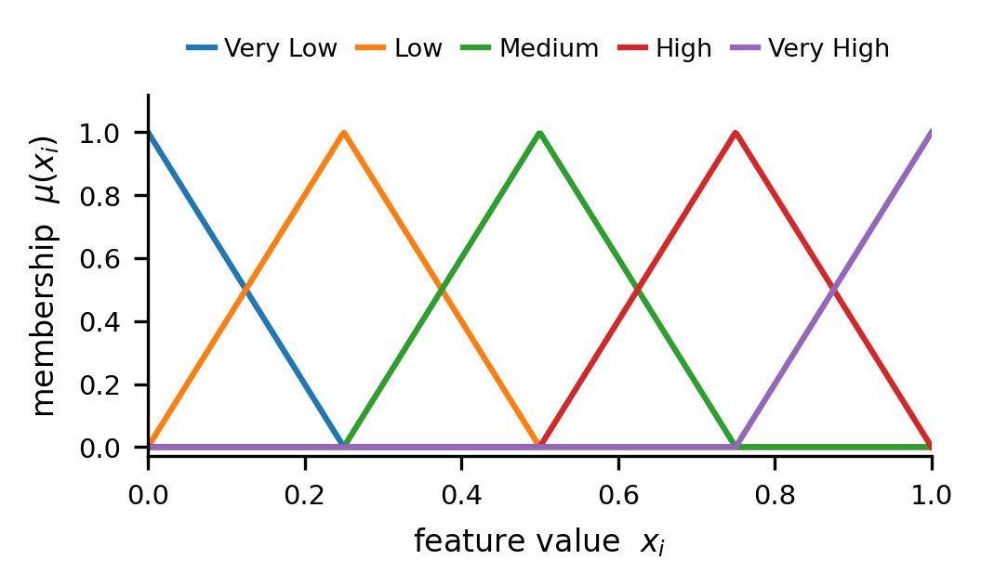
DisasterAware is an uncertainty-aware and hierarchically distributed DSS framework that addresses these gaps through concept-based fuzzy reasoning. The framework builds on fuzzy set theory [20] and Mamdani-type inference [21], which have a long record of use in fire-risk assessment [22], and distributes its computation across regional agents in the spirit of multi-agent [23] and hierarchical fuzzy systems [24]. The contributions are as follows.
Fig. 1. A five-term partition of unity, from very low to very high, over a normalized feature.

  - Concept abstraction layer (G1): Raw observations are mapped onto a small set of domain-meaningful concepts [25] (fire threat, suppression feasibility, asset exposure, and intervention urgency) before any decision is made, turning a fixed menu of options into an open, situation-driven decision space.
  - Hierarchically distributed inference (G2). Local fuzzy agents reason independently for their own regions, while a global coordinator assembles their outputs without performing any inference of its own.
  - Confidence-gated concept modulation (G3). Epistemic uncertainty is propagated by blending concept values with a persistence-based prior in proportion to observation confidence, with no prior probability distribution required.
  - Intrinsic traceability (G4). Every decision is linked to an explicit concept activation pattern, the rules it triggered, and the confidence of the observations behind it, so the reasoning can be inspected directly rather than approximated after the fact.
  - Strict simulation-decision separation (G5). The decision core operates only on observation-derived quantities and never accesses the true simulation state.
  - Satisficing-based evaluation with a graduated fail-safe (G6). Interventions are accepted when their estimated quality meets an adaptive threshold [26], and are otherwise attenuated toward a safe baseline.
These contributions turn wildfire decision support from a predefined and centralized toolkit into an open, distributed, and uncertainty-aware reasoning system whose key properties are established analytically rather than assumed. A further benefit of the concept-based organization is a substantial reduction in rule-base size, which keeps the system scalable as more intervention types are added.
The remainder of this article is organized as follows. Section II reviews background and related work on wildfire decision support, fuzzy reasoning under uncertainty, and distributed architectures. Section III presents the DisasterAware method, covering the problem formulation, architecture, concept-based fuzzy reasoning, distributed inference and coordination, and formal guarantees. Section IV reports simulation tests, including the environment, scenarios, acceptance criteria, and results. Section V concludes and outlines directions for future work.

II. Related Work
DisasterAware builds on four established lines of research: fuzzy inference for reasoning over imprecise observations, the formulation of a decision as a choice over an action space, decision making under epistemic uncertainty and partial observability, and the architectural organization of reasoning across a region. This section reviews the formulations each line has produced and the limitations that persist when these methods are taken to the scale and uncertainty of a real wildfire incident.

A. Fuzzy Inference and Rule-Base Complexity
Wildfire data are noisy, incomplete, and frequently reported in the linguistic terms used by incident commanders, such as a fire threat that is moderate to high. Fuzzy set theory [20] and the inference systems built on it [27] were introduced to reason over exactly this kind of graded, imprecise information, and they have since become a standard tool in environmental and fire-risk decision support [14, 22]. In a fuzzy inference system the $i^{th}$ input feature, written $x_{i}$ for $i = 1 … n$, is described by $m$ linguistic terms indexed by $k$. A membership function $μ_{ik}\left(x_{i}\right)∈\left[0,1\right]$ grades the degree to which feature $i$ belongs to term $k$, and a partition of unity requires these degrees to sum to one at every point ( 1 ) as depicted in Fig. 5.
$$\sum_{k=1}^{m}{μ_{ik}}(x_{i})=1, ∀x_{i}$$ | ( 1 )

Inference over the terms most commonly follows the Mamdani scheme [21]. A rule $r$ drawn from the rule base$R$ combines one term per feature in its antecedent and fires with a strength $α_{r}$ given by the minimum triangular-norm over the antecedent memberships ( 2 ).
$$α_{r}=\min_{i}{μ_{i}^{r}\left(x_{i}\right)}$$ | ( 2 )

The crisp output y is then formed from the fired rules. A common and transparent choice replaces centroid defuzzification with the firing-weighted average of singleton consequents $s_{r}$ ( 3 ), which keeps every output traceable to the rules that produced it [28].
$$y=\frac{\sum_{r}{α_{r}s_{r}}}{\sum_{r}{α_{r}}}$$ | ( 3 )

The principal limitation of this approach is scale. A complete rule base must enumerate every combination of the input terms, so for n features with m terms each the number of rules is the quantity ( 4 ).
$$|R|=m^{n}$$ | ( 4 )

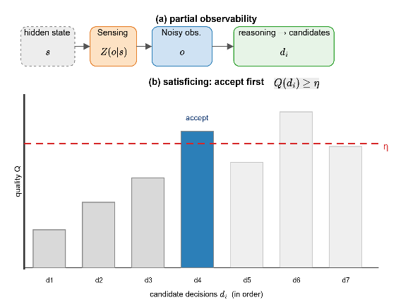
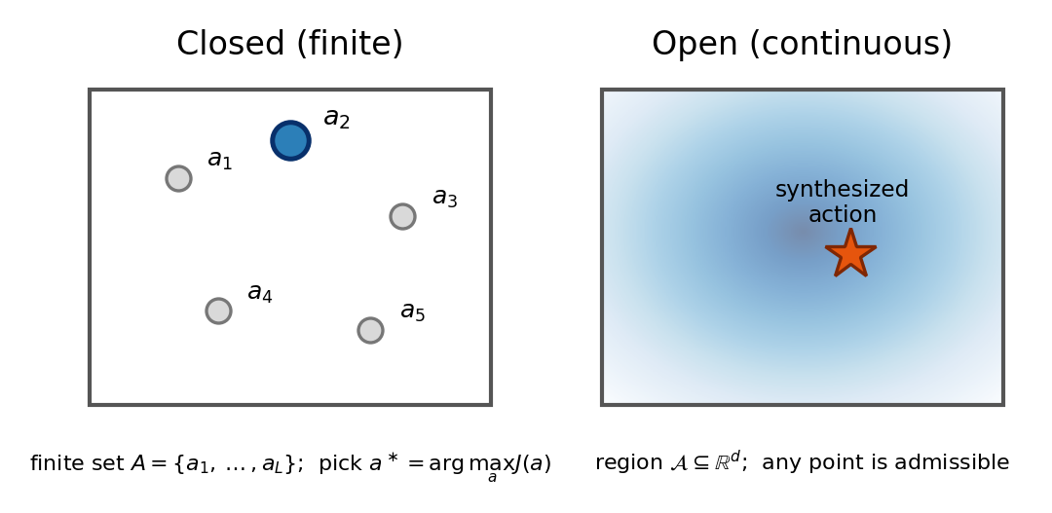
$R$ grows exponentially with the number of features, and even a handful of features yields rule bases that are impractical to author, validate, or run in real time. Hierarchical fuzzy systems [24] reduce this growth by chaining low-dimensional rule blocks, but the intermediate variables they introduce are often abstract and weaken the interpretability that motivates fuzzy reasoning in the first place. Reducing rule-base size while preserving the auditable, expert-readable structure of the rules therefore remains an open problem for fuzzy decision support.
Fig. 3. Decision making under partial observability (top), the first candidate decision (bottom).
Fig. 2. Closed (finite) decision space versus an open (continuous) decision space.

B. Open and Closed Decision Spaces
How the decision itself is represented is a design choice with direct consequences. Classical decision support fixes in advance a finite catalogue 𝒟 of M candidate actions, drawn from an underlying continuous action space 𝒞 ⊆ ℝᵈ (so 𝒟 ⊂ 𝒞 and |𝒟| = M < ∞), and returns the best entry under a scalar objective J, as in ( 5 ).
$$a_{D}^{*}=\text{arg}\underset{a∈D}{\text{max}} J(a), |D|=M<∞$$ | ( 5 )

Multi-criteria variants [9], [3] replace $J$ by a weighted aggregation of criteria but still optimize over the same finite 𝒟. Two limitations follow at once: the attainable objective is capped at the best listed entry, and 𝒟 is a zero-dimensional, measure-zero subset of the continuum $C$, so no action lying between the catalogued ones can even be expressed. This is a closed decision space (Fig. 2, left).
On the other hand, an open decision space removes the catalogue. The action ranges over the connected, compact region $C ⊆ R^{d}$ of positive Lebesgue measure [29], and the decision solves the continuous program in ( 6 ), synthesizing an intervention at an arbitrary point of $C$ rather than selecting one from a list (Fig. 2, right).
$$a_{C}^{*}=\text{arg}\underset{a∈C}{\text{max}} J(a), C⊆R^{d}$$ | ( 6 )

The finite catalogue is contained in the continuum, $D ⊆C$; hence, the continuous optimum can never be worse than the discrete one and the discretisation gap is non-negative; moreover, when $J$ is $L$-Lipschitz [29] and 𝒟 is δ-dense in 𝒞, that gap is bounded above ( 7 ).
$$0≤J(a_{C}^{*})-J(a_{D}^{*})≤L_{J} δ$$ | ( 7 )

Hence a closed design approaches the open optimum only as its catalogue is refined without bound $(L → ∞, δ → 0)$, whereas an open formulation attains it directly. For wildfire response, where effective interventions vary continuously with terrain, weather, and available resources, this gap is precisely the advantage of an open decision space, and synthesising interventions over a continuum rather than ranking a fixed menu is what classical DSS leaves unaddressed.

C. Uncertainty and Partial Observability
A third line of work addresses the uncertainty inherent in incident data. Probabilistic models posit a distribution and reason about expectations, whereas Dempster–Shafer evidence theory [19] reasons over masses assigned to subsets of a frame of discernment. Both require prior distributions or calibrated masses, which are seldom available for the epistemic, non-statistic uncertainty of wildfire sensing [15]. Partial observability is captured formally by the partially observable Markov decision process [18], in which the true state s ∈ S is hidden and only an observation drawn from a sensing model is available ( 8 ) (Fig. 3, top).
$$o∼Z(o∣s), s∈S$$ | ( 8 )

Exact optimal policies for such models are, however, intractable at incident scale. A pragmatic alternative is satisficing [26], which accepts a candidate decision as soon as its estimated quality Q meets an adequacy threshold η, as in ( 9 ) (Fig. 3, bottom).
$$\text{accept}⇔Q≥η$$ | ( 9 )

Stability of the resulting decisions under perturbed inputs can be characterized by Lipschitz continuity: a mapping f is L-Lipschitz when it satisfies ( 10 ), which bounds how far the output can move when sensor readings change slightly.
$$∥f(x)-f(x')∥≤L ∥x-x'∥$$ | ( 10 )

Combining prior-free uncertainty handling with stability guarantees of this kind, at a cost that stays tractable during an incident, is not offered by any single one of these frameworks.

D. Distributed and Hierarchical Decision Architectures
Finally, the way reasoning is organized across a region determines whether a system can keep pace with a spreading fire. Three architectures recur in the decision-support literature (Fig. 5). A centralized design routes all regional data to a single reasoner, which is simple but becomes a bottleneck and a single point of failure. A peer-to-peer distributed design spreads reasoning across communicating agents in the multi-agent tradition [23], removing the central bottleneck but incurring inter-agent message overhead whose per-cycle cost grows with the number of regional agents, as in ( 11 ).
$$τ=τ_{\text{local}}+τ_{\text{coord}}, τ_{\text{coord}}≪τ_{\text{local}}$$ | ( 11 )
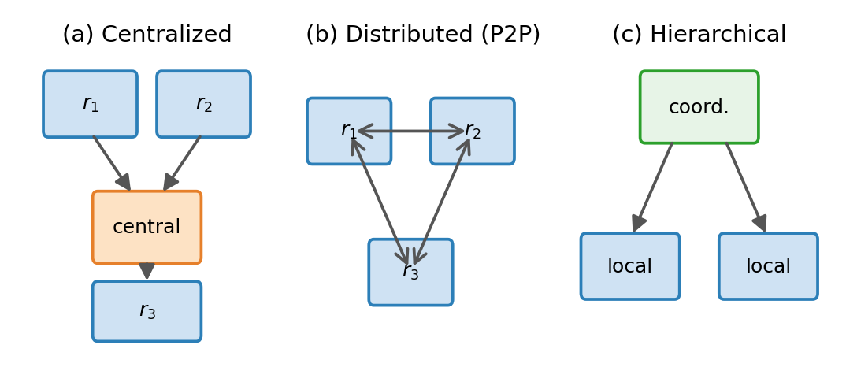
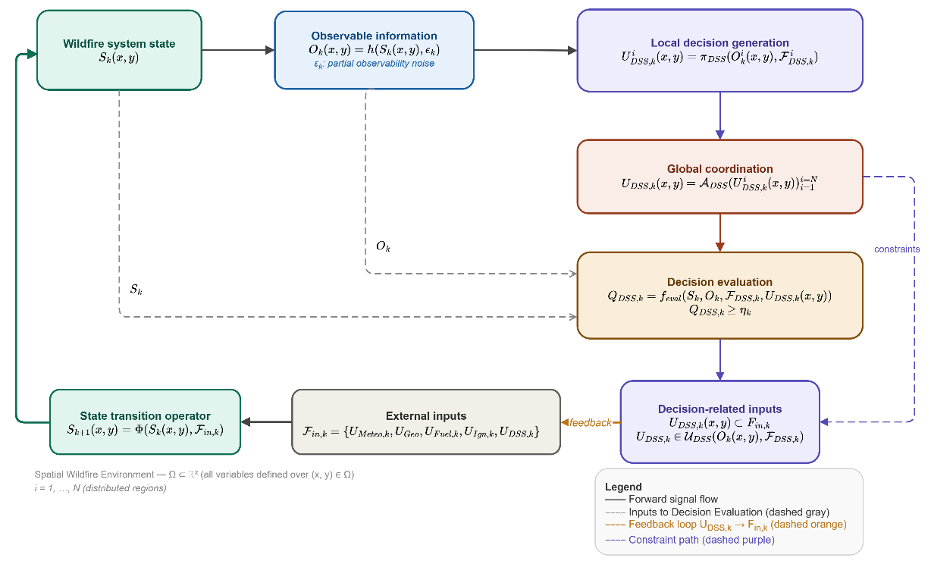
A hierarchical organization [24] instead decomposes the region into local reasoners coordinated by a higher level, attaining the regional decomposition of a distributed system without the peer-to-peer communication cost (Fig. 5). Choosing an architecture that preserves local autonomy and resilience while keeping coordination inexpensive is the central design question for a region-scale wildfire DSS.
Fig. 5. Three coordination architectures: a centralized reasoner, a peer-to-peer distributed design, and a hierarchical organization of local reasoners coordinated by a higher level.

Fig. 4. Conceptual architecture of the DisasterAware framework: a closed-loop, hierarchically distributed, uncertainty-aware decision pipeline over the spatial wildfire environment.

III. Method

A. DisasterAware Framework
DisasterAware casts wildfire DSS as a discrete-time, partially observable, spatially distributed, and satisficing decision process over an evolving wildfire environment, rather than as a single global optimization. The conceptual architecture is in Fig. 4: the environment is observed under uncertainty, region-local decisions are generated and then coordinated into a globally admissible intervention field, the field is evaluated, and the accepted interventions re-enter the environment solely as external inputs. All variables are fields over the spatial domain $Ω$, so each one is a function of the cell coordinates $(x, y)$, and the index $k$ marks the discrete time step. A superscript $i$ ranges over the $N$ disjoint regions defined below, and the subscript DSS labels quantities produced by the decision layer, keeping them apart from the physical environment.
The operational area is a spatial domain $Ω$, discretized into grid cells indexed by $(x, y)$, and time advances in discrete steps $k$. The system state S carries only physical wildfire variables at each cell, namely combustion status, available fuel, fire intensity, and time since ignition, and evolves through the transition operator $Φ$ under the external input set $F_{in}$, as in ( 11 ).
$$S_{k+1}(x,y)=Φ\left(S_{k}(x,y), F_{in,k}\right)$$ | ( 11 )

The external input set gathers meteorological $U_{Meteo,k}$, terrain $U_{Geo}$, fuel $U_{Fuel,k}$, and ignition forcing $U_{Ign,k}$together with the intervention field produced by the system $U_{DSS,k}$. The defining architectural principle is the strict separation of dynamics and decision. The system never writes to the state S, and its decisions influence evolution exclusively through the intervention component of $F_{in}$. This keeps the physical model independent of the reasoning layer and confines every decision effect to admissible, input-level modifications. Here $Φ$ is the state-transition operator of the wildfire environment: it advances the cell state by one step from the current state and the external inputs $F_{in}$, encoding the fire-propagation dynamics (fuel consumption, spread, and intensity change) of the underlying spread model. $Φ$ is a fixed environment model that the decision layer never alters, and a decision reaches it only through the intervention component of $F_{in}$.
The state is not directly accessible. The system perceives the fire only through the observation in ( 12 ), where $h$ is the observation operator and $ε$ is an epistemic disturbance arising from incomplete and imperfect sensing. The disturbance ε is treated as bounded but distribution-free: the uncertainty is structural incompleteness of information, not zero-mean noise that averages out. This rules out probabilistic state estimation and instead motivates the bounded, confidence-gated reasoning developed later, in which observations are mapped to interpretable concepts whose activation is gated by an explicit confidence measure. The bound on the disturbance norm keeps $ε$ within a known, finite magnitude at every step, so each observation stays in a fixed neighbourhood of the true state. It is worst-case rather than statistical: a set-membership envelope of admissible errors that assumes no probability distribution, which is what lets the framework treat epistemic uncertainty without priors.
$$O_{k}(x,y)=h\left(S_{k}(x,y), ε_{k}\right), ∥ε_{k}∥≤\overset{‾}{ε}$$ | ( 12 )

Decision generation is hierarchically distributed. The domain $Ω$ is partitioned into $N$ disjoint regions, and each region observes only its own area. Every region applies the same regional mapping $π$ to its local observation and regional contextual inputs, producing a region-specific, multi-action decision, as in ( 13 ). No region accesses the global state or another region's raw observations, so the cost of local reasoning is bounded independently of the overall problem size, a property that the concept-based design of Section III-C exploits to keep each regional decision tractable.
$$U_{DSS,k}^{i}(x,y)=π_{DSS}\left(O_{k}^{i}(x,y), F_{DSS,k}^{i}\right)$$ | ( 13 )

The regional decision mapping $π_{DSS}$ is the only component that performs inference: for each region it takes that region’s local observation together with its decision-related inputs and returns the region’s intervention field. Its concept-based form, which keeps the rule base compact and auditable, is specified in Section III-B.
Independent regional decisions may compete for shared and limited resources, they are integrated by the coordination operator $A$ into a single consistent field that must lie in the feasible intervention space $U$, as in ( 14 ). The contextual set $F_{DSS}$ carries value and resource related information and is deliberately kept distinct from $F_{in}$: it constrains admissibility without altering wildfire physics. Because $U$ depends on the uncertain observation and on resources that deplete over time, the feasible set is itself uncertain and non-stationary. Coordination is mediated only by $A$; regions never exchange information peer-to-peer, which is what allows the architecture to scale spatially without a quadratic growth in communication.
$$U_{DSS,k}=A_{DSS}\left(\{U_{DSS,k}^{i}\}_{i=1}^{N}\right)$$  $$U_{DSS,k}∈U_{DSS}\left(O_{k},F_{DSS,k}\right)$$ | ( 14 )

The coordination operator $A_{DSS}$ performs no inference of its own; it takes the regional intervention fields produced for all $N$ regions and returns the single global field $U_{DSS,k}$, resolving competition for shared and limited resources and keeping the result inside the feasible set $U_{DSS}$, as developed in Section III-C.
Finally, a generated field is not optimized but accepted once it is adequate. A multi-criteria function $f_{eval}$ scores the field, which is accepted when the satisficing condition in ( 15 ) holds against a time-varying threshold η.
$$Q_{DSS,k}=f_{eval}\left(O_{k},F_{DSS,k},U_{DSS,k}\right)≥η_{k}$$ | ( 15 )

The evaluation $f_{eval}$ is computed only from observable and contextual quantities and is deliberately separate from the generating mapping π, so that acceptance never depends on the unobservable true state. The accepted field then enters $F_{in}$ and drives the next transition, closing the loop. A non-enumerable joint decision space, continuous-state partial observability, distribution-free uncertainty, an evolving feasible set, and multi-criteria acceptance place the framework beyond the reach of exact optimization and define precisely the reasoning problem.
The evaluation function $f_{eval}$ maps the observation $O_{k}$, the decision-related inputs $F_{DSS,k}$, and a candidate field $U_{DSS,k}$ to a single quality score $Q_{DSS,k}$ on a common, normalized scale; it aggregates the acceptance criteria of the problem, such as expected protection, resource economy, and constraint compliance, and by construction it reads no part of the hidden state $S_{k}$, so that acceptance against the threshold $η_{k}$ stays observation-based. Its exact criteria, and the graduated fail-safe applied when the threshold is not met, are given in Section III-D.

B. Concept-Based Reasoning Specification
The regional decision mapping $π_{DSS}$ is realized as a concept-based fuzzy inference pipeline (Fig. 6). It first extracts six bounded features from the regional observation $O_{k}$, namely fire intensity, fuel load, spread potential, asset exposure, resource accessibility, and temporal urgency, each scaled to the unit interval so that every input shares a common range. The cardinality six is not a free parameter but the minimal feature set that makes the four situational concepts of Table II jointly computable: no proper subset spans all four, since resource accessibility alone carries suppression feasibility and temporal urgency alone carries intervention timing, while execution-level resource parameters are excluded to keep reasoning separate from actuation. This operational framing of the feature set draws on the authors’ experience in the TeamAware project . The features and the observable quantities they summarize are listed in Appendix A.
Each feature is described by five linguistic terms, from very low to very high, through triangular membership functions that form a partition of unity, so the memberships of a feature sum to one at every point, as in (1). Five terms keep each variable readable while still separating the operational regimes that incident commanders distinguish in practice. This five-term antecedent granularity also bounds the rule base, whose size grows as the number of terms raised to the number of antecedents by the count of (4); a finer antecedent partition would inflate the rule base exponentially for a representational gain that field practice does not require [27].
Rather than firing rules over the six features directly, the framework abstracts them into four situational concepts, fire threat level, suppression feasibility, asset exposure risk, and intervention urgency, that mirror the four questions a commander asks at each cell. Each concept is obtained analytically as a normalized weighted aggregation of the features that bear on it, as in ($B$), which needs no rules and keeps the mapping transparent. Table II lists the concepts and the features they combine.
$$c_{l,k}(x,y)=Γ_{l}(x_{1,k},…,x_{6,k}), l=1,…,4$$ | ( 1 )

II
Four Situational Concepts and Their Features
Concept | Operational question | Aggregated features
Fire threat level | How severe is the fire here? | Fire intensity, spread potential
Suppression feasibility | Can we intervene effectively? | Resource accessibility, fuel load
Asset exposure risk | What is at stake here? | Asset exposure, spread potential
Intervention urgency | How soon must action be taken? | Temporal urgency, fire threat, asset exposure
Inference then runs over the concept vector instead of the raw features. With four concepts and five terms each, a complete rule base holds 625 rules per intervention type, against 15625 for direct inference over the six features by the count of (4), a 25-fold reduction that keeps the rule base small enough to author and audit. A Mamdani min-norm combination fires the concept rules as in (2), and the firing-weighted defuzzification of (3) returns a continuous intensity for each intervention type, so the decision stays open rather than chosen from a fixed menu. The consequent intensity of each intervention type is anchored by five singleton levels, from very low to very high; this output granularity is needed because dispatch must separate no action from standby, and priority commitment from maximum commitment, distinctions a coarser output cannot express [28].
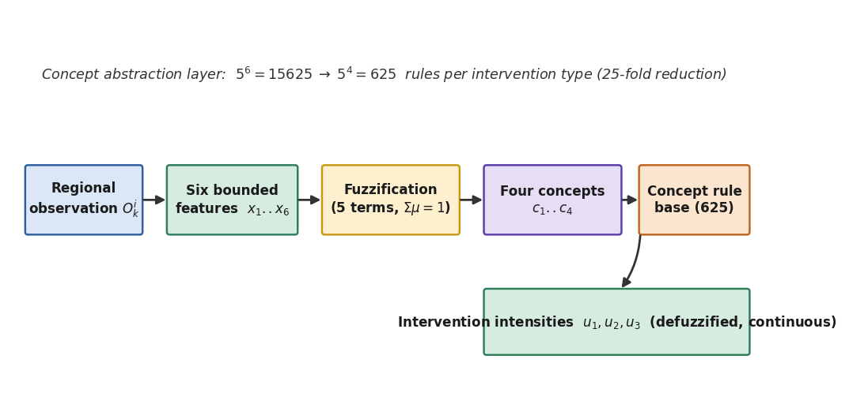
Fig. 6. Concept-based reasoning pipeline of the regional decision mapping: six bounded features are fuzzified, abstracted into four concepts, and mapped to continuous intervention intensities.

C. Distributed Decision Generation and Coordination
The regional inference $π_{DSS}$ runs independently inside every region. Each regional agent applies the same mapping $π_{DSS}$ to its own concept vector and decision-related inputs and returns a multi-action intervention, one continuous intensity per intervention type, as in (13). Four intervention types are supported, summarized in Table III: direct suppression, preventive fuel reduction, asset protection priority, and indirect attack, which builds a containment line or backfire ahead of the active edge to block the front where direct attack is infeasible.
TABLE III
Intervention Types
Type | Intervention | Effect on the environment
m=1 | Direct suppression | Reduces fire intensity at the targeted cells
m=2 | Preventive fuel reduction | Lowers available fuel ahead of the front
m=3 | Asset protection priority | Concentrates effort on high-value cells
m=4 | Indirect attack (containment line) | Blocks fire spread along a constructed line ahead of the front
Because regions draw on shared and limited resources, the regional fields cannot simply be concatenated. The coordination operator $A_{DSS}$ assembles them into the single global field $U_{DSS,k}$ as in (14), performing no inference of its own. It normalizes competing demands against the available capacity and projects the result onto the feasible set $U_{DSS}$, so the global field stays admissible even when several regions request the same crews (Fig. 7). The value- and resource-related quantities that define $U_{DSS}$ are listed in Appendix C.
Coordination is mediated only through $A_{DSS}$; regions never exchange messages peer-to-peer. The per-cycle communication therefore grows linearly with the number of regions $N$, as in (11), avoiding the quadratic overhead of a peer-to-peer design and giving the hierarchical organization of Section II-D its scalability.
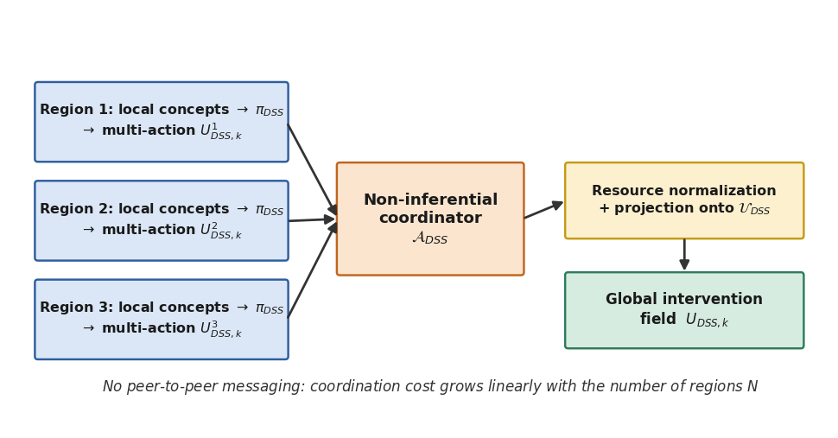
Fig. 7. Distributed decision generation and non-inferential coordination across regions, with resource normalization and projection onto the feasible set.

D. Explainability and Fail-Safe Governance
Because every decision passes through the concept layer, it carries its own explanation. Each intervention is linked to the concept activation pattern that produced it, the concept rules it fired, and the confidence of the observations behind it, so the reasoning can be inspected directly rather than approximated after the fact by post-hoc attribution (Fig. 8).
Epistemic uncertainty is propagated with no probability model. When an observation is of low confidence, its concept activation is blended with a persistence-based prior in proportion to an observation-confidence coefficient $γ_{k}$, giving the confidence-gated concept of ($D$); an overbar marks the gated quantity. High confidence passes the current estimate through unchanged, while low confidence leans on the last reliable value, so missing information attenuates the decision instead of corrupting it.
$${\overline{c}}_{l,k}=γ_{k}c_{l,k}+(1-γ_{k}){\overline{c}}_{l,k-1}$$ | ( 1 )

A generated field is accepted, not optimized: it is admitted once its quality $Q_{DSS,k}$ meets the adaptive threshold $η_{k}$ of (15). When the threshold is not met, a graduated fail-safe attenuates the field toward a safe baseline by the factor of ($D$), instead of discarding it, so the system degrades gracefully under poor information.
$$U_{DSS,k}⟵ρ_{k}U_{DSS,k}, ρ_{k}=min\{1,\frac{Q_{DSS,k}}{η_{k}}\}$$ | ( 1 )

Three properties are established analytically for the resulting mapping. Its outputs are bounded, since features, memberships, concepts, and defuzzified intensities all lie in fixed intervals. It is Lipschitz continuous in the observation in the sense of (10), so a small change in sensor readings can move the intervention only by a bounded amount. And it complies with partial observability, because evaluation and acceptance read only observation-derived quantities, never the hidden state $S_{k}$. These guarantees are what let the framework claim stability without assuming a noise distribution.
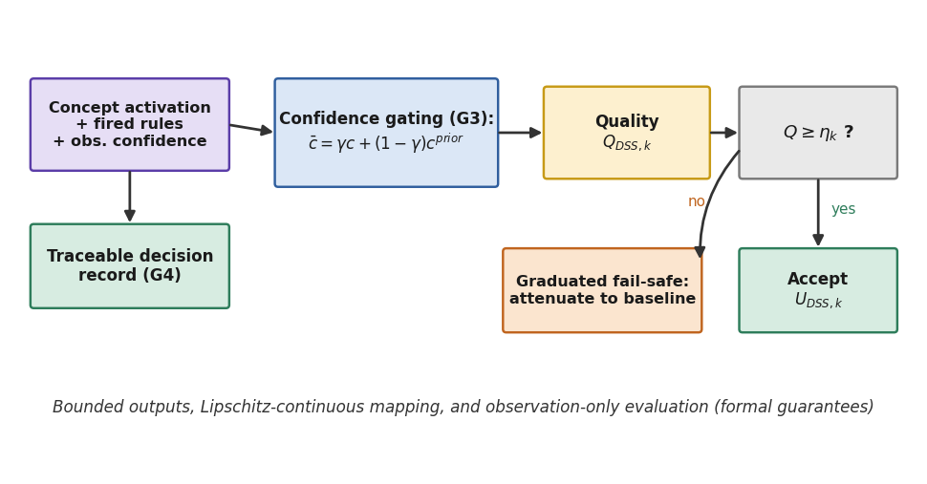
Fig. 8. Explainability and fail-safe governance: traceable decisions, confidence-gated concepts, satisficing acceptance, and graduated fail-safe.

IV. Simulation Test

A. Simulation Environment

B. Baseline and Scenarios

C. Metrics and Acceptance Criteria

D. Results and Sensitivity Analysis

V. Conclusion and Future Work

Appendix
This appendix collects the notation used by the DisasterAware framework. Table A.I lists every symbol that appears in Fig. 4, the conceptual architecture, together with a short description, so that each symbol is defined once and reused throughout Section III.
TABLE A.I

A. Notation
Notation for the DisasterAware Framework
Symbol | Meaning
$$Ω$$ | Spatial wildfire domain, defined as a subset of the plane; all fields are defined over the cells $(x, y)$.
$$k$$ | Discrete time-step index.
$$i, N$$ | Region index running from 1 to N; N is the number of disjoint regions.
$$S_{k}$$ | Wildfire system state field: combustion status, available fuel, fire intensity, and time since ignition.
$$Φ$$ | State transition operator; the state at step k+1 follows from the state and the external inputs at step k.
$$F_{in,k}$$ | External input set; gathers meteorological, terrain, fuel, and ignition forcing together with the system intervention.
$$h$$ | Observation operator mapping the hidden state to an observation.
$$ε_{k}$$ | Bounded, distribution-free epistemic disturbance that r epresents partial observability.
$$O_{k}$$ | Observation field formed from the state through the observation operator; the regional observation is its restriction to a region.
$$π_{DSS}$$ | Regional decision mapping, applied independently in every region.
$$U_{DSS,k}$$ | Coordinated global intervention field; the regional candidate of region i is its per-region counterpart.
$$A_{DSS}$$ | Non-inferential global coordination operator that merges the regional candidates into one field.
$$F_{DSS,k}$$ | Decision-related contextual inputs (value and resource information); kept distinct from the external inputs.
$$U_{DSS}$$ | Feasible (admissible) intervention space; the coordinated field is constrained to lie in it.
$$f_{eval}$$ | Multi-criteria evaluation function that scores a candidate field.
$$Q_{DSS,k}$$ | Decision-quality score of the coordinated field.
$$η_{k}$$ | Time-varying adequacy (satisficing) threshold; the field is accepted when its quality meets it.
$$U_{Meteo,k}$$ | Meteorological forcing component of the external input set.
$$U_{Geo}$$ | Terrain (static) forcing component of the external input set.
$$U_{Fuel,k}$$ | Fuel forcing component of the external input set.
$$U_{Ign,k}$$ | Ignition forcing component of the external input set.
The two sets that feed the framework decompose as follows; the parameters are drawn from the simulation data layers.

B. External Input Set
The external input set drives the environment and is summarized in Table A.II; each layer is a field defined over the grid cells.
TABLE A.II
Composition of the External Input Set
Symbol | Content
$$U_{Meteo,k}$$ | Air temperature, relative humidity, wind speed, wind direction, wind gust, and precipitation.
$$U_{Geo}$$ | Elevation, slope, orientation (aspect), and accessibility level.
$$U_{Fuel,k}$$ | Vegetation/fuel class, available combustible mass, and surface fuel moisture content.
$$U_{Ign,k}$$ | Binary ignition-injection indicator per cell.
$$U_{DSS,k}$$ | Coordinated decision field fed back by the system; the only decision-controlled component.

C. Decision-Related Inputs
The decision-related inputs supply the value- and resource-related quantities used for evaluation and feasibility, summarized in Table A.III.
TABLE A.III
Composition of the Decision-Related Inputs
Layer | Content
$$Value$$  $$at risk$$ | Exposed assets and socio-economic elements (critical facilities, population, infrastructure), aggregated into a per-cell protection-priority score.
$$Resource$$ | Available suppression capacity, operational availability status, suppression effectiveness, and estimated travel time to each grid cell.

Acknowledgment
This work was informed by the authors’ experience in the TeamAware project, funded by the European Union’s Horizon 2020 research and innovation programme under Grant Agreement No. 101019808.

References

[1] | CRED and UCLouvain, "EM-DAT, The International Disaster Database," Brussels, Belgium, 2024.
[2] | W. M. Jolly, "Climate-induced variations in global wildfire danger from 1979 to 2013," Nature Communications, vol. 6, 2015.
[3] | J. P. Shim, "Past, present, and future of decision support technology," Decision Support Systems, vol. 33, no. 2, pp. 111-126, 2002.
[4] | E. K. Noonan-Wright, "Developing the U.S. Wildland Fire Decision Support System," Journal of Combustion, vol. 2011, 2011.
[5] | M. A. Finney, "An overview of FlamMap fire modeling capabilities," in Fuels Management - How to Measure Success, USDA Forest Service Proc. RMRS-P-41, 2006.
[6] | R. C. Rothermel, "A mathematical model for predicting fire spread in wildland fuels," 1972.
[7] | S. Zhou and A. Erdogan, "A spatial optimization model for resource allocation for wildfire suppression and resident evacuation," Computers & Industrial Engineering, vol. 138, 2019.
[8] | T. Orphanoudakis, C. Betzelos and H. C. Leligou, "MORA: A multicriteria optimal resource allocation and decision support toolkit for wildfire management," Algorithms, vol. 18, no. 11, 2025.
[9] | E. Triantaphyllou, Multi-Criteria Decision Making Methods: A Comparative Study, Dordrecht: Kluwer, 2000.
[10] | M. Lourenco, L. B. Oliveira and A. Mora, "An integrated decision support system for improving wildfire suppression management," ISPRS International Journal of Geo-Information, vol. 10, no. 8, 2021.
[11] | F. Huot, "Next day wildfire spread: A machine learning dataset to predict wildfire spreading from remote-sensing data," IEEE Transactions on Geoscience and Remote Sensing, vol. 60, pp. 1-13, 2022.
[12] | M. A. Akhloufi, "Machine learning and deep learning for wildfire spread prediction: A review," Fire, vol. 7, no. 12, p. 482, 2024.
[13] | J. G. Borges, "A systematic review of applications of machine learning techniques for wildfire management decision support," Inventions, vol. 7, no. 1, p. 15, 2022.
[14] | P. Dubey, "Bridging spatiotemporal wildfire prediction and decision modeling using transformer networks and fuzzy inference systems," MethodsX, vol. 15, 2025.
[15] | M. P. Thompson and D. E. Calkin, "Uncertainty and risk in wildland fire management: A review," Journal of Environmental Management, vol. 92, no. 8, pp. 1895-1909, 2011.
[16] | S. M. Lundberg and S. I. Lee, "A unified approach to interpreting model predictions," in Advances in Neural Information Processing Systems (NeurIPS), 2017.
[17] | M. T. Ribeiro, S. Singh and C. Guestrin, "Why should I trust you?: Explaining the predictions of any classifier," in Proc. ACM SIGKDD, 2016.
[18] | L. P. Kaelbling, M. L. Littman and A. R. Cassandra, "Planning and acting in partially observable stochastic domains," Artificial Intelligence, vol. 101, pp. 99-134, 1998.
[19] | G. Shafer, A Mathematical Theory of Evidence, Princeton, NJ: Princeton University Press, 1976.
[20] | L. A. Zadeh, "Fuzzy sets," Information and Control, vol. 8, no. 3, pp. 338-353, 1965.
[21] | E. H. Mamdani and S. Assilian, "An experiment in linguistic synthesis with a fuzzy logic controller," International Journal of Man-Machine Studies, vol. 7, no. 1, pp. 1-13, 1975.
[22] | T. Tsataltzinos, L. Iliadis and S. Spartalis, "An intelligent fuzzy inference system for risk estimation: The case of forest fires in Greece," in IFIP AIAI, 2009.
[23] | M. Wooldridge, An Introduction to MultiAgent Systems, Chichester, U.K.: Wiley, 2009.
[24] | G. V. Raju, J. Zhou and R. A. Kisner, "Hierarchical fuzzy control," International Journal of Control, vol. 54, no. 5, pp. 1201-1216, 1991.
[25] | P. W. Koh, "Concept bottleneck models," in Proc. 37th Int. Conf. Machine Learning (ICML), 2020.
[26] | H. A. Simon, "Rational choice and the structure of the environment," Psychological Review, vol. 63, no. 2, pp. 129-138, 1956.
[27] | J. M. Mendel, "Fuzzy logic systems for engineering: a tutorial," Proceedings of the IEEE, vol. 83, no. 3, pp. 345-377, 1995.
[28] | L. A. Zadeh, "Outline of a new approach to the analysis of complex systems and decision processes," IEEE Transactions on Systems, Man, and Cybernetics, Vols. SMC-3, no. 1, pp. 28-44, 1973.
[29] | G. B. Folland, Real Analysis: Modern Techniques and Their Applications, New York, NY, USA: Wiley, 1999.
[30] | A. Virmaux and K. Scaman, "Lipschitz regularity of deep neural networks: Analysis and efficient estimation," in NeurIPS, 2018.


Çağlar Akman received the B.S. and M.S. degrees in Electrical and Electronics Engineering from the Middle East Technical University (METU), Ankara, Türkiye, in 2008 and 2017, respectively, where he is currently pursuing the Ph.D. degree.
He is currently the Senior Principal Team Manager of the Modeling and Sensor Technologies at HAVELSAN, Ankara, Türkiye, where he manages national and international research and development projects of advanced sensor systems, decision support architectures, and intelligent automation technologies. Over the past 10 years, he has acquired extensive experience in leading multidisciplinary R&D initiatives, managing national and international research collaborations, and coordinating complex technical projects across multiple organizations and consortia.
He serves as a Industrial Reviewer for TÜBİTAK (Turkish Scientific and Technical Research Council), evaluating research proposals across multiple research domains. He also performs peer review for IEEE Transactions and related journals, contributing to the quality assurance of peer-reviewed literature. Additionally, he has been a part-time lecturer at Atılım University. His research interests, expertise, and professional recognition reflect a strong commitment to advancing the fields of artificial intelligence, autonomous systems, decision support technologies, and sensor fusion in both civilian and defense applications.


Kemal Leblebicioğlu received his Ph.D. from the Department of Mathematics of the Middle East Technical University (METU), in 1988.
He has been a full professor in the Department of Electrical and Electronics Engineering of METU since 1999. He has a background in optimization, optimal control theory, computer vision, intelligent systems, flight control, walking robots, and unmanned vehicles.
Dr. Leblebicioğlu has been a member of numerous international program committees and has been (co-) author of more than 40 journal papers, book chapters, and numerous conference papers. He is on several IFAC technical committees. He was the editor of the journal ELEKTRIK published by TÜBİTAK (Turkish Scientific and Technical Research Council) from 1996 to 2009. He is on the editorial board of several Turkish technical journals. He organized an international workshop on computer vision and intelligent systems and two national conferences on control.
He conducted several R&D projects as project leader and researcher and gave consultancy to BİLTEN (TÜBİTAK’s Research Center on Electronics and Information Technologies), 3rd Supply and Maintenance Center of Turkish Air Forces (Ankara), TÜBİTAK-İltaren, and to ASELSAN on the topic of “real time automatic visual tracking of targets.” Now he is studying unmanned vehicles, in particular, unmanned air and underwater vehicles.
He completed a project (supported by TÜBİTAK) on the construction of a special unmanned under-sea vehicle, called ULISAR, which is a mixture of an ROV and a fully automated system. He completed a project, also supported by TÜBİTAK, on the coordinated guidance of multiple unmanned air vehicles.

Çağlar Akman and Kemal Leblebicioğlu are with the Department of Electrical and Electronics Engineering, Middle East Technical University, 06800 Ankara, Türkiye.

