AI-POWERED DECISION SUPPORT SYSTEM FOR WILDFIRE DISASTER RESPONSE AND MANAGEMENT (DISASTERAWARE)

A THESIS SUBMITTED TO
THE GRADUATE SCHOOL OF NATURAL AND APPLIED SCIENCES
OF
MIDDLE EAST TECHNICAL UNIVERSITY

BY

ÇAĞLAR AKMAN

IN PARTIAL FULFILLMENT OF THE REQUIREMENTS
FOR
THE DEGREE OF DOCTOR OF PHILOSOPHY
IN
ELECTRICAL AND ELECTRONIC ENGINEERING

August 2026
Approval of the thesis:

AI-POWERED DECISION SUPPORT SYSTEM FOR WILDFIRE DISASTER RESPONSE AND MANAGEMENT (DISASTERAWARE)

submitted by ÇAĞLAR AKMAN in partial fulfillment of the requirements for the degree of Doctor of Philosophy in Electrical and Electronic Engineering, Middle East Technical University by,

Prof. Dr. Naci Emre Altun
Dean, Graduate School of Natural and Applied Sciences

Prof. Dr. Nevzat Güneri Gençer
Head of the Department, Electrical and Electronics Eng.

Prof. Dr. Mehmet Kemal Leblebicioğlu
Supervisor, Electrical and Electronics Eng., METU

Examining Committee Members:

Prof. Dr. Mehmet Önder Efe
Artificial Intelligence and Data Eng., Hacettepe University

Prof. Dr. Mehmet Kemal Leblebicioğlu
Electrical and Electronics Eng., METU

Prof. Dr. Klaus Werner Schmidt
Electrical and Electronics Eng., METU

Assoc. Prof. Dr. Ahmet Güneş
Shipbuilding and Ocean Eng., ITU

Assist. Prof. Dr. Kenan Ahıska
Electrical and Electronics Eng., METU

Date: 31.08.2026

I hereby declare that all information in this document has been obtained and presented in accordance with academic rules and ethical conduct. I also declare that, as required by these rules and conduct, I have fully cited and referenced all material and results that are not original to this work.

Name Last name : Çağlar Akman
Signature :

ABSTRACT

AI-POWERED DECISION SUPPORT SYSTEM FOR WILDFIRE DISASTER RESPONSE AND MANAGEMENT (DISASTERAWARE)

Akman, Çağlar
Doctor of Philosophy, Electrical and Electronic Engineering
Supervisor : Prof. Dr. Mehmet Kemal Leblebicioğlu

August 2026, 201

Wildfire decision support systems use predefined decisions, cannot adjust the rule bases during an incident, and rarely expose the reasoning. DisasterAware closes these gaps with generative concept based fuzzy reasoning. One local agent per region maps confidence-gated observations onto decision concepts and, through a Takagi-Sugeno rule base, onto interventions; a coordination layer ranks regions and shares capacity. The main contribution is an open decision space. A staged loop tunes rules, writes new ones for uncovered situations, and, when the base has no answer, runs a generative model that may propose rules, blend interventions, and compose new ones from verified physical effects. Each modification must pass a forecast test, and a generated one must also clear deterministic gates so every decision stays traceable. The simulation core reproduces real fire propagation with 86 to 94 percent agreement. Over 1000 simulations, DisasterAware extinguishes 52 percent of the fires within the episode, where a static rule base extinguishes 10 percent. It leaves 28 percent fewer people affected. Against no intervention, it cuts the burned area by 70 percent. Producing a decision takes less than 0.2 percent of a decision cycle.
Keywords: Decision Support System, Concept-Driven Fuzzy Inference, Open Decision Space, Generative Rule Proposal, Traceability.

ÖZ

ORMAN YANGINLARINDA AFET MÜDAHALESİ VE YÖNETİMİ İÇİN YAPAY ZEKA DESTEKLİ KARAR DESTEK SİSTEMİ (DISASTERAWARE)

Akman, Çağlar
Doktora, Elektrik ve Elektronik Mühendisliği
Tez Yöneticisi: Prof. Dr. Mehmet Kemal Leblebicioğlu

Ağustos 2026, 201

Orman yangını karar destek sistemleri önceden tanımlı kararlar kullanır, olay sürerken kural tabanlarını ayarlayamaz ve gerekçesini nadiren gösterir. DisasterAware bu boşlukları üretken kavram temelli bulanık çıkarım ile kapatır. Her bölgedeki yerel ajan, güven kapılı gözlemleri karar kavramlarına ve Takagi-Sugeno kural tabanı ile müdahalelere eşler; eşgüdüm katmanı bölgeleri sıralar ve kapasite paylaştırır. Tezin ana katkısı açık karar uzayıdır. Kademeli döngü, kural ayarlar, kapsanmayan durumlar için yeni kural yazar ve kural tabanı yanıtsız kaldığında kural önerebilen, müdahaleleri harmanlayabilen ve doğrulanmış fiziksel etkilerden yenilerini oluşturabilen üretken bir model çalıştırır. Her değişiklik tahmine dayalı bir yeterleme testini, üretilen bir değişiklik ise belirlenimci doğrulama kapılarını geçer ve her karar izlenebilir kalır. Benzetim çekirdeği gerçek yangın ilerleyişini yüzde 86-94 uyumla yeniden üretir. 1000 benzetimde DisasterAware yangınların yüzde 52'sini olay süresi içinde söndürür; sabit kural tabanı ise yüzde 10'unu söndürür. Etkilenen kişi sayısını yüzde 28 azaltır. Müdahalesiz duruma göre yanan alanı yüzde 70 küçültür. Bir kararın üretilmesi karar çevriminin yüzde 0,2'sinden kısa sürer.
Anahtar Kelimeler: Karar Destek Sistemi, Kavram Güdümlü Bulanık Çıkarım, Açık Karar Uzayı, Üretken Kural Önerisi, İzlenebilirlik.

To my beloved wife Emine and our sons Kuzey, Rüzgar, and Atlas for their endless love, patience, and encouragement. You are my calm after every storm.

ACKNOWLEDGMENTS

I express my gratitude to my supervisor, Prof. Dr. Kemal Leblebicioğlu, for his guidance and support throughout this research. His mentorship has shaped this dissertation, and his encouragement kept me moving forward.
I am grateful to Dr. Tolga Sönmez, who encouraged me to pursue a PhD and whose career remains my example of academia and industry advancing together.
My heartfelt thanks go to İlayda and Furkan Öztürk, whose belief in me never wavered. Everything we have undertaken together has grown beyond the sum of its parts. I see them not as colleagues but as true siblings walking the same path.
Long before this research began, my family taught me how to think. My mother and father raised me to question, to reason, and to trust evidence; the generations before them had already laid those stones. Whatever scientific curiosity this dissertation shows was planted at home.
To my wife, Emine, my companion on every road and the meaning of my life. Every page of this dissertation carries a sacrifice she made without naming it. While I was buried in fires that existed only in simulation, she kept the real ones from reaching our door: she carried our family life so that I could give myself entirely to this work, and she held everything together when the research demanded more than I had left to give. Nothing here was finished alone. This degree is as much hers as it is mine.
To my sons, Kuzey, Rüzgar, and Atlas, you are the reason this work exists. I hope these pages show you that perseverance and discipline can turn the hardest dreams into reality. Walk this road further than I ever could and walk it with purpose. You are my greatest inspiration.
Thank you all, this belongs to you as much as to me.

TABLE OF CONTENTS
ABSTRACT v
ÖZ vi
ACKNOWLEDGMENTS viii
TABLE OF CONTENTS ix
LIST OF TABLES xiii
LIST OF FIGURES xv
LIST OF ABBREVIATIONS xviii
LIST OF SYMBOLS xix
CHAPTERS
1 INTRODUCTION 1
1.1 Existing Wildfire Decision Support Systems 4
1.2 Gap Analysis 6
1.3 Research Question and Hypothesis 10
1.4 Main Contributions of the Thesis 12
1.5 Organization of the Thesis 14
2 BACKGROUND INFORMATION 17
2.1 Wildfire Dynamics and Spread Modeling 17
2.1.1 Drivers of Fire Behavior 17
2.1.2 Families of Spread Models 18
2.1.3 Requirements of the Decision Layer on the Spread Model 19
2.2 Decision Support Foundations 20
2.2.1 Core Elements of Decision Support Systems 20
2.2.2 Closed versus Open Decision Spaces 21
2.2.3 Centralized and Distributed Decision Support Architectures 23
2.3 The Input Space: Heterogeneous Sensing to Observation Features 24
2.4 Concept-Driven Fuzzy Reasoning 26
2.4.1 Linguistic Uncertainty and Fuzzy Inference 26
2.4.2 Mamdani and Takagi-Sugeno Inference: Mechanism and Choice 28
2.4.3 The Rule Explosion Problem 31
2.4.4 Concepts as an Intermediate Abstraction 31
2.5 The Decision Space: Actions and Their Evaluation 33
2.5.1 Actions and Interventions in Wildfire Decision Support 33
2.5.2 Decision Cost and Its Components 35
2.5.3 Satisficing Acceptance and the Graduated Fail-Safe 38
2.5.4 Epistemic Uncertainty, Traceability, and Sensitivity 40
2.5.5 Generative Models and Large Language Models 41
2.5.6 Adaptive and Generative Decision Loops 42
3 DISASTERAWARE SIMULATION FRAMEWORK 45
3.1 Overall System Block Diagram 46
3.2 Simulation Input and External Sources 49
3.2.1 Meteorology Data Layer 50
3.2.2 Topography Data Layer 51
3.2.3 Fuel Data Layer 51
3.2.4 Ignition Layer 52
3.2.5 Decisional Data Layers 53
3.3 Simulation Core 56
3.3.1 Spatio-Temporal State Transition 56
3.3.2 Hybrid Fire Spread Model 57
3.3.3 Mathematical Formulation of Interaction and Scenario Control 66
3.4 Decision Support System Core 68
4 DISASTERAWARE DECISION SUPPORT FRAMEWORK 71
4.1 Decision Support System Block Diagram 72
4.2 Layer 1: Input Space 74
4.3 Layer 2: Observation, Features, and Confidence 74
4.4 Layer 3: Concept Space and the Feature-Concept Hierarchy 76
4.5 Layer 4: Decision Generation and Coordination 80
4.5.1 Rule Base and Candidate Intervention 81
4.5.2 Cost, Quality, and the Satisficing Test 83
4.5.3 Open Decision Space: Staged Adaptation 89
4.6 Hierarchical Organization: Local Agents and Global Coordination 106
5 SIMULATION AND PERFORMANCE RESULTS 109
5.1 Evaluation Criteria for Wildfire Decision Support Systems 110
5.2 Validation of the Simulation Core 112
5.3 Simulation Constraints and Assumptions 116
5.4 Sensitivity Analysis: Response to Parameter Bias 118
5.4.1 Simultaneous Ignitions vs Resource Level 120
5.4.2 Simultaneous Ignitions vs Observation Coverage 121
5.4.3 Decision Cycle and Decision Horizon 124
5.4.4 Satisficing Bound and Quality Gate 126
5.5 Performance of the Decision Layer 129
5.5.1 Evaluation Scenarios 130
5.5.2 Improvement Ladder Performance 133
5.5.3 Open Decision Space Performance 138
5.5.4 Timeliness and Scalability of the Decision Layer 151
5.6 Compliance with the Evaluation Criteria 152
6 CONCLUSION AND FUTURE WORKS 157
6.1 Conclusions 157
6.2 Future Works 161
REFERENCES 163
APPENDICES 175
A. Simulation Mathematics for Evolution of Burning Status 175
B. Simulation Mathematics for Fuel Mass Evolution 178
C. Simulation Mathematics for Fire Intensity Evolution 183
D. Complete Concept Mapping Specification 184
E. Representative Decision Rules 187
F. Generative AI Prompt Specifications 193
CURRICULUM VITAE 199

LIST OF TABLES
TABLES
Table 1.1 Representative wildfire decision support systems and their position on the three gap dimensions 6
Table 1.1 DSS gaps identified in wildfire decision support literature 7
Table 1.2 Mapping of thesis contributions to identified gaps 12
Table 2.1 The ten observation features, their sources, and their rationale 25
Table 2.2 Mamdani and zero-order Takagi-Sugeno inference compared 30
Table 2.3 Operational questions and the decision concepts derived from them 32
Table 2.4 Intervention families, representative orders, and input-level effects 34
Table 2.5 Decision cost components, their scope, and their rationale 36
Table 2.6 Scope of traceability and sensitivity analysis 40
Table 3.1 Meteorology data layer parameters 50
Table 3.2 Geometry (topography) data layer parameters 51
Table 3.3 Fuel data layer parameters 52
Table 3.4 Resource data layer parameters 54
Table 3.5 Value data layer parameters 55
Table 3.6 Admissible transformations of interaction operator 66
Table 4.1 Forecast cost terms of the candidate and of no action 87
Table 4.2 Terms of the quality test in the two regions of the cycle 88
Table 4.3 The verified effect vocabulary a clause may invoke 98
Table 5.1 Evaluation criteria for wildfire DSS 111
Table 5.2 Historical validation cases and their configuration 112
Table 5.3 Hindcast agreement metrics per historical case 115
Table 5.4 Simulation and decision parameters of all experiments 117
Table 5.5 Environment and decision layer assumptions 118
Table 5.6 Sensitivity design: Parameters, nominal values, and bias ranges 120
Table 5.7 DSS test configurations 129
Table 5.8 Evaluation scenarios 131
Table 5.9 Physical outcome per scenario and configuration at the end of the episode 135
Table 5.10 Decision-cost terms at the end of the episode per scenario and configuration 136
Table 5.11 Constraint outcomes over 160 runs, 7 130 decision cycles 140
Table 5.12 The generative product ledger: The objects created by stage ③ and the base actuators they draw on, with their definitions 143
Table 5.13 One decision, end to end 145
Table 5.14 Five of the admitted generative rules consuming generated macro interventions and the generated concept 146
Table 5.15 What stage ③ proposed and what the gates admitted, by object kind 148
Table 5.16 The admitted clause actuators and their definitions 149
Table 5.17 Decision latency of the closed loop 152
Table 5.18 Compliance with the evaluation criteria 153
Table 5.19 Evaluation of the research hypotheses 156
Table A.1 Spread rate parameters for each fuel type 177
Table B.1 Baseline combustion coefficients per fuel type 179
Table B.2 Suppression mapping calibration parameters 182
Table C.1 Fire intensity evolution parameters 183
Table D.1 Level 1 to 4 aggregation weights over the previous levels 184
Table D.2 Parameters of the concept layer 185
Table D.3 Trapezoidal parameters 185
Table E.1 Representative decision rules by operational regime 187
Table E.2 The generative rules admitted over the recorded runs 189

LIST OF FIGURES
FIGURES
Figure 1.1 Global trend in reported natural disasters 2
Figure 1.2 Research question, hypothesis, gaps, and contributions 14
Figure 2.1 Coupling between fire behavior, the grid state, and the decision layer 19
Figure 2.2 Information flow in centralized and distributed DSS architectures 23
Figure 2.3 Five-term trapezoidal membership partition with an example reading 28
Figure 2.4 Mamdani and zero-order Takagi-Sugeno inference pipelines 29
Figure 2.5 Staged adaptation loop with generative proposal and verification 43
Figure 3.1 DisasterAware system block diagram (simulation focused) 46
Figure 3.2 Grid domain representation and per-cell state structure 57
Figure 3.3 State transition block diagram 58
Figure 3.4 Wind-dependent directional propagation into target cell 61
Figure 3.5 DSS Simulation Core Interface 68
Figure 4.1 DisasterAware system block diagram (DSS focused) 73
Figure 4.2 Feature-concept hierarchy 76
Figure 4.3 Hierarchical concept activation example 78
Figure 4.4 (a) Confidence gating and (b) persistence decay 79
Figure 4.5 Layer 4 decision and adaptation flow 80
Figure 4.6 Consequent step and boundary shift 91
Figure 4.7 Resolution increase, rule instantiation, and term insertion 93
Figure 4.8 Generative proposal and the verification gates 94
Figure 4.9 Package objects: (a) macro intervention, (b) intermediate concept and (c) clause actuator 97
Figure 4.10 Global coordination and the no-harm guard 107
Figure 5.1 Agreement maps for the historical hindcasts (Green: Correctly predicted burn, Red: Simulated only, Blue: Observed only, Yellow: Ignition) 115
Figure 5.2 The physical cost over simultaneous ignitions and resource level (bold: least severe of the five worlds; small: five-world mean) 121
Figure 5.3 The physical cost over ignitions and coverage, pool is 0.25 122
Figure 5.4 The physical cost over ignitions and coverage, pool is 0.5 122
Figure 5.5 The physical cost over ignitions and coverage, pool is 0.75 123
Figure 5.6 The physical cost over ignitions and coverage, pool is 1 123
Figure 5.7 Optimum decision cycle for low ROS and no harm horizons 125
Figure 5.8 Optimum decision cycle for high ROS and no harm horizons 125
Figure 5.9 Sensitivity of the outcome to the decision cycle (mean of five paired worlds with 95% half widths) 126
Figure 5.10 Effect of the satisficing bound 127
Figure 5.11 Effect of the fail-safe quality gate 127
Figure 5.12 Representative world of S1 (left) and S2 (right) 131
Figure 5.13 Representative world of S3 (left) and S4 (right) 132
Figure 5.14 Sample interventions (full set) on a representative world 132
Figure 5.15 Legends for representative world 133
Figure 5.16 (a) Average burned area, burned forest, and affected population of the four configurations over the five scenarios, as shares of the no-DSS run; (b) share of runs in which the fire is extinguished within the twelve-hour episode, per scenario and configuration 137
Figure 5.17 Average physical cost of the four configurations by component, as shares of the no-DSS run, under the five scenarios 137
Figure 5.18 Average total cost of the four configurations by weighted component under the five scenarios 138
Figure 5.19 Left: EvFIS trials and acceptances at stage ① and stage ②. Right: The generative gates over proposals 139
Figure 5.20 Generated intermediate concept and the admitted rule 144
Figure 5.21 Generated macro interventions over the base interventions 144
Figure 5.22 One recorded incident from ignition to extinction 147
Figure 5.23 Generative products: (a) proposed and admitted by object kind, (b) the forecast cost each admitted actuator removed on the two reseeded rollouts 148
Figure 5.24 The cost of the decision layer against the number of local agents (median over three worlds per point) 151

LIST OF ABBREVIATIONS
ABBREVIATIONS
AI | : | Artificial intelligence
DEM | : | Digital elevation model
DSS | : | Decision support system
evFIS | : | Evolving fuzzy inference system
GIS | : | Geographic information system
HIL | : | Human-in-the-loop
LIME | : | Local interpretable model-agnostic explanations
LLM | : | Large language model
LoS | : | Line of sight
MAE | : | Mean absolute error
MF | : | Membership function
ML | : | Machine learning
POD | : | Probability of detection
ROS | : | Rate of spread
SHAP | : | Shapley additive explanations
UI | : | User interface
VIIRS | : | Visible infrared imaging radiometer suite
WFDSS | : | Wildfire decision support system
WUI | : | Wildland-urban interface

LIST OF SYMBOLS
SYMBOLS
The following list defines all symbols used in this thesis, organized by functional category. Five notational conventions apply throughout: Subscript k denotes the discrete time step; arguments (x, y) denote the grid cell; superscript $i$ identifies the operational region; a hat accent () indicates an estimated quantity, observed or forecast; and an overbar $(\overline{})$ indicates a confidence-gated or spatially averaged quantity.
1. Fire State and Propagation Variables
$$B_{k}(x,y)$$ | Burning status indicator
$$B_{k+1}^{pers}(x,y)$$ | Burning persistence term
$$B_{k+1}^{prop}(x,y)$$ | Burning propagation term
$$F_{burn,k}(x,y)$$ | Fractional burn rate
$$I_{k}(x,y)$$ | Local fire intensity proxy
$$I_{Ign,k}(x,y)$$ | External ignition injection indicator
$$R_{spread,k}(x,y)$$ | Rate of spread at time step $k$
$$τ_{k}(x,y)$$ | Time since ignition
$$Ψ_{k}(x,y)$$ | Propagation influence
$$Θ_{ign}$$ | Ignition threshold
$$Φ$$ | State transition operator
2. Fuel Variables
$$F_{load,k}(x,y)$$ | Available combustible fuel mass
$$F_{moist,k}(x,y)$$ | Surface fuel moisture
$$F_{red,k}(x,y)$$ | Suppression-induced fuel reduction
$$F_{type}(x,y)$$ | Fuel type classification
$$U_{Fuel,k}(x,y)$$ | Fuel-related input
$$ε_{fuelload}$$ | Fuel extinction threshold
3. Terrain / Geographic Variables
$$G_{access}(x,y)$$ | Terrain accessibility index
$$G_{aspect}(x,y)$$ | Terrain orientation (aspect)
$$G_{elev}(x,y)$$ | Terrain elevation
$$G_{slope}(x,y)$$ | Terrain slope
$$U_{Geo}(x,y)$$ | Terrain-related input
4. Meteorological Variables
$$W_{gust,k}(x,y)$$ | Wind gust field
$$W_{prec,k}$$ | Precipitation (domain-uniform scalar, no spatial variation)
$$W_{rh,k}(x,y)$$ | Relative humidity field
$$W_{temp,k}(x,y)$$ | Air temperature field
$$W_{wd,k}(x,y)$$ | Wind direction field
$$W_{ws,k}(x,y)$$ | Wind speed field
$$U_{Meteo,k}(x,y)$$ | Meteorological input
$$δ_{Meteo}$$ | Meteorological perturbation applied by operator
5. Value / Asset Variables
$$V_{bld}(x,y)$$ | Building footprint indicator
$$V_{crit}(x,y)$$ | Critical facility index
$$V_{evac}^{norm}(x,y)$$ | Accessibility to evacuation routes
$$V_{pop}^{norm}(x,y)$$ | Population density at grid cell (person/km²)
$$V_{prio}(x,y)$$ | Asset priority index
$$U_{Val,k}(x,y)$$ | Value-related contextual input
$$σ_{Val}$$ | Value priority scaling factor in $Θ_{UI}$
6. Resource / Suppression Variables
$$R_{avail,k}(x,y)$$ | Operational availability of suppression resources
$$R_{cap,k}(x,y)$$ | Available suppression capacity
$$R_{eff,k}(x,y)$$ | Nominal suppression effectiveness
$$R_{time,k}(x,y)$$ | Estimated travel time for suppression resources
$$U_{Res,k}(x,y)$$ | Resource-related contextual input
$$u_{m,k}^{i}(x,y)$$ | Candidate intervention degree for family m in region $i$
$$δ_{Res}(x,y)$$ | Resource availability perturbation applied by operator
$$η_{cap,k}$$ | Normalized suppression capacity factor
$$η_{avail,k}$$ | Normalized resource availability factor
$$η_{reach,k}$$ | Reachability (travel-time) factor
$$η_{eff,k}$$ | Suppression effectiveness factor
7. Observation / Sensing Variables
$$O_{k}^{i}(x,y)$$ | Region-specific observable information at time step k
$$O_{k}(x,y)$$ | Observable information at time step $k$
$$h^{i}(•)$$ | Region-specific observation function for $Ωᵢ$
$$γ_{k}^{i}$$ | Observation confidence for region $i$
$$ε_{k}^{i}\left(x,y\right)$$ | Observation uncertainty
8. Spatial Domain / Grid Variables
$$G$$ | Spatial grid domain
$$N$$ | Total number of operational regions / local agents
$$N_{x}$$ | Number of grid cells along the horizontal axis
$$N_{y}$$ | Number of grid cells along the vertical axis
$$N^{8}(x,y)$$ | 8-connected neighborhood
$$S_{k}(x,y)$$ | Wildfire system state over spatial grid at time step k
9. Decision Support System (DSS) Variables
$$F_{DSS,k}$$ | Contextual input set
$$F_{DSS,k}^{*}$$ | UI-modified decision-context set at step k
$$F_{in,k}$$ | External input set
$$F_{in,k}^{*}$$ | UI-modified external input set at step k
$$U_{DSS,k}(x,y)$$ | DSS-generated intervention input parameters
$$U_{DSS,k}^{i}\left(x,y\right)$$ | Regional intervention output from agent $i$
$$U_{DSS,safe}$$ | Conservative baseline intervention under fail-safe policy
$$U_{DSS}$$ | Feasible intervention space
$$U_{Ign,k}(x,y)$$ | Ignition input
$$π_{DSS}^{i}$$ | Regional decision-support mapping
$$A_{DSS}$$ | Coordination operator aggregating the regional decisions
$$σ_{i}$$ | Attention share assigned to region i by the coordinator
$$δ_{Ign}(x,y)$$ | Ignition perturbation applied by operator
$$λ_{k}$$ | Fail-safe blending factor between the DSS decision and the conservative baseline
$$Θ_{UI}$$ | User interaction operator
10. Fuzzy Logic Variables
$$N_{concept}$$ | Number of decision concepts
$$N_{feature}$$ | Number of input features
$$μ_{A_{r,n}}$$ | Membership of the antecedent term of rule r over concept n
$$v_{r,m}$$ | Singleton consequent value of rule $r$ for intervention family m
$$α_{r}$$ | Activation (firing) strength of rule $r$, the minimum of its antecedent memberships
$$α_{min}$$ | Coverage floor of the seeded rule base (0.05)
$$w_{j}$$ | Non-negative priority weight of cost term j
11. Functions / Mappings
$$f_{intensity}$$ | Fire intensity approximation function
$$f_{ros}$$ | Rate-of-spread mapping function
$$f_{supp}$$ | Suppression-to-mitigation mapping
$$g_{dir,k}$$ | Directional spread weighting factor
12. Feature Variables and Parameters
$$z_{k,l}^{i}(x,y)$$ | $l^{th}$ feature at $(x,y)$, region $i$, step $k$; $z ∈ [0,1]$, $l = 1…10$
$$β_{t}$$ | Travel-time decay coefficient
$$Δt$$ | Simulation time step
$$δ$$ | Admission margin of the generative verification gates (δ ≥ 0)
13. Decision Cost and Quality Variables
$$J$$ | Total normalized decision cost (weight sum of cost terms)
$$J_{phys}$$ | Physical decision cost (burned area, asset loss, population)
$$J_{burn}$$ | Burned-area cost term
$$J_{asset}$$ | Asset-loss cost term
$$J_{pop}$$ | Population-exposure cost term
$$J_{resp}$$ | Response cost term
$$J_{delay}$$ | Response-delay cost term
$$Q_{k}$$ | Decision quality at step $k$
$$J_{TH}$$ | Fixed satisficing ceiling on the normalized decision cost (0.35)
$$δ_{gain}$$ | Required relative gain over the no-action forecast (0.05)
$$δ_{v}$$ | Vocabulary margin of the package gate G5 (0.0001)
$$N_{term}$$ | Number of linguistic terms per fuzzy variable
$$N_{input}$$ | Largest number of features feeding a single concept
$$a_{k}^{eff}$$ | Gated concept activation at step $k$
$$a_{k}^{obs}$$ | Observation-based concept activation at step $k$
$$a_{k}^{per}$$ | Persistence-prior concept activation at step $k$
$$ρ$$ | Persistence decay factor of the effective concept activation
$$e_{k}$$ | Contextual-bandit state (deficit band and coverage-gap flag)
$$q_{k}$$ | Selected adaptation stage (contextual-bandit action)
$$η$$ | Quality gate for the graduated fail-safe (accept if $Q_{k} ≥ η$)
$$φ_{(i,j)}$$ | Bearing angle from cell $(i,j)$ toward $(x,y)$ in directional spread

INTRODUCTION
Decision makers in disaster response and other critical domains must combine many streams of information under uncertainty, time pressure, and resource limits, and a poor decision can have irreversible consequences. Decision Support Systems (DSS) are designed to extend the range of information an operator can weigh under such pressure (Sprague & Carlson, 1982; Power, 2002; Turban, Sharda, & Delen, 2011; Sharda, Delen, & Turban, 2018). Despite decades of development alongside data analytics and computational intelligence (Power & Heavin, 2017; Sharda, Delen, & Turban, 2018; Arnott & Pervan, 2005), classical DSS still assume full observability, stationary dynamics, and well-defined objectives (Keeney & Raiffa, 1976), assumptions that rarely hold in real operations, where epistemic uncertainty persists (French, Maule, & Papamichail, 2019; Walker, et al., 2003).
DSS research has therefore shifted toward hybrid architectures that combine simulation, expert knowledge, and uncertainty-aware reasoning (Marakas & O'Brien, 2013; Arnott & Pervan, 2005). At the same time, artificial intelligence (AI) methods have raised predictive accuracy but often operate as opaque systems whose reasoning is difficult to expose at the decision level (Ribeiro, Singh, & Guestrin, 2016; Abdul, Vermeulen, Wang, Lim, & Kankanhalli, 2018; Sanneman & Shah, 2020). In critical domains such as disaster management, effective human-machine teaming depends on decision outputs that operators can interpret, trace, and align with their own reasoning (McNeese, Schelble, Canonico, & Demir, 2021); hence, next-generation DSS must reason with incomplete and unreliable observations, preserve interpretability, and adapt as conditions evolve (French, Maule, & Papamichail, 2019; Thompson & Calkin, 2011; Comfort, Boin, & Demchak, 2010; Walker, et al., 2003).
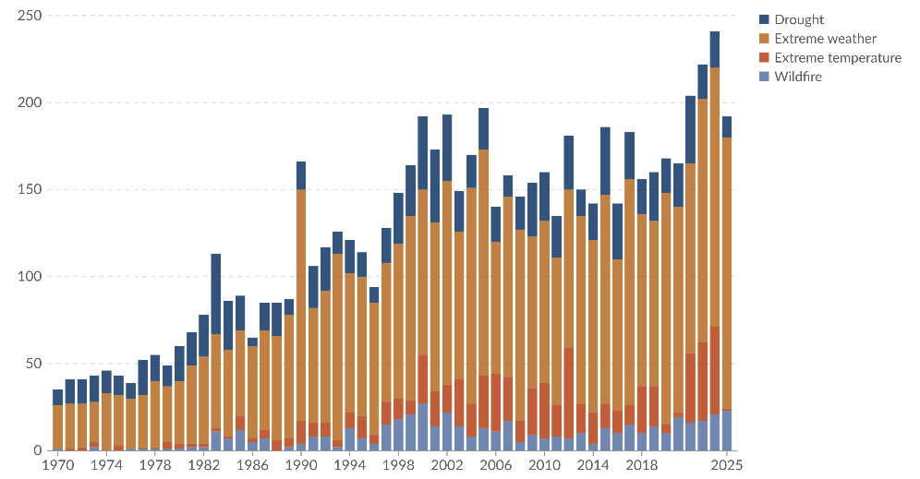
Figure 1.1 Global trend in reported natural disasters
Figure 1.1 shows the steep rise in reported natural disasters since 1970, with weather- and climate-related events, including wildfires, taking a growing share (CRED/UCLouvain, 2026). The EM-DAT documentation attributes much of the rise before 2000 to improvements in reporting and coverage rather than to hazard frequency, and it advises against reading the earlier period as a trend in hazard activity. Wildfire frequency, spatial extent, and intensity have all risen under climate change, land-use transformation, and the expansion of the wildland-urban interface (Bowman, et al., 2020; UNEP, 2022), and the resulting ecological, economic, and human impacts increasingly outpace conventional response capabilities (Thompson & Calkin, 2011; Pacheco, et al., 2015; Finney, An overview of FlamMap fire modeling capabilities, 2006).
Wildfire management is a demanding decision domain because fire behavior evolves in space and time under the joint influence of weather, terrain, fuel, and suppression. Wind and humidity set ignition probability and spread rate, slope and aspect steer propagation, fuel structure determines intensity and burn duration, and suppression actions feed back into the fire dynamics (Rothermel, 1972; Finney, An overview of FlamMap fire modeling capabilities, 2006; Sullivan, 2009a; Sullivan, 2009b; Sullivan, 2009c). Operational wildfire response relies not only on numerical indicators, but also on incomplete and linguistically expressed situational assessments such as “high spread potential,” “limited suppression feasibility,” or “uncertain fire boundary.” Fuzzy reasoning is well suited to this setting (Bellman & Zadeh, 1970), since it supports approximate inference over partial and imprecise evidence without probability distributions, which are rarely available in real time (Thompson & Calkin, 2011; Pacheco, et al., 2015).
Many DSS approaches exist for wildfire management, from optimization-based resource allocation and simulation-based systems to geospatial risk assessment and fuzzy reasoning (Thompson & Calkin, 2011; Pacheco, et al., 2015; Soualah, 2024; Vásquez, 2021; Finney, An overview of FlamMap fire modeling capabilities, 2006). Mature deployed systems such as WFDSS and FlamMap, together with recent ML-based hybrids, provide substantial operational value, yet each addresses only part of these requirements. The remaining challenge is therefore architectural. There is a need for a framework that simultaneously addresses adaptability under dynamic conditions, explainability of decision outputs, and support for distributed multi-level coordination within one coherent design (Thompson & Calkin, 2011; Vásquez, 2021; McNeese, Schelble, Canonico, & Demir, 2021). The DisasterAware framework is motivated not by a single methodological deficiency but by a set of structural limitations that recur across existing DSS. The next section examines these limitations, and the thesis contributions are then mapped to them.
This thesis presents DisasterAware, a decision support framework for wildfire response that is built and evaluated in simulation. The framework has two strictly separated parts. A simulation core reproduces fire spread on a grid of cells from weather, terrain, and fuel inputs, and a decision core observes that fire through imperfect sensors and proposes interventions. Inside the decision core, local fuzzy agents reason over a small set of operational concepts, a global layer coordinates regions without reasoning about individual cells, and every candidate intervention passes a verification gate before it is fielded. The evaluation reports the burned area, the share of ignitions extinguished, the decision cost, and the decision latency over repeated simulated scenarios, and compares the full framework with reduced configurations and with a fixed rule base.

Existing Wildfire Decision Support Systems
Reviews of wildfire decision support group the published systems into four families. Fire growth simulators predict where a fire will be, risk assessment tools map exposure and values at risk, optimization models allocate suppression resources, and integrated platforms bind these products to incident documentation (Martell, 2015; Pacheco, et al., 2015; Vásquez, 2021; Duff & Tolhurst, 2015). Machine learning has entered every family, mostly on the prediction side (Jain, et al., 2020), and large language models have recently been proposed as analysis assistants and response agents (Xie, et al., 2024; Chen, et al., 2025; Chandra, Kumar, Patra, & Agarwal, 2025). Table 1.1 lists representative systems from each family and records how each one handles the three questions that this thesis takes as its gap dimensions, namely how the decision space is formed and where the reasoning runs, how uncertainty and explanation are treated, and how the simulation and the decision logic are joined.
Two patterns follow from the table. First, the systems that reason about decisions do so over a predefined set of options, in one central place, and mostly offline, while the systems that run online are simulators that leave the decision to the analyst. Second, the systems that expose their reasoning are either static fuzzy rule bases or free-text language-model outputs, and neither ties the explanation to a quantified sensitivity of the closed-loop outcome. Field studies confirm the consequence in practice. Managers report that they use the tools to document decisions already made and that they question the reliability of outputs they cannot inspect (Rapp, Rabung, Wilson, & Toman, 2020; Fillmore & Paveglio, 2023; Rapp, et al., 2026). The next section consolidates these observations into three structural gaps.
System and source | Decision space and architecture | Uncertainty and explanation | Simulation and decision coupling
FARSITE and FlamMap, fire growth and behavior simulators (Finney, 1998; 2006) | No decision logic; the analyst reads the maps and forms the plan; standalone tools | Deterministic runs on fixed inputs; alternatives compared by the analyst; no rule-level explanation | Simulation only; decision reasoning stays outside the tool
Cell2Fire, cell-based growth simulator for landscape planning (Pais et al., 2021) | Offline planning over a predefined set of treatment options; centralized batch runs | Stochastic ensembles give burn probability; no reasoning trace | Simulator built to feed planning models; no real-time decision loop
WFDSS, incident decision platform of US federal agencies (Noonan-Wright et al., 2011; Fillmore & Paveglio, 2023) | Courses of action written and documented by incident staff; centralized web service | Probabilistic spread products; rationale kept as narrative documentation rather than traceable reasoning | Fire behavior models and decision records merged in one platform
Risk Management Assistance, analyst-delivered strategic products (Calkin et al., 2021; Schultz et al., 2021) | Strategic options prepared by analysts for a given incident; timely delivery reported as a critical need | Risk framing with expert judgment; the explanation is carried by the analyst | Analytics produced offline and handed to the incident team
MORA, multicriteria resource allocation toolkit (Orphanoudakis et al., 2025) | Optimization over a fixed action set; centralized solver | Requires a specified state; no rule-level trace of the recommendation | Spread dynamics enter as input data; no coupled simulator in the loop
Fuzzy logic with GIS for regional risk forecasting (Soualah, 2024) | Risk map without interventions; centralized and offline | Linguistic rules readable by the operator; static rule base | No simulation core; risk assessment only
Transformer-fuzzy decision model (Dubey & Dubey, 2025) | Fixed response classes; single centralized pipeline | Fuzzy stage is interpretable, prediction stage is a black box | Prediction and decision merged in one pipeline
Language-model assistants and agents for wildfire analysis and response (Xie et al., 2024; Chen et al., 2025; Chandra et al., 2025) | Open-ended outputs; no admission check before an action is fielded | Free-text justification; correctness not verifiable against a physical model | Models call external tools; no verified closed loop with a spread simulator

Table 1.1 Representative wildfire decision support systems and their position on the three gap dimensions

Gap Analysis
Despite advances in DSS research, the literature still exhibits several unresolved limitations that constrain operational effectiveness. Existing systems have delivered important capabilities in fire spread prediction, geospatial risk analysis, resource planning, and situation monitoring. However, many of these contributions are built on assumptions that are difficult to sustain under dynamic conditions: Predefined decision alternatives, centralized reasoning, limited treatment of uncertain observations, weak explainability, and constraint handling that presumes complete information (Arnott & Pervan, 2005; Turban, Sharda, & Delen, 2011). These limitations consolidate into three structural gaps, summarized in Table 1.2, each reflecting a structural rather than incidental shortcoming of current architectures.
Table 1.2 DSS gaps identified in wildfire decision support literature
Gaps of Existing Wildfire DSS Architectures
Gap 1: Many of the reviewed DSS frameworks rely on predefined decision alternatives evaluated within centralized, level-undifferentiated architectures, preventing adaptation to dynamic, unforeseen conditions and limiting scalability, local responsiveness, and level-appropriate coordination.
Gap 2: Many of the reviewed systems represent epistemic uncertainty only through prior probability distributions or calibrated belief intervals and expose the reasoning behind a recommendation only through post-hoc attribution, leaving decision sensitivity unquantified and eroding operator trust. Fuzzy approaches that avoid distributional assumptions remain outside mainstream wildfire DSS architectures.
Gap 3: In many of the reviewed systems, simulation dynamics and decision reasoning remain tightly coupled, and operational constraints are managed through offline optimization requiring complete state information, so no end-to-end workflow built on a strictly separated simulation core demonstrates real-time, cell-level decision support under operational conditions.

Gap 1 Closed Decision Spaces in Centralized Architectures: Many classical DSS frameworks organize decision support around an explicit set of candidate alternatives defined before evaluation begins (Power, 2002; Pacheco, et al., 2015; Sprague & Carlson, 1982). Discrete multi-criteria frameworks similarly evaluate a fixed alternative set against predefined criteria (Malczewski, 1999; Keeney & Raiffa, 1976). Wildfire management violates this assumption. Fire behavior evolves continuously with wind shifts, fuel variability, and terrain interactions, producing operational conditions that no fixed strategy set can represent (Pacheco, et al., 2015; Vásquez, 2021; Calkin, O'Connor, Thompson, & Stratton, 2021). Field studies confirm the mismatch. Practitioners often use existing DSS to validate and document decisions already made from experience (Fillmore & Paveglio, 2023; Rapp, Rabung, Wilson, & Toman, 2020). A recent review reports the same confirmatory pattern and the absence of effectiveness evaluation frameworks (Rapp, et al., 2026). The closed decision space is not an incidental limitation but a structural barrier to adaptive operational use. Centralized DSS architecture concentrates observation aggregation, decision evaluation, and response generation in a single analytical core. Every observation and every candidate decision must pass through this single core, so responsiveness degrades when the operational state changes rapidly or the spatial domain expands. Recent reviews of wildfire DSS call for tools that deliver responses within operationally useful timeframes (Vásquez, 2021). Meeting these timeframes while coordinating across regions argues for distributed rather than centralized reasoning.
A related limitation is the absence of explicit hierarchical differentiation between decision levels (Anthony, 1965). Wildfire operations span local intervention, regional coordination, and strategic prioritization (Turoff, Chumer, Van de Walle, & Yao, 2004; Comfort, Boin, & Demchak, 2010), but most DSS functions as a single-layer process, conflating inferential responsibilities with coordinative ones. Assessments of the U.S. Risk Management Assistance program likewise identify the timely delivery of decision products as a critical need, so coordination support must keep pace with the incident it serves (Calkin, O'Connor, Thompson, & Stratton, 2021).
Gap 2 Unrepresented Epistemic Uncertainty and Limited Explainability: Wildfire decisions are shaped as much by epistemic uncertainty, arising from incomplete or unreliable information, as by stochastic variability in fire dynamics (Morgan & Henrion, 1990; Walker, et al., 2003; Thompson & Calkin, 2011). Existing uncertainty-aware DSS approaches (Comes, Hiete, Wijngaards, & Schultmann, 2011) typically require either prior probability distributions (Bayesian) or pre-calibrated belief intervals (Dempster-Shafer), both of which are rarely available at cell-level resolution in real-time operational settings (Shafer, 1976; Pearl, 1988). Fuzzy logic has been proposed as a principled alternative for graded representation of operational evidence without distributional assumptions (Mendel, 2017; Zadeh, Fuzzy sets, 1965), yet its systematic integration into wildfire DSS architecture remains limited. Field studies report that managers question the reliability of model outputs and do not let DSS dictate their decisions (Rapp, Rabung, Wilson, & Toman, 2020). A tool hiding the observational uncertainty behind a recommendation gives the operator no basis for judging its reliability.
AI-based prediction models, including those entering wildfire management, increasingly operate as black boxes whose internal reasoning is difficult to interpret (Ribeiro, Singh, & Guestrin, 2016; Guidotti, et al., 2018). Emergency response requires traceable recommendations that operators can justify to multiple stakeholders (Fillmore & Paveglio, 2023). Post-hoc attribution methods such as SHAP and LIME provide statistical approximations of model behavior rather than causal rule-level traceability (Lundberg & Lee, 2017; Ribeiro, Singh, & Guestrin, 2016). Empirical studies (Schultz, Miller, Greiner, & Kooistra, 2021) report that managers use decision support outputs mainly to confirm decisions already made, and that the value of a tool lies in its ability to communicate the rationale behind a decision clearly and transparently (Fillmore & Paveglio, 2023; Rapp, Rabung, Wilson, & Toman, 2020). Recent hybrid predictive-fuzzy frameworks demonstrate that accuracy and interpretability are not mutually exclusive (Dubey & Dubey, 2025), but such an architecture remains absent from mainstream DSS.
Gap 3 Sim-Decision Coupling without an End-to-End Operational Workflow: Many DSS tightly integrate fire-spread simulation with decision reasoning. Modular architecture is essential for traceability and independent validation of components (Sugumaran & Degroote, 2010). Tight coupling prevents either component from being updated or verified in isolation (Pacheco, et al., 2015; Vásquez, 2021). As an example, WFDSS’s fire-behavior systems and decision records are architecturally merged within a single platform (Noonan-Wright, et al., 2011). In the architectural perspective of this thesis, this integration leaves either component difficult to replace independently. Recent hybrid architectures reinforce the same coupling. The transformer-fuzzy decision model of Dubey & Dubey (2025) couples prediction and response reasoning within a single integrated pipeline. As wildfire simulation science advances separately from DSS research, this coupling increasingly blocks the incorporation of new modeling capabilities into operational decision frameworks. Optimization-based DSS represent operational constraints such as resources, travel time, and suppression effectiveness through formal cost functions (Keeney & Raiffa, 1976; Pais, Carrasco, Moudio, & Shen, 2021). Recent operational toolkits follow the same formulation (Orphanoudakis, Betzelos, & Leligou, 2025). Many deterministic formulations are evaluated under fully specified state inputs, which are rarely available during active wildfire (Martell, 2007; Finney, 2006).
The gap is not lack of awareness but the absence of mechanisms integrating constraints into real-time, cell-level reasoning under incomplete and evolving observations. Distributed wildfire response further breaks the completeness assumption. Resources are dispersed, availability changes continuously during an incident, and local accessibility depends on conditions that can only be estimated from partial observations. Published DSS rarely provide operational mechanisms for constraint-sensitive reasoning at this granularity. These constraints compound the coupling problem. Without separable components and constraint-aware reasoning, complete workflows that connect observation, reasoning, and operator interaction in a single demonstrable pipeline remain rare, sustaining the distance between published capability and field adoption.

Research Question and Hypothesis
Formally, this thesis addresses the following research question: How can a wildfire decision support system generate adaptive intervention guidance over an open decision space, expose the reasoning behind every recommendation it derives from incomplete observations together with the sensitivity of the closed-loop outputs, and demonstrate the resulting pipeline end to end against a strictly separated simulation core, under distributed, decision-cycle-compatible latency constraints, with analytically stated and empirically evaluated pipeline properties?
This question gives rise to the following main hypothesis: A hierarchically distributed DSS architecture built on concept-driven fuzzy reasoning, equipped with adaptive and generative rule evolution behind a satisficing verification gate, intrinsic rule-level traceability with quantified sensitivity, and a strictly separated simulation core, addresses the three identified structural gaps within a single coherent framework and states its pipeline properties analytically while evaluating them empirically, a combination rarely available in existing operational DSS. This hypothesis is decomposed into three testable sub-claims:
H1 (Scalability and Adaptability): A hierarchically distributed architecture with concept-abstracted local fuzzy agents and non-inferential global coordination generates adaptive interventions over an open decision space under evolving wildfire conditions; the concept hierarchy reduces the antecedent combination space and the distributed implementation keeps decision latency compatible with the decision cycle as the number of local agents grows by an order of magnitude.
H2 (Auditable Traceability and Parameter Sensitivity): The combination of concept-driven fuzzy reasoning, intrinsic rule-level traceability, confidence-gated uncertainty encoding, and systematic sensitivity analysis produces intrinsically traceable, structurally inspectable decision outputs and auditable decision records that do not require post-hoc attribution methods such as SHAP or LIME.
H3 (Simulated Operational Feasibility Under Uncertainty): An end-to-end workflow that couples the strictly separated simulation core and decision core, together with satisficing-based decision acceptance and cost-aware constraint integration, produces feasible interventions across the tested incompletely observed, resource-constrained simulated scenarios, where every fielded intervention was screened by the satisficing test, the quality gate with its graduated fail-safe, the pool budget, and the no-harm guard.

Main Contributions of the Thesis
The thesis makes three architectural and methodological contributions that collectively address the structural gaps identified in Section 1.2. The contributions have distinct primary objectives, each addressing one gap as summarized in Table 1.3. They operate as interdependent parts of a single framework.
Table 1.3 Mapping of thesis contributions to identified gaps
Addressed Gap |  | Contribution
Gap 1: Closed decision spaces in centralized architectures | C1: Open decision space through concept-driven abstraction, adaptive rule generation, and hierarchically distributed reasoning with non-inferential global coordination Evaluated dimensions: Decision quality across the configuration ladder, adaptation activity and vocabulary growth, and decision latency at scale.
Gap 2: Unrepresented epistemic uncertainty and limited explainability | C2: Sensitivity analysis built on confidence-gated uncertainty propagation and intrinsic rule-level traceability Evaluated dimensions: Decision trace records and the sensitivity of closed-loop outputs to operational parameters.
Gap 3: Simulation-decision coupling without an end-to-end operational workflow | C3: End-to-end use-case demonstration over strictly separated simulation and decision cores with satisficing-based acceptance Evaluated dimensions: Simulation-core fidelity, campaign feasibility under partial observation and resource limits, and constraint compliance.

C1 Open Decision Space through Adaptive, Concept-Driven Reasoning: To address Gap 1, this thesis replaces the fixed menu of predefined alternatives with an open, concept-driven decision field. Ten observation features are hierarchically aggregated into five domain-meaningful decision concepts, so that rules are written in operational language rather than over raw signals. The field is then reshaped online. An evolving Takagi-Sugeno rule base adapts rule consequents, membership boundaries, and term resolution (Takagi & Sugeno, 1985; Angelov & Filev, 2004), a generative model proposes genuinely new candidate rules when the value-based stage controller invokes the generative stage, and every candidate passes a satisficing verification gate before it may act (Simon, 1956). Reasoning itself is confined to local fuzzy agents, while a non-inferential global layer ranks regional priorities, assigns resources and attention shares, and adjusts the acceptance gates of monitored regions, which keeps the open field scalable. The reshaping acts on three nested levels, the membership boundaries and consequents of existing rules, the resolution of their term sets, and the vocabulary itself. At the vocabulary level, the framework may introduce intermediate concepts, blend existing interventions, and compose verified effects, such as wetting, clearing, and coating, into new interventions. It cannot create new physical effects. Nothing enters the base without passing the gate chain, which ends in a reseeded forecast comparison on the simulator.
C2 Sensitivity Analysis with Traceability and Confidence-Gated Uncertainty: To address Gap 2, the reasoning pipeline is built so that explanation and uncertainty handling are structural rather than retrofitted. Epistemic uncertainty is propagated without prior distributions by blending each concept activation with a persistence-based estimate in proportion to observation confidence. Every decision remains traceable to the concepts that fired it, the rules involved, and the confidence behind them, and a sensitivity analysis quantifies how the operational parameters of the closed loop, including the decision cycle, the no-harm horizon, the observation coverage, the satisficing bound, and the quality gate, affect selected closed-loop outputs.
C3 End-to-End Use-Case Demonstration: To address Gap 3, the thesis enforces a strict separation between the simulation core and the decision core, which grounds analytically stated pipeline properties under incomplete observation and allows either side to be validated independently. On this foundation the framework is exercised in an end-to-end simulated use case that couples the spread simulation, the decision pipeline, and an operator dashboard, with satisficing acceptance and a graduated fail-safe screening every intervention before it is fielded. The use case addresses the research-to-practice distance reported in field studies (Fillmore & Paveglio, 2023; Rapp, Rabung, Wilson, & Toman, 2020).
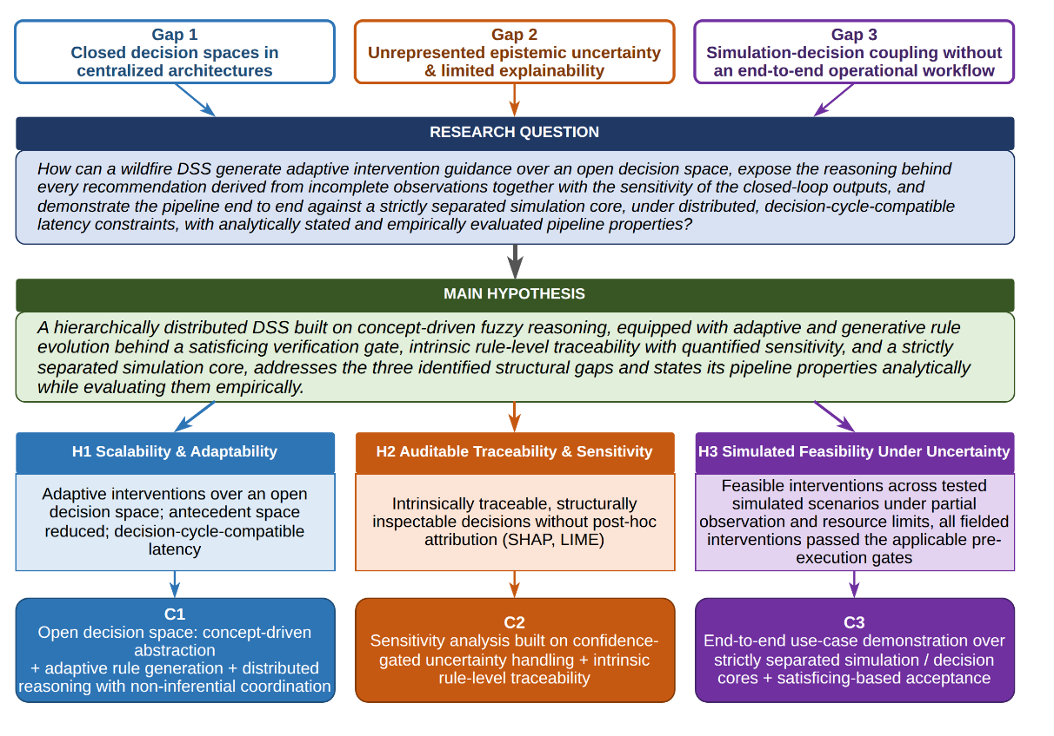
Figure 1.2 Research question, hypothesis, gaps, and contributions
The argument runs from the literature gaps through the research question and the hypotheses to the contributions, as illustrated in Figure 1.2.

Organization of the Thesis
The remainder of the thesis follows the path a decision travels, from background to evidence. Chapter 2 gives the background: wildfire dynamics and spread modeling, decision support foundations, the input space, concept-driven fuzzy reasoning, and the decision space with its cost model. Chapter 3 presents the DisasterAware simulation framework: the system architecture, the external input layers, and the simulation core with its state transition and hybrid spread model. Chapter 4 presents the decision support system layer by layer: the input space, observation and confidence, the concept hierarchy, decision generation with the staged adaptation loop, and the hierarchical organization of local agents and global coordination. Chapter 5 provides the empirical evidence: validation of the simulation core against historical fires, the sensitivity analysis that locates the operating point, the performance of the decision layer from the improvement ladder to the open decision space, and the compliance map. Chapter 6 summarizes the contributions and outlines future research.

BACKGROUND INFORMATION
This chapter presents the background on which the remainder of the thesis builds. Its purpose is twofold: To introduce the concepts on which the design chapters rely, and to justify, on the basis of the literature, the choices that shape DisasterAware. The chapter is organized as follows. Section 2.1 reviews wildfire dynamics and spread modeling. Section 2.2 introduces the foundations of decision support, including closed versus open decision spaces and centralized versus distributed architecture. Section 2.3 presents the input space, from heterogeneous sensing sources to the ten observation features. Section 2.4 develops concept-driven fuzzy reasoning. Section 2.5 defines the decision space: The admissible interventions, the cost, acceptance, and uncertainty machinery by which candidate decisions are judged, and the adaptive and generative loops that keep the decision space open.

Wildfire Dynamics and Spread Modeling
This section reviews the mechanisms of wildfire spread and the principal approaches to modeling it. The treatment is confined to the material required by the subsequent chapters: The physical drivers of fire behavior, the families of spread models, and the properties a decision layer requires from the model to which it is coupled.

Drivers of Fire Behavior
Fire behavior at any point of a landscape is governed by three groups of drivers, namely weather, terrain, and fuel. Weather contributes the most rapidly varying quantities: Air temperature, relative humidity, wind speed and direction, wind gusts, and precipitation. Wind pushes the flame front toward unburned fuel, while humidity and precipitation set the moisture content of fine fuels and, with it, the ease of ignition (Rothermel, 1972). Terrain contributes elevation, slope, aspect, and accessibility. A front burning upslope preheats the fuel above it and accelerates, aspect determines how much solar radiation dries the fuel over the day, and accessibility bounds where crews can act. Fuel contributes the most slowly varying quantities. The vegetation type, the available fuel load, and the fuel moisture determine how intense the combustion becomes and how long a cell keeps burning (Scott & Burgan, 2005).
These drivers are summarized operationally by a small set of quantities: The rate of spread (ROS) of the front, its direction, and the fire line intensity. The Rothermel model expresses ROS as a function of fuel properties, fuel moisture, wind, and slope, and it still underlies most operational tools (Rothermel, 1972; Andrews, 2018); the detailed parameterization used in this thesis is given in Appendix A. The significance of the model for this thesis lies not in its exact functional form but in the causal chain it encodes. Weather, terrain, and fuel jointly determine local spread, and any intervention that modifies one of these inputs alters the behavior of the fire.

Families of Spread Models
The literature groups spread models into three families. Physical and quasi-physical models resolve combustion chemistry and heat transfer; they are the most detailed and the most expensive to run (Sullivan, Wildland surface fire spread modelling 1: Physical and quasi-physical models, 2009a). Empirical and quasi-empirical models fit observed spread rates to environmental variables; they are fast and robust within the conditions for which they are calibrated (Sullivan, Wildland surface fire spread modelling 2: Empirical and quasi-empirical models, 2009b). Simulation models propagate a fire front across a landscape by applying one of the former families as a local kernel; FlamMap is the best-known operational example (Sullivan, Wildland surface fire spread modelling 3: Simulation and mathematical analogue models, 2009c; Finney, An overview of FlamMap fire modeling capabilities, 2006).
Grid-based simulation discretizes the landscape into cells, each holding fuel, moisture, and burn state. A cell ignites with a probability which grows with the number of burning neighbors, their alignment with the wind, and the local fuel condition, and it stops burning when its fuel is consumed or suppressed. This representation matches the resolution at which incident decisions are made, so it is preferred when the model is coupled to a decision layer.

Requirements of the Decision Layer on the Spread Model
A wildfire DSS does not require the highest-fidelity fire simulator available; it requires a testable environment. Testability comprises four properties: Scenarios can be reproduced exactly, the per-cell state can be observed and logged, the inputs through which interventions act can be controlled, and the outcome of a decision can be measured against the outcome of not deciding. Any spread model that offers these four properties, at any level of fidelity, is sufficient to run and evaluate the decision layer; higher fidelity refines the numerical results but alters neither the architecture nor the claims of this thesis. Beyond testability, the coupled model must run at an update rate compatible with the decision cycle.
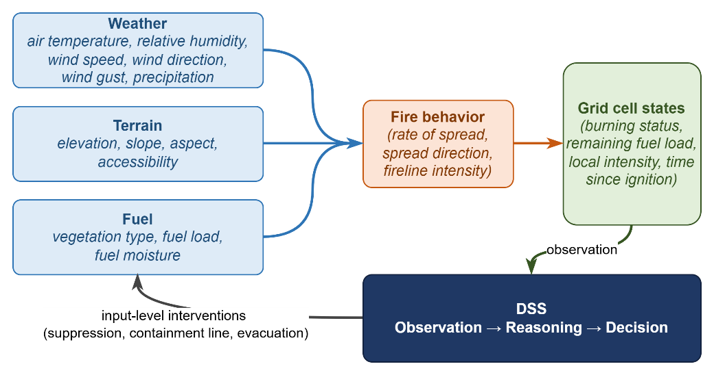
Figure 2.1 Coupling between fire behavior, the grid state, and the decision layer
Figure 2.1 summarizes this coupling: Weather, terrain, and fuel drive fire behavior; fire behavior updates the cell states; the DSS observes cell states and issues interventions; and interventions feed back into the model inputs.

Decision Support Foundations
This section establishes DSS foundations on which the remainder of the thesis rests. It first reviews the core elements that any operational DSS must supply and, in doing so, introduces the two spaces the framework mediates between, namely the input space of observable quantities and the decision space of orderable actions. It then examines the distinction between closed and open decision spaces, which motivates the central contribution of this thesis, and closes with a comparison of centralized and distributed architectures, which determines where reasoning takes place. Together these discussions supply the vocabulary in which the input space, the reasoning machinery, and the decision space of the subsequent sections are defined.

Core Elements of Decision Support Systems
A DSS mediates between two spaces, namely the input space and decision space. The input space comprises everything the system can observe or estimate: Sensor fields, forecasts, terrain and fuel maps, resource states, and the quantities derived from them. The decision space comprises everything the system is authorized to decide, namely the set of actions, with their intensities, locations, and timings, which can be ordered at a given moment.
A DSS is a software system that assists an operator in choosing among actions whose consequences are uncertain (Sprague & Carlson, 1982; Power, Decision support systems: Concepts and resources for managers, 2002). Decision support occupies a deliberate middle ground between full automation and unaided judgment (Power, A Brief History of Decision Support Systems, 2007). In the classical framework of Gorry and Scott Morton it targets semi-structured decisions, those for which parts of the reasoning can be modeled while the remainder requires human judgment (Gorry & Scott Morton, 1971; Simon, The New Science of Management Decision, 1960).
Wildfire response is a canonical instance of this class. The physics of spread can be modeled, and candidate responses can be scored, yet accountability, values, and situational judgment remain with the incident commander; the system therefore recommends, while the decision authority remains with the operator. Independent of domain, a working DSS supplies the same core elements (Turban, Sharda, & Delen, 2011; Sharda, Delen, & Turban, 2018):
Input interface, which transforms raw observations into usable, bounded variables; Knowledge base, which encodes the behavior of the domain, represented in this thesis in the form of fuzzy rules; Reasoning engine, which produces candidate decisions from the current inputs; Decision evaluation, which scores every candidate before it is allowed to act; Presentation and oversight, which enable the operator to inspect, question, and override the outcome.
In time-critical domains two further elements become essential: Explicit uncertainty handling, since inputs are incomplete and unreliable, and timeliness, since a correct recommendation that arrives late has no operational value (French, Maule, & Papamichail, 2019).

Closed versus Open Decision Spaces
In a closed decision space, the alternatives are enumerated before reasoning begins, and the system can only rank them. This structure characterizes classical multi-criteria decision making (Chen & Hwang, 1992; Zavadskas & Turskis, 2011), in which a fixed alternative set is scored against weighted criteria (Hwang & Yoon, 1981; Triantaphyllou, 2000; Malczewski, 1999). The approach fails in wildfire response for a structural reason. Fire behavior evolves continuously, and an incident routinely produces conditions that no predefined alternative covers (Fillmore & Paveglio, 2023; Rapp, Rabung, Wilson, & Toman, 2020).
An open decision space requires three capabilities: (i) modification of existing alternatives during operation, (ii) construction of genuinely new alternatives, and (iii) verification of every new alternative before it acts, since an unchecked generated action constitutes an operational hazard (Seshia, Sadigh, & Sastry, 2022).
Naturalistic decision research established early that experienced commanders do not select from menus at all. In the recognition-primed model, a decision maker constructs a single plausible course of action from recognized patterns, evaluates it by mental simulation, and repairs or replaces it when the simulation fails, so that option generation rather than option ranking is the expert behavior a support system should serve (Klein, 2017; Ross, Shafer, & Klein, 2006). The same expert behavior has a direct computational counterpart.
The evolving fuzzy systems literature made rule structure itself adaptive. Evolving Takagi-Sugeno models create a new rule online whenever incoming data are poorly represented by the existing base, and subsequent variants supplied principled mechanisms for splitting, merging, and pruning rules on streaming data (Angelov & Filev, 2004; Lughofer, 2011). An online value-based selector contributes to the timing of openness, learning from the outcomes of past trials when to invoke the structure-changing stages rather than discovering new actions itself (Sutton & Barto, 2018). Most recently, generative models, including large-language-model agents applied to wildfire analysis and response, have been used to draft candidate rules or actions that lie outside the current structure altogether (Xie, et al., 2024; Chen, et al., 2025; Chandra, Kumar, Patra, & Agarwal, 2025).
DisasterAware combines the three mechanisms: An evolving Takagi-Sugeno (1985) rule base for modification, a generative proposer for construction, and a satisficing acceptance gate for verification (Simon, 1956). The generative proposer is bounded on purpose: it composes new interventions only from physical effects the simulator already verifies, and new concepts only from features and concepts that already exist, so the decision space stays open while every realized action remains admissible.

Centralized and Distributed Decision Support Architectures
In centralized architecture every observation flows to a single reasoning core and every decision flows back out of it. This pattern offers simplicity and global consistency, but the reasoning core constitutes a bottleneck. Communication grows with the size of the domain, latency grows with communication, and a failure of the core silences the entire system (Shim, et al., 2002; Arnott & Pervan, 2005).
In a distributed architecture reasoning moves to local nodes and information flows in both directions. Local nodes send summaries upward when regional balance is needed, and the upper layer returns allocations and priorities downward. Multi-agent systems research provides the coordination mechanisms (Sycara, 1998; Wooldridge, 2009), and wildfire DSS reviews explicitly call for such designs (Vásquez, 2021).
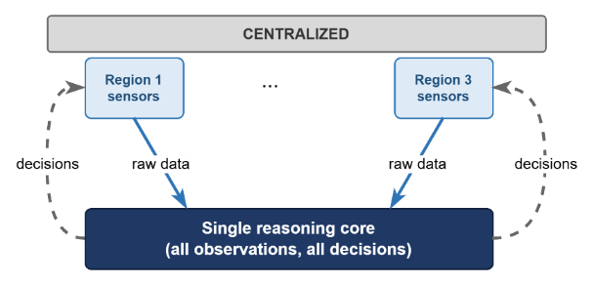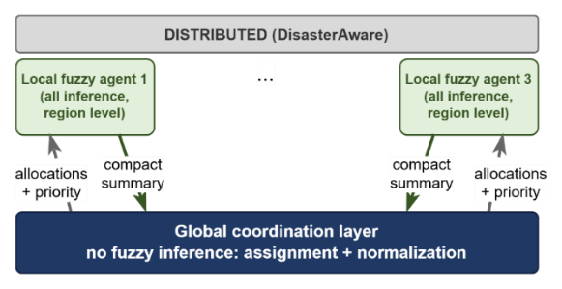
Figure 2.2 Information flow in centralized and distributed DSS architectures
DisasterAware follows the distributed pattern with one restriction. Local DSS agents perform all inference on region-level observations, while the global layer performs no inference at all; it only assigns resources and normalizes priorities across regions. Each Local DSS agent sends up three compact quantities: its region priority, its resource request, and a confidence summary of its observations. The global layer returns the resource allocation, the normalized priority weights, and the acceptance thresholds in force. Neither direction carries raw sensor fields or rule activations, which keeps the channel narrow, the coordination auditable, and the local decision path short. Figure 2.2 contrasts the two patterns and marks the restriction that keeps the global layer non-inferential, which preserves scalability.

The Input Space: Heterogeneous Sensing to Observation Features
A wildfire DSS draws on heterogeneous sensing sources, and none of them observes the fire state directly; each delivers a partial view with its own refresh cycle. For this reason, the features are defined as bounded, observation-derived quantities rather than raw signals.
Concretely, five families of sources feed the framework. Meteorological networks and numerical forecasts deliver gridded temperature, humidity, wind, and precipitation at a fixed cadence. Spaceborne and airborne imagery provides active-fire detections, burned-area mapping, and periodic vegetation and fuel updates, with wide coverage but coarse revisit intervals (Jain, et al., 2020). In-situ sensing, including ground stations and unmanned aerial platforms tasked over the incident, offers high-rate local observations with narrow footprints. Geographic information layers contribute to the quasi-static context, namely terrain, fuel models, road networks, assets, and population (Scott & Burgan, 2005). Finally, the response organization itself constitutes an information source. Resource tracking, dispatch logs, and field reports carry the evolving state of crews, equipment, and access (Martell, Forest fire management, 2007).
These sources are heterogeneous in every operationally relevant respect. They differ in modality, spatial coverage, refresh rate, and reliability, and they produce information of various kinds, from continuous physical fields to categorical status reports. No single raw signal can drive decision rules directly. The heterogeneous stream is therefore reduced by feature extraction to a small set of bounded, observation-derived quantities, and it is exactly this set that constitutes the input space of the framework.
The ten features and the reasoning behind each are compiled in Table 2.1. The set spans threat, exposure, feasibility, and timing, so no operational question of Section 2.4 is left without a supporting feature and none of the ten is redundant.
Table 2.1 The ten observation features, their sources, and their rationale
Feature | Primary source | Rationale
Fire intensity $z_{1}$ | Fire state estimation from imagery and in-situ sensing | Fireline intensity in the tradition of Byram and the Rothermel model is the standard descriptor of how intensely a front is burning
Spread potential $z_{2}$ | Fire state and weather | Rate of spread from fuel, wind, and slope in the Rothermel tradition remains the operational basis of spread assessment
Weather severity $z_{3}$ | Weather stations and forecasts | Fire-weather index systems condense a small set of weather observations into spread and intensity potential
Ignition proximity $z_{4}$ | GIS road and infrastructure layers | Human-caused ignitions cluster near roads and infrastructure, so distance to them drives ignition probability
Fuel load $z_{5}$ | Fuel model layers | Standard fuel models parameterize combustible load and drive every surface-fire prediction
Asset exposure $z_{6}$ | GIS asset and urban interface layers | Values-at-risk mapping quantifies what a fire threatens and supports risk-based response
Resource accessibility $z_{7}$ | Terrain, fuel, and access layers | Suppression difficulty combines the terrain, fuel, and access conditions of a site
Access and road status $z_{8}$ | GIS road status and field reports | Access governs both suppression logistics and evacuation egress
Suppression availability $z_{9}$ | Resource tracking | Fireline production rates and available capacity determine whether suppression can be mounted
Temporal urgency $z_{10}$ | Ignition timing and incident clock | Incident command is time-critical; recognition-primed decision research formalizes acting under urgency

Heterogeneity also imposes admission criteria on the input space. A quantity is admitted to the feature set only if it satisfies four conditions.
- Observability: It must be computable from what sensors and reports actually deliver, never from hidden simulator state.
- Boundedness: It must admit normalization to a fixed interval, so that membership functions remain stable across scenarios.
- Operational meaning: An expert must be able to read it and phrase rules over it without translation.
- Non-redundancy: It must contribute discriminative information that the remaining features do not already carry.

Concept-Driven Fuzzy Reasoning
This section assembles the reasoning machinery of DisasterAware. Fuzzy reasoning is chosen for three reasons established in the preceding sections. The evidence reaching a wildfire DSS is graded and linguistic rather than crisp; the knowledge that binds observations to interventions exists chiefly as expert phrasing, which fuzzy rules encode without translation; and the resulting inference chain remains inspectable, which the traceability requirement of this thesis makes mandatory.

Linguistic Uncertainty and Fuzzy Inference
Operational assessments in wildfire response arrive as graded, linguistic judgments. A spread potential is high, a suppression opportunity is marginal, a boundary estimate is uncertain. Fuzzy set theory supplies the formal counterpart of such judgments by admitting partial membership (Zadeh, Fuzzy sets, 1965; Mendel, 2017). A fuzzy set over a universe of discourse is characterized by a membership function that assigns each element a degree of membership, as formalized in ( 1 ); under this semantics a single wind reading may simultaneously hold membership 0.7 in strong and 0.3 in moderate. In ( 1 ), $Z$ denotes the universe of discourse of an input, $A$ a linguistic term over it, and $μ_{A}(z)$ the degree to which a reading $z$ belongs to $A$. This graded semantics removes the brittle thresholds of crisp classification and preserves expert phrasing under formalization (Pedrycz, 1993). Domain knowledge enters through linguistic rules of the canonical conjunctive form ( 2 ), whose activation strength is the conjunction of its antecedent memberships ( 3 ).
$$μ_{A}:Z→[0,1], L=\{(z,μ_{A}(z)):z∈Z\}$$ | ( 1 )
$$R_{r}: IF z_{1} is A_{r,1} AND … AND z_{n} is A_{r,n} THEN u is B_{r}$$ | ( 2 )
$$α_{r}=\min_{i}⁡μ_{A_{r,i}}(z_{i})$$ | ( 3 )
In ( 2 ) and ( 3 ), $z_{1},…,z_{n}$ denote the input variables, $A_{r,i}$ the linguistic terms selected by rule $R_{r}$, $B_{r}$ the consequent term over the output $u$, and $α_{r}$ the firing strength of rule $r$, with the minimum operator realizing the conjunction of the antecedents. Mamdani inference aggregates the consequents of the active rules and defuzzifies the aggregate into a crisp output (Mamdani, 1974), with the centroid form of ( 4 ) as the standard choice.
$u^{*}=\frac{∫u⋅μ_{agg}(u)du}{∫μ_{agg}(u)du}$, where $μ_{agg}(u)=\max_{r}{min(α_{r},μ_{B_{r}}(u))}⁡$ | ( 4 )
In ( 4 ), $μ_{agg}$ is the aggregated output membership, obtained by clipping each active consequent at its firing strength and taking the pointwise maximum, and $u^{*}$ is the resulting crisp output. The Takagi-Sugeno variant replaces the fuzzy consequent with a functional one and combines outputs as an activation-weighted average ( 5 ).
$$u=\frac{\sum_{r}{α_{r}⋅g_{r}(z)}}{\sum_{r}{α_{r}}}$$ | ( 5 )
In ( 5 ), $g_{r} (z)$ is the functional consequent of rule $r$, typically affine in the inputs. The identification theory behind this form is presented in (Takagi & Sugeno, 1985).
Figure 2.3 illustrates the five-term trapezoidal partition of a normalized input used for every feature and concept. Adjacent terms overlap so that every reading activates at most two terms. Suppose the normalized spread potential of a cell reads $z_{2}=0.62$. Fuzzification against the partition of the figure yields membership 0.53 in MEDIUM and 0.47 in HIGH, and every other term stays at zero. Two rules fire, IF spread potential is MEDIUM THEN suppression effort is moderate with strength 0.53, and IF spread potential is HIGH THEN suppression effort is HIGH with strength 0.47. The zero-order Takagi-Sugeno aggregation weights each singleton consequent by the strength of the rule that carries it, so the recommendation is 0.53 times 0.5 plus 0.47 times 0.8, which yields a suppression effort of 0.64 on the normalized intensity scale, and every intermediate quantity remains visible to the operator.
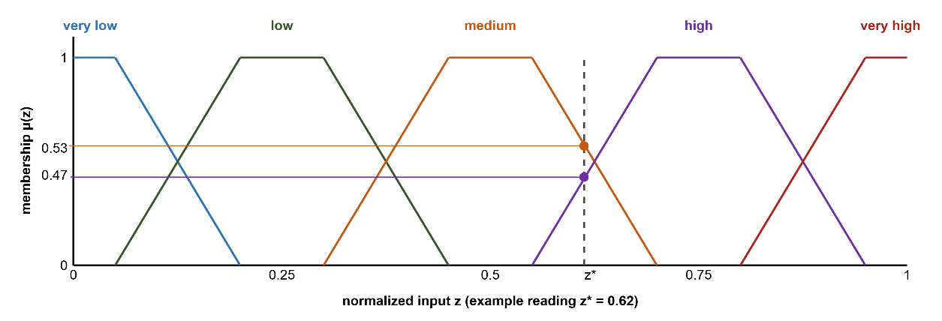
Figure 2.3 Five-term trapezoidal membership partition with an example reading

Mamdani and Takagi-Sugeno Inference: Mechanism and Choice
Two classical mechanisms called Mamdani (1974) and Takagi-Sugeno (1985) turn the activations of ( 3 ) into one crisp action. The difference between them determines what an online learner can touch, what a verification gate can compare, and what a forecast loop can afford. In both mechanisms, crisp inputs are fuzzified against the term partitions, and each rule fires with the strength of its weakest antecedent. The methods differ in the form of the consequent.
Mamdani inference keeps the consequent linguistic. Each active rule clips or scales a consequent membership set at its firing strength, the clipped sets are aggregated pointwise, and the aggregate is defuzzified into a crisp value, typically by the centroid of ( 4 ). The strengths of this construction are real: The knowledge remains linguistic end to end, the output set makes the ambiguity of a decision visible, and the scheme reads naturally for expert elicitation. Its costs are equally real. Every evaluation carries a numeric integration over the output universe; the output surface is piecewise and develops plateaus between rule cores, so nearby situations can read identically; and adaptation can act only on membership geometry, because the consequents are sets rather than parameters.
Takagi-Sugeno inference replaces the consequent set with a function of the inputs, as in ( 5 ), and obtains the crisp output directly as the firing-strength weighted average of the rule consequents. This thesis uses the zero-order special case, in which every consequent is a constant intensity:
$$u=\frac{\sum_{r∈R}{α_{r}⋅v_{r}}}{max\left(\sum_{r∈R}{α_{r}}, 1\right)}, v_{r}∈\left[0,1\right]$$ | ( 6 )
In ( 6 ), $R$ is the set of active rules, $α_{r}$ is the firing strength of rule $r$ from ( 3 ), and $v_{r}$ is its constant consequent, read directly as an intervention intensity on the unit interval. The lower bound of one in the denominator implements the coverage discipline of the framework. When the whole base fires weakly, the output is attenuated rather than renormalized upward, so a barely covered situation cannot masquerade as a confident command. The output is crisp by construction, no defuzzification step exists, and the value interpolates smoothly between the actions of the rules that share the situation.
Figure 2.4 contrasts the two pipelines step by step, and Table 2.2 condenses the comparison. The front of the pipeline is identical; everything that differs follows from the consequent form.
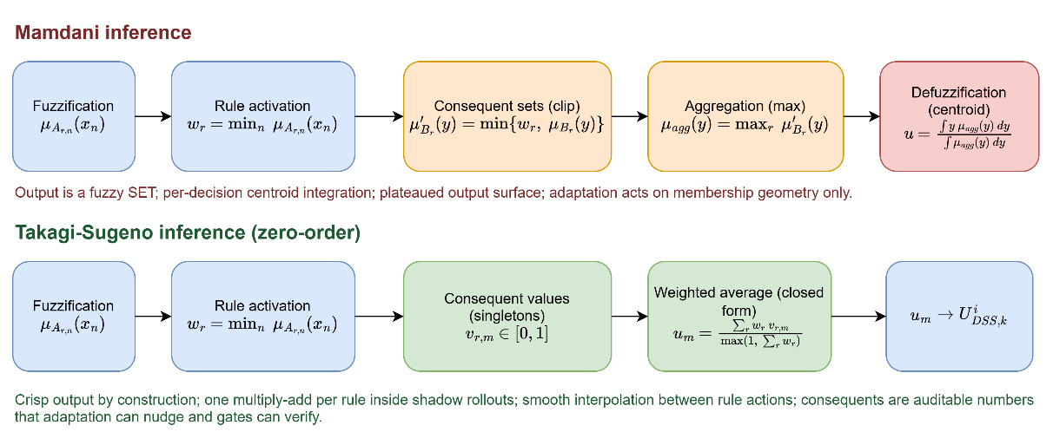
Figure 2.4 Mamdani and zero-order Takagi-Sugeno inference pipelines
Table 2.2 Mamdani and zero-order Takagi-Sugeno inference compared
Aspect | Mamdani | Takagi-Sugeno (zero-order)
Consequent form | Fuzzy set over the output universe | Crisp value in [0,1] per rule
Output computation | Clip, aggregate, then defuzzify by centroid | Firing-strength weighted average, closed form
Cost per evaluation | Numeric integration over the output universe | One multiply-add per active rule
Output surface | Piecewise, plateaus between rule cores | Smooth interpolation between rule actions
Adaptation surface | Membership geometry only | Memberships and consequent values; consequents are bounded numbers a learner can nudge
Verification of a generated rule | Requires defuzzification semantics per proposal | Consequents are auditable numbers; simulation gates compare scalars
Interpretability | Linguistic input and output | Linguistic antecedents; numeric output read as an intensity command

The choice of Takagi-Sugeno in DisasterAware follows four requirements of the architecture. The first is evaluation cost. Every shadow forecast executes the closed form of ( 6 ) thousands of times per incident, and a weighted average of scalar consequents is cheap enough for this load, whereas centroid defuzzification over an output membership surface would dominate the forecast budget. The second is actuation semantics. The outputs of the system are intensity commands such as suppression effort and evacuation priority, so a zero-order consequent already delivers the number that the actuator needs, and no output membership function has to be designed and then defuzzified only to recover it. The third is adaptivity. The staged adaptation of Chapter 4 changes consequents in small steps, instantiates rules on empty cells and inserts terms; each of these operations needs a numeric consequent whose effect on the weighted average is predictable, which a linguistic consequent cannot offer. The fourth is that interpretability is retained where it matters. The antecedents remain linguistic, so a decision still reads as a sentence about the situation, while the numeric consequent is audited as a dosage rather than as a phrase. Mamdani inference remains the right tool where the output itself must stay linguistic, for example in a downstream presentation layer that explains a decision to an operator in words, and DisasterAware does not exclude such a layer; the inference engine itself, however, needs numbers.

The Rule Explosion Problem
The obstacle to applying fuzzy inference directly over a rich observation vector is combinatorial. A complete rule base over the full feature set, with each feature partitioned into a fixed number of linguistic terms, contains the number of rules given in ( 7 ), where $N_{feature}$ denotes the number of features and $N_{term}$ the number of linguistic terms per feature. As an example, 10 features with 5 linguistic terms each would demand $5^{10}=9,765,625$ rules, close to 10M, and even a modest 3 terms per feature already yields $3^{10}=59,049$ rules. A base of this size cannot be elicited from experts, maintained by engineers, or audited by operators (Mendel, 2017).
$$|R|={N_{term}}^{N_{feature}}$$ | ( 7 )

Concepts as an Intermediate Abstraction
The decisive reduction is achieved through a conceptual middle layer. Rather than writing rules over raw features, DisasterAware first composes the features into a compact, multi-level concept hierarchy. Six base concepts summarize physically related features; three mid-level and two higher-level decision concepts built on them answer, each exactly once, the recurring operational questions; and a single top concept, operational priority, serves cross-region coordination. The questions, the decision concepts, and what constructs each are listed in Table 2.3.
Table 2.3 Operational questions and the decision concepts derived from them
Operational question | Decision concept
How severe is the fire threat in this cell? | Fire Threat Level
Can an intervention feasibly be mounted here? | Suppression Feasibility
How exposed are the assets here? | Asset Exposure Risk
How urgent is action here? | Intervention Urgency
Is evacuation pressure building here? | Evacuation Pressure

The derivation follows two principles. Each question must be one that incident commanders actually ask during response (Thompson & Calkin, 2011; Klein, 2017), and each concept must answer its question completely while answering no other, which keeps the concept set complementary and free of redundancy.
Rules are then written over these concepts, while features only feed the concept mappings. With $N_{feature}$ features grouped into $N_{concept}$ concepts drawing on at most $N_{input}$ features each, the rule burden collapses from a product to a sum, as summarized in ( 8 ). Representative rules are enumerated in Table E.1, and the complete concept construction mappings in Table D.1, so every rule that can act in the field is stated explicitly.
$${N_{term}}^{N_{feature}} ⇢ N_{concept}⋅{N_{term}}^{N_{input}}+{N_{term}}^{N_{concept}}$$ | ( 8 )
Here $N_{concept}$ is the number of decision concepts at the top of the hierarchy and $N_{input}$ the largest number of features feeding a single concept. In DisasterAware the concept mappings are realized as weighted aggregations rather than as rule bases, so only the decision rules over the concepts materialize as a rule base. The intermediate layer provides more than combinatorial economy. Concepts constitute the traceability vocabulary of the entire framework. Every recommendation can be read back as a statement over fire threat, suppression feasibility, asset exposure, intervention urgency, and evacuation pressure, and it is precisely this granularity that the evaluation machinery of Section 2.5 and the operator-facing explanations exploit.

The Decision Space: Actions and Their Evaluation
The concept hierarchy of the previous section supplies the vocabulary over which decision rules are written; the output of those rules is an assignment of intensities to concrete actions. This section therefore fixes the decision space in two steps: First the vocabulary of interventions that can be ordered at all, then the cost model, the acceptance rule, and the uncertainty treatment by which candidate assignments over that vocabulary are judged.

Actions and Interventions in Wildfire Decision Support
A wildfire DSS is operationally useful only if its outputs correspond to orders that an incident commander can issue. The decision space of DisasterAware is therefore built from a fixed vocabulary of intervention families, each applied with an intensity over the grid, so that every rule developed in the later chapters binds to a concrete, executable action (Thompson & Calkin, 2011; Pacheco, et al., 2015). Six intervention families cover the levers reported in the wildfire response literature.
Table 2.4 lists each family, the concrete orders it represents, the input-level effect through which it acts on the simulation inputs, and the literature that grounds it. The list is short and closed at the level of families, which keeps the action vocabulary interpretable and allows every recommendation to be read as an executable order; openness enters not through the invention of new physical effects but through the generation of new rules, through interventions composed from the verified effects and the existing families, and through intermediate concepts defined over the existing features and concepts.
Beneath the six doctrine intervention families the simulator verifies a short action list of physical effects: Wet, clear, ignite, coat, draft, evacuate, and prime. Each entry is a field the engine already writes and the cost model already prices, and the list is given in Table 4.3. Three further base actuators built on these effects, water drafting, aerial retardant drop, and tactical burn, are validated in the engine although no seed rule orders them, and they are announced to the generative stage together with their map availability, so a water-dependent actuator is offered only where the map carries a water body. A composed intervention may draw on the full action list and on every base actuator, and it enters the rule base only through the verification gates of Section 4.5. The generative stage never defines a new physical effect; it composes and deploys the effects the simulator already provides.
Table 2.4 Intervention families, representative orders, and input-level effects
Intervention | Representative orders | Input-level effect
Suppression effort (Martell, Forest fire management, 2007) | Direct attack on the active front; indirect attack with backburns and aerial retardant drops | Reduces local fire intensity and the ignition probability of neighboring cells
Resource deployment (Pais, Carrasco, Moudio, & Shen, 2021) | Dispatch, staging, and repositioning of crews, and aircraft across regions | Changes the suppression capacity available to each region
Containment line (Ager, Vaillant, & Finney, 2010) | Firebreak construction and control-line placement along selected boundaries | Removes fuel along the line and blocks propagation paths
Asset protection (Calkin, O'Connor, Thompson, & Stratton, 2021; Noonan-Wright, et al., 2011) | Point protection of structures and critical infrastructure in the fire path | Lowers the loss suffered by a protected asset if the fire reaches it
Evacuation (Turoff, Chumer, Van de Walle, & Yao, 2004) | Evacuation orders, shelter-in-place, staging of the exposed population | Reduces population exposure in threatened cells
Public warning (Comfort, Boin, & Demchak, 2010) | Alerts and information updates issued to the affected public | Raises preparedness and shortens evacuation lead time
Inaction is not modeled as a seventh family. No-intervention is the zero-intensity point of every family rather than a separate alternative, which keeps the decision space continuous and lets the cost model of this section price inaction the same way it prices action. The design has two practical consequences. First, deliberate restraint becomes an explicit, costed recommendation rather than a silent default, and the operator can verify that action is evaluated and that restraint carried the lower expected cost. Second, the adaptation loop can move continuously between restraint and engagement, since raising an intensity from zero requires no structural change to the decision but only a different point in the same intervention field.
A decision layer requires an explicit evaluation criterion before it can adapt, since every candidate intervention must be reduced to a scalar measure of expected cost. The following subsections ground the cost model of DisasterAware and the acceptance rule, the uncertainty treatment, and the sensitivity view built on it.

Decision Cost and Its Components
A candidate intervention is evaluated through its expected cost. Wildfire economics quantifies this through the cost-plus-loss principle. The total cost of a response comprises the expenditure on suppression and the net value lost to the fire (Martell, Forest fire management, 2007; Thompson & Calkin, 2011). DisasterAware adopts the same additive form, so the cost of a decision is the weighted sum of the response effort it spends and the losses it fails to prevent, in the form given in ( 9 ).
$$J\left(U_{DSS,k}\right)=\sum_{j}{w_{j}⋅J_{j}(U_{DSS,k})}, \sum_{j}{w_{j}}=1, J_{j}∈[0,1]$$ | ( 9 )
In ( 9 ), $U_{DSS,k}$ denotes the intervention field at decision step $k$, realized region by region as $U_{DSS,k}^{i}$, $J_{j}$ the individual loss and response terms, each normalized to [0,1], and $w_{j}$ their non-negative priority weights. The loss terms are the recognized values at risk in wildfire response. The components $J_{j}(U_{DSS,k})$, their scope, and the rationale for their inclusion are listed in Table 2.5.
Table 2.5 Decision cost components, their scope, and their rationale
Cost | What it prices | Normalization
Burned area $J_{burn}$ | Land and ecological loss over the affected cells. (Martell, 2007; Thompson & Calkin, 2011) | Burned cells relative to a reference fire of 5 % of the burnable cells, in saturating form
Asset loss $J_{asset}$ | Structures in the wildland-urban interface together with power, transport, and facilities. (Calkin, O'Connor, Thompson, & Stratton, 2021; Pais, Carrasco, Moudio, & Shen, 2021) | Value lost divided by the total exposed value
Population exposure $J_{pop}$ | Life safety of the exposed population. (Turoff, Chumer, Van de Walle, & Yao, 2004; Comfort, Boin, & Demchak, 2010) | Person-steps exposed divided by the population at risk times the horizon
Response cost $J_{resp}$ | Every ordered action, priced by applied intensity, including deployment, evacuation logistics, and warning. | Fielded capacity summed over the decision steps, divided by the reference capacity held over the horizon, capped at one
Response delay $J_{delay}$ | Capacity-weighted mean dispatch time of the fielded resources. (French, Maule, & Papamichail, 2019) | Dispatch time divided by a reference response time of sixty minutes, capped at one

Burned area captures land and ecological loss; asset loss captures, in a single term, both the property of the wildland-urban interface and the power, roads and facilities whose failure cascades beyond the fire (Pais, Carrasco, Moudio, & Shen, 2021); population exposure captures life safety; a response cost captures the resources committed by every ordered action, not only suppression; deployment, evacuation logistics, and public warning all contribute in proportion to the intensity at which they are applied, and deployed capacity is priced regardless of its eventual effectiveness, so that protective actions carry a nonzero cost for the adaptation loop; and a response-delay term penalizes slow action, measured as the capacity-weighted mean dispatch time of the resources actually fielded.
The weights $w_{j}$ are not free parameters. Their initial ordering follows the priority-setting literature (Dunn, Calkin, & Thompson, 2017), using pairwise comparison in the tradition of the analytic hierarchy process over the doctrine of wildfire risk management (Saaty, 1980; Thompson & Calkin, 2011); the vector is then normalized to sum to one, as ( 9 ) requires. The weights used in this thesis are $w_{burn} = w_{asset} = w_{pop} = 1.0 and w_{resp} = w_{delay} = 0.2$ before normalization by their total, which places the physical losses of life, assets, and land jointly first and prices response effort and delay as secondary, in line with published incident-management priority orderings; the cross-run comparisons of Chapter 5 are read on the physical cost, the burned-area, asset, and population terms with their weights renormalized, so no conclusion of this thesis hinges on the response and delay weighting.
The terms are expressed in different units, such as area, monetary value, persons, and time; each term is therefore normalized to [0,1] with respect to a scenario reference scale before weighing. Without this normalization the weighted sum, and any sensitivity analysis over the weights, would lose meaning. The burned area and asset-loss terms are disjoint by construction. Burned area prices land and ecological loss only, while structure and infrastructure values are counted exclusively in their own terms, so no value is counted twice. The reference scales are stated per component in the last column of the cost table, so the terms become dimensionless and mutually summable before the weights apply.
These reference scales also make the model transferable to a live incident. In the field the static scenario totals are replaced by a rolling reference envelope, namely the burned area, the exposed value, and the exposed population that the spread forecast predicts for the current operational period if no intervention is ordered, which is the operational counterpart of probabilistic spread products already in use. Two safeguards keep the construction sound. All denominators are frozen at the start of each operational period, so the adaptation loop cannot improve its apparent score by shrinking its own reference, and every denominator is bounded below, so the ratios stay defined when little or no spread is forecast. The composed plan is subject to one further safeguard. When its forecast is worse than taking no action, its offensive orders are withheld by the no-harm guard of Section 4.6, so a weighted trade-off can never field a plan that the forecast expects to do harm.
The component set is deliberately compact. Fewer terms would conceal trade-offs that commanders must weigh, while additional terms are unnecessary at operational granularity, since finer losses aggregate within the structure and infrastructure terms and are separated by the weights rather than by new components. A compact, interpretable sum allows the decision layer to evaluate candidates online and enables the operator to see why one intervention outranks another.

Satisficing Acceptance and the Graduated Fail-Safe
The cost model of the previous subsection serves as an acceptance criterion rather than as an objective for global optimization. Global minimization over a spatial decision field is computationally intractable under real-time constraints (Papadimitriou & Tsitsiklis, 1987) and presupposes information that incomplete observation cannot supply. DisasterAware follows the satisficing principle of bounded rationality (Simon, 1956; Gigerenzer & Selten, 2001; Simon, 1996). A candidate intervention is accepted when its expected cost clears an adaptive threshold, as given in ( 10 ).
$$accept(U_{DSS,k}) ⇔ {\hat{J}}_{k}(U_{DSS,k})≤min⁡(J_{TH}, (1-δ_{gain})·{\hat{J}}_{k}(0))$$ | ( 10 )
In ( 10 ), $J_{TH}$ is the fixed ceiling on the normalized cost and $δ_{gain}$ the required relative gain over the no-action forecast ${\hat{J}}_{k}(0)$, with $J_{TH} = 0.35$ and $δ_{gain} = 0.05$ in this thesis. The hat marks a cost evaluated on a shadow forecast rather than on the realized state. The bound is the tighter of the two conditions, so a situation in which inaction is already cheap demands a stronger candidate. When no candidate clears the threshold, the framework does not force a binary choice between acting and abstaining. A graduated fail-safe attenuates the best available intervention toward a conservative baseline, ( 11 ).
$${U_{DSS,k}}^{'}=λ_{k}⋅U_{DSS,k}+\left(1-λ_{k}\right)⋅U_{DSS,safe} , λ_{k}∈[0,1]$$ | ( 11 )
In ( 11 ), $U_{DSS,safe}$ is the conservative fallback intervention and $λ_{k}$ the attenuation weight set by decision quality. The weight is $λ_{k} = min(\frac{Q_{k}}{η}, 1)$, where $Q_{k}$ is the measured decision quality and $η$ the quality gate, with $η = 0.60$ in this thesis, so attenuation deepens in proportion to the quality deficit. A value of 1 realizes the intervention in full, intermediate values yield a proportionally reduced commitment, and 0 corresponds to complete fallback to the safe posture. The transition from full intervention through partial intervention to fallback is therefore continuous, auditable, and reversible as observation quality recovers.
The fallback $U_{DSS,safe}$ is not the absence of a decision but a pre-authorized conservative posture. Under it, monitoring and public warning remain active, deployed units hold their current safe positions, and no new offensive commitment is made. In the intervention vocabulary of Table 2.4, $U_{DSS,safe}$ holds suppression effort, resource deployment, containment line, and asset protection at zero and carries the current evacuation and public warning intensities forward. For a candidate with suppression effort 0.8, containment line 0.6, evacuation 0.7, and public warning 0.5, full fallback therefore keeps the evacuation at 0.7 and the warning at 0.5 and zeroes the offensive components. When, for instance, an indirect attack fails the acceptance test because confidence has collapsed over the target sector, attenuation drives the offensive component toward zero while the evacuation and warning components are retained; the original intensity returns once fresh observations restore confidence.

Epistemic Uncertainty, Traceability, and Sensitivity
The uncertainty that dominates an active incident is epistemic. The state is under-observed, not merely noisy (Morgan & Henrion, 1990; Walker, et al., 2003). Bayesian updating and Dempster-Shafer belief calibration both presuppose distributional knowledge that cell-level, real-time sensing does not supply (Pearl, 1988; Shafer, 1976; Zadeh, 1986). DisasterAware instead employs confidence gating. Every concept activation is blended with a persistence-based estimate in proportion to the confidence of the observations that produced it, following ( 12 ). $a_{k}^{obs}$ is the concept activation computed from current observations, $a_{k-1}^{per}$ its persistence-based estimate, carried as the decayed effective activation of the previous step, and $γ_{k}$ the observation confidence; a low-confidence input is thus attenuated toward the most recent trustworthy estimate rather than trusted outright. Each activation is carried as a five-term membership vector and the blend is applied to every term; a scalar reading is used only where a single value per concept is needed.
$${a_{k}}^{eff}=γ_{k}⋅{a_{k}}^{obs}+(1-γ_{k})⋅{a_{k-1}}^{per}, γ_{k}∈[0,1]$$ | ( 12 )
Inference runs over explicit concepts and rules, so every decision remains traceable to the concept activations that produced it, the rules they fired, and the confidence behind them. Explanation is thus a structural property of the pipeline, in contrast to post-hoc attribution methods (Ribeiro, Singh, & Guestrin, 2016; Guidotti, et al., 2018). On this chain, a sensitivity analysis quantifies how a perturbation of an operational parameter of the closed loop propagates to the decision, as in ( 13 ) where ${Sens}_{i,k}$ measures the change of the decision cost $J_{k}$ induced by a change of the varied quantity $p_{k,i}$, with Chapter 5 reading the physical part of the cost as the observed output. Table 2.6 summarizes what the pipeline traces for every decision, what is actually sensed, and which quantities the sensitivity analysis varies and observes.
$$Sens_{i,k}=(ΔJ_{k})/(Δp_{k,i} )$$ | ( 13 )
Table 2.6 Scope of traceability and sensitivity analysis
Scope | Content
Traced for every decision | Concept activations, the rules they fired with their firing strengths, and the observation confidence behind each input
Sensed from the field | Feature values $z_{f}$ with per-cell confidence $γ_{k}$; nothing hidden from observation enters the decision path
Sensitivity inputs (what is varied) | Closed-loop operational parameters: The decision cycle, the no-harm horizon, the observation coverage, the satisficing bound, and the quality gate, together with the fire load, the resource level, the regional partitioning, and the attention threshold
Sensitivity outputs (what is observed) | Decision cost $J_{k}$, read across runs as its physical part, intervention intensities $U_{DSS,k}$, and the acceptance outcome

Generative Models and Large Language Models
Generative models produce new content rather than only classifying or scoring existing content. The form most relevant to decision support is the large language model (LLM). An LLM is a neural network, usually a transformer, trained on large text corpora to predict the next token in a sequence (Vaswani, et al., 2017; Brown, et al., 2020). Through this pre-training it acquires broad linguistic competence and a wide store of world knowledge, which it can recombine into text that follows the structure and the vocabulary asked of it.
A pre-trained model can be applied to a new task without further training, through in-context learning. The task, the relevant context, and often a few examples are placed in the prompt, and the model answers from its fixed weights (Brown, et al., 2020). Domain knowledge can be supplied at query time instead of being written into the weights, and the model is steered by instructions and examples rather than retrained. This is what lets a single general model function as a task-specific component.
In DSS, generative models are used as proposers. They draft candidate actions, rules, or plans that a separate mechanism then evaluates. Their strength is the ability to suggest options that a fixed, hand-written repertoire does not contain. Their weakness is that they can produce fluent output that is factually wrong or unsafe (Amodei, et al., 2016), a failure often called hallucination (Ji, et al., 2023), and their internal reasoning is not directly auditable. A generated artifact is treated as untrusted by construction and is admitted only after explicit verification. In this thesis the model is a replaceable proposal mechanism with a fixed contract. It receives a deterministic summary of the situation together with the closed vocabulary, it must answer in the canonical rule form, and nothing it produces carries authority of its own, since admission rests entirely on the verification gates, which contain no model. Recent work in wildfire analysis has begun to deploy LLM agents as assistants whose outputs are drafted for expert review (Xie, et al., 2024).

Adaptive and Generative Decision Loops
The preceding sections defined the admissible interventions, the reasoning that produces candidate decisions, and the criteria by which candidates are judged. This section presents the mechanism that keeps the decision space open without compromising safety. DisasterAware organizes this as a staged adaptation loop in which a value-based controller chooses, from the outcomes of past trials, which stage to invoke. The stages ① and ② follow the evolving-fuzzy-systems literature (Angelov & Filev, 2004; Lughofer, 2011), the third extends it with generation (Xie, et al., 2024; Chen, et al., 2025; Chandra, Kumar, Patra, & Agarwal, 2025).
Figure 2.5 depicts the complete loop. The rule base issues decisions, the realized cost is fed back, the value-based stage controller selects one of the three operations forming a ladder of increasing invasiveness. Parameter tuning is the least invasive: The evolving-fuzzy stage adjusts the consequents and the membership boundaries of existing rules. Resolution increase goes one step further, instantiating a rule on an uncovered combination or inserting a linguistic term where the residual cost concentrates. Generative proposal is the most invasive: A generative model drafts a candidate rule outside the current rule structure, alone or as a package that brings one new vocabulary object: An intermediate concept combined from existing features and concepts, a macro intervention that blends existing interventions, or a clause actuator composed from the verified physical effects. The proposer supplies candidates only; the stages and gates that admit, field, and retain them are deterministic and model-free.
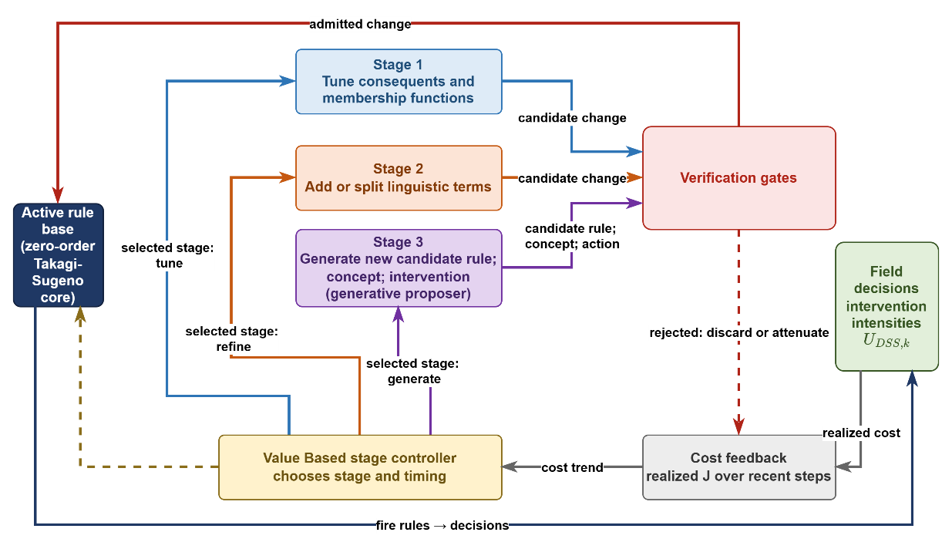
Figure 2.5 Staged adaptation loop with generative proposal and verification
The loop is disciplined by two safeguards. The value-based stage controller decides which stage is invoked, driven by the same cost function that evaluates decisions (Sutton & Barto, 2018). Every candidate must pass the satisficing acceptance gate before it may act, according to the admission condition in ( 14 ).
$$r^{'} admitted ⇔J_{R∪\{r'\}}≤J_{R}-δ, δ≥0$$ | ( 14 )
In ( 14 ), $J_{R}$ denotes the cost achieved under rule base $R$ and $δ$ a non-negative improvement margin, set to zero for a plain rule and to the vocabulary margin $δ_{v}$ for a package that grows the vocabulary, read on the physical part of the cost; an unverified generated rule therefore never reaches the field (Seshia, Sadigh, & Sastry, 2022). The action vocabulary of Section 2.5 remains fixed and interpretable, the rule structure over it evolves and is occasionally extended by generation, and everything that acts has been verified.
The adaptation loop is governed by a value-based, contextual-bandit formulation defined over the following elements. The context is compact: The size of the shortfall of the standing decision, in a low, mid, or high band, and a flag that marks a coverage gap. The action set consists of the three adaptation stages: Tuning the consequents and the membership boundaries of existing rules, growing the rule base, and requesting a generative proposal. The reward is the reduction of the forecast physical cost measured on the shadow run at the moment the modification is accepted, with a small negative reward for a rejected trial and a fixed charge for a package that grows the vocabulary, so that improvements confirmed by the forecast are favored while superfluous structural growth is discouraged.
The three adaptation stages also admit a direct interpretation in decision-space terms. Parameter tuning reshapes the boundaries of decision regions that already exist, so the same rules fire over slightly shifted conditions. Resolution increases partition a region more finely, so situations that previously received one response can now be distinguished. Generative proposal opens a region that no existing rule could reach, extending the reachable part of the decision space itself, and the verification gate decides whether that new region becomes part of the admissible space. When the proposal arrives as a package, the enlargement reaches the vocabulary itself: A new intermediate concept adds an antecedent axis to the space, and a new composed intervention adds a consequent that later rules may order. Openness therefore does not imply arbitrariness. Every enlargement of the space is priced by the cost model and admitted only through the verification gate.

DISASTERAWARE SIMULATION FRAMEWORK
This chapter defines the structural, computational, and physical foundations of the DisasterAware framework, which serves as the physical backbone of the entire architecture. Its objective is to formalize how wildfire dynamics are represented and computed before the reasoning mechanisms of the Decision Support System are introduced in Chapter 4.
Wildfire evolution is modeled as a spatio-temporal process over a discretized spatial domain partitioned into grid cells. Each cell represents a localized fire condition described by structured state variables: Whether combustion is active, the amount of remaining combustible fuel, local fire intensity, and combustion duration. This state-based representation treats fire propagation as a constrained dynamical system rather than a purely geometric spread.
A key design principle is the strict separation between physical state evolution and decision logic. The simulation layer models wildfire behavior under environmental and operational inputs without performing reasoning, optimization, or policy selection. Human interaction and scenario manipulation are permitted only through controlled input-level modifications, never through direct state overwriting. The remainder of this chapter is organized as follows:
Section 3.1 presents the layered architectural structure and inter-layer data flow of the DisasterAware framework.
Section 3.2 formalizes the external input structure: The simulation input set together with its meteorological, topographic, fuel, ignition, and decisional data layers, and the contextual inputs used by the DSS.
Section 3.3 formalizes the simulation core: The discrete-time state representation and its state variables, the hybrid fire spread transition mechanism, and the interaction and scenario control operator.
Section 3.4 introduces the observation interface that exposes the state to the Decision Support System, states the structural positioning of the DSS Core within the framework, and defers its design specification to the next chapter.

Overall System Block Diagram
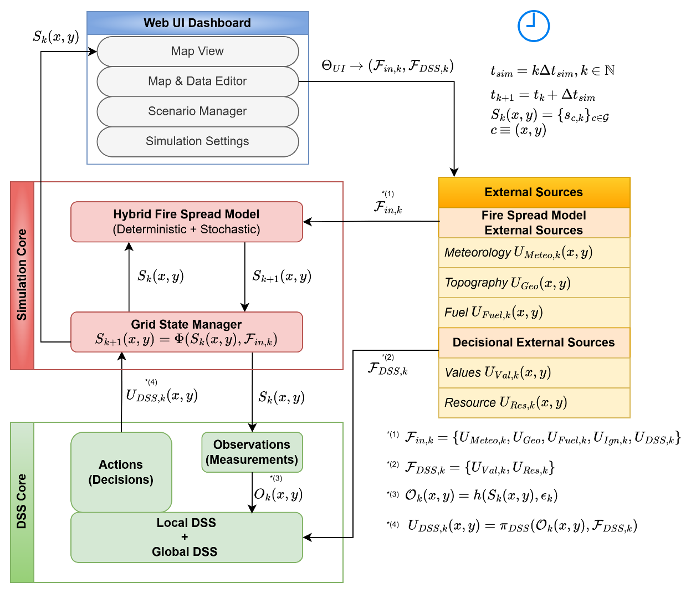
Figure 3.1 DisasterAware system block diagram (simulation focused)
Figure 3.1 presents the architectural structure of the DisasterAware framework. The system is designed as a discrete-time, state-driven, layered DSS architecture with a clear separation between input acquisition, physical state evolution, decision evaluation, and human interaction. The architectural objective is to preserve physical consistency within wildfire simulation while enabling adaptive and interpretable decision-making.
The architecture is organized into four principal layers: External Data Sources, Simulation Core, Decision Support System (DSS) Core, and Web UI Dashboard. Each layer performs a strictly defined function and communicates through structured interfaces rather than direct state manipulation. This separation keeps the physical state consistent and every interface inspectable.
The External Data Sources layer provides structured exogenous inputs including meteorological, terrain, fuel, and decisional parameters. These inputs function as boundary conditions for the simulation. Environmental inputs are independent of the system state, while decision-driven inputs generated by the DSS depend on observable quantities derived from the system state.
At the center of the framework lies the Simulation Core, which serves as the authoritative computational engine. Wildfire propagation is modeled over a spatial grid where each cell contains a structured representation of local fire conditions. The complete wildfire state includes burning status, available combustible mass, local fire intensity proxy, and time since ignition. This state is maintained and updated at every simulation time step.
The Grid State Manager enforces physical constraints such as non-negativity of fuel load and bounded combustion behavior. No external module, including the DSS or the UI, is permitted to directly overwrite internal state variables. All modifications must occur through controlled parameter influence, preserving simulation integrity.
The Decision Support System Core operates as a cognitive layer built on top of the Simulation Core. It reads only the observable quantities $O_{k}\left(x,y\right)$ derived from the system state through the observation process of Section 3.4, and it acts on the state only through the intervention inputs.
The DSS re-evaluates the situation once per decision cycle, an interval set in the evaluation chapter so that orders are revised before they age. Within a cycle, threshold symptoms such as a coverage gap additionally engage the adaptation mechanisms of the next chapter. When a decision is generated, it is translated into operational parameters that influence subsequent state transitions indirectly through the simulation engine.
The Web UI Dashboard forms the operational boundary between human operators and the computational layers. Unlike the Simulation Core, which is time-synchronous, the UI layer operates asynchronously. The operator can pause the simulation; resume execution; roll back to a stored checkpoint; restart from initial conditions; inject new ignition scenarios; modify operational resource availability; and cancel an active simulation.
The UI never directly modifies internal state variables. Instead, it adjusts permissible configuration parameters that affect future simulation steps. This ensures that human intervention remains controlled, traceable, and reversible. The data flow between layers follows a strict directional structure. External inputs feed the Simulation Core at each time step. The Simulation Core updates the authoritative wildfire state. The DSS observes the current state through observable information $O_{k}\left(x,y\right)$, uses contextual decision inputs $F_{DSS,k}$, evaluates risk, and generates structured intervention recommendations when required. The UI visualizes both physical state evolution and DSS outputs while allowing controlled scenario manipulation.
As shown in Figure 3.1, this layered organization enforces a clear separation between wildfire physics, decision cognition, and human supervision. The architecture is designed to ensure: (i) Physical consistency of fire propagation; (ii) Modular extensibility; (iii) Horizontal scalability; (iv) Traceable intervention logic; (v) Robust human-in-the-loop (HIL) control.

Simulation Input and External Sources
The simulation input set $F_{in,k}$ collects every parameter that influences wildfire evolution at discrete time step $k$. These inputs include both exogenous environmental factors and decision-driven intervention parameters generated by the DSS. These inputs function as boundary conditions and forcing mechanisms for the state transition process. At each discrete simulation step $k$, the external input set is updated and provided to the Simulation Core.
External inputs can be categorized into three distinct groups: (i) Environmental input: Including meteorological, terrain, and fuel-related factors that govern physical wildfire dynamics; (ii) Exogenous event inputs: Such as ignition events, which trigger fire initiation independently of system evolution; (iii) Decision-driven inputs: Intervention parameters generated by the DSS, representing operational actions influencing wildfire evolution.
$F_{in,k}$ ( 15 ) represents all external parameters that influence wildfire dynamics, namely meteorology $U_{Meteo,k}$ ( 16 ), topography $U_{Geo}$ ( 17 ), fuel $U_{Fuel\text{,k}}$ ( 18 ), ignition $U_{Ign,k}$ ( 19 ) and inputs generated by DSS $U_{DSS,k}$ ( 20 ). This structured separation ensures that environmental forcing, ignition triggering, and operational intervention remain conceptually and functionally distinct.
$$F_{in,k}=\left\{U_{Meteo,k},U_{Geo}, {U_{Fuel\text{,k}}, U_{Ign,k}, U}_{DSS,k}\right\}$$ | ( 15 )
In addition to the simulation input set $F_{in,k}$, the DSS process relies on a distinct contextual input set defined as $F_{DSS,k}= \{U_{Val,k}, U_{Res,k}$. This set represents value-related and resource-related information used by the DSS for decision evaluation. Unlike $F_{in,k}$, which directly influences the state transition operator, $F_{DSS,k}$ does not affect wildfire dynamics directly. Instead, it provides contextual information that guides decision-generation within the DSS layer.

Meteorology Data Layer
Meteorological inputs $U_{Meteo,k}$ ( 16 ) listed in Table 3.1 are spatio-temporal environmental drivers that influence ignition sustainability, rate of spread, fuel drying, and fire intensity.
$$U_{Meteo,k}\left(x,y\right)=\left[\begin{aligned}W_{temp,k}\left(x,y\right) \\ W_{rh,k}\left(x,y\right) \\ W_{ws,k}\left(x,y\right) \\ W_{wd,k}\left(x,y\right) \\ W_{gust,k}\left(x,y\right) \\ W_{prec,k}\end{aligned}\right]$$ | ( 16 )
Table 3.1 Meteorology data layer parameters
Parameter | Type | Unit | Purpose in Simulation
Air Temperature  $$W_{\text{temp,k}}\left(x,y\right)$$ | Spatio-temporal | °C | Represents ambient air temperature, influencing fuel drying rate, ignition thresholds, and fire intensity potential.
Relative Humidity  $$W_{\text{rh,k}}\left(x,y\right)$$ | Spatio-temporal | % | Represents atmospheric moisture and regulates live/dead fuel moisture levels.
Wind Speed  $$W_{\text{ws,k}}\left(x,y\right)$$ | Spatio-temporal | m/s | Serves as the primary driver of fire spread rate and significantly increases the rate of spread under high-speed conditions.
Wind Direction  $$W_{\text{wd,k}}\left(x,y\right)$$ | Spatio-temporal | rad | Determines the directional propagation of the fire front and controls anisotropic spread behavior.
Wind Gust Speed  $$W_{\text{gust,k}}\left(x,y\right)$$ | Spatio-temporal | m/s | Represents short-term wind fluctuations and stochastic acceleration in fire propagation.
Precipitation  $$W_{\text{prec,k}}$$ | Temporal | mm/h | Increases fuel moisture and can suppress, delay, or weaken active combustion processes.

Topography Data Layer
Terrain parameters $U_{Geo}$ ( 17 ) define static spatial constraints over which wildfire propagation occurs. Unlike meteorological variables, these parameters remain constant during short-horizon simulation but modulate directional spread, acceleration, and accessibility. The geometry parameters are listed in Table 3.2.
$$U_{Geo}\left(x,y\right)=\left[\begin{aligned}G_{elev}\left(x,y\right) \\ G_{slope}\left(x,y\right) \\ G_{aspect}\left(x,y\right) \\ G_{access}\left(x,y\right)\end{aligned}\right]$$ | ( 17 )
Table 3.2 Geometry (topography) data layer parameters
Parameter | Type | Unit | Purpose in Simulation
Elevation  $$G_{\text{elev}}\left(x,y\right)$$ | Spatial | m | Represents the altitude of each grid cell and influences local wind behavior, vegetation type distribution, and environment gradients.
Slope  $$G_{\text{slope}}\left(x,y\right)$$ | Spatial | rad | Represents terrain inclination and increases fire spread rate in the uphill direction due to flame heat transfer effects.
Aspect  $$G_{\text{aspect}}\left(x,y\right)$$ | Spatial | rad | Represents slope orientation and influences solar radiation exposure, fuel drying patterns, and directional fire propagation.
Accessibility Index  $$G_{\text{access}}\left(x,y\right)$$ | Spatial | [0,1] | Represents terrain traversability and influences responder mobility, intervention timing, and operational feasibility.

Fuel Data Layer
Fuel-related inputs $U_{Fuel,k}$ ( 18 ) describe the combustible material available at each grid cell. $F_{\text{type}}\left(x,y\right)$ is the vegetation class and $F_{load,0}\left(x,y\right)$ is the available combustible mass at the initial time. Fuel moisture $F_{moist,k}\left(x,y\right)$ is initialized from meteorological drivers or scenario configurations and thereafter evolves inside the transition operator under precipitation and the optional equilibrium moisture mode. The fuel parameters are listed in Table 3.3.
$$U_{Fuel,k}\left(x,y\right)=\left[\begin{aligned}F_{\text{type}}\left(x,y\right) \\ F_{load,0}\left(x,y\right) \\ F_{\text{moist,k}}\left(x,y\right)\end{aligned}\right]$$ | ( 18 )
Table 3.3 Fuel data layer parameters
Parameter | Type | Unit | Purpose in Simulation
Fuel Type  $F_{\text{type}}\left(x,y\right)$ | Spatial | – | Defines the vegetation within each grid cell and determines combustion characteristics such as burn rate and heat release behavior.
Fuel Load  $F_{\text{load,0}}\left(x,y\right)$ | Spatial | [0,1]$\frac{kg}{m^{2}}$ (norm.) | Represents the available combustible mass in each grid cell and directly controls fire intensity, burn duration, and energy release.
Fuel Moisture  $$F_{\text{moist,k}}\left(x,y\right)$$ | Spatio-temporal | – (mass fraction) | Represents moisture of surface fuels and determines ignition probability and combustion sustainability.

Ignition Layer
Ignition is separate from fire intensity. It is the activation of combustion at a specific grid cell and time step. Ignition may originate from predefined initial conditions, external events, or spotting effects. It functions as a triggering mechanism within the transition dynamics and does not constitute a persistent state variable. The ignition input is defined in ( 19 ) where $I_{Ign,k} (x,y)$ is a binary ignition injection indicator.
$$U_{Ign,k}\left(x,y\right)=\left[\begin{aligned}I_{Ign,k}\left(x,y\right)\end{aligned}\right]$$ | ( 19 )

Decisional Data Layers
The Decisional External Sources ($F_{DSS,k})$ layer represents the non-physical inputs that shape decision making within the distributed DSS. Unlike the meteorological, topographic, and fuel layers that govern fire dynamics, this layer carries the contextual information needed to evaluate operational priorities and constraints, and it therefore determines how simulation outcomes are interpreted and acted upon.
The DSS generates decision-driven intervention parameters $U_{DSS,k}$ ( 20 ) based on the observed quantities $O_{k}\left(x,y\right)$ and $F_{DSS,k}$. $R_{cap,k}\left(x,y\right)$ is the suppression capacity allocated to the cell, $R_{avail,k}\left(x,y\right)$ is operational availability status of resources, $R_{eff,k}\left(x,y\right)$ is suppression effectiveness, and $R_{time,k}\left(x,y\right)$ is estimated travel time to reach grid cell $\left(x, y\right)$.
These parameters do not represent physical measurements but structured representations of operational actions, which are incorporated into the external input set to influence wildfire dynamics. These fields are derived from the intervention intensities over the six families of Table 2.4: Each local agent turns its intensity vector into the slice of $U_{DSS,k}$ for its region, so ( 20 ) is the input-level realization of the decision, distinct from the resource pool $U_{Res,k}$ of Table 3.4.
$$U_{DSS,k}\left(x,y\right)= \left[\begin{aligned}R_{cap,k}\left(x,y\right) \\ R_{avail,k}\left(x,y\right) \\ R_{eff,k}\left(x,y\right) \\ R_{time,k}\left(x,y\right)\end{aligned}\right]$$ | ( 20 )
$F_{DSS,k}$ has two components: The Value Data and the Resource Data layers. The Value layer defines spatial exposure and asset importance, which supports risk-based prioritization. The Resource layer defines the available suppression capabilities and logistical constraints, which support feasible intervention planning. Together they turn the physical fire propagation output of the Simulation Core into actionable decision variables, keeping fire behavior modeling and decision reasoning separate.

Resource Data Layer
The Resource Data layer represents the operational capabilities available for wildfire intervention. While the fire behavior model estimates how fire evolves under environmental conditions, this layer defines the constraints and effectiveness of suppression actions. The resource data layer parameters are listed in Table 3.4.
Table 3.4 Resource data layer parameters
Parameter | Type | Unit | Purpose in Simulation
Suppression Capacity  $${\overline{R}}_{\text{cap,k}}\left(x,y\right)$$ | Spatio-temporal | m³ / step | Represents available suppression capability (i.e., water volume or manpower at grid cell at time step k).
Travel Time  $${\overline{R}}_{\text{time,k}}\left(x,y\right)$$ | Spatio-temporal | min or h | Represents estimated time required to reach a grid cell from current position.
Suppression Efficiency  $${\overline{R}}_{\text{eff,k}}\left(x,y\right)$$ | Spatio-temporal | [0,1] | Quantifies how effectively a resource reduces fuel load or fire intensity.
Resource Availability  $${\overline{R}}_{\text{avail,k}}\left(x,y\right)$$ | Spatio-temporal | [0,1] | Degree to which the resource is currently deployable.

Value Data Layer
The Values-at-Risk Data layer represents exposed assets, infrastructure, and socio-economic elements that may be affected by wildfire propagation. The value data layer parameters are listed in Table 3.5. All variables in this layer are spatially dependent and static during short-term operational simulations, although their priority weights may be dynamically adjusted based on operational objectives.
Table 3.5 Value data layer parameters
Parameter | Type | Unit | Purpose in Simulation
Building Footprint  $$V_{\text{bld}}\left(x,y\right)$$ | Spatial | {0,1} | Represents the presence of residential or commercial structures and enables identification of wildland-urban zones.
Critical Facility Index  $$V_{\text{crit}}\left(x,y\right)$$ | Spatial | {0,1} | Identifies high-priority assets such as hospitals, power plants, fuel depots, and water infrastructure.
Population Density  $$V_{\text{pop}}\left(x,y\right)$$ | Spatial | person/km² | Represents exposed population per grid cell and supports evacuation and safety prioritization.
Accessibility to Evacuation Routes  $$V_{\text{evac}}\left(x,y\right)$$ | Spatial | m | Indicates proximity to evacuation infrastructure and supports emergency planning decisions.
Protection Priority Score  $$V_{\text{prio}}\left(x,y\right)$$ | Spatial | – | Aggregated weighting factor combining multiple exposure indicators to rank cells by importance.

The protection priority score $V_{prio}(x,y)$ aggregates the four value indicators into a single scalar index that ranks each grid cell by its overall protection importance. The aggregation is a normalized weighted sum ( 21 ) where $V_{pop}^{norm} =\frac{V_{pop}}{max V_{pop}}$ is the max-normalized population density, and $V_{evac}^{norm} =\frac{V_{evac}}{max V_{evac}}$ is the max-normalized evacuation distance (higher value indicates poorer access to evacuation routes, hence earlier protective intervention).
$$V_{prio}(x,y) = w_{bld} · V_{bld}(x,y) + w_{crit} · V_{crit}(x,y) + w_{pop} · V_{pop}^{norm}(x,y) + w_{evac} · V_{evac}^{norm}(x,y)$$ | ( 21 )
The weights satisfy $w_{bld} + w_{crit} + w_{pop} + w_{evac} = 1$. The weight assignment reflects the operational priority. Critical facilities ($w_{crit} = 0.40$) receive the highest weight because their loss has cascading consequences (e.g., hospitals, power infrastructure, water supply). Population density ($w_{pop} = 0.25$) ranks second because human life exposure scales with density. Building footprint ($w_{bld} = 0.20$) captures structural asset density. Evacuation accessibility ($w_{evac} = 0.15$) receives the lowest weight because it represents a logistical constraint rather than a direct measure of asset value; however, it remains non-zero because locations with poor evacuation access require protective intervention earlier in the decision timeline.

Simulation Core
The Simulation Core is the computational foundation of the framework. It represents the wildfire as a state defined over a spatial grid and advances it in discrete time through a single transition operator built on a hybrid fire spread model. Each cell carries its burning status, fuel load, fire intensity, and time since ignition, and these evolve together under the meteorological, topographic, and fuel inputs that govern fire dynamics. The operator is deterministic apart from seeded ember spotting; stochastic forcing such as wind gusts enters only through the external input fields and never writes to the state directly. Its design criterion is testability and reproducibility rather than maximal physical fidelity.

Spatio-Temporal State Transition
Each grid cell in $G$ corresponds to a spatial coordinate pair $\left(x, y\right)$ and represents a localized fire condition ( 22 ). $N_{x}$ is the number of grid cells along the horizontal spatial axis, and $N_{y}$ is the number of grid cells along the vertical spatial axis.
$$G=\left\{\left(x,y\right) ∣ x=1,…,N_{x}, y=1,…,N_{y}\right\}$$ | ( 22 )
At each simulation step, the wildfire state over the grid is represented by $S_{k}$. The system state is defined as the collection of local cell states over the domain ( 23 ). $B_{k}\left(x,y\right)$ is the burning status of cell $\left(x,y\right)$, $F_{load,k}\left(x,y\right)$ is available combustible mass, $I_{k}\left(x,y\right)$ is local fire intensity proxy, and $τ_{k}\left(x,y\right)$ is time since ignition.
$$S_{k}=\left\{s_{k}\left(x,y\right)|(x,y)∈G\right\} \\ s_{k}=\left[\begin{aligned}B_{k}\left(x,y\right) \\ F_{load,k}\left(x,y\right) \\ I_{k}\left(x,y\right) \\ τ_{k}\left(x,y\right)\end{aligned}\right]$$ | ( 23 )
The state vector includes only internal wildfire variables. Environmental factors and operational interventions are not part of the state and are represented as external inputs influencing the state transition. Grid domain and the cell state vector representation is illustrated in Figure 3.2.
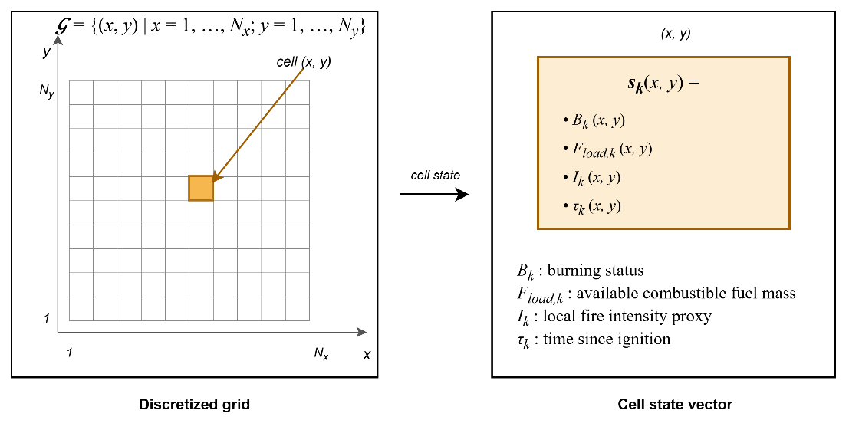
Figure 3.2 Grid domain representation and per-cell state structure

Hybrid Fire Spread Model
The hybrid model integrates deterministic combustion dynamics with stochastic variability to represent realistic wildfire behavior. The global state evolution ( 24 ) is governed by the transition operator where $F_{in,k}$ ( 15 ) includes meteorological forcing, topography, fuel conditions, ignition injection, and DSS-generated intervention parameters. $Φ$ denotes the structured state transition operator composed of burning status evolution, fuel mass evolution, and fire intensity update as defined in the subsequent subsections. The transition operator is deterministic apart from seeded ember spotting; any further stochastic variability enters only through exogenous input fields (e.g., wind gust fluctuations), which are treated as externally provided spatio-temporal inputs.
$$S_{k+1}\left(x,y\right)=Φ\left(S_{k}\left(x,y\right),F_{in,k}\right)$$  $$F_{in,k}=\left\{U_{Meteo,k},U_{Geo}, {U_{Fuel\text{,k}}, U_{Ign,k}, U}_{DSS,k}\right\}$$ | ( 24 )
The overall state transition and hybrid fire spread model is illustrated in Figure 3.3.
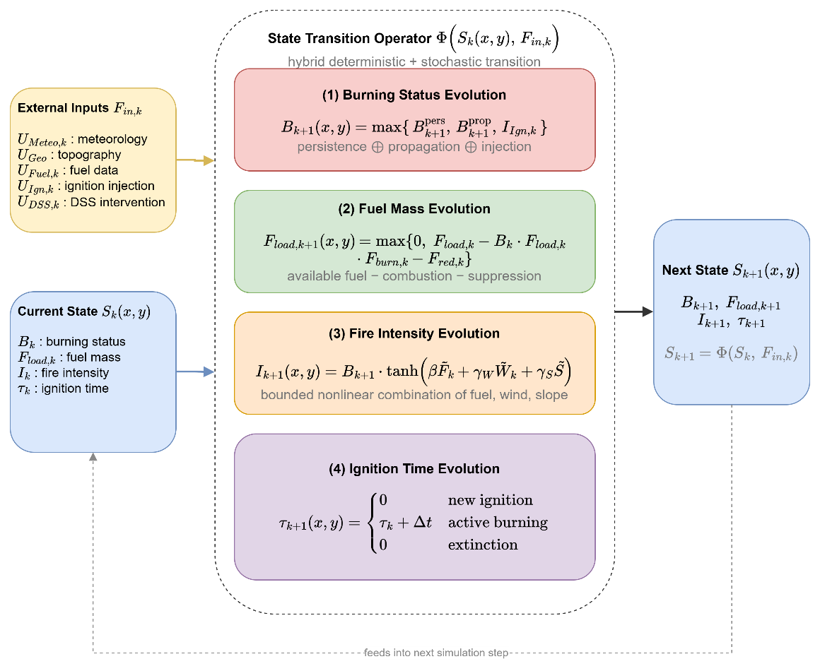
Figure 3.3 State transition block diagram

Burning Status Evolution
The burning status $B_{k}\left(x,y\right)∈\left\{0,1\right\}$ indicates whether the cell is actively burning at time step $k$. The burning status at the next step $B_{k+1}$ ( 25 ) is determined by four mechanisms: persistence of ongoing burning $B_{k+1}^{pers}$ ( 26 ), propagation from neighboring burning cells, seeded ember-spotting ignition, and external ignition injection $I_{Ign,k}\left(x,y\right)$. Combining these mechanisms, the burning status update rule is defined as ( 25 ).
$$B_{k+1}\left(x,y\right)=\max\left(B_{k+1}^{pers}\left(x,y\right),B_{k+1}^{prop}\left(x,y\right),B_{k+1}^{spot}\left(x,y\right),I_{Ign,k}\left(x,y\right)\right)$$ | ( 25 )
This formulation ensures that a burning cell persists while fuel remains available; neighboring burning cells may activate a new cell if sufficient spread influence accumulates; external ignition acts as an independent triggering mechanism. The spotting term activates a cell when a seeded ember of the spotting mechanism lands on it and ignites the remaining fuel.
The persistence term $B_{k+1}^{pers}$ ensures that a cell that is already burning remains burning as long as fuel exists and the fuel moisture stays below the extinction moisture, as stated in ( 26 ) where $1\left[∙\right]$ denotes the indicator function. Below a few percent of the nominal load a cell cannot sustain flaming combustion, so an extinction threshold $ε_{fuel_{load}}$ is applied. The second indicator quenches a burning cell once its fuel moisture reaches the fuel-type extinction moisture of the moisture damping factor, consistent with the precipitation mechanism of the hybrid model.
$$B_{k+1}^{pers}\left(x,y\right)=B_{k}\left(x,y\right)⋅1\left[F_{load,k}\left(x,y\right)>ε_{fuel_{load}} \right]⋅1\left[F_{moist,k}\left(x,y\right)<m_{ext}\left(F_{type}\left(x,y\right)\right)\right]$$  $$ε_{fuel_{load}}=0.03$$ | ( 26 )
Propagation to cell $\left(x,y\right)$ occurs if the accumulated influence exceeds a critical ignition threshold $Θ_{ign}$, where $Θ_{ign}$ is a model parameter representing the minimum spread intensity required to activate combustion in a new cell ( 27 ). In this thesis $Θ_{ign}$ = 0.125 where $Θ_{ign}∈\left(0,1\right)$ is a calibrated threshold relative to the base spread rate.
$$B_{k+1}^{prop}\left(x,y\right)=1\left[Ψ_{k}\left(x,y\right)> Θ_{ign}\right]$$ | ( 27 )
Wildfire spread to neighboring cells is modeled through local propagation influence. $N^{8}\left(x,y\right)$ denotes the 8-connected neighborhood of cell $\left(x,y\right)$. The total propagation influence received by cell $\left(x,y\right)$ at time step $k$ $Ψ_{k}\left(x,y\right)$ is defined in ( 28 ), where the rate of spread $R_{spread,k}\left(x,y\right)$ is ( 29 ). The rate-of-spread mapping $f_{ros}\left(⋅\right)$ is instantiated using a semi-empirical Rothermel-type formulation (Rothermel, 1972). Detailed parameterization is provided in Appendix A. $W_{ws,k}\left(x,y\right)$ is the wind speed field, $W_{wd,k}\left(x,y\right)$ is the wind direction field, $G_{slope}\left(x,y\right)$ is the terrain slope, $G_{aspect}\left(x,y\right)$ is the terrain orientation, $F_{moist,k}\left(x,y\right)$ is the fuel surface moisture, and $F_{type}\left(x,y\right)$ is the fuel type.
$$Ψ_{k}\left(x,y\right)=\frac{1}{8}\sum_{\left(i,j)∈N^{8}(x,y\right)}{B_{k}}\left(i,j\right)⋅R_{spread,k}\left(i,j\right)⋅ g_{dir,k}^{\left(i,j)→(x,y\right)}$$ | ( 28 )
$$R_{spread,k}\left(x,y\right)=f_{ros}\left(\begin{aligned}W_{ws,k}\left(x,y\right), W_{wd,k}\left(x,y\right), \\ {G_{slope}\left(x,y\right),G}_{aspect}\left(x,y\right), \\ F_{moist,k}\left(x,y\right),F_{type}\left(x,y\right) \end{aligned}\right)$$ | ( 29 )
The scalar magnitude $R_{spread,k}\left(x,y\right)$ does not determine spread direction. Directional influence ( 30 ) is introduced when propagating fire from a burning neighbor $\left(i , j\right)$ to target cell $\left(x,y\right)$. $φ_{\left(i,j)→(x,y\right)}$ is the geometric direction between cells. This ensures anisotropic spread aligned with wind direction.
$$g_{dir,k}^{\left(i,j)→(x,y\right)}=\max\left(0,\cos\left(W_{wd,k}\left(i,j\right)-φ_{\left(i,j)→(x,y\right)}\right)\right)$$ | ( 30 )
Figure 3.4 depicts the spatial structure of the propagation influence accumulation. The 3×3 stencil centered on the target cell $(x,y)$ represents the 8-connected neighborhood $N_{8\left(x,y\right)}$ defined in ( 28 ); the three cells shaded in red denote burning neighbors with $B_{k}\left(i,j\right) = 1$, while the remaining five are non-burning. The wind direction $W_{wd,k}$, represented by the large arrow in the upper-right region of the figure, establishes the axis of anisotropy.
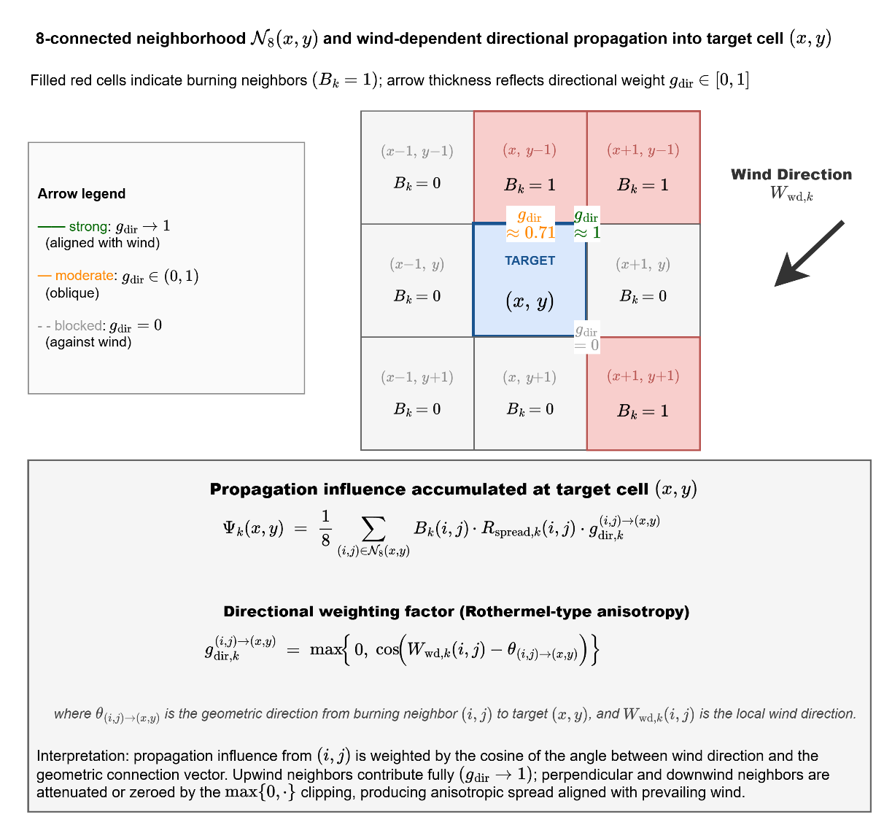
Figure 3.4 Wind-dependent directional propagation into target cell
For each burning neighbor, a propagation arrow is drawn toward the target cell with line weight proportional to its directional weight $g_{dir,k}^{\left(i,j\right)→\left(x,y\right)}$:
The arrow from the northeast neighbor is aligned with the wind vector and therefore receives full weight $g_{dir} → 1$; the arrow from the northern neighbor is oblique and receives an intermediate weight $g_{dir} ≈ 0.71$; and the arrow from the southeastern neighbor is oriented opposite to the wind and is entirely eliminated, $g_{dir} = 0$, by the $max\left\{0, ·\right\}$ clipping of the base kernel.
The aggregate propagation influence $Ψ_{k}\left(x,y\right)$ computed through ( 28 ) is therefore not a symmetric average over the 8-neighborhood but a wind-aligned weighted sum, and the ignition condition $Ψ_{k}(x,y) > Θ_{ign}$ $REF _Ref223041204 \backslash h$( 27 ) is consequently satisfied preferentially along the direction of prevailing wind. This mechanism realizes the Rothermel-type directional bias that is central to operationally realistic wildfire propagation.
The cosine kernel of ( 30 ) is the base form of this directional weighting. The implementation refines it with a wind-elongated elliptical correction whose length-to-breadth ratio grows with wind speed, keeps a small positive weight for flank and rear spread, scales diagonal influence by the center distance of the neighbor, and advances the front in substeps so that spread never exceeds one cell per substep. These refinements alter rates rather than mechanisms, and the ignition condition of ( 27 ) is unchanged.
External ignition injection $I_{Ign,k}\left(x,y\right)∈\left\{0,1\right\}$ directly activates combustion independent of neighbor influence. Ignition injection may represent lightning strikes, human-caused ignition, or scenario-based ignition input from the UI layer. Ignition injection is a scenario-level forcing that sets $B_{k+1}\left(x,y\right)=1$ regardless of local conditions; if $F_{load,k}\left(x,y\right)$ is insufficient, extinction follows naturally via the persistence condition in the next step. In contrast, the local fire intensity proxy $I_{k}\left(x,y\right)$ represents combustion strength after ignition has occurred and does not participate in the activation condition.
Ember spotting extends ignition beyond the resolved front. Each burning cell whose intensity exceeds 0.6, under wind above 3 m/s and precipitation below 1 mm/h, releases an ember with probability 0.02 per reference step, compounded consistently across substeps. The ember lands six cells downwind and ignites the target cell only if fuel remains there and the local fuel moisture is below the extinction threshold. Spotting is the only stochastic element of the transition operator, is driven by the seeded random stream of the scenario, and allows the fire to cross narrow barriers such as rivers, roads, and containment lines under strong and dry winds.
Precipitation acts on the dynamics through the dead fuel moisture. While it rains, $F_{moist}$ relaxes toward at least 0.35, a level above every extinction threshold, with a time constant of roughly thirty minutes scaled by the rain intensity; under sustained rain of at least 3 mm/h a burning cell is quenched once its fuel moisture has reached that level, so a front dies out gradually rather than instantaneously. When the optional equilibrium moisture mode is active, the dead fuel moisture follows the Simard equilibrium moisture content computed from air temperature and relative humidity, so diurnal weather cycles modulate flammability in the manner of operational fire behavior tools.
The rate-of-spread mapping $R_{spread,k}\left(x,y\right)$ is independent of instantaneous fuel mass $F_{load,k}\left(x,y\right)$. Fuel availability influences spread only indirectly through the burning persistence condition, preventing propagation from fuel-depleted cells. This structural separation avoids double-counting mitigation effects.

Fuel Mass Evolution
Fuel mass evolution governs the depletion of combustible material within each cell as a consequence of two distinct mechanisms: Combustion-driven consumption and intervention-driven suppression. Unlike the burning status variable, which represents the activation of combustion, the fuel mass variable represents the remaining energy potential available for future fire propagation. Hence, accurate modeling of fuel evolution is essential to ensure physical consistency, numerical stability, and interpretable interaction between wildfire dynamics and decision-driven mitigation. Combustion-driven consumption and suppression-driven reduction are applied within the same discrete step $k$ as a simultaneous update, represented by the combined terms in ( 31 ) where $B_{k}\left(x,y\right)∈\left\{0,1\right\}$ is the burning status indicator, $F_{burn,k}\left(x,y\right)∈\left[0,1\right]$ is the fractional burn rate of Appendix B, $F_{load,k}\left(x,y\right)$ is the currently available fuel mass, and $F_{red,k}\left(x,y\right)$ is intervention-based fuel reduction.
$$F_{load,k+1}\left(x,y\right)=\max\left(\begin{aligned}0, \left(\begin{aligned}F_{load,k}\left(x,y\right) \\ -F_{load,k}\left(x,y\right) B_{k}\left(x,y\right) F_{burn,k}\left(x,y\right) \\ -F_{red,k}\left(x,y\right)\end{aligned}\right)\end{aligned}\right)$$ | ( 31 )
Fuel cannot become negative and cannot increase unless explicitly modeled, $0≤F_{load,k+1}\left(x,y\right)≤1$. This formulation explicitly separates combustion-induced depletion from suppression-induced reduction while enforcing non-negativity of fuel mass. Fuel consumption due to combustion occurs only when the cell is actively burning. The term $B_{k}\left(x,y\right) F_{load,k}\left(x,y\right) F_{burn,k}\left(x,y\right)$ represents the fraction of available fuel consumed during the current simulation step. The multiplication by $B_{k}\left(x,y\right)$ ensures that fuel depletion due to combustion occurs only in actively burning cells. If the cell is not burning, no combustion-driven reduction takes place. This preserves physical realism and prevents unintended fuel decay in inactive regions. The burn fraction $F_{burn,k}\left(x,y\right)$ captures the local combustion intensity per time step and can be interpreted as a discretized approximation of heat-release-driven fuel consumption. The suppression-induced fuel reduction term $F_{red,k}\left(x,y\right)$ is computed from decision-driven inputs $U_{DSS,k}\left(x,y\right)$ and is not an independent input.
On the other hand, operational intervention modifies the fuel state through the suppression term ( 32 ). This mapping converts operational capability and reachability into a normalized fuel reduction effect. The suppression term may represent water or retardant application; mechanical fuel removal; controlled burn operations; and resource-constrained mitigation strategies. $f_{supp}$ is the suppression-to-fuel-reduction map of Appendix B, $R_{cap,k}$ is the allocated suppression capacity, $R_{avail,k}$ is operational availability status of resources, $R_{eff,k}\left(x,y\right)$ is suppression effectiveness at cell $\left(x , y\right)$, $R_{time,k}\left(x,y\right)$ is estimated travel time to reach $\left(x , y\right)$, and $G_{access}\left(x,y\right)$ is accessibility level at grid cell $\left(x , y\right)$.
$$F_{red,k}\left(x,y\right)=f_{supp} \left(\begin{aligned}R_{cap,k}\left(x,y\right),R_{avail,k}\left(x,y\right),R_{eff,k}\left(x,y\right), \\ R_{time,k}\left(x,y\right),G_{access}\left(x,y\right)\end{aligned}\right)$$ | ( 32 )
Suppression does not directly overwrite the burning state. Instead, it modifies the available fuel mass, which subsequently influences combustion persistence and propagation through the transition operator.

Fire Intensity Evolution
The local fire intensity proxy evolves according to ( 33 ). The function $f_{intensity}\left(⋅\right)$ approximates local fire strength as a function of available fuel, wind forcing, and terrain gradient. $I_{k+1}\left(x,y\right)$ denotes the updated intensity at the next time step; $I_{k}$ does not appear as an argument of $f_{intensity}$. $f_{intensity}$ is the local fire strength function of Appendix C, $F_{load,k}\left(x,y\right)$ is the available combustible mass, $W_{ws,k}\left(x,y\right)$ is wind speed, and $G_{slope}\left(x,y\right)$ is terrain slope.
$$I_{k+1}\left(x,y\right)=f_{intensity}\left(F_{load,k}\left(x,y\right),W_{ws,k}\left(x,y\right),G_{slope}\left(x,y\right)\right)$$ | ( 33 )
The fire intensity proxy serves as an intermediate physical-descriptive variable with the following roles: It does not control ignition activation; it does not directly modify the spread operator; it influences suppression effectiveness through the intervention mapping; and it provides structured features to the Decision Support System. Thus, intensity is a bounded combustion-strength indicator that links environmental forcing to operational response without introducing thermodynamic complexity.

Ignition Time Evolution
The ignition time variable $τ_{k}\left(x,y\right)$ represents the time elapsed since the most recent ignition event at grid cell $\left(x , y\right)$. Unlike fuel mass or intensity, $τ_{k}$ does not influence combustion physics directly. Instead, it serves as a temporal memory state that preserves the burning history of the cell. $τ_{k}$ is a useful state for decision features and explainability within the DSS layer. A deterministic update is ( 34 ).
$$τ_{k+1}\left(x,y\right)=\left\{\begin{matrix}0, & B_{k+1}=1∧B_{k}=0 \\ τ_{k}+Δt, & B_{k+1}=1∧B_{k}=1 \\ 0, & B_{k+1}=0\end{matrix}\right.$$ | ( 34 )
This update has three distinct operational meanings:
- Ignition Initialization: When a cell transitions from non-burning to burning $B_{k}=0, B_{k+1}=1,$ the ignition clock is initialized: $τ_{k+1}=0$. This marks the start of a new combustion phase.
- Active Burning Progression: When a cell remains in the burning state $B_{k}=1, B_{k+1}=1$, the ignition time increases linearly: $τ_{k+1}=τ_{k}+Δt.$ Thus, $τ_{k}$ measures the residence time of active combustion at the cell.
- Extinction Reset: When combustion ceases $B_{k+1}=0,$ the ignition clock resets to 0. It ensures extinguished cells carry no residual temporal memory.
$τ_{k}$ does not feed back into the burning activation condition in the present model.

Mathematical Formulation of Interaction and Scenario Control
The Interaction and Scenario Control mechanism enables controlled human intervention within the DisasterAware framework while preserving the physical consistency of wildfire dynamics. The external simulation input set is $F_{in,k}=\left\{U_{Meteo,k},U_{Geo},U_{Fuel,k},U_{Ign,k},U_{DSS,k}\right\}$ and decision-context set is $F_{DSS,k}=\left\{U_{Val,k},U_{Res,k}\right\}$. The user interaction operator $Θ_{UI}$ is a structured input transformation mapping that produces admissible modifications of the external input set and decision-context set ( 35 ).
$$Θ_{UI}:F_{in}×F_{DSS} ⟶ F_{in}^{*}×F_{DSS}^{*}$$  $$\left(F_{in,k}^{*}, F_{DSS,k}^{*})=Θ_{UI}(F_{in,k}, F_{DSS,k}\right)$$ | ( 35 )
The operator acts independently on four admissible inputs. For each component, the admissible transformation is defined by a bounded perturbation set in Table 3.6. All unmodified components pass through unchanged: $U_{Geo}^{*}=U_{Geo}$, $U_{Fuel,k}^{*}=U_{Fuel,k}$. The decision component $U_{DSS,k}$ is not an operator surface; it is produced by the DSS.
Table 3.6 Admissible transformations of interaction operator
Component | Admissible transformation | Constraint
Ignition $U_{Ign,k}$ | $$U_{Ign,k}^{*}\left(x,y\right)=U_{Ign,k}\left(x,y\right)+δ_{Ign}\left(x,y\right)$$ | $$U_{Ign,k}^{*}∈\left\{0,1\right\}$$
Meteo. $U_{Meteo,k}$ | $$U_{Meteo,k}^{*}=U_{Meteo,k}+δ_{Meteo}$$ | $$U_{Meteo,k}^{*}∈U_{Meteo}$$
Value $U_{Val,k}$ | $$U_{Val,k}^{*}\left(x,y\right)=σ_{Val}⋅U_{Val,k}\left(x,y\right)$$ | $$σ_{Val},U_{Val,k}^{*}∈\left[0,1\right]$$
Resource $U_{Res,k}$ | $$U_{Res,k}^{*}\left(x,y\right)=U_{Res,k}\left(x,y\right)+δ_{Res}\left(x,y\right)$$ | $$U_{Res,k}^{*}∈\left[0,1\right]$$

The operator $Θ_{UI}$ acts exclusively on the external input set $F_{in,k}$ and decision-context set $F_{DSS,k}$. The system state $S_{k}\left(x,y\right)$ is not in the domain of $Θ_{UI}$, $\frac{∂S_{k}}{∂Θ_{UI}}=0$. All operator influence propagates through physically consistent state transitions $S_{k+1}=Φ\left(S_{k},F_{in,k}^{*}\right)$, preserving the causal structure and state immutability.
$Θ_{UI}$ modifies only future state transitions. It does not alter the current state $S_{k}$ or any previously realized state $S_{j}$, $j<k$. This ensures that scenario exploration and operational overrides are prospective, not retrospective. The modified decision-context set influences decision generation $U_{DSS,k}=π_{DSS}\left(O_{k},F_{DSS,k}^{*}\right)$ and the modified simulation input set governs system evolution $S_{k+1}=Φ\left(S_{k},F_{in,k}^{*}\right)$
Within this formulation, user interaction supports multiple operational functions: Scenario intervention is modification of ignition inputs $U_{Ign,k}$ to inject or alter fire events. Environmental what-if analysis is controlled perturbation of meteorological inputs $U_{Meteo,k}$. Priority reconfiguration is modification of value-based context $U_{Val,k}$. Resource reallocation is modification of resource availability $U_{Res,k}$. These interaction capabilities allow the system to operate as a HIL DSS, where the operator can dynamically influence both the operational context and the evolution of the simulated environment.
Interaction does not bypass the DSS. Any modification applied to $F_{DSS,k}$ is incorporated into the decision-generation process through $π_{DSS}\left(⋅\right)$, ensuring that all intervention signals remain consistent with the decision architecture.
The Simulation Core additionally maintains per-step state snapshots under a bounded memory budget, enabling counterfactual replay. The operator can rewind the incident to any recorded step, modify the conditions or the intervention, and re-simulate. This mechanism underlies the with and without DSS comparisons on identical fire histories of Chapter 5. The replay is exact rather than approximate. A snapshot carries every mutable part of the run: the per-cell state vector, the fuel moisture field, the evacuated population, the accumulated cost integrals, and the state of the random number generator, and the exogenous weather driver is replayed unchanged. Two runs started from the same snapshot therefore differ only in the orders under test, and any difference in their outcomes is attributable to those orders alone. The comparison is a controlled experiment on the incident itself, not a statistical estimate over an ensemble.

Decision Support System Core
While the Simulation Core governs the physical evolution of wildfire dynamics through the state transition operator $S_{k+1}\left(x,y\right)=Φ\left(S_{k}\left(x,y\right),F_{in,k}\right)$, the DSS operates on observable quantities $O_{k}\left(x,y\right)=h\left(S_{k}\left(x,y\right),ε_{k}\right)$ derived from the simulation state through the observation process, rather than directly accessing the full system state. Observation uncertainty $ε_{k}\left(x,y\right)$ is incorporated within the DSS through uncertainty-aware reasoning mechanisms operating on $O_{k}\left(x,y\right)$. The DSS evaluates decision-relevant indicators derived from $O_{k}\left(x,y\right)$ and contextual inputs $F_{DSS,k}$ to generate structured intervention inputs $U_{DSS,k}$ that influence subsequent system evolution.
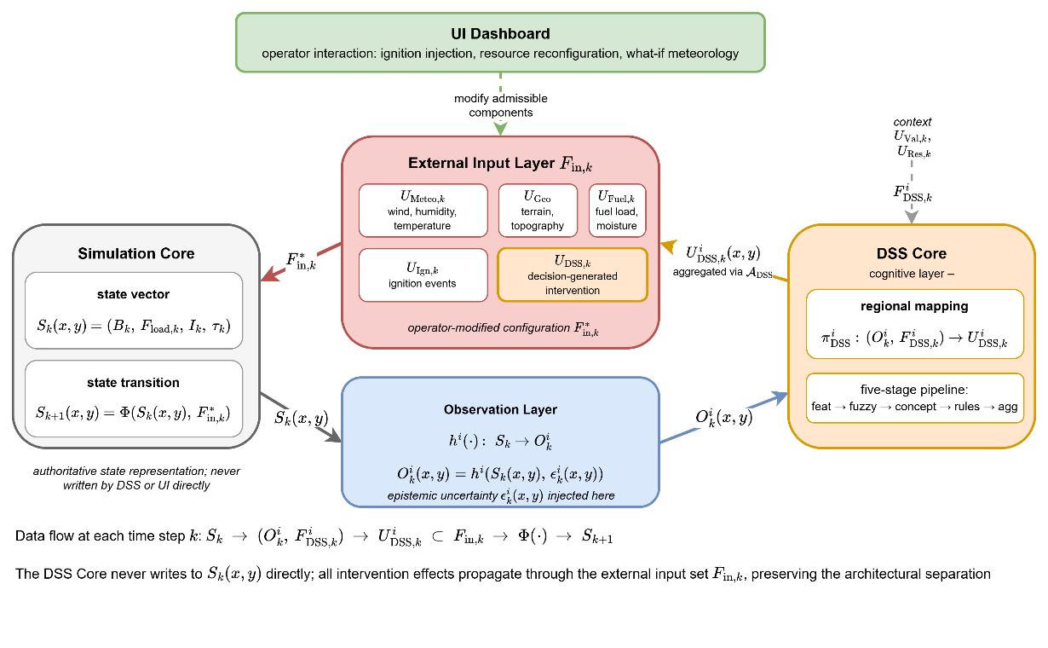
Figure 3.5 DSS Simulation Core Interface
The DSS interaction follows ( 36 ). This preserves the architectural separation between state evolution and decision generation. All decision impact must propagate through admissible modifications of the external input set. The information and control flow captured by ( 36 ) is summarized in Figure 3.5.
$$S_{k}\left(x,y\right)→ O_{k}\left(x,y\right),F_{DSS,k}→U_{DSS,k}\left(x,y\right)→Φ\left(∙\right)→S_{k+1}\left(x,y\right)$$  $$O_{k}\left(x,y\right)=h\left(S_{k}\left(x,y\right), ε_{k}\right)$$  $$U_{DSS,k}\left(x,y\right) = π_{DSS}^{i}\left(O_{k}\left(x,y\right),F_{DSS,k}\right) ⊂ F_{in,k}$$ | ( 36 )
The Simulation Core maintains the authoritative state vector $S_{k}\left(x,y\right)=\left(B_{k}, F_{load,k}, I_{k}, τ_{k}\right)$ and advances it through the state transition operator $Φ$. The Observation Layer applies the region-specific observation function $h^{i}\left(⋅\right)$ to project the state onto observable information $O_{k}^{i}\left(x,y\right)=h^{i}\left(S_{k}\left(x,y\right), ε_{k}^{i}\left(x,y\right)\right)$, injecting the epistemic uncertainty $ε_{k}^{i}\left(x,y\right)$ at this point and at this point only.
The observation is a per-cell projection with a confidence attached to it, not a copy of the state. For each sensor channel the observed value is the true value plus a bounded disturbance whose admissible size shrinks with the confidence of the cell, so a fully confident cell is observed exactly while a cell with vanishing confidence may carry the largest error of its channel. The confidence is composed per cell from the observability, coverage, freshness, and reliability of the sources that cover it, as developed in Section 4.3. A cell that no sensor covers therefore reaches the DSS with low confidence and is treated with caution rather than trusted, and the DSS never learns how large the disturbance actually was.
The decision-cost trajectory later supplied to the generative adaptation stage is computed from these observed quantities, not from the authoritative state. The DSS Core executes the regional mapping $π_{DSS}^{i}: \left(O_{k}^{i}, F_{DSS,k}^{i}\right)→U_{DSS,k}^{i}$ on the region-specific observation and the contextual inputs $F_{DSS,k}^{i}=\left(U_{Val,k}, U_{Res,k}\right)$, producing the regional decision field $U_{DSS,k}^{i}\left(x,y\right)$.
The two cores run on different clocks. The Simulation Core advances the state at every integration step, whereas the DSS is invoked once per decision cycle, which spans several integration steps, and the most recent intervention field is held constant in between. Within a cycle the DSS judges its candidates on a shadow copy of the Simulation Core rather than on the authoritative state: The copy is started from a snapshot of the current state, advanced over the no-harm horizon once under the candidate and once under no action, and then discarded. The snapshot mechanism of Section 3.3.3 makes the two shadow runs exactly comparable, and nothing a shadow run computes is written back to the authoritative state; the comparison that decides acceptance is the satisficing test of Section 4.5.2.
Regional decisions from the $N$ agents are aggregated through the coordination operator $A_{DSS}$, realized by the global coordination layer of Section 4.6, into the global intervention field, which is injected into the External Input Layer $F_{in,k}$ as the $U_{DSS,k}$ component alongside the four exogenous inputs $U_{Meteo,k}$, $U_{Geo}$, $U_{Fuel,k}$, and $U_{Ign,k}$. This component is the only part of the input set that the DSS writes; the four exogenous inputs remain under the control of the external sources and of the interaction operator.
The UI Dashboard can modify admissible components of $F_{in,k}$ through the interaction operator $Θ_{UI}$, yielding the operator-modified configuration $F_{in,k}^{*}$ that drives the next state transition $S_{k+1}\left(x,y\right)=Φ\left(S_{k}\left(x,y\right), F_{in,k}^{*}\right)$.

DISASTERAWARE DECISION SUPPORT FRAMEWORK
This chapter presents the DisasterAware DSS, the cognitive layer that operates on top of the simulation core. The simulation core governs the physical evolution of the wildfire state, while the DSS reads only the observable part of that state, through sensors with latency, coverage limits, and noise, and returns an intensity vector over the six intervention families. Between observation and decision the DSS works in four layers: the input space collects heterogeneous measurements, the observation layer turns them into features with a per-cell confidence, the concept space fuzzifies and aggregates the features into a small hierarchy of concepts, and the decision space fires a sparse Takagi-Sugeno rule base, tests each candidate on a shadow forecast, and adapts the rule base in stages when the candidate falls short. The pipeline is executed by one Local DSS agent per region and coordinated by a Global DSS that ranks the regions and assigns attention shares but performs no inference of its own. The remainder of this chapter is organized as follows:
Section 4.1 presents the DSS block diagram: The four-layer pipeline of a Local DSS agent and its hierarchically distributed organization, in which a non-inferential Global DSS ranks the regions and shares the common resource pool.
Section 4.2 defines Layer 1, the input space: The external data layers each region draws on, none of which observes the fire state directly.
Section 4.3 develops Layer 2, the observation model: The ten observation features and the confidence factors that qualify them, so that every quantity entering the reasoning carries a statement of how much it can be trusted.
Section 4.4 builds Layer 3, the concept space: The feature-concept hierarchy that aggregates the features into five decision concepts, and the confidence gating that blends observation with a persistence prior in proportion to confidence.
Section 4.5 develops Layer 4, decision generation and coordination: The sparse Takagi-Sugeno rule base and its candidate intervention field, the cost and quality measures by which candidates are judged, the satisficing acceptance test, and the staged adaptation that keeps the decision space open.
Section 4.6 presents the hierarchical organization: The Local DSS that runs this decision path inside its region, the global coordination that turns regional priorities into attention allocations, and the no-harm guard on the composed plan.

Decision Support System Block Diagram
Figure 4.1 presents the complete framework of a Local DSS agent. Unlike Figure 3.1, which emphasizes the simulation-relevant layers, this block diagram focuses on the layers relevant to the DSS.
The input space (Layer 1) collects heterogeneous, spatio-temporal measurements; the observation layer (Layer 2) turns them into the ten features, each with an explicit confidence; the concept space (Layer 3) abstracts the features into the four-level concept hierarchy; the decision space (Layer 4) fires the rules, evaluates the candidate intervention, and adapts the rule base when the candidate falls short.
The output of the local DSS ($U_{DSS,k}^{i}$) feeds the simulation core, and $S_{k+1}$ is obtained as described in Chapter 3. In operation, N agents execute this loop concurrently, each restricted to the cells of its own region, while the Global DSS coordinates them by ranking the regions and allocating the shared resource pool, without performing inference of its own.
The environment band on the right is common to all agents; each agent sees only its own regional projection of it. Layer 4 judges every candidate on a forecast started from the current state, not from the state in which the candidate was generated.
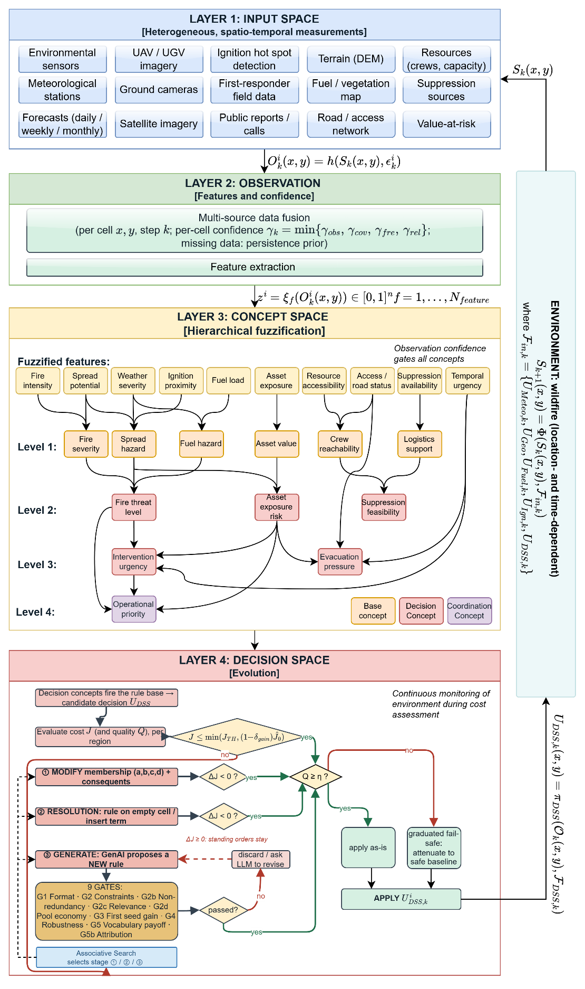
Figure 4.1 DisasterAware system block diagram (DSS focused)

Layer 1: Input Space
The input space of the DSS is a set of heterogeneous spatio-temporal measurements shown in Figure 4.1: Meteorology, imagery and ignition detections, terrain, fuel, road, and value-at-risk layers, and the resource and field reports of the response organization. None of these sources observes the fire state directly, so everything the DSS consumes is a partial, differently refreshed projection of a hidden situation.

Layer 2: Observation, Features, and Confidence
The observation layer turns the input space into the quantities on which reasoning operates. Any Local DSS agent $i$ receives at step $k$ the region-restricted observation defined in ( 37 ). The region-specific observation function projects the authoritative state onto the cells of region $i$ and injects the epistemic uncertainty at this point.
Epistemic means that the uncertainty comes from missing knowledge rather than from randomness: A camera may be occluded by smoke, a satellite product may arrive only every few hours, a road sensor may be offline, and a field report may be late or absent. No probability distribution over the error is assumed; the treatment that follows is bounded and confidence-driven.
$$O_{k}^{i}\left(x,y\right)=h^{i}\left(S_{k}\left(x,y\right), ε_{k}^{i}\left(x,y\right)\right), \left(x,y\right)∈G^{i}$$ | ( 37 )
Every observed cell carries an observation confidence composed from four factors. Observability $γ_{obs}$ is the degree to which the underlying quantity can be sensed at the cell; it is set from the sensor model of the channel, such as occlusion, line of sight, and product availability. Coverage $γ_{cov}$ is computed per cell from the footprints of the satellite, aerial, and in-situ assets that cover it, averaged over the region. Freshness $γ_{fre}$ decays exponentially with the age of the most recent report, with a half-life of 90 minutes: It is one for a report from the current step and falls toward zero as the report ages. Reliability $γ_{rel}$ is the trust assigned to the reporting channel; calibrated sensors are near one, unproven public reports lower.
The composition is conservative; the confidence equals the weakest factor rather than an average ( 38 ). Satellite products realize wide coverage with coarse freshness, aerial platforms high freshness over narrow footprints, in-situ sensors high reliability at fixed points, and field reports contextual observability with variable reliability.
$$γ_{k}^{i}\left(x,y\right)=min⁡\{γ_{obs},γ_{cov},γ_{fre},γ_{rel}\}$$ | ( 38 )
Confidence bounds the disturbance instead of describing it statistically, as stated in ( 39 ): The magnitude of the observation error at a cell cannot exceed $(1 - γ)·ε_{max}$, where $ε_{max}$ is the largest error the reporting channel can make when nothing is known about it. A fully confident observation ($γ = 1$) is exact, a vanishing confidence ($γ = 0$) admits the full $ε_{max}$, and intermediate confidence scales the admissible error linearly. In the simulation core the bound is realized directly: For each sensor channel the observed value is the true value plus a disturbance drawn uniformly in $±(1 - γ)·ε_{max}$ and clipped to the unit interval, and the burning status is read as burning when the disturbed value exceeds 0.5. The channel constants $ε_{max}$ are listed in Table D.2. The DSS never sees $ε$; it sees only $γ$, so ( 39 ) is the assumption that lets confidence stand in for error size in the gating of Layer 3. Missing observations are bridged by the persistence prior of the concept layer rather than by imputation.
$$|ε_{k}^{i}\left(x,y\right)|≤(1-γ_{k}^{i}\left(x,y\right))⋅ε_{max}$$ | ( 39 )
From the regional observation, the agent computes the ten features of Table 2.1 ( 40 ). Each feature inherits a feature-level confidence from the observation fields its extraction map consumes, so the pair of feature value and feature confidence is the complete interface between perception and reasoning.
$$z_{f,k}^{i}=ξ_{f}\left(O_{k}^{i}\right)∈[0,1], f=1,…,N_{feature}$$ | ( 40 )
The ten features are listed in Table 2.1: Fire intensity, spread potential, weather severity, ignition proximity, fuel load, asset exposure, resource accessibility, access and road status, suppression availability, and temporal urgency.

Layer 3: Concept Space and the Feature-Concept Hierarchy
Rules cannot be written over the features directly. With ten features and five linguistic terms per feature, a flat rule base spans 9,765,625 antecedent combinations, which can neither be elicited from experts nor audited by operators. The conceptualization layer maps physically related features into six base concepts, the base concepts into three mid-level and two higher-level decision concepts, and finally into the single coordination concept; decision rules are then written over the five decision concepts only, whose antecedent space contains $5^{5}=3125$ combinations, of which the evolving rule base instantiates only the small subset that observed situations activate. Figure 4.2 illustrates the solution of this problem by hierarchical conceptualization.
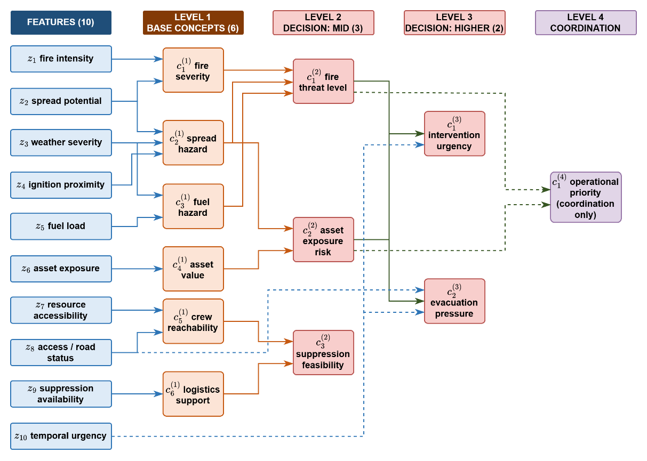
Figure 4.2 Feature-concept hierarchy
The five decision concepts answer, one for one, the five operational questions of Table 2.3, so a rule written over them reads as an operational statement. The mapping between features and concepts is fully specified by the sets of ( 41 ). Each concept is written in the positional notation c with a lower index for its place within a level and an upper index for its level, so that fire severity, spread hazard, fuel hazard, asset value, crew reachability, and logistics support are the six base concepts of level one, fire threat level, asset exposure risk, and suppression feasibility occupy level two, intervention urgency and evacuation pressure occupy level three, and operational priority is the single concept of level four, as listed in Table D.1.
Base Concepts | Decision concepts | ( 41 )
$$C_{1}^{(1)}=\left\{z_{1},z_{2}\right\} \\ C_{2}^{(1)}=\left\{z_{2},z_{3},z_{4}\right\} \\ C_{3}^{(1)}=\left\{z_{3},z_{5}\right\}, \\ C_{4}^{(1)}=\left\{z_{6}\right\}, \\ C_{5}^{(1)}=\left\{z_{7},z_{8}\right\}, \\ C_{6}^{(1)}=\left\{z_{9}\right\}$$ | $$C_{1}^{(2)}=\left\{c_{1}^{(1)},c_{2}^{(1)},c_{3}^{(1)}\right\} \\ C_{2}^{(2)}=\left\{c_{2}^{(1)},c_{4}^{(1)}\right\}, \\ C_{3}^{(2)}=\left\{c_{5}^{(1)},c_{6}^{(1)}\right\} \\ C_{1}^{(3)}=\left\{c_{1}^{(2)},c_{2}^{(2)},z_{10}\right\}, \\ C_{2}^{(3)}=\left\{c_{2}^{(2)},1-z_{8},z_{10}\right\} \\ C_{1}^{(4)}=\{c_{1}^{(2)},c_{2}^{(2)}\}$$ | ( 41 )
The activation of a base concept is the weighted sum of the term memberships of the features in its set, and the activation of every higher concept is the weighted sum of the activations of the concepts in its set, with the nonnegative weights of each concept normalized to one ( 42 ).
$$a_{n,k}^{(1),i}=\sum_{f∈Z_{n}}{ω_{n,f}⋅μ_{A_{n,f}}\left(z_{f,k}^{i}\right)} \\ a_{n,k}^{(l),i}=\sum_{m∈C_{n}^{(l)}}{ω_{n,m}^{(l)}⋅a_{m,k}^{(l-1),i}}, l=2,3,4$$ | ( 42 )
In ( 42 ), $a$ denotes a concept activation, with the subscripts giving the concept index $n$ and the step $k$ and the superscripts giving the level $l$ and the region $i$; $ω$ are the nonnegative aggregation weights, normalized to sum to one for each concept; $Z$ is the index set of the features assigned to a base concept, and $C$ the index set of the concepts one level below that feed a higher concept; $μ$ is the term membership of the fuzzified feature of Section 2.4; and $z$ is the feature value. Throughout the design an activation is carried as a five-term membership vector, one entry per linguistic term, and ( 42 ) applies term by term, so the aggregation yields a membership distribution rather than a single number. A scalar reading of a concept, the expected value of its vector over the term centers, is used only where one value per concept is required, by the coordinator and by the quality test. The input set of a concept is not restricted to the level immediately below: it may include a raw feature directly, entering through its term memberships or through its complement, and it may draw on concepts more than one level down, as ( 41 ) shows for evacuation pressure, which reads the complement of the access and road status feature and the temporal urgency feature directly. The weights $ω$ are fixed design constants listed in Appendix D.
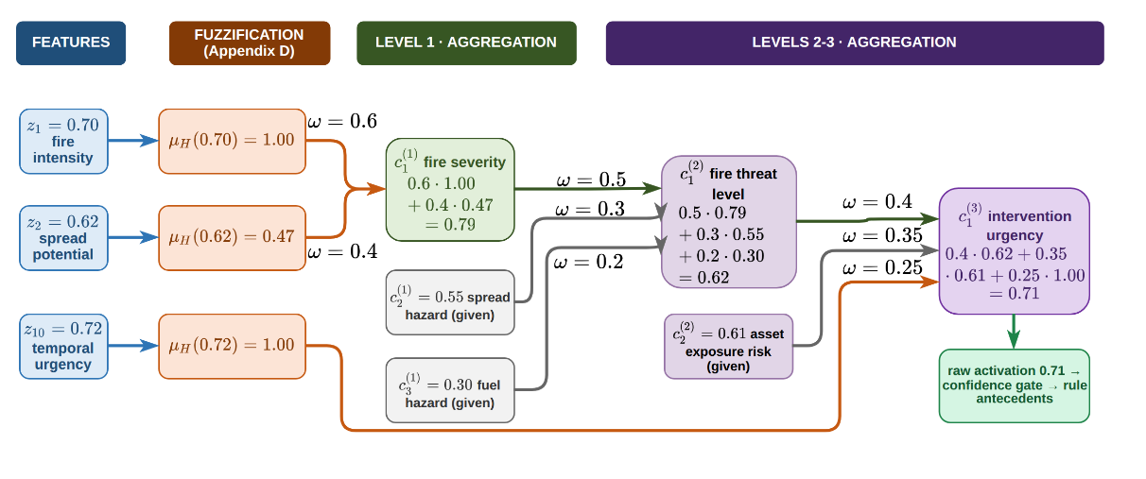
Figure 4.3 Hierarchical concept activation example
An example is illustrated in Figure 4.3. At level one, consider fire severity with feature set $\{z_{1}, z_{2}\}$, aggregation weights $0.6$ and $0.4$, and the severity-oriented term high of each feature. A fire intensity reading of $0.70$ lies on the core of high, giving membership 1.00, and a spread potential reading of $0.62$ lies on its lower shoulder, giving membership $0.47$; the aggregation of ( 42 ) therefore yields the activation $0.6 × 1.00 + 0.4 × 0.47=0.79$. Level two repeats the same operation over activations instead of memberships. Fire threat level draws on fire severity, spread hazard, and fuel hazard with weights $0.5$, $0.3$, and $0.2$; with the fire severity of $0.79$ just computed, a spread hazard of $0.55$, and a fuel hazard of $0.30$, the activation is $0.5 ×0.79+ 0.3 ×0.55+ 0.2 ×0.30=0.62$. Intervention urgency draws on fire threat level, asset exposure risk, and the feature temporal urgency with weights $0.4$, $0.35$, and $0.25$; with the $0.62$ just computed, an asset exposure risk of $0.61$, and a temporal urgency reading of $0.72$ whose high membership is $1.00$, the activation is $0.71$. One sensor-level number has now propagated through three levels, and at every step the intermediate value remains readable as an operational statement.
Raw activations are never consumed directly. Every activation is gated by its observation confidence and blended with a persistence-carried prior ( 43 ). A reliable observation passes through unchanged, while an uninformative one falls back to the decayed previous estimate.
$$a_{n,k}^{eff,i}=γ_{n,k}^{i}⋅a_{n,k}^{obs,i}+\left(1-γ_{n,k}^{i}\right)⋅ρ⋅a_{n,k-1}^{eff,i}, \\ γ_{n,k}^{i}=min⁡\{γ_{f,k}^{i}:f∈Z_{n}\}$$ | ( 43 )
In ( 43 ), the superscripts distinguish three activations of the same concept: The observed activation computed through ( 42 ), the persistence prior carried from the previous step, and the effective activation that the decision rules consume. The gate $γ$ is the observation confidence of ( 38 ), composed at concept level as the minimum of the feature confidences feeding the concept, and the decay factor $ρ ∈ [0, 1)$ discounts the previous effective activation, so a concept that ceases to be observed fades over successive steps instead of persisting indefinitely.
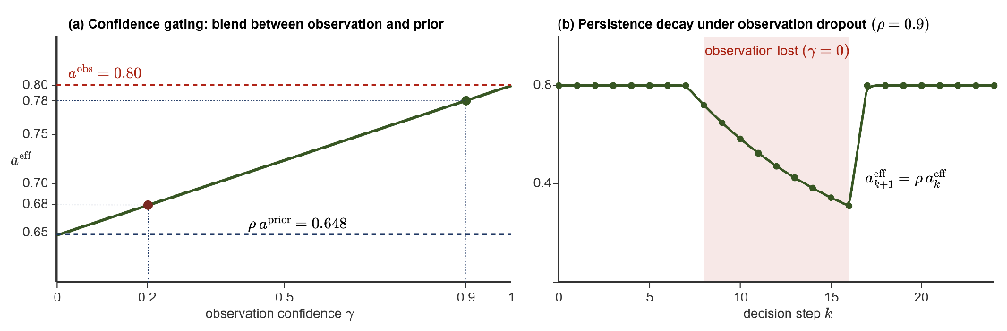
Figure 4.4 (a) Confidence gating and (b) persistence decay
In Figure 4.4, the plot (a) shows the effective activation against the confidence for an observed activation of $0.80$, a carried prior of $0.72$, and $ρ = 0.9$: At $γ = 0.9$ the effective value is $0.78$, at $γ = 0.2$ it is $0.68$, and the transition between trust and caution is linear, with no threshold to tune. The plotted values follow one component of the vector; the gate applies to every term alike. The plot (b) shows the temporal role of the prior. When observation is lost, effective activation decays geometrically by $ρ$ per step and snaps back to the observation as soon as confidence returns.

Layer 4: Decision Generation and Coordination
The decision space is where the gated concept activations of Table 2.3 become the executable interventions of Table 2.4. The layer operates once per decision cycle. The rule base fires on gated activations and produces a candidate intensity vector per region. The candidate is forecast on a shadow copy of the simulation and must pass a cost test and a quality test before it reaches the field. When it fails, one stage of the adaptation loop changes the rule base.
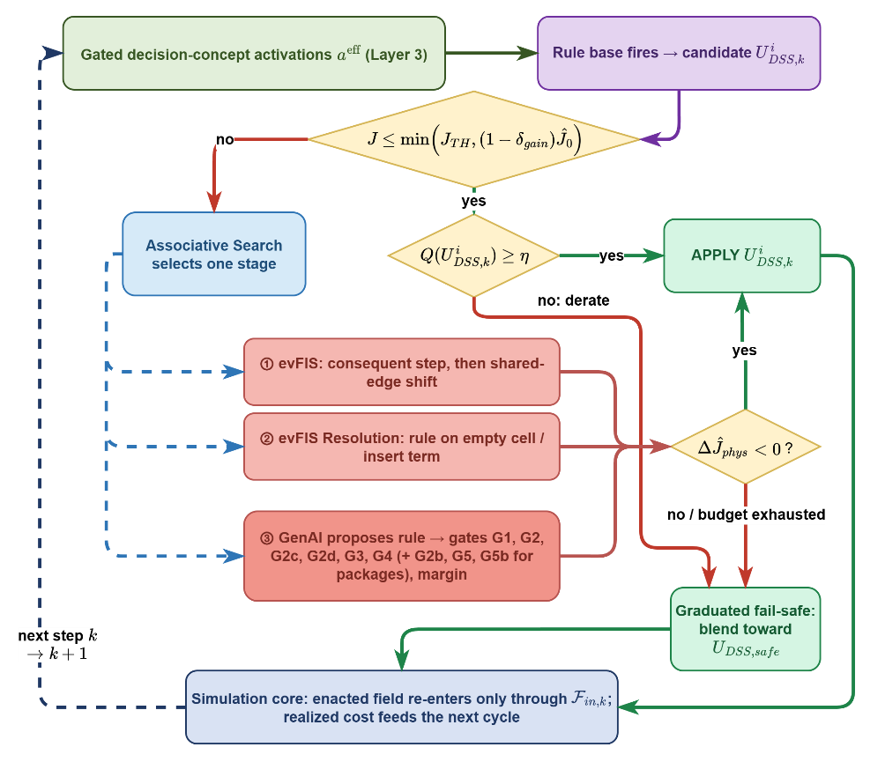
Figure 4.5 Layer 4 decision and adaptation flow
As illustrated in Figure 4.5, Layer 4 receives the gated decision-concept activations $a^{eff}$ of Layer 3, five term-membership vectors, one per decision concept with entries in [0,1] that already carry the confidence gating and the persistence prior of the concept layer, and it returns $U_{DSS,k}^{i},$ an intensity vector over the six intervention families for region $i$ at cycle $k$. Nothing else crosses the boundary. The layer never reads the physical state directly and never writes to it.
Two symptoms drive everything that follows. A cost deficit means that the forecast cost of the standing decision exceeds the satisficing bound; a coverage gap means that fire is alive while no rule fires above the coverage floor. Either symptom engages exactly one adaptation stage per cycle, chosen by the stage controller of Section 4.5.3.4: Stage ① retunes the rules that already exist, stage ② writes a rule where none exists, and stage ③ asks the generative proposer for a rule that the current vocabulary could not express. Every trial is kept only if the shadow forecast improves. Two further checks act on the decision itself rather than on the rule base: The quality test compares the orders with the concepts that demanded them, and when they fall short the graduated fail-safe attenuates the offensive orders; the no-harm guard withholds the offensive orders of a plan that is forecast to end worse than doing nothing.

Rule Base and Candidate Intervention
The rule base is written only over the five gated decision concepts. Every rule has the conjunctive form of ( 44 ). Each antecedent clause tests one decision concept against one linguistic term, and the consequent assigns one intensity to each intervention family, so a concept triggers an intervention exactly by the degree to which it satisfies the clause that names it.
$$R_{r}: IF a_{1,k}^{eff,i} is A_{r,1} AND … AND a_{5,k}^{eff,i} is A_{r,5} THEN U_{DSS,k}^{i} is B_{r}$$ | ( 44 )
In ( 44 ), $R_{r}$ denotes rule r, $a_{n,k}^{eff,i}$ the gated activation of decision concept $n$ in region $i$ at cycle $k$, $A_{r,n}$ the linguistic term the rule requires of that concept, and $B_{r}$ the consequent, the intensities the rule orders. The candidate of the region is the vector $U_{DSS,k}^{i}$, whose components $u_{m,k}^{i}$ are the intensities ordered for the six intervention families indexed by m. A concept absent from an antecedent is left unconstrained, so a rule may test one concept or all five.
A rule fires with the strength of its weakest clause, and the candidate is the firing-weighted average of the consequents of all rules that fire, ( 45 ). Here $α_{r}$ is the firing strength of rule $r$, the minimum membership over its antecedent clauses, $μ_{A_{r,n}}$ is the membership of the clause, read from the aggregated activation vector of ( 42 ) (an inserted term of stage ② is instead read on its own trapezoid, Section 4.5.3.2), and $v_{r,m}$ is the intensity that the rule assigns to family $m$. The denominator is floored at one, so weakly supported rules give weak orders.
$$u_{m,k}^{i} = \frac{\sum_{r}{α_{r} v_{r,m}}}{max(1, \sum_{r}{α_{r}})} \\ α_{r} = \min_{n ∈ ant(r)} μ_{A_{r,n}}(a_{n,k}^{eff,i})$$ | ( 45 )
The base is sparse by construction. The antecedent space admits $5^{5}$ = 3125 antecedent combinations, but a rule with fewer clauses covers many of them at once, and neighboring terms overlap, so a sparse base loses no coverage. The count in ( 46 ) gives what a single rule already covers, where $N_{term}$ is the number of linguistic terms partitioning each concept, $N_{concept}$ is the number of decision concepts and $N_{antecedent,r}$ is the number of antecedent clauses of rule $r$. A two-clause rule covers $5^{5-2}=125$ combinations and a five-clause rule covers $5^{5-5} = 1$.
$$N_{cover}\left(R_{r}\right)=N_{term}^{N_{concept}-N_{antecedent,r}}$$ | ( 46 )
The seeded base must satisfy the coverage condition ( 47 ), where $a^{eff} ∈ [0,1]⁵$ is any reachable vector of gated concept activations, $α_{r}(a^{eff})$ is the firing strength of rule $r$ at that reading, and $α_{min}=0.05$ is the coverage floor. In words, even the worst reading of the whole space leaves some rule firing with strength at least $α_{min}$. The full doctrine of Appendix E satisfies it. The minimal profile of five seed rules used in the evaluation deliberately does not: its rules sit on the high terms, so a low reading falls below the floor. Such a reading is a coverage gap; the layer falls back to the conservative fallback posture of ( 11 ) and adaptation is triggered.
$$\min_{a^{eff}∈[0,1]^{5}} \max_{r} α_{r}\left(a^{eff}\right)≥α_{min}>0$$ | ( 47 )
As an example, a fire threat activation of $0.60$ belongs to the term medium with membership $0.667$ and to the term high with membership $0.333$. If the base prescribes suppression effort $0.5$ for the first and $0.8$ for the second, both rules fire and ( 45 ) returns $0.600$, a value no rule states explicitly. Coverage is therefore graded rather than binary.
Each decision concept has one primary intervention family that answers it; this pairing is what the quality test of Section 4.5.2 and stage ② of Section 4.5.3.2 read. Fire threat level is answered by suppression effort, asset exposure risk by asset protection, intervention urgency by resource deployment, and evacuation pressure by evacuation, with public warning raised jointly. Suppression feasibility is a gatekeeper rather than a demander: high feasibility sends resource deployment toward the front, and low feasibility caps suppression effort and shifts intensity toward containment line and evacuation. Each concept also modulates secondary families: fire threat level adds containment line when direct attack is insufficient and scales resource deployment with the threat; asset exposure risk places the containment line to shield the exposed assets and calls for evacuation when exposure combines with a high threat; intervention urgency scales the intensities of all active families; and a very high evacuation pressure withdraws the offensive intensities. The seed rules of the minimal profile, R1 to R5 in Table E.1, realize these pairings one family at a time, and the full doctrine of Appendix E adds the secondary roles.

Cost, Quality, and the Satisficing Test
Every candidate is judged by two complementary measures, both computed on a shadow copy of the simulation before anything reaches the field. The cost asks what the candidate is expected to cost the incident. The quality asks whether it serves the concepts that demanded it. A candidate must clear both, and the two tests appear as the first two decision diamonds of Figure 4.5.

Cost Test
The cost is not evaluated on the current state. The candidate allocation is held constant on the simulation over a horizon of at least $τ_{horizon}$, stepped at $τ_{resolution}$, and the cost of the forecast end state is compared with a no-action shadow run started from the same state. The cost is the weighted five-term sum of ( 48 ), and the normalization of each term is stated below.
$$J=\frac{\sum_{j}{w_{j}J_{j}}}{\sum_{j}{w_{j}}}, j∈\left\{burn, asset, pop, resp, delay\right\}$$ |  | ( 48 )
$$J_{burn}=\frac{\frac{N_{burned}}{ρ_{burn}⋅N_{burnable}}}{1+ \frac{N_{burned}}{ρ_{burn}⋅N_{burnable}}} \\ J_{asset}=\frac{V_{lost}}{V_{total}}$$ | $$J_{pop}=\min\left(1, \frac{P_{steps}}{P_{total}⋅N_{decisions}}\right) \\ J_{resp}=\min\left(1, \frac{C_{steps}}{C_{ref}⋅N_{decisions}}\right) \\ J_{delay}=min(1, \frac{\overline{τ}}{τ_{reference}})$$ | ( 48 )
$J_{burn}$ is the burned area relative to a reference fire. $N_{burned}$ is the number of cells that have burned and $N_{burnable}$ the number of burnable cells of the scenario, with $ρ_{burn}=0.05$. The reference area $ρ_{burn}·N_{burnable}$ is therefore 5 % of the burnable land. The form $x/(1+x)$ with $x = N_{burned}/(ρ_{burn}·N_{burnable})$ reads 0.5 at the reference fire and approaches one for larger fires without reaching it.
$J_{asset}$ is the fraction of exposed value that the fire has taken, where $V_{lost}$ is the value of the structures and critical infrastructure standing on burned cells and $V_{total}$ the total value exposed in the scenario.
$J_{pop}$ is population exposure integrated over time. $P_{steps}$ sums the people present inside burning cells at every step, $P_{total}$ is the total population of the scenario at risk and $N_{decisions}$ the number of decision steps of the horizon, so the denominator is the worst case in which the entire population is exposed for the whole horizon.
$J_{resp}$ prices effort in the same way. $C_{steps}$ is the fielded capacity summed over the decision steps, and $C_{ref}$ is the reference capacity of the scenario, so the denominator is the reference force kept in the field for the whole horizon. A force held on the line for hours is therefore charged more than a short strike of the same size.
$J_{delay}$ prices timeliness. $\overline{τ}$ is the capacity-weighted mean dispatch time of the resources actually fielded, and $τ_{reference}$ is the reference response time of sixty minutes. Each of the last three terms is capped at one, so no single term can dominate the sum once its reference is exceeded.
The five-term total is the criterion by which a candidate is accepted. The response and delay terms price the decision itself, so a run that never intervenes carries neither of them, and a comparison on the total cost would reward inaction. The cross-run comparisons of Chapter 5 and the trial verdicts of the adaptation stages therefore use the physical cost $J_{phys}$: the burned-area, asset, and population terms of ( 48 ) with their weights renormalized, which for equal weights is their mean. It measures only what the fire did to the land, the assets, and the people, so a run that fought and a run that watched are compared on the same basis.

Acceptance Test
Acceptance on cost is satisficing rather than optimizing. The candidate is held on the shadow copy over the forecast horizon, and the resulting cost ${\hat{J}}_{k}\left(U_{DSS,k}\right)$ is compared with the forecast of taking no action from the same state, ${\hat{J}}_{k}\left(0\right)$.
${\hat{J}}_{k}\left(U_{DSS,k}\right) ≤ min(J_{TH}, (1-δ_{gain})⋅{\hat{J}}_{k}(0))$ $δ_{gain} =0.05$ | ( 49 )
The acceptance bound is the smaller of two quantities, and each one protects against a different mistake. The first is the fixed ceiling $J_{TH}$. It sets the highest cost at which the incident may be left. On a large fire this is the binding condition. A candidate is rejected if it leaves the incident expensive, even when it is far better than doing nothing. The second is $(1 - δ_{gain})·{\hat{J}}_{k}(0)$, a fixed fraction of the no-action forecast. On a small fire this is the binding condition. When doing nothing already costs less than the ceiling, the ceiling alone would accept every candidate, including one that changes nothing. The margin $δ_{gain}$ prevents this by requiring the candidate to beat the no-action forecast. Without it, the incidents that are easiest to improve would be the ones the adaptation stages never touch. Failing the cost test does not suspend action. The orders already produced by the standing rule base remain in force and are applied while adaptation runs, so an acceptable decision is never withdrawn in the hope of a better one. The quality measures what the cost cannot. A concept demands an action; the quality asks whether the candidate supplied it. For each scored concept, gated activation is compared, read as the scalar expected value of the activation vector, with the intensity the candidate assigns to the intervention family that answers that concept, and the quality is one minus the mean of these mismatches ( 50 ). $F\left(n\right)$ is the intervention family that answers concept $n$ defined in Section 4.5.1, ${a_{n}}^{eff}$ is the gated activation of that concept and $u_{f}$ the intensity the candidate orders for family $f$.
$$Q_{k}=1-\frac{1}{4}\sum_{n∈C_{Q}}{|{a_{n}}^{eff}-\max_{f∈F(n)} u_{f}|}, accept ⇔ Q_{k}≥η$$ | ( 50 )
$C_{Q}$ is the set of the four scored decision concepts. Suppression feasibility is excluded from $C_{Q}$. It is a modulator rather than a demander. Its activation states whether action is possible, not how much action is required. A high feasibility permits a strong response without calling for one, so a region with workable terrain and no fire would be penalized by a match test even though a null response is correct. A low feasibility calls instead for a reduction of the intensities that the other concepts demand, and a reduction is not something a match test can score. The family through which it acts, resource deployment, already answers intervention urgency in ( 50 ).
A candidate that suppresses heavily while the fire threat is low is penalized as much as one that ignores a high evacuation pressure, although only the second failure would raise the cost within the horizon. Quality therefore detects a misdirected response before its consequences appear. When the quality falls below the gate $η$, fixed at 0.60, the graduated fail-safe scales the offensive intensities by $Q_{k}$/$η$.
As an example of the fail-safe, take a region where smoke has degraded the optical sensors over a sector. The features that feed fire threat level lose confidence, the gate on that concept closes, and its activation falls back toward the decayed prior. The rule base still carries the strong suppression effort that the concept demanded a few cycles earlier, so the order now exceeds what the concept demands, the candidate is unbalanced, and the quality drops below the gate. The fail-safe attenuates the suppression effort and resource deployment toward the conservative fallback posture of ( 11 ), while the public warning raised in the same cycle for the exposed settlement is issued at full strength. When the wind clears the sector two cycles later, confidence recovers, the quality rises above the gate, and the suppression order returns to full strength without any external action.

Cost and Quality Acceptance Test Example
One decision cycle of an incident illustrates both tests. Two forecasts are run, one with the candidate allocation held constant and one with no action, and each is priced with the five-term cost of ( 48 ). Table 4.1 gives the terms of both, already normalized, with the weights that combine them.
Table 4.1 Forecast cost terms of the candidate and of no action
Term | Weight $w$ | Candidate $\hat{J_{k}}$ ($U$) | No action $\hat{J_{k}}$ ($0$)
Burned area, $J_{burn}$ | 1.0 | 0.5218 | 0.5376
Asset loss, $J_{asset}$ | 1.0 | 0.2226 | 0.3061
Population, $J_{pop}$ | 1.0 | 0.0004 | 0.0008
Response, $J_{resp}$ | 0.2 | 0.0549 | 0.0300
Delay, $J_{delay}$ | 0.2 | 0.2230 | 0.0000
Weighted sum |  | 0.8004 | 0.8506

Each cost is that weighted sum divided by the total weight, 3.4.
$\hat{J_{k}}\left(U\right)= \frac{0.8004}{3.4} = 0.2354$, $\hat{J_{k}}(0) = \frac{0.8506}{3.4} = 0.2502$ | ( 51 )
The cost test compares these two numbers, as the acceptance test of ( 49 ) requires.
$$0.2354 ≤ min(0.35, (1-0.05)× 0.2502) = 0.2377$$  $J_{TH} = 0.35$, $δ_{gain} = 0.05$ | ( 52 )
The candidate is accepted. The ceiling is not the binding condition: The forecast cost of no action, 0.2502, already lies below the ceiling of 0.35, so the ceiling alone would accept every candidate. The margin sets the requirement.
Acceptance on cost applies to the incident as a whole. The quality test of ( 50 ) is evaluated in each region, over the four scored concepts. Table 4.2 lists their terms. The activation is what the concept demands, the intensity is what the candidate orders from the family that answers it, and ordering more than is asked for counts as much as ordering less.
Table 4.2 Terms of the quality test in the two regions of the cycle
Region | Concept | Activation $a_{n}^{eff}$ | Ordered intensity $u_{f}$ | Mismatch |$a_{n}^{eff}$ − $u_{f}$|
Region 1 | fire threat | 0.597 | 0.360 | 0.237
Region 1 | asset exposure | 0.541 | 0.049 | 0.492
Region 1 | intervention urgency | 0.639 | 0.554 | 0.085
Region 1 | evacuation pressure | 0.497 | 0.000 | 0.497
Region 2 | fire threat | 0.687 | 0.360 | 0.327
Region 2 | asset exposure | 0.831 | 0.000 | 0.831
Region 2 | intervention urgency | 0.816 | 0.920 | 0.104
Region 2 | evacuation pressure | 0.674 | 0.000 | 0.674

Two of the four mismatches of Region 1 are moderate, but the quality result of ( 53 ) stands above the gate, 0.672 ≥ 0.60, so the orders of that region are applied as written.
$$Q_{1} = 1 - \frac{1}{4}(0.237 + 0.492 + 0.085 + 0.497) = 0.672$$  $$Q_{1}=0.672>η=0.60$$ | ( 53 )
The second region orders slightly more than intervention urgency asks for, and answers two demands with nothing: Asset exposure asks for $0.831$, and evacuation pressure asks for $0.674$. The cost test cannot see this, because assets that are not burning and people who are not exposed carry no cost inside the forecast horizon. The quality test of ( 54 ) falls below the gate, so the fail-safe engages. It does not cancel the orders; it attenuates the offensive ones in proportion to the deficit ( 55 ).
$$Q_{2} = 1 - \frac{1}{4}(0.327 + 0.831 + 0.104 + 0.674) = 0.516$$  $$Q_{2}=0.516<η=0.6$$ | ( 54 )
$$u_{f}' = \frac{Q_{2}}{η}u_{f} = 0.86u_{f}$$ | ( 55 )
Suppression falls from 0.360 to 0.310 and resource deployment from 0.920 to 0.791. Evacuation and public warning are never attenuated. Neither is ordered in this cycle, which is the omission the quality test records.

Open Decision Space: Staged Adaptation
Adaptation is a local search on the rule base. Its objective is the forecast physical cost $J_{phys}$ of Section 4.5.2, and its moves are the three stages. In a cycle in which the standing decision falls short, one stage proposes a bounded number of trials, each a single change to a working copy of the rule base; the changed base is run on the shadow simulation over the trial horizon, and the change is kept only if the forecast physical cost falls, ( 58 ); otherwise it is rolled back, so the seed base of Appendix E is never modified. The stages differ only in the kind of change they may propose: stage ① moves a number inside an existing rule, stage ② writes a rule where none exists, and stage ③ asks a generative proposer for a rule that the current vocabulary cannot express. The first two are the evolving fuzzy (evFIS) mechanism; the third is generative. All three are judged on the same forecast quantity (stage ② admits a non-inferior rule, Section 4.5.3.2), so the ladder is one optimization with three move types of increasing reach.
The trial criterion is the physical cost and not the total cost of ( 48 ) because on a small fire and a short horizon the response and delay terms of any added commitment exceed the physical gain the forecast can show; a total-cost criterion would reject every trial at the moment the base most needs to grow. Each stage has an admitting symptom. A cost deficit, the forecast cost above the bound of ( 49 ) while a rule still fires, admits stage ①, since there is a rule to tune. A coverage gap, fire alive while no rule fires above the floor, admits stage ②, since there is nothing to tune and a rule must be written. Stage ③ is admitted by either symptom. Which allowed stage runs in a cycle is chosen by the controller of Section 4.5.3.4. No stage edits the products of another: a consequent that moved was moved by stage ①, a rule that appeared was written by stage ② or ③, and a name that entered the vocabulary was admitted by stage ③, which keeps the ledger auditable.

evFIS: Parameter Adaptation
Stage ① changes one number at a time inside rules that already exist; it adds no rule and no term. It has two moves. The consequent step takes the two rules with the highest firing strength and moves the consequents $v_{r,m}$ of each of the two by a fixed step $δ$ = 0.05, up or down, clipped to the unit interval, ( 56 ). Since the field decision of ( 45 ) is the firing-weighted average of the consequents, the order moves toward the new value in proportion to the firing strength of the rule. Two rules are stepped rather than one because with a small base one rule dominates every cycle and the second would never be tuned.
$$v_{r,m}←clip_{0,1} \left(v_{r,m}±δ\right), m∈cons\left(r\right)$$ | ( 56 )
The boundary shift moves the edge that two neighboring terms share. The falling edge of the left term $A^{-}$ is the rising edge of the right term $A$, and the two coincide, $\left(a_{A},b_{A}\right)=\left(c_{A^{-}},d_{A^{-}}\right)$ ( 57 ). Both terms move together by the same step, so the memberships still sum to one at every reading, as the five-term partition of Section 2.4 requires. The step may not exceed the width of the core it narrows, $δ≤c_{A^{-}}-b_{A^{-}}$, or that core would vanish. This move changes the reading of every rule that uses either term, so it is tried only after the consequent trials are spent.
$$\left(a_{A},b_{A}\right)←\left(a_{A}-δ,b_{A}-δ\right), \left(c_{A^{-}},d_{A^{-}}\right)←\left(c_{A^{-}}-δ,d_{A^{-}}-δ\right)$$  $$\left(a_{A},b_{A}\right)=\left(c_{A^{-}},d_{A^{-}}\right), 0<δ≤c_{A^{-}}-b_{A^{-}}$$ | ( 57 )
Each move is a trial: it is forecast on the shadow simulation, kept if the forecast physical cost strictly falls, and rolled back otherwise, ( 58 ). The same strict criterion governs the admissions of stage ③. The one exception is stage ②, which accepts a rule on an empty cell when it is non-inferior, because an uncovered cell must carry a rule before anything can be tuned. Figure 4.6 shows both moves.
$$kept ⇔ Δ{\hat{J}}_{phys}<0$$ | ( 58 )
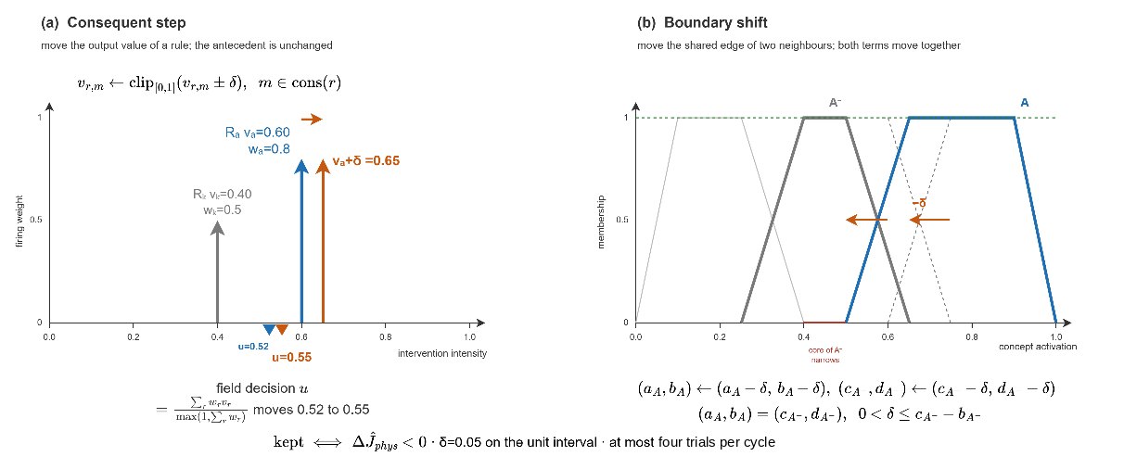
Figure 4.6 Consequent step and boundary shift

evFIS: Rule Instantiation and Resolution Increase
The adaptation stage ② grows the base where it is silent. It has two modes. The first writes a rule on an empty combination. The two decision concepts with the highest activation, $c^{(1)}$ and $c^{(2)}$, each at its dominant term $t^{*}$, name the combination that describes the present situation, ( 59 ).
$A_{new}=\left\{\left(c^{(1)},t^{*}\left(c^{(1)}\right)\right),\left(c^{(2)},t^{*}\left(c^{(2)}\right)\right)\right\}$, $t^{*}\left(c\right)=\underset{t∈T_{c}}{argmax}μ_{t}\left({a_{c}}^{eff}\right)$ | ( 59 )
If no active rule sits on that combination, a rule is written on it. Its consequents are not guessed, each of the strongest concepts places its own crisp activation as the intensity on the primary family of Section 4.5.1 that answers it, so the new rule orders what the situation demands. The rule is kept if the forecast physical cost does not rise, since an empty cell has no rule to compare against and the base must grow toward covering the space. If the combination already carries a rule, nothing is written; changing its numbers is the work of stage ①.
The second mode makes the term set finer. A reading is ambiguous when no term of the strongest concept reaches a membership of 0.62: the value lies between two term cores, so two different situations produce the same combination, and no rule written on that combination can tell them apart. A narrow trapezoidal term $X$ is then inserted into the partition of that concept, centered on the crisp reading $x$ with a core of ±0.05 and a support of ±0.12, ( 60 ), and the rule of the first mode is written on the refined combination, which names $X$ in place of the ambiguous base term. The new rule fires only near $x$, which is what separates the two situations. The first insertion raises the number of expressible combinations from 3125 to 3750, ( 61 ).
$$\max_{t∈T_{c^{(1)}}}{μ_{t}\left(a_{c^{\left(1\right)}}^{eff}\right)}<0.62 ⇒ T_{c^{(1)}}←T_{c^{(1)}}∪\left\{X\right\}$$$X=\text{trap}\left(x-0.12, x-0.05, x+0.05, x+0.12\right)$, $x={a_{c^{(1)}}}^{eff}$ | ( 60 )
$$\left|C\right|=\prod_{c∈dec}{\left|T_{c}\right|} : 5^{5}=3125 → 6⋅5^{4}=3750$$ | ( 61 )
An inserted term does not enter the activation vectors of Layer 3. It is read on the crisp activation of its own concept against its own trapezoid, so the five-term algebra of Layer 3 is unchanged. Inserted terms are dropped when the vocabulary is reset and are otherwise restored from the lineage store, the persistent record of every admitted rule and vocabulary object. Both modes are seen in Figure 4.7.
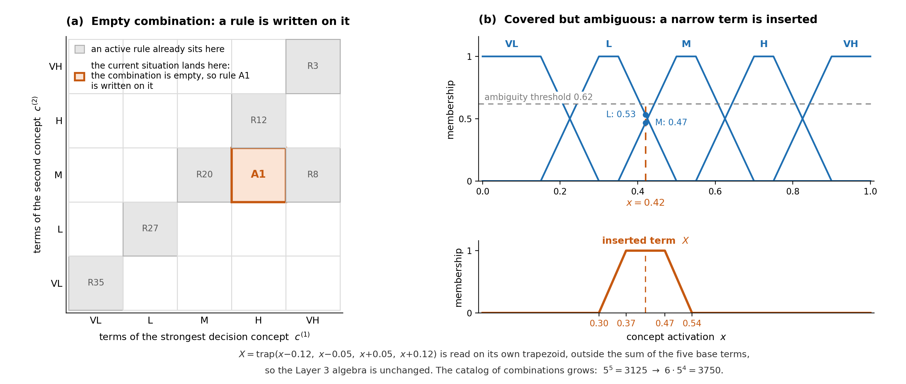
Figure 4.7 Resolution increase, rule instantiation, and term insertion

Generative Proposals and Vocabulary Packages
Stage ③ is called when the vocabulary itself falls short: the standing decision fails the cost test or leaves a coverage gap. It solves the same problem as the other stages, a change to the rule base that lowers the forecast physical cost, but draws its candidates from a larger space. A candidate is one new rule in the form of ( 44 ), alone or together with one new vocabulary object that the rule uses. This space is far too large to enumerate, and most of it leaves the forecast unchanged. The stage therefore splits the search into two parts, as Figure 4.8 shows.
A proposer samples one candidate from the stated facts of the situation, and a fixed chain of gates decides whether the candidate is kept. The gates are the constraints and the acceptance test of the optimization: G1 and G2 check that the candidate is a well-formed rule over the closed vocabulary, G2b to G2d check that it is not redundant, that it applies to the present situation, and that it does not ask for capacity the pool cannot fund, and G3 and G4 apply the acceptance test of ( 58 ) on two independently seeded forecasts. Nothing in the gates depends on the proposer, so any candidate generator can stand in its place: the evaluation campaign of Chapter 5 uses a deterministic template proposer that aims a rule at the dominant terms of the situation, and the recorded runs use a large language model. The proposer decides where to look; the gates decide what is kept, and they are what make an admitted rule an improvement.
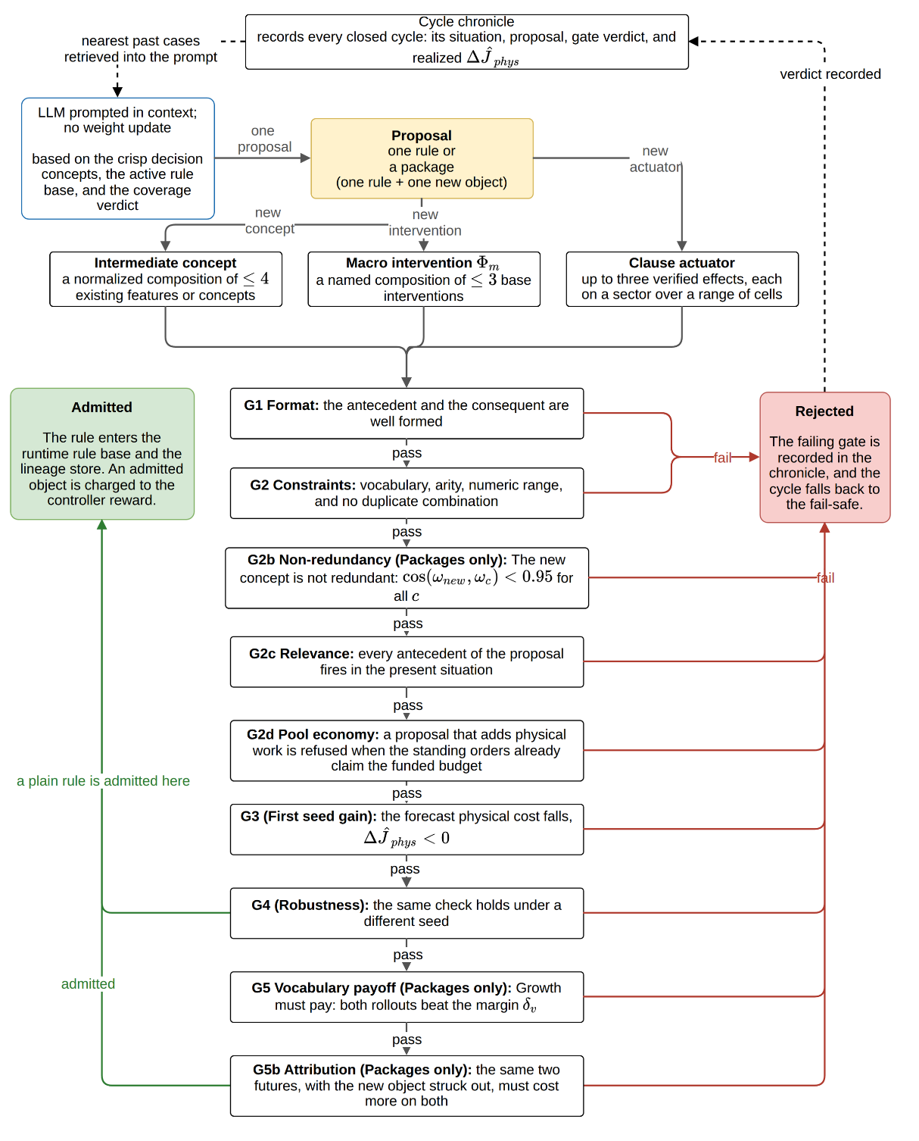
Figure 4.8 Generative proposal and the verification gates
The proposer of the recorded runs is a pretrained, general-purpose language model used in context only, with no fine-tuning and no weight update. It receives the situation of the cycle: the crisp value of every decision concept, the active rule base in IF-THEN form, the coverage verdict, the affordances of the map (a nearby water body, the closest asset, the resources on hand), the pool state, and the nearest past cases with their verdicts; the full text of the prompt is given in Appendix F. The reply is restricted to a fixed form that admits only the decision concepts, the admissible interventions, and the five linguistic terms, very low (VL) to very high (VH), and the model returns exactly one proposal. The proposal is untrusted by construction: it acts only after it clears every gate that applies to it, so the guarantee comes from validation, not from the model.
A proposal is a plain rule or a package, and its form follows from the reason the stage was called. A plain rule of Section 4.5.3.3.1 is enough when the existing concepts can express the situation and an existing intervention answers it, but no rule sits on the cell that holds now.
When a plain rule cannot help, the proposal is a package: one rule together with one new object that the rule uses. The object is a macro intervention of Section 4.5.3.3.2 when two or three families must act as one at a fixed ratio; a clause actuator of Section 4.5.3.3.3 when the tactic is a placement, a where and a how, that no base family carries; or an intermediate concept of Section 4.5.3.3.4 when the five decision concepts cannot name a recurring situation, so that every rule the stage could write lands on a used cell. An object that no rule cites is inert and cannot be verified, so an object is never admitted on its own. The stage never edits a rule: a proposal on a covered cell is refused at G2, since retuning an existing rule is the work of stage ①. Every proposal, rule or package, then passes the gate chain of Section 4.5.3.3.5.

Plain Rule
A plain rule is an antecedent over existing decision concepts and a consequent over existing interventions, written on an empty cell in the form of ( 44 ). Mechanically it is what stage ② writes, except that the proposer chooses the cell and the consequent values from the situation instead of copying the concept demands, so it may pair concepts and interventions that no doctrine rule pairs. It grows the rule base without growing the vocabulary and faces the six universal gates.

Macro Intervention
A macro intervention $Φ_{m}$ is a named combination of at most three base interventions (families of Table 2.4 or base actuators) with fixed weights $β_{j}$, ( 62 ), as in Figure 4.9. A rule may order the macro as one consequent with intensity $v$, and inside the aggregation of ( 45 ) that single order expands into base orders with intensities $β_{j}v$. A backburn is an example, containment line at weight 0.6 and suppression effort at weight 0.4 ordered together, which separate rules would let the aggregation dilute. A macro adds no physics; it runs through the existing resource fields and is priced by the response term.
Macro intervention: $Φ_{m}=\left\langle \left(b_{1},β_{1}\right),…,\left(b_{p},β_{p}\right)\right\rangle , p≤3,$  $$(m,v)↦(b_{j},β_{j}v)$$  Intermediate concept: $a_{c'}=\sum_{i}{ω_{i}a_{i}}, \sum_{i}{ω_{i}}=1, i≤4$ | ( 62 )

Clause Actuator
A clause actuator is a new intervention composed from verified physical effects, Figure 4.9 (c). The proposer does not receive a menu of tactics. It receives a basis of seven effects that the engine already implements, listed in Table 4.3; seven sectors that place an effect relative to the fire; a range of cells measured from the front; and an amount. The sectors are head, flank, and rear, selected by bearing against the direction of spread; ring, the band around the fire without a bearing test; fire zone (recorded as at_fire in the ledger), the burning cells and the two rings around them; assets, the assets within fifteen cells of the fire; and populated, every cell holding population.
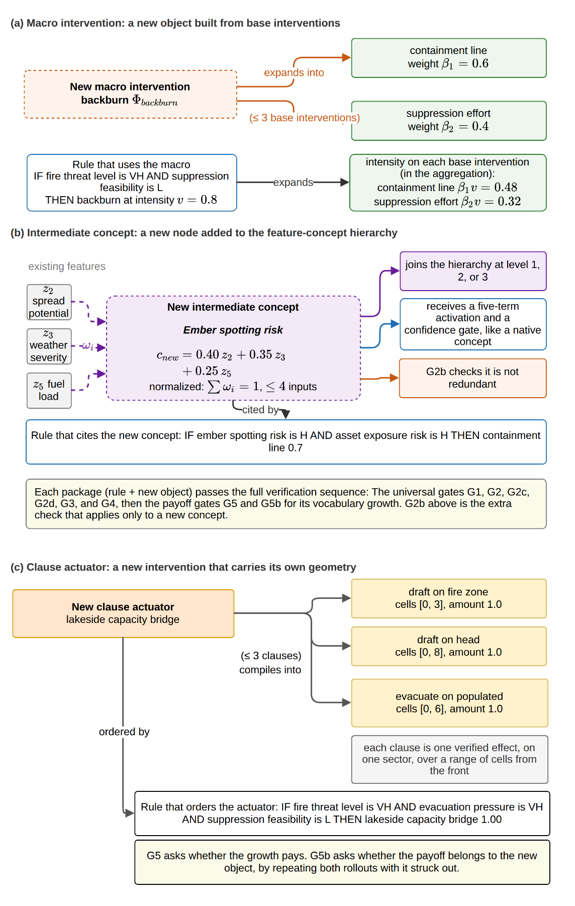
Figure 4.9 Package objects: (a) macro intervention, (b) intermediate concept and (c) clause actuator
Table 4.3 The verified effect vocabulary a clause may invoke
Effect | Effect in the engine | Limiting condition
wet | Raises capacity and crew availability: A pre-wetted band. | Workable ground; draws on the pool.
clear | Marks cells as cut and raises capacity: A containment line. | Workable ground, never built-up or water; draws on the pool.
ignite | Sets the cells alight: A firing operation. | Never built-up or water; adds fire the forecast then judges.
coat | Raises the moisture floor to 0.45 of the amount laid: Retardant or soil. | The only thresholded effect; acts only where that floor reaches the extinction moisture of the fuel.
evacuate | Raises the evacuation order. | Only where population is present; spends no pool capacity.
prime | Raises the public warning. | Only where population is present; spends no pool capacity.
draft | Multiplies capacity already on the cells, by a factor falling with the distance to water. | Needs a water body; acts only where capacity exists, so it raises the yield of committed crews.

An actuator is a name and at most three clauses, and each clause is one effect on one sector over one range with one amount. When the map reports a lake near the front, for instance, the proposer can compose an actuator that drafts from the water body and wets the fuel ahead of the head, an intervention that no seed rule contains and no menu offers. The novelty lies in the composition and in its grounding to the map, not in new physics: an actuator can be new, the effects it invokes cannot.
The limiting conditions carry operational content. Wet and clear draw on the shared crew pool, so on an incident whose pool is spent they only redivide capacity already committed. Coat is thresholded: a coating below the extinction moisture of the fuel underneath slows the fire without stopping it. Draft multiplies capacity instead of requesting it, which makes it the only effect that can add real work to a saturated incident. These facts are placed in the situation the proposer receives. Geometry matters as much: a sector is resolved against the fire as it stands in this cycle, so a band written far ahead of a small fire resolves to no cells, and the written amount is multiplied by the intensity the rule realizes.
The engine never executes text. An actuator arrives as a named list of clauses; the name is checked for collision and each clause against the effect and sector lists, and anything outside them is refused at G2 before a simulation is spent. The definition is installed on a working copy of the vocabulary and the rule on a working copy of the base. When the rule fires, each sector is resolved to a set of cells on the current map and intersected with the region and with the ground the effect may touch (a clearing or igniting clause also with the cells where a line can be dug, so a generated actuator cannot cut a line through a settlement or light a fire on water), the amount is multiplied by the realized intensity, and the result is written to the same intervention input fields that the base families write. The simulator, the cost model, and the audit trail therefore treat a generated actuator and a doctrinal order identically: the decision space is open at the level of interventions and closed at the level of physics.

Intermediate Concept
An intermediate concept is a new node of the feature-concept hierarchy: a normalized weighted sum of at most four existing features or concepts, ( 62 ), Figure 4.9 (b). It joins the hierarchy at the level its inputs allow, receives a five-term activation and a confidence gate like every native concept, and reaches the decision only through rules that cite it. It always arrives as a package with the rule that cites it, such as the interface exposure concept among the admitted rules of Appendix E. A later proposal may cite it exactly as a native concept and may order a generated intervention in the same rule, so generated concepts and generated interventions can be bound together.
Every admitted object is written to the lineage store, so later rules in the same incident may cite it and a later incident restores it unless the vocabulary is reset. The basis of effects itself is not proposable: adding an effect means implementing and validating a field in the physical model, which is the work of Chapter 3, not of the proposer.

Verification Gates
G1 checks format. The reply must be parsed into an antecedent list of concept-term pairs and a consequent list of intervention-intensity pairs. A well-formed reply reads, for example, IF fire threat level is very high (VH) AND suppression feasibility is low (L) THEN evacuation 0.80 and public warning 0.60. Some examples show what G1 rejects:
- A reply that arrives as free prose, such as 'the fire is severe, so the crew should begin evacuating'.
- A reply that names an antecedent combination with no consequent.
G1 exists because the proposer is a text generator, so a reply must first be a rule before anything else can be checked.
G2 checks the constraints, the content of a well-formed rule against the closed vocabulary and its boundaries. Every antecedent must name an existing decision concept and one of its linguistic terms. Every consequent must name one of the six base intervention families listed in Table 2.4, one of the three base actuators offered for the current map, or a previously admitted macro or clause actuator, with an intensity in [0, 1]; an antecedent may also name a previously admitted intermediate concept. The limits on the number of antecedents and consequents must hold. And the antecedent combination must not already carry an active rule. Neither G1 nor G2 costs a simulation step. Some examples show what G2 rejects:
- A proposal that orders an intervention outside the vocabulary, such as cloud seeding, fails on vocabulary, because the physics implements no such effect. An order for a base actuator such as an aerial retardant drop does not fail here: The actuator is offered to the proposer whenever the map supports it, even though no seed rule uses it.
- A proposal of suppression effort 1.3 fails on range.
- A proposal that re-issues the antecedent of an existing rule, for instance R26 of Table E.1 (fire threat level is very high), with different numbers fails on duplication, since renumbering an existing rule belongs to adaptation stage ①, not to growth.
G2b applies only to a package that proposes a new intermediate concept and checks non-redundancy. A new concept is a normalized weighted combination of existing features or concepts, so it is fully described by its weight vector $ω_{new}$ over those inputs. G2b compares this vector against the weight vector $ω_{c}$ of every existing concept defined over the same inputs, through the cosine of the angle between them, as given in ( 63 ).
$$G2b: cos(ω_{new},ω_{c})<0.95 ∀c$$ | ( 63 )
If the cosine reaches 0.95 for any existing concept, the two vectors point in the same direction. The new concept is then a near-duplicate, and the package is rejected. Such a concept adds no new direction. It only enlarges the antecedent space and the search, without adding information. This is the concept-level counterpart of the duplicate-combination check in G2. Like G1 and G2, G2b is an algebraic test and costs no simulation step. An example of G2b rejection:
- A proposed concept built from fire threat and asset exposure with weights (0.60, 0.40) is checked against an existing concept with weights (0.62, 0.38). Their cosine is almost 1.0, so the proposal is rejected at G2b.
G2c requires relevance. Every antecedent of the proposal must fire in the present situation. A rule written for some other, imagined situation cannot answer the shortfall that called the stage. If a term fails only by its form, it is repaired to the nearest reading that still holds, as long as the repair keeps the protective intent, and every repair is recorded in the provenance note of the new rule. An example of G2c rejection:
- A proposal whose antecedent requires fire threat level to be High is checked against the present reading, where fire threat level is 0.15, inside the Low term. The antecedent does not fire, so the proposal is rejected at G2c.
G2d enforces pool economy. If the current orders already ask for more capacity than the budget allows, a proposal that adds more physical work is refused, and the gate names both the demand and the budget. Such an order cannot add real effort since it only splits the same capacity and weakens the work already under way. Orders that use no capacity, such as evacuation and public warning, and orders that add capacity, such as water drafting, still pass. An example of G2d rejection:
- A proposal adds a suppression order of 0.30 while the standing orders already claim the full funded budget of 1.0. The extra order could only re-divide committed capacity, so the proposal is rejected at G2d, while an evacuation order, which spends no capacity, would pass.
G3 is the first gate that costs a simulation and checks the first seed gain. The candidate rule is appended to a working copy of the base, and the decision that this extended base produces is played on a shadow copy of the simulator. Its forecast is evaluated on the common trial basis of the adaptation loop, under the physical cost (burned area, asset, and population), taken at the trial horizon. G3 runs the same shadow forecast again without the candidate and compares the two, as given in ( 64 ). The forecast physical cost must strictly fall. A stage-③ rule always lands on an uncovered combination, since any duplicate has already died at G2; even so, admission demands a strict improvement on both reseeded forecasts, so the base grows only where growth demonstrably pays. An example of G3 rejection:
- A candidate that orders a heavy resource deployment on a cell where the fire is already out leaves the burned area, the asset loss, and the population exposure unchanged, so the forecast physical cost does not fall and G3 fails; the effort the order would add is priced by the pool-economy gate G2d and by the total cost of the standing decision, not by this gate.
G4 repeats the same comparison once more with a different random seed driving the spotting draws of the shadow forecast to check robustness. The two runs are the two cases $V_{a}$ and $V_{b}$ of ( 64 ), a paired comparison on two independently drawn futures. A single forecast can favor a candidate by chance. G3 and G4 are kept as two gates, not one, because each records a distinct verdict. A failure at G3 means the candidate did not help even once. A failure at G4 means it helped on one future but not on a fresh one. An example of G4 rejection:
- A candidate that passes G3 but fails to lower the cost on the second seed fails at G4, because a gain that does not survive a fresh future is not admitted.
$$Δ{\hat{J}}_{phys}^{(ν)}={\hat{J}}_{phys}^{\left(ν\right)}(R∪\{r'\})-{\hat{J}}_{phys}^{\left(ν\right)}(R), ν∈\{V_{a},V_{b}\}$$  $G3: Δ{\hat{J}}_{phys}^{(V_{a})}<0;$ $G4: Δ{\hat{J}}_{phys}^{(V_{b})}<0$ | ( 64 )
In ( 64 ), $R$ is the current rule base, $r'$ is the candidate rule while $V_{a}$ and $V_{b}$ are random seeds. Seed $V_{a}$ draws one future in which no ember crosses the line and the fire keeps to its predicted extent. Seed $V_{b}$ draws a different future in which a spot fire starts beyond the line and the fire runs in a new direction. G3 scores the candidate on seed $V_{a}$, and G4 scores it again on seed $V_{b}$.
G5 applies only to a package and checks the vocabulary payoff. A package must earn its vocabulary growth. G5 requires that both reseeded forecasts reduce the physical cost by more than the vocabulary margin $δ_{v}$, not merely reduce it, as given in ( 65 ). As a negative example, a package whose new object lowers the cost by less than $δ_{v}$ on either seed fails here, since the growth does not pay for itself. Every admitted package is also charged a fixed margin against the controller reward of Section 4.5.3.4, so the vocabulary grows only when growth clearly pays.
$$G5: Δ{\hat{J}}_{phys}^{(a)}<-δ_{v} ∧ Δ{\hat{J}}_{phys}^{\left(b\right)}<-δ_{v} δ_{v}=0.0001$$ | ( 65 )
G5b is the last gate and applies to a package that grows the intervention vocabulary. G5 weighs the package against no package, and the rule carrying a new object may order ordinary interventions in the same consequent list, so a package can clear G5 on the strength of an order the framework already had. G5b runs the same two futures again with the consequent on the new object removed and the ordinary orders of that rule left standing, and requires the cost to be higher without the object on both. It is not run when the new object is the only consequent, since G5 has then already measured the object alone, and a new concept is not ablated because the rule is written on it. As a negative example:
- A package that lowers the cost while its own rule stripped of the new actuator lowers it by the same amount fails here: The gain belongs to the ordinary order, and the vocabulary does not grow on borrowed credit.
A proposal is rejected the moment it fails a gate that applies to it, and the failing gate is named. A plain rule faces G1 and G2, then the relevance gate G2c and the economy gate G2d, and finally the forecast gates G3 and G4. A package faces the same gates and, in addition, G2b when it proposes a new concept, G5 for its vocabulary growth, and G5b when the new object is an intervention ordered beside ordinary orders. For a package the two forecasts of G3 and G4 are read once against the margin of G5, so a package that fails to improve is recorded as a G5 rejection. A proposal is admitted only when it clears every gate that applies to it. A rejection at G1, G2, G2b, G2c, or G2d costs no simulation, so the proposal is returned to the model with the failing gate named, within a bounded revision budget. A rejection at G3, G4, G5, or G5b has already spent a forecast, so it ends the stage for this cycle, and the controller may select the stage again later.
When no trial is admitted in the cycle, the standing orders stay in force, attenuated by the graduated fail-safe only when the quality test also failed. Every closed cycle is written in the cycle chronicle. Each record holds the situation that entered the cycle, the proposal it produced, the gate that admitted or rejected it, and the realized change in the physical forecast. The chronicle is not only a log. Before the next proposal is requested, the records whose situations are nearest to the current one are retrieved and placed in the prompt, each with its verdict, so the prompt carries what has already worked and what has already been refused in similar situations, which suppresses the repetition of a recorded rejection. Nothing in this retrieval is opaque since the retrieved records are the same objects the audit trail exposes.
The clause grammar is compact to write and large to enumerate. Across the seven effects, the seven sectors, the admissible ranges of the reach, and the graded amounts, an actuator of up to three clauses spans on the order of ${10}^{13}$ definitions. Each candidate costs two reseeded shadow forecasts, and most of the space returns a forecast identical to the baseline, since an empty sector, a coating below the extinction moisture of its fuel, or an effect rationed away on a spent pool changes nothing the forecast reads. Enumeration and local search are therefore impractical on this space. The proposer instead restricts attention through the stated facts of the situation, namely the map facts, the pool state, and the limiting conditions of Table 4.3, and the gates, which contain no model, decide what is kept.

Value-Based Stage Selection
The stage of a cycle is chosen by a contextual bandit, called associative search (Sutton & Barto, 2018). The controller keeps a table of action values $H$($e$, $q$), one for each pair of a context $e$ and a stage $q$, and each value estimates the reward that stage $q$ earns in context $e$. In each cycle the controller reads the context, runs the stage with the highest value with probability 1 − $ε$ and a uniformly random allowed stage with probability $ε$, and after the trial moves the value of the chosen pair a step $α$ toward the realized reward $r_{k}$, ( 66 ).
$$\begin{aligned}q_{k}=\underset{q∈A\left(e_{k}\right)}{\text{argmax}}H\left(e_{k},q\right) with probability 1-ε \\ otherwise a uniformly random stage in A\left(e_{k}\right) with probability ε \\ H\left(e_{k},q_{k}\right)←H\left(e_{k},q_{k}\right)+α\left(r_{k}-H\left(e_{k},q_{k}\right)\right); α=0.05, ε=0.10\end{aligned}$$ | ( 66 )
The context is small: the size of the shortfall of the standing decision, in a low, mid, or high band, and a flag that marks a coverage gap. Under a cost deficit all three stages are allowed; under a pure coverage gap only stages ② and ③, since an empty combination has nothing to tune. A stage that has not been tried in a context is tried once before the greedy rule applies, so no stage is starved at the start of an incident.
The reward is the reduction in forecast physical cost that the trial achieved, the same quantity that the acceptance test ( 58 ) reads. A rejected trial earns a small negative reward, and an admitted package is charged a fixed margin of 0.02 for its vocabulary growth. A stage that keeps failing, or that grows the vocabulary without lowering the forecast, therefore loses value in its own table and is selected less often, and across the few trials an incident allows the controller settles on the stage that helps most in each context.

Hierarchical Organization: Local Agents and Global Coordination
A Local DSS agent decides only the cells inside one region. It runs the whole decision path of the previous sections in its own region and turns the gated concept activations into a candidate intervention. All inference stays inside the region, so the decision path is short, and every order can be traced back to the concepts.
The Global DSS coordinates the regions and performs no inference of its own. It runs no features, concepts, or rules, and it only ranks the regions and shares the capacity between them. Each Local DSS sends up three small values, which are its operational priority, its resource request, and a short confidence summary, and nothing else leaves the region, so the channel stays narrow and easy to audit. In return the coordinator sends back the allocation, the normalized priority weights, and the acceptance thresholds.
The coordinator ranks the regions by operational priority, the concept at the top of the hierarchy that blends a region's fire threat level and asset exposure risk and fires no local rule. It marks the highest as the focus and gives each region an attention share $σ_{i}$. A region whose operational priority reaches a fixed fraction of the highest priority is attended and keeps the full share, with the attention threshold at 0.35; a region below that fraction is monitored, and its share decreases with its relative priority, as ( 67 ), where $p_{i}$ is the crisp value of the operational priority concept for region $i$, while $p_{max}$ is the largest of these values across all regions in the cycle. The floor on a monitored share is 0.50. The set of attended regions collects the regions whose priority reaches the threshold:
$$σ_{i}=\left\{\begin{aligned}1,\text{ if }p_{i}≥τ_{att}p_{\text{max}} \\ 0.5+0.5\frac{p_{i}}{p_{\text{max}}},\text{ otherwise}\end{aligned}\right.$$ | ( 67 )
$$N_{Local_{DSS}}^{focus}=\left|\{i:p_{i}≥τ_{att}p_{\text{max}}\}\right|$$
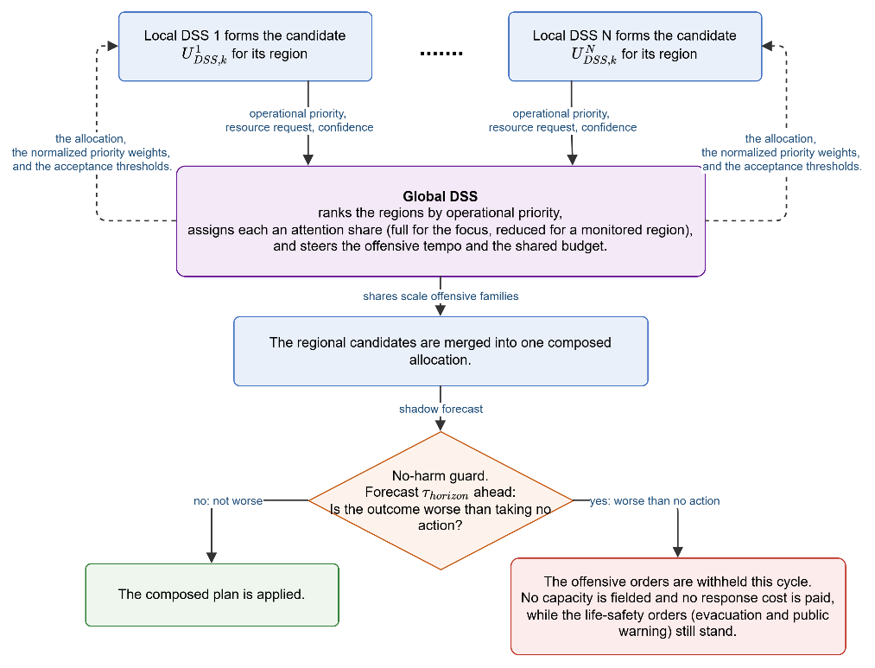
Figure 4.10 Global coordination and the no-harm guard
The share acts on the offensive side only. It scales the suppression effort and resource deployment and puts more of the shared budget on the focus, while evacuation and public warning are left untouched. Containment line and asset protection are not scaled by the share either; they are bounded by the pool alone. The share also sets how good an order must be to be accepted. An attended region keeps the normal quality threshold, but a monitored region must clear a higher one, so an offensive order in a low-priority region needs stronger decision quality before it uses shared capacity. The regional candidates are then merged into one plan, which the no-harm guard forecasts. When the plan is forecast worse than taking no action, its offensive orders are withheld for the cycle while the life-safety orders still stand. Figure 4.10 summarizes global coordination and the guard.
As an example, three agents report priorities of 0.82 (an intense fire close to a settlement), 0.24 (a similar fire in empty forest), and 0.12 (a quiet region). The coordinator makes the first agent the focus with a share of 1.00 and monitors the other two with shares of 0.65 and 0.57, so the first agent fields full suppression effort and resource deployment, the second a lighter suppression effort on a smaller budget, and the third protection and monitoring. The composed plan is forecast at 0.22 against 0.33 for taking no action, so it clears the no-harm guard and is fielded. In a later cycle the wind reverses and the same plan is forecast at 0.40 against 0.31; the no-harm guard withholds the offensive orders, only the public warning and evacuation of the first agent are fielded, and the offensive posture resumes once the forecast turns favorable again.

SIMULATION AND PERFORMANCE RESULTS
This chapter evaluates the DisasterAware framework empirically. Its purpose is twofold: To demonstrate that the three contributions C1 to C3 hold not only analytically but under simulated operations, and to establish that the simulation environment on which this demonstration rests is itself a faithful proxy of real fire behavior. The remainder of this chapter is organized as follows:
Section 5.1 derives the evaluation rubric: The eight criteria that the wildfire decision support literature asks an operational DSS to demonstrate, from predictive fidelity to scalability, against which the results of the whole chapter are evaluated.
Section 5.2 validates the simulation core: Four blind hindcasts of documented wildfires, driven by real terrain, fuel, and weather data, scored against the satellite record on spatial agreement and arrival time.
Section 5.3 states the experimental ground: The constraints and assumptions under which every experiment runs, and the simulation and decision parameters shared by all campaigns.
Section 5.4 quantifies the sensitivity of the outcome to parameter bias: With every parameter at its nominal value, one parameter at a time is displaced across its bias range, and the response of the physical cost identifies which deviations move the outcome, which deviations the loop tolerates, and why.
Section 5.5 reports the performance of the decision layer: The improvement ladder from no action to the full open decision space, the record of the adaptation stages and the generative products, and the timeliness and scalability of the loop itself.
Section 5.6 returns to the rubric of Section 5.1: The criterion by criterion compliance map, together with the criteria that are met and the reasons they remain open.

Evaluation Criteria for Wildfire Decision Support Systems
What a wildfire DSS must demonstrate has not been established by a single, agreed method. Published evaluations differ in what they measure, on which fires they measure it, and against which reference they score it, so results reported for different systems are rarely comparable, and no shared rubric has emerged that a new framework could simply adopt. Beneath this variety the literature divides into two loosely connected traditions: One asks whether the models inside the tool are right, and the other asks whether the tool changes the decision for the better.
The technical tradition evaluates the predictive models inside a tool and states that they should be assessed on their intended use, the spatial progression of real fires, before their results are used (Cruz, Alexander, & Wakimoto, 2003; Alexander & Cruz, 2013). The decision-support tradition evaluates the tool's effect on the decision itself (Martell, A review of recent forest and wildland fire management decision support systems research, 2015), and its most recent review reports a concerning finding. Most wildfire DSS evaluations so far have measured adoption and use rather than whether the tool improves the decision, which the review identifies as the main gap in the field (Rapp, et al., 2026).
An evaluation chapter must therefore address both traditions together. It must validate the model core as required by the technical tradition, and it must measure the decision effect as required by the decision-support tradition. Table 5.1 lists eight criteria with the measurement used for each in the literature. Section 5.2 validates the model core against the technical tradition, Sections 5.4 and 5.5 measure the decision effect, and Section 5.6 audits the evidence against these criteria.

Table 5.1 Evaluation criteria for wildfire DSS
Criterion | Measurement in the literature
Predictive fidelity:  The simulation core reproduces observed fire behavior from real inputs | Retrospective hindcasts against historical fires; spatial-overlap and arrival-time scores (Duff, et al., 2016; Fox-Hughes, Bridge, & Faggian, 2024; Filippi, Mallet, & Nader, 2014)
Decision quality:  Recommended interventions improve the outcome relative to a no-tool alternative | Outcome deltas against no-action and baseline policies on matched scenarios (Rapp, et al., 2026; Duff & Tolhurst, 2015).
Timeliness: Decision latency compatible with operational tempo | Decision-cycle wall time; detection-to-first-order time (Noonan-Wright, et al., 2011)
Robustness under degraded observation: Graceful behavior under sensor loss, noise, and communication failure | Performance versus outage and noise level; fail-safe engagement statistics (Comes, Hiete, Wijngaards, & Schultmann, 2011)
Uncertainty handling: Input uncertainty is represented and propagated to the decision | Ensemble and input-uncertainty propagation studies (Benali, et al., 2017; Cruz & Alexander, 2013)
Adaptability: The system extends its own knowledge when it does not cover the situation | Learning curves; coverage growth; rediscovery of withheld knowledge (Angelov & Filev, 2004)
Explainability and auditability: Every recommendation is traceable to its evidence | Trace completeness; interpretability as an adoption gate (Fillmore & Paveglio, 2023)
Scalability: Cost grows manageably with domain size and number of regions | Runtime and quality versus grid size and agent count (Pais, Carrasco, Moudio, & Shen, 2021).

Validation of the Simulation Core
In DisasterAware, the simulation core is a close enough model of real fire behavior to support the decision-layer results. The test is a blind hindcast. The simulator is given only the real inputs of a documented fire, with no tuning on that fire. All spread parameters are frozen at the literature-calibrated values of Appendix A before any hindcast is run, and no parameter is adjusted on any of the four cases. It runs for the recorded duration, and its burned area is compared with the observed burned area.
The inputs come from independent public data. Terrain is taken from the Copernicus GLO-30 elevation model (Copernicus, 2022). Fuel is taken from the ESA WorldCover 2021 land-cover product and mapped to the internal fuel classes (European Space Agency, 2022). Weather is taken from the ERA5 hourly at the ignition point, and dead-fuel moisture is set by the equilibrium-moisture model (Open-Meteo, n.d.). The ignition points and the reference burned area come from NASA FIRMS VIIRS 375 m active-fire detections (NASA FIRMS, n.d.). The reference mask is limited to the simulated time window and to the main detection cluster. This approach follows the widespread practice of testing fire models on independent, observed fires rather than on the data used to build them. The validation set has four documented fires in Turkey, chosen to cover different fuel, terrain, and wind conditions: Çanakkale–Kayadere, Manavgat, Marmaris, and Milas–Kemerköy. Their case definitions are given in Table 5.2.
Table 5.2 Historical validation cases and their configuration
Case | Bounding box (°E, °N) | Start date
Sc1: Kayadere (Çanakkale) | 26.50–27.00 E, 39.90–40.20 N | 2023-08-22
Sc2: Manavgat (Antalya) | 31.30–31.80 E, 36.72–37.08 N | 2021-07-28
Sc3: Marmaris (Muğla) | 28.10–28.55 E, 36.75–37.05 N | 2021-07-29
Sc4: Milas (Muğla) | 27.70–28.35 E, 36.95–37.35 N | 2021-08-01

The simulation core models free fire spread and does not represent suppression. A free run therefore overpredicts the final burned area, so area-overlap scores are not used as the primary measure, because they would conflate the spread error with the missing suppression and with the sparse satellite footprint. The core is instead evaluated on how the fire front propagates. Let ${FR}_{Sim}$ be the set of cells the model burns and ${FR}_{Re}$ the set of cells the satellite records as burned, and let $∂{FR}_{Sim}$ and $∂{FR}_{Re}$ be their fronts, the outer boundary cells of each set. Three criteria are used, each robust to suppression and to the length of the run: Coverage, front position error, and arrival-time agreement.
Coverage is represented as the probability of detection (POD). It is the share of the observed burn that the model reaches, the number of cells common to ${FR}_{Mod}$ and ${FR}_{Re}$ divided by the size of ${FR}_{Sat}$, ( 68 ). It stays informative even when the free run overshoots because extra simulated cells do not lower it.
$$POD=\frac{|{FR}_{Sim}∩{FR}_{Re}|}{|{FR}_{Re}|}$$ | ( 68 )
The acceptance level of 0.70 on the probability of detection is taken from the level at which the wildfire-simulation literature reports good agreement between simulated and observed footprints. Parameterizing FARSITE with vegetation-derived fuel maps raised the Sorensen coefficient from 0.38 for standard inputs to 0.70 (Price, 2022), and calibrated cell-based growth models reach 0.7 to 0.9 while uncalibrated semi-empirical models typically fall between 0.5 and 0.7 (Pais, Carrasco, Martell, Weintraub, & Woodruff, 2021). A probability of detection of at least 0.70 therefore marks the boundary of a reproduction of the observed extent that is as reliable as a well-behaved uncalibrated model. Since the probability of detection is insensitive to overprediction, this level is a necessary rather than a sufficient indication of agreement, and the front-position and arrival-time criteria carry the discriminating burden.
Front position error measures how far the simulated front lies from the observed one. With $D(x,G_{Set})$ the distance from a cell $x∈G$ to the nearest cell of a set $G_{set}$, as in ( 69 ), the front-to-front distances have a mean $\overline{d_{Front}}$, given in ( 70 ) and reported as front mean. Front position error expressed in meters is a standard output of FARSITE-style validation (Finney, 1998). In this study each distance is judged relative to the equivalent radius of the observed burn area ( 71 ), where $N_{burned}$ is the number of burned cells and $A_{cell}$ is the area of a cell. The error of front position should be less than 0.3 (success greater than 0.7 similar to POD).
$$D(x,G_{Set})=\min_{y∈G_{Set}}‖x-y‖$$ | ( 69 )
$$\overline{d_{Front}}=\frac{Σ_{x∈∂{FR}_{Sim}}D(x,∂{FR}_{Re})+Σ_{y∈∂{FR}_{Re}}D(y,∂{FR}_{Sim})}{|∂{FR}_{Sim}|+|∂{FR}_{Re}|}$$ | ( 70 )
$$R =\sqrt{\left(\left|N_{burned}\right| A_{cell}\right)/π}, {TH}_{Front}=1-\frac{\overline{d_{Front}}}{R}$$ | ( 71 )
Arrival-time agreement assesses the rate of spread directly. Over the $N_cells$ common to ${FR}_{Sim}$ and ${FR}_{Re}$, it compares the simulated arrival time at each cell with the first satellite detection time there. The mean absolute time (MAE) difference between them is $τ_{MAE}$ ( 72 ). It is the direct rate-of-spread test and is the least sensitive to suppression and to the length of the run. The error is judged relative to the observed fire duration $T$, the span of the satellite detections. The error of MAE ( 73 ) is accepted when it is less than 0.3; the largest observed ratio is 0.29. The observed duration may exceed the simulated window, because the satellite record of a case continues after the simulated window closes; the agreement is computed over the cells the two records share.
$$τ_{MAE}=\frac{1}{N_{cells}}Σ_{c∈{FR}_{Sim}∩{FR}_{Re}}\left|t_{c}^{Sim}-t_{c}^{Re}\right|; N_{cells}=|{FR}_{Sim}∩{FR}_{Re}|$$ | ( 72 )
$${TH}_{MAE}=1-τ_{MAE}/T$$ | ( 73 )
Table 5.3 reports the agreement metrics per case, averaged over 50 stochastic replicates. Figure 5.1 shows the corresponding agreement maps, in which correctly predicted burn, overprediction, and missed burn are distinguished. It shows that the simulation core has an acceptable overall success rate over real scenarios. The overall success of a case is the arithmetic mean of the three normalized scores. It is a reporting convenience rather than a literature-based composite measure, which is why the three scores are also reported separately.
Table 5.3 Hindcast agreement metrics per historical case
 | Sc1 | Sc2 | Sc3 | Sc4
$$A_{cell} \left(m^{2}\right)$$ | $$8100$$ | $$8100$$ | $$8100$$ | $$8100$$
$$N_{burned}$$ | $$1288$$ | $$3922$$ | $$387$$ | $$4915$$
$$R (m)$$ | $$1823.03$$ | $$3179.96$$ | $$1000.19$$ | $$3559.83$$
$$T (hr)$$ | $$14.00$$ | $$72.80$$ | $$14.00$$ | $$58.70$$
$\overline{d_{Front}}$ (m) | $$329.00$$ | $$305.00$$ | $$113.00$$ | $$391.00$$
$τ_{MAE}$ (h) | $$1.46$$ | $$1.39$$ | $$4.04$$ | $$2.58$$
$$1-\frac{\overline{d_{Front}}}{R}$$ | $$82\%$$ | $$90\%$$ | $$89\%$$ | $$89\%$$
$$1-\frac{τ_{MAE}}{T}$$ | $$90\%$$ | $$98\%$$ | $$71\%$$ | $$96\%$$
$POD$ (–) | $$92\%$$ | $$93\%$$ | $$97\%$$ | $$85\%$$
Overall Success | $$88\%$$ | $$94\%$$ | $$86\%$$ | $$90\%$$

Sc1 | 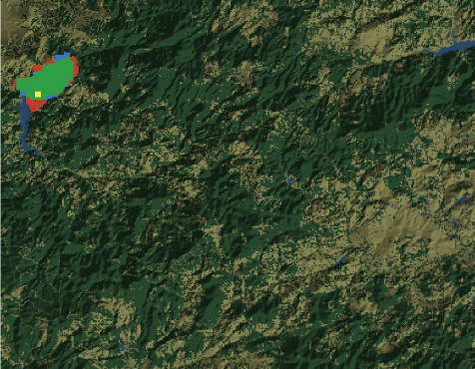 | Sc2 | 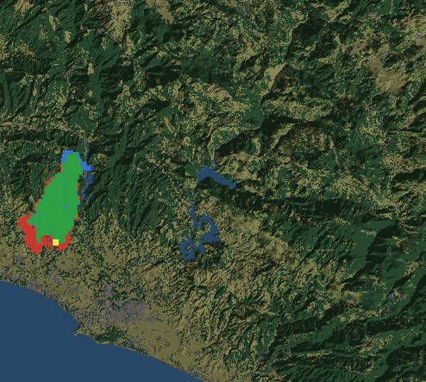
Sc3 | 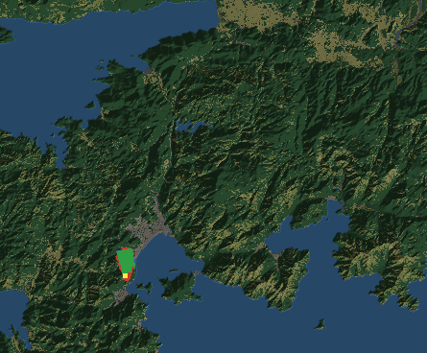 | Sc4 | 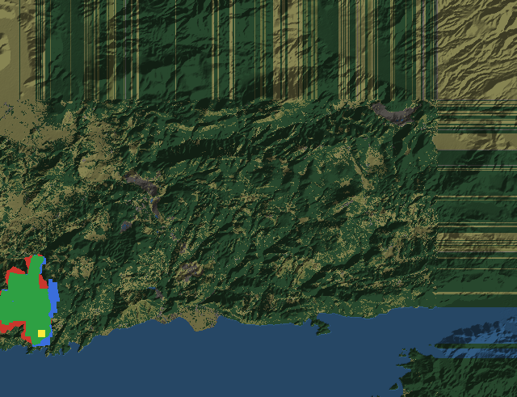
Figure 5.1 Agreement maps for the historical hindcasts (Green: Correctly predicted burn, Red: Simulated only, Blue: Observed only, Yellow: Ignition)

Simulation Constraints and Assumptions
All experiments run on the DisasterAware testbed, whose two cores are presented in Chapters 3 and 4 and are kept strictly separated by design: The simulation core advances the physical state of the fire, and the decision core reads that state only through the observation model and acts on it only through the intervention families.
Two kinds of scenario are used. Synthetic scenarios are generated procedurally on grids of 72×50 cells (ladder campaign) and 80×60 cells (sensitivity and latency studies) at 30 m resolution with terrain presets (rolling hills, Mediterranean coast), seeded settlements and road networks, and capacity-limited resource bases; ignition points are chosen among burnable cells farthest from the bases, so that trivial fires do not mask parameter effects. Historical scenarios reconstruct documented fires on 90 m grids from real terrain, fuel, and weather data. Unless stated otherwise, the decision engine runs with the thresholds of Chapter 4, and the full seed rule base of Appendix E; deviations (thin seed profiles, adaptation off, perturbed observation) are the controlled variables of the individual experiments and are stated per experiment. Table 5.4 lists the parameters of all runs in one place, grouped by subsystem.
Table 5.4 Simulation and decision parameters of all experiments
Parameter | Sym | Value / range | Unit
Grid size (synthetic) | $$-$$ | $$72 × 50 / 80 × 60 / up to 160 × 120$$ | cells
Cell size (synthetic / hindcast) | $$C_{Size}$$ | $$30 / 90$$ | m
Simulation step | $$Δt$$ | $$2-30$$ | min
Decision cycle | $$-$$ | $$2 - 20 (def: 12)$$ | min
Attention Threshold | $$τ_{att}$$ | $$0.35$$ | —
Satisficing bound | $$J_{TH}$$ | $$0.35$$ | —
Quality gate | $$η$$ | $$0.60$$ | —
Trial basis (shadow forecast) | $$-$$ | $$24 (campaigns) / 45 (threshold sweeps)$$ | min
Monte Carlo runs per condition | $$N_{MC}$$ | $$50 (ladder, hindcasts) / 10 (thresholds, latency) / 5 (sensitivity)$$ | runs
Hardware / wall time per run | $$-$$ | i9-10900K, 32 GB RAM | —

Modeling and decision layer assumptions, common at operational-scale fire simulation (Sullivan, Wildland surface fire spread modelling 1: Physical and quasi-physical models, 2009a) are listed in Table 5.5.
Table 5.5 Environment and decision layer assumptions
Environment layer assumptions
Precipitation is a single domain-uniform value.
Dead-fuel moisture follows the equilibrium-moisture model, not measured fuel sticks.
Fuel classes come from a land-cover product through a fixed mapping, which flattens within-class variability.
Ember transport and crown-fire transitions enter only through the spread terms.
Crews and aircraft are modeled as capacity fields, not individual units.
Decision layer assumptions
Decisions are taken on a fixed decision cycle rather than continuously.
Sensing and inter-region communication are reliable, except where an experiment perturbs them.
The cost priorities that weight J are fixed and known for a given run.
Any change proposed by the generative component takes effect only after passing the verification gates.
The no-harm guard treats the shadow forecast as the proxy for the no-action outcome over its horizon.
Evacuation is charged only through the response capacity it consumes; the societal cost of displacement lies outside the objective.
The population term counts exposure inside actively burning cells only; smoke and proximity exposure outside the fire front are not modeled.
Fire duration is priced only through the burned area and the accumulated exposure it produces, not as a separate cost term.

Sensitivity Analysis: Response to Parameter Bias
This section quantifies how the outcome responds when the operational parameters of the closed loop deviate from their configured values. Every parameter of Table 5.6 has a nominal value, the value the framework actually runs with, and a bias is a controlled deviation from that nominal value. The question of the section is therefore not which parameter values are best, but how far the outcome moves when a known parameter is set wrong, and how much bias each parameter tolerates before the outcome degrades. This framing matters operationally: In a fielded system the parameters are set by configuration and doctrine, not re-tuned per incident, so the practical risk is not a suboptimal choice but a miscalibrated one.
The method applies one bias at a time (Morris, 1991; Saltelli, et al., 2008): A single parameter is displaced across its bias range while every other parameter holds its nominal value, and the response is recorded on the physical decision cost, the burned-area, asset, and population terms of the forecast. Displacing one parameter at a time keeps the attribution unambiguous, since any movement of the outcome belongs to the displaced parameter alone; interactions between simultaneous miscalibrations are outside the scope of this design. Each bias level is repeated over five independent worlds, and the figures show the mean over the five worlds. The study comprises 990 runs in total.
A bias study can only show what its operating point allows. Where the fire is beaten under every setting, or lost under every setting, no bias can move the result, and the study would report a robustness that belongs to the situation rather than to the system. The two situational axes, the fire load and the resource level, are therefore swept first to locate an operating point at which the decision layer is neither winning nor losing outright, and the biases of the operational parameters are then applied around that point. The shape of each response curve is read in two ways: A flat stretch around the nominal value is the tolerance of the parameter, the miscalibration the loop absorbs, and the point where the curve turns is the margin beyond which the error becomes visible in the outcome. Table 5.6 lists the parameters, their nominal values, and their bias ranges.
Table 5.6 Sensitivity design: Parameters, nominal values, and bias ranges
Parameter | Nominal value | Bias range | Definition
Simultaneous ignitions | 4 | 1-12 | Number of fires started at step 0, placed on the least reachable burnable cells. Sets the fire load.
Resource level | 0.25 | 0.10 - 1.00 | Scale on the availability of the pool the planner suggests for this map. It binds as a total budget across the regions.
Local regions (𝑁) | 4 | 1-16 | Number of sub areas the grid is partitioned into. Each is evaluated on its own and competes for the shared pool.
Attention threshold ($τ_{att}$) | 0.35 | 0.05 - 0.95 | Priority at which a region is attended rather than monitored. A monitored region gets a smaller share and a tighter gate.
Satisficing bound ($J_{TH})$) | 0.35 | 0.05-0.95 | Cost at which the orders in force are accepted. The effective bound is $min(J_{TH}, 0.95 J_{0})$, so it tightens when inaction is already cheap.
Fail-safe quality gate ($η$) | 0.60 | 0.05-0.95 | Minimum decision quality for offensive orders at full strength. Below it they are scaled by Q/η, while evacuation and warning are never reduced.

Simultaneous Ignitions vs Resource Level
Figure 5.2 depicts the physical decision cost over fire load and suppression pool, expressed as a share of the free burn of the same world. At a tenth of the pool, once there is more than one ignition, the cost stays between 77 and 83% of the free burn whatever else is set, so the fire is lost throughout. With a full or a three quarter pool and up to four ignitions it stays between 14 and 32%, so the fire is held throughout.
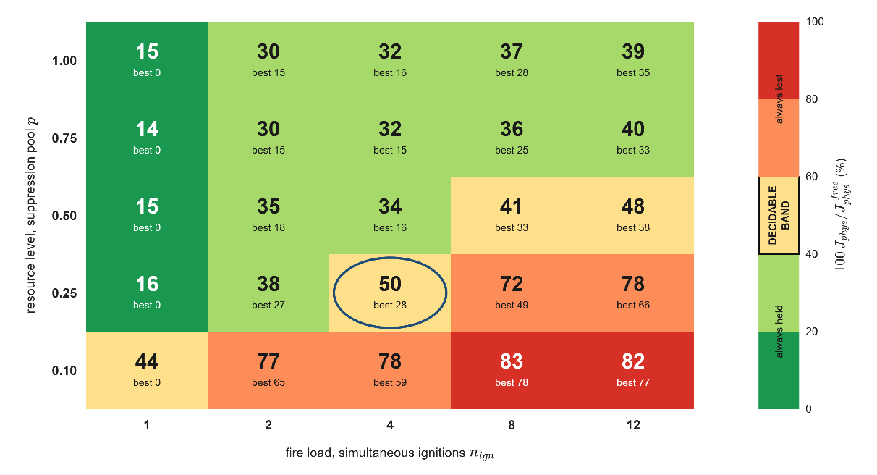
Figure 5.2 The physical cost over simultaneous ignitions and resource level
Only a few cells fall inside the decidable band, and the sweeps that follow are run at the one nearest the midpoint of the free burn, four simultaneous ignitions with a quarter of the pool. That setting retains 50% of the free burn cost on the mean and 28% in the least severe of the worlds.

Simultaneous Ignitions vs Observation Coverage
Figure 5.3 to Figure 5.6 report the physical cost of the decision layer over the fire load and the observation level, one figure per resource pool. They are drawn from separate world sets, so individual cells are not comparable with the cells of Figure 5.2. Each cell gives the cost as a share of the free burn of the same world, with the rows varying the deployed sensors and the columns the simultaneous ignitions.
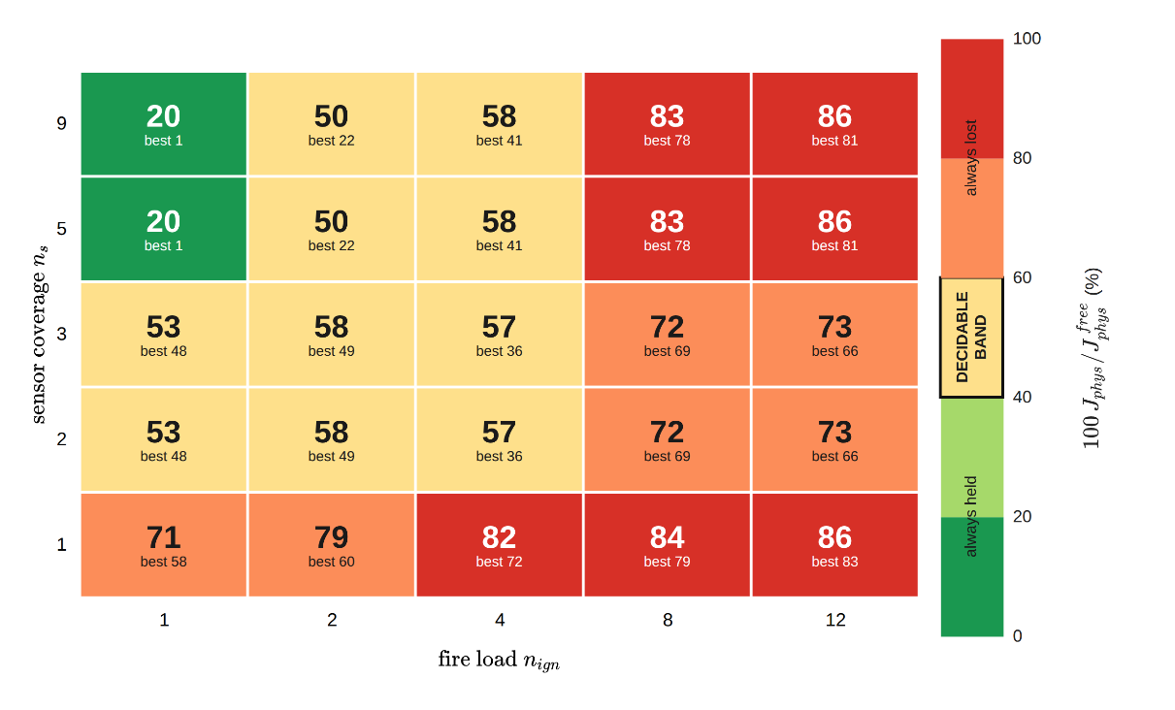
Figure 5.3 The physical cost over ignitions and coverage, pool is 0.25
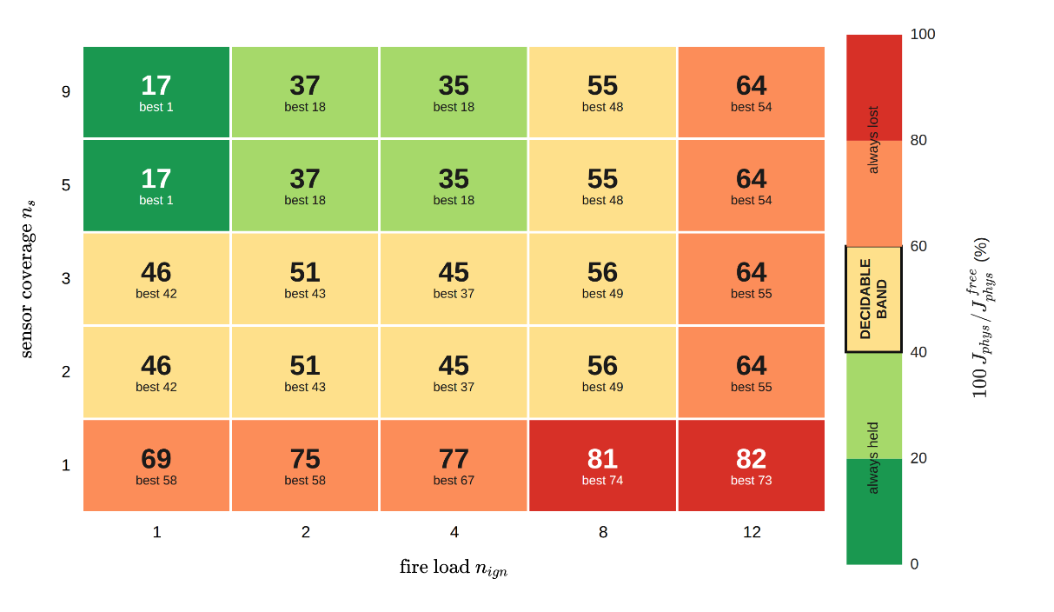
Figure 5.4 The physical cost over ignitions and coverage, pool is 0.5
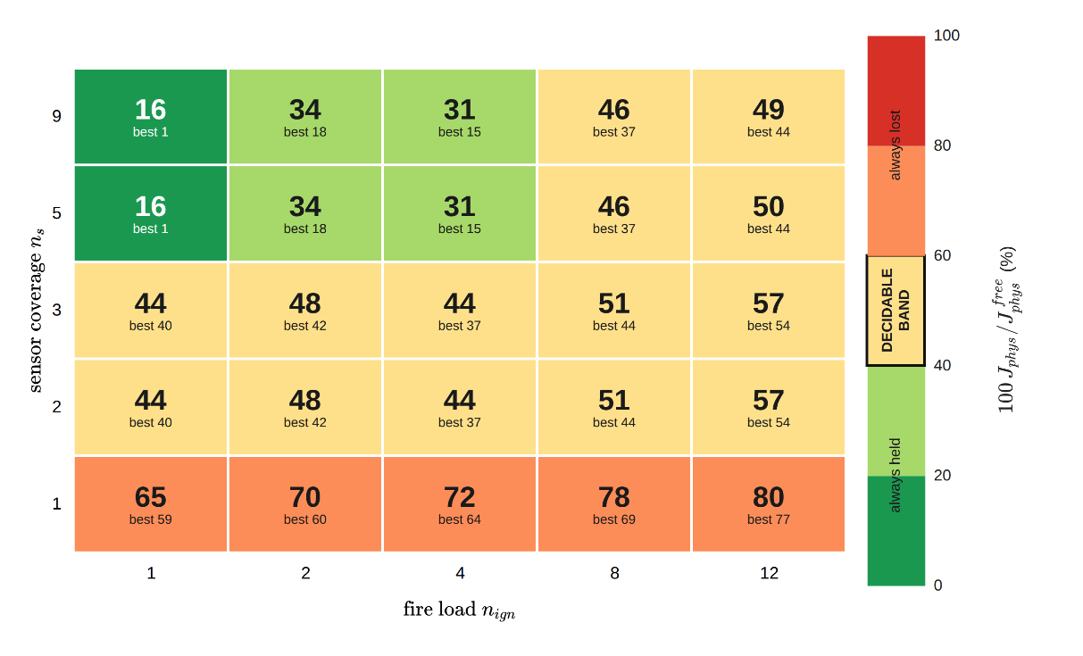
Figure 5.5 The physical cost over ignitions and coverage, pool is 0.75
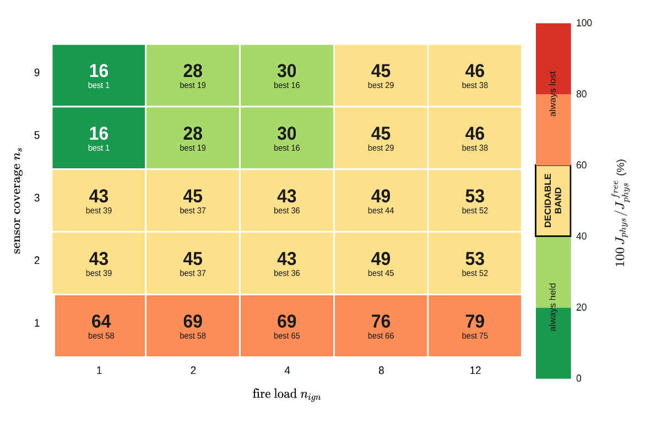
Figure 5.6 The physical cost over ignitions and coverage, pool is 1
Figure 5.3 to Figure 5.6 separate the effect of observation from the effect of resource. Observation decides the outcome at a light fire load, where a single ignition falls from about 70% of the free burn with 1 sensor to about 20% with full coverage, and coverage saturates early because 5 and 9 sensors, and 2 and 3 sensors, give the same result. Resource decides the outcome at a heavy fire load, where 12 ignitions with full coverage drop from 86% at the quarter pool in Figure 5.3 to about 46% at the full pool in Figure 5.6, while the single-ignition cells barely move. The two inputs are therefore complementary rather than interchangeable. A blind map is not recovered by resource, and a scarce pool is not recovered by observation, so the decision layer changes the outcome only inside the decidable band, where both are sufficient for the fire at hand. As a bias reading, the outcome tolerates a loss of coverage down to five sensors with no measurable cost and degrades steeply below that level.
In Figure 5.3, two regularities of the grids require comment. First, two and three sensors give identical results, as do five and nine, because the sweep deploys the first assets of the ranked list of the network planner and the additional assets do not change the observed state of the burning cells. Second, at the quarter pool the cost rises from three to five sensors at eight and twelve ignitions, from 72 and 73% to 83 and 86%. Wider coverage exposes more burning regions than a quarter pool can serve, so decision quality falls below the gate and the graduated fail-safe derates the offensive orders in 25 to 30% of the region cycles, compared with 2 to 4% under narrower coverage. Observation therefore improves the outcome only when the resource pool can act on what is observed. The rise reduces to one or two points at half a pool and is absent from three quarters upward.

Decision Cycle and Decision Horizon
The decision cycle is the interval at which the decision layer replans, so it sets how long a committed plan is allowed to age while the front continues to advance. For a DSS it is the difference between orders that describe the fire as it is and orders that describe the fire as it was, because a longer cycle does not change what the layer is able to decide, only how often it decides. The decision cycle is computed as ( 74 ).
$$Δt_{decision}=max\left(Δt,min\left(\frac{C_{size}}{2R_{spread}},\frac{τ_{Horizon}}{5}\right)\right)$$ | ( 74 )
The first bound requires that the fire front advance no more than half a cell between two consecutive decisions $C_{size}/(2R_{spread} )$, so that orders still refer to the cells the fire actually occupies. The second requires that the plan be revised at least five times before the horizon over which it was judged expires $τ_{Horizon}/5$, so that the no-harm guard can correct its own forecast before the commitment matures. The smaller of the two bounds is therefore selected, and the result is floored at the integration step, since the decision layer cannot act more often than the physics is advanced. Figure 5.7 and Figure 5.8 evaluate the two bounds over the rates of spread and the no harm horizons.
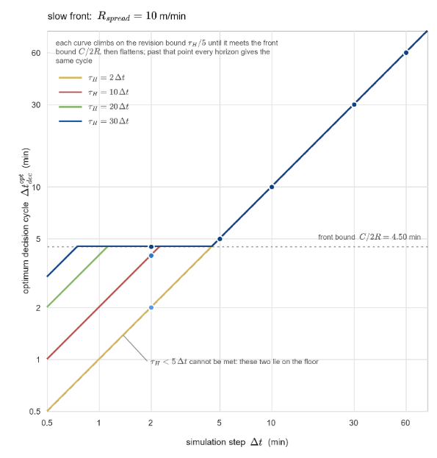
Figure 5.7 Optimum decision cycle for low ROS and no harm horizons
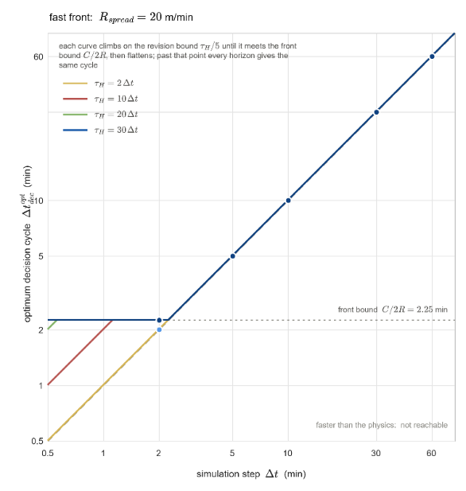
Figure 5.8 Optimum decision cycle for high ROS and no harm horizons
Figure 5.9 presents the paired gain over the decision cycle for the two fire types. That the basic fire shows the same ordering as the complex fire establishes that the benefit of a short cycle is not an artifact of a strained resource pool, although the five-world half widths at the two-minute level, 8.3 points for the complex fire and 9.2 for the basic fire, leave the size of the effect uncertain. The campaign cycle of twelve minutes is the zero of this sweep and the cycle derived in ( 74 ) is its shortest level; every lengthening of the cycle degrades the paired gain monotonically for both fire types, so the cost of replanning late is graded rather than cliff-edged.

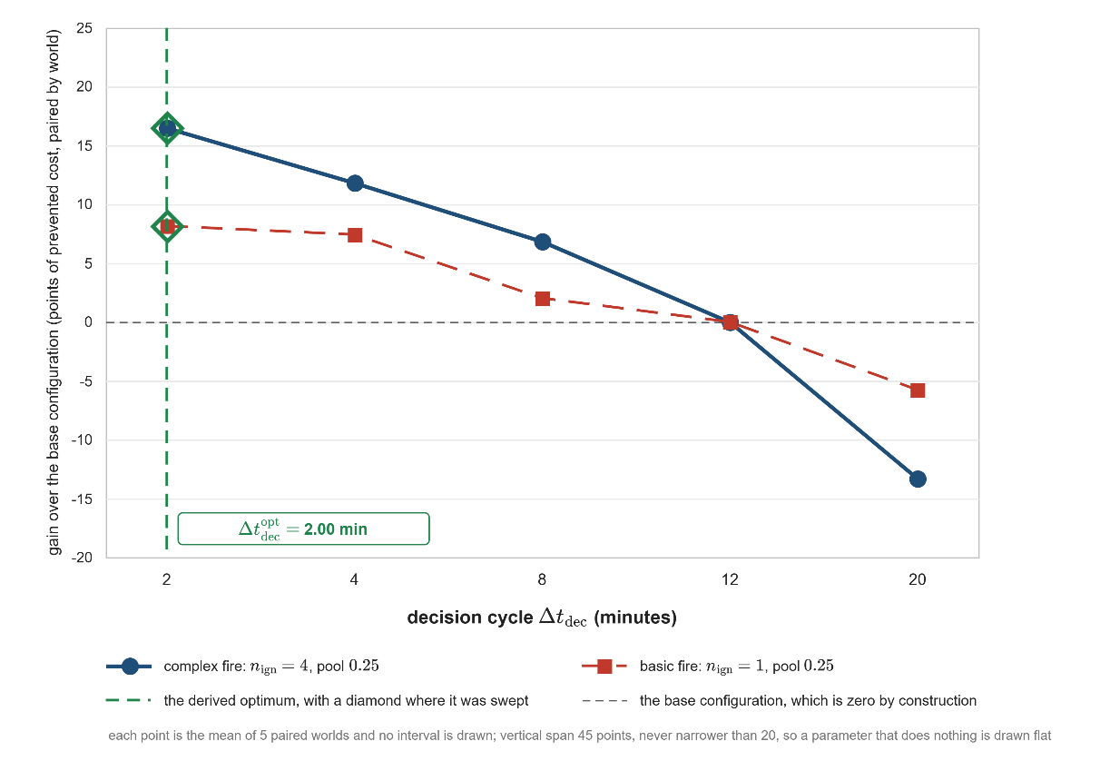
Figure 5.9 Sensitivity of the outcome to the decision cycle (mean of five paired worlds with 95% half widths)

Satisficing Bound and Quality Gate
Neither the satisficing bound nor the fail-safe quality gate acts on the outcome directly. Each governs a rate on the running incident. The bound decides how often the standing decision is judged insufficient. The gate decides how often an offensive order is reduced before it is fielded. Figure 5.10 and Figure 5.11 report the two rates over the whole unit interval.
In Figure 5.10, the bound sets how often the adaptation ladder is climbed. At $0.05$ every decision cycle declares a cost deficit. At the configured $0.35$ the share is 42.0%. Above 0.45 the curve is flat at 29.5%, because the relative margin against no action is then always the smaller of the two requirements and the ceiling no longer binds. A lower ceiling makes the standing decision harder to accept, so the system escalates more often, which is the direction the acceptance test asks for. Between the nominal ceiling of 0.35 and 0.45 the engagement rate falls by about 1.2 percentage points per 0.01 of upward bias, and below the nominal it rises steeply toward the saturated case at 0.05, so the acceptance machinery tolerates an upward bias of the ceiling and responds proportionally to a downward one.
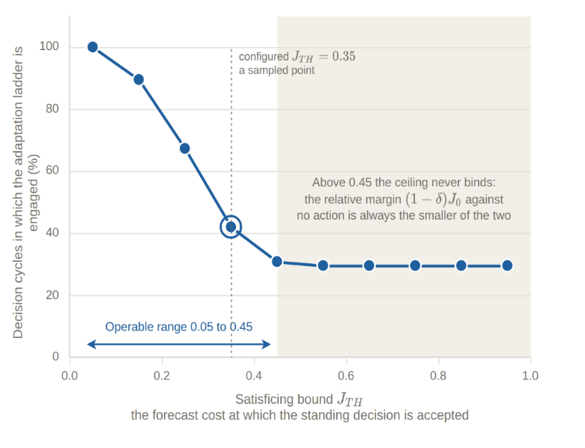
Figure 5.10 Effect of the satisficing bound
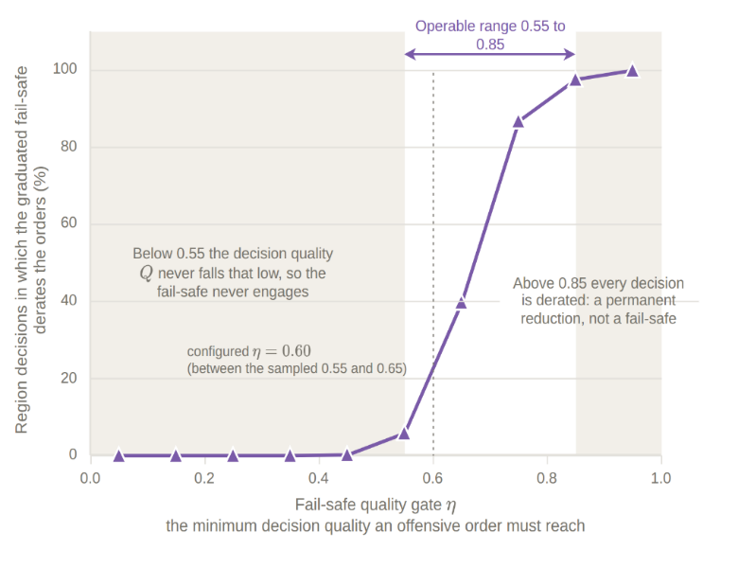
Figure 5.11 Effect of the fail-safe quality gate
Two further parameters of Table 5.6 were swept in the same design. The number of local regions is a weak parameter: On the basic fire every partition from one to sixteen regions lies within 1.5 points of the four-region setting, and on the complex fire the differences, between 6 points below and 4 points above, are smaller than their half widths. The attention threshold is flat between 0.15 and 0.50, where the attended set does not change; at 0.95, where every region but the focus is monitored, the complex fire gains 7.5 points with a half width of 4.0, so a stricter focus helps when capacity is scarce, while the basic fire is unaffected.
Both settings are defined on the unit interval, yet each acts over a fraction of it. The reason is the same in the two cases. A threshold on a bounded quantity acts only where that quantity varies. The ceiling is compared against the forecast cost of taking no action, which spans 0.06 to 0.46 with a median of 0.23 at this operating point, so a ceiling above that span is never the binding requirement. The gate is compared against the decision quality, which stays between 0.55 and 0.85 for this rule base and this scenario.
The range over which a threshold can be swept is therefore a property of the distribution it cuts, and not of the interval on which the parameter is defined. The scope of this analysis is set by the data behind it. The biases are applied one at a time around a single operating point, so interactions between simultaneous biases are not measured, and the biased quantities are the parameters of the decision loop; a bias of the plant itself, such as a mis-specified fuel map or a mis-forecast wind field, enters the evidence only through the degraded-observation scenario of Section 5.5 and would require dedicated runs to be separated. Within this scope the steep directions are the decision cycle and a resource pool below one half, and the tolerant directions are the observation coverage, the ceiling above its nominal value, and the quality gate inside the band that the decision quality actually occupies.

Performance of the Decision Layer
In the performance test, there are four configurations facing identical fires as listed in Table 5.7. $T_{F5}$ against $T_{0}$ prices the minimum decision layer itself; $T_{F5+Ev}$ against $T_{F5}$ prices evFIS based parametric adaptation; $T_{DisasterAware}$ against all three prices the open decision space.
Table 5.7 DSS test configurations
$T_{0}$ issues no orders and fixes the cost of inaction.
$T_{F5}$ runs the decision layer on the minimal seed base of five rules
$T_{F5+Ev}$ adds the evFIS adaptation stages ① and ②, consequent tuning, and resolution growth.
$T_{DisasterAware}$ runs the full staged adaptation, the open decision space in full.

Each configuration is evaluated as a Monte Carlo over the same fixed seed set in every scenario. Every seed generates one scenario-conformant world, the map, the ignitions, and the weather drawn to the specification of the scenario, and all configurations replay that identical world, so the outcome differences come from the decision mechanism alone; $T_{0}$, run on the same history, additionally serves as the exact no-action counterfactual.
The seed set is fixed before the campaign and shared by all configurations. Episodes run until extinction or a cap of twelve hours. As the cost terms accumulate over time, cross-configuration comparisons are read at the end of the episode, when every run has reached extinction or the twelve-hour cap, and the share of runs in which the fire is extinguished within the episode is reported. Comparisons are based on two costs. Physical cost $J_{Phy}$ is against the no-intervention reference and is using renormalized cost of assets, people, and burned area because $T_{0}$ pays no response cost by definition and a comparison on the total cost would reward inaction. The total cost $J_{Tot}$ is reported for other configurations. The costs ( 75 ) are based on ( 48 ).
The evaluation uses two campaigns. The improvement ladder of Section 5.5.2 is a Monte Carlo campaign of 1000 runs: the four configurations over the five scenarios with fifty seeds each. In this campaign the generative stage ③ is served by a deterministic stand-in proposer, which writes a strong rule on the dominant terms of the situation brief; every proposal still passes the full gate chain of Section 4.5.3, so the campaign is repeatable and measures what the open decision space delivers through the gates. The live language model is exercised in a separate set of 160 recorded runs on the same scenarios, with the complete cycle ledger kept. Section 5.5.3 first reports the adaptation activity of the ladder campaign and then reads that ledger for the products of the generative stage.
$$J_{Phy}=\frac{\sum_{j}{w_{j}J_{j}}}{\sum_{j}{w_{j}}}, j∈\left\{burn, asset, pop\right\} \\ J_{Tot}= \frac{\sum_{j}{w_{j}J_{j}}}{\sum_{j}{w_{j}}}, j∈\left\{burn, asset, pop, resp, delay\right\}$$ | ( 75 )

Evaluation Scenarios
The tests run on four scenario families built from the landscape type and the resource sufficiency, and one degraded-observation variant. The landscape axis separates the two operational faces of the problem, namely remote forest, where the burned-area term dominates and suppression and containment lines are the focus, and the wildland-urban interface (WUI), where assets and population dominate and protection, evacuation, and warning are focused. The resource axis separates the comfortable regime, in which almost any allocation succeeds, from the capacity-limited regime, in which allocation quality is what separates the configurations. Weather is held at critical fire weather, dry fuels, and strong wind, in all scenarios, so that the scenario axes remain the only controlled difference.
For each scenario, fifty distinct worlds are generated; Table 5.8 defines the five scenarios, representative worlds are illustrated in Figure 5.12 and Figure 5.13, a sample of interventions in Figure 5.14, and the legend in Figure 5.15.
Table 5.8 Evaluation scenarios
ID | Landscape | Resource* | Ignitions | What it assesses
S1 | Remote Forest  (≈2 small settlements) | Sufficient | 1 remote | Baseline suppression competence when capacity is not the constraint
S2 | Remote Forest  (≈2 small settlements) | Limited | 3 remote | Area protection under scarcity; allocation quality
S3 | WUI  (≈ 15 settlements, high assets) | Sufficient | 2 near the interface | Life/asset prioritization; evacuation and warning discipline
S4 | WUI  (≈ 15 settlements, high assets) | Limited | 2 near the interface | Full operational stress; the demonstrative scenario
S5 | as S4 | as S4 | as S4 | S4 under degraded observation

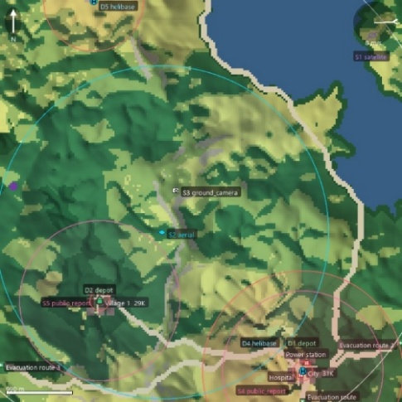 | 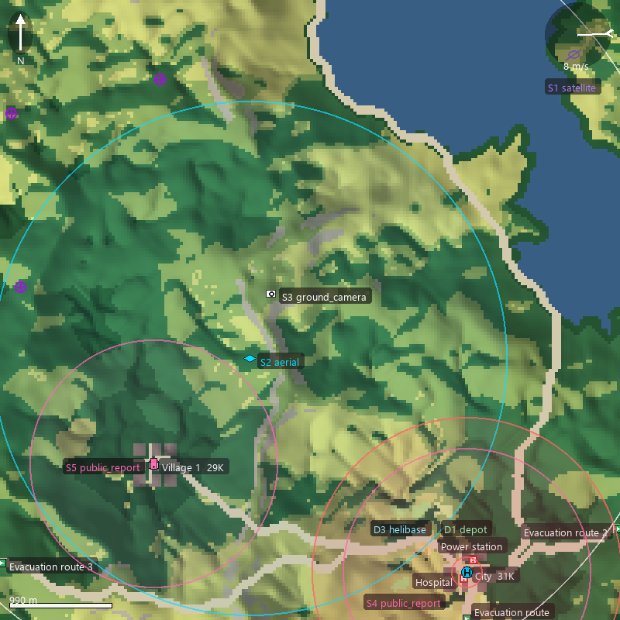
Figure 5.12 Representative world of S1 (left) and S2 (right)
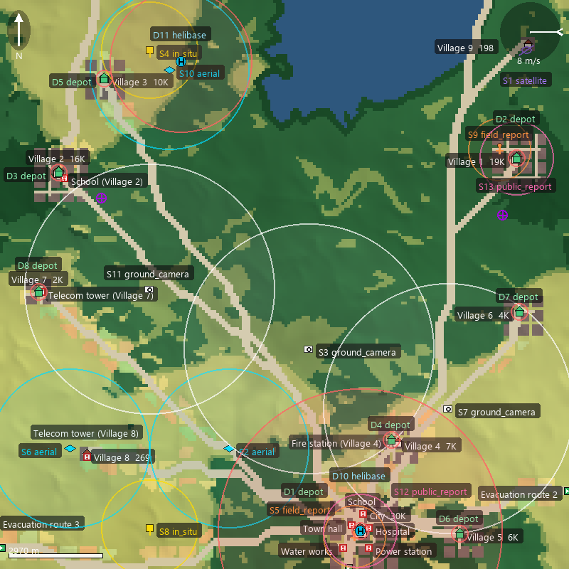 | 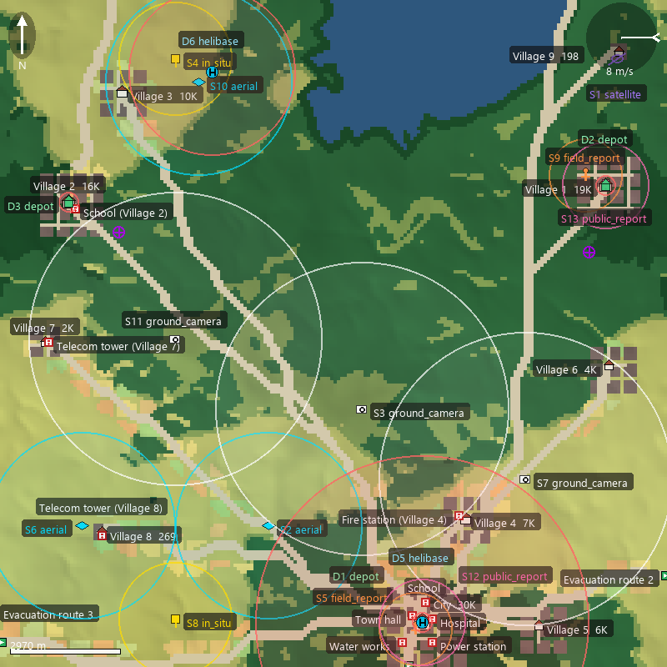
Figure 5.13 Representative world of S3 (left) and S4 (right)
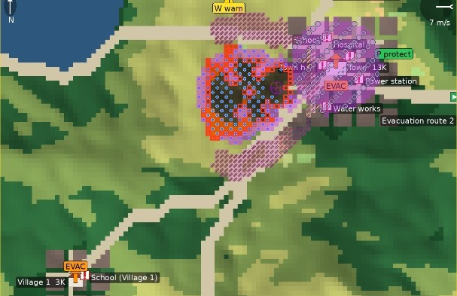
Figure 5.14 Sample interventions (full set) on a representative world
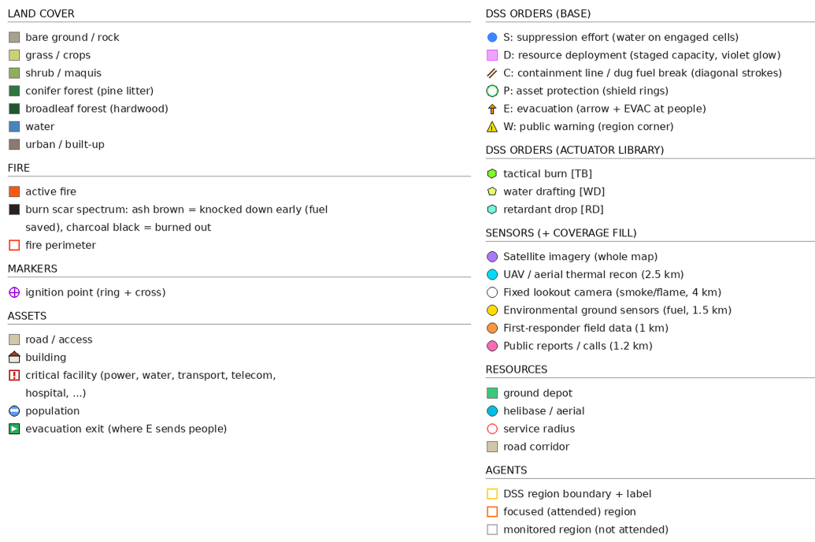
Figure 5.15 Legends for representative world

Improvement Ladder Performance
Table 5.9 and Table 5.10 report the physical outcome and the matching decision-cost terms per scenario at the end of the episode. The configurations form a ladder, and each configuration is expected to show a visible gain over the one below it.
$T_{F5}$ lowers the mean burned area from 251 ha under free burn to 85 ha, a 66% reduction, and lowers the mean physical cost from 0.596 to 0.160.
$T_{F5+Ev}$ adds a small but consistent gain over the static rules. It brings the mean burned area to 83 ha and the mean affected population from 498 to 396, lowers the burned area in three of the five scenarios and the physical cost in all five, and raises the share of incidents extinguished within the episode from 10% to 46%. The mean total decision cost falls with it, from 0.193 to 0.176, and the saving comes from the delay term, which drops from 0.353 to 0.251: The tuned consequents commit the same resources sooner rather than committing more of them.
$T_{DisasterAware}$ supplies the second step, and its gain lies less in the burned area than in finishing the incident: It raises the share of incidents extinguished within the episode to 52%, five times the static rule base, lowers the mean affected population to 358 (498 under the static base, a 28% reduction), lowers the mean burned area to 76 ha, a 70% reduction against free burn and a tenth below the static rule base, and brings the mean total decision cost to 0.168 and the mean physical cost to 0.140, the lowest of the four configurations in every scenario, at a response cost no higher than that of the static base (0.503 against 0.530). The margin over the F5+Ev configuration is small on the mean but consistent: DisasterAware lies below it in all five scenarios on burned area, physical cost, and total cost, and the paired difference on burned area, 7 ha with a 95% half-width of 4 ha, excludes zero. The population cost term of Table 5.10 moves the other way, from 0.002 to 0.004, because it prices exposure at the moment of burning, while the affected population counts the residents of cells that burned; both are small against the burned-area and asset terms. Two readings of this margin belong together.
First, the against-no-action comparison is made on the physical cost, and the no-action total of 0.526, which carries no response and no delay term, is shown for reference only. Second, DisasterAware also holds access to the three base actuators that F5 and F5+Ev cannot order, but the stand-in proposer of the ladder campaign composed only doctrinal families (the town-shield macro), so the margin of this rung measures the open decision mechanism alone; the wider action vocabulary enters only in the recorded runs of Section 5.5.3.
The average outcome, physical cost and total cost are shown in Figure 5.16, Figure 5.17 and Figure 5.18, respectively. The ± values of Table 5.9 are 95% confidence half-widths, 1.96 times the standard error over the fifty Monte Carlo runs of the configuration under that scenario.
Scenario S5 repeats S4 under degraded observation and prices the confidence machinery directly. The mean burned area of DisasterAware rises from 52.3 to 54.3 hectares, a loss of four per cent that stays inside the 95% interval of either cell, and the configuration remains the best of the four, so reduced observation degrades the response instead of breaking it.
Table 5.9 Physical outcome per scenario and configuration at the end of the episode
 | Burned (ha) | Burned Forest (ha) | Affected  Pop. | Evac.  Pop. | Extinguished (%)
S1
$T_{0}$ | 262.3 ± 7.1 | 127.9 | 3812.1 | 0.0 | 0
$T_{F5}$ | 93.5 ± 19.2 | 45.9 | 360.9 | 10.8 | 16
$T_{F5+Ev}$ | 88.6 ± 21.1 | 42.6 | 275.3 | 182.9 | 32
$T_{DisasterAware}$ | 78.7 ± 20.0 | 39.5 | 264.9 | 199.6 | 34
S2
$T_{0}$ | 266.4 ± 5.2 | 129.3 | 3837.8 | 0.0 | 0
$T_{F5}$ | 181.4 ± 17.6 | 88.6 | 909.6 | 14.5 | 2
$T_{F5+Ev}$ | 177.5 ± 17.5 | 87.7 | 788.0 | 170.0 | 6
$T_{DisasterAware}$ | 168.2 ± 20.0 | 82.7 | 720.8 | 172.3 | 8
S3
$T_{0}$ | 235.4 ± 8.2 | 60.3 | 6759.4 | 0.0 | 0
$T_{F5}$ | 33.5 ± 8.0 | 4.0 | 225.4 | 2.0 | 20
$T_{F5+Ev}$ | 29.8 ± 7.3 | 5.6 | 163.5 | 2.1 | 76
$T_{DisasterAware}$ | 27.0 ± 6.4 | 4.6 | 135.8 | 64.1 | 84
S4
$T_{0}$ | 245.1 ± 7.6 | 62.2 | 7231.7 | 0.0 | 0
$T_{F5}$ | 55.1 ± 7.3 | 8.4 | 496.8 | 2.1 | 6
$T_{F5+Ev}$ | 58.2 ± 8.1 | 14.4 | 358.9 | 7.8 | 56
$T_{DisasterAware}$ | 52.3 ± 8.1 | 12.2 | 333.1 | 370.5 | 64
S5
$T_{0}$ | 245.1 ± 7.6 | 62.2 | 7231.7 | 0.0 | 0
$T_{F5}$ | 60.0 ± 8.1 | 11.1 | 498.2 | 5.6 | 8
$T_{F5+Ev}$ | 61.0 ± 8.9 | 14.8 | 396.3 | 4.9 | 60
$T_{DisasterAware}$ | 54.3 ± 7.9 | 12.0 | 337.7 | 562.8 | 72

Table 5.10 Decision-cost terms at the end of the episode per scenario and configuration
Scenario | $$J_{burn}$$ | $$J_{asset}$$ | $$J_{pop}$$ | $$J_{resp}$$ | $$J_{delay}$$ | $$J_{total}$$ | $$J_{phys}$$
S1
$T_{0}$ | 0.655 | 0.957 | 0.236 | — | — | 0.544 | 0.616
$T_{F5}$ | 0.346 | 0.135 | 0.002 | 0.688 | 0.408 | 0.207 | 0.161
$T_{F5+Ev}$ | 0.318 | 0.110 | 0.004 | 0.628 | 0.362 | 0.185 | 0.144
$T_{DisasterAware}$ | 0.295 | 0.094 | 0.003 | 0.620 | 0.377 | 0.174 | 0.131
S2
$T_{0}$ | 0.659 | 0.962 | 0.243 | — | — | 0.548 | 0.621
$T_{F5}$ | 0.547 | 0.324 | 0.006 | 0.974 | 0.225 | 0.328 | 0.292
$T_{F5+Ev}$ | 0.539 | 0.291 | 0.008 | 0.956 | 0.206 | 0.315 | 0.279
$T_{DisasterAware}$ | 0.515 | 0.278 | 0.008 | 0.944 | 0.206 | 0.303 | 0.267
S3
$T_{0}$ | 0.642 | 0.883 | 0.161 | — | — | 0.496 | 0.562
$T_{F5}$ | 0.183 | 0.056 | 0.001 | 0.136 | 0.401 | 0.102 | 0.080
$T_{F5+Ev}$ | 0.167 | 0.044 | <0.001 | 0.091 | 0.259 | 0.083 | 0.070
$T_{DisasterAware}$ | 0.155 | 0.033 | <0.001 | 0.111 | 0.271 | 0.078 | 0.063
S4
$T_{0}$ | 0.652 | 0.927 | 0.191 | — | — | 0.520 | 0.590
$T_{F5}$ | 0.284 | 0.103 | 0.002 | 0.422 | 0.377 | 0.161 | 0.129
$T_{F5+Ev}$ | 0.293 | 0.089 | 0.001 | 0.360 | 0.213 | 0.146 | 0.128
$T_{DisasterAware}$ | 0.271 | 0.077 | 0.003 | 0.427 | 0.224 | 0.142 | 0.117
S5
$T_{0}$ | 0.652 | 0.927 | 0.191 | — | — | 0.520 | 0.590
$T_{F5}$ | 0.300 | 0.112 | 0.002 | 0.428 | 0.355 | 0.168 | 0.138
$T_{F5+Ev}$ | 0.301 | 0.099 | 0.001 | 0.374 | 0.213 | 0.152 | 0.134
$T_{DisasterAware}$ | 0.279 | 0.080 | 0.004 | 0.413 | 0.220 | 0.144 | 0.121

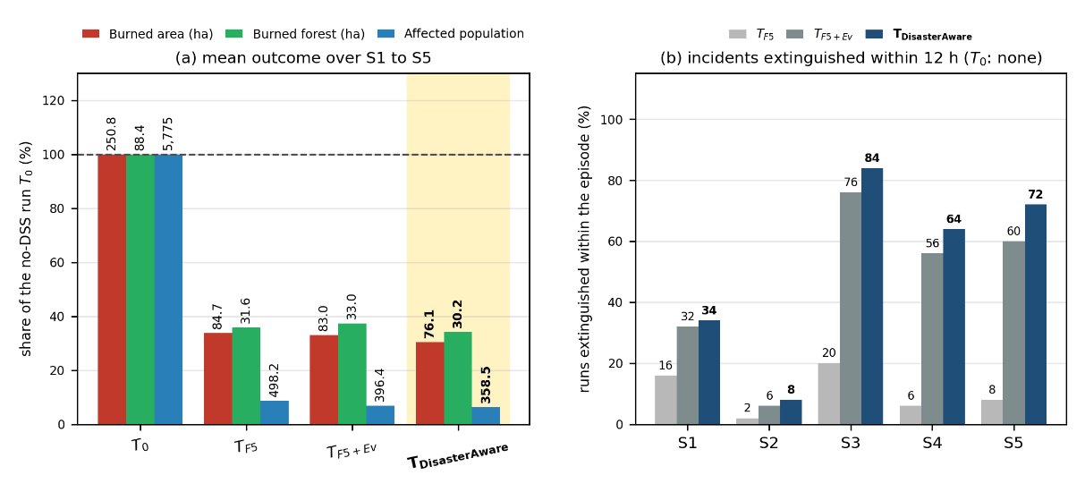
Figure 5.16 (a) Average burned area, burned forest, and affected population of the four configurations over the five scenarios, as shares of the no-DSS run; (b) share of runs in which the fire is extinguished within the twelve-hour episode, per scenario and configuration
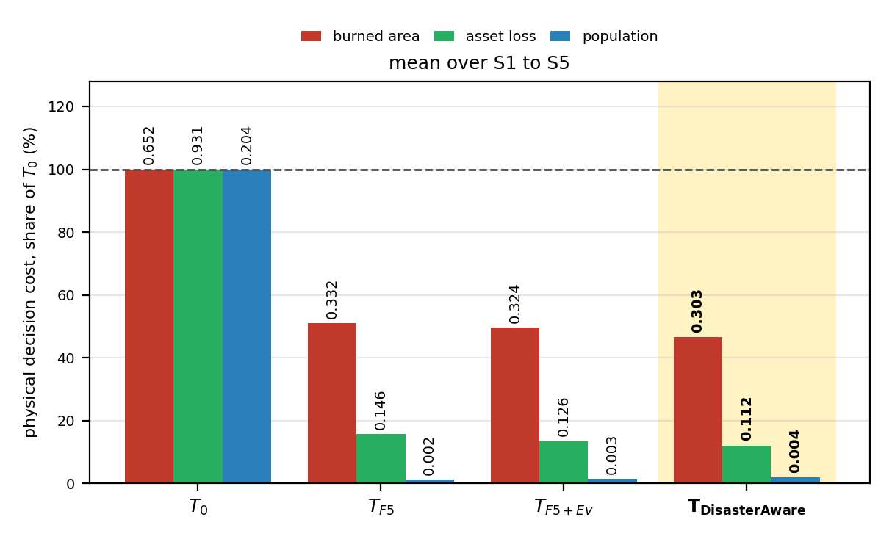
Figure 5.17 Average physical cost of the four configurations by component, as shares of the no-DSS run, under the five scenarios
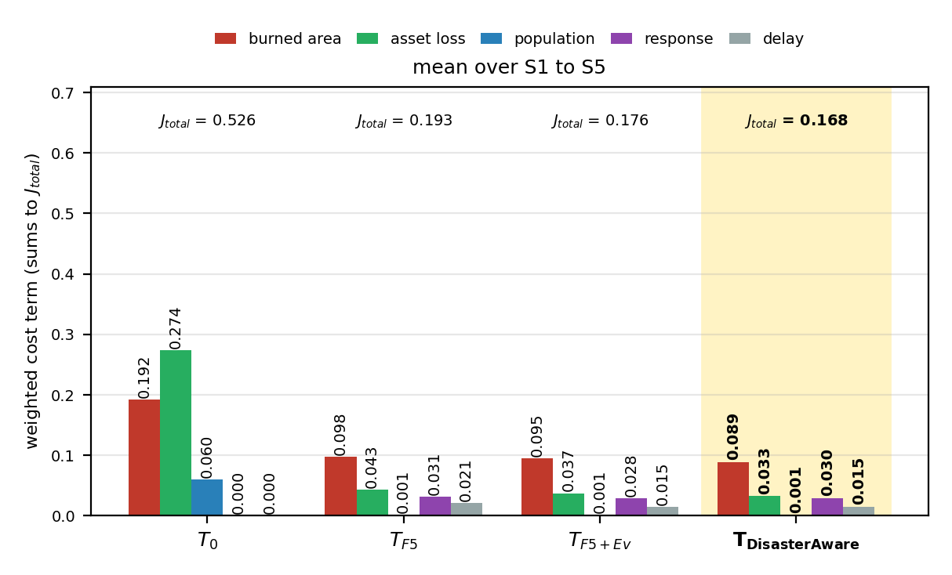
Figure 5.18 Average total cost of the four configurations by weighted component under the five scenarios

Open Decision Space Performance
Adaptation runs only on demand. It is triggered by a forecast cost above the satisficing bound or by a coverage gap while fire is alive, so the volume of trials measures how often the standing decision fell short, and the acceptance rate measures how strictly the tests filtered the responses. Over the 250 DisasterAware runs of the ladder campaign, stage ① made 2 304 consequent-step trials and kept 1 480 (64%); stage ② made 2 272 trials and kept 552 (24%), each instantiating a rule on an antecedent cell that was empty while fire was alive; stage ③ was invoked 1 144 times, 222 proposals were refused at G2 before any simulation was spent, 922 were tested on the forecast, and 392 were admitted, 272 as plain rules and 120 as packages carrying the town-shield macro intervention (asset protection at 1.0 with a containment line at 0.8). The rule base grows from the five seed rules to 8.8 active rules on average at the end of an episode, at most 19, and the rules born of adaptation carry 52% of the firing strength of the fielded decisions, so the orders behind Table 5.9 come in equal measure from doctrine and from what the loop wrote during the incident. The graduated fail-safe attenuated the offensive orders in 11% of the region cycles. Figure 5.19 shows the two evolving-fuzzy funnels on the left and the generative cascade on the right. Low acceptance rates are the intended behavior of a gated design, since trials are cheap and rejected safely on the forecast, and the selectivity of the gates is what makes the admitted edits trustworthy.
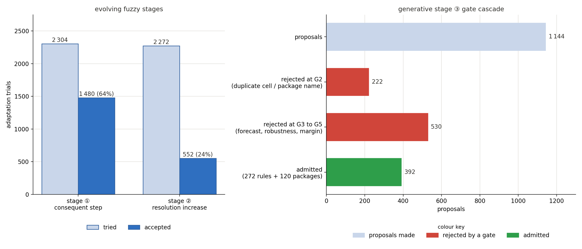
Figure 5.19 Left: EvFIS trials and acceptances at stage ① and stage ②. Right: The generative gates over proposals
The recorded runs use the full seed base of Appendix E and a five-minute decision cycle, whereas the ladder campaign uses the five-rule profile and the twelve-minute cycle. The stand-in proposer of the ladder campaign writes rules over the existing vocabulary and one macro package only, so the products of the generative stage are read from the recorded runs with the live proposer: 160 runs with 7 130 decision cycles, of which 142 runs over 6 140 cycles carry the adaptation ledger. In that record, adaptation stage ①, the parametric layer, made 616 consequent-step trials and kept 129 of them (21%). The stage-① record is therefore a sequence of small, bounded corrections, and each of them passed its own forecast test at the moment of acceptance. Adaptation stage ②, the resolution layer, made 359 trials and kept 40 (11%); further candidate situations were filtered out before a trial was even attempted. The accepted trials instantiate new rules on antecedent cells that were empty while fire was alive. Adaptation stage ③, the generative layer, was invoked 232 times, and 47 proposals were admitted through the applicable verification gates, 36 as plain rules and 11 as packages that brought new vocabulary. Admissions are a flow, and the rule base is a stock: After deduplication and the strength-based pruning of the persistent store, 42 generated rules survive in the persistent store, and twenty representative rules are listed under their final naming in Appendix E. They carry the seven generated macro interventions and the one generated intermediate concept listed in Table 5.12. The lower acceptance rates of the live proposer against the stand-in reflect what each proposes: The stand-in aims a strong rule at the dominant terms, which the forecast usually rewards, while the live model explores packages and placements whose value the gates more often refuse.
Of the candidate interventions the rule base produced over the 160 recorded runs and 7 130 decision cycles, 96.5% reached the field; the remainder were withheld between the rule output and the order by the graduated fail-safe, which engaged in 5 338 region cycles, and by the no-harm veto, which held the offensive families in 113 cycles. The counts are collected in Table 5.11. The number of orders the physics could not honor after execution is not reported here, because the pool record that would carry it was added to the cycle log after these runs were made; the logs are silent on that quantity rather than clear of it.
Table 5.11 Constraint outcomes over 160 runs, 7 130 decision cycles
Quantity | Value
Candidate interventions | 157 247
Fielded interventions | 151 745
Withheld between rule output and order | 5 502
Graduated fail-safe engagements (region cycles) | 5 338
No-harm veto (cycles) | 113
Post-execution actuator shortfall | not logged

Performance of Adaptation Stages ① and ②
In the recorded runs, every modification applied by the evFIS adaptation stages ① and ② is logged. Each entry is a bounded, reversible edit that passed its own forecast test at the moment it was admitted; nothing in the record is a slow parameter drift. In total, the 129 accepted trials applied 167 consequent updates (103 escalations and 64 de-escalations), one accepted trial adjusting the consequents of up to two fired rules; the record further holds 40 rules instantiated on empty antecedent cells by stage ②, 4 of them with a term insertion, and 5 membership-boundary shifts made by stage ①. There are five types of modification mechanisms. In the ledger excerpts below, rule identifiers read R for seed rules, A for rules instantiated by stage ②, and G for rules generated by stage ③; the five linguistic terms are abbreviated VL, L, M, H, and VH; and family, concept, and object names are written as one word, as the ledger records them.
Consequent step (escalation): This operation increases the intensity of selected consequents by 0.05. It is applied when the forecast cost remains above the satisficing bound and the associated rule continues to fire. This indicates that the rule recommends appropriate actions, but their current intensities are insufficient.
G5: downwind_retardant_shield 0.90 → 0.95; asset_protection 0.70 → 0.75; resource_deployment 0.70 → 0.75
Consequent step (de-escalation): This operation decreases the intensity of selected consequents by 0.05. It is kept, like every trial, only when the forecast physical cost does not rise, which happens in the later phases of an incident when a lighter order holds the fire as well as the standing one. This indicates that the current actions are stronger than the remaining situation requires.
G33: suppression_effort 0.90 → 0.85; water_drafting 0.80 → 0.75; containment_line 0.70 → 0.65 (t = 90 min)
Membership-boundary shift: This operation moves a shared boundary between two adjacent membership functions. As a result, the existing rules begin to fire earlier or later for the same input value. It is a move of stage ① and is tried under a cost deficit after the consequent trials of the cycle are spent.
suppression_feasibility: Shared edge moved inside the H to VH band (0.67–0.84)
Term insertion: This operation adds a new term to a crowded part of a concept. It is a move of stage ② and is applied when a rule is instantiated on an uncovered combination whose reading falls between two terms, so that the existing partition does not provide sufficient resolution.
suppression_feasibility: New term inserted at 0.74, splitting the H to VH band
Rule instantiation: This operation creates a new rule for an antecedent combination that is not covered by any existing rule. It is applied when the fire remains active and the current input falls into an uncovered antecedent cell. The new rule is admitted because it fills this coverage gap and is non-inferior to the available alternatives.
A1: IF suppression_feasibility VH ∧ asset_exposure_risk VH THEN asset_protection 0.56, resource_deployment 0.23

Performance of Adaptation Stage ③
Table 5.12 lists every vocabulary object of the generative stage ③ that survives in the persistent store after deduplication and pruning: Seven named macro interventions and one intermediate concept, each born at a stated moment of a specific incident under a logged cost deficit. The three base actuators these products draw on, water drafting, aerial retardant drop, and tactical burn, are validated by the physics although no seed rule orders them, so a macro that draws on water drafting composes a capability the seed doctrine ignored, not a new physical effect.
One product is renamed. The logged definition of the macro formerly called downwind_backburn is a containment line at full intensity with suppression effort behind it, and it carries no igniting actuator and no igniting clause, so the name claimed a counter-fire the definition does not perform. It is listed as downwind_containment_shield. The macro that does carry fire is counterfire_strip, which composes the tactical burn with a containment line.

Table 5.12 The generative product ledger: The objects created by stage ③ and the base actuators they draw on, with their definitions
Product | Definition
Base actuator:  tactical burn | A firing crew ignites a strip ahead of the front, so a counter-fire consumes the fuel the head is running toward.
Base actuator:  water drafting | Engines and aircraft draft from the nearest water body, raising sustained capacity near water; on a map without water it does nothing.
Base actuator: Retardant drop | Aircraft coat the fuel ahead of the head with long-term retardant, so the coated cells resist ignition even after they dry.
Macro:  downwind_containment_shield | containment_line 1.0 + suppression_effort 0.7
Macro: downwind_retardant_shield | retardant_drop 1.0 + containment_line 0.8
Macro: drafting_sustained_attack | water_drafting 1.0 + suppression_effort 0.9
Macro:  head_knockdown | water_drafting 1.0 + suppression_effort 0.9 + retardant_drop 0.6
Macro: wet_containment_line | water_drafting 1.0 + containment_line 0.8
Macro: counterfire_strip | tactical_burn 1.0 + containment_line 0.6
Macro: drafting_retardant_shuttle | retardant_drop 1.0 + water_drafting 0.6
Concept:  interface_exposure | 0.5 asset_exposure_risk + 0.5 evacuation_pressure
Product | Definition

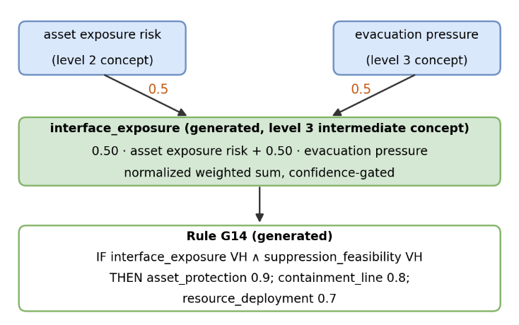
Figure 5.20 Generated intermediate concept and the admitted rule
One of these products is a new intermediate concept illustrated in Figure 5.20. The five seed concepts could not name the pressure that builds where exposed assets and evacuation demand meet, so the generative stage defined interface_exposure, an intermediate concept at level three of the hierar chy of Figure 4.2. It enters the concept hierarchy like a native concept, so later rules may cite it. The concept and the admitted rule G14 that fires on it to protect the wildland-urban interface are shown in Figure 5.20.
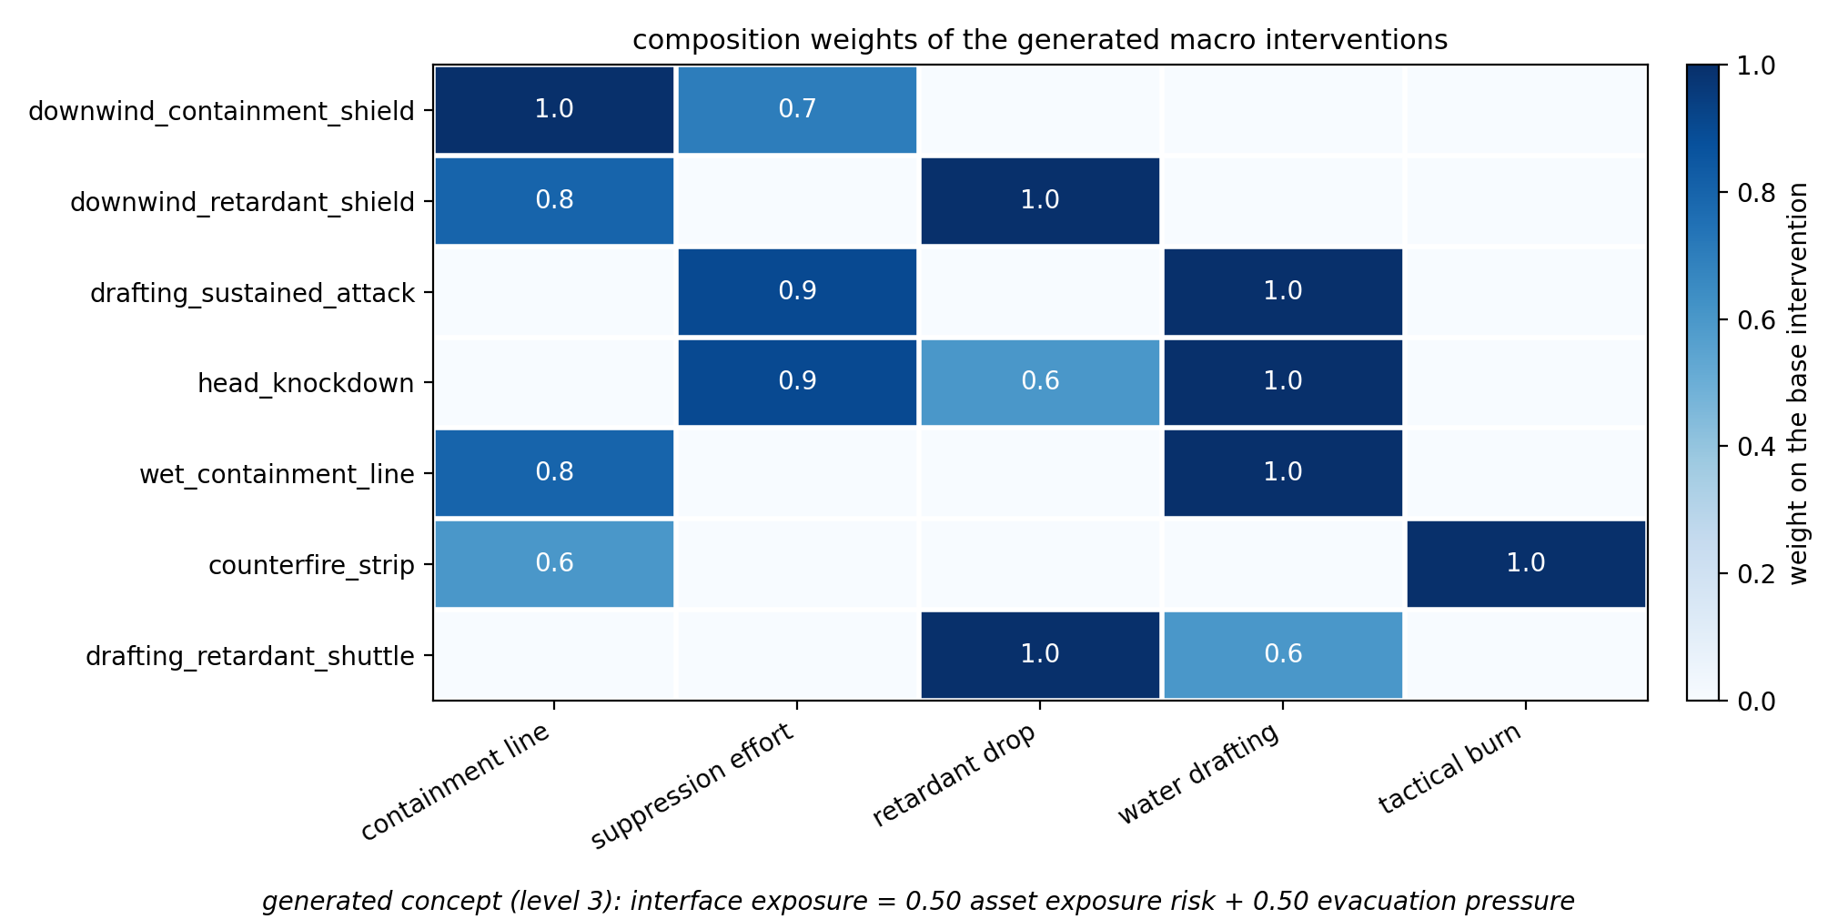
Figure 5.21 Generated macro interventions over the base interventions
The composition weights of the seven macros are shown in Figure 5.21. A weight is the intensity applied to one base intervention, so wet_containment_line applies full water drafting together with a partial containment line, and the weights are not required to sum to one. The macro names are assigned by the proposer and describe intent rather than composition; downwind_containment_shield, for example, contains no igniting effect and acts through containment and suppression.
Table 5.13 One decision, end to end
Step | What the record holds
Observation | fire intensity 0.97 (confidence 0.97), ignition proximity 1.00 (0.97), asset exposure 1.00 (1.00), fuel load 0.70 (0.12), suppression availability 1.00 (1.00)
Concept gate | fire threat level 0.12, asset exposure risk 0.97, suppression feasibility 1.00, intervention urgency 0.12, evacuation pressure 0.97
Concept activation, effective | fire threat level 0.36, asset exposure risk 0.85, suppression feasibility 0.79, intervention urgency 0.38, evacuation pressure 0.62
Rules fired, firing strength | G5 0.50, R20 0.19, G2 0.19, G4 0.19, G1 0.17, G3 0.17, G6 0.17, G7 0.17, G8 0.17, G9 0.17, R26 0.11, R7 0.07
Candidate orders | water drafting 0.84, containment line 0.83, retardant drop 0.82, suppression effort 0.80, asset protection 0.75, resource deployment 0.70, evacuation 0.66
Satisficing test | forecast cost 0.0490 against a no-action forecast of 0.2568 and a bound of 0.2500, the smaller of the ceiling 0.35 and the relative margin, which the recorded runs took on the no-action total cost (0.2568 is its physical part), accepted
Quality gate | decision quality 0.776 against a gate of 0.60, no derating
Fielded order | the candidate as written (water drafting 0.84, containment line 0.83, retardant drop 0.82, suppression effort 0.80, asset protection 0.75, resource deployment 0.70, evacuation 0.66), at an attention share of 1.00, the region being attended
The rule base and the gates are also observable one decision at a time. Table 5.13 reproduces a single decision of a recorded incident from end to end, five minutes after ignition, for the region the coordinator was attending. The row order is the order the layer works in, so each line is produced by the line above it: The sensors deliver ten readings with a confidence apiece, of which the row lists the five that feed the concepts of the fired rules while the complete vector is stored in the cycle record; the confidences gate the concepts, the gated concepts fire the rules, the fired rules compose the candidate orders, and the two acceptance tests decide whether those orders are fielded as written.
Table 5.14 Five of the admitted generative rules consuming generated macro interventions and the generated concept
Rule | IF | THEN
G4 | suppression_feasibility VH ∧ intervention_urgency VH ∧ fire_threat_level M | downwind_containment_shield 0.9; retardant_drop 0.8; asset_protection 0.6
G6 | fire_threat_level ≥ H ∧ suppression_feasibility VH | head_knockdown 0.95; resource_deployment 0.8
G7 | suppression_feasibility VH ∧ fire_threat_level ≥ H ∧ evacuation_pressure VH | wet_containment_line 0.9; resource_deployment 0.8
G8 | suppression_feasibility VH ∧ fire_threat_level H | counterfire_strip 0.9; resource_deployment 0.8
G14 | interface_exposure VH ∧ suppression_feasibility VH | asset_protection 0.9; containment_line 0.8; resource_deployment 0.7

Table 5.14 lists five of the admitted generative rules, which consume generated macro interventions or the generated concept, in full: Every antecedent is a decision concept with a linguistic term, and every consequent is an intervention with an intensity. Rule G14 shows the composed case, a generated rule that fires on the generated concept interface_exposure to protect the wildland-urban interface, so a concept the system invented and a rule that uses it enter through the same gates. Twenty representative admitted rules are listed in Appendix E.
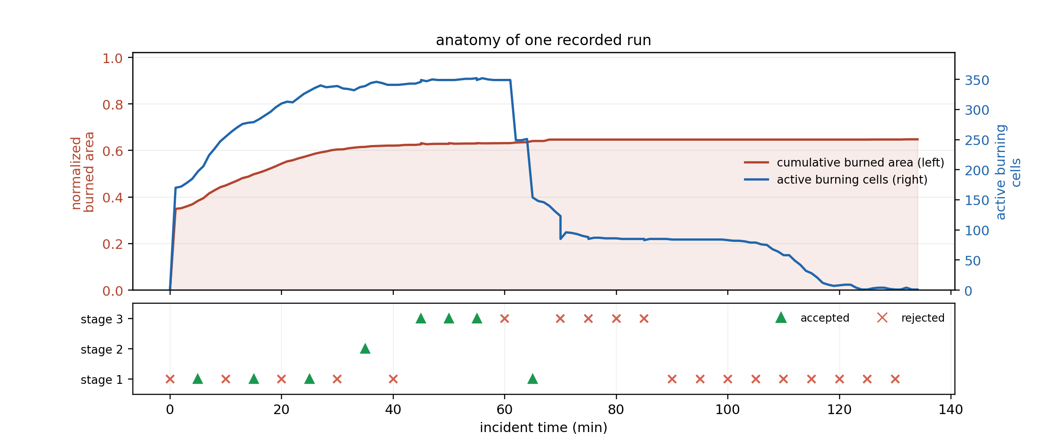
Figure 5.22 One recorded incident from ignition to extinction
Figure 5.22 depicts one recorded incident from ignition to extinction. The upper panel shows the cumulative burned area, which rises and then flattens as the fire is held, together with the count of actively burning cells, which peaks near the middle of the incident and is then driven back down to near zero. The lower panel marks the adaptation events by stage, with accepted trials as triangles and rejected trials as crosses. The accepted trials fall before and around the collapse of the active front, while later proposals are mostly rejected because little is left to improve.

Discovered Clause Actuators
The products of Table 5.12 are compositions of orders the doctrine already carries. A second campaign tests whether the stage can also create an intervention that carries its own geometry, that is, an order stating where on the map to act and how, in terms no base family expresses. It is reported separately because it runs the gate chain that ends in G5b. Five seeds were run in two arms over 205 decision cycles on the same worlds and under the same gates, the arms differing only in whether the reason a sector resolved to no cells is stated in the situation the proposer receives, as described in Section 4.5. The stage was entered 35 times and admitted 19 proposals.
The proposer is a generative model, with one call per proposal and the standing mission brief of Appendix F. Table 5.15 and Figure 5.23 report what was proposed and what survived, by kind of object.
Table 5.15 What stage ③ proposed and what the gates admitted, by object kind
Object kind | Proposed | Admitted | Where the refusals fell
Plain rule | 13 | 6 | G3: 6, G4 A/B: 1
Intermediate concept | 7 | 5 | G5: 2
Macro intervention | 1 | 1 | None
Clause actuator | 14 | 7 | G5: 7
Total | 35 | 19 | G3: 6, G4 A/B: 1, G5: 9

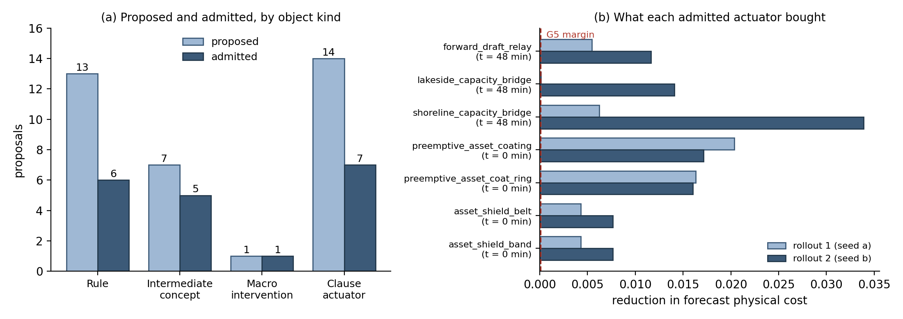
Figure 5.23 Generative products: (a) proposed and admitted by object kind, (b) the forecast cost each admitted actuator removed on the two reseeded rollouts
Seven of the fourteen proposed clause actuators were admitted, and they are listed in Table 5.16; the moment at which each was written is given in Figure 5.23. Two groups appear and they are separated in time. The actuators written in the first cycle coat the assets and the populated cells before the fire reaches them, which is a preventive tactic with no counterpart in the seed doctrine, since the base asset protection family raises a defensive posture but lays no retardant. The actuators written at minute 48 draft from the water body into the burning cells and the head and evacuate the population behind them, which is the substitution described in Section 4.5.3: On an incident whose pool is already spent, drafting raises the yield of crews that are committed instead of asking for crews that are not.
Table 5.16 The admitted clause actuators and their definitions
Actuator | Clauses
asset_shield_band | coat on assets [0, 6] at 1.0; coat on populated [0, 6] at 1.0; draft on assets [0, 8] at 1.0
asset_shield_belt | coat on assets [0, 4] at 1.0; coat on populated [0, 5] at 1.0; draft on at_fire [0, 6] at 0.8
preemptive_asset_coat_ring | coat on assets [0, 4] at 1.0; coat on populated [0, 4] at 1.0; coat on head [1, 6] at 1.0
preemptive_asset_coating | coat on assets [0, 4] at 1.0; coat on populated [0, 3] at 1.0
forward_draft_relay | draft on at_fire [0, 3] at 1.0; draft on ring [0, 8] at 1.0; evacuate on populated [0, 15] at 1.0
lakeside_capacity_bridge | draft on at_fire [0, 3] at 1.0; draft on head [0, 8] at 1.0; evacuate on populated [0, 6] at 1.0
shoreline_capacity_bridge | draft on at_fire [0, 8] at 1.0; draft on ring [0, 15] at 1.0; evacuate on populated [0, 15] at 1.0

The actuator names in Table 5.16 were written by the proposer and are quoted as recorded. Each clause reads effect on sector [inner, outer] at intensity: The effect is one of the seven of Table 4.3, the sector is one of the seven of Section 4.5.3.3.3, the two numbers are the inner and outer distance in cells from the reference cells of the sector, and the intensity scales the amount.
The gain reported in Figure 5.23 belongs to the actuator and not to its company. Every admitted actuator was the only consequent of the rule that ordered it, so the two rollouts of G5 compare a situation in which the new object acts against one in which nothing acts in its place. G5b, which repeats the comparison with the new object struck out and the ordinary orders of its rule left standing, refused no proposals in this campaign. That is reported as it stands rather than as a property of the gate: The situation given to the proposer also states that a new object must stand on its own, so no package arrived padded and the gate was never put to work.
One admission sits at the margin rather than comfortably above it. In Figure 5.23 (b) the first rollout of lakeside_capacity_bridge removed a forecast cost of the order of the margin itself, while its second rollout removed 0.014. The admission is regular, since G5 requires both rollouts to clear the margin and both did, but the case shows the limit of an AND-condition with a small margin: An object can enter on a gain that one future barely registers. The later history of the same actuator, which a separately admitted rule ordered again at minute 114, is the evidence that the gain was real rather than a fluke of the first seed.
The refusals carry as much information as the admissions. Of the seven refused actuators, six returned a forecast identical to the one without them on the first rollout, which means the tactic did not touch anything the forecast records, and one raised the cost. An identical forecast has three causes in this framework, all of them geometric: The sector resolved to no cells at the moment the actuator was written, the coating fell below the extinction moisture of the fuel it was laid on, or the effect drew on a pool with nothing left to give. Two of the sectors, assets and populated, resolve without reference to the written range, so two actuators whose coating clauses differ only in their ranges compile to the same coating order and are measured identically, which is why the two actuators of the first row pair in Table 5.16 removed identical forecast costs.
Two of the admitted objects show the vocabulary being used rather than merely being grown. The actuator forward_draft_relay is ordered by a rule whose antecedent is capacity_starved_head_pressure, an intermediate concept the same campaign created, so one generated object is invoked through another. The actuator lakeside_capacity_bridge, written at minute 48, is ordered again at minute 114 of the same incident by a separately admitted rule that was not part of the package which created it. This is the property the open decision space claims: An object admitted through the gates enters the vocabulary on the same footing as a doctrinal one and is available to whatever the rest of the incident writes.
Both arms produced admitted actuators, four of seven in the arm that raises the geometry diagnosis and three of seven in the arm that suppresses it. The diagnosis is therefore not what makes the open space productive; it is a statement about the incident that changes what the proposer attends to, and the gates decide the rest.

Timeliness and Scalability of the Decision Layer
Scalability asks how the cost grows as the problem grows. One decision covers the whole loop: The features and their confidences, the concept gates, the rule base, the global coordination, the two shadow forecasts of the acceptance test, and any adaptation stage that runs. The cost is reported as a share of the decision cycle because the cycle length is set by the deployment and not by the framework.
Figure 5.24 gives that share for one to sixteen local regions at cycles of two, six and twelve minutes. Every point lies between $0.03$ and $0.27$%, and 16 times the agents cost only $1.28$ times the share. Each agent reasons only over its own region, so more regions split the same work instead of multiplying it. Two further sweeps locate the real driver: Six times the forecast horizon raised the median decision by a factor of $1.4$, and four times the grid raised it by a factor of $6.9$. The number of agents can therefore be raised by an order of magnitude at almost no cost, while the size of the domain remains the binding driver of computational load.
Timeliness asks whether the layer decides fast enough for the tempo of the incident. Table 5.17 reports the wall time of one decision over ten worlds against the decision cycle of twelve minutes. The spread between the median and the slowest decision comes from the adaptation stages, which run only when the acceptance test fails and each add a shadow forecast. In all ten worlds the first offensive order is fielded at the first decision, one simulation step after ignition. Even the slowest decision uses less than two thousandths of the time available, and no step of the loop delays the first response.
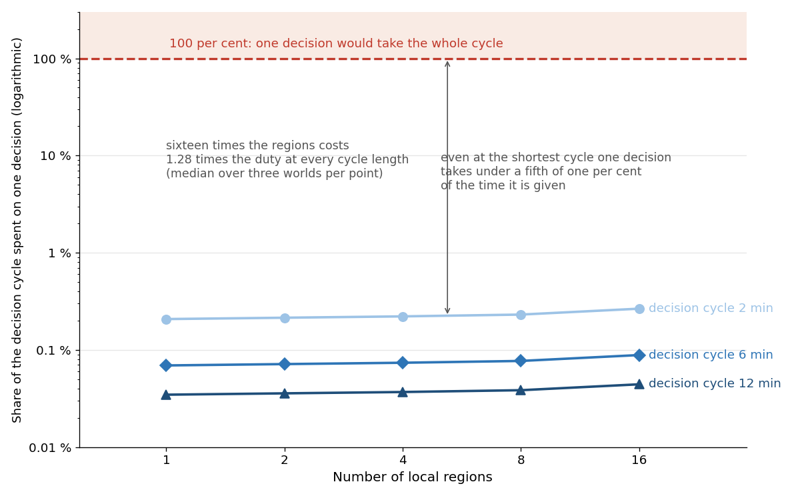
Figure 5.24 The cost of the decision layer against the number of local agents (median over three worlds per point)
Table 5.17 Decision latency of the closed loop
Quantity | Value
Decision latency, median | 274 ms
Decision latency, ninetieth percentile | 909 ms
Decision latency, slowest observed | 1 277 ms
Decision cycle | 12 min (720 000 ms)
Median latency as a share of the cycle | 0.04%
Ignition to first fielded offensive order | 2 min, in all ten worlds

Compliance with the Evaluation Criteria
Section 5.1 turns the literature into eight criteria. This section returns to them and states, for each, where the evidence sits and what it supports. Table 5.18 gives the map. Three criteria are met in full. Five are met on the axis this chapter measured and left open on another, and these are stated here rather than in Chapter 6, because a rubric that reports only its successes carries no information.
Table 5.18 Compliance with the evaluation criteria
Criterion | Evidence in this chapter
Predictive fidelity | Section 5.2, Table 5.3 and Figure 5.1. Four blind hindcasts driven by real terrain, fuel, and weather; overall agreement between 86 and 94% on the front-propagation criteria and probability of detection between 85 and 97%; the final burned area is overpredicted by design in the suppression-free core.
Decision quality | Section 5.5.2, Table 5.9, Table 5.10, Figure 5.16 to Figure 5.18. Against no action DisasterAware lowers the mean burned area from 251 to 76 ha (70%) and the mean physical cost from 0.596 to 0.140, and it extinguishes 52% of the incidents within the episode against 10% for the static base; DisasterAware attains the lowest cost in every scenario, and the intermediate rung lowers the physical cost in every scenario but the burned area in three of five. No baseline policy beyond no action is tested.
Timeliness | Section 5.5.4, Table 5.17. Median decision 274 milliseconds against a twelve-minute cycle, ninetieth percentile 909 milliseconds; the first offensive order is fielded two minutes after ignition in all ten worlds.

Table 5.18 (cont'd) Compliance with the evaluation criteria
Criterion | Evidence in this chapter
Robustness under degraded observation | Section 5.5.1 and Section 5.5.2, scenario S5 of Table 5.8 and Table 5.9. Under degraded observation the mean burned area rises from 52.3 to 54.3 ha (4%), and the configuration remains the best of the four. The criterion is met for observation loss; sensor noise and communication failure are not tested.
Adaptability | Section 5.5.3, Table 5.12, Table 5.14, Figure 5.19 to Figure 5.21; the clause-actuator campaign in Table 5.15, Table 5.16 and Figure 5.23. Stage ① kept 129 of 616 trials and stage ② 40 of 359; stage ③ admitted seven macro interventions and one intermediate concept, each with a logged birth moment. In the ladder campaign of Section 5.5.2, stage ① kept 1 480 of 2 304 trials, stage ② 552 of 2 272, and stage ③ admitted 392 of 1 144 proposals.
Explainability and auditability | Section 5.5.3, Table 5.12, Table 5.14, Figure 5.22. Every admitted edit, rejected proposal, and generated object is logged with the deficit that triggered it, the gate that judged it, and the rule that consumes it. Trace completeness is demonstrated; interpretability to the operator has not yet been evaluated.
Scalability | Section 5.5.4, Figure 5.24. One decision costs 0.03 to 0.27% of the decision cycle, and sixteen times the agents cost 1.28 times that share; the cost follows the number of cells, not the number of agents; the size of the domain itself is not bounded by this evidence.

The chapter set out to show that the three contributions hold under simulated operations and that the simulator they rest on is a faithful proxy of real fire behavior. The hindcasts settle the second point. The improvement ladder settles the first for the decision layer, since the concept driven rule base beats no action, the evolving stages ① and ② beat the static base, and the open decision space beats both. The sensitivity study locates the operating point at which those comparisons carry information and identifies the settings the loop is actually sensitive to. Two of the items left open in the table matter most for the next step. Uncertainty is represented and carried into the decision but is not propagated as an ensemble, and scalability is demonstrated against the number of agents but not bounded against the size of the domain. Both are taken up in Chapter 6.
The evidence of this chapter maps onto the three sub-claims of Section 1.3 as follows. H1 rests on the improvement ladder and the scaling study: DisasterAware outperforms the static base in every scenario, and one decision costs less than 0.2 per cent of the twelve-minute cycle as the number of local agents grows from one to sixteen. The scaling study partitions a fixed domain ever more finely, so it measures the overhead of distribution rather than growth of the domain itself; the domain-size driver is reported separately in Section 5.5.4. H2 rests on the adaptation ledger and the sensitivity study: Every fielded order carries its concept, rule, and confidence trace, every admitted or rejected edit is logged with its reason, and the response of the loop to its operational parameters is quantified. H3 rests on the end-to-end campaign: Across the four scenario families and the degraded-observation variant, every fielded intervention passed the applicable pre-execution gates, with the counts reported in the constraint outcome ledger, and the first offensive order was fielded at the first decision cycle.
The clause-actuator campaign of Section 5.5.3 adds the vocabulary level to that evidence line. DisasterAware did not only choose better among the orders it was given; it composed seven interventions that the seed doctrine does not contain, each one admitted only after lowering the forecast physical cost on two independently reseeded futures, and one of them was later ordered by a rule that had no part in creating it.
Table 5.19 Evaluation of the research hypotheses
 | Evidence base | Acceptance criterion | Observed result
H1 | The improvement ladder of Section 5.5.2 and the scaling study of Section 5.5.4. | DisasterAware outperforms the static rule base in every scenario family, at a decision latency compatible with the decision cycle. | The open decision space gives the lowest cost in all five scenarios, and one decision costs less than 0.2 per cent of the twelve-minute cycle from one to sixteen agents.
H2 | The adaptation ledger, the decision trace of Table 5.13, and the sensitivity study of Section 5.4. | Every fielded order carries its concept, rule, and confidence trace, and the response of the closed loop to its operational parameters is quantified. | The trace and the ledgers are complete over the recorded runs, and the sensitivity of the outcome to the decision cycle, the satisficing bound, and the quality gate is reported.
H3 | The end-to-end campaign of Section 5.5 with the degraded-observation variant and the constraint ledger of Table 5.11. | Every fielded intervention passes the applicable pre-execution gates, and the first offensive order arrives within the first decision cycle. | All 151 745 fielded orders passed the applicable pre-execution gates, 5 502 candidates were withheld, and the first offensive order was fielded at the first decision cycle.

CONCLUSION AND FUTURE WORKS
This chapter closes the thesis. The preceding chapters state three contributions, build the framework that embodies them, and test that framework against a rubric fixed in advance. What remains is to assess the results as a whole. Section 6.1 revisits the contributions and sets out, for each, what the evidence supports and where it stops. Section 6.2 turns the points where it stops into the studies that should follow this work. The assessment follows the chain the thesis was built on: The gaps identified in Chapter 1, the hypotheses raised against them, the contributions that carry those hypotheses, and the performance results of Chapter 5 that support each one.

Conclusions
This thesis proposes DisasterAware, a distributed decision support system for wildfire response. The system reads ten observation features from heterogeneous sensing, and each feature carries confidence. Five decision concepts translate these features into operational language, and a sparse Takagi-Sugeno rule base written over the concepts produces intervention intensities. A satisficing acceptance test and a graduated fail-safe decide whether a candidate decision may be fielded, and a global coordinator that performs no inference of its own ranks the local agents and shares the resource pool between them. When the standing decision falls short, a three-stage ladder adapts the rule base: First its parameters (stage ①), then its resolution (stage ②), and finally its vocabulary (stage ③), where a generative stage proposes new rules, macro interventions, clause actuators, and concepts that must pass the same gates before they act. The whole framework runs against a simulation core that is kept strictly separate from the decision core, so that each side can be validated on its own.
The argument runs from three structural gaps to three tested hypotheses. Chapter 1 identifies the gaps: Gap 1, closed decision spaces in centralized architectures; Gap 2, unrepresented epistemic uncertainty and limited explainability; and Gap 3, simulation-decision coupling without an end-to-end operational workflow. Against them the thesis raises three hypotheses: H1, that a hierarchically distributed, concept-abstracted architecture generates adaptive interventions over an open decision space at a latency compatible with the decision cycle; H2, that concept-driven reasoning with confidence-gated uncertainty encoding yields intrinsically traceable decisions without post-hoc attribution; and H3, that an end-to-end workflow over strictly separated cores fields only interventions that pass every applicable pre-execution gate. Each hypothesis is carried by one contribution, each contribution answers one gap, and Chapter 5 judges all three against criteria fixed in advance; Table 5.19 records the verdicts, and the paragraphs below state, for each contribution, how the gap is closed and which results support the closure.
The first contribution, the open decision space, answers Gap 1 and carries H1, and it is delivered. A closed catalogue over five concepts with five terms each needs 3 125 rules, which no expert can author or audit. The framework instead starts from the seed base and adds only what the field demands: 40 rules instantiated on uncovered situations, seven generated macro interventions and one generated concept over the recorded evaluation runs. A separate campaign on the clause grammar added seven admitted clause actuators, orders that carry their own map geometry, together with five intermediate concepts and one further macro intervention, all admitted through the same gate chain. Every addition passes a forecast test before it is admitted, and the additions matter for the outcome, since DisasterAware extinguishes five times as many incidents within the episode as the static rule base, exposes 28 per cent fewer people, and lowers the mean burned area by a tenth, with a lower mean in every scenario family. The distributed side of the contribution holds as well, because sixteen times the number of agents raises the cost of a decision by a factor of 1.28, so the hierarchy opens the number of agents at almost no price.
The second contribution, uncertainty handling with built-in explanation, answers Gap 2 and carries H2, and it is delivered. Every fielded order traces to the concepts that demand it, the rules that fire, and the confidence behind each feature, without any post-hoc attribution method. Every edit the adaptation ladder admits is logged with the deficit that triggers it, every rejected proposal with the gate and the reason that rejects it, and every generated object with its definition, its birth moment and the rule that consumes it. The sensitivity study completes the contribution: It states which settings move the outcome and which do not, and it explains the flat cases from the mechanism rather than leaving them as unexplained robustness. Under degraded observation the confidence gates do what they are designed to do, since DisasterAware loses four per cent of its performance and remains the best of the four tested.
The third contribution, the end-to-end demonstration over strictly separated cores, answers Gap 3 and carries H3, and it is delivered. The simulation core is validated first and independently: Four blind hindcasts driven by real terrain, fuel and weather data agree with the satellite record between 86 and 94 per cent on the front-propagation criteria; the final burned area is overpredicted by design, since the core runs without suppression while the recorded fires were fought. On that validated ground the decision core runs end to end, from ignition through observation, reasoning, coordination, and adaptation to extinction. Against no action the seeded rule base lowers the mean burned area from 251 to 85 hectares, the evolving stages ① and ② take it to 83, and DisasterAware to 76, a reduction of 70 per cent, while the mean physical cost falls from 0.596 to 0.140 and the share of incidents extinguished within the episode rises from 10 to 52 per cent. DisasterAware attains the lowest cost in every scenario, although the intermediate rung does not lower the burned area in every scenario, and the loop that produces it spends 274 milliseconds at the median against a decision cycle of twelve minutes.
Taken together, the three contributions are not only implemented but shown to work, each against the criterion set for it in advance. The framework opens the decision space and pays almost nothing for its hierarchy, explains every order it gives from its own record, and improves the outcome of every scenario it is evaluated on, on a simulator that is itself validated against real fires. The hypothesis of this thesis is therefore supported by the evidence, and the limits that remain, stated openly in this chapter, mark the path of the future work rather than a gap in the argument.
Three boundaries of this evidence deserve a direct statement. The first boundary concerns the comparison base. Every quantitative comparison in Chapter 5 is internal. The configurations of the ladder differ only in the capabilities they enable, and the paired runs share their worlds, so the measured differences isolate the contribution of each capability. No external system appears in these comparisons. Deployed tools such as WFDSS support the documentation and evaluation of decisions but do not generate interventions over an open decision space, so a like-for-like comparison target does not exist in the reviewed literature. The internal ladder with its paired with-DSS and without-DSS design is therefore the appropriate form of the comparison for the claims of this thesis.
The second boundary concerns the validation base of the simulator. The hindcast study covers four historical fires, and the agreement of 86 to 94 per cent is reported over stochastic replicates of these cases. The simulation core is designed as a faithful proxy for the decision layer rather than as a contribution to fire science, and testability was preferred over maximal fidelity by design. A broader historical case base would strengthen the proxy claim and is a natural extension of the validation.
The third boundary concerns the generative stage. The proposer is a large language model, so the individual proposals are not reproducible in a bitwise sense. The campaign is therefore documented with the pinned model version, the access path, the standing prompt, and the seed design, which makes the procedure repeatable, and the admission decisions do not rest on the model at any point. Every proposal is judged by deterministic gates that end in reseeded forecast comparisons on the simulator, and the verdict and the margin of every gate are logged. A different proposer would produce different candidates, but nothing enters the rule base on the authority of the model.

Future Works
The evaluation of this thesis is entirely in a simulated setting, and this is both its strength and its boundary. Simulation makes the comparisons controlled, repeatable and safe, but it also means that the two most important questions that remain are questions about the world outside the simulator. The first is whether the framework serves the people for whom it is built. The second is whether its architecture carries beyond the hazard it was built on. These two directions define the field side of the future work.
The first direction is validation with operators in the field. The framework has been demonstrated end to end against a simulator and against the satellite record of four historical fires, but it has not yet faced an incident commander. The traceability record is designed to be read, so the first study should place that record in front of experienced fire officers and ask whether they read it, whether they trust it, and whether the reasons it gives change the decisions they make. A natural form for this study is a tabletop exercise, in which commanders manage a simulated incident once with the framework and once without it, so that the effect of the tool can be separated from the skill of the operator. Such an exercise would also evaluate the parts of the design that a simulator cannot: Whether the concepts speak the language of the field, whether the pace of the interface matches the pace of command, and whether an operator accepts an order that a machine has adapted during the incident. What survives this contact belongs to the framework; what does not survive it marks the next design cycle.
The second direction is transfer to other hazards. Nothing in the decision layer is specific to fire. The concepts, the confidence gates, the satisficing acceptance, and the graduated fail-safe are defined over an abstract state and an abstract set of interventions, and the simulation core is coupled to them only through a narrow interface. Floods, industrial plumes and search and rescue pose the same kind of problem, because each is a process that spreads over a landscape, is observed incompletely, and must be answered with limited resources under time pressure. A transfer study would keep the decision layer unchanged, replace the simulation core with a model of the new hazard, and rewrite only the feature definitions and the seed rules. The cost of that rewriting is itself the result of the study, since it measures how much of the framework is architecture and how much is wildfire. A successful transfer would show that the contributions of this thesis describe a general way of building decision support under uncertainty; a failed one would show precisely where the generality ends.
Two further studies remain inside the simulator, and both take up a boundary stated in Chapter 5. The first study concerns uncertainty. Chapter 5 represents epistemic uncertainty through confidence gating and reports the spread of every outcome over stochastic replicates, but it does not propagate weather and fuel uncertainty as an ensemble. An ensemble study would run the closed loop over a set of equally plausible forecasts and report the decisions that remain stable across the set, which would turn the present per-replicate spread into a statement about forecast uncertainty.
The second study concerns scale. The scaling result of Chapter 5 bounds the cost of the hierarchy against the number of local agents. The complementary study would grow the domain itself, holding the number of agents fixed while the cell count and the incident size increase, and would state where the decision cycle stops being sufficient.
These four studies order themselves naturally. The operator study validates the interface the framework already exposes, the transfer study tests the generality of its architecture, and the ensemble and scale studies widen the envelope of the evidence. None of them requires a change to the framework itself; each extends the evidence around it.

REFERENCES

Abdul, A., Vermeulen, J., Wang, D., Lim, B., & Kankanhalli, M. (2018). Trends and trajectories for explainable, accountable and intelligible systems: An HCI research agenda. CHI Conference on Human Factors in Computing Systems (pp. 1-18). ACM. doi:10.1145/3173574.3174156
Ager, A., Vaillant, N., & Finney, M. (2010). A comparison of landscape fuel treatment strategies to mitigate wildland fire risk in the urban interface and preserve old forest structure. Forest Ecology and Management, 259(8), pp. 1556-1570. doi:10.1016/j.foreco.2010.01.032
Alexander, M., & Cruz, M. (2013). Are the applications of wildland fire behaviour models getting ahead of their evaluation again? Environmental Modelling & Software, 41, 65-71.
Amodei, D., Olah, C., Steinhardt, J., Christiano, P., Schulman, J., & Mané, D. (2016). Concrete problems in AI safety. arXiv:1606.06565.
Andrews, P. L. (2018). The Rothermel surface fire spread model and associated developments: A comprehensive explanation. USDA Forest Service, Rocky Mountain Res. Stn., Fort Collins, CO, USA.
Angelov, P. P., & Filev, D. P. (2004). An approach to online identification of Takagi-Sugeno fuzzy models. IEEE Transactions on Systems, Man, and Cybernetics, Part B, 34(1), 484-498.
Anthony, R. (1965). Planning and control systems: A framework for analysis. Harvard University Press.
Arnott, D., & Pervan, G. (2005). A critical analysis of decision support systems research. Journal of Information Technology, 20(2), 67-87. doi:10.1057/palgrave.jit.2000035
Bellman, R., & Zadeh, L. (1970). Decision-making in a fuzzy environment. Management Science, 17(4), B141-B164. doi:10.1287/mnsc.17.4.B141
Benali, A., Sá, A., Ervilha, A., Trigo, R., Fernandes, P., & Pereira, J. (2017). Fire spread predictions: sweeping uncertainty under the rug. Science of the Total Environment, 592, 187-196.
Bowman, D. M., Kolden, C. A., Abatzoglou, J. T., Johnston, F. H., van der Werf, G. R., & Flannigan, M. (2020). Vegetation fires in the Anthropocene. Nature Reviews Earth & Environment, 1(10), 500-515. doi:10.1038/s43017-020-0085-3
Brown, T., Mann, B., Ryder, N., Subbiah, M., Kaplan, J., & Dhariwal, P. (2020). Language models are few-shot learners. Advances in Neural Information Processing Systems (NeurIPS).
Calkin, D., O'Connor, C., Thompson, M., & Stratton, R. (2021). Strategic wildfire response decision support and the risk management assistance program. Forests, 12(10), p. 1407. doi:10.3390/f12101407
Chandra, R., Kumar, S. S., Patra, R., & Agarwal, S. (2025). Decision support system for forest fire management using ontology with big data and LLMs. Cluster Computing, 28, 548.
Chen, S., & Hwang, C. (1992). Fuzzy multiple attribute decision making: Methods and applications. Springer. doi:10.1007/978-3-642-46768-4
Chen, Y., Li, L., Ma, Z., Hu, Q., Zhu, Y., Deng, M., & Yu, R. (2025). Empowering LLM agents with geospatial awareness: Toward grounded reasoning for wildfire response. arXiv:2510.12061.
Comes, T., Hiete, M., Wijngaards, N., & Schultmann, F. (2011). Decision maps: A framework for multi-criteria decision support under severe uncertainty. Decision Support Systems, 52(1), 108-118. doi:10.1016/j.dss.2011.05.008
Comfort, L., Boin, A., & Demchak, C. (2010). Designing Resilience: Preparing for Extreme Events. University of Pittsburgh Press.
Copernicus. (2022). Copernicus DEM: Global and European digital elevation model, GLO-30. Retrieved 2026, from https://registry.opendata.aws/copernicus-dem
CRED/UCLouvain. (2026). EM-DAT: The International Disaster Database. Retrieved from https://ourworldindata.org/grapher/natural-disasters-by-type?country=Drought~Extreme+weather~Extreme+temperature~Wildfire~Glacial+lake+outburst+flood~Dry+mass+movement~Wet+mass+movement~Fog
Cruz, M., & Alexander, M. (2013). Uncertainty associated with model predictions of surface and crown fire rates of spread. Environmental Modelling & Software, 47, 16-28.
Cruz, M., Alexander, M., & Wakimoto, R. (2003). Definition of a fire behavior model evaluation protocol: a case study application to crown fire behavior models. Fire, Fuel Treatments, and Ecological Restoration (USDA Forest Service Proceedings RMRS-P-29).
Dubey, P., & Dubey, P. (2025). Bridging spatiotemporal wildfire prediction and decision modeling using transformer networks and fuzzy inference systems. MethodsX, 15, p. 103498. doi:10.1016/j.mex.2025.103498
Duff, T., & Tolhurst, K. (2015). Operational wildfire suppression modelling: a review evaluating development, state of the art and future directions. International Journal of Wildland Fire, 24, 735-748.
Duff, T., Cawson, J., Cirulis, B., Nyman, P., Sheridan, G., & Tolhurst, K. (2016). Conditional performance evaluation: using wildfire observations for systematic fire simulator development. Forests, 9, 189.
Dunn, C., Calkin, D., & Thompson, M. (2017). Towards enhanced risk management: Planning, decision making and monitoring of US wildfire response. International Journal of Wildland Fire, 26(7), pp. 615-625. doi:10.1071/WF16223
European Space Agency. (2022). ESA WorldCover 2021: Global land cover product at 10 m resolution. Retrieved 2026, from https://esa-worldcover.org/
Filippi, J.-B., Mallet, V., & Nader, B. (2014). Representation and evaluation of wildfire propagation simulations. International Journal of Wildland Fire, 23, 46-57.
Fillmore, S., & Paveglio, T. (2023). Use of the Wildland Fire Decision Support System (WFDSS) for full suppression and managed fires within the Southwestern Region of the US Forest Service. International Journal of Wildland Fire, 32(4), pp. 622-635. doi:10.1071/WF22206
Finney, M. (1998). FARSITE: Fire Area Simulator - model development and evaluation. USDA Forest Service, Rocky Mountain Research Station.
Finney, M. (2006). An overview of FlamMap fire modeling capabilities. Fuels Management — How to Measure Success: Conference Proceedings (pp. 213-220). USDA Forest Service, Rocky Mountain Research Station.
Fox-Hughes, P., Bridge, C., & Faggian, N. (2024). An evaluation of wildland fire simulators used operationally in Australia. International Journal of Wildland Fire, 33.
French, S., Maule, J., & Papamichail, N. (2019). Decision Behaviour, Analysis and Support (2 ed.). Cambridge University Press.
Gigerenzer, G., & Selten, R. (Eds.). (2001). Bounded rationality: The adaptive toolbox. Cambridge, MA: MIT Press.
Gorry, G., & Scott Morton, M. (1971). A framework for management information systems. Sloan Management Review, 13(1), 55-70.
Guidotti, R., Monreale, A., Ruggieri, S., Turini, F., Giannotti, F., & Pedreschi, D. (2018). A Survey of Methods for Explaining Black Box Models. ACM Computing Surveys, 51(5), 1-42. doi:10.1145/3236009
Hwang, C., & Yoon, K. (1981). Multiple attribute decision making: Methods and applications. Springer. doi:10.1007/978-3-642-48318-9
Jain, P., Coogan, S. C., Subramanian, S. G., Crowley, M., Taylor, S., & Flannigan, M. D. (2020). A review of machine learning applications in wildfire science and management. Environmental Reviews, 28(4), 478-505. doi:10.1139/er-2020-0019
Ji, Z., Lee, N., Frieske, R., Yu, T., Su, D., Xu, Y., . . . Fung, P. (2023). Survey of hallucination in natural language generation. ACM Computing Surveys, 55, pp. 1-38.
Keeney, R., & Raiffa, H. (1976). Decisions with multiple objectives: preferences and value trade-offs. Wiley.
Klein, G. A. (2017). Sources of Power: How People Make Decisions. MIT Press.
Lughofer, E. (2011). Evolving Fuzzy Systems: Methodologies, Advanced Concepts and Applications. Berlin, Germany: Springer.
Lundberg, S., & Lee, S.-I. (2017). A unified approach to interpreting model predictions. Advances in Neural Information Processing Systems 30 (NIPS 2017), (pp. 4765-4774). Long Beach, CA.
Malczewski, J. (1999). GIS and multicriteria decision analysis. John Wiley & Sons.
Mamdani, E. H. (1974). Application of fuzzy algorithms for control of simple dynamic plant. Proceedings of the Institution of Electrical Engineers, 121(12), 1585-1588. doi:10.1049/piee.1974.0328
Marakas, G. M., & O'Brien, J. A. (2013). Introduction to information systems. McGraw-Hill.
Martell, D. (2007). Forest fire management. Handbook of operations research in natural resources (pp. 489-509). Boston: MA: Springer US.
Martell, D. (2015). A review of recent forest and wildland fire management decision support systems research. Current Forestry Reports, 1, 128-137.
McNeese, N. J., Schelble, B. G., Canonico, L. B., & Demir, M. (2021). Who or what is my teammate? Team composition considerations in human–AI teaming. Human Factors, 63(3), 474-488. doi:10.1177/0018720820968694
Mendel, J. (2017). Uncertain rule-based fuzzy systems. Springer.
Morgan, M., & Henrion, M. (1990). Uncertainty: A Guide to Dealing with Uncertainty in Quantitative Risk and Policy Analysis. Cambridge university press.
Morris, M. (1991). Factorial sampling plans for preliminary computational experiments. Technometrics, 33, 161-174.
NASA FIRMS. (n.d.). Fire Information for Resource Management System: VIIRS 375 m active fire data. Retrieved 2026, from https://firms.modaps.eosdis.nasa.gov
Noonan-Wright, E., Opperman, T., Finney, M., Zimmerman, G., Seli, R., Elenz, L., . . . Fiedler, J. (2011). Developing the US wildland fire decision support system. Journal of Combustion, 2011, p. 168473. doi:10.1155/2011/168473
Open-Meteo. (n.d.). Open-Meteo historical weather API: ERA5 reanalysis. Retrieved 2026, from https://open-meteo.com
Orphanoudakis, T., Betzelos, C., & Leligou, H. (2025). MORA: A multicriteria optimal resource allocation and decision support toolkit for wildfire management. Algorithms, 18(11), p. 677. doi:10.3390/a18110677
Pacheco, A., Claro, J., Fernandes, P., de Neufville, R., Oliveira, T., Borges, J., & Rodrigues, J. (2015). Cohesive Fire Management within an Uncertain Environment: A Review of Risk Handling and Decision Support Systems. Forest Ecology and Management, 347, 1-17. doi:10.1016/j.foreco.2015.02.033
Pais, C., Carrasco, J., Martell, D. L., Weintraub, A., & Woodruff, D. L. (2021). Cell2Fire: A cell-based forest fire growth model to support strategic landscape management planning. Frontiers in Forests and Global Change, 4(692706).
Pais, C., Carrasco, J., Moudio, P., & Shen, Z.-J. (2021). Downstream protection value: Detecting critical zones for effective fuel-treatment under wildfire risk. Computers, Environment and Urban Systems, 90, p. 101703. doi:10.1016/j.compenvurbsys.2021.101703
Papadimitriou, C. H., & Tsitsiklis, J. N. (1987). The complexity of Markov decision processes. Mathematics of Operations Research, 12(3), 441-450.
Pearl, J. (1988). Probabilistic Reasoning in Intelligent Systems: Networks of Plausible Inference. Morgan Kaufmann. doi:10.1016/C2009-0-27609-4
Pedrycz, W. (1993). Fuzzy Control and Fuzzy Systems. Wiley.
Power, D. J. (2002). Decision support systems: Concepts and resources for managers. Quorum Books.
Power, D. J. (2007). A Brief History of Decision Support Systems. Retrieved from http://dssresources.com/history/dsshistory.html
Power, D. J., & Heavin, C. (2017). Decision Support, Analytics, and Business Intelligence (2 ed.). Business Expert Press.
Price, S. (2022). Modeling of fire spread in sagebrush steppe using FARSITE: an approach to improving input data and simulation accuracy. Fire Ecology, 18, 22.
Rapp, C., Courtney, K. L., Franz, S., Colavito, M., Aldworth, T., & Cheng, A. (2026). Wildfire decision support tools: barriers, facilitators, and future directions for effectiveness. Fire Ecology.
Rapp, C., Rabung, E., Wilson, R., & Toman, E. (2020). Wildfire decision support tools: An exploratory study of use in the United States. International Journal of Wildland Fire, 29(7), pp. 581-594. doi:10.1071/WF19131
Ribeiro, M. T., Singh, S., & Guestrin, C. (2016). Why Should I Trust You? ACM SIGKDD Conference (pp. 1135–1144). ACM. doi:10.1145/2939672.2939778
Ross, K. G., Shafer, J. L., & Klein, G. (2006). Professional Judgments and Naturalistic Decision Making. In The Cambridge Handbook of Expertise and Expert Performance (pp. 403-420). Cambridge: Cambridge University Press.
Rothermel, R. C. (1972). A mathematical model for predicting fire spread in wildland fuels. Intermountain Forest & Range Experiment Station, Forest Service, US Department of Agriculture.
Saaty, T. (1980). The analytic hierarchy process: Planning, priority setting, resource allocation. McGraw-Hill.
Saltelli, A., Ratto, M., Andres, T., Campolongo, F., Cariboni, J., Gatelli, D., . . . Tarantola, S. (2008). Global Sensitivity Analysis: The Primer. Chichester: Wiley.
Sanneman, L., & Shah, J. (2020). Explaining reward functions to humans for better human-robot collaboration. arXiv preprint arXiv:2006.10548. Retrieved from https://arxiv.org/abs/2006.10548
Schultz, C., Miller, L., Greiner, S., & Kooistra, C. (2021). A qualitative study on the US Forest Service's risk management assistance efforts to improve wildfire decision-making. Forests, 12(3), p. 344. doi:10.3390/f12030344
Scott, J. H., & Burgan, R. E. (2005). Standard fire behavior fuel models: A comprehensive set for use with Rothermel’s surface fire spread model. USDA Forest Service, Rocky Mountain Res. Stn., Fort Collins, CO, USA.
Seshia, S. A., Sadigh, D., & Sastry, S. S. (2022). Toward verified artificial intelligence. Communications of the ACM, 65(7), 46-55.
Shafer, G. (1976). A Mathematical Theory of Evidence. Princeton University Press.
Sharda, R., Delen, D., & Turban, E. (2018). Business Intelligence, Analytics, and Data Science: A Managerial Perspective. Pearson.
Shim, J. P., Warkentin, M., Courtney, J. F., Power, D. J., Sharda, R., & Carlsson, C. (2002). Past, present, and future of decision support technology. Decision support systems, 33(2), 111-126. doi:10.1016/S0167-9236(01)00139-7
Simon, H. (1956). Rational choice and the structure of the environment. Psychological Review, 63(2), 129-138.
Simon, H. (1960). The New Science of Management Decision. Englewood Cliffs: Prentice Hall.
Simon, H. (1996). The Sciences of the Artificial. Cambridge: MIT Press.
Soualah, L. (2024). Forecasting forest fire risk in Algeria using fuzzy logic and GIS. Trees, Forests and People, 17, 100614. doi:10.1016/j.tfp.2024.100614
Sprague, R. H., & Carlson, E. D. (1982). Building Effective Decision Support Systems. Englewood Cliffs: Prentice Hall.
Sugumaran, R., & Degroote, J. (2010). Spatial decision support systems: principles and practices. Crc Press.
Sullivan, A. L. (2009a). Wildland surface fire spread modelling 1: Physical and quasi-physical models. International Journal of Wildland Fire, 18(4), 349-368.
Sullivan, A. L. (2009b). Wildland surface fire spread modelling 2: Empirical and quasi-empirical models. International Journal of Wildland Fire, 18(4), 369-386.
Sullivan, A. L. (2009c). Wildland surface fire spread modelling 3: Simulation and mathematical analogue models. International Journal of Wildland Fire, 18(4), 387-403.
Sutton, R. S., & Barto, A. G. (2018). Reinforcement Learning: An Introduction (2nd ed.). Cambridge, MA, USA: MIT Press.
Sycara, K. (1998). Multiagent systems. AI Magazine, 19(2), 79-92. doi:10.1609/aimag.v19i2.1370
Takagi, T., & Sugeno, M. (1985). Fuzzy identification of systems and its applications to modeling and control. IEEE Transactions on Systems, Man, and Cybernetics, 15(1), 116-132. doi:10.1109/TSMC.1985.6313399
Thompson, M. P., & Calkin, D. E. (2011). Uncertainty and risk in wildland fire management. Journal of Environmental Management, 92(8), 1895-1909. doi:10.1016/j.jenvman.2011.03.015
Triantaphyllou, E. (2000). Multi-criteria decision making methods: A comparative study. Springer. doi:10.1007/978-1-4757-3157-6
Turban, E., Sharda, R., & Delen, D. (2011). Decision support and business intelligence systems (9 ed.). Upper Saddle River: Pearson Education.
Turoff, M., Chumer, M., Van de Walle, B., & Yao, X. (2004). The design of a dynamic emergency response management information system (DERMIS). Journal of Information Technology Theory and Application (JITTA), 5(4), 1-36.
UNEP. (2022). Spreading like Wildfire: The Rising Threat of Extraordinary Landscape Fires. Geneva: United Nations Environment Programme (UNEP). Retrieved from https://www.unep.org/resources/report/spreading-wildfire
Vásquez, F. (2021). Decision support system development of wildland fire. Forests, 12(7), 943. doi:10.3390/f12070943
Vaswani, A., Shazeer, N., Parmar, N., Uszkoreit, J., Jones, L., Gomez, A., . . . Polosukhin, I. (2017). Attention is all you need. Advances in Neural Information Processing Systems (NeurIPS).
Walker, W., Harremoes, P., Rotmans, J., Van der Sluijs, J., Van Asselt, M., Janssen, P., & Krayer von Krauss, M. (2003). Defining uncertainty: a conceptual basis for uncertainty management in model-based decision support. Integrated Assessment, 4(1), 5-17.
Wooldridge, M. (2009). An introduction to multiagent systems (2 ed.). Wiley.
Xie, Y., Jiang, B., Mallick, T., Bergerson, J. D., Hutchison, J. K., & Verner, D. R. (2024). WildfireGPT: Tailored large language model for wildfire analysis. arXiv:2402.07877.
Zadeh, L. A. (1965). Fuzzy sets. Information and Control, 8(3), 338-353. doi:10.1016/S0019-9958(65)90241-X
Zadeh, L. A. (1986). A simple view of the Dempster–Shafer theory of evidence and its implication for the rule of combination. AI Magazine, 7(2), 85-90. doi:10.1609/aimag.v7i2.542
Zavadskas, E., & Turskis, Z. (2011). Multiple criteria decision making (MCDM) methods in economics: An overview. Technological and Economic Development of Economy, 17(2), 397-427. doi:10.3846/20294913.2011.593291

APPENDICES
- Simulation Mathematics for Evolution of Burning Status
This appendix provides the formulations underlying the simulation in Chapter 3. The rate of spread $R_{spread,k}\left(x,y\right)$ is the forward propagation of wildfire at grid cell $\left(x,y\right)$ and time step $k$. It is computed internally within the hybrid fire spread model using meteorological forcing, terrain properties, fuel characteristics, and fuel moisture. The spread formulation is not intended to reproduce physical wildfire propagation in metric units. It provides a grid-consistent, DSS-oriented abstraction inspired by semi-empirical wildfire behavior models.
The formulation adopted in this work is a semi-empirical, Rothermel-like mapping designed to preserve structural interpret ability (i.e., the output $R_{spread,k}$ is expressed in normalized cells-per-step rather than in metric units) while remaining computationally stable and easily calibratable for DSS simulation purposes (Rothermel, 1972). The rate of spread $R_{spread,k}\left(x,y\right)$ is calculated by $f_{ros}$ ( 29 ). Each multiplicative component of the rate-of-spread function $f_{ros}$ corresponds directly to a physically interpretable effect and is tied to an already-defined state or input variable ( 76 ). All terms are evaluated at $\left(x,y\right)$ and time $k$.
$$R_{spread,k} \left(x,y\right)=r_{base} \left(F_{type}\left(x,y\right)\right)×g_{moist}\left(x,y\right)×g_{wind}\left(x,y\right)×g_{slope}\left(x,y\right)× g_{aspect}\left(x,y\right)$$ | ( 76 )
Fuel-Type Base Spread Rate $r_{base} \left(∙\right)$ defines the baseline spread potential of each fuel class under nominal environmental conditions. It is calibrated in units of cell per simulation step. Moisture damping factor $g_{moist}$ is ( 77 ) where $F_{moist,k}\left(x,y\right)$ is surface fuel moisture fraction and $m_{ext}\left(F_{type}\right)$ is extinction moisture threshold for the given fuel type
$$g_{moist}\left(x,y\right)=\max\left(0,1-\frac{F_{moist,k}\left(x,y\right)}{m_{ext}\left(F_{type}\left(x,y\right)\right)}\right)$$ | ( 77 )
If fuel moisture equals the extinction threshold, spread is suppressed ( 78 ). The damping structure is selected for stability and interpretability; it prevents negative spread rates and ensures bounded behavior.
$$F_{moist,k}≥m_{ext}⇒g_{moist}=0$$ | ( 78 )
Wind amplification factor $g_{wind}$ is ( 79 ) where $W_{ws,k}\left(x,y\right)$ is the wind speed, $a_{w}\left(F_{type}\right)$ is a wind sensitivity coefficient and $w_{0}$ is a scaling constant. This factor models the acceleration of fire spread due to wind speed. The hyperbolic tangent ensures that spread increases with wind speed but does not grow unbounded for extreme winds. The use of $\tanh\left(⋅\right)$guarantees numerical stability. The wind scaling constant $w_{0}$ controls the saturation behavior of wind amplification. A value of 10 m/s is selected to reflect moderate-to-strong wind regimes while preserving numerical stability.
$$g_{wind}(x,y)=1+a_{w}(F_{type}(x,y))⋅tanh\left(\frac{W_{ws,k}\left(x,y\right)}{w_{0}}\right)$$ | ( 79 )
Slope acceleration term $g_{slope}$ is ( 80 ) where $G_{slope}\left(x,y\right)$ is terrain slope (radians) and $a_{s}\left(F_{type}\right)$ is slope sensitivity. Fire spreads faster on steep terrain due to flame preheating of fuels on the upslope side. The factor is isotropic within a cell: it accelerates propagation on steep cells regardless of the local spread direction. The tangent function reflects nonlinear growth with increasing slope angle.
$$g_{slope}\left(x,y\right)=\min\left(3, 1+a_{s}\left(F_{type}\left(x,y\right)\right)⋅\tan\left(G_{slope}\left(x,y\right)\right)\right)$$ | ( 80 )
Aspect-wind orientation term $g_{aspect}$ is ( 81 ) where $G_{aspect}\left(x,y\right)$ is terrain orientation angle, $W_{wd,k}\left(x,y\right)$ is wind direction field, $a_{asp}\left(F_{type}\right)$ is aspect coefficient. This term captures interaction between terrain orientation and wind direction. If wind direction aligns with terrain orientation, $\cos\left(⋅\right)≈1$ and spread increases. If wind opposes terrain orientation, $\cos\left(⋅\right)<0$ and spread decreases.
$$g_{aspect}\left(x,y\right)=1+a_{asp}\left(F_{type}\left(x,y\right)\right)∙\cos\left(G_{aspect}\left(x,y\right)-W_{wd,k}\left(x,y\right)\right)$$ | ( 81 )
Different fuel types exhibit distinct intrinsic combustion and propagation characteristics due to variations in fuel structure, packing ratio, moisture retention capacity, and heat-release behavior. These differences are parameterized in Table A.1 through a fuel-dependent base spread rate and sensitivity coefficients that modulate environmental amplification effects. The base spread parameter $r_{base}$ is expressed in units of grid cells per simulation step and therefore must be interpreted relative to the spatial grid resolution $Δx$ and the discrete simulation time step $Δt$.
In contrast, the extinction moisture threshold $m_{ext}$ is a dimensionless mass fraction, representing the critical fuel moisture level above which sustained combustion is suppressed. The environmental coefficients $a_{w}$, $a_{s}$, and $a_{asp}$ are dimensionless parameters, governing the relative amplification of spread rate due to wind speed, terrain slope, and wind-aspect alignment, respectively. Together, these parameters provide a resolution-consistent, yet physically interpretable abstraction of fuel-dependent wildfire spread dynamics suitable for discrete-time grid-based simulation.
Table A.1 Spread rate parameters for each fuel type
$$Fuel Type$$ | $$r_{base}$$ | $$m_{ext}$$ | $$a_{w}$$ | $$a_{s}$$ | $$a_{asp}$$
Grass | 2.00 | 0.15 | 25.0 | 2.0 | 0.30
Shrub | 0.80 | 0.20 | 15.0 | 2.0 | 0.25
Pine litter | 0.80 | 0.25 | 6.0 | 2.2 | 0.20
Hardwood | 0.30 | 0.30 | 4.0 | 1.8 | 0.15

The parameter values of Table A.1 are calibrated against the standard fire-behavior literature rather than chosen ad hoc. At the reference discretization of 90 m cells and 30 min steps, one cell per step corresponds to 3 m/min, so the base rates carry a direct metric interpretation. When a scenario uses a different discretization, the base rates are rescaled by the factor $(90\frac{m}{Δx})·(\frac{Δt}{30} min )$, so the metric spread rates are preserved. With the wind amplification factor, the calibrated values reproduce the benchmark head-fire rates of the standard fuel models: Grass reaching tens of m/min, shrub 5-10 m/min, long-needle litter 2-4 m/min and compact hardwood litter below 1 m/min. The slope acceleration term is additionally saturated at three times the base rate since the tangent term otherwise diverges on the near-vertical cells of real digital elevation models.
- Simulation Mathematics for Fuel Mass Evolution
This section provides detailed mathematical formulation and explanation for both the fractional burn rate calculation and the suppression of fuel reduction maps.
Fractional burn rate calculation: The discrete combustion consumption ratio $F_{burn,k}\left(x,y\right)$ represents the fraction of available fuel mass consumed at grid cell $\left(x,y\right)$ during a single simulation time step $Δt$ under active burning conditions. Unlike fuel load $F_{load,k}$, which is a dynamic state variable, $F_{burn,k}$ is not stored as part of the state vector. Instead, it is computed algebraically at each simulation step as a bounded function of fuel type and surface fuel moisture ( 82 ) where $b_{base}\left(F_{type}\right)∈\left(0,1\right)$ is the baseline combustion coefficient associated with the fuel class, $F_{moist,k}\left(x,y\right)∈\left[0,1\right]$ is the surface fuel moisture fraction, ${sat}_{\left[0 , 1\right]}\left(⋅\right)$ is the saturation operator ensuring boundedness. The term $\left(1 − F_{moist,k}\right)$: A linear moisture damping factor, reducing combustion efficiency as moisture increases.
$$F_{burn,k}\left(x,y\right)={sat}_{\left[0 , 1\right]}\left(b_{base}\left(F_{type}\left(x,y\right)\right)⋅\left(1-F_{moist,k}\left(x,y\right)\right)\right)$$ | ( 82 )
The coefficient $b_{base}$ is expressed as a fraction of fuel consumed per simulation time step and therefore depends on the chosen time resolution $Δt$. It is not a universal physical constant but a calibrated simulation parameter. Different fuel classes exhibit distinct combustion rates due to structural density, packing ratio, and heat-release characteristics. These differences are abstracted through the fuel-dependent baseline coefficient $b_{base}$. Surface fuel moisture inhibits combustion efficiency. When $F_{moist,k}→1$, the burn fraction approaches zero. When $F_{moist,k}→0$, combustion proceeds at the baseline rate.
The baseline combustion coefficients used in this study are summarized in Table B.1. Values are selected to produce realistic burn residence times under nominal dry conditions for the adopted grid resolution and simulation time step.
Table B.1 Baseline combustion coefficients per fuel type
Fuel Type | $b_{base}$(fraction per step) | Typical Burn Duration (qualitative)
Grass | 0.85 | Short, fast consumption
Shrub | 0.35 | Moderate consumption
Pine litter | 0.15 | Sustained surface burn
Hardwood | 0.08 | Slow combustion

These coefficients are calibrated such that, in dry conditions and absent suppression, fuel mass decreases significantly over several time steps without causing numerical instability.
Suppression of fuel reduction map: The suppression function $f_{supp}\left(⋅\right)$ produces a step-normalized fuel reduction applied at grid cell $\left(x , y\right)$ during simulation step $k$. Unlike continuous-time rate formulations, the present model operates in discrete simulation steps. Therefore, the suppression term directly represents the amount of fuel removed within a single time step, expressed in normalized load units and bounded by the remaining load. It acts as an absolute reduction, unlike the combustion term, which removes a fraction of the remaining load through $F_{burn,k}$. The suppression-induced fuel reduction term is defined as ( 83 ) where $α_{s}∈\left[0,1\right]$ is global suppression scaling coefficient, $η_{cap,k}$ is operational capa city factor, $η_{avail,k}$ is operational availability factor, $η_{reach,k}\left(x,y\right)$ is reachability factor, $η_{eff,k}\left(x,y\right)$ is local suppression effectiveness factor. This multiplicative structure guarantees bounded and interpretable mitigation dynamics.
$$F_{red,k}\left(x,y\right)=α_{s}⋅η_{cap,k}⋅η_{avail,k}⋅η_{reach,k}\left(x,y\right)⋅η_{eff,k}\left(x,y\right)$$ | ( 83 )
Global scaling term $α_{s}∈\left[0,1\right]$ is a global suppression scaling coefficient representing overall doctrine or scenario-level mitigation strength per simulation step. In practical terms, $α_{s}$ absorbs the modeling choice of “how strong one step of suppression can be” under nominal conditions.
Suppression cannot exceed the operational capability that is actually present. This is captured by separating capacity magnitude $η_{cap,k}$ ( 84 ) where from availability gating $η_{avail,k}$ ( 85 ). $R_{cap,k}$ is the available suppression capacity (e.g., water volume, manpower equivalent, sortie capability) at step $k$ and $R_{cap,max}$ is the maximum reference capacity used for normalization
$$η_{cap,k}=\frac{R_{cap,k}}{R_{cap,max}}$$ | ( 84 )
Thus $η_{cap,k}∈\left[0,1\right]$ expresses the fraction of maximal capability currently available. $R_{avail,k}∈\left\{0,1\right\}$ is availability of the suppression resources
$$η_{avail,k}=R_{avail,k}$$ | ( 85 )
This factor encodes a strict necessary condition. If resources are not deployable, suppression impact is zero regardless of other terms.
Even if resources exist, mitigation effectiveness must decay with increasing travel time and poor accessibility. This is represented by a smooth reachability term ( 86 ) where $R_{time,k}\left(x,y\right)$ is the estimated travel time to reach $\left(x , y\right)$ at step $k$, $G_{access}\left(x,y\right)∈\left[0,1\right]$ is the static accessibility index of the terrain and $β_{t}>0$ is the decay rate with travel delay
$$η_{reach,k}\left(x,y\right)=exp\left(-β_{t} R_{time,k}\left(x,y\right)\right)⋅G_{access}\left(x,y\right)$$ | ( 86 )
The exponential structure ensures boundedness and numerical stability. Operationally, it implements the principle that interventions arriving late cannot mitigate near-term fire growth at the same step, and inaccessible terrain reduces the usable effectiveness of resources.
Suppression success is not independent of local fire severity. High intensity fires typically resist suppression, reducing the effective mitigation that can be achieved within a single step. This is modeled by ( 87 ). $R_{eff,k}\left(x,y\right)∈\left[0,1\right]$ is the nominal suppression efficiency at $\left(x , y\right)$, $I_{k}\left(x,y\right)∈\left[0,1\right]$ is the local fire intensity proxy and $γ_{I}≥0$ is intensity resistance.
$$η_{eff,k}\left(x,y\right)=\frac{R_{eff,k}\left(x,y\right)}{1+γ_{I} I_{k}\left(x,y\right)}$$ | ( 87 )
As $I_{k}$ increases, the denominator increases and $η_{eff,k}$ decreases. This captures the intuitive and operationally observed phenomenon that extreme fire behavior reduces the marginal impact of suppression. Suppression effectiveness is computed using the current-state intensity $I_{k}\left(x,y\right)$, ensuring that mitigation decisions are based on observable fire conditions at time step $k$, prior to state transition.
The final multiplicative formulation of $f_{supp}$ in ( 32 ) is explicitly written as ( 88 ). Each factor enters multiplicatively, so a vanishing capacity, availability, or reachability annuls the mitigation, high intensity attenuates it, and the product remains bounded for discrete-time simulation.
$$F_{red,k}^{raw}\left(x,y\right)=α_{s}⋅\left(\frac{R_{cap,k}}{R_{cap,max}}\right)⋅R_{avail,k}⋅\exp\left(-β_{t}R_{time,k}\left(x,y\right)\right)⋅G_{access}\left(x,y\right)⋅\frac{R_{eff,k}\left(x,y\right)}{1+γ_{I}I_{k}\left(x,y\right)}$$ | ( 88 )
The calibration parameters summarized in Table B.2 regulate the strength, spatial decay, and operational sensitivity of the suppression mapping. These parameters are not arbitrary numerical coefficients; rather, they encode interpretable characteristics of wildfire response systems under discrete-time grid simulation.
To preserve physical realism, suppression-driven fuel reduction cannot exceed available fuel mass $0≤F_{red,k}\left(x,y\right)≤F_{load,k}\left(x,y\right)$. Implementation uses the saturation rule $F_{red,k}\left(x,y\right)=\min\left\{F_{load,k}\left(x,y\right),F_{red,k}^{raw}\left(x,y\right)\right\}$. This prevents negative fuel states and ensures compatibility with the fuel evolution equation.
The global suppression gain $α_{s}$ represents the maximum achievable fuel reduction fraction within a single simulation step and is therefore dimensionless (fraction per step). The travel-time decay parameter $β_{t}$ has units of inverse minutes; the reference value 0.03 per minute. It governs the exponential attenuation of suppression effectiveness as arrival time increases. The intensity resistance coefficient $γ_{I}$ is dimensionless and models the nonlinear reduction in suppression efficiency under increasing fire intensity.
Calibration may be performed using historical wildfire response data, operational doctrine constraints, or structured sensitivity analysis across scenario ensembles.
Table B.2 Suppression mapping calibration parameters
Parameter | Typical Range | Effect When Increased
Global suppression gain $α_{s}$ | 0.01 – 0.30 | Stronger overall mitigation per simulation step
Travel-time decay coefficient $β_{t}$ | 0.01 – 0.10 (per minute) | Faster decay of suppression effectiveness with increasing delay
Intensity resistance factor $γ_{I}$ | 0.5 – 5.0 | High-intensity fires become progressively harder to suppress

- Simulation Mathematics for Fire Intensity Evolution
The fire intensity proxy $I_{k}\left(x,y\right)$ is a bounded indicator representing local combustion strength. It does not model flame temperature or heat flux directly but provides a normalized scalar quantity suitable for suppression resistance modeling; risk prioritization; decision-layer feature extraction; and visualization. To ensure numerical stability, scale invariance, and resolution consistency, intensity is constructed using normalized inputs ( 89 ). $F_{load,\max{}}$ is the maximum fuel load, $W_{ws,\max{}}$ is a reference maximum wind speed (e.g., 20 m/s), $G_{slope,\max{}}$ is the maximum slope angle allowed in the terrain model.
$$0≤\tilde{F},\tilde{W},\tilde{S}≤1$$
${\tilde{F}}_{k}\left(x,y\right)=\frac{F_{load,k}\left(x,y\right)}{F_{load,\max{}}}$,${\tilde{W}}_{k}\left(x,y\right)=\frac{W_{ws,k}\left(x,y\right)}{W_{ws,\max{}}}$, $\tilde{S}\left(x,y\right)=\frac{\tan\left(G_{slope}\left(x,y\right)\right)}{\tan\left(G_{slope,\max{}}\right)}$ | ( 89 )
The local fire intensity proxy is defined as ( 90 ). The intensity proxy is normalized and bounded within the interval [0,1] in order to ensure numerical stability and consistent interpretation across grid cells. $β>0$ is the global intensity gain parameter, $γ_{W}∈\left[0,1\right]$ is the wind weighting coefficient, $γ_{S}∈\left[0,1\right]$ is the slope weighting coefficient. $B_{k+1}$ ensures that non-burning cells have zero intensity.
$$I_{k+1}\left(x,y\right)=B_{k+1}\left(x,y\right)∙\tanh\left(β\left({\tilde{F}}_{k}\left(x,y\right)+γ_{W}{\tilde{W}}_{k}\left(x,y\right)+γ_{S}\tilde{S}\left(x,y\right)\right)\right)$$ | ( 90 )
The normalized structure ensures that fuel load remains the dominant contributor; wind and slope function as amplifying modifiers; intensity remains bounded in $\left[0,1\right]$. The fire intensity evolution parameters are listed in Table C.1.
Table C.1 Fire intensity evolution parameters
 | Range | Value | Interpretation
$$β$$ | $$1≤β≤3$$ | 2.0 | Moderate global intensity amplification
$$γ_{W}$$ | $$0≤γ_{W}≤0.7$$ | 0.5 | Wind moderately increases intensity
$$γ_{S}$$ | $$0≤γ_{S}≤0.5$$ | 0.3 | Slope has secondary influence

- Complete Concept Mapping Specification
This appendix states every numerical constant of the concept layer involving the wiring of the hierarchy ( 41 ); the aggregation rule ( 42 ); the gating rule ( 43 ). The term partitions of all features and concepts are the five-term trapezoidal partitions of the background chapter, applied to the unit interval. The saturated end terms carry full membership at the boundaries of the unit interval.
Table D.1 Level 1 to 4 aggregation weights over the previous levels
Concept | Contributor set | Weights $ω$
$c_{1}^{(1)}$ fire severity | $z_{1}$ fire intensity, $z_{2}$ spread potential | 0.60, 0.40
$c_{2}^{(1)}$ spread hazard | $z_{2}$ spread potential, $z_{3}$ weather severity, $z_{4}$ ignition proximity | 0.45, 0.35, 0.20
$c_{3}^{(1)}$ fuel hazard | $z_{3}$ weather severity, $z_{5}$ fuel load | 0.40, 0.60
$c_{4}^{(1)}$ asset value | $z_{6}$ asset exposure | 1.00
$c_{5}^{(1)}$ crew reachability | $z_{7}$ resource accessibility, $z_{8}$ access and road status | 0.55, 0.45
$c_{6}^{(1)}$ logistics support | $z_{9}$ suppression availability | 1.00
$c_{1}^{(2)}$ fire threat level | $c_{1}^{(1)}$, $c_{2}^{(1)}$, $c_{3}^{(1)}$ | 0.50, 0.30, 0.20
$c_{2}^{(2)}$ asset exposure risk | $c_{2}^{(1)}$, $c_{4}^{(1)}$ | 0.40, 0.60
$c_{3}^{(2)}$ suppression feasibility | $c_{5}^{(1)}$, $c_{6}^{(1)}$ | 0.50, 0.50
$c_{1}^{(3)}$ intervention urgency | $c_{1}^{(2)}$, $c_{2}^{(2)}$, $z_{10}$ temporal urgency | 0.40, 0.35, 0.25
$c_{2}^{(3)}$ evacuation pressure | $c_{2}^{(2)}$, $1-z_{8}$ (inverted access and road status), $z_{10}$ temporal urgency | 0.45, 0.25, 0.30
$c_{1}^{(4)}$ operational priority | $c_{1}^{(2)}$, $c_{2}^{(2)}$ | 0.55, 0.45

Table D.2 Parameters of the concept layer
Constant | Value | Role
$ρ$ persistence decay | 0.90 | Geometric forgetting rate of the prior in ( 43 )
$α_{min}$ coverage floor | 0.05 | Lower bound of the aggregate firing strength guaranteed by the overlapping partitions
$ε_{max}$ satellite imagery | 0.05 | Largest observation error of the channel at zero confidence, ( 39 )
$ε_{max}$ aerial reconnaissance | 0.03 | Same, aerial thermal reconnaissance
$ε_{max}$ lookout camera | 0.06 | Same, fixed lookout camera
$ε_{max}$ in-situ sensor | 0.02 | Same, environmental ground sensors
$ε_{max}$ field report | 0.10 | Same, first-responder field reports
$ε_{max}$ public report | 0.20 | Same, public reports and calls

Table D.3 Trapezoidal parameters
Term | Trapezoidal edge values (a, b, c, d)
very low | (0.00, 0.00, 0.15, 0.30)
low | (0.15, 0.30, 0.35, 0.50)
medium | (0.35, 0.50, 0.55, 0.70)
high | (0.55, 0.70, 0.75, 0.90)
very high | (0.75, 0.90, 1.00, 1.00)

The membership side of equation ( 42 ) is computed with vectors, exactly as in the code. Each feature value is fuzzified into a five-term membership vector over the partition of Table D.3, and the aggregation in ( 42 ) combines these vectors term by term. A concept activation is therefore a five-term membership vector, not a single number. Rule antecedents use this vector directly, because the membership of a linguistic term is just the matching component of the vector. A single scalar is needed only in three places: The priority sent to the coordinator, the quality measure, and reporting. In those cases the vector is reduced to its expected value over the term centers. The worked examples in the decision chapter follow the highest component of each vector. Since every component passes through the same weighted sums, this component is a faithful sample of the full computation. There is one exception in the wiring. Evacuation pressure uses the complement of access and road status, as given in the wiring equation. With Table D.3 and these conventions, the membership side of ( 42 ) is fully defined. Per-pair term tables are not required, and adaptation can later refine the shared partition by splitting terms where the field needs it.

- Representative Decision Rules
The evaluation runs the decision layer on the minimal profile. Table E.1 includes only the strongest seed of that family per intervention family. There are five rules: R1 for asset protection, R2 for evacuation and public warning, R3 for containment line, R4 for resource deployment, and R5 for suppression effort. These five rules are the irreducible core of the doctrine. Every intervention family remains reachable, coverage of the term space is deliberately surrendered, and everything else must be recovered by the staged adaptation of the decision layer.
Each rule follows the canonical form of ( 44 ). The antecedent is a conjunction over the gated activations of the decision concepts, namely fire threat level, asset exposure risk, suppression feasibility, intervention urgency, and evacuation pressure. Each concept is described by one of the five terms very low, low, medium, high, and very high; a concept absent from the antecedent is a do-not-care condition. The consequent assigns normalized intensities in the unit interval to one or more of the six intervention types, namely suppression effort, resource deployment, containment line, asset protection, evacuation, and public warning.
Each intensity reaches the simulation only through the resource input layer, and the channel differs by family: Suppression effort, containment line and asset protection place capacity with different spatial patterns, namely on the active front, on a band ahead of it and around the protected assets; resource deployment raises availability and shortens response time; and evacuation and public warning are population-side orders that move no suppression resource and act on the cost alone. Rule effects are of two kinds. A raise adds one linguistic term, that is 0.25 on the normalized intensity scale, whereas a cap bounds the intensity from above at the value the rule states. Both are blended by the firing strength of the rule, so a weakly fired effect shifts the intensity only slightly. Rule identifiers are stable across the thesis, so a rule cited in the evaluation chapter can be looked up here.
Table E.1 Representative decision rules by operational regime
ID | Antecedent  (IF, over gated decision concepts) | Consequent  (THEN, intervention intensities)
R1 | asset exposure risk is very high AND suppression feasibility is low | asset protection 0.9, containment line 0.6
Evacuation and warning regime
R2 | evacuation pressure is very high AND suppression feasibility is very low | evacuation 1.0, public warning 1.0, resource deployment 0.7 for evacuation support (offensive intensities withdrawn)
Feasibility-limited regime
R3 | fire threat level is very high AND suppression feasibility is very low | containment line 0.9, evacuation 0.6, public warning 0.8
Life-safety boundary
R4 | intervention urgency is very high | resource deployment 1.0 (priority preemption across regions)
Backbone coverage rules: Fire threat level (primary: Suppression effort)
R5 | fire threat level is very high | suppression effort 1.0, resource deployment 0.8

Every rule in the operational base carries one of three provenance classes, recorded in its explanation trail. Expert-seeded rules constitute the initial base and encode doctrine; evFIS-tuned rules are expert-seeded rules whose membership shoulders or consequent coefficients have been modified by the first adaptation operator, with the modification history retained; generative rules entered the base through the verification gates and the admission of ( 64 ), and remain permanently marked as machine-proposed. The evaluation chapter reports, per scenario, the size of the instantiated active base and the share of each provenance class, which quantifies how far the open decision space is actually exercised.
Rules and interventions produced by the open decision space. The evaluation seeds only the five rules of the minimal profile; each rule defined in Table E.2 was written or changed by the adaptation stages during a run and admitted through the verification gates of Section 4.5. Table E.2 lists only a subset of the generated rules.
Table E.2 The generative rules admitted over the recorded runs
ID | Antecedent  (IF, over gated decision concepts) | Consequent  (THEN, intervention intensities)
G1 | fire threat level H AND suppression feasibility VH | suppression effort 0.9; retardant drop 0.8; resource deployment 0.7
G2 | suppression feasibility VH AND intervention urgency VH | suppression effort 0.9; retardant drop 0.8; resource deployment 0.7
G3 | suppression feasibility VH AND fire threat level H AND intervention urgency VH | suppression effort 0.95; retardant drop 0.85; resource deployment 0.9
G4 | suppression feasibility VH AND intervention urgency VH AND fire threat level M | downwind_containment_shield 0.9; retardant drop 0.8; asset protection 0.6
G5 | asset exposure risk VH AND suppression feasibility VH | downwind retardant shield 0.9; asset protection 0.7; resource deployment 0.7
G6 | fire_threat_level ≥ H AND suppression_feasibility VH | head_knockdown 0.95; resource_deployment 0.8
G7 | suppression feasibility VH AND fire threat level ≥H AND evacuation pressure VH | wet containment line 0.9; resource deployment 0.8
G8 | suppression_feasibility H ∧ fire_threat_level H | counterfire_strip 0.9; resource_deployment 0.8
G9 | suppression feasibility VH AND asset exposure risk H AND evacuation pressure H | suppression effort 0.9; water drafting 0.8; resource deployment 0.7
G10 | asset exposure risk VH AND suppression feasibility VH AND intervention urgency VL | asset protection 0.9; containment line 0.8; retardant drop 0.7
G11 | suppression feasibility VH AND asset exposure risk VH AND fire threat level VL | suppression effort 0.9; water drafting 0.8; resource deployment 0.8
G12 | suppression feasibility VH AND asset exposure risk VH AND evacuation pressure VH | suppression effort 0.9; water drafting 0.8; retardant drop 0.7
G13 | suppression feasibility VH AND asset exposure risk VH AND intervention urgency VH | suppression effort 0.95; water drafting 0.8; retardant drop 0.7

Table E.2 The generative rules admitted over the recorded runs (cont'd)
ID |  | Antecedent  (IF, over gated decision concepts) | Consequent  (THEN, intervention intensities)
G14 | interface exposure VH AND suppression feasibility VH |  | asset protection 0.90; containment line 0.80; resource deployment 0.70
G15 | fire threat level H AND asset exposure risk VH AND suppression feasibility VH |  | suppression effort 0.9; retardant drop 0.8; asset protection 0.7
G16 | asset exposure risk VH AND suppression feasibility VH AND evacuation pressure VL |  | containment line 0.8; retardant drop 0.7; resource deployment 0.7
G17 | fire threat level H AND suppression feasibility L |  | containment line 0.9; retardant drop 0.8
G18 | suppression feasibility VH AND fire threat level VL AND intervention urgency VL |  | suppression effort 0.9; water drafting 0.8; containment line 0.7
G19 | intervention urgency H AND suppression feasibility L AND asset exposure risk H |  | retardant drop 0.9; containment line 0.8; water drafting 0.7
G20 | asset exposure risk H AND evacuation pressure VH AND suppression feasibility L |  | water drafting 0.9; suppression effort 0.8; retardant drop 0.7

Term set: VL = very low, L = low, M = medium, H = high, VH = very high; “≥ X” denotes a premise satisfied at level X or above. Intervention intensities are on [0, 1] and are reproduced verbatim from the source list. No premise set occurs twice within a block, and no undefined linguistic label remains.
Objects created by the open decision space. A generated rule is written in the vocabulary in force at the time, and part of that vocabulary is itself generated. Table E.3 lists representative objects admitted by the campaign of Section 5.5.3, with the definition recorded in the lineage store; a rule of the previous table that cites a name not listed here refers to an admitted object whose definition is recorded in the same store. A concept is a normalized weight vector over existing inputs, a macro is a weighted composition of base families, and a clause actuator is a list of verified effects with the sector and range each acts on.
Table E.3 Vocabulary objects admitted by the generative stage, with their recorded definitions (Examples)
Kind | Name | Recorded definition
Clause actuator | asset_shield_band | coat on assets [0, 6] at 1.0; coat on populated [0, 6] at 1.0; draft on assets [0, 8] at 1.0
Clause actuator | asset_shield_belt | coat on assets [0, 4] at 1.0; coat on populated [0, 5] at 1.0; draft on at_fire [0, 6] at 0.8
Clause actuator | forward_draft_relay | draft on at_fire [0, 3] at 1.0; draft on ring [0, 8] at 1.0; evacuate on populated [0, 15] at 1.0
Clause actuator | lakeside_capacity_bridge | draft on at_fire [0, 3] at 1.0; draft on head [0, 8] at 1.0; evacuate on populated [0, 6] at 1.0
Clause actuator | preemptive_asset_coat_ring | coat on assets [0, 4] at 1.0; coat on populated [0, 4] at 1.0; coat on head [1, 6] at 1.0
Clause actuator | preemptive_asset_coating | coat on assets [0, 4] at 1.0; coat on populated [0, 3] at 1.0
Clause actuator | shoreline_capacity_bridge | draft on at_fire [0, 8] at 1.0; draft on ring [0, 15] at 1.0; evacuate on populated [0, 15] at 1.0
Intermediate concept | capacity_starved_head_pressure | fire_threat_level 0.50, intervention_urgency 0.30, suppression_feasibility 0.20
Intermediate concept | head_run_pressure | fire_threat_level 0.40, intervention_urgency 0.30, evacuation_pressure 0.20, suppression_feasibility 0.10
Intermediate concept | village_interface_pressure | intervention_urgency 0.40, evacuation_pressure 0.30, fire_threat_level 0.30
Macro intervention | waterborne_relay_and_shelter | water_drafting 1.00, evacuation 0.60, public_warning 0.50

- Generative AI Prompt Specifications
A single interface couples the framework to the LLM: The stage-③ generative proposer, which runs inside the live decision cycle. The interface carries no free-form instructions. It is a fixed content: A fixed system instruction, a deterministic situation context assembled by the engine, and a machine-readable reply whose grammar is closed over the framework’s own vocabulary, so that anything outside the admissible decision space is unparseable. The model identifier and the transport are pinned per campaign and recorded in every run log.
The stage-③ proposer: Inputs and admissible outputs: At each invocation the proposer receives a compact, auditable summary of the current situation (i.e., the decision-concept activations, the observation confidence, the recent decision-cost trajectory, the rule-base statistics, and the location where residual cost concentrates) together with the complete current vocabulary: All decision concepts including learned intermediate concepts, all interventions including learned macros, the five fuzzy terms, and an actuator library annotated with map availability (a water-dependent tactic is declared unavailable on a map without a water body, so it cannot be ordered by construction).
The reply is one candidate rule: At most three antecedents, each pairing a decision concept with a fuzzy term, and at most three consequents, each pairing an intervention with an intensity in [0,1]. Optionally, the proposal may be a package that grows the vocabulary by exactly one new object, which the accompanying rule is required to use.
Three package forms exist. A new intermediate concept is a named, weighted composition of at most four existing features or concepts, with the weights normalized on installation. A new macro intervention is a named, weighted bundle of at most three base interventions, the weights interpreted as relative proportions of the bundle. A new clause actuator is a genuinely new tactic rather than a blend: An ordered set of clauses, each applying one verified physical effect (i.e., wetting, clearing, igniting, coating, evacuating, priming, or drafting) to a named sector of the fire (head, flank, rear, ring, at-fire, assets, populated) over a radial cell band with an amount. The instruction requires the tactic to be drawn from wildfire practice and named honestly; a backburn, for example, is the igniting effect applied to a ring sector ahead of the head, a maneuver no weighted blend of the base channels can express.
What remains fixed is the physical basis itself: The observation features, the decision axes, and the seven verified physical effects are the surface the simulation core can actually execute, so the generative stage is combinatorially open but physically closed; in other words, new observables and new tactics over the existing physics, never new physics. Every proposal, packaged or not, then passes the verification gates G1–G5b of Section 4.5 before any order can be influenced by it.
Reply discipline and transport: The proposer runs under a system instruction that admits exactly one minified JSON object and nothing else, with no tools enabled and a bounded wall-clock budget (ninety seconds by default): A slow call becomes a skipped stage recorded in the log, never a stalled decision cycle. Obvious notation slips, such as a numeric threshold written where the grammar wants a linguistic term, are translated to the nearest term, and every such repair is stamped into the resulting rule’s provenance note so the audit trail states what the model actually wrote. When the transport or the model is unavailable, the stage reports itself unavailable and the staged adaptation simply never escalates beyond the evolving-fuzzy stages.
System instruction (abstract): You are a rule proposer for a wildfire response framework. You will be given a snapshot summary of the current fire situation and the framework’s complete vocabulary. Your task is to propose a single candidate rule that reduces residual decision cost. Constraints are as follows:
- Use only the decision concepts, interventions, fuzzy terms, and map-available actuators given to you.
- At most three antecedents and three consequents; intensities lie in [0,1].
- You may optionally extend the vocabulary by exactly one new object (intermediate concept, macro intervention, or clause actuator); if you do, the proposed rule must use it.
- A new clause actuator may compose only the verified physical effects, must be drawn from real wildfire practice, and must be named honestly.
- Do not invent new observables, new physical effects, or any object not on the supplied lists.
- Output: One minified JSON object on a single line. No explanation, no rationale, no code fences, no other text.
Example mission brief (verbatim, one recorded run): The mission brief below is an example of the standing prompt that is built once per incident and sent verbatim on every generative call of that run; it is also written to the run log for audit. It gives the model the map affordances (including the water body), the six seeded doctrine families, the actuator library that no seed rule orders, and the basis of seven verified physical effects from which a new clause actuator may be composed.
=== MISSION BRIEF (standing; applies to every decision of this incident) ===
MAP
{W} x {H} cells at {res} m. Land cover: {cover summary}.
Water: {n} cells near {location}; engines and aircraft can draft there.
Assets, by value: {asset list: type, name, cell, population, value}.
Resources: staged capacity {cap}, mean travel time {t} min, air support {yes/no}.
PRIORITIES
Protection effort: critical {w}, population {w}, building {w}, evacuation {w}.
Decision cost J: burn {w}, asset {w}, population {w}, response {w}, delay {w}.
Trials and comparisons are judged on the physical part (burn + asset + population).
WHAT YOU MAY ORDER
Doctrine families (seed rules use only these): suppression effort, resource deployment, containment line, asset protection, evacuation, public warning.
Actuator library (available physics, not yet in any rule; finding a use is your job):
tactical_burn: ignite a strip between the containment band and the front so a counter-fire consumes the fuel ahead of the head. Risky in strong wind or near assets; the forecast gates reject reckless orders.
water_drafting: refill from the nearest water body, raising sustained capacity near water. Does nothing on a map without water.
retardant_drop: aircraft coat the head sector with long-term retardant; coated cells resist ignition after drying. Needs no road access, but each pass is finite and expensive.
New actuator (as data): a package of clauses, each = one effect (wet, clear, ignite, coat, evacuate, prime, draft) on a sector (head, flank, rear, ring, at_fire, assets, populated) within a cell range [rin, rout] from the front, with an amount. This is a new tactic in WHERE and HOW; a re-weighting of existing channels belongs to the tuning stage and fails the novelty gates.
WHEN TO INVENT WHAT
plain rule: the situation is expressible in the current concepts and an existing action answers it.
new concept: the same kind of situation recurs and the five decision concepts cannot name it (e.g. ember pressure on a settlement edge). Concepts enter Layer 3 and later rules may cite them.
composite intervention: two channels must act as one at a fixed ratio (e.g. hardening a town: protection + line).
clause actuator: the tactic needs its own geometry (a flank firing operation, a deep pre-wetted band). Use only what this map supports: no water, no drafting or drops; no population nearby, no evacuation or priming.
RULES OF THE GAME
Every proposal must fire in the situation it is proposed for (current dominant terms, or '>=' for a rising threat).
Orders must be strong enough to move a 45-minute forecast.
Every candidate passes the simulation gates: form, vocabulary, relevance, availability, two reseeded A/B forecasts, and a growth margin for new vocabulary.
A rejected proposal returns once with the failing gate named; fix exactly that.
Return only the JSON.
=== END OF MISSION BRIEF ===

CURRICULUM VITAE

PERSONAL INFORMATION
Akman, Çağlar

EDUCATION
Degree | Institution | Year of Graduation
MS | METU Electrical and Electronics Engineering | 2017
BS | METU Electrical and Electronics Engineering | 2008
High School | Yusuf Ziya Öner Fen Lisesi, Antalya | 2002

WORK EXPERIENCE
Year | Place | Enrollment
2014- Present | HAVELSAN | Modelling and Sensor Technologies Team Leader
2013-2014 | AYESAS | Senior Software Engineer
2008-2013 | KAREL | Senior Design Engineer
2007 | TUBITAK | Part Time Engineer

FOREIGN LANGUAGES
Advanced English, Beginner German

PUBLICATIONS
- Çakmak, E., Duğan, N., Alkan, İ., Göze, A. G., Akman, Ç., & Çatalbaş, B. (2026, July). Landing of Autonomous UAVs on Maritime Platforms Using LSTM Layered Neural Network-Based Motion Predictor and Energy-Efficient Landing Trajectory Optimization. In 2026 34th Signal Processing and Communications Applications Conference (SIU) (pp. 1-4). IEEE.
- Şener, P., Erten, G., Göze, A. G., Hamurcu, M. C., Akman, Ç., & Kılıçarslan, M. (2026, May). A Real-Time Multi-Sensor Fusion Framework for UAV Threat Assessment. In 2026 8th International Congress on Human-Computer Interaction, Optimization and Robotic Applications (ICHORA) (pp. 1-6). IEEE.
- Kabak, Y., Kose, I. G., Akman, C., & Ramscar, D. (2023, December). TeamAware: Profile-Based Interoperability Framework for First Responders. In International Conference on Information Technology in Disaster Risk Reduction (pp. 98-111). Cham: Springer Nature Switzerland.
- Gunes, A., ihsan Gullu, A., Alam, M. S., Sucu, E. S., Köse, S., Göze, A. G., ... & Akman, Ç. (2023, July). NLoS Measurement Elimination in UWB Signals Using Anomaly Detection. In 2023 31st Signal Processing and Communications Applications Conference (SIU) (pp. 1-4). IEEE.
- Korkmaz, I. O., Özateş, T., Koç, E., Aydın, E., Kor, E., Dilek, D., ... & Akman, Ç. (2022, May). Indoor localization with transfer learning. In 2022 30th Signal Processing and Communications Applications Conference (SIU) (pp. 1-4). IEEE.
- Aytekin, A., Bağcı, F., Bozdağ, M., Camuzcu, N., Duru, A., Elma, M. S., ... & Akman, Ç. (2022, May). Relative Localization for Swarm Aerial Vehicles. In 2022 30th Signal Processing and Communications Applications Conference (SIU) (pp. 1-4). IEEE.
- Akman, Ç., & Sönmez, T. (2021). Body Motion Capture and Applications. In Decision Support Systems and Industrial IoT in Smart Grid, Factories, and Cities (pp. 181-223). IGI Global.
- Akman, Ç., Demir, O., & Sönmez, T. (2021, June). Covid-19 SEIQR Spread Mathematical Model. In 2021 29th Signal Processing and Communications Applications Conference (SIU) (pp. 1-4). IEEE.
- Köse, S., Gökalp, İ., Dökme, Ç., Akman, Ç., & Sönmez, T. (2019). Hybrid RSSI and fingerprinting method for indoor localization. In USMOS 19, National Defense Applications Modeling and Simulation Conference.
- Gökalp, İ., Köse, S., Narman, A., Hajizada, E., Özbey, M., Can, S., Akman, Ç., & Sönmez, T. (2019). Body motion analysis system. In USMOS 19, National Defense Applications Modeling and Simulation Conference.
- Akman, Ç., Sönmez, T., Özuğur, Ö., Başlı, A. B., & Leblebicioğlu, M. K. (2018). Sensor fusion, sensitivity analysis and calibration in shooter localization systems. Sensors and Actuators A: Physical, 271, 66-75.
- Akman, Ç., Sönmez, T., Özuğur, Ö., & Leblebicioğlu, K. (2016, May). Shooter localization system calibration and implementation. In 2016 24th Signal Processing and Communication Application Conference (SIU) (pp. 2025-2028). IEEE.
PATENTS
- Akman, Ç. (Co-inventor), & HAVELSAN (Assignee). (2017, June 5). Ateşli silah yön ve konum tespit sistemi (Patent No. TR 2017/08288). Türk Patent ve Marka Kurumu.
- Akman, Ç. (Co-inventor), & HAVELSAN (Assignee). (2018, December 31). Hareket algılama, analiz ve takip için bir sistem (Patent No. TR 2018/21331). Türk Patent ve Marka Kurumu.
- Akman, Ç. (Co-inventor), & HAVELSAN (Assignee). (2021, April 7). Kapalı alanlarda kullanıcı konumlandırma için hibrit bir yöntem (Patent No. TR 2021/006182). Türk Patent ve Marka Kurumu.
- Akman, Ç. (Co-inventor), & HAVELSAN (Assignee). (2021, April 14). Acil durum ekiplerinin durumsal farkındalıklarının tespiti için bir düzenek ve bu düzeneğin çalıştırılması için bir yöntem (Patent No. TR 2021/006597). Türk Patent ve Marka Kurumu.
- Akman, Ç. (Co-inventor), & HAVELSAN (Assignee). (2022, September 23). Otonom sürülerde ultra geniş bant teknolojisi ile göreli konumlandırma yöntemi (Patent No. TR 2022/014693). Türk Patent ve Marka Kurumu.
- Akman, Ç. (Co-inventor), & HAVELSAN (Assignee). (2022, November 14). Ön kurulumsuz ultra geniş bant tabanlı iki referans noktalı iç-dış ortam konumlandırma yöntemi (Patent No. TR 2022/017180). Türk Patent ve Marka Kurumu.
- Akman, Ç. (Co-inventor), & HAVELSAN (Assignee). (2022, November 14). Tek referans noktalı ön kurulumsuz iç ortam konumlandırma yöntemi (Patent No. TR 2022/017194). Türk Patent ve Marka Kurumu.
- Akman, Ç. (Co-inventor), & HAVELSAN (Assignee). (2023, November 6). Ön kurulumsuz UGB tabanlı kapalı ortam haberleşme yöntemi (Patent No. TR 2023/014409). Türk Patent ve Marka Kurumu.
- Akman, Ç. (Co-inventor), & HAVELSAN (Assignee). (2023, December 5). GNSS verisi olmayan ortamlarda taşınabilir cihaz kamerası ile hedef konumlandırma yöntemi (Patent No. TR 2023/016496). Türk Patent ve Marka Kurumu.
- Akman, Ç. (Co-inventor), & HAVELSAN (Assignee). (2023, December 7). Askerî ekipler için modüler bir durumsal farkındalık sistemi (Patent No. TR 2023/016722). Türk Patent ve Marka Kurumu.
- Akman, Ç. (Co-inventor), & HAVELSAN (Assignee). (2023, December 22). Birden çok hareketli cihaz kamerası ile hedefin küresel sistemde konumlandırılması yöntemi (Patent No. TR 2023/018133). Türk Patent ve Marka Kurumu.
- Akman, Ç. (Co-inventor), & HAVELSAN (Assignee). (2023, December 22). Ultra geniş bant destekli yük tespit ve konumlandırma yöntemi (Patent No. TR 2023/018144). Türk Patent ve Marka Kurumu.
- Akman, Ç. (Co-inventor), & HAVELSAN (Assignee). (2023, December 22). Askerî ve acil durum operasyon ekiplerinin durumsal farkındalığı için bir akıllı saat sistemi (Patent No. TR 2023/018154). Türk Patent ve Marka Kurumu.
- Akman, Ç. (Co-inventor), & HAVELSAN (Assignee). (2023, December 22). Müşterek görev yapan otonom insansız hava araçları için göreli konumlandırma yöntemi (Patent No. TR 2023/018155). Türk Patent ve Marka Kurumu.
- Akman, Ç. (Co-inventor), & HAVELSAN (Assignee). (2023, December 25). UGB ve LIDAR destekli kapalı ortam haritalama ve keşif yöntemi (Patent No. TR 2023/018284). Türk Patent ve Marka Kurumu.
- Akman, Ç. (Co-inventor), & HAVELSAN (Assignee). (2024, December 19). Kamikaze insansız deniz aracından kaçınma algoritması için bir yöntem (Patent No. TR 2024/019848). Türk Patent ve Marka Kurumu.

HOBBIES
Playing piano, playing chess, playing table tennis, and swimming

